Network and Data Centre Management
Internet of Things and Smart City

Author – William Thomas
Organization - UWTSD
City - Swansea

Abstract – This paper will outline the advantage and disadvantages of IoT. What IoT is and how it benefits us if we adapt it to a smart city such as medical equipment and prevent traffic jams.

Introduction
The report will cover information based on IoT (Internet of Things). For example, IoT can allow objects to be controlled or monitored remotely. Some of the objects (devices) can have configurations on them such as a motion sensor controlling the lights in the room. IoT sounds wonderful but there are security risks too it such as software attacks or physical attacks.

What is IoT? [1-2]

IoT (Internet of Things)?
IoT also known as Internet of Things is a group of devices such as smart phones, sensors or computers with networking capabilities that allow them to exchange data for example a motion sensor can detect when something passes and send a signal to a remote device for that device to run a set script such as if the motion sensor was connected to a lamp and someone passes the motion sensor then the lamp would turn on for several moments or minutes depending on the time length set. IoT can be implemented in any networking scenario such as a smart city, homes or even health monitoring. [1]

Advantages of IoT?
- Automation of tasks – Tasks could be set up on an interval, so a device would be triggered with its set coding statement’s such as each day at 11pm the heating would turn on overnight unless the user places an interval to shut off or manually shuts it off. This is a huge benefit as it allows no human error and that the tasks are all done automatically.
- Time-Saving – IoT devices can save a person a lot of time as the devices are automatically and run of a set schedule which rules out human-error.
- Information – IoT devices can store information depending on what device it is for example you could own a coffee maker which is connected to your network and once the coffee maker runs low on supplies than you could get a text message / reminder next time you pass a shop. This information can be helpful to show how much coffee supplies are needed each week and how much is spent. [2]
- Monitor – You can monitor all the connected IoT devices and change the functions remotely such as changing the schedule times the device is in-use or not in-use.

Disadvantages/Risks of IoT?
- Security – IoT devices store information depending on what the device does for example, if IoT was added into your home and you used a temperature sensor connected to the air conditioning remotely, it could be intercepted by a hacker to give false readings and cause unnecessary problems. This would be bad if it was placed in a server room and they changed the settings to keep the room warm instead of cold.
- Compatibility – Not all devices will be compatible when trying to use them together. Some could cause problems straight away or later down the line. Devices from different manufacturers could cause problems in monitoring or other related features.
- Complexity – The IoT design could be complex and could cause the network to slow down to a crawl. If devices stop working, it could be device related or network related depending on the amount of traffic going through the network.

IoT in smart cities? [3-4]

IoT in Major areas around the city?
IoT can be used in many different areas in a smart city and below are a few examples of what it can do –
- IoT can be put in-place for fixing traffic problems for example it can learn the traffic patterns (traffic jams and peak hours) and adjust the traffic lights accordingly. This could speed up the amount of traffic going by and decrease the amount of traffic jams caused throughout the city.
- IoT sensors can be placed around buildings or inside buildings to monitor the amount of people who enter the building on a regular basis such as how many people entered the bank on Tuesday or how many people went to get a coffee on Monday. The IoT sensor would send a signal to the devices connected for them to keep a record of that person’s entry or exit. The sensor on the building could also detect the vibrations of the building to determine it’s stable for the next few years or if the building is overloaded / threatened and it could collapse at any given moment. [3]
- An IoT sensor could be placed inside each public bin so the government officials could know which bins need to be changed. They could also gather information on which bins are needed to be changed more than others as it could be in a populated place, so it needs more maintenance than the others. [4]

IoT in Homes?
- Automation – A home could be fully automated such as at 7am each IoT device runs a script such as start the coffee maker or start the wake-up alarm. [5]
- Security – Sensors could be placed around the house to ensure that nobody can get in undetected. An alert could be configured on the devices to automatically send a text message to a certain number with the sensor name, location, time and other information stored.
There are many smart homes around the world where each device is connected to a central hub for example the house heating, windows and smart tv could all be connected to an amazon echo where the amazon echo acts as a IoT central hub. When given a command it finds the correct IoT device and triggers the action that has been requested by the user.

IoT in Healthcare?
- IoT devices can be placed on a patient at home or in the hospital. If the IoT devices are placed on the patient who stays at home then the doctor can remotely check the patients current heart rate, current pulse or even blood pressure. The information doesn’t have to be current as it has a log going back 5 or 10 minutes to give a better understanding of the patient’s health. If the IoT devices are placed on the patient who stays inside the hospital when the staff can monitor the patient from the desk they are working from remotely. [6]
- If sudden changes happen that can become life threaten then IoT device would record it and alert the doctor.

IoT for Schools?
- IoT devices can be placed at or around school. If the IoT devices were placed inside the school then areas such as classrooms and staffrooms would feature IoT motion sensors and IoT light sensors so once a person enters a room the lights would come on and turn off once no movement is detected for 5 minutes. This is a huge benefit as it would decrease the electricity bill the schools use and that there is no chance the lights would be left on since there is no human-error. [7]

IoT for the Enviroment?
- IoT devices can monitor pollution and natural calamities such as the emissions from car engines or large company buildings (factories). Water pollution such as the amount of toxic waste or harmful chemicals travel through a local city river or water pipeline. IoT devices can be setup to detect an impending earthquake or tsunamis that could hit the city.
This section was about how IoT can benefit a smart city. It can benefit the traffic problems we have daily. It could help with our local hospitals as not many patients have to stay over night as they can be monitored remotely. The environment can be monitored closely and hopefully be improved when reviewing the information.

How IoT can impact a data centre?

Impacts of IoT in a Data Centre?
IoT can have a massive impact on a company’s growth as it allows them to manage operational efficiencies around the workplace and the overall cost the company spends on the electric bill each year. The IoT device would have sensors and other IoT devices all connected to each other communicating causing less need for human-interaction for those areas. The IoT can collect information for the employees such as the amount of times someone enters or leaves the office. IoT is mostly used for RFID readers for data centers where the employees with the right access can get into the right company rooms and can be revoked access at any given time. A company could use IoT technology to log each device for example if a laptop was removed from room 4 to room 1 the IoT sensors would track the laptop around the building so that the company can find out where the machines are located at any given time and what they need to invest in such as more machines for that room. IoT devices can be used for traffic management, this can benefit the company as it could limit some areas of the company’s bandwidth for extremely important times such as limiting someone’s bandwidth due to them streaming a video and increasing someone’s bandwidth due to uploading company information to the servers.

Security aspects of IoT in a data centre?
IoT devices use embedded systems for M2M communication (machine to machine), homes and sensors. IoT devices are very secure over a local network but over the internet the IoT security becomes trickier as it’s more vulnerable to attacks. Additional security could be added to the IoT devices to protect them from attackers. IoT devices have been imbedded into many systems around the system such as banking and homes.

IoT used in task 1?
- IoT Design Image?
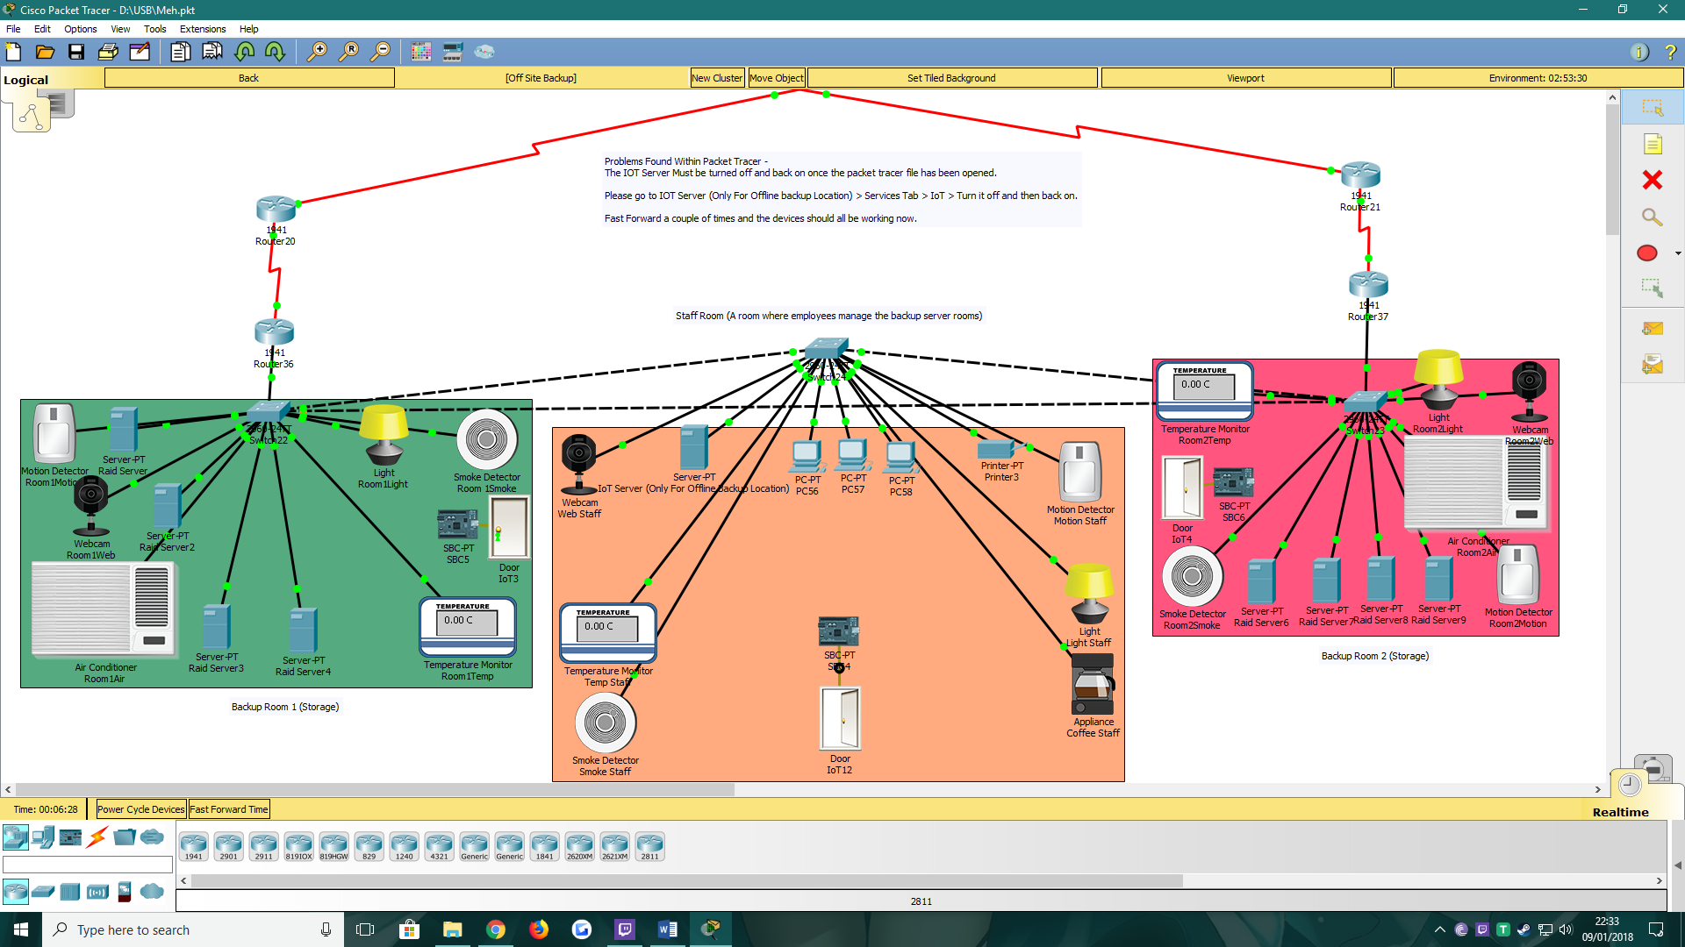

Green – Backup Room 1
Orange – Staff Room
Pink – Backup Room 2
- IoT Devices Used?
- The Image above was created in Cisco Packet Tracer. The Image shows an off-site backup location where there are two server rooms that store company information.
- Two Server rooms were created encase of something happening such as hardware failure, floods, fire and even network problems for those servers.

IoT devices used –
Motion Detector – The motion detector is an important IoT device for this configuration as it sends a signal to the Light and Webcam.

Webcam – Once received a signal from the motion sensor the webcam will turn on and record for 30 seconds. If the motion sensor keeps detecting movement then the webcam will stay on.
Light – The motion sensor will send a signal to the lights to turn on until the person leaves or unless no movement is detected for 30 seconds.

Temperature Monitor – The Temperature Monitor is connected to the Air conditioner. The role of the temperature monitor is to take the room’s current temperature.

Air Conditioner – Each few seconds the Air conditioner receives a signal from the temperature monitor and then checks the configured range to see if it needs to turn on or not.

Door – Each door is connected to an RFID card reader for any employee to easily access with their employee card.

Smoke Detector – Each room has its own smoke detector encase of any systems overheating and causing a huge fire that could lead to data corruption / data loss.

Coffee Maker – The Staff room has an IoT coffee maker on which it boots up once the motion detector detects movement. The coffee maker would automatically start and notify the employees once done. The employees would also be notified if the machine was running low on supplies.

- How does the IoT work?
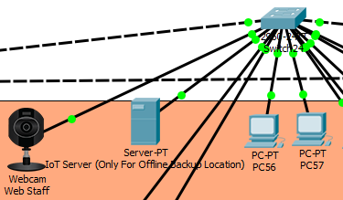
There is a IoT server located in the Staff room for the offline-storage backup location. The server registers the IoT devices that connect to it via the network. They could connect wirelessly or wired.
Before connecting the IoT server to the IoT devices they must all have an IP address. The IoT server must be a static IP address whist the IoT devices can use static or dynamic IP’s. Once the IP configurations are all done the user must create an IoT profile on the server for the devices to use to connect. This profile username and password should be the same on all devices connecting.
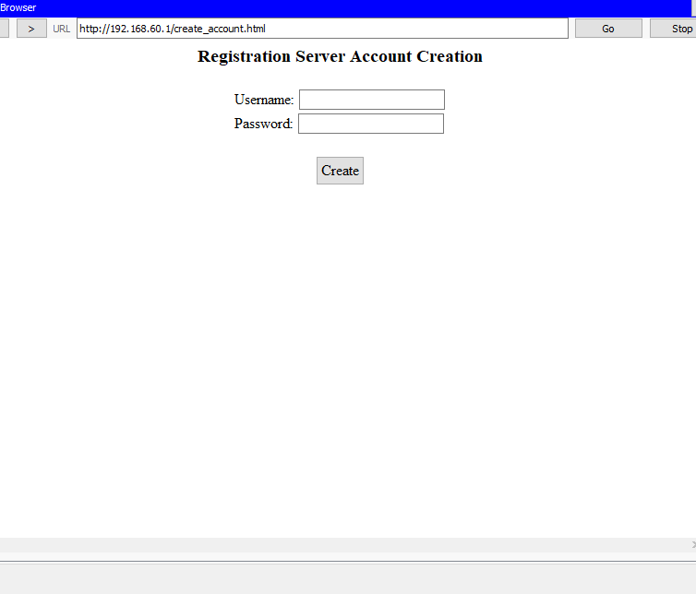
This is the account creation screen for the IoT server. Once created an account all the IoT devices must receive the username, password and IP address of the server.
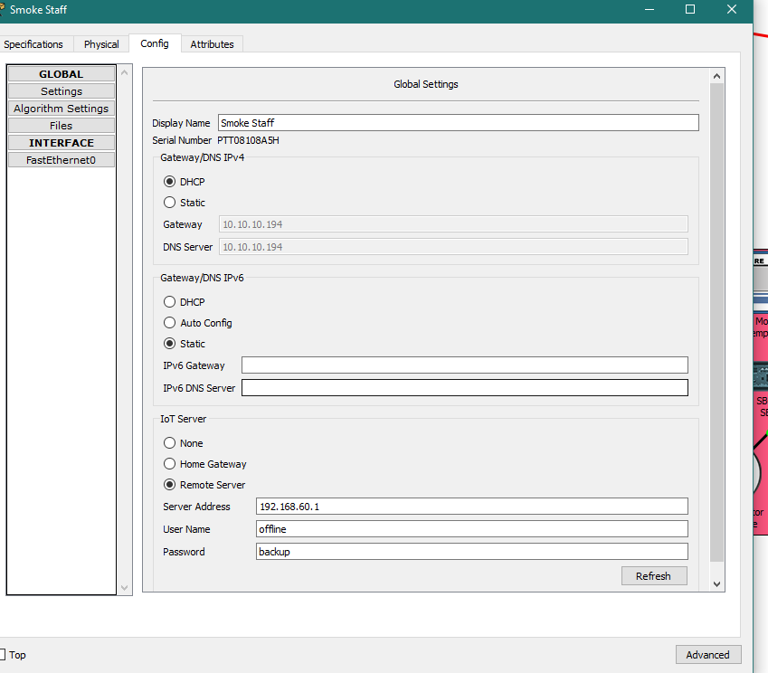
Each device must have the right information to connect to the IoT server.

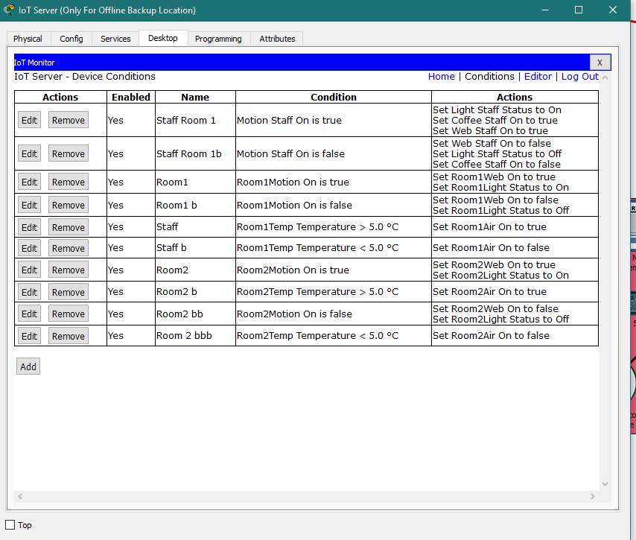
Once connected to the IoT server. Conditions can be made so devices can trigger other devices if the primary devices state changes. The screenshot above shows the current IoT conditions for the simulation. If the motion detection detects movement then it would trigger the lights and the camera or if the temperature falls below 5 degrees, then the air conditioner would turn off unless it was over 5 degrees. Each Device in the network is configured for port security as it allows a network manager to set several source MAC addresses for the port.

- Would a smart city use an IoT server?
A smart city can have one IoT server or multiple depending on the scale they wish to make the IoT infrastructure. The IoT server would have all the conditions saved for each device and runs the appropriate scripts when the primary device detects a signal.

Conclusion
To conclude this report, the author has explained what IoT is and what advantages and disadvantages it may bring. The author has written about how IoT could be used for different scenarios around the city for example using IoT in healthcare would all the doctor to keep remote tabs on the patients’ health from any distance. IoT can benefit the world and there are many reasons for adapting it and creating a smart build such as smart home, smart office or smart campus.

References
- M. Chernyshev, Z. Baig, O. Bello and S. Zeadally, "Internet of Things (IoT): Research, Simulators, and Testbeds," in IEEE Internet of Things Journal, vol. PP, no. 99, pp. 1-1.
Date/Time Accessed – 08/01/2018 10:29
http://ieeexplore.ieee.org.ezproxy.uwtsd.ac.uk/stamp/stamp.jsp?tp=&arnumber=8234579
- P. Matta, B. Pant and M. Arora, "All you want to know about Internet of Things (IoT)," 2017 International Conference on Computing, Communication and Automation (ICCCA), Greater Noida, India, 2017, pp. 1306-1311.
Date/Time Accessed – 08/01/2018 10:52
http://ieeexplore.ieee.org.ezproxy.uwtsd.ac.uk/stamp/stamp.jsp?tp=&arnumber=8229999
- S. Sidid and S. Gaur, "Smart grid building automation based on Internet of Things," 2017 Innovations in Power and Advanced Computing Technologies (i-PACT), Vellore, India, 2017, pp. 1-4.
Date/Time Accessed – 08/01/2018 11:05
http://ieeexplore.ieee.org.ezproxy.uwtsd.ac.uk/stamp/stamp.jsp?tp=&arnumber=8245201
- L. Sumi and V. Ranga, "Sensor enabled Internet of Things for smart cities," 2016 Fourth International Conference on Parallel, Distributed and Grid Computing (PDGC), Waknaghat, 2016, pp. 295-300.
Date/Time Accessed – 08/01/2018 14:41
http://ieeexplore.ieee.org.ezproxy.uwtsd.ac.uk/stamp/stamp.jsp?tp=&arnumber=7913163
- V. Goyal and K. S. Umadevi, "Simple architecture for smart home using Internet of Things," 2017 Innovations in Power and Advanced Computing Technologies (i-PACT), Vellore, India, 2017, pp. 1-4.
Date/Time Accessed – 08/01/2018 15:04
http://ieeexplore.ieee.org.ezproxy.uwtsd.ac.uk/stamp/stamp.jsp?tp=&arnumber=8245145
- J. J. P. C. Rodrigues et al., "Enabling Technologies for the Internet of Health Things," in IEEE Access, vol. PP, no. 99, pp. 1-1.
Date/Time Accessed – 08/01/2018 15:21
http://ieeexplore.ieee.org.ezproxy.uwtsd.ac.uk/stamp/stamp.jsp?tp=&arnumber=8246498
- Y. Wang et al., "A smart campus internet of things framework," 2017 IEEE 8th Annual Ubiquitous Computing, Electronics and Mobile Communication Conference (UEMCON), New York City, NY, USA, 2017, pp. 498-503.
Date/Time Accessed – 08/01/2018 16:08
http://ieeexplore.ieee.org.ezproxy.uwtsd.ac.uk/stamp/stamp.jsp?tp=&arnumber=8249106

marking criteria and Student FEEDBACK

This section details the assessment criteria. The extent to which these are demonstrated by you determines your mark. The marks available for each criterion are shown. Lecturers will use the space provided to comment on the achievement of the task(s), including those areas in which you have performed well and areas that would benefit from development/improvement.

Common Assessment Criteria Applied (Assignment 1) | Marks available | Marks  awarded
1. Research-informed Literature
Extent of research and/or own reading, selection of credible sources, application of appropriate referencing conventions.
Inclusion of a wide range of research-informed literature, but you could expand the scope of reference sources. Some areas could do with more referencing. (Grade mark: 70.00%) | 15 | 10.5
2. Knowledge and Understanding of Subject
Extent of knowledge and understanding of concepts and underlying principles associated with the discipline.
Clear awareness of challenges to established views and the limitations of the knowledge base. (Grade mark: 73.33%) | 15 | 11
3. Analysis
Analysis, evaluation and synthesis; logic, argument and judgement; analytical reflection; organisation of ideas and evidence
Logical work, supported by evaluated evidence. Very good analysis, developed. Your introduction need improvement and you should improve upon your conclusion and clearly outline your future recommendation. The report is fully based on IoT and Smart city, how does the implementation fits into the scenario given to build a functional/working enterprise network & data centre to support UWTSD campuses and partner college. (Grade mark: 63.33%) | 30 | 19
4. Practical Application and Deployment
Deployment of methods, materials, tools and techniques; application of concepts; formulation of innovative and creative solutions to solve problems.
PAD: Good implementation of the enterprise network and the services as requested. The use of the DHCP, VPN and IoT devices enhances the implementation. Good explanations behind the areas designed. Basic security configuration on devices throughout. The network would have received higher marks had the configurations on the devices been stronger. (Grade mark: 73.33%) | 30 | 22
5. Skills for Professional Practice
Attributes in professional practice: individual and collaborative working; deployment of appropriate media; presentation and organisation.
Work flow well. Formatted. You should spell out all acronyms first time used. (Grade mark: 80.00%) | 10 | 8

Assignment Mark (Assessment marks are subject to ratification at the Exam Board. These comments and marks are to give feedback on module work and are for guidance only until they are confirmed. ) | Late Submission Penalties (tick if appropriate) |  | 70.5%
 | Up to four weeks late |  | 70.5%
 | First Attempt? |  | 70.5%

