Assignment 1
-
Usability Engineering

James Craddock-Jones
256515
25/03/2022

Contents
Introduction 4
What is The Task at Hand? 4
What are The Current Systems in Place? 4
Other Systems Around the World 7
New System Design 9
Target User Group 9
Who are the target user group? 9
What are the requirements of the target user group? 9
Human Factors within Design 10
Visual Perception 10
Human Memory 11
Human Reasoning 11
Interface Metaphors 12
Affordance 12
Walkthrough and Review of Paper Prototype 14
Paper Prototype 14
Results from Prototype Review 24
New System Development System HTA 24
System Design 25
Main Menu 25
Register an Account 26
Login 27
Forgot Password 28
Home Menu 29
Book Booster Dose 30
Record Test Results 31
Local Restrictions 32
Vaccine Records 34
Processing Menu 34
Evaluation of System Design 36
References 37
Appendix 37
A: Feedback of Design From Aaron 37
Visibility of system status 37
Match between system and real world 38
User control and freedom 38
Consistency and standards 38
Error prevention 38
Recognition rather than recall 38
Flexibility and efficiency of use 38
Aesthetic and minimalist design 39
Help users recognise, diagnose, and recover from errors 39
Help and documentation 39
Recommendations: 39
B: Aaron’s Design 39
C: Feedback for Aaron 43
Visibility of system status – Score: 3 43
Match between system and real world – Score: 2 43
User control and freedom – Score: 2 43
Consistency and standards – Score: 1 43
Error prevention – Score: 2 43
Recognition rather than recall – Score: 1 43
Flexibility rather than recall – Score: 2 43
Aesthetic and minimalist design – Score: 1 43
Recommendations: 44

Introduction

What is The Task at Hand?
The task is to create a new design and build the COVID passes system for the Welsh Government. This new system will require a prototype design built for either a website or mobile application that users can interact with to get the details they need to go to public venues.
The prototype must also be able to upload COVID test results to the Welsh Government as well as provide information about local restrictions in different areas of Wales and provide the Welsh Government information on where the user has been, for example, venues so that effective track and trace can be applied when needed.

What are The Current Systems in Place?
The current system in place is the NHS online website that provides the user with their COVID pass in a bar code for domestic use such as pubs and clubs and international travel to provide proof of vaccination COVID-19. The website has these two pass categories separated on a home screen where the user can choose the one they need.
The NHS online website also provides the user with more information about each of their vaccinations, such as the manufacturer, date of vaccination, the vaccination number, if it was their first, second, or third dose, and more the batch numbers.
The website gives the user the choice of how they can obtain their COID pass, for example, whether they would like to have a PDF version of their COVID pass to print off or just use the one provided. Every pass has an expiration date that is roughly one month from when you requested the COVID pass. (2)
To register to NHS online to gain access to a COVID pass, the user must set up an account providing either identification, passport, full UK driving licence, or full European driving licence. Users must also be over 12. (2)
Below are a few examples of the current NHS COVID pass system used across most of the UK. You can view your COVID pass and COVID records and get a COVID pass for travelling worldwide.
The first image is the main menu, allowing you to select a COVID pass for domestic use or travel. Personally, looking at the user design, this should have been done with noticeable buttons rather than hyperlinks. I state this as it would be easier for the user to interpret that they are clickable and would have allowed for a much larger clickable zone helping with usability.
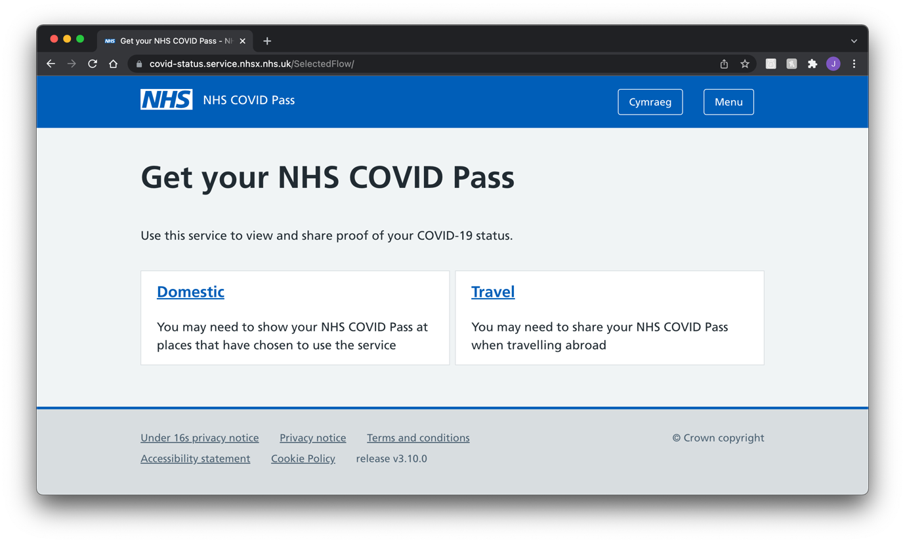
The next page shown below is the COVID pass menu for domestic use. The design for this page is simple and easy to understand and interpret, though it does have its issues regarding wasting space and relying too much on black space to fill the page.
For example, the bottom buttons could have been placed on the left-hand side, while the COVID pass could have been placed on the right, taking up more space.
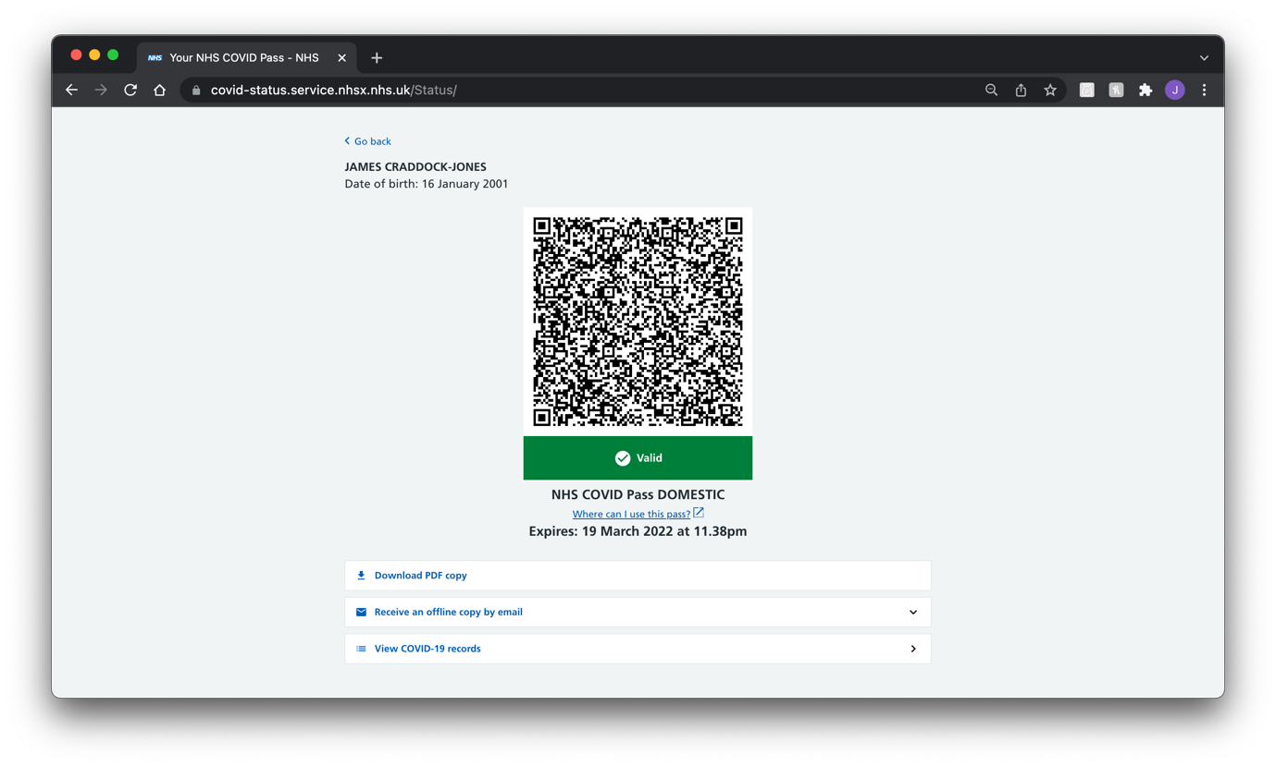
The following menu provides the user with their COVID-19 records. For example, vaccinations that they have been administered. This menu uses a simple design that can come across as simple to the user and hides the data that could overwhelm them by default, such as batch numbers.
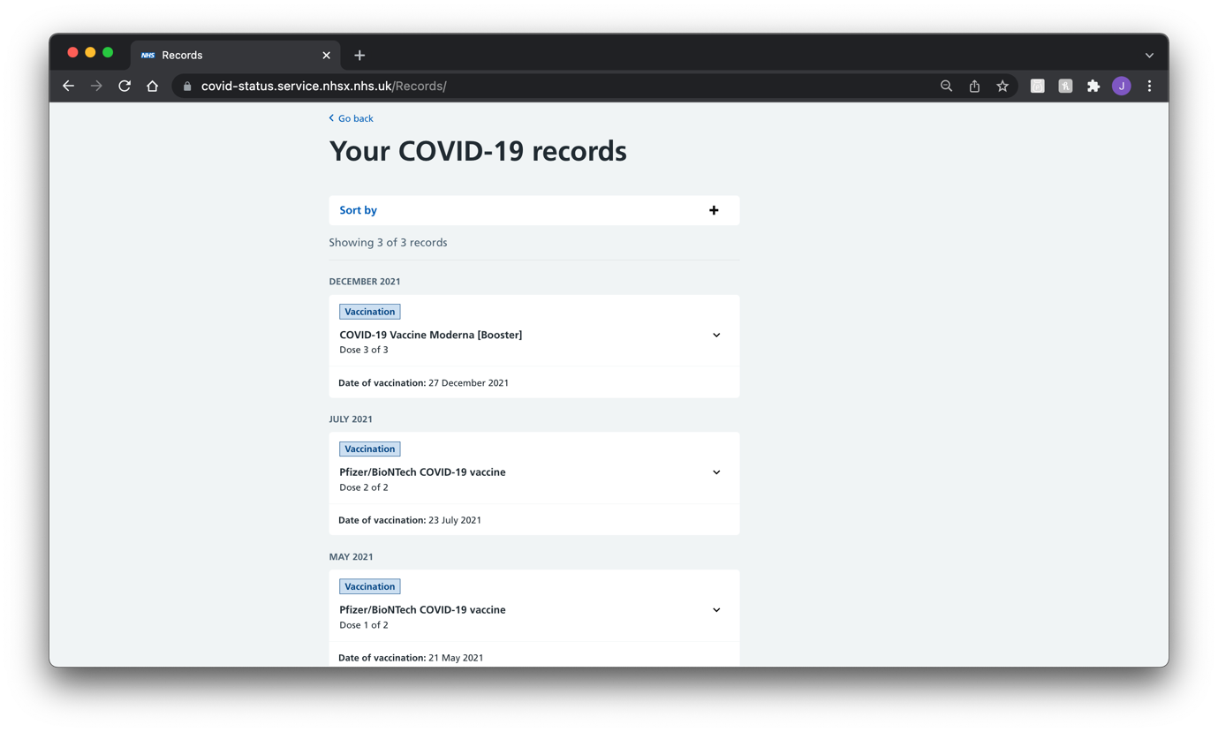
The following two menus are related to international travel. This could have been designed significantly better by having one QR code that can bring up the records of all COVID vaccinations. This could have been done rather than having to have one QR code for each vaccination, thus drastically simplifying the process for the user.
Doing it this way would have also allowed for the same design as the domestic pass, allowing for better usability through the user remembering design cues, simplifying the learning curve.
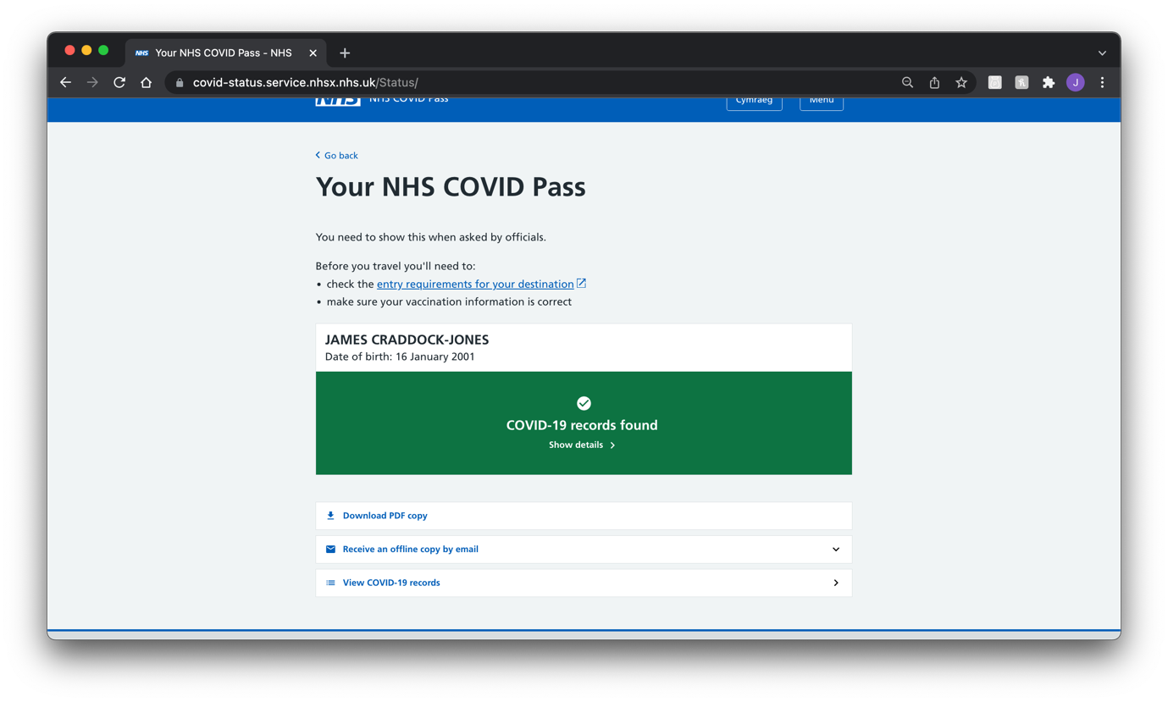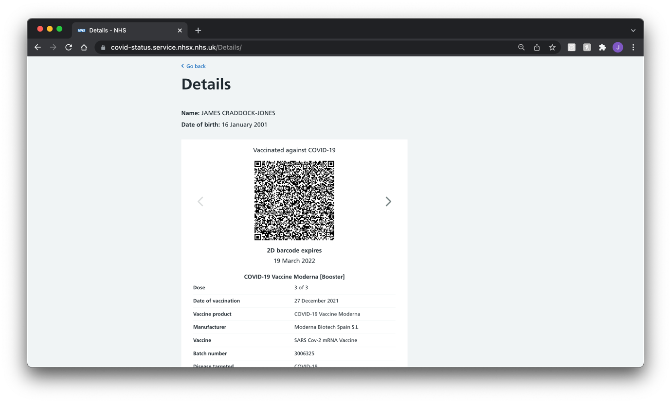

Other Systems Around the World
One system is the EU Digital COVID Certificate. This can be found across all European countries. The advantage of this system is that it is recognised as valid across the whole EU while also providing services in English and other languages that nationals may also use. (1)
Like the UK COVID pass system, this system also provides a QR code as the primary verification method. In addition, this system is also recognised around the world like the UK system making it easy to use around the world when travelling. (1)
This pass also covers people who recently had COVID or have recently had a negative test. This pass is given out free of charge to anyone within the EU whose country supports the system. (1)
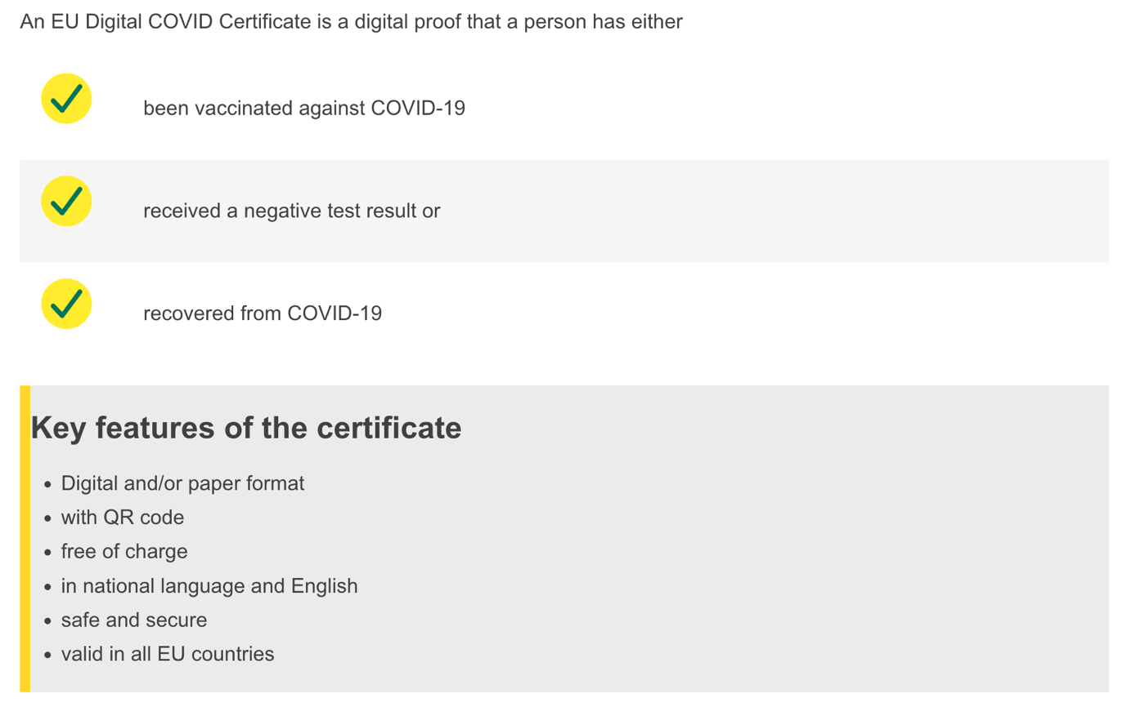
(1)
Everyone who is an EU national or is living within a member state is entitled to a COVID pass through this system. Like the UK system, only children over the age of 12 can apply for a pass. (1)
Below is how the system’s QR codes work and validate the QR code against the different signatures that venues have been provided.
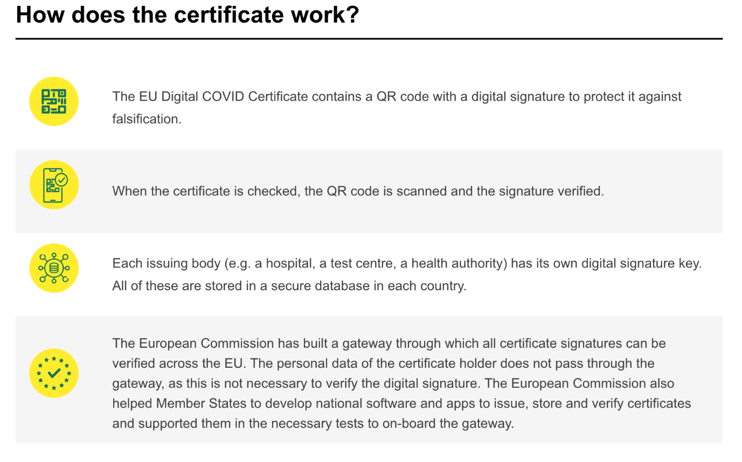
(1)

New System Design

Target User Group

Who are the target user group?
Due to COVID passes being used in pubs, clubs, theatres and other public venues in Wales. It is safe to assume that the target audience for the system would be young adults (16-21) to adults of an age range from 22 up to mid to late 30. These tend to be the age ranges that use venues listed, such as theatres, pubs, and clubs.

What are the requirements of the target user group?
From the observation that has taken place, I have found that the user would like a more streamlined experience when using the system. For example, a more basic design is clear to understand with all the required information on demand.
In addition, I have found that they would like the new design to be more polished in that all menus follow the same design principles to allow for the design to be easier to learn. The current design does not do this well enough and is confusing due to its rushed appearance.

Human Factors within Design

Visual Perception
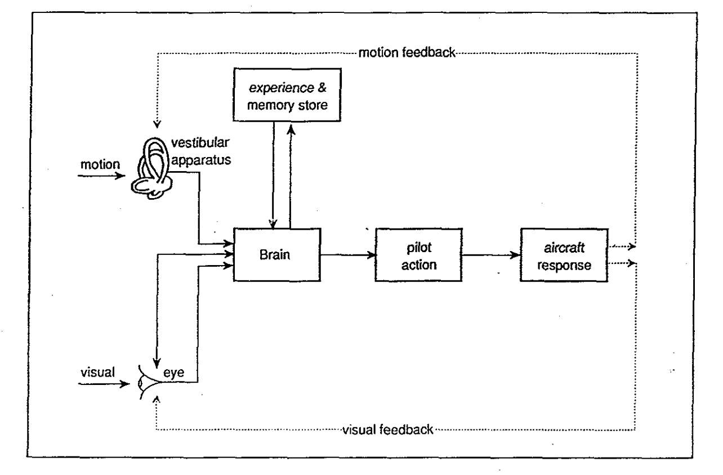
(3)
Visual perception involves gathering information from the eyes, for example, motion and light. The eyes have three processes that are involved with adaptation, one being the adjustment of light via the pupil expanding and contracting in different lighting conditions, another being the intensity of light, and the third being two mechanisms that occur with the rod and cones within the retina of the eyes to preserve light and the many different colours. (3)
Visual perception also includes calling from memory past experiences with the combination of learning and expectation, and this is “well reflected in the popular saying that one sees what one expects to see.” (3)
The following stages, pilot action and aircraft response, deal with the response to the stimulus, for example, twisting a door handle and pulling the door towards you to open it or pushing a door. (3)

The intended design of the new system will make sure that elements of the GUI are recognisable to the user from the real world and or other GUI designs to help the user quickly learn how the new system works. This would mean, for example, making the buttons look like different button GUI designs and the same for input forms so that the user recalls what to do from memory and past experiences.
Human Memory 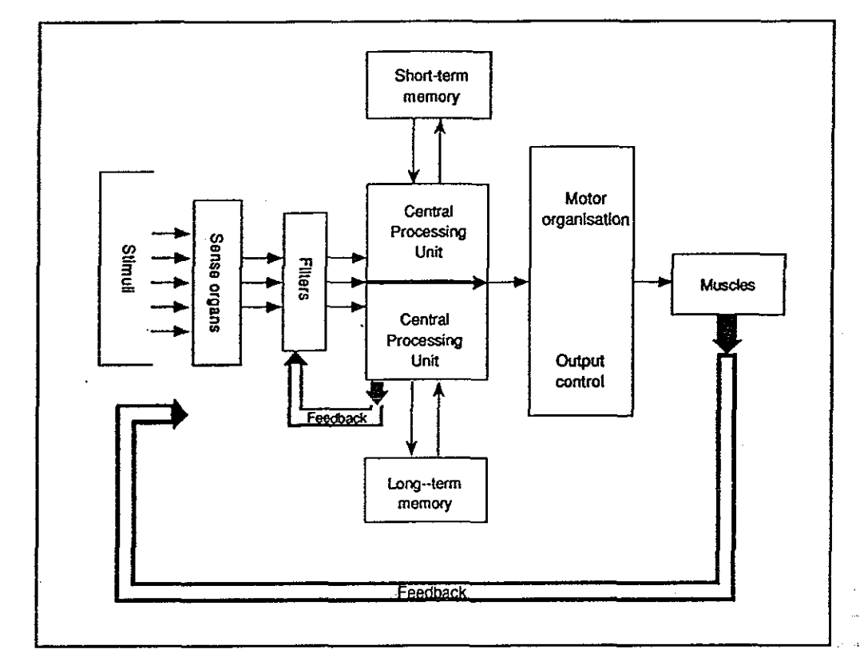
(3)
Memory is the most vital key to any human information system, with no system being able to process without it. The downside to human memory is that it is a limited resource and must be treated like that when designing a user interface. An overly complex system can easily overwhelm the memory system within the human brain. (3)
There are two types of human memory, which can be trained to be further improved. One is long term memory which is the retention of information over a long period, for example, a few weeks, months or even years. While on the other hand, short term memory only lasts if needed and fades away over a short period when no longer needed. (3)
This ties somewhat into visual perception, so the same will be done to combat this in the design like that, so making sure that elements of the GUI are recognisable to the user from the real world and or other GUI designs to help the user quickly learn how the new system works.

Human Reasoning
Human reasoning allows individuals who are characterised by their ability to think instinctively, without any constraints, and in a manner that any critical piece of information might be analysed by using logic to obtain a more comprehensive understanding. (4)
People can get information by accumulating facts or figures, comprehending them, and then determining whether they are right or wrong through their ability to reason. In a nutshell, reasoning is any procedure that encompasses reaching a judgment based on a combination of facts. (4)
Throughout the design, this will be incorporated in many ways. For example, taking design cues from other designs allows the user to recall from existing knowledge gained elsewhere and repurpose that with minimal learning curves.
This could be taking design cues with how elements such as buttons or menus are laid out or placed on the GUI and colours schemes for such elements.

Interface Metaphors
Interface metaphors are a collection of GUI actions, images, and procedures that take advantage of the users' prior understanding of similar interface designs they may have used. (5)
The goal of interface metaphors is to give the user immediate knowledge about interacting with the user interface. They are made to look like tangible things, but they also get their characteristics. A computer desktop or a web gateway are examples of this. (5)
Interface metaphors can be based on an action, an item, or a mix. They can communicate with the users existing experience to help them grasp the unknown. (5)
Examples are the floppy disk representing save in applications and the graphical icons for files and folders that help symbolise a computer’s file system. (5)
Like human reasoning, the same can be applied to the design by incorporating design cues from other GUI designs. For example, taking design cues from different designs allows the user to recall existing knowledge gained elsewhere and repurpose that with minimal learning curves.

Affordance
Affordance refers to the relationship between someone’s understanding with a physical or electronic entity. Affordances in a graphical interface are perceivable, actionable possibilities. (6)
Users see a graphical interface and conclude which activities are available based on expectations and prior experiences using other GUIs. (6)
Throughout his publication, The Design Of Everyday Things, Don Norman, an expert within human-computer interaction research, Don wonderfully outlines the significance of affordances within graphical interfaces. “When affordances are taken advantage of, the user knows what to do just by looking: no picture, label, or instruction needed.” (6)
To make the design comply with this design factor, the new system’s design will make elements such as buttons stick out to look obvious that they are clickable like real-life buttons.
This will be hard to do with the current modern styling of flat objects/colours, unlike almost a decade ago when skeuomorphic GUI design was still a trend before changes to design were made in operating systems like iOS 7 and Windows 8.
The below image shows this shift in GUI design with iOS 7 (left) vs iOS 6 (right).
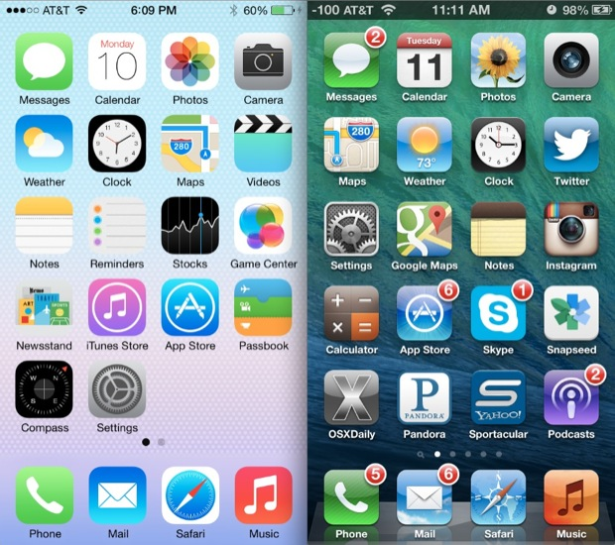
(7)
In addition, the Windows 8 start menu vs Windows 7 start menu shown below.
Windows 8:
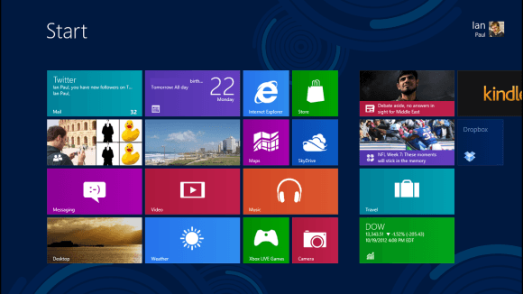
(8)

Windows 7:
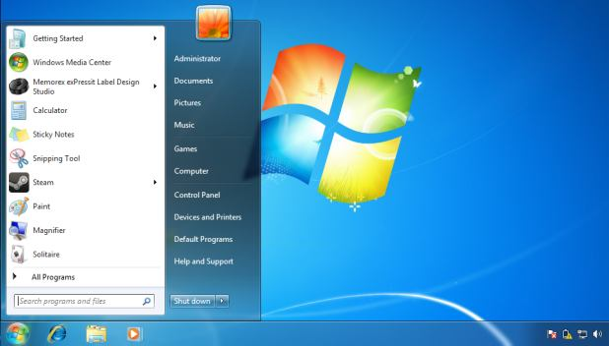
(9)

Walkthrough and Review of Paper Prototype

Paper Prototype
Below is the paper prototype that was shown to Aaron for feedback on how it could be improved. Where helpful, a page number has been placed next to clickable objects such as buttons that correlate with the page number on the top left-hand side.

Main Menu
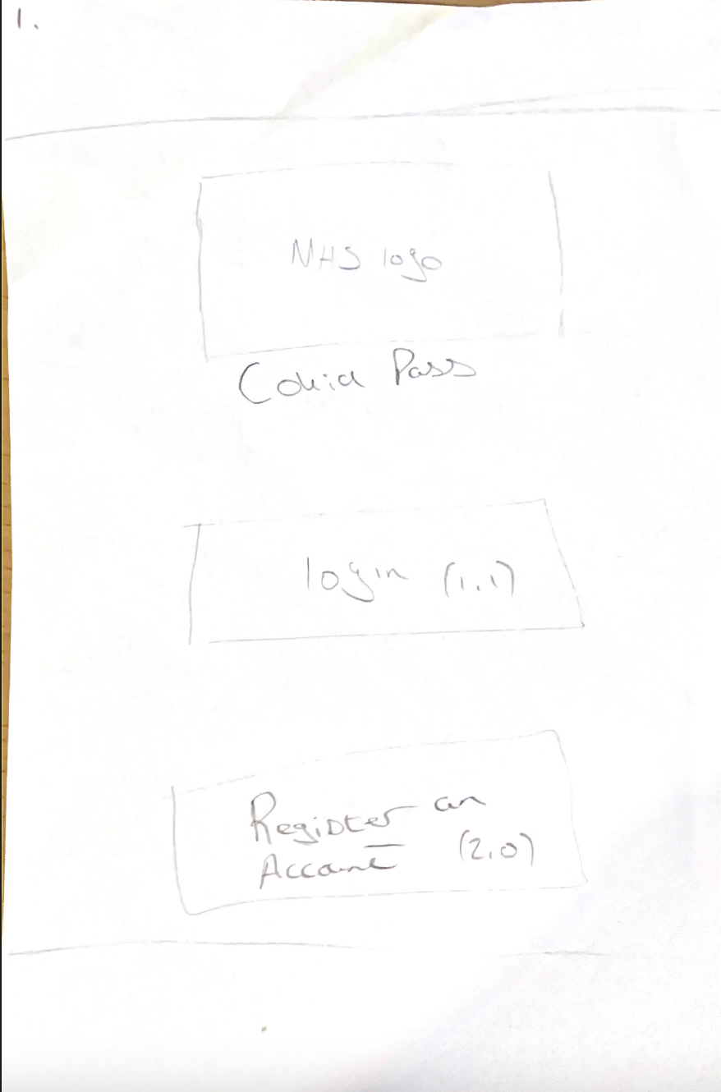

Login
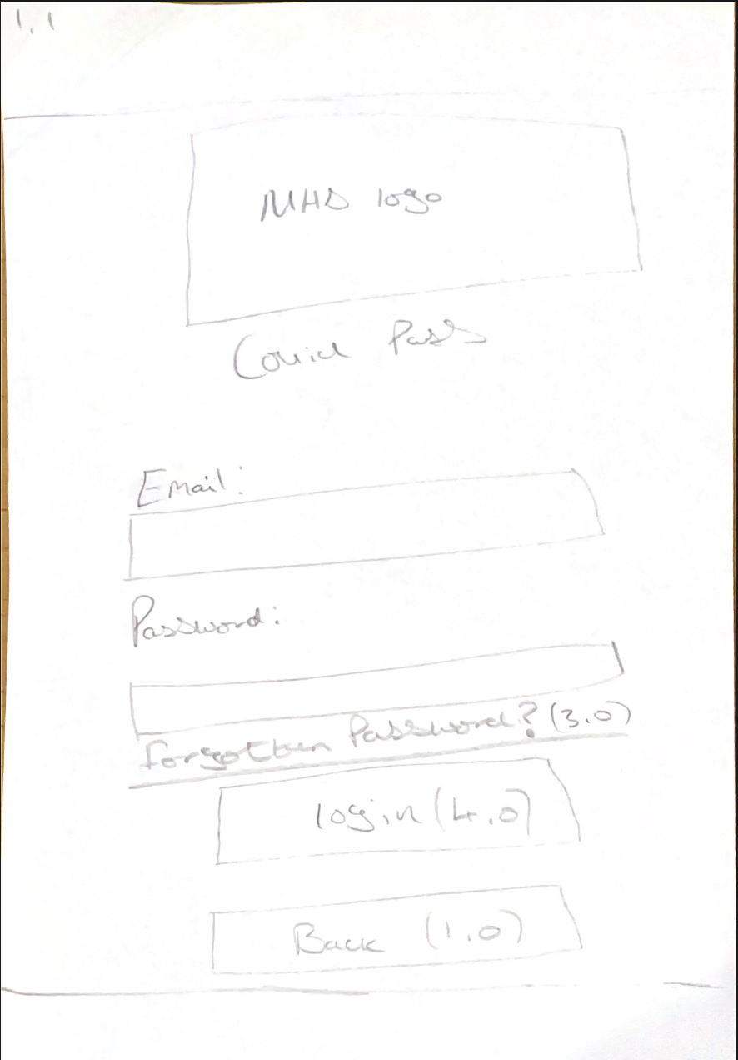

Register an Account
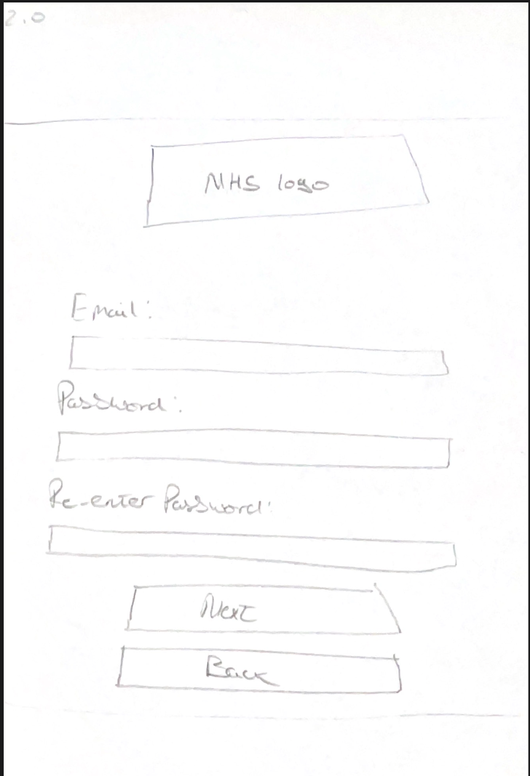

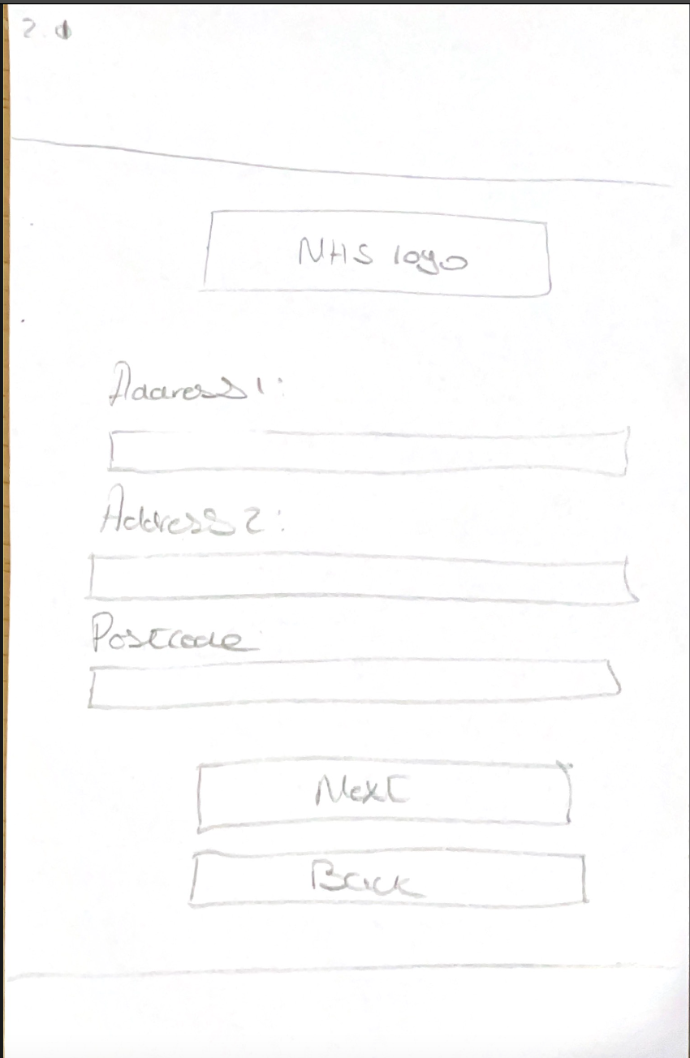
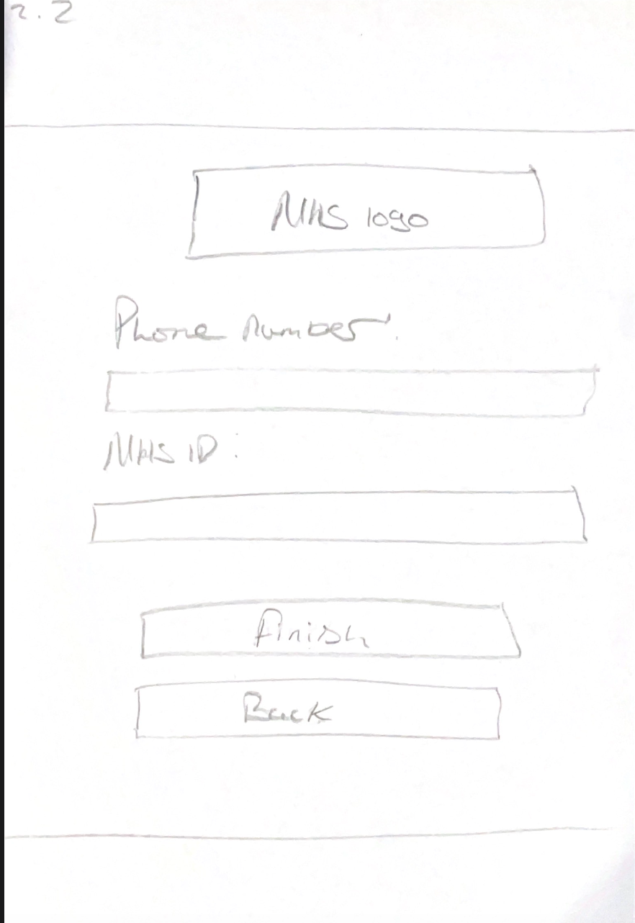

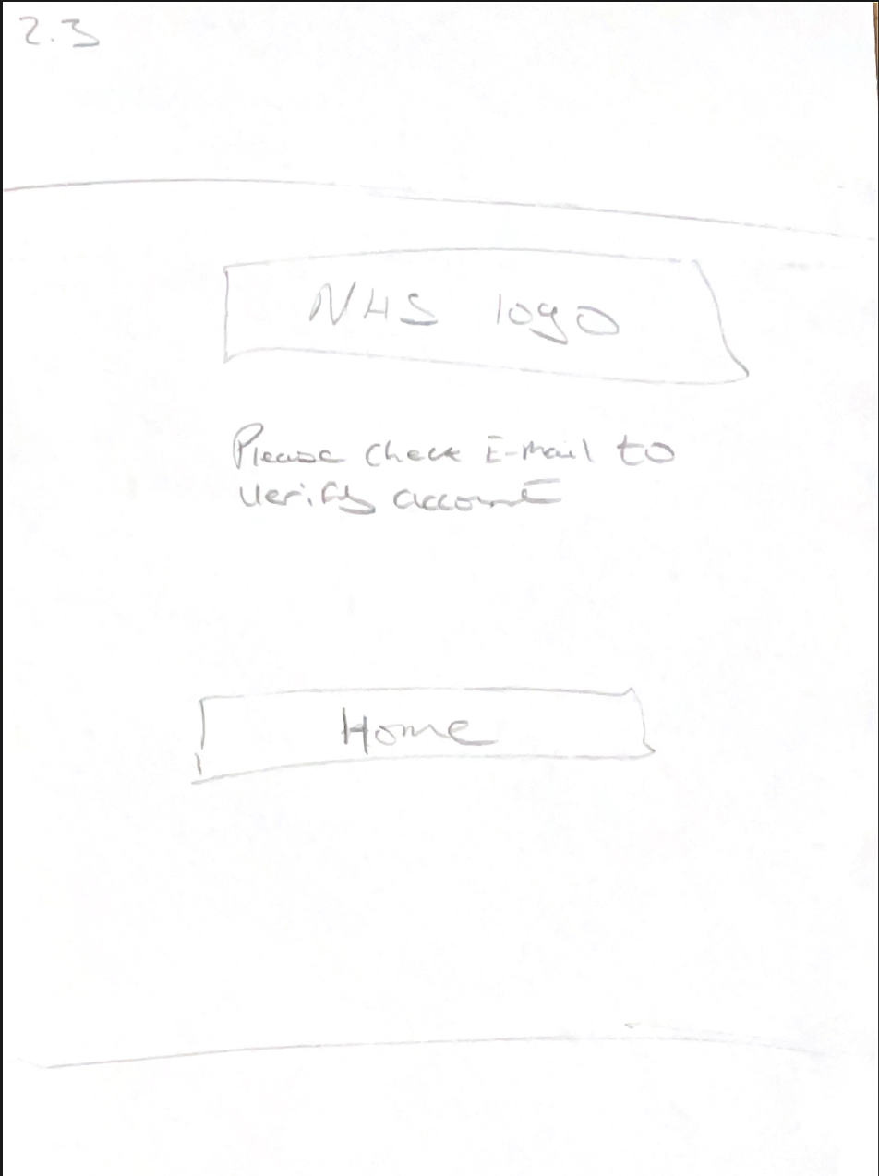

Forgot Password
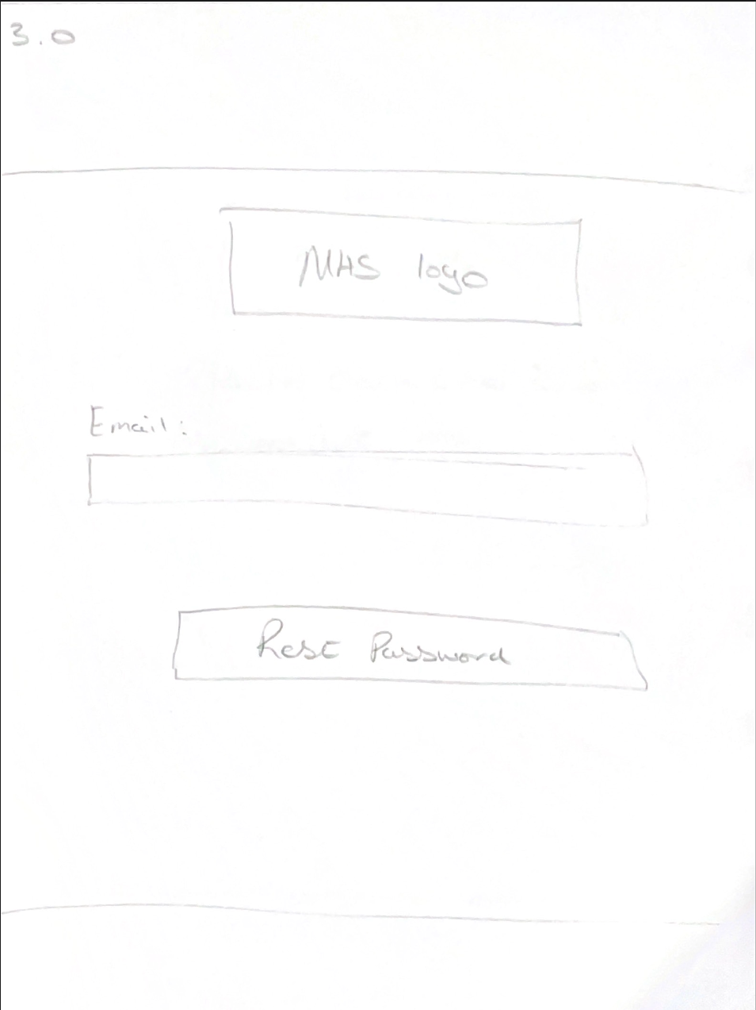
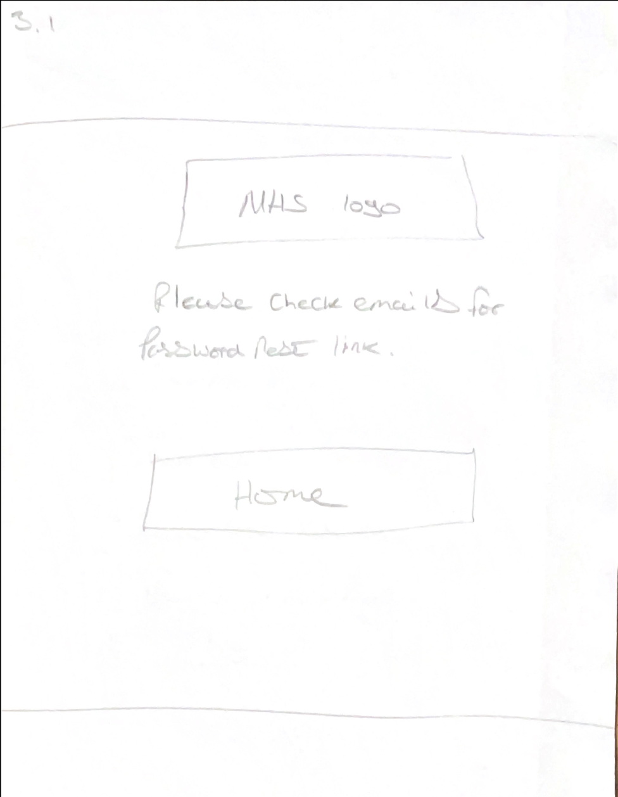

Home Menu
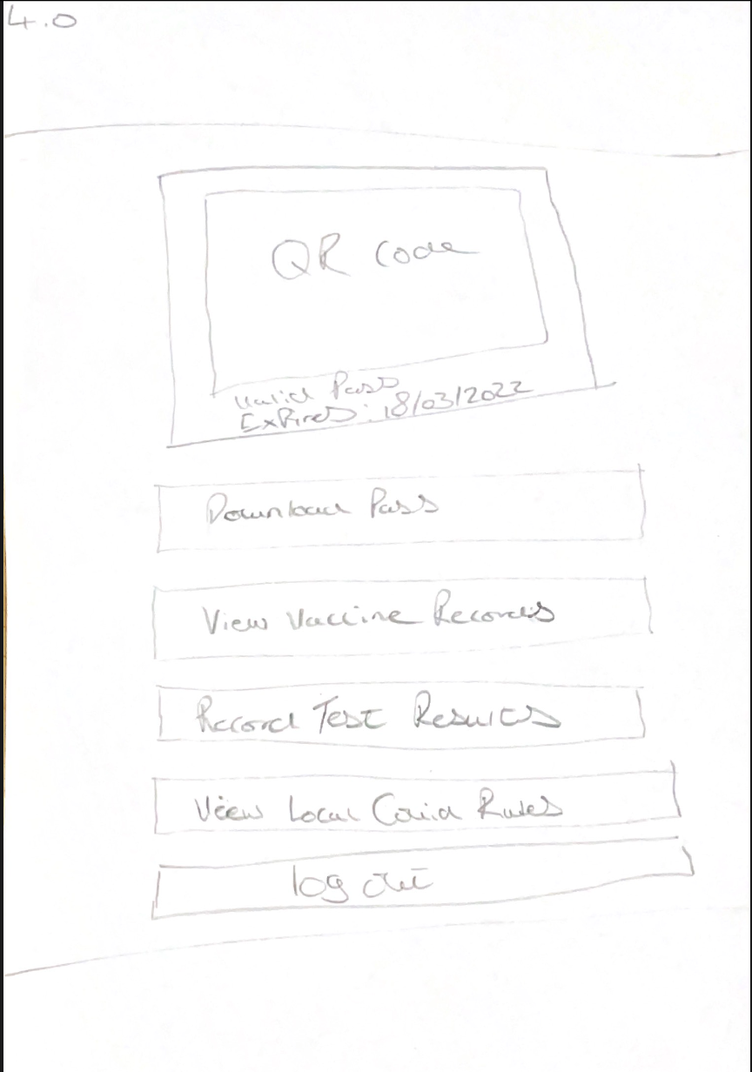

Results from Prototype Review

Results
See Appendix A for feedback.

Feedback To Aaron
I provided the whole feedback to Aaron can be seen in Appendix C. The summary of the feedback that I provided to Aaron is that the design applies many human factors—for example, taking design cues from other systems.
In addition, he has kept the design minimal and consistent throughout, so it does not overwhelm the user when they are using the system.
The design fell apart with the location of the back buttons not being in an ideal place (top right side of the menu), making error prevention for the user a little cumbersome.
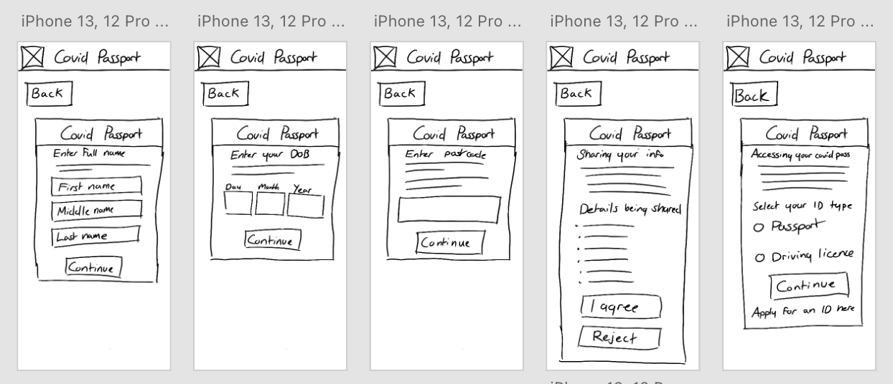Furthermore, there was no processing menu within the design, meaning the user would not be notified of system status when loading or processing data.

Changes made to design
The design will now show a little message under the NHS logo telling the user what process they are going through to know where they are and what they are required to do.
A processing message will be displayed as and when needed. For example, when completing the registration steps, providing COVID test data, booking a booster dose, and loading vaccine data from the NHS database.
One area in which is disagree with Aaron on is the main menu. I believe that designing it in the way Aaron has recommended might cause confusion and make the login menu much more complex than it needs to be.

New System Development
System HTA
Below is the system HTA, which serves as a task analysis for what the system will do once complete. This includes the processes and temps on handling logins and registers, booking boosters, uploading tests results, viewing local restrictions, viewing vaccine records, and providing test results.
Due to its size, the HTA diagram will be included with this document.
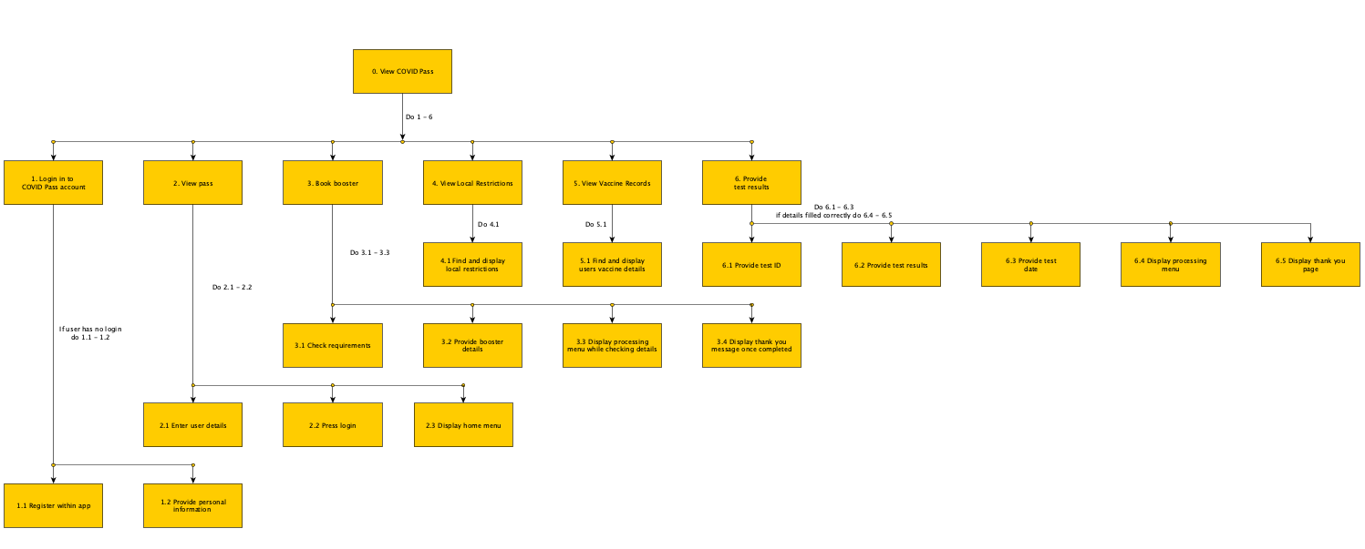

System Design

Main Menu
Below is the main menu that greets the user when they open the app for the first time. Here the user can choose to set up an account, login into an existing account, and change language between English and Welsh.
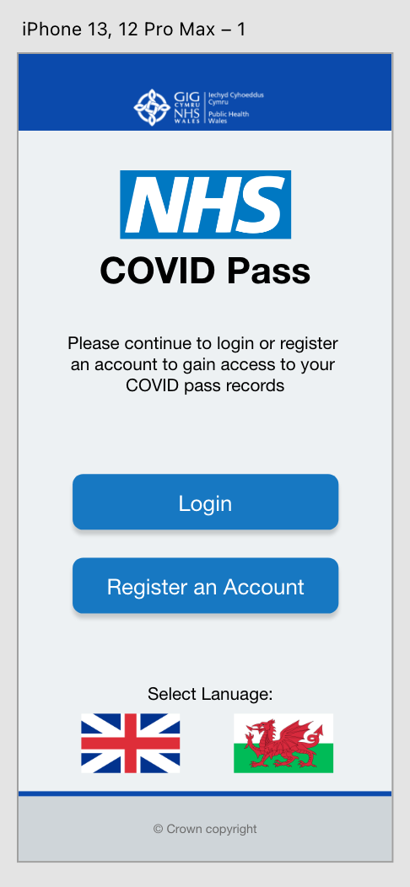

Register an Account
Below is the process that the user will go through when creating an account. The user will provide their complete address details, email, password, phone number, and NHS ID to verify the account against existing NHS records.
A processing menu will be shown when the user presses the finish button to display the system is processing the data they have provided.
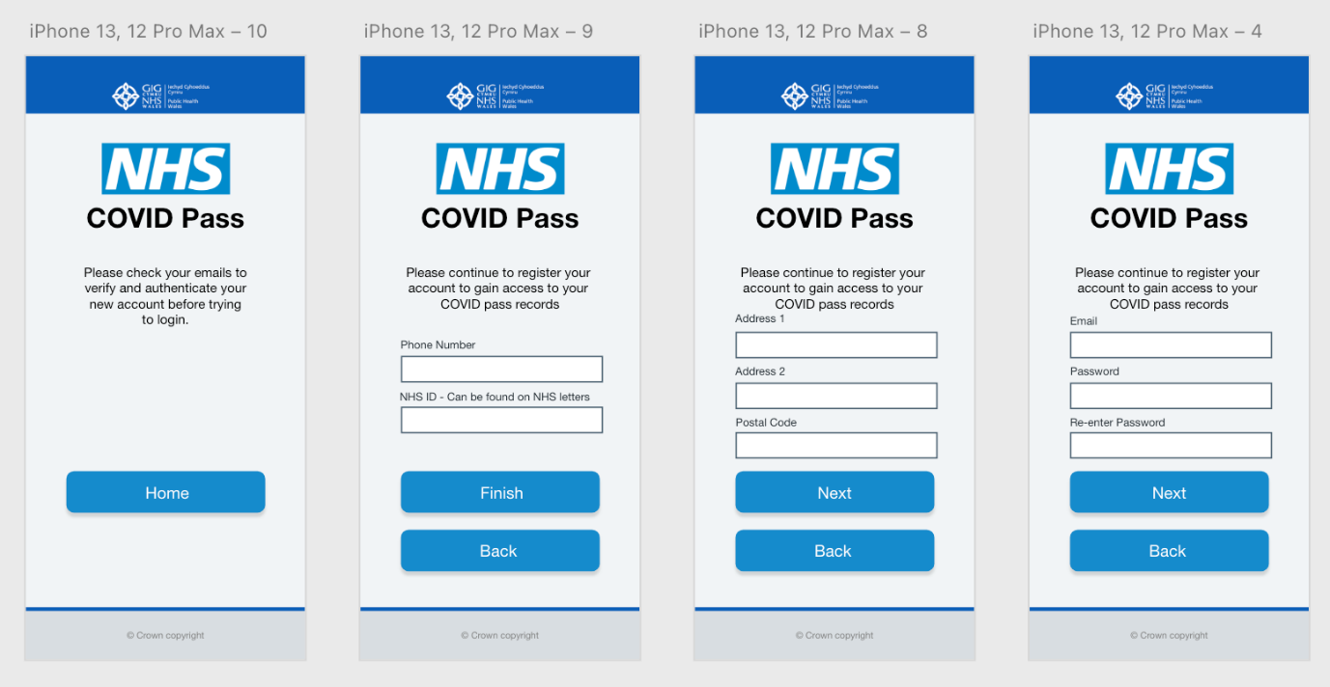

Login
Below is the design for the login menu. The menu requires the user to input the correct account details to progress onto their account’s home menu. This menu also provides a little link that takes the user to a menu to reset their accounts password.
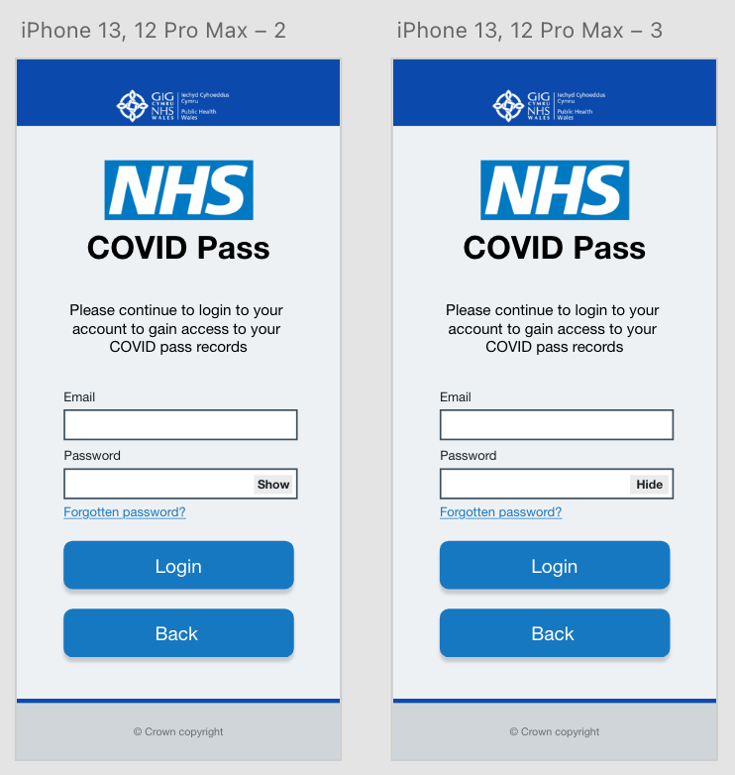

Forgot Password
Below is the menu that has been designed for requesting a password reset. The user must provide their account’s email. The processing menu will be shown here when pressing the “Send Rest Request” to show the system is processing the request.
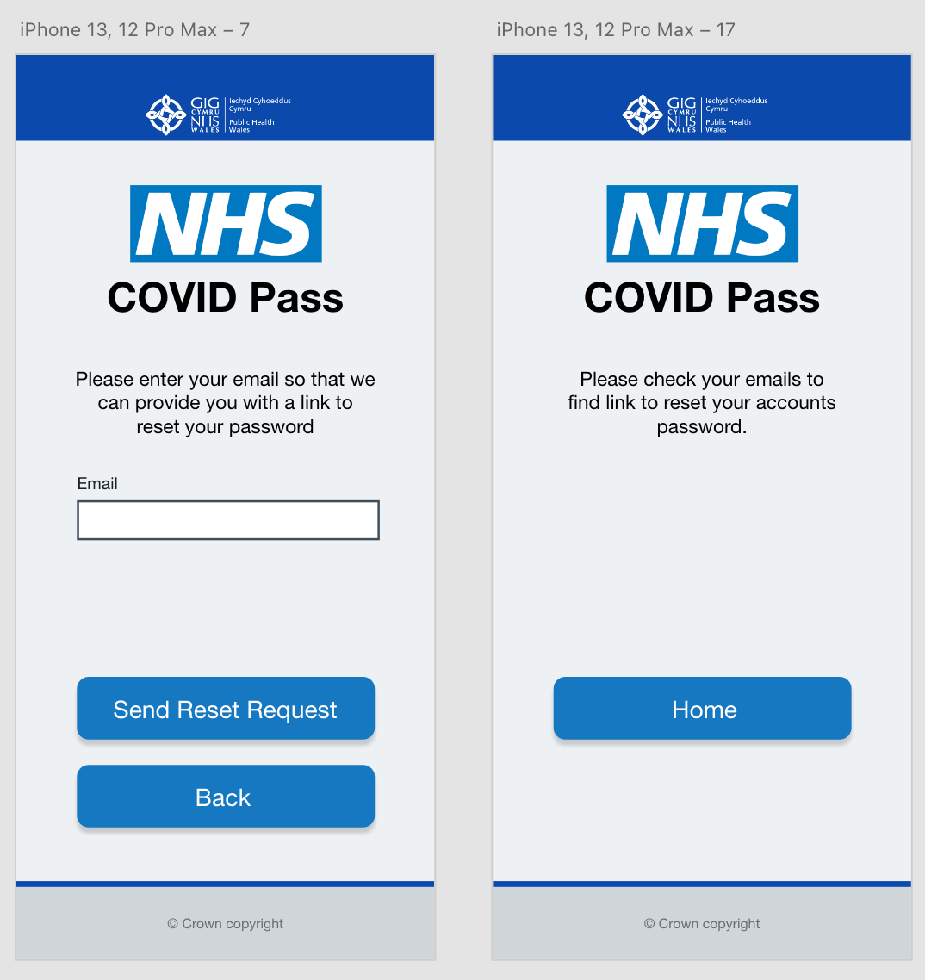

Home Menu
Below are the various home menus that can be shown to the user depending on certain variables. For example, if the user has not received their booster, they will be shown the interface on the far-right. If they are fully vaccinated, the middle menu will be shown, and the far-left menu will be shown if they have downloaded their pass.
This menu also provides access to the rest of the system regarding vaccine records, local restrictions, and recording COVID test results.
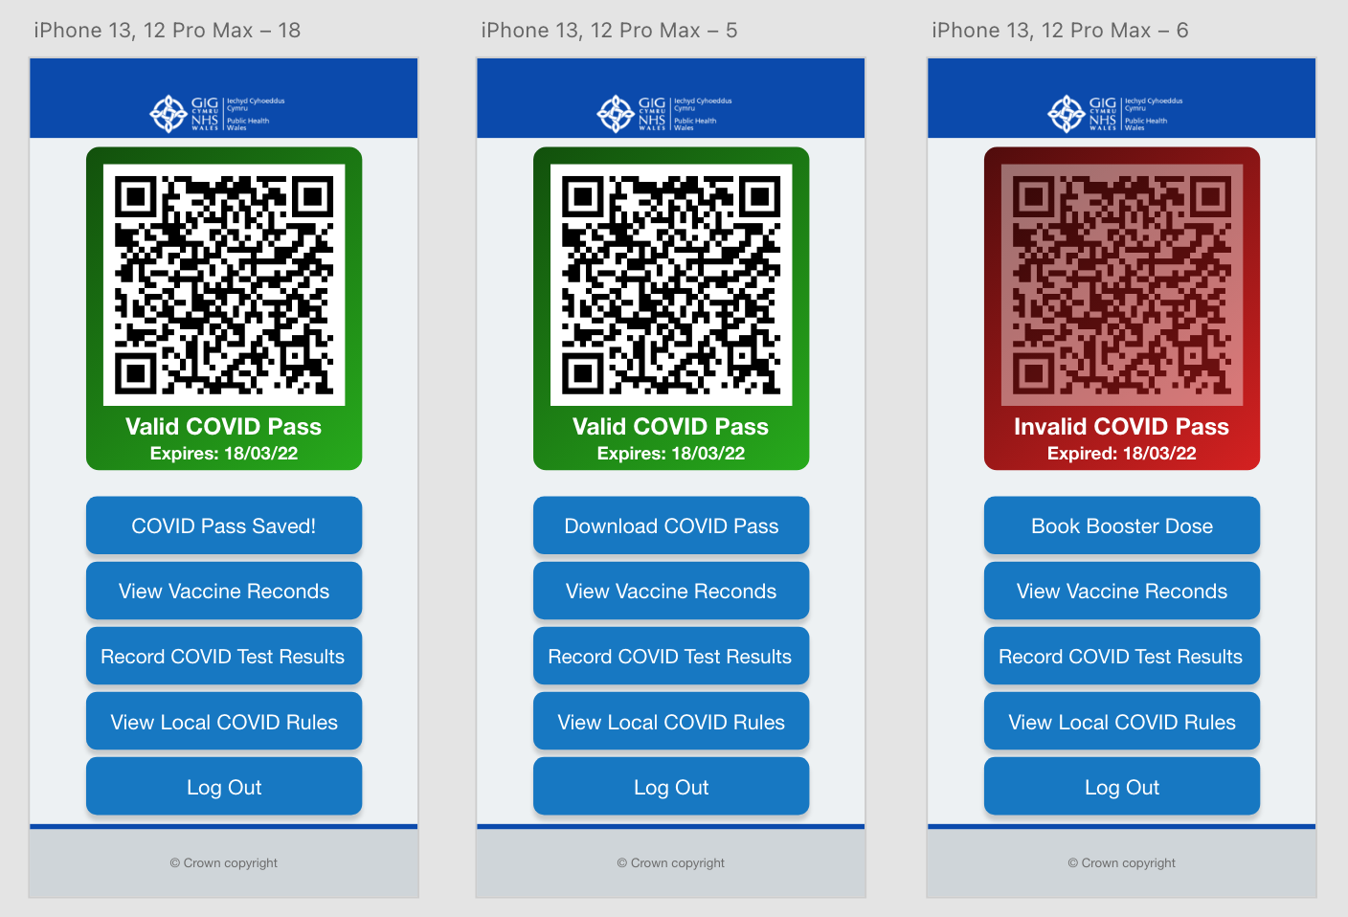

Book Booster Dose
Below is the menu which will be used to book booster doses if the user has not received any. The user will be required to enter a date, region and venue for the booster. The processing menu will be shown between the booking and thank you pages.
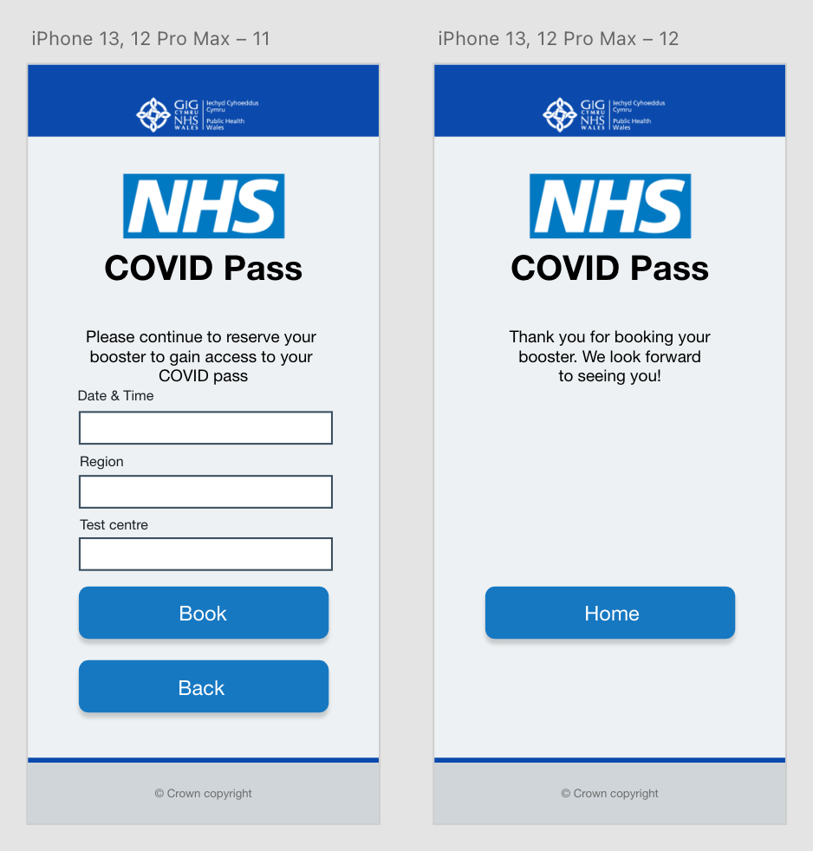

Record Test Results
Below is the menu which will be used to record COVID results. The user will be required to enter the test result, test ID, and the date the test was done. The processing menu will be shown between the recording and thank you pages.

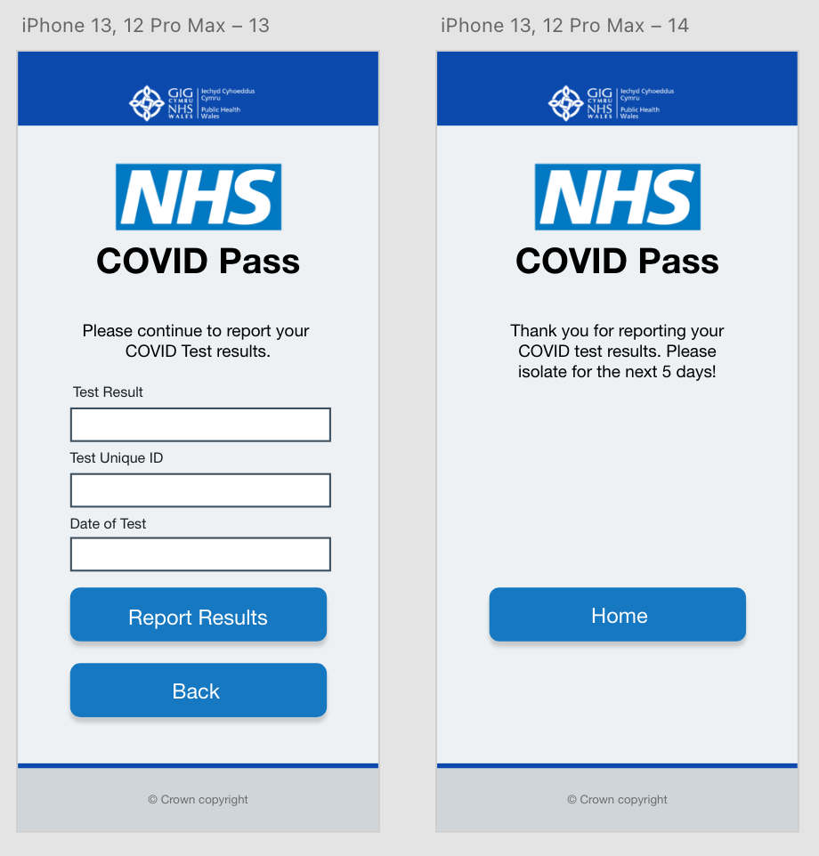

Local Restrictions
Below is the menu that handles the local restrictions. The user does not have to do anything here as the system handles that for the user.
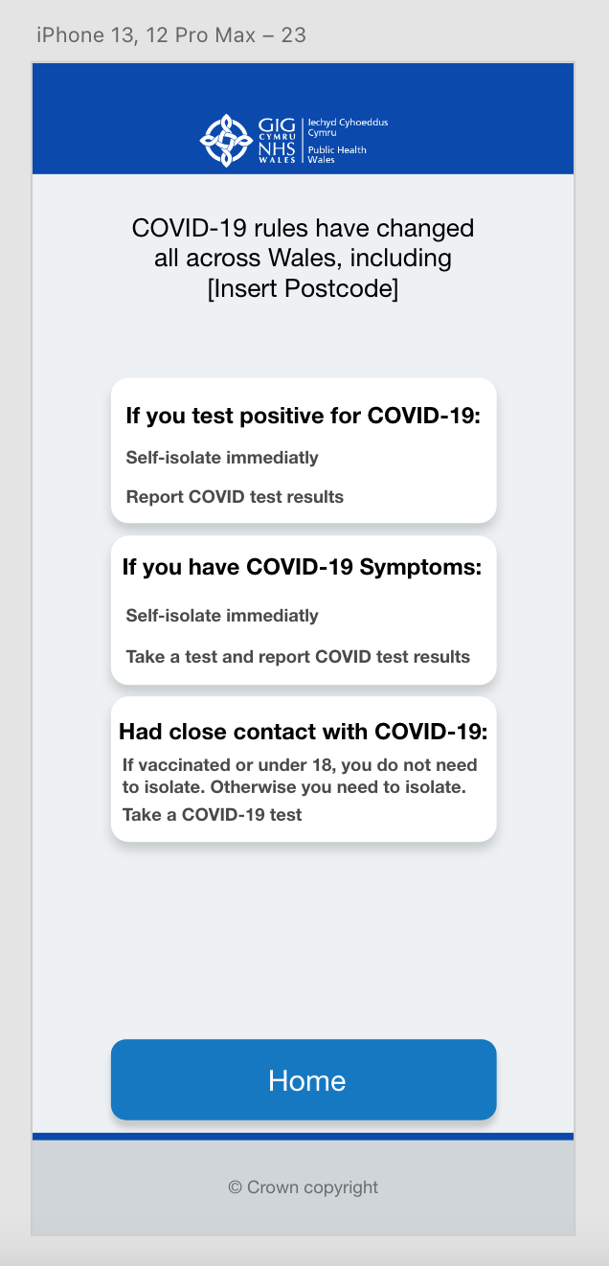

Vaccine Records
Below is the vaccine records menu. This menu provides the user with information regarding how many doses they have received, the date they received them, and the vaccine manufacturer.
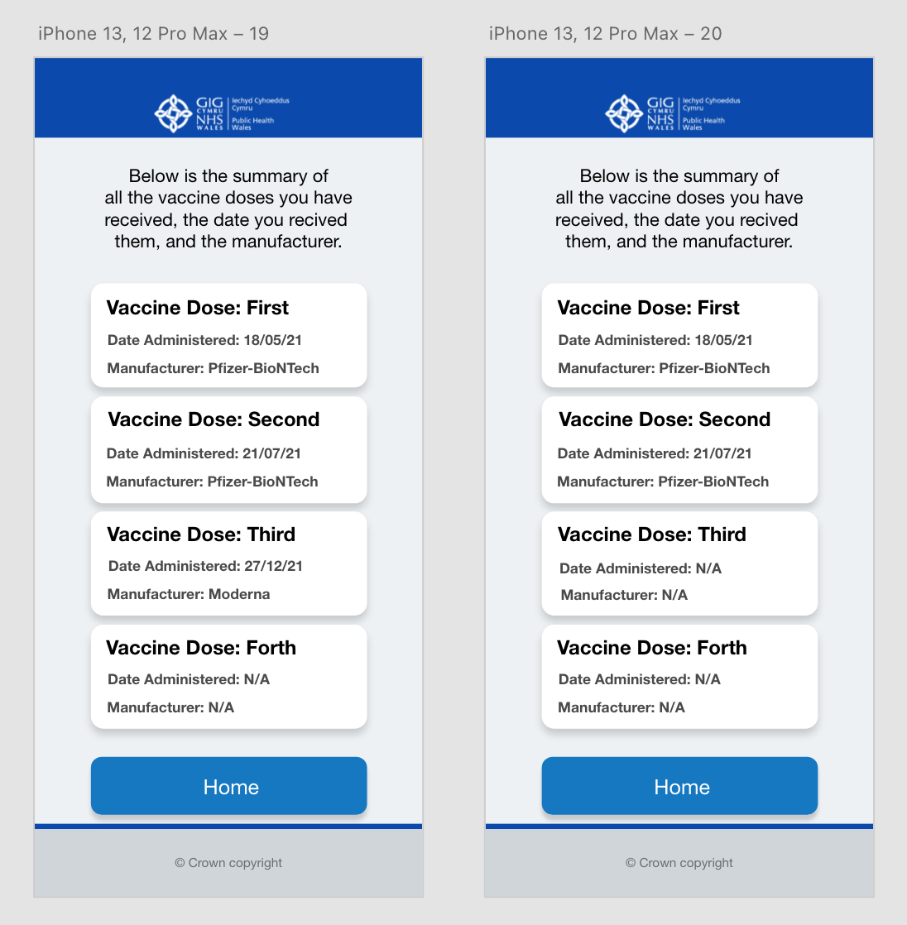

Processing Menu
This is the processing menu shown to the user when the system is processing data.
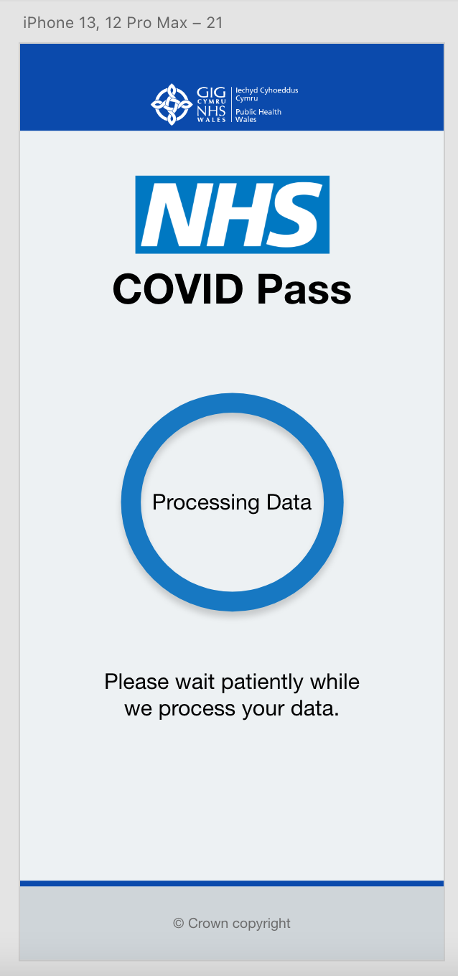

Evaluation of System Design
I have relied on the user’s recall throughout the design by using a similar design to the standard NHS website. This allows the user to use human reasoning and interface metaphors to recall their experience using the NHS website and apply it to this application.
One change was made to this with the buttons. This was done so that the colour pallet could be simplified by different shades of blue, rather than making the buttons an entirely different colour as the NHS website does with buttons being green.
The downside to doing the buttons like so was that recall could not be used here from the NHS website, but to help the user know they are clickable and to bring in some affordance, a drop shadow was applied to all the blue buttons to distinguish them from the rest of the GUI. This also helped the button look more like a real-life button as the drop shadow applied depth.
One area which can be improved is the local restrictions menu. I say this because the design is not best suited to the amount of information needed to be displayed to the user. The design is very cramped and restricted in the amount of detail provided to the user.
I designed the local restrictions menu this way so that recall could be used from the vaccine records menu, but instead, it has caused an issue with the amount of information that could be provided at a given time.
There are advantages and disadvantages to registering an account with this system. The advantage and disadvantage are that the system uses people’s unique NHS ID to register an account. While doing it this way simplifies the process, it makes it harder for those who do not know their NHS ID to sign up and use the application.
When viewing vaccine records, the design is simple and straight to the point as all the information that the user requires is displayed clearly in an understandable format. The information provided has been simplified compared to the current system so that the user does not get overwhelmed by all the information.
This menu and the local restrictions menu will require some human reasoning to use, given that the design is somewhat different from the rest. Although, it is not different enough that the user will struggle to adapt and use the GUI.
The message shown at the top of most menus allows the user to know the system’s status, allowing the user to know where they are at a given time and what is required from them. The processing menu also provides them with the crucial information that the system is loading and has not crashed.

References
- European Commission, EU Digital COVID Certificate, https://ec.europa.eu/info/live-work-travel-eu/coronavirus-response/safe-covid-19-vaccines-europeans/eu-digital-covid-certificate_en Date of Access: 03/02/2022

- Welsh Government, Get your NHS COVID Pass, https://gov.wales/get-your-nhs-covid-pass Date of Access: 03/02/2022

- ATC Training, Human Factors Training Manual, https://www.globalairtraining.com/resources/DOC-9683.pdf Date of Access: 10/02/2022

- Brice Foundation, Human Reasoning and Ethics, https://www.bricefoundation.org/single-post/2019/03/25/human-reasoning-and-ethics Date of Access: 17/02/2022

- The Audiopedia, What is INTERFACE METAPHOR? What does INTERFACE METAPHOR mean? INTERFACE METAPHOR meaning, https://www.youtube.com/watch?v=L5n3CDnyk5o Date of Access: 17/02/2022

- N. Babich, What Is Affordance and How Does it Impact Design?, https://xd.adobe.com/ideas/principles/web-design/what-is-affordance-design/ Date of Access: 24/02/2022

- OSXDaily, iOS 7 vs iOS 6 Side-by-Side Visual Comparisons, https://osxdaily.com/2013/06/11/ios-7-vs-ios-6-visual-comparison/ Date of Access: 24/02/2022

- M. Stanojevic, Windows 7 vs. Windows 8 comparison: Old meets new, https://windowsreport.com/windows-7-vs-windows-8/ Date of Access: 24/02/2022

- L. Hoàng, Windows 7: Disable Highlighting New Programs in the Start menu, https://www.tech-recipes.com/rx/21773/windows-7-disable-highlighting-new-programs-in-the-start-menu/ Date of Access: 24/02/2022

Appendix

A: Feedback of Design From Aaron

Visibility of system status
Severity score out of 5:
1 | 2 | 3 | 4 | 5
Reasons why: The buttons which are labelled with appropriate text help towards telling the user what the system may do, for example ‘LOGIN’ or ‘RESET PASSWORD’ other than that there are no indications of what the system is doing or processing.

Match between system and real world
Severity score out of 5:
1 | 2 | 3 | 4 | 5
Reasons why: The phrases and concepts used are very common practice which should provide enough for the design.

User control and freedom
Severity score out of 5:
1 | 2 | 3 | 4 | 5
Reasons why: Overall the control given to the user is clear and concise although, on the reset password page there is no way to navigate back a page, only reset the password button is present.

Consistency and standards
Severity score out of 5:
1 | 2 | 3 | 4 | 5
Reasons why: The design seems pretty consistent all the way through with a very vertical design that does fit the requirements of a phone screen well.

Error prevention
Severity score out of 5:
1 | 2 | 3 | 4 | 5
Reasons why: Although there are controls for going back a page which could help with error prevention, there are no warning screens present or windows present to notify a user if they would have entered some information wrong. Retyping the password for the account creation process is a good example of error prevention and is applied here.

Recognition rather than recall
Severity score out of 5:
1 | 2 | 3 | 4 | 5
Reasons why: Although the design minimises what the user needs to do on each page, it is important to remind the user what process they are going through, for example if they are creating an account, put a title or text suggesting what stage of the process they are at to help users not get confused.

Flexibility and efficiency of use
Severity score out of 5:
1 | 2 | 3 | 4 | 5
Reasons why: The design provides navigation tools which are consistently in the same position, all users would use this navigation easily. Possibly provide more ways of interacting with navigation for example swiping right on the phone would go back also.

Aesthetic and minimalist design
Severity score out of 5:
1 | 2 | 3 | 4 | 5
Reasons why: The design is very minimalistic and does well in not distracting the user will unnecessary elements.

Help users recognise, diagnose, and recover from errors
Severity score out of 5:
1 | 2 | 3 | 4 | 5
Reasons why: There are no error messages present in the current design, users can however use the back button to go back a step if need be.

Help and documentation
Severity score out of 5:
1 | 2 | 3 | 4 | 5
Reasons why: Additional documentation is not present but could be assumed that the process is so common and streamlined that the text on screen is enough for 99% of users.

Recommendations:
I feel that the first page in the prototype could be removed and a registration button be added to the login page which should remove one extra step in the process but may be beneficial to keep as this software is to be used by the general public which will have a wide range of skillsets and making the process simple to understand will help In the design.

B: Aaron’s Design
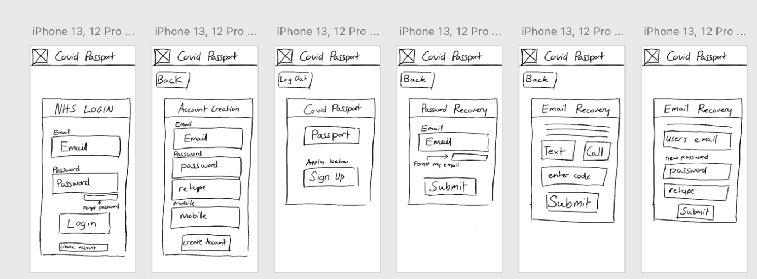

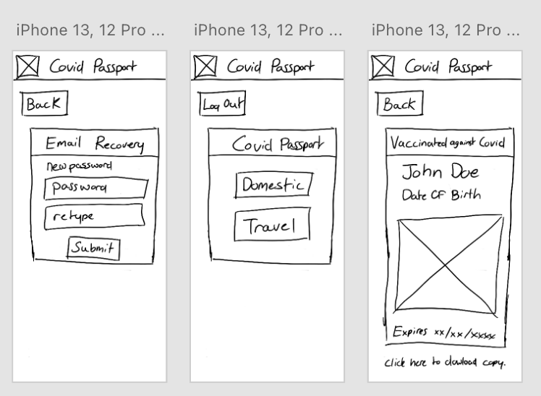

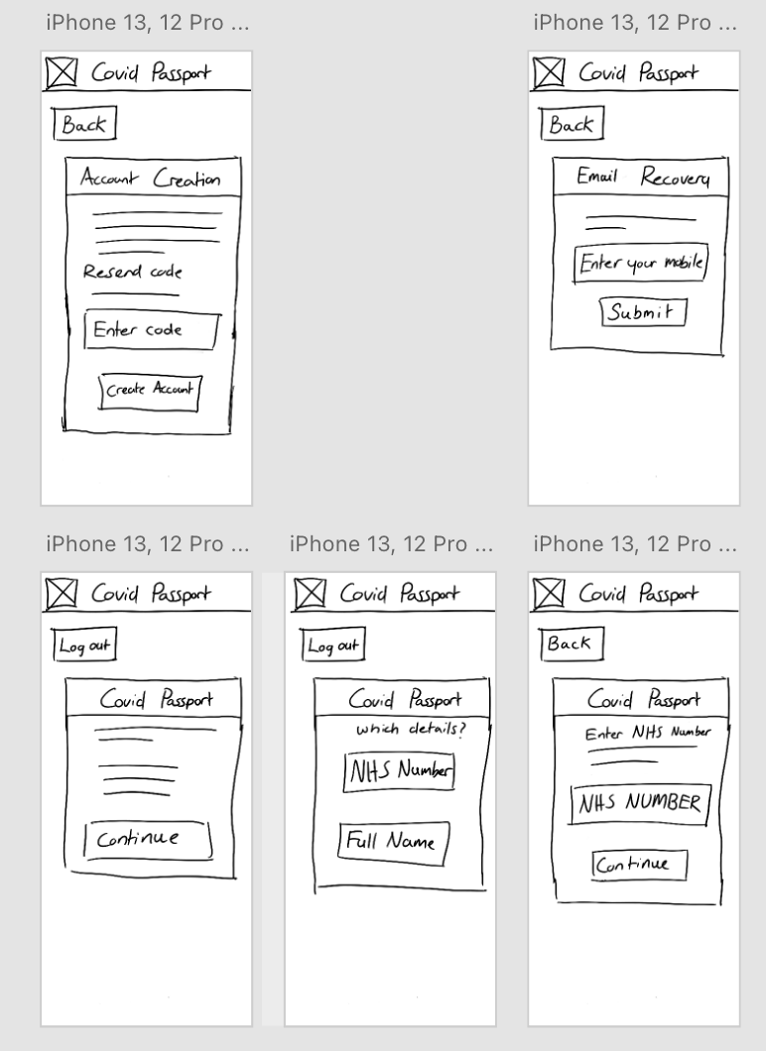

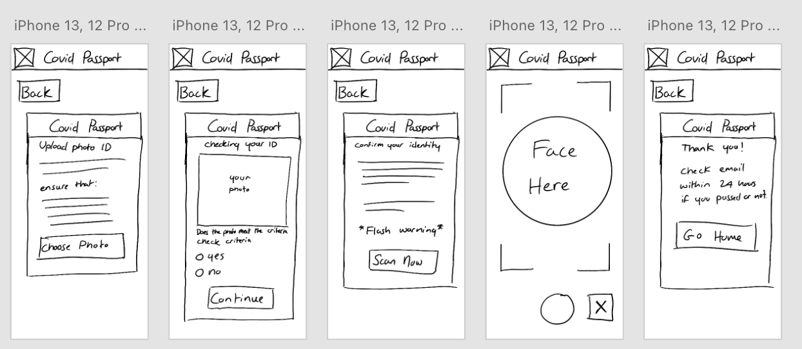

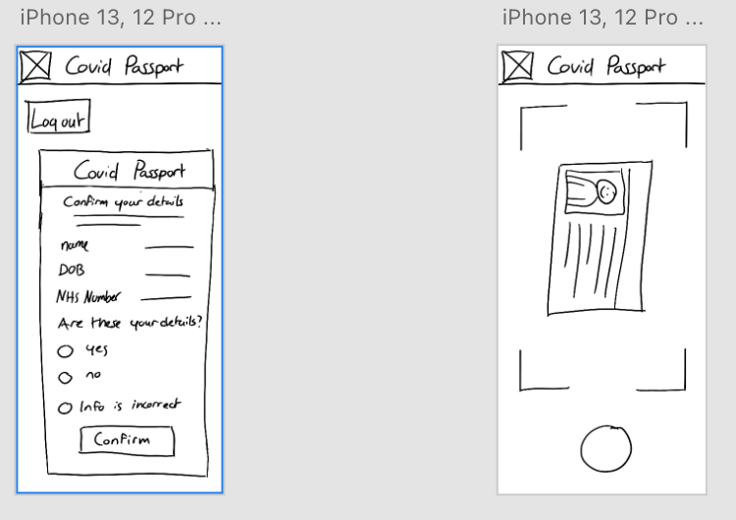

C: Feedback for Aaron

Visibility of system status – Score: 3
There are no loading screens to inform the user that the system is processing something in the background. the system on the other hand does provide the user with their location status through the many different menus.

Match between system and real world – Score: 2
The design makes use of buttons with a similar design to buttons in the real world.

User control and freedom – Score: 2
Back buttons need repositioning as they are not displayed in the most noticeable of areas at the first few glances

Consistency and standards – Score: 1
Design is consistent throughout the system.

Error prevention – Score: 2
As stated before, the back buttons are positioned in an area that would go unnoticed when for example, registering an account.

Recognition rather than recall – Score: 1
Design is consistent throughout the system and takes design cues from other GUI designs making it easier to use.

Flexibility rather than recall – Score: 2
The design provides shortcuts back to the home menu but does not provide back buttons in a suitable position when needed.

Aesthetic and minimalist design – Score: 1
Design is consistent throughout the system and takes design cues from other GUI designs making it easier to use. While also being minimalistic by showing the user only the required information.

Recommendations:
relocate back buttons to a more suitable location and add loading screens to show the user the system is processing something.

