

The Impact of Product Recalls on Businesses and Projects.

Quality Management in an Operational Environment

Adrian Cartlidge – 2415605

Contents

1. Abstract 2
2. Introduction 3
3. Developing a suitable process that can be followed in the event of a product recall. 3
3.1. Literature review 3
3.2. Challenges in Managing Product recalls 4
3.3. Developing a suitable Recall Process 4
4. The costs associated with product recall and how they can be managed. 8
4.1. Direct Costs 8
4.2. Indirect Costs 9
4.3. Managing Recall Costs 10
5. Restoring consumer confidence during and after a product recall 11
6. Conclusion 12
7. References 13

Abstract
Product recalls can have devastating effects on businesses, resulting in significant financial losses, reputational damage, and lack of consumer trust. This report examines the impacts of product recalls on businesses and projects, highlighting the need for a proactive and structured approach to managing recalls effectively. A comprehensive seven-stage framework is developed, applicable across multiple industries, to guide organisations in responding to product recalls in a timely and efficient manner. The framework addresses the critical aspects of product recall management, including developing a suitable recall process, managing direct and indirect costs, and restoring consumer confidence. By adopting this framework, businesses can minimise the negative consequences of product recalls, ensure compliance with regulatory requirements, and maintain a competitive edge in their respective markets.

Introduction
Product recalls represent significant challenges for businesses across various industries, impacting their operational processes, financial performance and reputation. A company’s decision to recall a product from the market often comes from the need to mitigate potential harm to consumers, which can stem from various defects or safety concerns. The research on product recalls is extensive and covers various industries, strategies, costs, regulatory compliance and consumer behaviour. Research indicates that a proactive approach to the management of a product recall can lead to improved consumer perceptions and potentially enhance a company’s reputation, despite the immediate financial impact of this approach (Eilert et al., 2017) (Hora et al., 2001) (Murphy & Popa, 2012) (Lu & Shanker, 2015).
There are two main types of product recall, voluntary and mandatory. Voluntary recalls are initiated when a company or manufacturer identifies a defect or safety issue with one of its products. By adopting this proactive recall strategy a company can address the issues before they escalate and tend to experience less negative feedback from the consumer compared to those that react late (Hora et al., 2011) (Chen et al., 2009). Consumers generally perceive these actions positively, which can reduce the negative impacts on consumer loyalty and brand reputation (Murphy & Poa, 2012) (Mak et al., 2020). However, mandatory recalls are imposed by regulatory authorities when a product is found to be unsafe and fails to meet safety standards. These recalls often come from external pressures, such as customer complaints, inspections or reports of any harm associated with the product. The lack of preparation for product recalls can lead to panic and poor management, which can aggravate the situation and can significantly harm the company’s reputation (Ahsan & Gunawan, 2014).
While product recalls are often viewed as a form of crisis management, they also offer companies a chance to demonstrate their commitment consumer safety and quality. By establishing strong operational processes and ensuring clear communication with consumers, companies can not only mitigate the adverse effects of product recall but also enhance their reputation and build consumer trust over time (Yu et al., 2022) (Muralidharan et al,. 2019) (Giannetti & Srinivasan, 2021).
The financial consequences of product recalls goes beyond just the immediate costs of retrieving products from the market. Studies indicate that product recalls can result in significant long term indirect costs such as damage to brand reputation and loss of market share (Lu & Shanker, 2015) (Liu et al., 2016) (Freedman et al., 2012). Effectively managing these costs including the types of remedies provided to customers, is essential for shaping customer perceptions and can even affect the likelihood of repeat purchases (Liu et al., 2016) (Raithel et al., 2021).
The purpose of this report is to analyse the impacts of product recalls on businesses and develop a product recall process that can be used across multiply industries. The report also identifies strategies for reducing recall costs and restoring consumer confidence and trust during and after a product recall.

Developing a suitable process that can be followed in the event of a product recall.

Literature review
In the event of a product recall organisations and manufacturers must follow a structured process to remove unsafe or defective products from the market. This process is essential for protecting consumer health and safety, as well as maintaining a company’s integrity and compliance with regulatory standards.
Major regulatory bodies’ worldwide set guidelines that manufacturers must following that cover various manufacturing sectors. For example in the UK, Medicines and Healthcare products regulatory agency (MHRA) (GOV.UK, 2014), the Office for Product Safety and Standard (OPSS) (GOV.UK, 2019) and the Food Standards Agency (FSA). In the USA, the Food and Drug administration (FDA), the consumer product Safety commission (CPSC) and in Europe the EU rapid alert system.
The effectiveness of the product recall process is crucial in mitigating negative consumer perceptions and safeguarding a company’s reputation. A well executed product recall strategy can significantly reduce the adverse effects associated with product harm (Yu et al., 2022) (Muralidharan et al,. 2019). A proactive strategy and quick action can help maintain consumer trust and reduce financial losses (Chen et al., 2009) (Yan et al., 2017) ,while a poorly managed recall can lead to severe reputational damage and financial consequences, as evidenced by the substantial losses incurred by Toyota during their recall in 2009 and 2010 (Marucheck et al,. 2011).

Challenges in Managing Product recalls
Managing a product recall can present many challenges. One of the primary difficulties is being prepared for a product recall when it occurs. Many companies neglect to establish contingency plans and provide adequate training, which can lead to chaos during an actual product recall (Ahsan & Gunawan, 2014).
The financial implications of product recall can be substantial, particularly in medical industries where the stakes are higher due to potential health risks (Thirumalai & Sinha, 2011). The associated product recall costs can include direct costs related to the process as well as indirect costs such as lost sales and reputational damage (Hora et al., 2011). Managing these costs can be challenging and will be discussed in more detail later in the report.
The complexity of global supply chains requires companies to navigate multiply regulatory frameworks and meet various stakeholder expectations making product recall more difficult to manage. (Diallo et al.,2014) (Maruceck et al., 2011). Implementing effective traceability systems are essential for managing product recalls, yet many companies struggle to so. Lastly, the psychological impacts on consumers is another challenge, as product recalls suggest poor quality and can deter future purchases. (Huh & Choi, 2016).

Developing a suitable Recall Process
The seven stage framework shown in Figure 1 and table 1 presents the effective process steps that can be followed during a product recall. The framework is derived from best practices and insights from existing literature focusing on a proactive structured approach.

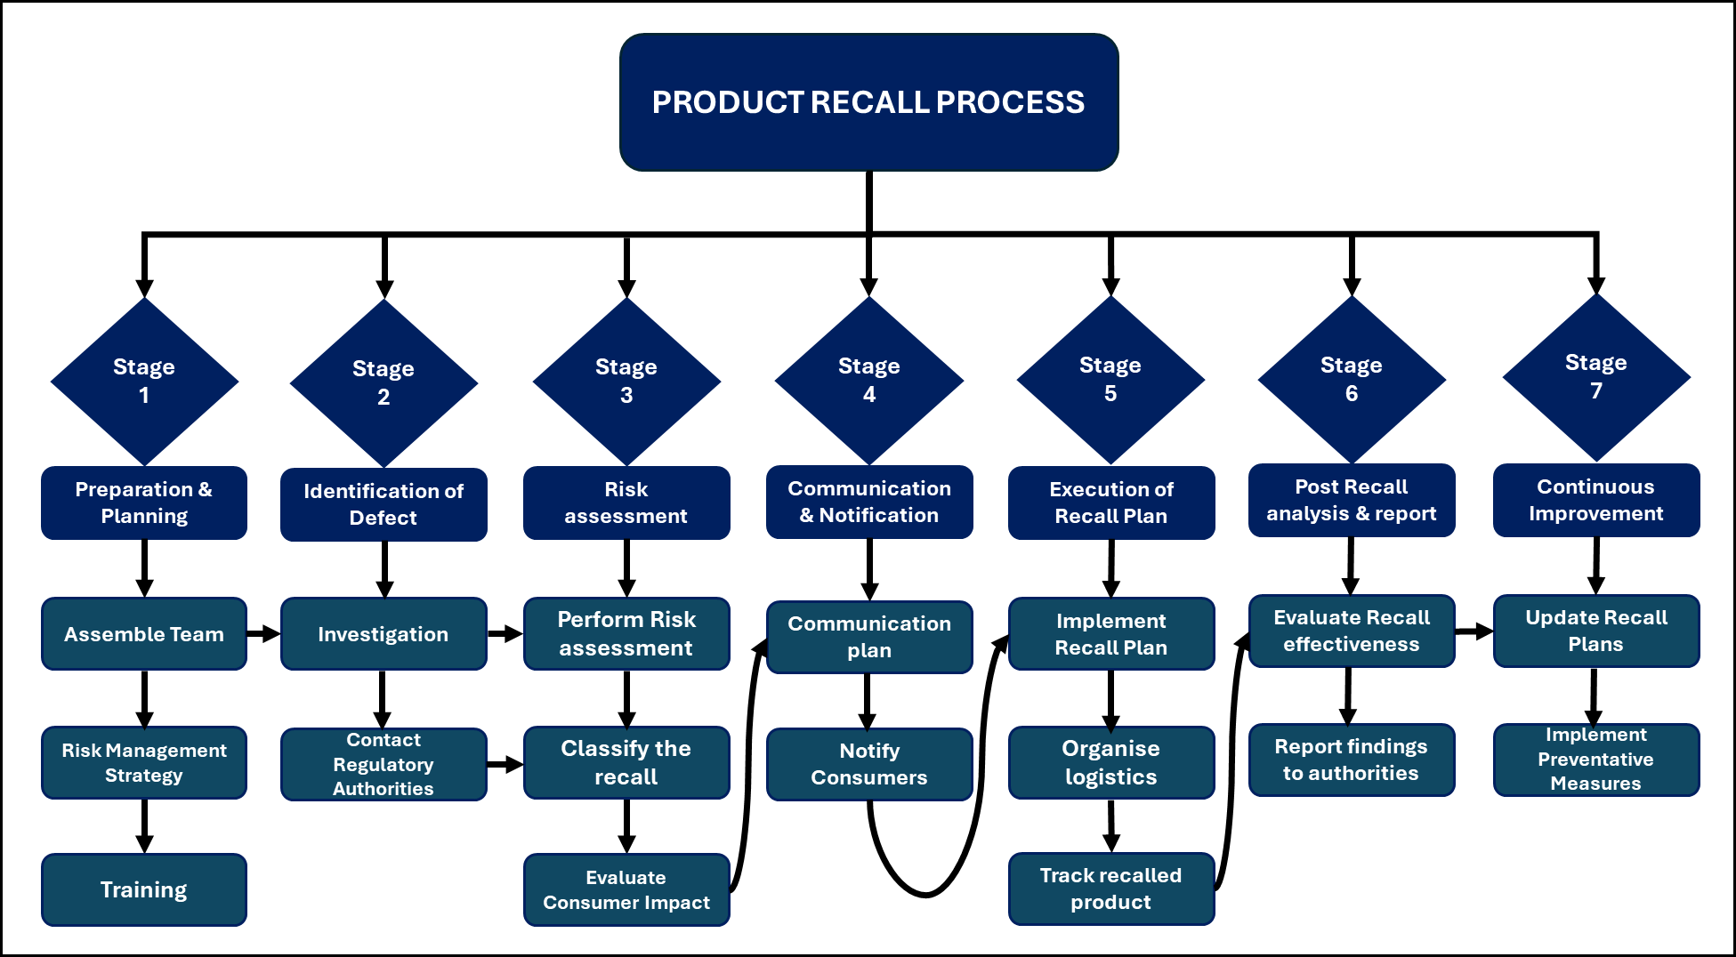
Figure 1 – Product recall process

Stage | Process Step
Stage 1  Preparation and planning | Before a product recall occurs, companies should have a comprehensive recall plan in place. The plan should include:
Stage 1  Preparation and planning | Assemble a team | Assemble a team and clearly assign roles and responsibilities for each team member (Ahsan & Gunawan, 2014).
Stage 1  Preparation and planning | Risk management strategies | Create contingency plans to tackle potential risks linked to product recalls to ensure a prompt and effective action (Ahsan & Gunawan, 2014).
Stage 1  Preparation and planning | Training and awareness | Hold regular training sessions with employees to ensure they understand product recall procedures and the significance of adhering to regulatory requirements (Hora et., 2011).
Stage 2  Identification of the defect | Once a potential defect is identified companies must:
Stage 2  Identification of the defect | Conduct an investigation | Gather information to identify the nature of the defect and determine its severity. This might involve reviewing customer complaints, quality control data and production records (Yu et al., 2022).
Stage 2  Identification of the defect | Engage Regulatory Authorities | Notify the relevant regulatory bodies, such as the MHRA and CPSC about the defect and seek guidance on the next steps (Eilert et al., 2017)
Stage 3 -  Risk Assessment | Conduct a thorough risk analysis to evaluate the potential impact of the defect on the consumer:
Stage 3 -  Risk Assessment | Classify the recall | Evaluate the severity of the recall according to the classification guide for each industry (e.g., Class I, II, or III), which is based on the potential risk to the consumer (Raithel & Hock, 2020). This classification will provide guidance to the urgency and scope of the recall.
Stage 3 -  Risk Assessment | Evaluate Consumer impact | Review the possible health impacts to consumers and proiritise actions accordingly (Muralidharan et al,. 2019).
Stage 4 -Communication and Notification | Provide effective and transparent communication about the product recall:
Stage 4 -Communication and Notification | Develop a communication plan: | Create a communication plan to alert consumers and retailers about the recall and ensure regulatory bodies are kept informed. This should include clear steps for returning or safely disposing of the affected products (Chang & Chang, 2014).
Stage 4 -Communication and Notification | Notify Consumers | Utilise multiply communication channels, including press releases, social media and direct notification, to effectively reach the affected consumers. (Comba et al., 2013)
Stage 5 – Execution of the recall plan | Implement the recall plan effectively:
Stage 5 – Execution of the recall plan | Logistics Management | Organise the logistics for handling defective products and managing customer returns. This could include working closely with distributors and retailers (Raithel et al., 2021).
Stage 5 – Execution of the recall plan | Track recalled products | Establish procedures for tracking recalled products, ensuring effective removal from the market (Tang et al., 2015).
Stage 6 –  Post Recall Analysis and Reporting. | After completing the product recall organisations should conduct a thorough review and report the findings:
Stage 6 –  Post Recall Analysis and Reporting. | Evaluate recall effectiveness | Evaluate the effectiveness of the recall and identify areas for improvement. This could include examining consumer feedback and the rate of which the defective products are returned (Ketchen et al., 2014).
Stage 6 –  Post Recall Analysis and Reporting. | Report findings to the Regulatory Authorities | Submit findings to the appropriate regulatory authority, that details the recall process, the outcomes, and any corrective actions taken (Diallo et al., 2016)
Stage 7 –  Post Recall Analysis and Reporting | Review lessons learnt and feedback for the Product recall process to enhance future practices:
Stage 7 –  Post Recall Analysis and Reporting | Update Recall Plans | Revise Product recall plans by incorporating lessons learnt and feedback from stakeholders (Miglani et al., 2021)
Stage 7 –  Post Recall Analysis and Reporting | Implement Preventative Measures | Identify the root cause of the defected product and implement preventative measures to prevent similar issues occurring in the future (Liu et al., 2016).
Table 1
While this framework is generic it can be tailored to fit the needs of the specific industry and the circumstance of the product recall. An specific example is show in Figure 2 for a medicine/drug recall in the UK.

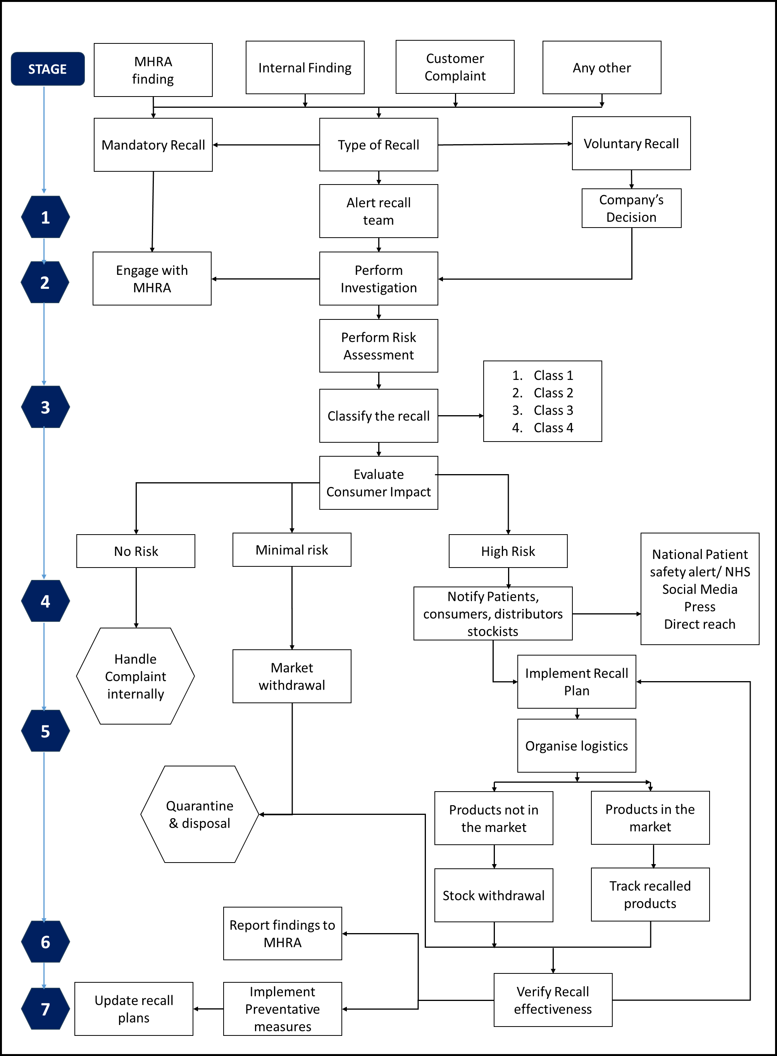
Figure 2 – Medicine/drug recall process in the UK based on 7 stage framework

The proposed process highlights the significance of preparation, efficient logistics, clear communication and continuous improvement. By adhering to these structured steps, organisations can lower risks, decrease costs, enhance quality, meet regulatory requirements and maintain consumer trust. As industries evolve, ongoing collaboration and communication between manufacturers and regulatory bodies will be essential for enhancing the effectiveness of the product recall process (Marucheck et al., 2011).

The costs associated with product recall and how they can be managed.
The cost associated with product recalls are often complex and can significantly impact a company’s financial performance. These cost can categorised into direct and indirect expenses each having their own financial consequences. These two categories are reviewed in more detail below and strategies presented on how they can be managed.

Direct Costs
Direct or tangible costs refer to the clear and immediate expenses incurred during a product recall. These costs can be substantial depending on the size of the recall (Hora et al., 2011). According to the food Marketing Institute, the average cost of a food related product recall is approximately $10 million, not including legal or regulatory fines (Rutgers Business Review, 2024). Some examples of these costs are shown in figure 3.
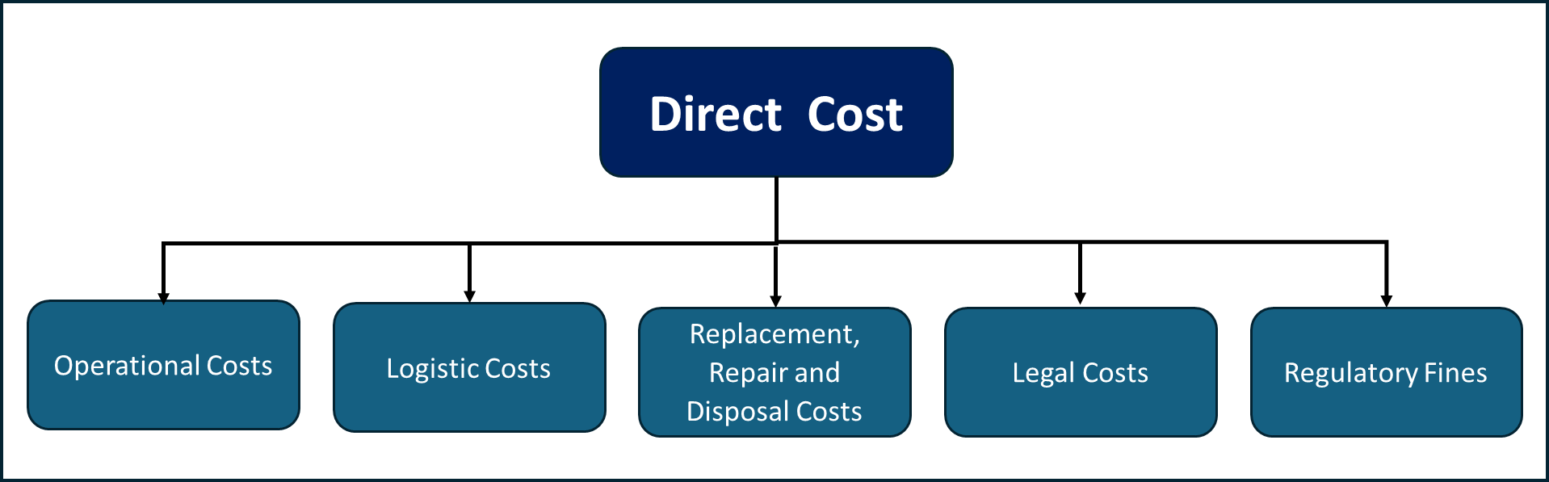
Figure 3 – Direct Costs associated with Product Recall
One of the primary direct costs related to the recall process is operational and logistical expenses. These costs include communication, transportation warehousing and the additional labour required to manage the recall effectively (Velthuis et al., 2010). The costs related to reverse distribution is often two to three times higher than those associated with forward distribution. This is mainly due to the complexities and urgencies involved during the product recall process (Ahsan, 2013).
Companies can incur substantial costs when replacing or repairing defective products. This is especially true in industries such as automotive and electronics, where rectifying defects can be expensive and replacements must adhere to strict safety and quality standards (Ahsan, 2013). In situations where products cannot be repaired or replaced, companies may also face costs related to the disposal and destruction of the recalled items (Velthuis et al., 2010).
Additionally legal costs and regulatory fines represent another significant direct cost. Companies may encounter legal feed from consumer claims or regulatory fines for noncompliance resulting from product recalls (Hora et al., 2011). Legal and liability costs can escalate rapidly, particularly in industries where safety is critical such as automotive and medical sectors (Thirumalai & Sinha, 2011).
The case study below illustrates the direct costs that can be incurred during a product recall in the automotive industry. It highlights the financial implications associated with operational, logistical and legal challenges.
In 2014, General Motors recalled over 2.6 million vehicles due to a faulty ignition switch. The direct costs of the recall included logistics, repairs and replacement which amounted to approximately $2 billion. This type of recall can lead to increased scrutiny from regulators and legal claims from consumers, further escalating the financial impact on the company. (Kalaignanam et al., 2013). Other significant costs related to this recall included customer notifications and dealership repairs.
Direct costs are more apparent and quantifiable, enabling a company to plan better and prepare for potential product recalls.

Indirect Costs
Indirect costs are often intangible and more difficult to quantify. Indirect costs often have a more significant long term financial impact. For instance, after a major recall, a company may lose up to 55% of its customers temporarily and some permanently (Rutgers Business Review, 2024). Some examples of these costs can be shown in figure 4.
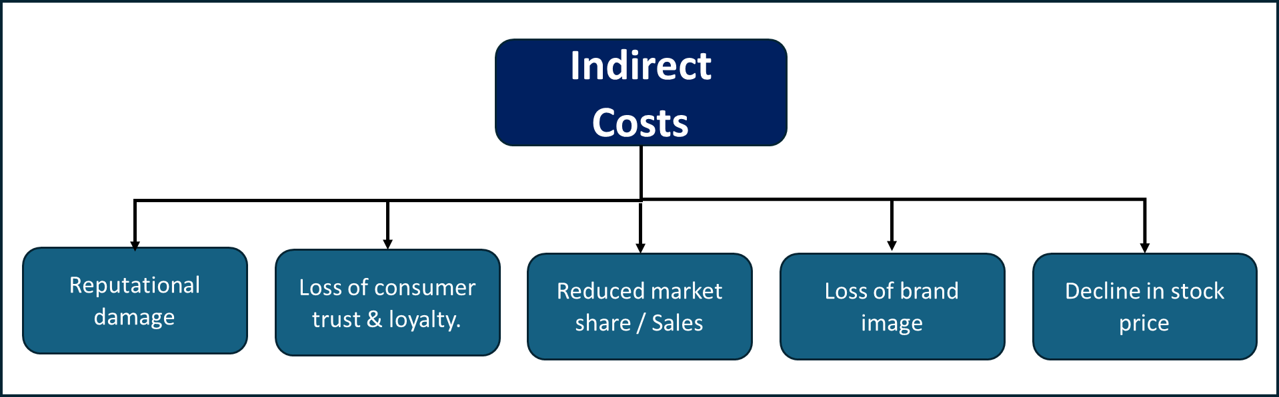
Figure 4 – Indirect Costs
One of the most significant indirect costs is the potential damage to a company’s reputation. Rhee and Haunschild highlights that a serious product recall can result in significant reputational harm, which may not only impact current sales but also future consumer trust and loyalty (Rhee and Haunschild, 2006).
After a product recall, companies of experience a decline in market share forcing customers to seek alternative products from competitors. The damage to a brand image during a recall crisis can have long term financial consequences, as consumers may hesitate to buy from a company that has previously faced quality issues (Chen et al., 2009).
Product recalls can trigger an immediate drop in stock prices, raising concerns among investors and shareholders regarding the company’s future profitability. Chen et al. noted that product recalls can provoke a negative market reaction that affects a company’s overall financial position (Chen & Nguyen, 2013)
The case study below illustrates the severity of indirect costs that can be incurred during a product recall in the food industry that extend beyond immediate financial implications.
The peanut butter recall in 2009, linked to a salmonella outbreak, resulted in the recall of over 3900 products of which 9 people died in the process. As a result the Peanut Corporation of America (PCA) suffered long term reputational damage, criminal charges and imprisonment, highlighting that such incidents can lead to a lasting negative brand image which prevent customers purchasing future products (Kalaignanam et al., 2013). PCA ultimately filed for bankruptcy, illustrating how indirect costs can lead to most severe financial consequences for a company.
Indirect costs frequently have a lasting effect on a company’s overall performance and require careful management and strategic planning to reduce their impact.

Managing Recall Costs
Managing the cost associated with product recalls is essential for companies to mitigate financial losses and protect their reputation. Several cost saving strategies have been identified below to effectively manage product recall costs:
Proactive Planning and Risk Management
One of the most effective methods to manage recall costs is through proactive planning and risk management. The development of contingency plans before a product is released into the market is crucial (Ahsan & Gunawan, 2014). By establishing a comprehensive risk management framework that includes identifying potential recall triggers and outlines response protocols, can help companies minimise the cost impact of product recalls.
Quality Control and inspection
Investing in strong quality control measures can help prevent recalls from occurring in the first place. Companies should enforce strict quality assurance protocols throughout the production process to identify and resolve potential issues before the product reaches the market. Regular inspection and testing can also help catch defects early. Those that prioritise safety and quality are better equiped to avoid expensive product recalls (Ollinger & Houser, 2020).
Efficient Logistics Management
Effective logistics management can greatly reduce the costs related to product recalls. Optimising the logistic process to create reverse logistic systems to facilitate quick retrieval of recalled products (Ashan, 2013).
Traceability Systems
Implementing effective traceability systems allows companies to quickly identify affected product and streamline the recall process, thereby reducing operational costs (Memon et al., 2015).
Communication strategies
Creating clear communication plans that utilise various communication channels, including press, direct outreach and social media, can ensure timely and transparent communication with consumers. This approach helps maintain trust and minimises reputational damage (Hsu & Lawrence, 2016)
In addition to these strategies, financial considerations plays a crucial role in managing product recalls and determining their effectiveness. Companies need to assess the costs associated with recall remedies in relation to the potential harm to consumers and the impact on their own reputations. The selected remedy can significantly influence consumer perceptions and the overall success of recall (Liu et al., 2016)
All these strategies are integral to the product recall process, as discussed in section 2.3

Restoring consumer confidence during and after a product recall
Restoring consumer confidence and trust is a challenging task that demands strategic planning and effective communication. It is essential for companies to understand consumer perception during and after a product recall as this can greatly affect brand image and consumer trust. The way in which a company handles a product recall can have a significant impact on consumer behavior. Companies should adopt a proactive approach to crisis management, ensuring they meet consumer expectations and address safety concerns. Research has identified several strategies that can assist organisations navigate this complex landscape, which are discussed below and illustrated in Figure 4.
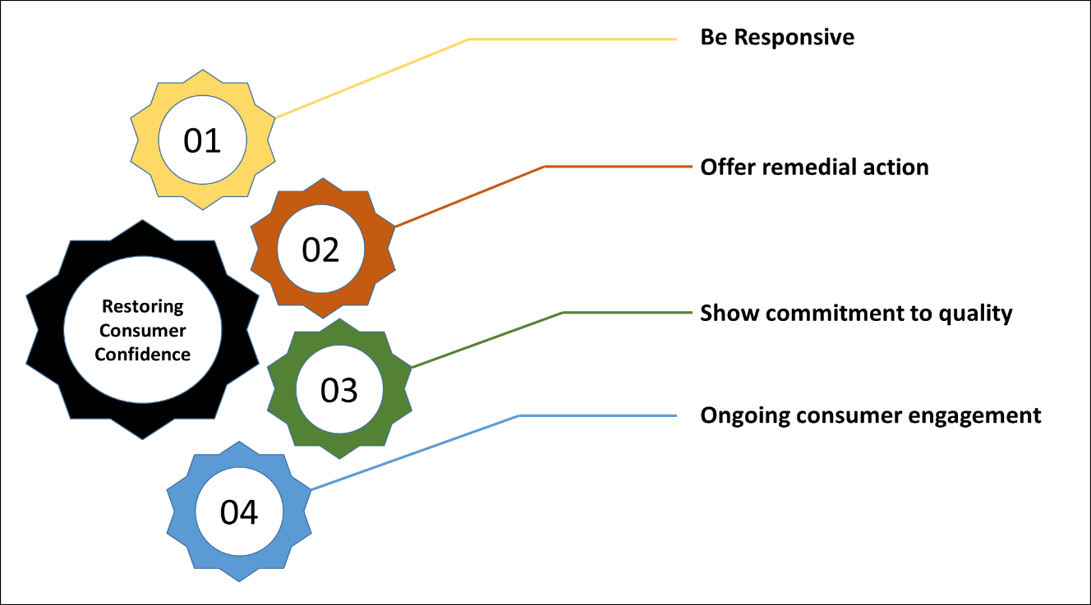
Figure 4- Restoring Consumer Confidence
01 - Be responsive
Effective communication is essential; clear and timely notifications can greatly impact how consumer view a situation and help rebuild trust. Companies should straightforward details about the defect, the associated risk and the measures being taken to resolve the issue. For example voluntary recalls are generally view more positively than mandatory one, as they demonstrate a company’s dedication to consumer safety, which can influence future purchasing decisions afer a recall (Yu et al.,22).
Addressing recalls promptly can enhance stock market performance and boost consumer trust (Eilert et al., 2017), whilst delays in addressing safety issues can result in significant reputational harm and decline in consumer confidence (Yan et al., 2017). Using various channels to share information can help ensure that consumers are well informed, alleviating anxiety and uncertainly related to the product recall (Muralidharan et al., 2019).
02 - Offer remedial action
The options available to consumers whether it is a refund, replacement or repair plays an essential role in rebuilding confidence (Liu et al., 2016). Consumers respond favourably to generous to compensation or remedial action, mitigating negative impacts of product recalls (Yan et al., 2017). Companies that provide timely remedies are also likely to experience less damage to their reputation and can even benefit from increased consumer loyalty post recall (Murphy & Popa, 2012). The severity of the defect and how a company addresses it can significantly affect consumer perceptions; even a minor issue, if handled well, can result in positive consumer reactions, while serious problems may, necessitates more extensive remedial measures (Raithel et al., 2021).
03 - Show commitment to Quality
Showing a strong commitment to quality and safety through the corrective action process can greatly influence consumer trust. By implementing effective quality assurance measures and demonstrating improvements in product reliability, brands can reassure consumer about the brands dedication to safety (Kalaignanam et al., 2013).
04 - Ongoing consumer engagement
Engaging with consumers after a product recall is crucial for restoring confidence. By ensuring open lines of communication and being responsive to stakeholder concerns, companies can create a feeling of partnership and loyalty (Muralidharan et al., 2019). It is important for companies to look beyond the immediate response to a product recall but to develop long term strategies aimed at strengthening consumer trust (Mak et al., 2020).

Conclusion
Product recalls are a necessary part of modern business and vital for ensuring consumer safety and corporate responsibility. As the landscape of product safety continues to evolve, companies must remain vigilant and prepared to face the challenges posed by product recalls to safeguard their reputation and financial stability.
The product recall process across different industries underscores the importance of a timely and structured approach to product recalls. By effectively identifying defects, assessing risks, communicating with stakeholders, executing the recall plans and conducting post recall analysis companies can mitigate the impact of product recalls on their reputation, financial health and most important consumer safety.
The cost of poor quality is reflected in not only immediate financial losses but also long-term effects on brand equity and consumer trust. To effectively manage these costs, a combination proactive planning, strong quality assurance measures, responsive consumer communication and efficient logistics is essential.
To restore consumer confidence a comprehensive strategy is necessary, which includes effective communication, suitable remedial action, timely responses, and ongoing consumer engagement. By addressing consumer concerns in a direct and clear manner, companies can rebuild trust, essential for long term recovery.
In summary, product recalls create a range of challenges for businesses, such a financial setbacks, and risks to their reputation and disruption in operations. The effectiveness of recall management strategies, the types of products affected and the corporate governance frameworks in place significantly influence the overall impact on the company. By focusing on strategies discussed in this report, companies can reduce the negative effects of product recalls and potentially strengthen their relationship with the consumer.

References
Ahsan, K. and Gunawan, I. (2014). Analysis of product recalls: identification of recall initiators and causes of recall, International Journal of Operations and Supply Chain Management, 97-106.
Ahsan, K. (2013). Trend analysis of car recalls: evidence from the us market. International Journal of Managing Value and Supply Chains, 4(4), 1-16.
Chang, S. C. and Chang, H. (2014). Corporate motivations of product recall strategy: exploring the role of corporate social responsibility in stakeholder engagement. Corporate Social Responsibility and Environmental Management, 22(6), 393-407.
Chen, Y., Ganesan, S., & Liu, Y. (2009). Does a firm's product-recall strategy affect its financial value? an examination of strategic alternatives during product-harm crises. Journal of Marketing, 73(6), 214-226.
Comba, L., Dabbene, F., Gay, P., & Tortia, C. (2013). Open problems in traceability: from raw materials to finished food products. Journal of Agricultural Engineering, 44(2s).
Diallo, T., Henry, S., & Ouzrout, Y. (2014). Diallo, T.M.L., Henry, S. and Ouzrout, Y. (2014) ‘Using Unitary Traceability for an Optimal Product Recall’, in B. Grabot et al. (eds) Advances in Production Management Systems. Innovative and Knowledge-Based Production Management in a Global-Local World. Berlin, Heidelberg: Springer Berlin Heidelberg, pp. 159–166.
Diallo, T., Henry, S., & Ouzrout, Y. (2016). ‘14 - Effective Use of Food Traceability in Product Recall’, in M. Espiñeira and F.J. Santaclara, Advances in Food Traceability Techniques and Technologies. Woodhead Publishing, pp. 263–273.
Eilert, M., Jayachandran, S., Kalaignanam, K., & Swartz, T. (2017). Does it pay to recall your product early? an empirical investigation in the automobile industry. Journal of Marketing, 81(3), 111-129.
Freedman, S., Kearney, M., & Lederman, M. (2012). Product recalls, imperfect information, and spillover effects: lessons from the consumer response to the 2007 toy recalls. The Review of Economics and Statistics, 94(2), 499-516.
GOV.UK 2014, Medical devices regulations: compliance and enforcement [Online]. Available at: https://www.gov.uk/government/publications/report-a-non-compliant-medical-device-enforcement-process [Accessed 23 November 2014].
GOV.UK 2019, Business regulation: guidance and tools [Online]. Available at: https://www.gov.uk/guidance/business-regulation-guidance-and-tools [Accessed 23 November 2014]
Hora, M., Bapuji, H., & Roth, A. V. (2011). Safety hazard and time to recall: the role of recall strategy, product defect type, and supply chain player in the U.S. toy industry. Journal of Operations Management, 29(7-8), 766-777.
Hsu, L. and Lawrence, B. (2016). The role of social media and brand equity during a product recall crisis: a shareholder value perspective. International Journal of Research in Marketing, 33(1), 59-77.
Huh, K. and Choi, C. J. (2016). Product recall policies and their improvement in Korea. Management and Production Engineering Review, 7(4), 39-47.
Kalaignanam, K., Kushwaha, T., & Eilert, M. (2013). The impact of product recalls on future product reliability and future accidents: evidence from the automobile industry. Journal of Marketing, 77(2), 41-57.
Ketchen, D. J., Wowak, K. D., & Craighead, C. W. (2014). Resource gaps and resource orchestration shortfalls in supply chain management: the case of product recalls. Journal of Supply Chain Management, 50(3), 6-15.
Kshetri, N. and Loukoianova, E. (2019). Blockchain adoption in supply chain networks in Asia. IT Professional, 21(1), 11-15. Available at https://doi.org/10.1109/mitp.2018.2881307 [Accessed 25 November 2024].
Liu, A., Liu, Y., & Luo, T. (2016). What drives a firm's choice of product recall remedy? the impact of remedy cost, product hazard, and the CEO. Journal of Marketing, 80(3), 79-95.
Lu, Y. and Shankar, V. (2015). The dynamic impact of product-harm crises on brand preference and advertising effectiveness: An empirical analysis of the Automobile Industry. Management Science, 61(10), 2514-2535.
Mak, S., Tang, F., Li, C., & W, L. (2020). The influence and good practice of product recall on brand image and customer perceived product quality. International Journal of Business Humanities and Technology, 10(2).
Marucheck, A., Greis, N. P., Mena, C., & Cai, L. (2011). Product safety and security in the global supply chain: issues, challenges and research opportunities. Journal of Operations Management, 29(7-8), 707-720.
Memon, M. S., Lee, Y. H., & Mari, S. I. (2015). Analysis of traceability optimization and shareholder’s profit for efficient supply chain operation under product recall crisis. Mathematical Problems in Engineering, 2015, 1-8.
Miglani, A., Saini, C., Musyuni, P., & Aggarwal, G. (2021). A review and analysis of product recall for pharmaceutical drug product. Journal of Generic Medicines: The Business Journal for the Generic Medicines Sector, 18(2), 72-81.
Muralidharan, E., Bapuji, H., & Hora, M. (2019). The more i err, the less i pay. European Journal of Marketing, 53(5), 916-943.
Murphy, W. and Popa, M. (2012). To recall or not to recall a flawed product: corporate responses and consumer perceptions of toy recalls. Journal of Psychology Research, 2(6).
Öllinger, M. and Houser, M. (2020). Ground beef recalls and subsequent food safety performance. Food Policy, 97, 101971.
Pagiavlas, S., Kalaignanam, K., Gill, M., & Bliese, P. D. (2021). Regulating product recall compliance in the digital age: evidence from the “safe cars save lives” campaign. Journal of Marketing, 86(5), 135-152.
Qiu, Q., Dewey-Mattia, D., Subramhanya, S., Cui, Z., Griffin, P., Lance, S., … & Crowe, S. (2021). Food recalls associated with foodborne disease outbreaks, United States, 2006–2016’, Epidemiology and Infection, Cambridge University Press, 149.
Raithel, S. and Hock, S. J. (2020). The crisis‐response match: an empirical investigation. Strategic Management Journal, 42(1), 170-184.
Raithel, S., Mafael, A., & Hock, S. J. (2021). The effects of brand equity and failure severity on remedy choice after a product recall. Journal of Product and Brand Management, 30(8), 1247-1261.
Rhee, M. and Haunschild, P. R. (2006). The liability of good reputation: a study of product recalls in the U.S. automobile industry. Organization Science, 17(1), 101-117.
Rutgers Business Review, (2024). Managing the product recall process [Online] Available at : https://rbr.business.rutgers.edu/sites/default/files/documents/rbr-060109.pdf [Accessed 15 November 2024].
Steven, A. B. and Agudelo, R. A. B. (2016). Emerging market presence, inventory, and product recall linkages. Journal of Operations Management, 46(1), 55-68.
Tang, Q., Li, J., Sun, M., Lv, J., Gai, R., Lin, M., & Xu, L. (2015). Food traceability systems in China: the current status of and future perspectives on food supply chain databases, legal support, and technological research and support for food safety regulation. Bio Science Trends, 9(1), 7-15.
Thirumalai, S. and Sinha, K. (2011). Product recalls in the medical device industry: an empirical exploration of the sources and financial consequences. Management Science, 57(2), 376-392.
Velthuis, A., Reij, M., Baritakis, K., Dang, M., & Wagenberg, C. v. (2010). Recall costs balanced against spoilage control in dutch custard. Journal of Dairy Science, 93(6), 2779-2791.
Yan, L., Shankar, V., & Yun, W. (2017). Crisis management strategies and the long-term effects of product recalls on firm value. Journal of Marketing, 81(5), 30-48.
Yu, W., Cui, F., Han, X., & Lv, M. (2022). Does a corporation’s food recall strategy affect its brand image and consumers’ intention to purchase? a study in the context of cereal recall in China. British Food Journal, 125(4), 1437-1452.

