THE IMPACT OF SOCIAL MEDIA MARKETING ON CONSUMER BEHAVIOR OF NIKE: A STUDY OF MARKETING

Name: Pendyala Bikshapathy
Student No: 2128324
Supervisor: David Coker

Abstract
This study intends to investigate how Nike, a well-known company in the sports clothing sector, uses social media marketing to influence consumer behaviour. This study offers insightful information for marketers by analysing the impact of Nike's social media marketing methods on consumer awareness, attitudes, purchase intentions, and brand loyalty. To gather information and examine the connection between social media marketing and customer behaviour, the study makes use of both qualitative and quantitative methodologies. The research results advance knowledge of successful marketing tactics in the digital age and provide Nike and other business professionals with suggestions for improving their social media operations.

TABLE OF CONTENTS
Chapter 1. Introduction 5
1.1 Overview and Scope 5
1.2 Background of the Research 6
1.3 Research Rationale 7
1.4 Research Aim and Objectives 7
1.5 Research Question 8
1.6 Problem Statement 9
1.7 Scope of the Study 10
1.9 Structure of dissertation 11
Chapter 2: Literature Review 12
2.1 Introduction 12
2.2 Theory and Module 12
2.3 Brand Awareness and E-WOM of Nike 17
2.4 Consumer Engagement and Brand Loyalty of Nike 20
2.5 Consumer relationship management and Brand Equity of Nike 23
2.6 Literature Gap 26
2.7 Summary 27
Chapter 3: Methodology 29
3.1 Introduction 29
3.2 Research Onion 29
3.3 Research philosophy 30
3.4 Research approach 31
3.5 Research method 31
3.6 Research Design 32
3.7 Data collection process 32
3.8 Sampling method 33
3.9 Data analysis technique 33
3.10 Ethical consideration 34
3.11 Research Timeline 35
3.12 Summary 35
Chapter 4: Data Analysis 37
4.1 Introduction 37
4.2 Quantitative data analysis 37
4.3 Conclusion 57
Chapter 5: Conclusion 58
5.1 Linking with Objective 58
5.2 Limitations 60
5.3 Recommendation 61
5.3 Conclusion 62
Reference List 63

Chapter 1. Introduction

1.1 Overview and Scope
Social media platforms have developed into effective commercial tools for connecting with and influencing their target markets' purchasing decisions. This study focuses on how Nike, a significant player in the sports apparel sector, uses social media marketing to influence consumer behaviour. This study intends to advance knowledge of the connection between social media marketing and consumer behaviour by analysing Nike's social media marketing techniques and how they affect customers. The purpose of this study is to investigate and evaluate the influence of social media marketing on Nike's consumer behaviour. Nike has successfully connected with its target audience on social media channels thanks to its iconic brand image and inventive products (Abeza et al, 2017). Nike has tapped into the potential of social media through websites like Facebook, Instagram, Twitter, and YouTube to produce interesting content, promote brand loyalty, and sway customer choices. The impact of Nike's social media marketing on consumer behaviour will be examined in this study using both qualitative and quantitative research approaches. To learn more about how social media marketing affects customer awareness, attitudes, purchase intentions, and brand loyalty towards Nike, surveys, interviews, and data analysis will be undertaken.
The study will investigate various aspects of consumer behavior influenced by Nike's social media marketing efforts, including:
- Brand exposure and awareness: The study will investigate how Nike's social media presence raises customer awareness of the company, its goods, and its advertising campaigns.
- Attitudes and perceptions: The study will look at how Nike's brand image, perceived quality, and personality are influenced by social media marketing.
- Purchase intentions: The study will look at how social media marketing affects consumers' intentions to buy products, including whether they are likely to buy Nike goods and how much social media content affects their decision-making.
- Brand loyalty: The study will examine how social media marketing has influenced Nike customers' brand loyalty, taking into account the effects of engagement, user-generated content, and community development.
A combination of qualitative and quantitative research techniques will be used to accomplish the goals. While interviews and content analysis will offer qualitative insights, surveys will be used to gather quantitative data. Utilising statistical methods, the data analysis will look for correlations and trends in consumer behaviour.

1.2 Background of the Research
Social media has changed how businesses engage with customers in the current digital era. Social media marketing has become an essential tool for businesses to communicate with their target audience, develop brand awareness, and affect consumer behaviour due to the broad popularity and wide reach of platforms like Facebook, Instagram, Twitter, and YouTube.
Nike, a well-known international company in the sportswear sector, has acknowledged social media's potential as an effective marketing tool. Nike has successfully used social media channels to connect with customers on a more personal and engaging level thanks to its strong brand identity and innovative product offers (Tian et al, 2022). Nike has been successful in influencing consumer perceptions, influencing purchasing behaviour, and promoting brand loyalty by developing captivating content, utilising influencers, and fostering online communities. Consumer behaviour, which includes people's thoughts, attitudes, and deeds when making judgements about purchases, is influenced by a variety of circumstances. As people increasingly turn to social media platforms for information, product recommendations, and social validation, new dynamics have emerged in consumer behaviour. Social media has grown to be a powerful influencer, influencing customer views and preferences.
The study of how social media marketing affects consumer behaviour has received a lot of interest recently. The impact of social media on customer views, buying intentions, brand loyalty, and engagement has been the subject of numerous research. However, further research is necessary to fully understand how social media marketing specifically affects customer behaviour in the context of Nike's marketing initiatives. This study intends to add to the body of knowledge on social media marketing and its effects on brand performance by analysing the interaction between Nike's social media marketing techniques and consumer behaviour. Marketers and decision-makers in the sports clothing sector will benefit from understanding the elements that influence customer interaction, perception creation, and purchase decisions in response to Nike's social media marketing.

1.3 Research Rationale
The rationale for undertaking this study stems from the realisation of the expanding significance of social media marketing and the significant influence it has on customer behaviour. Social media platforms have become potent tools for businesses in the modern business landscape to interact with their target audience and influence consumer views. Nike, a market leader in the sports apparel sector, uses social media marketing to establish a more personal connection with its customers (Tornikoski et al,2019). However, in order to create efficient marketing plans and keep a competitive advantage, it is imperative to fully comprehend how Nike's social media marketing methods affect consumer behaviour. As more people turn to social media platforms for product information, suggestions, and social validation, there have been substantial shifts in consumer behaviour. The information and interactions consumers come across on social media have an impact on their opinions, intentions to make purchases, and brand loyalty. In order to get insight into the shifting dynamics of consumer decision-making processes, it is imperative to examine the effect of social media marketing on customer behaviour within the unique context of Nike.

1.4 Research Aim and Objectives
The purpose of this study is to look into how social media marketing has affected Nike's consumer behaviour. The following goals have been created to accomplish this goal.
- To evaluate how Nike's social media marketing has affected consumer awareness and brand exposure.
  - Assess the degree to which Nike's social media activity raises consumer awareness of the company and its advertising initiatives.
  - Examine how social media may help Nike's brand messaging and content reach a wider audience.

- To investigate how social media marketing affects consumer opinions of Nike.
  - Examine how social media interactions and content affect consumer perceptions of Nike, including the brand's image, perceived value, and personality.
  - Examine how social media influences how customers view Nike's principles, authenticity, and reliability.

- To assess how social media marketing has affected consumers' plans to buy Nike products.
  - Evaluate the impact of social media marketing on customer decision-making, including the propensity to buy Nike products.
  - Examine how influencers, user-generated material, and social media content affect consumers' propensity to make purchases.

- To investigate how social media marketing might help Nike customers develop brand loyalty.
  - Look at how social media activity and participation affect how Nike brand loyalty grows among users.
  - Research the effects of user-generated content, online communities, and brand advocacy on Nike brand loyalty.
- To offer Nike and other marketers in the sports apparel sector advice on how to use social media marketing effectively.
  - Compile the information to provide Nike and other professionals in the field with useful advice on how to maximise their use of social media marketing.
  - Identify critical success criteria and best practises for using social media to engage customers, foster brand loyalty, and affect buying patterns in the sports clothing sector.

This study intends to advance knowledge of the effects of social media marketing on customer behaviour in the context of Nike by addressing these research objectives. The results will help marketers and decision-makers create effective social media strategies and comprehend the elements that influence consumer engagement and loyalty.

1.5 Research Question
The following research question is designed to direct the study and address the goal and objectives.
"What is the impact of social media marketing on the consumer behavior of Nike?"
This broad study topic covers a range of consumer behaviour traits influenced by social media marketing, such as brand loyalty to Nike and customer knowledge, attitudes, and purchase intentions. The goal of the study is to provide a thorough understanding of how Nike's social media strategies affect consumer behaviour by examining the effects of social media marketing on these factors.
The following sub-questions will be used to further analyse this research question:
- How does Nike's social media marketing affect brand exposure and consumer awareness?
- How does social media marketing affect consumers' opinions of and attitudes towards Nike?
- What effect does social media marketing have on consumers' plans to buy Nike products?
- How does social media marketing encourage Nike customers to stick with the brand?
- What information and suggestions about successful social media marketing tactics may be given to Nike and marketers in the sports clothing industry?
These sub-questions will be addressed in the research, which will delve into particular facets of the overall impact of social media marketing on consumer behaviour, offering a comprehensive knowledge of the connection between Nike's social media strategy and customer responses.

1.6 Problem Statement
Understanding the effects of social media marketing on Nike's consumer behaviour is the issue this study seeks to solve. Examining how Nike's social media marketing initiatives affect consumer attitudes, perceptions, purchase intentions, and brand loyalty is crucial given the growing importance of social media platforms and their impact on consumer decision-making processes.
Although social media marketing has become a crucial component of Nike's overall marketing strategy, in-depth research on the precise effects of these initiatives on consumer behaviour is lacking. To optimise marketing strategies and keep a competitive edge in the sports clothing market, Nike must fully comprehend how its social media marketing affects consumer engagement and purchasing behaviour.

1.7 Scope of the Study

The goal of this study is to better understand how Nike's consumer behaviour in the sports apparel sector is impacted by social media marketing. The focus of the study is on how Nike's social media marketing initiatives have affected consumer awareness, opinions, purchase intentions, and brand loyalty. Given Nike's worldwide presence and diverse customer base, the research will have a global perspective in terms of geographic coverage. The study will not, however, directly examine regional or national differences in consumer behaviour. To obtain information and insights for the study, mostly qualitative and quantitative research techniques will be used (Amminen et al, 2020). Quantitative data will be gathered through surveys, allowing for the evaluation of consumer attitudes, perceptions, and purchase intentions. We will use qualitative techniques like content analysis and interviews to get a thorough understanding of how consumers feel about Nike's social media marketing and how they have used it. Nike's social media marketing tactics, including its usage of websites like Facebook, Instagram, Twitter, and YouTube, will be the main subject of the study. It will look at the effects of consumer behaviour on content, engagement strategies, influencers, and user-generated content. It's vital to remember that the focus of this study is only on how social media marketing affects customer behaviour in the context of Nike. The main focus of this research will not be on additional variables like cost, product quality, or offline marketing initiatives that may affect consumer behaviour. The availability of data and the time needed to gather and analyse the essential information will be used to define the study's timeline. But it's important to recognise that consumer behaviour and social media trends are always changing, thus the results might only apply to the study's time frame.

1.9 Structure of dissertation

Figure: Dissertation structure
(Source: Self-developed)

Chapter 2: Literature Review

2.1 Introduction
In the current digital era, research on how social media marketing (SMM) affects customer behaviour has become essential. Brands such as Nike have realised the value of utilising social media to communicate with those they want to reach and influence consumer behaviour as customers spend more and more time on the platform social media. This research will investigate the precise effects of SMM on Nike's customer behaviour, highlighting important factors including "brand equity, consumer engagement, brand loyalty, and electronic word-of-mouth (e-WOM)". As an industry leader within the sportswear sector, Nike is a pioneer in the use of SMM techniques to engage with customers. Nike has been effective in gaining the attention plus allegiance of customers all around the world thanks to its compelling content, powerful brand ambassadors, plus innovative advertising strategies. To further strengthen Nike's marketing initiatives and keep its competitive edge, this is crucial to comprehend the underlying mechanics and unique effects of SMM on customer behaviour. It wants to add to the corpus of knowledge about the subject by investigating how SMM affects consumer behaviour in the setting of Nike. This study will provide clarity regarding the consumer behaviour patterns affected by Nike's SMM methods, offer insights into their efficacy, and point out any potential weaknesses or areas for development. The results of the research will ultimately have important ramifications for marketers as well as companies looking to use social media to influence customer behaviour and accomplish corporate goals.

2.2 Theory and Module
Maslow's Hierarchy of Needs in Consumer Behaviour
The hierarchical hierarchy for Needs theory created by Abraham Maslow provides a useful framework for studying motivation among people and its influence on customer behaviour. According to this view, people have a hierarchy of wants that range from fundamental physiological demands to higher-level psychosocial and personal fulfilment requirements. This paradigm helps explicate how Nike's marketing activities target and affect consumers' requirements, ultimately moulding their behaviour, in the larger picture of internet marketing as well as consumer behaviour.
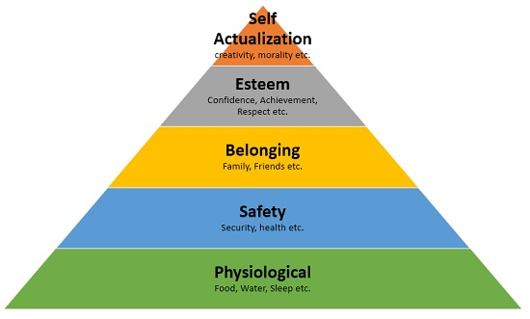
Figure 1: Maslow Hierarchy of Needs in Consumer Behaviour
(Sources: Self-made)
Physiological Needs
Physiological needs relate to the basic requirements of essential human life, such as nourishment, water, a place to live, and clothes, at the bottom of Maslow's hierarchy. Nike's internet-based marketing methods could tackle such requirements indirectly by highlighting items that provide comfort, utility, and performance, therefore addressing consumers' physiological requirements (Ikpo Kobi et al. 2020). Nike's advertising emphasising the ease of wearing and durability of its athletics or footwear, for example, speak to consumers' physiological requirements.
Safety Needs
The need for security, stability, and defence from physical injury, danger, or uncertainties are all examples of safety requirements. Nike's internet-based marketing may meet these demands by emphasising product safety, standards of excellence, and customer satisfaction. Nike, for instance, may use social media channels to share knowledge regarding the safety precautions used in product design as well as manufacture, ensuring consumers that they are safe when using Nike items.
Social Needs
The need for belonging, acceptability, and social contact are all examples of social wants. Nike's digital marketing initiatives may meet consumers' social demands by building participation and promoting similar principles and experiences. Nike may enhance customer connections, stimulate user-generated content, and foster a feeling connected to one another among its fans by using social media platforms. Nike may develop a sense of neighbourhood and social identity among its target audience by using social media celebrities and displaying real-life tales of individuals linked through physical activity.
Esteem Needs
Esteem requirements include a need for acknowledgment, respect, and self-worth. the company's social media marketing may meet these objectives by highlighting people who accomplished success, improvement in themselves, or personal growth as a result of their affiliation with the company (Schivinskiet al. 2022). Nike may appeal to consumers' desires for personal success and recognition by highlighting motivating tales of athletes, fitness fanatics, and everyday people overcoming hurdles. Social media platforms are an excellent channel for sharing such tales, allowing customers to connect with Nike's corporate image and experience a feeling of pride and self-esteem as a result of their engagement with the company.
Self-Actualization
Maslow's hierarchy of needs places self-actualization at the top, encompassing the quest for personal progress, fulfilment, and the realisation of one's capacity. Nike's social media marketing may help consumers achieve achieving one's by offering experiences, challenges, and pastimes that promote personal growth. Nike may motivate customers to discover their hobbies, create goals, and engage in pursuits that line with their achieving one's desires through social media marketing focusing on empowerment, personal accomplishment, and engagement in social issues. Maslow's Hierarchy of Business Needs can help us understand the influence of social media promotion on customer behaviour in the context of Nike. Nike can successfully impact consumer views, attitudes, and purchasing intentions, including loyalty to brands by matching their marketing activities with the hierarchical requirements of their target audience. Nike's social media advertising approaches can have an enormous effect on consumer behaviour and establish an intense emotional bond between the brand and its customers by addressing their safety and physiological requirements, fostering relationships with others, boosting confidence, and allowing self-actualization. Nike can build meaningful and compelling social media advertising strategies that appeal to its target demographic and promote customer engagement as well as loyalty by understanding and using various tiers of Maslow's hierarchy.
Psychological Theory
Understanding customer behaviour is necessary for developing effective marketing tactics. Consumer behaviour psychology gives useful insights into the mental and emotional procedures that drive decisions among consumers. This theory provides insight into how psychological elements communicate with social media advertising strategies to impact customers' opinions, views, and buying intentions in the larger context of Nike's social internet advertisement and consumer behaviour.
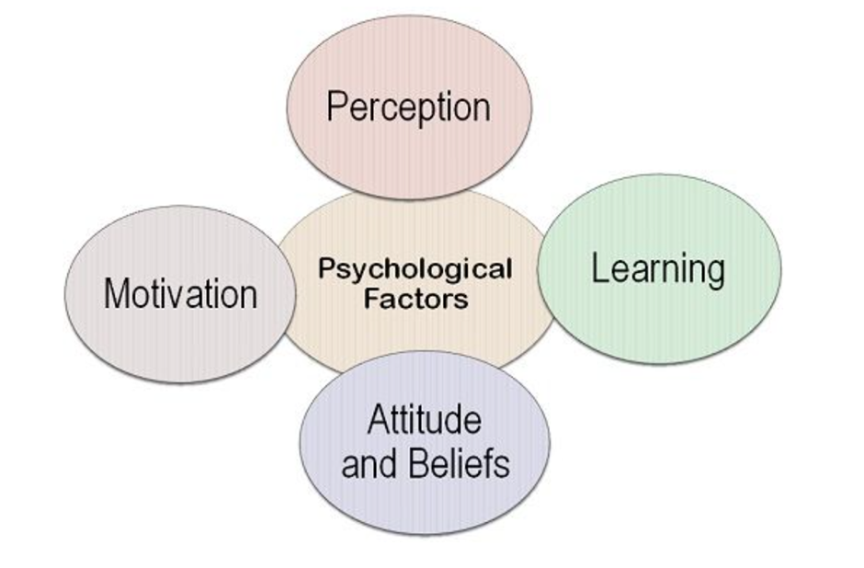
Figure 2: Psychological Theory
(Sources: Self-made)
Perception
Perception is how people comprehend and arrive at a sense of the knowledge they're given from their surroundings. Nike's social media advertisement may affect what customers think in a variety of ways (Mohammad Shafieeet al. 2019). Visual components, such as appealing photos and videos, may capture customers' attention and foster good brand connections. Nike may mould consumers' opinions of the company as inclusive, fashionable, and connected with their values by utilising influencers and highlighting diverse personalities in their advertisements.
Attitudes
Individuals' overall judgements or sentiments towards a specific brand or product are represented by attitudes. Social media marketing has a big impact on customer opinions regarding Nike. Nike may promote favourable attitudes by linking the brand with feelings such as enthusiasm, inspiration, and strength through exciting and pertinent content. Nike can establish a strong brand image and enhance customer sentiments towards the brand by continuously offering content that connects with the audience they are targeting.
Motivation
Motivation is defined as the internal urges or desires that guide people's behaviour. Nike's social media advertising may appeal to consumers' drives for accomplishment, improvement oneself, and social recognition. Nike may drive consumers to embrace an athletic lifestyle and identify the company with personal progress by presenting great athletes and persons who have conquered hurdles. Nike may motivate consumers to interact with its goods and offerings by using inspiring messages and calls to action.
Emotions
Emotions are important in consumer decision-making. Nike may use social media marketing to elicit pleasant feelings and build emotional ties with customers. Nike can create storylines that appeal to the feelings of consumers, such as satisfaction, inspiration, and nostalgia, by employing storytelling tactics (Arzhanovaet al. 2020). Emotional appeals have the ability to alter customer attitudes, promote engagement, and build brand loyalty. Nike's social media promotions, for example, frequently focus on uplifting messaging, highlighting individuals overcoming hurdles, and celebrating personal triumphs, which may elicit favourable emotions from customers.
Social Influence
Social media networks are essentially social, and interactions between individuals have a large effect on consumer behaviour. Nike's social media marketing may employ influencers, content contributed by users, and comments to build social proof and trust. Positive social connections and brand involvement can increase customer trust and impression of Nike's offerings and services. Nike may use a social impact to drive customer behaviour by cultivating a feeling connected to others and promoting social sharing. Consumer behaviour psychology gives insights into the mental and emotional functions that affect customers' attitudes, perceptions, and purchasing intentions. Understanding those psychological variables is critical for building effective marketing strategies in the context of Nike's social network promotion and customer behaviour. Nike can build compelling web ads that resonate with its target audience, enhance brand loyalty, and drive audience participation and buying behaviour by taking into account customers' views, attitudes, motives, emotions, and social influences ( Harrigan et al. 2021). Utilising the power of neurology in social media marketing may assist Nike in developing a strong and long-lasting relationship with customers, eventually contributing to the efficacy of its advertising campaigns.

2.3 Brand Awareness and E-WOM of Nike
In the larger picture of Nike, reputation and online word-of-mouth (e-WOM) serve critical roles in the influence of social media marketing on customer behaviour. Social networking sites platforms have changed the way companies communicate with customers, creating new chances to increase brand recognition and e-WOM. on the basis of this research, we will investigate the role of reputation and e-WOM on Nike customer behaviour, as well as how methods such as social media marketing contribute to their efficacy.
Brand Awareness:
The extent whereby customers are familiar with a company's name and are able to identify and recall it while making purchase decisions is referred to as brand awareness. Building great brand recognition is a primary goal for firms such as Nike. Social media marketing is critical for growing brand visibility.
Nike connects with millions of customers globally through the use of social media sites such as Facebook, Twitter, Instagram, and YouTube. Nike exposes their brand to a large audience through smart content production and dissemination. Nike boosts their presence in consumers' thoughts by continuously publishing entertaining and relevant information, making it a greater probability for them for thinking about Nike when making purchasing choices relating to sports clothes, footwear, and accessories.
Nike may use the internet for marketing to highlight its brand identity, principles, and distinctive selling points (Kapnia, 2022). To build a distinct and memorable image of the brand, the firm employs aesthetically attractive photos, videos, and influencer collaborations. Nike increases brand awareness and generates a sense of familiarity and loyalty by using its distinctive emblem, slogans, and brand spokespersons in social media initiatives.
Electronic Word-of-Mouth (e-WOM):
The distribution of information and views about a business or product via online platforms is referred to as digital referrals (e-WOM). It has a considerable influence on consumer behaviour since customers frequently base their purchasing decisions on the suggestions and experiences of individuals.
Consumers can engage in e-WOM through social media platforms, which provide a powerful conduit. Consumers may express their ideas, share their impressions of Nike items, and suggest them to others on their social media profiles by using remarks, likes, shares, and recommendations. Positive e-WOM has an opportunity to have a major impact on the perception of the brand, purchasing intent, and, ultimately, how customers act.
Nike aggressively promotes e-WOM by producing compelling and shareable material that is relevant to its target audience (Rabbaneeet al. 2020). Nike harnesses the power of real and relevant consumer experiences by adding narrative, user-generated material, and testimonials into their social networking sites' marketing initiatives. This strategy boosts company credibility and trust since customers are more likely to believe suggestions from those around them and social media influencers.
Nike also regularly connects with customers on social media channels, reacting to their opinions and resolving their issues. This direct engagement builds community and motivates customers to membership in e-WOM. Nike not only improves its brand reputation but also strengthens customer connections by accepting and respecting consumer input.
Impact of Social Media Marketing on Brand Awareness and e-WOM:
Nike's brand recognition and e-WOM are greatly influenced by social media marketing. Here are a few significant ways that social media marketing techniques improve their effectiveness:
a. material Creation and Distribution: Nike's social networking site's marketing initiatives are centred on providing captivating and shareable material that is relevant to its target audience (Rabbaneeet al. 2020). Nike catches consumers' attention and invites them to connect with the brand through aesthetically engaging pictures, videos, and stories. Nike develops a personal relationship with consumers by using narrative approaches and incorporating real-life situations, enhancing the chance of brand memory and triggering positive e-WOM.
b. Influencer Partnerships: Nike works with influencers as well as brand ambassadors who share its target demographics and beliefs. These influencers have a large number of followers and have a lot of clouts, so their endorsements and suggestions may help drive brand awareness and e-WOM. Nike is able to tap into their follower' relationships and enhance awareness of the company by leveraging their endorsements and good experiences using Nike items by using the impact of the internet influencers. People with influence serve as reliable information sources and can produce organic e-WOM since people who follow them are more inclined to believe their suggestions.
c. User-Generated Content: Nike regularly encourages consumers to create and share brand-related content. Nike displays real-life events and viewpoints on its social media channels by presenting user-generated material, which connects with other customers. Because it is viewed as more real and trustworthy, user-generated material is a strong kind of e-WOM (Kapnia, 2022). It also fosters a feeling of community and invites people to interact with that it's the company and contributes their own stories.
d. Social Listening and Engagement: Nike regularly listens to and participates in conversations taking place on social media platforms. Nike receives important insights about consumer opinions and personal tastes by tracking mentions, comments, and reviews. Responding to client feedback and resolving their problems not only develops customer connections but also demonstrates the brand's dedication to customer pleasure. This, in turn, can boost brand reputation and produce favourable e-WOM.
e. Viral Campaigns: Nike has successfully produced viral social media initiatives that have sparked significant interest and participation. These advertisements frequently include new and creative aspects that pique the interest of customers and urge them to share the information with their networks. Because viral ads are extensively shared and debated on social media platforms, they may greatly increase brand recognition and encourage e-WOM.
In the context of Nike, brand recognition and electronic referrals (e-WOM) are critical sections of social networking marketing and have a significant influence on customer behaviour. Nike can boost brand awareness, recognition, and recall with effective social media marketing activities. Nike increases good e-WOM and brand reputation by developing interesting and shareable content, utilising influencers, promoting user-generated content, actively connecting with customers, and creating viral campaigns (Spangenberg and Lorek, 2019). Strong brand awareness combined with favourable e-WOM helps consumer trust, commitment, and, eventually, purchase behaviour. It is evident that the use of social media marketing is critical for Nike in terms of maximising the impact of brand recognition and e-WOM, allowing the brand to interact with its intended customer base and generate customer engagement and loyalty.

2.4 Consumer Engagement and Brand Loyalty of Nike
Effective social networking site marketing tactics must result in consumer involvement and commitment to the brand. Understanding whether social networking marketing affects customer behaviour and generates enthusiasm and commitment is critical in the context of Nike. This research investigates the influence of social media advertising on Nike's consumer engagement and devotion to the company, highlighting the strategies and methods that have contributed to its success.
Consumer Engagement: Consumer engagement relates to a consumer's level of involvement, communication, and sense of connection with a brand. Nike can communicate with the people it wants to reach in meaningful ways thanks to social media channels. The following are important elements that influence customer engagement:
a. Relevance driving authenticity of content: Nike develops material that is relevant to the passions, beliefs, and goals of its target audience. Nike catches consumers' fascination and builds a true connection by discussing issues such as sports, fitness, and personal achievements. Nike uses real-life tales, content created by consumers, and other collaborations with athletes and other influencers to develop a connection of emotion with viewers.
b. Interactive Campaigns as well as Contests: Nike leverages social media platforms to stimulate active engagement from customers through interactive programmes and contests. These initiatives frequently include challenges, competitions, and the submission of user-generated content (Švecová and Odehnalová, 2019). Nike engages customers and drives them to participate with the organisation and share their observations with others by building a feeling of brotherhood and friendly rivalry.
c. Social Listening as well as Responsiveness: Nike pays close attention to consumer input and participates in social media dialogues. Nike exhibits their dedication to customer happiness by reacting to complaints, addressing problems, and appreciating consumer contributions. This response boosts customer engagement by making them sense heard and appreciated, ultimately improving the brand-consumer connection.
d. Gamification and Rewards: To increase customer involvement, Nike adds gamification components to their social media marketing campaigns. Nike encourages customers to get involved in challenges, measure their progress, and publicly announce their victories by providing incentives, and badges, including virtual accolades. This gamified methodology adds an additional dimension of excitement to the brand and fosters continuous interaction.
Brand Loyalty
The level of commitment and recurrent purchases shown by individuals towards a certain brand is referred to as brand loyalty (techsenselabs, 2020). Nike relies heavily on social media marketing to build brand loyalty. Here are some of the important characteristics that influence brand loyalty:
a. Emotional Branding: Nike uses emotional branding to engage with their target audience. Nike draws with consumers' emotions and ideals through engaging storytelling, motivating messaging, and captivating graphics. Nike creates an emotional relationship with its customers by connecting itself with ideals like dedication, success, and empowerment. This leads to brand loyalty.
b. Consumer Relationship Development: Nike uses social media channels to develop and maintain consumer connections (Tian et al. 2022). Nike helps its customers feel valued and appreciated by giving personalised experiences, unique content, and access to limited-edition merchandise. This personalised approach increases consumer loyalty and enhances the link between the brand and the consumer.
c. User-Generated Material and Brand Advocacy: Nike aggressively promotes brand advocacy or user-generated material. Nike enhances the voice of its committed customers by publishing their stories, experiences, and comments on social media channels. This not only fosters a feeling of community but also motivates people to interact with the business and generate brand loyalty based on favourable feedback shared by current consumers.
d. Loyalty Programmes and Unique Offers: To reward its loyal consumers, Nike uses loyalty programmes and unique offers. Nike encourages repeat purchases and increases brand loyalty by offering incentives such as savings, early entrance to new items, and special events. These loyalty programmes also create a sense of exclusivity, enabling customers to feel more privileged and attached to the business.
e. Influencer Partnerships: Nike collaborates with notable people, athletes, and personalities who exemplify the brand's ideals and connect with the demographic it is targeting (Tornikoski and Maalaoui, 2019). Nike harnesses the authority and reaches of these influencers to increase brand loyalty. Influencers act as brand ambassadors, promoting Nike items and sharing their own experiences with their audiences. This affiliation with notable people boosts customers' trust and devotion to the Nike brand.
Nike relies heavily on social networking site marketing to increase customer involvement and brand loyalty. Nike effectively appeals to their intended demographic by generating relevant and true-to-life content, promoting interactive marketing, actively listening to and reacting to customers, and introducing gamification features. Nike creates brand loyalty including emotional branding, consumer connection development, brand advocacy, loyalty programmes, special deals, and influencer alliances.
The high levels of involvement, as well as loyalty displayed by Nike's customers, show the impact of SMM on customer behaviour. With the help of its marketing tactics, Nike is capable of developing a stronger connection with its customers, eliciting pleasant feelings, and fostering a feeling of community (Arzhanovaet al. 2020). Nike increases brand recognition, encourages e-WOM, as well as ultimately promotes customer engagement as well as brand loyalty through utilising social media channels successfully. Brands such as Nike must comprehend the connection between SMM, customer interaction, plus brand loyalty in order to remain competitive in this ever-changing digital marketplace. Nike can keep a close relationship with customers, encourage brand loyalty, as well as promote long-term revenue growth by constantly modifying and improving their SMM methods.

2.5 Consumer relationship management and Brand Equity of Nike
CRM as well as brand equity were essential marketing components that have a direct impact on customer behaviour as well as brand performance. Knowing the way SMM affects CRM with brand equity within the setting of Nike is crucial. This study examines the effects of SMM on Nike's CRM as well as brand equity, emphasising the approaches and techniques that increase their efficiency.
Consumer Relationship Management
The term "customer relationship management" describes the procedures and methods used by businesses to create and preserve enduring bonds with their clients. Nike's CRM has been significantly improved through SMM. The following are important elements that make CRM effective:
a. Personalised Communication: Nike uses the platforms of social media to communicate with its clients in a personalised as well as targeted way. Nike may target specific customers with messaging, offers, plus recommendations by examining customer data plus preferences (Harrigan et al. 2021). This tailored strategy improves consumer pleasure, fortifies the bond between the brand plus the consumer, plus encourages loyalty.
b. Responsive Customer Support: On social media, Nike regularly interacts with its users, answering their questions, addressing their issues, and soliciting their opinions. Nike shows that it cares about its consumer base by offering timely and efficient customer service. Responding quickly not only addresses problems but also fosters customer loyalty & trust, resulting in lasting partnerships.
c. Customer Feedback and Co-creation: Nike aggressively incorporates its customers into every phase of product creation and decision-making, as well as encourages consumers to offer input. Nike creates a sense of worth and appreciation for its consumers by seeking out and adopting their feedback. The brand-consumer connection is strengthened as well as the feeling of ownership increases through this co-creation strategy.
d. Loyalty Programs and Rewards: Nike uses rewards as well as loyalty programmes to encourage consumer loyalty and improve ties with its clients. Nike recognises as well as rewards customer loyalty through exclusive discounts, initial exposure to newly released products, plus awards (Kapnia, 2022). These initiatives not only encourage repeat purchases but additionally promote a feeling of appreciation as well as exclusivity.
Brand Equity:
Brand equity is the term used to describe a brand's strength as well as an intangible value within the marketplace. For Nike, SMM is essential for creating and sustaining brand equity. The following are important elements that affect brand equity:
a. Brand Awareness and Visibility: Nike uses the platform of social media to raise brand visibility as well as awareness. Nike makes sure that its brand is always on people's minds by generating strategic content, interesting campaigns, and forming relationships with influencers. By forging a solid position in the marketplace, greater brand equity can be built by increasing brand awareness.
b. Brand Reputation and Trust: Nike has chances on platforms social media to establish and preserve a solid brand reputation. Nike gains the trust plus credibility of customers by continually providing high-quality items, following moral corporate principles, as well as actively resolving customer issues. By luring and keeping customers, a solid brand reputation increases brand equity.
c. Emotional Branding: Nike uses emotional branding to build a deep emotional bond among its audience (Rabbaneeet al. 2020). Nike appeals to the emotions & values of its audience through fascinating narratives, and motivational messages, with eye-catching imagery. This psychological branding technique builds a close link between the brand as well as the consumer plus raises brand equity.
d. Brand Associations and Perceived Value: Nike can influence brand connections and communicate the worth of its products through SMM. The brand increases its perceived value by highlighting the special qualities, advantages, and experiences connected with Nike items. Brand equity is boosted by favourable brand connotations and perceived value, which set Nike apart from rivals.
Nike's brand equity as well as customer connection management have been significantly improved via SMM. Nike builds greater connections with consumers by using personalised communications, quick customer service, customer feedback plus co-creation, plus loyalty programmes (Serajpouret al. 2021). The development of brand equity involves a number of factors, including improved brand recognition, strong brand associations, emotional branding, plus emotional branding.
Recognizing the effects of Businesses of social media like Nike must comprehend the effects of social media in order to communicate with their target market, foster brand loyalty, and promote commercial expansion. Here are some major effects of social media.:
Reach and Visibility: Social media networks, that have "billions of active users", give companies like Nike a wide audience. Nike can boost its visibility as well as reach a larger audience with SMM, including potential buyers who might not be previously introduced to this brand via conventional marketing methods. Nike is able to raise brand awareness as well as draw in new customers because of this increased reach.
Brand Building and Reputation: Nike has a platform in social media to sculpt the reputation & image of its brand. Nike may convey its company values, and personality, with differentiators via strategic content production, consistent messaging, plus compelling campaigns (Eyada, 2020). Nike's brand reputation may be further boosted by positive interactions, user-generated content, as well as brand promotion on social media, which will build customer trust & credibility.
Consumer Engagement and Relationship Building: Nike as well as its customers can communicate directly and interactively thanks to social media channels. Nike may interact using its audience via comments, messages, plus discussions by utilising social media platforms. Nike is able to hear customer comments, respond to issues, and forge a solid "brand-consumer relationship" because of such two-way communication. Engaging content, competitions, as well as interactive campaigns may enhance the bond between brands and customers by encouraging participation from customers and fostering a feeling of community.
Influencer Marketing: Influential people use social media channels for advertising to the people they are following, a practice known as influencer marketing (Qureshi and Rashid, 2023). Athletes, fitness buffs, plus influencers whose fit into Nike's brand values plus target market are eligible for collaboration. By partnering with influencers, Nike may take advantage of their credibility as well as reach to raise customer trust, raise brand recognition, and boost engagement & sales.
E-Commerce and Sales: E-commerce services are being progressively incorporated into the platform of social media, enabling users to make buys right from the site. Nike may use social media to spotlight new launches, promote existing ones, and offer seamless buying experiences. Nike's e-commerce website may see a boost in traffic from social media, which could result in more sales & conversions.
Data and Analytics: The platform of Social media offers insightful data & analytics that Nike may use to guide its marketing initiatives (Kostov, 2020). Nike may learn more about the preferences, and interests, including buying habits of its target audience through studying customer behaviour, and engagement metrics, including demographics. These findings may be utilised to improve social media strategy, personalise content, plus fine-tune marketing campaigns towards better outcomes.
Nike's marketing initiatives are significantly impacted by social media. Nike may reach a larger audience, develop its brand, interact with customers, boost sales, plus amass useful consumer data by utilising social media channels wisely. Nike is able to modify its marketing tactics, increase the value of its brand, as well as maintain competition in the digital sphere by comprehending the effects of social media.

2.6 Literature Gap
Finding literature gaps has a crucial phase in the study's process because it identifies areas where there is a lack of existing material or where additional study is required (Slaton and Pookulangara, 2022). The minimal research, especially concentrating on the significance of the influencers of social media in influencing consumer behaviour regarding the Nike brand, presents a possible literature gap within the setting of the effect of SMM on customer behaviour towards Nike. There's a demand for additional studies that explicitly study the effect of influencer advertising on customer behaviour regarding Nike, despite the fact that influencers of social media have significantly increased in significance in the marketing environment (Bandara, 2020). There might not be enough studies particularly examining the impact of "social media influencers" on buyer attitudes towards Nike items, despite previous studies exploring the overall efficacy of influencer marketing or looking at the function of influencers within other sectors. Both academics and marketing professionals can benefit from knowing the way social media celebrities like athletes, fitness fanatics, or fashion celebrities might affect consumers' perceptions, attitudes, as well as purchasing choices concerning Nike. An in-depth understanding of the effects of SMM on customer behaviour may be gained by examining the efficacy of various influencers kinds, the traits that render them effective, plus the processes that they affect consumer behaviour regarding Nike (Mou, 2020). By filling in this knowledge vacuum, researchers will be able to shed the spotlight on the precise function of "social media influencers" in the setting of Nike's marketing initiatives, assisting marketers in creating more successful influencer campaigns including constructing targeted consumer engagement methods. Additionally, gaining a grasp of the distinctive characteristics of influencer marketing of Nikes can add to the wealth of information on SMM including customer behaviour within the sportswear sector.

2.7 Summary
In summary, SMM has a large and complex effect on Nike's consumer behaviour. Nike can reach as well as engage among its "target audience" using the platform of social media, increasing brand awareness, fostering customer relationships, plus promoting brand loyalty. Nike improves their "customer relationship management (CRM)" initiatives through personalised communication, quick customer service, customer feedback plus co-creation, including loyalty programmes. Additionally, by raising brand awareness, building a solid brand reputation, utilising emotive branding, plus forging powerful brand connections, SMM enables Nike to raise its brand equity. Nike's brand value and customer engagement are further enhanced by the usage of celebrities as well as athletes as brand ambassadors. Additionally, by integrating e-commerce, the platform of social media allows Nike to broaden its audience, enhance its brand image, encourage consumer involvement, and increase sales. Nike can improve its marketing techniques and tailor its content thanks to the data as well as analytics it can access via social media sites. Research especially concentrating on the effect of SM influencers on customer behaviour towards the Nike brand, though, may be lacking in the available literature. The efficacy of influencer marketing as well as its function in influencing customer opinions, and attitudes, including buying choices for Nike items can be better understood with the help of additional study in this field. To develop strong customer relationships, strengthen brand equity, plus spur business growth in the cutthroat sportswear market, Nike must first fully comprehend the effects of SMM on customer behaviour.

Chapter 3: Methodology

3.1 Introduction
This methodology section is associated with considering effective research approaches and methods to gain greater results. In this aspect, the survey's population and the process were used to determine an appropriate sample size of fifty people who participated. We'll go over why this number of samples was determined and why it's suitable for the study. Moving further, we will describe the steps required in developing the questionnaire instrument, including the development of topics and the various response possibilities. We will thoroughly review the survey's structure as well as the target population to confirm its veracity and dependability, as well as discuss any testing done to detect potential concerns with the discussions that are or response options. It will be considered why we chose this strategy and how it allows us to collect credible data to answer the study questions. The next section will discuss the survey's population including the process used to determine an appropriate sample size comprising fifty people who participated. We'll go over why this number of samples was determined and why it's suitable for the study. Moving further, we will describe the steps required in developing the questionnaire instrument, including the development of topics and the various response possibilities. We will thoroughly review the survey's structure as well as the target population to confirm its veracity and dependability, as well as discuss any testing done to detect potential concerns with the discussions that are or response options.

3.2 Research Onion
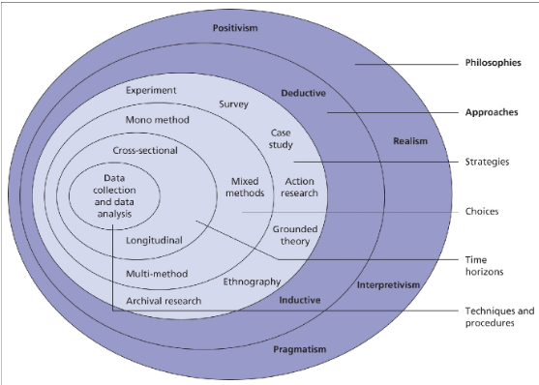
Figure 1: Research onion
(Source: Saunders et al. 2015)
The research onion is a hierarchical architecture that has numerous layers, representing a separate stage in research planning and implementation. It starts with the philosophical presumptions that define the procedure for conducting research and goes through several stages such as study design, data gathering, and data interpretation. These stages are linked and build on other people to construct a thorough research project. The philosophical assumptions that guide the study's conduct are found at the uppermost layer that makes up the research onion (Amminen and Poucher, 2020). For this investigation, positive thinking will be used, presuming that reality is quantifiable and unbiased. In the research process, this viewpoint emphasises the use of actual proof and objective measurement. Moving on to the following layer, we come across the deductive research approach used in this study. This method involves developing research hypotheses according to current assumptions and then validating them with survey data. The study intends to examine and corroborate theoretical statements obtained from known bodies of literature using a method known as deductive reasoning.

3.3 Research philosophy
The positivist approach to research, which is based on the belief that social issues can be examined validly using statistical techniques to examine connections between them, is appropriate for investigating the effects of online marketing on buyer behaviour in light of Nike's advertising tactics. Positivism emphasises observable and quantitative parts of the world that may be validated through gathering data and statistical examination. To collect quantitative data for the study on the impact that social media promotion on Nike buyer behaviour, we used a positivist methodology. Surveys, for instance, were carried out among staff members and managers to gain their perspectives and ideas on the subject (Bloomfield and Fisher, 2019). This numerical information is then able to be statistically analysed to detect correlations and to evaluate hypotheses about variable causal links. Furthermore, libertarian philosophical research permits the use of a logical technique. This entails creating and empirically analysing a quantitative questionnaire based on current research and hypotheses. Hypotheses can be developed by relying on recognised principles of internet marketing to comprehend how these ideas interact in the particular situation under examination. The quantitative testing of those hypotheses may indicate the degree of intensity and trajectory of these relationships. The study intends to create empirical data and measurable insights on the impact of social media promotions on customer behaviour in conjunction with Nike's marketing efforts by using a positivist research methodology and a deductive strategy. The emphasis on gathering and analysing quantitative data enables rigorous examination of causal relationships and adds to an improved comprehension of the topic.

3.4 Research approach
In this study, a particular deductive technique is used to examine the impact of social media promotion on consumer behaviour in the context of Nike's advertising strategy. This method is ideal for assessing existing notions and hypotheses based on earlier research or contemporary understanding. We can test these hypotheses and models methodically and properly by employing a logical technique. Deductive research is developing a conceptual framework based on material that has previously been published after which it quantitatively evaluates it through data collection and analysis. It may investigate how these principles interact by applying existing theories of social media advertisement and consumer behaviour to Nike's advertising techniques. It can establish the intensity and direction of these relationships using surveys and quantitative analyses of data, offering significant insights into the consequences of social media advertisements on customer behaviour. This study intends to build on current knowledge and theories by employing a deductive methodology, providing a systematic and rigorous assessment of the link between digital marketing and consumer behaviour within the unique context of Nike's marketing efforts. The survey data will enable for empirical assessment of these theories, adding to improved awareness of the issue.

3.5 Research method
This study used the quantitative research approach to explore the impact of social networking site marketing on customer behaviour in the context of Nike's advertising strategies. This strategy entails gathering and analysing numerical data in order to discover trends, cycles, and correlations. We hope to collect measurable and objective information that can be quantitatively examined through empirical studies. Surveys and questionnaires will be the methods utilised to collect data from a broad sample of consumers, providing a thorough knowledge of their behaviour in reaction to Nike's social media advertising efforts (Ceraet al. 2020). To investigate the links between marketing campaigns on social media and consumer behaviour, mathematical methods such as regression analyses, correlational modelling, and hypothesis testing will be used. It can acquire accurate and quantified insights into the influence of social networking site marketing on customer behaviour by using the technique known as quantitative research. This method allows us to derive trustworthy conclusions and generalise about a bigger population. The results of this research will add to the body of research on consumer behaviour and provide significant insights for strategists and professionals in establishing effective social media advertising approaches in relation to Nike's marketing objectives.

3.6 Research Design
In this study, the method of case study research is used to explore the impact of social media promotion on consumer behaviour in the setting of Nike's marketing efforts. This design enables an in-depth examination of a given occurrence in its real-world setting. Data will be gathered through a variety of means, including inquiries, observations, and an examination of marketing materials including social media efforts. This all-encompassing strategy allows for a thorough knowledge of the complicated relationships between social network marketing and customer behaviour. The case study format presents rich and extensive insights into the particular circumstances of Nike's marketing initiatives, allowing for a more in-depth examination of the elements driving customer behaviour (Labra et al. 2020). It enables the investigation of real-world problems and serves as a foundation for extracting practical conclusions. The study's findings will add to existing research on social media communication as well as consumer behaviour, assisting marketers and operators in establishing more successful tactics in the ever-changing world of online advertising.

3.7 Data collection process
Questionnaires were employed as the major quantitative data collection method in this study, which aimed to investigate the impact of web marketing on customer behaviour in the context of Nike's promotional strategies (Maarouf, 2019). Surveys are picked because they enable the collection of consistent replies from an array of participants, who can then be statistically analysed to discover patterns and trends, ultimately confirming the data's accuracy. This study intends to discover key difficulties linked to the oversight practises about the influence of digital marketing on customer behaviour in light of Nike's advertising tactics by using questions as a gathering information approach. Surveys allow researchers to collect complete and standardised information, allowing for a detailed assessment of the research issue. This study will use surveys to gather significant insights into the relationship connecting social media promotion and customer behaviour in the setting of Nike's promotional strategies. The data gathered will be statistically analysed to identify correlations, trends, and possible repercussions for marketing practices. The use of questions as the primary method of data collection improves the findings' dependability and universality. It allows researchers to collect a large sample size, which increases the study's accurate representation and provides a solid foundation for making conclusions on the effects of digital marketing on customer behaviour in relation to the brand's marketing efforts (Moore et al. 2021). The study intends to contribute to the current state of knowledge in the field of communications by using this quantitative approach, providing insights that might assist marketers or those who practise creating effective digital advertising techniques and comprehending the effects they have on consumer behaviour.

3.8 Sampling method
The convenience sampling approach was used in this study to select a survey population size of 50 respondents. Convenience sampling is a method of sampling with no probability in which participants are chosen based on their proximity and access to the subject of the study. Respondents have been selected in this scenario depending on their accessibility and commitment to participate throughout the study. Convenience sampling is frequently employed in studies where the emphasis is on pragmatism and efficiency since it allows investigators to collect data fast and conveniently. However, it is crucial to highlight that easy sampling may add bias to the collection because it does not precisely represent the total population (Pandey and Pandey, 2021). Although convenience sampling limits the applicability of the findings, the results may nevertheless reveal significant insights and patterns within the investigation's specific context. Convenient sampling enables the collection of information from consumers who have personal knowledge or knowledge of Nike's advertising strategies using social media in this study exploring the impact of marketing via social media on buying habits in the context of Nike's advertising strategy.

3.9 Data analysis technique
The survey results will be analysed using SPSS, which is a commonly employed statistical analysis programme in the fields of social sciences. Filtering information to ensure its reliability and precision is the first stage in data analysis. This includes looking for missing data, oddities, and contradictions. To acquire a greater awareness of the assembled data and sample, statistical analyses will be generated (Sajid et al. 2019). For every variable, dispersion measures such as average deviation and variation will be computed, as well as indications of central tendencies such as mode, mean, and median. To test hypotheses as well as find correlations between variables, inferential statistics has been utilised. Given the goals of the research along with the kind of information, the relevant statistical tests have been selected. In the setting of Nike's marketing tactics, correlation analysis or else regression analysis, for instance, could be used to investigate the link between SMM as well as consumer behaviour. The analysis's results have been assessed in light of its objectives plus the body of prior research. We'll look at how the findings affect theory and application. The results of the analysis have been presented in a simple and straightforward way using tables, graphs, including charts (Teti et al. 2020). A thorough analysis of the findings plus their meanings has been included in the study's report's outcomes chapter. It can throw light on the consequences of the findings, and their importance in answering the study questions, including any shortcomings or areas that require more research. To fully explain the results of the investigation, the interpretation has been backed by pertinent theories as well as literature.

3.10 Ethical consideration
The survey's structure was closely followed in respect of ethical considerations, considering any possible prejudices that might arise in the incorrect interpretation of information gathered from diverse internet sources. Applicable university rules & regulations were cited to guarantee the ethical concerns of the present dissertation. Due to the potential for inherent prejudice in the opinions offered in the aforementioned study, it is vital to stress that needless explanations of the investigation's question have been prevented (Zangirolam, 2020). Additionally, an exhaustive review of the research survey was conducted to uphold a high standard of secrecy, guaranteeing that the data is kept private as well as securely saved using secret keys for encryption. Significant efforts were made to reduce plagiarism by abiding by university norms in order to preserve the high standard of education at the institution of higher learning. Each scholarly statement is properly supported by pertinent citations, plus measures have been made to prevent topic prejudice in qualitative research, resulting in the production of dependable data. This is accomplished through utilising appropriate study designs, techniques, plus philosophies that are in line with each dissertation's issues. It is significant to note that there was no evidence of manipulation; rather, pertinent information about research participants has been assessed to offer unbiased answers for the questions being investigated, avoiding erroneous interpretations (Zhang et al. 2021). It is important to note that every idea, detail, method, and material required to finish this study project was painstakingly incorporated. This thorough method made it easier to come up with pertinent concepts, which were then used in all areas of the research paper. This website is available to experts, readers, plus curious viewers who want to learn new things and get insightful recommendations.

3.11 Research Timeline
Gantt chart

Figure: Gantt chart Source: Author

3.12 Summary
In summary, In the framework of Nike's marketing strategy, this investigation seeks to ascertain the effect of SMM on customer behaviour. Data are gathered by questionnaires using a sample size of 50 respondents using a quantitative research approach. Filtration techniques have been used throughout the analysis of the gathered data employing the SPSS programme to guarantee accuracy. Inferential statistics have been used to test hypotheses as well as find correlations, whereas descriptive statistics have been produced to comprehend the sample as well as variables. Tables, graphs, and charts have been used to present the results of the analysis. The findings have been thoroughly explored, taking into account their theoretical and practical consequences, and their limits will be mentioned. The study seeks to advance knowledge of the connection between SMM as well as consumer behaviour by offering insightful information to both scholars as well as practitioners.

Chapter 4: Data Analysis

4.1 Introduction
This data analysis part is associated with presenting results based on regression, correlation, descriptive statistics for sharing effective value. In this dimension, it has been focused on presenting tables and graphs to show the results from the data analysis. It has been shown that the highly regarded impact demonstrates Nike's marketing efforts' effectiveness in developing an excellent brand image and recognition within the target demographic. Furthermore, It has also been shown that acknowledgement of Nike's marketing relevance with respect to the brand's quality shows that their messaging as well as advertisements have succeeded in conveying the brand's dedication to supplying high-quality items. It has been analysed by Nike's social media marketing to show the current situation of the brand equity. Therefore, this chapter 4 of the research emphasises the importance of marketing actions in moulding consumer views and sustaining the brand's quality reputation. It also assists in showing strategies that Nike may use this to boost their marketing tactics and maintain a favourable perception of the company among their target audience.

4.2 Quantitative data analysis
The table below is associated with correlation analysis that shows the relationship between different factors regarding the impact of social media marketing on consumer behaviour of Nike. In the context of correlation value regarding the Nike marketing campaign most commonly seen through the social media platform and the likeliness of Nike social media post is 0.22 based on the total number of correspondents of 50. This value shows that most of the audiences are engaged on Facebook and Instagram. Apart from that likeliness regarding interacting with Nike social media posts and the time period of seeing the Nike marketing campaign is 2.87. In this context this data shows that audiences are associated with effective interaction towards the Nike product and services ( Schivinskiet al. 2022). In the contacts of likeliness of the Nike social media campaign and the Nike influence marketing strategy it has been found the correlation value is 0.581. This data shows that the influence through social media marketing is sufficient but it is also needed to make improvements to gain more effectiveness regarding customer engagement with the contents.
Correlation
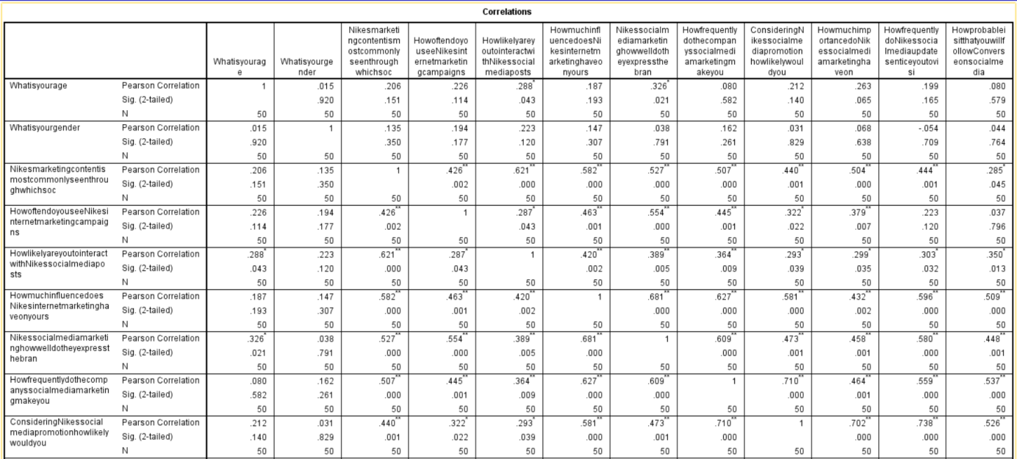
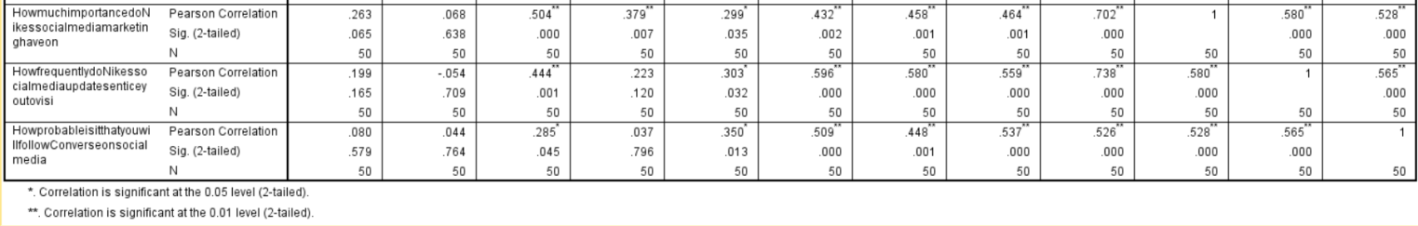
Table 1: Correlation of all the variable
(Sources: Self-Made)
In the above table it can be found that correlation is significantly at the 0.05 level (2-tailed) that indicates a meaningful relationship between the variables being studied. Apart from that it can also be found from the correlation of staying updated with the Nike changes in product and services and campaign through the social media platform is 0. 08 and it shows that Facebook is the platform where changes in posts are highly seen by the audience ( Serajpour et al. 2021).
Regression
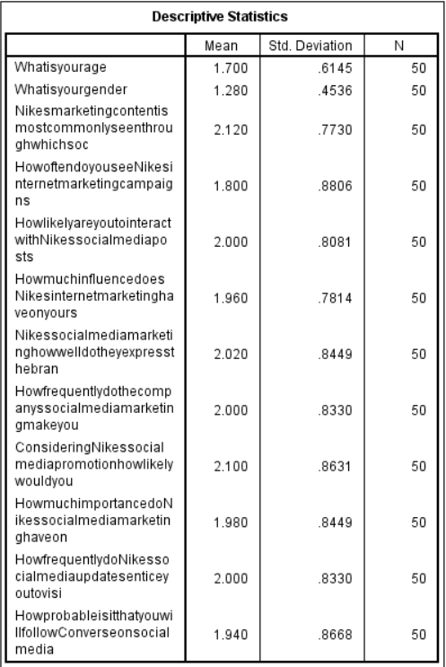
Table 2: Descriptive statistics of all the variable
(Sources: Self-Made)
The table above is associated with descriptive statistics of the essential variable related to the research topic. In the context of age group, it can be found that the mean value is 1.70 and the standard deviation is 0.614 and this value shows that most of the respondents are associated with 18 to 24 and 25 to 35. In the contest of Nike marketing content most commonly seen through social media it has been observed the mean value is 1.280 and the standard deviation is 0.4536 and this data mainly shows that most of the audiences have viewed facebook and instagram( MohammadShafiee et al. 2019). In the context of likeliness regarding seeing the Nike campaign, it has been observed the mean value is 2.12 and this value shows that the audiences are associated with somewhat likely regarding seeing the marketing campaign.
In the context of following the conversion of Nike social media posts of new product and services has been found that the mean value is 1.94 and it shows that the audiences are associated with somewhat likely to see changes in Nike campaigns. In the contest of visiting Nike website and physical stores for searching product and services it has been found the mean value is 2 and the standard deviation is 0.833. Add to that, this data shows that most customers occasionally visit Nike website and physical stores and also some audiences are related to rarely visiting platforms.
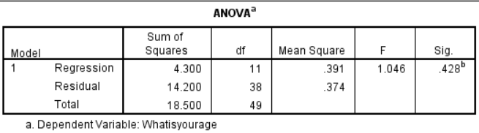
Table 3: ANOVA
(Sources: Self-Made)
According to the table 4 of ANOVA test, it has been obtained the the regression value 4.3 and the residual value 14.20. This table also represents the mean square value of 0.391 and and 3.74 respectively (Eyada, 2020). The regression value shows the future impact on a factor due to making changes in other.
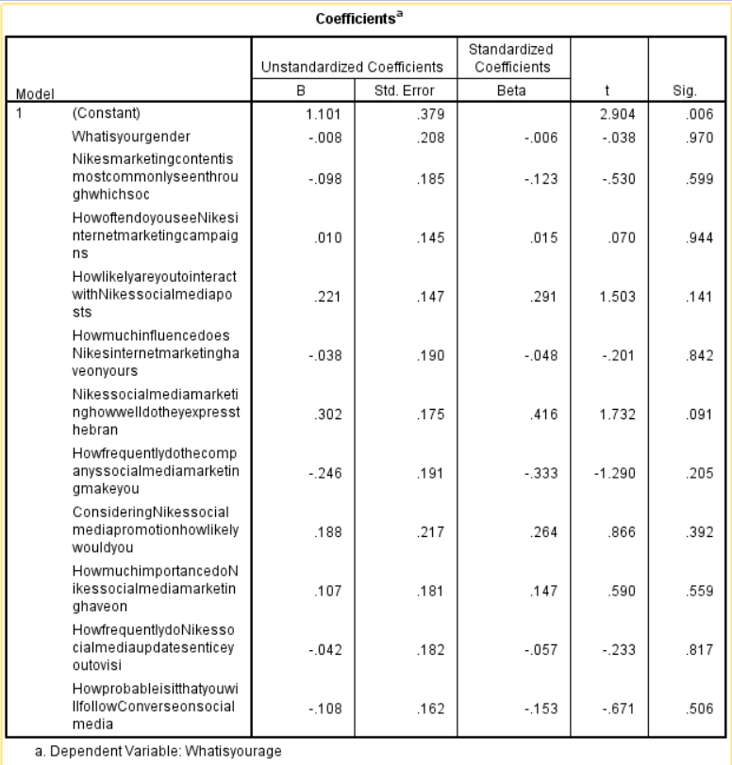
Table 4: Coefficients
(Sources: Self-Made)
In the coefficient table it can be understood that in the constant model the unstandardized coefficients B value is 1.101. It can also be found that unstandardized coefficient Std Error value .379. It can also find that the standardised coefficient Beta value is Null and it can understand that the t value is 2.904 and sig value is 0.006. In the coefficient table it can be understood that in the gender model the unstandardized coefficients B value is -.008. It can also be found that unstandardized coefficient Std Error value .208. It can also find that the standardised coefficient Beta value is -.006 and it can understand that the t value is -.038 and sig value is 0.970 ( Arzhanova et al. 2020). In the coefficient table it can be understood that in Nike's marketing content is most commonly seen through which social media platforms model the unstandardized coefficient B value is -.098. It can also be found that unstandardized coefficient Std Error value .185. It can also find that the standardised coefficient Beta value is -.123 and it can understand that the t value is -.530 and sig value is 0.599. In the coefficient table it can be understood that in How often do you see Nike's internet marketing campaigns model the unstandardized coefficient B value is .010. It can also be found that unstandardized coefficient Std Error value .145. It can also find that the standardised coefficient Beta value is -.015 and it can understand that the t value is -.070 and sig value is 0.944 ( Harrigan et al. 2021). In the coefficient table it can be understood that in How likely are you to interact with Nike's social media posts (through likes, comments, and shares) the unstandardized coefficient B value is .221. It can also be found that unstandardized coefficient Std Error value .147. It can also find that the standardised coefficient Beta value is .291 and it can understand that the t value is .1503 and sig value is 0.141. In the coefficient table it can be understood that in How much influence does Nike's internet marketing have on your shopping decisions the unstandardized coefficient B value is -.038. It can also be found that unstandardized coefficient Std Error value .190. It can also find that the standardised coefficient Beta value is -.048 and it can understand that the t value is -.201 and sig value is 0.842. In the coefficient table it can be understood that in How frequently do Nike's social media updates entice you to visit their website of physical locations model the unstandardized coefficient B value is -.042. It can also be found that unstandardized coefficient Std Error value .182. It can also find that the standardised coefficient Beta value is -.057 and it can understand that the t value is -.233 and sig value is 0.817. In the coefficient table it can be understood that in How probable it is that you will follow Converse on social media to keep up with their latest items and promotions the unstandardized coefficient B value is -.108. It can also be found that unstandardized coefficient Std Error value .162 (Slaton and Pookulangara, 2022). It can also find that the standardised coefficient Beta value is -.048 and it can understand that the t value is -.153 and sig value is 0.506.

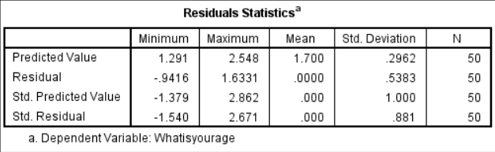
Table 5: Coefficients
(Sources: Self-Made)
Based on above table 6, residuals statistics where the predicted value found 1.291 minimum and 2.548 maximum related to the topic of the impact of social media marketing on consumer behaviour of Nike (Qureshi and Rashid, 2023). In this dimension, it has been found the residual mean value 0 and standard deviation of 1.000.
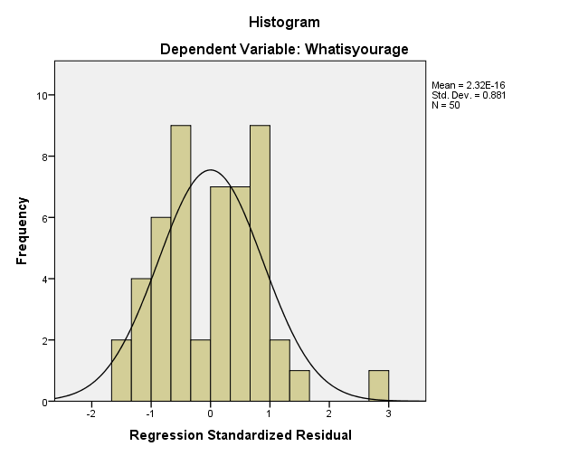
Figure 1: Histogram chart on Regression Standardised Residual
(Sources: Self-made)
Frequency
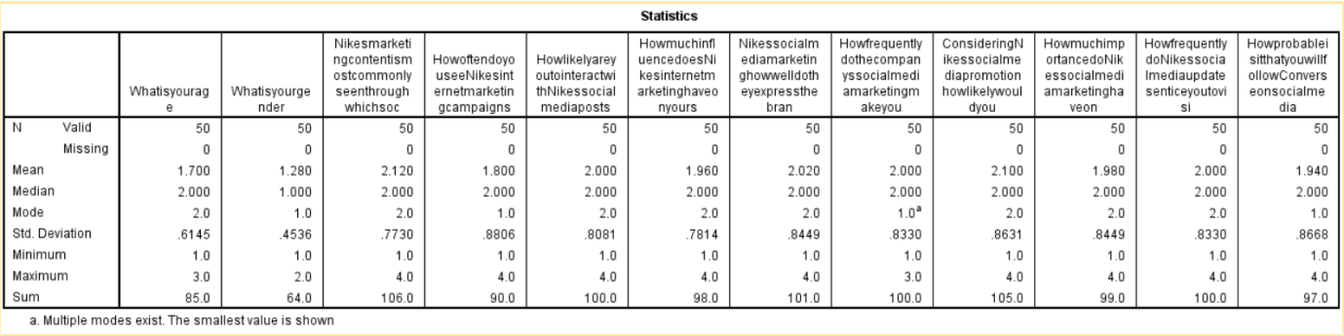
Table 6: Statistics of all the variable
(Sources: Self-Made)
In the above statistics table it can gain the knowledge of all variables details. In the above table it can be understood that the total valid participant of all the variables is 50 people and the missing participant is 0 (Kostov, 2020). It can understand that the mean value of the variable is 1.70 and the age variable is 1.280. It can understand that the variable Nike's marketing content is most commonly seen through which social media platforms mean value is 2.210 and another variable mean value is 1.80, 2.000, 1.960 and 2.020, 2.000, 2.100, 1.980, 2.000, 1.940 etc. It can also be found that the median value of all variables is 2.000, 1.000, 2.000, 2.000, 2.000, 2.000, 2.000, 2.000, 2.000, 2.000, 2.000, 2.000 (Mou, 2020). It can also be found that the vade value of all variables is 2.0, 1.0, 2.0, 1.0, 2.0, 2.0, 2.0, 1.0, 2.0, 2.0, 2.0, 1.0. It can also found from above table is the Std division of all the variable is .6145, .4536, .7730, .8806, .8081, .7814, .8449, .8330, .8631, .8449, .8330, .8668 etc. It can also be found that the minimum value of all variables is 1 and maximum value of variable is 4.0.
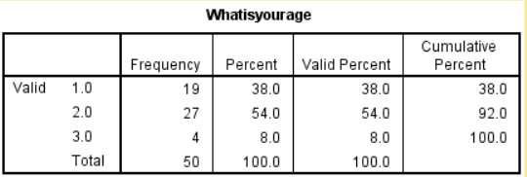
Table 7: What is your age
(Sources: Self-Made)
The above frequency table 8 shows the frequency of age group of respondents. In this dimension, it has been found that 54% or 27 respondents are associated with the age group of 25 to 35 and 38% or 19 respondents are associated with the age group of 18 to 24 (Bandara, 2020). Apart from that this table shows that 4% of participants are related to the age of 36 to 45.
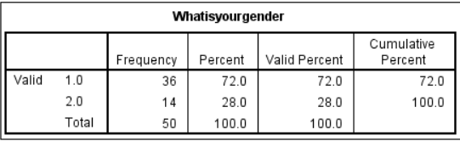
Table 8: What is your gender
(Sources: Self-Made)
In the context of gender based questions, it has been observed that 72% of respondents are male and 28% are female in this online survey. Therefore, 36 respondents are male and 28 are female in this survey.
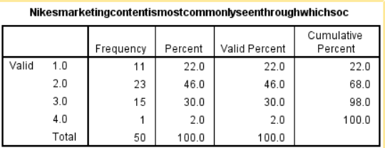
Table 9: Nike's marketing content is most commonly seen through which social media platforms
(Sources: Self-Made)
The table 9 shows Nike’s marketing content that is most commonly seen through the social media platforms. In this dimension, it has been found 22% of the respondents are related to daily seeing content whereas 46% of respondents are related to weely seeing the social media content of Nike business process (Santoki and Parekh, 2020). This table also shows that 30% or the 15 respondents are related to monthly seeing the content of Nike and 1 respondent rarely or never sees the content. Therefore, it can be said that this data would be useful for business regarding personalised targeting and lead generation by Nike.
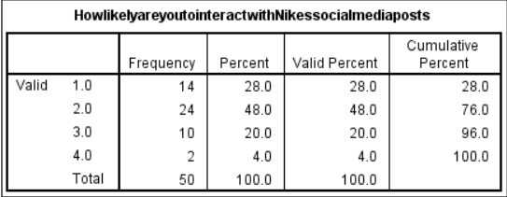
Table 10: How likely are you to interact with Nike's social media posts (through likes, comments, and shares)
(Sources: Self-Made)
The above frequency table 10 is associated with showing the audience interaction with Nike's social media posts (Fontaine, 2020). In this portion, it has been found that 28% or 14 respondents are very likely and 48% or 24 respondents are moderately likely towards the posts of Nike based on likes, comments and shares. This table also represents that 10 audiences are related to slight likely and 2 are associated with not interacted with the posts
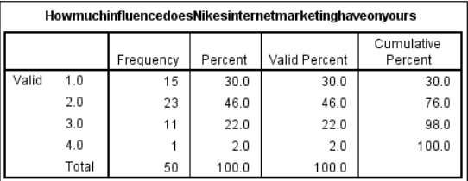
Table 11: How much influence does Nike's internet marketing have on your shopping decisions
(Sources: Self-Made)
In the context of digital marketing influence of Nike on the shopping decisions of customers, it has been found that 30% audiences are highly influential and 46% audiences are moderately influential (Chanpaneri and Jain, 2021). In this context, it has also been found that 22% of the audience group are slightly influential. Therefore, it can be said that this data would be useful for business for making more strong marketing campaigns to influence those groups who are rarely or slightly influence and not influential.
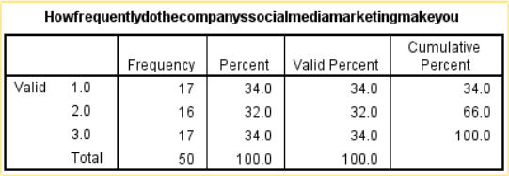
Table 12: How frequently do the company's social media marketing make you want to buy their products
(Sources: Self-Made)
In the context of making analysis regarding a company's social media marketing that makes an audience for buying the product, it has obtained maximum respondents of 17 for option 1 and 3 whereas 16 found from option 2. This data shows that 17 audiences viewed that they are related to very often buying of Nike products due to Nike’s marketing and 16 are related to occasionally and 17 also rarely (Kapnia, 2022). Therefore, 34% of the audience are related to rare where company needs to make strategy to engage them higher through strategic marketing campaigns.
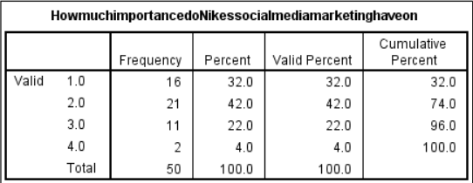
Table 13: How much importance do Nike's social media marketing have on your opinion of the brand's quality
(Sources: Self-Made)
According to table 13, it has been mainly examined the Nike’s social media marketing has generated a value of good brand equity (Starkey, 2022). In this dimension, the moderately is highly viewed where 21 respondents viewed. It has also been found 16 respondents who are associated with significantly impotence of Nike’s social marketing for the option of the brand’s quality.
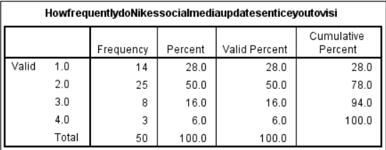
Table 14: How frequently do Nike's social media updates entice you to visit their website of physical locations
(Sources: Self-Made)
Based on the above table 14, it has been found the frequency of Nike’s social media updates that entice audiences to visit their website and physical store (Li et al. 2020). In this dimension, the option 2, occasionally is highly viewed that is 25 and then option that is associated with the frequency of 25. This table also shows that 8 respondents out of 50 are related to rarely visits Nike’s site.
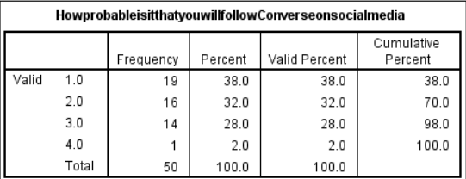
Table 15: How probable is it that you will follow Converse on social media to keep up with their latest items and promotions
(Sources: Self-Made)
According to the above frequency table regarding following the converse on social media to keep up with their latest items and promotions, it has been found the frequency of 19 regarding 1 and 16 regarding the option 2 (Dar and Tariq, 2021). Add to that, it has also been found the frequency of the option. In this dimension, it can be said that most of the audiences are related to very likely to follow the Nike updates and then also some audience groups are related to somewhat likeliness.
. 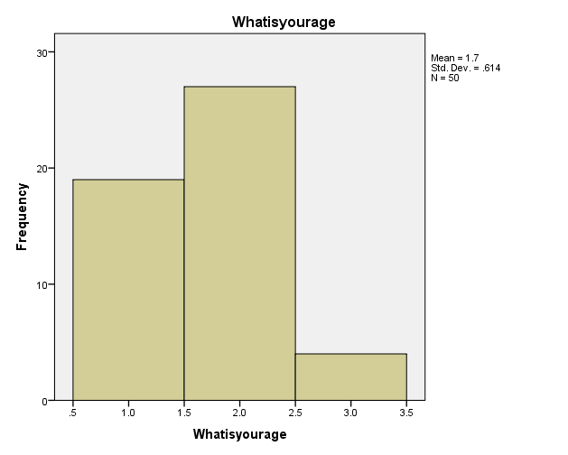
Figure 2: What is your Age
(Sources: Self-made)
Furthermore, the data histogram shows that 4% of the study's participants, or a tiny number, are between the ages of 36 and 45 (Babin and Harris, 2023). These statistics emphasise the survey the weight of the sample predominance of persons aged 25 to 35, which is followed by people under 18 to 24, with a comparatively smaller percentage in the 36 to 45 age range.In this context, it shows the mean value of 1.7 and standard deviation of 0.614.
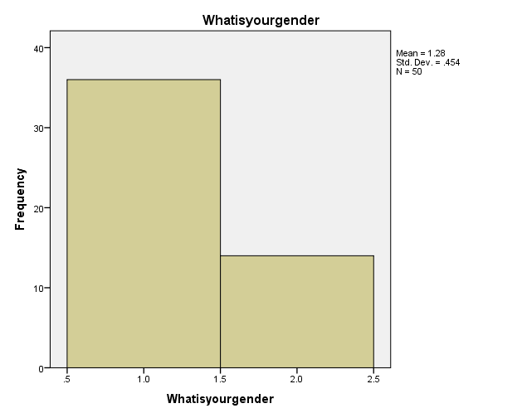
Figure 3: What is your Gender
(Sources: Self-made)
Out of the total 50 participants, 36 are men and 14 are women, as seen in the gender breakdown in the graph above. The gender distribution in the study sample is depicted in the graph in a simple and understandable manner (Cooley and Parks, 2019). Furthermore, the 1.28 mean as well as 0.454 standard deviation provide information on the central tendency as well as dispersion for the variable being evaluated within the individual in the group.
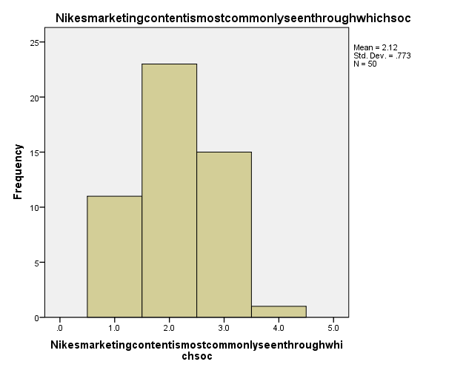
Figure 4: Nike's marketing content is most commonly seen through which social media platforms
(Sources: Self-made)
In the aforementioned histogram chart on Nike's marketing materials, it may be shown that 11 respondents said they saw the materials on a daily basis, while 23 respondents said they see them on a weekly basis. In addition, 15 participants said they often view Nike's marketing materials (Hollensenet al. 2022). It's interesting that only one respondent said they rarely or never saw Nike's marketing material on social media networks. The histogram gives participants' replies to questions on how frequently they come across Nike's marketing material a visual representation about the frequency distribution. This data makes it easier to comprehend the diverse degrees of involvement in Nike's marketing initiatives on various social media platforms. Marketers can modify their efforts through analysing these replies to learn more about the efficacy and audience reach of their advertising strategies across various platforms.
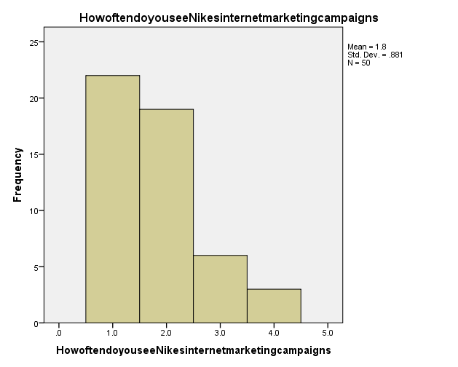
Figure 5: How often do you see Nike's internet marketing campaigns
(Sources: Self-made)
For the question, "how often do you see Nike's internet marketing campaigns," 22 participants indicated through Facebook for advertising efforts, as seen in the aforementioned histogram chart. 46 individuals also mentioned seeing Nike's marketing activities on Instagram. Six interviewees also cited utilising Twitter for marketing activities, while three participants suggested Snapchat (Darabiet al. 2020). The histogram gives a visual depiction of the replies of participants about the platforms where they come across Nike's online marketing efforts. Marketers who are pushing Nike's ads can learn more about the popularity as well as audience reach of various platforms by analysing this data. The participants within the survey were exposed to Nike's internet marketing efforts on average 1.8 times per participant, on average, as well as the variable 0.881 times per person. This data gives an overview of the preferences of those surveyed plus the platforms wherein Nike's marketing efforts have been most commonly seen, with an overall of 50 participants.
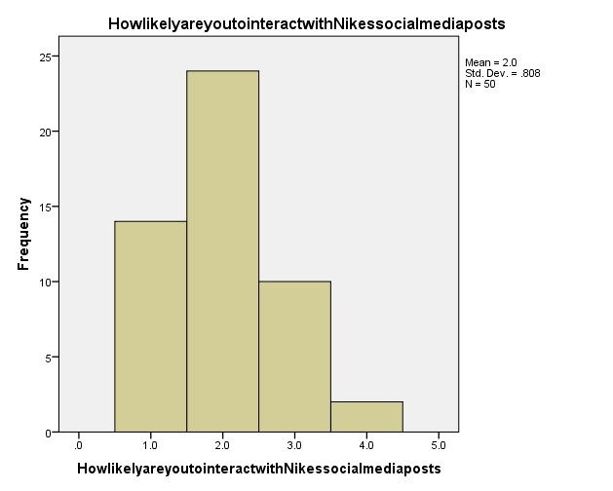
Figure 6: How likely are you to interact with Nike's social media posts (through likes, comments, and shares)
(Sources: Self-made)
The data reflects the respondents' varying levels of interaction. According to the data, 28% of the individuals, or 14 responses, are classified as "very likely" to interact with Nike's posts. This indicates that these people are very interested in the subject and participate with likes, comments, shares. Furthermore, the chart shows that 48% of the participants, or 24 people, are "moderately motivated" to interact over Nike's posts. This group accounts for a sizable section of the target demographic, with a reasonable level of interest and involvement in the brand's internet-based content.
This histogram shows the mean value of 2 regarding the audience interaction towards Nike’s social media post. This group accounts for a sizable section of the audience, with a reasonable level of curiosity and engagement within the organisation's social media content (Valerie and Hariandja, 2022). Furthermore, the table shows that 10 responders have a modest chance of engaging with the posts. This indicates a reduced degree of engagement than in the previous categories. Furthermore, two respondents stated that they did not connect with Nike's social media post at all. In the end, the data suggests a high level of audience involvement with Nike's internet-based material, with a sizable proportion of respondents indicating a very likely or slightly probable willingness to interact.
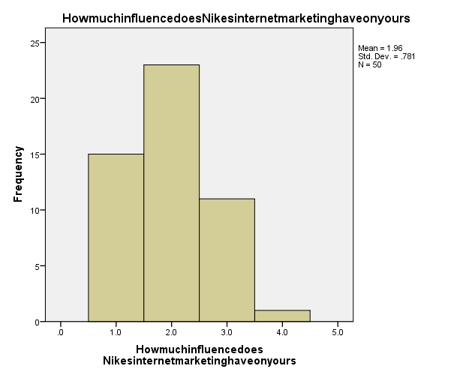
Figure 7: How much influence does Nike's internet marketing have on your shopping decisions
(Sources: Self-made)
The data offered on the impact of Nike's online advertising on customer purchasing decisions is useful for organisations. According to the statistics, 30% of the population is rated as highly influential, showing that Nike's internet advertising activities have an important influence on their purchasing decisions. This group represents a big opportunity enabling the company to use its influence and boost its promotional efforts in order to keep and attract additional consumers (Brown et al. 2020). Nike's internet advertising has a significant impact on their purchasing decisions, albeit to a smaller extent than the extremely influential group. Nike has an opportunity to continue connecting with these individuals and potentially raise their level and engagement through focused marketing methods in this area. According to the study, 22% of the public is moderately influential. Though this group has some power, Nike may need to pay more close attention to them in order to increase their involvement and control over their purchasing decisions. Overall, the data helps organisations, such as Nike, identify areas of possibility for boosting their marketing strategies. Nike may build more focused campaigns by focusing on individuals that are rarely or minimally influenced, alongside those that have yet to be influenced.

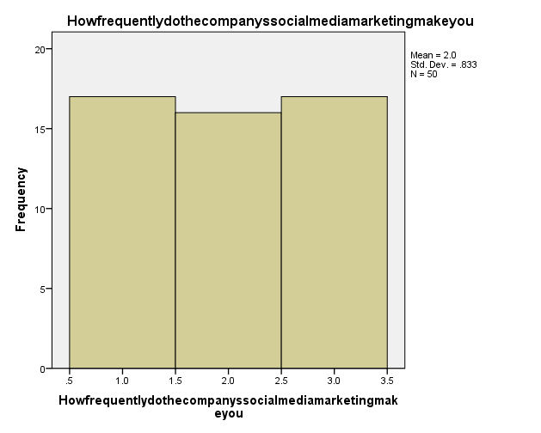
Figure 8: How frequently do the company's social media marketing make you want to buy their products
(Sources: Self-made)
According to the histogram figure 9, 17 respondents said they are rarely determined by Nike's advertisement. Through focused marketing activities, this group provides a potential for the organisation to connect with them and turn its customers into more frequent purchasers.The realisation that 34% of the audience is "rare" emphasises the need of adopting measures to increase their involvement (Li et al. 2021). The organisation may create marketing strategies to effectively target and influence this demographic by analysing their individual preferences, interests, as well as motivations.

To capitalise on this chance, the brand can use personalised promotions, limited-time offers, or interactive material to build a better connection for this "rare" customer. The organisation may grow through recognising their wants and delivering compelling reasons to buy.
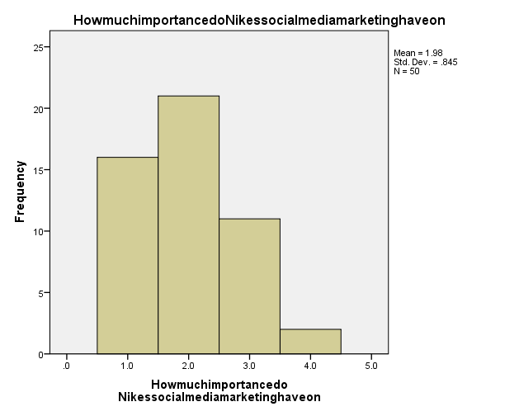

Figure 9: How much importance do Nike's social media marketing have on your opinion of the brand's quality
(Sources: Self-made)
The Histogram figure 10 shows an assessment of Nike's social networking marketing that demonstrates that it has produced a high amount of brand equity. According to the research, the majority of respondents (21 people) have a modest view of the influence of Nike's social networking marketing on brand equity. This suggests that these respondents recognise Nike's marketing efforts as having a favourable impact on growing and improving brand equity.Furthermore, the chart shows that 16 respondents link Nike's social media marketing to the value of the brand's quality (Courey, 2019). This finding implies that these people see Nike's advertising strategies as playing a role in developing their view of the brand's general excellence and repute. The report emphasises Nike's social media marketing's beneficial impact on brand equity.

4.3 Conclusion
In conclusion, the data analysis done for this study offers insightful information about how social media marketing affects consumer attitudes towards Nike. Significant correlations between several aspects of Nike's SMM plus customer involvement were found using correlation analysis. A substantial amount of engagement is shown by audiences' propensity to participate when Nike's social media postings and by how frequently users visit the company's advertising campaigns on websites like Facebook & Instagram. Furthermore, the relationship among influence marketing strategy of Nike's with their social media campaign emphasises how well social media works to change customer behaviour. By highlighting the potential effects of modifications to one component on other variables, the regression analysis provided additional support for these findings. The analysis's coefficients provided insight into the connections between various variables and how they affected customer behaviour. The findings show that consumers' propensity to engage with the post of Nike's social media has a favourable impact on their purchasing choices. The effectiveness of the marketing content may still be enhanced though, to increase client involvement. The descriptive statistics shed light on the characteristics among the respondents, like the respondents distribution by age & gender. A large number of responders were between the ages of 18 and 24 and 25 to 35, showing that Nike's SMM is particularly successful in attracting younger consumers. In comparison to female respondents, there were more male respondents, according to their gender distribution. These results highlight how important SMM is for Nike in terms of shaping consumer behaviour and increasing engagement. The report emphasises how crucial it is to keep marketing tactics improving in order to increase consumer engagement as well as brand loyalty. Nike may use these findings to create focused and potent social media ads that have an important effect on consumer behaviour.

Chapter 5: Conclusion

5.1 Linking with Objective
Objective 1: To analyze the concept of customer buying behaviour and ways marketing activities are utilized to influence it
One of the most important goals in the area of marketing has been to analyze client purchasing behaviour and comprehend how marketing initiatives affect it. Customer purchase behaviour can be the procedure that people use to make decisions about what to buy, such as their motives, and preferences, as well as deciding considerations (Amminen and Poucher, 2020). A solid knowledge of theories of consumer behaviour, like the customer decision-making process as well as psychological aspects that affect purchasing decisions, is necessary to accomplish this goal. Customer purchasing behaviour is significantly influenced by marketing activity. Companies employ a variety of techniques to draw in, keep, and influence customers. Advertising, promotions, placement of products, price strategies, and individualized marketing techniques are a few examples of these tactics. Knowing consumer behaviour allows marketers to efficiently adjust their initiatives to meet customers' requirements, wants, as well as preferences.
Businesses can acquire knowledge about how they can successfully advertise their goods or services within the marketplace by analyzing the link between marketing activity and consumer purchasing behaviour. Companies may develop advertising strategies as well as plans that are specifically targeted toward the decision-making procedure of their target audiences, maximizing their effect(Courey, 2019). Additionally, by comprehending consumer purchasing patterns, businesses can modify and advance their marketing strategies to satisfy shifting consumer desires. Marketing professionals may make wise decisions, maximize their marketing strategies, as well as improve overall business performance by researching the idea of client buying behaviour as well as how marketing activities impact it. This goal motivates marketers to continuously improve their comprehension of consumer behaviour as well as develop creative strategies to effectively impact as well as engage consumers.
Objective 2: To investigate the ways social media marketing strategies are being performed to increase the possibility of influencing customer buying behaviour
In the current digital era, it is crucial to investigate the methods used in SMM tactics to raise the likelihood of influencing consumer buying behaviour. Because social media has become so prevalent, companies need to understand ways they can employ these platforms to influence customer behaviour (Amminen and Poucher, 2020). A variety of strategies are included in SMM plans to interact with and sway potential clients via different social media platforms. These techniques could involve developing interesting content, utilizing influencer marketing, launching targeted advertising initiatives, interacting with consumers via interactive posts, plus utilizing data analytics to maximize advertising expenditures. Businesses may learn a lot about the most efficient ways to engage and affect client purchasing behaviour by researching SMM strategies. Analyzing effective case studies, analyzing customer reactions to various social media initiatives, and spotting new trends in SMM are all part of this purpose.
Businesses may create more specialized and focused marketing strategies by having a better understanding of the way platforms affect consumer purchasing behaviour. Companies may reach a larger audience, increase brand recognition, and forge enduring relationships with consumers by utilizing social media. Additionally, social media gives businesses a platform for client feedback as well as involvement, enabling them to respond to issues, offer assistance, and improve relationships with customers. Investigating the methods used by SMM strategies to affect consumer purchasing behaviour promotes ongoing learning & improvement. Companies can optimize their plans to meet changing customer preferences by keeping up with the most recent trends as well as strategies in SMM. This goal motivates marketers to look into creative uses of SM platforms to successfully sway consumer purchasing decisions.
Objective 3: To analyze the leading sports and fitness apparel industry leader, Nike has utilized social media marketing strategies to ensure a positive influence on the buying behaviour of the customers.
A compelling goal is to examine how Nike, an industry innovator in sports as well as fitness apparel, has used SMM techniques to assure a favourable impact on consumer purchasing behaviour. Nike's SMM strategy has proven crucial in influencing customer views, generating engagement, along with eventually influencing purchasing decisions. Investigating Nike's SMM tactics can provide information about how the company uses sites like Instagram, Twitter, as well as YouTube. Nike has successfully used these routes to establish a "strong online presence", interact with the demographic they are targeting, and creatively present their goods.
Nike's social media advertising has emphasized building community and people who inspire to live an active lifestyle. Nike has effectively placed itself as a lifestyle brand that goes beyond selling items with great narrative, user-generated material, and collaboration with sports and influencers.
Furthermore, Nike's usage of social media monitoring and data-driven conclusions has enabled the company to gain a deeper understanding of its customers' preferences, behaviors, and purchasing habits. Nike can customize its advertising campaigns, distribute personalized content, as well as offer targeted incentives that resonate with consumers because of this intelligence.

5.2 Limitations
Primary research on the impact of online advertisements on Nike consumer behaviour may have several drawbacks. Consider the following important limitations:
Sample Bias: Primary studies can result from sample bias, in which respondents may not exactly represent the total population being studied. The sample may contain people with characteristics more likely to use websites such as Facebook or have a good attitude about Nike, resulting in biased results that could prove not transferable to the general population.
Self-Reporting Bias: Because the research depends mainly on self-reported information such as interviews or questionnaires, it is susceptible to responder bias (Bandara, 2020). Participants might offer socially acceptable responses or might not remember their actual behaviour and views accurately. As a result, quantifying the genuine impact of Internet marketing on customer behaviour might be inaccurate.
Limited Scope: Primary research has a limited scope because it often focuses on a single period and geographical area. This narrow scope may not adequately represent the constantly changing character of social media advertising and its influence on customer behaviour across different countries and durations. These results may not be applicable in different circumstances or may need to be validated by other research.
External influences: The influence that external influences on customer behaviour may not be fully accounted for in primary research. Decisions made by customers can be influenced by factors such as economic situations, rival activity, or cultural trends, and those factors may not be adequately managed or accounted for in the methodology used in the study.
Cost and Time Restrictions: Conducting preliminary studies can be tedious and costly. Insufficient funds, financial constraints, or time constraints might restrict sample size, data-gathering methods, or analytic depth. These limits can have an impact on the thoroughness and dependability of the investigation's findings.

5.3 Recommendation
Based on Nike's experience with social media marketing and consumer behaviour, here are three suggestions for improving their strategies:
- Based on this primary research result, Nike should prioritize the creation of personalized and engaging content that connects with its target demographic. Nike can adjust their social media advertising strategies to produce relevant and interesting content by analyzing their users' preferences, interests, and demands. This may include interactive postings, quizzes, polls, and other obstacles designed to stimulate active engagement and develop a sense of camaraderie among Nike fans. Personalization can also include personalized suggestions for products based on a user's tastes and past browsing. Nike can promote customer participation, brand loyalty, as well as purchasing behaviour by delivering personalized and interactive content.
- Collaboration with appropriate influencers can dramatically increase Nike's social media promotional impact. Identifying influencers that share Nike's principles and have a large following in their target market might help them grow their reach and overall influence (Aktaş and Şimşek, 2020). Nike can harness influencers' reliability and trustworthiness to sell their goods and communicate with a larger audience by working with them. Influencers can provide appealing content such as evaluations of goods, sponsored posts, and recommendations that appeal to their audiences and encourage people to examine Nike's products. Strategic alliances with influencers may successfully tap into their current fan base, raise brand recognition, and increase conversion.
- According to the primary research discussion, Companies want to participate in social listening processes and exploit customer input to better understand consumer feelings and preferences. Nike may acquire significant insights regarding consumer interactions, opinions, and demands by monitoring social media channels and online debates about their brand. This data can be utilized to discover areas for enhancement, respond to client issues, and spot new trends. Reacting to customer feedback quickly and favorably displays that Nike respects its consumers and is committed to offering a memorable shopping experience. Integrating content created by users, such as created by users reviews, images, and testimonials, can also create reliability and social proof, hence increasing the influence of Nike's marketing through social media on consumer behaviour.

5.3 Conclusion
In conclusion, it has been found based on linking with research objectives that Nike may boost the impact they have on consumer behaviour by improving their internet marketing methods. These activities can enhance engagement; trust in the brand, and ultimately revenues and consumer happiness. When analyzing the findings of the main study that influence the impact of social media advertising on buyer behaviour, it is critical to recognize and solve these limitations. Integrating primary research with other information, reports from the sector, and expert perspectives can provide an enhanced understanding of the subject. Finally, analyzing Nike's social media marketing methods teaches other organizations in the sports and fitness gear industry vital lessons. It emphasizes the significance of developing a solid reputation, engaging consumers honestly, and using social media provides a platform to drive good purchasing behaviour.

Reference List
Abeza, G., O’Reilly, N. and Seguin, B. (2017). Social Media in Relationship Marketing: The Perspective of Professional Sport Managers in the MLB, NBA, NFL, and NHL. Communication & Sport, 7(1), pp.80–109; DOI: 10.1177/2167479517740343.
Aktaş, H. and Şimşek, G. eds., (2020). Consumer Behavior Models. Peter Lang. Available at: https://www.researchgate.net/profile/Buenyamin-Ayhan/publication/343820431_Consumer_Behavior_Models/links/5f4280ec299bf13404e9a22b/Consumer-Behavior-Models.pdf
Amminen, K., and Poucher, Z. (2020). Research philosophies. In The Routledge international encyclopedia of sport and exercise psychology, 535-549 DOI:0.47750/pnr.2023.14.03.215.
Arli, D., Badejo, A., Carlini, J., France, C., Jebarajakirthy, C., Knox, K., Pentecost, R., Perkins, H., Thaichon, P., Sarker, T. and Wright, O., (2020). Predicting intention to recycle on the basis of the theory of planned behaviour. International journal of nonprofit and voluntary sector marketing, 25(2), p.e1653. Available at: https://www.researchgate.net/profile/Denni-Arli/publication/336740535_Predicting_intention_to_recycle_on_the_basis_of_the_theory_of_planned_behaviour/links/5ee257f992851ce9e7d97f4c/Predicting-intention-to-recycle-on-the-basis-of-the-theory-of-planned-behaviour.pdf
Arzhanova, K.A., Beregovskaya, T.A. and Silina, S.A., 2020, November. The impact of the Covid-19 pandemic on consumer behavior and companies’ internet communication strategies. In Research Technologies of Pandemic Coronavirus Impact (RTCOV 2020) (pp. 50-57). Atlantis Press.
Babin, B.J. and Harris, E.G., 2023. CB Consumer Behaviour. Cengage Canada.
Bandara, D.M.D., 2020, November. Impact of social media advertising on consumer buying behavior: with special reference to fast fashion industry. In Proceedings of the International Conference on Business & Information (ICBI).
Barysevich, A. (2020). How social media influence 71% consumer buying decisions. [online] Search Engine Watch. Available at: https://www.searchenginewatch.com/2020/11/20/how-social-media-influence-71-consumer-buying-decisions/ [Accessed 28 Mar. 2023].
Bloomfield, J., and Fisher, M. (2019). Quantitative research design. Journal of the Australasian Rehabilitation Nurses Association, 27-30 DOI: 10.7759/cureus.6692.
Brennan, L., Langley, S., Verghese, K., Lockrey, S., Ryder, M., Francis, C., Phan-Le, N.T. and Hill, A., (2021). The role of packaging in fighting food waste: A systematised review of consumer perceptions of packaging. Journal of Cleaner Production, 281, p.125276.Available at: https://eprints.bournemouth.ac.uk/31363/1/paper_JCP%20last%20submitted.pdf
Brown, S., Brison, N. and Bennett, G., 2020. Corporate Social Marketing: An analysis of consumer response to Nike’s campaign featuring Colin Kaepernick. Global Sport Business Journal, 8(1), pp.33-50.
Cera, G., Mlouk, A., Cera, E., and Shumeli, A. (2020). The impact of entrepreneurship education on entrepreneurial intention. A quasi-experimental research design. Journal of Competitiveness, 21-25 DOI: 10.7441/joc.2020.01.03.
Chanpaneri, A. and Jain, P., 2021. A content marketing as the leading technique in digital marketing: A case of Nike. International Journal of Research and Analytical Reviews. www. ijrar. Org.
CHOWDARY, Y.A.V.M., (2020). How to market at each stage of the buying decision process using the Howard Sheth Model. Available at: https://d1wqtxts1xzle7.cloudfront.net/64039428/M2_CIA1_1927827-libre.pdf?1595945810=&response-content-disposition=inline%3B+filename%3DCIA_1_A_report_How_to_market_at_each_st.pdf&Expires=1681388874&Signature=Tnh9vFvoJLc-Kb27Q7t1mhwiao~vSu9hpQs-NfUU3CR3B2qo9y4CEl0ahC2AkdLAe7MuMyFBVNBFiVEFURkzv-nJ-Gq0mQAaMv43okWTagdCq30KDr7xOz-4U4gQY2gy42T7TQJXw~VYQ-fFc7DR0OLNcFLr0QiNiy4Ezff3hxcgMyLN~VMoFWvlxMdc7MPmay7XebHId8f1XZxSsnwq5Iw9XEgJTV3~0Ni1PO5wSUgCz8TvE2lhD1dX6UazoPOfkd3rO12~z8wNb0o9XmsBeLCcbDs6BOeql7Z0K~H0Kw6kJv95r58qdMHV4~NF6e1PD-R7lJIuyYVg7VSKvxPNRg__&Key-Pair-Id=APKAJLOHF5GGSLRBV4ZA
Cooley, D. and Parks-Yancy, R., 2019. The effect of social media on perceived information credibility and decision making. Journal of Internet Commerce, 18(3), pp.249-269.
Courey, A.K., 2019. The Effects of Social Activism on Business Strategy and Revenue as Observed in the NFL and Nike Consumer Trends (Doctoral dissertation, University of Oregon).
Dar, T.M. and Tariq, N., 2021. Footprints of Digital Marketing on Customers’ Purchase Decision. Electronic Research Journal of Social Sciences and humanities, 3, pp.20-30.
Darabi, M., Azizian Kohan, N. and Moharamzadeh, M., 2020. A study of brainwave processing to evaluate the effectiveness of Nike brand advertising on athletes' decision to buy. Consumer Behavior Studies Journal, 6(2), pp.112-133.
Delgosha, M.S. and Hajiheydari, N., (2021). How human users engage with consumer robots? A dual model of psychological ownership and trust to explain post-adoption behaviours. Computers in Human Behavior, 117, p.106660.Available at: https://eprints.whiterose.ac.uk/169320/1/Consumer%20robotics%202nd%20revision.pdf
Desai, V. and Vidyapeeth, B., (2019). Digital marketing: A review. International Journal of Trend in Scientific Research and Development, 5(5), pp.196-200. Available at: https://d1wqtxts1xzle7.cloudfront.net/90185943/ijtsrd23100-libre.pdf?1661336613=&response-content-disposition=inline%3B+filename%3DDigital_Marketing_A_Review.pdf&Expires=1681464639&Signature=FtneGaJUuAIQxtyeq93eDlpWXSOMlO2WL1Or7O-5mxjfl6PZbdp9RXPoQuZjIZFb-nUJwCG1TODuNZ1eagen-ZOjxpnTwFANzdV9szrWY3bwF54rKqtI90Q9tHl9yjo~eNglKzFiC3tzjWyIPUnGZq2pQwYzYhh6FNYlDc1lL1om17EaQkpEy-vUFUVjfFYuNvOjZPQys6iDK478C~PLX5yGlJcUy0he5MXUeHOfo58-oV80pO2Pq5nlRp7YRLQ6HxvDwadtPDNw-w5fGE3nj1Xcyni3uhUr6YN7f2DXlHWQzsP5UC4PhRxU0~LcsCOj~6GHApUX-F-1GqStDIGTCg__&Key-Pair-Id=APKAJLOHF5GGSLRBV4ZA
Dindasari, M.A. and Sukawati, T.G.R. (2022). PERAN BRAND AWARENESS MEMEDIASI SOCIAL MEDIA MARKETING TERHADAP NIAT BELI SEPATU NIKE DI KOTA DENPASAR. E-JurnalManajemen Universitas Udayana, 11(10), p.1792; DOI: 10.24843/ejmunud.2022.v11.i10.p03.
Duygun, A. and Şen, E., (2020). Evaluation of consumer purchasing behaviors in the COVID-19 pandemic period in the context of Maslow's hierarchy of needs. PazarlamaTeorisiveUygulamalarıDergisi, 6(1), pp.45-68. Available at: https://www.researchgate.net/profile/Erdal-Sen/publication/342212059_Evaluation_of_Consumer_Purchasing_Behaviors_in_the_COVID-19_Pandemic_Period_in_the_Context_of_Maslow's_Hierarchy_of_Needs/links/5ee8e83f92851ce9e7e82b40/Evaluation-of-Consumer-Purchasing-Behaviors-in-the-COVID-19-Pandemic-Period-in-the-Context-of-Maslows-Hierarchy-of-Needs.pdf
Eyada, B., (2020). Brand activism, the relation and impact on consumer perception: A case study on Nike advertising. International Journal of Marketing Studies, 12(4), pp.30-42. Available at: https://pdfs.semanticscholar.org/9425/fd5b7a7769ecd2e6a035fac20b6ab72e02f6.pdf
Eyada, B., 2020. Brand activism, the relation and impact on consumer perception: A case study on Nike advertising. International Journal of Marketing Studies, 12(4), pp.30-42.
Fernandes, S., Venkatesh, V.G., Panda, R. and Shi, Y., (2021). Measurement of factors influencing online shopper buying decisions: A scale development and validation. Journal of Retailing and Consumer Services, 59, p.102394. Available at: https://toad.halileksi.net/wp-content/uploads/2022/07/measurement-of-factors-influencing-online-shopper-buying-decisions-toad.pdf
Fontaine, S.P., 2020. Analyzing the Social Media Presence of Nike, Adidas, and New Balance Using Social Listening.
Gopinath, R., (2019). Factors influencing consumer decision behaviour in FMCG. International Journal of Research in Social Sciences, 9(7), pp.249-255. Available at: https://d1wqtxts1xzle7.cloudfront.net/64182550/6%29_July_2019_article-IJMRA-15838-libre.pdf?1597433033=&response-content-disposition=inline%3B+filename%3DFACTORS_INFLUENCING_CONSUMER_DECISION_BE.pdf&Expires=1681390754&Signature=FA7BWLpG7O~Udu1KsQ9nprSZ6kIMwhGF3PAuL5aqJc0fcw0EpNDKuSIht6wXjNQFCarL7POgTKJ-IhlWa-JWx3uRpgDiziOo3yfNwx8FdZzgIxDNyfXtDl8BLy-PfZrfJ6ClERy68bLaj0Ydhde7HA4uir9rQkkQhYePXOd2IReUHadlISafD11MyrGFNoUPPj9tfYyjVImVNWHVf5LE9yQcxusMxO5cFka44KahB9MyhQkwp7ig7KkQiCD15EPe6Es618jLiz34B2SILwWAFsNFYJLAqukUjZKw56OZ-CVSn1ZIvsBfP4qiUn9~SRFjAQVE3QXFaPUO5O3wv~~ygA__&Key-Pair-Id=APKAJLOHF5GGSLRBV4ZA
Haralayya, B., (2021). Effect of Branding on Consumer Buying Behaviour at Vijay Bharat Motors Pvt Ltd, Bidar. Iconic Research And Engineering Journals, 4(12), pp.207-222. Available at: https://www.irejournals.com/formatedpaper/1702796.pdf
Harrigan, M., Feddema, K., Wang, S., Harrigan, P. and Diot, E., 2021. How trust leads to online purchase intention founded in perceived usefulness and peer communication. Journal of Consumer Behaviour, 20(5), pp.1297-1312.
Hollensen, S., Kotler, P. and Opresnik, M.O., 2022. Metaverse–the new marketing universe. Journal of Business Strategy, (ahead-of-print).
https://ua.pressbooks.pub, (2021). THEORY OF PLANNED BEHAVIOR [Available at: https://ua.pressbooks.pub/persuasiontheoryinaction/chapter/theory-of-planned-behavior/] [Accessed on: 14-04-2023]
Ikpo Kobi, P., Okolo Victor, O. and OranusiIfeanyichukwu, N., 2020. EFFECTS OF SOCIAL MEDIA ON CONSUMER BRAND AWARENESS AND PATRONAGE OF NIKE LAKE RESORT SERVICES IN ENUGU: AN INNOVATION ADOPTION THEORY & HIERARCHY OF EFFECTS MODEL EXPOSITION. Studies, 4(2), pp.71-88.
Ioanas, E., (2020). Social media and its impact on consumers behavior. Jurnal Analisa Kesehatan, 1(1), pp.1-1. Available at: https://training.unmuhkupang.ac.id/index.php/JAK/article/download/2/1
istockphotos.com, (2023). Maslow’s Hierarchy of Needs. [Available at: https://www.istockphoto.com/vector/hierarchy-of-needs-chart-of-human-motivation-gm622908888-109101807/], [Accessed on: 14-04-2023].
Jastor.org (2020) Psychological theories of consumer choice - JSTOR. [Available at: https://www.jstor.org/stable/2488898], [Accessed on: 14-04-2023].
Jin, S.V., Muqaddam, A. and Ryu, E., (2019). Instafamous and social media influencer marketing. Marketing Intelligence & Planning, 37(5), pp.567-579. Available at: https://farapaper.com/wp-content/uploads/2021/05/Fardapaper-Instafamous-and-social-media-influencer-marketing.pdf
Kapnia, K., 2022. The rise of social media marketing and its impact on consumer purchasing behavior in sports apparel.
Kaur, A. and Malik, G., (2020). Understanding the psychology behind panic buying: a grounded theory approach. Global Business Review, p.0972150920973504.Available at: https://journals.sagepub.com/doi/pdf/10.1177/0972150920973504
Kemp, S. (2022). Digital 2022: Global overview report. [online] DataReportal. Available at: https://datareportal.com/reports/digital-2022-global-overview-report [Accessed 28 Mar. 2023].
Kostov, T., 2020. Impact of social media marketing on consumer behavior.
Kothe, E.J., Ling, M., North, M., Klas, A., Mullan, B.A. and Novoradovskaya, L., (2019). Protection motivation theory and pro‐environmental behaviour: A systematic mapping review. Australian Journal of Psychology, 71(4), pp.411-432. Available at: https://www.tandfonline.com/doi/pdf/10.1111/ajpy.12271?needAccess=true&role=button
Kotut, D.N., (2019). Influence Of Social Media On Consumer Behavior Among University Students In Nairobi City County, Kenya (Doctoral dissertation, University Of Nairobi). Available at: http://erepository.uonbi.ac.ke/bitstream/handle/11295/108971/Kotut_Influence%20Of%20Social%20Media%20On%20Consumer%20Behavior%20Among%20University%20Students%20In%20Nairobi%20City%20County,%20Kenya.pdf?sequence=1
Labra, O., Castro, C., Wright, R., and Chamblas, I. (2020). Thematic analysis in social work: A case study. Global social work-cutting edge issues and critical reflections, 1-20.
Li, F., Larimo, J. and Leonidou, L.C., 2021. Social media marketing strategy: definition, conceptualization, taxonomy, validation, and future agenda. Journal of the Academy of Marketing Science, 49, pp.51-70.
Li, R., Vafeiadis, M., Xiao, A. and Yang, G., 2020. The role of corporate credibility and bandwagon cues in sponsored social media advertising. Corporate Communications: An International Journal, 25(3), pp.495-513.
Loxton, M., Truskett, R., Scarf, B., Sindone, L., Baldry, G. and Zhao, Y., (2020). Consumer behaviour during crises: Preliminary research on how coronavirus has manifested consumer panic buying, herd mentality, changing discretionary spending and the role of the media in influencing behaviour. Journal of risk and financial management, 13(8), p.166. Available at: https://www.mdpi.com/1911-8074/13/8/166
Maarouf, H. (2019). Pragmatism as a supportive paradigm for the mixed research approach: Conceptualizing the ontological, epistemological, and axiological stances of pragmatism. International Business Research, 1-12 DOI: 10.5539/ibr.v12n9p1.
Mohammad Shafiee, M., Rahmatabadi, Y. and Soleymanzadeh, O., 2019. The impact of social networks marketing communication on brand equity, relationship equity and customer responses. Consumer Behavior Studies Journal, 6(1), pp.105-124.
Moore, Z., Harrison, D., and Hair, J. (2021). Data quality assurance begins before data collection and never ends: What Marketing researchers absolutely need to remember. International Journal of Market Research, 693-714, DOI: 10.1177/14707853211052183.
Mou, J.B., 2020. Study on social media marketing campaign strategy--TikTok and Instagram (Doctoral dissertation, Massachusetts Institute of Technology).
Naraine, M. (2019). Follower Segments Within and Across the Social Media Networks of Major Professional Sport Organizations. Sport Marketing Quarterly, 28(4), pp.222–233; DOI: 10.32731/smq.284.122019.04.
Nguyen, Q., (2023). A research on controversy marketing of Nike. Available at: https://www.theseus.fi/bitstream/handle/10024/788787/Nguyen_Quan.pdf?sequence=2
onlinemanipal.com, (2021). Seven O’s framework of consumer behaviour. [Available at: https://www.onlinemanipal.com/blogs/what-is-consumer-behavior-and-why-is-it-important], [Accessed on: 14-04-2023]
Ozdemir, S., Zhang, S., Gupta, S. and Bebek, G., (2020). The effects of trust and peer influence on corporate brand—Consumer relationships and consumer loyalty. Journal of Business Research, 117, pp.791-805. Available at: https://dora.dmu.ac.uk/bitstream/handle/2086/19228/JBR-D-17-02872.pdf?sequence=1&isAllowed=n
Pandey, P., and Pandey, M. (2021). Research methodology tools and techniques (01 ed.). Bridge Center.
Qin, Y.S. (2020). Fostering brand–consumer interactions in social media: the role of social media uses and gratifications. Journal of Research in Interactive Marketing, 14(3), pp.337–354, DOI: 10.1108/jrim-08-2019-0138.
Qureshi, R.M. and Rashid, S., 2023. Impact of Digital Marketing on Impulsive Buying Behavior. Journal of Marketing Strategies, 5(1), pp.23-45.
Rabbanee, F.K., Roy, R. and Spence, M.T., 2020. Factors affecting consumer engagement on online social networks: self-congruity, brand attachment, and self-extension tendency. European Journal of Marketing, 54(6), pp.1407-1431.
Redda, E.H., (2019). Attitudes towards online shopping: Application of the theory of planned behaviour. Acta Universitatis Danubius. Œconomica, 15(2), pp.148-159. Available at: https://journals.univ-danubius.ro/index.php/oeconomica/article/viewFile/5290/4877
Reddy, G. (2017). Digital marketing impact on the consumer decision making process in Nike’s customer retail operations in South Africa. [online] repository.up.ac.za. Available at: https://repository.up.ac.za/handle/2263/59756.
Roy, P., (2022). Theory and Models of Consumer Buying Behaviour: A Descriptive Study. Available at SSRN 4205489. Available at: https://www.researchgate.net/profile/Dhananjoy-Datta/publication/362760297_THEORY_AND_MODELS_OF_CONSUMER_BUYING_BEHAVIOUR_A_DESCRIPTIVE_STUDY/links/62fdb869ceb9764f72046ed4/Theory-and-Models-of-Consumer-Buying-Behaviour-A-Descriptive-Study.pdf
Saini, M., D, S., Kutty, N.M. and Agrawal, R. (2022). Brand Influencing Customers Buying Behaviors: A Case Study on Nike. ECS Transactions, 107(1), pp.5597–5604; DOI: 10.1149/10701.5597ecst.
Sajid, M., Muhammad, N., and Zakaria, R. (2019). Construct validation in secondary data: a guideline for medical data mining. In Journal of Physics: Conference Series, 012115, DOI: 10.1088/1742-6596/1366/1/012115.
Sajid, M., Muhammad, N., and Zakaria, R. (2019). Construct validation in secondary data: a guideline for medical data mining. In Journal of Physics: Conference Series, 012115, DOI: 10.1088/1742-6596/1366/1/012115.
Santoki, A. and Parekh, M.H., 2020. Marketing strategies during COVID-19. Journal of Critical Reviews, 7(11), pp.4040-4045.
Schivinski, B., Pontes, N., Czarnecka, B., Mao, W., De Vita, J. and Stavropoulos, V., 2022. Effects of social media brand-related content on fashion products buying behaviour–a moderated mediation model. Journal of Product & Brand Management.
Serajpour, S., Fattahi, M. and Zameni, F., 2021. The impact of social network marketing on consumer Willingness for brand purchase, given the mediating role of customer engagement. Revista de economíaresistiva, 9(1), pp.67-81.
Shahbaznezhad, H., Dolan, R. and Rashidirad, M., (2021). The role of social media content format and platform in users’ engagement behavior. Journal of Interactive Marketing, 53(1), pp.47-65. Available at: https://journals.sagepub.com/doi/pdf/10.1016/j.intmar.2020.05.001
Sheth, J., (2021). New areas of research in marketing strategy, consumer behavior, and marketing analytics: the future is bright. Journal of Marketing Theory and Practice, 29(1), pp.3-12. Available at: https://www.researchgate.net/profile/Jagdish-Sheth/publication/348399244_New_areas_of_research_in_marketing_strategy_consumer_behavior_and_marketing_analytics_the_future_is_bright/links/6021f92392851c4ed55b8471/New-areas-of-research-in-marketing-strategy-consumer-behavior-and-marketing-analytics-the-future-is-bright.pdf
Shiel, C., do Paço, A. and Alves, H., (2020). Generativity, sustainable development and green consumer behaviour. Journal of Cleaner Production, 245, p.118865. Available at: https://eprints.bournemouth.ac.uk/33045/1/JCP%20Generativity%20Revised%20manuscript%20clean_02.10.pdf
Slaton, K. and Pookulangara, S., 2022. Collaborative consumption: An investigation into the secondary sneaker market. International Journal of Consumer Studies, 46(3), pp.763-780.
slideplayer.com, (2020). Consumer learning theory [Available at: https://slideplayer.com/slide/6509214/], [Accessed on: 14-04-2023]
Soen, K. and Yin, B., (2019). Customer Behaviour Analysis of E-commerce: What information can we get from customers' reviews through big data analysis. Available at: https://www.diva-portal.org/smash/get/diva2:1328724/FULLTEXT01.pdf
Sok, J., Borges, J.R., Schmidt, P. and Ajzen, I., (2021). Farmer behaviour as reasoned action: a critical review of research with the theory of planned behaviour. Journal of Agricultural Economics, 72(2), pp.388-412. Available at: https://onlinelibrary.wiley.com/doi/pdfdirect/10.1111/1477-9552.12408
Spangenberg, J.H. and Lorek, S., (2019). Sufficiency and consumer behaviour: From theory to policy. Energy Policy, 129, pp.1070-1079. Available at: https://www.hb.fh-muenster.de/opus4/frontdoor/deliver/index/docId/10464/file/Energy_Policy_II.pdf
Spangenberg, J.H. and Lorek, S., (2019). Sufficiency and consumer behaviour: From theory to policy. Energy Policy, 129, pp.1070-1079. Available at: https://www.hb.fh-muenster.de/opus4/frontdoor/deliver/index/docId/10464/file/Energy_Policy_II.pdf
Starkey, P., 2022. “TikTok Made Me Try It”: Social Media’s New Role in Marketing Strategies and Its Effect on Consumer Behavior.
Švecová, J. and Odehnalová, P., (2019). The determinants of consumer behaviour of students from Brno when purchasing organic food. Review of Economic Perspectives, 19(1), pp.49-64. Available at: https://sciendo.com/pdf/10.2478/revecp-2019-0003
techsenselabs.com, (2020). Social Media Marketing Types [Available at: https://techsenselabs.com/learn/social-media-marketing-types-2/], [Accessed on: 14-04-2023]
Teti, M., Schatz, E., and Liebenberg, L. (2020). Methods in the time of COVID-19: the vital role of qualitative inquiries. International Journal of Qualitative Methods, 1609406920920962, DOI: 10.1177/1609406920920962.
Tian, K., Zeng, Y. and Nie, Z., (2022). An empirical study on factors affecting purchase intention of cross-border ecommerce consumer in post-pandemic era. Available at: https://iceb.johogo.com/proceedings/2022/58_ICEB_2022_paper_11_wip.pdf
Tornikoski, E. and Maalaoui, A., (2019). Critical reflections–The Theory of Planned Behaviour: An interview with Icek Ajzen with implications for entrepreneurship research. International Small Business Journal, 37(5), pp.536-550. Available at: https://ore.exeter.ac.uk/repository/bitstream/handle/10871/38782/Tornikoski%20&%20Maalaoui%20(2019)%20Discussion%20with%20I%20Ajzen%20-ISBJ.pdf?sequence=2
Valerie, I. and Hariandja, E.S., 2022, August. INFLUENCE OF VALUES, BRAND ACTIVISM, BRAND CONSCIOUSNESS, AND BEHAVIORAL INTENTIONS IN PREDICTING NIKE’S SPORTSWEAR CONSUMPTION IN INDONESIA. In Proceeding National Conference Business, Management, and Accounting (NCBMA) (Vol. 5, pp. 535-558).
Zangirolam, D. (2020). Research methodology topics: Cross-sectional studies. Journal of Human Growth and Development, 22(9), 356-360; DOI: 10.10258.3265.4587.2145-8.
Zangirolam, D. (2020). Research methodology topics: Cross-sectional studies. Journal of Human Growth and Development, 22(9), 356-360; DOI: 10.10258.3265.4587.2145-8.
Zhang, F. and Zhu, L., (2019). Enhancing corporate sustainable development: Stakeholder pressures, organizational learning, and green innovation. Business Strategy and the Environment, 28(6), pp.1012-1026. Available at: https://www.researchgate.net/profile/Feng-Zhang-113/publication/331618147_Enhancing_corporate_sustainable_development_Stakeholder_pressures_organizational_learning_and_green_innovation/links/628c7490a60b817ec3d0999b/Enhancing-corporate-sustainable-development-Stakeholder-pressures-organizational-learning-and-green-innovation.pdf
Zhang, L., Tan, P., and Richards, D. (2021). Relative importance of quantitative and qualitative aspects of urban green spaces in promoting health. Landscape and urban planning, 104131, DOI: 10.1016/j.landurbplan.2021.104131.

