How a school develops one aspect of its SDP: A report that critically reflects on the actions, impacts and evidence base.

Word count: 2493

Introduction

This report will be exploring an aspect of my first placement’s School Development Plan (SDP), specifically attendance, and the cyclic processes they have implemented for an on-going improvement guided by the Welsh Government (WG) framework (2014; 2022). The execution of the new Curriculum for Wales with its 4 purposes has enhanced the SDP’s objectives to giving every learner greater opportunity to aspire and achieve by broadening access to higher quality learning regardless of their background or circumstances (Welsh Government, 2022).

School context
School X is an English-medium school, with a learning age of 11-16 years old. It has a total of 906 students with 3.8% identified as English as Additional Language (EAL) and 14.2% as Black, Asian and Minority Ethnic (BAME). Located in a socially deprived area, 33.8% are eligible for free school meals (eFSM) which is considered as one of the highest within the Local Authority (LA) (Welsh Government, 2023c). Despite the social challenges School X faces, the evidence shows School X exceeding expectations in attendance. Consequently, this becomes a fascinating area to explore, and the next section involves a critical analysis of the literatures surrounding SDP and attendance before introducing its action plan, impacts and collected evidence in compliance with BERA Guidelines (2019).

Literature Review

The SDP is an annual or interval reflective process that identifies areas of development, apply strategic actions and measures outcomes against determinable goals continuously in a collective manner (Fernandez, 2011). This is seen through the WG (2015, 2022) implementation of self-evaluation in schools to ensure we are performing efficaciously for our learners. The framework suggests a minimum of 3 years to be covered in an SDP. Furthermore, this involves stakeholders, from LAs and the regional consortia (Estyn, 2022) in maintaining consistent goals and plans, to the learners, staff and community for a transparent purpose, participation and differing perspectives (Welsh Government, 2021). The idea that the more effective SDP become, the gap between students' achievements lessens (Fernandez, 2011; Huber and Conway, 2015). However, self-evaluation reports have become unsustainable for schools (Lloyd, 2019). According to Meyer and VanGronigen (2019), SDP’s strategies are adequate but lacking in rigor in lower performing schools due to administrative pressure and lack of training and time. Thus, Lloyd (2019) expressed Estyn cutting self-evaluation reports out to lessen administrative pressure in schools and directing the focus back to the purpose of self-evaluation.

Factors that influence SDPs
In context with Welsh schools, the National Mission to alleviate the impacts of poverty on our learners significantly influences the design of SDPs for an equitable education (WG, 2022; 2023a). Poverty is rising in Wales, and it is causing gaps in attainments, especially in GCSEs (Evans, 2023). Food poverty is one area and Forsey (2017) reported that malnutrition, persistent hunger and lack of resources diminishes students’ success in low-income backgrounds. Hence why Miles (2022) advocated that there must be a better quality of teaching and learning to achieve equity for disadvantaged students.
For an even bigger picture, the concept of social justice as a foundation for equality, equity and rights influence the macro-actions of governments and local authorities (Kushal, 2022; Kuttner, 2023). Smith (2018) presented different political leadership views of social justice leading to distinctive national missions and actions. In contrast to this wider picture, Swansea Council’s vision (2023) focuses on protecting the United Nations Convention on the Rights of the Child (UNCRC), a branch on delivering social justice, to ensure every child is valued. As a result, attendance policies within the LA incorporates the vision of collaborations between schools to improve, support and challenge attendance.

Attendance
The WG (2023b) argues that an attendance of 95% and above is a positive, important contributor to learners’ academic skills, progression, health and wellbeing. Any student that has missed over 20% of half day school hours are considered Persistent Non-Attenders (PSNA). In 2014, Gottfried stated that chronic absenteeism leads to school disengagement (Keppens, 2023) and a diminished numeracy and literacy skills, resulting in negative chain of impacts on their life, including health and employment (Rocque et al., 2017), and an increasing chance to commit crime (Heyne et al., 2019).

There are numerous factors that affects attendance. Firstly, lack of training of school staff, intense bureaucratic pressure to hit attendance targets and low socio-economic areas are prominent with lower attendance (Reid, 2006). However, Tobias 2019 justified that unstable home environments, consisting of drug misuse, parental mental health, alcoholism and domestic abuse (Cleaver et al., 2011) negatively affects child’s development as it hinders them of benefits from attending school. Furthermore, a shifting parental view post-COVID, industrial actions, cost of living crisis and increasing inaccessibility to services including Child and Adolescent Mental Health Service (CAMHS) has negatively affected attendance as well (Burtonshaw and Dorrell, 2023; Estyn, 2024). In an international perspective, bigger phenomenon like climate change, migration and demography has shown ramifications on school attendance (Kearney et al., 2022).

One major approach at tackling chronic absenteeism or PSNA is adopting a community-based approach (WG, 2023b) that involves stakeholders, such as staff, parents, and external multi-agencies (Heyne et al., 2020). This is supported with evidence by Estyn (2024) that reported about schools productively and collectively working with stakeholders and adopting strategies for Emotionally Based School Avoidance (EBSA). Working and helping parents is the first step to reducing barriers (Tobias, 2019). In-school strategies can also be effective long-term (EEF, 2023), for example, notifying parents on attendance through text messaging (Heppen et al., 2020) or letters (Mac Iver et al., 2022) and strong teacher-student relationships (Havik, Bru and Ertesvag, 2014). Although there is the argument of school days extensions to counteract the absences (Aucejo and Romano, 2016), school budget and costs will most likely be the limitation (Sibieta, 2020).

Lastly, Sheppard (2010) argued that absences should be perceived and tackled through a psychology lens, but Kearney et al. (2022) proposed a social justice lens. Strategies like focusing on disaggregated data, social inclusivity and a multi-tiered system of support (MTSS) (Kearney and Graczyk, 2020) ensures learners are equipped for the 21st century climate, which is aligned with Donaldson’s (2015) four purposes. However, Bradbury (2021: 101) argued that a “datafied education” has no room for thinking alternatively as students and teachers’ worth become merely data.
Through this analysis of literatures, the next section will critically discuss the processes of School X’s action point to improve attendance with references from the literatures that have been analysed.

Developing an action point

This section will focus on understanding one of School X’s priorities in Wellbeing and Attitudes to Learning using the WG’s guidance (2022) on school improvement. They must improve their attendance while securing their quartile 1 and 2 positions in their respective family of schools.

Self-evaluation
The first phase of improvement is self-evaluation where School X reflectively identify rooms for development through professional discussions on school processes and sharing of ideas and strengths (Welsh Government, 2022). From the information gathered, the Deputy Head (2024a) identified the need to address PSNA and learners with attendance ranging between 75-90% to push attendance figures by 2%. Firstly, they acknowledged that they must re-establish their pre-COVID attendance figures of 94% as it is a national and LA target to be on or above 95% (Welsh Government, 2023b). However, the difficulty lies with the lack of positive parental perception on education and capacity which is inherently linked to the area being socially deprived (Deputy Head, 2024a). They could be experiencing unstable home environments (Reid, 2006). Tobias (2019) argued that schools lose track of effective solutions when they focus excessively on hitting attendance targets instead of the societal circumstances. Nevertheless, examining the societal issues within their area to explain how and why their attendance are impacted whilst being mindful of their targets is an evident strength of School X.

Data analysis
The next phase of improvement is analysing qualitative or quantitative data, either acquired by schools or others, to compare school outcomes against their prioritised goals (Welsh Government, 2022). The Deputy Head (2024a) stated that School’s X pre-COVID attendance figures became a basis of comparison for post-COVID figures, obtained through the SIMs system. School X achieved a 90.3% attendance rate for Autumn term 2023, an increase of 1.8% from 88.5% for the year 2022-2023. They also use the LA’s attendance summary with all the secondary schools’ attendance figures for comparison and patterns which is urged by WG (2022). However, Colagrossi (2018) considered the Finnish education system as ahead of many Western education systems due to schools not sharing and comparing data, resulting in less competition between schools whether they are top performers or not (ABC News Australia, 2020). Despite that, the UK Government (2024) argues data sharing can be used for early indicators of pupil absence.

Involving stakeholders
The community-based approach (WG, 2023b) is apparent in School X. The Deputy Head, Wellbeing Manager (WM) and Education Wellbeing Officer (EWO) oversee attendance and are supported by internal and external agencies such as Head of Years, pastoral team, headmaster, CAMHS, family support and so on as they work meticulously with parents (See Appendix 2). A trusting environment from School X make parents cooperate and perceive them as first access to help (Cleaver et al., 2011). However, there are other competing elements, like capacity, for the school’s budget that may influence effectiveness (Sibieta, 2020). Therefore, this stresses the importance of self-evaluation and professional development to maintain efficiency.

Strategic planning
In the penultimate phase, two of School X’s strategic actions involves an EBSA plan booklet for PSNA and a ‘golden hour’ for learners most likely not attend school. The EBSA booklet, reviewed weekly, is just one of attendance strategies that involves a meeting with EWO, WM and parents, while the pastoral team during golden hour phones parents of learners daily with the capacity to go in. The other strategies and the rest of the process work interconnectedly (See appendices 1 and 2). As parental perception on attendance is changing post-COVID (Estyn, 2024), re-building of trust is essential and time-consuming (Tobias, 2019) with immense pressure from top leadership (Reid, 2006). However, the EBSA booklet and the role of pastoral staff shows effective use of School’s X staff, resources, system and governing body (Kearney and Gracyzk, 2020; Welsh Government, 2014; 2022).

Measuring impact
The last phase of School X’s improvement before self-evaluation commences again is to measure Key Stage 4 (KS4) outcomes, student engagement, quantifiable data and an Estyn inspection, if possible, which gets reviewed weekly, termly or within intervals of School X’s three-year plan (Deputy Head, 2024a). Their recent Estyn report (2023) announced students in KS3 and KS4 to have high engagement and attitude to learning and appraised School X’s notable increase of almost 2% in attendance post-COVID, making them a case study for other schools. KS4 attendance is depleting nationally (Estyn, 2024) but School X increased theirs by 18.3% in Autumn term compared to previous years due to their strategic use of incentives and strong sport community (Deputy Head, 2024a). Comparing and evaluating their own data became useful for their self-evaluation.

At last, this section presented an analytical understanding of the cyclic process of School X’s improvements on attendance; therefore, the next section will evaluate and reflect on the overall picture.

Reflection and Evaluation

School X has been successful at improving their attendance to secure their positions within their family of school. The small outcome of a 1.8% increase is a massive achievement for a school especially post-COVID as it increases student attainment in GCSEs (Behavioural Insight team, 2020). It is evident that their strengths are sourced from having a positive community relationship and being knowledgeable of their needs, and their effective use of resources, staff and time. According to their Estyn report (2023), competent, reflective and proactive leadership has been the driver for these developments. These strategies are recommended by both WG (2023b) and Estyn (2024) for best practice in successfully engaging students, and as a result, they managed to tackle barriers, such as EBSA amongst learners, to some extent. It is apparent that School X has fully engaged with the National Mission to alleviate effects of poverty (WG, 2023a) by being equitable using EWO and external agencies effectively, but also being the first inquirer and contact when families are struggling. Therefore, they are a good example of a school breaking down the barrier to care accessibility in education for disadvantaged students and families (Kearney et al., 2022).

However, Estyn report said there must be further improvements (2023). The impact of COVID and cost of living are still prevalent today that schools have no control of (Estyn, 2024), resulting in an increase of disadvantaged students’ attainment gap by 0.5-1 month (EEF, 2022). Even though School X is exceeding expectations as a school in a socially deprived area, they have not solved all PSNA problems, including uncooperative parents or alleviating responsibilities at home (Tobias, 2019). Therefore, it will take three more years to bring back pre-COVID attendance figures according to the Deputy Head (2024a). Consequently, WG (2023a) is proposing a stronger teamwork with CAMHS and a shared publications of school attendance for an increase collaboration.

Recommendations
From my professional experience and the Estyn report on exceptional work of middle and senior leadership team on improving attendance, there should be more emphasis on positive relationships and quality of teaching and learning between teachers/tutors and students (Evidence Based Review, 2020). Effective leadership is a crucial element, but according to Havik, Bru and Ertesvag (2014), parents prefer to know how teachers can emotionally and instructionally support and provide safety for their children. Kearney and Graczyk (2020) expressed how interventions should be adaptable to individual's needs, and pedagogy should not be an exception. Through this, we can start effectively differentiating resources as an individual, department or within and across Areas of Learning Experience (AoLE). This is supported by Miles (2022) that advocated for a better teaching and learning to deliver the National Mission. Although disaggregated data (Kearney et al., 2022) can be helpful for teachers to learn about their students, the over reliance on data for measuring impact can increase inequality as well (Bradbury, 2021).

Conclusion

This report has examined attendance as one of School X’s aspect on their SDP and shown the understanding of the cyclic processes they undergo for continuous improvement. They ensure that improvements align with the school and community’s needs, LA’s vision and National Mission (Welsh Government, 2022) that are all within the umbrella of social justice. The information collected and evidence-based literatures gave me a great insight into why attendance is important in a child’s development. There are no best approaches to tackle attendance issues (Estyn, 2024) as every school and their needs is different (Sibieta, 2020) but adaptation and reflection is key with quality of teaching and learning always being of high standards (Miles, 2022). Therefore, the professional teaching strands that was central to this report was enabling improvement, wider reading and research and supporting formal leadership roles. Professional development and a transparent collaboration within school and wider community is crucial for improving attendance and student outcomes.

Appendices

APPENDIX 1:
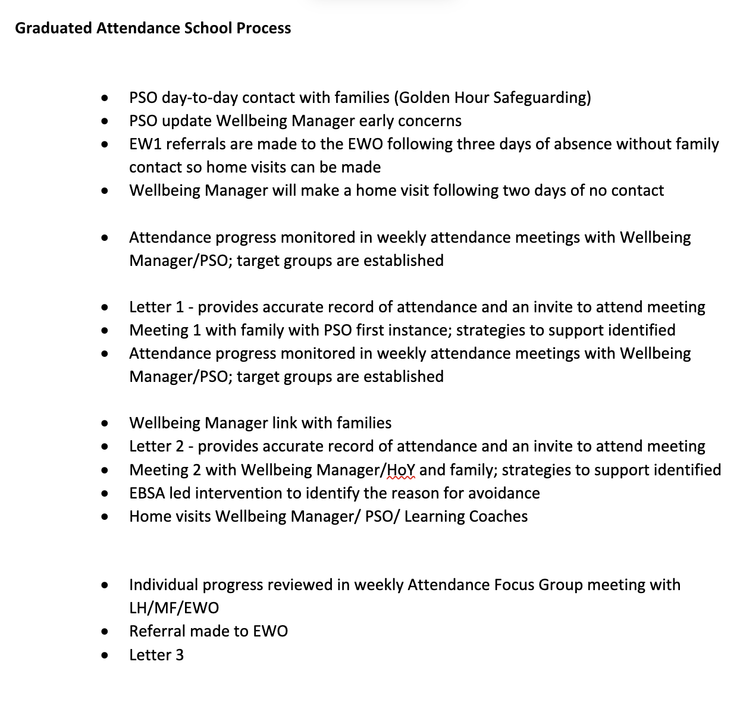
School X’s Graduated Attendance Process, emailed by Deputy Head (2024b)

APPENDIX 2:

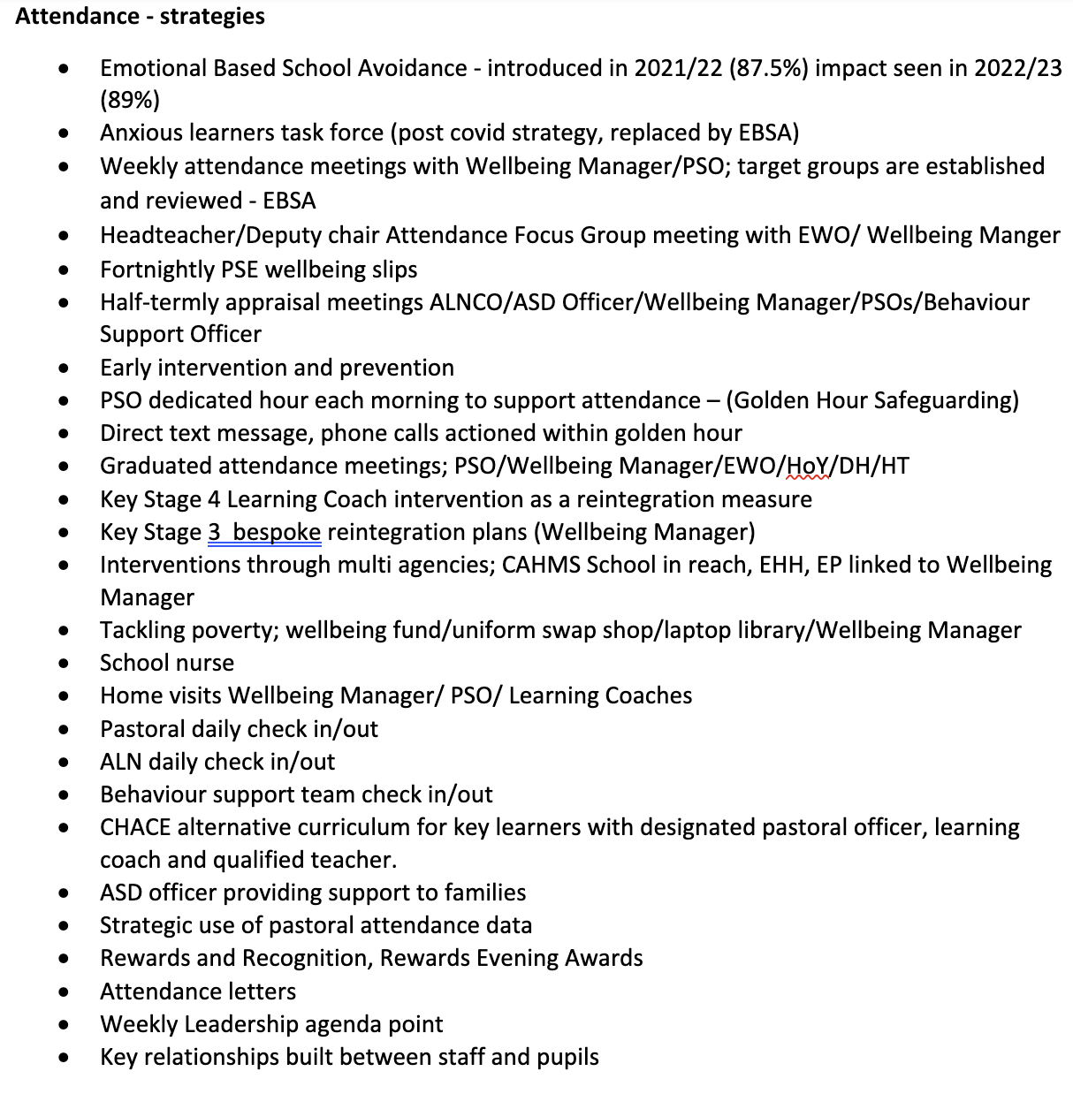
School X’s Attendance strategies, emailed by Deputy Head (2024c)

References

ABC News (Australia), (2020). Why Finland’s schools outperform most others across the developed world| 7.30. Date uploaded: Jan 31st 2020. Available at: https://www.youtube.com/watch?v=7xCe2m0kiSg (Accessed: 14/02/24)

Aucejo, E.M. and Romano, T.F. (2016) ‘Assessing the effect of school days and absences on test score performance’, Economics of education review, 55, pp. 70–87. Available at: https://doi.org/10.1016/j.econedurev.2016.08.007.

The Behavioural Insights Team (2020). Improving student attendance. Available at: https://www.bi.team/articles/improving-student-attendance-2/ (Accessed: 13/02/24)

BERA (2019). Ethical Guidelines for Educational Research, fourth edition. BERA.
Bradbury, A. (2021). Ability, Inequality and Post-Pandemic Schools: Rethinking Contemporary Myths of Meritocracy. 1st ed. Bristol: Bristol University Press. https://doi.org/10.2307/j.ctv1qgnq00.9
Burtonshaw, S. and Dorrell, E. (2023) Listening to, and learning from, parents in the attendance crisis. London: Public First. Available from: https://www.publicfirst.co.uk/wp-content/uploads/2023/09/ATTENDANCE-REPORTV02.pdf [Accessed: 1/2/ 2024]
Cleaver, H., Unell, I., and Aldgate, J. (2011). Children’s needs – Parenting capacity: The impact of parental mental illness, problem alcohol and drug use, and domestic violence on children’s development. Second ed. London: The Stationery Office. https://assets.publishing.service.gov.uk/media/5a7ac995ed915d670dd7e8fc/DFE-00108-2011-Childrens_Needs_Parenting_Capacity.pdf
Colagrossi, M. (2018) 10 reasons why Finland’s education system is the best in the world. Available at: https://www.weforum.org/agenda/2018/09/10-reasons-why-finlands-education-system-is-the-best-in-the-world/ (Accessed: 13/02/24)
Deputy Head (2024a) Conversation with student-teacher. 16 January.
Deputy Head (2024b) Email to student-teacher. 23 January.
Deputy Head (2024c) Email to student-teacher. 23 January.
Donaldson, G. (2015) Successful Futures. Available at: https://www.gov.wales/sites/default/files/publications/2018-03/successful-futures.pdf (Accessed: 09/02/24)
Education Endowment Foundation (2022) The Impact of COVID-19 on Learning: A review of the evidence. Available at: https://d2tic4wvo1iusb.cloudfront.net/production/documents/guidance-for-teachers/covid-19/Impact_of_Covid_on_Learning.pdf?v=1707903665 (Accessed: 14/02/24)
Education Endowment Foundation (2023) Attendance Interventions: Rapid Evidence Assessment. Available at: https://d2tic4wvo1iusb.cloudfront.net/production/documents/pages/Attendance-REA-report.pdf?v=1706790598 [Accessed: 1/02/2024]
Estyn (2023). A Report on Cefn Hengoed Community School. Cardiff: Estyn.
Estyn (2024) Improving attendance in secondary schools. Cardiff: Estyn. Available at: https://www.estyn.gov.wales/system/files/2024-01/Improving%20attendance%20in%20secondary%20schools.pdf (Accessed: 14/02/24)
Evidence Based Education (2020) Great Teaching Toolkit: Evidence Review. Available at: https://www.cambridgeinternational.org/Images/584543-great-teaching-toolkit-evidence-review.pdf (Accessed: 13/02/24)
Fernandez, K.E. (2011) ‘Evaluating School Improvement Plans and their Effect on Academic Performance’, Educational policy (Los Altos, Calif.), 25(2), pp. 338–367. Available at: https://doi.org/10.1177/0895904809351693.
Forsey, A. (2017). Hungry Holidays: A report on hunger amongst children during school holidays. Feeding Britain. London: appg hunger. Available at: https://feedingbritain.files.wordpress.com/2015/02/hungry-holidays.pdf (Accessed: 13/02/24)
Gottfried, M. A. (2014). ‘Chronic absenteeism and its effects on students’ academic and socioemotional outcomes’, Journal of Education for Students Placed at Risk, 19(2), 53–75.

Havik, T., Bru, E. and Ertesvåg, S.K. (2014) ‘Parental perspectives of the role of school factors in school refusal’, Emotional and behavioural difficulties, 19(2), pp. 131–153. Available at: https://doi.org/10.1080/13632752.2013.816199.

Heyne, D., Grend Landell, M., Melvin, G. and Gentle-Genitty, C. (2019) ‘Differentiation Between School Attendance Problems: Why and How?’, Cognitive and behavioral practice, 26(1), pp. 8–34. Available at: https://doi.org/10.1016/j.cbpra.2018.03.006.

Heppen, J.B., Kurki, A., and Brown, S. (2020). Can Texting Parents Improve Attendance in Elementary School? A Test of an Adaptive Messaging Strategy (NCEE 2020–006). National Center for Education Evaluation and Regional Assistance. Washington, DC: U.S. Available at: http://ies.ed.gov/ncee.
Huber, D.J. and Conway, J.M. (2015) ‘The Effect of School Improvement Planning on Student Achievement’, Planning & changing, 46(1–2), pp. 56-.
Kearney, C.A. and Graczyk, P.A. (2020) “A Multidimensional, Multi-tiered System of Supports Model to Promote School Attendance and Address School Absenteeism,” Clinical child and family psychology review, 23(3), pp. 316–337. Available at: https://doi.org/10.1007/s10567-020-00317-1.
Kearney, C., Benoit, L., Gonzalvez, C and Keppens, G. (2022) ‘School attendance and school absenteeism: A primer for the past, present, and theory of change for the future’, Frontiers in education (Lausanne), 7. Available at: https://doi.org/10.3389/feduc.2022.1044608.

Keppens, G. (2023) ‘School absenteeism and academic achievement: Does the timing of the absence matter?’, Learning and instruction, 86, pp. 101769-. Available at: https://doi.org/10.1016/j.learninstruc.2023.101769.
Khushal, S. (2022). ‘Dismantling Racism in Schools through Anti-Oppressive Frameworks: The Pivotal Role of Leadership in Achieving Racial Equity’, YU-WRITE: Journal of Graduate Student Research in Education, 1(1).
Kuttner, P.J. (2023) “The Right to Belong in School: A Critical, Transdisciplinary Conceptualization of School Belonging,” AERA open, 9. Available at: https://doi.org/10.1177/23328584231183407.
Lloyd, R. (2019) A new approach to self-evaluation report- but what does this mean for schools? ESTYN. 21 October 2019. Available at: https://www.estyn.gov.wales/blog/new-approach-self-evaluation-reports-what-does-it-mean-schools (Accessed: 01/02/24)

Mac Iver, M.A., Willis, K., Mac Iver, D. and Cruz, A. (2022) ‘The Impact of Nudge Letters on Improving Attendance in an Urban District’, Education and urban society, 54(2), pp. 164–185. Available at: https://doi.org/10.1177/00131245211004561.
Meyers, C.V. and VanGronigen, B.A. (2019) ‘A lack of authentic school improvement plan development’, Journal of educational administration, 57(3), pp. 261–278. Available at: https://doi.org/10.1108/JEA-09-2018-0154.
Miles, J. (2022) Senedd.tv. Published: 22 March 2022. Available at: https://www.senedd.tv/Meeting/Archive/1fafcdf8-0a86-40dc-81ba-804ab657a3f9?autostart=True (Accessed: 12/02/24)
Reid, K. (2006) ‘An evaluation of the views of secondary staff towards school attendance issues’, Oxford review of education, 32(3), pp. 303–324. Available at: https://doi.org/10.1080/03054980600775557.

Rocque, M., Jennings, W. G., Piquero, A. R., Ozkan, T., & Farrington, D. P. (2017). ‘The importance of school attendance: Findings from the Cambridge study in delinquent development on the life course effects of truancy’, Crime & Delinquency, 63(5), pp: 592–612.

Sheppard, A. (2010) Raising school attendance. The British psychological society. Available at: https://www.bps.org.uk/psychologist/raising-school-attendance (Accessed: 01/02/24)

Sibieta, L. (2020) Review of school spending in Wales: Building evidence, fairness, transparency and clear expectations. Cardiff: Welsh Government https://www.gov.wales/sites/default/files/publications/2020-10/review-of-school-spending-in-wales.pdf (Accessed: 03/04/24)

Smith, E. (2018) Introduction to Social Justice and Education. SAGE: London

Swansea Council (2023) Abertawe 2023- Made in Swansea. Swansea: Swansea Council. Available at: https://www.swansea.gov.uk/abertawe2023madeinswansea#:~:text=Introduction,strong%20education%20system%20across%20Swansea. (Accessed: 05/02/24)
Tobias, A. (2019) ‘A grounded theory study of family coach intervention with persistent school non-attenders’, Educational psychology in practice, 35(1), pp. 17–33. Available at: https://doi.org/10.1080/02667363.2018.1518215.

UK Government (2024) Pupil attendance in schools. Available at: https://explore-education-statistics.service.gov.uk/find-statistics/pupil-attendance-in-schools (Accessed: 20/02/24)
Welsh Government (2014). School Development Plans. Cardiff: Welsh Government. Available at: https://www.gov.wales/sites/default/files/publications/2018-03/school-development-plans.pdf (Accessed: 14/02/24)
Welsh Government (2015) National Model for Regional Working. Cardiff: Welsh Government. Available at: https://www.gov.wales/sites/default/files/publications/2018-03/the-national-model-for-regional-working.pdf (Accessed: 14/02/24)

Welsh Government (2021) Engaging with stakeholders. Available at: https://hwb.gov.wales/evaluation-improvement-and-accountability/the-national-resource-evaluation-and-improvement/evaluation-and-improvement-principles/engaging-with-stakeholders/ (Accessed: 13/02/24)

Welsh Government (2022). School improvement guidance: framework for evaluation, improvement and accountability. Available at: https://hwb.gov.wales/evaluation-improvement-and-accountability/school-improvement-guidance-framework-for-evaluation-improvement-and-accountability (Accessed: 13/02/24)

Welsh Government (2023a) Our National Mission: high standards and aspirations for all. Cardiff: Welsh Government. Available at: https://www.gov.wales/sites/default/files/publications/2023-03/our-national-mission-high-standards-and-aspirations-for-all_0.pdf (Accessed: 12/02/24)

Welsh Government (2023b). Belonging, engaging and participating. Cardiff: Welsh Government. Available at:
https://www.gov.wales/sites/default/files/publications/2023-10/improving-school-attendance-guidance_0.pdf

Welsh Government (2023c). My Local School. Available at: https://mylocalschool.gov.wales/School/6704031?lang=en (Accessed: 09/02/24)

