Site Investigation Case Study
Proposed Restaurant and Ice Cream Parlour Development- Swansea Foreshore
Written by Seren Adams
Student ID: 2502932
Date: 16th March 2026
Word Count: 2130
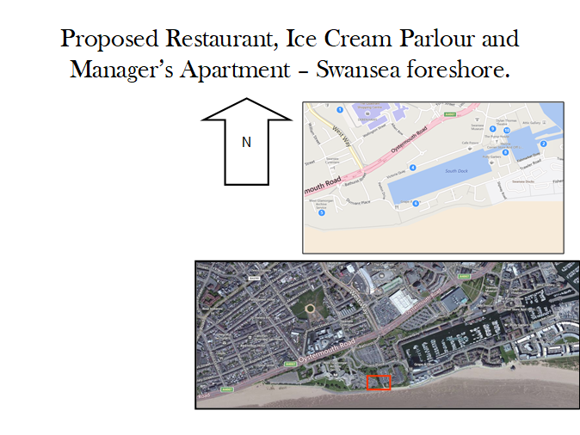

Table of Contents

Title Page………………………………………………………………………………………………………1
Table of Contents…………………………………………………………………………………………..2
Introduction………………………………………………………………………………………………….3
Historical Background…………………………………………………………………………………….4-5
Preliminary ground conditions & recommended strategy………………………………………6
Highest risk factors & Regulations……………………………………………………………………..7
Authorities & stakeholders & Foundation Justification…………………………………………..8
Pile Foundations……………………………………………………………………………………………..9
References…………………………………………………………………………………………………….10

- Introduction
The proposed development comprises a joint venture between the City and County of Swansea and Marriott Hotels, located on the Swansea Foreshore between County Hall and the existing Marriott Hotel. The scheme involves the construction of a multi-functional building with an approximate gross internal floor area of 2000m2, incorporating a restaurant, café bar, ice cream parlour and commercial kitchen at ground floor level, alongside meeting rooms, staff facilities and a manager’s apartment at upper level. The design includes a glazed façade opening onto the promenade, reflecting the leisure focused character of the surrounding Maritime Quarter.
This report presents a preliminary desktop study undertaken at the feasibility stage, with the aim of informing a future detailed site investigation. The assessment evaluates the historical development of the site, identifies key geotechnical risks, and proposes an appropriate ground investigation strategy. In addition, relevant regulations, stakeholders and foundation solutions are considered in relation to the anticipated ground conditions.
A thorough understanding of subsurface conditions is key in construction, as ground behaviour directly influences foundation design, structural performance and project viability. Early identification of potential risks such as contamination, weak strata or groundwater issues enables mitigation strategies to be implemented, reducing the likelihood of structural failure, delays and cost overruns.
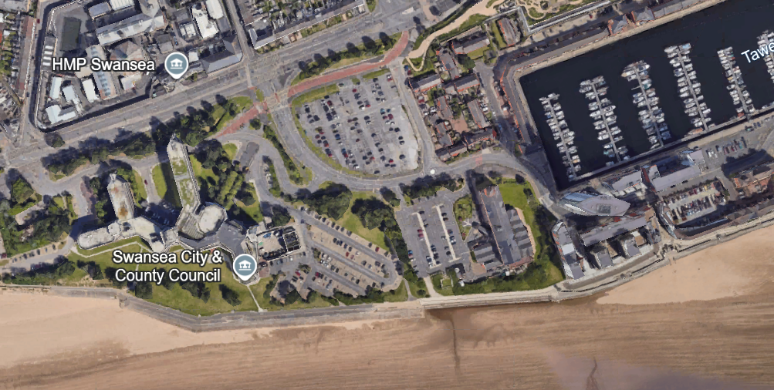
Figure 1: Aerial view of Swansea Marina illustrating the proposed development site located between County Hall and the Marriott Hotel, adjacent to the River Tawe (Source: Google Maps, 2026).

2.0 Historical Background of the Site
The Swansea foreshore site is situated within an area that has undergone significant industrial and post-industrial transformation since the mid- 19th century. During this period, Swansea developed into a major global centre for copper smelting and coal export, which required the construction of extensive dock infrastructure and the reclamation of land along Swansea Bay (City and County of Swansea, 2023). This process of land reclamation typically involved the deposition of large volumes of made ground, often consisting of mixed and uncontrolled materials such as industrial waste and dredged sediments (Tomlinson and Woodward, 2015). As shown in Figure 2, the extensive dock network required significant land reclamation, contributing to the presence of made ground across the Swansea Marina area.

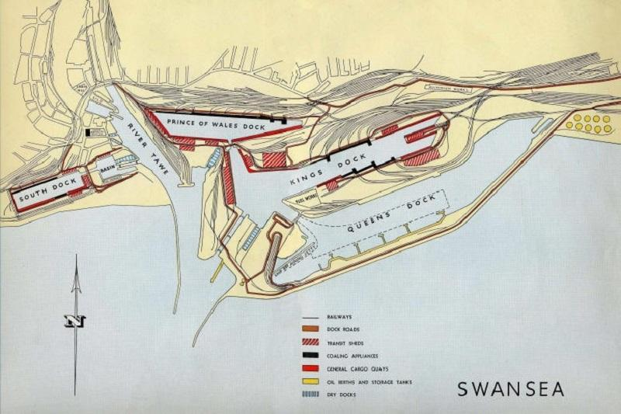

Figure 2: Historical map of Swansea docklands illustrating dock expansion and industrial land use in the 19th and early 20th centuries.

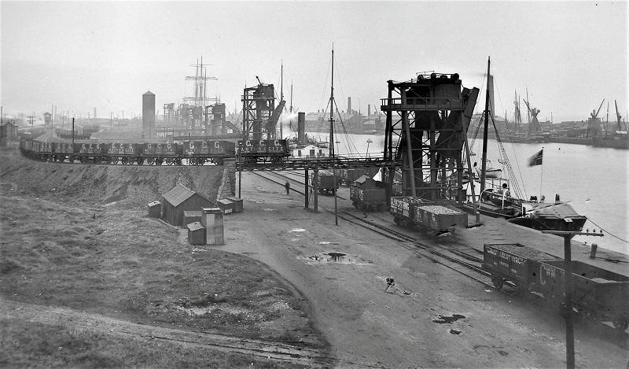
Figure 3: historical image of Swansea docklands illustrating industrial activity, rail transport and maritime operations in the late 19th and early 20th centuries.
Throughout the late 19th and early 20th century, Swansea docklands became heavily industrialised, supporting extensive maritime trade through the development of shipping infrastructure, warehouses, rail connections and processing facilities (City and County of Swansea, 2023). As illustrated in Figure 3, this period was characterised by intensive dock activity, with rail infrastructure and loading equipment facilitating large scale coal export and industrial operations. However, the decline of heavy industry during the mid-20th century led to widespread dereliction across the dockland areas. The closure of South Dock in 1969 marked a significant turning point, after which the area underwent regeneration (City and County of Swansea, 2023).
From the late 1970s onwards, the Swansea Marina development transformed the former docklands into a mixed-use residential and leisure area as part of a wider regeneration strategy (City and County of Swansea, 2024). Despite this redevelopment, the legacy of historical industrial activity continues to influence the underlying ground conditions, particularly through the presence of made ground and potential contamination. Made ground associated with reclaimed dockland sites is often variable and poorly compacted, presenting challenges for foundation design (Tomlinson and Woodward, 2015). In addition, historic industrial processes may have introduced contaminants such as hydrocarbons and heavy metals into the soil, posing environmental and construction risks (Environment Agency, 2020). These factors are critical in assessing geotechnical risk and determining appropriate construction solutions.

- Preliminary Ground Conditions
The historical use of the site as reclaimed dockland introduces several significant geotechnical risks. The presence of made ground is a primary concern, as such materials are inherently variable, loosely compacted and often contain voids. This results in low bearing capacity and an increased risk of both total and differential settlement, which can adversely affect structural integrity (Tomlinson and Woodward, 2015).
In addition, contamination is a key risk due to the site’s industrial heritage. Activities such as fuel storage, metal processing and coal handling may have introduced hydrocarbons, heavy metals and other pollutants into the soil. These contaminants pose risks to human health, groundwater and construction workers, and may necessitate remediation measures (Environment Agency, 2020).
The coastal location of the site further complicates the ground conditions. High groundwater levels, influenced by tidal fluctuations, can reduce effective stress within soils and compromise stability during excavation (BS 5930, 2015). In addition, soft marine deposits, such as silts and clays commonly found in coastal environments, are likely to exhibit low shear strength and high compressibility, increasing the risk of long-term settlement (Tomlinson and Woodward, 2015). Evidence from nearby borehole data suggests that such deposits may be present beneath the site, reinforcing the need for careful geotechnical assessment and appropriate foundation design.

- Recommended Site Investigation Strategy
A comprehensive site investigation should be undertaken in accordance with BS 5930:2015 and Eurocode 7 in order to accurately characterise subsurface conditions and inform foundation design (BS 5930, 2015; BS EN 1997-1, 2004). Given the variability of made ground and the presence of soft underlying strata, a combination of intrusive and non-intrusive techniques is essential to obtain reliable data.
Borehole drilling should be carried out across the site to establish the soil profile and determine the depth of competent bearing strata. Standard Penetration Tests conducted within the boreholes provide an indication of soil density and strength, while laboratory testing of recovered samples allows for the determination of key parameters such as moisture content, shear strength and compressibility (Tomlinson and Woodward, 2015).
Trial pits should be excavated to assess near surface conditions and identify potential obstructions or buried structures. In addition, groundwater monitoring installations should be implemented to assess fluctuations over time, particularly in response to tidal influence, which is a key consideration for coastal sites (BS 5930, 2015).
Chemical testing of soil samples is also required to assess contamination levels and inform any necessary remediation strategies. This is particularly important given the industrial history of the site, as contaminants such as hydrocarbons and heavy metals may be present (Environment Agency, 2020).
- Highest Risk Factors
The most significant risks associated with the site include the presence of made ground, potential contamination and high groundwater levels. The variability and low strength of made ground represent the greatest structural risk, as such materials are often poorly compacted and highly heterogeneous, resulting in reduced bearing capacity and an increased likelihood of differential settlement (Tomlinson and Woodward, 2015).
Contamination presents both environmental and financial risks, as remediation processes can be complex, time consuming and costly. Historic industrial activities associated with dockland use may have introduced pollutants such as hydrocarbons and heavy metals into the soil, which must be identified and managed appropriately (Environment Agency, 2020).
High groundwater levels further increase construction complexity, particularly during excavation works, where water ingress can reduce soil stability and require dewatering techniques. Groundwater conditions are especially significant in coastal environments, where tidal fluctuations can influence water levels and soil behaviours (BS 5930, 2015).
These risks are interlinked and must be considered collectively when designing both the site investigation strategy and foundation system, in order to ensure safe and effective construction.
- Regulations and Codes of Practice
All site investigation and foundation design works must comply with relevant legislation and industry standards to ensure structural safety and regulatory compliance. Key standards applicable to this development include:
- Building Regulations 2010- Approved Document A (Structure)
- BS 5930:2015- Code of Practice for Ground Investigation
- BS EN 1997 (Eurocode 7) - Geotechnical Design
- CDM (Design and Management_ Regulations 2015
These frameworks provide guidance on structural design, ground investigation procedures and construction safety management. Compliance with these standards ensures that the development is designed and constructed safely, with consideration given to ground conditions, load bearing capacity and long-term structural performance.
- Local Authorities and Stakeholders
Key stakeholders involved in the proposed development include:
- City and County of Swansea Council Civic Centre, Oystermouth Road, Swansea, SA1 3SN
- Natural Resources Wales Ty Cambria, 29 Newport Road, Cardiff, CF24 0TP
- Swansea Building Control Services
- Environmental Health Department
These organisations play a critical role in the approval, regulation and oversight of the development. The City and County of Swansea Council is responsible for planning approval and ensuring that the development aligns with local planning policies. Natural Resource Wales oversees environmental protection, including the management of potential contamination and impacts on groundwater.
Building Control Services ensure that the design and construction comply with Building Regulations, particularly in relation to structural safety. The environmental Health Department may also be involved in assessing risks associated with land contamination and ensuring that appropriate mitigation measures are implemented.
- Foundation Justification
Based on the anticipated ground conditions derived from nearby borehole data, shallow foundation solutions such as raft foundations are unlikely to be suitable. The presence of made ground and soft compressible deposits would result in low bearing capacity and an increased risk of excessive and differential settlement, potentially leading to structural instability (Tomlinson and Woodward, 2015).
A piled foundation system is therefore considered the most appropriate solution. Piles function by transferring structural loads through weak upper layers into deeper, more competent strata such as dense sands or glacial deposits, which provide sufficient load bearing capacity (BS EN 1997-1, 2004). This approach effectively bypasses problematic near surface conditions identified within the site. As illustrated in Figure 4, piled foundations transfer structural loads through weak layers into deeper more competent strata, reducing settlement and improving overall stability.
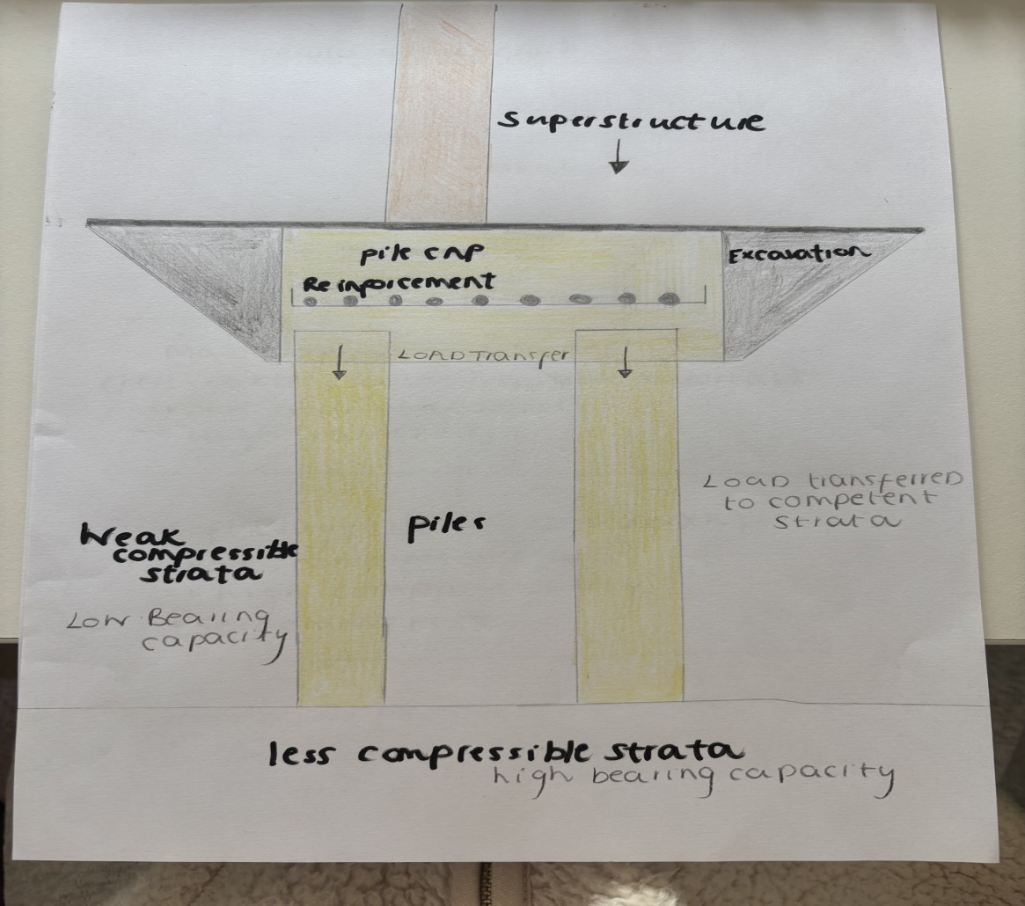

Figure 4: Piled foundation system illustrating load transfer from superstructure through reinforced concrete piles into competent bearing strata.

Both driven and bored piles may be considered. However, given the proximity of existing structures such as the Marriott Hotel and County Hall, bored piles are preferable due to reduced vibration and noise levels during installation. Although potentially more costly, this method minimises the risk of damage to adjacent buildings and reduces the likelihood of project delays or claims arising from construction related disturbance.
From both an engineering and risk management perspective, piled foundations provide a reliable and predictable solution for this type of site. Their ability to achieve load transfer to competent strata ensures long term structural performance, particularly in reclaimed dockland environments where ground conditions are highly variable.
8.2 Type of Pile Foundations
When selecting an appropriate piling method for the proposed development, both bored concrete piles and driven piles should be considered.
Bored piles are constructed by drilling into the ground and filling the excavation with reinforced concrete. This method generates minimal vibration and noise, making it particularly suitable for sites in close proximity to existing structures, such as the Marriott Hotel and County Hall, where reducing the risk of structural disturbance is essential (Tomlinson and Woodward, 2015).
In contrast, driven piles are installed by mechanically driving prefabricated piles into the ground using impact or vibratory methods. While this approach can offer cost efficiencies and faster installation, it produces significant vibration and noise, increasing the risk of disruption and potential damage to adjacent structures (Tomlinson and Woodward, 2015).
From a QS and risk management perspective, the selection of piling method requires a balance between initial cost and overall project risk. Although driven piles may have lower upfront costs, the potential for vibration related damage, delays and associated claims may increase overall project cost. Bored piles, while more expensive, provide a lower risk and more controlled solution in sensitive environments.
Given the proximity of existing infrastructure and the variable ground conditions identified through preliminary assessment and nearby borehole data, bored piling is considered the most appropriate method for this development, offering a more predictable and reliable construction process, in line with established geotechnical practice (BS EN 1997- 1, 2004).
- Conclusion
The Swansea foreshore site presents a range of significant geotechnical challenges due to its industrial history and coastal location. The presence of made ground, potential contamination and high groundwater levels necessitates a comprehensive and carefully planned site investigation.
Analysis of nearby borehole data indicates that weak and compressible surface layers overlie more competent strata at depth, supporting the selection of a piled foundation system as the most appropriate solution (Tomlinson and Woodward, 2015). Through the implementation of appropriate site investigation techniques, informed foundation design and adherence to relevant standards, including BS 5930 and Eurocode 7, the risks associated with the site can be effectively managed.
Overall, this approach enables the safe and sustainable development of the site, ensuring long term structural performance while addressing the challenges associated with reclaimed dockland environments.

References
BS 5930 (2015) Code of practice for ground investigations. London: British Standards Institution.
BS EN 1997-1 (2004) Eurocode 7: Geotechnical design. London: British Standards Institution.
City and County of Swansea (2022) Life after the Lords of Gower- 19th century. Available at: Life after the Lords of Gower - 19th century - Swansea (Accessed: 16th April 2026).
City and County of Swansea. (2023) Planning Committee: Public Reports Pack, 9 May 2023. Available at: https://swansea.moderngov.co.uk/documents/g11013/Public%20reports%20pack%20Tuesday%2009-May-2023%2014.00%20Planning%20Committee.pdf (Accessed: 16 April 2026).
City and County of Swansea (2023) Planning Committee: Schedule, 5 September 2023. Available at : https://swansea.moderngov.co.uk/documents/s96039/05.3%20-%20SCHEDULE%20-%205TH%20SEPTEMBER%202023.pdf (Accessed: 17th April 2026).
Environment Agency (2020) Land contamination risk management guidance. Available at Land contamination risk management (LCRM) - GOV.UK (Accessed: 25th March 2026).
Mellett, C. (2017). Swansea Bay WwTW Wind Turbine. Available at: https://waterprojectsonline.com/case-studies/swansea-bay-wwtw-wind-turbine/ (Accessed 16th April 2026).
Swansea Marina (n.d.). Vibrant City by the Sea. Available at: Swansea Marina — Vibrant City by the Sea (Accessed: 16th April 2026).
Tomlinson, M. and Woodward, J. (2015) Pile Design and Construction Practice. 6th edn. London: CRC Press.

