communication skills
Melanie Nelson – 1604696
Communication skills – EMPL4004
Lecturer – Mr Peter Allen



Contents
Introduction 3
Communication 4
Workplace related issue 7
Conflict 8
references 9

Introduction

in this assignment I will talking about communication, different ways of communicating and how communication occurs it will show how people understand and how effective communication is whether it be verbal, non-verbal, written or through the use of technology.

It will also give a short report of an issue of conflict in the work place, why it occurred and how it was resolved along with a power point presentation

Communication

Communication is a transmission, interpretation or exchange of information from one person or persons to another, the person sending the message is called the sender while the person receiving the message is referred to as the receiver.
There are many ways of communicating, the three main forms are verbal, non-verbal and written communication, technology is also hugely used as a way of communicating

Verbal
Verbal communication is the use of words to present ideas, thoughts and feelings. Having good communication is the ability to explain, listen to others and present your ideas clearly through spoken words, this involves using a variety of styles and approaches that are suitable for the person or people that you are addressing (Elizabeth Haworth, 2010).
The main purpose of verbal communication is relaying messages to one or more recipients, it can be used from simple sounds to complex discussions and relies on both language and emotion to achieve the desired effect. (Hanes, 2015)

Non-verbal
Non-verbal communication is the way In which ideas, opinions and messages are communicated without talking, this can be through the use of body language, facial expressions, gestures, tone of voice, signs and symbols, it is very important to be able to recognise what a person’s body language is saying (Elizabeth Haworth, 2010).
People tend to have much less control over their body language than what they are actually saying, to a certain extent; non-verbal communication is much more emotional in nature and somewhat instinctive, if there is a mis-match between the two it would probably be wiser to trust the non-verbal message rather than the words used (Anon., n.d.)

Written communication
Written communication is the process of transferring a message through written symbols, in other words; any message exchanged between two or more persons that make use of written words is called written communication
(Anon., n.d.).

Written communication is very important in todays business world, it is essential for preparing worthy promotional materials for business development and effectively ensuring that rules and regulations are followed.
Different styles of communication need different styles of writing, but all require literacy skills.

writing is more unique and formal than speech, effective writing involves a careful choice of words, its organisation and the order that it is placed, also writing can be more valid and reliable than speech, but while speech is spontaneous writing can cause delays as feedback is not instantaneous (Anon., n.d.)

technology also helps aid communication, for example; mobile phones, computers, and tablets can be used to make and receive calls, send text messages and emails, also to store, record and communicate information very quickly and efficiently over long distances (Elizabeth Haworth, 2010).

Everyone communicates or send messages constantly; the figure below describes and shows how communication occurs:

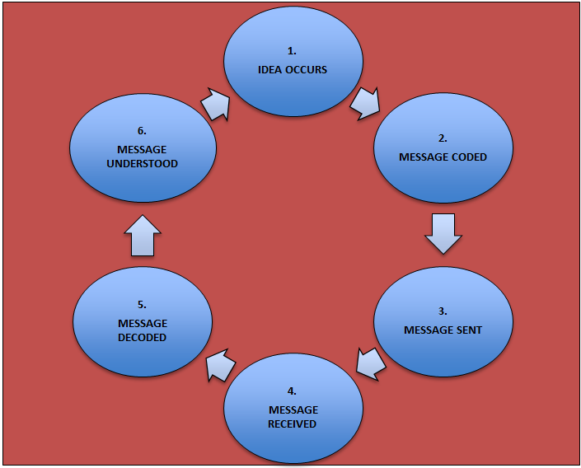

- A person has an idea
- They code the message (using words or non-verbal means
- They send the message to someone else
- A second person receives the message (by hearing what has been said or by noticing non-verbal communications)
- The second person decodes the message
- The message is understood

Workplace related issue

There are many factors that can case issues in the work place in this report I will be looking in to conflict in the workplace

Sue has been working in a small restaurant and catering business for a couple of months and really enjoys working there, she is very hard working and always suggests new ideas for the business and ways that could increase productivity, she gets on very well with her co- workers and her boss seems very pleased with her efforts, she is excellent at interacting with the customers and introducing services and what the company has to offer.
At times the restaurant got very busy it was difficult for to get a break, but she still managed to get everything done on time, everyone there respected each other and understood their roles in the workplace, communication was vital for an efficient working environment. Good communication is an integral element for business success it also is an important factor in client relationships, profitability, team effectiveness and employee engagement (Dispain, 2017).

A few months in working at the company the boss hired a new member of staff to join the team as the restaurant was getting a lot more busier and there were more bookings for catering. We were introduced to the new employee (Joan) she shown around the facility and and we talk about rules, regulations, health and safety precautions and procedures.

Joan seemed very pleasant at first, but a couple of weeks into her working at the company other employees noticed that she was making a lot of mistakes and not adhering to health and safety one member of staff to have a talk with her and go over the Health and safety procedures again, in doing so it was obvious that Joan was not happy with the conversation, she nodded her head in agreement but seemed somewhat disengaged.

Joan had mentioned in previous conversations that she had worked in the catering business before and that she has a lot of experience which believed would be a good asset to the company. As time went on it became more apparent of Joan’s disregard and disrespect for her role in in the company and her attitude to other employees, this made it very frustrating for other employees and caused conflict which made the workplace an uncomfortable environment.

After much consideration sue thought it best to contact the manager and discuss the situation, the manager called for a staff meeting were all members could discus there issues and concerns at the meeting it was discovered that Joan did not fully understand her role in the workplace and was not communicating how she felt effectively it was decided that she needed more training which she was happy to do, this made her feel more confident and comfortable in her role, this resolved the issue and made the workplace a much more comfortable environment.

Conflict
Conflict can be a difference of ideas and opinions between a team or group of people from different backgrounds who have different experiences and skills. It is most likely that most people will experience some sort of conflict in or out of the work place (Anon., n.d.)

We are all aware that there are some levels of difference in positions between two or parties involved in the conflict. But the true reason for the disagreement may be different from each other in fact conflict is more or less accompanied by significant levels of misunderstanding that magnifies the perceived disagreement by far, sometimes people, are unaware that they may be a part of the conflict, while others may be shocked to realise that they are not involved in the disagreement. (Anon., n.d.).

Conflict can be seen as a problem to some but this isn’t how conflict should be seen, it can also be an opportunity for growth and an effective for individuals to open up amongst their group or teams, however when conflict diminishes productivity and conflict becomes worse, then conflict management would be needed to come up with a resolution (Eveans, 2013).

Resolving conflict may take time and depend on the scale of the conflict, having a mediator with the skills and strategies may be necessary to resolve the issues (Eveans, 2013)

References
Anon., n.d. academic leadership support. [Online]
Available at: https://www.talent.wisc.edu/onlinetraining/aboutwhatisit.html
Anon., n.d. businessjargons.com/written-communication.html. [Online].
Anon., n.d. Interpersonal skills: skillsyouneed.com. [Online].
Anon., n.d. what is conflict. [Online]
Available at: https://sielearning.tafensw.edu>rm_c19
Anon., n.d. written communication-meaning, advantages and disadvantages/managmentstudyguid.com. [Online].
Dispain, M., 2017. power of good communication in the workplace. [Online].
Elizabeth Haworth, H. H. H. H., 2010. Health and social care level 2 BTEC 2. In: The study skills handbook. s.l.:Pearson Education Limited, pp. 6-7.
Eveans, B., 2013. typesofconflict. [Online].
Hanes, T., 2015. livestrong.com. [Online].



