

Predictive Analytics in Digital Marketing: Evaluating the Impact of AI Marketing on Consumer Behaviour, Engagement and Conversion Rates in the Tourism Industry.

Student Name: Dewan Ashrafi
Student ID: 1916230

Dissertation submitted as part of the requirements for the award MBA (Marketing)


Master’s Degrees by Examination and Dissertation
Declaration Form.
1. This work has not previously been accepted in substance for any degree and is not being concurrently submitted in candidature for any degree.
Signed…….………. Dewan Ashrafi………………………………………...
Date ………………13-02-2024………………………………………………....

2. This dissertation is being submitted in partial fulfilment of the requirements for the degree of master’s in business administration.
Signed…….………. Dewan Ashrafi………………………………………...
Date ………………13-02-2024………………………………………………....
3. This dissertation is the result of my own independent work/investigation, except where otherwise stated.
Other sources are acknowledged by footnotes giving explicit references.
A bibliography is appended.
Signed candidate: …………………Dewan Ashrafi……………….………….
Date ………………13-02-2024……………………………………....

4. I hereby give consent for my dissertation, if accepted, to be available for photocopying, inter- library loan, and for deposit in the University’s digital repository
Signed (candidate)…………Dewan Ashrafi…………………….……...
Date ………………13-02-2024……………………………………....
Supervisor’s Declaration.
I am satisfied that this work is the result of the student’s own efforts.
Signed: ……………Tushara Balendran…………………………………….
Date ………………13-02-2024……………………………………....

ACKNOWLEDGEMENTS

I extend my heartfelt gratitude to my teacher Prof. Tushara Brenden for her invaluable guidance, illuminating teaching methods, and extensive expertise, which she generously shared without hesitation. for her unwavering support, invaluable guidance, and insightful feedback throughout this journey. Her expertise and encouragement have been instrumental in shaping my research and academic growth.

I am also indebted to my other teacher

I am deeply thankful to all the participants of the survey whose valuable insights and cooperation were indispensable in gathering data and enriching the findings of this study.

My parents' unwavering belief in my abilities has been a continuous source of support, and I am deeply grateful. I also express profound appreciation to my wife, whose understanding and support have alleviated countless household responsibilities, allowing me the necessary time to dedicate to this project.

Abstract

Introduction

In the swiftly changing technological landscape, Artificial Intelligence (AI) has emerged as a powerful force behind ground-breaking progress, reshaping numerous facets of modern business sectors. Its integration has become an essential element in business operations and has also played a central role in fostering innovative strategies, particularly within marketing. Despite apprehensions regarding AI's effects on employment, ethical considerations, and privacy issues, its incorporation into business practices appears unavoidable.

This dissertation aims to delve into the profound implications and intricate dynamics woven within this intersection, explicitly focusing on the impact of AI-powered marketing on consumer engagement and conversion rates. By leveraging predictive analytics, this study endeavours to dissect the evolving landscape where advanced technology meets consumers' nuanced preferences and behaviours in the travel and tourism industry context. Through a meticulous evaluation, this research seeks to illuminate the far-reaching effects of AI marketing strategies, unveiling their influence on shaping consumer decisions and industry paradigms.

Background

The travel and tourism industry comprises businesses and services facilitating, promoting, and organising travel for various purposes. It includes transportation, accommodation, attractions, and hospitality-related services, contributing substantially to global economies through job creation, revenue generation, and cultural exchange (Marketline, 2024). In 2022, the worldwide travel and tourism industry expanded by 41.4%, reaching a total value of $3.17 trillion. Projections suggest that by 2027, the industry will achieve a value of $6.29 trillion, reflecting a substantial increase of 98.5% compared to 2022 (Marketline, 2024).

Figure 1: Projected value of the global travel and tourism industry: $ million, 2022–27
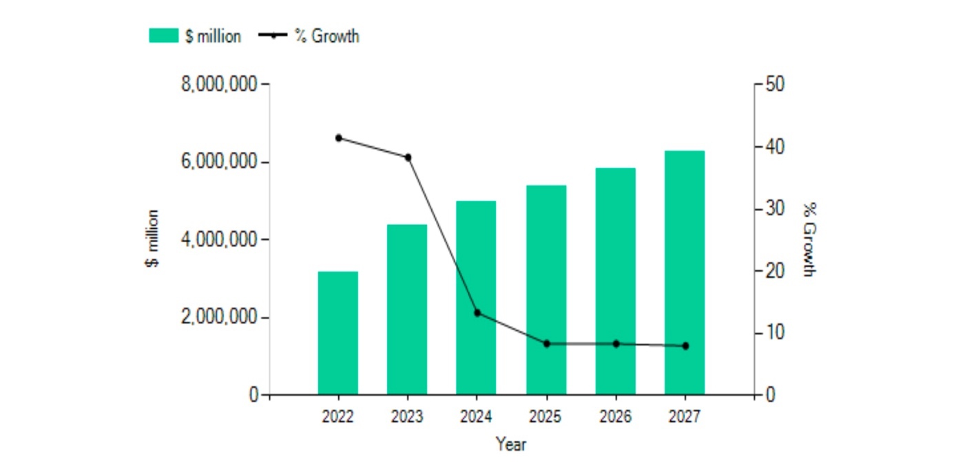
Source: (Marketline, 2024)

The forecast anticipates that the revenue in the Travel & Tourism sector will hit $927.30 billion by 2024. Furthermore, it is predicted that 76% of the total revenue in the Travel & Tourism market will be derived from online sales by 2028 (Statista, 2023b). The projected increase in revenue and the substantial portion expected from online sales by 2028 highlight the crucial role that digital marketing plays in reaching and engaging consumers in this sector. As the majority of revenue is anticipated to come from online channels, it underscores the importance of leveraging digital marketing strategies to effectively connect with and cater to the target audience's needs in the travel and tourism market.

Marketing has evolved from traditional, mass communication methods to a more targeted, personalised, and technology-driven approach, reflecting the changing dynamics of consumer behaviour and the business landscape (Faruk, Rahman and Hasan, 2021). According to S Pascalau and R. Urziceanu (2021), traditional marketing is associated with higher resource costs, time-consuming processes, and less activity, and it generally operates locally. In contrast, online marketing is cost-effective, time-saving, and offers greater interactivity, allowing real-time updates and personalised interactions and promoting customer loyalty. Moreover, traditional marketing, while once dominant, has limitations compared to digital methods. It often involves broad-reaching campaigns without specific targeting, incurring high costs and lacking interactivity. It also has less precise Key Performance Indicators (KPIs), limited segmentation, less adaptability, and potential environmental impact (Birt, 2021). These drawbacks have prompted a shift towards digital marketing, which offers precise targeting, cost-effectiveness, interactivity, and better measurability, aligning more closely with the preferences and behaviours of today's consumers.

Digital marketing refers to the section of marketing that promotes products and services using the Internet and online-based digital technology, including smartphones, computers, and other digital media and platforms (Aaker, 2016). There were 5.3 billion internet users globally as of October 2023, or 65.7% of the world's population (Petrosyan, 2023). This highlights the crucial role of digital marketing, offering an unparalleled platform to connect with a diverse audience. Given most of the global population's internet access, digital marketing becomes essential for businesses to effectively engage and promote products or services globally. The widespread internet usage emphasises the need for companies to establish a robust digital presence and employ digital marketing strategies for effective communication and resonance with their target audiences on a global scale.

AI is a branch of computer science that concentrates on crafting machines and software capable of emulating human-like abilities, encompassing problem-solving, reasoning, language comprehension, pattern recognition, and decision-making skills. (Goodfellow, Bengio and Courville, 2016). Alan Turing is widely considered the founding figure of theoretical computer science and artificial intelligence. In the early 50s, he was the first to conduct substantial research in the field of 'Machine Intelligence', a pivotal advancement in its early study (Turing, 1950) (B. Jack. Copeland, 2004). The concept of Artificial intelligence first appeared in Academia in 1956. Still, it was not until 2012 that the superior capabilities of deep learning compared to earlier AI methods garnered amplified funding and attention (Russel and Norvig, 2020).

Today, advanced systems with artificial intelligence capabilities utilise machine learning (ML). Machine learning refers to systems learning from specific training data to automate the creation of analytical models and tackle associated tasks. Deep learning (DL), a subset of machine learning, revolves around artificial neural networks (Janiesch, Zschech and Heinrich, 2021).

Machine Learning (ML): ML involves algorithms that enable machines to learn patterns and make predictions or decisions without being explicitly programmed. It focuses on developing techniques that allow computers to improve their performance on a task through experience, using data to train models. ML algorithms include regression, decision trees, support vector machines, and clustering algorithms (Koza et al., 1996) (IBM, 2024).

Deep Learning (DL): DL is a specialised field within ML that deals with artificial neural networks—specifically, deep neural networks composed of multiple layers (hence the term "deep"). These networks can automatically learn data representations, extracting intricate patterns and features through successive processing layers. DL has shown exceptional performance in tasks like image and speech recognition, natural language processing, and other complex pattern recognition tasks (Criddle, 2023).

Both ML and DL are integral parts of AI. They provide the mechanisms through which AI systems can learn, reason, and make decisions by analysing and understanding vast amounts of data. AI encompasses various techniques and approaches. ML, particularly DL, serves as a crucial component within the broader field of AI, enabling machines to exhibit intelligent behaviour and perform tasks that typically require human intelligence (IBM, 2023). Extensive and intricate datasets, known as big data, play a crucial role in advancing AI technology, surpassing the capacities of conventional processing methods. These datasets, characterised by their volume, variety, velocity, and veracity, significantly drive technological advancements and continual innovation.

The digital era has ushered in a revolutionary paradigm shift in marketing strategies, significantly influenced by the synergy between predictive analytics and artificial intelligence (AI). Within the intricate tapestry of industries, the travel, tourism, and hospitality sector is a focal point where these technologies hold immense potential to reshape marketing approaches. As per a global survey of marketers in 2022, 62% of participants acknowledged the integration of artificial intelligence into their digital marketing strategies (Dencheva, 2023b). In 2021, the artificial intelligence (AI) market in marketing was valued at approximately $15.84 billion. Forecasts anticipate a significant rise, projecting the value to exceed $107.5 billion by 2028 (Dencheva, 2023a).

Li and Karahanna (2015) and Verhoef et al. (2017) describe predictive analytics harnessing advanced statistical models and machine learning algorithms to extract actionable insights from the vast troves of available data. Its capabilities encompass understanding consumer behaviour, forecasting trends, enabling personalised recommendations, and optimising marketing initiatives. By comprehensively analysing historical and real-time data, predictive analytics empowers marketers to tailor strategies, ultimately enhancing consumer engagement and influencing conversion rates.

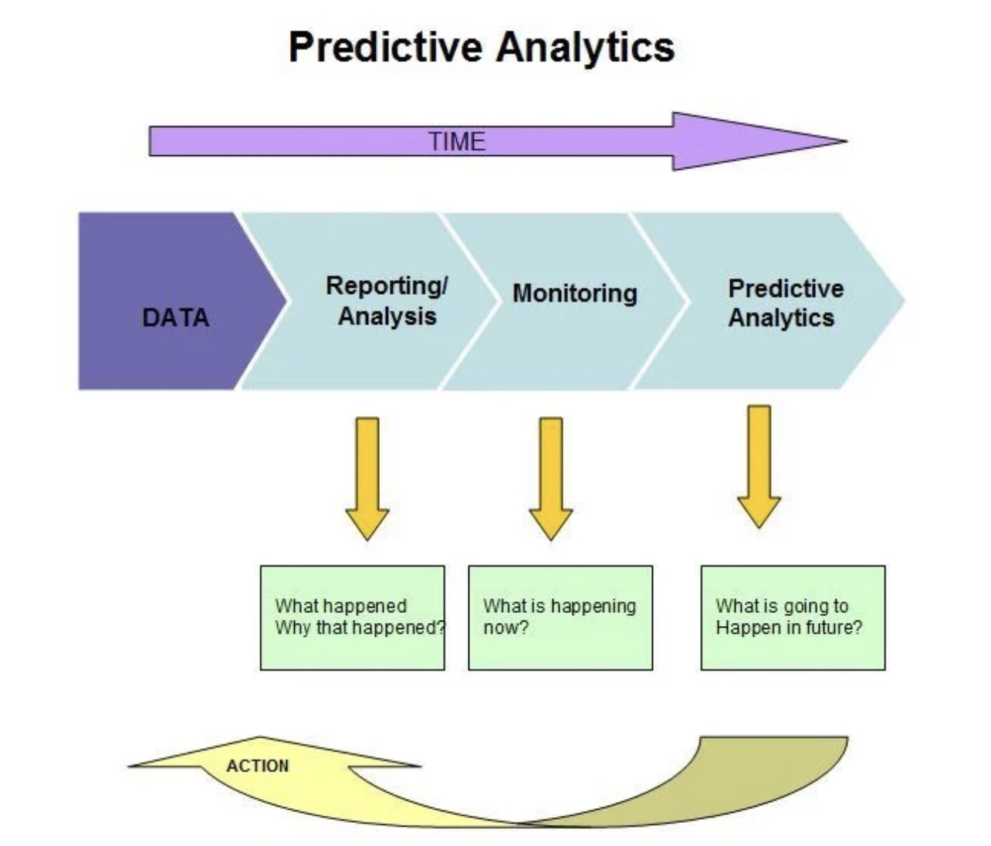
Image source: (PAT RESEARCH, 2019)

However, despite the remarkable potential of these technologies, their specific impact and strategic implications within the travel, tourism, and hospitality industry still need to be explored. This industry thrives on consumer experiences and perceptions, making it a fertile ground for applying predictive analytics and AI in marketing strategies.

This dissertation aims to bridge this gap by exploring the interplay between predictive analytics and AI-driven marketing in travel, tourism, and hospitality. By drawing on theories posited by Li and Karahanna (2015), Verhoef et al. (2017), Rajagopal et al. (2020), and Sivarajah et al. (2017), among others, this research endeavours to unravel the nuanced dynamics and strategic implications for businesses operating within this sector.

Through a comprehensive analysis of empirical data and theoretical frameworks, this study seeks to provide actionable insights and strategic recommendations. By exploring how predictive analytics and AI influence consumer engagement and conversion rates, it aims to offer a roadmap for industry stakeholders navigating the transformative digital landscape within the travel, tourism, and hospitality domain.

This comprehensive exploration intends to contribute to academic discourse and provide practical guidance for industry practitioners looking to harness the potential of predictive analytics and AI-driven marketing strategies to optimise consumer engagement and conversion rates in this ever-evolving sector.

The travel and tourism industry has undergone a remarkable evolution catalysed by the digitisation of consumer touchpoints. From the early days of online travel agencies (OTAs) and travel forums to the current era of immersive online experiences, the industry has embraced digital platforms as integral components of its operations. The advent of AI marks the next chapter in this evolution, introducing predictive analytics to anticipate and meet consumer needs at unprecedented levels of precision.

Rationale

The rationale for this study lies in the evolving landscape of digital marketing within the travel, tourism, and hospitality industry, marked by the increasing integration of artificial intelligence (AI) and predictive analytics.
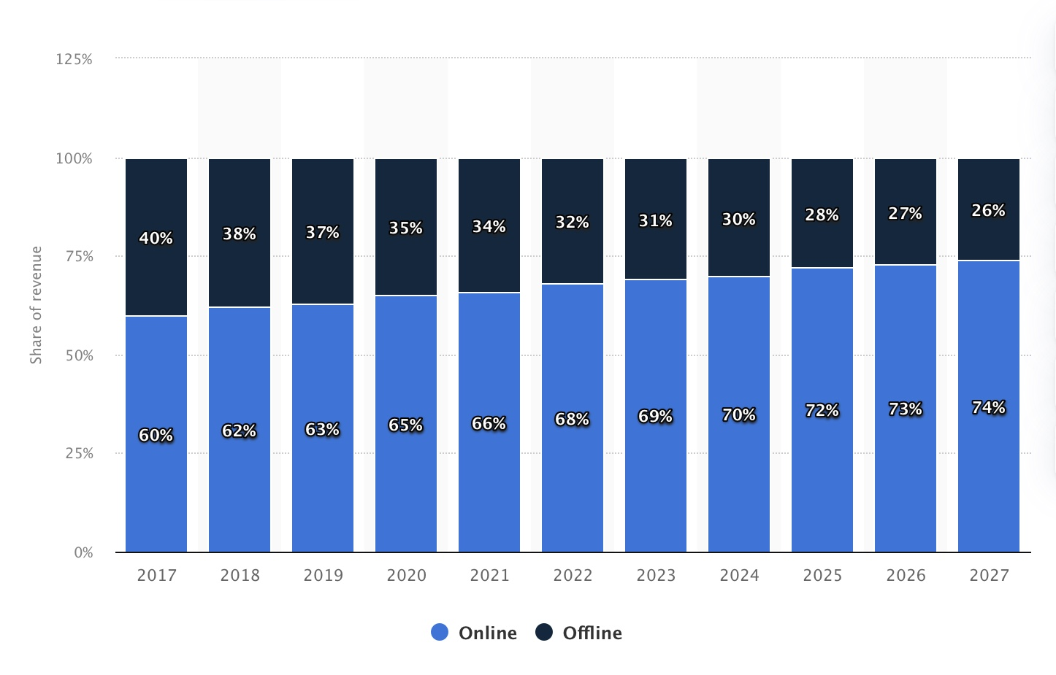
Online sales channels accounted for over two-thirds of the revenue generated in the global travel and tourism market (Department, 2023). The global online travel industry, valued at approximately $475 billion in 2022, was projected to surpass $521 billion in 2023 and exceed $1 trillion by 2030 (Statista, 2023).

The travel industry is rapidly adopting AI technologies to enhance marketing strategies. As businesses increasingly invest in predictive analytics, understanding the implications and effectiveness of these technologies is crucial for staying competitive (Almasi et al., 2023). According to Krey et al. (2021), The travel, tourism, and hospitality industry present distinctive challenges, such as complex consumer decision-making processes and diverse touchpoints. Examining how predictive analytics addresses these challenges is essential for tailoring strategies to the specific needs of this dynamic sector.

Businesses in the travel industry are making substantial investments in AI marketing, aiming to optimise consumer experiences and drive conversions. Understanding the impact of predictive analytics has strategic implications for businesses seeking to refine their marketing strategies and achieve a competitive edge (Bulchand-Gidumal et al., 2023).

The travel industry revolves around consumer experiences and preferences. Predictive analytics in the travel industry has transformative potential, aligning marketing with evolving consumer expectations by anticipating preferences. The study also addresses the growing ethical and privacy concerns associated with AI adoption in marketing, providing valuable insights for navigating these dimensions. Additionally, it contributes to the evolving academic discourse on AI's impact on marketing within the travel sector, offering nuanced insights for industry professionals to inform marketing strategies and decision-making processes.
In essence, the rationale for this study is grounded in the imperative to comprehensively explore and understand the implications of predictive analytics in AI marketing within the unique context of the travel industry. By addressing this research gap, the study aims to provide valuable insights that contribute to academic knowledge and offer practical guidance for businesses navigating the transformative landscape of digital marketing in travel, tourism, and hospitality.

Aim
To evaluate the impact of predictive analytics, powered by AI algorithms, on consumer engagement and conversion rates in digital marketing campaigns for the Travel and Tourism Industry.
Objectives
- To assess the current landscape of predictive analytics implementation in digital marketing within the travel and tourism industry.

- Investigate the impact of AI marketing on consumer behaviour in the Travel and Tourism Industry.

- Evaluate the effectiveness of AI marketing in driving engagement and conversion rates.
- Identify Opportunities and challenges utilising AI-powered marketing in Travel, tourism, and hospitality.
Research Question
1. What is the current landscape of predictive analytics implementation in digital marketing within the travel, tourism, and hospitality industry?
2. How does AI marketing impact consumer behaviour in the Travel and Tourism Industry?
3. To what extent is AI marketing effective in driving engagement and conversion rates within the travel, tourism, and hospitality sector?
4. What opportunities and challenges are associated with utilising AI-powered marketing in the Travel, tourism, and hospitality?

Background
Introduction

Chapter overview (summary of introduction, literature review) diagram flow chart

Literature Review

AI is regarded as one of the most potentially ground-breaking and inventive technologies within the tourism sector (Obschonka and Audretsch, 2020). According to Harvard Business School (2021), Predictive analytics involves utilising data to anticipate future trends and occurrences, drawing on historical data to predict possible scenarios that can inform strategic decision-making. Predicting customers' behaviour is a strategic capability that empowers businesses in a dynamic marketplace. Predictive analytics proves valuable in marketing by predicting sales trends and enabling strategic campaign planning (Elalem, Maier and Seifert, 2022). Furthermore, leveraging historical behavioural data allows the anticipation of a lead's progression through the sales funnel, with models indicating the likelihood of conversion based on engagement with content offerings. This insight empowers planning targeted advertisements at different stages in the customer's journey. As it constitutes a significant subset of applications within machine learning, it is interchangeable with machine learning in specific contexts (Siegel, 2015). By understanding and anticipating customer actions, businesses can increase conversion rates and maintain a competitive edge (Kalaivani and Sumathi, 2018). Ultimately, this strategic capability contributes significantly to overall business success and enhances customer satisfaction.

Consumer behaviour refers to the cognitive, emotional, and physical actions individuals undertake when selecting, purchasing, using, and disposing of products and services in order to meet their needs and desires (Priest, Carter and Statt, 2013). However, Studies have indicated that predicting consumer behaviour remains a challenging task, even for experts in the field (Schivinski, 2019). And, predicting customer behaviour in traditional marketing poses challenges due to limitations in data collection and analysis (Shlomo, 2022). The travel and tourism sector's marketing often deals with a lot of amounts of data. The complexity of predicting consumer behaviour and engagement in this context, coupled with the need to analyse and interpret extensive datasets, can make predictive analytics in travel and tourism marketing a complex task. (Gan and Ouyang, 2022). Moreover, the substantial expansion of high-dimensional big data poses a heightened challenge for data scientists in extracting valuable insights efficiently because conventional data mining techniques are inadequate for processing big data (Oo and Thein, 2022). Integrating Artificial Intelligence (AI) in predictive analytics can significantly enhance the efficiency and accuracy of travel and tourism marketing predictions. AI technologies, such as machine learning algorithms, excel at processing large and complex datasets, identifying patterns, and making predictions based on historical and real-time data.

AI denotes the capacity of a digital computer to execute tasks typically associated with human capabilities, encompassing reasoning, generalisation, deriving meaning, and the ability to learn from prior experiences (ZULAIKHA et al., 2020). In essence, artificial intelligence (AI) pertains to machines endowed with the capability to acquire knowledge and emulate or simulate intelligent human behaviours. The digital transformation has redefined marketing strategies, leveraging predictive analytics and artificial intelligence (AI) to enhance consumer engagement and conversion rates. This literature review explores existing research on the impact of AI-driven predictive analytics on consumer behaviour, engagement, and conversion rates within the Travel, Tourism, and Hospitality industry.

The Current Landscape of Predictive Analytics in Digital Marketing within the Travel, Tourism, and Hospitality Industry

AI technologies have completely revolutionised the travel and tourism sector, presenting numerous new opportunities and advantages. In the travel and tourism sector, substantial volumes of data are generated by both service providers and customers. Tourism companies, destination managers, and consumers alike produce and utilise extensive data, employing data analytics to enhance decision-making across various operational levels (Li et al., 2018)

Research by Kishan, K. et al. (2024) highlights the increasing adoption of predictive analytics tools by major players in the travel and hospitality sector. These tools aid in predicting historical data, industry trends, and external factors to predict demand for travel destinations, accommodations, and services, consumer preferences, optimising pricing strategies, and personalising marketing campaigns. The use of machine learning algorithms allows businesses to analyse vast datasets, including customer behaviours, seasonal trends, and external factors, providing a comprehensive understanding of the market landscape. Li et al. (2022) conducted a meta-analysis examining the efficacy of AI-driven marketing strategies in the tourism industry. Their findings revealed positive outcomes linked to the adoption of AI technology for predictive analytics, dynamic pricing, and personalised marketing. AI technologies cited included machine learning algorithms and natural language processing. The study underscored the significance of continual evaluation and enhancement of AI models to maximise their impact on marketing endeavours.

Moreover, study by Lee, Kwon and Back (2021) on the implementation of predictive analytics underscores its role in enhancing customer experience. By analysing historical booking patterns and customer reviews, businesses tailor their marketing strategies to meet evolving consumer expectations. The current landscape suggests a paradigm shift in how businesses within the tourism sector harness predictive analytics to gain a competitive edge.

In predicting customer behaviour, the application of supervised learning becomes imperative, serving as a foundation for subsequent data processing. As Kotu and Deshpande (2019) described, supervised learning constitutes a predictive model designed to anticipate outcomes when confronted with novel input instances. This model employs algorithms to interact with datasets, constructing a classification model conducive to future data processing. Consequently, the integration of machine learning, particularly supervised learning, facilitates the automation of real-time processes, furnishing valuable data for predicting customer behaviours.

While the terms "AI," "automation," and even "robotics" are often used interchangeably, they encompass distinct concepts. Specifically, AI predominantly employs algorithms for process learning, engaging in logical reasoning, learning, and problem-solving. In contrast, automation and robotics rely on sensors and manual programming for their operations (Mascarenhas, 2018). Numerous forward-looking applications of AI in marketing operations focus on enhancing personalised experiences and engaging customers, along with progressively refining the customer value proposition by leveraging AI-driven data to offer tailored product and service recommendations (Faggella, 2019) (Kumar et al., 2019)

Investigate the impact of AI marketing on consumer behaviour in the Travel and Tourism Industry.

Studies by Wang et al. (2020) underscore the unique characteristics of consumer behaviour in the travel industry. Understanding these behaviours is crucial for tailoring predictive analytics models. Concurrently, the integration of AI technologies has catalysed a paradigm shift in marketing dynamics within the travel and tourism industry.
AI-powered algorithms can pinpoint the ideal audience for a campaign, eliminating wasted impressions and focusing on users who are most likely to convert. This leads to increased efficiency and a higher return on investment (ROI) (Huang and Rust, 2020) (Kovalenko, 2023). However, Huang and Rust (2020) question AI's capability to understand and analyse human's emotion. While contemporary mechanical AI exhibits robust autonomy in gathering and consolidating diverse data sources, it frequently loses the context of the data, posing challenges in modelling, particularly for emotional data. The automated data collection process can hinder achieving customer intimacy as it involves machines communicating with machines. And, Current thinking AI, though powerful, may not be neutral and transparent, which can result in biased recommendations or entail unintended consequences. According to Prayag et al. (2016), emotions have a significant impact on different phases of the tourist experience. During the pre-travel stage, emotions play a crucial role in motivating tourists and influencing destination selection processes. Moreover, there is a pressing need to anticipate forthcoming changes in strategic decision-making, planning, forecasting, policy/strategy recommendations, and transformative decision-making related to AI, with a specific focus on the cultural implications of such scenarios (Stone et al., 2020). Lastly, evaluating marketing's ability to enhance outcomes by integrating products with smart technology (SHIH-YU, 2019) emerges as a strategic imperative for further research exploration.
Kong et al. (2023) conducted extensive research focusing on the influence of AI on destination marketing within the tourism sector. Their analysis highlighted the potential of AI-driven recommendation systems, chatbots, and virtual assistants in offering personalised travel recommendations, addressing consumer inquiries, and improving engagement with prospective travellers. The study also emphasised the importance of integrating human expertise with AI technologies to create seamless and personalised experiences. AI marketing has the potential to revolutionise the Travel and Tourism Industry by providing personalised experiences, optimising operations, and driving customer engagement and loyalty. As technology continues to advance, the impact of AI on consumer behaviour in this industry is expected to grow, shaping the way travellers plan, book, and experience their journeys.

The effectiveness of AI marketing in driving engagement and conversion rates.

Approximately 40% of users leave a website due to feeling inundated by an excessive number of choices (Interactive, 2024). AI can analyse vast amounts of user data to understand individual preferences and behaviours. This allows for the creation of highly personalised ads, content, and recommendations, which are more likely to resonate with users and lead to conversions (Alqurashi et al., 2023). Research by Rajagopal et al. (2020) and Sivarajah et al. (2017) describe how AI, through its machine learning algorithms and natural language processing capabilities, enables marketers to automate processes, analyse intricate datasets, and deliver highly personalised experiences across diverse digital touchpoints. This level of personalisation augments engagement and significantly impacts consumer decision-making processes, thereby influencing conversion rates.

The utilisation of AI algorithms and machine learning to support models diminishes the risk of human error, enhances the efficiency of audience data, and enables the scalability of display advertising (Haleem et al., 2022). People prefer to engage with marketing campaigns that are pertinent to their interests or address their needs. Marketers can enhance the effectiveness of their advertising by developing targeted strategies for specific customer segments, ensuring they reach the most relevant consumer groups likely to positively respond. This optimisation can be achieved by harnessing the digital superintelligence provided by AI models and algorithms (Hermann, 2021) (Kühl, Mühlthaler and Goutier, 2019) (Yau, Saad and Chong, 2021).

AI-powered algorithms can pinpoint the ideal audience for a campaign, eliminating wasted impressions and focusing on users who are most likely to convert. This leads to increased efficiency and a higher return on investment (ROI).
Opportunities and challenges utilising AI-powered marketing in Travel, tourism, and hospitality.
The incorporation of AI in marketing strategies presents a spectrum of opportunities and challenges within the travel, tourism, and hospitality industry. Study by (Hermann, 2021) meticulously examines these facets, shedding light on the nuanced landscape of AI-powered marketing.

Opportunities:

Enhanced/ Hyper Personalisation: One of the primary opportunities identified by Bulchand-Gidumal et al. (2023), is the ability of AI to deliver highly personalised experiences. Through data analysis and machine learning, AI tailors marketing messages and recommendations to individual preferences, fostering a deeper connection between the consumer and the brand (Deloitte, 2024).

Predictive Customer Insights: AI's capacity to analyse vast datasets enables businesses to gain predictive insights into consumer behaviour (Gkikas and Theodoridis, 2021). This predictive capability allows for proactive decision-making, such as anticipating travel trends, optimising pricing strategies, and customising marketing campaigns to align with evolving consumer preferences.

Operational Efficiency: Study by Kazak, Chetyrbok and Oleinikov (2020) highlights how AI streamlines operational processes in the hospitality sector. Chatbots and virtual assistants powered by AI handle routine customer queries, reservation management, and other operational tasks, freeing up human resources to focus on more complex and value-driven activities.

Challenges

Data Privacy Concerns: The research by Bulchand-Gidumal et al. (2023) emphasises the critical issue of data privacy in AI-powered marketing. The collection and utilisation of extensive consumer data raise concerns about privacy infringement. The study participants also expressed grievances regarding the complexities encountered in various phases of AI implementation and deployment, spanning from data collection and processing to job restructuring, due to legal and ethical concerns. They attributed the inadequacy of legacy legislation in providing a conducive legal framework for the AI-driven industry. Moreover, participants noted an excessive level of concern among users spurred by regulators and the media. Additionally, they highlighted the overly restrictive nature of European and Spanish data protection and privacy laws, such as the European General Data Protection Regulation (GDPR). Striking a balance between personalisation and respecting user privacy emerges as a key challenge for tourism businesses.

Implementation Costs: While AI holds transformative potential, the initial investment required for infrastructure, training, and integration can be significantly challenging to Implement AI systems. These include the requirement for top-notch data quality (Paschen, Pitt and Kietzmann, 2020), which can be both arduous and costly to obtain (Sivarajah et al., 2017) alongside the intricacy of aligning AI systems with human workers effectively (Thiebes, Lins and Sunyaev, 2020).

Consumer Trust: The study underscores the importance of building and maintaining consumer trust in the context of AI marketing. Transparency in how AI is used, ethical considerations, and clear communication about data usage are essential for fostering trust. Lalicic and Weismayer (2021) recommends that businesses actively address these concerns to prevent potential backlash.

Research provide a comprehensive analysis of the opportunities and challenges associated with AI-powered Predictive marketing in the tourism sector. This examination equips businesses with valuable insights for navigating the dynamic landscape of AI implementation.

Literature Gap

While there is an increasing fascination with AI and the integration of service robots in the travel and tourism industry (TTI), current academic literature primarily remains theoretical (Filieri et al., 2021). Even though there is a wealth of literature on AI in marketing (Chintalapati and Pandey, 2021) (García-Madurga and Grilló-Méndez, 2023), there is a scarcity of research focusing on predictive marketing based on customer behaviour and engagement in the travel and tourism sector. This study aims to fill this gap by providing targeted insights into how predictive analytics influences consumer behaviour, engagement, and conversion rates within travel-related contexts.

The existing literature in the field of predictive analytics in the travel industry often focuses on its potential to reshape marketing strategies and enhance consumer experiences. However, a noticeable research gap exists regarding a comprehensive examination of the ethical implications and privacy concerns associated with adopting AI in travel marketing. Additionally, there is a lack of in-depth studies providing nuanced insights into the evolving academic discourse on the impact of predictive analytics on consumer behaviour, engagement, and conversion rates within the unique context of the travel sector. Bridging these gaps is essential for a holistic understanding of the challenges and opportunities at the intersection of predictive analytics, ethics, and consumer dynamics in the travel industry.

Marketing Models

In a rapidly changing and intensely competitive global market, marketers must examine how marketing communication models impact consumers. Marketing models are essential tools for businesses as they enable strategic decision-making, provide insights into consumer behaviour, optimise marketing efforts, measure performance, and predict future trends. These models help businesses develop comprehensive marketing strategies, understand how consumers interact with marketing stimuli, allocate resources efficiently, evaluate campaign effectiveness, and anticipate market changes (Montazeribarforoushi, Keshavarzsaleh and Ramsøy, 2017).

RACE Model
The concept underlying the RACE marketing planning model is to offer a straightforward framework for organisations to create a digital marketing or omnichannel communications strategy that addresses the complexities of reaching and captivating online audiences to encourage both sales conversions. This model offers a strategic blueprint delineating the fundamental phases of a digital marketing strategy: Reach, Act, Convert, and Engage presenting a methodical strategy for conceptualising and implementing digital marketing initiatives, with emphasis on addressing each stage of the customer journey (Chaffey, 2019).

Figure 7: AI for Tourism Marketing (RACE Model)
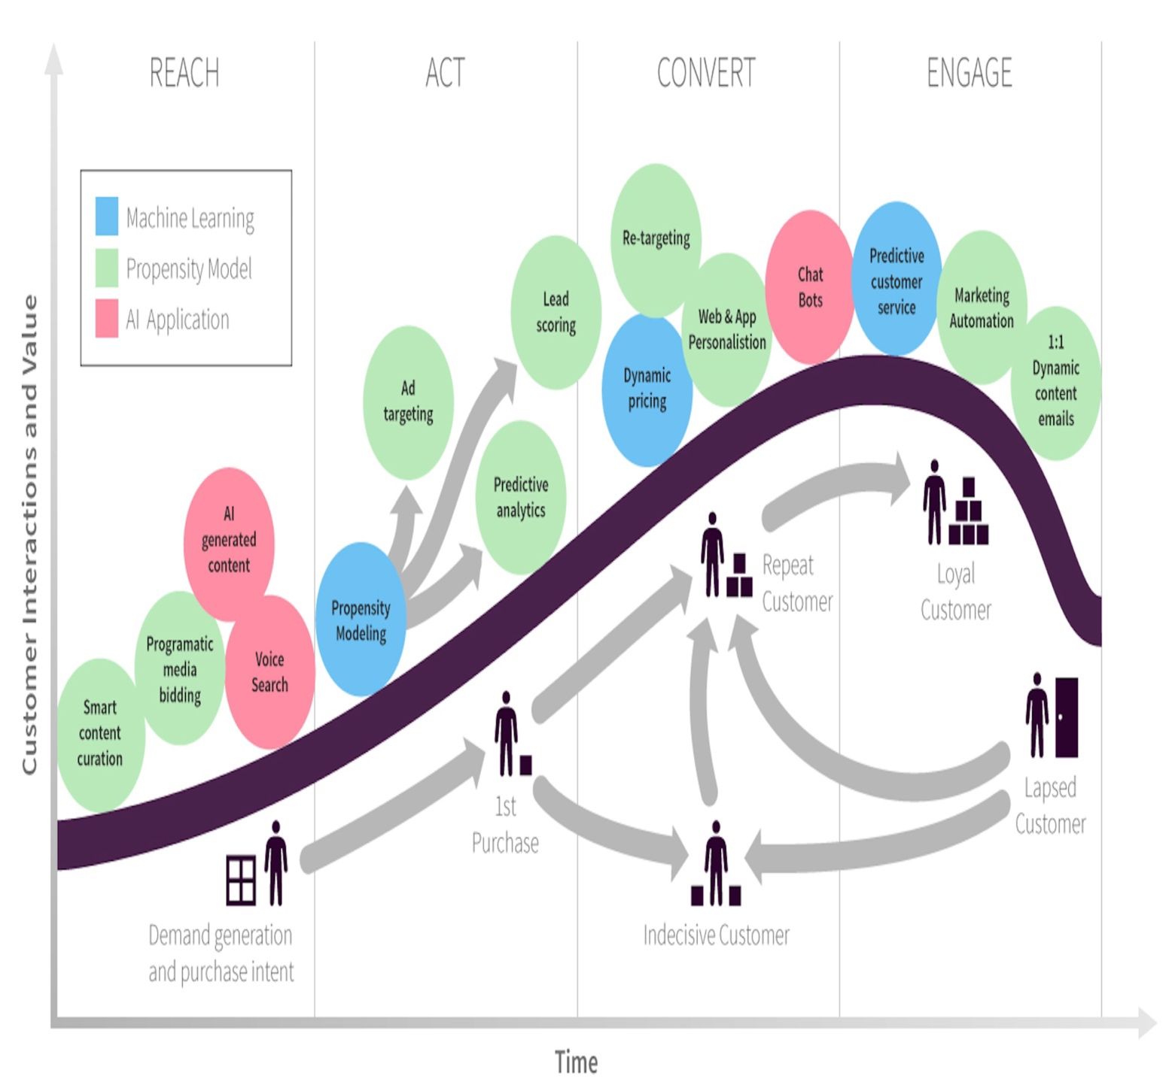Source: (Chaffey, 2019)
Aligning tourism companies' marketing with the RACE model ensures a comprehensive approach to engaging users, guiding them from awareness to advocacy and retention.
The customer life journey encompasses a few phases. These phases are (Chaffey, 2019) (Chaffey, 2022) (CIM, 2022):
Reach (Awareness): The Reach stage involves expanding the audience reach through targeted digital marketing efforts. AI-powered Marketing play a pivotal role here by enabling businesses to identify and engage with potential customers more precisely. Research by scholars like Huang and Rust (2020) highlights the effectiveness of AI in segmenting target audiences based on behavioural patterns and preferences, thus enhancing the reach of marketing campaigns. Tourism businesses often cater to a diverse and global audience (Liu, Fan and Qiu, 2020). Therefore, marketing for tourism businesses involve vast amount of data. The "Reach" stage, in order to create demand and purchase intent, utilise AI to identify target audiences by analysing vast data sets such as demographics, travel history, and online behaviour, enabling the pinpointing of ideal customer segments for specific offerings, personalised ad targeting, and the delivery of highly relevant ads across various channels based on individual profiles and preferences to attract potential travellers effectively, while also optimising content marketing by analysing user engagement data to create personalised content recommendations that attract tourists with content relevant to their interests and travel intent.
Act (Consideration): In the Act phase, the focus shifts to investigating the impact of AI marketing on consumer behaviour in the travel and tourism industry. This involves analysing how AI-driven marketing initiatives prompt consumers to take action. The objective is to prompt target customers to take action, such as visiting a website or engaging with promotional content. AI marketing tools facilitate this process by delivering personalised recommendations and targeted messaging to individual consumers. Studies by Zhao, Lyu and Luo (2022) underscore the role of AI in driving consumer engagement through dynamic pricing strategies and personalised marketing communications. By analysing consumer data in real-time, AI algorithms can identify actionable insights and deliver relevant content that encourages consumers to interact with the brand (Varsha P. S. et al., 2021). Research prove the use of AI-powered chatbots and AR (Augmented Reality) improve user experience and conversion rates (Sidlauskiene, Joye and Auruskeviciene, 2023) (Shah and Shay, 2019). Utilise AI-powered chatbots for round-the-clock traveller assistance, including answering queries, offering recommendations, and facilitating real-time bookings, alongside leveraging augmented reality (AR) experiences to provide immersive virtual tours of destinations, accommodations, and attractions, enhancing user engagement, and driving informed booking decisions.

Convert (Decision/ Purchase): The Convert phase delves into evaluating the effectiveness of AI marketing in driving engagement and conversion rates within the travel and tourism sector. This entails measuring how AI-powered marketing strategies influence consumers' decision-making processes and lead to desired outcomes, such as bookings, reservations, or purchases. Conversion is the pivotal stage where engaged prospects transition into paying customers. AI marketing techniques, backed by predictive analytics, optimise the conversion process by anticipating consumer needs and preferences. Bag et al. (2022) emphasise the importance of high-quality data in facilitating AI-driven conversion optimisation strategies. Personalised recommendations, Dynamic package creation and Risk assessment and fraud prevention powered by AI are the vital elements of the convert stage. (De Bruyn et al., 2020) (Gajdošík and Marciš, 2019) (Haleem et al., 2022). AI can analyse past behaviour and preferences to suggest relevant destinations, activities, and travel packages, thereby increasing booking conversions. Secondly, AI enables the dynamic creation of personalised travel packages based on individual budgets, interests, and travel styles, exceeding customer expectations and driving conversions. Finally, AI algorithms can analyse booking data to identify potential fraudulent transactions, reducing risks and enhancing security for both travelers and businesses. By leveraging predictive models, travel businesses can tailor their offerings and promotional incentives to match the specific preferences of individual consumers, thereby increasing the likelihood of conversion.

Engage (Post-purchase/ Retention & Advocacy): The Engage stage focuses on nurturing long-term relationships with customers and fostering brand loyalty. AI-powered marketing initiatives enable continuous engagement with consumers through personalised interactions and tailored communications. Research by Trunk, Birkel and Hartmann (2020) highlights the significance of blending human expertise with AI technologies to deliver seamless and individualised experiences that resonate with people and more effective decision making. By leveraging predictive analytics to anticipate consumer behavior and preferences, travel brands can cultivate lasting relationships with customers, driving repeat business and brand advocacy. Additionally, AI enables the dynamic creation of personalised travel packages based on individual budgets, interests, and travel styles, exceeding customer expectations. Furthermore, AI algorithms can analyse booking data to identify potential fraudulent transactions, reducing risks and enhancing security for both travelers and businesses (Haleem et al., 2022).

By applying the RACE model, the research aims to comprehensively assess the impact of AI marketing on various stages of the consumer journey within the travel and tourism industry, ultimately providing insights and recommendations for enhancing marketing strategies in this sector.

Advantages of the RACE Model
Structured Approach: The RACE model provides a structured framework for planning and executing digital marketing strategies. By dividing the process into identifiable phases such as Reach, Act, Convert, and Engage, the model guarantees comprehensive coverage of the customer journey. This systematic breakdown assists marketers in establishing precise aims and goals for each phase, promoting a more concentrated and tailored strategy (Fedoryshyna et al., 2021).
Comprehensive Analysis: By considering each stage individually, the RACE model enables a comprehensive analysis of the effectiveness of AI marketing strategies in attracting, engaging, and converting tourists. As campaigns advance through the stages, they generate valuable insights and data. These findings can be examined to fine-tune strategies, improve tactics, and elevate overall performance. This iterative approach empowers marketers to base their decisions on data, resulting in more impactful campaigns and improved return on investment (ROI).
Fostering Customer-Centricity: The RACE model places a strong emphasis on prioritising the customer and cultivating relationships. It directs marketers to actively engage with their audience throughout the entire process, facilitating the establishment of deep and enduring connections (Fedoryshyna et al., 2021). This emphasis on interaction and engagement nurtures brand loyalty, trust, and advocacy, crucial elements for contemporary marketing success.
Integration of Data: The model emphasises the integration of data from various digital channels, which aligns with the use of predictive analytics in digital marketing and allows for a more holistic evaluation of AI marketing efforts (Chaffey and Smith, 2022). The RACE model demonstrates versatility and relevance across diverse sectors and digital platforms. Whether a company operates in e-commerce, B2B services, or non-profit sectors, the model's fundamentals can be adapted to align with specific goals and environments. Its adaptable nature enables marketers to personalise approaches according to the distinct requirements of their audience and industry. For instance, when a prospective customer explores destinations on YouTube and conducts related searches, Google may suggest tailored travel itineraries and flight options for that location.

Disadvantages of the RACE Model
Simplistic Representation: The RACE model provides a simplified representation of the customer journey, which may overlook the complexity of consumer behaviour and engagement in the tourism industry.
Limited Focus: The model primarily focuses on digital marketing channels, potentially neglecting the influence of offline touchpoints and traditional marketing strategies on consumer behaviour and conversion rates.
Lack of Flexibility: The rigid structure of the RACE model may limit its adaptability to specific research contexts or variations in consumer behaviour within the tourism industry.
Overemphasis on Conversion: While the model emphasises the conversion stage, it may not adequately address the importance of long-term engagement and customer loyalty, which are critical factors in the tourism sector.

Overall, while the RACE model offers a valuable framework for analysing the impact of AI marketing on consumer behaviour and conversion rates in the tourism industry, researchers should be mindful of its limitations and consider complementing it with other analytical approaches for a more comprehensive understanding.

Honeycomb Model

The Honeycomb model, alternatively referred to as the Kietzmann Honeycomb model, delineates seven fundamental functional components of social media. Designed to analyse the factors shaping user engagement on social platforms, this model aims to gauge the efficacy of social media platforms (Kietzmann et al., 2011). The Honeycomb Model can certainly be adapted and applied to AI and digital marketing contexts. While originally conceived to illustrate the components of social media engagement, the principles underlying the model can be extended to encompass various aspects of AI-driven digital marketing strategies. Because both social media and AI-powered predictive analytics share similarities in their reliance on data utilisation, focus on personalisation, aim to enhance user engagement, facilitate targeted marketing efforts, and optimise performance metrics. Both play crucial roles in understanding user behaviour, personalising experiences, and optimising marketing strategies to drive business results. The utilisation of the Honeycomb model for evaluating AI marketing in the tourism industry presents a compelling argument due to its multifaceted analytical framework. By dissecting social media into seven key functional components, the model offers a nuanced lens through which to scrutinise the impact of AI-driven strategies. Its emphasis on user-centricity aligns well with the objective of AI marketing, which aims to enhance user experiences through personalised interactions. Moreover, the model's versatility enables researchers to assess the effectiveness of AI initiatives by measuring metrics such as customer engagement and conversion rates within the tourism sector. Through a thorough analysis of these components, the Honeycomb model not only provides insights into the current landscape but also offers actionable recommendations for optimising AI marketing strategies to drive meaningful outcomes in the tourism industry.

Identity: This block encompasses personal details like name, age, and interests (Kietzmann et al., 2011). In the context of predictive analytics in digital marketing, the identity aspect of the Honeycomb model relates to the establishment of a brand's online presence through AI-driven strategies.
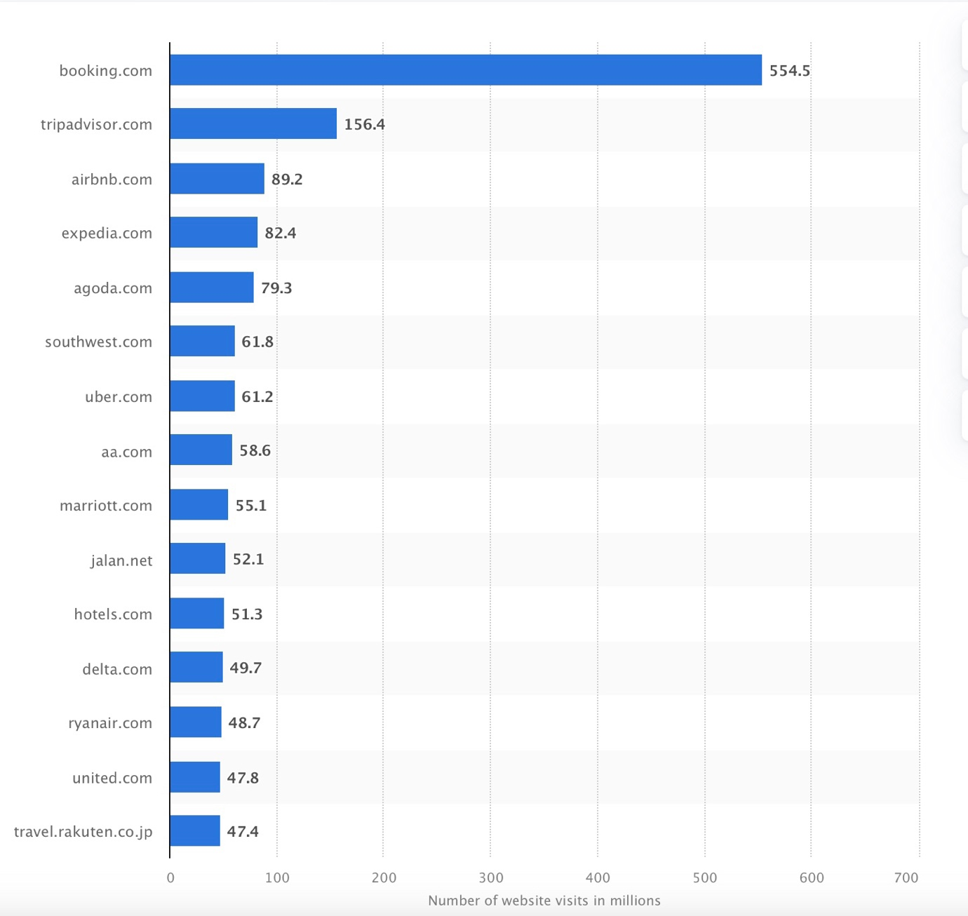
Source: (statista, 2023)
The global online travel market reached a value of $1.3 trillion in 2020, despite experiencing a decline attributed to the COVID-19 pandemic (Statista, 2024a). By 2022, online sales channels constituted approximately two-thirds of the total revenue generated in the global travel and tourism sector (Statista, 2024b).
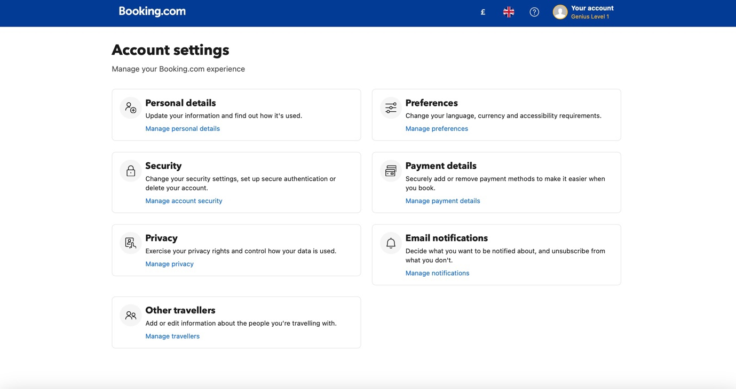
Source: (Booking.com, 2024)
Major players in the travel industry maintain robust online presences, often encouraging customers to create accounts where they provide personal details. Furthermore, travel and tourism providers boast substantial followings across their social media channels, affording them access to extensive datasets encompassing users, viewers, subscribers, and followers (Airbnb, 2024) (TripAdvisor, 2024).
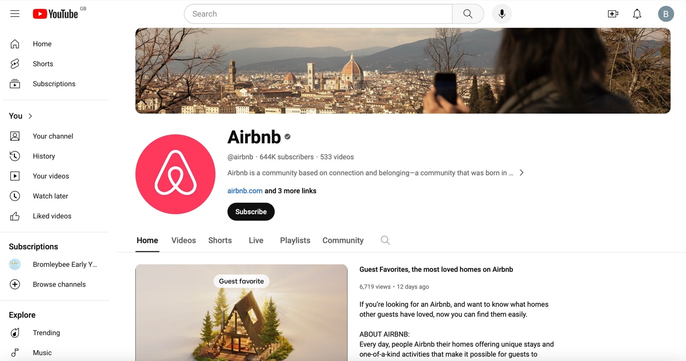
Source: Airbnb Homepage on YouTube (Airbnb, 2024)

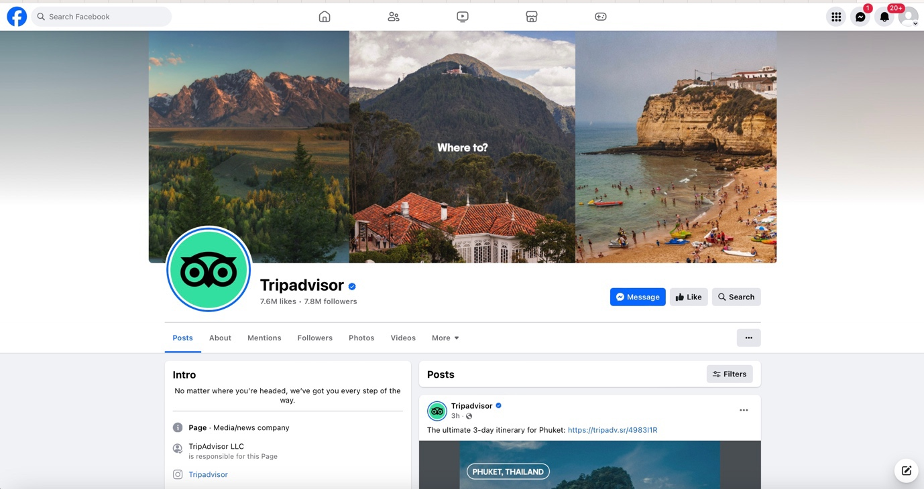
Source: TripAdvisor's Facebook Page ((TripAdvisor, 2024)
Utilising AI, companies can leverage this wealth of customer data from their profiles and their browsing behaviour to craft personalised marketing initiatives tailored to individual preferences and behaviours, thereby bolstering brand recognition and identity.

Conversations: This stage focuses on fostering meaningful dialogues and interactions between consumers and brands through various digital channels (Kietzmann et al., 2011). Specifically, within the tourism industry, the Conversation Stage entails leveraging AI-powered tools such as chatbots, virtual assistants, and personalised messaging systems to engage with potential travellers and existing customers (Kong et al., 2023). Through these AI-driven communication channels, tourism businesses can address customer inquiries, provide real-time assistance, offer personalised recommendations, and gather feedback.
Moreover, the conversation Stage also encompasses social media interactions, where AI algorithms analyse user-generated content, comments, and messages to understand consumer sentiment, preferences, and trends (Zachlod et al., 2022) (Liu, Gupta and Patel, 2021). By actively participating in conversations on social media platforms, tourism businesses can build stronger relationships with their audience, enhance brand loyalty, and gather valuable insights for refining their marketing strategies.
Sharing: The Sharing stage, as per the Honeycomb Model, refers to the dissemination of content and information among users on social media platforms (Kietzmann et al., 2011). This stage encompasses activities such as sharing posts, retweeting, forwarding messages, and spreading user-generated content. In the tourism industry, sharing plays a crucial role as travellers often share their experiences, photos, reviews, and recommendations with their social networks.

Analyzing the Sharing stage within the context of AI marketing in tourism, predictive analytics can provide valuable insights into the sharing behavior of consumers (Babu and Kanaga, 2021). By leveraging AI algorithms, marketers can analyze vast amounts of social media data to identify patterns and trends related to sharing behavior. For instance, AI-powered sentiment analysis can determine which types of content are more likely to be shared based on the emotional responses of users. Additionally, natural language processing (NLP) techniques can help identify influential users and key topics that drive sharing activity within the tourism industry (Khurana et al., 2022).

Furthermore, predictive analytics can enable marketers to predict the virality of content and anticipate the impact of sharing on consumer engagement and conversion rates. By understanding the factors that influence sharing behavior, such as the appeal of visual content, storytelling narratives, or unique experiences, marketers can tailor their content strategies to encourage more sharing among target audiences.
Moreover, AI-driven personalization techniques can enhance the sharing experience by delivering relevant and timely content to users based on their preferences, behaviors, and past interactions. By leveraging predictive analytics, marketers can identify the most effective channels and formats for sharing content, optimize content delivery schedules, and measure the impact of sharing on key performance indicators (KPIs) such as website traffic, brand awareness, and conversion rates (Gołąb-Andrzejak, 2023).

Presence: The Presence stage in the Social Media Honeycomb Model refers to the establishment of an online presence by individuals or organizations on social media platforms (Kietzmann et al., 2011). It encompasses activities such as creating profiles, pages, or accounts on platforms like Facebook, Instagram, Twitter, and LinkedIn. In the context of the tourism industry, establishing a strong presence on social media platforms is essential for reaching and engaging with potential travelers, building brand awareness, and influencing consumer decision-making.

Analyzing the Presence stage within the framework of predictive analytics and AI marketing offers valuable insights into how tourism businesses can optimize their online presence to enhance consumer engagement and drive conversion rates. Predictive analytics help marketers identify the most relevant social media platforms for their target audience, based on demographic, psychographic, and behavioral data (Nair and Gupta, 2021). By leveraging AI algorithms, marketers can analyze historical data to predict which platforms are most likely to yield high engagement and conversion rates for specific segments of travellers.

Moreover, AI-powered personalization techniques can enhance the presence of tourism businesses on social media platforms by delivering tailored content and experiences to users based on their preferences and interests (Kumar et al., 2019). For example, AI algorithms can analyze user interactions and engagement metrics (Bag et al., 2022) to dynamically adjust content strategies, recommend personalized travel itineraries, and offer targeted promotions or discounts.

Furthermore, predictive analytics help tourism businesses track and measure their online presence across various social media platforms, enabling them to identify strengths, weaknesses, and opportunities for improvement. According to Schrage et al. (2023) by monitoring key performance indicators (KPIs) such as follower growth, engagement rates, sentiment analysis, and brand mentions, marketers can optimize their social media strategies in real-time to maximize the impact of their presence on consumer behavior and conversion rates.

Relationships: The Relationships stage refers to the interactions and connections established between users on social media platforms (Kietzmann et al., 2011). In the context of the tourism industry, building and nurturing relationships with consumers is paramount to fostering brand loyalty, driving repeat business, and generating positive referrals. Analyzing the Relationships stage within the framework of predictive analytics and AI marketing offers valuable insights into how tourism businesses can cultivate meaningful connections with their target audience.

Predictive analytics can play a crucial role in identifying and segmenting target audiences based on their preferences, behaviors, and demographics (Nair and Gupta, 2021). By leveraging advanced data analytics techniques, marketers can personalize their messaging and communication strategies to resonate with different consumer segments, thereby strengthening relationships and driving engagement (Kumar et al., 2019). AI-powered chatbots and virtual assistants can further enhance the customer experience by providing personalized recommendations, addressing inquiries, and resolving issues in real-time, thereby fostering deeper connections with consumers (Chaturvedi and Verma, 2023).

Predictive analytics help marketers track and measure the effectiveness of relationship-building initiatives across various touchpoints and channels. By analyzing metrics such as customer satisfaction scores, Net Promoter Scores (NPS), and sentiment analysis data, marketers can assess the health of customer relationships and identify areas for improvement (Rallis et al., 2022). AI algorithms can also predict customer churn and identify at-risk segments, enabling proactive intervention strategies to retain valuable customers and enhance overall loyalty (Faritha Banu et al., 2022).

Furthermore, AI-driven predictive modeling techniques can anticipate consumer needs and preferences, enabling marketers to deliver personalized offers, incentives, and rewards that strengthen relationships and drive repeat business. By utilising predictive analytics to anticipate consumer behavior and sentiment, marketers can proactively engage with customers at key touchpoints throughout the customer journey, thereby deepening relationships and increasing brand affinity (Gkikas and Theodoridis, 2021). By leveraging advanced analytics and AI technologies, marketers can personalize interactions, optimize engagement strategies, and foster brand loyalty in the competitive landscape of the tourism industry.

Reputation: The Reputation stage in the Social Media Honeycomb Model refers to the perception and image of a brand or organization within the online community (Kietzmann et al., 2011). In the context of the tourism industry, a positive reputation is crucial for attracting new customers, retaining existing ones, and building long-term trust and credibility.
AI powered predictive analytics' impact extends beyond the purchase or booking process, encompassing customer satisfaction, which is related to reputation and plays a crucial role in retaining customers and driving additional sales. Personalised post-booking communication plays a key role in enhancing traveller experiences and driving engagement (Barnes et al., 2020). By leveraging AI to recommend relevant add-ons and activities aligned with user profiles and booking details, businesses can unlock additional revenue streams. Similarly, AI-powered travel guides tailored to individual interests and booking specifics can elevate the entire experience.

Predictive analytics can play a crucial role in monitoring and analysing online sentiment, customer reviews, and social media conversations related to tourism businesses. By leveraging sentiment analysis algorithms and natural language processing techniques, marketers can gain valuable insights into consumer perceptions, opinions, and attitudes towards their brand (Schrage et al., 2023). AI-powered reputation management tools can help identify and address negative feedback and sentiment in real-time, enabling proactive reputation management strategies to mitigate potential damage and protect brand reputation. AI can monitor online reviews and social media mentions, identifying emerging issues and allowing businesses to respond promptly and professionally, mitigating potential damage and showcasing responsiveness (Khurana et al., 2022).

Moreover, predictive analytics can help tourism businesses identify key influencers and advocates within their target audience who can positively impact brand reputation and credibility (Sands et al., 2022) (Harrigan et al., 2021). By analyzing social media engagement metrics, audience demographics, and content preferences, marketers can identify influencers who align with their brand values and engage them in collaborative campaigns and partnerships. AI algorithms can also predict the potential reach and impact of influencer-generated content, enabling marketers to optimize their influencer marketing strategies for maximum effectiveness.

Furthermore, AI-driven predictive modeling techniques can anticipate shifts in consumer preferences and market trends that may impact brand reputation and perception (Haleem et al., 2022). By analyzing historical data and external factors such as industry trends, competitor activities, and socio-economic factors, marketers can proactively adjust their messaging and positioning strategies to maintain a positive reputation and capitalize on emerging opportunities. AI-powered sentiment analysis tools can also help identify emerging issues or crises that may impact brand reputation, enabling swift response and crisis management strategies to minimize reputational damage (Babu and Kanaga, 2021).

Influence: The Influence stage of the Social Media Honeycomb Model refers to the ability of individuals or entities to affect the opinions, attitudes, and behaviors of others within the online community (Kietzmann et al., 2011). In the context of the tourism industry, influencers wield significant power in shaping consumer perceptions, preferences, and purchase decisions. Analyzing the Influence stage within the framework of predictive analytics and AI marketing provides valuable insights into how tourism businesses can leverage influencer marketing strategies to drive engagement and conversion.

Predictive analytics help identify and evaluate potential influencers within the tourism industry by analyzing social media engagement metrics, audience demographics, and content preferences (Kennedy, Kunkel and Funk, 2020). By using machine learning algorithms and predictive modeling techniques, marketers can identify influencers who align with their brand values and target audience demographics. AI-powered influencer identification tools can also assess the authenticity and credibility of influencers, enabling marketers to collaborate with individuals who have genuine influence and impact within their niche.

Furthermore, predictive analytics can optimize influencer marketing campaigns by forecasting the potential reach, engagement, and conversion impact of influencer-generated content (Harrigan et al., 2021). By analysing historical data and performance metrics, marketers can identify key success factors and optimize their influencer marketing strategies for maximum effectiveness. AI algorithms can also predict consumer response to influencer content, enabling marketers to tailor messaging and creative assets to resonate with their target audience and drive desired actions.

Moreover, predictive analytics can measure the ROI and effectiveness of influencer marketing campaigns by tracking key performance indicators such as engagement rates, click-through rates, and conversion metrics. By analyzing campaign data in real-time, marketers can identify trends, insights, and opportunities for optimization to maximize the impact of influencer collaborations on consumer behavior and conversion rates.

Advantages and Disadvantages of the Honeycomb Model

The Honeycomb Model, proposed by Kietzmann et al. (2011), presents a holistic framework encompassing various dimensions of social media engagement, including identity, conversations, sharing, presence, relationships, reputation, and influence. By leveraging this model, researchers can systematically assess the multifaceted impact of AI marketing strategies on consumer behavior and engagement within the tourism domain.

The adaptability of the Honeycomb Model allows for tailored insights specifically tailored to the intricacies of the tourism industry. This adaptability ensures that analyses remain relevant and contextualized, shedding light on how AI-driven marketing initiatives uniquely influence each facet of social media engagement in the tourism sector (Senadheera, Warren and Leitch, 2016). However, The Honeycomb Model's static nature may not keep pace with the dynamic evolution of social media platforms and consumer behavior, potentially leading to outdated insights. According to Effing and Spil (2016) the framework offers a solid basis for exploring the various roles of social media, but its scope is constrained as it solely concentrates on the operational aspect.

The practical application of the Honeycomb Model is underscored by its ability to inform actionable digital marketing strategies (Talwar et al., 2020). By dissecting the effects of AI-powered marketing interventions on consumer identity, conversations, and sharing behavior, among other dimensions, marketers can fine-tune their campaigns to maximize engagement and conversion rates.

Integrating predictive analytics with the Honeycomb Model adds another layer of analytical prowess (Latib, Bolong and Ghazali, 2014). By melding insights from the model with predictive modeling algorithms, researchers can forecast future consumer behavior trends in tourism, empowering stakeholders with foresight to steer marketing endeavors effectively. On the contrary, Booij and Spruit (2012) contend that a downside of the Honeycomb model is its failure to consider crucial content-related and time-related attributes of social media.

Based on the above discussion here is a comparison between the Honeycomb Model for Social Media and the RACE Model for AI powered digital marketing, detailing their resemblances, definitions, and principal components.

Comparison between RACE and the Honeycomb models
Aspect | Honeycomb | RACE
Framework | Also known as the Social Media Honeycomb, delineates seven key functional blocks of social media: Identity, Conversations, Sharing, Presence, Relationships, Reputation, and Influence. | Stands for Reach, Act, Convert, and Engage. It provides a structured approach to digital marketing, emphasizing the stages of a customer's journey through awareness, engagement, conversion, and retention.
Focus | Focuses on understanding the various functions and attributes of social media platforms. | Focuses on guiding marketers through the stages of the customer journey, from initial contact to conversion and retention.
Applicability | Suitable for analysing and understanding the different dimensions of social media platforms and user interactions. | Well-suited for planning and executing digital marketing strategies with a focus on achieving specific business objectives.
User Engagement | Emphasizes aspects such as conversations, sharing, relationships, and influence to gauge user engagement on social media. | Highlights user engagement as a crucial component, particularly in the "Engage" phase, where the focus is on building relationships and fostering interactions with customers.
Measurement and Evaluation | Provides a framework for assessing various aspects of social media presence and activity but may lack specific metrics for measuring campaign effectiveness. | Offers a structured approach to measurement and evaluation at each stage of the customer journey, facilitating the tracking of key performance indicators (KPIs) and ROI.
Adaptability | Offers flexibility in analysing different facets of social media but may require adaptation to suit specific marketing objectives. | Highly adaptable to different industries and campaign goals, allowing marketers to tailor strategies based on the desired outcomes.
Integration with Predictive Analytics and AI | AI can facilitate personalized engagement and content recommendations in line with the dimensions outlined in the Honeycomb model. | It can integrate with predictive analytics and AI tools to enhance digital marketing efforts. Predictive analytics can inform decision-making at each stage of the RACE model,

Overall, while both models share the goal of guiding marketers in effectively engaging and converting customers, they differ in complexity, flexibility, and scope of application.

Consumer Behaviour

According to Hawkins, Mothersbaugh and Best (2007) all marketing strategies are founded upon predictions and a thorough comprehension of consumer behaviour. As per the American Marketing Association (AMA, 2024), consumer behaviour stands as a critical examination into how individuals and organisations satisfy their desires and needs by engaging in the selection, acquisition, usage, and disposal of goods, ideas, and services. Kardes, Cronley, and Cline (2014) further elaborate that consumer behaviour encompasses the entirety of actions related to obtaining, utilising, and discarding products and services, including the emotional, cognitive, and behavioural responses exhibited by consumers prior to or following these actions. According to Kotler and Keller (2012), consumer purchasing behaviours are shaped by a blend of cultural, social, and individual elements, with culture, subculture, and social status exerting significant sway over consumer behaviour. The notion of consumer extends beyond just individual purchasers to include organisational consumers, highlighting the significance of the ultimate user within the product or service supply chain (Dictionary, 2024).

There are four types of consumer behaviours (AMA, 2024):
- Habitual buying behaviour
- Variety-seeking Buying behaviour
- Complex buying behaviour
- Dissonance-reducing buying behaviour
Habitual Buying Behaviour: According to Wood and Neal (2009) Habitual buying behaviour involve consumers repeating past actions automatically, primarily influenced by contextual cues associated with previous performance. These habits are characterised by their quick activation in memory and slow modification, compounded by daily demands, but can be influenced by deliberate processes and broken through effortful self-control, ultimately shaping individuals' perceptions of their behaviour.
Predictive analytics powered by AI analyses consumer data to identify patterns of habitual behaviour, such as frequent purchases of travel packages to specific destinations or consistent booking behaviours. By recognizing and understanding these habits, marketers can tailor their digital marketing strategies to target consumers more effectively, offering personalized recommendations and promotions that align with their habitual preferences. Additionally, predictive analytics can forecast future consumer behaviour based on past habits, enabling marketers to anticipate and adapt to changing consumer needs and preferences in the tourism industry.
Variety-seeking behaviour: Individuals engage in variety-seeking behaviour in consumption by switching between different products, categories, or brands to avoid the reduction in satisfaction caused by continually purchasing or consuming the same items (Ratner, Kahn and Kahneman, 1999). Over the course time, people usually switch between possibilities or choose various alternatives within a given set of options (Shaddy, Fishbach and Simonson, 2021). In the realm of marketing, variety-seeking behaviour extends to shifting between marketing tactics and offerings. Previous studies have revealed that consumers opt for a range of diverse products, even when they have the option to repeatedly purchase their preferred items from a specific set of choices (Ratner and Kahn, 2002). Repeated buying or consumption of a product reduces its marginal utility, diminishing its attractiveness and leading to customer boredom (McAlister, 1982; McAlister and Pessemier, 1982); existing items no longer meet consumers' need for stimulation (Choi, 1991). Consequently, customers seek freshness, diversity, and variety by engaging with items of different qualities to attain satisfaction. This pattern highlights the common occurrence of variety-seeking behavior among consumers when making purchasing decisions (McAlister, 1982).

Repeated buying or consumption of a product reduces its marginal utility, diminishing its attractiveness and leading to customer boredom (McAlister, 1982; McAlister and Pessemier, 1982); existing items no longer meet consumers' need for stimulation (Choi, 1991). Consequently, customers seek freshness, diversity, and variety by engaging with items of different qualities to attain satisfaction. This pattern highlights the common occurrence of variety-seeking behaviour among consumers when making purchasing decisions (McAlister, 1982).
Predictive analytics helps identify patterns in consumer behaviour related to variety-seeking, such as shifts in preferences for different types of travel experiences or destinations. Research suggests, the use of AI technology in service marketing influences consumers' decision-making by increasing variety-seeking behaviour. (Zhang, Yang and Zhang, 2022). AI-powered marketing strategies can be tailored to target consumers exhibiting variety-seeking behavior by offering them a diverse range of travel options or personalized recommendations based on their past choices. Additionally, understanding how variety-seeking behavior influences engagement and conversion rates in the tourism industry can provide valuable insights for marketers aiming to optimize their digital marketing efforts using AI technologies.
Complex Buying Behaviour: Complex buying decisions involve extensive consumer involvement and research into the product or service before making a purchase, distinguishing them from other types of buying behaviour. These decisions are often unfamiliar due to the infrequency of purchases, leading to longer purchase cycles and changes between purchases. However, readily available information on product attributes, benefits, and pricing can simplify the complex buying process (Syed Zeeshan Zahoor and Shah, 2023).

Complex buying behaviour arises when individuals make high-value purchases and are presented with numerous alternatives. Marketers focusing on this segment must possess thorough understanding of their offerings to ensure their marketing efforts furnish consumers with comprehensive information necessary for informed decision-making (Lincoln, 2022). Formulating effective marketing strategies becomes challenging for marketers due to the multitude of factors involved in complex buying behaviour (Xhema, 2019). AI demonstrates remarkable proficiency in managing extensive datasets (Rahmani et al., 2021), a capability particularly beneficial for the data-intensive travel and tourism industry (Agrawal et al., 2022). Consequently, AI proves adept at addressing complex buying behaviour within this sector.

Dissonance-reducing buying behaviour:
Dissonance-reducing buying behaviour, characterized by significant consumer involvement, often accompanies significant purchases. In this situation, consumers face difficulty discerning differences between brands or their offerings, leading to limited pre-purchase research or investigation commonly observed in complex buying situations. Consumers exhibit high involvement in the purchase process, yet struggle to discern distinctions among brands. This lack of clarity can lead to post-purchase dissonance, where consumers fret over the possibility of having made an erroneous decision. They often select products based on price or convenience initially, seeking reassurance after the purchase that their decision was correct. Consequently, consumers may experience unease, fearing potential post-purchase regret. (University, 2024)

Consumer Decision Making Process

Customer decision refers to the process by which individuals or organisations choose from among various alternatives to satisfy their needs or desires. It involves a series of mental activities and evaluations undertaken by consumers before making a purchase or taking a specific action (Stankevich, 2017).

Figure: Traditional Purchase Funnel
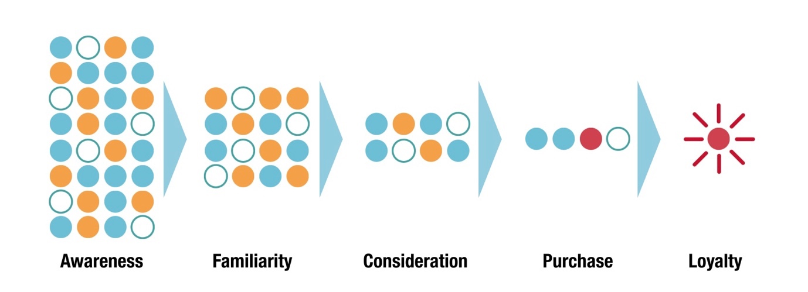
Source: (Court et al., 2009))

The five phases of a decision-making process were initially outlined by philosopher John Dewey in his work "How We Think," published in 1910 (Dewey, 2008). Subsequent research further developed Dewey's original concepts, laying the groundwork for the analysis of consumer buying decision processes (Simpson, 2019). The customer decision-making process, often referred to as the consumer buying process, describes the steps that individuals go through when making a purchase decision. The Five-Stage Model is widely recognized as a prevalent framework for understanding the consumer decision-making process, delineating five distinct stages: recognizing a need or problem, conducting an information search, evaluating alternatives, making a purchase, and conducting post-purchase evaluation (Kotler and Keller, 2012). This straightforward model effectively elucidates the steps involved in consumer purchasing decisions.

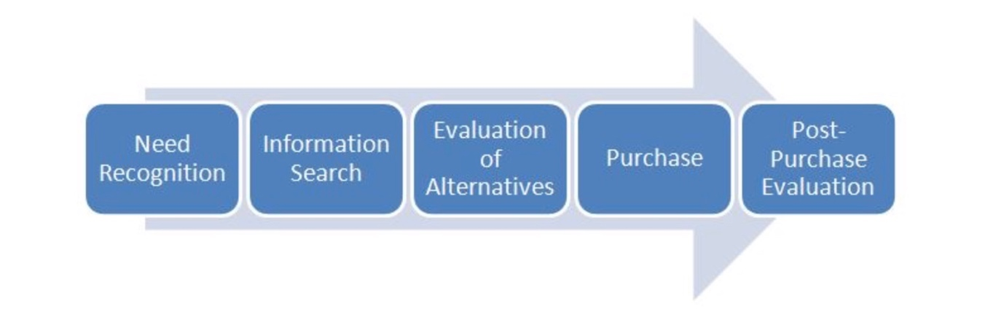
Source:

Recognition of Need or Problem: This is when consumers identify a need or problem that requires a solution. For example, a consumer may realise they need a vacation to relieve stress and explore new destinations.
The initial phase of the model is the recognition of need or problem, where consumers become aware of their requirements (Babin and Harris, 2023). Marketers aim to deliberately create a discrepancy between consumers' current state and their desired state to incite a need, prompting consumers to identify and acquire a product or service. This disparity can arise spontaneously and may be a fundamental urge, termed as an internal stimulus. Conversely, an external stimulus occurs when individuals are influenced by external factors. Marketers induce a sense of imbalance or need through advertising and promotional activities. Once consumers acknowledge an unmet need and recognize that a product can fulfil it, they develop a desire (Stankevich, 2017).
Additionally, providing information about offerings, pricing, and packages empowers potential buyers to make well-informed purchasing decisions (CFI, 2024) (Indeed, 2022). According to Cohen, Prayag and Moital (2013), Tourism consumer behaviour entails a lot of factors including decision-making, values, motivations, self-concept, personality, expectations, attitudes, perceptions, satisfaction, trust, and loyalty. Consequently, marketing within the tourism industry to create desire or need for certain product and service in consumers necessitates handling extensive volumes of data. Through predictive analytics, marketers can analyse vast amounts of data to understand consumer behavior, interests, and past interactions with travel-related content. By leveraging AI algorithms, personalised recommendations and promotions can be delivered to potential travelers, enticing them with compelling offers and experiences that align with their need (ZULAIKHA et al., 2020).
In this stage, AI tools track online activities, such as search queries on search engines or websites, social media interactions, and browsing behaviour, to identify signals indicative of travel-related interests or intentions. For instance, predictive analytics may recognize patterns suggesting an upcoming vacation plan, a desire for adventure travel experiences, or an interest in specific destinations based on previous online interactions (Huang and Rust, 2020). With the aid of predictive analytics, AI algorithms can analyse vast amounts of data, including demographics, browsing history, and online behaviour, to identify audiences effectively (ZULAIKHA et al., 2020). By leveraging AI marketing techniques, such as personalized recommendations, targeted advertisements, and customized promotions, tourism businesses can effectively respond to these identified needs and problems.
Information Search: After recognising a need, consumers begin to search for information about potential solutions. In the context of tourism, this might involve researching destinations, accommodations, activities, and travel options online. AI-powered digital marketing plays a crucial role here by providing personalised recommendations, suggesting travel destinations based on past behaviour or preferences, and presenting targeted ads for relevant products and services.

From the perspective of information value, factors influencing online consumer search behavior include relevance, accuracy, depth, timeliness, clarity, accessibility, variety, personalization, interactivity, privacy, security, and social influence (Grant, Clarke and Kyriazis, 2007). These factors collectively shape consumers' online search behavior and influence their decisions and actions. According to Wang et al. (2016), contemporary travellers possess more individualised preferences and prioritise personalised services, a shift from the preferences observed in the pre-Internet and social media era. A study involving 6,661 tourists and analysing data from 244,980 travel instances revealed robust correlations between tourists' interests and their chosen travel destinations (Sohrabi et al., 2020). This research underscores the efficacy of marketing strategies tailored to promote destinations aligned with traveller's specific interest categories, offering valuable insights for marketers in the tourism industry. By analysing big data encompassing demographics, browsing behaviours, and past interactions, AI algorithms identify patterns and trends indicative of individual interests and preferences (Singh, Bansal and Sharma, 2022). AI-driven algorithms analyze vast datasets comprising consumer preferences, historical behavior, and real-time interactions across digital platforms to provide tailored and relevant information to consumers seeking travel-related services. Through predictive analytics, AI models anticipate the specific information needs of consumers based on their past behavior and preferences, thereby presenting them with personalized recommendations, curated content, and targeted advertisements that align with their interests and intentions.
Moreover, AI-powered chatbots and virtual assistants play a crucial role in assisting consumers during the information search process. By leveraging natural language processing and machine learning algorithms, these AI-driven tools can engage in conversational interactions with consumers, addressing their queries, providing real-time assistance, and offering relevant information about travel destinations, accommodations, activities, and pricing options (Chaturvedi and Verma, 2023).
Additionally, predictive analytics enables tourism businesses to optimize their digital marketing efforts by identifying the most effective channels, content types, and messaging strategies to reach and engage their target audience during the information search stage (Alqurashi et al., 2023). Through data-driven insights derived from AI algorithms, marketers refine their content strategies, allocate resources effectively, and deliver timely and impactful information to consumers at various touchpoints across their digital journey.

Evaluation of Alternatives: Once consumers gather information, they evaluate various alternatives to satisfy their need. This stage is crucial as it directly influences consumer behavior, engagement, and conversion rates. In tourism, this could involve comparing different travel packages, reading reviews, and considering factors like cost, convenience, and amenities. For instance, in tourism industry, consumers look at various things when considering and booking hotels online, using quick decision-making methods at first and then considering all factors before making a final booking, which has implications for how hotels set prices and online platforms are designed (Hu and Yang, 2020).
Consumers exploring market alternatives often seek distinguishing factors among offerings, including price, quality, features, customization options, brand recognition, industry trends, and availability (Indeed, 2023). A study highlights how the internet has reduced the distinction between search and experience goods by making information more accessible and enabling consumers to research products before purchase (Huang, Lurie and Mitra, 2009). It found that although consumers spend similar amounts of time researching both types of goods online, there are differences in browsing and purchasing behaviors. In this phase, consumers utilize AI-powered tools and predictive analytics to assess different travel destinations, accommodation options, activities, and other relevant factors based on their preferences, budget, and needs. Product reviews and interactive multimedia have a greater influence on consumer behavior for experience goods compared to search goods (Kim, 2020). AI marketing influence consumers' evaluations by highlighting unique selling points, offering discounts or personalised deals, and providing real-time pricing predictions. (Goh, Hui and Png, 2014)

Purchase Decision: After evaluating alternatives, consumers make a purchase decision. This could involve booking a flight, hotel room, or tour package.
Crucially, the purchase decision can be influenced by the evaluation of alternatives or may be influenced by situational factors such as effective point-of-sale marketing techniques and environmental factors at the point of sale. According to Evans, Jamal and Foxall (2009), the outcome of the evaluation of alternatives may change, even in the final moments before the purchase, due to the influence of other people's attitudes or a combination of other factors. AI marketing facilitate the purchase decision by streamlining the booking process, offering incentives like loyalty rewards or limited time offers, and providing seamless integration across multiple platforms for a hassle-free experience (Hu and Yang, 2020).

Post-Purchase Evaluation: After the purchase, consumers assess their experience and satisfaction with the chosen product or service. In tourism, this involves reflecting on the overall travel experience, accommodations, activities, and customer service. AI marketing can enhance post-purchase evaluation by sending follow-up emails or surveys to gather feedback, offering personalised recommendations for future trips based on past experiences, and addressing any concerns or issues to improve customer satisfaction and loyalty.

Customers' perceptions of a product's performance can lead to either satisfaction or dissatisfaction, significantly impacting their level of loyalty and the opinions of peers, friends, and family regarding purchases play a pivotal role in post-purchase evaluations (Dudovskiy, 2013). Throughout these stages, AI-powered predictive analytics can analyse consumer behaviour, preferences, and engagement patterns to tailor marketing strategies, optimise content delivery, and predict future trends. By leveraging AI marketing effectively, businesses in the tourism industry can better understand consumer needs, enhance engagement, and improve conversion rates.

Cognitive dissonance refers to the psychological discomfort experienced when incoming information conflicts with one's established beliefs, prompting individuals to utilize defensive strategies to mitigate the discomfort and uphold consistency in their perception of the world and self (Britannica, 2023). In the context of consumer behaviour, cognitive dissonance occurs after a purchase decision when the consumer experiences doubt or regret about their choice (Marikyan, Papagiannidis and Alamanos, 2020). Cognitive dissonance is strongly related to brand loyalty and customer retention (Yakın et al., 2023).

Marketers in Travel and Tourism industry minimise cognitive dissonance by employing many strategies.

Providing Clear and Accurate Information: Utilizing predictive analytics enables marketers to personalize marketing communications by aligning messages closely with consumers' preferences and past behaviours, thereby providing precise and accurate information. (Bulchand-Gidumal et al., 2023). By delivering tailored recommendations and offers, marketers reduce the likelihood of post-purchase dissonance by enhancing perceived satisfaction with the chosen tourism products or services.
Reviews and Loyalty Programmes: AI-driven loyalty programs act as another potent tool for boosting engagement and fostering repeat business (Chaturvedi and Verma, 2023). Personalised rewards and promotions based on specific actions, such as early booking, positive reviews, or referrals, not only incentivise desired behaviours but also demonstrate appreciation for high-value customers. Dynamically adjusting program benefits based on individual behaviour and engagement levels ensures that loyalty programs remain relevant and rewarding for each customer, maximising their impact.
Optimising customer experience: AI is being utilized to optimize the overall customer experience across various touchpoints in the tourism industry (Forbes, 2023). By analysing vast amounts of data, AI algorithms can identify potential pain points or areas of friction in the consumer journey and recommend proactive interventions to address them (Edelman and Abraham, 2022). This proactive approach helps to mitigate any discrepancies between consumers' expectations and their actual experiences, thus reducing cognitive dissonance.

Follow-Up Communication and Additional Support: Many companies with the help of AI follow up customers after a purchase to thank them for their business and address any questions or concerns they may have (Mckinsey, 2023). This proactive approach demonstrates care and support for the customer's post-purchase experience. Clear and transparent communication can help set realistic expectations and reduce the likelihood of post-purchase dissatisfaction. Offering additional support or resources, such as tutorials, troubleshooting guides, or customer service assistance, help consumers feel more confident and satisfied with their purchase. Knowing that help is available ease concerns and reduce cognitive dissonance.

Overall, minimising cognitive dissonance requires marketers to focus on building trust, providing accurate information, and offering support throughout the customer journey. By addressing any post-purchase doubts or concerns effectively, marketers can enhance customer satisfaction and loyalty.

Customer Lifetime Value (CLTV) Prediction Models

Customer lifetime value (CLTV), or simply lifetime value, represents the cumulative revenue anticipated from a customer throughout their association with a company. This computation incorporates factors such as customer acquisition expenses, operational costs, and production costs related to the goods or services offered. While often underestimated, understanding the lifetime value of customers is pivotal for a company's expansion (CFI, 2023).
Figure: Customer Lifetime Value Calculation

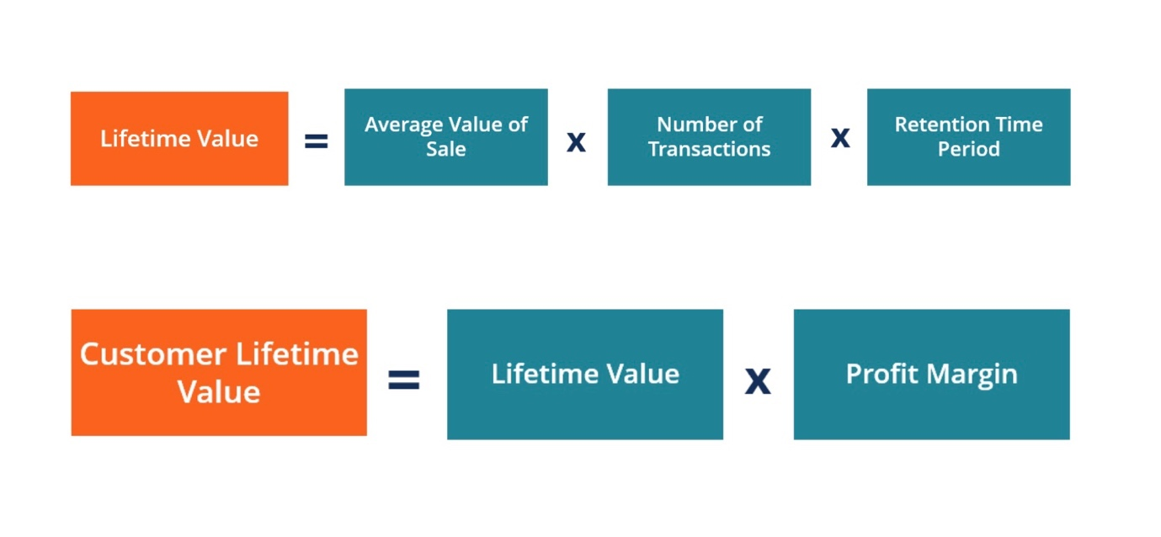
Customer lifetime value (CLTV) holds significant importance within the realm of predictive analytics in digital marketing, particularly in assessing the impact of AI marketing on consumer behaviour, engagement, and conversion rates in the tourism industry. CLTV provides invaluable insights into the long-term revenue potential of individual customers, enabling marketers to tailor their strategies to maximize customer retention, engagement, and satisfaction Customer lifetime value (CLTV) holds significance as it prompts companies to prioritize the longevity of their customer relationships over short-term gains. It serves as a crucial metric as it sets a threshold for the investment required to acquire new customers. (Bendle et al., 2010).

The factors to consider when predicting Customer Lifetime Value (CLTV) include data availability, industry segmentation, business goals, and model interpretability. Limited datasets may benefit from simpler models like RFM, while richer datasets may require more complex models such as Gradient Boosting Machines (GBM) or Recurrent Neural Networks (RNNs). Industry segmentation helps tailor the model to capture segment-specific nuances, aligning with business objectives that prioritize high-spending customers or frequent travelers. Additionally, choosing models based on their interpretability, opting for transparent models like decision trees or "black box" models like neural networks, impacts understanding and application. By considering these factors, organizations can develop CLTV models suited to their specific needs and objectives. (Sun, Liu and Gao, 2023)

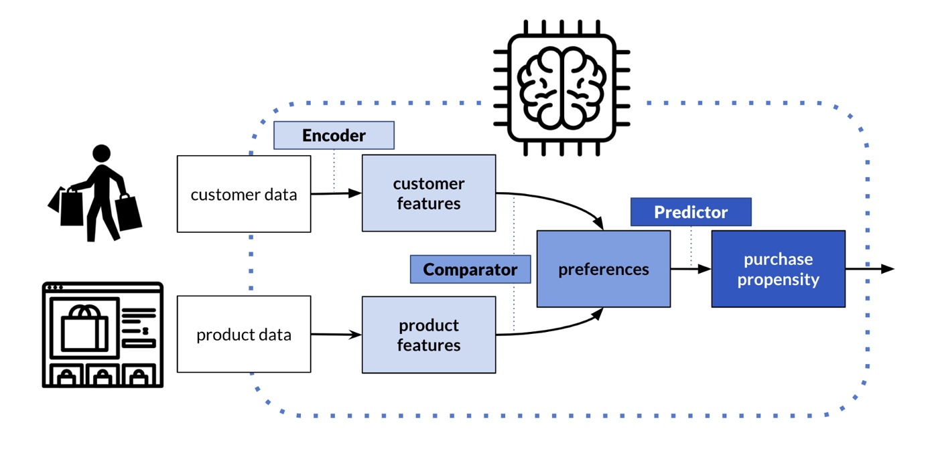

GBM Model
Gradient Boosting Machine (GBM) is a powerful predictive modelling technique widely used in various industries, including digital marketing and the tourism sector. It is a machine learning technique used for both regression and classification tasks. It is an ensemble learning method that builds multiple decision trees sequentially, with each tree attempting to correct the errors of the previous one. In the GBM model, each tree is trained on the residuals (the difference between the actual and predicted values) of the previous trees, thereby improving the overall predictive accuracy (Wang and Ross, 2018).
GBM works by combining multiple weak predictive models, typically decision trees, to create a strong ensemble model. It builds trees sequentially, with each tree focusing on the mistakes made by the previous ones, gradually reducing prediction errors. This iterative process allows GBM to learn complex relationships and patterns in the data, making it highly effective for predictive analytics tasks (Piryonesi and El-Diraby, 2019).

In the tourism industry, GBM can be used to predict various outcomes, such as customer preferences, booking likelihood, and lifetime value. By analyzing historical data on customer interactions, demographics, and past behaviors, GBM can identify key factors influencing consumer decisions and engagement. This insight enables marketers to tailor their strategies more effectively, personalize marketing communications, and optimize resource allocation for maximum impact.

However, it's essential to note that GBM requires careful tuning and validation to avoid overfitting and ensure reliable predictions. Additionally, interpreting GBM models can be challenging due to their complexity, requiring expertise in data analysis and machine learning techniques. Despite these challenges, GBM offers significant potential for enhancing digital marketing efforts in the tourism industry, driving better engagement and conversion rates through data-driven insights and predictive analytics.

Research Methodology

The concept of 'Research' as defined by Cambridge Dictionary (2023) involves a comprehensive examination of a topic with the aim of uncovering new information or achieving a deeper understanding. Research methodology, as described by Panneerselvam (2014), encompasses a collection of principles, methodologies, and procedures utilised to address research inquiries. One approach to structuring research methodology is based on the theoretical framework known as the "Research onion," as outlined by Saunders et al. (2007). This dissertation aims to explore the multifaceted layers of research methodologies encapsulated within the Research Onion framework to attain a holistic comprehension of the complex interplay between AI marketing strategies and consumer responses in the travel and tourism sector. By peeling back, the layers of the research onion, this research endeavour to uncover insights that illuminate the efficacy and implications of predictive analytics in shaping marketing practices and consumer experiences within the digital domain of travel and tourism.

Research Design
This chapter describes the methodological framework of this research project, beginning with the research philosophy and going on through data collection, data analysis procedures, and ethical considerations. This is the second step to acquiring information and data to fulfil this study's objectives. This chapter outlines the methodology framework utilising Saunder's Study Onion model. It begins by examining the selection of each layer of the Onion Model concerning the current investigation. The Research Onion model, devised by Saunders et al. (2007), serves as a useful framework for organising research methodology. In this study focusing on AI-driven predictive analytics in the tourism sector, the model will be systematically applied. It will commence with the outer layer, encompassing research philosophy (positivism), followed by the approach (deductive), and subsequently the research strategies (survey). The choice of time horizon will be cross-sectional, considering the one-time nature of data collection. Lastly, data collection methods will involve online questionnaires, aligning with the quantitative research methods layer of the onion. This methodological structure aims to uphold a clear and rigorous approach throughout the research process, including assessment of data collection, analysis, and sampling procedures employed in the study.

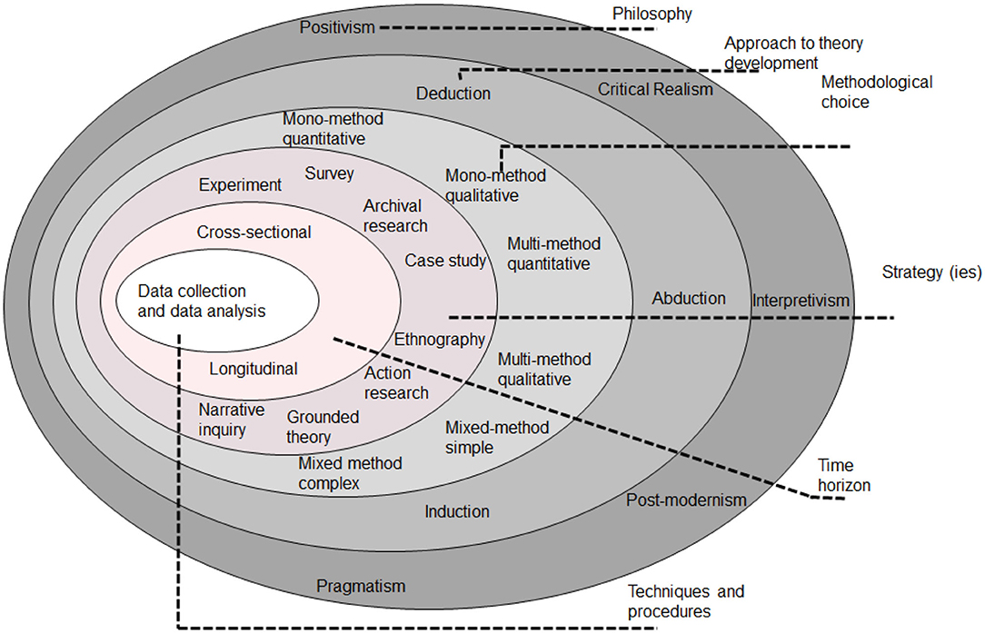

Figure 11: Research Onion (Saunders et al., 2019)

By considering the research method an "onion," with the study subject at the centre, the researcher needs to "peel" layers to reach the centre. In this research 'Research Onion' method was followed to fulfil the objectives.
Research Design (Confused)

The current study's research framework focused on "Predictive Analytics in Digital Marketing: Evaluating the Impact of AI Marketing on Consumer Behaviour, Engagement and Conversion Rates in the tourism Industry," follows the structure outlined in the Saunders Research Onion Model (2007). This model encompasses various stages crucial for ensuring methodological consistency. Both quantitative and qualitative methods are commonly employed to gather nuanced insights. Adopting a cross-sectional temporal horizon aligns with the perspectives of researchers such as Saunders, Lewis, and Thornhill (2007), enabling an exploration of AI's current practices in the Tourism marketing. The significance of the model lies in its coherent structure, ensuring that each step is purposefully linked to the study objectives. The study aims to establish the effectiveness of predictive analytics powered by AI in digital marketing within the tourism industry. It seeks to evaluate how AI-driven marketing initiatives influence consumer behaviour, engagement metrics, such as website and social media interactions, and ultimately, conversion rates. By examining these factors, the research intends to shed light on the role of AI in shaping marketing strategies and enhancing consumer experiences in the tourism sector.

Research Philosophy

Research philosophy is a collection of beliefs about the reality of the situation under investigation (Becker et al., 2012). It provides the foundation of the study by distinguishing ontology (the nature of reality), epistemology (the nature of knowledge or facts), and axiology (the values, beliefs, and ethics of the study) (Winit-Watjana, 2016)

Epistemology is the philosophical study that understands and explains knowledge's nature, origin, and development. Epistemology covers perception, memory, insight, inference, and testimony (Martinich and Stroll, 2019). Empiricism also works well in this situation since it interacts with cognitive science and history.
Axiology pertains to research ethics. It investigates how to make good choices philosophically. Establishing, measuring, and understanding positive and negative study behaviour. It examines how much weight the researcher wants to give to participants, data, and audience. (Kivunja and Kuyini, 2017).
Ontology describes the nature of reality, what concepts occur through inquiry, and how it affects society and its surroundings (Steup, 2010). Ontology separates reality from experience. It shows how it impacts behaviour. Ontology separates reality from perception. (Steup, 2010). In this study, the research ontology contains positivism.

Positivism is using observed social reality to generate law-like ggeneralisations Positivism means suggested' or 'offered.' This eemphasisespositivist approaches that provide pure data and facts without subjective interpretation or prejudice (Saunders et al., 2019). Positivism is a philosophical stance that eemphasisesempirical observation and scientific methods to understand and interpret phenomena. In the context of the study on predictive analytics in digital marketing within the tourism industry, adopting a positivist approach entails a focus on quantifiable data and measurable outcomes. Positivism aligns with the study's objective of evaluating the impact of AI marketing on consumer behavior, engagement, and conversion rates, as it eemphasisesthe use of objective data and statistical analysis to draw conclusions.

Positivism allows researchers to collect and aanalyselarge datasets generated by AI-driven marketing initiatives to identify patterns, correlations, and trends in consumer behavior. By employing positivist methodologies such as surveys, experiments, and quantitative data analysis, researchers can objectively measure the effectiveness of AI marketing strategies in influencing consumer behavior, engagement metrics, and conversion rates.

Furthermore, a positivist approach facilitates the ggeneralisationof findings to broader populations within the tourism industry. Through rigorous empirical investigation, researchers can develop predictive models that forecast consumer responses to AI marketing interventions, providing valuable insights for marketers and policymakers.

Overall, positivism provides a systematic and rigorous framework for studying the impact of AI marketing on consumer behaviour, engagement, and conversion rates in the tourism industry, enabling researchers to generate reliable and actionable knowledge to inform marketing strategies and decision-making processes.
.
In this research, all the data comes from primary research; therefore, positivism applies in this research. The data were compiled using a scientific approach, and Positive data underpins all factual knowledge.

3.2 Research approach

The research approach refers to the systematic and structured manner in which researchers conduct their investigations, varying in fundamental reasoning and investigative techniques. Deduction, induction, and abduction stand as the primary approaches for theory development (Saunders, Lewis, and Thornhill, 2019).

The deductive approach involves verifying a theoretical proposition through a research strategy tailored for this purpose (Saunders, Thornhill, and Lewis, 2015). Commonly employed in quantitative research, it typically initiates a study proposal with the goal of testing or validating a theory rather than originating it (Creswell, 2013). This entails proposing a hypothesis, gathering data for testing, and subsequently evaluating its affirmation or negation based on the outcomes (Creswell, 2009).

In the current study, a deductive approach was adopted to evaluate the impact AI powered Predictive analytics on customers in the tourism sector. Leveraging existing information on AI marketing and marketing communication models, the researcher aimed to test research objectives regarding the influence of AI on customers. This involved several steps: firstly, reviewing literature on AI powered Predictive analytics marketing, tourism industry to understand the current knowledge and identify relevant theories and models connecting AI marketing and consumer's engagement, behaviour and convertion rates. Secondly, selecting an appropriate research design, such as a cross-sectional survey, to collect data from tourism consumers to test the research objectives. Lastly, aanalysingthe collected data, interpreting the results, ssummarisingkey findings addressing the research objectives, and evaluate AI marketing influence on the tourism consumers.

3.4 Research Strategy

The research strategy shows the general direction of the study and how the research will be executed (Wedawatta, Ingirige and Amaratunga, 2011). Research strategies consist of overall planning, including experimental, action, ethnography, survey, Grounded theories and case study research.

Typically, the deductive research approach is associated with the survey methodology (Saunders, Lewis, and Thornhill, 2019). This approach is widely used in the field of business and management research, primarily focusing on addressing questions related to "who," "what," "how much," "where," and "how many." Consequently, it is frequently applied in descriptive and exploratory research (Saunders, Thornhill, and Lewis, 2015). A survey is a systematic method for gathering data from a group of individuals to describe, understand, or explain the characteristics, perspectives, actions, or attitudes of a larger population (Fowler, 2013). For this study, a survey questionnaire approach has been employed to collect detailed, reliable, and easily comprehensible data from users of social media platforms (followers and/or consumers of luxury fashion brands) to aanalysethe research problem.
Data type divides research into three categories: Quantitative, qualitative, and mixed method (University of Newcastle Library, 2022).

Quantitative: The feature of this research data is that information is gathered and aanalysedusing statistically oriented approaches such as polls or surveys, which concentrate on acquiring numerous data from individuals (Almalki, 2016).
Qualitative: Qualitative methods are termed "inductive" because they assume reality is socially created, variables are hard to measure, complicated, and entangled, the topic is essential, and data will come from an insider's perspective (Rovai, Baker and Ponton, 2014).
Mixed: This study integrates qualitative and quantitative research processes (e.g., qualitative and quantitative viewpoints, data collection, analysis, and reasoning) for broad and deep understanding and corroboration (Johnson, Onwuegbuzie and Turner, 2007).
This study uses mixed techniques to aanalyseall primary data sources and combine quantitative and qualitative research approaches to get precise results and meet research objectives.

Types of Research

The current study has employed both primary and secondary research methodologies to gather and aanalysedata in support of its research objectives. These methods enabled the researcher to obtain a comprehensive understanding of the research topic from various sources, thereby enhancing the robustness and reliability of the analysis.

Primary Research

According to Saunders, Lewis, and Thornhill (2019), primary research involves the collection of new, original data or information tailored to a specific research project. Also known as field research, primary research allows researchers to address specific research questions or objectives through methods such as interviews, surveys, observations, or experiments (Saunders, Thornhill, and Lewis, 2015).

The research "onion" provides a structured framework for conducting primary research, guiding researchers in selecting appropriate methodologies that align with their research questions and objectives. This structured approach ensures a cohesive research methodology, thereby enhancing the quality, validity, and reliability of the study by addressing research philosophy, approach, strategy, choices, time horizon, and techniques.

In this study, primary research was conducted through a survey questionnaire. The survey questionnaire is a popular and efficient method of collecting primary data from a large number of respondents (Bryman, 2016). This approach allows the researcher to gather sstandardiseddata on attitudes, opinions, behaviours, or demographic characteristics related to the research topic (Fowler, 2013). In the case of this study, the survey questionnaire has provided valuable insights into the impact of AI powered Predictive analytics on tourists.

Advantages and Disadvantages of Primary Research

Maslow's Hierarchy of Needs Theory provides a comprehensive framework for understanding human motivation and behaviour. It suggests that individuals are motivated to fulfil basic needs before progressing to higher-level needs. In the context of the research on predictive analytics in digital marketing within the tourism industry, we can elaborate on how each level of Maslow's hierarchy applies:

1. Physiological Needs: At the foundational level are physiological needs such as food, water, and shelter. In the context of travel and tourism, consumers seek destinations and experiences that satisfy these basic needs. Predictive analytics can aanalysedata to identify popular destinations known for their culinary offerings, comfortable accommodations, and access to essential amenities.

2. Safety Needs: Once physiological needs are met, individuals pprioritisesafety and security. In the tourism industry, travelers look for destinations and services that offer safety assurances, such as low crime rates, reliable transportation, and emergency support. AI marketing can tailor messages to highlight safety features and provide reassurance to potential travelers.

3. Social Needs: Humans have a natural inclination for social interaction and belonging. Travel experiences often fulfill social needs by providing opportunities for bonding with family and friends, meeting new people, and participating in group activities. Predictive analytics can identify trends in social travel preferences, allowing marketers to promote group tours, social events, and networking opportunities.

4. Esteem Needs: Esteem needs involve seeking recognition, respect, and self-esteem. In the tourism industry, consumers may seek travel experiences that enhance their status or self-image. AI marketing can ccustomiseoffers to appeal to consumers' desire for unique and prestigious experiences, such as luxury accommodations, VIP access, or exclusive tours.

5. SSelf-Actualisation At the pinnacle of Maslow's hierarchy is sself-actualisation which involves rrealisingone's full potential and pursuing personal growth and fulfillment. Travel and tourism experiences often facilitate sself-actualisationby offering opportunities for exploration, learning, and self-discovery. Predictive analytics can help marketers identify niche interests and tailor experiences that align with consumers' aspirations and values, such as adventure travel, cultural immersion, or spiritual retreats.

Analysis of Data

4.1 Introduction

This section presents an analysis of survey data aimed at evaluating the impact of AI marketing on consumer behaviour, engagement, and conversion rates in the tourism industry. It explores respondents' utilization of online platforms for leisure travel, experiences with AI-powered features in travel services, and the frequency of personalized recommendations during travel planning. Additionally, it examines respondents' perceptions of recommendation accuracy, factors influencing travel decisions, and concerns regarding AI implementation in the tourism sector. By analysing these survey findings, this section aims to provide insights into the role of predictive analytics in digital marketing strategies within the tourism industry.

4.2 Questionnaire Analysis
Question 1. Do you typically use online platforms or apps to research and book travel for leisure purposes? (e.g., booking platforms, Airlines, price comparison websites)
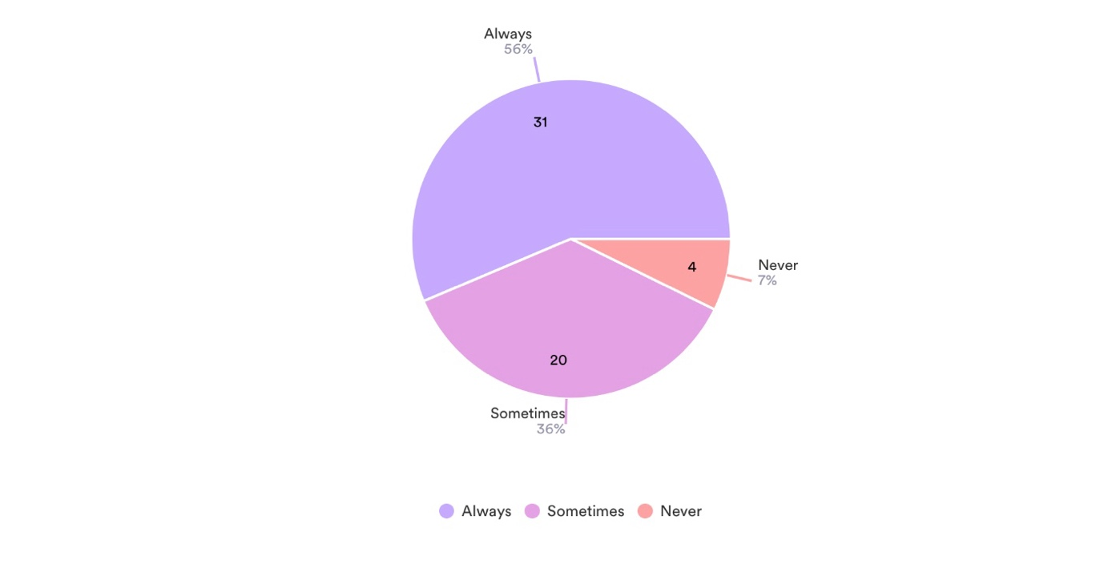
The survey revealed that a majority of respondents, 96% have experience of using online platform to plan and book their holidays and 56% often utilize online platforms or apps for leisure travel purposes. Meanwhile, 36% reported using these platforms occasionally, with only a small minority of 4% indicating that they never rely on online channels for leisure travel booking.

Question 2. Have you ever used any travel apps or services that use AI for features like chatbot assistance, itinerary optimisation, or in-destination recommendations?
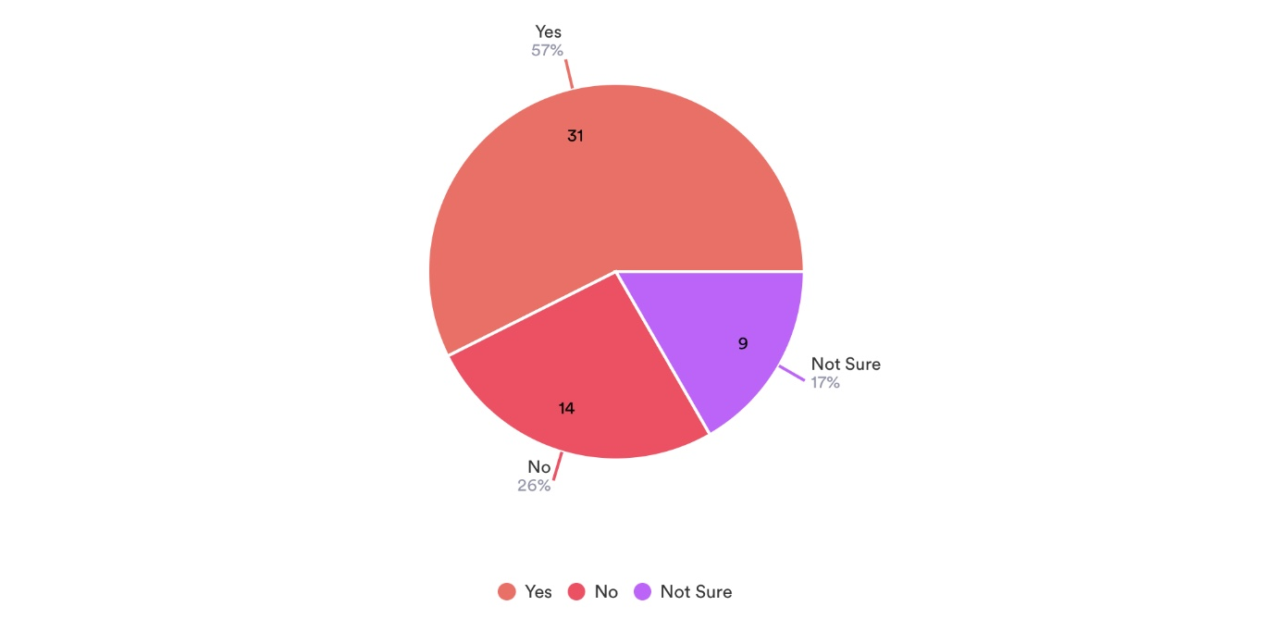
The survey findings indicate a significant uptake of AI-infused travel services among respondents, with 57% affirming their use of such apps or services. In contrast, a smaller proportion of 26% reported not having utilized any travel apps or services featuring AI functionalities.

Question 3. How often have you encountered personalised recommendations for travel destinations, activities, or accommodations during your online travel planning? (e.g., Travel websites, Airlines, Booking platforms)
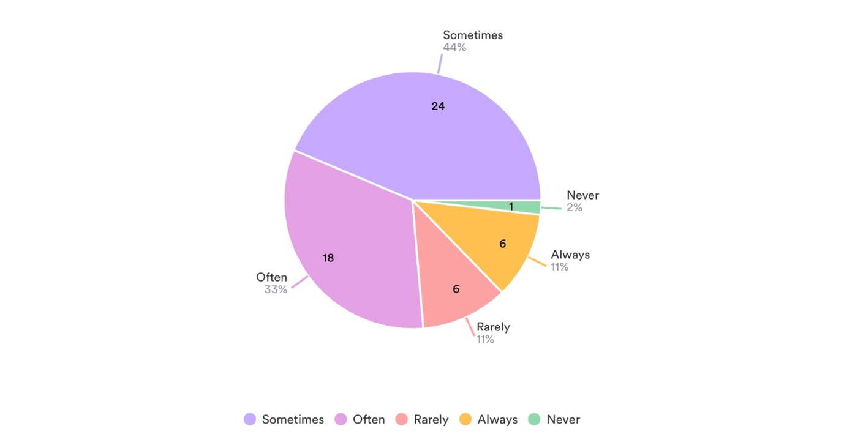
A majority of respondents, constituting 11%, reported they always receive personal recommendations encounters with personalized recommendations for travel destinations, activities, or accommodations during their online travel planning. Additionally, 44% of participants stated experiencing such recommendations sometimes, while a small minority of 13% indicated rare or no encounters with personalized suggestions.

Question 4. In which area or sector within the tourism industry have you encountered the application of AI? (e.g., Accommodation, Transportation, Food & Beverage?
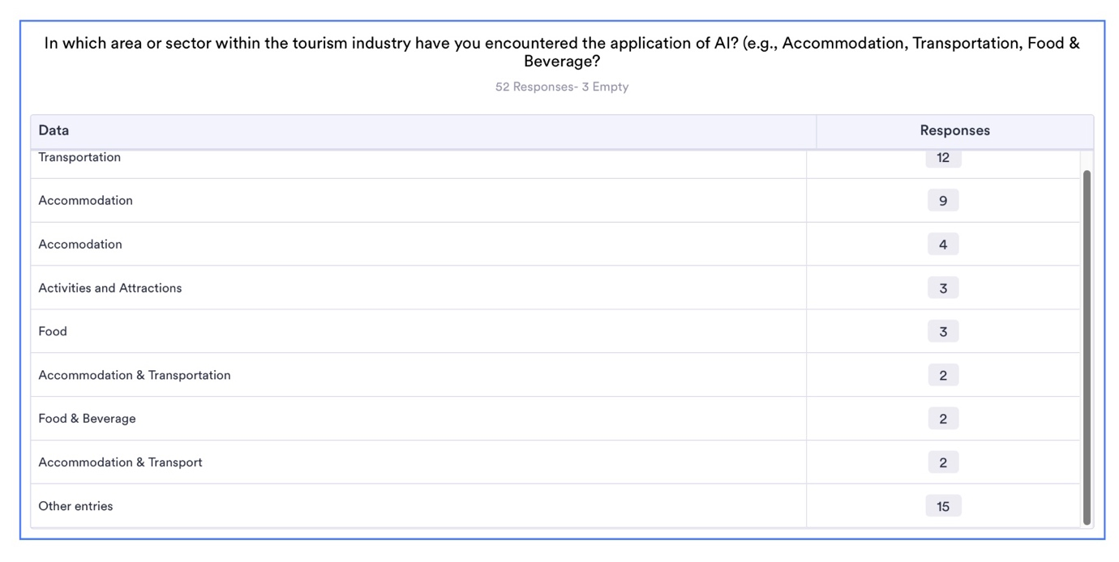
This was an open-end question. In the survey, accommodation was selected by respondents as most common in encountering the application of AI in the tourism industry, indicating a significant presence of AI in this area with 13. Transportation followed closely, with 12 of respondents mentioning AI applications in this sector. 4 people chose both sectors. However, a smaller proportion, 3, reported encountering AI applications in activities and attractions, suggesting a relatively lower integration of AI in this aspect of the tourism industry. The food and beverage sector had the lowest reported encounter rate, with only 2 of respondents mentioning AI applications in this domain.
Question 5. On a scale of 1 to 5, how accurate are these recommendations from websites and apps to predict your travel needs or preferences? (Fill only if you receive recommendations/ suggestions)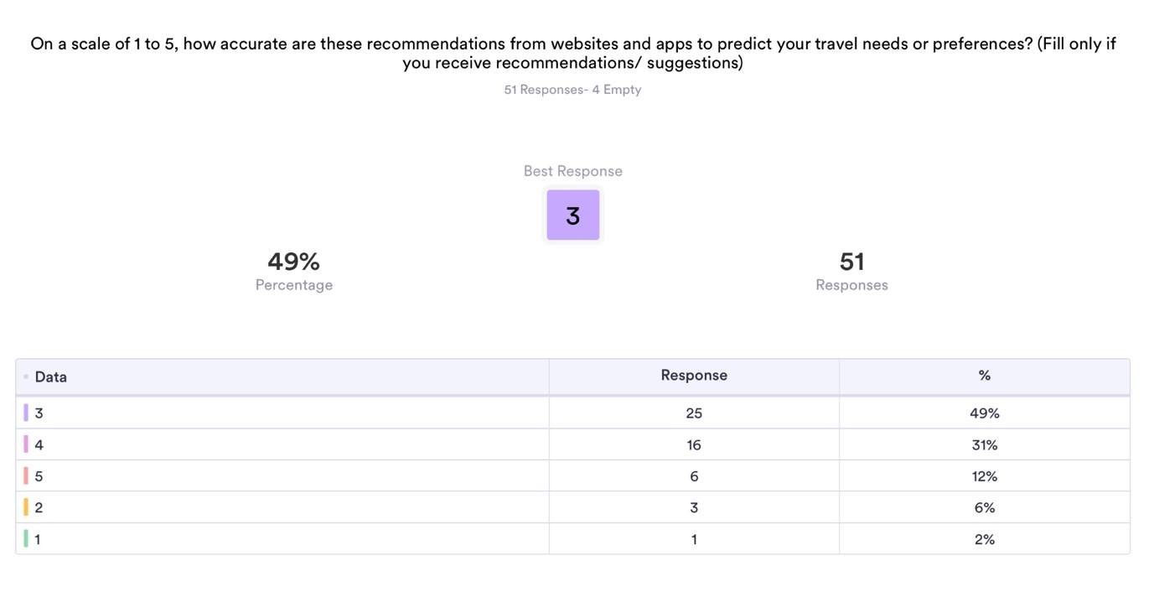
The survey revealed that respondents rated the accuracy of travel recommendations based on that an average of 3 on a scale of 1 to 5, suggesting a moderate level of perceived accuracy. Only 2% felt their recommendations were incorrect.

Question 6. How often do these recommendations influence your travel decisions?
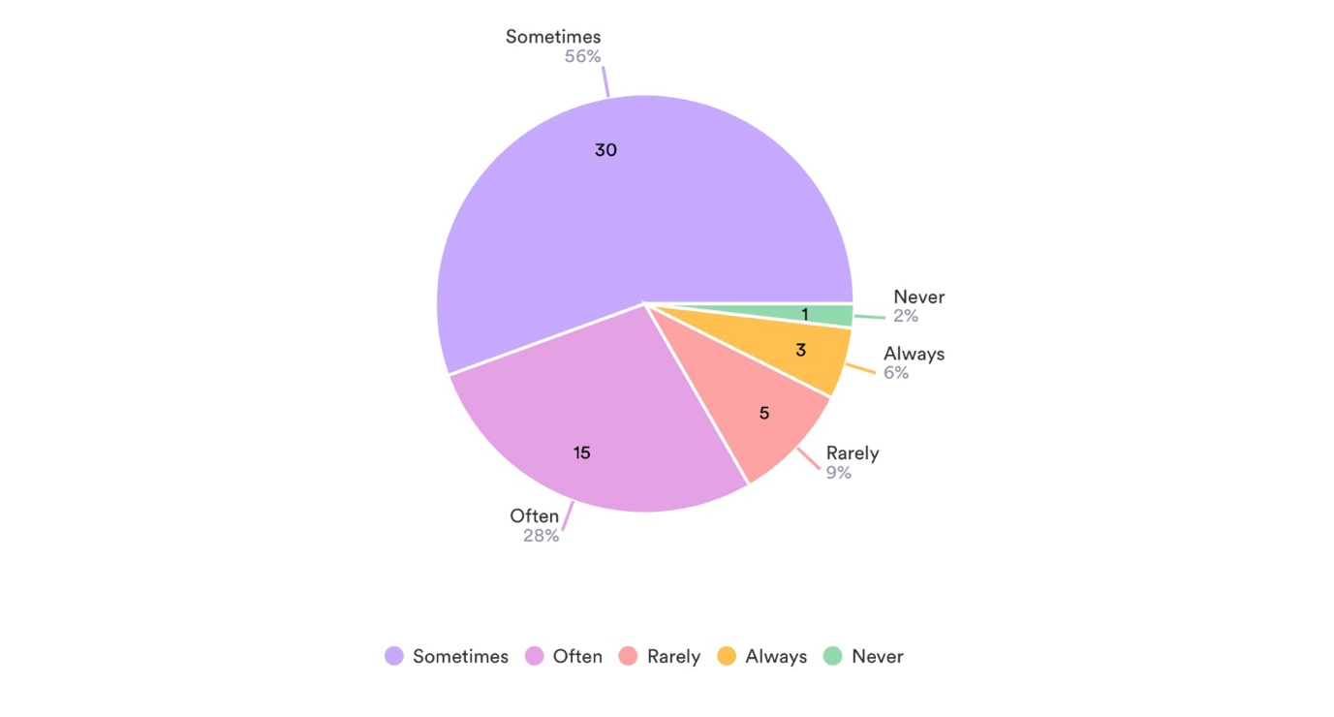
The survey results highlight that travel recommendations wield varying degrees of influence on individuals' travel decisions. Notably, 28% of respondents acknowledged that travel recommendations often play a significant role in shaping their travel choices, indicating a substantial impact. Additionally, 56% of participants reported that while recommendations sometimes influence their decisions, they may not consistently sway their travel plans. Conversely, a smaller proportion, constituting 9% of respondents, indicated that they are rarely influenced by travel recommendations, suggesting a segment of travellers less responsive to such suggestions or perhaps relying on other factors in their decision-making process. And only 2% never influenced by these recommendations. These findings underscore the nuanced nature of how travel recommendations impact individuals' travel choices, reflecting diverse preferences and decision-making patterns among respondents.
Question 7. What factors do you consider when evaluating the usefulness of travel recommendations?
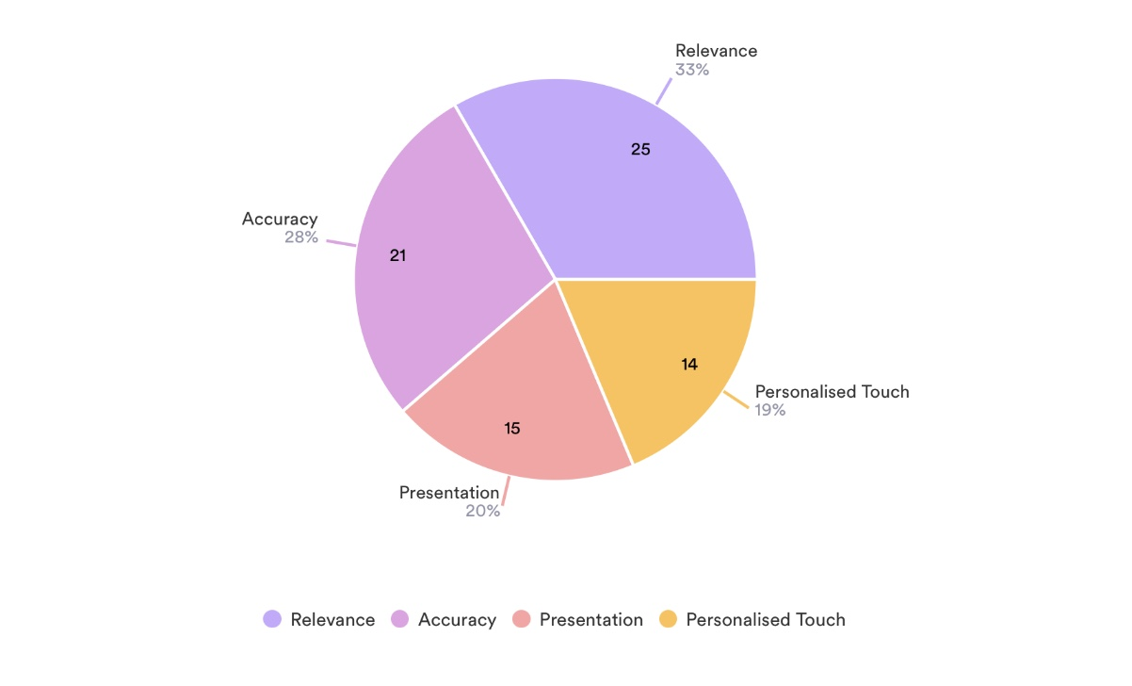
33% of respondents highlighted relevance as a critical factor, indicating the importance of recommendations aligning with their specific travel needs and preferences. Additionally, 28% of participants emphasized the significance of accuracy in recommendations, suggesting a preference for reliable and precise suggestions. A substantial portion of respondents, comprising 19%, emphasized the value of a personalized touch, underscoring the desire for tailored recommendations that resonate with their individual preferences. Moreover, 20% of respondents considered the presentation of recommendations, indicating an appreciation for visually appealing and user-friendly interfaces. These findings underscore the multifaceted nature of factors that contribute to the perceived usefulness of travel recommendations, reflecting the diverse considerations individuals weigh in their decision-making process.

Question 8. Do you think these recommendations/ Suggestions are based on your Online activities or purchase history?
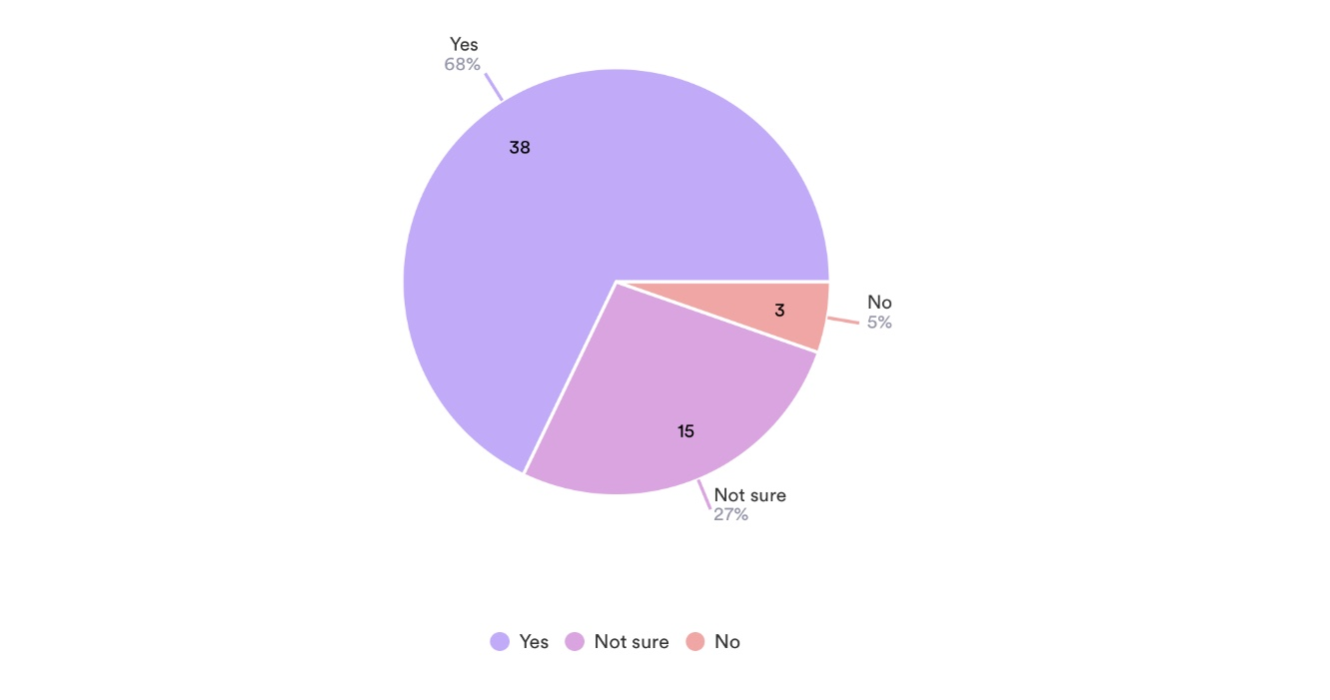
In response to this question, the majority of respondents (68%) indicated that they believe the online recommendations they receive are tailored based on their past activities or purchase history, indicating the success of predictive analytics by AI in identifying consumer needs and preferences. Only a small proportion, comprising 5% of respondents, stated that these recommendations are not influenced by their past activities, while 27% expressed uncertainty regarding the extent to which they are related to their online history.

Question 9. On a scale of 1 to 5, how comfortable are you with travel platforms and businesses using your data for personalised marketing purposes?

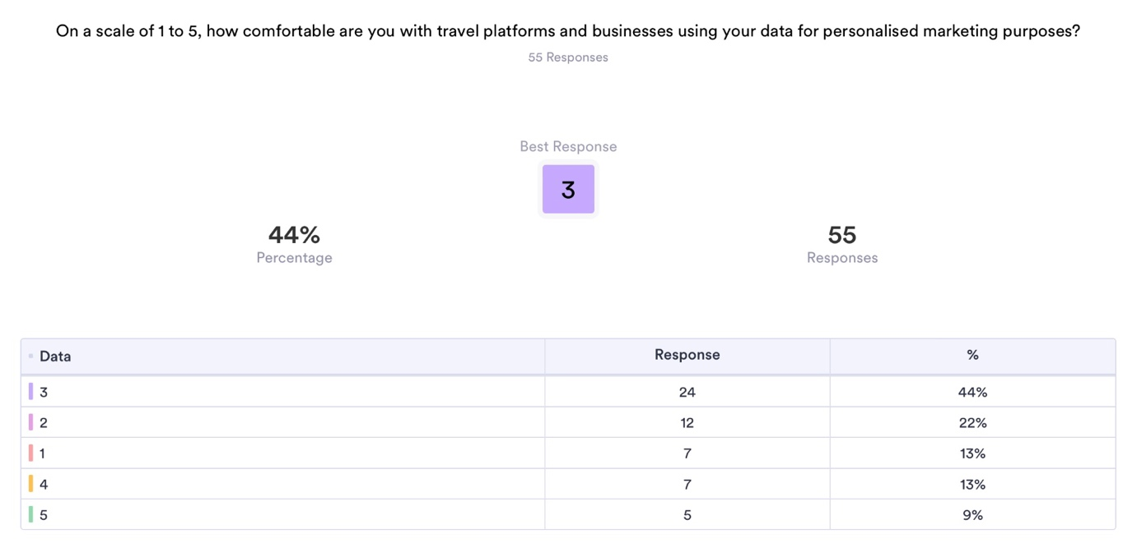
The survey findings indicated that respondents rated their comfort level with travel recommendations at an average of 3 on a scale ranging from 1 to 5, suggesting a moderate level of perceived comfort. However, a notable 9% of respondents expressed discomfort with the use of their data by travel platforms for personalized marketing purposes and felt that some recommendations were inaccurate.

Question 10. What are your biggest concerns about AI being used in the travel and tourism industry? (e.g., data privacy, bias, lack of human interaction, manipulation)
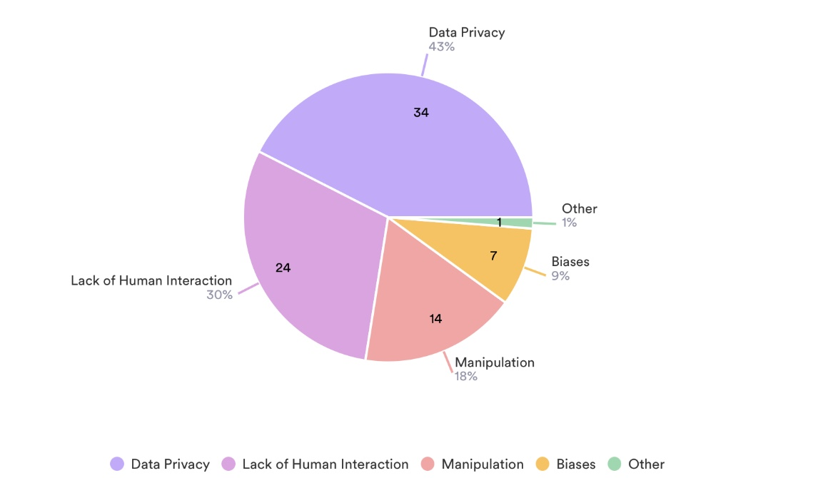
The survey revealed various concerns among respondents regarding the usage of AI in the travel and tourism industry. Data privacy emerged as the primary concern, with 43% of respondents expressing apprehensions about the privacy of their personal information. Additionally, 9% of respondents cited biases as a concern, indicating worries about fairness and impartiality in AI-driven recommendations. 30% expressed concerns about the lack of human interaction, highlighting a desire for more personalized and human-centric experiences. Finally, 14% of respondents raised concerns about potential manipulation associated with AI usage in travel services.
Question 11. How do you think AI-Powered Predictive Analytics can be used to enhance your travel planning and booking experience?
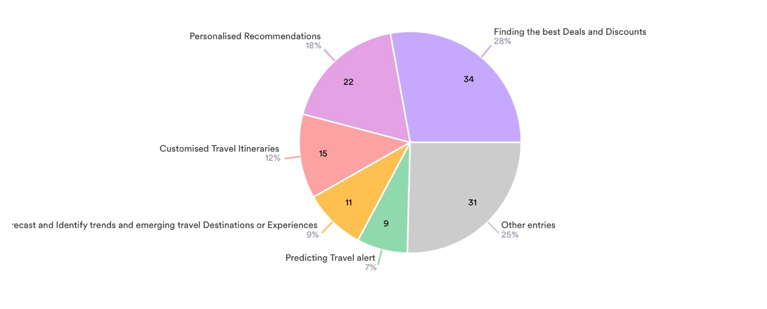
A significant portion of respondents, 28%, recognized the advantage of finding the best deals and discounts through AI-driven platforms. Additionally, 18% of respondents emphasized the importance of personalized recommendations in enhancing their travel experiences. Real-time pricing predictions were identified as a valuable benefit by 7% of respondents, indicating the usefulness of AI in ensuring competitive pricing strategies. Customizing travel itineraries was mentioned by 12% of respondents as a benefit, reflecting the desire for tailored and flexible travel plans. Lastly, 9% of respondents acknowledged the potential of AI in forecasting emerging travel trends, highlighting its role in providing insights into evolving consumer preferences and destination popularity.

Discussion
Over the past decade, a majority of sectors have witnessed a significant shift towards digitalization. Specifically, the travel industry has actively nurtured its online visibility and is continuously advancing, as evidenced by the recent integration of Artificial Intelligence (AI) in travel and tourism operations. The first survey question regarding the utilization of online platforms or apps for leisure travel purposes provides valuable insights into the prevailing trends and behaviours among respondents. The findings reveal a widespread reliance on digital channels for various aspects of travel planning and booking.

Firstly, the high percentage of respondents, 96%, who reported using online platforms or apps to plan and book their holidays underscores the ubiquitous nature of digital tools in the travel industry. This indicates a shift away from traditional methods of travel booking, such as visiting travel agencies or making phone reservations, towards more convenient and accessible online options. Furthermore, the fact that 56% of respondents stated that they often utilize online platforms or apps for leisure travel highlights the frequency with which individuals turn to digital channels when planning their trips. This suggests that online platforms have become integral components of the travel planning process, offering convenience, flexibility, and a wide range of options to users.

Moreover, the 36% of participants indicating occasional use of these platforms underscore the continued preference for digital tools in travel planning, albeit with some still opting for alternative methods. Projections suggest a robust expansion of the global online travel industry, reaching an estimated market size of approximately $475 billion in 2022, with online channels contributing over 60% of the sector's revenue in 2017, expected to increase to 69% by 2023. Van Nuenen and Scarles (2021) acknowledged the popularity of online travel platforms and attribute much of this growth to the widespread adoption of interactive digital platforms, technology, and AI within the tourism sector.

However, the small minority of 4% indicating that they never rely on online channels for leisure travel booking highlights a potential segment of the population that either prefers traditional booking methods or may have limited access to digital technologies. The global picture Understanding the reasons behind this reluctance or inability to use online platforms could provide valuable insights for businesses looking to cater to a diverse range of customers.

Overall, the survey results indicate a strong preference for online platforms and apps for leisure travel purposes among the majority of respondents. This underscores the importance for businesses in the travel and tourism industry to prioritize their online presence, invest in user-friendly digital platforms, and leverage digital marketing strategies to effectively reach and engage with consumers in today's increasingly digital landscape.

