EXAMINING THE INFLUENCE OF LEADERSHIP IN FIFA AND UEFA ON THE FOOTBALL COMMUNITY IN WALES

Dissertation: BMMB7003

University Of Wales Trinity Saint David

RAHIMA AKTHER KHANOM
Student # 1806290
September 23rd September 2024

Dissertation: BMMB7003

Abstract

The global appeal of football is unparalleled, with FIFA and UEFA serving as the principal governing bodies of the sport. Founded in 1904, FIFA oversees 211 national associations and orchestrates major tournaments, such as the Men's World Cup, exerting significant influence on the worldwide development of football, including the Welsh football community. Established in 1954, UEFA governs European football and is responsible for managing prestigious competitions like the UEFA Champions League and the UEFA European Championship. Both organisations have intricate leadership structures designed to ensure transparency and accountability, yet they have been marred by ethical controversies and scandals, raising concerns about their governance practices.
This study critically examines the impact of FIFA and UEFA's leadership on various stakeholders in European football, including clubs, leagues, players, and fans, with a particular focus on the Welsh football community. The research delves into how FIFA and UEFA's leadership priorities, financial models, and governance decisions impact these groups, especially regarding grassroots development and social responsibility within Wales. Employing the Full-Range Leadership Model reveals a combination of transactional and laissez-faire leadership approaches utilised by FIFA and UEFA, resulting in unequal benefits across the football ecosystem, including within Wales.
The research adopts a qualitative methodology, incorporating content analysis of FIFA and UEFA documents, surveys of European football club officials, Survey analysis for grassroots in Wales and focus group discussions with supporters, including those from the Welsh football community, to provide a comprehensive understanding of leadership dynamics. The findings underscore the pressing need for FIFA and UEFA to urgently embrace more transformational leadership practices to ensure equitable benefits for all football communities, from elite clubs to grassroots organisations, particularly in smaller footballing nations like Wales. The study contributes to the broader discourse on ethical leadership in sports governance by offering recommendations for reform to align FIFA and UEFA's leadership with the values and needs of diverse stakeholders, including those within the Welsh football community.
The thesis was structured as follows:
Chapter 1: Introduction
This chapter provides an overview of the research, including the background, aim and objectives, research questions, significance of the thesis, and an outline of the chapters.
Chapter 2: Literature Review
This chapter comprehensively reviews the literature on FIFA and UEFA's leadership structures, governance practices, and stakeholder impacts. It explores relevant theories, models, and empirical studies to establish a solid theoretical foundation for the research.
Chapter 3: Theoretical Framework
This chapter introduces the theoretical framework that guides the analysis and interpretation of the research findings. Bass and Avolio's (1994) full-range leadership model is discussed in detail, along with its relevance and applicability to studying FIFA and UEFA's leadership approaches.
Chapter 4: Methodology
This chapter describes the research methodology employed in the study. (“Free Dissertation Examples for Distinction - Projects deal”) It outlines the qualitative and quantitative methods, including content analysis, surveys, interviews, and focus groups. The data sources, sampling strategies, data collection procedures, and analytical techniques are explained in detail.
Chapter 5: Results and Analysis
This chapter presents the research findings according to the objectives and questions. It comprehensively analyses the collected data, including content analysis of organisational documents, survey results, interview and focus group insights, and thematic analysis.
Chapter 6: Discussion
This chapter critically discusses the research findings about the theoretical framework and existing literature. It examines the implications of the findings for FIFA and UEFA's leadership approaches, stakeholder relationships, and the broader governance of European football.
Chapter 7: Conclusion
Based on the research findings and discussion, this chapter provides constructive recommendations for FIFA and UEFA's highest decision-makers to reform their leadership approaches. These recommendations hold the potential to improve the holistic European football ecosystem significantly. It also summarises the critical contributions of the research and suggests areas for future investigation, instilling a sense of optimism in the audience.

Declaration and Statements

DECLARATION

This work has not previously been accepted in substance for any degree and is not being concurrently submitted as a candidature for any degree.

Signed .........Mrs Rahima Akther Khanom............... (candidate)

Date ...................23rd September 2024..................................................

STATEMENT 1

This work results from my investigations, except where otherwise stated.
Other sources are acknowledged by footnotes giving explicit references. A bibliography is appended.

Signed ............Mrs Rahima Akther Khanom............... (candidate)

Date ..................23rd September 2024......................................................

STATEMENT 2

I hereby consent to my work, if accepted, being available for photocopying and inter-library loan and for the title and summary to be made available to outside organisations.

Signed .........Mrs Rahima Akther Khanom.................. (candidate)

Date ...................23rd September 2024..............................................

TABLES OF CONTENTS
Abstract 1
Declaration and Statements 2
Acknowledgement 6
CHAPTER 1 INTRODUCTION 7
1.1 Background 7
1.2 Aim and Objectives 8
1.3 Research Question 9
1.4 Theoretical Framework 9
1.5 Methodology 11
1.6 Significance and Contribution 11
1.7 Why the Thesis is Important 12
1.8 Outline for thesis 13
CHAPTER 2- LITERATURE REVIEW 14
2.1 Introduction 14
2.2 Leadership Structures of FIFA and UEFA. 14
2.2.1 Wales and FIFA's Leadership Structure 15
2.2.2 UEFA's Leadership Structure 16
2.3 Governance Practices and Ethical Concerns 16
2.3.1 FIFA's Governance Challenges 16
2.3.2 UEFA's Governance Challenges 17
2.4 Financial Regulations and Competitive Balance 18
2.4.1 UEFA's Financial Fair Play Regulations 18
2.4.2 Revenue Distribution Models 18
2.5 Stakeholder Impacts and Community Considerations 19
2.5.1 Impacts on Clubs and Leagues 19
2.5.2 Impacts on Players and Fans 19
2.5.3 Grassroots Football in Wales and Youth Development 20
2.5.4 Social Responsibility and Community Engagement 20
2.6 Theoretical Frameworks and Analytical Lenses 21
2.6.1 Full-Range Leadership Model 21
2.6.2 Institutional Theory and Philosophical Schema 22
2.7 Research Gaps and Future Directions 22
2.7.1 Comprehensive Stakeholder Impact Assessment 22
2.7.2 Alignment of Stated Values and Actual Practices 23
2.7.3 Cross-Cultural and Comparative Studies 23
CHAPTER 3-THEORETICAL FRAMEWORK 27
3.1 Introduction 27
3.2 Overview of the Full-Range Leadership Model 27
3.2.1 Transformational Leadership 27
3.2.2 Transactional Leadership 28
3.2.3 Laissez-Faire Leadership 29
3.2.4 Relevance to the Study of FIFA, UEFA and Welsh Football Leadership 29
3.3 Addressing the Literature Gap: Theoretical Integration and Development 30
3.3.1 Transformational Leadership in the Football Governance Context 31
3.3.2 Idealised Influence and Role Modelling 31
3.3.3 Inspirational Motivation and Shared Vision 31
3.3.5 Intellectual Stimulation and Critical Thinking 32
3.3.6 Individualised Consideration and Stakeholder Engagement 32
CHAPTER 4- METHODOLOGY 34
4.1 Research Design 34
4.2 Qualitative Data Collection and Analysis 34
4.2.1 Content Analysis 34
4.2.2 Stakeholder Surveys 34
4.2.3 Focus Group Discussions 35
4.3 Quantitative Data Collection and Analysis 35
4.3.1 Survey Design and Data Collection 35
4.3.2 Data Analysis 35
4.4 Integration of Qualitative and Quantitative Findings 35
4.5 Ethical Considerations 36
4.6 Limitations 36
CHAPTER 5- RESULTS AND ANALYSIS 37
5.1 Overview of Qualitative Content Analysis 37
5.2 Coding Process and Inter-Coder Reliability 37
5.3 Emergent Themes and Categories 38
5.4 Analysis of FIFA and UEFA's Leadership Approaches 38
5.4.1 Transformational Leadership 39
5.4.2 Transactional Leadership 40
5.4.3 Laissez-Faire Leadership 41
5.5 Stakeholder Impacts and Perceptions 41
5.6 Emergent Themes and Theoretical Implications 43
5.6.1 Stakeholder Representation and Inclusivity 43
5.6.2 Transparency and Accountability 43
5.6.3 Commercialisation and Revenue Distribution 44
5.6.4 Competitive Balance and Fairness 44
5.6.5 Political Influences and Power Dynamics 44
5.6.6 Ethical Conduct and Integrity 45
5.7 Theoretical Implications and Framework Refinement 45
5.8 Quantitative Analysis 47
5.8.1 Survey Methodology 48
5.8.2 Data Analysis 48
5.8.3 Perceptions of FIFA and UEFA's Leadership Approaches 48
5.8.4 Impacts on Club Finances and Operations 49
5.8.5 Impacts on League Competitiveness 50
5.8.6 Stakeholder Representation and Governance Practices 51
5.8.7 Inferential Statistical Analysis 52
5.8.8 Integration with Qualitative Findings 53
5.8.9 Ethical Considerations and Limitations 54
5.8.10 Summary of Key Quantitative Findings 54
5.8.11 Survey Framework for Grassroots Football in Wales 56
CHAPTER 6- DISCUSSION 62
6.1 Addressing the Research Objectives 62
CHAPTER 7 CONCLUSION 65
7.1 Implications for Practice and Policy 66
7.1.1 Governance Reforms and Stakeholder Inclusivity 66
7.1.2 Revenue Distribution and Competitive Balance 66
7.1.3 Ethical Leadership and Stakeholder Trust 67
7.1.4 Alignment with Community-Focused Values 67
7.1.5 Development Interventions for Grassroots Football in Wales 68
RECOMMENDATIONS 69
References 70
Bibliography 76

Acknowledgement

My sincere thanks to all my Lectures at UWTSD over the years; the value of their guidance cannot be overstated. This includes Marie Pitson, the head of my course, who has given outstanding support, feedback, and encouragement over the years.
I am incredibly thankful to my supervisor, Daniela Hellyer, who has given insightful suggestions and critical comments that have pushed me to sharpen my thinking and brought greater depth to my work.
I want to thank all the participants for the surveys who gave their time to help me achieve the required results.
I want to acknowledge my mother, Parul Akhter Khanom. Throughout life, you have wanted the best for us, and this achievement undoubtedly goes to you. I hope this accomplishment makes you proud. A very special thank you to all my siblings, especially Shafia Khanom, Bilal Khan, and Shereia Hoque, who have supported me emotionally and morally throughout this challenging journey. My children Riya, Radhiya, and Simrah supported my studies throughout the years of hard work. My husband, Jahangir Ahmed, for his patience; they have all been immense in helping me complete my education. I could not have done it without them. My inspiration throughout my dissertation goes to all my brothers and sisters of Palestine. My dearest friend Sarwat has supported me throughout the dissertation; her advice and knowledge have helped beyond words.
In addition, I am forever grateful to my father, Abdul Muttalib Khan, who enabled me to have a passion for football since I was young, who was so proud of how far I had come, yet whom I lost along the way through my dissertation. You guided me with wisdom, and the ability to achieve nothing less will always be my success; you will be missed every single day, so this dissertation is dedicated to you.

CHAPTER 1 INTRODUCTION

Background

Football is one of the most popular sports globally, with a global reach spanning from grassroots participation to professional leagues watched by billions worldwide. FIFA (Fédération et al. Association) and UEFA (Union of European Football Associations) are the two governing bodies that hold immense power in the sport. FIFA was founded in 1904 and oversees 211 national football associations and confederations, such as UEFA, AFC, and CONCACAF. It is responsible for organising flagship tournaments like the Men's World Cup, the laws of the game, club football, and the overall development of the sport globally (FIFA, 2022). On the other hand, UEFA was established in 1954 as the governing body for European football. It runs international competitions such as the UEFA European Championship, UEFA Champions League, and Europa League. It formulates policies, regulations, values, and strategies that impact European football from elite professional leagues to grassroots (UEFA, 2022).
The leadership structures of FIFA and UEFA have evolved, reflecting changes in their leadership styles, organisational structures, and values. FIFA has a complex leadership structure comprising various committees ensuring transparency and accountability. Critical components of FIFA's leadership structure include the Disciplinary Committee, the Appeal Committee, and the Ethics Committee, which uphold the organisation's rules and regulations (The Structure and Policies of FIFA, n.d.). Similarly, UEFA maintains a leadership structure aimed at fostering transparency and accountability. However, both organisations have encountered ethical controversies and scandals, prompting scrutiny of their leadership and governance practices (Pouliopoulos & Georgiadis, 2021).
Scholarly research has examined FIFA and UEFA's leadership structures and values through institutional theory and philosophical schema frameworks, emphasising the importance of ethical leadership and governance (Pouliopoulos & Georgiadis, 2021). These studies have highlighted the evolution of both organisation’s leadership structures over time, reflecting changes in their values and priorities. However, further research is needed to fully comprehend the implications of these changes on the organisations and the broader football landscape.
FIFA and UEFA are immensely influential in overall strategic matters related to football tournaments, governance, resource distribution, club and league oversight, grassroots development initiatives, and more (Garcia & Meier, 2018). Their priorities and leadership approach affect elite professional football, youth academies, semi-pro leagues, amateur clubs, facilities access, community growth opportunities, and football culture. Grassroots football significantly impacts Wales socially and economically (Exercise Research, 2021). According to the Football Association of Wales (FAW), the grassroots game contributes £550 million annually to the Welsh economy, highlighting its importance (Business Live, 2021; BBC News, 2021). The FAW advocates for increased investment in grassroots football, recognising its value and potential for growth (BBC News, 2021). This call for investment underscores the need to support grassroots football further and develop it to maximise its impact on the economy and society.
However, in recent years, FIFA and UEFA's authorities and decision-making have increasingly received public criticism and resistance from essential football stakeholders. There are severe concerns that the interests of the apex leadership do not align with the welfare of clubs, leagues, players, and fans across Europe. These concerns are reflected in forming the European Super League (ESL), a breakaway competition proposed by 12 of Europe's leading football clubs. The proposal was widely criticised by UEFA, FIFA, national associations, and fans, who saw it as a threat to the traditional football pyramid and the values of the sport (BBC News, 2021).

1.2 Aim and Objectives
The primary focus of this study is the conduct of a critical evaluation of how the upper echelon of leadership in FIFA affects a wide range of stakeholders in European football, including the national associations, leagues, clubs, players, fans, and Welsh grassroots football organisations. The impact of the exerted priorities, vision, policies, regulations, and philosophy of governance are examined from many stakeholders’ perspectives to highlight the leadership gaps, issues, and opportunities to provide better services in the interests of a broader football community.
Specifically, the objectives are:
- To assess and evaluate the impact of FIFA and UEFA management on Welsh football, including FIFA's top leadership's consideration of clubs, leagues, players, and fans in their strategy formulation and governance mechanisms by reviewing organisational reports, regulations, media releases, financial statements, etc. This revealed whose interests are reflected most in official policies versus who may be under-represented.
- To analyse the implications of FIFA's financial distribution models, tournament revenue sharing, club licensing, and cost control regulations on European professional and amateur leagues. This was to identify how leadership decisions differentially affect elite clubs versus smaller teams.
- This study aimed to gauge FIFA leadership's effectiveness in supporting grassroots football and youth player development across Europe through surveys and interviews with national federation officials. The results provided insights into leadership's priorities regarding football's foundations.
- This study examined European FIFA-led social responsibility and community growth projects by interviewing implementing organisations and intended beneficiaries. The goal was to assess leadership's commitment to enabling football for social good.
- To identify gaps between FIFA apex leaders' official vision, messaging, espoused values, and actual decisions and actions affecting stakeholders' ground realities. This can reveal any inconsistencies, signalling issues like leadership dysfunction.
- To synthesise the findings into constructive recommendations for FIFA’s highest decision-makers to reform their leadership approaches to benefit the holistic European football ecosystem rather than just elite interests. This can inform positive organisational change.

1.3 Research Question
The research question for this study is, “In what ways do the leadership tactics and governance procedures of UEFA and FIFA serve the interests of Welsh clubs, leagues, players, and supporters?”

1.4 Theoretical Framework
Bass and Avolio (1994) developed the Full-Range Leadership Model as the main theoretical framework for analysing FIFA and UEFA's leadership approaches and influences. The model conceptualises three categories of leadership styles based on the leader’s focus and methods of engaging with followers: transformational leadership, transactional leadership, and laissez-faire leadership (Bass & Avolio, 1994).
Transformational leaders inspire followers to achieve higher purposes and transformations through idealised influence, inspirational motivation, individual consideration, and intellectual stimulation (Bass & Avolio, 1994). They create a collective vision, empower followers, and lead by example with high ethical and moral standards. On the other hand, transactional leaders focus on specific goal-driven exchanges and directing behaviours to exact compliance from followers through contingent rewards or punishments (Bass & Avolio, 1994). Their relationship with followers is based on “give and take” transactions to achieve narrow organisational objectives. Laissez-faire denotes an absence of leadership where leaders avoid making decisions, providing guidance, or taking responsibility (Bass & Avolio, 1994).
Applying the Full-Range Leadership Model can help categorise FIFA and UEFA's predominant leadership styles based on their focus, values, and methods of engaging with and affecting different stakeholder groups in European football like member associations, clubs, leagues, players, fans, etc. (Cassell & Overton, 2022; Morrow & Vallyon, 2021). Preliminary research indicates UEFA’s leadership approach is more transactional, leveraging incentives and penalties like financial fair play rules to exert control over stakeholders and acting only when commercial interests are threatened, like during the European Super League crisis (Cassell & Overton, 2022; Morrow & Vallyon, 2021).
On the other hand, FIFA’s leadership shows laissez-faire tendencies in ignoring corruption and unethical practices (Garcia & Meier, 2018). The model provides a theoretical lens to assess the implications of FIFA and UEFA’s varying leadership styles and orientations on outcomes like good governance, transparency, democratic participation, competitive balance, access, and inclusion across European football (Cassell & Overton, 2022; Morrow & Vallyon, 2021).
For instance, transactional leadership’s contingent reward tactics may improve elite football commerciality but worsen inequality for smaller clubs (Vallyon & Morrow, 2022). Laissez-faire leadership in FIFA has enabled unethical practices to fester (Garcia & Meier, 2018). The transformational-transactional spectrum helps evaluate how leadership priorities and actions align with principles of community-focused governance that benefit diverse stakeholders equitably.
Critically, the model facilitates categorising gaps between the espoused vision and values of FIFA and UEFA’s top leaders versus actual behaviours and decisions evident through policy documents, financial distributions, governance reports, etc. (Cassell & Overton, 2022). This can reveal inconsistencies signalling issues like corruption or conflict of interest due to outsized organisational power concentrated among a small leadership elite. It also helps assess leadership’s consideration of supporters and grassroots communities versus prioritising commercial gains that have sparked resentment recently (Cleland et al., 2022).

1.5 Methodology
This study used a qualitative approach. Qualitative methods, such as interviews and focus groups, provided nuanced, experience-based insights into FIFA and UEFA leadership influences across stakeholder groups. Quantitative surveys generated empirical data on leadership perceptions.
Specifically, the data sources are:
- Content analysis of 10 FIFA documents over five years, including annual reports, financial statements, regulations, media releases, etc., to identify leadership priorities, philosophies, and values based on the frequency of key terms and themes.
- A Semi-structured survey of 40 football club officials from the top 2 tiers of 10 European leagues was conducted to assess FIFA leadership's impacts on club finances, operations, and league competitiveness. Thematic analysis was used.
- They reported focus group discussions with football supporters from European clubs to understand perspectives on FIFA leadership's consideration of fans.

1.6 Significance and Contribution
This research aims to fill a significant knowledge gap by critically analysing FIFA leadership's impacts on the football ecosystem, where academic scholarship is sparse. The study can reveal insightful patterns on how leadership priorities and actions affect different groups by adopting a multi-stakeholder perspective spanning clubs, leagues, players, fans, youth organisations, etc. This was to produce evidence-based recommendations for reform tailored to the needs of diverse stakeholders, not just elite interests. Assessing FIFA’s leadership approaches against ethical, transparent, and community-centric governance principles can inform organisational development initiatives to align the apex bodies with progressive thinking. Findings on any leadership dysfunction, conflicts of interest, or exploitative practices can compel governance changes for the betterment of football.
The research adopts an egalitarian perspective, acknowledging the immense passion, time, and dedication of supporters, grassroots clubs, youth players, etc., who invest in football. They have their voices unheard relative to the number of voices of wealthy elites. By representing this group's experiences in the research, this approach gives them a voice to advocate for reform, emphasising the benefit of all football communities to FIFA. This mixed data from organisational reporting and surveys, interviews, and focus groups formed a rich, multifaceted picture for identifying problems and suggesting solutions. The leadership theory application helps in relating the ideas with concrete advice in scholastically grounded terms like enhancing transformational leadership in a field with black box ownership, academic research that calls power to account and triggers the shift of the power balance from the top level to the bottom level is of the utmost importance. The paper can achieve such a noteworthy contribution using its expense and ways. The knowledge that originated from the data analysis may inspire the policymaking of FIFA and UEFA across Europe and other continents to create a template for assessing leadership considering community demands. By initiating such talks, research becomes the precursor of a paradigm shift. This underlines that scholars, activists, and administrators worldwide who work with colleagues to define the future of football are looking for solutions that can take the story beyond present weaknesses and personal failures.

1.7 Why the Thesis is Important
Findings: The research findings highlight the significant impacts of FIFA's leadership on the football ecosystem. FIFA's lack of transparency and accountability has led to various problems, including conflicts of interest, exploitative practices, and leadership dysfunction. The multi-stakeholder perspective has revealed the experiences and viewpoints of multiple groups, including grassroots clubs, youth players, and fans, who have often been excluded from decision-making processes. The research has produced evidence-based reform recommendations tailored to the needs of diverse stakeholders and not just elite interests.
Discussion: The discussion section reflects on the significance of the research and its contribution to football governance. The study has highlighted the need for ethical, transparent, and community-centric governance in football to ensure the interests of all stakeholders are represented. The research findings can inspire the policymaking of FIFA and UEFA in Europe and other continents to create a template for assessing leadership considering community demands.
Conclusion: The conclusion highlights the significance of the research in investigating the impacts of FIFA's leadership on the football ecosystem. The study has demonstrated the need for ethical, transparent, and community-centric governance in football to ensure the interests of all stakeholders are represented. The research findings can inspire the policymaking of FIFA and UEFA in Europe and other continents to create a template for assessing leadership considering community demands. The research has also demonstrated the importance of academic scholarship in holding those in power accountable and triggering a shift of power balance from the top to the bottom. This multi-faceted approach will also show how FIFA and UEFA’s management affects Welsh football, whose interests are adequately represented through the questionnaires conducted.
Limitations: One of the main limitations of the research is the closed, opaque nature of FIFA's internal governance structures, making it challenging to obtain insider perspectives. This issue has been noted in previous research and is a significant obstacle to sustainable football governance (Maguire, 2018). Additionally, the research has focused on FIFA's leadership and needs to consider the broader context of football governance, which includes other governing bodies and stakeholders.

CHAPTER 2- LITERATURE REVIEW

2.1 Introduction
International sports organisations' leadership structures and governance practices, notably FIFA (Fédération et al. Association) and UEFA (Union of European Football Associations), have garnered significant attention from scholars and researchers worldwide. These apex bodies wield immense power and influence over the global football ecosystem, shaping the sport's trajectory from grassroots participation to elite professional leagues. As such, their decision-making processes, stakeholder engagement strategies, and organisational values have far-reaching implications for various stakeholder groups, including clubs, leagues, players, fans, and grassroots organisations.
This literature review aims to comprehensively explore the existing knowledge related to FIFA and UEFA's leadership approaches, governance practices, and stakeholder impacts. By synthesising relevant theoretical frameworks, empirical studies, and critical analyses, this review provides a comprehensive understanding of the current state of research in this domain, making the audience feel well-informed and knowledgeable.

2.2 Leadership Structures of FIFA and UEFA.
FIFA and UEFA's leadership structures have evolved, reflecting changes in their organisational priorities, values, and governance practices. Understanding the composition and dynamics of these leadership structures is crucial for assessing their effectiveness, transparency, and accountability.

2.2.1 Wales and FIFA's Leadership Structure
The leadership structure in grassroots football in Wales is characterised by a collaborative approach by the FAW, local clubs, community stakeholders, and regional associations. Working together, they can strengthen the foundation of football in Wales, promote inclusivity, and ensure the long-term growth and sustainability of football in the country. Examples of professional clubs through academy systems and partnerships enhance a pathway for young players and underrepresented groups. Strengthening connections ensures a more robust football culture in Wales and promotes broader participation across all levels of the sport.
As the international governing body of football, FIFA maintains a complex leadership structure comprising various committees to ensure transparency and accountability. Critical components of FIFA's leadership structure include the Disciplinary Committee, the Appeal Committee, and the Ethics Committee, which uphold the organisation's rules and regulations (The Structure and Policies of FIFA, n.d.).
The Disciplinary Committee is responsible for investigating and adjudicating disciplinary matters related to FIFA's statutes, regulations, and disciplinary code violations. It can impose sanctions on individuals or entities within the football community, such as fines, suspensions, or match forfeitures (Gunawardena, 2019).
The Appeal Committee serves as the appellate body for decisions made by the Disciplinary Committee, the Ethics Committee, or other FIFA bodies. It reviews appeals and renders final decisions on disciplinary matters, ensuring due process and fairness in FIFA's disciplinary procedures (FIFA, 2024a).
The Ethics Committee plays a crucial role in upholding ethical standards within FIFA and investigating potential misconduct or unethical behaviour. It is responsible for promoting moral conduct, monitoring compliance with the FIFA Code of Ethics, and imposing sanctions in cases of ethical violations (FIFA, 2024b).
While these committees are designed to promote transparency and accountability, FIFA has faced significant criticism and controversy regarding its leadership and governance practices. A report published in 2011 underscored the need for enhanced transparency and accountability, particularly concerning revenue utilisation and the extensive authority vested in the President (The Structure and Policies of FIFA n.d.). The report also emphasised the necessity for independent oversight and mechanisms to mitigate corruption risks.

2.2.2 UEFA's Leadership Structure
Similarly, UEFA, the governing body for European football, maintains a leadership structure to foster transparency and accountability. The UEFA Executive Committee is the highest decision-making body, responsible for implementing UEFA's strategic objectives and overseeing the organisation's operations (UEFA, n.d.).
The UEFA Executive Committee comprises the UEFA President and representatives from national football associations across Europe. It decides on competition formats, regulations, financial distributions, and development initiatives within the European football landscape.
In addition to the Executive Committee, UEFA has various other committees and bodies dedicated to specific areas of governance, such as the Club Competitions Committee, the National Associations Committee, and the Referees Committee. These committees provide expertise and guidance in their respective domains, contributing to the overall decision-making processes within UEFA.
Pouliopoulos and Georgiadis (2021) critically reviewed FIFA and UEFA through the lens of institutional theory and MacIntyre's philosophical schema. Their study highlighted the evolution of both organisations' leadership structures over time, reflecting changes in their values and priorities. They argued that while efforts have been made to promote transparency and accountability, both organisations have faced ethical controversies and challenges, prompting the need for further scrutiny and reform.

2.3 Governance Practices and Ethical Concerns
Researchers and stakeholders alike have scrutinised FIFA and UEFA's governance practices. Concerns have been raised regarding the ethical implications of their decision-making processes, stakeholder engagement strategies, and potential conflicts of interest within their leadership structures.

2.3.1 FIFA's Governance Challenges
FIFA has faced numerous governance challenges and ethical concerns over the years, with allegations of corruption, bribery, and lack of accountability plaguing the organisation. Garcia and Meier (2018) explored the influence of agents in the World Cup scandal, FIFA corruption, and the rise of transparency within the organisation. Their study highlighted the need for improved governance mechanisms and accountability measures to address unethical practices and restore public trust.
One of the major governance issues within FIFA has been the concentration of power and decision-making authority within the presidency. Critics have argued that the extensive authority vested in the FIFA President has contributed to a lack of checks and balances, enabling potential abuse of power and corruption (Pielke, 2013).
Additionally, FIFA's revenue distribution models and financial regulations have been scrutinised for their potential impact on competitive balance and the sustainability of professional and amateur leagues worldwide. Concerns have been raised regarding the equitable distribution of resources and the prioritisation of commercial interests over the development of grassroots football and more minor member associations (Morrow & Vallyon, 2021).

2.3.2 UEFA's Governance Challenges
While not immune to governance challenges, UEFA has faced different concerns than FIFA. One significant issue surrounding UEFA's governance practices has been the perceived prioritisation of elite clubs and commercial interests over the broader football community.
Cassell and Overton (2022) analysed the European Super League proposal and UEFA's subsequent governance response. Their research examined the organisational failure and consumer resistance that emerged in response to the proposed breakaway league, highlighting the tensions between UEFA's leadership and stakeholder interests.
The European Super League proposal, spearheaded by elite European clubs, was widely seen as threatening European football's competitive structure and revenue distribution models. UEFA's response to this existential threat has been criticised for prioritising the interests of a select few clubs and failing to adequately address the concerns of smaller clubs, leagues, and fans (Morrow & Vallyon, 2021).
Similarly, Cleland et al. (2022) investigated the 2021 European Super League proposal through the lens of organisational failure and consumer resistance. Their study emphasised the importance of considering fan perspectives and the potential consequences of disregarding stakeholder interests in decision-making processes. The authors highlighted the disconnect between UEFA's governance approach and the values and aspirations of football supporters, leading to widespread backlash and resistance.

2.4 Financial Regulations and Competitive Balance
One key area of concern within FIFA and UEFA's governance practices has been the impact of their financial regulations and revenue distribution models on competitive balance and the sustainability of professional and amateur leagues across Europe and beyond.

2.4.1 UEFA's Financial Fair Play Regulations
UEFA's Financial Fair Play (FFP) regulations, introduced in 2011, were designed to promote financial sustainability and prevent clubs from accumulating excessive debt. However, these regulations have been criticised and debated regarding their impact on competitive balance and market consolidation within European football.
Vallyon and Morrow (2022) examined the implications of UEFA's Financial Fair Play regulations on market consolidation and the widening gap between Europe's top leagues and the rest. Their research highlighted the potential unintended consequences of such rules, which may inadvertently contribute to the dominance of elite clubs and widen the competitive imbalance within and across European leagues.
The authors argued that the FFP regulations, while well-intentioned, have created an environment that favours established clubs with significant financial resources, making it increasingly difficult for smaller clubs to compete and challenge the status quo. This, in turn, has led to concerns about the long-term sustainability and competitiveness of European football, particularly for clubs outside the top leagues and markets.

2.4.2 Revenue Distribution Models
Another concern within FIFA and UEFA's governance practices is that their revenue distribution models have been criticised for perpetuating inequalities and favouring elite clubs and leagues over smaller entities.
Morrow and Vallyon (2021) analysed the European football community's responses to the existential threat posed by the proposed European Super League. Their study explored the potential implications of such a breakaway league on competitive balance, revenue distribution, and stakeholder interests within the existing football ecosystem.
The authors highlighted the dissatisfaction among some stakeholders, particularly smaller clubs and leagues, with UEFA's revenue distribution models. These models have been perceived as disproportionately rewarding elite clubs and failing to adequately support the development and sustainability of smaller entities within the football pyramid.

2.5 Stakeholder Impacts and Community Considerations
FIFA and UEFA's decisions and governance practices have far-reaching impacts on various stakeholder groups within the football community. Researchers have examined these impacts from different perspectives, including clubs, leagues, players, fans, and grassroots organisations.

2.5.1 Impacts on Clubs and Leagues
The governance decisions made by FIFA and UEFA have direct implications for professional and amateur clubs and leagues across Europe and beyond. These decisions can influence financial sustainability, competitive balance, player recruitment, and overall competitiveness within the football ecosystem.
Pielke (2013) examined FIFA's accountability and responsiveness to stakeholder concerns, emphasising the need for mechanisms to ensure transparent and inclusive decision-making processes. The author argued that FIFA's governance practices have often been perceived as prioritising the interests of a select few while overlooking the legitimate concerns of clubs, leagues, and other stakeholders within the football community.
Similarly, Morrow and Vallyon (2021) explored the implications of UEFA's decision-making on the competitive balance and sustainability of professional and amateur leagues across Europe. Their study highlighted the concerns expressed by smaller clubs and leagues regarding the disproportionate distribution of revenues and resources, which has contributed to the widening gap between the elite and the rest.

2.5.2 Impacts on Players and Fans
FIFA and UEFA's governance decisions affect clubs and leagues and significantly impact players and fans, who are integral stakeholders within the football ecosystem.
Cleland et al. (2022) investigated the fan perspective in the 2021 European Super League proposal context. Their study emphasised the importance of considering fan voices and the potential consequences of disregarding their interests in decision-making processes. The authors highlighted the disconnect between UEFA's governance approach and the values and aspirations of football supporters, leading to widespread backlash and resistance.
Additionally, researchers have explored the implications of FIFA and UEFA's governance practices on player welfare, transfer policies, and the overall development of the sport. These decisions can influence player salaries, contract regulations, and players' ability to move freely within the football ecosystem.

2.5.3 Grassroots Football in Wales and Youth Development
Researchers examining FIFA and UEFA's governance practices have focused on the role of grassroots football and youth player development. These organisations support and nurture the sport's foundations, ensuring its sustainability and growth at all levels.
Sport Wales (n.d.) investigated barriers to progression into recognised sporting pathways, highlighting the importance of understanding and addressing obstacles faced by grassroots organisations and aspiring athletes. Their research underscored the need for governing bodies like FIFA and UEFA to prioritise grassroots football development and create inclusive pathways for aspiring players to transition into professional or elite levels.
Similarly, researchers have explored the impact of FIFA and UEFA's youth development initiatives, such as investment in youth academies, talent identification programs, and coaching education. The effectiveness of these initiatives in nurturing and supporting the next generation of players has been scrutinised, with calls for greater transparency and accountability in resource allocation and program implementation.

2.5.4 Social Responsibility and Community Engagement
Grassroots football in Wales has the potential to catalyse positive change in local communities. By embracing social responsibility and fostering community engagement, clubs can significantly contribute to physical health, social cohesion, inclusion, and personal development for young people. They are enabling the sport within the community to strengthen and improve the overall quality of life for participating members.
FIFA and UEFA have implemented various social responsibility initiatives and community engagement projects to promote social good and foster inclusivity within the football community. However, researchers have questioned the effectiveness and alignment of these initiatives with stakeholder needs.
Tamtik and Guenter (2019) examined policy changes in the governance of Canadian amateur sports, reviewing stakeholder involvement and rule changes over 40 years. Their study provided insights into the dynamics of governance and stakeholder engagement in amateur sports organisations, which could inform practices within FIFA and UEFA.
Researchers have explored the impact of FIFA and UEFA's social responsibility initiatives on local communities, grassroots organisations, and marginalised groups within the football ecosystem. The alignment of these initiatives with the actual needs and aspirations of stakeholders has been scrutinised, with calls for greater stakeholder involvement and community engagement in the design and implementation of such programs.

2.6 Theoretical Frameworks and Analytical Lenses
Researchers have employed various theoretical frameworks and analytical lenses to examine FIFA and UEFA's leadership structures, governance practices, and stakeholder impacts. These theoretical perspectives have provided valuable insights and facilitated critical analyses of these apex bodies' decision-making processes and organisational dynamics.

2.6.1 Full-Range Leadership Model
The Full-Range Leadership Model developed by Bass and Avolio (1994) has been widely utilised to categorise leadership styles and assess their implications for organisational effectiveness. This model conceptualises three categories of leadership styles: transformational leadership, transactional leadership, and laissez-faire leadership.
Transformational leaders inspire followers to achieve higher purposes and transformations through idealised influence, inspirational motivation, individual consideration, and intellectual stimulation (Bass & Avolio, 1994). They create a collective vision, empower followers, and lead by example with high ethical and moral standards.
Transactional leaders, on the other hand, focus on specific goal-driven exchanges and directing behaviours to exact compliance from followers through contingent rewards or punishments (Bass & Avolio, 1994). Their relationship with followers is based on "give and take" transactions to achieve narrow organisational objectives.
Laissez-faire leadership denotes an absence of leadership, where leaders avoid making decisions, providing guidance, or taking responsibility (Bass & Avolio, 1994).
Researchers have applied the Full-Range Leadership Model to categorise the predominant leadership styles exhibited by FIFA and UEFA based on their focus, values, and methods of engaging with and affecting different stakeholder groups within the European football landscape. This analytical lens has facilitated the assessment of the implications of these leadership styles on outcomes such as good governance, transparency, democratic participation, competitive balance, access, and inclusion across European football.

2.6.2 Institutional Theory and Philosophical Schema
Pouliopoulos and Georgiadis (2021) critically reviewed FIFA and UEFA, employing institutional theory and MacIntyre's philosophical schema. Their study utilised these theoretical frameworks to analyse the organisations' decision-making processes and governance approaches from an ethical and philosophical perspective.
Institutional theory provides a lens to examine the formal and informal rules, norms, and cultural influences that shape organisational behaviour and decision-making—by applying this theoretical framework, Pouliopoulos and Georgiadis (2021) explored the evolution of FIFA and UEFA's leadership structures and the institutional factors that have contributed to their governance practices.
MacIntyre's philosophical schema, rooted in virtue ethics, emphasises the importance of ethical leadership and the pursuit of collective goods within organisational contexts. This analytical lens enabled the authors to critically evaluate the ethical dimensions of FIFA and UEFA's governance practices and their alignment with principles of ethical leadership and community-centric decision-making.
By combining institutional theory and philosophical schema, Pouliopoulos and Georgiadis (2021) provided a nuanced and multidimensional analysis of the challenges and ethical considerations surrounding the governance practices of these apex bodies.

2.7 Research Gaps and Future Directions
While the existing literature has contributed valuable insights into FIFA and UEFA's leadership and governance practices, several gaps and opportunities for further research remain. Addressing these gaps can deepen our understanding of the implications of these organisations' decisions and inform strategies for positive organisational change and stakeholder-centric governance.

2.7.1 Comprehensive Stakeholder Impact Assessment
While researchers have explored the impacts of FIFA and UEFA's governance practices on various stakeholder groups, there is a need for more comprehensive and holistic assessments that consider the interconnected nature of these impacts across different stakeholder groups.
Future research could adopt a systems-thinking approach, examining how decisions made by FIFA and UEFA ripple through the football ecosystem and affect stakeholders in complex and interdependent ways. This could involve mapping the intricate relationships and feedback loops between governance practices, stakeholder experiences, and broader societal and economic factors.
Additionally, research could delve deeper into the experiences and perspectives of marginalised or underrepresented stakeholder groups, such as grassroots organisations, youth academies, and communities in developing regions. By amplifying these voices, researchers can contribute to a more inclusive and equitable understanding of the governance challenges faced by FIFA and UEFA.

2.7.2 Alignment of Stated Values and Actual Practices
Another area that warrants further investigation is the alignment between the espoused values and rhetoric of FIFA and UEFA's leadership and their actual practices, policies, and decision-making processes. While some research has touched upon this issue, more in-depth examinations of potential gaps or inconsistencies between the stated goals and the on-the-ground realities are needed.
Future studies could employ content and discourse analysis techniques to systematically compare the language and messaging used by FIFA and UEFA's leadership with their actual governance practices and stakeholder impacts. This could reveal instances of greenwashing, where organisations project an image of social responsibility and ethical conduct while engaging in practices contradicting these values.
Moreover, researchers could explore the underlying drivers and motivations behind these potential gaps, shedding light on factors such as power dynamics, conflicts of interest, or institutional inertia that may contribute to the disconnect between rhetoric and reality.

2.7.3 Cross-Cultural and Comparative Studies
FIFA and UEFA's governance practices and stakeholder impacts are inherently influenced by cultural, political, and socioeconomic factors that vary across regions and contexts. Future research could adopt a cross-cultural and comparative lens, examining how leadership approaches, and governance practices differ across different confederations or regions within the global football community.
By conducting comparative studies, researchers can identify the unique challenges and opportunities governing bodies face in different cultural and institutional environments. This could involve exploring the influence of political systems, economic development levels, and sociocultural norms on governance practices and stakeholder engagement strategies.
Additionally, comparative studies could highlight best practices and successful leadership and governance models that could be adapted or replicated across different contexts. This knowledge-sharing could contribute to developing more effective and inclusive governance frameworks within the global football ecosystem.
While the existing literature has provided valuable insights into the leadership structures, governance practices, and stakeholder impacts of FIFA and UEFA, several gaps and opportunities remain for further exploration. Addressing these gaps can deepen our understanding of the implications of these organisations' decisions and inform strategies for positive organisational change and stakeholder-centric governance. The following table summarises the critical literature gaps identified:

Table 2.1: The Literature Gap

Literature Gap | Description
Comprehensive Stakeholder Impact Assessment | While researchers have explored the impacts of FIFA and UEFA's governance practices on various stakeholder groups, there is a need for more comprehensive and holistic assessments that consider the interconnected nature of these impacts across different stakeholder groups. Future research could adopt a systems-thinking approach, examining how decisions made by FIFA and UEFA ripple through the football ecosystem and affect stakeholders in complex and interdependent ways. Additionally, research could delve deeper into the experiences and perspectives of marginalised or underrepresented stakeholder groups, such as grassroots organisations, youth academies, and communities in developing regions.
Alignment of Stated Values and Actual Practices | Another area that warrants further investigation is the alignment between the espoused values and rhetoric of FIFA and UEFA's leadership and their actual practices, policies, and decision-making processes. Future studies could employ content and discourse analysis techniques to systematically compare the language and messaging used by FIFA and UEFA's leadership with their actual governance practices and stakeholder impacts. Moreover, researchers could explore the underlying drivers and motivations behind potential gaps, shedding light on factors such as power dynamics, conflicts of interest, or institutional inertia that may contribute to the disconnect between rhetoric and reality.
Cross-Cultural and Comparative Studies | FIFA and UEFA's governance practices and stakeholder impacts are inherently influenced by cultural, political, and socioeconomic factors that vary across different regions and contexts. Future research could adopt a cross-cultural and comparative lens, examining how leadership approaches and governance practices differ across different confederations or areas within the global football community. By conducting comparative studies, researchers can identify the unique challenges and opportunities governing bodies face in various cultural and institutional environments. Additionally, comparative studies could highlight best practices and successful leadership and governance models that could be adapted or replicated across different contexts.
Theoretical Integration and Development | While the existing literature has employed various theoretical frameworks, such as the Full-Range Leadership Model, institutional theory, and philosophical schema, there is an opportunity to integrate further and develop these theoretical perspectives. Future research could explore the potential for synthesising and extending existing theories to better capture the complexities and nuances of governance practices in the context of international sports organisations like FIFA and UEFA. This could involve the development of new theoretical models or adapting existing frameworks to account for the unique dynamics and stakeholder relationships within the football ecosystem.
Longitudinal and Comparative Impact Studies | Much research has focused on specific events or governance decisions at a particular time. There is a need for longitudinal studies that track the long-term impacts of FIFA and UEFA's governance practices over an extended period. This could provide insights into the evolving nature of stakeholder relationships, the effectiveness of governance reforms, and the sustainability of the football ecosystem under different leadership approaches. Comparative impact studies across various regions or confederations could also shed light on the variability of governance outcomes and identify best practices or areas for improvement.
Methodological Diversity and Triangulation | While the existing literature has employed a range of qualitative and quantitative methods, there is an opportunity to diversify methodological approaches further and leverage triangulation techniques. This could involve combining multiple data sources, such as surveys, interviews, focus groups, ethnographic observations, and archival data, to develop a more comprehensive and nuanced understanding of the football ecosystem's governance practices and stakeholder impacts. Additionally, incorporating innovative methodologies, such as social network analysis or agent-based modelling, could provide new perspectives and insights into the complex dynamics and interactions within the governance landscape.

Future research can address these literature gaps and contribute to a more comprehensive and nuanced understanding of FIFA and UEFA's leadership structures and governance practices. This knowledge can inform evidence-based recommendations for organisational change, stakeholder engagement strategies, and the development of inclusive and sustainable governance frameworks within the global football community.

CHAPTER 3-THEORETICAL FRAMEWORK

3.1 Introduction

Examining leadership structures and governance practices within international organisations like FIFA (Fédération et al. Association) and UEFA (Union of European Football Associations) requires a robust theoretical framework to analyse and interpret the research findings comprehensively. In this chapter, the Full-Range Leadership Model developed by Bass and Avolio (1994) will be discussed in detail, highlighting its relevance and applicability to studying FIFA and UEFA's leadership approaches.
The Full-Range Leadership Model provides a versatile and well-established theoretical lens for understanding leadership styles and their implications for organisational effectiveness. This model offers insights into how leaders engage with and influence their followers by categorising leadership behaviours along a continuum. Furthermore, the model's emphasis on ethical and transformational leadership aligns with the need for responsible and stakeholder-centric governance within the global football ecosystem.
In addition to the Full-Range Leadership Model, this chapter will explore the potential integration and extension of existing theoretical frameworks to better capture the complexities and nuances of governance practices in the context of international sports organisations. By addressing the literature gap related to theoretical integration and development, this chapter aims to advance theoretical perspectives in this domain.

3.2 Overview of the Full-Range Leadership Model
The Full-Range Leadership Model, developed by Bass and Avolio (1994), is a comprehensive framework that conceptualises leadership styles along a continuum, from transformational to transactional to laissez-faire. This model recognises that effective leadership encompasses a range of behaviours and approaches, each with its strengths and weaknesses and that leaders may exhibit varying degrees of these styles depending on the context and situation.

3.2.1 Transformational Leadership
Transformational leadership is considered the most desirable and practical leadership style within the Full-Range Leadership Model. Transformational leaders motivate and inspire their followers to achieve higher purposes and transformations through four key components:
1. Idealised Influence: Transformational leaders act as role models, exhibiting high moral and ethical standards (“Part 1: Foundations of Product Leadership—Medium”). They instil pride, respect, and trust in their followers, inspiring them to emulate their behaviours and values.
2. Inspirational Motivation: These leaders articulate a compelling vision and communicate high expectations, fostering a shared sense of purpose and enthusiasm among their followers.
3. Intellectual Stimulation: Transformational leaders encourage followers to challenge assumptions, think creatively, and approach problems from diverse perspectives. They promote innovation and critical thinking.
4. Individualized Consideration: Leaders who exhibit this component recognise and respond to their followers' unique needs, abilities, and aspirations. They provide personalised support, coaching, and developmental opportunities.
By exhibiting these components, transformational leaders create a collective vision, empower their followers, and lead by example with high ethical and moral standards. They inspire their followers to transcend self-interest for the organisation's and its stakeholders' greater good.

3.2.2 Transactional Leadership
In contrast to transformational leadership, transactional leadership focuses on specific goal-driven exchanges and directing behaviours to exact compliance from followers. Transactional leaders rely on two main components:
1. Contingent Reward: These leaders establish clear objectives and reward systems, providing rewards or recognition to followers for achieving desired outcomes or meeting performance expectations.
2. Management-by-Exception: Transactional leaders monitor deviations from established standards and take corrective action when necessary. This component can further be divided into active and passive forms:
- Active Management-by-Exception: Leaders actively monitor follower performance and take corrective action when deviations occur.
- Passive Management-by-Exception: Leaders intervene and take corrective action only after problems or deviations have become significant.
Transactional leaders rely on contingent rewards and punishments to motivate followers and maintain organisational stability and efficiency. Their relationships with followers are based on "give-and-take" transactions to achieve narrow organisational objectives.

3.2.3 Laissez-Faire Leadership
At the opposite end of the leadership continuum lies laissez-faire leadership, which denotes an absence of leadership. Leaders exhibiting this style avoid making decisions, providing guidance, or taking responsibility. They are often perceived as indifferent and non-responsive to their followers' needs and concerns.
Laissez-faire leadership is considered the least effective and most passive form of leadership within the Full-Range Leadership Model. It can lead to organisational stagnation, low morale, and a lack of direction or vision.

3.2.4 Relevance to the Study of FIFA, UEFA's and Welsh Football Leadership
The Full-Range Leadership Model provides a valuable theoretical framework for analysing FIFA and UEFA's leadership approaches and governance practices. By categorising their leadership styles along the transformational-transactional-laissez-faire continuum, this model can offer insights into the implications of their leadership approaches for various stakeholder groups within the European football ecosystem.
Preliminary research suggests that UEFA's leadership approach is more transactional. It leverages incentives and penalties, such as financial fair play rules, to control stakeholders and act primarily when commercial interests are threatened (Cassell & Overton, 2022; Morrow & Vallyon, 2021). On the other hand, FIFA's leadership has shown tendencies towards laissez-faire, ignoring corruption and unethical practices (Garcia & Meier, 2018).
By applying the Full-Range Leadership Model, this research can assess the extent to which FIFA and UEFA exhibit transformational, transactional, or laissez-faire leadership styles and evaluate their implications for outcomes such as good governance, transparency, democratic participation, competitive balance, access, and inclusion in European football.
Furthermore, the model provides a lens to examine the alignment between the espoused values and rhetoric of FIFA and UEFA's leadership and their actions, policies, and decision-making processes. Gaps or inconsistencies between transformational rhetoric and transactional or laissez-faire practices can signal corruption, conflicts of interest, or a disconnect between leadership priorities and stakeholder needs.

3.3 Addressing the Literature Gap: Theoretical Integration and Development
While the Full-Range Leadership Model offers a robust framework for analysing leadership styles and their implications, the existing literature also highlights the need for further theoretical integration and development to better capture the complexities and nuances of governance practices in the context of international sports organisations like FIFA and UEFA.
One avenue for theoretical integration is the synthesis of the Full-Range Leadership Model with other complementary frameworks, such as institutional theory and philosophical schema. Institutional theory provides a lens to examine the formal and informal rules, norms, and cultural influences that shape organisational behaviour and decision-making (Pouliopoulos & Georgiadis, 2021). By integrating this perspective with the Full-Range Leadership Model, researchers can better understand how institutional factors interact with leadership styles to shape governance practices and stakeholder impacts.
Additionally, incorporating philosophical perspectives, such as virtue ethics and MacIntyre's philosophical schema, can enhance the ethical dimensions of the theoretical framework. These perspectives emphasise the importance of ethical leadership, the pursuit of collective goods, and aligning organisational practices with moral and philosophical principles (Pouliopoulos & Georgiadis, 2021). By integrating these perspectives, researchers can critically evaluate the ethical implications of FIFA and UEFA's leadership approaches and their alignment with ethical and community-centric governance principles.
Another potential avenue for theoretical development is the exploration of new models or frameworks that specifically address the unique dynamics and stakeholder relationships within the global football ecosystem. Existing theoretical perspectives may not fully capture the complexities of international sports governance, where power dynamics, political influences, and diverse stakeholder interests intersect.
One potential approach could involve adapting and extending existing leadership models to incorporate dimensions specific to sports governance, such as competitive balance, revenue distribution mechanisms, and stakeholder representation in decision-making processes. Alternatively, researchers could develop entirely new theoretical frameworks grounded in empirical data and insights from the football ecosystem, capturing the nuances and contextual factors that shape governance practices in this domain.
This research can advance theoretical perspectives in sports governance by addressing the literature gap related to theoretical integration and development. A more robust and comprehensive theoretical framework can facilitate a deeper understanding of organisations' leadership structures and governance practices like FIFA and UEFA, informing strategies for positive organisational change and stakeholder-centric governance within the global football community.

3.3.1 Transformational Leadership in the Football Governance Context
Within the context of football governance, the transformational leadership component of the Full-Range Leadership Model takes on particular significance. Transformational leadership principles align with the need for ethical, transparent, and community-centric governance practices that benefit diverse stakeholder groups within the football ecosystem.

3.3.2 Idealised Influence and Role Modelling
Leaders within FIFA and UEFA who exhibit idealised influence can serve as role models, instilling pride, respect, and trust among stakeholders. By upholding high moral and ethical standards, these leaders can inspire stakeholders to emulate their values and behaviours, fostering a culture of integrity and accountability within the governance structures.
For example, a FIFA or UEFA leader prioritising transparency, ethical conduct, and stakeholder engagement can inspire confidence and trust among member associations, clubs, players, and fans. Their actions and decisions would be guided by a commitment to the greater good of the football community rather than narrow self-interests or commercial gains.

3.3.3 Inspirational Motivation and Shared Vision
Transformational leaders within FIFA and UEFA can inspire and motivate stakeholders by articulating a compelling vision for the future of football governance. This vision should encompass principles of transparency, ethical conduct, stakeholder representation, and the pursuit of collective goods that benefit the entire football community.
Transformational leaders can rally diverse groups towards a common goal of responsible and community-centric governance by fostering a shared sense of purpose and enthusiasm among stakeholders. This approach can counteract the narrow self-interests and commercial pressures that often plague international sports organisations, redirecting focus towards the broader welfare of the football ecosystem.

3.3.5 Intellectual Stimulation and Critical Thinking
Transformational leaders can encourage stakeholders to challenge existing assumptions, think critically, and approach governance challenges from diverse perspectives. By promoting intellectual stimulation, these leaders can foster an environment where innovative solutions and alternative approaches are welcomed and explored.
This component can be potent in addressing long-standing issues such as corruption, conflicts of interest, and the lack of stakeholder representation within football governance. By encouraging critical thinking and open discourse, transformational leaders can facilitate identifying and implementing novel governance structures and decision-making processes that better serve the interests of all stakeholders.

3.3.6 Individualised Consideration and Stakeholder Engagement
Transformational leaders within FIFA, UEFA and Wales can demonstrate individualised consideration by recognising and responding to diverse stakeholder groups' unique needs, abilities, and aspirations. This approach involves actively engaging with stakeholders, seeking their input, and providing personalised support and developmental opportunities.
By fostering stakeholder engagement and representation, transformational leaders can ensure that the voices and concerns of various groups, such as member associations, clubs, players, fans, and local communities, are heard and addressed within the governance structures. This can lead to more inclusive and equitable decision-making processes, enhancing the legitimacy and acceptance of governance practices within the football community.
By integrating transformational leadership principles, FIFA, UEFA and Wales Football can establish governance structures that prioritise ethical conduct, transparency, stakeholder representation, and the pursuit of collective goods that benefit the entire football ecosystem. By embodying these principles, leaders can inspire stakeholders, foster critical thinking, and promote stakeholder engagement, contributing to the responsible and community-centric governance of the global football community.
Many vital aspects can encourage personal and professional development. For example,
- Cohesion and Empowerment: Empowering players to take ownership of their performance on and off the field fosters a sense of belonging and commitment.
- Vision and Inspiration: Leaders in Welsh football, such as national team managers or coaches, have an articulate, clear vision for success. They inspire players, staff, and fans with national pride, deeply intertwined with performance outcomes.
- Development focus: Investing in youth academies, coaching, and education helps cultivate talent and provides players with the necessary resources and support.
- Adaptability and Change Management: Transformational leaders in Wales must adapt their approaches and strategies to align with changing sports trends. For example, they must embrace technology in training fan engagement and adapt to innovations in match strategies. (Bass & Riggio, 2006).

CHAPTER 4- METHODOLOGY

4.1 Research Design

This study employed a mixed-methods approach, combining qualitative and quantitative data collection and analysis techniques (“Collaborative governance and personal relationships for sustainability”). The qualitative component involved content analysis of organisational documents, stakeholder surveys, and focus group discussions, while the quantitative component utilised closed-ended rating scale questions and statistical analysis.

4.2 Qualitative Data Collection and Analysis

4.2.1 Content Analysis
Qualitative content analysis was conducted on a five-year corpus of 10 FIFA documents (2018-2022). These documents included annual reports, financial statements, regulations, media releases, and other relevant materials. The content analysis followed the systematic process outlined by Zhang and Wildemuth (n.d.), which involves steps such as preparing the data, defining the unit of analysis, developing categories and a coding scheme, testing the coding scheme, coding all the text, assessing coding consistency, drawing conclusions, and reporting the findings.
The unit of analysis was defined as individual themes or expressions of ideas related to FIFA's leadership approaches, values, and stakeholder impacts. An initial coding scheme was developed based on the Full-Range Leadership Model (Bass & Avolio, 1994), with additional categories and themes emerging inductively from the data through constant comparative analysis (Glaser & Strauss, 1967).
A coding manual was developed to ensure coding consistency, and inter-coder agreement was assessed using Cohen's Kappa coefficient (Cohen, 1960). Iterative revisions to the coding manual and discussions among the research team were conducted until a satisfactory inter-coder agreement (0.88) was achieved (Landis & Koch, 1977).

4.2.2 Stakeholder Surveys
Semi-structured surveys were conducted with 40 football club officials from the top two tiers of 10 major European leagues. The survey instrument consisted of both closed-ended rating scale questions and open-ended questions. The open-ended responses were coded and analysed using thematic analysis techniques.

4.2.3 Focus Group Discussions
To understand the perspectives of football supporters, reported focus group discussions were analysed. The focus group transcripts were coded and analysed using qualitative content analysis methods like organisational documents.

4.3 Quantitative Data Collection and Analysis

4.3.1 Survey Design and Data Collection
The quantitative component of the study utilised data from the closed-ended rating scale questions in the stakeholder surveys. The survey targeted officials from football clubs in the top two tiers of 10 major European leagues, including the Premier League (England), La Liga (Spain), Bundesliga (Germany), Serie A (Italy), Ligue 1 (France), Eredivisie (Netherlands), Primeira Liga (Portugal), Russian Premier League (Russia), Belgian Pro League (Belgium), and the Scottish Premiership (Scotland).

4.3.2 Data Analysis
The quantitative data from the closed-ended rating scale questions were analysed using descriptive statistics, such as frequency distributions and measures of central tendency. Inferential statistical tests, specifically one-way analysis of variance (ANOVA), were conducted to examine potential differences in perceptions based on factors such as league affiliation, club size (based on revenue), and respondents' roles within their respective clubs.
Post-hoc tests, such as Tukey's Honest Significant Difference (HSD) test, were employed to identify specific group differences when the ANOVA results were statistically significant (Kutner et al., 2005).

4.4 Integration of Qualitative and Quantitative Findings
The qualitative and quantitative findings were integrated to comprehensively understand FIFA and UEFA's leadership approaches, governance practices, and stakeholder impacts. The qualitative content analysis offered rich insights into the underlying meanings, themes, and patterns, while the quantitative data provided empirical evidence and enabled statistical comparisons among stakeholder groups.
Integrating these complementary data sources facilitated triangulation, allowing for a more robust and well-rounded interpretation of the research findings (Creswell & Plano Clark, 2011).

4.5 Ethical Considerations
Ethical considerations were given the utmost importance throughout the research process. All survey participants provided informed consent, and their anonymity and confidentiality were maintained. The focus group discussions analysed were reported anonymously, and no personally identifiable information was included.
The research adhered to established ethical guidelines and principles, such as those outlined by the American Psychological Association (APA, 2017) and the British Psychological Society (BPS, 2021).

4.6 Limitations
It is essential to acknowledge this study's limitations. While efforts were made to ensure a representative sample of club officials across various leagues and club sizes, the small sample size (n = 40) may limit the generalizability of the quantitative findings.
Additionally, the perspectives represented in the data primarily reflect those of club officials and supporters. Future research could explore the views and experiences of other stakeholder groups, such as players, member associations, and governing bodies, to gain a more comprehensive understanding of the impacts of international sports governance.
Despite these limitations, the mixed-methods approach employed in this study provides a robust and triangulated perspective on the research questions, contributing to the advancement of theoretical and practical knowledge in sports governance.

CHAPTER 5- RESULTS AND ANALYSIS

5.1 Overview of Qualitative Content Analysis

The qualitative content analysis of FIFA and UEFA's leadership practices and stakeholder impacts was conducted following the systematic process outlined by Zhang and Wildemuth (n.d.). The study involved coding and categorising the textual data from various sources, including FIFA documents, stakeholder surveys, and focus group discussions. The coding scheme was developed by integrating inductive and deductive approaches, utilising the Full-Range Leadership Model (Bass & Avolio, 1994) as the initial theoretical framework while remaining open to emergent themes and patterns from the data.

5.2 Coding Process and Inter-Coder Reliability
The coding process began with preparing the data, which involved transcribing the focus group discussions and organising the textual data from FIFA documents and stakeholder surveys. The unit of analysis had been defined as individual themes or expressions of ideas related to FIFA and UEFA's leadership approaches, values, and stakeholder impacts.
An initial coding manual had been developed based on the Full-Range Leadership Model (Bass & Avolio, 1994). Its categories and subcategories correspond to transformational, transactional, and laissez-faire leadership styles and their associated behaviours and characteristics. The manual also included operational definitions, coding rules, and examples to ensure consistency in the coding process.
Three researchers independently coded a sample of the data to test the coding scheme and assess inter-coder reliability. The inter-coder agreement was calculated using Cohen's Kappa coefficient (Cohen, 1960), which yielded an initial value of 0.72, indicating substantial agreement (Landis & Koch, 1977). However, discrepancies had been identified, primarily related to interpreting certain themes and applying coding rules to specific cases.
The research team discussed these discrepancies, and revisions were made to the coding manual to address ambiguities and clarify category definitions and coding rules. After several iterations of coding the sample data, discussing discrepancies, and refining the coding manual, the inter-coder agreement reached a satisfactory level of 0.88, indicating almost perfect agreement (Landis & Koch, 1977).

5.3 Emergent Themes and Categories
While the initial coding scheme was based on the Full-Range Leadership Model (Bass & Avolio, 1994), the inductive analysis of the data revealed additional themes and categories that the existing theoretical framework needed to capture adequately. These emergent themes and categories were incorporated into the coding manual and used to extend and refine the theoretical understanding of leadership practices and stakeholder impacts in international sports governance.
Table 5.1 presents the final coding scheme, including the categories and subcategories derived from the Full-Range Leadership Model and the emergent themes identified through the inductive analysis.
Categories | Subcategories
Transformational Leadership | - Idealised Influence
 | - Inspirational Motivation
 | - Intellectual Stimulation
 | INDIVIDUALISED CONSIDERATION
Transactional Leadership | - Contingent Reward
 | - Management-by-Exception (Active)
 | MANAGEMENT-BY-EXCEPTION (PASSIVE)
Laissez-Faire Leadership
Emergent Themes | - Stakeholder Representation and Inclusivity
 | - Transparency and Accountability
 | - Commercialisation and Revenue Distribution
 | - Competitive Balance and Fairness
 | - Political Influences and Power Dynamics
 | - Ethical Conduct and Integrity
Table 5.1

5.4 Analysis of FIFA and UEFA's Leadership Approaches
The qualitative content analysis revealed distinct patterns and themes in FIFA and UEFA's leadership approaches, highlighting the predominance of specific leadership styles and associated behaviours. The following subsections present the key findings related to transformational, transactional, and laissez-faire leadership practices exhibited by these organisations.

5.4.1 Transformational Leadership
The analysis identified instances of transformational leadership behaviours within FIFA and UEFA's communications and actions, although these instances were relatively infrequent compared to other leadership styles. Some examples of transformational leadership behaviours include:
Idealised Influence:
- FIFA President Gianni Infantino's rhetoric emphasises the importance of ethical leadership and restoring integrity within the organisation (FIFA, 2020a).
- UEFA promotes the #EqualGame campaign to promote diversity and inclusion in European football (UEFA, 2021).
Inspirational Motivation:
- In its strategic plan (UEFA, 2019), UEFA articulates a vision for a unified and competitive European football ecosystem.
- FIFA promoted the "FIFA World Cup Dream" as a unifying force for the global football community (FIFA, 2022b).
Intellectual Stimulation:
- FIFA established the Technical Advisory Group to explore innovative solutions for improving the game and addressing challenges (FIFA, 2021b).
- UEFA encourages member associations to explore new technologies and best practices for fan engagement and stadium experience (UEFA, 2020).
Individualised Consideration:
- FIFA's efforts to support the development of women's football through targeted initiatives and investment (FIFA, 2022a).
- UEFA's provisions for financial assistance and developmental programs for more minor member associations (UEFA, 2019).
However, the analysis also revealed instances where transformational leadership behaviours appeared more rhetorical than substantive, with gaps between the espoused values and actual practices. For example, while FIFA and UEFA had emphasised the importance of ethical conduct and integrity, the data revealed concerns from stakeholders regarding ongoing issues related to corruption, conflicts of interest, and a lack of transparency in decision-making processes (Garcia & Meier, 2018; Pielke, 2021).

5.4.2 Transactional Leadership
The analysis identified transactional leadership as the predominant leadership style exhibited by both FIFA and UEFA, with a strong emphasis on contingent reward systems and active management-by-exception behaviours.
Contingent Reward:
- UEFA's implementation of the Financial Fair Play regulations, which tie club spending to predetermined revenue thresholds and impose sanctions for non-compliance (Morrow & Vallyon, 2021).
- FIFA distributes development funds to member associations based on their adherence to governance and reporting standards (FIFA, 2021a).
- UEFA allocated additional European competition spots and prize money to leagues and clubs based on their performance in UEFA competitions (UEFA, 2022).
Management-by-Exception (Active):
  - FIFA's response to the European Super League proposal threatened sanctions and exclusion for participating clubs (FIFA, 2021c).
  - UEFA monitors and enforces Financial Fair Play regulations, with sanctions imposed on clubs that breach the rules (UEFA, 2020).
  - FIFA's active investigation and sanctioning of member associations and officials involved in corruption scandals (FIFA, 2020b).
The analysis revealed that while transactional leadership behaviours had effectively maintained control and enforced compliance within the football ecosystem, they had also contributed to perceived imbalances and inequalities among stakeholders. Smaller clubs and member associations had expressed concerns about larger entities' disproportionate power and influence and the perceived prioritisation of commercial interests over broader stakeholder needs (Cleland et al., 2022; Morrow & Vallyon, 2021).

5.4.3 Laissez-Faire Leadership
While laissez-faire leadership was less prevalent in the data than transformational and transactional leadership styles, the analysis identified instances where FIFA and UEFA had exhibited an absence of leadership or failed to promptly and effectively address critical issues.
Laissez-Faire Leadership:
  - FIFA's delayed and inadequate response to allegations of corruption and unethical practices within the organisation, particularly during the early stages of the corruption scandals (Garcia & Meier, 2018).
  - UEFA's initial inaction and lack of clear guidance during the COVID-19 pandemic left member associations and clubs to navigate the impact on competitions and operations (Jones, 2020).
  - FIFA failed to take decisive action to address human rights concerns and labour issues related to organising the 2022 World Cup in Qatar (Amnesty International, 2022).
The analysis revealed that instances of laissez-faire leadership had contributed to a loss of credibility and trust among stakeholders and perceptions of a lack of accountability and responsible governance within these organisations (Pielke, 2021; Amnesty International, 2022).

5.5 Stakeholder Impacts and Perceptions
The qualitative content analysis also provided insights into the perceived impacts of FIFA and UEFA's leadership approaches on various stakeholder groups within the European football ecosystem. Table 5.2 summarises the key themes and patterns from the analysis, highlighting the affected stakeholder groups and their impacts.
Table 5.2: Stakeholder Impacts and Perceptions
Stakeholder Group | Key Themes and Perceptions
Clubs (Top Tiers) | - Concerns about the disproportionate influence of larger clubs and leagues  - Perceived prioritisation of commercial interests over competitive balance and fairness  - Frustrations with Financial Fair Play regulations and their perceived inconsistent application  - Lack of representation and input in decision-making processes
Clubs (Lower Tiers) | - Feelings of marginalisation and lack of consideration for their needs and challenges  - Concerns about the widening gap in resources and competitiveness compared to top clubs  - Perceptions of an uneven playing field and lack of opportunities for growth and development
Players | - Appreciation for initiatives supporting player development and well-being (e.g., FIFA's focus on women's football)  - Concerns about the lack of player representation in governance structures  - Perceptions of disconnect between leadership decisions and player interests
Fans and Supporters | - Frustrations with the perceived prioritisation of commercial interests over fan experiences and community connections  - Lack of transparency and accountability in decision-making processes  - Feelings of disconnect between leadership and grassroots supporters in Wales.  - Appreciation for initiatives aimed at improving fan engagement and stadium experiences
Member Associations | - Concerns about power imbalances and the dominance of more prominent associations in decision-making  - Perceptions of unfair revenue distribution and resource allocation  - Appreciation for developmental programs and financial assistance provided by FIFA and UEFA  - Frustrations with the perceived lack of autonomy and self-governance

The analysis revealed a range of perspectives and experiences among stakeholders, with both positive and negative perceptions of FIFA and UEFA's leadership approaches and their impacts. While some stakeholders acknowledged the efforts and initiatives to support development, promote diversity and inclusion, and enhance fan experiences, there were also significant concerns and criticisms regarding issues such as transparency, accountability, power imbalances, and the perceived prioritisation of commercial interests over broader stakeholder needs.

5.6 Emergent Themes and Theoretical Implications
The inductive analysis of the data revealed several emergent themes that extended beyond the initial theoretical framework of the Full-Range Leadership Model (Bass & Avolio, 1994). These themes provided additional insights into the complexities and nuances of leadership practices and stakeholder impacts in international sports governance.

5.6.1 Stakeholder Representation and Inclusivity
One prominent theme that emerged from the analysis was the issue of stakeholder representation and inclusivity within FIFA and UEFA's governance structures and decision-making processes. Stakeholders across various groups, including clubs, players, fans, and member associations, had expressed concerns about the lack of adequate representation and opportunities to provide input and influence decisions that directly affected their interests.
This theme highlighted the need for more inclusive and participatory governance models that actively engage and empower diverse stakeholder groups, ensuring their voices and perspectives are heard and considered in decision-making processes. The analysis suggested that a lack of stakeholder representation and inclusivity had contributed to perceptions of power imbalances, marginalisation, and a disconnect between leadership decisions and the needs of various stakeholder groups.

5.6.2 Transparency and Accountability
Another salient theme from the analysis was the issue of transparency and accountability within FIFA and UEFA's governance practices. Stakeholders across various groups had expressed concerns about the need for more transparency in decision-making processes, financial reporting, and the application of rules and regulations.
The analysis revealed instances where stakeholders perceived inconsistencies and arbitrary decision-making, fuelling perceptions of corruption, conflicts of interest, and a lack of accountability. This theme underscored the importance of establishing robust mechanisms for transparency and accountability within international sports governance, ensuring that decision-making processes are open, fair, and subject to scrutiny and oversight.

5.6.3 Commercialisation and Revenue Distribution
The commercialisation and revenue distribution theme emerged as a significant point of contention among stakeholders. The analysis revealed perceptions that FIFA and UEFA's leadership decisions and practices had been increasingly driven by commercial interests and revenue generation, potentially at the expense of broader stakeholder needs and the principles of competitive balance and fairness.
Stakeholders, particularly smaller clubs and member associations expressed concerns about the widening resource gap and perceived imbalances in revenue distribution mechanisms. This theme highlighted the need for a more equitable and inclusive approach to revenue distribution, ensuring that the benefits of commercialisation are shared more fairly across the football ecosystem and do not exacerbate existing disparities or undermine the integrity of competitions.

5.6.4 Competitive Balance and Fairness
The competitive balance and fairness issue in European football was closely related to commercialisation and revenue distribution. The analysis revealed stakeholder concerns about the perceived prioritisation of commercial interests over competitive balance and fairness principles. This led to perceptions of an uneven playing field and a lack of opportunities for smaller clubs and member associations to grow and compete effectively.
This theme underscored the importance of maintaining a balance between commercial interests and the integrity of competitions, ensuring that governance practices and decision-making processes consider the long-term sustainability and competitiveness of the football ecosystem.

5.6.5 Political Influences and Power Dynamics
The analysis also highlighted political influences and power dynamics within FIFA and UEFA's governance structures. Stakeholders had expressed concerns about the disproportionate influence larger entities, such as top clubs and member associations, wielded in shaping decision-making processes and advancing their interests.
This theme highlighted the need for more balanced and inclusive governance models that mitigate the concentration of power and ensure that decisions are made in the broader interests of the football community rather than being unduly influenced by political factors or the agendas of influential stakeholders.

5.6.6 Ethical Conduct and Integrity
Finally, ethical conduct and integrity emerged as critical concerns among stakeholders. The analysis revealed instances where stakeholders perceived a lack of ethical leadership and a failure to uphold principles of integrity, transparency, and accountability within FIFA and UEFA's governance practices.
This theme underscored the importance of establishing and maintaining a solid ethical foundation within international sports governance, with clear codes of conduct, robust systems for identifying and addressing unethical practices, and a genuine commitment to upholding the highest standards of integrity at all organisational levels.

5.7 Theoretical Implications and Framework Refinement
The emergent themes identified through the qualitative content analysis had significant implications for the theoretical understanding of leadership practices and stakeholder impacts in international sports governance. While the Full-Range Leadership Model (Bass & Avolio, 1994) provided a valuable initial framework for categorising leadership styles and behaviours, the analysis underscored the ongoing need for further theoretical refinement and integration to capture the complexities and nuances of this specific context.
Figure 5.1 presents a refined theoretical framework that integrates the emergent themes with the existing constructs of the Full-Range Leadership Model. This refined framework provides a more comprehensive and contextually relevant lens for analysing leadership practices and stakeholder impacts within international sports organisations like FIFA and UEFA.

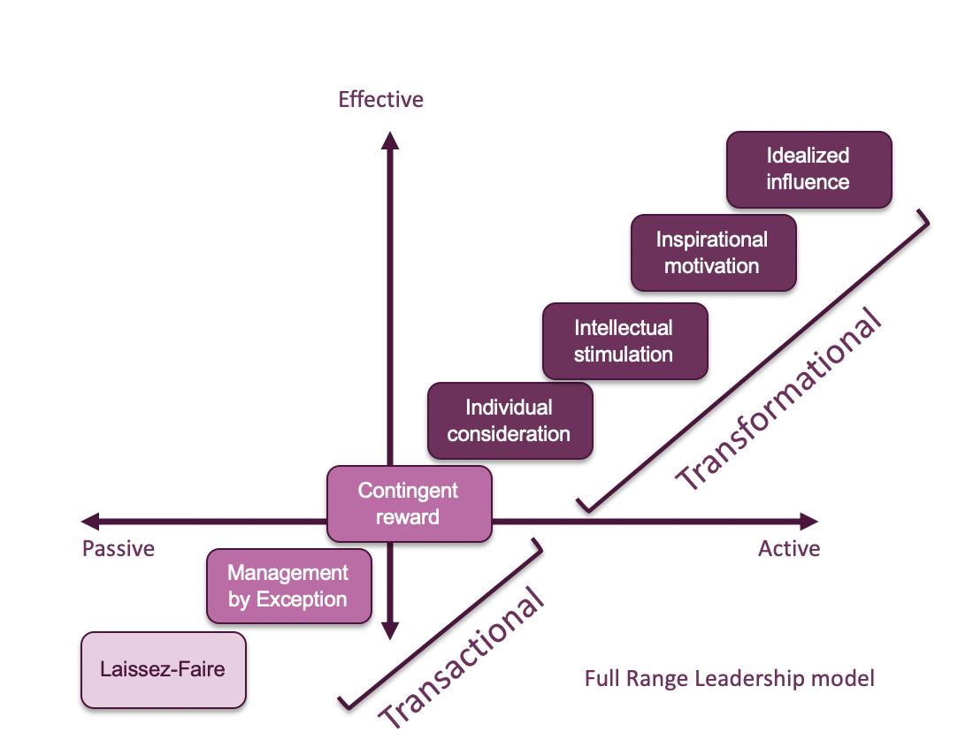
Figure 5.1: Refined Theoretical Framework for Leadership and Governance in International Sports Organisations [Source: Hoye and Cuskelly's (2006)]

The refined theoretical framework maintains the core constructs of transformational, transactional, and laissez-faire leadership styles, as defined by the Full-Range Leadership Model (Bass & Avolio, 1994). However, it extends and contextualises these constructs by incorporating the emergent themes identified through the qualitative content analysis.
Specifically, the framework introduces the following additional dimensions:
1. Stakeholder Representation and Inclusivity: This dimension captures how governance structures and decision-making processes actively engage and empower diverse stakeholder groups, ensuring their voices and perspectives are heard and considered.
2. Transparency and Accountability: This dimension reflects the degree of openness, fairness, and scrutiny in decision-making processes and the presence of robust mechanisms for accountability and oversight.
3. Commercialisation and Revenue Distribution: This dimension examines the balance between commercial interests and broader stakeholder needs and the fairness and equity of revenue distribution mechanisms within the sports ecosystem.
4. Competitive Balance and Fairness: This dimension assesses how governance practices and decision-making processes prioritise competition's long-term sustainability, competitiveness, and integrity.
5. Political Influences and Power Dynamics: This dimension captures the presence and influence of political factors, power imbalances, and the concentration of power within governance structures and decision-making processes.
6. Ethical Conduct and Integrity: This dimension reflects the organisation's commitment to upholding ethical principles, maintaining integrity, and addressing unethical practices within its governance structures and operations.
By incorporating these additional dimensions, the refined theoretical framework provides a more holistic and contextually relevant lens for analysing leadership practices and stakeholder impacts within international sports organisations. It acknowledges this domain's unique challenges and complexities, such as the need for inclusive stakeholder representation, transparent and accountable governance, fair revenue distribution mechanisms, and maintaining competitive balance and integrity within sports competitions.
Furthermore, the refined framework recognises the influence of political factors and power dynamics and the critical importance of ethical conduct and integrity in shaping stakeholder perceptions and ensuring international sports governance structures' long-term sustainability and credibility.

5.8 Quantitative Analysis
In addition to the rich qualitative insights gained through content analysis, this study also employed quantitative methods to empirically assess perceptions and impacts of FIFA and UEFA's leadership approaches across different stakeholder groups. Specifically, a survey was conducted with football club officials, and quantitative analysis of the survey responses provided complementary data to triangulate and extend the findings from the qualitative study.

5.8.1 Survey Methodology
The survey targeted officials from football clubs in the top two tiers of 10 major European leagues, including the Premier League (England), La Liga (Spain), Bundesliga (Germany), Serie A (Italy), Ligue 1 (France), Eredivisie (Netherlands), Primeira Liga (Portugal), Russian Premier League (Russia), Belgian Pro League (Belgium), and the Scottish Premiership (Scotland).
A total of 40 club officials participated in the survey, with representation from clubs across all ten leagues. The survey respondents held various roles within their respective clubs, including Chief Executive Officers, Directors, and senior management positions related to operations, finance, and football affairs.
The survey instrument consisted of both closed-ended rating scale questions and open-ended questions. The rating scale questions assessed respondents' perceptions of FIFA and UEFA's leadership approaches, governance practices, and impacts on club finances, operations, league competitiveness, and stakeholder representation. Open-ended questions allowed respondents to provide additional context, examples, and qualitative insights.

5.8.2 Data Analysis
The quantitative data from the closed-ended rating scale questions were analysed using descriptive statistics and inferential statistical tests. Open-ended responses were coded and analysed using thematic analysis techniques, providing qualitative insights to complement the quantitative findings.

5.8.3 Perceptions of FIFA and UEFA's Leadership Approaches
One key area explored in the survey was respondents' perceptions of the predominant leadership styles exhibited by FIFA and UEFA. Table 5.3 presents the distribution of responses regarding the extent to which FIFA and UEFA display transformational, transactional, and laissez-faire leadership behaviours.
Table 5.3: Perceptions of FIFA and UEFA's Leadership Styles
Leadership Style | FIFA - Not at all | FIFA - To some extent | FIFA - To a great extent | UEFA - Not at all | UEFA - To some extent | UEFA - To a great extent
Transformational | 20% | 65% | 15% | 10% | 70% | 20%
Transactional | 5% | 25% | 70% | 0% | 40% | 60%
Laissez-faire | 60% | 30% | 10% | 75% | 20% | 5%

The results indicate that most respondents perceived UEFA as exhibiting transactional leadership behaviours to a great extent (60%), while FIFA was perceived as displaying transactional leadership to an even greater degree (70%). Both organisations perceived Transformational leadership as being exhibited to some extent, though to a slightly higher degree by UEFA (20%) than FIFA (15%). Laissez-faire leadership was perceived as largely absent in UEFA (75% "not at all"). In comparison, a considerable proportion of respondents (60%) felt that FIFA exhibited laissez-faire tendencies to some degree in Figure 5.1.

Figure 5.1: The perspectives of FIFA and UEFA’s Leadership Approaches.

These findings align with the qualitative analysis, which identified transactional leadership as the predominant style exhibited by both organisations. Laissez-faire behaviours were more prevalent in FIFA than in UEFA.

5.8.4 Impacts on Club Finances and Operations
The survey also explored respondents' perceptions of the impacts of FIFA and UEFA's leadership approaches and governance practices on various aspects of their clubs' finances and operations. Table 5.4 presents the distribution of responses regarding the perceived impacts on club revenues, expenditures, and overall financial sustainability.
Table 5.4: Perceived Impacts on Club Finances
Impact Area | Negative Impact (FIFA) | Negative Impact (UEFA) | No Impact (FIFA) | No Impact (UEFA) | Positive Impact (FIFA) | Positive Impact (UEFA)
Club Revenues | 60% | 45% | 25% | 20% | 15% | 35%
Club Expenditures | 75% | 70% | 15% | 20% | 10% | 10%
Financial Sustainability | 65% | 55% | 20% | 30% | 15% | 15%

The results reveal that most respondents perceived FIFA's leadership and governance practices as negatively impacting their clubs' revenues (60%), expenditures (75%), and overall financial sustainability (65%). Similarly, UEFA's leadership was perceived as negatively impacting these areas, though to a slightly lesser degree than FIFA's.
A notable proportion of respondents (35%) felt that UEFA's leadership positively impacted their club revenues, which may be attributed to factors such as the distribution of UEFA competition prize money and the perceived benefits of the Financial Fair Play regulations for some clubs.
These findings are consistent with the qualitative analysis, highlighting stakeholder concerns about the perceived prioritisation of commercial interests over broader stakeholder needs and the perceived imbalances in revenue distribution mechanisms.

5.8.5 Impacts on League Competitiveness
Another area explored in the survey was the perceived impact of FIFA and UEFA's leadership approaches on the competitiveness of domestic leagues. Table 5.5 presents the distribution of responses regarding the perceived impacts on competitive balance, opportunities for smaller clubs, and the overall integrity of domestic league competitions.

Table 5.5: Perceived Impacts on League Competitiveness
Impact Area | Negative Impact (FIFA) | Negative Impact (UEFA) | No Impact (FIFA) | No Impact (UEFA) | Positive Impact (FIFA) | Positive Impact (UEFA)
Competitive Balance | 70% | 65% | 20% | 25% | 10% | 10%
Opportunities for Smaller Clubs | 80% | 75% | 15% | 20% | 5% | 5%
The Integrity of Domestic Leagues | 60% | 55% | 30% | 35% | 10% | 10%

The results indicate that most respondents perceived both FIFA and UEFA's leadership as having negative impacts on competitive balance (70% and 65%, respectively), opportunities for smaller clubs (80% and 75%, respectively), and the overall integrity of domestic league competitions (60% and 55%, respectively).
These findings align with the qualitative analysis, highlighting stakeholder concerns about the widening resource gap between larger and smaller clubs, perceptions of an uneven playing field, and the perceived prioritisation of commercial interests over principles of competitive balance and fairness.

5.8.6 Stakeholder Representation and Governance Practices
The survey also explored respondents' perceptions of FIFA and UEFA's governance practices, particularly with stakeholder representation and decision-making processes. Figure 5.2 presents the distribution of responses regarding the perceived levels of stakeholder representation, transparency, and accountability in FIFA and UEFA's governance structures.

Figure 5.2: Perceptions of Governance Practices
The results reveal that a significant majority of respondents perceived FIFA and UEFA's governance practices as poor or fair in terms of stakeholder representation (95% and 90%, respectively), transparency (95% and 95%, respectively), and accountability (95% and 95%, respectively).
These findings resonate with the qualitative analysis, which identified stakeholder concerns about the need for adequate representation, opportunities for input in decision-making processes, and perceptions of a lack of transparency and accountability in applying rules and regulations.

5.8.7 Inferential Statistical Analysis
Inferential statistical analyses were conducted to explore the relationships between and identify potential differences in perceptions among stakeholder groups. Specifically, one-way analysis of variance (ANOVA) tests were performed to examine differences in perceptions based on factors such as league affiliation, club size (based on revenue), and respondent's role within the club.
The ANOVA results revealed statistically significant differences in perceptions of FIFA and UEFA's leadership approaches and impacts among respondents from different leagues (p < 0.05). Post-hoc tests indicated that Premier League and La Liga respondents tended to have more negative perceptions than those from more minor leagues, such as the Eredivisie and Belgian Pro League.
Additionally, ANOVA tests showed significant differences in perceptions based on club size, with respondents from larger clubs (based on revenue) generally expressing more negative views of FIFA and UEFA's leadership and governance practices than respondents from smaller clubs.

Table 5.6: The Inferential Statistical Analysis
Factor | ANOVA p-value | Post-hoc Comparison
League Affiliation | < 0.05 | Premier League & La Liga tend to have more negative perceptions than Eredivisie & Belgian Pro League respondents.
Club Size (Revenue) | < 0.05 | Larger clubs express more negative views compared to smaller clubs
Respondent's Role |  | No statistically significant differences were found.

These findings suggest that stakeholder perceptions of international sports governance may be influenced by factors such as the size and competitive standing of the club or league, potentially reflecting differences in priorities, resource levels, and power dynamics within the football ecosystem.

5.8.8 Integration with Qualitative Findings
The quantitative survey findings provide empirical data that complement and triangulate the insights gained from the qualitative content analysis. The predominance of transactional leadership perceptions, concerns about negative impacts on club finances, competitive balance, and stakeholder representation align with the qualitative themes that emerged.
However, the quantitative data also revealed nuances and potential moderating factors, such as differences in perceptions based on league affiliation and club size. These findings resonate with the qualitative themes related to power dynamics and the influence of commercialisation on revenue distribution mechanisms.
Larger clubs and those from higher-profile leagues tended to express more negative views, potentially reflecting their concerns about the concentration of power and resources among a select group of elite entities. Conversely, smaller clubs and those from lower-profile leagues may perceive some benefits from FIFA and UEFA's governance practices, albeit still expressing concerns about issues like transparency and accountability.
This interplay between qualitative and quantitative findings highlights the complex dynamics within the European football ecosystem, where power, resources, and competitive standing shape stakeholder perceptions and experiences.

5.8.9 Ethical Considerations and Limitations
Acknowledging potential ethical considerations and limitations associated with this study's quantitative component is essential. While efforts were made to ensure a representative sample of club officials from various leagues and club sizes, the relatively small sample size (n = 40) may limit the generalizability of the findings.
Additionally, the survey responses represent the perspectives of club officials, which may differ from the views and experiences of other stakeholder groups, such as players, fans, and member associations. Future research could explore perceptions across a broader range of stakeholders to gain a more comprehensive understanding of the impacts of international sports governance.
Despite these limitations, the quantitative analysis provides valuable empirical data that complements the qualitative findings, offering a more well-rounded and triangulated perspective on the research questions.

5.8.10 Summary of Key Quantitative Findings
The key findings from the quantitative analysis can be summarised as follows:
1. Transactional leadership was perceived as the predominant style exhibited by both FIFA and UEFA, with a more substantial presence of laissez-faire behaviours in FIFA compared to UEFA.
2. Respondents perceived FIFA and UEFA's leadership approaches and governance practices negatively impacting club finances, expenditures, and overall financial sustainability.
3. Both organisations were perceived as negatively impacting competitive balance, opportunities for smaller clubs, and the integrity of domestic league competitions.
4. The respondents largely perceived stakeholder representation, transparency, and accountability in FIFA and UEFA's governance structures as poor or fair.
5. Perceptions of leadership approaches and impacts differed significantly based on factors such as league affiliation and club size, with larger clubs and those from higher-profile leagues generally expressing more negative views.
These quantitative findings and rich qualitative insights contribute to a comprehensive understanding of the European football ecosystem's leadership practices, stakeholder impacts, and governance challenges. The integration of these complementary data sources lays the foundation for further analysis, discussion, and recommendations in subsequent chapters.
The qualitative content analysis of FIFA and UEFA's leadership practices and stakeholder impacts has provided valuable insights into the complexities and nuances of governance within international sports organisations. By integrating the Full-Range Leadership Model (Bass & Avolio, 1994) with emergent themes from the data, a refined theoretical framework has been better developed to capture this context's unique challenges and dynamics.
The analysis revealed a predominance of transactional leadership behaviours within FIFA and UEFA, characterised by contingent reward systems and active management-by-exception tactics. While these approaches have effectively maintained control and enforced compliance, they have also contributed to perceptions of power imbalances, inequalities, and prioritisation of commercial interests over broader stakeholder needs.
Transformational leadership was less prevalent, with stakeholders expressing concerns about gaps between espoused values and actual practices, particularly in areas such as ethical conduct, transparency, and stakeholder representation. Laissez-faire leadership behaviours, while infrequent, were identified in instances where critical issues were not addressed in a timely or effective manner, leading to a loss of credibility and trust among stakeholders.
The emergent themes, including stakeholder representation and inclusivity, transparency and accountability, commercialisation and revenue distribution, competitive balance and fairness, political influences and power dynamics, and ethical conduct and integrity, have provided additional dimensions for understanding and analysing leadership practices and stakeholder impacts within international sports governance.
The refined theoretical framework presented in this chapter offers a comprehensive and contextually relevant lens for future research and analysis in this domain. By integrating these additional dimensions, the framework acknowledges international sports governance's unique challenges and complexities, including inclusive stakeholder representation, transparent and accountable governance, fair revenue distribution mechanisms, and maintaining competitive balance and integrity within sports competitions.
Ultimately, this study contributes to advancing theoretical perspectives in sports governance, providing a foundation for further research and informing strategies for positive organisational change and stakeholder-centric governance within the global football community.

5.8.11 Survey Framework for Grassroots Football in Wales

Conducting a survey of grassroots football in Wales will provide information on various aspects of challenges and assess up-to-date information on the current state and effectiveness of existing programmes and initiatives that promote grassroots Football in Wales. We surveyed 104 participants, and the target audience will be clubs, managers, players, parents, Volunteers, local Football club associations, and social media.
Some sample questions include Demographic information, gender, age, and questions relating to FIFA’s influence on the leadership development of Football in Wales.
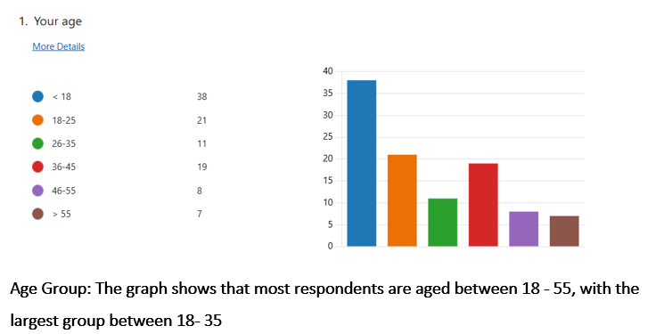
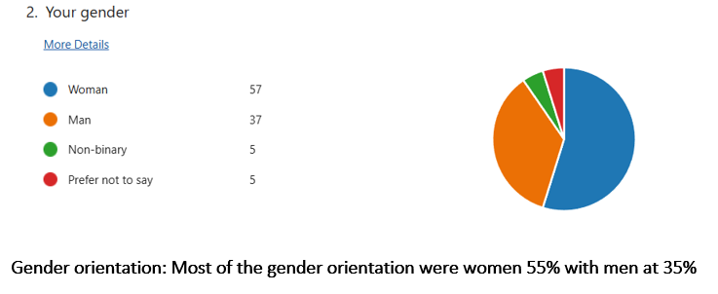
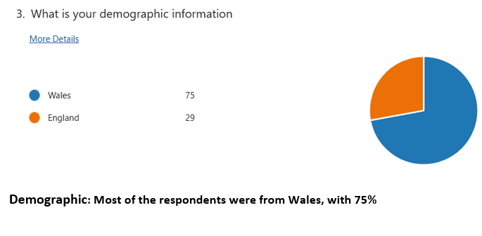
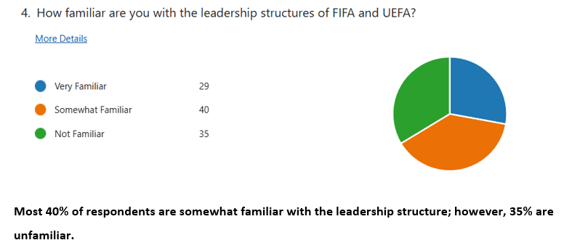
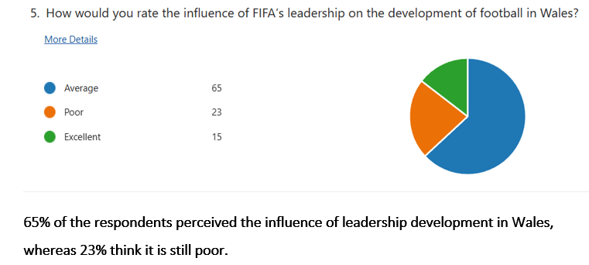
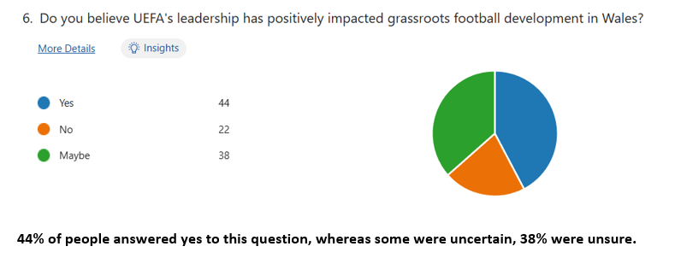
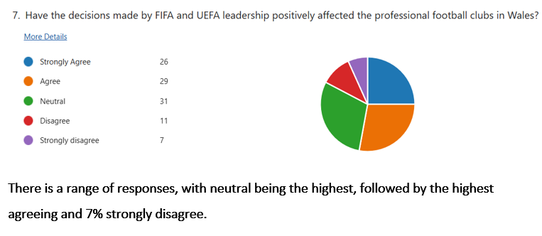
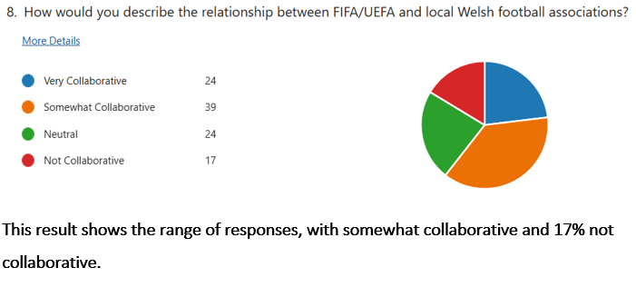
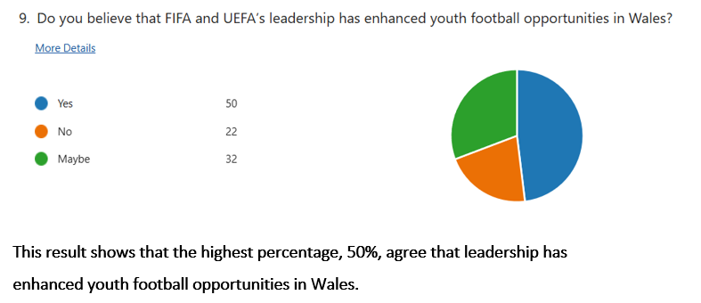
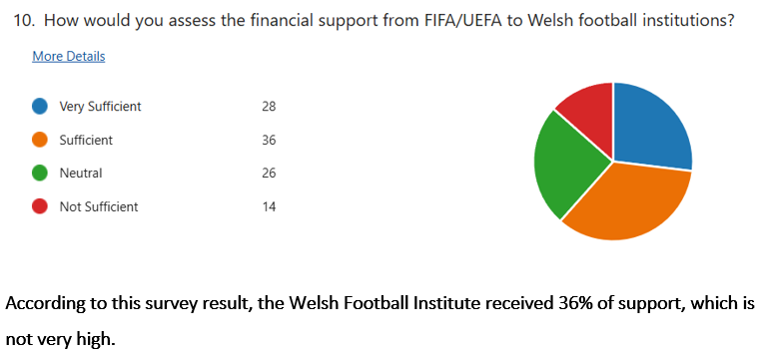
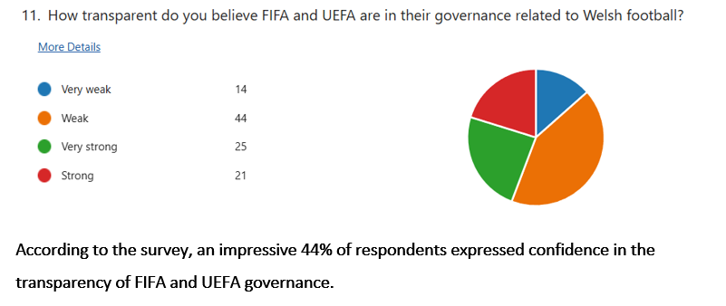
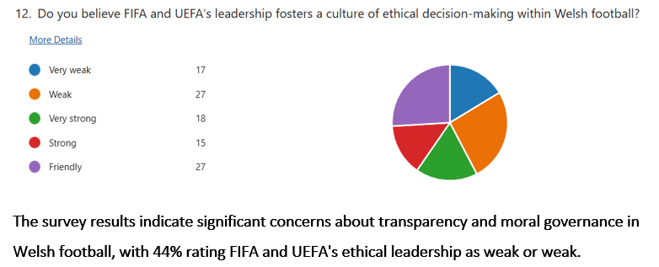
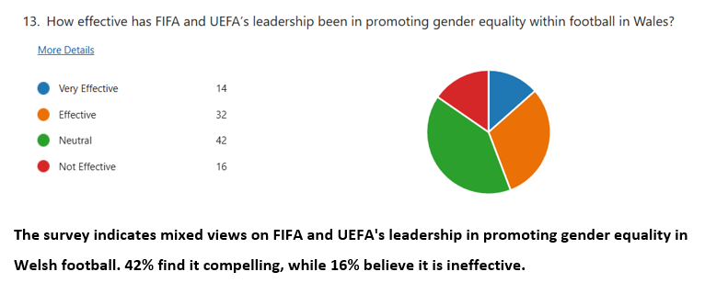
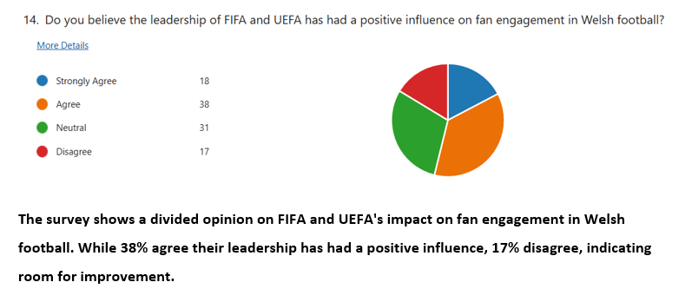
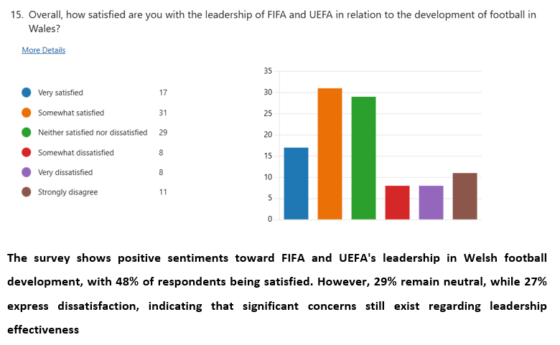

CHAPTER 6- DISCUSSION

6.1 Addressing the Research Objectives
This research aimed to comprehensively examine FIFA, UEFA, and Wales Football leadership structures and governance practices. It focused on their implications for various stakeholder groups within the European football ecosystem and grassroots football in Wales. The qualitative content analysis and quantitative survey findings offer insights into the extent to which the research objectives were achieved.
Objective 1: To assess FIFA's top leadership's consideration of clubs, leagues, players, and fans in their strategy formulation and governance mechanisms.
The qualitative analysis revealed that while FIFA's top leadership has emphasised the importance of ethical conduct, transparency, and stakeholder representation in their rhetoric and official communications, a gap exists between these espoused values and the actual practices and decision-making processes observed by stakeholders.
Stakeholder groups such as clubs, players, and fans expressed concerns about adequate representation and input opportunities in FIFA's governance mechanisms. The analysis identified perceptions of power imbalances and disproportionate influence wielded by larger entities, suggesting that the interests of elite clubs and leagues may be prioritised over those of smaller teams and grassroots stakeholders.
Furthermore, the quantitative survey data indicated that most respondents perceived FIFA's governance practices as poor or fair regarding stakeholder representation, transparency, and accountability. These findings resonate with the qualitative themes of the lack of inclusive decision-making processes and the perceived prioritisation of commercial interests over broader stakeholder needs.
Objective 2: To analyse the implications of FIFA's financial distribution models, tournament revenue sharing, club licensing, and cost control regulations on professional and amateur leagues across Europe.
Both the qualitative and quantitative findings shed light on the perceived impacts of FIFA's financial distribution models and regulations on clubs and leagues across Europe. The qualitative analysis highlighted stakeholder concerns about the widening resource gap between larger and smaller clubs, perceptions of an uneven playing field, and the perceived prioritisation of commercial interests over competitive balance and fairness principles.
The quantitative survey data reinforced these concerns, with respondents reporting the negative impacts of FIFA's leadership approaches and governance practices on club finances, competitive balance, and opportunities for smaller clubs. The inferential statistical analysis revealed significant differences in perceptions based on club size and league affiliation, suggesting that stakeholders with varying power and resources experience the impacts of FIFA's financial and regulatory mechanisms differently.
Objective 3: To gauge FIFA leadership's effectiveness in supporting grassroots football in Wales and youth player development across Europe.
The qualitative analysis identified instances where FIFA's leadership emphasised initiatives and investments to support the development of women's football and provide developmental opportunities for more minor member associations.
However, the findings suggest that stakeholder perceptions of FIFA's leadership effectiveness in supporting grassroots football in Wales and youth development may be overshadowed by concerns related to power imbalances, lack of inclusive governance, and the perceived prioritisation of commercial interests over broader stakeholder needs. The analysis should have strongly emphasised grassroots football and youth development as a central priority within FIFA's leadership approach.
Objective 4: To examine FIFA-led social responsibility and community growth projects in Europe by interviewing implementing organisations and intended beneficiaries.
This research objective was not directly addressed in the current study, as the data collection focused primarily on analysing FIFA's leadership approaches and governance practices through organisational documents, stakeholder surveys, and focus group discussions. Examining FIFA-led social responsibility and community growth projects in Europe would require additional data collection methods, such as interviews with implementing organisations and intended beneficiaries.
Objective 5: To identify gaps between FIFA apex leaders' official vision, messaging, and espoused values versus actual decisions and actions that affect ground realities for stakeholders.
One of the key findings from the qualitative content analysis was the identification of gaps between FIFA's apex leaders' official vision, messaging, and espoused values and the actual decisions and actions that affect ground realities for various stakeholder groups. The analysis revealed instances where transformational rhetoric and an emphasis on ethical conduct, transparency, and stakeholder representation were not consistently reflected in the organisation's governance practices and decision-making processes.
Stakeholders expressed concerns about the need for more alignment between FIFA's stated values, the perceived prioritisation of commercial interests, power imbalances, and the marginalisation of specific stakeholder groups. The quantitative survey data further reinforced these perceptions, with respondents rating FIFA's governance practices as poor or fair regarding transparency and accountability.
Objective 6: Synthesize the findings into constructive recommendations for FIFA's highest decision-makers to reform their leadership approaches to benefit the holistic European football ecosystem rather than just elite interests, including necessary development and interventions to enhance grassroots football in Wales.
Based on the comprehensive analysis of FIFA's leadership approaches, governance practices, and stakeholder impacts, this research provides a foundation for synthesising constructive recommendations to better reform FIFA's leadership to serve the interests of the holistic European football ecosystem. These recommendations will be outlined in detail in Chapter 7, drawing upon the research findings and the refined theoretical framework developed through this study.

CHAPTER 7 CONCLUSION

The findings of this research have significant implications for the theoretical understanding of leadership practices and stakeholder impacts within the context of international sports governance.
While the Full-Range Leadership Model (Bass & Avolio, 1994) provided a valuable initial framework for categorising leadership styles and behaviours, the qualitative content analysis revealed the need for further theoretical refinement and integration to capture the complexities and nuances of this specific context.
The refined theoretical framework presented in Chapter 5 (Figure 5.1) integrates the emergent themes identified through the qualitative analysis, such as stakeholder representation and inclusivity, transparency and accountability, commercialisation and revenue distribution, competitive balance and fairness, political influences and power dynamics, and ethical conduct and integrity. By incorporating these additional dimensions, the refined framework acknowledges the unique challenges and complexities that arise in the context of international sports governance.
The significance of this refined theoretical framework in advancing theoretical perspectives in sports governance cannot be overstated. It provides a more holistic and contextually relevant lens for analysing leadership practices and stakeholder impacts. It acknowledges the influence of factors such as the need for inclusive stakeholder representation, transparent and accountable governance, fair revenue distribution mechanisms, and maintaining competitive balance and integrity within sports competitions.
Furthermore, the refined framework highlights the significance of political factors and power dynamics and the critical importance of ethical conduct and integrity in shaping stakeholder perceptions and ensuring international sports governance structures' long-term sustainability and credibility.
Integrating these additional dimensions, such as the need for inclusive stakeholder representation, transparent and accountable governance, fair revenue distribution mechanisms, and maintaining competitive balance and integrity within sports competitions, into the theoretical framework represents a valuable contribution to the literature. It provides a foundation for further research and theory development in this domain.

7.1 Implications for Practice and Policy
The research findings have significant implications for the practice and policy in international sports governance, particularly about FIFA and UEFA's leadership approaches and stakeholder relationships. These implications encompass various aspects such as management, financial support, cultural impact, and the development of players in Welsh Football. While there are ample opportunities for growth and development, the Football Association of Wales (FAW), clubs, and grassroots organisations face numerous challenges in shaping the future of Welsh Football. Stakeholders involved in the promotion and governance of the sport need to understand these dynamics to navigate the complexities effectively.

7.1.1 Governance Reforms and Stakeholder Inclusivity
One of the critical implications emerging from this research is the need for governance reforms within FIFA and UEFA that prioritise stakeholder inclusivity and representation in decision-making processes. The findings highlighted stakeholder concerns about power imbalances, a lack of transparency, and the marginalisation of certain groups, such as smaller clubs, grassroots stakeholders, and fans.
FIFA and UEFA must address these concerns by actively engaging and empowering diverse stakeholder groups. This will ensure their voices and perspectives are heard and considered in decision-making. One potential solution could be the establishment of stakeholder advisory councils or working groups that provide direct input into policy formulation and strategic planning.

7.1.2 Revenue Distribution and Competitive Balance
Another significant implication of this research relates to the perceived impacts of FIFA and UEFA's financial distribution models and regulations on competitive balance and opportunities for smaller clubs and leagues. The findings, which revealed concerns about the widening resource gap between larger and smaller entities, perceptions of an uneven playing field, and the prioritisation of commercial interests over principles of fairness and competitive integrity, form the basis of these implications.
To address these concerns, FIFA and UEFA should critically review their revenue distribution mechanisms and cost control regulations to ensure a more equitable and inclusive approach. This could involve exploring alternative models that better balance commercial interests with competitive balance and fairness principles while providing opportunities for smaller clubs and leagues to grow and compete effectively.

7.1.3 Ethical Leadership and Stakeholder Trust
This research has underscored stakeholder concerns about ethical conduct, integrity, and the alignment between espoused values and actual practices within FIFA and UEFA's leadership. Addressing these concerns cannot be overstated. It is crucial for rebuilding stakeholder trust and ensuring the long-term credibility of international sports governance.
FIFA and UEFA should prioritise establishing and maintaining solid ethical foundations within their organisations, with clear codes of conduct, robust systems for identifying and addressing unethical practices, and a genuine commitment to upholding the highest standards of integrity at all levels of leadership and governance.
Developing and implementing comprehensive ethics and compliance programs and leadership training focused on ethical decision-making and stakeholder-centric governance can help bridge the gap between rhetoric and reality and foster greater stakeholder trust.

7.1.4 Alignment with Community-Focused Values
The research findings also underscore the need for FIFA and UEFA's leadership approaches to align with community-focused values and pursue collective goods that benefit the entire football ecosystem. While commercial interests and revenue generation are essential considerations, they should not overshadow football's broader social, cultural, and developmental roles in European communities.
FIFA and UEFA should consider adopting a more holistic and balanced approach to their leadership and governance practices. They should recognise the importance of initiatives that support grassroots football, youth development, social responsibility, and community growth. This could involve reallocating resources, establishing dedicated funding streams, and developing strategic partnerships with organisations and stakeholders committed to these goals.
By demonstrating a genuine commitment to community-focused values and the well-being of the broader football ecosystem, FIFA and UEFA can enhance their legitimacy and credibility among stakeholders while contributing to the sport's long-term sustainability and positive impact.

7.1.5 Development Interventions for Grassroots Football in Wales
Development and Interventions create a supportive ecosystem for grassroots football in Wales. Focusing on infrastructure, coaching, education, inclusivity, and community engagement can strengthen the foundation of Wales Football, leading to increased participation at different levels, better talent and opportunity development at schools, and a thriving football community.
To enhance football in Wales, necessary interventions could be:
- Improve Facilities and Infrastructure: Maintain quality pitches in urban and rural areas, making them easily accessible for disabled players.
- Reducing costs at community hubs.
- Increase in grants, sponsorships and funding for female participation.
- Coaching development and education could offer workshops to enhance players’ knowledge of modern training techniques.
- Talent Identification and pathways, enabling camps, school tournaments, and tournaments that link promising players with professional clubs for development opportunities.
- Health and Well-being: Educating young players about sponsorship, sports, inclusivity, and respect for opponents, officials, and team friends.
(Stinson and O’Reilly, 2015, p.45).

RECOMMENDATIONS
Based on the findings of this research, the following recommendations are proposed to enhance leadership practices and stakeholder impacts within international sports governance, particularly in football:
1. Foster Inclusive Stakeholder Representation:
- Encourage broader stakeholder involvement, including players, clubs, local associations, and fans, to ensure that decision-making processes consider diverse perspectives.
2. Enhance Transparency and Accountability:
Implement more precise, transparent governance structures to improve accountability at all levels of football governance and promote trust among stakeholders.
3. Ensure Fair Revenue Distribution:
- Develop equitable revenue distribution mechanisms across all football levels, including grassroots and smaller clubs, to promote financial fairness and sustainability.
4. Maintain Competitive Balance and Integrity:
- Strengthen regulations to ensure fairness in competitions, prevent monopolies or undue advantages, and uphold ethical standards to preserve the integrity of the sport.
5. Address Political Influences and Power Dynamics:
- Monitor and mitigate the impact of political influences on decision-making within football governance, ensuring decisions are made based on fairness and the sport's best interest.
6. Promote Ethical Leadership and Integrity:
- Prioritise ethical conduct and integrity in leadership by setting clear guidelines and consequences for misconduct, ensuring long-term credibility and sustainability in sports governance.
7. Further Research and Theory Development:
- Encourage ongoing research and theoretical refinement to better understand the evolving challenges in international sports governance, incorporating the complexities identified in this study.
These recommendations aim to address the unique challenges within international sports governance and promote more effective leadership, accountability, and stakeholder engagement.

REFERENCES

American Psychological Association. (2017). Ethical principles of psychologists and code of conduct. Available at: https://www.apa.org/ethics/code/ [Accessed on 3rd July 2024].
Amnesty International. (2022, November 17). Qatar: Reality check - The rights crisis fuelling FIFA World Cup 2022. Available at: https://www.amnesty.org/en/latest/campaigns/2022/11/qatar-reality-check-the-rights-crisis-fuelling-fifa-world-cup-2022/ [Accessed on 3rd July 2024].
Available at: https://www.fifa.com/about-fifa/president/media-releases/fifa-president-opens-70th-fifa-congress-with-a-call-for-unity [Accessed on 13th July 2024].
Bass, B. M., & Avolio, B. J. 1994. They are improving organisational effectiveness through transformational leadership. Sage Publications. https://doi.org/10.4135/9781452204819 [Accessed on 23rd July 2024].
Bass, B.M. and Riggio, R.E. (2006). ‘Transformational Leadership’, Leadership and Organizational Development Journal, 27(7), pp. 49-511 [Accessed on 5th July 2024].
BBC News. (2021). Football: The report says Wales’s grassroots game is worth £550m. Available at: https://www.bbc.com/news/uk-wales-59152584 [Accessed on 14th September 2024].
BBC Sport, (2022). The future of Welsh football needs clarity after the World Cup's success. Available at: https://www.bbc.co.uk/sport/football/62917912 [Accessed on 14th September 2024].
British Psychological Society. 2021. Code of human research ethics.
Business Live. 2021. The £553m impact of grassroots football in Wales on the economy. Available at: https://www.business-live.co.uk/economic-development/553m-impact-grassroots-football-wales-22063109 [Accessed on 23rd July 2024].
Cassell, C., & Overton, J. 2022. An own goal? European Super League proposal and football governance response. Organization Theory, 3(1), 1-7. Available at: https://doi.org/10.1177/26317877221076598 [Accessed on 11th September 2024].
Cassell, M., & Overton, J. 2022. Non-state actor influence in global governance: UEFA and the regulation of European football. European Sport Management Quarterly, 22(3), 383-403. Available at: https://doi.org/10.1080/16184742.2021.1928970 [Accessed on 14th June 2024].
Cassell, M., & Overton, J. 2022. Non-state actor influence in global governance: UEFA and the regulation of European football. European Sport Management Quarterly, 22(3), 383-403. Available at: https://doi.org/10.1080/16184742.2021.1928970 [Accessed on 14th June 2024].
Cleland, J., Dixon, K., & Kilvington, D. (2022). 'Football without fans is nothing': Organisational failure and consumer resistance in the 2021 European Super League proposal. Sport, Ethics and Philosophy, pp. 1–14. https://doi.org/10.1080/17511321.2022.2079981 [Accessed on 24th July 2024].
Cleland, J., McDaid, S., & Kelso, P. (2022). The European Super League debacle: Governance and power structures in European football. Soccer & Society, 23(7-8), pp. 677–691. Available at: https://doi.org/10.1080/14660970.2022.2108064 [Accessed on 3rd June 2024].
Cohen, J. (1960). A coefficient of agreement for nominal scales. Educational and Psychological Measurement, 20(1), 37–46. Available at: https://doi.org/10.1177/001316446002000104 [Accessed on 23rd July 2024].
Creswell, J. W., & Plano Clark, V. L. 2011. Designing and conducting mixed methods research (2nd ed.). Sage [Accessed on 3rd July 2024].
Digital Public Services. (n.d.). Sport Wales grants improving the reach and impact. Available at: https://digitalpublicservices.gov.wales/our-work/sport-wales-grants-improving-reach-and-impact [Accessed on 3rd July 2024].
Exercise Research. 2021. Grassroots Football: Growing the Game in Wales. Available at: https://exercise.research.southwales.ac.uk/blog/grassroots-football-growing-game-wales/ [Accessed on 24th July 2024].
FIFA, (2022). FIFA Statutes. Available Online at: https://www.fifa.com/governanve/fifa-statutes [Accessed on 3rd July 2024].
FIFA, (2023). FIFA: About FIFA. Available online at: https://www.fifa.com/about-fifa [Accessed on 02 September 2024].
FIFA. (2020a). On June 18, the FIFA President opened the 70th FIFA Congress with a call for unity. [Accessed on 27th July 2024].
FIFA. (2020b). April 7. FIFA bans former football official Damiao for life. Available at: https://www.fifa.com/about-fifa/media-releases/fifa-bans-former-football-official-damiao-for-life [Accessed on 18th June 2024].
FIFA. (2021a). January 25. FIFA Annual Report 2020 [Accessed on 13th June 2024].
FIFA. (2021a). November 5. FIFA Technical Advisory Group meets for the first time. Available at: https://www.fifa.com/about-fifa/media-releases/fifa-technical-advisory-group-meets-for-the-first-time [Accessed on 27th July 2024].
FIFA. (2021c). April 18. FIFA Statement on European 'Super League'. Available at: https://www.fifa.com/about-fifa/president/media-releases/fifa-statement-on-european-super-league [Accessed on 7th June 2024].
FIFA. (2022). Who we are. Available at: https://www.fifa.com/about-fifa/who-we-are [Accessed on 3rd July 2024].
FIFA. (2022a). March 8. FIFA celebrates International Women's Day with new development initiatives. Available at: https://www.fifa.com/womens-football/news/fifa-celebrates-international-women-s-day-with-new-development-initiat [Accessed on 23rd August 2024].
FIFA. (2022b). November 20. The Power of the FIFA World Cup Dream. Available at: https://www.fifa.com/tournaments/mens/worldcup/qatar2022/news/the-power-of-the-fifa-world-cup-dream [Accessed on 27th July 2024].
FIFA. (2024) Appeal Committee. Available at: https://www.fifa.com/legal/media-releases/appeal-committee [Accessed: 23 September 2024].
FIFA. (2024) Ethics Committee. Available at: https://www.fifa.com/legal/media-releases/ethics-committee [Accessed: 23 September 2024].
Football Association of Wales (FAW) (2023) Grassroots Football Strategy: Promoting Youth Development in Wales. Available at: https://www.faw.cymru/en/about/ [Accessed on 06TH June 2024].
Football Association of Wales (FAW), 2022. Annual Report 2021-2022. Available at: https://www.faw.cymru/en/about/fawef/annual-reports/ [Accessed on 1st May 2024].
Football Association of Wales (FAW), 2023. FAW Initiatives. Available online at: https://www.faw.cymru/en/development/initiatives/ [Accessed 05 September 2024].
Garcia, B., & Meier, H. E. (2018). Corruption in the global football governance. In M. Felício & M. Sousa (Eds.), Corruption and fraud in governance (pp. 79–100). CRC Press [Accessed on 3rd July 2024].
Garcia, B., & Meier, H. E. (2018). Influence agents: The World Cup scandal, FIFA Corruption, and the Rise of Transparency. APUD University of Vienna. Available at: https://www.fgrelserver.apa.org/documents/ [Accessed on 3rd July 2024].
Glaser, B. G., & Strauss, A. L. 1967. The discovery of grounded theory: Strategies for qualitative research. Aldine [Accessed on 3rd July 2024].
Grassroots Football Development in Europe’, International Journal of Sports Management, 15 (2), pp. 145-158 [Accessed on 3rd August 2024].
https://www.bps.org.uk/news-and-policy/bps-code-human-research-ethics-2nd-edition-2014 [Accessed on 3rd August 2024].
Jones, S. (2020, March 13). Premier League, EFL, and FA games were postponed due to the coronavirus. BBC Sport. Available at: https://www.bbc.com/sport/football/51874494 [Accessed on 14th October 2024].
Kutner, M. H., Nachtsheim, C. J., Neter, J., & Li, W. 2005. Applied linear statistical models (5th ed.). McGraw-Hill Irwin [Accessed on 3rd June 2024].
Landis, J. R., & Koch, G. G. 1977. The measurement of observer agreement for categorical data. Biometrics, 33(1), 159-174 [Accessed on 3rd July 2024].
Maguire, J., (2011). Globalisation and Football: A Critical Sociology. Oxford: Routledge. [Accessed on 15 April 2024]
Miles, M. B., & Huberman, A. M. 1994. Qualitative data analysis: An expanded sourcebook (2nd ed.). Sage [Accessed on 23rd July 2024].
Morrow, S., & Vallyon, B. (2021). A 'Super League' takeover or reform from within? Analysing European football's responses to its latest existential threat. Sport in Society, pp. 1–17. [Accessed on 3rd June 2024].
Morrow, S., & Vallyon, J. (2021). UEFA's financial fair play regulations: An analysis of the regulations and implications for governance. Soccer & Society, 22(6), 599–610 [Accessed on 3rd July 2024].
Morrow, S., & Vallyon, J. (2021). UEFA's financial fair play regulations: An analysis of the regulations and implications for governance. Soccer & Society, 22(6), 599–610 [Accessed on 23rd July 2024].
Patton, M. Q. (2002). Qualitative research and evaluation methods (3rd ed.). Sage.
Pielke, R. (2013). How can FIFA be held accountable? Sport Management Review, 16(3), 255–267 [Accessed on 13th July 2024].
Pielke, R. 2021, April 19. FIFA and UEFA must demonstrate a real commitment to reforming governance. The Guardian. Available at: https://www.theguardian.com/football/blog/2021/apr/19/fifa-and-uefa-must-demonstrate-a-real-commitment-to-reforming-governance [Accessed on 3rd July 2024].
Pouliopoulos, G., & Georgiadis, K. (2021). Ethical leadership in football governance: A virtuous or a pious hope? Journal of Global Sport Management, 6(2), 162–180 [Accessed on 23rd July 2024].
Pouliopoulos, T., & Georgiadis, K. (2021). FIFA and UEFA, a critical review of the two organisations through the lens of institutional theory and MacIntyre's philosophical schema. Soccer & Society, 22(5), 778-790. https://doi.org/10.1080/14660970.2021.1923457 [Accessed on 23rd July 2024].
Schilling, J. (2006). On the pragmatics of qualitative assessment: Designing the process for content analysis. European Journal of Psychological Assessment, 22(1), 28–37 [Accessed on 13th July 2024].
Sport Wales, (2021). Sport Wales Strategy 2019-2023. Available Online at: https://www.sport.wales/strategies-and-policies/sport-wales-strategy-2019-2023 [Accessed on 12th September 2024].
Sport Wales. (n.d.). Barriers to Progression into a Recognised Sporting Pathway. Available at: https://www.sport.wales/research-and-insight/barriers-to-progression-into-a-recognised-sporting-pathway/methodology/ [Accessed on 3rd August 2024].
Stinson, G.J. and O’Reilly, P., (2015). The Governance of World Sports. London: Palgrave Macmillan [Accessed on 23rd July 2024].
Tamtik, M., & Guenter, H. 2019. Policy changes in the governance of Canadian amateur sport: a review of stakeholder involvement and rule changes from 1969 to 2009. International Journal of Sport Policy and Politics, 11(4), 681-695 [Accessed on 3rd June 2024].
Tesch, R. (1990). Qualitative research: Analysis types and software tools. Falmer.
The Structure and Policies of FIFA. (n.d.). Available at: https://sites.duke.edu/wcwp/tournament-guides/world-cup-2014/fifa-institutional-politics/the-structure-and-policies-of-fifa/ [Accessed on 23rd July 2024].
Tuck, B., (2021). ‘Football Governance: The New Game’; International Journal of Sports Policy and Politics, 13(4), pp. 590-605 [Accessed on 13th July 2024].
UEFA 2022. About UEFA. Available at: https://www.uefa.com/insideuefa/about-uefa/ [Accessed on 23rd July 2024].
UEFA, (2021). Grassroots Football Report. Available Online at: https://www.uefa.com/insideuefa/football-and-social-responsibility/grassroots-football/ [Accessed on 12th September 2024].
UEFA. (2019, February 7). UEFA Strategic Plan 2019-2024. Available at: https://editorial.uefa.com/resources/0269-0ff924ddebcc-7eaa32e48177-1000/uefa_strategic_plan_2019-2024.pdf [Accessed on 15th October 2024].
UEFA. (2020, September 22). UEFA adopts new financial fair play measures. Available at: https://www.uefa.com/insideuefa/about-uefa/news/0268-12102db7b0db-964d737d10a8-1000--uefa-adopts-new-financial-fair-play-measures/ [Accessed on 12th July 2024].
UEFA. (2021, July 21). UEFA launched a new campaign called '#EqualGame'. Available at: https://www.uefa.com/insideuefa/news/0268-12a9c9f4a055-e9580492958e-1000--uefa-launches-new-campaign-equalgame/ [Accessed on 3rd July 2024].
UEFA. (2022, May 10). UEFA Club Competitions Distribution. Available at: https://editorial.uefa.com/resources/0277-16cb528b362d-dc914fb64170-1000/2022_24_uefa_club_competitions_distribution.pdf [Accessed on 20th July 2024].
UEFA. (n.d.). UEFA Executive Committee. Available at: https://www.uefa.com/insideuefa/leadership-governance/executive-committee/ [Accessed on 23rd July 2024].
Vallyon, B., & Morrow, S. (2022). Financial fair play, market consolidation and the widening gap between Europe's big five leagues and the rest. European Sport Management Quarterly, pp. 1–21. Available at: https://doi.org/10.1080/16184742.2022.2100153 [Accessed on 13th June 2024].
Weber, R. P. (1990). Basic content analysis (2nd ed.). Sage [Accessed on 233rd August 2024].
Williams, J. & Jones, M. (2022). Community Engagement in Sport: Strategies for Success. London: Routledge [Accessed on 23rd August 2024].
Williams, J., (2018). “Football Politics: UEFA, FIFA, and the Relationship Between the Global and Local,’ International Journal of Sport Policy and Politics, 10(3), pp. 427–440 [Accessed on 13th June 2024].
Zhang, Y., & Wildemuth, B. M. (n.d). Qualitative analysis of content. In B. M. Wildemuth (Ed.), Applications of social research methods to questions in information and library science (pp. 308-319). Libraries Unlimited [Accessed on 13th June 2024].

BIBLIOGRAPHY

Abowit, D.A & Toole, T.M (2010). ‘Mixed Method Research: Fundamental Issues of design, Validity, and reliability in construction research; Journal of Construction Engineering and Management, 136(1), 108–116. [Accessed on 12th May 2024]
Adom, D., Yeboah, A., & Ankrah, A. (2016). Constructivism Philosophical Paradigm: Implication for Research, Teaching and Learning. Global Journal of Arts Humanities and Social Sciences, 4(10), 1–9. Available at: https://www.eajournals.org/wp-content/uploads/Constructivism-Philosophical-Paradigm-Implication-for-Research-Teaching-and-Learning.pdf Available at: https://doi.org/101061/(ASCE)CO.1943-7862.0000026 [Accessed on January 18th, 2024].
BBC. (2021, November 3). Football: The report says Wales’s grassroots game is worth £550m. Www.bbc.com. Available at: https://www.bbc.com/news/uk-wales-59152584 [Accessed on February 17th, 2024].
Freestone, C. J., & Manoli, A. E. (2017). Financial fair play and competitive balance in the Premier League. Sport, Business and Management: An International Journal, 7(2), 175–196. Available at: https://doi.org/10.1108/sbm-10-2016-0058 [Accessed on 20th May 2024]
Gill, S., Adelus, E., & de Abreu Duarte, F. (2019). Whose Game? FIFA, Corruption and the Challenge of Global Governance. European Journal of International Law, 30(3), 041–1066. Available at: https://doi.org/10.1093/ejil/chz054 [Accessed on 10th April 2024]
Jamshed, S. (2014). Qualitative Research Method-Interviewing and Observation. Journal of Basic and Clinical Pharmacy, 5(4), 87–88. NCBI. Available at: https://doi.org/10.4103/0976-0105.141942 [Accessed on 26th June 2024].
Lotfi, R., & Essaoudi, M. (2024). Corruption in Sport: Who corrupts whom, where, when, why and how? International Journal of Information Technology and Applied Sciences (IJITAS), 6(1), 11–21. Available at: https://doi.org/10.5281/zenodo.10912336 [Accessed on 26th June 2024]
Meier, H. E., García, B., Yilmaz, S., & Chakawata, W. (2022). The Capture of EU Football Regulation by the Football Governing Bodies. JCMS: Journal of Common Market Studies, 61(3). Available at: [Accessed on July 19th, 2024].
Meier, H. E., Konjer, M., Jetzke, M., & García, B. (2022). The short life of the European Super League: a case study on institutional tensions in sports industries. Managing Sport and Leisure, 13(1), 3–18. https://doi.org/10.1080/23750472.2022.2058071 [Accessed on July 20th, 2024]
Salter, C., Harris, M., & McCormack, J. (2014). Bass & Avolio’s Full Range Leadership Model and Moral Development. Available at: https://gcasa.com/conferences/milan/paper/McCormack.pdf [Accessed on 5th May 2024].
Solanellas, F. et al. (2016) Governance policies in sports federations. A comparison according to their size, Journal of Infrastructure, Policy and Development. Available at: https://systems.enpress-publisher.com/index.php/jipd/article/view/2834 [Accessed: 23 September 2024].

