Burnout Among Healthcare Professionals in the UK Health and Social Care Sector
Student Name: Naila Hasan
Student ID: 2520503
Module Name: Digital Skills and Research Methods
Module Code: LCHS4007
Lecturer Name: Hajra Mustasim

TABLE OF CONTENTS
Introduction 2
Task 1 – Selection of a Research Topic 2
Task 2 – Evaluating Information Sources 3
Task 3 – Research Methodologies 4
Task 4 – Data Collection 5
Conclusion 7
References 8

Introduction
Healthcare professionals in the United Kingdom have made it a crisis because burnout is impacting staff and patient wellbeing, retention, and the quality of patient care. Burnout, characterised by emotional depletion, depersonalisation, and decreased personal achievement, not only jeopardises the mental health of the individual but also destabilises organisations in the NHS and care systems beyond it. This report discusses the incidence and consequences of burnout, gives a research proposal that seeks to investigate further the determinants of burnout, and speaks of why this subject is important to professional development. This report consists of an introduction, four tasks and a conclusion.

Task 1 – Selection of a Research Topic
Burnout in relation to a professional is the state of constant work-related stress experienced by a professional that results in emotional and work disengagement and ineffectiveness. Recently, the results of studies in the UK demonstrate that burnout is still common in the NHS workforce, and post-pandemic stress only makes it worse. Indicatively, a United Kingdom cohort study has observed that enhanced workplace assistance during the three-year period was found to substantially decrease burnout and depression, reflecting the extent of the issue and the possibility of preventing them (Collett et al., 2023). Systematic reviews indicate that, except for low personal accomplishment, 42% of NHS mental health staff experience depressive burnout, 22% depersonalisation, and 19% usually report experiencing chronic psychosocial pressure regardless of their role (Sideri et al., 2025).
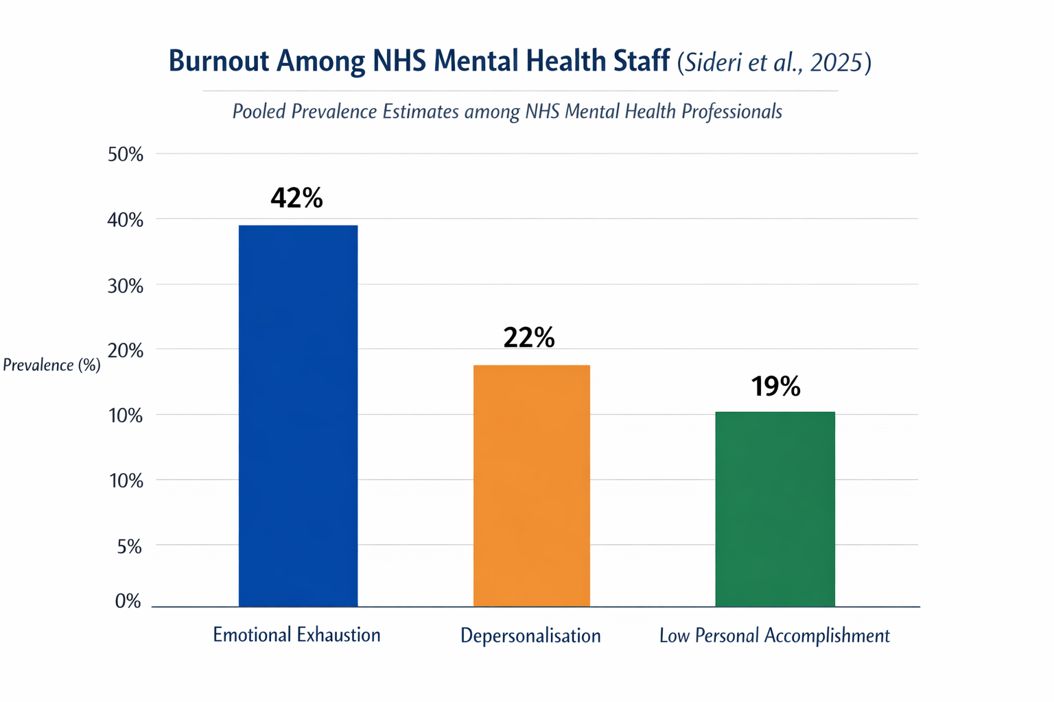
Nurses, support staff, allied health professionals and doctors in the NHS and the private social care are affected by burnout. Its influence encompasses rising sickness absence, turnover intentions and actual turnover that jeopardise continuity of service and the quality of care to patients. In the UK, as an example, at least half of emergency ambulance workers report personal and professional fatigue in the form of burnout, signifying rampant exhaustion and psychological burnout (Miller, 2026).
I picked this topic, as it is important to the provision of care that is safe and high-quality. I have personally experienced the impact that chronic stress can have on employee motivation and organisational outcomes, and I would like to be informed about the measures to help maintain sustainable healthcare provision. The topic is also closely related to my interest in academics, focusing on organisational wellbeing and my future goals in health services research and management. The study of burnout is not solely about the well-being of the workforce but is also a source of policy that supports patient care and the sustainability of healthcare organisations.

Task 2 – Evaluating Information Sources
A variety of reliable academic sources give insights into the nature and commonness of burnout and assist in stressing the significance of this problem in the context of UK health and social care.
The prospective cohort study by Collett et al. (2023) was conducted on a nationwide sample of UK healthcare specialists (follow-up of three years) to understand the effects of perceived workplace support and lifestyle change on depression and burnout. The researchers concluded that increased workplace support and lifestyle were associated with less emotional exhaustion and depersonalisation, two burnout dimensions. It is important to note that with a 10% change in depression scores (measured with PHQ-9) the intention to leave the role in 2 years also increased (Collett et al., 2023).
The source under consideration is of great value as it utilises longitudinal data, exposing the time dependence of associations between support, mental health, burnout, and staff retention - variables important to plan interventions. This study provides evidence that specific organisational strategies can decrease psychological strain and turnover by showing how the dynamics of the workplace reduce burnout levels over time. And yet, although it helps in building knowledge about associations, it does not comprehensively describe underlying causal processes or explain broad structural issues like staffing policies.
A systematic review of the prevalence of burnout in NHS mental health professionals (2025) is a synthesis of the findings of numerous studies that aimed to estimate the prevalence of burnout dimensions among this population. This meta-analytic data demonstrates high rates of emotional exhaustion (42%), which underscores the long-term nature of burnout in the environment where employees are exposed to high emotional demands and the lack of resources (Sideri et al., 2025).
This source can be used to formulate prevalence standards and to situate the risk of burnout in the context of professional groups. It weaves together information spanning various studies, enhancing the generalisability of such research as opposed to single-site studies. The research has, however, restricted its scope to mental health professionals, but it cannot be directly applied to wider NHS groups (like acute care nurses or ambulance employees).
Lastly, empirical studies on burnout among the UK dental workforce (2025) state that 61% of dental professionals were highly rated on emotional exhaustion and manifestations of pervasive negative psychosocial influences, such as depressive symptoms and detachment among dentists, a subgroup of health professionals (Knights et al., 2025). This source notes that another important aspect of burnout is in less-researched UK health professions that are not in a hospital setting.
Despite the strong evidence of burnout prevalence and its relationship with the nature of support and wellbeing presented in these publications, there are still gaps in the literature regarding the effectiveness of different interventions, comparative studies across different areas of care, and organisational-level predictors of long-term retention rates. Further empirical research is required to measure structural factors as well as practicable solutions.

Task 3 – Research Methodologies
Research methodologies identify the way through which data are gathered and examined in order to respond to research questions.
Quantitative research implies the use of numerical information. An example of such a quantitative design could be the use of validated burnout questionnaires (e.g., Maslach Burnout Inventory) to assess levels of emotional exhaustion and depersonalisation in a large group of NHS employees (Ghanad, 2023).
Qualitative research is about subjective experiences and meanings, conducted usually in the form of interviews or focus groups (Mulisa, 2022). To illustrate, talking to frontline nurses about their experience of burnout and work-related stress creates excellent contextual comprehension that cannot be achieved through the numerical approach (Islam and Aldaihani, 2022).
Mixed-methods research combines the two methodologies to produce an inclusive knowledge (Gupta and Gupta, 2022). In the proposed study involving burnout, the mixed-methods approach is the best design since it would allow incorporating both quantitative indicators of burnout and qualitative data analysis, focusing on the views of the staff and the impact of the organisation (Bhangu et al., 2023). Quantitative surveys can provide prevalence trends and correlations, whereas qualitative interviews may show subtle descriptions of prevalence trends, including organisational culture and support mechanisms on the managerial level (Bisaria et al., 2026).
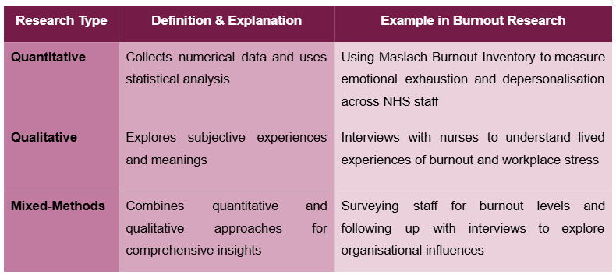
Mixed methods would help quantify burnout levels and inform practical measures to support the workforce by approaching the complexity of this occupational phenomenon.

Task 4 – Data Collection
Primary data is the collection of original data directly with participants, surveys, interviews, or observations; secondary data applies existing data, including published statistics, workforce surveys, or administrative records (Alahmari et al., 2022).
In this study on burnout, the primary data will be central because it will permit the customisation of measurements of burnout levels and factors related to burnout in real-time care environments. Prevalence and correlations of emotional exhaustion and depersonalisation among the participants of the NHS can be observed by quantitative surveys using validated tools, such as the Maslach Burnout Inventory (Barbara et al., 2025). A qualitative semi-structured interview will involve probing of the perceptions of staff, stressors in the workplace, and coping mechanisms so as to bring out profound information that cannot be determined by some numerical data. These approaches collectively answer the research questions of not only the level of burnout but also of the organisational or individual causes of burnout (Zhang et al., 2026).
There are also practical difficulties involved in primary data collection, such as time constraints of the participants, possible fatigue associated with the response and inability to obtain representative samples under high-pressure conditions. Nevertheless, its customised character renders it instrumental in the context of knowing the existing realities and develops certain hypotheses (Alahmari et al., 2022).
Secondary data, including NHS staff surveys or longitudinal studies, can help place findings in a context; they can be used to make comparisons with larger workforce trends, and they can contribute to a stronger study. Primary and secondary data are mutually fortifying to validate and be reliable, guaranteeing that a conclusion is based on existing experiences and sources of information (Zhang et al., 2026).
This research design focuses on primary data by incorporating secondary data and understanding the complexity of burnout in healthcare facilities, and offers actionable information to guide organisational policies and intervention strategies.
Table 1. Differences between primary and secondary data collection
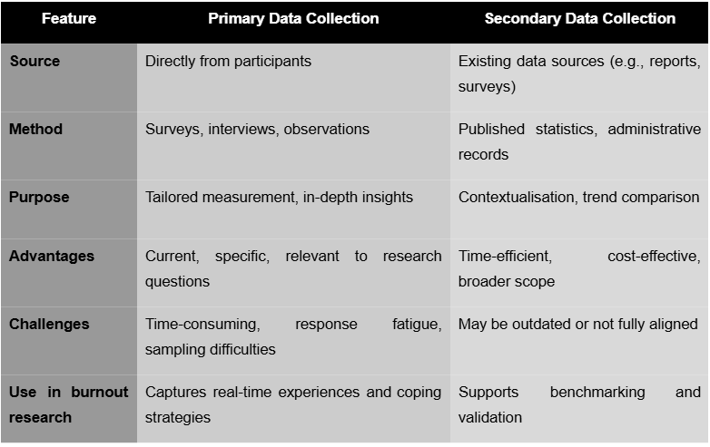

Conclusion
The problem of burnout among healthcare professionals working in the UK health and social care sector is very acute and threatens the well-being of the staff, as well as their retention and the provision of care quality. In the academic literature, burnout rates remain high in all occupations and stress the significance of organisational support in reducing psychological distress and turnover among staff. A quantitative and qualitative dataset would provide a fruitful study to inform interventions and policy based on prevalence and lived experience. Effectively managing burnout is also a factor in ensuring a long-term, healthy workforce that health systems can deliver effective, loving care to patients and staff members.

References
Alahmari, M.A., Al Moaleem, M.M., Hamdi, B.A., Hamzi, M.A., Aljadaani, A.T., Khormi, F.A., Darraj, M.A., Shrwani, R.J., AlOmar, A.A., Tahhah, M.K. and Alyousefy, M.A., 2022. Prevalence of burnout in healthcare specialties: a systematic review using Copenhagen and Maslach burnout inventories. Medical science monitor: international medical journal of experimental and clinical research, 28, pp.e938798-1.
Barbara, P., Bellizzi, A., Barbara, D. and Camilleri, A., 2025. Burnout among mental health professionals working in an inpatient setting within the Maltese NHS.
Zhang, Z., Peters, D., Xiao, L., Sun, J., Moradbakhti, L., Hall, A. and Calvo, R.A., 2026. Understanding Workplace Relatedness Support among Healthcare Professionals: A Four-Layer Model and Implications for Technology Design. arXiv preprint arXiv:2602.06916.
Collett, G., Kotecha, A. and Gupta, A., 2023. Burnout and depression amongst UK-based healthcare professionals: insights from a 3-year prospective cohort study regarding potential mitigation strategies. Journal of Occupational and Environmental Medicine, pp.10-1097.
Sideri, A.D., Kipoulas, E., Leddy, A. and Hackmann, C., 2025. Prevalence and Risk Factors of Burnout Among Mental Health Professionals in the NHS: A Systematic Review. Counselling and Psychotherapy Research, 25(4), p.e70055.
Miller, E., 2026. The prevalence of burnout in UK emergency ambulance staff: a mixed-methods survey study. British Paramedic Journal, 10(4), pp.25-33.
Knights, J., Young, L., Humphris, G., Newton, T. and UK Dental Team Mental Health Research and Implementation Group, 2025. Burnout and depression in the UK dental workforce: findings from a cross-sectional survey: Burnout and depression in the UK dental workforce: findings from a cross-sectional survey. British Dental Journal, 239(3), pp.189-196.
Ghanad, A., 2023. An overview of quantitative research methods. International journal of multidisciplinary research and analysis, 6(08), pp.3794-3803.
Mulisa, F., 2022. When does a researcher choose a quantitative, qualitative, or mixed research approach?. Interchange, 53(1), pp.113-131.
Islam, M.A. and Aldaihani, F.M.F., 2022. Justification for adopting qualitative research method, research approaches, sampling strategy, sample size, interview method, saturation, and data analysis. Journal of International Business and Management, 5(1), pp.01-11.
Gupta, A. and Gupta, N., 2022. Research methodology. SBPD publications.
Bhangu, S., Provost, F. and Caduff, C., 2023. Introduction to qualitative research methods–Part I. Perspectives in clinical research, 14(1), pp.39-42.
Bisaria, C., Madhubala Kumari, D.S.S. and Patel, B.K., 2026. Research methodology: Tools and techniques. BR Publications.

