Marks and Spencer
Operating Environment Analysis Report

Author: William Crews
Module: BMSP6006
Lecturer: Glenn Behenna
Submission Date: 22/11/2019

Executive Summary
Marks and Spencer is a well-established international retailer of own-brand clothing, food and homeware with over 1400 locations world-wide that employs over 79000 people and serves 18.9 million customers weekly. New entrants in the luxury food market has led to a slow-down in the growth of the food segment. Consumer confidence has been eroded in clothing in recent years, and market share has declined, as the offering is seen as dated and, in the words of CEO Steve Rowe, “frumpy”. The retail industry is under pressure from rising costs, uncertainty surrounding Brexit and weakening demand. Several steps have been taken to reverse these trends. A restructuring plan has been implemented which will see 120 underperforming stores close, to concentrate resources. Strategic partnerships with Ocado, for online grocery delivery and Microsoft for in-store AI technology have been made to raise competitive advantages for M&S. Marketing strategy is changing and a program instituted to see M&S become a leader in sustainability to capitalise on the growing number of consumers concerned with the environmental impact of their purchases. While M&S faces growing threats, there are many opportunities as well. Revamping its online platform and supply chain logistics, closing underperforming stores and concentrating resources to increase profitability, and regaining relevance in the clothing market are among the most important.

Table of Contents

- Introduction
  - History
  - Current Position
- Main Findings
  - Internal Operating Environment Analysis
    - Business Competencies: Assets, strategic alliances and financial position
    - Key Internal Drivers
    - Stakeholder Management
    - Internal Factor Evaluation for M&S
    - McKinsey’s 7-S Framework Analysis
    - Four Factors of Competitive Advantage
  - External Operating Environment Analysis
    - Retail Industry Analysis
    - PEST Analysis
    - Competitive Profile Analysis
    - Main Threats to M&S
    - Main Opportunities for M&S
    - External Factor Matrix for M&S
- Conclusions and Recommendations
  - Conclusions
  - Recommendations
    - Capitalise on M&S brand loyalty
    - Get ahead of the curve in digital sales
    - Control costs and maximise sales

1.0 Introduction

1.1 History
Marks and Spencer was incorporated in 1926 with the opening of the flagship Marks & Spencer selling houseware and clothing in Marble Arch, but the company has its beginnings in 1894, when Michael Marks joined forces with Tom Spencer. They opened their first shop together in 1904. Marks and Spencer championed employee welfare, starting their first program in 1933, which provided subsidised staff canteens, dental and health care, pensions and even camping holidays and hairdressing. (Marks in Time, 2019)

1.2 Current Position
M&S currently operates 1043 Marks and Spencer stores located in the UK and 428 internationally, serving approximately 18.9 million customers weekly and employing approximately 79000 employees (statista.com, 2019). The retail industry in the UK is under pressure. This past year saw the worst Christmas in 10 years for retailers. Costs of goods continue to rise, demand has weakened due to a loss in consumer confidence due to the uncertainty caused by Brexit and a possible global economic slowdown (www2.deloitte.com, 2019). M&S has seen a decline in after-tax profits over the past five years, from £506m in 2014 to £29m in 2018, which rose to £37m for the year reported in 2019 (corporate.marksandspencer.com, 2019). M&S has a market share of 7.6% (clothing) in the UK market, down from a high of 13.5% in 1997 (globaldata.com, 2018). The company had world-wide revenue of almost £10.4 billion in 2018, mostly from UK sales. This is split 61% in food sales and 39% in clothing and home. (corporate.marksandspencer.com, 2019) 54% of M&S’ customer base is over age 55, majority female. Men make up 42% of shoppers and only 22% of customers are under the age of 35. (bbc.co.uk/news, 2016)

This report will present an analysis of the internal and external environment in which Marks and Spencer currently operates and make recommendations for the future direction the company should take.

2.0 Main Findings

2.1 Internal Operating Environment

2.1.1 Business Competencies: Assets, strategic alliances and financial position

As of 30 March 2019, M&S held total assets of £7.2 billion, down from £7.55 billion in 2018. Tangible asset worth was down from 2018 reporting by £361 million. Intangible assets were valued at £500 million, down from 2018 reporting by £99 million. Net assets in 2019 were valued at £2.681 billion down £273 million. In this period M&S managed to lower liabilities by £77 million (telegraph.co.uk, 2019).

M&S’ after-tax profits have declined dramatically since 2014. The biggest decline was seen from 2016 to 2017 (year-end 2016 profits of £404m, 2017 profits of £29.2m, 2018 profits of £37m ) (telegraph.co.uk, 2019). A restructuring plan, which has cost £512 million in one-off costs and lost revenue, is one main cause of this decline. A further £150 million is due to be spent on the closure of M&S’ least profitable shops, bringing the total of stores closing to 120 (Van Rompeay, 2019). Declining sales have also contributed to the loss in profits. Like-for-like sales of clothing fell by 5.5% from 2018 to 2019. According to CEO Steve Rowe, this is attributed to buying errors, an outdated supply chain, and slow and complicated logistics, which meant popular sizes were not available in stores and the perception that the brand has become “frumpy”. Increased online competition and competition from discount retailers entering the market has also hurt M&S (Wood, Z, 2019). M&S has also maintained its dividend per share at 18.7p for the past few years, however this has dipped to 13.9p for the latest fiscal year (corporate.marksandspencer.com, 2019).

2.1.2 Key Internal Drivers

Significant change to the corporate structure and culture has begun at M&S. The historically top-heavy, hierarchical structure is giving way to smaller teams, eliminating the extra layers of management and committees (Wood, Z. & Butler, S. 2018). Rowe recently announced changes to the management structure to “move the business closer to its customers” and speed response time, improving resilience, and lowering management costs (corporate.marksandspencer.com, 2016). The restructuring also includes the closure of 120 of its underperforming high street locations that have precipitated the decline in profits and will focus on becoming a global digital retail leader. The five year plan is to move a full 30% of its sales online in this time. 351 management positions will be eliminated from the payroll in these store closures (Singh, P, 2018). The key driver of the company’s strategy is to get back to the basics of traditional values, every day low prices and streamlining operations to lower costs. According to Rowe, its mission is to restore value and style in clothing and home offerings and to begin a turn-around in food sales. The major theme for the company as a whole is to address falling profits and “face the facts” of the situation in which M&S finds itself. (corporate.marksandspencer.com/aboutus, 2019)

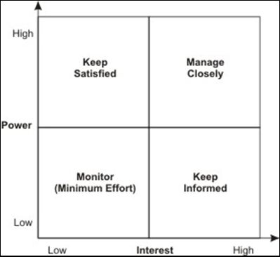
2.1.3 Stakeholder Management
Keep Informed

Community
Monitor

Gov’t agencies
Media
Competitors
Manage Closely

Customers
Suppliers
Keep Satisfied

Employees
Shareholders
Matrix: (https://rainasreflections.wordpress.com/2013/01/13/stakeholder-analysis/, 2013)

Stakeholder management is embodied in the company’s Plan A sustainability initiative. This program consists of 100 points designed to position M&S as a global leader in sustainability and tackle five big issues: waste, resource scarcity, climate change, fair trade partnerships and health. With consumers increasingly aware of the impact of their buying choices, this program is designed to create long-term sustainable value.

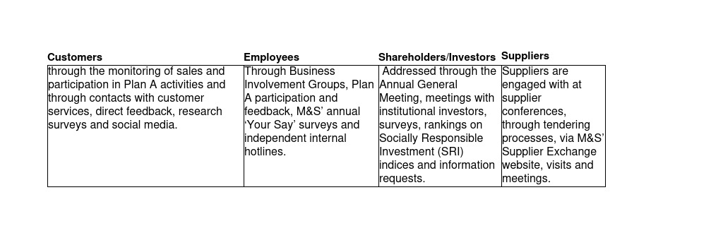
Each stakeholder group is monitored and engaged with in a variety of ways:
(corporate.marksandspencer.com/sustainability, 2019).

2.1.4 Internal Factor Evaluation for M&S
The total weighted score of 2.45 is considered moderately low. This indicates that M&S is not in a strong position overall. The M&S website reflects this, speaking of the weak position it finds itself. The company is restructuring to address the major issues facing it, but the needed turn-around has not yet been fully realised.

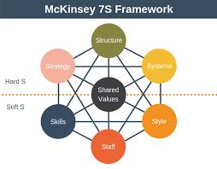
2.1.5 McKinsey’s 7-S Framework Analysis

Image: https://expertprogrammanagement.com/2018/11/mckinsey-7s-framework/

McKinsey’s 7-S framework has been employed to visualise the forces at work at M&S as they restructure to create value and enhance competitive advantage:

- Structure – Restructuring into specialist teams, moving away from the historically bureaucratic, top-heavy management structure (Wood, Z. & Butler, S. 2018).
- Strategy – changing marketing strategy from the “One Brand” approach, separating food and clothing/home. Taking a back-to-basics direction, focussing on brand loyalty, quality and value (Vizard, S. 2018).
- Systems – New systems such as the Retail Data Academy to build a data-literate work-force, new online platform and industry-leading distribution systems at Castle Donington to become more responsive.
- Style – New teams will be tasked with individual responsibility in the areas of marketing, merchandising and customer relationship management.
- Skills - Building digital skills and bolstering skills such as brand development and encouraging colleagues to become data-literate through the Retail Data Academy.
- Staff - Promoting current staff through education and team-building programs, attracting new staff with incentives such as a higher starting wage, to enhance the company’s skillset.
- Shared Values – Incorporating the six above to build M&S’ competitive advantage. Embodied in the “Four I’s” (Inspiration, Innovation, Integrity and In-touch).

2.1.6 Factors of Competitive Advantage

Sustainable competitive advantage is influenced by many factors, but generally fall into two categories: comparative advantage and differential advantage. A comparative advantage exists when a company can produce a product or service more efficiently than its competitors, which leads to greater profitability. A differential advantage exists when a company’s offering is seen as superior to competitors, whether this be attributed to quality, technological superiority, innovation or service (Twin, A. 2019).

M&S’ competitive advantage is currently greatest in the differential advantages it possesses. The main differential advantages are quality, customer responsiveness and reputation. The most valuable intangible asset continues to be the M&S brand, with an estimated value of £3.4 billion in 2018 (Vizard, S., 2018). Recently, 67% of respondents rated M&S 5 stars for quality and 37% gave five stars for service. The company is also afforded great consumer sentimentality for its “quintessential Britishness” (Gilliland, N., 2018). M&S was ranked number one supermarket, with 57% rating their experiences with M&S as “always positive” (Tesco received 30%) (Ainsworth, P,. 2018). A recent customer service insight program, replacing an outdated mystery shopper program, based on InMoments voice of customer software saw an overall increase of 23% in satisfaction across its stores (Cameron, N. 2018).

Recent investments in new technology at its fulfilment centre at Castle Donington are aimed at restoring comparative advantage by providing efficient distribution to stores. According to Rowe, it has struggled to cope at peak times, with dated systems and a slow website (Wood, Z. & Butler, S. 2018). However, he says 2019 saw it operate at its best peak performance since opening with an investment in new search functions, later delivery cut-off times and new systems. A further £9 million is to be invested in process improvements. (Rowe, S, 2019)

Strategic partnerships with Microsoft for AI technology and Ocado for online grocery sales will also attempt to address the issue of lagging comparative advantage. Beginning in 2018, as part of the Digital First Retailer initiative and Technology Transformation Program, M&S began working with Microsoft to optimise operational performance and create an enhanced retail experience, with a more agile, resilient approach with industry-leading technology. (corporate.marksandspencer.com, 2019)

A £750 million joint venture with Ocado, the online grocery delivery firm saw M&S buy a 50% stake. Shareholders were concerned as M&S stock fell 12%. However, CEO Rowe believes that the venture will deliver sustained, long-term growth, utilising Ocado’s established technology and supply chain, the venture will bring M&S’ food offering online for the first time, in a bid to compete with other grocery chains. (Neate, R, 2019)

2.2 External Operating Environment

2.2.1 Retail Industry Analysis:
Total retail sales revenue, excluding fuel, in the UK for 2018 was £380 billion, up £14 billion from 2017. 20% of retail sales is now online. (statista.com, 2019) The retail sector is under pressure from rising costs, lack of consumer confidence due to Brexit, the threat of a global economic slowdown and the worst Christmas in 10 years (2018). (deloitte.com, 2019)

Growth in retail sales has declined in recent years. Retail sales growth was 4.7% in 2016 (while UK GDP was 1.9%) but has declined to just 1.9% in 2017 while UK GDP was 1.78% (Gilliland, N, 2018). (GDP figures: data.worldbank.org, 2019)

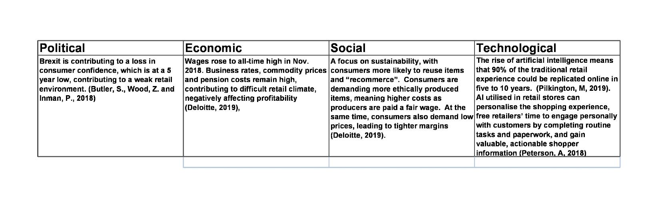
2.2.2 PEST Analysis
2.2.3 Competitive Profile Matrix
Based on market share as of 2018.

A comparison of the three closest competitors in clothing sales reveals M&S lags behind rival Next. Next online platform and faster distribution network outperform M&S and are perceived as superior because the quality is comparable, but is more current.

2.2.4 Main threats to M&S include:
- Political uncertainty with the delay of Brexit, which could bring rising costs, disruption of the supply chain.
- Increased competition from rivals online and new entrants in the luxury food market including discount retailers Aldi and Lidl.

2.2.5 Main Opportunities for M&S:
The main areas of opportunity for M&S are the improvements planned for the distribution centre (additional £9 million investment in new systems), updating their online presence to increase sales online to 30% of business, launching the partnership with Ocado to bring M&S food offering for home delivery. Another area is, of course, to complete the closure of its worst performing stores to concentrate resources and enable the company to invest in and revamp remaining stores and becoming a world leader in sustainability with its Plan A program.

2.2.6 External Factor Matrix for M&S
Total weighted score of 2.6 is average. This indicates M&S may be on the right track to address external threats and capitalise on opportunities. However, the company will need to ensure these new strategies are carried out in order to fully benefit from these opportunities and rise above the threats it faces.

- Conclusions and Recommendations

3.1 Conclusions

Following several years of stagnation with declining market-share and profits, M&S is undertaking a corporate restructure to become more responsive and resilient in the face of increasing competition and rising costs. A back-to-basics approach, focussing on the strength of the brand, trimming underperforming stores, investing in new technology for its website, supply chain logistics and educating colleagues to become digital leaders has been launched under direction of CEO Steve Rowe. M&S has invested in new strategic partnerships such as that with Ocado to bring its food offering online for home deliver and with Microsoft for AI technology to enhance the retail experience. The Plan A initiative is driving M&S towards being a world leader in sustainability to capitalise on the increasing market of consumers who understand that their buying choices impact the environment and climate change.

  - Recommendations

    - Capitalise on the M&S brand:

Emphasise the quality that M&S is known for and enhance the clothing offering to appeal to today’s consumer. M&S struggles to appeal to younger consumers and even older customers, who increasingly follow trends and strive to dress more fashionably than in the past (Wood, Z. & Butler, S. 2018). This must also incorporate marketing to effectively communicate these changes to consumers and must address pricing pressure from retailers offering similar items. If communicated effectively, consumers are inclined to purchase from M&S, if given a competitive choice, due to the brand perception M&S enjoys (Vizard, S. 2018).
3.2.2 Reclaim market-share in online sales:
Investment in new technology to improve the speed of its website must continue in order to achieve the goal of 30% of sales moving to online by 2022. A successful launch of the online partnership with Ocado to deliver M&S food to households is vitally important. This partnership will save money by using the distribution network and systems that Ocado has already built (Shaverien, A. 2019).
These investments must be supported with marketing efforts, especially on social media. M&S has seen great success in this area, especially with shoppable Instagram posts and Facebook advertisements, according to M&S Marketing Director for Clothing and Home, Nathan Ansell (Hammet, E. 2018).
3.2.3 Maximise Profitability while Controlling Costs
Complete the restructuring campaign to trim its real estate portfolio to eliminate underperforming stores, changing the management structure to eliminate unnecessary bureaucracy and invest in remaining stores to improve the shopping experience. Expand the use of AI to target consumers in-store and online. Continue investment into new systems and technology at its Castle Donington distribution centre to improve availability of product in stores and capture sales.

References:
Ainsworth, P, 12/12/2018, Brand Loyalty Index; M&S Voted Customers’ Favourite Supermarket, viewed on 03/31/2019, <https://cxm.co.uk/brand-loyalty-index-ms-voted-customers-favourite-supermarket/>

Atkinson, E, 25/05/2016, Who Is Mrs. M&S?, viewed on 27/01/2019 <https://www.bbc.co.uk/news/uk-36380151>

bbc.co.uk, 22/05/2018, M&S to Close 100 Stores by 2022, viewed on 27/01/2019 <https://www.bbc.co.uk/news/business-44197128

Butler, S, Wood, Z and Inman P, 26/05/2018, Six reasons why Britain’s retailers can’t make ends meet, viewed on 31/03/2019, <https://www.theguardian.com/business/2018/may/26/six-reasons-why-british-retailers-are-struggling>

Cameron, N, 20/02/2018, What Marks and Spencer Did to Boost Customer Satisfaction Globally, viewed on 31/03/2019, <https://www.cmo.com.au/article/633573/what-marks-spencer-did-boost-customer-satisfaction-globally/>
corporate.marksandspencer.com, 2019 viewed on 27/01/2019 <https://corporate.marksandspencer.com/documents/policy-documents/code-of-ethics.pdf>

corporate.marksandspencer.com, 2019, viewed on 20/01/2019 <https://corporate.marksandspencer.com/aboutus/m-and-s-today>

corporate.marksandspencer.com/media/press-releases, 2019, viewed on 03/20/2019, https://corporate.marksandspencer.com/media/press-releases/2018/microsoft-and-m-and-s-launch-strategic-partnership-aimed-at-transforming-the-retail-experience-using-the-power-of-ai

corporate.marksandspencer.com/sustainability, 2019, viewed on 31/03/2019, <https://corporate.marksandspencer.com/sustainability/people>

deloitte.com, 2018, viewed on 29/01/2019 <https://www2.deloitte.com/uk/en/pages/consumer-business/articles/retail-trends.html Retail Trends 2019>

expertprogrammanagement.com, 2018, viewed on 31/03/2019, <https://expertprogrammanagement.com/2018/11/mckinsey-7s-framework/>

Gilliland, N, 29/05/2018, Five reasons for M&S’ woes: from loyalty to innovation, viewed on 27/01/2019 <https://econsultancy.com/five-reasons-for-m-s-woes-from-loyalty-to-innovation/>

Globaldata.com, 22/05/2018, M&S Lose Decades Long Status as Number One Clothing Retailer to Primark, viewed on 28/01/2019 <https://www.globaldata.com/ms-lose-decades-long-status-number-one-clothing-retailer-primark/

Hammett, E, 05/09/2018, M&S hires first chief digital and data officer to drive ‘modern digital mindset, viewed on 28/01/2019 <https://www.marketingweek.com/2018/09/05/marks-spencer-first-chief-digital-data-officer/>

Hammett, E, 06/09/2018 M&S is transforming its marketing team into specialists rather than generalists, viewed on 29/01/2019 <https://www.marketingweek.com/2018/09/06/ms-marketing-team-specialists/>

marksintime.marksandspencer.com, viewed on 28/01/2019 <https://marksintime.marksandspencer.com/download?id=996>
Neate, R, 02/2019, Marks and Spencer Agrees £750m Food Delivery Deal with Ocado, viewed on 03/15/2019, https://www.theguardian.com/business/2019/feb/27/marks-and-spencer-agrees-750m-food-delivery-deal-with-ocado

Peterson, A, 09/2018, How Artificial Intelligence is Powering the Retail Experience, viewed on 31/03/2019, <https://www.thestorefront.com/mag/how-artificial-intelligence-is-powering-the-retail-experience/>

Pilkington, M, 29/01/2019, How Will Technology Affect the Retail Industry, viewed on 31/03/2019, <https://www.forbes.com/sites/quora/2019/01/29/how-will-technology-affect-the-retail-industry/#7bb9a6bd1005>

rainasreflections.wordpress.com, 2013, viewed on 31/03/2019, <https://rainasreflections.wordpress.com/2013/01/13/stakeholder-analysis/>

researchbriefings.files.parliament.uk, October 2018 Retail Sector in the UK, viewed on 28/01/2019 <researchbriefings.files.parliament.uk/documents/SN06186/SN06186.pdf 29>

Schaverien, A, 2019, Why A Marks & Spencer-Ocado Partnership Makes Sense for Both Retailers, viewed on 02/02/2019 <https://www.forbes.com/sites/annaschaverien/2019/01/30/ocado-marks-and-spencer-mands-partnership-waitrose/#7cdb397f74dd>

statista.com, 2018, viewed on 27/01/2019 <https://www.statista.com/statistics/534719/uk-premium-brands-mands-performance-customer-evaluation/>

statista.com, 2018, Marks and Spencer – Statistics and Facts, viewed on 28/01/2019 <https://www.statista.com/topics/3707/marks-and-spencer/ >

statista.com, 2018, Grocery Market Share in Great Britain, viewed on 29/01/2019 <https://www.statista.com/statistics/300656/grocery-market-share-in-great-britain-year-on-year-comparison/>

shares.telegraph.co.uk, 31/03/2019, MKS share information, viewed on 31/03.2019, <https://shares.telegraph.co.uk/fundamentals/?epic=MKS>

Singh, P, 17/07/2018, M&S to Cut 351 Store Management Roles, viewed on 31/03/2019, <https://fashionunited.uk/news/business/m-s-to-cut-351-store-management-roles/2018071730786>

Vizard, S, 19/04/2018, M&S’s shake-up suggests its ‘one brand’ marketing strategy didn’t work, viewed on 28/01/2019 https://www.marketingweek.com/2018/04/19/marks-spencer-one-brand-marketing-strategy/

Wood, Z & Butler, S, 23/05/2018, Seven Reasons Why Marks & Spencer is in Trouble, viewed on 28/01/2018 https://www.theguardian.com/business/2018/may/23/seven-reasons-why-marks-spencer-is-in-trouble

Wood, Z & Butler, S, 23/05/2018, Marks & Spencer reports sharp drop in annual profits, viewed on 29/01/2019 <https://www.theguardian.com/business/2018/may/23/marks-and-spencer-reports-sharp-drop-in-annual-profits>

worldbank.org, 2018, viewed on 27/01/2019 https://data.worldbank.org/indicator/NY.GDP.MKTP.KD.ZG?end=2017&locations=GB&start=1961

https://www.statista.com/topics/3707/marks-and-spencer/ Marks and Spencer – Statistics and Facts

http://sharestobeclosed.telegraph.co.uk/fundamentals/?epic=MKS

https://www.theguardian.com/business/2019/nov/06/marks-and-spencer-profits-plunge-clothing-sales-fall Marks & Spencer profits plunge as clothing sales continue to fall Zoe Wood November 6, 2019

22-05-2019 Stefan Van Rompaey Marks & Spencer profit suffers from restructuring https://www.retaildetail.eu/en/news/general/marks-spencer-profit-suffers-restructuring

ALEXANDRA TWIN Updated Aug 30, 2019 Competitive Advantage https://www.investopedia.com/terms/c/competitive_advantage.asp

Rowe, S. (2019) 2019 Strategic Report, https://corporate.marksandspencer.com/documents/msar-2019/strategic-report.pdf

https://www.statista.com/statistics/287915/retail-sales-value-annually-great-britain-excluding-fuel/

