Digital and material process B2 Thursday 4th April

To help feed imagery for your Visual Studies 2 project, we are using the theme of revolt as this weeks trend. As well as providing imagery we will also be trialling ideas in process. You may wish to consider the approach from todays session to explore the two other trends from Visual Studies 2 of submerge & reform.

You have been provided with positive and negative photocopies of text and different gridded texture. You are asked to use these to play and explore the idea of revolt, this is an up-coming trend that has links to a pink and red colour palette. You will explore the process of painting with Dysperse dyes onto the provided photocopies, which you will then collage with before transferring the designs through the “heat transfer” method onto synthetic cloth.

The task is to complete at least 2 images during the session using different drawing methods.
- Russian Constructivist inspired montages using bold shapes and colour (see examples examples) that could become fashion prints
- Lo tech fashion illustration with interesting montaged shapes and text that could be explored as a print for fashion or an idea that illustrates how a print may sit on the body. (see examples below)

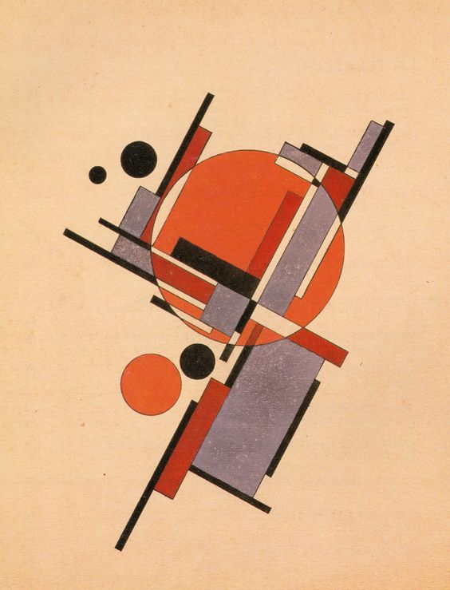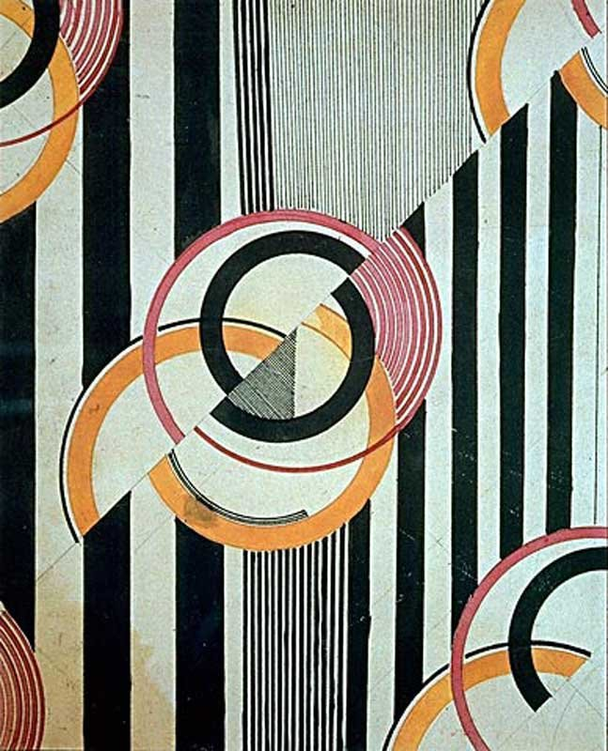

Lakov Chernikhov Liubov Popova
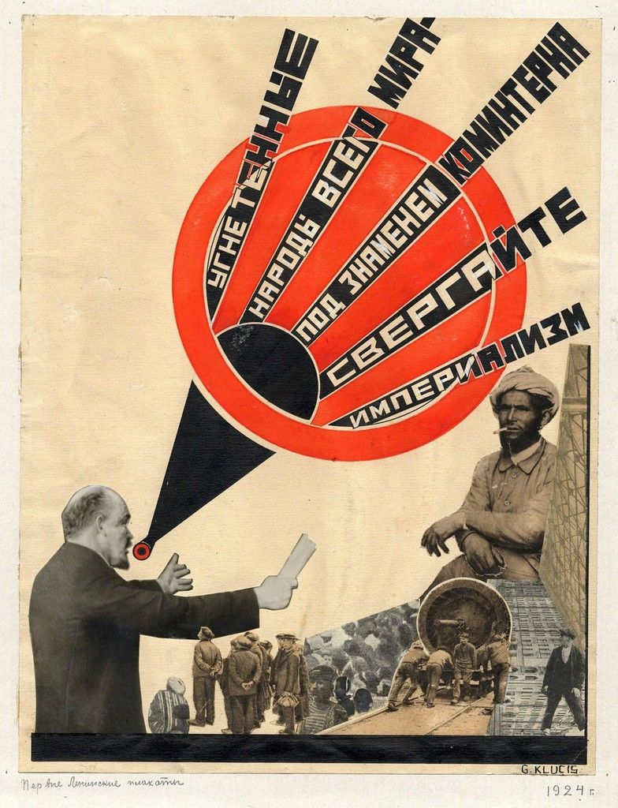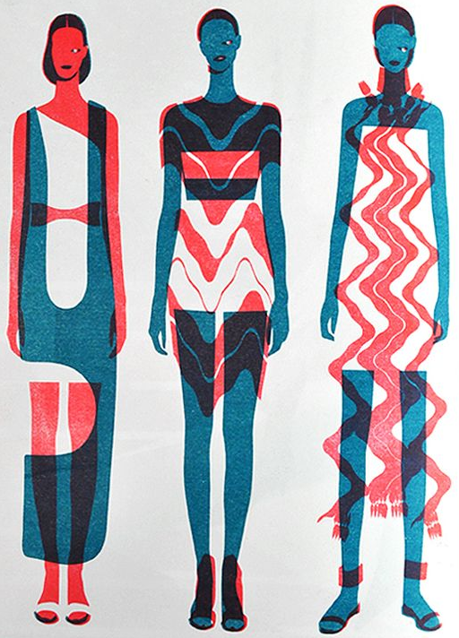

Gustav Klutsis John Lisle

NB

Photocopies left over from the session are on the notice board and all Dysperse dye colours from the session have been left in the fridge (all labelled with colour and %)

For your information and to add to your own technical notes the disperse dyes were mixed at 90% warm water and 10% Dyperse colour. Heatpress was set to 200˚C and 40 seconds.

Colours mixed were: (colour test swatch fabric also attached to the notice board)

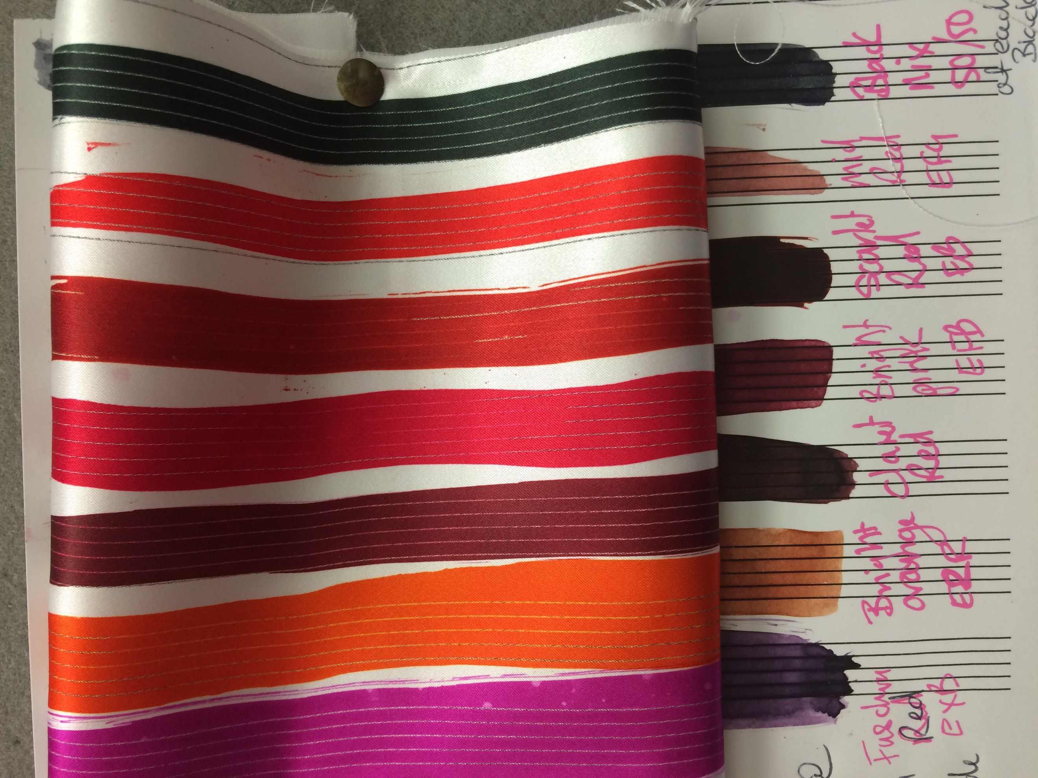
Left to right
10% Fuchsia Red EXB
10% Bright Orange E2R
10% Claret Red
10% Bright Pink EFB
10% Scarlet Red EB
10% Mid Red EFG
5% Full Black EBT & 5% Charcoal black mix

