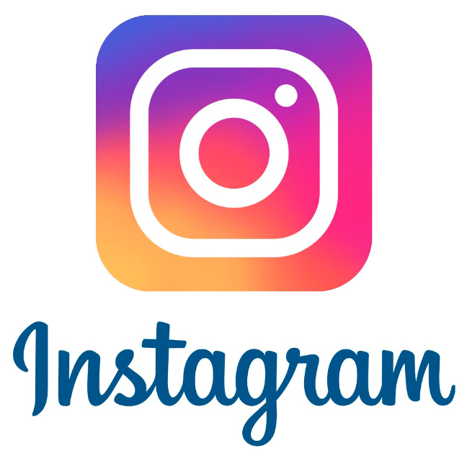
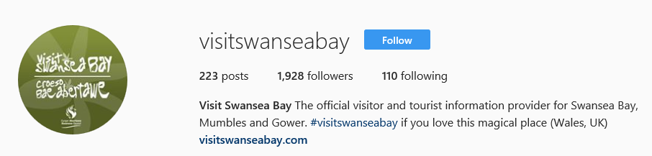

PID - Consultancy Project – Visit Swansea Bay
Instagram

Jessica Harrison | P140704 | 16th March 2018

Content Page
- Project Justification……………………………………………………………………..3
  - Aim……………………………...………………………………………………..3
  - Objectives…………………….……………………………………………….…3
  - Desired Outcomes…………………………………………………………..….3
  - Links………………………………………………………………………….…..3
- Approach to be Adopted / Already adopted……………………………….......…….4
- Business Case……………………………………………………………………..……5
- About the Project Management……………………………………………….…..…..6
- Management Strategy………………………………………………………..………...6
- Communication Strategy……………………………………………………………….6
- Project Plan………………………………………………………………………….…..7
- Project Control Mechanisms…………………………………………………………...7
- Project Reporting Systems & Procedures………………………………………..…..8
- Additional Information……………………………………………………………….8
- References……………………………………………………….…………………..9

1.0 Project Justification
The project that is taking place is the help Visit Swansea Bay get their Instagram more active and for more people to know about Visit Swansea Bay so they can gain followers and be in competition with other organisations such as Visit Wales which is their main challenger.
Since the BID they had a known 1.8 K followers and now currently have 1.9K through myself passing on advice to Lucy that I am working with on this project.
1.1 Aim – The aim is to be able to make Visit Swansea Bay known on Instagram and to get more visitors to interact with them and for Visit Swansea bay to keep more active online to make people want to see the posts they do.
1.2 Objectives – To be able to complete the aim, I will need to work out what they are doing wrong on their Instagram to be able to improve on this, See what they are doing on their Facebook and Twitter as they have a good response on there. To make some suggestions in how to change this to keep it active daily and to be able to then gain more followers.
1.3 Desired Outcomes – For the Instagram to me more active and used more over time and for Visit Swansea Bay and visitors to interact more with each other.
1.4 Links – Visit Swansea Bay have a lot of partners due to their guides and other work that they do within the Tourism and Marketing board so this can help boost activity by the organisations joining in to.

2.0 Approach to be adopted / Already adopted

TASK | DATE COMPLETED | DATE TO COMPLETE BY
Come up with a project | 31/01/2018
Contact Visit Swansea Bay | 18/02/2018
Had Approval from Lucy | 19/02/2018
Get information for the BID | 19-/02/2018
Submit the BID to Turn it in | 20/02/2018
Presented BID | 21/02/2018
Passed the BID (Feedback) | 28/02/2018
Shared information with Lucy | 05/03/2018
Prepared PID | 26/02/2018
Complete the PID | 15/02/2018
Submit the PID to turn it in | 15/02/2018
Feedback on the PID |  | End March
Show Lucy Feedback |  | End March
Start Report |  | 26/03/2018
Draft Report |  | 28/03/2018
Finish Report |  | 05/03/2018
Feedback on Report |  | End May
Show Lucy Report |  | End May
Send Lucy Report to use |  | End May
Test if my theory works |  | End May
Have feedback from Lucy |  | End May

3.0 Business Case

The project is to get Visit Swansea bay more active on Instagram and to get their profile well known. The reason for doing this is because they only have 1.9k followers, where as their Twitter has 14.4k and their Facebook has 71.4k so this shows a big difference to what they are spending more time on.
The business case is to identify what Visit Swansea Bay are doing wrong on their Instagram and what they are not doing on their Instagram to get people engaging with them.
For this case to work I need to find out what they are doing more on their Facebook and Twitter to be able to identify most of the problems. This is something that I am doing for free so it does not have any costs in anything I do or what they do as an organisation and because I am able to do all the work and research for them it’s not taking up any of their time. There is no risk to the business and will only gain benefits from this for the organisation to get more known on social media.

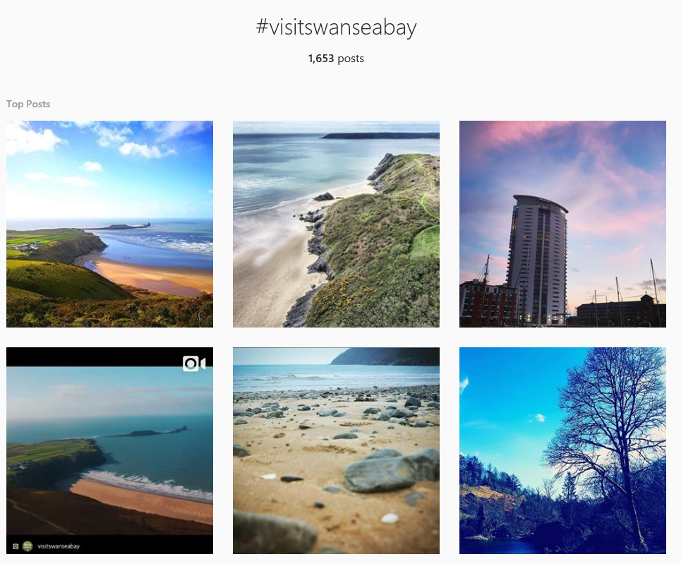
This image shows that even the system they are using with the #visitswansea bay not enough people know about it and since they have been active from 9th November 2012 this is very poor in getting visitors to interact with them. Comparing again to Visit wales and using their #visitwales they have an amazing visitor interaction with 210,340 posts.

4.0 About the project management team
I will be working this by myself and then reporting back to Lucy from the Marketing and Digital team after I complete every part of my work. I will mainly be using social media to get all the information I need to know as its mostly primary research that I will be using for this project.

5.0 Management Strategy
The main techniques I will be using is social media as my platform, this will help me get a survey out to everyone and to see who actually knows about Visit Swansea Bay. This will help me see all different types of comments from all ages, regarding my questions and their answers. This will also tell me what they think they need to improve on and hopefully by putting the survey out there that it will gain more interaction on their Instagram. I will also be using word of mouth and generally seeing what people think of their Instagram just by looking at it.
What I must achieve is to start getting them more interactive and for them to take my report away and work on all the advice I have given them that will work to improve on their Instagram and to get more known as a location through this.
There are no risks to the project I am doing, so this will not have an impact on Visit Swansea Bay in any way possible.

6.0 Communication Strategy
The Visit Swansea Bay team of Tourism, Marketing and Digital are all interested to see how this works and to see if I can help them in any way as it will not only boot the Instagram profile it will boost everything else such as their social media, website, brochures, magazines as people will know more about them. I will be letting my team know how I get on and if I need to pass any information on to help them.
The resources that I will require to do this is the internet (Wi-Fi), Laptop, Computer, Books, Pens, IPad, Samsung Tablet and word of mouth.

7.0 Project Plan
Task | When to do it by?
Look for a problem | February
Ask if you can solve the problem to the business | February
Start looking for problems | February
To be able to solve their Instagram interaction | February
Start comparing the Visit Swansea bay to Visit Wales | February
Look at their other social media | February
Detect their main problem | March
Start looking for ways to improve | March
Make a survey | March
Send out a survey to social media | March
Get at least 100 Responses | April
Start making a list of all the responses | April
Put the answers into charts | April
Use the information to help me solve the problem | April
Start making plans to solve the problems | April
Test these theories out on my own Instagram to see if it works | April
Pass on information if its worked after a week | April
Make charts of how it worked on my own Instagram | April
Put all my plans together | April
See if there has been any changes since the survey has been sent out and any advice I’ve given so far | April
Put it all into the Report | April
Send the Report to Lucy | May

8.0 Project control mechanisms
I will not physically be logging into Visit Swansea Bays Instagram I will be doing it from an outsiders point of view and working from it on the outside as I find I will get better results this way as if I log in then I will get attached and will start doing what I have advised within my report. I have all time limit dates as shown in my project plan and my approaches to be adopted and that have already been done. I will me monitoring the Instagram page and monitoring myself and keeping on my deadlines and completing everything to my schedules. I will be Reporting back to Lucy mainly, but I can also report back to the whole of the tourism team so it can help with any other sources such as Enjoy Swansea Bay, so it can help them with my project and also other projects too.

9.0 Project reporting systems & Procedures
The systems and procedures I have in place to work and report back to Lucy is quite simple, I am currently working on the Tourism Team within Swansea City Council and Lucy works on the Marketing/Digital Team by based in the Tourism area so this is how we are able to keep in contact over what I am doing and I am able to help and give ideas quiet easily as we are working together four times a week. If I’m not in and I need to contact her then I usually message, her via her Swansea council email and then she gets back to me straight away, so we go have a good system on reporting to each other that works for us both.

10.0 Additional Information
The Visit Swansea Bay tourism team are known to promote Swansea bay, Mumbles and Gower as a year-round destination for leisure and business tourism and aim to increase the volume of visitors and their overall spend within the local economy. They are not doing this through a main social media site which could help them boost their economy via Instagram, As people use Instagram instead of Trip Advisor now, so instead of reading reviews people want to see the real image and this is what makes people choose to go to a destination, so they need to sell themselves through pictures and this is what their Instagram is for so they need to keep active to reach their aim.

11.0 References
- Vincent, L, (2018), Visit Swansea Bay. Available at: https://www.visitswanseabay.com/ [Accessed 5 February 2018].
- @Visitwales, @Swansea_Council, @hellturn & @flydriveexplore, (February 2018), #visitswanseabay Images [ONLINE]. Available at: https://www.instagram.com/explore/tags/visitswanseabay/ [Accessed 5 March 2018].
- Visit Swansea Bay, Mumbles and Gower, @visitswanseabay, (2018), Visit Swansea Bay Facebook [ONLINE]. Available at: https://www.facebook.com/visitswanseabay [Accessed 9 March 2018].
- Instagram, (February 2017), Instagram Image [ONLINE]. Available at: http://1000logos.net/wp-content/uploads/2017/02/Instagram-app-logo.jpg [Accessed 5 March 2018].
- @visitswanseabay, (March 2018), Visit Swansea Bay Twitter [ONLINE]. Available at: https://twitter.com/visitswanseabay/ [Accessed 9 March 2018].
- @ryansheppeck, @eilir30, @uk.shots & wxmmerv, (09 March 2018), #visitwales Images [ONLINE]. Available at: https://www.instagram.com/explore/tags/visitwales/ [Accessed 9 March 2018].
- VisitSwanseaBay Image, (14 March 2018), Visit Swansea Bay Instagram [ONLINE]. Available at: https://www.instagram.com/visitswanseabay/ [Accessed 14 March 2018].

