Organization of the live event and a Planning document
A Taste of Trinity Food Festival
Live Events Project (BMTP 5021)
Lecturer- Debbie Jenkins
Ayda Bekisoglu 2303753
Group compresses of Ayda, Carys, Angelika and Demi

Event Overview 1
Event Name 1
Event Type 1
Concept & Theme 1
Target Audience 1
Timing, Location & Programme 1
Date & Time 1
Venue 1
Key activities/sessions 1
Closing & wrap-up 1
Aims and Objectives 1
Overall Aim 1
Objectives 2
Project Planning Techniques 2
Work Breakdown Structure (WBS) 2
Gantt Chart 2
Running Order 3
EMBOK Domains: 3
Administration 3
Design 3
Marketing 3
Operations 4
Risk Management 4
Market Research & Target Audience 4
Market Segments 4
Competitor Analysis 4
Consumer Preferences 5
Event Marketing Plan 5
Marketing Channels 5
Promotional Timeline 5
Sponsorship 5
Budget & Financial Plan 5
Project Income 5
Expected Expenditure 5
Venue & Equipment 5
Marketing & Promotion 6
Staffing & Security 6
Catering & logistics 6
External Suppliers 6
Risk Management & Health & Safety 6
Risk Assessment 6
Health & Safety Measures 6
Legal Requirements 6
Emergency plan 6
Contingency plan 7
Alternative Venue 7
Weather Contingencies 7
Key Supplier Failures 7
Crisis Communication Plan 7
Evaluation strategy 7
Post-event Surveys 7
Key Performance Indicators (KPIs) 7
Attendance Measuring: 8
Debrief Meeting 8
Sustainability & Event Legacy 8
Sustainable Considerations 8
New Economics & Legacy 8
Event Impacts 8
Key Areas of Managing Event Operations 8
Staff Rota: 8
Logistics & On-site Management: 8
Division of Work & Responsibilities 8
Email Correspondence 8
Task Assignments 8
Coordinator 8
Shaper 9
Plant 9
Monitor Evaluator 9
Implementer 9
Completer Finisher 9
Resource Investigator 9
Team worker 9
Specialist 9

Event Overview
Event Name: A Taste of Trinity Food Festival
Event Type: Festival
Concept & Theme: “A Taste of Trinity” highlights the importance of a healthy diet and the diverse, international foods within our university and Swansea Community. The event will feature local businesses offering nutritious products, while also showcasing local dishes from the organizer's countries. According to Alliance in Partnership (2024), food expresses culture, and exploring cultural diversity through food fosters empathy and appreciation. We aim to provide an opportunity for those unfamiliar with nutrition or cultural diversity to learn and engage through the event.
Target Audience: Our focused target market is families and elderly individuals to raise awareness of community diversity. AnnaFreud (N/A) emphasizes that valuing diversity supports the wellbeing of marginalized groups and promotes healthy attitudes in children and families.

Timing, Location & Programme
Date & Time: The event takes place on the 9th of March 2025, with the set-up date on the 8th of March 2025. The event will be from 10:00 am to 17:00 pm.
Venue: Dylan Thomas Centre
Key activities/sessions: Food service and fair getting to know companies
Closing & wrap-up: one of the event organizers will wrap up the event thanking all attendees and stall holders in participating

Aims and Objectives
Overall Aim: The primary objective of the Taste of Trinity Food Festival is to provide our attendees with a meaningful experience that highlights the incredible diversity within the Swansea Community. We aim to create an event where people not only enjoy delicious food but also gain a greater appreciation for the cultural richness that our city has to offer. By featuring a variety of diverse stallholders, we hope to showcase a wide range of flavors and traditions from different backgrounds. Through this diversity, we believe attendees will leave with a broader understanding of the community’s unique blend of cultures, all while enjoying an unforgettable culinary experience. Carmarthenshire County Council (2023) highlights the importance of defining objectives and aims early on during the planning process of an event.
Objectives:
- We want to show the university’s diversity, helping customers appreciate Swansea’s rich, varied community. This will expand the Swansea community's knowledge of other cultures and introduce new outlooks that may have been disregarded.
- We intend to provide the small businesses who will attend this event with a number of new customers, due to the exposure this event will bring them.
- With the hopes that this event goes completely smoothly, we want this to become an annually occurring event hosted by students from the course as they’ll also be set the same assignment.

Project Planning Techniques
Work Breakdown Structure (WBS): Parker.,C (2025) expresses that the WBS provides a hierarchical structure of project activities breaking down the project into smaller tasks. Lehmann-Benz., A (2023) highlights several advantages with the use of the WBS; easier allocation of areas of responsibility, better budget planning and cost control, easier reporting on the overall project and current activities. Our Work Breakdown Structure can be seen in the Appendices (appendix 1). Our team carried out this structure putting our personal tasks down under each of our titles. This ensured that each group member had an equal amount of responsibility as other peers within the team, as well as ensuring that department tasks were separated accurately to also tailor our skills.
Gantt Chart: According to Abode Experience Cloud (2022), Gantt charts provide a detailed chart that overviews a large amount of information, this includes timelines, tasks, dependencies and milestones. This tool allows all team members to clearly understand the project's progress and deadlines, ensuring everyone knows what needs to be done and when. Kashyap.,S (2024) highlights several benefits from the use of the Gantt chart; improved communication, assists in measuring the projects progress, detecting the overlapping tasks, practice better time management and improving accountability and flexibility. Once the roles and responsibilities were clearly defined, Carys and I collaborated to create a Gantt chart that outlines a timeline for task completion. For our event, we developed a Gantt chart divided into four categories, each reflecting the individual roles within our team. Under each category we listed the tasks to be completed, with specific timeframes leading up to the event (Appendix 2). According to Grant.,M (2024), Gantt Charts are effective tools for identifying tasks that could be delayed. This feature is especially valuable as prioritizing tasks required attention and skills in tasks management, beneficial to my personal workflow but also essential for ensuring the smooth execution and success of all projects.
Running Order:
8:30 - All stall holders and organizers will be ready to start setting up in the Dylan Thomas Center.

10:00- Doors will be open and guests will begin arriving

11:30- dishes from the Trinity menu will begin being served

17:00- Doors will close, stall holders will clean their areas

17:45- Stall holders begin to make their way out of the building

EMBOK Domains:
EMBOK Event Management Body of Knowledge (N/A) states that the EMBOK is a framework that outlines the knowledge and skills needed to plan, create and manage events.
Administration: Our financing primarily came from our stallholders, who paid a £5 fee to secure a table. Since our tickets were free, it was essential to generate revenue through stall fees. We kept our attendees informed through regular updates on social media platforms, ensuring they were aware of any event news, as well as attracting potential businesses. When reaching out to potential stallholders, we included detailed information in our emails, along with event flyers allowing them to learn more about the event beforehand. As our team was a small group it was easy to maintain open communication. We ensured everyone was on the same page, actively listening to each other, addressing concerns and making necessary adjustments. This fostered strong collaboration and enhanced communication throughout the event planning process.
Design: The event theme celebrates international cultures and cuisines. Stallholders will be encouraged to showcase their companies' global foods, providing attendees with an immersive experience of diverse food and culture.
Marketing: With the use of getting into contact with Bwyd Abertawe we have had the opportunity to work alongside the company, accepting the offer of them being our sponsors. With the use of the company promoting our event we have had several companies contact us with the use of following our sponsors social media (Appendix 3). Next, the creation of our social media began to take place (appendix 4). In designing the posters, we used vibrant colors and clear descriptions to give potential attendees a strong sense of what to expect. Our goal was to generate excitement and anticipation by appealing to the emotions of the audience, using pathos to evoke enthusiasm. As Mckee.,H (N/A) explains, pathos is an emotional appeal that helps connect with the audience. Tomlinson., M (2020) emphasizes that effective marketing plays a key role in the success of an event, as it helps build awareness, trust and interest. According to Crouch., M (2022), successful marketing not only attracts attendees but also encourages word-of-mouth promotion.
Operations: Some attendees purchased tickets online, giving us an estimate of the expected attendance, which we shared with the gastronomy students to help them prepare the right amount of taster dishes. Stallholders are responsible for their own transportation but can park for free at the venue. If the venue's car park fills up, additional parking is available at the nearby Sainsbury's. For product storage, stallholders may need to bring bain-maries, and we'll coordinate with them to ensure those with such equipment are positioned near the available power sockets, which are placed in designated areas.
Risk Management: As studied by Vizjak.,A , Rudancic-Lugaric., A and Milas., M (2011) states that risk management planning involves creating and maintaining a system for identifying, assessing, documenting and managing risks. With the use of putting together the risk assessment, our group understood what elements could put our event at risk. Through the risk assessment, our group identified the factors that could potentially jeopardize our event. As outlined by Evotix (2024), the risk assessment allows individuals to evaluate the likelihood of various risks and establish a scale to assess their potential impact. The risk assessment (appendices 5).

Market Research & Target Audience
Market Segments: Our event targets two key demographics, each with distinct preferences. Families will prioritize a variety of entertainment and attractions for children, along with a safe environment. The venue is secure, and we will ensure food safety by using recycled cardboard containers for tasters, ensuring children don't break plates putting themselves at risk. On the other hand, elderly attendees will be interested in gaining knowledge to improve their diets, as noted by MedlinePlus (2024).
Competitor Analysis: Our event coincides with the Swansea Marina Market, which also highlights local products. Given the similarities between the two events, we have reached out to the event organizers to explore a potential collaboration, with the hopes of crossing-promoting both events (see appendix 6).
Consumer Preferences: McDonald., S and Beesely.,S (2023) note that rising living costs are putting financial pressure on parents. Offering a free event helps dim this strain, providing families with an opportunity for enjoyable activities without the financial burden. It creates excitement for both parents and children, offering fun and entertainment at no extra cost.

Event Marketing Plan
Marketing Channels: For our event we discussed with the individual who obtained the marketing role and agreed on a posting strategy. We determined that weekly posts and stories updated on different days each week would be effective in maintaining engagement. According to Sally (2019), research shows that the optimal times to post on social media to reach parents are during the evenings or weekends, when they are most likely to be in a receptive mindset to engage with content. Throughout the event planning process, many emails have been sent out to a variety of companies primarily from our personal emails. This decision was made in the interest of professionalism, as we believed using personal emails would convey a more polished image of ourselves.
Promotional Timeline: Our marketing was executed across both Instagram and Facebook platforms. We ensured consistency by synchronizing our Instagram posts with our Facebook profile. Additionally, we engaged with local communities by joining several local groups and sharing our event posters on their feeds. However, the individuals in control of the marketing didn’t establish specific times or dates for posting, which impacted the overall effectiveness of reaching parents. This is an area that could be improved upon in the future.
Sponsorship: Our event has secured several valuable sponsorships, including sponsorship with Bwyd Abertawe, as previously mentioned. Additionally, we have collaborated with Castell Howell, where Edward Morgan generously contributed £100 worth of ingredients for our dishes (see appendix 7). Furthermore, Radnor has kindly provided hydrating drinks for both our team and event attendees.

Budget & Financial Plan
Project Income: Our income primarily stems from the payments made by our stall holders, as each stall costs £5.
Expected Expenditure: The expected expenditure would be around £50 - £70. This cost is minus the £100 from Castell Howell. By having the money left over we would spend it on decorations around the venue to ensure we have nothing left over as it could cause complications.
Venue & Equipment: As the venue is part of our university, we have had the opportunity to use the venue without the need to pay for it as well as their equipment.
Marketing & Promotion: Our costs from the marketing and promotion of the event have mostly been for printing posters out at the UWTSD IQ campus. However, we paid for it through our personal pockets as we didn’t want to take such a small amount of finance out of our budget.
Staffing & Security: The Gastronomy students have agreed to take part in the event as their time will go towards their placement hours. This in turn will mean that we won’t have to pay for their time. Security will only consist of two volunteers from the first year to greet attendees and direct them in the right direction, their time will also go towards their placement.
Catering & logistics: The gastronomy students will cater for us as they will make the international tasting dishes, their time will go towards their placement ours. Our stall holders will bring their own equipment to keep their prepared dishes warm, such as bain maries.
External Suppliers: Our external suppliers will be Castell Howell and Radnor as explained previously in this report.

Risk Management & Health & Safety
Risk Assessment: As discussed previously in this report, our risk assessment was put together on the 23rd of January 2025. Our risk assessment can be viewed in the Appendices (see appendix 5)
Health & Safety Measures: The venue will have first aid equipment present within the venue. As we won’t have individuals who have experience in security, controlling crowds could be quite difficult. However, as it is an open-door event attendees can walk in and out whenever they please.
Legal Requirements: All our stall holders who are selling alcohol at the event have an alcohol license; the venue itself have a license as well.
Emergency plan: In the case of a fire all attendees and stall holders will have to evacuate the building to ensure that all individuals are safe and away from the danger. Several steps have been highlighted through FIU showing the number of steps that must be carried out in the event of a fire:
- Stop all activities
- Assess that all persons can evacuate
- Follow exit signs
- Use the stairs
- Allow others to enter the stairwell
- Steer clear of hazards
- Move away from the building
- Do not re-enter the building without an “all clear”

Contingency plan
A contingency plan prepares companies for potential negative events, despite its unpredictable nature. Kenton.,W (2024) explains that a contingency plan aims to help a company handle negative events with minimal disruption.
Alternative Venue: In case our primary venue is unavailable, we can either utilize an accommodation space within our group or repurpose a suitable area within the university to create a festival-like atmosphere.
Weather Contingencies: While our event will be held indoors, bad weather could still discourage some families from attending.
Key Supplier Failures: If a key supplier fails to deliver their products, our first step will be to reach out to Bwyd Abertawe for support in securing necessary supplies. If that doesn’t resolve the issue, we will purchase additional items from a nearby supermarket to ensure the event proceeds smoothly.
Crisis Communication Plan: Park University (2023) explains that a crisis communication plan is a proactive approach to prepare and manage any potential issues that arise. Our team uses a WhatsApp group to discuss any issues and find solutions. With four members, two will focus on the fair and two on the food banquet, ensuring an even distribution of tasks. This setup allows us to share responsibilities and support each other if any tasks or issues arise.

Evaluation strategy
Gravells., A (N/A) states that evaluations can help you improve upon your own practices and experiences you’ve learnt. It is also stated that evaluation is a tool used to ensure the quality of a product or service.
Post-event Surveys: We will collect feedback from attendees and stallholders using microphones and recording their responses with their consent, asking a few questions about the event, what could be improved and the best/worst parts.
Key Performance Indicators (KPIs): KPIs, as explained by Twin A. (2025), help measure a company's success in strategy, finances, and operations, often in comparison to others in the industry. Our goal is to ensure attendees leave having learned something new, whether it's a new dish or knowledge about food. By interacting with attendees, we can gauge their engagement and understanding.
Attendance Measuring: Using feedback we’ll gain an understanding of engagement and with the use of pre-sold tickets, we’ll estimate attendance numbers. Students at the door will track those without tickets, reporting the data to the organizing team.
Debrief Meeting: Debrief Meeting: After the event, on March 10th, 2025, our team will meet to evaluate the event while it's still fresh, discussing what went well and what could be improved for future success.

Sustainability & Event Legacy
Sustainable Considerations: Our event will use eco-friendly cardboard dishes for the tasters, helping to minimize environmental impact. Additionally, we will work with local businesses, which support sustainability by reducing carbon footprints and contributing to emissions reduction efforts.
New Economics & Legacy: The event will highlight local businesses, encouraging attendees to engage with them, which could increase their customer base and profits. This will also foster community engagement, showcasing Swansea’s diverse international culture and strengthening local connections.
Event Impacts: While some attendees will travel by car, contributing to environmental impact, there may also be social challenges, as some individuals may feel uncomfortable with the diversity in Swansea, potentially causing tension among attendees.

Key Areas of Managing Event Operations
Staff Rota: As the event is one day, a rota is unnecessary. The gastronomy lecturers have already assigned students based on their placement hours, and event organizers will be present throughout, taking out the need for additional scheduling.
Logistics & On-site Management: The Dylan Thomas Centre car park will be open to all attendees and stallholders for easy access and parking. We will also notify the university's tech department to address any potential issues with technology.

Division of Work & Responsibilities
Email Correspondence: Ayda, Demi, Carys and Angelika
Task Assignments: Ayda: Human Resources, Demi: Marketing, Angelika: Finances and Carys: Venue
Coordinator: Carys, Ayda, Angelika
Shaper: Ayda, Carys, Angelika
Plant: Ayda, Demi, Carys and Angelika
Monitor Evaluator: Ayda, Carys, Angelika
Implementer: Ayda, Carys
Completer Finisher: Ayda, Carys, Angelika
Resource Investigator: Ayda, Carys, Angelika
Team worker: Ayda, Carys, Angelika and Demi

Specialist: Ayda, Carys and Angelika

References:
- Association for project Management (2025) Parker., C ‘use of Product Breakdown Structures and Work Breakdown Structures’.
Available at: https://www.apm.org.uk/resources/find-a-resource/use-of-product-breakdown-structures-and-work-breakdown-structures/
(Accessed 20th February 2025)

- Adobe Experience Cloud (2022) ‘What is a Gannet Chart? Benefits, how to use them, and more’
Available at: https://business.adobe.com/blog/basics/what-is-a-gantt-chart
(Accessed 20th February 2025)

- Alliance in Partnership (2024) ‘The impact of food on cultural understanding’
Available at: https://www.allianceinpartnership.co.uk/promoting-diversity-through-school-lunch-menus-bringing-pupils-together/#:~:text=Food%20is%20one%20of%20the,that%20shapes%20future%20global%20citizens.
(Accessed date: 13th February 2025)

- AnnaFreud (N/A) ‘Supporting Families from Diverse Communities’
Available at: https://www.annafreud.org/resources/under-fives-wellbeing/working-with-families-facing-challenges/working-with-families-from-diverse-communities-early-years/
(Accessed date: 14th February 2025)

- Castell Howell Trade Food Service Shows (N/A)
Available at:https://www.foodshow.wales/
(Accessed date: 12th February 2025)

- Crouch., M (2022) ‘What is marketing really?’.
Available at: https://www.growthmode.co/article/what-is-marketing-really#:~:text=Marketing%2C%20as%20a%20whole%2C%20is,yes%2C%20even%20finance%20and%20operations. (Accessed 28th February 2025)

- Carmarthenshire County Council (2023) ‘Establishing Aims and Objectives’
Available at: https://www.carmarthenshire.gov.wales/business/organising-events/community-toolkit/establishing-aims-and-objectives/
(Accessed date: 13th February 2025)

- EMBOK Event Management Body of Knowledge (N/A) ‘EMBOK Model’
Available at: https://www.embok.org/index.php/embok-model
(Accessed date: 20th February 2025)

- Evotix (2024) ‘7 Benefits of Conducting A Risk Assessment’
Available at: https://www.evotix.com/resources/blog/7-benefits-of-conducting-a-risk-assessment
(Accessed date: 15th February 2025)

- FIU (N/A) ‘Environmental Safety and Safety’
Available at: https://ehs.fiu.edu/safety-programs/fire/evacuation-procedure/
(Accessed date: 21st February 2025)

- Grant., M (2024) ‘Gannet Chart: Definitions, Benefits and How It’s used’
Available at: https://www.investopedia.com/terms/g/gantt-chart.asp
(Accessed date: 14th February 2025)

- Gravells., A (N/A) ‘Evaluation & Reflective Practice’
Available at: https://www.anngravells.com/information/evaluation#:~:text=Obtaining%20feedback%20and%20data%20for%20analysis,-Obtaining%20feedback%20and&text=This%20information%20will%20help%20you,for%20your%20own%20professional%20development.
(Accessed date: 21st February 2025)

- IBTM World (2022) ‘5 Key Step to Increase Audience Awareness with Event Branding’
Available at: https://www.ibtmworld.com/en-gb/blog/event-management/audience-awareness-event-branding-guide.html#:~:text=One%20of%20the%20key%20reasons,often%20tangibly%20engage%20with%20it.
(Accessed date: 18th February 2025)

- Johsson.,J (2024) ‘Why Sponsors Bring Major Value to Your Event’
Available at: https://info.6connex.com/blog/how-your-event-can-benefit-from-sponsorships#:~:text=By%20bringing%20on%20sponsors%2C%20your,existing%20interest%20in%20your%20offerings.
(Accessed date: 14th February 2025)

- Kenton.,W (2024) ‘What are Contingencies and Contingency Plans? Definitions and Examples’
Available at: https://www.investopedia.com/terms/c/contingency.asp
(Accessed date: 15th February 2025)

- Kashyap.,S (2024) ‘What is Gantt Chat- Definition, Benefits, Importance & Tools’
Available at: https://www.proofhub.com/articles/gantt-charts
(Accessed date: 20 February 2025)

- Lehmann-Benz., A (2023) ‘The Work Structure Breakdown: Definitions, Benefits and Practical Tips on How to Create it’
Available at: https://www.theprojectgroup.com/blog/en/work-breakdown-structure/
(Accessed date: 20th February 2025)

- Mckee.,H (N/A) ‘Ethos, Pathos and Logos’
Available at: https://thedecisionlab.com/reference-guide/philosophy/ethos-pathos-and-logos
(Accessed date: 12th February 2025)

- McDonald.,S and Beesely.,S (2023) ‘Consumers in Wales 2023’
Available at: https://www.which.co.uk/policy-and-insight/article/consumers-in-wales-2023-aScmo3w9uW1a
(Accessed date: 25th February 2025)

- MedlinePlus (2024) ‘Nutrition for Elder Adults’
Available at: https://medlineplus.gov/nutritionforolderadults.html
(Accessed date: 20th February 2025)

- Park University (2023) ‘How to Develop an Effective Crisis Communication Strategy’
Available at: https://www.park.edu/blog/how-to-develop-an-effective-crisis-communication-strategy/#:~:text=A%20crisis%20communication%20strategy%20is,is%20consistent%20across%20all%20platforms.
(Accessed date: 25th February 2025)

- Sally (2019) ‘School Marketers: The Best Time to Post on Social Media’
Available at: https://www.ambleglow.co.uk/school-marketers-the-best-times-to-post-on-social-media-for-maximum-engagement/
(Accessed date: 21st February 2025)

- Tasteoftrinity2025 [Instagram] (2025)
Available at: https://www.instagram.com/tasteoftrinity2025?igsh=MW12MXV0cjMyZzBsNA==
(Accessed date: 14th February 2025)

- Tomlinson., M (2020) ‘Why event Marketing is Important to your Events Success?’.
Available at: https://www.penguins.co.uk/blog/why-event-marketing-is-important-to-your-events-success
(Accessed 28th February 2025)

- Twin., A (2025) ‘KPI: What are Key Performance Indicators? Types and Examples’
Available at: https://www.investopedia.com/terms/k/kpi.asp
(Accessed date: 21st February 2025)

- Vizjak.,A , Rudancic-Lugaric., A and Milas., M (2011) ‘The Importance of Risk Management as a Key Component of Event Organization in Tourist Destination’
Available at:
file:///Users/ayda/Downloads/977468.THE_IMPORTANCE_OF_RISK_MANAGEMENT.pdf
(Accessed date: 5th February 2025)

- Zuckerberg., M (2004) [Facebook]
Available at: https://www.facebook.com/
(Accessed date: 15th February 2025)

Appendices:
Appendix 1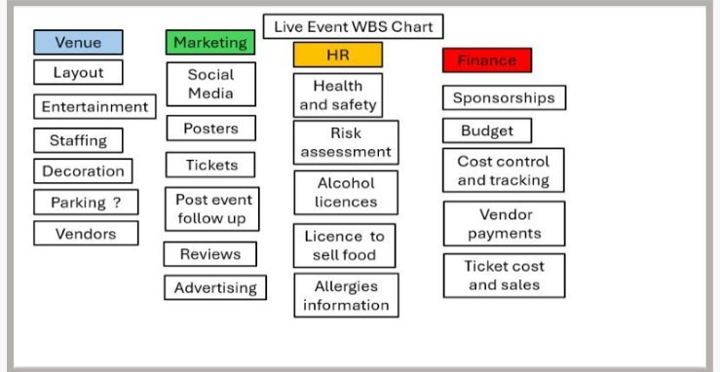

Appendix 2:
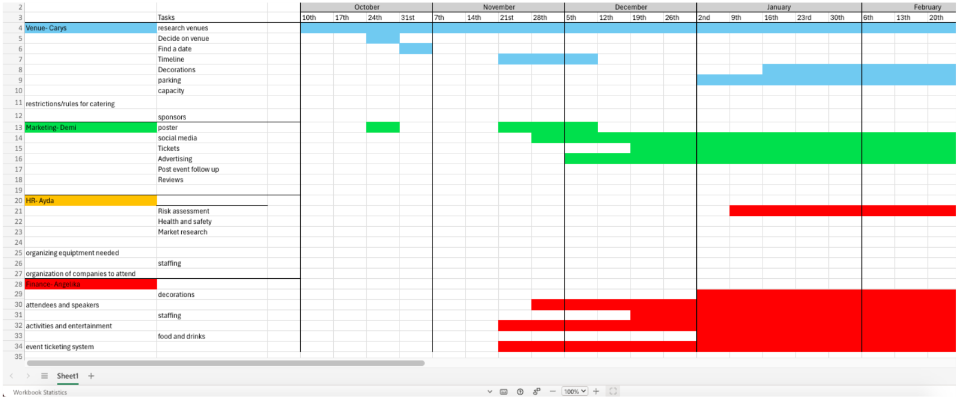
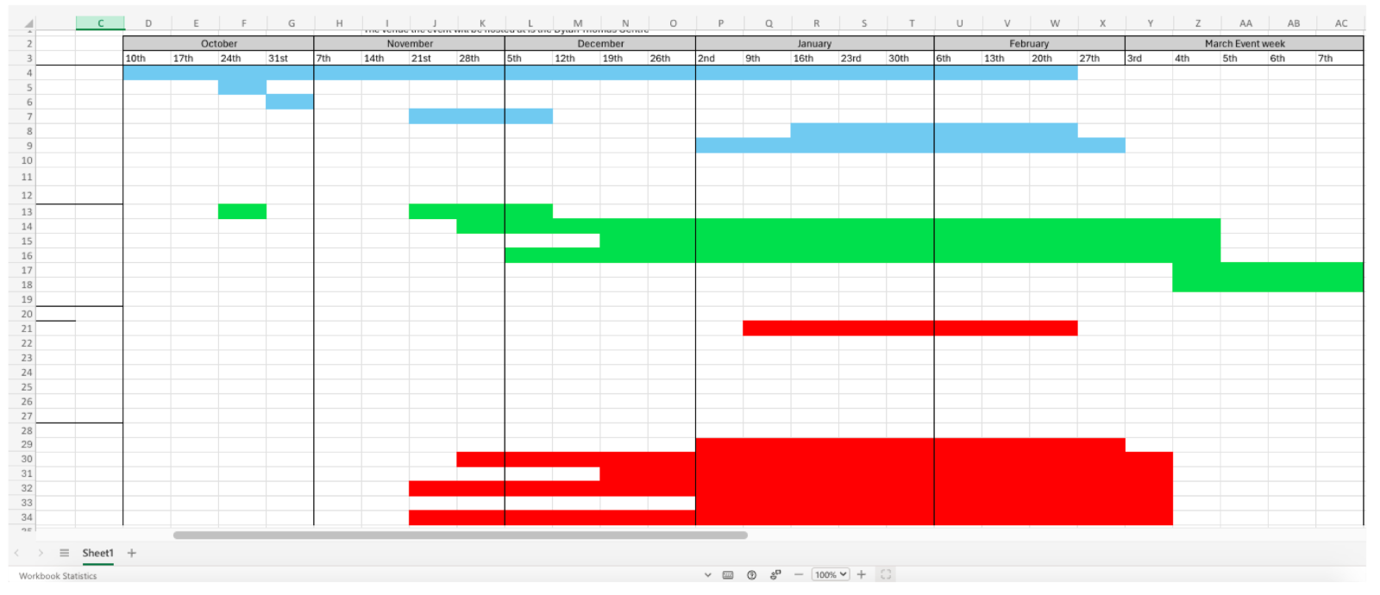
Appendix 3

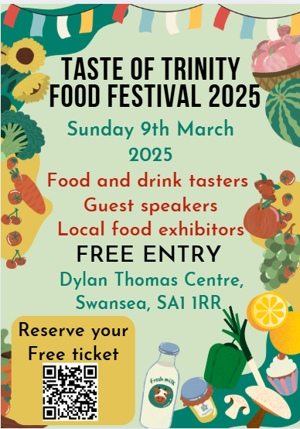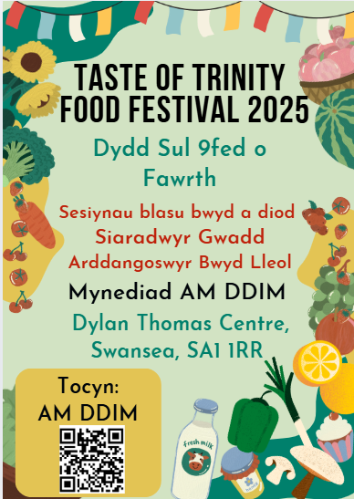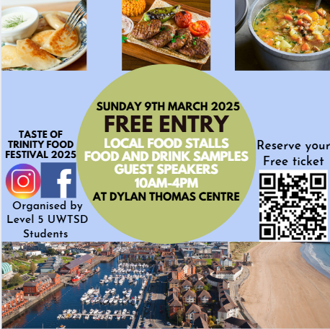

Appendix 4:
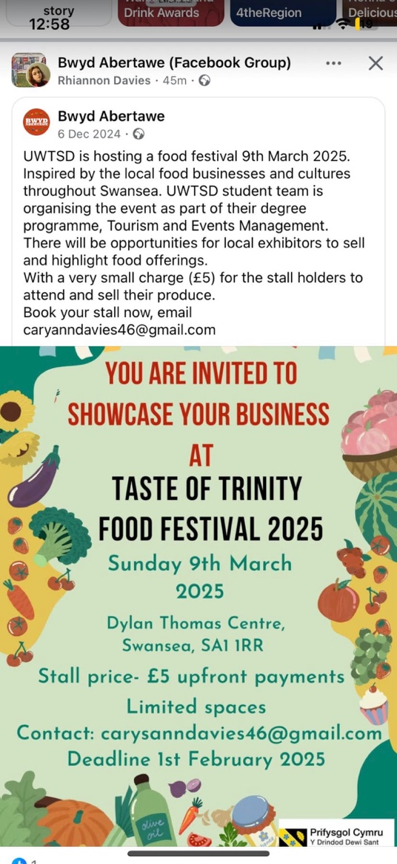

Appendix 5:

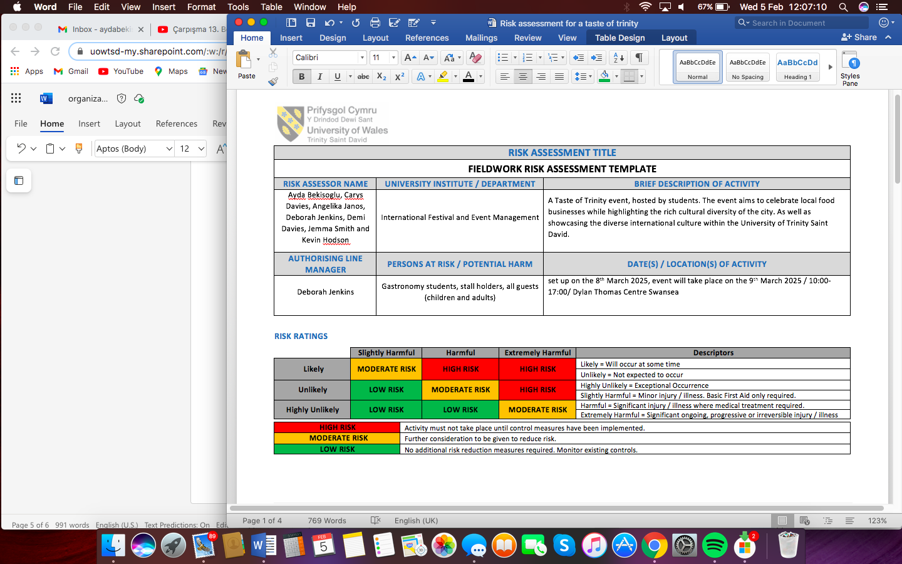
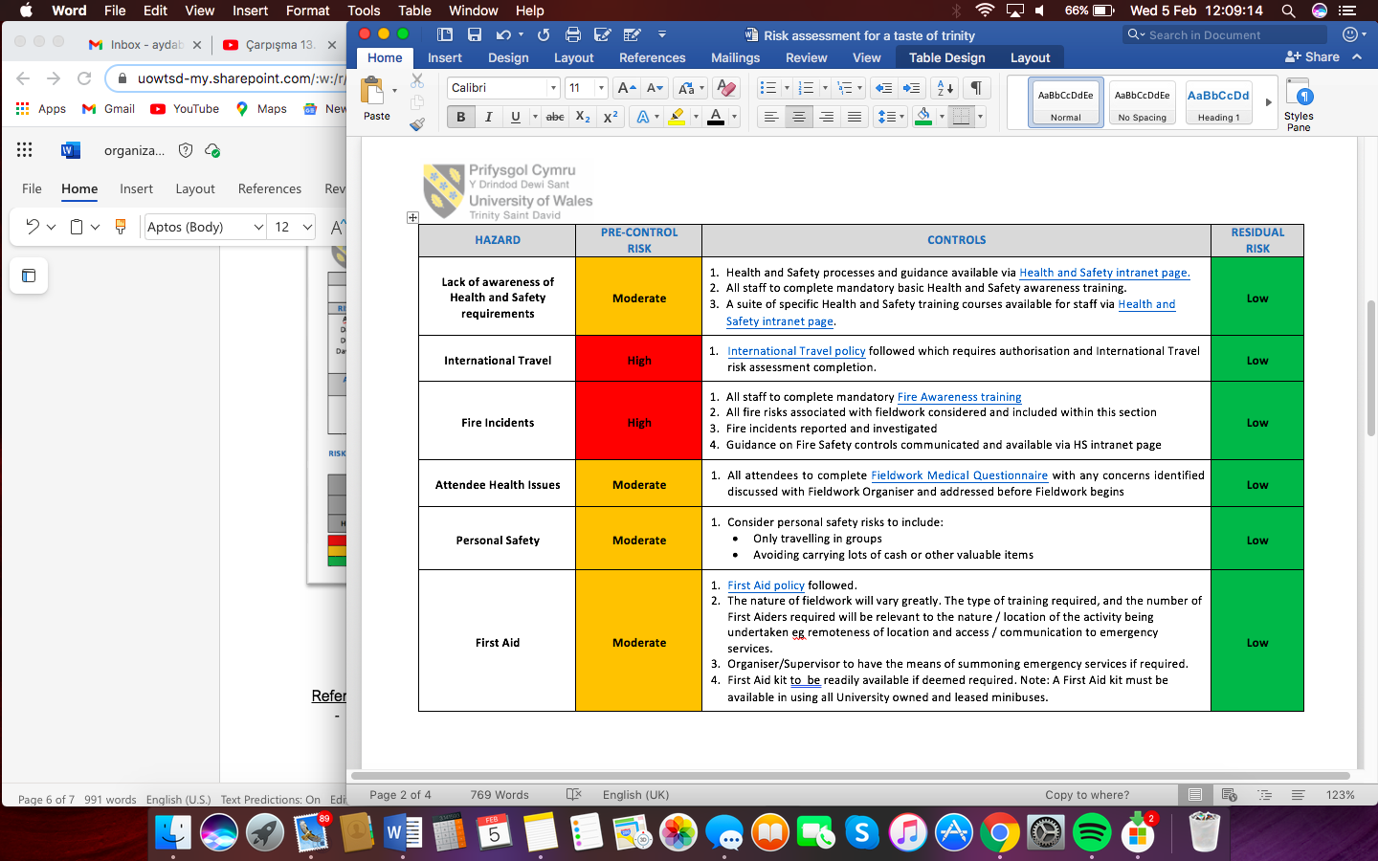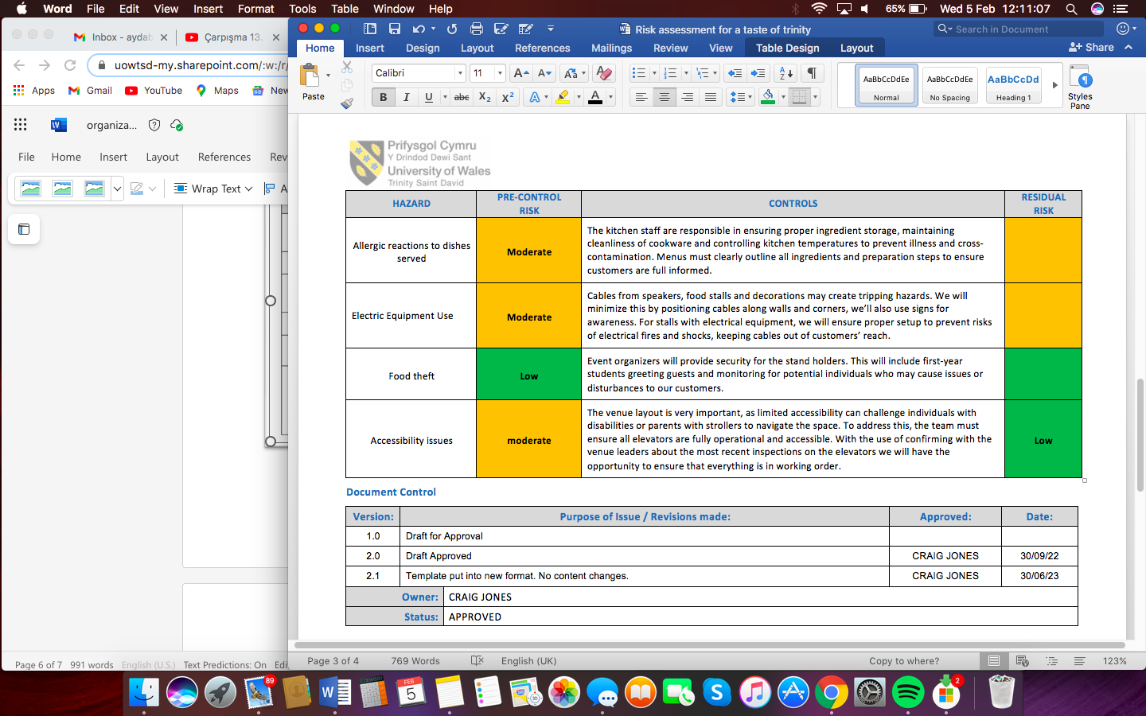
Appendix 6:
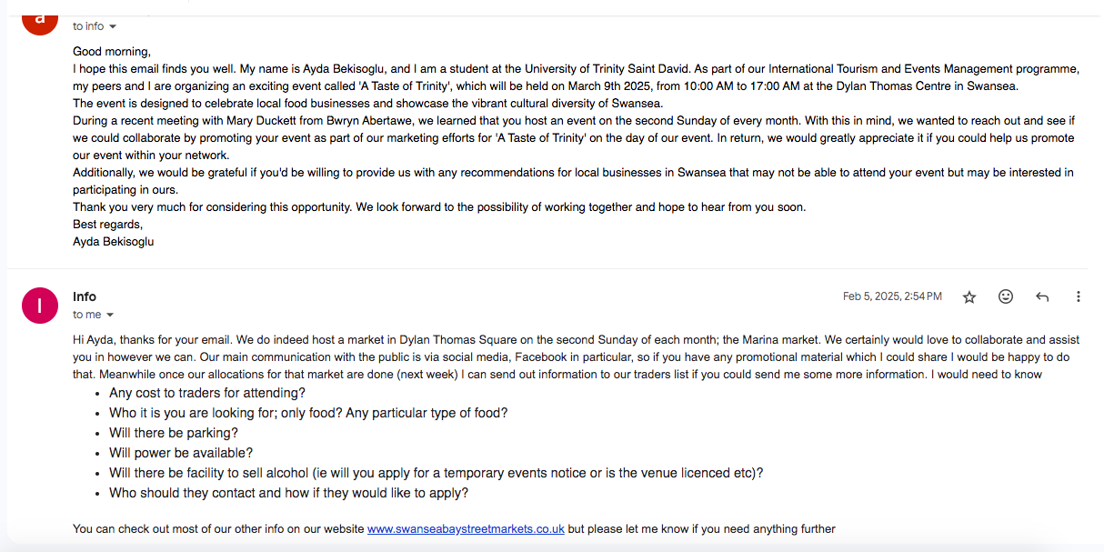
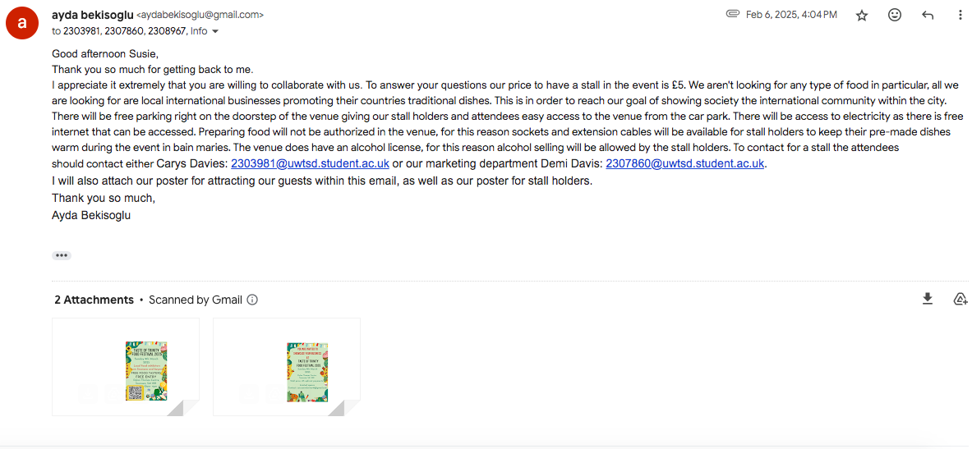

Appendix 7:
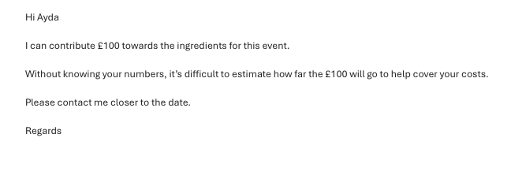

Appendix 8:
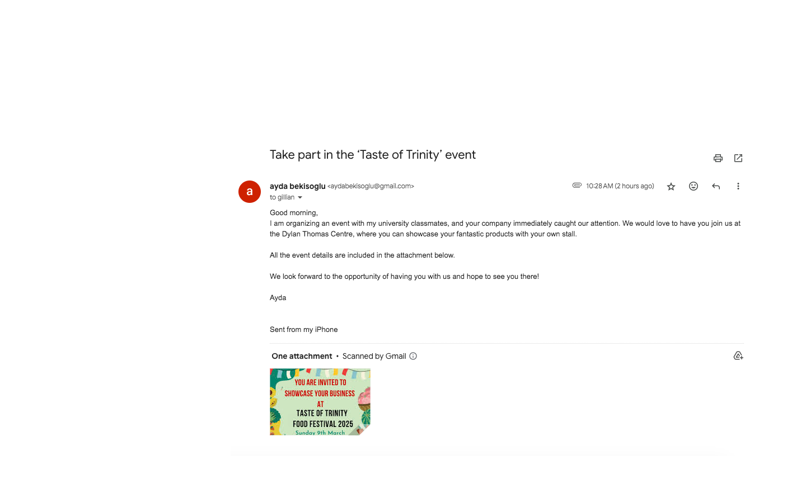
Appendix 9:


