DS 1 Template

My Screenshots/Photos
- Please add 4–6 screenshots or photos of your digital life.
- You can use your phone or laptop.
- For each screenshot, write one or two sentences explaining what it shows.

Screenshot/Photo 1
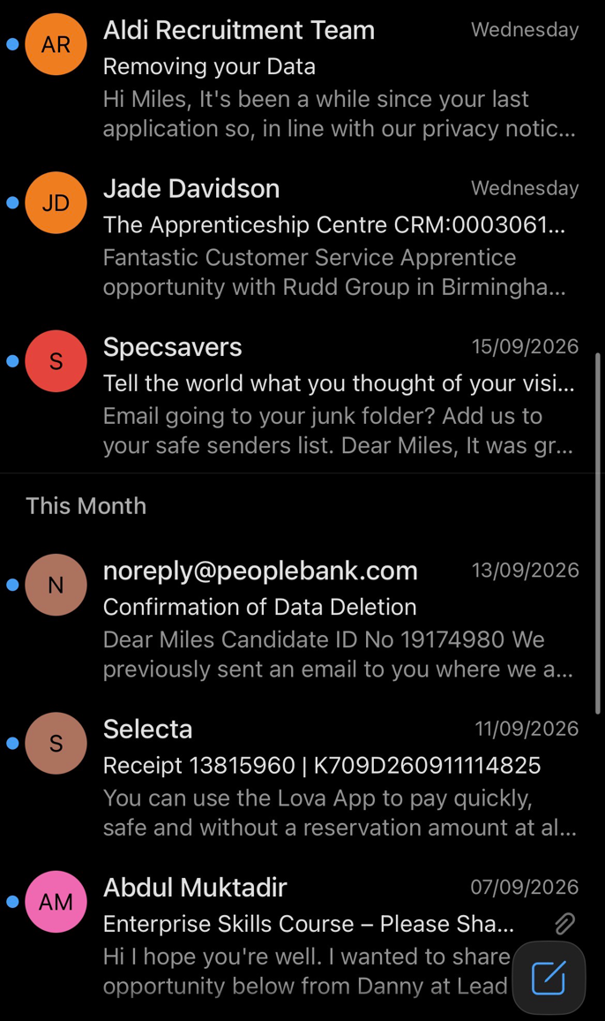
This is my everyday life outlook email account– this is where I go to enhance my employability, receive receipts for my purchases and confirm passwords for new apps that I have downloaded.

Screenshot/Photo 2
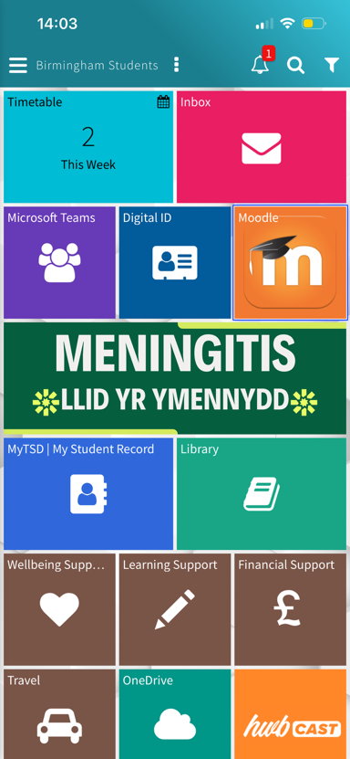
This is my UWTSD Hub – here I can keep up to date with my studies. My timetable is here, as well as the library. I also get to access my moodle account which keeps me updated on slides from class, assignments, and homework

Screenshot/Photo 3
[Insert Photo/Screenshot below]
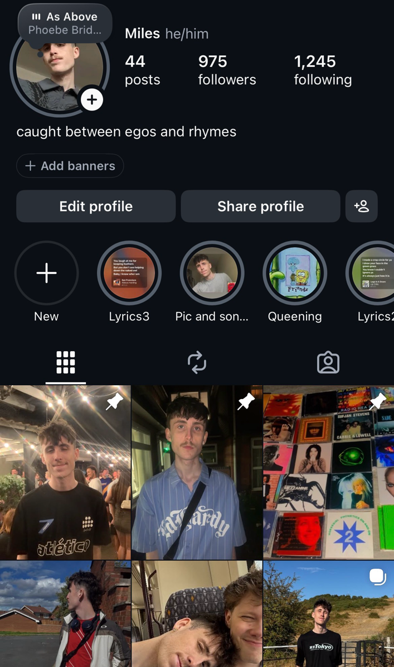
This is my instagram profile – here I get to express my individuality, keep my friends updated with how I am doing and it is an excellent way to help others get an idea of what I am like as a person.

Screenshot/Photo 4
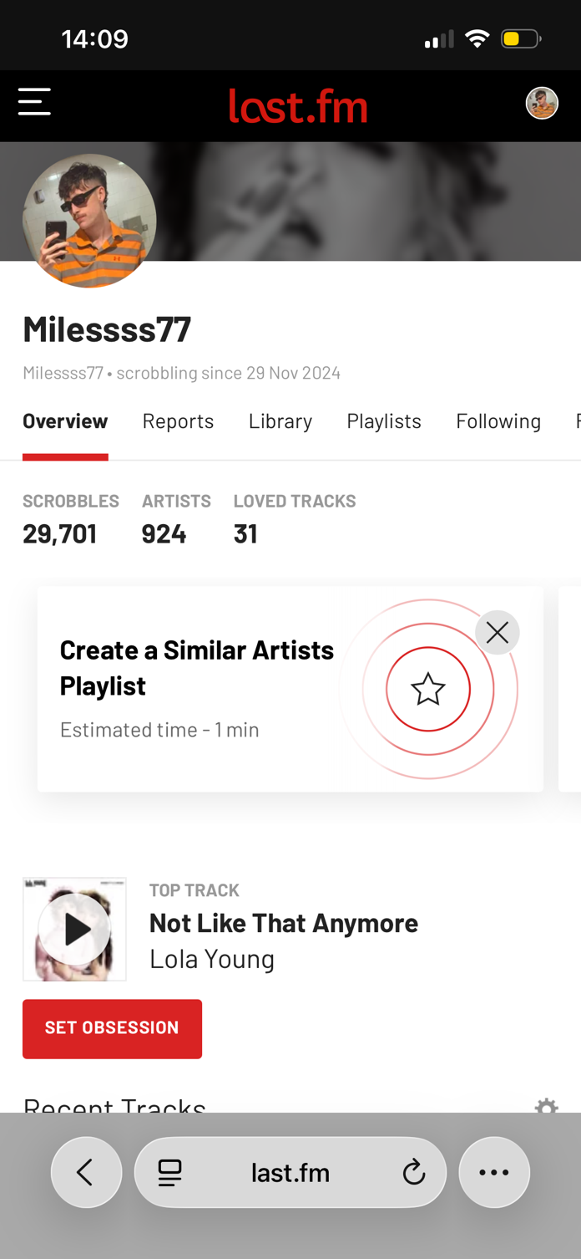
This is my Last.fm profile where I get to keep my friends updated with all the songs that I am listening to, this is an effective way to find things in common with my friends.

Screenshot/Photo 5
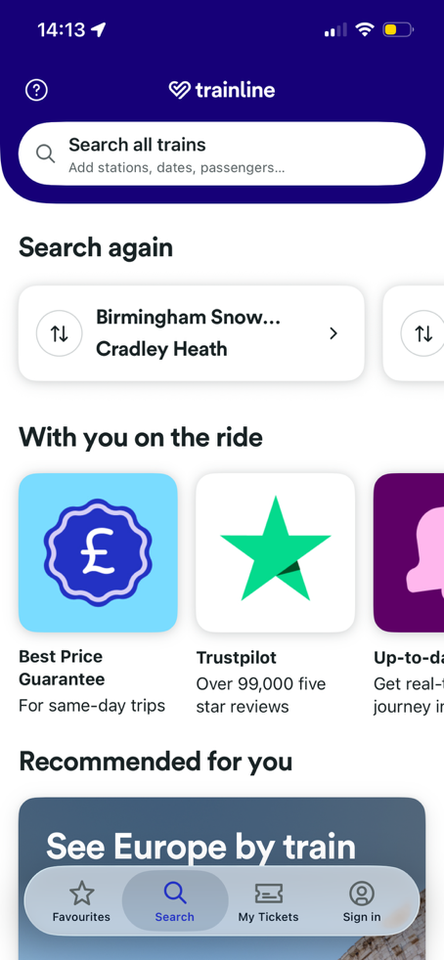
This is the Trainline app on my phone that I must use every day to meet up with friends, go to my classes and make new memories.

Screenshot/Photo 6
[Insert Photo/Screenshot below]
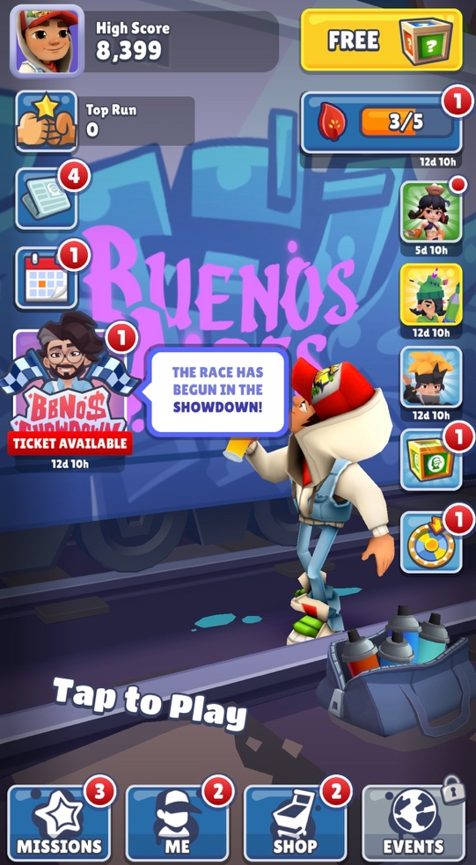
This is subway surfers, a game that I play to alleviate the stress of everyday life and to regulate me so that I can go into each day with a recalibrated energy.

My Short Reflection
- Write 5–8 simple sentences about your digital life.
- You can use the sentence starters below if helpful.
My digital life is integral for my living. It helps me curate an identity so that others can get a glimpse of who I am, as well as keep up with me socially. I feel confident when u am navigating travel on my phone. I want to improve my ability to keep up with emails because a lot of them are unopened. I often use these tools as a product of habit. I hope this module will help me handle a lot of my digital outlets seamlessly. I find keeping up with all of it overwhelming from time to time. Digital skills are important to me because I take a lot of pride in my sense of self.

Sentence starters
- I use digital tools to …
- I feel confident when I …
- I want to improve …
- I often use these tools: …
- I sometimes feel nervous about …
- I hope this module will help me …
- Digital skills are important for me because …
You can write more if you want.

Submission Checklist
Before you submit, please check:
​​​ ☐ I added 4–6 screenshots
☐ I wrote short sentences for each screenshot
☐ I wrote my short reflection
☐ My work is my own
☐ My file opens correctly
​​☐ My file opens correctly

