UWTSD
Engine Performance Characteristics
Powertrain technology
William Wallace (1902566)
1902566



Abstract
This assignment will be explaining how to use an engine dyno and the data gained from the engine dyno and it will break down what’s happening during and engine pull by using graphs it also show what to do and use to make you engine dyno results have more uses by giving thermal efficiency and also the explain the effects from pulse tuning and talk about the Vtec system and how it works

Contents
Abstract 1
1.0 Introduction 3
1.1 Aims 3
1.2 Background 3
2.0 Methodology 3
2.1 Engine dyno session 3
2.2 Excel data 3
3.0 Analysis 5
3.1 torque 5
3.2 Brake power 6
3.3 SFC (specific fuel consumption) 6
4.0 Conclusion 7
5.0 Recommendations for further study 7
6.0 References 7
7.0 Appendices 8

1.0 Introduction

1.1 Aims
The purpose of this assignment is to know how to use an engine dyno and have a further understanding of data collected from an engine dyno by using the data to extract useful parameters like corrected Power, Torque, BMEP, SFC, Thermal Efficiency, construct power, SFC and torque to then create graphs to go into more depth of what the data shows

Background
The engine used was a Honda 1.6 Vtec that is mounted to the dyno with a small driveshaft, the dyno measures load and engine speed which mean you can calculate the torque and power it measures the load with an external scale which you can affect by attaching weights to the external face to get a reading. This engine dyno is a better for finding the performance of the engine because it doesn’t have the losses from the gearbox, driveshaft and differential which means you can compare to cars engines without the losses affecting the results

2.0 Methodology

2.1 Engine dyno session
First thing is to start the engine and all the cooling systems that are used to cool the engine, this must be better than the factory cooling system as the engine isn’t getting any air flow like it would in a vehicle.
Then the engine dyno must be engaged to give resistance to the engine this is done with a motor that has magnets which creates the resistance this mean the dyno is very magnetic and must have precautions so you should be very careful with metal objects and technology
The engine dyno has pressure points that are used to detect the torque being applied to it this can also be done from the outside by attaching a torque arm which can be used to calculate the accuracy of the dyno by using this formula, force (newton) × length (meters) = torque this means you must know the length and weight of the torque arm
Once the engine is at an operating temp you can put the engine through the tests needed to get the data like a step test which is recording the load of the engine through increment of 50 rpm starting from 1000rpm and finishing at 5500rpm it only takes data when the engine is maintaining the rpm this mean it is taking much more time to be performed so you can do as much as it would be overheating.
A sweep test can also be performed to analyse the acceleration of the engine by letting the engine accelerate at a constant rate like 300rpm per second this is different to the step test as its at a constant rate of acceleration
You can also control the dyno manually by controlling the throttle and the resistance the dyno gives to the engine this wouldn’t be used as often as there is a difficulty being actuate with it

2.2 Equipment
- 1.6 Honda Vtec engine
- Engine dyno
- Torque arms /weights

2.3 Excel data
To calculate the torque the formula is
$$T=W\left(load\right) × R (radius of the torque arm)$$
$$T=load × 0.81878$$
To Calculate the Brake Power the formula is

$$BP=\frac{2π×N\left(engine speed\right)×T(torque)}{60}$$
To Calculate the corrected Power
$$\frac{P_{s}}{BP}=\frac{1.01325}{p_{a}(bar)}\sqrt{\frac{T_{a}(temp in kelvin)}{293}}$$
The pressure was given in mBar so dividing it by 1000 to convert it to bar and the temp was given in degree c so + 273 to convert it to kelvin
$$brake power ×\frac{1.01325}{1027.82÷1000}×\sqrt{\frac{18+273}{293}}$$

To calculate S.F.C first you need to find the specific gravity of fuel you do this by dividing the density of the fuel by the density of water by measuring the fuel and water in pounds per gallon the fuel was 6 pounds per gallon and water is 8.325 pounds per gallon
$$specific gravity of fuel=\frac{6}{8.325}=0.72$$
This mean that you can now use the specific gravity of fuel to convert the fuel flow rate from l/min to kg/min by multiplying the fuel flow rate (l/min) by the specific gravity of fuel (0.72)
$$kg/min=\frac{(l/min)}{0.72}$$

Then you can convert the fuel flow rate from kg/min into kg/hour by multiplying it by 60
$$kg/min×60 =kg/hour$$

Then you can divide the fuel flow rate (kg/hour) by the brake power in kW to convert watts to kw divide by 1000
$$\frac{kg/hour}{brake power(watts)÷1000}=S.F.C$$

To calculate the piston area of the engine the formula is

$$A=\frac{πd^{2}(bore meters)}{4}$$

To calculate the B.M.E.P use this formula

$$B.M.E.P=\frac{BP(60×2)}{L(stroke)×A(piston area)×N(engine speed)×n(number of pistons)}$$

To calculate Break Thermal Efficiency, you will need this formula

$$η_{t}=\frac{(BP/1000)}{S.F.C (\frac{kg}{sec})×C.V(grams)}$$

$$thermal efficency=\frac{(BP/1000)}{(\frac{kg/min}{60})×(45.8×1000)}×100$$

3.0 Analysis

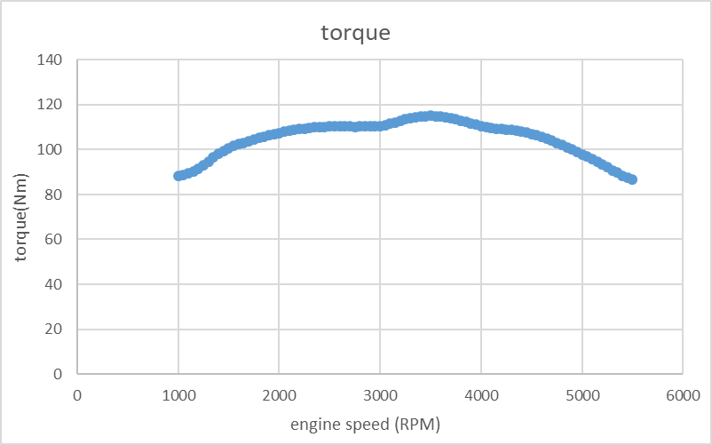
3.1 torque
This torque graph shows that the engine produces it peak torque at 3500 rpm this makes sense as an engine usually does this. In this example the engine is getting an increased power in waves as there is a pulse tuning effect which means the valves and air frequency match to help push pressurised air into the piston to produce more power/torque. The reason this works is because when the cylinder is moving towards BDC (bottom dead centre) it is pulling air into the cylinder, once it has reached BDC the inlet valve will close and the air will bounce of the valve and move in the opposite direction towards the inlet manifold then it will bounce the air back. The next time the intake opens it will push pressurised air into the cylinders but this only work through sections of the rev range because it must match the frequency of the inlet valves, this can be fine-tuned by changing the length of the intake which changes the air frequency this is why the graph has up and downs and especially why one of the peaks is at 3500rpm because this is where the peak torque is and will help increases the peak torque further

3.2 Brake power
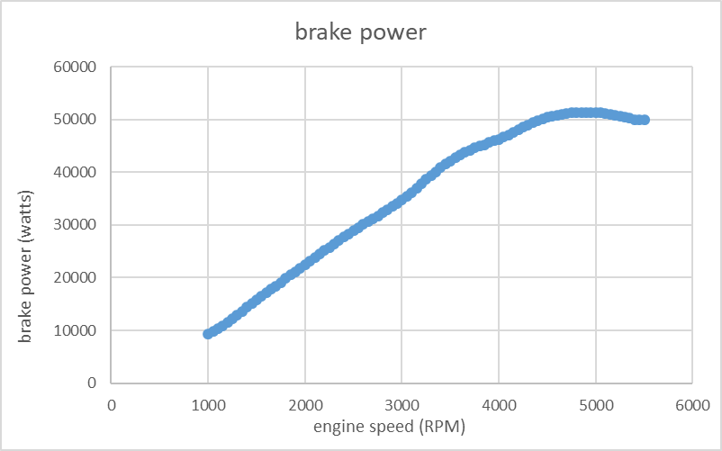
This power graph is very linier at the start then it also shows the power/torque gain from the pulse tuning effect mostly again at 3500rpm where help to bring the power up but this does not help to increase the peak power as it is in the middle of the rev range it also has a power loss where there is a power small turn at the very end of the test is a small power increase this is because the engine has VVT (variable valve timing) that is activated at 5500rpm this isn’t fully recorded as in the test as we didn’t go past 5500 rpm but the bigger cams are allowing more fuel and air into the cylinder to increase power but only the very start of the VVT is taking effect this would help increase power when the previous valves are running out of steam

3.3 SFC (specific fuel consumption)
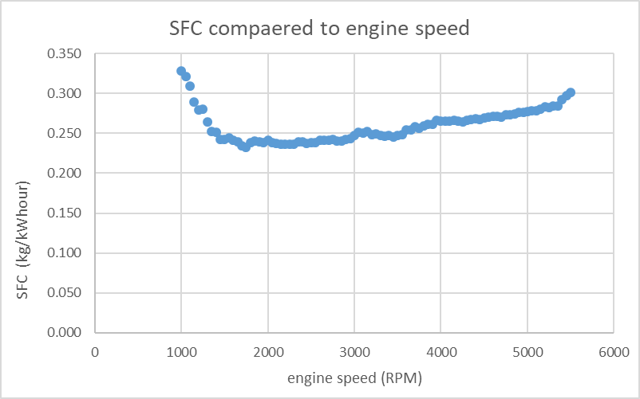

The SFC (specific fuel consumption) is high at idle because the load on the engine is high and the engine is spaying lots of fuel to help deal with the load once the car gets away from idle it has a drop at 3500 rpm this could also be because of the pulse effect where the car can push more air into the engine meaning it does need as much fuel because it can burn the fuel more efficiently

4.0 Conclusion
In conclusion this assignment has gone through how to operate an engine dyno with set up procedures it also talks about the details of how it works with the motor, it also goes though the data given by the dyno and what to do with it using excel with step by step formulas to get useful information that would be used by car company’s and garages to know what the engine is doing this would mainly be done with the graphs that was created as they are easy to see the changes the engine experiences through the rev range, these graphs also show the engine characteristics and different systems and how technologies work to produce power/torque mostly shown by pulse tuning and how VVT could affect the power/torque band if the engine when through its full rev range as that would have engaged Vtec

5.0 Recommendations for further study
This assignment could have studied the full rev range which would mean the data from the Vtec could of been found and see how it effects the power and torque it could also new filters to see how much difference it can make to the SFC and the power and using different fuel to fine how it effects the all perimeters of the engine like SFC and power

6.0 References
Glen, G. (2003 1 Mar) “hot rods” [online]. Available: https://www.hotrod.com/articles/ctrp-0303-engine-testing-methods-pros/ [2020, January 17]

7.0 Appendices


