

MSc in Cybersecurity and Digital Forensics

ACCA7028

Data Security, Governance and Compliance

Title: Apply the principles and practices of Data security, Governance and Compliance based on a given scenario.

Lecturer: Dr. Dipo Dunsin

Student Name: Md. Tarequr Rahman Sharif

Student ID Number: 2437470

Abstract
NatureGreen (NG) is a multinational organisation that is heavily dependent on cloud solutions, wireless networks and BYOD. Nevertheless, it does not have official security measures and grievous policies, which leaves the data of staff members, details of their customers, and precious intellectual capital at great risk. This report employs a literature-based review of the key security frameworks and models to develop an approach applicable to NG. It takes into consideration the ISO 27001, the NIST Cybersecurity Framework, COBIT, ITIL, and cloud-specific standards, including ISO 27017 and ISO 27018. A unified governance and compliance plan is suggested, which puts emphasis on risk management, effective policies, and technical layered controls. The report finds that NG must transition to an official governance framework that falls in line with the recognised standards and revise it regularly to satisfy the changing regulations.

Table of Contents
Abstract i
1. Introduction 1
1.1 Background of information security 1
1.2 Purpose, aims and objectives 1
1.3 Structure of the report 2
2. NatureGreen Scenario and Security Problem Definition 2
2.1 Company overview and IT environment 2
2.2 Essential assets, stakeholders and threat drivers 2
2.3 Problem statement and requirements 3
3. Security Frameworks and Models: Review and Analysis 4
3.1 Security framework and model overview 4
3.2 ISO/IEC 27001 and 27002 4
3.3 NIST Cybersecurity Framework 5
4. Integrated Security, Governance and Compliance Approach for NatureGreen 7
4.1 Security governance framework and strategy 7
4.2 Compliance, laws and ethics 9
4.3 Risk management approach 9
4.4 Security practices and policies 10
4.5 Technical and organisational defences 11
4.6 Contingency planning, incident response and service level agreements 12
5. Significance of Changing Regulations and Standards 13
5.1 Shifting threat environment and technology 13
5.2 Advantages and obstacles of updates to NatureGreen 13
6. Conclusion 14
7. References 15

1. Introduction

1.1 Background of information security
Global organisations are using cloud platforms, wireless networks, mobile applications and social media to give services and cooperate [1]. According to recent surveys, it is estimated that approximately 94% of enterprises utilise one or more cloud services [2]. Such digitalisation increases agility and adds to the size of the attack surface. The average cost of a data breach report released by IBM in 2024 puts the total cost of a cradle of data breaches around USD 4.88 million, which, according to the FBI, was more, at over USD 16 billion in 2024 [3]. Ransomware and other attacks thus continue to be business risks. To counter this, regulators are imposing stronger privacy and cybersecurity regulations and putting increased accountability on boards and top management. In a business such as NatureGreen (NG), relying on cloud and wireless solutions and being pressured by the need to allow customers to bring their own devices (BYOD), proper security governance and adherence are essential in safeguarding customers, employees and intellectual property.
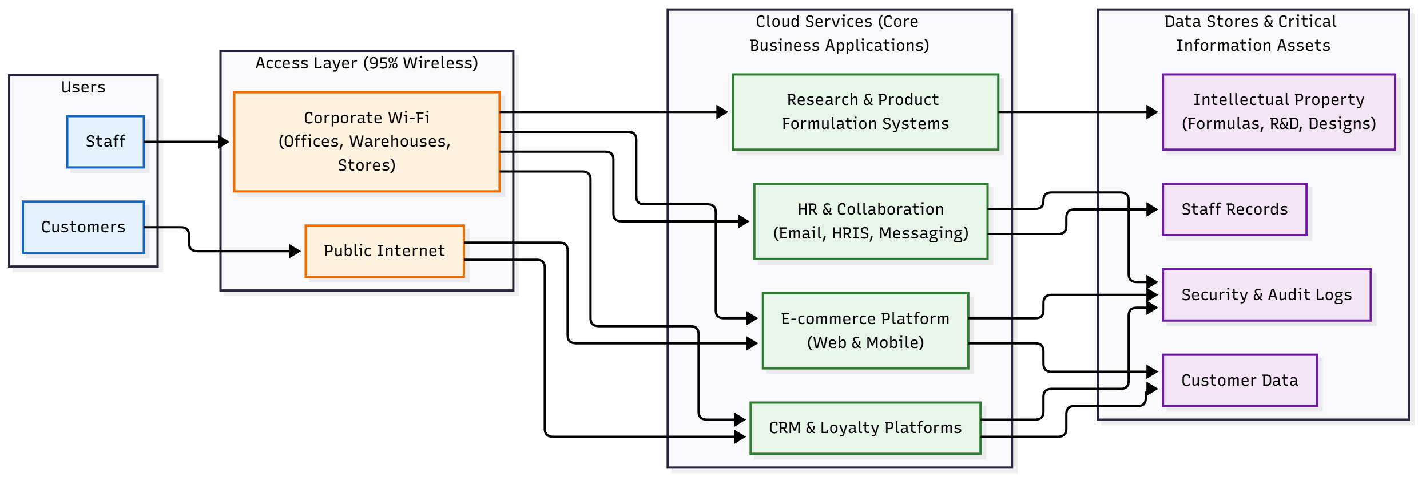
Figure 1: NatureGreen High-Level IT Environment (self-made).

1.2 Purpose, aims and objectives
This report is aimed at analysing identified information security frameworks and models and developing an operational security, governance and compliance strategy of NatureGreen. The report aims to achieve three goals,
- To overview the main security framework and models that may be applied to the cloud-based, wireless, and BYOD context of NG.
- To suggest a specific governance and control framework that addresses particular risks and assets of the NG.
- To explain why regulations and standards need to be revised on a regular basis and how the NG can be responsive in a structured manner.

1.3 Structure of the report
Section 2 will describe the NatureGreen scenario, the important assets, the stakeholders and the essence of the security problem. Section 3 will examine and analyse some of the notable security frameworks and standards. Section 4 will leverage these insights to come up with an integrated approach to NG. Section 5 will adhere to the necessity of new rules and requirements, and Section 6 contains concluding thoughts.

2. NatureGreen Scenario and Security Problem Definition

2.1 Company overview and IT environment
NatureGreen is a brand in the world offering products that uphold healthy living. Its business model relies on digital channels to reach its customers, control the operations and organise a widely distributed workforce. The company heavily relies on cloud services to provide IT services as well as support for web and mobile applications. It has approximately 95% of its network connectivity wireless, which serves activities at offices, warehouses, retail stores and manufacturing facilities. NG is also active on social media and online to advertise its products and brand. This mix of worldwide scope, reliance on clouds, wireless networks, and openness presents a complicated environment and a number of potential attack points of vulnerability to the attacker.

2.2 Essential assets, stakeholders and threat drivers
Under such circumstances, NG has some key information resources: customer information on e-commerce pages and loyalty programmes, employee information in HR and cooperation systems, as well as intellectual property associated with product compositions, research, supplier contracts and naming [4]. The core business processes backed up by cloud-based applications, the wireless network, and the connected devices constitute fundamental infrastructure [5]. The stakeholders here are the senior management and the board of directors, the information technology and security team, business managers, employees, customers, regulators and other external service providers.

2.3 Problem statement and requirements
NG is facing the pressure to enable its staff and customers to use its services via their individual devices. But there is no security policy regime or institutionalised governance to determine the manner through which risks will be addressed and who will make critical decisions. With the environment getting open and complex, it remains unclear how the privacy and integrity of data and services can be upheld, as well as made available. In the absence of a systematic strategy, NG will be vulnerable to data breaches, ransomware attacks, theft or loss of intellectual property, and service downtimes that may hurt reputation and finances [6]. The organisation needs a rational system of governance, a risk-based security management strategy, stated security policies and standards, and a means to realise and show adherence to applicable laws and regulations.
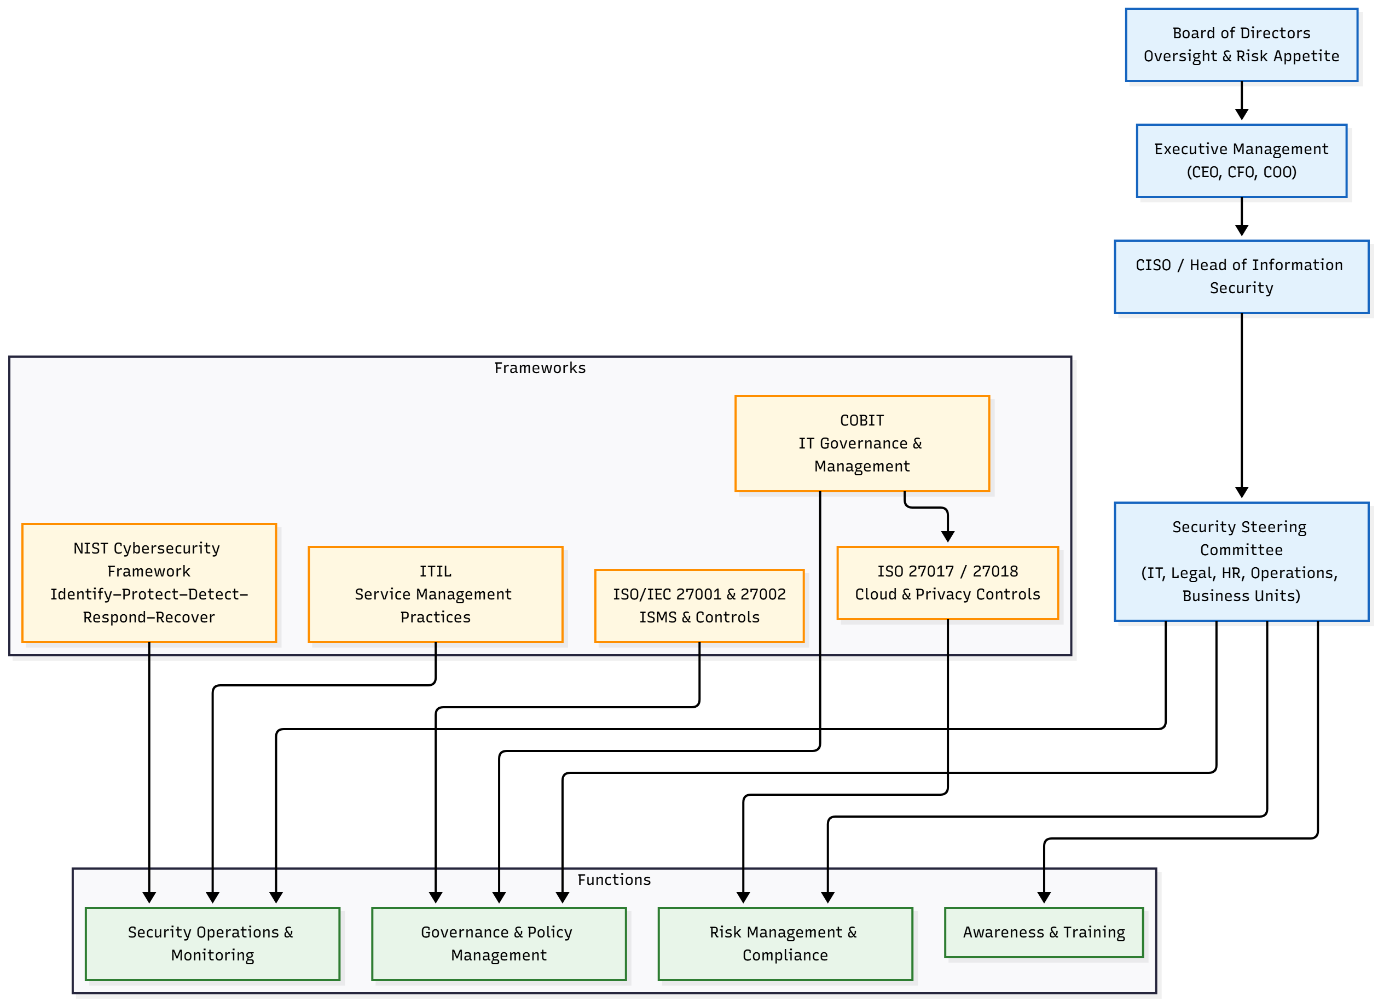
Figure 2: Integrated Security Governance Model for NatureGreen (self-made).

3. Security Frameworks and Models: Review and Analysis

3.1 Security framework and model overview
Security structures and designs provide systematic direction on the way information risks are handled, defining the controls and aligning security with the business goals [7]. They normally involve governance, the process of risk management, a list of controls, and mechanisms used to implement continual improvement.

3.2 ISO/IEC 27001 and 27002
The ISO/IEC 27001 is the major standard for establishing restrictions, executing and enhancing an information security management system (ISMS) internationally. It is risk-oriented and is structured on the Plan-Do-Cheque-Act cycle [8]. An organisation articulates the extent of its ISMS, identifies the assets, evaluates and manages the risks, and chooses the controls at Annexe A, which classifies measures in various domains. The ISO/IEC 27002 offers implementation guidelines of these controls that outline good practices in policies, processes and technical measures [9]. The two standards collectively provide a management framework and not a technology checklist.
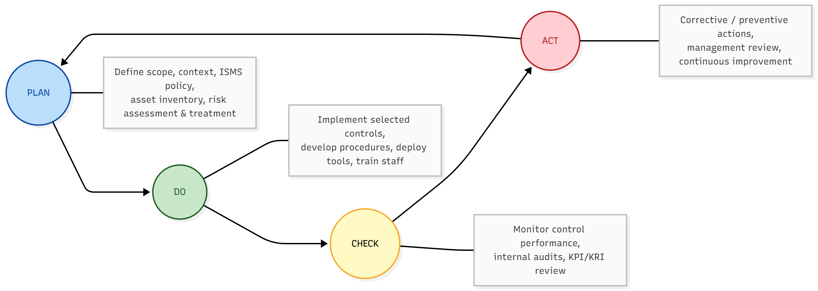
Figure 3: ISO/IEC 27001 PDCA-Based ISMS Cycle (self-made).
In the case of NatureGreen, the adoption of the ISMS that is grounded on the ISO 27001 and 27002 would formalise the process of security governance and risk management. It would warrant NG to identify and document their vital assets, recognise threats to its cloud and wireless environment, risk treatment plans, policies, roles, audit and management review. This would take the organisation out of ad hoc decisions and put it on an auditable and disciplined security posture.

3.3 NIST Cybersecurity Framework
The NIST Cybersecurity Framework weaves security activities into five main operations, namely: Identify, Protect, Determine, Respond and Recover. The functions are broken down into groups and sub-groups of statements on what is desired [10]. The framework is flexible and technology-neutral, enabling organisations to develop a current profile of capabilities, a target profile of where they want to be and a pathway of bridging the gaps [11].
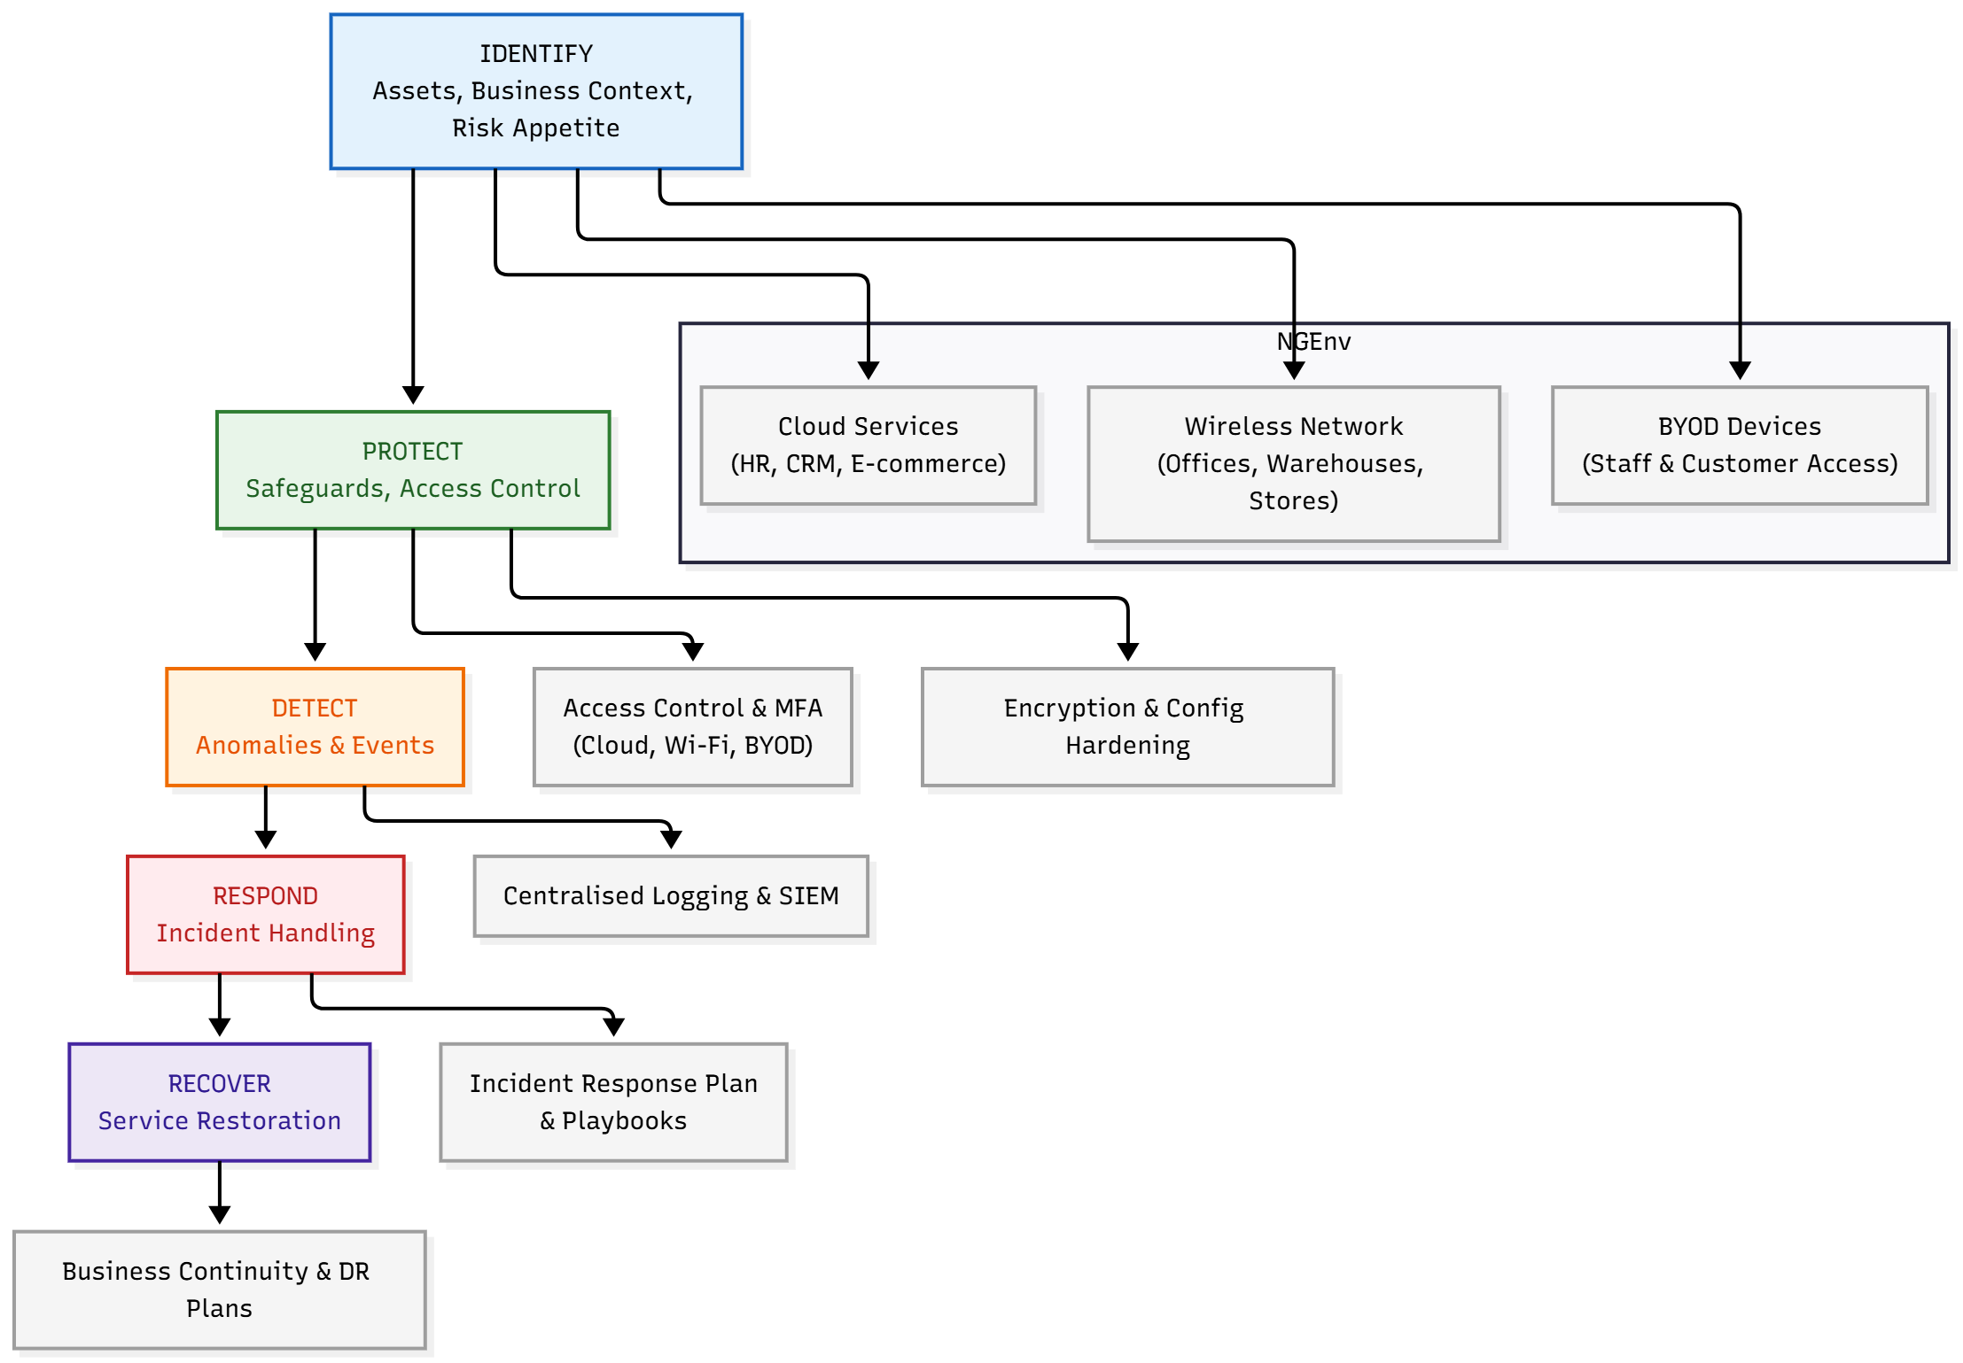
Figure 4: NIST CSF Functions Mapped to NatureGreen’s Environment (self-made).
In the case of NG, the framework offers a straightforward method of mapping controls throughout its cloud, wireless and BYOD environment. The Identify feature aids in the total inventory of services, wireless access points and mobile devices, and designates ownership [12]. The Protect option leads to access controls, encryption, network partitioning and safe definition. Detect, Respond and Recover functions organise monitoring of the activities and their attack on services. The alignment of activities with these functions enables NG to convey its security posture to the top management and to prioritise investments.

3.4 COBIT and ITIL
COBIT is a model of information management and governance of enterprises in terms of management and governance. It focuses on IT and security strategy consistency with business strategy, assigned decision rights and accountability, and process-based and metric-based performance measurement [13]. Governance elements consist of policies and procedures, organisational structures, culture and behaviour, information flows and infrastructure.
ITIL has paid attention to IT service management practices, including incident management, change enablement and continuous improvement. The aspect of security is built into the risk appraisal of alterations and the regular management of incidents and issues [14]. COBIT would inform the security governance structure in NG, defining the roles of the board, executive management, the CISO and other stakeholders and detailing who decides risk appetite, investments and policies. ITIL assists in supporting operational security by making sure that incidents have been registered and addressed regularly and that modifications in cloud and wireless infrastructure have been managed.

3.5 Standards relating to cloud and privacy
Cloud-specific and privacy-related standards support general frameworks, which deal with shared infrastructure and outsourced processing. The database ISO/IEC 27017 includes principles of the security controls of the cloud providers and consumers, which can be mutual responsibility, virtualisation, setting up and monitoring. The current standard ISO/IEC 27018 is aimed at securing personally identifiable information in the public cloud, and its controls include consent, data minimisation and transparency.
In the case of an international and cloud-heavy organisation like NG, these standards serve to organise the relationships with the cloud providers and prove to the regulators and customers that necessary safeguards are taken. They endorse contract clauses on the data location, encryption, breach notification and audit rights, and comply with wider privacy laws like the EU General Data Protection Regulation [15].

3.6 Comparative evaluation and selection
These guidelines and models have strengths that are complementary. The criteria of the formal management system are outlined in ISO 27001 and 27002 so that the NG will oversee security in a risk-based and audit-trailable way. The NIST Cybersecurity Framework also introduces an outcome-based framework that facilitates communications and gap analysis [16]. COBIT and ITIL deal with governance and service management in such a way that business objectives are matched with security decisions and processes and are integrated into operations. The use of cloud and privacy standards, including ISO 27017 and 27018, increases the foundations for cloud relationships and data protection responsibilities of NG [17]. In the case of NG, the most suitable approach is to incorporate them into a congruent security, governance and compliance model instead of depending on a single framework.
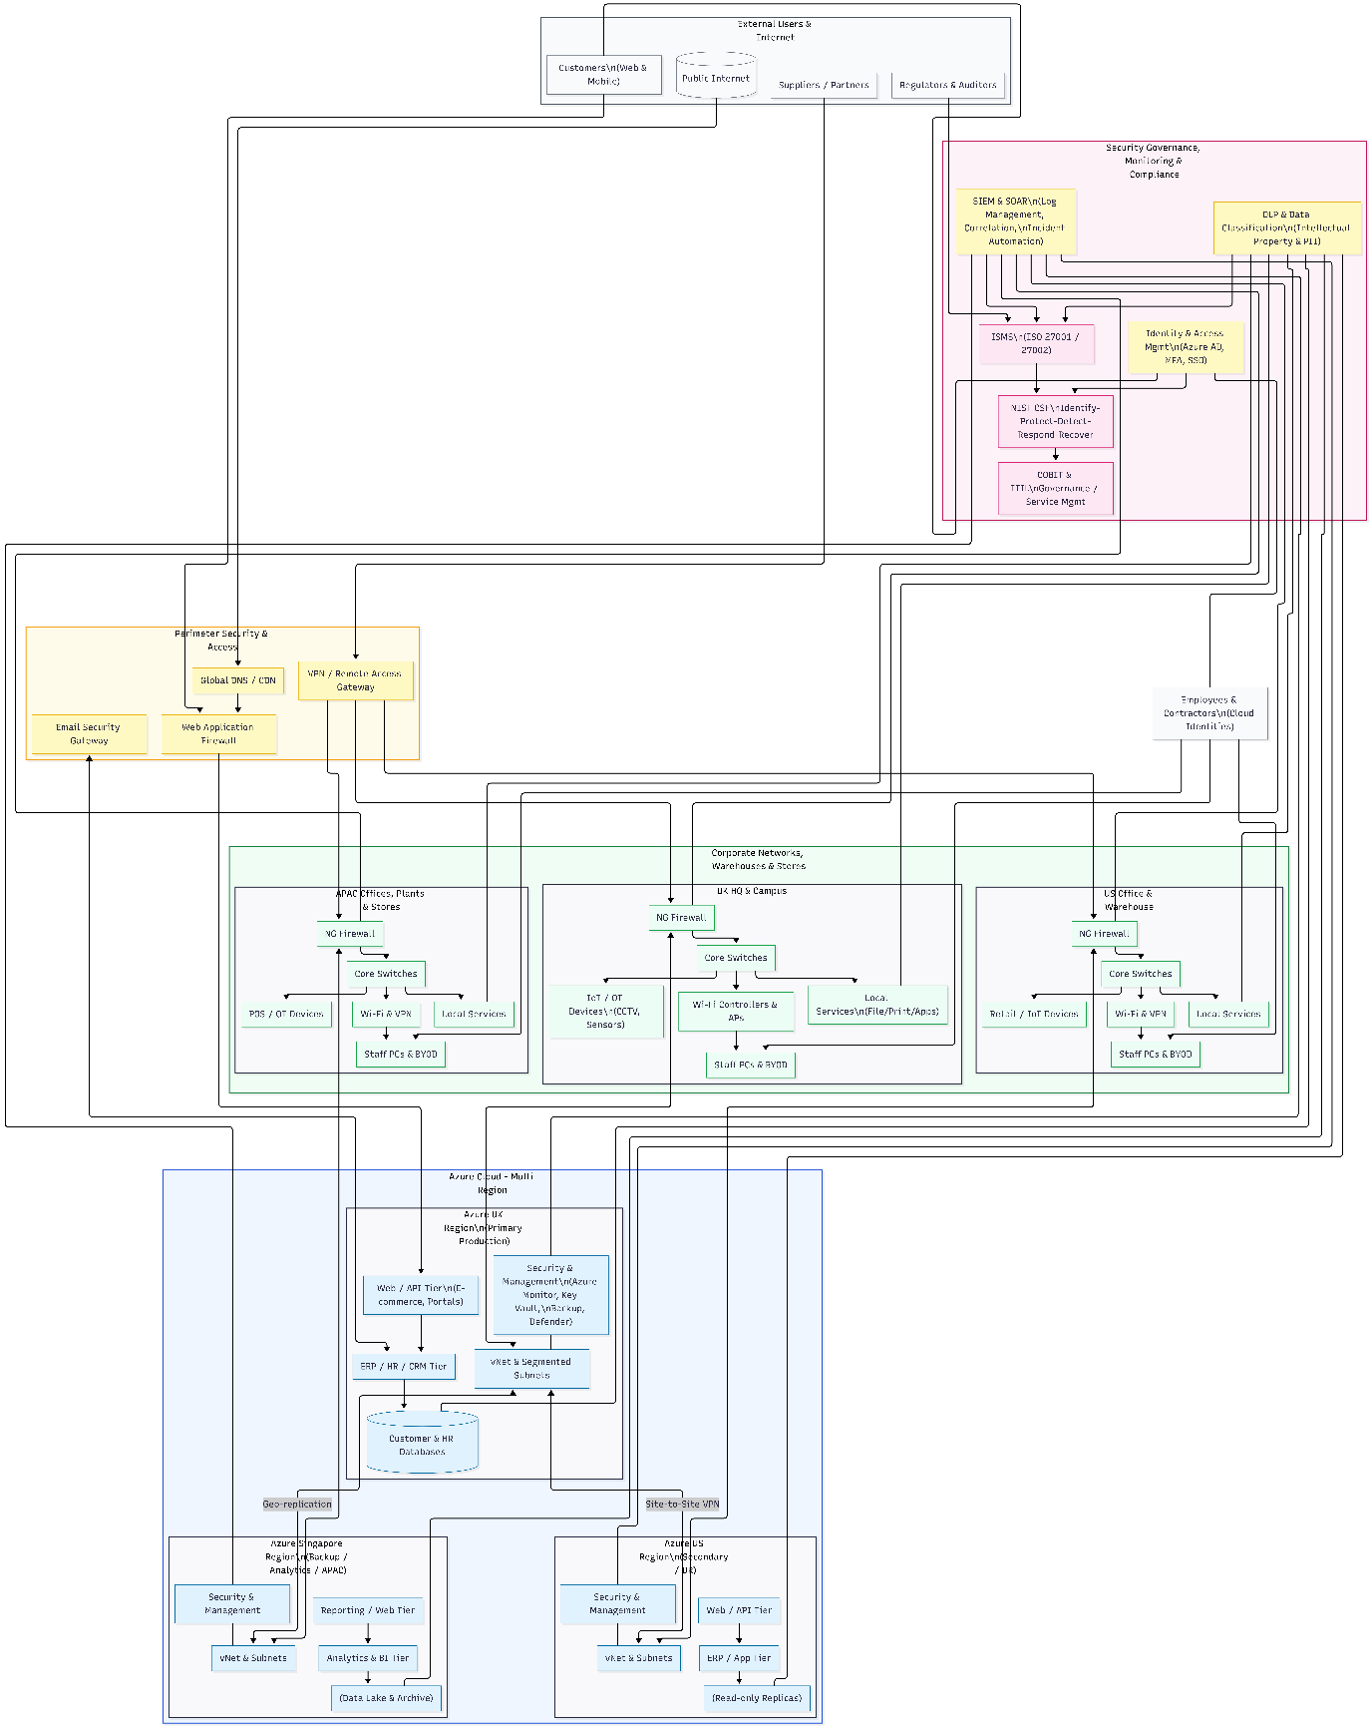
Figure 4.1: NatureGreen Secure Multi-Region Cloud and Corporate Network Architecture (self-made).

4. Integrated Security, Governance and Compliance Approach for NatureGreen

4.1 Security governance framework and strategy
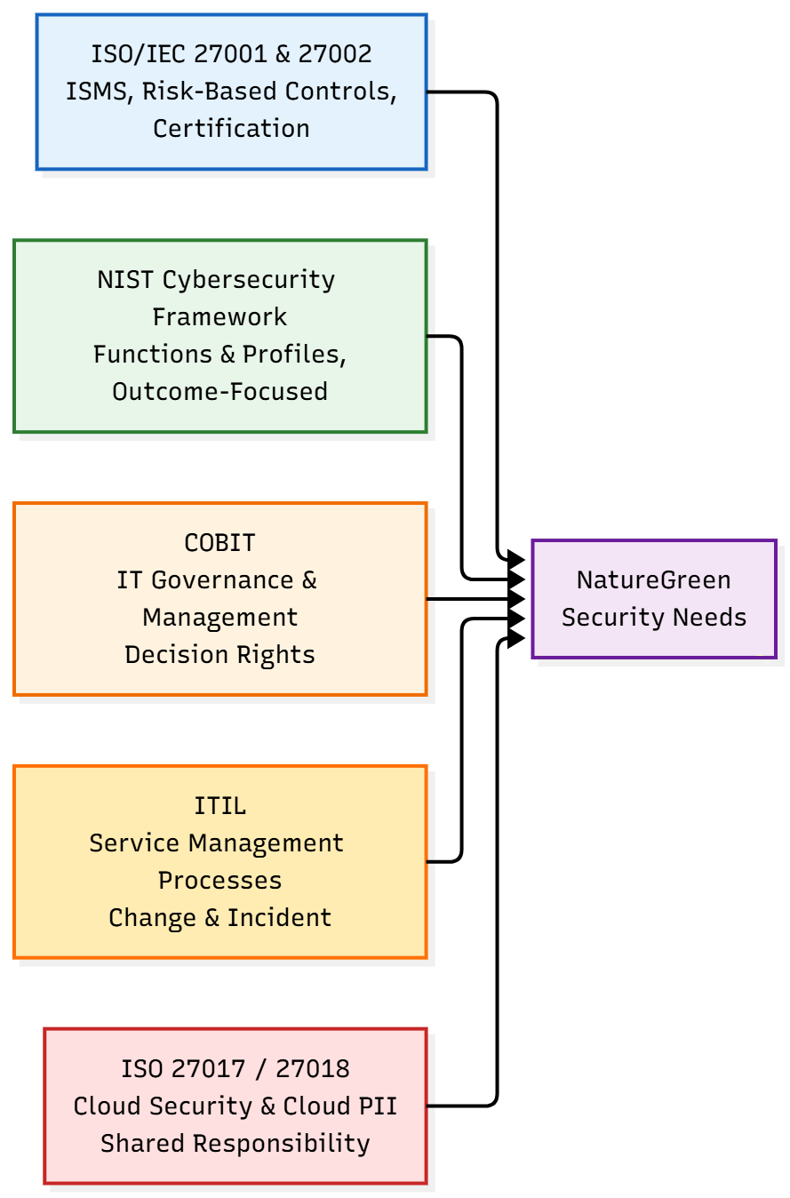
Figure 5: Comparative Overview of Key Security Frameworks and Standards (self-made).
A good security programme of NG commences with effective governance. The board must keep the general responsibility of information security and set risk appetite, such as risk of data loss, downtime and regulatory hazards. Responsibility should be placed on an executive as Chief Information Security Officer or other position with responsibility for strategy, policies and investment propositions. The major risks should be reviewed by a cross-functional security steering committee comprising IT, legal, HR, operations and business leaders who should approve policies and supervise major projects.
According to the principles of COBIT, asset ownership, risk ownership, and assurance obligations ought to be recorded to ensure that the roles and decision rights are evident [18]. Security has to become part of the strategic planning and budgetary process of NG, whereby any projects that include cloud services, wireless infrastructure or BYOD are pre-evaluated on their impact on security.

4.2 Compliance, laws and ethics
Being a global organisation, NG has to be compliant with various data protection, consumer protection, intellectual property and cybercrime legislations. It is possible to map legal and regulatory requirements to internal controls, which can be done using ISO 27001 and the NIST Cybersecurity Framework to prove a due diligence effort and audit responses [19]. NG is expected to have a compliance register and list all relevant laws and standards, which would provide responsibility for how changes are monitored and each requirement is attached to policies, procedures, and technical controls.
Regular reviews and internal audits should test the approach of adherence and find gaps. In addition to formal compliance, NG has ethical obligations to process customer and staff information fairly and openly, prevent intrusive actions and report the material incidents honestly and promptly. Policies, training and senior leadership communications in the organisation should reflect these principles.

4.3 Risk management approach
The centre of the security approach by NG should be risk management. According to the ISO 27005 and the NIST recommendations, NG can embrace a systematic process. They are identified and classified as information assets, and they include customer databases, human resources, research repository, cloud platforms and wireless networks. Among such issues are threats, vulnerabilities, including phishing, ransomware, misconfigured cloud services, weak wireless settings, lost or stolen BYOD devices, and insider misuse of intellectual property. The qualitative or semi-quantitative scales are then used to estimate likelihood and impact.
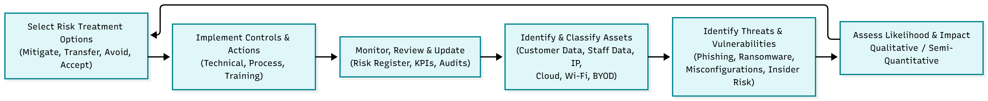
Figure 6: Risk Management Process for Information Security at NatureGreen (self-made).
The outcomes are documented in a risk register that contains the list of risks, the risk owners, available controls and intended treatments. Risks with high priority could be alleviated through new controls, process redesign, transferring risk with insurance or outsourcing, or by accepting risk with acknowledgement in the management. The register ought to be reviewed at least once a year, and in case of any significant changes, say with new cloud services, or expansion of BYOD.

4.4 Security practices and policies
NG must have a rational set of security policies to be able to transform governance and risk decisions into everyday behaviour. First on the list is the information security policy, which mentions the objectives, scope, roles and responsibilities. Under this, there are sub-policies and standards which deal with particular issues. Mobile device policy and BYOD must specify what personal devices can access corporate resources, technical needs, like encrypting a device and managing mobile devices, and user expectations, like timely reporting of loss [20].
An access control policy must utilise the principle of least privilege and outline onboarding, change and account removal procedures. The cloud security policy must include permitted providers, minimum configuration standards, data location policies and encryption rules. Staff behaviour on social media and corporate networks should also be directed by social media and acceptable use policies. Data classification and handling policy must differentiate between public, internal, confidential, and highly confidential information and give special protection to intellectual property and personal data [21]. Policies should be taught via training and available documents, and their adherence should be checked and enforced.
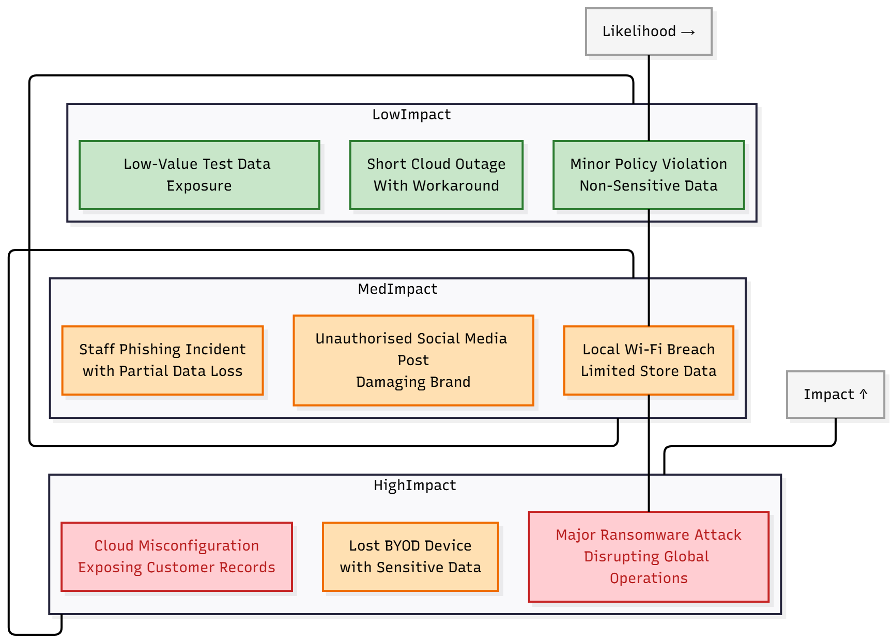
Figure 7: Information Security Risk Matrix Highlighting Key NatureGreen Risks (self-made).

4.5 Technical and organisational defences
Policies must have practical protection mechanisms, which are layered. NG should apply secure wireless settings, such as strong authentication, contemporary encryption and separation of corporate and guest networks at the network layer. Rogue access points or suspicious activity can be detected by means of wireless monitoring. Multi-factor authentication, role-based access, periodic access reviews and separation of duties should be enforced in identity and access management in cloud environments [22]. Customer and staff data require encryption of data in rest and transit, as well as logs and alarms on abnormal access.
The BYOD controls are to be deployed by mobilising the use of the mobile device or application controls, which impose the compliance of the devices, push security configuration, and support remote lock and wipe functionality. In the case of intellectual property, it is possible to observe and regulate the transfer of sensitive information by data loss prevention solutions, and limit copying or printing by digital rights management.

4.6 Contingency planning, incident response and service level agreements
Security incidents will happen despite the great controls, thus NG needs well-constructed contingency planning. An incident response plan would lay out how to detect, classify and escalate events and delegate roles to investigate and make a decision, communicate and liaise with regulators or law enforcement. Some of the situations to be dealt with in the plan should include instances of ransomware attacks, compromise of the cloud service, wireless breach, and loss of large amounts of data. Consistent practices will help to build preparedness and define deficiencies.
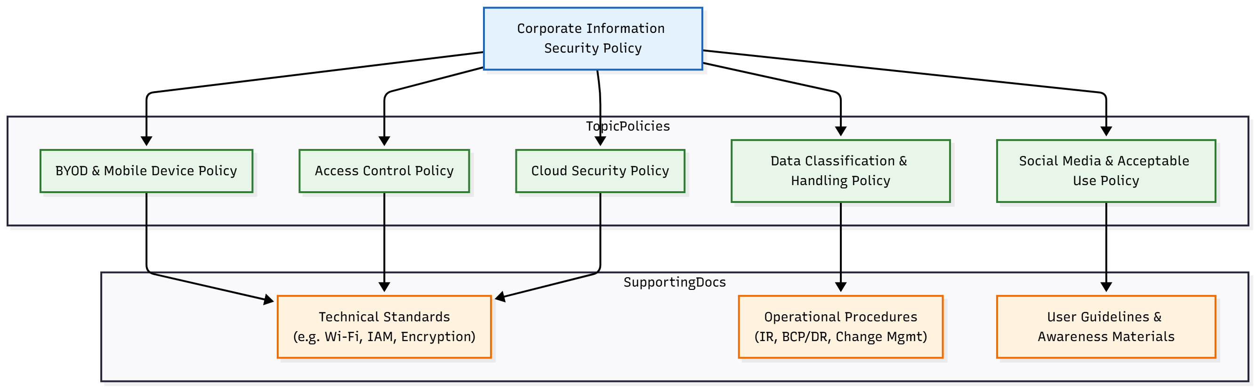
Figure 8: Information Security Policy Hierarchy for NatureGreen (self-made).
Recovery time and recovery point goals of key services should be characterised by business continuity and disaster recovery plans, and how cloud and on-premise systems will be reinstated. Since NG depends on outsourced services, the service level agreements with the cloud and network vendors should explicitly outline security issues. These should also contain the availability requirements, the time of incident notification, supporting forensic investigations, reporting about data breaches, and independent certification, such as ISO 27001.
Figure 9: Integrated security, governance and compliance framework for NatureGreen (self-made)

5. Significance of Changing Regulations and Standards

5.1 Shifting threat environment and technology
The organisational threat environment of organisations such as NG is dynamic. The number of cybercrime losses reported to the authorities is growing at an impressive pace, with FBI data showing more than USD 16.6 billion in losses in 2024 and a considerable amount of growth per year [23]. The emergence of new attack vectors is also presented by businesses switching to cloud-native systems, the internet of things, artificial intelligence tools and supply chains of complexity. Malfunctioned cloud services, API insecurity and vendor breaches have culminated in severe infections. In that regard, policies and norms have to change to accommodate emerging technologies and practices and make the multi-party ecosystems accountable.

5.2 Advantages and obstacles of updates to NatureGreen
In the case of NG, the constantly updated regulations and standards will set a better understanding of the baseline expectations, support security practices in line with the industry colleagues and facilitate audits and certifications. They also assist in justifying the investments in modern controls and training as they connect them with the recognised requirements. Regular changes, however, present difficulties which are expenses of revising policies, training and adjusting technical controls. Formal governance structure and information security management system assist NG in managing these pressures by integrating scheduled reviews of the relevant laws, regular risk and control assessment and planned incorporation of contingent requirements.

6. Conclusion
The environment of NatureGreen is well-connected and cloud-based, and has a robust wireless infrastructure with increasing BYOD demands, but an immature security governance system. This puts essential resources, such as customer information, employee data and intellectual property, at high risk and undergoing rapid transformation due to cyber threats. With the incorporation of ISO 27001 and 27002 as the core of an information security management system, risk-oriented mapping with the use of the NIST Cybersecurity Framework, and relying on COBIT, ITIL and cloud or privacy standards, including ISO 27017 and 27018, NG can establish a consistent security, governance, and compliance strategy. Transparent governance frameworks, effective policies, multi-level technical controls, formal risk management and contingency plans will minimise risk and enable compliance with the regulations.

7. References
- S. Gupta, S. Modgil, A. Kumar, U. Sivarajah, and Z. Irani, “Artificial intelligence and cloud-based Collaborative Platforms for Managing Disaster, extreme weather and emergency operations,” International Journal of Production Economics, vol. 254, p. 108642, Sep. 2022, doi: 10.1016/j.ijpe.2022.108642.
- R. Krivec, “Cloud computing statistics (How many companies use cloud computing?),” Colorlib, May 23, 2025. https://colorlib.com/wp/cloud-computing-statistics/
- D. Bonderud, “Cost of a data breach in 2024 for the financial industry,” IBM, Aug. 08, 2025. https://www.ibm.com/think/insights/cost-of-a-data-breach-2024-financial-industry
- N. A. Dhanalakshmi, N. X. Hui, N. Roopini. R, and N. R. Supriya, “Technological advancements in E-Commerce and customer relationship management,” International Journal of Engineering and Management Research, vol. 10, no. 6, pp. 9–20, Dec. 2020, doi: 10.31033/ijemr.10.6.2.
- E. Dritsas and M. Trigka, “A survey on the applications of cloud computing in the industrial internet of things,” Big Data and Cognitive Computing, vol. 9, no. 2, p. 44, Feb. 2025, doi: 10.3390/bdcc9020044.
- M. Ahmed, Ransomware Evolution. CRC Press, 2024.
- T. C. on S. D. for P. Security, Structural design for physical security: State of the Practice. 2021.
- E. Humphreys, Implementing the ISO/IEC 27001:2013 ISMS Standard. Artech House, 2016.
- A. Calder, Information Security based on ISO 27001/ISO 27002. Van Haren, 2020.
- Calder, NIST Cybersecurity Framework: A pocket guide. IT Governance Publishing Ltd, 2018.
- Brumfield, Cybersecurity Risk management: Mastering the Fundamentals Using the NIST Cybersecurity Framework. John Wiley & Sons, 2021.
- R. Palanisamy, A. A. Norman, L. M. Kiah, and T. Herawan, Bring your own device security Policy compliance framework. Springer Nature, 2025.
- Isaca, COBIT 2019 Framework: Introduction and Methodology. 2018.
- Cybellium, Mastering ITIL. Cybellium Ltd, 2023.
- P. Voigt and A. Von Dem Bussche, The EU General Data Protection Regulation (GDPR): A Practical Guide. Springer Nature, 2024.
- A. Calder, NIST Cybersecurity Framework: A pocket guide. IT Governance Publishing Ltd, 2018.
- V. R. Krothapalli, Mastering cloud Auditing: Comprehensive concepts, best practices, tools, and techniques for auditing modern cloud systems (English Edition). BPB Publications, 2025.
- S. L. Lambert, K. Agnew, T. N. A. Fezzey, and J. H. Batchelor, “Delineating responsibilities for COBIT 2019 IT control activities between cloud service providers and cloud service users,” Journal of Emerging Technologies in Accounting, pp. 1–19, May 2025, doi: 10.2308/jeta-2023-063.
- J. Edwards, A comprehensive guide to the NIST Cybersecurity Framework 2.0: Strategies, Implementation, and Best Practice. John Wiley & Sons, 2024.
- A. T. A. M, A. W. A. Wahab, and M. Y. I. Idris, “Systematic literature review on security access control policies and techniques based on privacy requirements in a BYOD environment: State of the art and future directions,” Applied Sciences, vol. 13, no. 14, p. 8048, Jul. 2023, doi: 10.3390/app13148048.
- R. Johnson, Security policies and implementation issues: . Jones & Bartlett Publishers, 2014.
- Indu, P. M. R. Anand, and V. Bhaskar, “Identity and access management in cloud environment: Mechanisms and challenges,” Engineering Science and Technology an International Journal, vol. 21, no. 4, pp. 574–588, May 2018, doi: 10.1016/j.jestch.2018.05.010.
- Reuters, “FBI says cybercrime costs rose to at least $16 billion in 2024,” reuters.com, Apr. 23, 2025. https://www.reuters.com/world/us/fbi-says-cybercrime-costs-rose-least-16-billion-2024-2025-04-23/

