By Mathew Jones (2317425) – Software Engineering
Introduction to web and data concepts (ACCA4023)
HTML & CSS Web Development
Contents
‘Introduction’ section 2
Requirements’ section: 2
‘Implementation’ section: 2
Validation 6
'Evaluation’ section: 7
Website usability 7
Website accessibility 8
Search engine optimisation 9
Usefulness (usability and utility) 9
Search Engine Optimisation (SEO): 9
Accessibility: 10
References 12
Website references 12
Appendices 15

‘Introduction’ section
- An abstract: a short summary description of the contents of the report
In this report I will giving an introduction of my website which is based on Wales. I will be describing what is the purpose of it, what it contains and who are the target audience. I will then screen grab all my web pages, validate the home page and CSS code for my home page. I will be using validator.w3 for the HTML and jigsaw.w3 for the CSS. Additionally, I will be researching about web usability, accessibility, and search engine optimisation, using peer reviewed journals/conference papers. Finally, I will evaluate my completed website on its usefulness, search engine optimisation and accessibility.

Requirements’ section:
- A brief introduction to the website, describing its purpose, subject matter and the intended target audience.
My website is about Wales, and I discuss the geography of Wales, demographics, history, culture, and some interesting facts. Its purpose is to educate people about Wales and raise awareness about it. The subject matter is what makes a country a country and will discuss about the things stated above. The intended audience is anyone around the world, young or old.

‘Implementation’ section:
- Use something like the ‘snip tool’ and Include Screen grabs of all of the pages of the completed website (not the code).

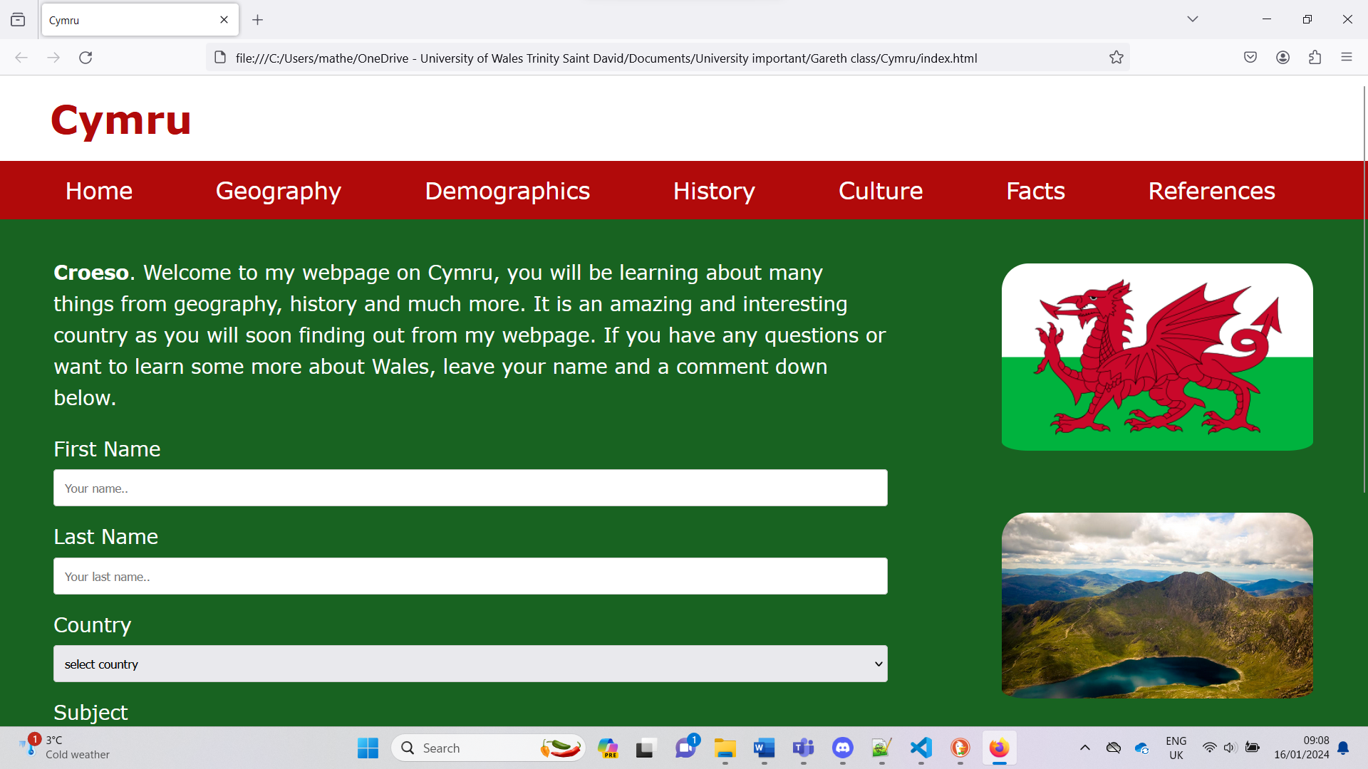

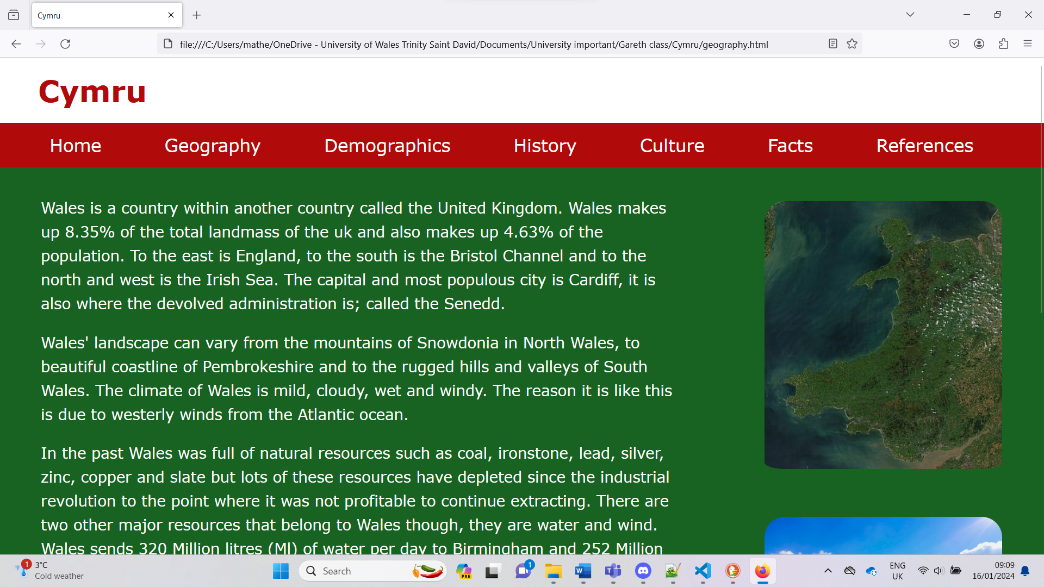

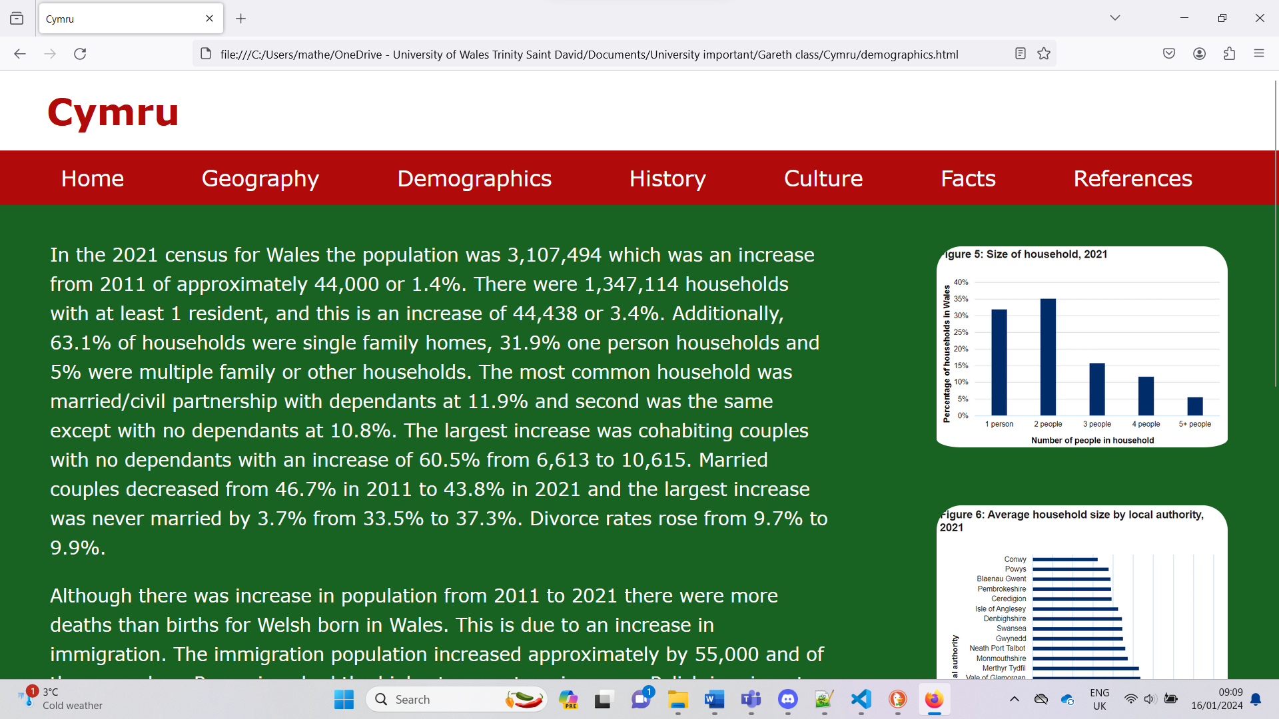

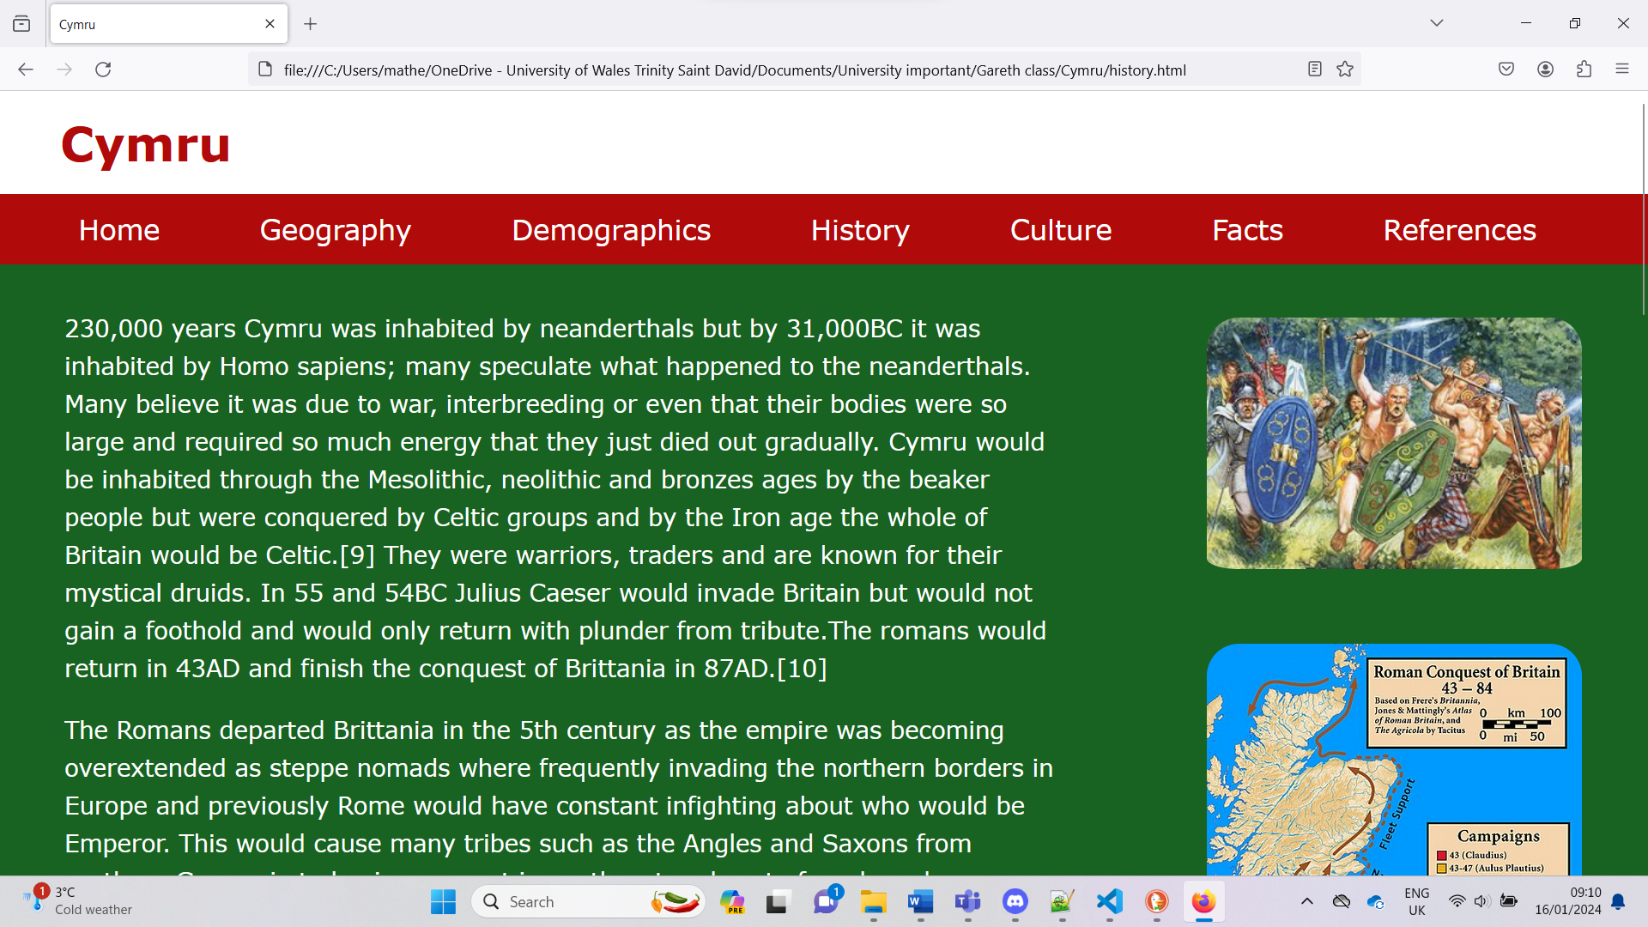

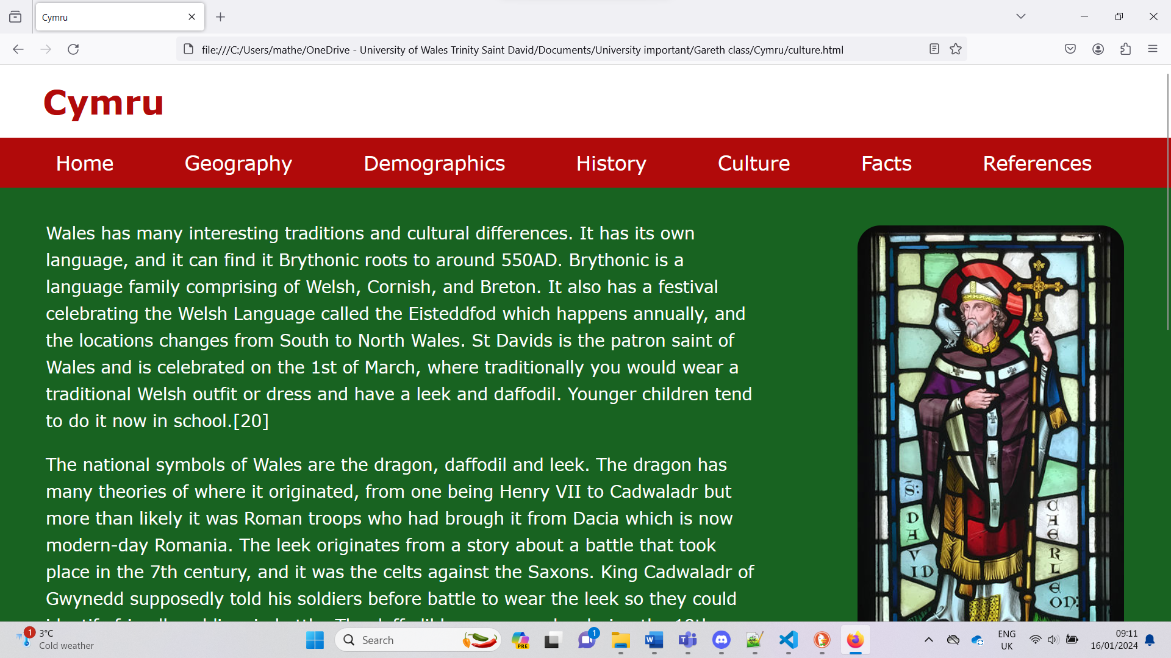

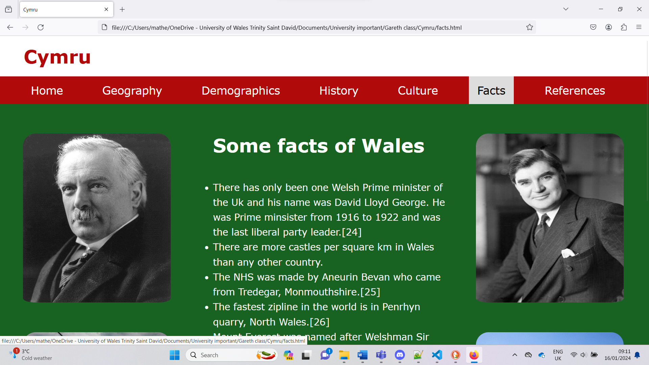

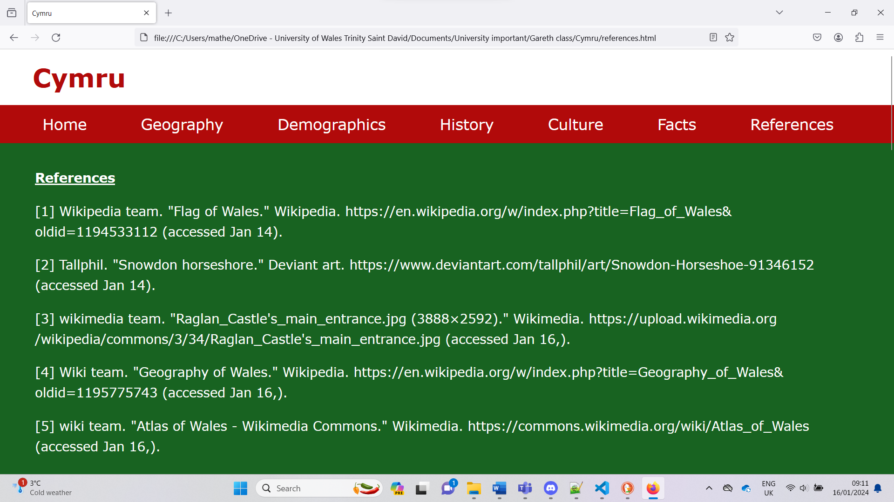

Validation
You should validate both your HTML and CSS code of your completed website and provide the validation results. If you had any errors, provide a brief description of how you corrected the error. Where you are unable to correct the error, give a description of what you suspect the cause is. Please do not describe every single error in cases of repeated errors – a general statement will do!
The validators can be found at:
HTML (http://validator.w3.org/) - you are only required to validate the HTML of your home page

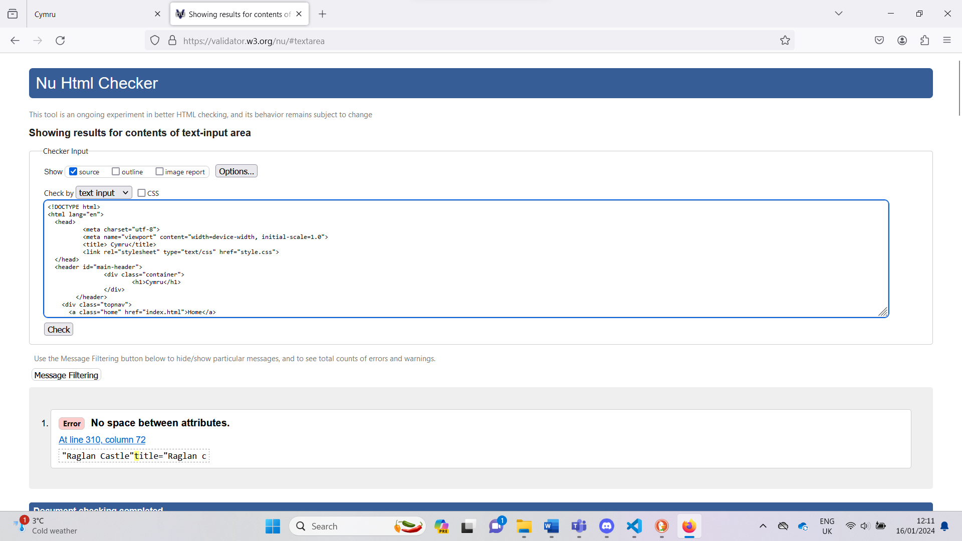

The error was there was no space between attributes and has now been rectified by putting a space in between.

CSS (http://jigsaw.w3.org/css-validator/) – you are only required to validate your website’s main CSS
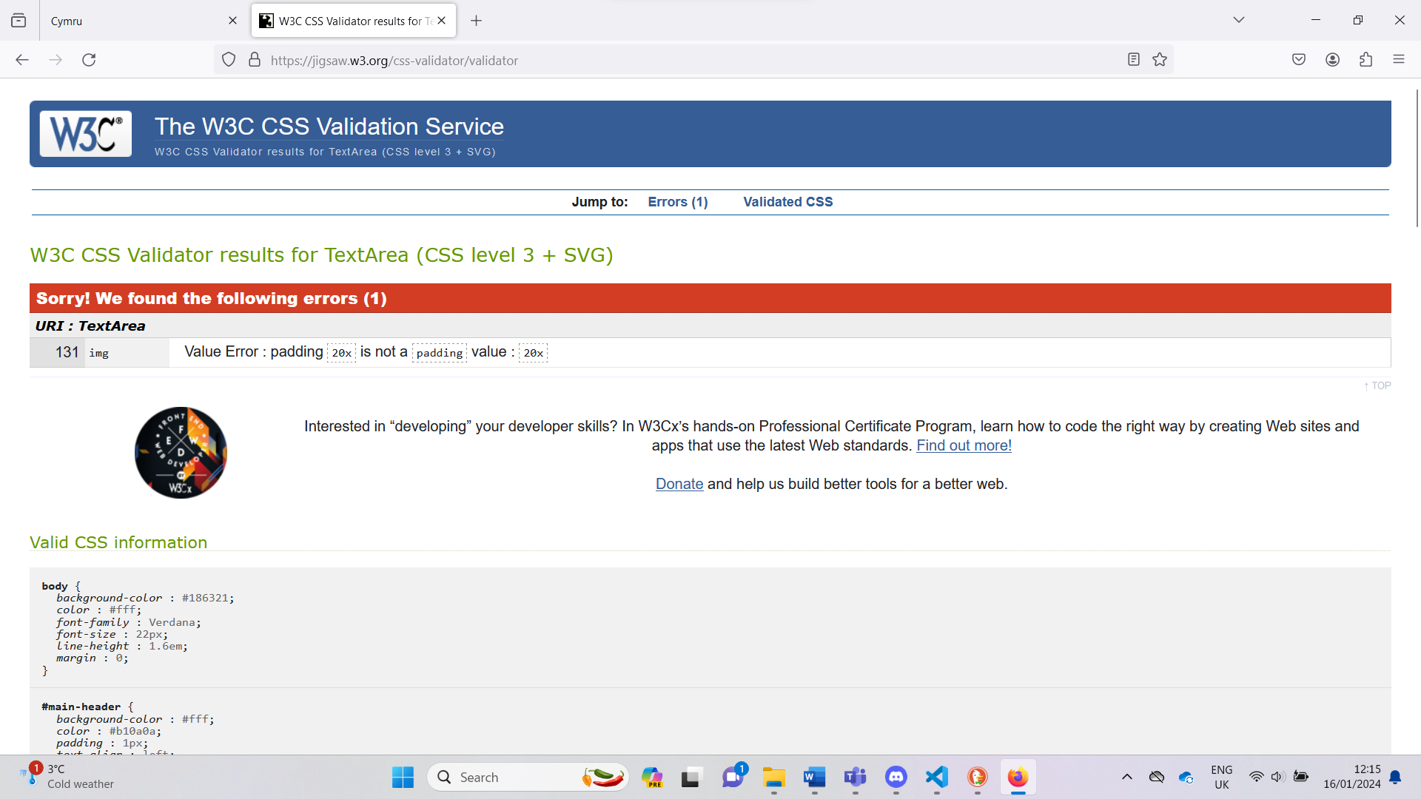

The error was that padding 20x is not a padding value I can rectify by either adding a p or deleting it if it wasn’t working in the first place. After putting a p where it should have been it improved my image layout and have decide to keep the padding.

'Evaluation’ section:

  - Website usability, accessibility, and search engine optimisation are all very important when analysing the quality of a website. Research each of these terms and describe each term and its role in web development in detail. For each term, your discussion should include at least one example of a relevant research study from a peer reviewed journal or conference paper relating to the term. For each example, summarise the study and its key findings.

Website usability

Website usability is how easy is it for a user to use a website for it’s intended purpose, for instance is it easy for the user to purchase items on a shopping website. Additionally, you are to make sure the user is satisfied with the efficiency and that the customer is happy with the appearance. [1] This will also have the advantage of attracting customers to your site as websites with poor design and visuals will not attract users.

The first research study is looking at if an organisations recruitment website can change the users’ opinion of an organisation and found that the perception of the users views on the organisation were affected if the website was easy to navigate and/or if they looked appealing. [2] The second research study researched the effects of websites on consumers satisfaction and intention to use the website. The study found that if the website was easy to use then the customer would become satisfied which then made customers more likely to use the website. The study states that the most effective way to improve your website is not a complex design but a website that is designed and structured in a simple and making sure it is easy for the user to navigate. [3]

Website accessibility

Web accessibility is about creating a website that is easily navigable for users that have temporary/permanent disability, poor computer literacy and other situations such as poor lighting or even a broken mouse. Theses disabilities could range from poor vision, colour blindness, poor hearing, individuals unable to move their arms, cognitive/learning difficulties and many more. [4]
You can assist these users by having video captions so those who have poor hearing or are just in a loud area are able to read, large links, buttons, and controls will assist those with reduced dexterity such as the elderly, voice recognition and keyboard compatibility for those who are unable to use their arms, users who are temporarily injured or even individuals who have a broken mouse. Having understandable content, easy to navigate, clear and consistent layouts will assist those who have cognitive/ learning difficulties. For those who have poor eyesight you could make the colour contrast easily visible as well as having the option to have customisable text, this will also assist for those who have dyslexia. Additionally having text to speech will assist those who have dyslexia and users who are blind. [4]
The research study is looking at local government website accessibility in Poland and focuses on disability, e-administration, and web access for the users with poor vision. It also discusses the EU implementing WCAG guidelines 2.1. They looked at 182 websites concluded that giving tools to change contrast or font size is not enough and more needs to be done, for instance if a user was to access a PDF, then the website would not be able to assist. It goes on talk about the employees who manage the content need to be competent if needed must have more training. Additionally, it discusses their websites being overloaded with content and wasn’t necessary, having a simple and centralised design would rectify this. [5]

Search engine optimisation

Search engine optimisation or SEO is about increasing your ranking in search engines such as Google. It is done by optimising your websites, web pages and the contents. It is essential as most users only use the first page of Google so having your website higher up on the ranking will increase traffic going to your website. [6] The research study I used was a conference proceeding at it was discussing the features of the development of search optimization in the strategy of electronic marketing. It goes on to discuss the importance of improving SEO and the benefits of it. It will increase website traffic, reduce advertising costs, provide more channels, and increase advertisement for companies. Additionally, they discuss the importance of e marketing strategy which is email customers, and this is important as it allows you to have a global audience, track and analyse results, optimise your approach, appear more open which will be attractive to customer and lower cost. To finalise this study shows that optimising SEO is essential and researching and how to improve your websites chances of rising the search list is not only beneficial but necessary. [7]

  - Provide an evaluation of your completed website as follows:

Usefulness (usability and utility)
Taking into consideration the design of your website, evaluate its utility (functionality), usability (look and feel and ease of use), and content (information) and provide recommendations for future improvements.
I believe the design for my website to below average, there are improvements to be made. I have lined up words and images to the best of my ability currently, the functionality is average it does what it’s meant to do which is changes pages to educate users about Wales. The colour I chose as I was creating a website about Cymru, the wording is clear to see as well as images. The contents of the website I believe is where it stands out and for future improvements, I would spend more time learning about where the line of code goes as well as how to position images, text and learn about different codes such implementing text to speech/voice recognition.

Search Engine Optimisation (SEO): Document the on-page SEO techniques applied to your website with examples of where and how these have been applied.
I have used three on-page SEO techniques for my website, they are including keywords. For example, I have used Wales many times, this should increase website for those searching for that. Additionally having a website with a lot of content will increase the total amounts of keywords. Finally using multimedia is seen to increase your position on search results and I have used many images to improve the look and feel of my website.

Accessibility: With reference to WCAG 2.1, evaluate and briefly discuss the accessibility of your implemented website with respect to the four main principles that provide the foundation for web accessibility.
I believe my website is perceivable as I completed a contrast test and passed all the test with one colour ration. The other two didn’t achieve a AAA but they still done well. I chose the colours due to my website being about Cymru, but I didn’t use the exact red and green due to the contrast score being lower, it’s more important for the user to be able to read the information on my webpage than design choices. My website is completely operable for its purpose as I will need to operate is the navigation bar. The user interface of website is very simple to understand, writing is clear and easy to read as I chose a font that was designed to be that way. My content should be accessible as technologies advance as my website is just for educational purposes. There were things I was unable to do such as voice recognition, text to speech, customisable text, and keyboard capability, I will ensure in my next website to learn these skills and implement them.

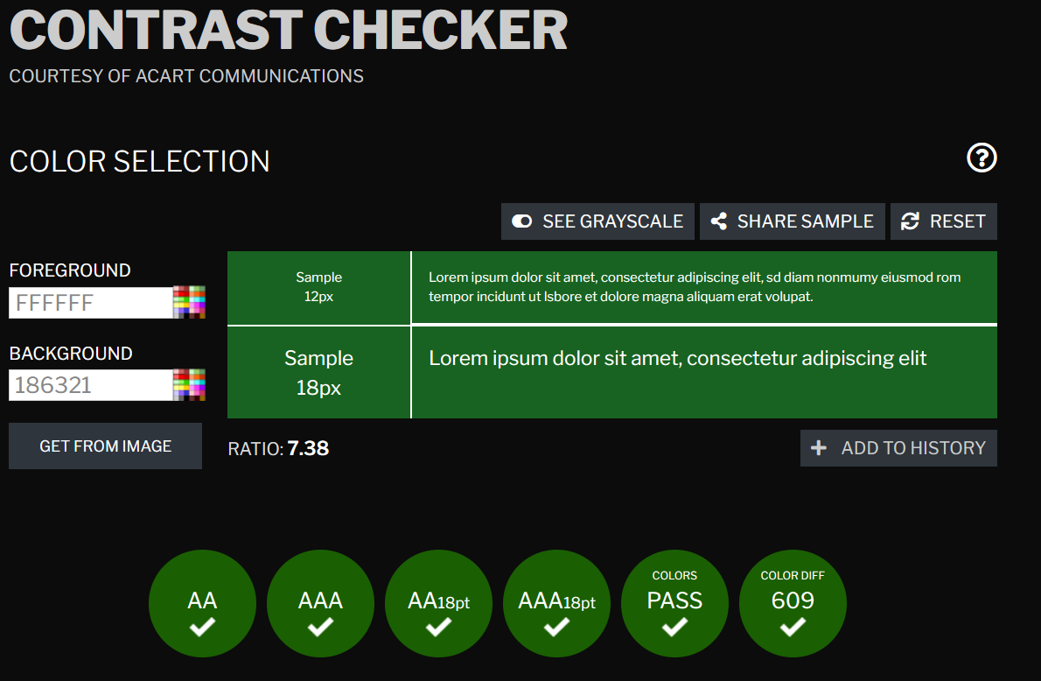

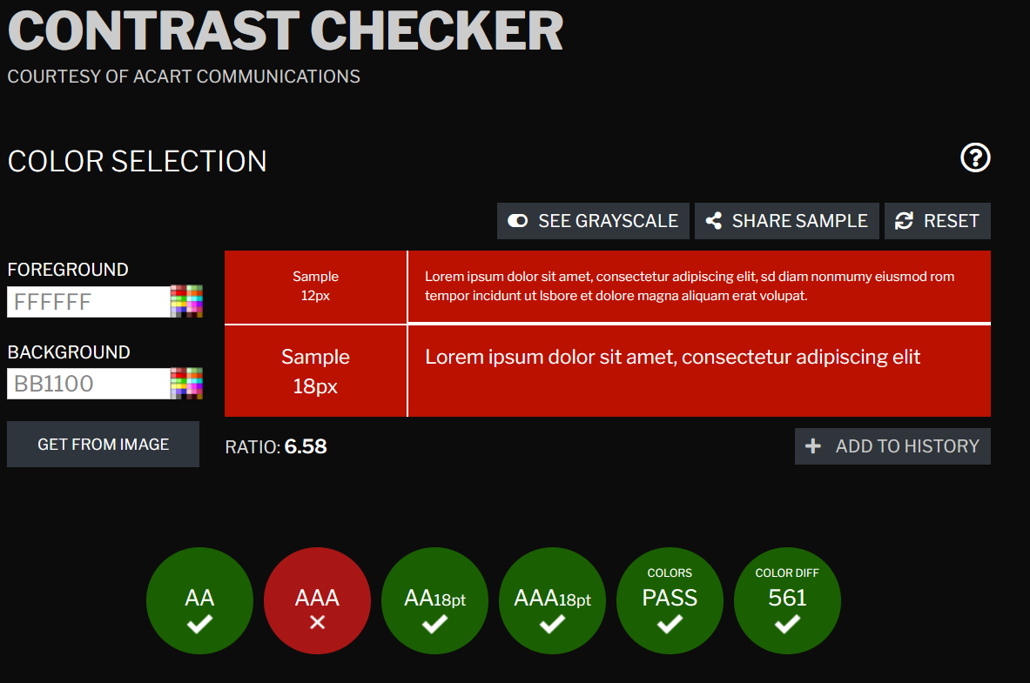

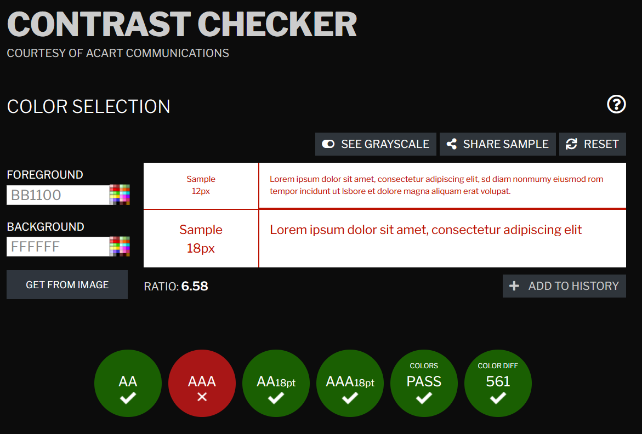

References

[1] Interaction design team. "What is Usability - The Ultimate Guide." The Interaction Design Foundation. https://www.interaction-design.org/literature/topics/usability (accessed Jan 15,).
[2] P. W. Braddy, A. W. Meade and C. M. Kroustalis, "Online recruiting: The effects of organizational familiarity, website usability, and website attractiveness on viewers’ impressions of organizations," Computers in human behavior, vol. 24, no. 6, pp.2992–3001, 2008. doi: 10.1016/j.chb.2008.05.005. Accessed: Jan 15, 2024, [Online].
[3] D. Belanche, L. V. Casaló and M. Guinalíu, "Website usability, consumer satisfaction and the intention to use a website: The moderating effect of perceived risk," Journal of retailing and consumer services, vol. 19, no. 1, pp.124–132, 2012. doi: 10.1016/j.jretconser.2011.11.001. Accessed: Jan 15, 2024, [Online].
[4] W. W. A. I. (WAI). "Introduction to Web Accessibility." Web Accessibility Initiative (WAI). https://www.w3.org/WAI/fundamentals/accessibility-intro/ (accessed Jan 15,).
[5] K. Król and D. Zdonek, "Local government website accessibility: Evidence from Poland," Administrative sciences, vol. 10, no. 2, pp.1–17, 2020. doi: 10.3390/admsci10020022. Accessed: Jan 16, 2024, [Online].
[6] M. Ellis. "What Is SEO? Search Engine Optimization Best Practices." Moz. https://moz.com/learn/seo/what-is-seo (accessed Jan 16,).
[7] M. A. A. Dalbouh, "Features of the development of search optimization in the strategy of electronic marketing," 2023. doi: 10.1051/e3sconf/202341902020.

Website references

[1] Wikipedia team. "Flag of Wales." Wikipedia. https://en.wikipedia.org/w/index.php?title=Flag_of_Wales&oldid=1194533112 (accessed Jan 14).
[2] Tallphil. "Snowdon horseshore." Deviant art. https://www.deviantart.com/tallphil/art/Snowdon-Horseshoe-91346152 (accessed Jan 14).
[3] wikimedia team. "Raglan_Castle's_main_entrance.jpg (3888×2592)." Wikimedia. https://upload.wikimedia.org/wikipedia/commons/3/34/Raglan_Castle's_main_entrance.jpg (accessed Jan 16,).
[4] Wiki team. "Geography of Wales." Wikipedia. https://en.wikipedia.org/w/index.php?title=Geography_of_Wales&oldid=1195775743 (accessed Jan 16,).
[5] wiki team. "Atlas of Wales - Wikimedia Commons." Wikimedia. https://commons.wikimedia.org/wiki/Atlas_of_Wales (accessed Jan 16,).
[6] N. Dalton, "Where to go hiking in the Brecon Beacons National Park, Wales", The Travel Magazine, https://www.thetravelmagazine.net/hiking-brecon-beacons-national-park/ (accessed Jan 16, 2024).
[7] L. Burke. "Geograph:: Pembrokeshire Cliffs © Lis Burke." Geograph. https://www.geograph.org.uk/photo/54481 (accessed Jan 16,).
[8] Gov Wales team. "Demography and migration in Wales (Census 2021) | GOV.WALES." Gov.Wales. https://www.gov.wales/demography-and-migration-wales-census-2021-html (accessed Jan 16,).
[9] T.E.o.G.M. History, "Who Lived in Britain Before the Celts?", Give Me History, https://www.givemehistory.com/who-lived-in-britain-before-the-celts (accessed Jan 16, 2024).
[10] wiki team. "History of Wales." wikipedia. https://en.wikipedia.org/w/index.php?title=History_of_Wales&oldid=1190367947 (accessed Jan 16,).
[11] wiki team. "Llywelyn ap Gruffudd." Wikipedia. https://en.wikipedia.org/w/index.php?title=Llywelyn_ap_Gruffudd&oldid=1195824903 (accessed Jan 16,).
[12] Wiki team. "Glyndŵr rebellion." Wikipedia. https://en.wikipedia.org/w/index.php?title=Glynd%C5%B5r_rebellion&oldid=1194070250 (accessed Jan 16,).
[13] Wiki team. "Henry VII of England." Wikipedia. https://en.wikipedia.org/w/index.php?title=Henry_VII_of_England&oldid=1194919126 (accessed Jan 16,).
[14] Wiki team. "Laws in Wales Acts 1535 and 1542." Wikipedia. https://en.wikipedia.org/w/index.php?title=Laws_in_Wales_Acts_1535_and_1542&oldid=1185557368 (accessed Jan 16,).
[15] "Celtic Warfare." Celtic. http://celticsarecelts.weebly.com/celtic-warfare.html (accessed Jan 16,).
[16] Wiki team. "Roman conquest of Britain." Wikipedia. https://en.wikipedia.org/w/index.php?title=Roman_conquest_of_Britain&oldid=1195017424 (accessed Jan 16,).
[17] Wiki team. "Anglo-Saxons." Wikipedia. https://en.wikipedia.org/w/index.php?title=Anglo-Saxons&oldid=1187932252 (accessed Jan 16,).
[18] Wiki team. "Child_coal_miners_(1908)_crop.jpg (1225×951)." Wikimedia. https://upload.wikimedia.org/wikipedia/commons/4/4c/Child_coal_miners_%281908%29_crop.jpg (accessed Jan 16,).
[19] P. Rowland. "16 haunting pictures of the devastating destruction suffered by Swansea during the Blitz." Wales Online. https://www.walesonline.co.uk/incoming/gallery/16-haunting-pictures-devastating-destruction-6731590 (accessed Jan 16,).
[20] Wiki team. "Saint David's Day." Wikipedia. https://en.wikipedia.org/w/index.php?title=Saint_David%27s_Day&oldid=1193554504 (accessed Jan 16,).
[21] Wiki team. "Culture of Wales." Wikipedia. https://en.wikipedia.org/w/index.php?title=Culture_of_Wales&oldid=1192805198 (accessed Jan 16,).
[22] Wiki team. "Dwynwen." Wikipedia. https://en.wikipedia.org/w/index.php?title=Dwynwen&oldid=1195800922#Dydd_Santes_Dwynwen (accessed Jan 16,).
[23] C. Matthews. "Celebrate St David's Day: history and traditions." BBC countryfile. https://www.countryfile.com/people/historical-figures/st-davids-day (accessed Jan 16,).
[24] Wiki team. "David Lloyd George." Wikipedia. Https://en.wikipedia.org/w/index.php?title=David_Lloyd_George&oldid=1195628887 (accessed Jan 16,).
[25] Wiki team. "Aneurin Bevan." Wikipedia. https://en.wikipedia.org/w/index.php?title=Aneurin_Bevan&oldid=1194027081 (accessed Jan 16,).
[26] Z. World. "Zip World Penrhyn Quarry." Zip World. https://www.zipworld.co.uk/location/penrhyn-quarry (accessed Jan 16,).
[27] D. Evans. "Sir George Everest: The Welshman who named world’s tallest mountain." https://www.herald.wales/uncategorised/sir-george-everest-the-welshman-who-named-worlds-tallest-mountain/ (accessed 16/01/24).
[28] Wiki team. "Menai Suspension Bridge." Wikipedia. https://en.wikipedia.org/w/index.php?title=Menai_Suspension_Bridge&oldid=1188029899 (accessed Jan 16,).
[29] U.O.o. en.wikipedia. "Harlech Castle, Wales, view from below the castle, looking north-east." Wikipedia. https://commons.wikimedia.org/wiki/File:Harlech_Castle_low.jpg (accessed Jan 16,).

Appendices

Homepage

<!DOCTYPE html>
<html lang="en">
<head>
<meta charset="utf-8">
<meta name="viewport" content="width=device-width, initial-scale=1.0">
<title> Cymru</title>
<link rel="stylesheet" type="text/css" href="style.css">
</head>
<header id="main-header">
<div class="container">
<h1>Cymru</h1>
</div>
</header>
<div class="topnav">
<a class="home" href="index.html">Home</a>
<a href="geography.html">Geography</a>
<a href="demographics.html">Demographics</a>
<a href="history.html">History</a>
<a href="culture.html">Culture</a>
<a href="facts.html">Facts</a>
<a href="references.html">References</a>
</div>
<div class="row">
<div class="leftcolumn">
<div class="card">
<p><b>Croeso</b>. Welcome to my webpage on Cymru, you will be learning about many things from geography, history and much more. It is an amazing and interesting country as you will soon finding out from my webpage. If you have any questions or want to learn some more about Wales, leave your name and a comment down below.</p>
</div>
<div class="card">
<form action="action_page.php">

<label for="fname">First Name</label>
<input type="text" id="fname" name="firstname" placeholder="Your name..">

<label for="lname">Last Name</label>
<input type="text" id="lname" name="lastname" placeholder="Your last name..">

<label for="country">Country</label>
<select id="country" name="country">

<option>select country</option>
<option value="AF">Afghanistan</option>
<option value="AX">Aland Islands</option>
<option value="AL">Albania</option>
<option value="DZ">Algeria</option>
<option value="AS">American Samoa</option>
<option value="AD">Andorra</option>
<option value="AO">Angola</option>
<option value="AI">Anguilla</option>
<option value="AQ">Antarctica</option>
<option value="AG">Antigua and Barbuda</option>
<option value="AR">Argentina</option>
<option value="AM">Armenia</option>
<option value="AW">Aruba</option>
<option value="AU">Australia</option>
<option value="AT">Austria</option>
<option value="AZ">Azerbaijan</option>
<option value="BS">Bahamas</option>
<option value="BH">Bahrain</option>
<option value="BD">Bangladesh</option>
<option value="BB">Barbados</option>
<option value="BY">Belarus</option>
<option value="BE">Belgium</option>
<option value="BZ">Belize</option>
<option value="BJ">Benin</option>
<option value="BM">Bermuda</option>
<option value="BT">Bhutan</option>
<option value="BO">Bolivia</option>
<option value="BQ">Bonaire, Sint Eustatius and Saba</option>
<option value="BA">Bosnia and Herzegovina</option>
<option value="BW">Botswana</option>
<option value="BV">Bouvet Island</option>
<option value="BR">Brazil</option>
<option value="IO">British Indian Ocean Territory</option>
<option value="BN">Brunei Darussalam</option>
<option value="BG">Bulgaria</option>
<option value="BF">Burkina Faso</option>
<option value="BI">Burundi</option>
<option value="KH">Cambodia</option>
<option value="CM">Cameroon</option>
<option value="CA">Canada</option>
<option value="CV">Cape Verde</option>
<option value="KY">Cayman Islands</option>
<option value="CF">Central African Republic</option>
<option value="TD">Chad</option>
<option value="CL">Chile</option>
<option value="CN">China</option>
<option value="CX">Christmas Island</option>
<option value="CC">Cocos (Keeling) Islands</option>
<option value="CO">Colombia</option>
<option value="KM">Comoros</option>
<option value="CG">Congo</option>
<option value="CD">Congo, Democratic Republic of the Congo</option>
<option value="CK">Cook Islands</option>
<option value="CR">Costa Rica</option>
<option value="CI">Cote D'Ivoire</option>
<option value="HR">Croatia</option>
<option value="CU">Cuba</option>
<option value="CW">Curacao</option>
<option value="CY">Cyprus</option>
<option value="CZ">Czech Republic</option>
<option value="DK">Denmark</option>
<option value="DJ">Djibouti</option>
<option value="DM">Dominica</option>
<option value="DO">Dominican Republic</option>
<option value="EC">Ecuador</option>
<option value="EG">Egypt</option>
<option value="SV">El Salvador</option>
<option value="GQ">Equatorial Guinea</option>
<option value="ER">Eritrea</option>
<option value="EE">Estonia</option>
<option value="ET">Ethiopia</option>
<option value="FK">Falkland Islands (Malvinas)</option>
<option value="FO">Faroe Islands</option>
<option value="FJ">Fiji</option>
<option value="FI">Finland</option>
<option value="FR">France</option>
<option value="GF">French Guiana</option>
<option value="PF">French Polynesia</option>
<option value="TF">French Southern Territories</option>
<option value="GA">Gabon</option>
<option value="GM">Gambia</option>
<option value="GE">Georgia</option>
<option value="DE">Germany</option>
<option value="GH">Ghana</option>
<option value="GI">Gibraltar</option>
<option value="GR">Greece</option>
<option value="GL">Greenland</option>
<option value="GD">Grenada</option>
<option value="GP">Guadeloupe</option>
<option value="GU">Guam</option>
<option value="GT">Guatemala</option>
<option value="GG">Guernsey</option>
<option value="GN">Guinea</option>
<option value="GW">Guinea-Bissau</option>
<option value="GY">Guyana</option>
<option value="HT">Haiti</option>
<option value="HM">Heard Island and Mcdonald Islands</option>
<option value="VA">Holy See (Vatican City State)</option>
<option value="HN">Honduras</option>
<option value="HK">Hong Kong</option>
<option value="HU">Hungary</option>
<option value="IS">Iceland</option>
<option value="IN">India</option>
<option value="ID">Indonesia</option>
<option value="IR">Iran, Islamic Republic of</option>
<option value="IQ">Iraq</option>
<option value="IE">Ireland</option>
<option value="IM">Isle of Man</option>
<option value="IL">Israel</option>
<option value="IT">Italy</option>
<option value="JM">Jamaica</option>
<option value="JP">Japan</option>
<option value="JE">Jersey</option>
<option value="JO">Jordan</option>
<option value="KZ">Kazakhstan</option>
<option value="KE">Kenya</option>
<option value="KI">Kiribati</option>
<option value="KP">Korea, Democratic People's Republic of</option>
<option value="KR">Korea, Republic of</option>
<option value="XK">Kosovo</option>
<option value="KW">Kuwait</option>
<option value="KG">Kyrgyzstan</option>
<option value="LA">Lao People's Democratic Republic</option>
<option value="LV">Latvia</option>
<option value="LB">Lebanon</option>
<option value="LS">Lesotho</option>
<option value="LR">Liberia</option>
<option value="LY">Libyan Arab Jamahiriya</option>
<option value="LI">Liechtenstein</option>
<option value="LT">Lithuania</option>
<option value="LU">Luxembourg</option>
<option value="MO">Macao</option>
<option value="MK">Macedonia, the Former Yugoslav Republic of</option>
<option value="MG">Madagascar</option>
<option value="MW">Malawi</option>
<option value="MY">Malaysia</option>
<option value="MV">Maldives</option>
<option value="ML">Mali</option>
<option value="MT">Malta</option>
<option value="MH">Marshall Islands</option>
<option value="MQ">Martinique</option>
<option value="MR">Mauritania</option>
<option value="MU">Mauritius</option>
<option value="YT">Mayotte</option>
<option value="MX">Mexico</option>
<option value="FM">Micronesia, Federated States of</option>
<option value="MD">Moldova, Republic of</option>
<option value="MC">Monaco</option>
<option value="MN">Mongolia</option>
<option value="ME">Montenegro</option>
<option value="MS">Montserrat</option>
<option value="MA">Morocco</option>
<option value="MZ">Mozambique</option>
<option value="MM">Myanmar</option>
<option value="NA">Namibia</option>
<option value="NR">Nauru</option>
<option value="NP">Nepal</option>
<option value="NL">Netherlands</option>
<option value="AN">Netherlands Antilles</option>
<option value="NC">New Caledonia</option>
<option value="NZ">New Zealand</option>
<option value="NI">Nicaragua</option>
<option value="NE">Niger</option>
<option value="NG">Nigeria</option>
<option value="NU">Niue</option>
<option value="NF">Norfolk Island</option>
<option value="MP">Northern Mariana Islands</option>
<option value="NO">Norway</option>
<option value="OM">Oman</option>
<option value="PK">Pakistan</option>
<option value="PW">Palau</option>
<option value="PS">Palestinian Territory, Occupied</option>
<option value="PA">Panama</option>
<option value="PG">Papua New Guinea</option>
<option value="PY">Paraguay</option>
<option value="PE">Peru</option>
<option value="PH">Philippines</option>
<option value="PN">Pitcairn</option>
<option value="PL">Poland</option>
<option value="PT">Portugal</option>
<option value="PR">Puerto Rico</option>
<option value="QA">Qatar</option>
<option value="RE">Reunion</option>
<option value="RO">Romania</option>
<option value="RU">Russian Federation</option>
<option value="RW">Rwanda</option>
<option value="BL">Saint Barthelemy</option>
<option value="SH">Saint Helena</option>
<option value="KN">Saint Kitts and Nevis</option>
<option value="LC">Saint Lucia</option>
<option value="MF">Saint Martin</option>
<option value="PM">Saint Pierre and Miquelon</option>
<option value="VC">Saint Vincent and the Grenadines</option>
<option value="WS">Samoa</option>
<option value="SM">San Marino</option>
<option value="ST">Sao Tome and Principe</option>
<option value="SA">Saudi Arabia</option>
<option value="SN">Senegal</option>
<option value="RS">Serbia</option>
<option value="CS">Serbia and Montenegro</option>
<option value="SC">Seychelles</option>
<option value="SL">Sierra Leone</option>
<option value="SG">Singapore</option>
<option value="SX">Sint Maarten</option>
<option value="SK">Slovakia</option>
<option value="SI">Slovenia</option>
<option value="SB">Solomon Islands</option>
<option value="SO">Somalia</option>
<option value="ZA">South Africa</option>
<option value="GS">South Georgia and the South Sandwich Islands</option>
<option value="SS">South Sudan</option>
<option value="ES">Spain</option>
<option value="LK">Sri Lanka</option>
<option value="SD">Sudan</option>
<option value="SR">Suriname</option>
<option value="SJ">Svalbard and Jan Mayen</option>
<option value="SZ">Swaziland</option>
<option value="SE">Sweden</option>
<option value="CH">Switzerland</option>
<option value="SY">Syrian Arab Republic</option>
<option value="TW">Taiwan, Province of China</option>
<option value="TJ">Tajikistan</option>
<option value="TZ">Tanzania, United Republic of</option>
<option value="TH">Thailand</option>
<option value="TL">Timor-Leste</option>
<option value="TG">Togo</option>
<option value="TK">Tokelau</option>
<option value="TO">Tonga</option>
<option value="TT">Trinidad and Tobago</option>
<option value="TN">Tunisia</option>
<option value="TR">Turkey</option>
<option value="TM">Turkmenistan</option>
<option value="TC">Turks and Caicos Islands</option>
<option value="TV">Tuvalu</option>
<option value="UG">Uganda</option>
<option value="UA">Ukraine</option>
<option value="AE">United Arab Emirates</option>
<option value="GB">United Kingdom</option>
<option value="US">United States</option>
<option value="UM">United States Minor Outlying Islands</option>
<option value="UY">Uruguay</option>
<option value="UZ">Uzbekistan</option>
<option value="VU">Vanuatu</option>
<option value="VE">Venezuela</option>
<option value="VN">Vietnam</option>
<option value="VG">Virgin Islands, British</option>
<option value="VI">Virgin Islands, U.s.</option>
<option value="WF">Wallis and Futuna</option>
<option value="EH">Western Sahara</option>
<option value="YE">Yemen</option>
<option value="ZM">Zambia</option>
<option value="ZW">Zimbabwe</option>

</select>

<label for="subject">Subject</label>
<textarea id="subject" name="subject" placeholder="Write something.." style="height:200px"></textarea>

<input type="submit" value="Submit">

</form>
</div>
</div>
<div class="rightcolumn">
<div class="card">
<a><img src="images/Flag_of_Wales.svg.png" alt="The flag of Wales" title = "Flag of Wales[1]">
</a>
<a><img src="images/snowdon_horseshoe.jpg" alt="Snowdon Mountain" title = "Snowdon[2]">
</a>
<a><img src="images/Raglan_Castle.jpeg" alt="Raglan Castle" title = "Raglan castle[3]">
</a>
</div>
</div>
</div>
<footer id="main-footer">
<p> Copyright &copy; 2023 Penlan Enterprises</p>
</footer>
</html>

Geography

<!DOCTYPE html>
<html lang="en">
<head>
<meta charset="utf-8">
<meta name="viewport" content="width=device-width, initial-scale=1.0">
<title> Cymru</title>
<link rel="stylesheet" type="text/css" href="style.css">
</head>
<header id="main-header">
<div class="container">
<h1>Cymru</h1>
</div>
</header>
<div class="topnav">
<a class="home" href="index.html">Home</a>
<a href="geography.html">Geography</a>
<a href="demographics.html">Demographics</a>
<a href="history.html">History</a>
<a href="culture.html">Culture</a>
<a href="facts.html">Facts</a>
<a href="references.html">References</a>
</div>
<div class="row">
<div class="leftcolumn">
<div class="card">
<p>
Wales is a country within another country called the United Kingdom. Wales makes up 8.35% of the total landmass of the uk and also makes up 4.63% of the population. To the east is England, to the south is the Bristol Channel and to the north and west is the Irish Sea. The capital and most populous city is Cardiff, it is also where the devolved administration is; called the Senedd. [4]
</p>
<p>
Wales' landscape can vary from the mountains of Snowdonia in North Wales, to beautiful coastline of Pembrokeshire and to the rugged hills and valleys of South Wales. The climate of Wales is mild, cloudy, wet and windy. The reason it is like this is due to westerly winds from the Atlantic ocean. [4]
</p>
<p>
In the past Wales was full of natural resources such as coal, ironstone, lead, silver, zinc, copper and slate but lots of these resources have depleted since the industrial revolution to the point where it was not profitable to continue extracting. There are two other major resources that belong to Wales though, they are water and wind. Wales sends 320 Million litres (Ml) of water per day to Birmingham and 252 Million litres (Ml) to Liverpool and Manchester.
</p>
</div>
<div class="card">
<h2>Key facts</h2>
<ul>
<li>Continent = Europe</li>
<li>Region = Great Britain</li>
<li>Capital = Cardiff</li>
<li>Population = 3,105,000 (2021 est)</li>
<li>Total area = 21,218km2</li>
<li>Highes point = Yr Wydda (1,085m)</li>
<li>Highest waterfall = Pistyll Rhaeadr (73m)</li>
<li>Longest river = Afon Hafren (354km)</li>
<li>Largest lake = Llyn Efyrnwy (4.5km2)</li>
<li>Climate = Temperate</li>
</ul>
</div>
</div>
<div class="rightcolumn">
<div class="card">
<a><img src="images/wales_from_space.jpg" alt="Satellite image of Wales" title = "Wales from space[5]">
</a>
<a><img src="images/brecon_beacons.jpg" alt="Brecon Beacons" title = "Brecon beacons[6]">
</a>
<a><img src="images/coast.jpg" alt="Pembrokeshire coast" title = "pembrokeshire coast[7]">
</a>
</div>
</div>
</div>
<footer id="main-footer">
<p> Copyright &copy; 2023 Penlan Enterprises</p>
</footer>
</html>

Demographics

<!DOCTYPE html>
<html lang="en">
<head>
<meta charset="utf-8">
<meta name="viewport" content="width=device-width, initial-scale=1.0">
<title>Cymru</title>
<link rel="stylesheet" type="text/css" href="style.css">
</head>
<header id="main-header">
<div class="container">
<h1>Cymru</h1>
</div>
</header>
<div class="topnav">
<a class="home" href="index.html">Home</a>
<a href="geography.html">Geography</a>
<a href="demographics.html">Demographics</a>
<a href="history.html">History</a>
<a href="culture.html">Culture</a>
<a href="facts.html">Facts</a>
<a href="references.html">References</a>
</div>
<div class="row">
<div class="leftcolumn">
<div class="card">
<p>In the 2021 census for Wales the population was 3,107,494 which was an increase from 2011 of approximately 44,000 or 1.4%. There were 1,347,114 households with at least 1 resident, and this is an increase of 44,438 or 3.4%. Additionally, 63.1% of households were single family homes, 31.9% one person households and 5% were multiple family or other households. The most common household was married/civil partnership with dependants at 11.9% and second was the same except with no dependants at 10.8%. The largest increase was cohabiting couples with no dependants with an increase of 60.5% from 6,613 to 10,615. Married couples decreased from 46.7% in 2011 to 43.8% in 2021 and the largest increase was never married by 3.7% from 33.5% to 37.3%. Divorce rates rose from 9.7% to 9.9%.[8]</p>
<p>Although there was increase in population from 2011 to 2021 there were more deaths than births for Welsh born in Wales. This is due to an increase in immigration. The immigration population increased approximately by 55,000 and of those numbers Romanians had the highest percentage increase. Polish immigrants remain the highest group with 24,832 or 0.8% of the population, in second was India with 13,000 and in total 6.9% of residents were born outside the UK. Additionally in 2011 27.3% or 837,000 residents were born outside of Wales, this increased to 29.1% or 905,000 of this increase 23,000 were from England.[8]</p>
</div>
<div class="card">
<a><img src="images/non_uk_births.png" alt="Non Uk births graph." title = "Non UK births graph[8]">
</a>
<a><img src="images/percentage_born_outside_uk.png" alt="Percentage of people born outside the uk graph." title = "Percentage born outside the uk[8]">
</a>
</div>
</div>
<div class="rightcolumn">
<div class="card">
<a><img src="images/cymru_housholds.png" alt="A graph on houshold sizes" title = "Household sizes in the uk[8]">
</a>
<a><img src="images/household_by_authority.png" alt="A graph on household sizes by local authority" title = "Household sizes by authority[8]">
</a>
<a><img src="images/legal_status.png" alt="A graph showing percentages of legal status, e.g. Married,divorced." title = "Legal status graph[8]">
</a>
</div>
</div>
</div>
<footer id="main-footer">
<p> Copyright &copy; 2023 Penlan Enterprises</p>
</footer>
</html>

Demographics

<!DOCTYPE html>
<html lang="en">
<head>
<meta charset="utf-8">
<meta name="viewport" content="width=device-width, initial-scale=1.0">
<title> Cymru</title>
<link rel="stylesheet" type="text/css" href="style.css">
</head>
<header id="main-header">
<div class="container">
<h1>Cymru</h1>
</div>
</header>
<div class="topnav">
<a class="home" href="index.html">Home</a>
<a href="geography.html">Geography</a>
<a href="demographics.html">Demographics</a>
<a href="history.html">History</a>
<a href="culture.html">Culture</a>
<a href="facts.html">Facts</a>
<a href="references.html">References</a>
</div>
<div class="row">
<div class="leftcolumn">
<div class="card">
<p>230,000 years Cymru was inhabited by neanderthals but by 31,000BC it was inhabited by Homo sapiens; many speculate what happened to the neanderthals. Many believe it was due to war, interbreeding or even that their bodies were so large and required so much energy that they just died out gradually. Cymru would be inhabited through the Mesolithic, neolithic and bronzes ages by the beaker people but were conquered by Celtic groups and by the Iron age the whole of Britain would be Celtic.[9] They were warriors, traders and are known for their mystical druids. In 55 and 54BC Julius Caeser would invade Britain but would not gain a foothold and would only return with plunder from tribute.The romans would return in 43AD and finish the conquest of Brittania in 87AD.[10]
</p>
<p>
The Romans departed Brittania in the 5th century as the empire was becoming overextended as steppe nomads where frequently invading the northern borders in Europe and previously Rome would have constant infighting about who would be Emperor. This would cause many tribes such as the Angles and Saxons from northern Germania to begin conquest in southeast and east of modern-day England. Additionally, England gets their name from the tribe, the angles. The Celtic tribes over the years would be pushed more westerly until the borders we now know today were created of Cornwall, Scotland and Cymru. Many celts also immigrated to the northwest of France and created the nation of Brittany which shares many similarities with the Cymraeg language.
</p>
<p>
After the borders had been made and all had settled many Duchies formed within Cymru such as Gwynedd, Dyfed, and Gwent. Only once would Cymru be united and that was in 1055 by Gruffydd ap Llywelyn but was a short reign as Gruffydd would die in 1064 and the Kingdom would splinter into many duchies again. In the 1282 the last Prince of Wales Llywelyn ap Gruffydd was killed leading to the annexation by Edward I of England.[11] There was a famous rebellion in 1400 by Owain Glyn Dŵr, in the early days the campaign was very succesful but in 1405 Owain would be defeated by Henry IV's son would later be crounded Henry V. Owain would continue using Guerrilla tatics until 1412 where Owain is never heard of again. This would be the last attempt of Welsh Independence. [12]
</p>
<p>
The modern-day Cymraeg flag can find it’s link to Henry VII in 1485 where he landed at Milford Haven on the 7th of August with an army of 2000 and flew the red dragon. He would raise an army as he marched to have battle with Richard III at the Battle of Bosworth field where he would be victorious and become King of England. He also carried the red dragon standard to his coronation in St Paul’s Cathedral.[13][1] The son of King Henry VII, Henry VIII would incorporate Cymru into England by the Laws in Wales act in 1535 and 1542. This caused the main language of Cymru to become English but for many commoners nothing would change, and they would continue to speak Cymraeg.[14]
<p>
In 1707 the acts of union would pass joining Scotland and England to become Great Britain. The Scottish and English flags would be joined but Cymru would not be included. In 1801 Ireland would be included to create the United Kingdom of Great Britain and Ireland, Cymru again would not be included on to the flag. In the 18th century Wales was going through rapid growth due to the industrial revolution. Coal, iron, copper, and many other resources would be extracted to build infrastructure and export to the rest of the world. This would continue into the 19th century and in the early 20th century the first world war would begin in 1914. [10]
</p>
<p>
Wales fully participated in the war and lost 35,000. The had a total of 275,000 which is a 12.72% loss. The first world war would end on the 11th of November 1918, this left many dead and wounded soldiers leaving a scar on Cymru. During the 1920s and 1930s, 430,000 emigrated from Wales to find work in England as the Great depression was happening. In 1925 the political party Plaid Cymru was formed and was created primarily to make the Cymraeg language the only official language. In 1966 Plaid Cymru won their first seat in Sir Gaerfyrddin. In 1939 Cymru would be brought into war with Nazi Germany after they had invaded Poland on the 3rd of September 1939. Cymru would be bombed in Caerdydd, Abertawe, and other regions around Cymru, 300,000 soldiers would be deployed from Cymru and around 15,000 would die. It would end after the USSR occupying Berlin and the Americans dropping a nuclear bomb on Hiroshima and Nagasaki. [10]
</p>
</div>
</div>
<div class="rightcolumn">
<div class="card">
<a><img src="images/celts.jpg" alt="The celts" title = "Celtic warriors[15]">
</a>
<a><img src="images/roman_britain_campaign.jpg" alt="Map of Roman campaign in Britain" title = "Roman campaign in Great britain[16]">
</a>
<a><img src="images/saxon_conquest.png" alt="Map of Saxon conquest" title = "Saxon conquest[17]">
</a>
<a><img src="images/child_coal_miners.jpg" alt="Child coal miners" title = "Child coal miners[18]">
</a>
<a><img src="images/blitz.webp" alt="Image of bombed Swansea during the blitz" title = "Swansea bombed during the blitz[19]">
</a>
</div>
</div>
</div>
<footer id="main-footer">
<p> Copyright &copy; 2023 Penlan Enterprises</p>
</footer>
</html>

Culture

<!DOCTYPE html>
<html lang="en">
<head>
<meta charset="utf-8">
<meta name="viewport" content="width=device-width, initial-scale=1.0">
<title> Cymru</title>
<link rel="stylesheet" type="text/css" href="style.css">
</head>
<header id="main-header">
<div class="container">
<h1>Cymru</h1>
</div>
</header>
<div class="topnav">
<a class="home" href="index.html">Home</a>
<a href="geography.html">Geography</a>
<a href="demographics.html">Demographics</a>
<a href="history.html">History</a>
<a href="culture.html">Culture</a>
<a href="facts.html">Facts</a>
<a href="references.html">References</a>
</div>
<div class="row">
<div class="leftcolumn">
<div class="card">
<p>Wales has many interesting traditions and cultural differences. It has its own language, and it can find it Brythonic roots to around 550AD. Brythonic is a language family comprising of Welsh, Cornish, and Breton. It also has a festival celebrating the Welsh Language called the Eisteddfod which happens annually, and the locations changes from South to North Wales. St Davids is the patron saint of Wales and is celebrated on the 1st of March, where traditionally you would wear a traditional Welsh outfit or dress and have a leek and daffodil. Younger children tend to do it now in school.[20]</p>

<p>The national symbols of Wales are the dragon, daffodil and leek. The dragon has many theories of where it originated, from one being Henry VII to Cadwaladr but more than likely it was Roman troops who had brough it from Dacia which is now modern-day Romania. The leek originates from a story about a battle that took place in the 7th century, and it was the celts against the Saxons. King Cadwaladr of Gwynedd supposedly told his soldiers before battle to wear the leek so they could identify friendly soldiers in battle. The daffodil became popular during the 19th century and meaning of daffodil in Welsh is cenhinen bedr which translates to “ST Peters leek”, it is thought to be linked to the leek. The national food is the Cawl.[21]</p>

<p>There is also a Welsh valentine called Saint Dwynwen and is celebrate on the 25th of January. Saint Dwynwen is the patron saint of lovers; she is not officially commemorated by the catholic or Anglican church but has been by the Orthodox church.[22] But out of all these the main thing that most Welsh people would say that makes them proud of being Welsh is rugby.</p>
</div>
<div class="card">
<a><img src="images/st_davids_celebrations_cardiff.webp" alt="Traditional Welsh dresses" title = "Traditional Welsh dress[23]" >
</a>
<a><img src="images/daffodils.jpg" alt="Daffodils" title = "Daffodils[21]">
</a>
</div>
</div>
<div class="rightcolumn">
<div class="card">
<a><img src="images/saint_davids.jpg" alt="Saint Davids" title = "Saint David[20]">
<a><img src="images/welsh_rugby.jpg" alt="Welsh rugby" title = "Welsh rugby[21]">
</a>
</a>
</div>
</div>
</div>
<footer id="main-footer">
<p> Copyright &copy; 2023 Penlan Enterprises</p>
</footer>
</html>

Facts

<!DOCTYPE html>
<html lang="en">
<head>
<meta charset="utf-8">
<meta name="viewport" content="width=device-width, initial-scale=1.0">
<title> Cymru</title>
<link rel="stylesheet" type="text/css" href="style.css">
</head>
<header id="main-header">
<div class="container">
<h1>Cymru</h1>
</div>
</header>
<div class="topnav">
<a class="home" href="index.html">Home</a>
<a href="geography.html">Geography</a>
<a href="demographics.html">Demographics</a>
<a href="history.html">History</a>
<a href="culture.html">Culture</a>
<a href="facts.html">Facts</a>
<a href="references.html">References</a>
</div>
<div class="row">
<div class="leftfactscolumn">
<div class="card">
<a><img src="images/david_lloyd_george.jpg" alt="A picture of David Lloyd George, the first and only Prime Minister to come from Wales" width = "350" height = "400" title = "David Lloyd George[24]">
</a>
<a><img src="images/zipline.jpg" alt="Penrhyn quarry zipline. The fastest zipline in the world" title = "Penrhyn quarry zipline[26]">
</a>
<a><img src="images/everest.jpg" alt="A picture of Sir George Everest who surveyed the height of Mount Everest" title = "Sir George Everest[27]">
</a>
</div>
</div>
<div class="centrefactscolumn">
<div class="card">
<ul>
<h1 >Some facts of Wales</h1>
<br>
<li>There has only been one Welsh Prime minister of the Uk and his name was David Lloyd George. He was Prime minsister from 1916 to 1922 and was the last liberal party leader.[24]</li>
<li>There are more castles per square km in Wales than any other country.</li>
<li>The NHS was made by Aneurin Bevan who came from Tredegar, Monmouthshire.[25] </li>
<li>The fastest zipline in the world is in Penrhyn quarry, North Wales.[26]</li>
<li>Mount Everest was named after Welshman Sir George Everest who surveyed the height for many years.[27]</li>
<li>First suspension bridge and largest at it's time was constructed acoss the Menai straight between Anglesey and the Welsh mainland. It was completed in 1826.[28] </li>
<br>
<p>Thank you spending time on my website. I hope it was educatioinal and you enjoyed learning!</p>
</ul>
</div>
</div>
<div class="rightfactscolumn">
<div class="card">
<a><img src="images/aneurin_bevan.jpg" alt="Snowdon Mountain" width = "350" height = "400" title = "Aneurin Bevan[25]">
</a>
<a><img src="images/the_menai_suspension_bridge.jpg" alt ="The Menai suspension bridge" title = "Menai suspension bridge[28]">
</a>
<a><img src="images/harlech_castle.jpg" alt="Harlech Castle" width = "350" height = "185" title = "Harlech castle[29]">
</a>
</div>
</div>
</div>
<footer id="main-footer">
<p> Copyright &copy; 2023 Penlan Enterprises</p>
</footer>
</html>

Referencing

<!DOCTYPE html>
<html lang="en">
<head>
<meta charset="utf-8">
<meta name="viewport" content="width=device-width, initial-scale=1.0">
<title> Cymru</title>
<link rel="stylesheet" type="text/css" href="style.css">
</head>
<header id="main-header">
<div class="container">
<h1>Cymru</h1>
</div>
</header>
<div class="topnav">
<a class="home" href="index.html">Home</a>
<a href="geography.html">Geography</a>
<a href="demographics.html">Demographics</a>
<a href="history.html">History</a>
<a href="culture.html">Culture</a>
<a href="facts.html">Facts</a>
<a href="references.html">References</a>
</div>
<div class="row">
<div class="leftcolumnreference">
<div class="card">
<p><b><u>References</u></b>
</p>
<p>[1] Wikipedia team. "Flag of Wales." Wikipedia. https://en.wikipedia.org/w/index.php?title=Flag_of_Wales&oldid=1194533112 (accessed Jan 14).
</p>
<p>[2] Tallphil. "Snowdon horseshore." Deviant art. https://www.deviantart.com/tallphil/art/Snowdon-Horseshoe-91346152 (accessed Jan 14).
</p>
<p>[3] wikimedia team. "Raglan_Castle's_main_entrance.jpg (3888×2592)." Wikimedia. https://upload.wikimedia.org/wikipedia/commons/3/34/Raglan_Castle's_main_entrance.jpg (accessed Jan 16,).
</p>
<p>[4] Wiki team. "Geography of Wales." Wikipedia. https://en.wikipedia.org/w/index.php?title=Geography_of_Wales&oldid=1195775743 (accessed Jan 16,).
</p>
<p>[5] wiki team. "Atlas of Wales - Wikimedia Commons." Wikimedia. https://commons.wikimedia.org/wiki/Atlas_of_Wales (accessed Jan 16,).
</p>
<p>[6] N. Dalton, "Where to go hiking in the Brecon Beacons National Park, Wales", The Travel Magazine, https://www.thetravelmagazine.net/hiking-brecon-beacons-national-park/ (accessed Jan 16, 2024).
</p>
<p>[7] L. Burke. "Geograph:: Pembrokeshire Cliffs © Lis Burke." Geograph. https://www.geograph.org.uk/photo/54481 (accessed Jan 16,).
</p>
<p>[8] Gov Wales team. "Demography and migration in Wales (Census 2021) | GOV.WALES." Gov.Wales. https://www.gov.wales/demography-and-migration-wales-census-2021-html (accessed Jan 16,).
</p>
<p> [9] T.E.o.G.M. History, "Who Lived in Britain Before the Celts?", Give Me History, https://www.givemehistory.com/who-lived-in-britain-before-the-celts (accessed Jan 16, 2024).
</p>
<p>[10] wiki team. "History of Wales." wikipedia. https://en.wikipedia.org/w/index.php?title=History_of_Wales&oldid=1190367947 (accessed Jan 16,).
</p>
<p> [11] wiki team. "Llywelyn ap Gruffudd." Wikipedia. https://en.wikipedia.org/w/index.php?title=Llywelyn_ap_Gruffudd&oldid=1195824903 (accessed Jan 16,).
</p>
<p>[12] Wiki team. "Glyndŵr rebellion." Wikipedia. https://en.wikipedia.org/w/index.php?title=Glynd%C5%B5r_rebellion&oldid=1194070250 (accessed Jan 16,).
</p>
<p>[13] Wiki team. "Henry VII of England." Wikipedia. https://en.wikipedia.org/w/index.php?title=Henry_VII_of_England&oldid=1194919126 (accessed Jan 16,).
</p>
<p>[14] Wiki team. "Laws in Wales Acts 1535 and 1542." Wikipedia. https://en.wikipedia.org/w/index.php?title=Laws_in_Wales_Acts_1535_and_1542&oldid=1185557368 (accessed Jan 16,).
</p>
<p>[15] "Celtic Warfare." Celtic. http://celticsarecelts.weebly.com/celtic-warfare.html (accessed Jan 16,).
</p>
<p>[16] Wiki team. "Roman conquest of Britain." Wikipedia. https://en.wikipedia.org/w/index.php?title=Roman_conquest_of_Britain&oldid=1195017424 (accessed Jan 16,).
</p>
<p>[17] Wiki team. "Anglo-Saxons." Wikipedia. https://en.wikipedia.org/w/index.php?title=Anglo-Saxons&oldid=1187932252 (accessed Jan 16,).
</p>
<p>[18] Wiki team. "Child_coal_miners_(1908)_crop.jpg (1225×951)." Wikimedia. https://upload.wikimedia.org/wikipedia/commons/4/4c/Child_coal_miners_%281908%29_crop.jpg (accessed Jan 16,).
</p>
<p>[19] P. Rowland. "16 haunting pictures of the devastating destruction suffered by Swansea during the Blitz." Wales Online. https://www.walesonline.co.uk/incoming/gallery/16-haunting-pictures-devastating-destruction-6731590 (accessed Jan 16,).
</p>
<p>[20] Wiki team. "Saint David's Day." Wikipedia. https://en.wikipedia.org/w/index.php?title=Saint_David%27s_Day&oldid=1193554504 (accessed Jan 16,).
</p>
<p>[21] Wiki team. "Culture of Wales." Wikipedia. https://en.wikipedia.org/w/index.php?title=Culture_of_Wales&oldid=1192805198 (accessed Jan 16,).
</p>
<p>[22] Wiki team. "Dwynwen." Wikipedia. https://en.wikipedia.org/w/index.php?title=Dwynwen&oldid=1195800922#Dydd_Santes_Dwynwen (accessed Jan 16,).
</p>
<p>[23] C. Matthews. "Celebrate St David's Day: history and traditions." BBC countryfile. https://www.countryfile.com/people/historical-figures/st-davids-day (accessed Jan 16,).
</p>
<p>[24] Wiki team. "David Lloyd George." Wikipedia. https://en.wikipedia.org/w/index.php?title=David_Lloyd_George&oldid=1195628887 (accessed Jan 16,).
</p>
<p>[25] Wiki team. "Aneurin Bevan." Wikipedia. https://en.wikipedia.org/w/index.php?title=Aneurin_Bevan&oldid=1194027081 (accessed Jan 16,).
</p>
<p>[26] Z. World. "Zip World Penrhyn Quarry." Zip World. https://www.zipworld.co.uk/location/penrhyn-quarry (accessed Jan 16,).
</p>
<p>[27] D. Evans. "Sir George Everest: The Welshman who named world’s tallest mountain." https://www.herald.wales/uncategorised/sir-george-everest-the-welshman-who-named-worlds-tallest-mountain/ (accessed 16/01/24).
</p>
<p>[28] Wiki team. "Menai Suspension Bridge." Wikipedia. https://en.wikipedia.org/w/index.php?title=Menai_Suspension_Bridge&oldid=1188029899 (accessed Jan 16,).
</p>
<p>[29] U.O.o. en.wikipedia. "Harlech Castle, Wales, view from below the castle, looking north-east." Wikipedia. https://commons.wikimedia.org/wiki/File:Harlech_Castle_low.jpg (accessed Jan 16,).
</p>
</div>
</div>
</div>
<footer id="main-footer">
<p> Copyright &copy; 2023 Penlan Enterprises</p>
</footer>
</html>

CSS

body {
background-color: #186321;
color: #fff;
font-family: Verdana; /*I chose Verdana as it is an accesible font*/
font-size:22px;
line-height:1.6em;
margin:0;
}

#main-header{
background-color:#fff;
color:#b10a0a;
padding: 1px;
text-align: left;
}

.container{
margin-left: 55px;
}

.topnav {
background-color: #b10a0a;
overflow: hidden;
}

.topnav a {
float: left;
color: #fff;
text-align: center;
padding: 15px 20px;
text-decoration: none;
font-family: Verdana; /*I chose Verdana as it is an accesible font*/
font-size: 26px;
margin-left: 53px;
}

.topnav a:hover {
background-color: #ddd;
color: black;
}

.leftcolumn {
float: left;
width: 61%;
text-align: left;
margin-top: 20px;
margin-left: 60px;
}

.centrecolumn {
float: left;
width: 30%;
text-align: left;
margin-top: 20px;
margin-left: 160px;
margin-right: 60px;
}

.rightcolumn {
float: left;
width: 35%;
text-align: center;
}

.leftfactscolumn {
float: left;
width: 25%;
text-align: left;
margin-top: 20px;
margin-left: 80px;
}

.centrefactscolumn {
float: left;
width: 40%;
text-align: left;
margin-top: 50px;
}

.rightfactscolumn {
float: right;
width: 25%;
text-align: left;
margin-top: 20px;
padding-left: 1px;

}

.leftcolumnreference {
float: left;
width: 90%;
text-align: left;
margin-top: 20px;
margin-left: 60px;
}

.card {
background-color: #186321;
padding: 0px;
margin-top: 0px;
margin-left: 0px;
}

.row::after {
content: "";
display: table;
clear: both;
}

@media screen and (max-width: 800px) {
.leftcolumn, .rightcolumn {
width: 100%;
padding: 0;
}
}

@media screen and (max-width: 400px) {
.topnav a {
float: none;
width: 100%;
}
}

img {
width: 350px;
border-radius: 30px;
float: right;
padding: 20px;
padding-bottom: 20px;
margin-top: 50px;
margin-right: 60px;
}

#main-footer {
width: 100%;
background: #b10a0a;
color: #fff;
font-family: Verdana; /*I chose Verdana as it is an accesible font*/
text-align: center;
padding: 0.1px 0px;
transition: 0.4s;
width: 100%;

}

input[type=text], select, textarea {
width: 100%;
padding: 12px;
border: 1px solid #ccc;
border-radius: 4px;
box-sizing: border-box;
margin-top: 6px;
margin-bottom: 16px;
resize: vertical
}

input[type=submit] {
background-color: #b10a0a;
color: #fff;
padding: 12px 20px;
border-radius: 4px;
cursor: pointer;
}

input[type=submit]:hover {
background-color: #03085a;
}

