Research Proposal



M5X02111 Research Methods
Tourism Management Kathryn Flynn Thomas Fowler: P150535

Contents Page
Chapter 1 – Research Proposal – Pages 3 - 4
- Title of Research
- Aim & Objectives
- Research Rationale
- Literature Review

Chapter 2 – Research Methodology – Pages 5 - 7
- Research Onion
- Data Collection Methods
Quantitative Research
- Questionnaire
Qualitative Research
- Interviews
- Observations

- Paradigms
Secondary Research

Chapter 3 – Sampling Framework – Page 8
- Probability Sampling
- Non-Probability Sampling

Chapter 4 Key Terms – Page 9
- Content analysis
- SPSS
- Validity
- Reliability

Chapter 5 – Resources, Timing and Risks – Page 10
Resources & Timings
Research Ethics and Risks/limitations

Chapter 6 – Conclusion & Recommendations – Page 11

Chapter 7 – References – Page 12

Chapter 8 – Appendices – Page 13
Research Proposal This report is a research proposal that will provide an insight into the type of techniques most relatable to a chosen topic area when preparing for a future dissertation. The term research can be defined as a “systematic and methodical approach into an investigation with a view of increasing knowledge”, (Collis. J, Hussey. R, 2009, P.3).

Title of Research Investigating the Impacts Generated through Sporting events in both Swansea and Cardiff.

Aim
- Investigating the Impacts created from different types of Sporting events in both Swansea and Cardiff

Objectives
- To explore the Impacts created from Sporting events

- To discover the Motivations behind Visitors attending Sporting events

- To observe the Behaviours of attendees during Sporting events

Research Rationale Getz (2007) defines the term event as an “occurrence at a given location and time where people come together to witness a schedule of entertainment”. Events vary in stature which causes each unique event to generate different economic numbers according to the scaling and size of the occasion; these unique events can be categorised as major, mega, hallmark or localised events (Bowdin, G.A.J. et al., 2011).

Literature Review Swansea and Cardiff are the two largest cities in Wales and both destinations are well known for hosting some incredible sporting events. Swansea are the only Welsh football team in the premier league welcoming some of the biggest club names in the world and have been doing so since 2011 while Cardiff are known more for their Welsh Rugby with match days attracting thousands of locals and international visitors every fixture.
The impact from being a premier league team is worth around £58m every season with the city itself benefiting from an economic impact of £55m which all comes from visitor expenditure (Hart. E, ITV News, 2013). Swansea City share their liberty stadium with rugby side Ospreys which again raises the sporting profile even more for the city.
Bowdin, G.A.J. et al., (2011) defines the term major events as “events that can attract media attention, significant number of visitors and economic benefits”. This quote relates to the city of Cardiff and the ability to offer a substantial amount of major events throughout a calendar year which rewards the city with a global recognition, and some of these events include; Premier League Darts night, Boxing, Welsh Rugby Internationals, Welsh Open Snooker and the most recent the Champions League Final which is one of the biggest events in world football contributing an estimated £45m to the city with 170,000 visiting the capital during the weekend of the event (Wales Online, 2017).
Environmental impacts created from sporting events include new infrastructure, waste management, and use of transport (Bladen. C, et al. 2012). In this proposal the researcher will try and gain feedback on these impacts through interviews, questionnaires, articles and reports to see how much they impact on each destination.
Social aspects also have an impact on sporting events with impacts including the Inconvenience for local residents, traffic, reduced parking and congestion. Although there are some negatives Bladen. C, et al. (2012) provides a positive to counteract the negatives with both cities benefiting from global recognition through the entertainment of the events on show.
Maslow’s motivational theory relates to people who have the need to attend something that interests them. Maslow (cited by Bladen. C, et al. 2012. P.7) stated the fact that “people develop social interactions beyond family togetherness which can initiate the need for events”. This quote illustrates the fact that events are planned well in advance to allow people the opportunity to prepare any time off work and to spread the word.

Research Methodology The term methodology is an “approach to the research process encompassing a framework of methods” (Collis. J, Hussey. R, 2009, P.11). This section will provide the researcher with a range of data collection methods most applicable when investigating into the topic chosen.
Research Onion Saunders et al. (2015) developed the research onion to describe the stages through which a researcher must consider when formulating effective methodology.
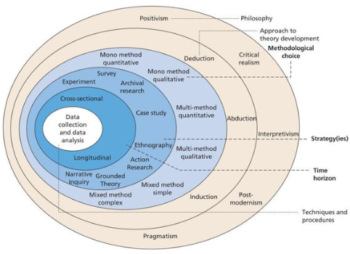

Source: © Mark Saunders, Philip Lewis and Adrian Thornhill 2015.
Data Collection Methods The purpose of collecting data is to obtain the information, record the information, make decisions about the information, and implement the information and to provide others with the information and the final analysis (Finn et al., 2000).
Proposed Data Collection methods include:
- Quantitative Research
- Qualitative Research
- Secondary Research

Quantitative Research Saunders, et al; (2016) describes this method as “analysing data gained through participant responses that need to be displayed into useful information”. This quote refers to analysis techniques such as tables, graphs and statistics which allows the researcher to display their information in a way which trends can be identified.

Questionnaire Collis, Jill & Hussey, Roger, (P.205, 2014) defines the term questionnaire as a “method for collecting primary data in which a sample of respondents are asked a variety of questions to gain important data relating to a particular topic”.
Questionnaires are used frequently at sporting events as event organisers can use this method to gain customer feedback relating to all aspects of their experience which can support and improve decision making for future sporting events, in this instance the researcher will be aiming to receive 100 completed questionnaires to obtain enough information to generate quantitative data (Bladen. C, et al. 2011, P.166). examples of questions can be found in the appendix.

Qualitative Research Saunders, et al; (2016) describes this method as an “interactive and iterative process which is thoughtful and reflective”. Using this method will involve the researcher conducting face to face interviews as well as observing all aspects of each type of event visited. These methods meet the objectives of this research as it provides data relating to customer satisfaction, motivations, impacts and the overall outcome of an event from a visitor’s perspective.

Interviews Collis, Jill & Hussey, Roger, (P.207, 2014) defines the term interview as the “method for collecting primary data in which a sample of interviewees are asked questions to find out what they think, do or feel”. This quote explains that interviews are one of the main research methods to use with the main purpose is to gather information relating to key concepts surrounding sporting events and is a good way to build relationships with the respondents.

Observations The researcher will also use the method of observation which will involve attending different types of sporting events in both Swansea and Cardiff, Bladen. C, et al. (2011) uses the phrase “participant observation”, with an explanation that the researcher will observe attendee’s body language, facial expressions and listen out for any comments regarding the event.

Paradigms Collis, Jill & Hussey, Roger, (2014) defines the term paradigm as the “framework that guides the way research should be conducted based on people’s philosophies and assumptions about their knowledge on the topic chosen”. One of the paradigms is positivism which states that there are single true answers to questions, which can be found by carefully applying scientific procedures. This shows that the researcher will use a deductive approach with a view to provide explanatory theories about the topic to understand social phenomena (Collis, Jill & Hussey, Roger, 2014).
Phenomenology is the other paradigm that is concerned with understanding human behaviour and focuses on the meaning, rather than measurement of social phenomena.’ (Collis and Hussey, 2003, p. 53). Reality is socially constructed, based on participants’ perceptions, and needs to be ‘understood’ rather than trying to generate ‘facts’ (Saunders et al, 2007). This relates to how the researcher will observe behaviours at sporting events and to analyse attendee perceptions about the event attended through a short interview.

Secondary Research Finn et al., (2000; P40 - P41) defines secondary research as “information collected by a second user, which can support the understanding of an issue and can help generate ideas”. This shows the following secondary data methods that are available:
- Newspaper Articles/ Reports
- Official Websites for Sporting Teams and Venues
- Marketing Campaigns/ Social Media/ Advertisement
- TripAdvisor – Customer Reviews

Sampling Framework Sampling is a statistical method of obtaining representative data or observations from a selection of people (Long, J. 2007). The type of sampling related to this topic is both probability and non-probability with the sampling techniques being stratified and purposive.
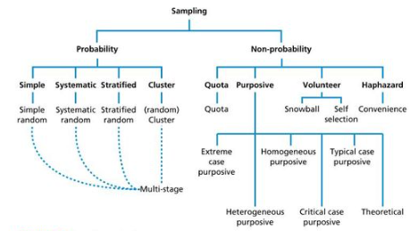
Source: Saunders, M., Lewis, P. & Thornhill, A., (2012).

Probability Sampling Long, J. (2007) defines stratified sampling as “the technique used to separate the data collected from peoples age, gender and interests”. The researcher will use this technique when evaluating results from online questionnaire responses to meet the objective of discovering visitor motivation and interests.

Non-Probability Sampling Purposive sampling is a technique where the researcher will interview certain people within a certain location because of their knowledge and position within a certain field (Long, J. 2007). These interviews would ideally be with people who have an important part of any sporting event internally and with people who regularly attend sporting events either in Swansea or Cardiff.

Content Analysis Collis, Jill & Hussey, Roger, (2014) defines content analysis as “the method by which selected items of qualitative data are systemically converted to numerical data for analysis”. Content analysis can be used to analyse many forms of communication such as newspapers, interview transcripts and recordings of non-participant observations.
Finn et al., (2000) backs up the previous statement by defining content analysis as a “technique used to analyse data in a describing manner”. The data that is scheduled to be collected for this project will be placed into graphs/ charts and from the displaying data will then have a summary of the results into short paragraphs.

SPSS SPSS which stands for Statistical Package for the Social Sciences is a useful method to use for these research project as it is a Windows based program that performs data entry and analysis with the creation of tables and graphs. SPSS is capable of handling large amounts of data and can perform all of the analyses covered in the text (Finn et al., 2000).

Validity Veal, A.J. (2011) defines this term as “the extent to which the data collected accurately reflects what the subject area is all about”. The value of this term is for the researcher to make sure the right people are being asked the right questions to gain the right information, so this is important to consider when creating and delivering questionnaires/ interviews.

Reliability Veal, A.J. (2011) defines this term as “the extent to which research findings would be the same if the research were to be repeated at a later date”. This shows that posting the survey more than once on two different media platforms could be unreliable as the same person may fill in the survey for a second time, to avoid this the researcher should stick to one media platform unless the contacts receiving the email are not connected to any of the researcher’s social media accounts.

Resources & Timings For this research there are many different resources available to the researcher such as university resources from the library i.e. academic books, academic websites, newspaper articles, journals, computers with internet access to design the online survey and the need for money to print out interview questionnaires.
A Gantt chart is a useful technique to use whilst working on a project over a long period of time. Russell (2007) defines a Gantt charts as “the tasks, resources, milestones, dates and time estimates all recorded on one database". Shown in the table below are the proposed times of the year for completing each sub heading for the dissertation. When the dissertation starts this information will be placed into a Gantt chart (example can be seen in Appendix 1).
 | Headings for future Dissertation | Suggested word count | Completed Work
1 | Introduction | 500 | October – November
2 | Review of Literature | 3,500 | October – December
3 | Research Methods | 2,000 | December – January
4 | Analysis of Results | 2,500 | January - March
5 | Conclusions & Recommendations | 2,000 | March – May

Research Ethics and Risks/limitations Confidentiality is one ethical issue that is important to consider, and it is all about protecting individuals who participate in online surveys and face to face interviews from any potential harm before research is publicised. In this proposal the researcher will not recall anyone’s personal details, the responses provided will be placed as data into graphs/charts so that individual identity cannot be identified (Finn et al., 2000). Also informing the respondents that they will be anonymous is important as it should mean they are more likely to answer honestly (Mitchell & Jolley, 2007, p. 288).
A risk of posting a survey on social media or via email is that individuals don’t want to give their time up and dismiss the notification without giving it a thought. To counteract this risk, the researcher will place a short description explaining what the questionnaire is all about, how long it would take to fill in and the main purpose for the researcher to gather this data response.
Trying to gain feedback from attendees on the day of sporting events can be a limitation as it can be time consuming for people. So, the best way to counteract this limitation is to do the interviews a few days or even weeks leading up to the event with people potentially having more free time to take part which will produce more accurate data.
Conclusion & Recommendations To summarise, the overall aim of this research proposal is to Investigate the Impacts created from different types of Sporting events in both Swansea and Cardiff. To gather data relating to this topic there was a need to address the research methodologies to use and how they would benefit the project, qualitative and quantitative techniques were discussed with the objective of generating feedback through online questionnaires, face to face interviews and researcher observations. Secondary research was also mentioned to provide the researcher with more knowledge and understanding relating to the topic area.
Sampling techniques selected included stratified sampling supports the research methodology as it separates data collected from peoples age group, gender, interests and motivations while purposive sampling relates to the researching conducting interviews with people who have a certain degree of knowledge about sporting events internally and externally. With all the data collection methods in place it was important for the researcher to consider any risks that may occur regarding the participants and factors that had to be addressed included confidentiality of personal details, people filling in questionnaires more than once and invasion of privacy from observations.
Overall the researcher has considered many characteristics that are needed when preparing for a dissertation project and has identified many ways in which to generate data and to expand knowledge on the topic area chosen.

References
Bladen, C., et al, (2012). Events management: an introduction, London: Routledge.
Bowdin, G.A.J. et al., 2011. Events management 3rd ed., Oxford: Elsevier Butterworth-Heinemann.
Collis, Jill & Hussey, Roger, (2014). Business research: a practical guide for undergraduate & postgraduate students Fourth.,
Finn et al., (2000). Tourism and leisure research methods: data collection, analysis, and interpretation, Harlow: Longman.
Getz, D., (2007). Event studies: theory, research and policy for planned events, Amsterdam; London: Elsevier Butterworth-Heinemann.
Hart, E. (2013). Premier League status worth £58 million for Swansea, available online at - http://www.itv.com/news/wales/2013-01-03/premier-league-status-worth-58-million-for-swansea/ - accessed 01/03/18
Long, J. (2007). Researching leisure, sport and tourism: The essential guide. London: SAGE.
Mullins, L.J., (2016). Management and organisational behaviour 11th ed., Harlow: Pearson.
Saunders, M. N. K, Lewis, Philip & Thornhill, Adrian, (2016). Research methods for business students 7th ed., New York, N.Y.: Pearson Education.
Social Research Methods (2018), available online at - http://www.socialresearchmethods.net/kb/contents.php - accessed 24/02/18
Survey Monkey, (1999-2018). Available online at - https://www.surveymonkey.com – accessed 25/02/18
Veal, A.J., (2011). Research methods for leisure and tourism: a practical guide 4th ed., Harlow: Financial Times Prentice Hall.

Appendices
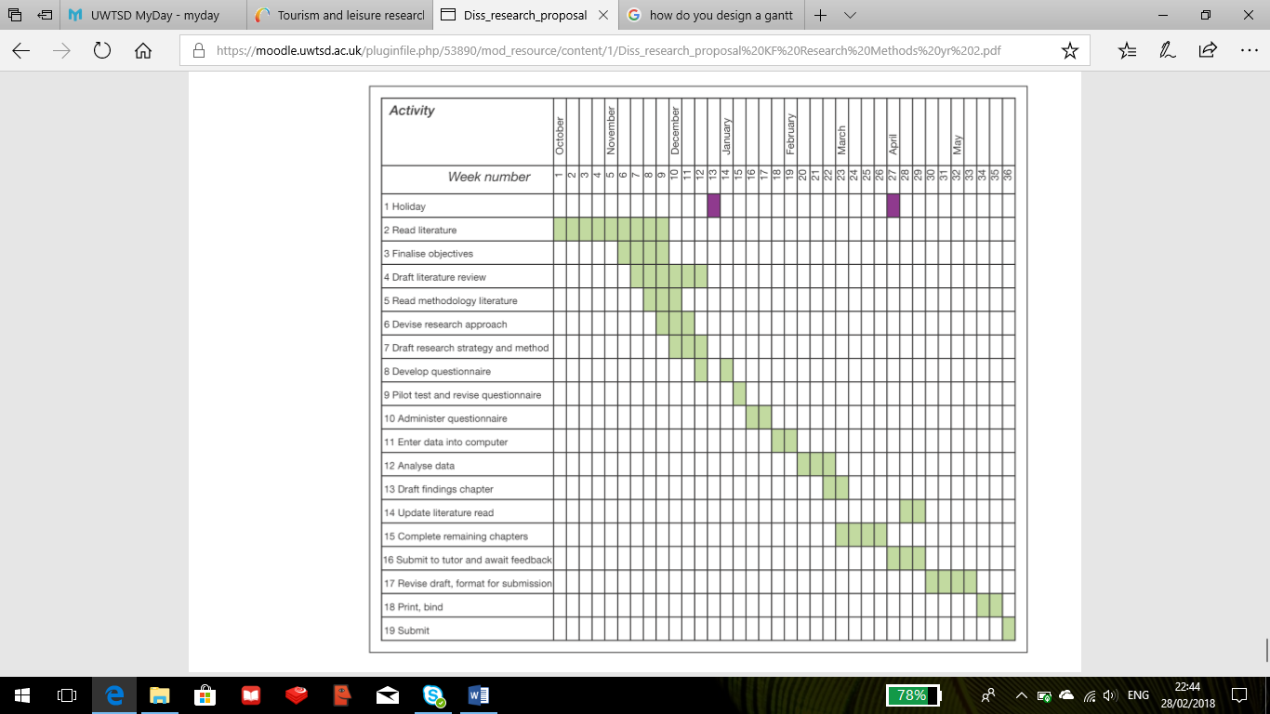
Appendix 1 – Example of Gantt Chart

Appendix 2 - Proposed Dissertation Online Questionnaire – Survey Monkey


