
Skills for the Workplace
Module Assignment Submission
Student Name: | Mark Evans
Student Number: | 1403013
Module No: | BMSK5005
Module Title: | Workplace Culture and its impact on Organisational Efficiency

Statement of Confirmation of Authenticity
By the act of making this submission, the student declares that this is the work of the student named above. The work has not, in whole or in part, been knowingly presented elsewhere for assessment, or where assessment has been built on a previous assessment, this has been identified. Where materials have been used from other sources it has been properly acknowledged. If this statement is untrue, the student acknowledges that an assessment offence has been committed.
Attention is drawn to the plagiarism and unfair practice policies of both the University and of ILM.

Table of Contents
Introduction 2
Critically assess the culture and context of an organisation 3
Types of Organisational Culture that applies to Mcdonalds 3
Bureaucratic Culture 3
Clan Culture 3
Market culture 3
Entrepreneurial Culture 4
Power Culture 4
Role Culture 4
Person Culture 4
Organisational culture practices by McDonald’s 4
Features of McDonald’s Organisational Culture 5
Diversity and Inclusion 5
People-centricity 5
Individual learning 5
Organisational learning 5
Ethos and values practiced by McDonald’s 5
Ethos of McDonald’s 6
Values of McDonald’s 6
Evaluate an organisation within its broader environment using appropriate environmental and organisational analysis techniques. 6
External environment analysis 6
PESTLE Analysis of McDonald’s 7
Political 7
Economic 7
Social 8
Technological 8
Legal 8
Environmental 8
Competitive situation analysis of McDonald’s 8
Competitive Situation Analysis Of McDonald’s 9
Internal environment analysis 9
SWOT Analysis of McDonald 10
Stakeholder Analysis 11
Employees 11
Customers 11
Investors 12
Communities 12
Suppliers 12
The Government 12
Trade Unions 12
Critically appraise the cultural and ethical behaviour present in one or more organisations. 12
Business Ethics 12
McDonald's Business Ethics 13
McDonald’s CSR Practices 13
Economic Responsibilities of CSR 14
Legal Responsibilities of CSR 14
Ethical responsibilities of CSR 14
Philanthropic Responsibilities of CSR 14
Stakeholder approach of CSR practiced in McDonald 14
Nutrition and Well-being 14
Responsibility to sustainable supply chain 15
Environmental Responsibility 15
Employee Experience 15
Responsibility toward community 16
Conclusion 17
References 18

Introduction

Mullins (2016) states that ‘In its broadest sense, our understanding of workplace culture is that it embodies the ethos and values of a particular organisation, which are expressed through the way it operates and the practices it undertakes. If the latter is deemed to be wrong, then the former needs to be addressed, for any issues to be resolved effectively. Anything else would be a superficial change and unlikely to have a lasting impact. This report will detail McDonald's plc's workplace culture. McDonald's is the UK's restaurant and hospitality authority (Idris et al, 2022). They operate locally and globally. They profited from the USA, UK, EU, Canada, Australia, and other affluent nations. They provide burgers, fries, chicken pieces, breakfast items, fruit, and soft drinks. Their firm has more than 33,000 branches worldwide. They strive to fulfil customers with 1.5 million competent experts. This report explores workplace culture and how McDonald's practices the most important components. Second, it examines McDonald's business environment using approaches and ideas. This study evaluates McDonald's culture and behaviour (Baykal, 2022).

Critically assess the culture and context of an organisation

Cancialosi (2017) states that culture includes habits, tenets, styles, attitudes, religious organisations, laws, and regulations issued by the state. In this way, workplace culture exists to ensure the firm's core structures and progress. Workplace culture may be seen from numerous angles. Customers must agree to the firm's terms and guidelines for it to succeed. This boosts product marketing profits. Workplace culture sets the company's potential and constraints for customers, which promotes trust. National culture, culture and nation, corporate culture, cultural management, and professional culture are all ways to develop a company's corporate culture (Smith & Drudy, 2022).

Types of Organisational Culture that applies to Mcdonalds

According to Browaeys & Price (2015) the basic kinds of organisational culture are:

Bureaucratic Culture

Included in this noun are all-purpose templates for assembling the core laws, regulations, policies, and terms and conditions required to efficiently operate the business. Cultures like this help businesses manage their resources and provide quality goods and services (Smith & Drudy, 2022). A typical example of bureaucratic culture is hierarchical systems found in business, academia, and government, where employees, students, and citizens are ranked according to their qualifications (real or perceived).

Clan Culture

As a result, businesses need to hire people from a wide variety of backgrounds to cater to customers with various cultural expectations. The workers' understanding of the real requirements of the many cultural people informs product development and marketing, and this understanding is fostered by the company's emphasis on clan culture (Xenikou, 2022).

Market culture

In a market-based society, maximisation of profit and market share are seen as essential to long-term financial health and increased sales. Better service for everyone is the result of a deeper understanding of customers' expectations and requirements. This is useful for the marketer's work (Tampi & Nabella., 2022) as Team-centric material like employee spotlights, interviews, and other forms of exposure may let customers see the real people behind the brand and give staff a sense of belonging and importance. An example of this would be inviting employees to share their own positive experiences working for the firm in their own words may be a powerful way to attract top talent and demonstrate to new employees why they should consider working for your company. Particularly effective in this regard is Spotify's use of lighthearted and humorous staff features on Instagram.

Entrepreneurial Culture

An entrepreneur's mindset always involves taking significant risks and dealing with unwelcome challenges. It is inherent to the very definition of entrepreneurship (Browaeys and Price, 2015). (Buchanan & Huczynski, 2019) state that the following four kinds of cultures are necessary for companies to function effectively:

Power Culture

A company's power comes from the money it makes thanks to the efficient use of its workers and the results they produce. In the realm of small businesses, authority is exercised only in the form of faith and confidence in the firm's staff (Zeyada, 2018).

Role Culture

The primary earning factors of an organisation, such as financial support, personnel support, and management support, are what shape its role culture and ensure its smooth operation. They are often huge institutions like the National Health Service or the major UK retail banks. A person's power stems from their position of authority, the scope of their responsibilities, and the number of people who answer to them. They are extremely risk-averse and sluggish to adapt to shifting conditions outside the company.

Person Culture

The culture of each employee plays a significant part in the success of a corporation as a whole. All goods produced in this society must adhere to strict norms. To connect with customers, each worker makes an effort to use his or her cultural perspectives in the course of his work (Idris et al, 2022).

Organisational culture practices by McDonald’s

Administrative control plays a crucial part in McDonald's success. Considering that they operate in the restaurant industry, the company's primary goal is to assure patrons that they are receiving better meal options. The company's culture is a major selling point. As a result, they provide a way to attract the most discerning clients and most talented workers in their field (Baykal, 2022).

Features of McDonald’s Organisational Culture

McDonald's as an organisation displayed a wide range of cultural conditions and idiosyncrasies. In the following lines, An overview of a few key distinctions (Tampi & Nabella, 2022).

Diversity and Inclusion

McDonald's gives the client's preferences and needs first attention because the consumer is more important to the firm's success than the company itself. That is why McDonald's has a culture that actively encourages its workers to take an active role in shaping the company's future (Smith & Drudy, 2022).

People-centricity

Since the consumer is more important to McDonald's success than the firm itself, the company's policies and practises are tailored to meet the preferences of its customers. For this reason, McDonald's has developed a culture that actively encourages its workers to take part in shaping the company's future (Andrew Thompson, 2017).

Individual learning

McDonald's is a corporation where staff are encouraged to invest in themselves via training so that they may provide better service to customers. Through Hamburger University, the firm provides its staff with access to a variety of training programmes, and it also hosts internships for college students (Idris et al, 2022).

Organisational learning

Since it is the people who work for a company who are ultimately responsible for its success, McDonald's also uses organisational learning events to train its staff. The corporation sets up these gatherings for the purpose of education via formal meetings, seminars, policy formulation, and consultation with the administrative body of the organisation (Zeyada, 2018).

Ethos and values practiced by McDonald’s

According to these principles and values, it is essential to assist individuals so that they may ultimately become paying consumers. In this company, responsibilities are shared out evenly between the highest and lowest ranks in an office. The use of such a power appliance is a standard bureaucratic method of controlling one's staff. Clients and office managers are linked by a common set of values (Smith & Drudy, 2022). Any artefact, dress code, motto, office design, ceremony, or engaging cultural programme that embodies the company's values is what we mean when we say in.

Ethos of McDonald’s

Ethos is any item, action, or substance a company uses to advertise and sell its wares. McDonald's employs logos and brand graphics to sell fast food. McDonald's ethos is the company's underlying collection of principles and regulations. McDonald's is the world's largest restaurant chain. They were crucial to understanding customer demands and opinions regarding products. Their sales strategies, such as giving discounts, are based on this data. McDonald's consumers like open communication channels (Baykal, 2022).

Values of McDonald’s

McDonald's believes they must care for and respect their customers' wishes. They exclusively utilise fresh foods to serve their neighbourhood. They serve mankind and the planet by not littering unnatural locations. As the world's most recognised fast food brand, McDonald's welcomes customers from all backgrounds and cultures. Millions of employees contributed to their achievement. The company's future success depends on prioritising customers. To maintain customers, recruit new ones, and develop assets by focusing on breakfast and family gatherings.

Evaluate an organisation within its broader environment using appropriate environmental and organisational analysis techniques.

External environment analysis
When assessing the external environment of a company, it is crucial to do an external analysis. The external environment of an organisation may be described and evaluated using a number of analytical approaches. PESTLE analysis is a framework for talking about the most important, interconnected elements. Several corporations have begun using this instrument for strategic analysis. McDonald's management employs these instruments to assess the efficacy of corporate strategy and policy decisions made to boost sales. Political, economic, social, technical, environmental, and legal (PESTLE) aspects are all interrelated and may have a significant influence on any company (CIPD, 2021)
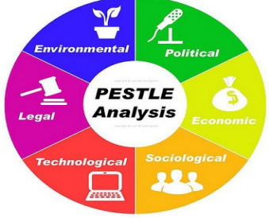

PESTLE Analysis of McDonald’s

Political
McDonald's pays income taxes. McDonald's also faces political challenges, notably the UK government's Brexit agreement concerns. They will lose money in EU countries as a result. Politics are regulated by legislation. McDonald's allegedly do not pay enough taxes. McDonald's paid £85 million in fiscal tax to UK authorities over 14 years while making over £3 billion in sales. Despite subsequent tax reductions, the business charged £20 million more.

Economic
A company's economic impact is one of the key indicators used to assess the rates of interest, inflation, revenue, growth, currency exchange, and unemployment in the nations where it operates. Customers' purchasing power is based on several economic conditions. Customers are not required to buy McDonald's expensive coffee. Management of labourer salaries is another economic aspect that has an obvious impact on the company's growth.

Social
PESTLE analysis relies heavily on the influence of social factors in order to understand the perspective of consumers.

Technological
They went live with their website to attract clients from all over the globe and boost their profile in the United Kingdom, home to the most lucrative restaurant industry on the planet. They announce new culinary offerings on their website and spread the word through various social media and instant messaging platforms. They also use a variety of search engines to promote their wares.

Legal
McDonald's business plan has a number of legal implications, including health and safety in the workplace, provident funds, festivals bonuses, and workers' minimal rights. In addition, the Customer Data Protection Act, Consumer Bill of Rights, and Employment Acts.

Environmental
When assessing a company's larger surroundings, environmental parameters are among the most important metrics to evaluate. Climate, location selection, weather, business meetings, the greenhouse effect, and other environmental factors are only some of the challenges McDonald's encounters.

Competitive situation analysis of McDonald’s

Every firm must use the market to gauge its competitiveness relative to other businesses in its industry. This helps them recognise where they are susceptible and where their accomplishments will come from, enabling them to explore new ways. The Five Porter Forces were used to analyse McDonald's competitiveness. This model highlights five factors that affect a company's success or failure. This approach gives buyers, suppliers, consumers, new entrants, and replacements equal negotiating power (adamkasi, 2020).

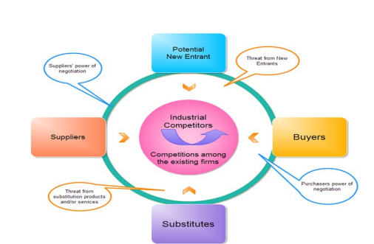

Competitive Situation Analysis Of McDonald’s

Competition hinders McDonald's expansion. Suppliers, buyers, present rivals, replacement threats, and new entrants form the competitive environment (Porter, 1991). Low entrance barriers might lead to stiff competition for coffee cafes. Coffee company requires no money, equipment, or intelligence. Due to its size, comprehensiveness, and competitive advantages, McDonald's may charge more and less than its rivals. Future replacements will be more important. Social coffee drinking will not change soon. Shakes, tea, and social interactions may change throughout time. McDonald's is competitive. In London, both small, individually owned cafes and multinational chains like McDonald's, Costa Coffee, Café Lucius Domatiums, and EAT. McDonald's greatest rivals are coffeehouse chains, so it must analyse their actions before advertising. McDonald's buys ethical coffee because they create the greatest coffee, their brand is well-known globally. The company purchases 93% fair trade coffee and has strengthened social, ethical, and environmental standards. They are less competitive than other UK companies, but produce fantastic coffee. They provide premium things and meals at reasonable prices.

Internal environment analysis

Any corporation, institution, or organisation may use SWOT analytical tools to establish a strong business plan. It analyses the company's strengths, weaknesses, risks, and opportunities. The application system's main advantage is SWOT analysis tools may help any company establish a good strategic plan. It considers the company's SWOT and other factors.

SWOT Analysis of McDonald

McDonald’s SWOT Analysis in terms of CSR function

Strengths | Weaknesses
- Promotion of Corporate Social Responsibility via the "Ronald McDonald House" McDonald's expanded their devoted outreach and bolstered their social communication as part of their corporate social responsibilities.  - McDonald's maintains a commanding position in the global food sector, with restaurants in more than 100 countries and a reputation for consistently high-quality products.  - McDonald's is well-aware of the significance of its brand, and the company works hard to ensure that its goods continue to meet or exceed consumers' expectations.  - McDonald's amazing strength as a model of sustainable company has been an inspiration to numerous small businesses operating in the UK market. They have put in a lot of hard work and made a lot of sacrifices to get where they are now.  - McDonald's is in a position of significant income and profitability because of the position they have attained.  Opportunities  Opportunities  - The company is putting more emphasis on healthy food options, thus they need to update their CSR ideas.  - Potential for online and doorstep sales and distribution  - Can help businesses succeed in every market, wherever in the world | - Occasionally provide junk food or other harmful options.  - Their brand's allure is dwindling.  - Gaining a significant increase in salary may be a strength or a weakness.  - McDonald's has been struggling to promote its goods in a favourable light as of late.  - In each industry, competition is dwindling.  - McDonald's CSR plan has several gaps in its development, which is a problem (Smithson, 2015).  Threats  - In addition to environmental hazards, McDonald's is worried about the quality of its meals.  - In developed nations, where people are better able to monitor their dietary intake, fast food is losing popularity.  - Fast-paced growth in the restaurant industry's marketing sector has led to a rise in intense competition.  - There are several variables, both external and internal, which operate as roadblocks to progress.

Stakeholder Analysis
Since McDonald's is the largest restaurant chain in the world, the corporation gives its shareholders priority when making decisions. To keep the interest groups happy, the company practises CSR (Corporate Social Responsibility). Employees and consumers make up the bulk of their core set of stakeholders. Each of them is defined in further detail below:

Employees
According to their priority list, they view their workers as first-class stakeholders. Because workers are the most dependable earning power for the organisation and the growth of their firm primarily relies on the effective use of the employees’ labour. McDonald’s grants its staff adequate rights and magnificent essential demands of life.

Customers

Customers want the organisation to provide them with nutritious and tasty options. Customers are seen as second-tier stakeholders since they are the ones who ultimately decide whether or not the company succeeds. Despite customers' frequent complaints about the quality of the meal.

Investors

A company's earnings and income are something that every investor hopes will increase. McDonald's has lately failed to provide returns to shareholders. They introduced high-end Mc Cafe items to respond to the unforeseen demand.

Communities

To maintain a high position of authority occasionally, local McDonald's restaurants may host a variety of charity events aimed at helping the less fortunate. This allows them to get the attention of the human welfare organisation and receive recognition for their outstanding contributions to society. Participating in such events helps them become more visible to the local community that supports their company.

Suppliers

McDonald's sources its raw ingredients from a wide range of vendors. Investors in the company are also the providers of its primary goods. The success of the business is largely contingent on the efficiency of its suppliers, who provide a variety of food products. McDonald's (2017) claims that its suppliers seek out business with the fast food chain so that they may increase their own profits.

The Government

Having McDonald's plc fill a number of positions inside the government may be a boon to the state's ability to carry out its duties on behalf of the people. McDonald's holds a recruiting test to hire people, legitimising the government's actions. Earnings from the government's fiscal activities might be beneficial for the state as well (Smith & Drudy, 2022).

Trade Unions

The original aim of the trade union movement was to improve working conditions for employees by granting them more legal protections, better working conditions, higher pay, and more perks. If there is a disagreement between the employees and the management, the union will play a crucial role.

Critically appraise the cultural and ethical behaviour present in one or more organisations.

Business Ethics
Implementing ethical or legal characteristics in an organisation helps leaders act with integrity. Managers and staff must be ethical if the organisation is to deliver exceptional customer service and preserve order and discipline. Collins (2021) contends that a company's ethical commitment shows good leadership. Strange workplace events may cause problems. Ethics and related areas may reduce community animosity. Misusing staff, taking bribes, dumping trash in rivers and canals, and hurting the environment and water may affect an organization's operations. In this instance, the government must rewrite some laws to preserve workplace order and perform administrative responsibilities morally (Xenikou, 2022).

McDonald's Business Ethics

McDonald's leadership has always prioritised ethics. The board enacted rules, legal standards, a comprehensive governance framework, and initiatives to improve employee life. Six permanent committees oversee the board's ethical conduct. As the world's biggest company, McDonald's must behave ethically as a leader. They must show they deserve residents' goodwill in the neighbourhoods where they do business. McDonald's is known for doing business ethically, and its employees are dedicated to keeping that reputation by implementing industry-leading practises in data privacy, workplace safety, and social responsibility. McDonald's is committed to doing the right thing for its stakeholders, which includes supplying personnel training, minimising fraud, and ensuring dependable online ordering (Xenikou, 2022).

McDonald’s CSR Practices

Carroll’s Four-Part Model of CSR practiced in McDonalds

McDonald's must participate in CSR to preserve its market position and attract new consumers. They rose to the top of the market by adhering to CSR rules. McDonald's executives are gathering data on socioeconomic aspects that affect their bottom line. Carroll's four-part model is the most used CSR framework. In this framework, he sets out companies' various responsibilities to the communities in which they operate and to those to whom they owe obligations, such as the law, the economics, ethics, and charity. However, this paradigm has problems. First, the model does not account for how historical, environmental, and rational variables differ across nations. This model solely uses U.S. data, thus it doesn't account for internal disputes (Smith & Drudy, 2022).
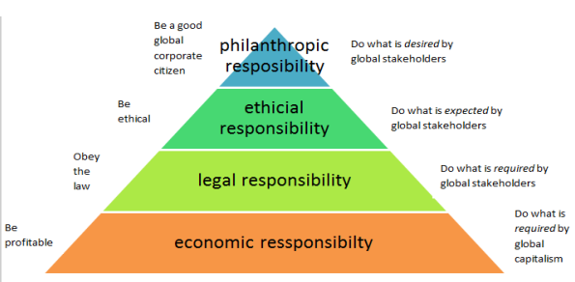

Economic Responsibilities of CSR

When they talk about a company's "economic responsibilities," they are referring to the duties that mandate a return on investment for the business's owners and other interested parties. It necessitates a) being profitable enough to attract and retain investors and shareholders, b) being a for-profit enterprise, c) needing competitive advantages that can be maintained over time, and d) having performance-enhancing support activities (Baykal, 2022).

Legal Responsibilities of CSR

Companies have a legal and ethical obligation to enhance their products, especially in child care, by making healthier, less dangerous food. McDonald's has created policies and legislation to support its CSR approach for customers. They provide excellent customer service. The "Global Happy Meal project" promotes the nutritional value of fast food and encourages consumers to adopt healthier lives.

Ethical responsibilities of CSR

The most trustworthy office workers are those who combine professional competence with a strong moral compass. CSR's ethical obligations have arisen as an important factor in a company's success in order to: a) ensure their operations are compatible with moral principles; and b) ensure the company's financial success by adhering to social, legal, and religious standards (Baykal, 2022).

Philanthropic Responsibilities of CSR

Such corporate obligations are crucial to guaranteeing the community's welfare, and they take the shape of things like (a) supporting and performing great and artistic business, and (b) contributing to society via charity and humanitarian actions. McDonald's management is eager to assist customers, and this is particularly true of those with disabilities (Xenikou, 2022).

Stakeholder approach of CSR practiced in McDonald
McDonald's corporate social responsibility (CSR) strategy, which prioritises its stakeholders, is deeply ingrained in the company's culture (Carroll, 2011). They provide a number of services to those who have a vested interest in their company, increasing the likelihood that everyone involved will succeed. McDonald's uses a multi-pronged strategy to satisfy the needs of its stakeholders. As part of their efforts to improve their CSR practises, they focus on the following five areas: a) educating consumers on the importance of a healthy diet and lifestyle; b) ensuring a steady flow of products from its suppliers; c) giving back to the community; d) protecting the environment on a global scale; and e) enhancing the skills of its employees (Smith & Drudy, 2022).

Nutrition and Well-being
McDonald's recognises that its customers are a key constituency and works hard to meet their varied preferences and expectations. The government takes into account kids' preferences for trendy drinks and quick meals. The authority's many services guarantee effective diet and health management. The administration also has the chance to promote the health of kids and their families by showing them ads for various meals accompanied by comedic movies that the kids would like (Smith & Drudy, 2022).

Responsibility to sustainable supply chain
McDonald's suppliers are also essential stakeholders since they provide raw ingredients and finished items. McDonald's suppliers, who have a stake in the company's success, conduct much of its CSR activity. Suppliers must consider ethical, environmental, safety, and security issues in food transit to provide high-quality nutrition. McDonald's trains its suppliers to maintain a consistent supply of products and services. Before we sent them food, they promised to handle it responsibly. Before providing, they must use proper packaging (Xenikou, 2022).

Environmental Responsibility
McDonald's has joined GELB, a global leader in energy management, to cut energy costs. Optimizing energy consumption reduces workplace dangers and pollution. GELB has adopted energy-wasting programmes and methods to cope with currency fluctuations. Adopting this energy-saving approach would save money over time. Their current trend of reducing manufacturing energy usage is good for the environment. The company's performance in this area helps preserve the environment (We’re Upping Our Commitment to Renewable Energy in a Big Way as We Continue to Address Climate Change, n.d.).

Employee Experience
McDonald's seven worldwide Hamburger Universities (HU) are a cutting-edge training and development centre. HU-certified restaurant managers are in demand. The corporation advertises "employees are worth it" to encourage employee engagement. Its global strategy team focuses on employee engagement via flexibility, the future, and family and friends. This reflects market activity and people's intentions. McDonald's has also integrated its value into recruiting, training, and promotion. Values activation activities, such as a Values Activation Council, have helped individuals communicate about their triumphs and challenges while working together. (Baykal, 2022).

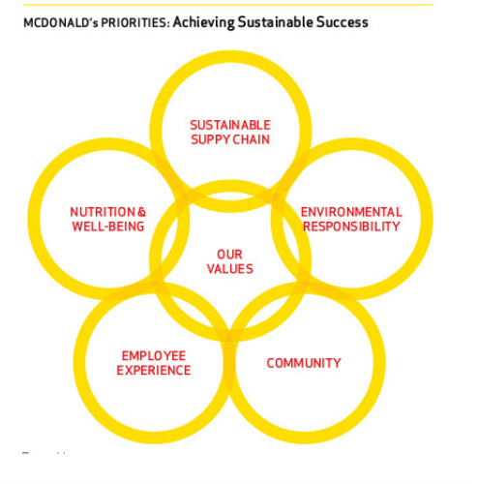
To sum up, McDonald's has been able to attract and keep a highly skilled, large, and invested workforce because to its emphasis on employee growth and development. Worker value proposition, talent management, and respect and inclusion are just few of the many aspects of the people-focused programmes and policies that have contributed to the successful cultural environment and working environment (Smith & Drudy, 2022).

Responsibility toward community

Every organisation takes a different way to build customer and community relationships. Selling to locals is financially beneficial, thus they conduct this task for profit. McDonald's has recruited volunteers to service disabled customers. They naturally help customers. They host activities to strengthen community relationships. The Ronald McDonald Family Room, Ronald McDonald Care Mobile, and Ronald McDonald House aid needy children worldwide. The firm is socially responsible. McDonald's community efforts are vital, particularly for city residents in remote areas. Locally, via communities, charities, and children's programmes; worldwide, through partnership and sponsorships; and after a disaster, by aiding the destitute and incapable (Xenikou, 2022).

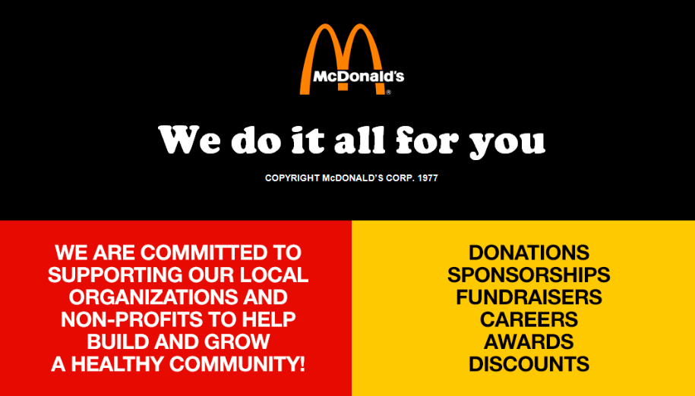

Conclusion

The McDonald's brand has a long history of assuring customers in the United Kingdom that their food is both fresh and healthy. McDonald's progressing operations are directly affected by the current interest rate. It's also preventing the company from expanding to a larger level. McDonald's use cutting-edge technical methods of advertising to expand their company. The health of the economy determines the company's continued existence and serves as the foundation for its growth in the years to come. Affiliate marketing is a key component of their overall business plan. McDonald's political success is hindered by the company's need to pay taxes. The lower interest rates offered by the bank loan allow the corporation to preemptively lower the prices of its items. When it comes to promoting a well-known company's goods in far-flung regions of the globe, technology now plays a crucial role in the marketing strategy that is used. An organisation's culture encompasses many aspects of its day-to-day operations. McDonald's plc. Is the most well-known restaurant chain in the world, While generating a profit is its primary objective, they have also initiated several compassionate and social initiatives. Everything they do is tied to satisfying the desires of their clients.

References

Adamkasi. (2020, March 24). Porter’s Five Forces of McDonald’s. Porter Analysis. https://www.porteranalysis.com/porters-five-forces-of-mcdonalds/

Andrew Thompson. (2015, October 4). McDonald’s Organizational Culture Analysis. Panmore Institute. https://panmore.com/mcdonalds-organizational-culture-analysis

Baykal, E. (2022). Family Firms and the Effects of Organizational Culture on Their Innovation. Research Anthology on Strategies for Maintaining Successful Family Firms, 1082–1102. https://doi.org/10.4018/978-1-6684-3550-2.ch049

Buchanan, D. A., & Huczynski, A. A. (2019). Organizational Behaviour. In Google Books. Pearson UK. https://books.google.co.uk/books/about/Organizational_Behaviour.html?id=Y6ilDwAAQBAJ&redir_esc=y

Browaeys, M.-J., & Price, R. (2015). Understanding Cross-cultural Management. In Google Books. Pearson. https://books.google.co.uk/books/about/Understanding_Cross_cultural_Management.html?id=g4q3rQEACAAJ&redir_esc=y

Cancialosi, C. (2017, July 17). What is Organizational Culture? | Complete Definition and Characteristics. GothamCulture. https://gothamculture.com/what-is-organizational-culture-definition/

Collins, J. (2021, September 20). 3 Benefits of Ethical Leadership in the Workplace. Dr. Jim Collins. https://www.drjimcollins.com/3-benefits-of-ethical-leadership-in-the-workplace/

CIPD. (2021, December 6). PESTLE Analysis. CIPD; CIPD. https://www.cipd.co.uk/knowledge/strategy/organisational-development/pestle-analysis-factsheet

Idris, I., Suyuti, A., Supriyanto, A. S., & AS, N. (2022). Transformational Leadership, Political Skill, Organizational culture, and Employee Performance: A Case From Tourism Company In Indonesia. GeoJournal of Tourism and Geosites, 40(1), 104–110. https://doi.org/10.30892/gtg.40112-808

Porter, M. E. (1991). Towards a dynamic theory of strategy. Strategic Management Journal, 12(S2), 95–117.

Mullins, J. (2016) Management & Organisational Behaviour. 11th edn. Harlow: Pearson.

Smithson, N. (2015, October 5). McDonald’s Stakeholders: A CSR Analysis. Panmore Institute. https://panmore.com/mcdonalds-stakeholders-csr-analysis

We’re upping our commitment to renewable energy in a big way as we continue to address climate change. (n.d.). Corporate.mcdonalds.com. https://corporate.mcdonalds.com/corpmcd/en-us/our-stories/article/OurStories.Renewable-Energy.html

Smith, D., & Drudy, L. (2022). Corporate Culture and Organisational Ethics. Issues in Business Ethics, 231–243. https://doi.org/10.1007/978-94-024-2111-8_14

Xenikou, A. (2022). Leadership and organizational culture. Handbook of Research Methods for Organisational Culture, 23–38. https://doi.org/10.4337/9781788976268.00009

