Academic Paper, Module 4
Sabine Denis, SI 1708972
MA in Ecology and Spirituality
August 2018

Discuss how story has informed the narrative of activism. With references to examples, indicate how story could inform our understanding of sacred activism.

“Give people a fact or an idea and you enlighten their minds; tell them a story and you touch their souls.” – Hasidic Proverb

Change the story, change the world?

As kids, stories fill our imagination and substantiate our games and, as we grow up, we continue to live by our stories. Why? What is the power of stories? And how can they help to shape the way we act in the world? I will start with a brief “story” of human communication, before explaining how modern and postmodern stories have influenced the narrative of activism.
I will then discuss the call for a new story that comes from different activist milieus. I will finish this paper by concluding that, although we may need alternative stories to reflect a different worldview, true sacred activism does not entail a story that we, humans, can tell (Akomolafe 2017:712).
In the framework of this paper, I will focus on environmental activism, nevertheless there are, of course, many other types of activism: economic, civil, religious, social, political activism etc. With regard to “stories”, they should be understood, in the context of this writing, as any narrative, oral or written, concerning our relationship with nature, be it a scientific analysis or an academic research, a folktale or myth etc.

The power of stories

Where do stories come from? At first, humans, like animals, merely exchanged information about the environment in which they lived, e.g. the weather, dangerous animals or the healing plants (Zipes 2012: 4). This changed with the Cognitive Revolution, seventy thousand years ago, when people started talking about things that do not exist but rather are a product of the human imagination. This enabled humans to cooperate much more effectively, and on a much larger scale, because they could bond through the fictions they shared (Harari 2011:151). In early history, stories were centered around gods and kingdoms. In modern times, they pertain to money, human rights, corporations or politics etc. These stories, transmitted from generation to generation, have enable our species to construct a solid social order to survive. They are powerful, because they are agreed upon (Harari 2011:151). Not all stories may be shared or believed by everyone, however, in general, people believe the stories they are told and seem to have lost the ability to distinguish fiction from reality (Gabbai 2015). Just look at our trust in the value of money, an otherwise essentially worthless commodity, as we cannot eat it or use it in any other way than to light a fire. It constitutes a quintessential example of how stories can unlock human cooperation beyond the own tribe or community.
In academic circles, these fictions are called “social constructs” (Kripal 2014:72). I will come back to constructivism later in this paper, when I talk about the post-modern stories. As long as the communal belief persists, the imagined reality exerts a force in the world (Harari, 2011:164):
“Ever since the Cognitive Revolution, Sapiens have been living in a dual reality. On the one hand, the objective reality of rivers, trees and lions; on the other hand, the imagined reality of Gods, nations and corporations. Since large-scale human cooperation is based on myths, the way people cooperate can be altered by changing the myths – by telling different stories.”

According to Yval Harari, much of history revolves around telling stories and convincing people to believe them. That is also what many activists believe, e.g. Mary Midley, Thomas Berry: we need to change the story to change the future. Could it be as simple as that? If we want to change behavior, do we just have to change the story?

The modern story: the hero

Ever since the scientific revolution of the sixteenth and seventeenth centuries, we try to understand the world and ourselves as machines that can be “predicted and explained by means of quantification, reductionism and systematic experimentation” (Harding 2006: 33). The new confidence in scientific materialism conquered the Western world rapidly and the story of modernity became the story of the Hero. “A Hero with a Thousand Faces”, as Joseph Campbell calls him (1968). I deliberately use “him” because the hero is almost always a white, young male, who “ventures forth from the world of common day into a region of supernatural wonder: fabulous forces are there encountered and a decisive victory is won: the hero comes back from this mysterious adventure with the power to bestow boons on his fellow man” (Campbell 1968: 23). The modern story has not only a hero but also has action, and a lot of it (Le Guin 1986: 150).

Synchronously, the current story of activism is one of heroism: the activist receives a calling to enter a world of strange powers (corporate powers, nation states etc.) and must face trials in fighting the system and, in the end, saves the world. The activist uses the same logic of power and control as the modern hero. Without realizing it, the activist so becomes part of the system he is challenging by believing in the story that people can change the world and that things and people are fictile (Wheatley 1997).

The post-modern story: the trickster

As a counter reaction, Postmodernist Constructionism seeks to demonstrate that science is not as neutral as it self declares and challenges the modernist idea of reality by negating the existence of an external reality and considering everything to be a product of the human imagination (Flaskas 1995:144). “The focus shifts from what exists (ontology) to how we know what exists (epistemology)” (Akomolafe 2017: 399). Postmodernism rejects the claim of one scientific truth and asserts that humans construct these truths for certain purposes, depending on the particular historical context. This is called Contextualism or Constructionism, asserting that all human behaviour is best explained or constituted in their local linguistic and cultural contexts (Kripal 2014:72). In postmodernity, there is no truth, except that everything is a story: there are no facts; “the world is a construction of our consciousness and a resonance of our own voice” (Akomolafe 2015:226). Here again, it is a monolith position: the story is all there is. They are self-legitimating in the sense that they give the society in which they are told an opportunity to define its values and actions (Oni 2012: 9).

The post-modern activist is convinced of the power of storytelling to change the world (Akomolafe 2017:396). The typical hero of the postmodern story would be the trikster. He is at the same time a creator or constructor and a destroyer (Hyde 2017). In a constructionist logic, the trickster “pokes, plays with, enjoys and shatters things as they are until they become what is” (Kripal 2014 :123). The tricksters change and create new cultures and are the catalysts for transformation by overstepping the boundaries and changing the story.

The call for a new story

The old stories have been stories of mastery, dominion, construction and destruction and have basically alienated the human beings from each other and from their non-human environment (Wheatley 1997). Because of the damage the old stories have created, think of climate change, wars etc., there have been many calls for a new story of how we relate to the world and to our natural environment in particular. Nor the Hero story, nor the Trickster stories have proven to be able to mend our long lost relationship to nature. Could a new story inform our understating of sacred ecological activism?

What is sacred activism? Contrary to popular belief, Sacred Activism is not traditional activism with a touch of spirituality, but is a new way to stand in the world, that challenges our striving for action and victory (Akomolafe 2018).
It is an activism that does not deny the existence of scientific truth, nor the fact that values may be shaped by cultures, but it goes one step further and questions the entanglement of the militant himself (McIntosh and Carmichael 2016: 72). It challenges the activist to look into himself and discover how he is part of the story and how his actions are based on “the assumption that we can change the world by acting on it” (Kaplan and Davidoff 2014: 5). It probes the human autonomy and independence and stresses the deep interconnectedness of all human and non-human beings. It favours a rhizomic interaction between humans and nature, in a continuous flow (Deleuze and Guattari 1987). This kind of activism cannot be informed by the old stories of the hero or trickster but needs a new narrative, like the carrier bag theory of fiction, the universe stories or the quantum accounts etc. These are only some examples of stories that could support a more sacred or spiritual activism.

In “The Carrier Bag Theory of Fiction”, Ursula Le Guin argues that the heroic male stories should be replaced female novels or “carrier bags of words”: “A novel is a medicine bundle, holding things in particular, powerful relation to one another and to us” (Le Guin 1986:149). Thomas Berry and Brian Swimme have rewritten the story of the universe, combining scientific insight and perennial traditions to recreate a mutually enhancing human-earth relationship in “The Journey of the Universe” (Swimme, B. and Grim, J. 2014). The new quantum narratives are a story-web of multidimensional relationships, without beginning or ending, in a continual state of becoming (Nelson 2012: 61). Quantum Physicist, Karen Barad (2007) for instance, tells the story of the dance between matter and meaning, in which matter is animate and dynamic (Hinton 2013: 169), whereas Donna Haraway (2015) tell us that “we are all compost”. These stories might be able to help construct a new form of activism in as far as they question the activist’s entanglement and reshape a dynamic and intimate relationship with the world (Akomolafe 2017: 106).

Conclusion: Which story for Sacred Activism?

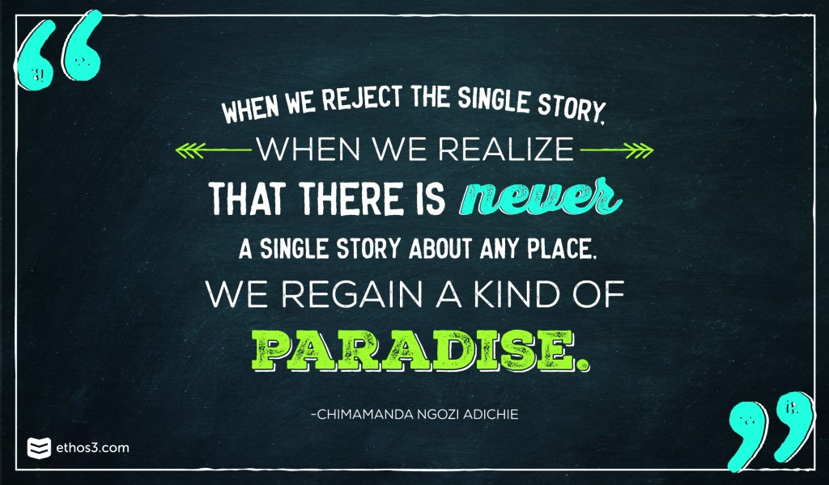

The quote above is from Chimamanda Adichie’s beautiful Tedx testimonial “The dangers of a single story” (2007). For me, it applies to the topic of this paper. Activism, and sacred activism, should not be informed by one single story, but should rather be based on a multitude of stories. Because, even with stories, it is all a matter of power: “It is impossible to talk about the single story without talking about power. There is a word, an Igbo word, that I think about whenever I think about the power structures of the world, and it is ‘nkali.’ It’s a noun that loosely translates to ‘to be greater than another.’ Like our economic and political worlds, stories too are defined by the principle of nkali: How they are told, who tells them, when they’re told, how many stories are told, are really dependent on power.” (Adichie 2007). Those in power define the “dominant narrative” and if there is only one story, it will inevitably be domineering (Merchant 2003: 241). If we strive to replace the mainstream story by a new, regenerative story, we will be perpetrating the logic of domination and control, rather than embracing the diversity of possibilities. It is unfortunate that the domineering story today is killing our planet, that is true. It is therefore important to start telling different stories to open up people’s worldviews. That is why we welcome the carrier bags, the quantum narratives and the compost stories a.o., but we should be prudent not to claim “The” New Story. A palette of new stories is important, but we should be conscious of where the storytelling power lies and how it is used. “The Tolowa had wonderful stories that thought them how to live sustainably and they were slaughtered. The point is that telling new stories is necessary but not sufficient” (Jensen 2011). This does not mean that we should stop telling the Tolowa stories or any of the other new stories, but that we should be aware of the power dynamics (Starhawk 1987: 14). Traditional activism is built upon Power-over stories. Rather than overthrow the existing power or deny it, the new ecologists should redeem that power into Power-with, “not by getting rid of it but by resting the ego down to the deeper self” (McIntosh and Carmichael 2016: 6010). Starhawk calls this the Power-from-within that “stems from a different consciousness that sees the world as a living being, with inherent value and dynamics” (Starhawk 1987: 15). Power-from-within leads to Power-with because it sees the world as relationships, rather than as matter that can be molded. According to Starhawk, the language of Power-from-within, is poetry and magic; whereas the language of Power-with is gossip. This corresponds to Harari’s theory that gossip is the foundation of our species’ survival (Harari 2011: 95). Gossip has a bad reputation today, but it was, and still is, a very useful tool to survive in the world. I do not want to go as far as to conclude that our new stories should become gossip, but it is important that they should focus on relationships and connection, if they are to help us build a new form of activism.

Stories may help to shape our sacred activism, but we should always remain conscious that the world is not a story (Akomolafe 2017: 460) and the world has an agency on its own and reacts, initiates, sabotages, shrugs: “Though important, many accounts of the world seem to be discarding a little too easily the contributions of the world in his own” (Akomolafe 2017: 460). Any new story we tell, will always be different from reality: “our stories will always be sabotaged by the territory; the world has her own genius” (Akomolafe 2017: 712). This is echoed by David Abraham: “To live in a storied world is to know that intelligence is not an exclusive human faculty located somewhere inside our skulls, but is rather a power of the animate earth in which we humans, like the hawks and the thrumming frogs, all participate” (Abraham 2005: 1603). I will therefor conclude that the stories that might inform the narrative of a true sacred activism are not ours to tell. As our teacher, Bayo Akomolafe, said: “We are not the storytellers of the world; the world tells her story through us! We are merely the codifiers.”

Reference list

Abraham, D. 2005. Storytelling and Wonder. Encyclopaedia of Religion and Nature. 2005. Ed. Tayler, B. London: Thoemmes.

Adichi, C.N. 2009. The danger of a single story. Available from https://www.ted.com/talks/chimamanda_adichie_the_danger_of_a_single_story/up-next.

Akomolafe, B. 2018. Sacred activisms. Available from: http://bayoakomolafe.net/sacred-activisms/.

Akomolafe, B. 2017. These Wilds Beyond Our Fences. Letters to my daughter on humanity’s search for home. Berkeley: North Atlantic Books.

Akomolafa, B. 2015. What would a mountain do? Activism in an Age of Entaglement. Impuls Conference Berlin. Available from: http://bayoakomolafe.net/project/what-would-a-mountain-do-activism-in-an-age-of-entanglement/.

Barad, K. 2007. Meeting the Universe Halfway: Quantum Physics and the Entanglement of Matter and Meaning. London: Duke University Press

Campbell, J. 1968. The Hero with A Thousand Faces. Princeton: Princeton University Press.

Deleuze, G. and Guattari, F. 1987. Thousand Plateaus, Minneapolis: University of Minnesota Press - tr. Brian Massumi

Flaskas, C. 1995. Postmodernism, constructionism and the idea of reality: A contribution to the ‘ism’ discussions. Australian and New Zealand Journal of Family Therapy 16(3): 143–6. Available from https://doi.org/10.1002/j.1467-8438.1995.tb01046.x

Gabbai, A. 2015. What makes Human different? Fiction and Cooperation. Smithsonian Magazine. Available from https://www.smithsonianmag.com/arts-culture/what-makes-humans-different-fiction-and-cooperation-180953986/

Harari, Y.N., 2011. Sapiens, A Brief History of Humankind. London: Penguin Random House.

Hinton, P. 2013. The Quantum Dance and the World’s ‘Extraordinary Liveliness’: Refiguring Corporeal Ethics in Karen Barad’s Agential Realism. Somatechnics 3(1): 169-189. Edinburgh University Press.

Hyde, L. 2017. Trickster Makes This World: How Disruptive Imagination Creates Culture. London: Canongate

James, W. 1891 The Moral Philosopher and the Moral Life. International Journal of Ethic. 1(3): 330–354. Available from: http://www.jstor.org/stable/2375309.

Jensen, D. 2006. End Game. Volume I. New York: Seven Stories Press.

Kaplan, A. and Davidoff, S. 2014. A delicate Activism: a radical approach to change. Cape Town: The Protheus Initiative.

Kripal, J. 2014. Comparing Religions. Oxford: Wiley Blackwell.

Le Guin, U. 1986. The Carrier Bag Theory of Fiction. In Dancing at the Edge of the World. Grove Press.

Nelson, I.B. 2012. Storytelling beyond the Anthropocene: A quest through the crises of ecocide toward new ecological paradigms. Queenlands University Press.

Merchant, C. 2003. Reinventing Eden: The Fate of Nature in Western Culture. New York: Routledge.

McIntosh, A. and Carmichael, M. 2016. Spiritual Activism. Cambridge: Green Books.

Oni, P. 2012. The Cognitive Power of Storytelling: Re-reading Hannah Arendt in a Postmodernist/Africanist Context. University of Lagos.

Peterson, A. 2005. Social construction of Nature and Environmental Ethics. Encyclopaedia of Religion and Nature. 2005. Ed. Tayler, B. London: Thoemmes.

Starhawk. 1987. Truth or Dare. Encounters with Power, Authority, and Mystery. San Francisco: HarperCollins.

Swimme, B. and Grim, J. 2014. Journey of the Universe An Epic Story of Cosmic, Earth, and Human Transformation. Yale: Yale University Press

Wallace, A.F.C. 1957. The Trickster: A Study in American Indian Mythology by Paul Radin Review in The Annals of the American Academy of Political and Social Science 309: 180-181. Available from: http://www.jstor.org/stable/1031959.

Wheatly, M. 1997. The New Story is Ours to Tell. World Business Academy/Perspectives on Business and Global Change,
Available from: https://www.margaretwheatley.com/articles/new.html

Zipes, Jack. 2012. The Irresistible Fairy Tale: The Cultural and Social History of a Genre. Princeton University Press. Available from DOI:10.23943/princeton/9780691153384.003.0001

