Please delete the box below and replace it with an “appropriate” passport style photograph that clearly shows your face. Your photo should be roughly the same size as the box:

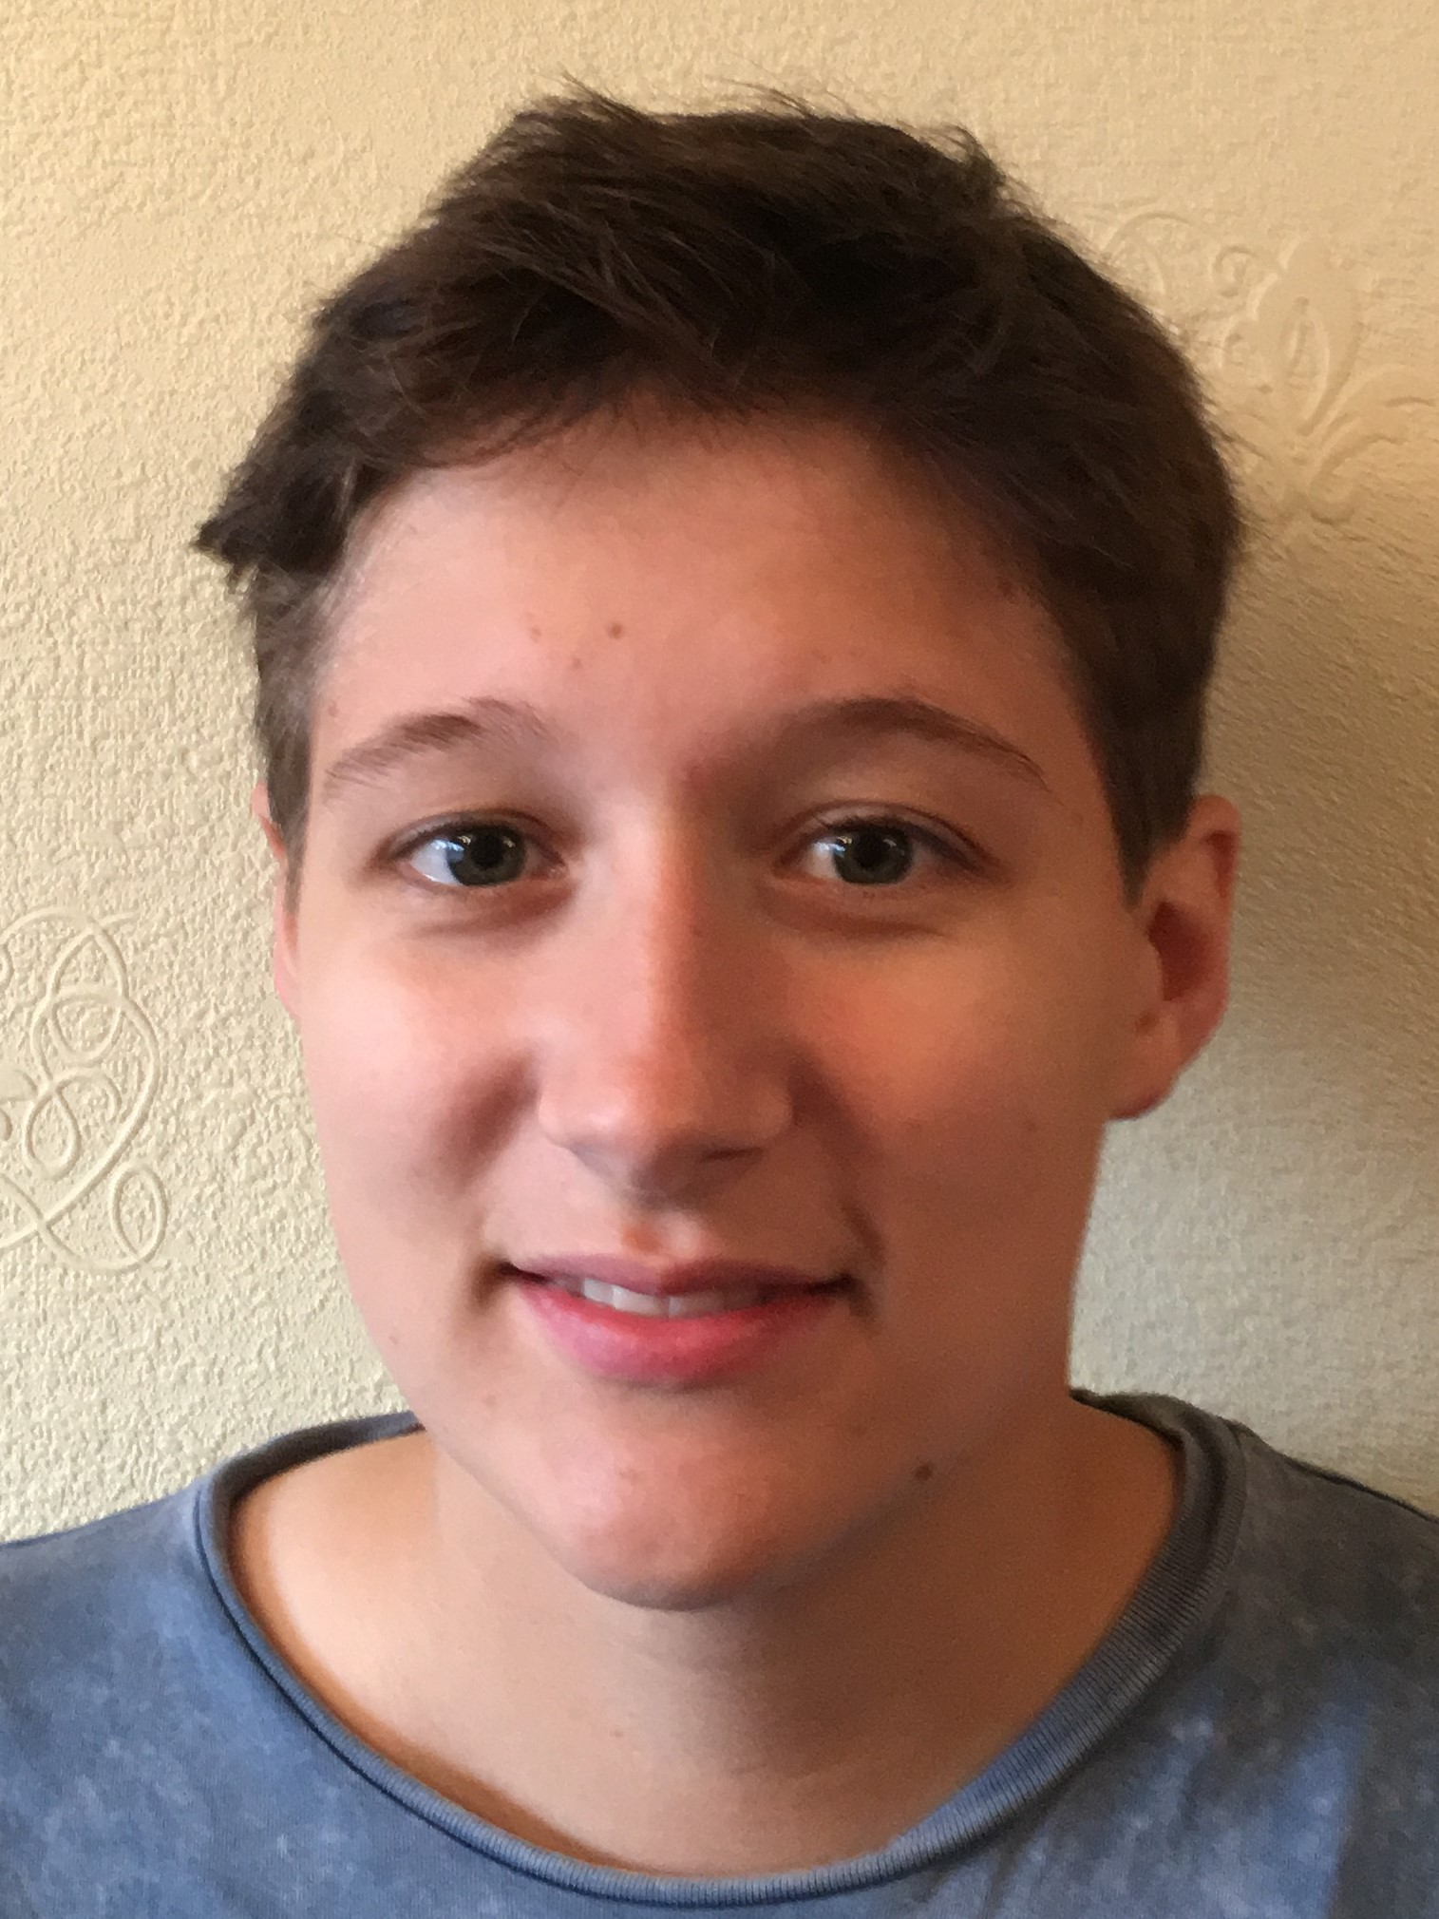

Name: Emma Chambers

Student number: 1701797

Student email address: 1701797@student.uwtsd.ac.uk

Contact number: 07495 753369

Please use the remaining space to give a brief outline of why you have chosen your course of study and any relevant special interests or experiences:

As a long-time lover of the outdoors, I chose to study Outdoor Adventure Education to gain the skills and knowledge in order to be a successful practitioner in this environment. I also have a passion for volunteering particularly with youths and disabled youths so I would love to have the chance to combine these interests to facilitate these experiences for these groups who often don’t get the chance to enjoy these types of activities.

Personally my interests include climbing, hiking and running and I have spent a lot of time in places such as Snowdonia and the Brecon Beacons and have also had the opportunity to do this further afield in South Africa and Nepal whilst volunteering and working in these areas.

