

PROFESSIONAL CAREER DEVELOPMENT

REFLECTIVE PORTFOLIO

LECTURER: DR. KINGSLEY OMEIHE

STUDENT: ALEXANDRA - VALENTINA GHITA
STUDENT NUMBER: 2127554
MODULE CODE: BMSW4005_BIRM

ABSTRACT

This report has focused on personal development through a SWOT analysis and the development of a personal development plan. The SWOT analysis evaluated my strengths and weaknesses, as well as the opportunities and threats in the workplace. My personal development plan was used to describe my long-term goals and actions. The report also goes over different learning theories.
In this report, I used the model to reflect on a personal professional development plan and highlight how it helped me learn better. The evaluation emphasises the necessity of ongoing learning and growth in career planning and development, as well as comprehending ethical and legal consequences in the employment market.

TABLE OF CONTENT

1. INTRODUCTION 5
2. SWOT ANALYSIS 5
3. PERSONAL DEVELOPMENT PLAN 6
4. LEARNING STYLE THEORIES 7
4.1 KOLB LEARNING STYLES MODEL 7
4.1.1 HONEY & MUMFORD LEARNING STYLES MODEL 9
4.1.2 NEIL FLEMING LEARNING STYLES MODEL 10
4.2 HOW IMPACTED LEARNING STYLES THEORY IN WORKPLACE 11
5. REFECTIVE MODEL ASSESS – GIBB`S REFLECTIVE CYCLE 12
6. CONCLUSION 15
REFERENCE 16

TABLE OF FIGURE

Figure 1 SWOT ANALYSIS 6
Figure 2 Personal development Cycle 7
Figure 3 The Kolb Learning Styles (Kurt, 2022) 8
Figure 4 Honey & Mumford Learning Styles (Unknow, 2011) 9
Figure 5 Neil Fleming Learning Styles (Source: Adult Learning Theory (weebly.com) 10
Figure 6 What`s your learning style? 11
Figure 7 Gibb's reflection cycle 12

INTRODUCTION

The report starts with a personal SWOT analysis, in which I evaluate myself based on the strengths and shortcomings I recognised when constructing a professional CV. The report then includes a personal development plan that defines my goals.
The report then investigates learning style ideas. The study then explores how the learning styles has affected me at my workplace, while admitting that it oversimplifies learning's complexity. Finally, the article discusses the Gibbs reflection model.
To achieve personal and professional success, the report emphasises the necessity of self-awareness, personal growth, and continual learning. It emphasises the need of identifying one's own strengths and weaknesses, setting clear targets, tracking progress, and utilising a variety of tools to achieve success. In addition, the study advises people to discover their own distinct learning styles and preferences to improve their learning and training experiences.

SWOT ANALYSIS

In order to achieve goals and objectives, SWOT analyses identify the internal and external factors affecting the organization. In order to achieve their objectives, organizations need to identify internal and external factors that may negatively or positively affect them. (Namugenyi et al., 2019). To evaluate a company's current position and to develop strategies that will lead it to achieve its goals, SWOT analysis is commonly used in marketing, business planning, and strategic planning. A SWOT analysis can be used for a variety of purposes, including assessing a new product or service, assessing business opportunities, and analyzing a company's market position ( Thompson, et. al., 2018).
This SWOT analysis, I will evaluate myself based on the strengths and weaknesses that I noticed when creating a professional CV for mock interview assessment. With this research, I intend to acquire insight into areas where I may develop, capitalise on opportunities, and prevent dangers to my personal and professional success.
I will be able to use my strengths, address my shortcomings, capitalise on opportunities, and minimise threats by devising strategies for leveraging my strengths, addressing my weaknesses, capitalising on opportunities, and minimising dangers. For example, I may delegate chores to avoid being unduly responsible, strengthen my critical thinking abilities to be more constructive, seek out mentoring and job shadowing opportunities to learn more about new sectors, and avoid burnout by establishing clear boundaries between work and home life.

-Increased competition in the job market
-Economic downturns
-Burnout and stress from a demanding workload

SWOT
Analysis
WEAKNESSES
STRENGTHS
THREATS
OPPORTUNITIES

Figure 1 SWOT ANALYSIS

PERSONAL DEVELOPMENT PLAN

Personal development plans can help people enhance their professional abilities, personal connections, and general well-being (Beausaert, et.al., 2011). Establishing objectives and developing a plan to achieve those goals entails recognising areas where one needs to improve. The plan may be used to assess progress, identify roadblocks, and make changes as required (Covey, 2004).
This personal development cycle is designed to help me improve my leadership skills, which are essential in both personal and professional life. The plan follows a cycle of establishing purpose or direction, identifying development needs, identifying learning opportunities, formulating an action plan, undertaking the development, recording the outcomes, and evaluating and reviewing progress. I will be able to build my leadership abilities and attain their personal and professional goals by following this cycle.
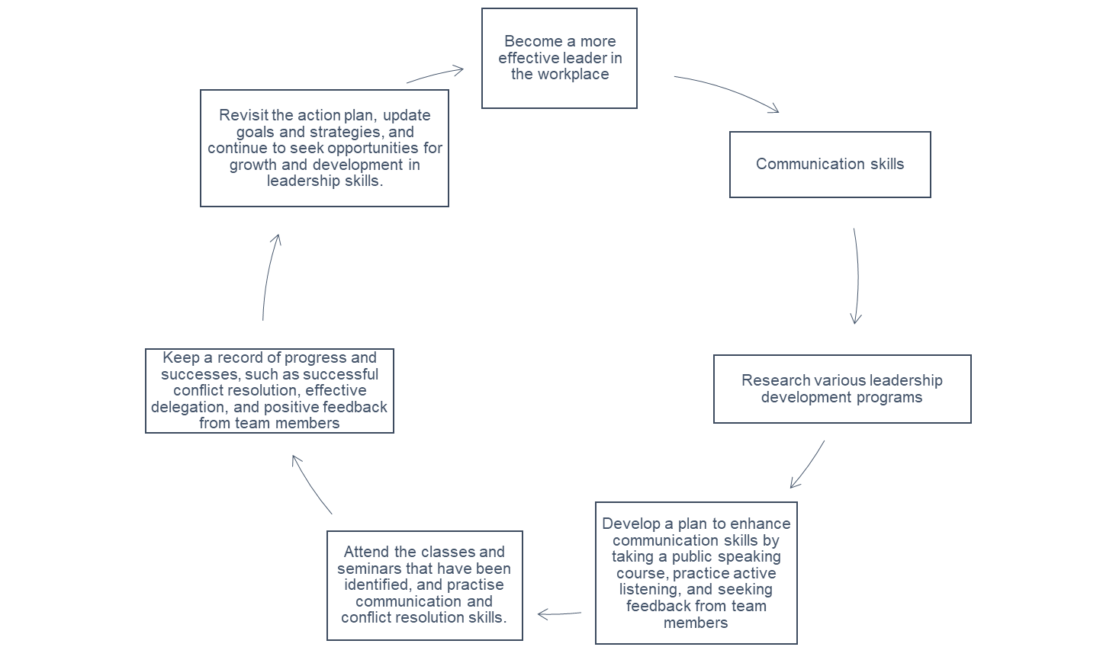
Figure 2 Personal development Cycle

LEARNING STYLE THEORIES

There are different types of learning styles, which refer to the different ways people prefer to learn and process information. The learning process is emphasized in different ways by different theories about learning styles. This response will review some of the prominent theories of learning styles, including the VARK model, Kolb's experiential learning theory, and Gardner's multiple intelligences theory (Gardner, 1983).

KOLB LEARNING STYLES MODEL

The different ways in which individuals learn and process information can be classified as learning styles. In the 1970s, David A. Kolb developed the Kolb Learning Style Inventory (LSI), which is one of the most well-known models of learning styles. (Kolb, 1984)
Concrete experiences and reflective observation are the hallmarks of the diverging learning style. They tend to be more imaginative and sensitive to others' feelings, and they learn by observing and collecting information. The ability to brainstorm and generate ideas is often a strength for them, but they may have difficulty making decisions (Kolb & Kolb, 2005).
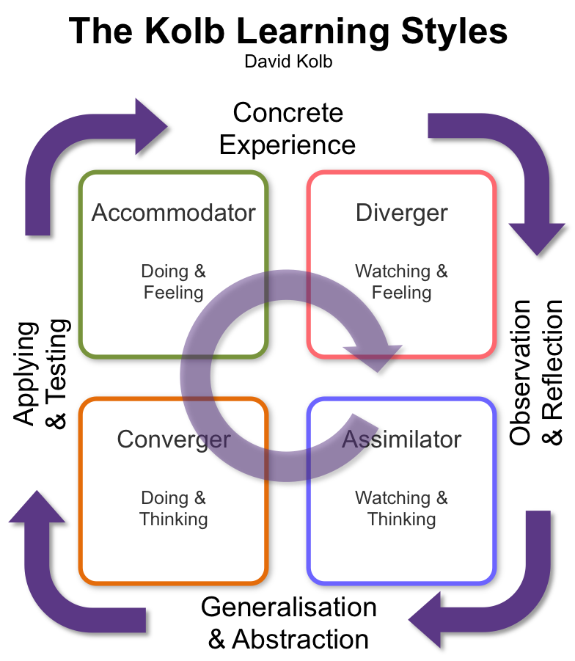
Abstract conceptualization and reflective observation are the hallmarks of the assimilating learning style. This learning style is characterized by thinking and analysing information and is characterized by being logical and rational. It may be difficult for them to apply their theories and models to real-world situations, though they are often good at creating models (Kolb & Kolb, 2005).
Abstract conceptualization and active experimentation are central to the convergent learning style. Individuals with this learning style like to learn by doing and trying, and they are more practical and hands-on. They are frequently competent at problem solving and decision making but may struggle with open-ended jobs or circumstances (Kolb & Kolb, 2005).
Figure 3 The Kolb Learning Styles (Kurt, 2022)
The accommodating learning approach places a premium on tangible experience and active exploration. Individuals with this learning style like to learn by doing and experiencing things directly, and they are more spontaneous and intuitive. They are frequently excellent at adjusting to new conditions and difficulties, but they may struggle with abstract or theoretical notions (Kolb, & Kolb, 2005).
Kolb's learning style model has had a significant impact on education and training because it provides a framework for analysing individual variances in learning preferences. The approach, according to some detractors, oversimplifies the complexity of learning and ignores other elements that may affect learning, such as motivation and past knowledge. (Felder & Silverman, 1988).

HONEY & MUMFORD LEARNING STYLES MODEL

Another common method to analysing individual differences in learning is Honey and Mumford's learning styles model. Based on Kolb's research, this model outlines four main learning styles: activist, reflector, theorist, and pragmatist (Honey & Mumford 1982).
Activists are distinguished by a desire for active experimentation and experiential learning. They like experimenting with new ideas and tactics, but they may not take the time to reflect on their experiences or explore alternate points of view (Kolb, et.al., 2001).
However, reflectors like to learn via observation and reflection. They like examining and absorbing information, yet they may be slow to act or make judgements. (Kolb, et.al., 2001).
Theorists emphasize abstract conceptualising and the development of hypotheses or models. They like examining complicated ideas and connecting them, but they may difficulty with practical uses or hands-on work (Kolb, et.al., 2001).
At last, pragmatists prefer to learn by doing and implementing what they learn in real-world settings. They are concerned in the actual effects of their study rather than theoretical or abstract principles. (Kolb, et. al., 2001).
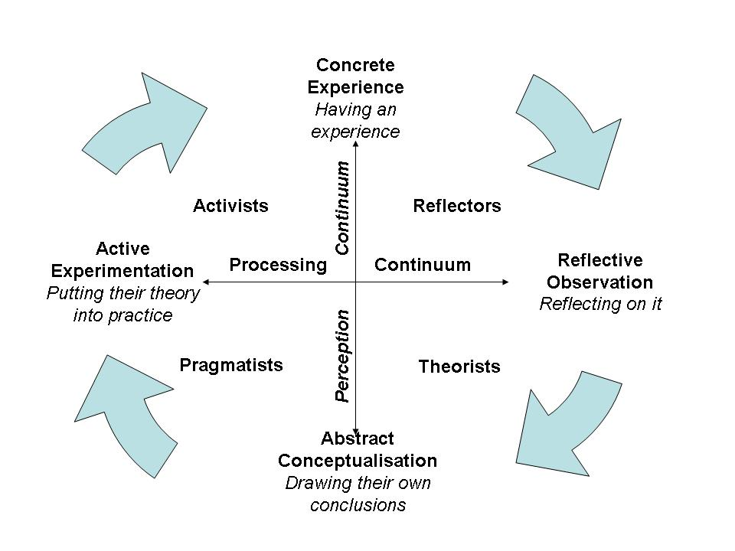
Figure 4 Honey & Mumford Learning Styles (Unknow, 2011)

NEIL FLEMING LEARNING STYLES MODEL

Another prominent method for understanding learning styles is Neil Fleming's model. This paradigm specifies four basic learning preferences: visual, auditory, reading/writing, and kinesthetic/tactile (Fleming, 1995)
Visual learners prefer visual tools such as diagrams, charts, and films to learn. People may fail to understand textual instructions or lectures without visual help (Pashler, et.al, 2009).
Auditory learners prefer spoken material such as lectures, conversations, and podcasts. They may have difficulty understanding or writing instructions that lack oral explanations (Pashler, et.al, 2009).
Students who enjoy reading and writing prefer to study through written resources such as textbooks, articles, and notes. They like to take notes and summarise material in their own terms (Pashler, et.al, 2009).
At last, kinesthetic/tactile learners like to learn via hands-on activities and experiences. They like experimenting and exploring and may struggle to sit quietly for lengthy amounts of time (Pashler, et.al, 2009.

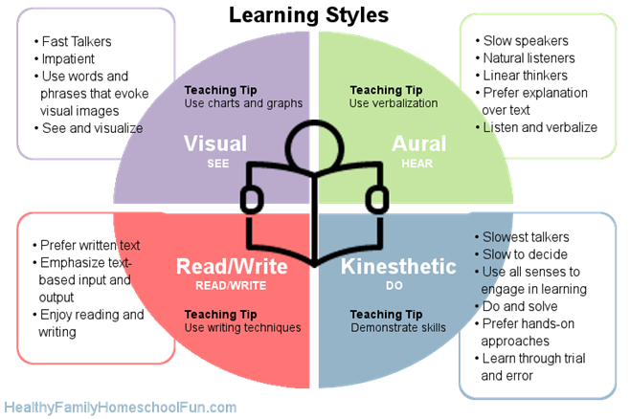
Figure 5 Neil Fleming Learning Styles (Source: Adult Learning Theory (weebly.com)

4.2 HOW IMPACTED LEARNING STYLES THEORY IN WORKPLACE

After evaluating the three learning style and completing the questionnaires provided in week two to identify which learning style I had corresponded, I discovered that I am a part of Neil Flaming`s visual module. So, I decided to write about this method and how it's going to help me at my workplace.
My visual learning style may impact how I approach assignments and projects at work. If I am provided visual tools, such as flowcharts, mind maps, or schematics, I may be more successful at processing information and solving issues. I may also be more effective in communicating my thoughts and methods to others if I utilise visual assistance rather than verbal explanations. In addition, I may find it useful to employ visual assistance while organising my work or arranging my day. For example, to assist me recall key information, I may make a visual to-do list or use color-coded labels and tags.
As previously said, visual learners assimilate information more effectively when it is provided in a visual style. This indicates that visual learners may acquire new skills or concepts more effectively if they are given visually, such as through diagrams, charts, and other visual aids. Visual learners may succeed in jobs requiring spatial reasoning in the workplace, such as design or architecture. They may also benefit from employing visual aids while organising their work or arranging their day.
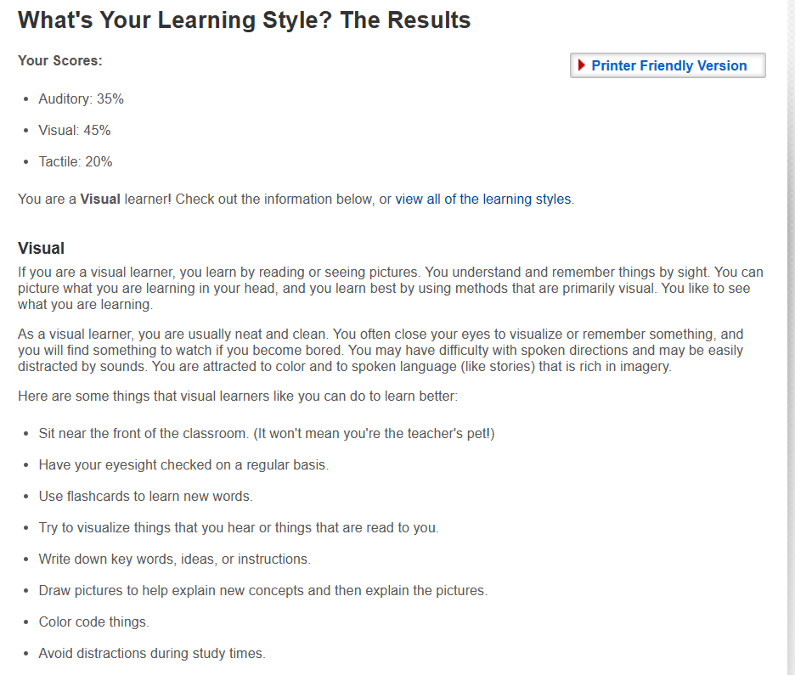
Figure 6 What`s your learning style?

REFECTIVE MODEL ASSESS – GIBB`S REFLECTIVE CYCLE

Graham Gibbs developed Gibb's Reflective Cycle in 1988 as a mechanism for learning from experiences. Furthermore, due of its cyclic character, such as providing a framework for looking at encounters, it gives a framework for looking at encounters (University of Edinburgh). The procedure is separated into six phases:
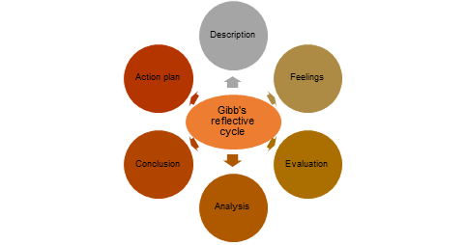
Figure 7 Gibb's reflection cycle

Using Gibb's reflective cycle, I will describe how this course has improved my learning process across the six stages.

- DESCRIPTION
The professional career development course included a variety of themes, such as how to write a professional CV, how to prepare for a mock interview and for open book assessment, and how to comprehend employment laws. Self-awareness was another important component of the course. As we discussed our strengths and weaknesses, as well as our values and motivations, we learned how important it is to know ourselves. Using a series of reflective exercises, we developed a clear understanding of our personal and professional goals, and how we could leverage our strengths to achieve them. I learned a great deal about myself and my career goals during this section of the course, which will be extremely useful in my career. I learnt how to write a professional CV that highlighted my skills and knowledge during the session. I also discovered the importance of successfully presenting myself in job interviews, as well as how to prepare for and perform well in a mock interview. In addition to learning about these issues, I had to pass an open book assessment that examined my understanding of the course material. A mock interview evaluation was also given to me, which assessed my ability to apply the skills I acquired in a simulated job interview environment. Finally, I developed a greater awareness of employment-related legal and ethical issues, such as discrimination and equal opportunity.
- FEELINGS
As someone who had never had any formal training in career development, I was initially overwhelmed by the amount of information the course covered. I became more confident in my abilities as I applied the skills I learned, including creating a CV and preparing for mock interviews. Having newfound knowledge of employment legislation empowered me in my job search and helped me become more confident about my job application.

- EVALUATION
My personal and professional growth was greatly enhanced by this course. As I pursue my career goals, the skills I learned, such as creating a professional CV and performing well in interviews, will be essential for my success. In addition, I have gained a better understanding of the ethical and legal implications of the job market due to my understanding of employment legislation.
- ANALYSIS
It was a very positive experience in the course that highlighted the importance of continuing learning and development, especially regarding career planning and development. The course provides me with the practical skills and knowledge I will need throughout my career. My confidence was also built by the course's mock interview and open book assessment, which provided me with safe and supportive environments for practicing my skills.
- CONCLUSION
Overall, the personal career development course was a beneficial experience for me. Throughout the course, I gained valuable skills such as CV writing, mock interviews, open book assessment, career development, and employment regulations, all of which will be useful in my future work. The course also provided a safe setting in which I could hone my talents and gain confidence. Looking forward, I will continue to reflect on my learning and seek out possibilities for growth and development in my career.

- ACTION PLAN
In the future, I plan to use the skills and knowledge I gained during the course to improve my career prospects. Through practice and feedback from others, I will continue to refine my CV and prepare for job interviews. In addition, I will keep up to date with changes in employment legislation so that I can better understand my rights as an employee and make informed career decisions. As a final step, I will take advantage of additional opportunities for learning and development, since I believe that continuing education is essential if you want to remain competitive in the current job market

Objective | Timeline | Activities | Success criteria | Resources
Improve my leadership skills | 12 months | - Learn about successful leadership strategies by attending leadership development courses and seminars.  - Take advantage of leadership opportunities at work, such as leading teams or projects.  - Study leadership and management books to learn about various techniques and views. | - Receive good evaluations on leadership talents from colleagues and superiors.  - Effectively manage a high-performing team to project completion.  - Track my progress over time and meet my personal development goals consistently. | - Leadership development courses and workshops.  - Books on leadership and management  - Feedback from colleagues / supervisor.  - Goal setting and reflection tools for identifying areas for improvement.
Improve my English language skills | 6 months | - Enrol in a language course in English.  - Practice English with native speakers.  - Reading resources in English, such as books, newspapers, and magazines.  - Watch English-language films and television series. | - The ability to speak English more confidently in a group setting or with native speakers.  - Improved ability to read and comprehend English language materials.  - A greater ability to understand and listen to English-language TV and movies. | - English language courses.  - English language materials (books, newspapers, and magazines).  - English language movies and TV shows.
Improve my public skills | 6 months | - Find chances for public speaking practise.  - Participate in public speaking classes or seminars to discover successful speaking tactics and strategies.  - Take feedback from co-workers, mentors.  - Read public speaking books. | - Improved confidence and comfort when speaking in public.  - Increased ability to structure and deliver excellent speeches.  - Improved audience engagement and persuasion | - Public speaking courses or workshops  - Feedback from colleagues  - Public speaking books
In this action plan, I had outlined my aims, actions, success criteria, and resources for increasing my leadership, English language, and public speaking abilities. There are several essential abilities that can help me both personally and professionally. I am convinced that by defining clear objectives, measuring my progress, and utilising diverse tools, I will be able to achieve success in each of these areas. I aspire to become a more successful leader, to speak more effectively in English, and to give riveting presentations with ease because of this strategy.

6. CONCLUSION

This report focuses on personal and professional growth through a SWOT analysis and a personal development plan. This study has helped me identify my strengths, weaknesses, opportunities, and threats, which will help me reach my goals and objectives. Furthermore, my personal growth plan defines my long-term goals. In addition, the learning styles model is discussed in this study, which provides a framework for examining individual learning preferences. Overall, the importance of self-reflection, planning, and ongoing learning in personal and professional growth has been demonstrated in this research. I can become a more successful leader, communicator, and problem solver by using the skills and approaches mentioned in this study, and eventually fulfil my personal and professional goals.

REFERENCE

Beausaert, S., Segers, M. and Gijselaers, W., 2011, The Personal Development Plan Practice Questionnaire: the development and validation of an instrument to assess the employee's perception of personal development plan practice. International Journal of Training and Development, 15: 249-270.
Covey, S. R., 2004, The 7 habits of highly effective people: powerful lessons in personal change. Simon and Schuster.
Felder, R. M., & Silverman, L. K., 1988, Learning and teaching styles in engineering education. Engineering Education, 78(7), 674-681.
Fleming, N. D., 1995, I’m different; not dumb. Modes of presentation (VARK) in the tertiary classroom. In Proceedings of the 1995 Annual Conference of the Higher Education and Research Development Society of Australasia (HERDSA), HERDSA, Po Box 51, Jamison Centre, ACT 2614, Australia.
Gardner, H. (1983). Frames of mind: The theory of multiple intelligences. Basic Books.
Honey, P., & Mumford, A., 1982, The manual of learning styles. Peter Honey.
Kolb, A. Y., & Kolb, D. A., 2005, Learning styles and learning spaces: Enhancing experiential learning in higher education. Academy of Management Learning & Education, 4(2), 193-212.
Kolb, D. A., 1984, Experiential learning: Experience as the source of learning and development. Prentice-Hall.
Kolb, D. A., Boyatzis, R. E., & Mainemelis, C., 2001, Experiential learning theory: Previous research and new directions. Perspectives on cognitive, learning, and thinking styles, 1(8), 227-247.
Kurt, S., 2022. Kolb’s Experiential Learning Theory & Learning Styles. Available at: https://educationaltechnology.net/kolbs-experiential-learning-theory-learning-styles/ [Accessed 20 March 2023].
Namugenyi., C., et.al., 2019, Design of a SWOT Analysis Model and its Evaluation in Diverse Digital Business Ecosystem Contexts, 23rd International Conference on Knowledge-Based and Intelligent Information & Engineering Systems, Procedia Computer Science 159.
Pashler, H., McDaniel, M., Rohrer, D., & Bjork, R., 2009, Learning styles: Concepts and evidence. Psychological Science in the Public Interest, 9(3),
Thompson, A. A., Peteraf, M. A., Gamble, J. E., & Strickland III, A. J., 2018, Crafting & executing strategy: The quest for competitive advantage: Concepts and cases. McGraw-Hill Education.
University of Edinburgh, Available at: Gibbs' Reflective Cycle | The University of Edinburgh [Accessed 20 March 2023].
Unknow, 2011, Honey and Mumford's Learning Styles Questionnaire. Available at: http://www.nwlink.com/~donclark/hrd/styles/honey_mumford.html [Accessed 20 March 2023].
Links:
Adult Learning Theory (weebly.com)

