
strutegic management of sme
DEVIMO POP-UPS


BA LEADERSHIP AND SKILLSFOR WORKPLACE

NAME | DAMALIE HARIET KAJUMBULA
STUDENT NUMBER | 1604705
MUDULE | 6004
LECTURER | REXON NTING

Contents
Introduction: 1
1.0 Background: 1
2.0. Organisations Current Strategic Direction 2
2.1 Key resources 2
2.2 Customer Segmentation 2
2.3 Marketing 3
2.4 Targeting Clients: 4
2.5 Benchmark: 5
2.6 Positioning and BLUE OCEAN Strategy 5
2.7 Indirect competitors: 6
2.8 Future services: 7
3.0. PESTEL Analysis 7
3.1. Political & Legal 8
3.2. Economic 9
3.3. Social 9
3.4. Technological 9
3.5. Environmental 10
4.0. SWOT Analysis 10
4.1. Strengths 10
4.2. Weaknesses 11
4.3. Opportunities 11
4.4. Threats 11
5.0. Stakeholder Analysis: 11
6.0 NEW SUSTAINABLE STRATEGY: 12
References 12

Introduction:
The report includes an appraisal of Devimo’s current Strategic Direction as well as an analysis of its external and internal environment using PESTLE and SWOT the scanning tools, and the CANVAS model for sustainability. Furthermore, it includes the stakeholders’ analysis, an evaluation of their expectations and their relative power to influence the strategic decision making of Devimo. It ends with a proposed new strategy and an explanation of how it will sustain Devimo for a long-term.

1.0 Background:
Devimo is a Belgian company whose main activity is the management of commercial infrastructures in Belgium. Working as a team of four entrepreneurs and in collaboration with AG Real Estate, it has been managing stores since 1968, when it initiated the first Belgian mall; the Westland Shopping centre, and it since then managed 60% of the great shopping malls with up to 1,400 and 111 collaborators. However, based on the decision to specialise itself in managing stores only, the name changed to Devimo Consult in 1983, with the AG Fortis still owning one third of the company in the year 2000 after the restructuring of the shareholders until 2008, when AG Real Estate acquired all Devimo shares and became the unique shareholder.
  - Vision and Objectives:
Vision is an important factor of the strategic management process that involves; environmental scanning, strategy formulation, strategy implementation, and evaluation and control (Papulova 2014). The vision of Devimo includes customer loyalty, widening the customer base, value creation, brand awareness and growth, and these are manifested in the three pillars, as its core values and as its strategic objectives to help in the achievement of the vision.
Visibility: Devimo offer a renting proposition to its clients and make sure it meets a lot of potential customers daily inside the biggest and the most famous shopping mall of Brussels and thus, increase their brand awareness. In addition, focusing on increasing the number of shoppers by welcoming investors who can invest in pop-ups with different products and creating a culture that facilitates the ability to add value through innovation (Fahey at el,2010) is in line with its vision.
Convenience: Devimo ensures its focus is on providing the most convenient renting experience to its clients as well as offering a smart package to make renting a place easy for them.
Reliability: Devimo works as a team to give the clients great attention in a new shopping experience in the biggest mall of Brussels which is the best Pop-up store. In addition, they encourage customer involvement whereby, customers interact with the brand’s pop-up which creates brand awareness and strengthens the customer and team relationship.
To enhance brand image – Pop-ups are a new and trendy way to promote a company’s service or products especially when customers perceive the company to be dynamic and innovative. E-commerce can be used as one of the channels to deliver customer value and this can be viewed as making a real contribution to the customers (Chi Lin, 2003).Since shopping through the Internet is accepted by many customers, there is an opportunity for Devimo to attract businesses that do not have physical shops to enable them promote their products but are able to do it through setting up pop up stores. Devimo applies the human value management process to identify how the relationships between organizations, competitiveness, innovation advancements and knowledge management affect strategic management and the formulation of competitive strategies (Carneiro A., 2000).
Furthermore, Devimo applies differentiation as a customer-oriented strategy that leads to strong positioning based on the client and the type of mall. This is how Devimo creates its competitive edge to attract and retain its customers (Mercado, 2004). Also, Strategic positioning is demonstrated its motto which says, “it is the key to the town centre”, as the city is accessible by car and public transports, which makes everyone to enjoy City 2.
Source: http://www.city2.be

2.0. Organisations Current Strategic Direction
The purpose and direction of Devimo is expressed by its strategy through its mission, vision, values and objectives (Andersen & Schroder, 2010; Gerry J.2017)).As a key driver of the firm’s growth (Weinzimmer, 2000), strategy involves the identification of the strategic objectives and goals at all the three levels of the organisation that align with the vision (Scholes & Whittington, 2010). It is also a source of sustainable competitive advantage using various strategic management practices to guarantee their fit within the constraints of their business (Agwu 2018). Strategic direction not only involves the actions taken by Devimo to achieve its strategic goals (Hammar 2017), but also the supplier selection and its product development process (Scott & Laws 2010).The plans and actions taken by Devimo towards its vision of the future include; Target customers, Key resources, Marketing, Segmenting of customers and the Blue ocean strategy.

2.1 Key resources
This includes the resource-based view of strategy where Devimo should make sure it has the required resources such as Human, financial, physical, intellectual, and consider the generic capabilities as the basis for strategic direction (O’Regan & Ghobadian 2004). The main source of revenue for Devimo is the renting of the vacant places for pop-up stores and additional services required by its clients and its prices are determined by the type of pop-up (road show or premises), location in the mall, length of period and the type of services the client wants.
2.2 Customer Segmentation:
Segmenting the customers plays a big role in the success of the marketing campaigns. Besides being one of the ways of operationalizing says Kara and Kaynak, (1997) market segmentation is important in determining both the marketing concept and marketing strategy development, which provide effective guidelines for Devimo’s segmentation of its customers. The current marketing strategy of Devimo offers more customized services to the customers; however, there is need to standardize the services relevant to each segment as part of the implementation in the marketing plan (Abell, 2006).
Based on the size of the marketing budget and the communication channel of the company, Devimo’s customers are as the segments stated below as part of its strategic direction.
This includes large retailers such as Hypermarkets that use social networks for communication, but its core business is mainly offline, and also the Affordable clothes chains, with a large marketing budget to enable them use online and e-commerce. These include middle class shops such as Zara and H&M and their core business deals directly with the customers.
Furthermore, is the Trend setters’ segment which includes business with large offline core-business and strong online communication, such as Coca Cola and Red Bull, which operate directly with customers but use online and social networks for communication. Other examples include car manufacturers such as, L’Oreal, which through Devimo was able to use a hairdresser salon to advertise its new Garnier shampoo.
Also, included is a segment of Telecom services for example, the Belgacom Groups which is present online via face book, and offline via their stores. In addition, they use the innovation strategy to satisfy their customers’ needs, for example offering locations for festivals, which involve costs to create awareness through advertisements.
In addition, there are many other small segments as stated in the Large Marketing Budget stated in this report, which include; small independent stores and small scale online retailers The independent stores use traditional channels for advertisements and communication, while, the online retailers use both traditional channels and online.

2.3 Marketing:
The marketing as a strategic objective is used by Devimo not only to promote its brand but also its products and services as well as widening its customer base and market growth. Brick & Mortar to E-commerce is one of its marketing channels which help to link the segmented clients to e-commerce as a marketing tool but it has the limitation of not covering all some clients, for example the B2B companies such as Coca-Cola could not be represented. In addition, advertisement is also used through the marketing campaigns and brand images but also has a limitation of being subjective due to lack of information. Also, by using the smart package, Devimo makes it possible to have a pop-up store as well as a road show in the allays of the City2 to attract more visitors inside the pop-up store as the package includes, insurance, a matching system, Ban contact machines and a reliable Internet connection(Mitchell, 1996).
Also, Devimo believes that pop-up shops are aimed at companies that are more innovative in their communication and so, online is a good criterion to segment the market. McDonald, at el, (2003) states that,” marketing is an attitude of mind rather than a set of techniques simply to sell products or services concerning customer satisfaction”. Customer segmentation helps in identifying and defining the target markets, and by defining well its target groups, companies can improve their attractiveness and build strong competitive advantage as they work especially on delivering values for specific clients with specific needs and requests.
Other ways of marketing includes; Installing beach flags in the entry of the shopping centre and in front of the pop-ups themselves to advertise the concept of pop-ups and to develop its culture as well as raise pop-ups’ visibility. Furthermore, marketing also involves collaborating with clients in order to understand their needs, and with consumers to find out their likes in the concept of the pop-up store and which type of pop-ups they prefer, which helps to improve the quality of services offered.

Figure: 1
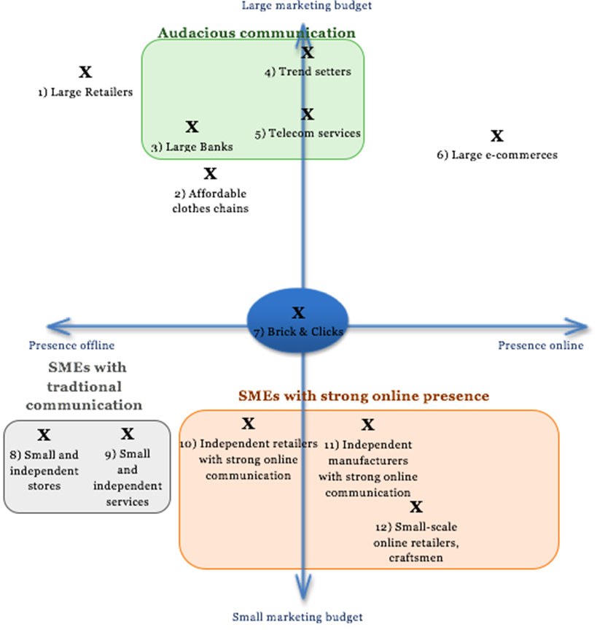

2.4 Targeting Clients:
Big companies
Devimo’s focus is on targeting big companies with big budgets that will bring more revenues through promoting its services to large audiences like the one in the City 2 shopping centre, while, small entrepreneurs will not bring as many customers to City2, and this budget difference expresses the difference of “attractiveness” that these companies represent for Devimo (Marques at el, 2011).
Also, customer loyalty of these big companies helps to promote the brand of Devimo (McDonald, at el, 2003) as these companies are well-known, such as D’Ieteren, Coca-Cola, and will attract their loyal customers to enter the City 2 shopping centre, enhancing the mall’s attendance rate and thus its reputation which makes it easier to manage few clients than to spend too much time on small businesses. These kinds of stands will benefit from the visibility to attract the loyal customers as well as developing the curiosity of the new ones in the mall.
E-commerce’s:
In addition, it targets big companies with big budgets who can afford its e-commerce which is growing as more people are purchasing online. For example, Amazon is currently creating pop-up stores all around the world to meet their clients physically. These companies are famous for their large publicity and once they attract their clients to visit the pop-up stores, they will settle.
Furthermore, are the many traditional brick-and-mortar businesses that supplement their physical outlets with e-commerce capabilities on the Web (Steinfield, at el, 2002). However, most of these companies do not have brick-and-mortar product which is an opportunity for Devimo to offer this service to those who could be interested in the service. These companies can attract new customers in order to enlarge their customer base; at the same time they can attract their current online customers to buy offline so, creating a pop-up store could help them overcome the problem of having too much stock which is a problem faced by many e-commerce businesses.

2.5 Benchmark:
A benchmark is relevant to learn what our competitors are doing ,for example showing success stories videos on the website as Pop-Media did, and providing the appropriate insurance as Popupimmo did, can be used by Devimo to save its clients time in searching for an appropriate insurance and also, AG Real Estate could create a tailor-made insurance for pop-up store. Furthermore, is the amalgamation with competitors as ventures to enlarge the pop-up locations in different cities.
Through benchmarking, Devimo is able to identify ways of improving its services and strategic options to improve its strategic direction. For example, competitors not offering locations in large Brussels malls since Devimo manages almost all of them as well as Devimo managing the large malls outside of Brussels and 60% of the big shopping centres in Begium2 can be used as a competitive advantage for Devimo. It also has an advantage in that competitors rent locations they do not own, while Devimo rents the location it manages and has therefore a big advantage as there are fewer intermediaries

2.6 Positioning and BLUE OCEAN Strategy
According to Kim and Mauborgne (2014), the Blue Ocean Strategy challenges companies to break out of Red bloody ocean competition that makes them get outcompeted. It is about breaking away from competition and growing in demand, and Devimo pop-ups uses strategic positioning as part of its marketing plans to achieve its competitive edge (Graham, 2008). A good positioning should be feasible to send out the message which aligns with Devimo’s vision and its corporate strategy to help in fulfilling its strategic goals. The emphasis should therefore be on the sustainability of its positioning and making sure it will still be relevant in the future (Leal Filho, 2000).
Also, the BLUE OCEAN strategy is used as a generic capability (Porters Generic Strategy), by Devimo as a competitive advantage against its competitors as per the BLUE OCEAN Strategy Canvas Model stated below, which applies differentiation to identify processes to improve or eliminate in order to create a sustainable competitive advantage against its competitors, who are homogeneous (Fredrickson and Stephanopoulos, 1981) with different expectation

Figure:2
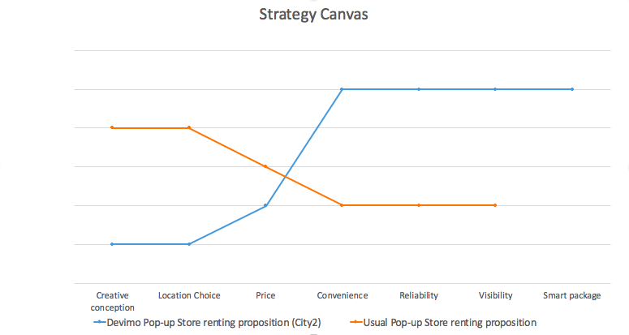

After putting the orange line on the graph, we used the Four Actions Framework to create the blue line. This shows what to eliminate, raise, reduce or create to make its competitors irrelevant.
Create:
According to Scott, at el (Google LLC, 2014) multi-location internet platform can be used for universal remote media control across multiple platforms, devices, and locations. Devimos’ focus is only on the City2, whereas its competitors focus on having platforms in different cities which makes it easy for them to provide detailed information and data to its clients about the location of its renting spaces and type of visitors as well as pictures (Lee, at el, 2006). But, Devimo can only provide information about the price, features, surface and details of availabilities, which makes it inconveniencing for the clients while making bookings as it is difficult to choose a location for a pop-up. One of the ways Devimo can improve the visibility of its client’s pop-up stores is to create more advertisements such as putting a big panel in the entrance of City2 with advertisements for the pop-up stores, putting adverts on the Website and distributing flyers at the entrance of the City2.
Reduce:
In addition, it should aim at increasing the numbers of locations so that it is able to provide more detailed information on its renting places, but it only manages malls that AG Real Estate owns which is a limitation can be reduced by partnering with other competitors located in different cities.

2.7 Indirect competitors:
Though launching a popup as a promotion channel can be expensive, but pop-ups are a big opportunity for companies using different alternatives to popups to make advertising such as online advertising, social media, flyers, panels, radio, television, celebrity endorsement, product placement because of the benefits that pop-ups may offer to these companies as stated below:
1. Source of Revenue Stream – Pop-up shops provides an effective way to explore adding value for businesses. Not only is it a fraction of what one would pay for an actual physical retail location, but an additional revenue stream (Anderson and Andersson, 2004).
2. Engage Customers Offline – In fact, not all customers buy online some people would like to physically touch and value the product before buy it (Burke, 2002).
3. Market Merchandise around a Season – giving consumers a physical location to access it close to a holiday or celebrations such as Saint-valentine’s day is a great opportunity to empty the remaining stocks during the period and make profit.
4. Educate New Customers – a pop-up shop can help one to create awareness, demonstrate its new product and show its value (Belk, at el, 1989). It is also a great opportunity to get instant feedback to further improve the concept.
5. Go to Where Your Customers Are – If one is doing business online only, it could be a good idea to meet the customers physically to understand their needs which can increase the sales (Pine, at el, 2009).
6. Generate Brand Awareness – By involving customer’s offline and delighting them with a good experience and quality products, one can generate effective brand awareness (Bartl, at el, 2013).

2.8 Future services:
Finally, the strategic direction involves future services with benefits that could outweigh the costs attached to these services, as the targets are mainly the big international firms.
Kiosques: It is a permanent stand that would be in the public area of the mall. Devimo plans to invest in the purchase and the creation of several kiosques that will be rented out to businesses and the rent of this kind of facilities varies between 1200 and 1500 €/m2/year, depending on the business sector of the shop.
Guerilla marketing: As an innovative tool that focuses on low cost unconventional marketing tactics that yield maximum results, these advertisements can be used to increase the attendance of the mall. For example, Coca Cola is one of the Gorilla marketing leaders, by setting up unconventional vending machines (ex: Free Hug to the machine gives one a Coca Cola).

Figure:3

3.0. PESTEL Analysis
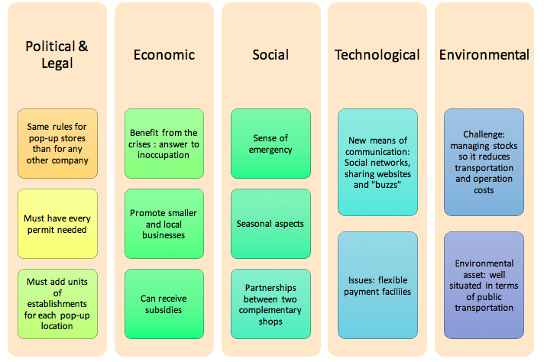
According to Rastogi &Trivedi, (2016) the PESTLE technique can be used effectively to identify the external risk. It is a tool used by Devimo to analyse and understand the external forces that it is exposed to Aguilar (1967). It is necessary to analyse the environment regarding the numerous external factors that the Pop-Up stores are exposed to such as regulations and new technologies. The Pestle analysis which includes the six factors stated below can be used to identify the opportunities that Devimo should be able to exploit as well as risks that it should be able to manage or eliminate. The diagram stated above shows the findings from a macroeconomic perspective in both Devimo and the pop-up stores managers’ points of view, and this is used to plan a relevant marketing strategy for the pop-up stores.
The six different factors of the external market: Political, Economic, Social, Technological, Legal and Environment.
However, Political and Legal are strongly linked together so they will be assessed and analysed together to have a clear vision and a more precise idea of the current trends of the external market to implement the right market strategy.

3.1. Political & Legal
The firm’s concern are the tax laws, Government policies and decisions that influence and affect the pop-up store market. Political matters depend on the conditions of the country in which the market strategy is implemented, and they may affect the decisions made by the businesses. Similarly, the Legal is concerned with laws such as: labour laws, social obligations and marketing rules of quality, safety and rights of employees.
The pop-up shops established in Brussels have to abide by the Belgian legislation governing their business. According to the European website “ecommercenews.eu”, pop-up stores are very popular however; the analysis shows how rules differ for pop-up stores such as having every permit needed. However, the minister of local government, Liesbeth Homans, explained the that the reason why there is no more flexibility for a pop-up store than for a regular shop is because the information about legal issues of pop-up stores in Belgium cannot be found easily. Therefore, a pop-up store must choose legal status and rely on the same rules than any other company to constitute a company to be independent.
According to Liesbeth Homans, the owner of the pop-up store must be ensure the chosen place to implement the business is at the level of the town planning environment to avoid unfair competition. Therefore, Devimo has to reassure its potential customers on the policies and legal status of the permits and also make sure they follow these policies. However, there is no specific legal procedure to open a pop-up store, as it is the same as for the opening of any other businesses so they will be able to sign a lease agreement, for example, pop-up stores restaurants must follow the regulation for Horeca business.
Furthermore, are the issues regarding leasing which involves setting a period for a commercial lease of more than a year, which is an opportunity for Devimo and the pop-up store managers to challenge the law on behalf of its clients. This not only strengthens the relationship between Devimo and the clients but also strengthens the customer loyalty as well as promoting its brand which aligns with the vision of Devimo. Also, there should be legal documents and knowledge management system on the web regarding the pop up shops showing relevant, reliable and up-to-date information on the law (Boella at el, 2016), while the managers should make sure that these laws are effectively communicated to the staff and that they are followed(Noe, at el 2017).

3.2. Economic
The triple bottom line which involves undertaking economic, social, and environmental retail sustainability as strategic objectives, is very vital concerning the economic environment of the marketing strategy (Wilson, 2015). For example, inflation may have an impact on not only the pop-up shops but also on the customers’ purchasing power. The economic factor also looks at investment facilities, exchange rates, interest rates and it can directly impact the market and thus the growth of the pop-up business (Froot, K. and Stein, J., 1991). According to the analysis, Devimo aims at benefiting from the crisis and this can be achieved through promoting the smaller and local businesses by making it possible for them to afford the pop-up shops as per its segmentation strategy. Also, findings from a study conducted by Syndicate Neuter pour Independents in Flanders, shows 16% of local authorities have supported pop-up stores materially and financially which is a huge economic factor that can be used for marketing.

3.3. Social
Social and cultural factors are important, as they may affect the customers’ purchasing power and demand. This latter aspect relates to age distribution and local population growth rate, while, social factors involve trends of population, domestic markets, cultural trends and demographic. This involves the assessment of the purchasing power of the City 2 customers and the pop-up stores retailers as well as the seasonal aspects to define the best renting price of its locations. In addition, the cultural values as well as social responsibility should be included in Devimo’s strategic direction to promote its business. Finally, partnership with complementary shops will enable Devimo to enlarge its locations which aligns with its vision of market growth.

3.4. Technological
Technological factors can influence the marketing strategy and businesses in numerous ways. The analysis outlines new means of communication, social networks and shared data bases as important, however, Zahra and Covin, (1993) outlines the importance of globalisation whereby, companies can source technology from anywhere and whenever it is most cost effective. So, this must be included in the new technological advancement as an innovation strategy in Devimo’s strategic direction. Internet has also brought new means of communications such as Devimo’s website and pop-up store websites as channels of communication to consumers. But unfortunately; lots of entrepreneurs find traditional, computer-based point of sale systems too costly. However, Impulse purchases are important when it comes to pop-up stores since it is linked to the sense of emergency previously described.
To conclude the technological factors, Devimo should make sure that the payment facilities is possible with a strong and reliable internet connection or could sign partnerships with innovative payment systems such as iZettle (which is unfortunately not yet available in Belgium) that allows making card payments via smartphones or tablets.

3.5. Environmental
Logistics can be an indispensable part of programmes because of its integrated environmental management cross‐functional nature (Wu and Dunn, 1995). Environmental factors such as location, waste disposal laws and energy consumption regulation impact marketing and business plans. (Randolph, 2004), therefore all businesses including Devimo should make sure environmental assets are well situated for public protection.
In the case of pop-up stores in Devimo, environmental factors are not analysable. However, one can note the fact that Devimo is well situated in terms of public transportation and it can be an asset for the environmental factors.
In terms of waste disposal, it is important that pop-up stores manage their stock levels. Stock management is an important issue and not only for pop-up stores who would for example try to co-ordinate sales between online and physical shops but also for other retailers. According to the study conducted by CEBR, 40% of respondents with more than one location found managing stocks a challenge as a result of having more than one location and 25% said they had lost sales due to bad stock management. Reducing operating and transporting costs will benefit both the pop-up store owner and the environment.

4.0. SWOT Analysis
According to Lee, and Sai On Ko, (2000) SWOT analysis is a strategic management tool used to examine and assess the Strengths, Weaknesses, Opportunities and Threats within the company. It is strategically used by Devimo to analyse the issues from its business environment and its strategic capability that may influence the strategic development of the Pop-up shops (Scholes & Whittington, 1964).

Figure:4
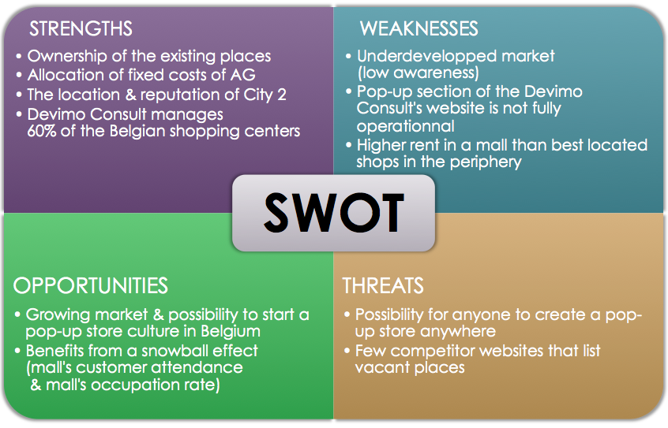

4.1. Strengths
AG Real Estate developed through Devimo Pop-Up already owns the existing places for renting, of which the renting may contribute to AG Real Estate a better allocation of fixed costs. In addition, Devimo Consult manages 60% of the shopping centres in the whole country with little rivalry in terms of buildings that can be occupied by some pop-up stores.
Furthermore, is that the shopping foundation forms an excellent reputation for City 2 and also benefits from a valuable localisation in the heart of Brussels. Indeed, the mall is the biggest entertainment destination shopping centre in the capital of Belgian.

4.2. Weaknesses
Compared to the European neighbouring countries, Belgium is the only one with fewer pop-up stores. This means that the awareness of pop-ups is still quite low and remains as underdeveloped market of today.
Currently, the pop-up section on Devimo’s website is not fully operational because of rent which is higher .A lot of improvement needs to be done on the website due to the presence of online competitors and the list of localisations of vacant places for pop-up stores which lacks visibility.

4.3. Opportunities
The opportunity is the possibility to start a pop-up store culture in Belgium like in other European countries as there are few pop-up stores in Belgium which is in line with the vision of growing the market.
In addition, the mall has already a mass of customers which is a great audience that will contribute to increasing the occupation rate, rent earnings and attract new pop-up stores. This will touch a larger range of customers hence widening the customer base.

4.4. Threats
The fact that there are few competitor websites that list unoccupied places as well as the ability for anyone to open a pop-up store is directly relevant as many new entrants the opportunity to enter the market in different places. Also, this threat could prevent Devimo from fulfilling its pop-up store culture being implemented in Belgium and its division would be unprofitable.
5.0. Stakeholder Analysis:
As one of the tools used to not only to identify the stakeholders of an organisation, but also to assess how the interest and power of each group can affect the decision making of the organisation (Eden & Ackermann 2015). According to the segmentation model stated below, the stakeholders include; the partners whose expectations are financial returns; and the suppliers whose expectations are revenue and safety. These are key players who are likely to affect the decision making of Devimo and they should be involved in its strategic decisions. There are customers whose expectations are quality of the products or services as well as value for their money and employees whose expectations are income and safety. Both customers and employees may not have power to influence the decisions but as they are drivers of the business, they should be given attention. The other stakeholders include the communities whose expectations include health, safety and economic development, while, the expectation for the government are taxes and gross domestic product. The government can exercise its authority of enforcing laws, however, both government and communities have low power and interest and therefore less likely to affect the decision making of Devimo.

Figure:5

Business Model Canvas
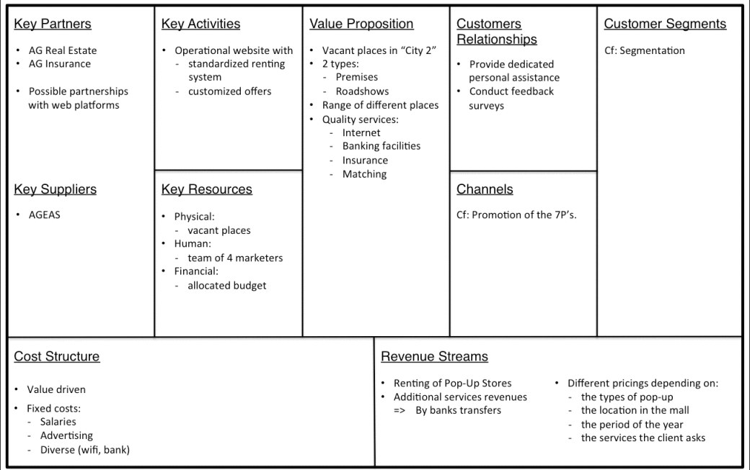

(Source: http://www.segmentationstudyguide.com)

6.0 NEW SUSTAINABLE STRATEGY:
As Devimo is a service industry operating in a competitive environment, it should be able to respond to the forces it is exposed to in its business environment. I propose the innovation strategy for the long term future because it is one of the strategic objectives inseparable from the culture that facilitates the ability to ‘add value’ (Füller, at el 2007).Through innovation Devimo should be able to increase the prospects of widening its operations by partnering with competitors in other areas which aligns with its vision of market growth and widening its customer base. Furthermore, using the innovation strategy can be used to link the external environment with the cultural values, organisational structure, and market segmentation for the achievement of Devomo’s strategic objectives.

References:
Aguilar, F.J., 1967. Scanning the business environment. Macmillan.
Agwu, E., 2018. Analysis of the impact of strategic management on the business performance of SMEs in Nigeria. Academy of Strategic Management, 17(1).
Abell, D.F., 2006. The future of strategy is leadership. Journal of Business Research, 59(3), pp.310-314.
Ackermann, F., Eden, C. and Pyrko, I., 2016. Accelerated multi-organization conflict resolution. Group Decision and Negotiation, 25(5), pp.901-922.
Auer, P. and Di Luzio, A. eds., 1992. The contextualization of language (Vol. 22). John Benjamins Publishing.
Boella, G., Di Caro, L., Humphreys, L., Robaldo, L., Rossi, P. and van der Torre, L., 2016. Eunomos, a legal document and knowledge management system for the web to provide relevant, reliable and up-to-date information on the law. Artificial Intelligence and Law, 24(3), pp.245-283.
Carneiro, A., 2000. How does knowledge management influence innovation and competitiveness? Journal of knowledge management, 4(2), pp.87-98.
Chi Lin, C., 2003. A critical appraisal of customer satisfaction and e-commerce. Managerial Auditing Journal, 18(3), pp.202-212.
Fahey, T.J., Woodbury, P.B., Battles, J.J., Goodale, C.L., Hamburg, S.P., Ollinger, S.V. and Woodall, C.W., 2010. Forest carbon storage: ecology, management, and policy. Frontiers in Ecology and the Environment, 8(5), pp.245-252.
Froot, K.A. and Stein, J.C., 1991. Exchange rates and foreign direct investment: an imperfect capital markets approach. The quarterly journal of economics, 106(4), pp.1191-1217.
Füller, J., Jawecki, G. and Mühlbacher, H., 2007. Innovation creation by online basketball communities. Journal of Business Research, 60(1), pp.60-71.
Graham, H., 2008. Marketing strategy and competitive positioning. Pearson Education India.
Kim, W.C. and Mauborgne, R., 2014. Blue ocean strategy expanded edition: How to create uncontested market space and make the competition irrelevant. Harvard business review Press.
Leal Filho, W., 2000. Dealing with misconceptions on the concept of sustainability. International journal of sustainability in higher education, 1(1), pp.9-19.
Lin, C.F., 2002. Segmenting customer brand preference: demographic or psychographic. Journal of Product & Brand Management, 11(4), pp.249-268.
McDonald, M., Christopher, M. and Bass, M., 2003. Market segmentation. In Marketing (pp. 41-65). Palgrave, London.
Mercado, A., 2004. Worlds of* production and economic practices in the industrial district of Tlaquepaque and Tonala, Mexico. University of California, Los Angeles.
Noe, R.A., Hollenbeck, J.R., Gerhart, B. and Wright, P.M., 2017. Human resource management: Gaining a competitive advantage. New York, NY: McGraw-Hill Education.
O’Regan, N. and Ghobadian, A., 2004. The importance of capabilities for strategic direction and performance. Management decision, 42(2), pp.292-313.
Randolph, J., 2004. Environmental land use planning and management. Island Press.
Rastogi, N.I.T.A.N.K. and Trivedi, M.K., 2016. PESTLE technique–a tool to identify external risks in construction projects. International Research Journal of Engineering and Technology (IRJET), 3(1), pp.384-388.
Steinfield, C., Bouwman, H. and Adelaar, T., 2002. The dynamics of click-and-mortar electronic commerce: opportunities and management strategies. International Journal of Electronic Commerce, 7(1), pp.93-119.
Papulova, Z., 2014. The significance of vision and mission development for enterprises in Slovak Republic. Journal of Economics, Business and management, 2(1), pp.12-16.
Picot-Coupey, K., 2014. The pop-up store as a foreign operation mode (FOM) for retailers. International Journal of Retail & Distribution Management, 42(7), pp.643-670.
Porter, M.E. and Locations, C., 2000. Company strategy. The Oxford handbook of economic ge
Pressman, S. and Scott, R., 2009. Consumer Debt and the Measurement of Poverty and Inequality in the US∗. Review of Social Economy, 67(2), pp.127-148.ography, pp.253-274.
Scott, N. and Laws, E., 2010. Advances in service networks research. The Service Industries Journal, 30(10), pp.1581-1592.
Vandenbroucke, M., 2016. Socio‐economic stratification of English in globalized landscapes: A market‐oriented perspective. Journal of Sociolinguistics, 20(1), pp.86-108.
Wilson, J.P., 2015. The triple bottom line: Undertaking an economic, social, and environmental retail sustainability strategy. International Journal of Retail & Distribution Management, 43(4/5), pp.432-447.
Wu, H.J. and Dunn, S.C., 1995. Environmentally responsible logistics systems. International journal of physical distribution & logistics management, 25(2), pp.20-38.
Zahra, S.A. and Covin, J.G., 1993. Business strategy, technology policy and firm performance. Strategic management journal, 14(6), pp.451-478.

