
Brad Tonner (2314152)

Databases and Application Development
ACCA5026

Table of Contents
2. A brief introduction about the AdventureWorks Cycles case study. 2
3. An Entity Relationship Diagram showing Primary Keys, Foreign Keys and all non-key attributes. 3
4. Suitable screenshots of work completed when creating the content for File 1. 4
6. References to any sources that have contributed to your completion of the assignment (to be added at the end of your report). 14
Bibliography 14
7. An appendix that lists all the prompts used in any generative AI tools, if applicable, as part of your assignment 15

2. A brief introduction about the AdventureWorks Cycles case study.

This is my AdventureWorks Cycles assignment. We have been asked for consultation to create the most suitable database for their online cycling marketplace. The database will be created using MySQL.
I have set the database up in the most logical way possible. I have included simple tables as follows:
- Categories – this is to be able to separate each product into a certain category. This will enable the company to see which categories have the most sales and generate the most revenue.
- Customers – this enables companies to be able to hold customer data such as name, address and email address. This will be the most efficient way of having simple product shipping and being able to search for past orders.
- Feedback – this enables all customer feedback to be held in the database. Companies can then make decisions on where they need to improve and see what customers like the most about their service.
- Manufacturers – this holds the information for all of the manufacturers who are selling products via this database. This will hold contact details and company information.
- Order Details – this will store the top level information for each order, such as order ID, customer ID, date and total amount.
- Orders - this will store all of the smaller details of each order. Companies will be able to view the quantity of items they are selling by checking the quantity sold per product ID. They can see how much income they are generating via sales and the customers they sold items to.
- Products – this table will store all of the products on sale with their descriptions, price, manufacturer ID and category ID.

My database also consists of appropriate indexing, check constraints and tests, to minimise error and keep everything highly automated. I have shown evidence of testing, transactions and roll backs in the sections identified on the table of contents.

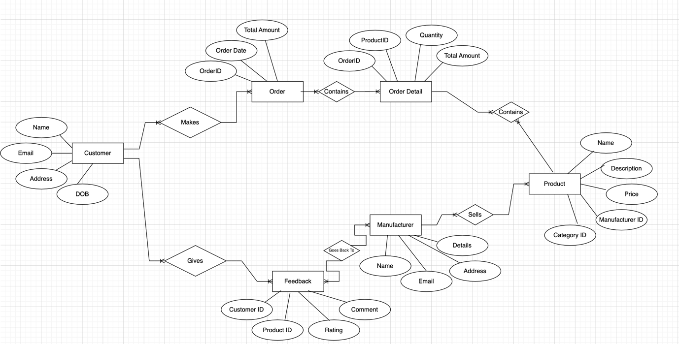
3. An Entity Relationship Diagram showing Primary Keys, Foreign Keys and all non-key attributes.
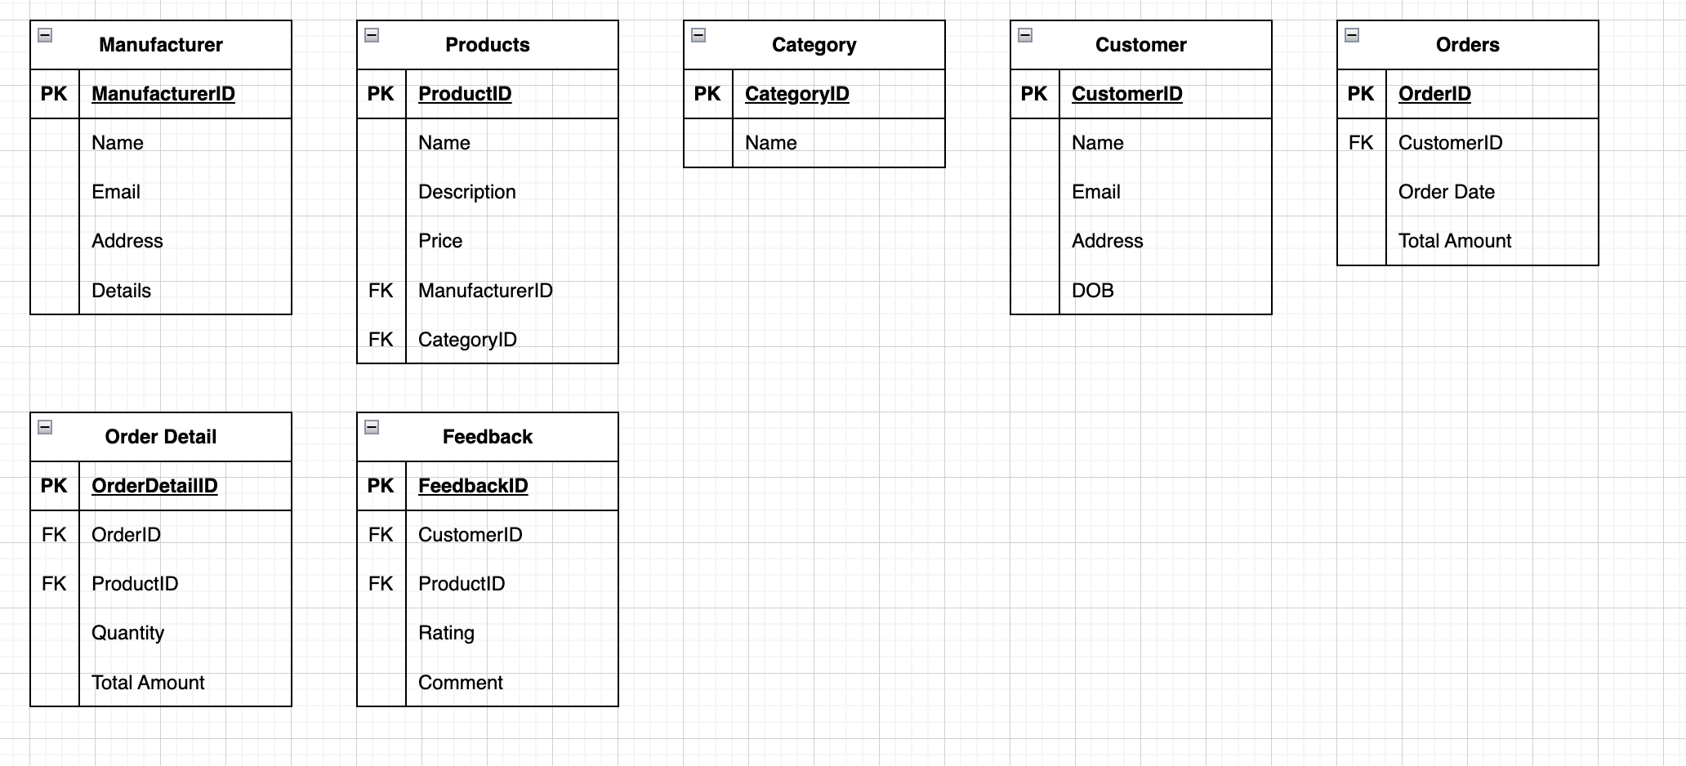
I have come up with 7 different tables for my database. They are described as follows
- Manufacturer – this is all details about the manufacturers that are selling certain products.
- Products – this allows us to identify different products being sold with description, price, who is selling them and what category they come under.
- Category – this allows us to separate the products into certain categories.
- Customer – this allows us to store customer data and information, which will help with sales processing.
- Orders – this will allow the company to store and view all orders that customers have placed.
- Order detail – this will allow us to delve into each individual order to know exactly what has been purchased by a customer.
- Feedback – this will store all customer feedback so each manufacturer can view what their customers think of their service.

4. Suitable screenshots of work completed when creating the content for File 1.
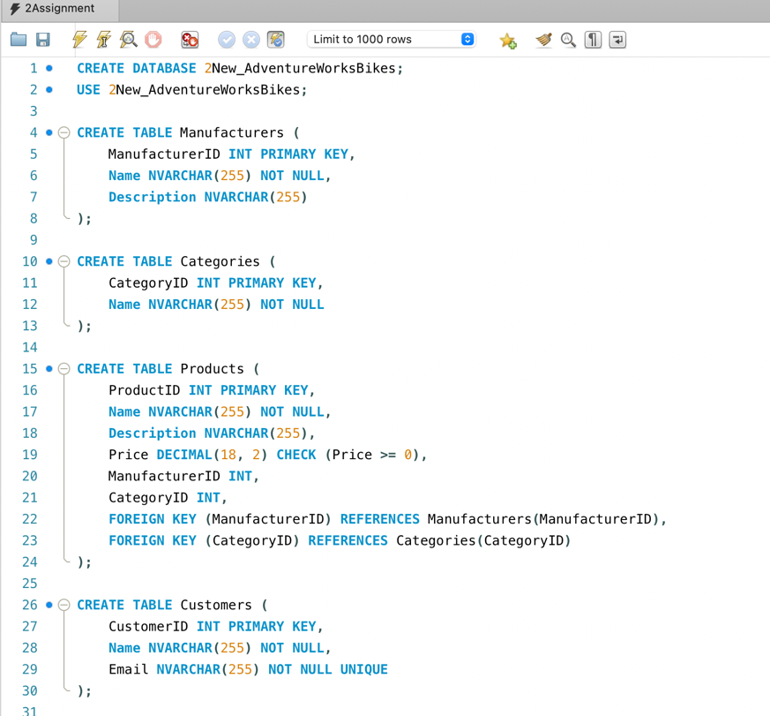
a. SQL code used to generate each table structure
Each table in my database has a primary key, which is unique to each table. This makes it easy to reference and index in a database. The foreign keys in each table establish the relationships between the tables. This is essential for keeping good data integrity and maintains consistency between tables. [3]
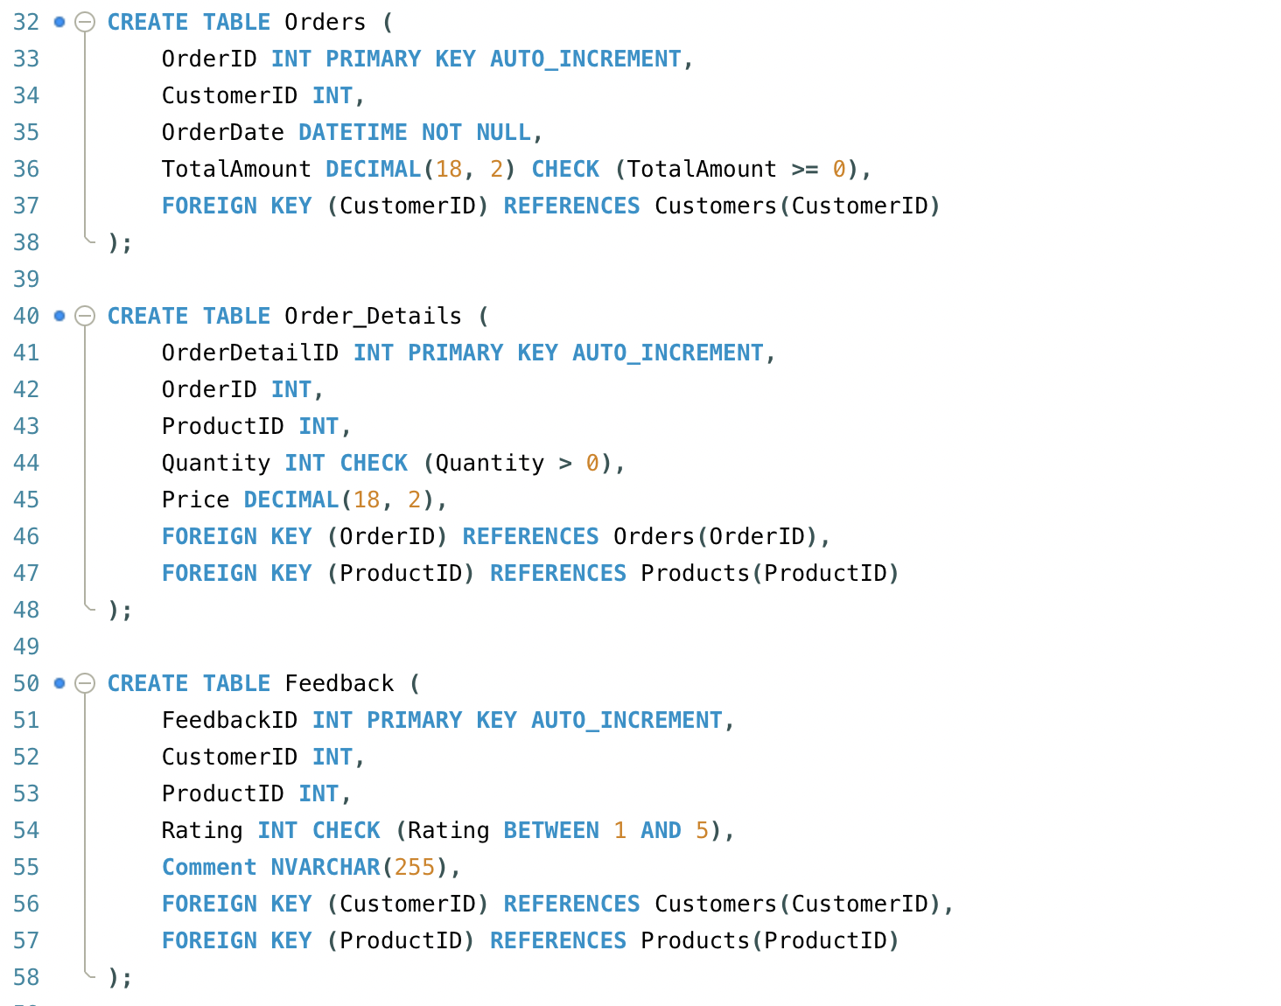

b. SQL code used to create the referential integrity constraints

The referential integrity constraints in your database are enforced using foreign keys. These constraints ensure that the relationships between tables are maintained, and that the data remains consistent. These constraints ensure that each ManufacturerID and CategoryID in the Products table must exist in the Manufacturers and Categories tables. By maintaining these constraints, my database ensures data accuracy, consistency, and integrity across related tables, making it more reliable and robust. Integrity constraints are necessary because data in a database must always be valid and consistent. Data might be inconsistent because of entry errors, duplicate entries of rows, or other violations. [1]
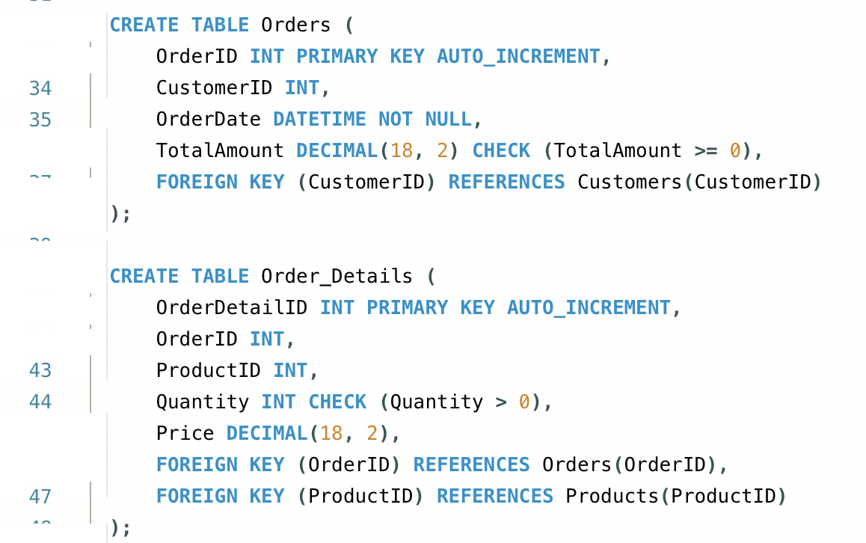
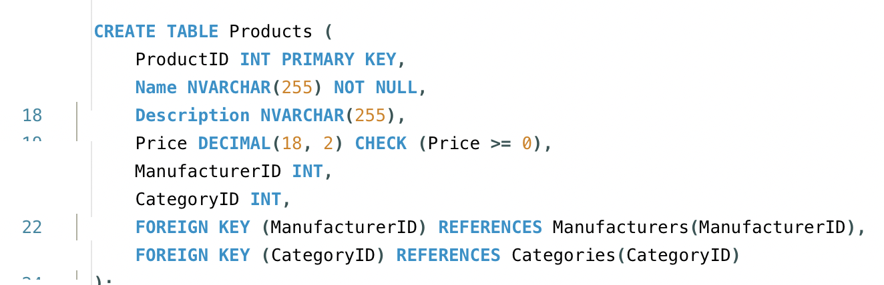
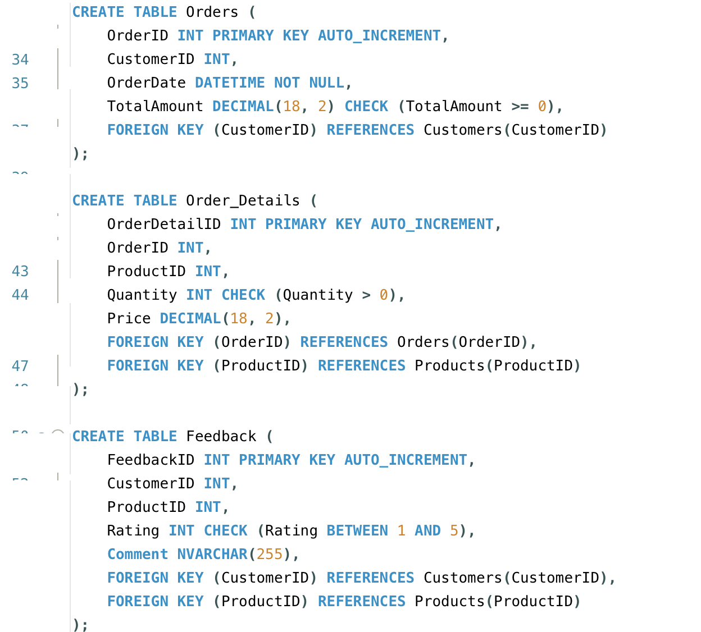
c. SQL code used to create the check constraint(s)

I have circled the check constraints in the screenshots above. These have been put in place to ensure that no order amount (GPB) is less than 0, as this is not possible. The order quantity must be more than 0 and the customer feedback rating needs to be between 1 and 5. These check constraints are critical for maintaining data accuracy and consistency in your database. They enforce specific rules that the data must adhere to, ensuring that only valid data can be inserted into the tables.

d. SQL code to populate each table with sample data (minimum of four records per table)
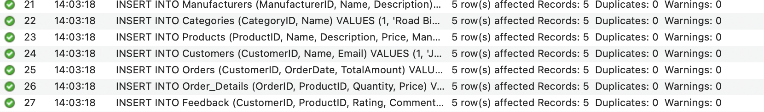
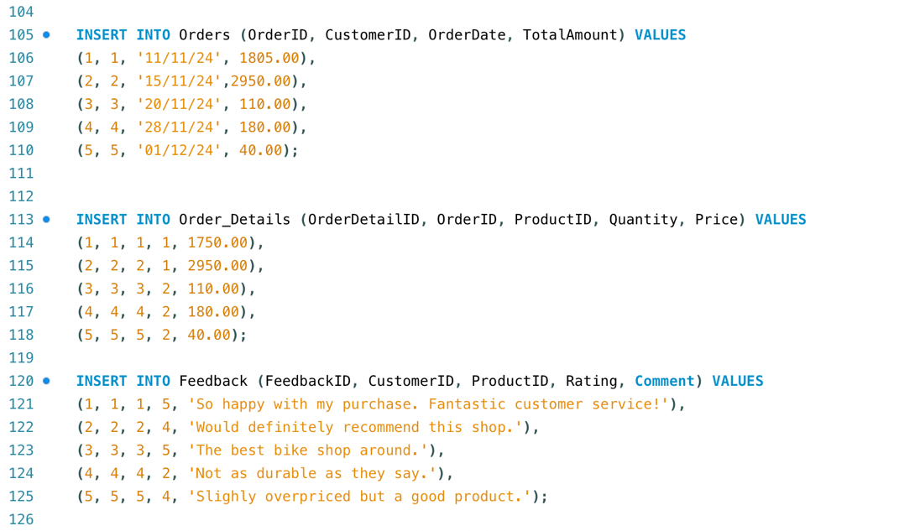
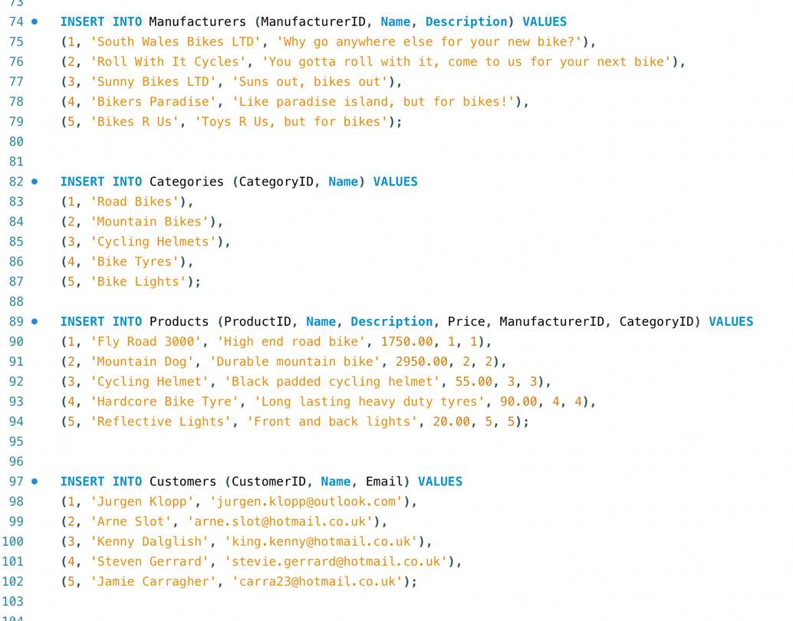
The above screenshots show that I have added realistic data to each table. I have added 5 different entries to each table, showing different products, prices, customers and categories etc.

e. SQL code to demonstrate evidence of testing carried out to validate the constraints

The below screenshot shows that I have tested the constraints and entries that I have put in my database. It clearly shows the different orders that have been placed, the total amount as well as the quantities, products and order ID which is auto incremented.
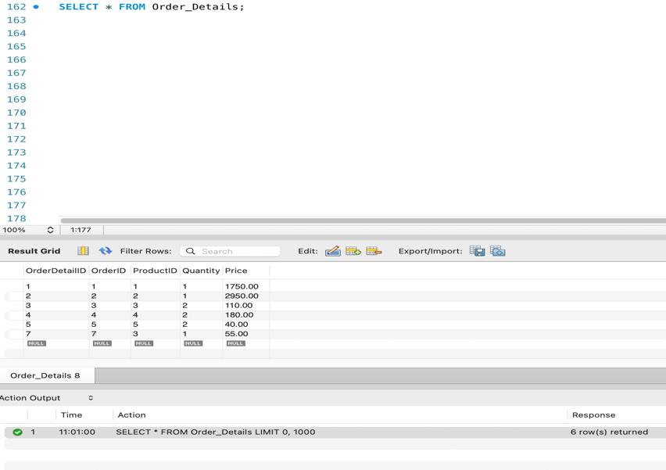

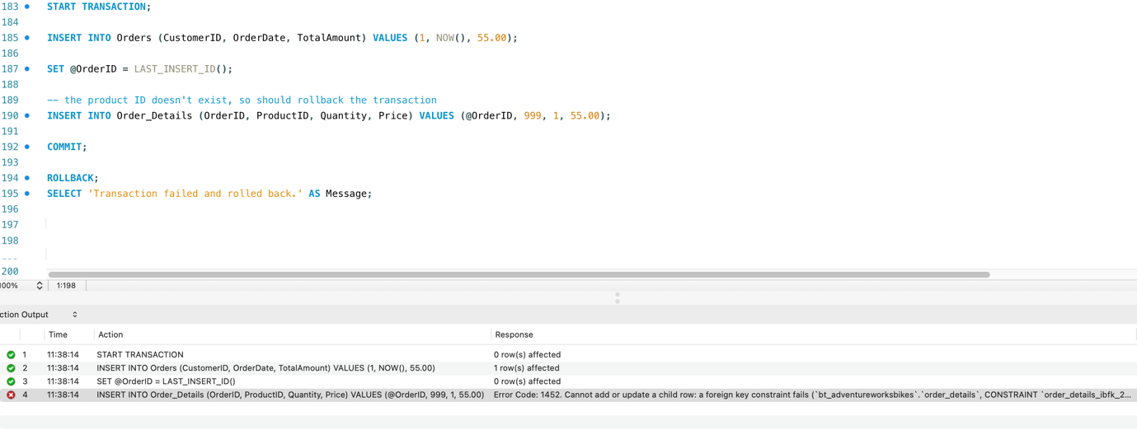
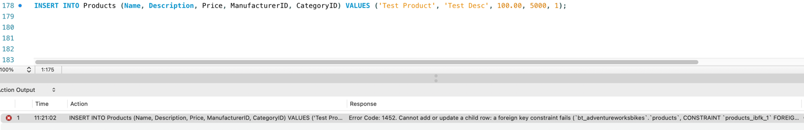
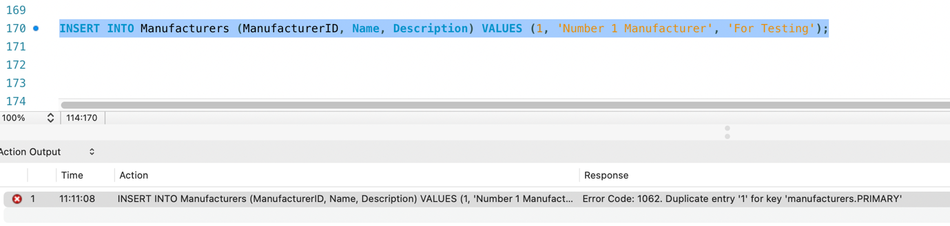
This is a test to try and insert a duplicate manufacturing ID into the manufacturer table. The error is returned that there is a duplicate entry for ‘1’ (ManufacturerID). This is a Primary Key test constraint.
The below screenshot shows a rollback occurring when a faulty transaction is run. I inserted a product ID which doesn’t exist, and the transaction failed and was rolled back.

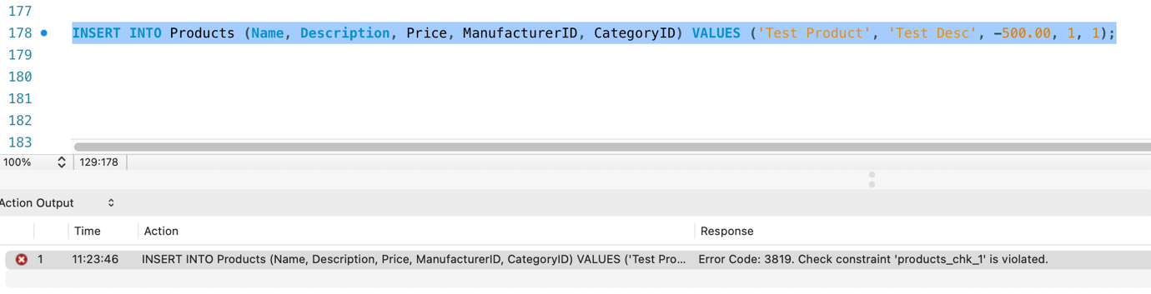
The below screenshot is a test to try and add a new product (Test Product) into the Products table. However, the test product has an invalid manufacturer ID (5000), so is unable to be added into the products table.

The below screenshot is a test to try and add a new product with a negative price into the products table. You can see that the check constraint in the products table has been violated, and the product is unable to be added.
5. Appropriate documented contents for sections 2 and 3 of Task 1
Section 2 – Transactional Scenario
This is the script that I have used to create a transaction or trigger a rollback. I have set it to complete the following steps:
- Insert a new order into the ‘Orders’ table using the customer ID that is set to the name that I have selected. It uses the current date and time, NOW(), and the amount of £55.00 (price of a helmet).
- SET @OrderID creates a new order ID to auto incremement
- Insert into Order_Details then adds the new order into that table. It uses the Product ID of the helmet, as well as the quantity (1) and price (£55.00).
- COMMIT starts the transaction with the message ‘Transaction committed successfully’ to show,
- ROLLBACK occurs when there is an error in a transaction, with the message ‘Transaction failed and rolled back’. This confirms that the transaction did not go through successfully.
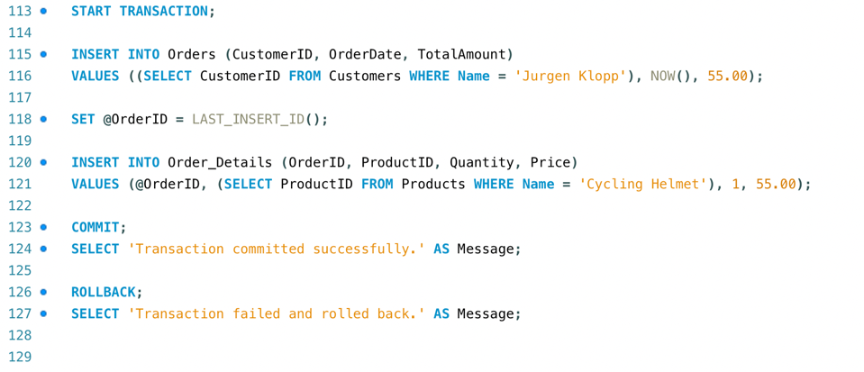

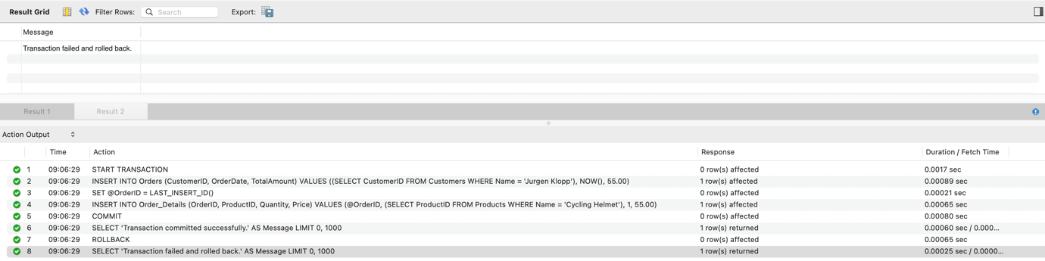
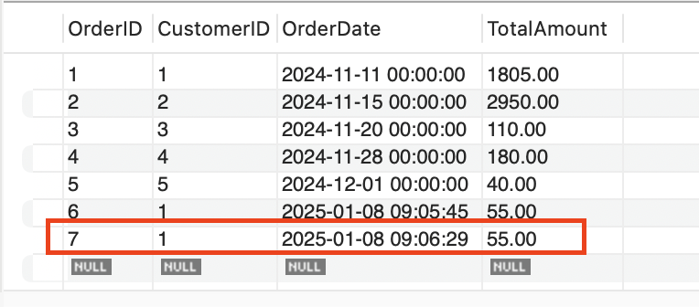
The below screenshots show that I have requested a transaction to be run for the customer Jurgen Klopp to purchase 1 x cycling helmet for £55.00 on the 8th January 2025. The transaction has gone through successfully and is showing in my Orders table.

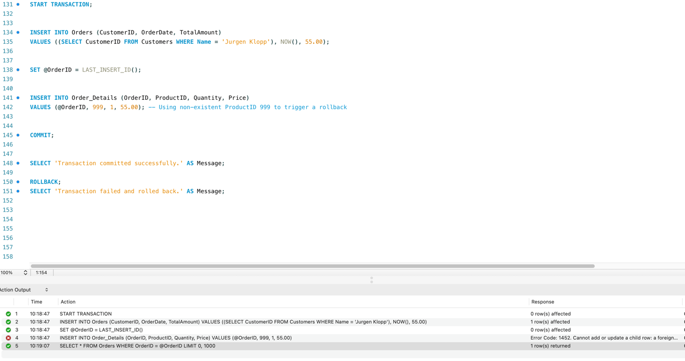
The screenshots below show that I have requested the same transaction to go through, but I have changed the Product ID 999, which doesn’t exist. This will trigger a rollback as shown below.
Section 3 – Secondary Indexes
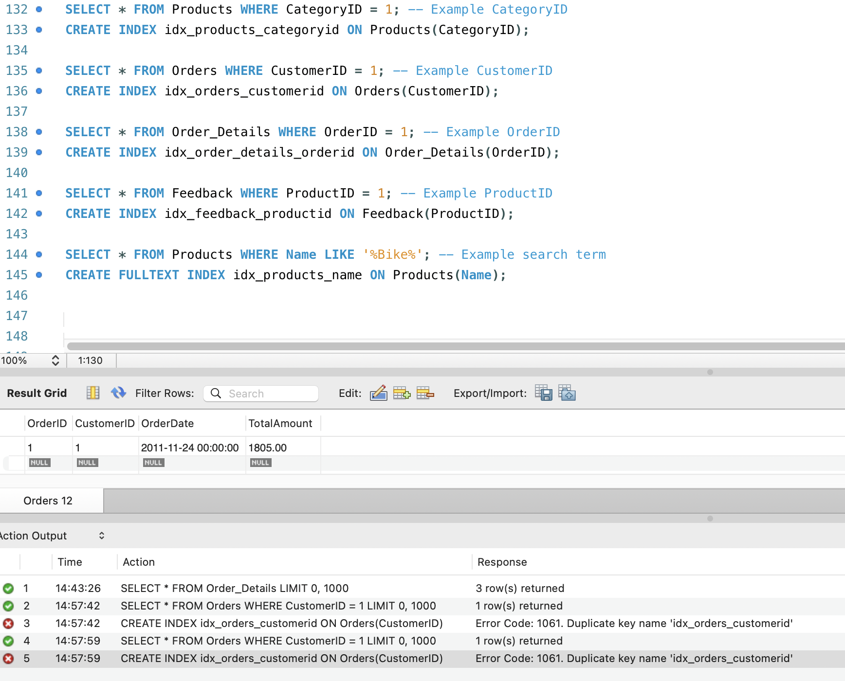
The below screenshot shows that I have put index’s in my code for tuning enhancements.

Category ID - This index speeds up searches for products within specific categories, a common operation in an online marketplace.
Orders - This index optimizes queries that retrieve orders for a specific customer, enhancing the performance of customer order history retrieval.
Order Details - This index improves the speed of fetching order details for a specific order, important for order processing and review.
Feedback - This index enhances the performance of queries that fetch customer feedback and reviews for specific products.
Products - This full-text index improves the performance of search queries that involve text searching and partial matches, making it faster to find products based on their names.
An index is a structure that holds the field the index is sorting and a pointer from each record to their corresponding record in the original table where the data is actually stored. Indexes are used in things like a contact list where the data may be physically stored in the order you add people’s contact information but it is easier to find people when listed out in alphabetical order. Ultimately, indexing makes columns faster to query by creating pointers to where data is stored within a database. Imagine you want to find a piece of information that is within a large database. To get this information out of the database the computer will look through every row until it finds it. If the data you are looking for is towards the very end, this query would take a long time to run. [2]

6. References to any sources that have contributed to your completion of the assignment (to be added at the end of your report).

Bibliography

[1] | “Progress Documentation,” 12 April 2017. [Online]. Available: https://docs.progress.com/bundle/openedge-sql-development-117/page/Need-for-integrity-constraints.html#:~:text=Integrity%20constraints%20are%20necessary%20because,and%20consistent%20at%20all%20times.. [Accessed 02 01 2025].
[2] | “Atlassian,” 09 December 2019. [Online]. Available: https://www.atlassian.com/data/sql/how-indexing-works. [Accessed 02 01 2025].
[3] | B. Bitesize, “Introducing Databases,” [Online]. Available: https://www.bbc.co.uk/bitesize/guides/zc93tv4/revision/5. [Accessed 02 01 2025].

7. An appendix that lists all the prompts used in any generative AI tools, if applicable, as part of your assignment

