DS2 Assignment Khasrul Islam

City Bike Rental

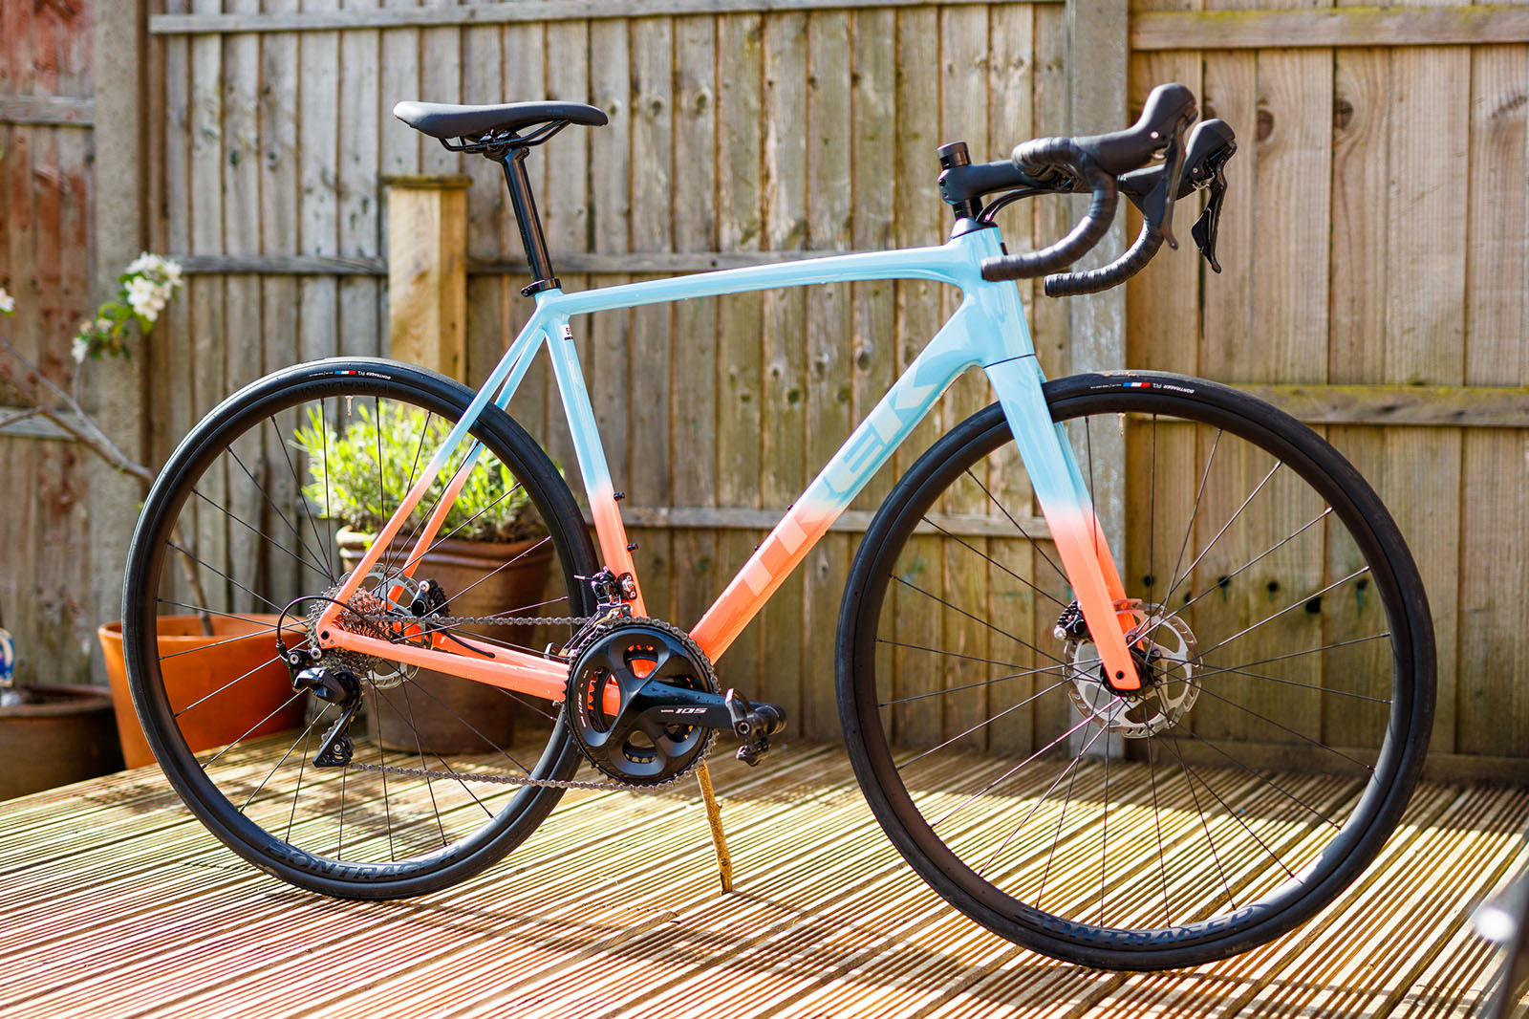

The Data on the Excel to demonstrate Tools used
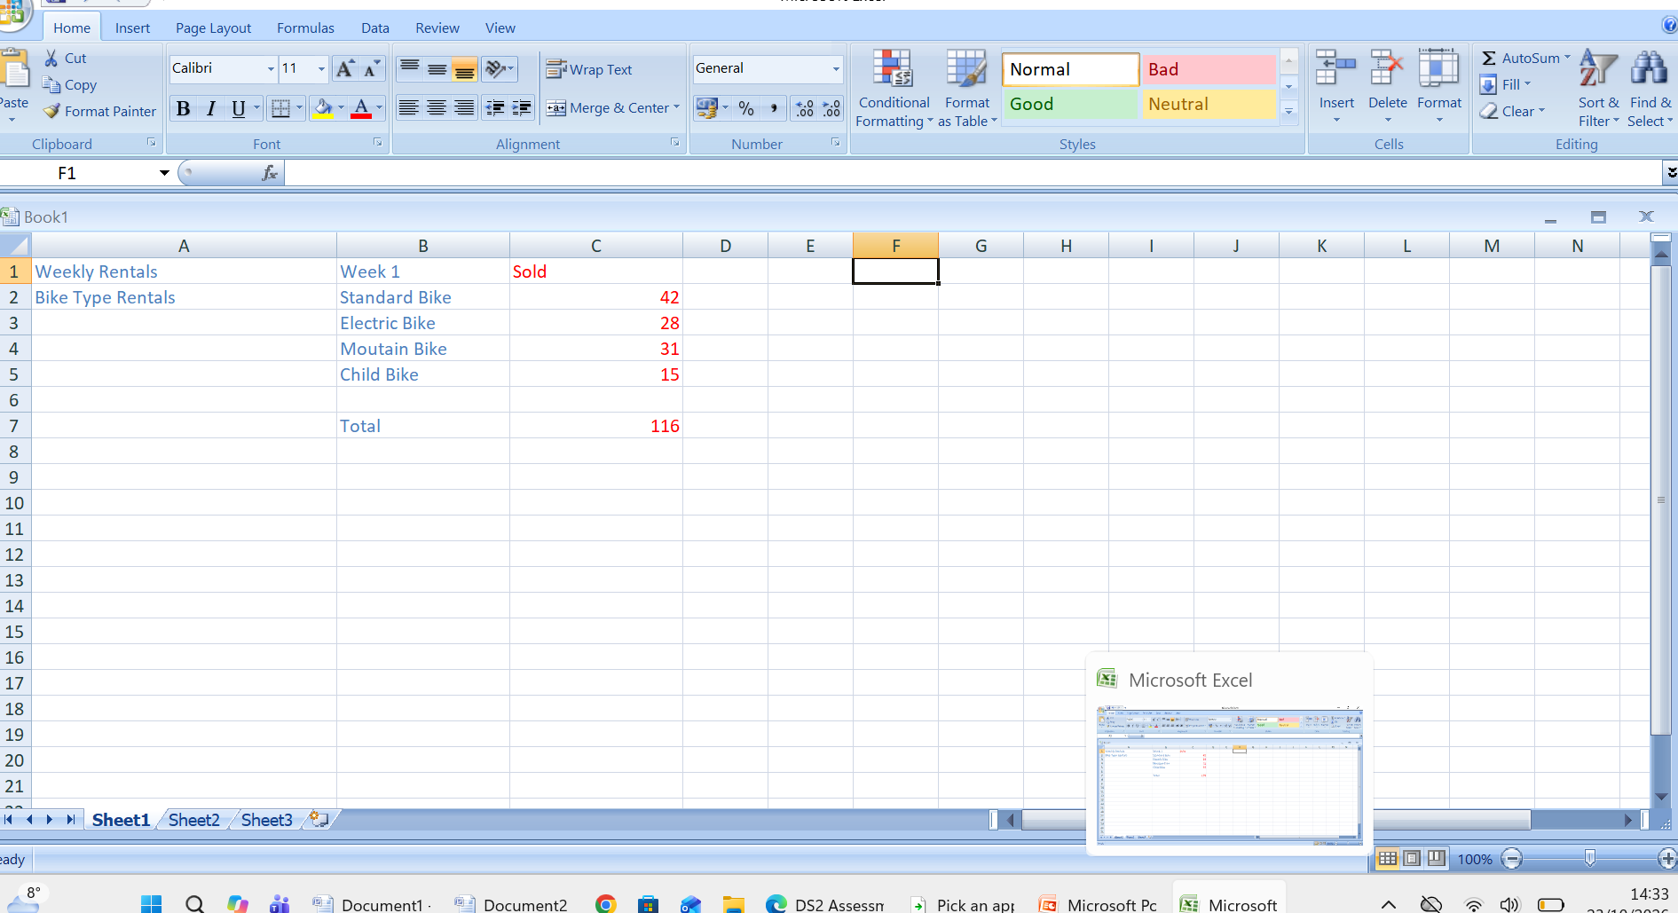

Figures on Bar chart

