Cover Sheet

Student Name: Dafydd Smith
Student Number: 1701805
Course Title: 3D Computer Animation

Module
Research Practices

Assignment Brief
Write a proposal of 2,500 words which explores the surrounding research context for your
emergent area or field of interest.

Tutor
Scott Smith

Word Count:
2397

I am writing this Research Project because of my interests in 3D modelling for games and movies, and for my love for movies in general. I have chosen 3 images from movies that I specifically find to be iconic and revolutionary to the VFX industry.

Before the 90’s, many, if not all visual effects in movies were simple stop motion and people in costumes.
Even though computer animation was used in films such as “Star wars” and “Tron” it wasnt until the early 1990’s with filmes such as “Terminator 2” and “Jurassic park” that there was a use of combining both computer generated imagery composited with live action footage.

Jurassic Park
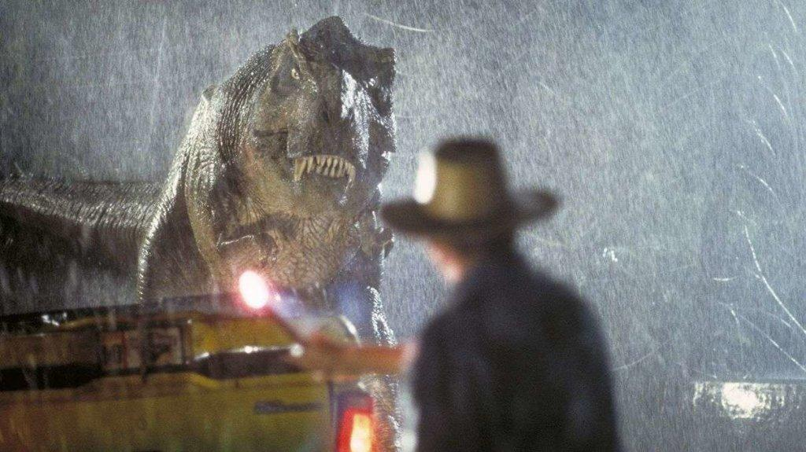

In Jurassic Park, the the T Rex and all of the other dinosaurs were created by Stan Winston, ILM Studios and lastly Phil Tippett, a master of stop motion.
Tippett used a different form of stop motion and really pushed stop motion further than it was before. Tippett knew that the thing stopping stop motion from looking realistic was the sense of everything being more of a flipbook, there was no motion blur to the movement or any sense that the audience were looking at a real object moving in the real world.
Tippett overcame this with a technique he called “Go Motion” which completely changed the way stop motion could be used in films to make them appear more realistic.
The way it works is very simple, yet effective. He moved the model very slightly right before the camera was exposed and took the photo. In the case of the T Rex the models were ILM and Stan Winston's computer controlled models.

Jurassic Park was a huge success as a movie but also was a great leap in terms of CGI (Computer Generated Imagery) which was the most essential part of bringing these dinosaurs to the big screen.
Nowadays CGI is a major part of TV and films which are vastly more impressive than the effects in jurassic park. But at the time of the release this type of CGI was revolutionary.

“Jurassic Park was kind of the nail in the coffin for stop-motion animation in the context of live action feature films. Until it was decided to run everything with CG, everything was done with a system we developed at ILM (Industrial Light & Magic), essentially a computerised live puppet.” (Sked, 2019)
But then, as Tippett puts it, “everything changed”.”
““We were working with technology that was relatively new to all of us. It was a matter of figuring out what you could do and what you couldn’t do. So that was a very vertical learning curve for everybody..….The problem was there wasn’t enough competent computer graphic animators at that time. Their training hadn’t gotten them to a point where they were conversant with doing this particular kind of thing…….All the digital work that had been done previously at ILM for Young Sherlock Holmes, The Abyss and the Terminator 2 robot were all kind of hallucinogenic things…...When you are trying to make real animals look like they actually exist on earth it is a totally different kind of thing.”
So Tippett and his team created a device that was a very early form of what is now known as ‘motion capture’. Dubbed the dinosaur input device, it was essentially a stop-motion model with sensors on it.”” (Sked, 2019)

Ever since Tippet was young he had a passion for hollywood monsters and dinosaurs which continued all the way into adulthood.
His main inspiration while growing up was Ray Harryhausen’s 1985 movie “The 7th Voyage of Sinbad”.
All of this inspired him to to make his very own film involving dinosaurs.

Because of his dinosaur knowledge and his animation talents he became a key member in the making of Jurassic Park.
“I knew a bunch of stuff about dinosaurs, which was why Kathleen Kennedy and Steven (Spielberg) wanted to hire me,” Tippett says. “I understood all the current paleontology, so I had some value from that point of view.” (Sked, 2019)

The Sales of Jurassic Park were highly boosted by a real world major scientific discovery just a day before Jurassic Park was released. Scientists had found trapped insects which were found in some ancient amber, these are said to be the first ever insects
“The effect was really important,” says science historian Elizabeth Jones, who is currently at work on a book on the story of Jurassic Park and ancient DNA. “It boosted ancient DNA as an early science. Something that people had never heard of suddenly became extremely popular.”(Boissoneault, 2018)

Star Wars
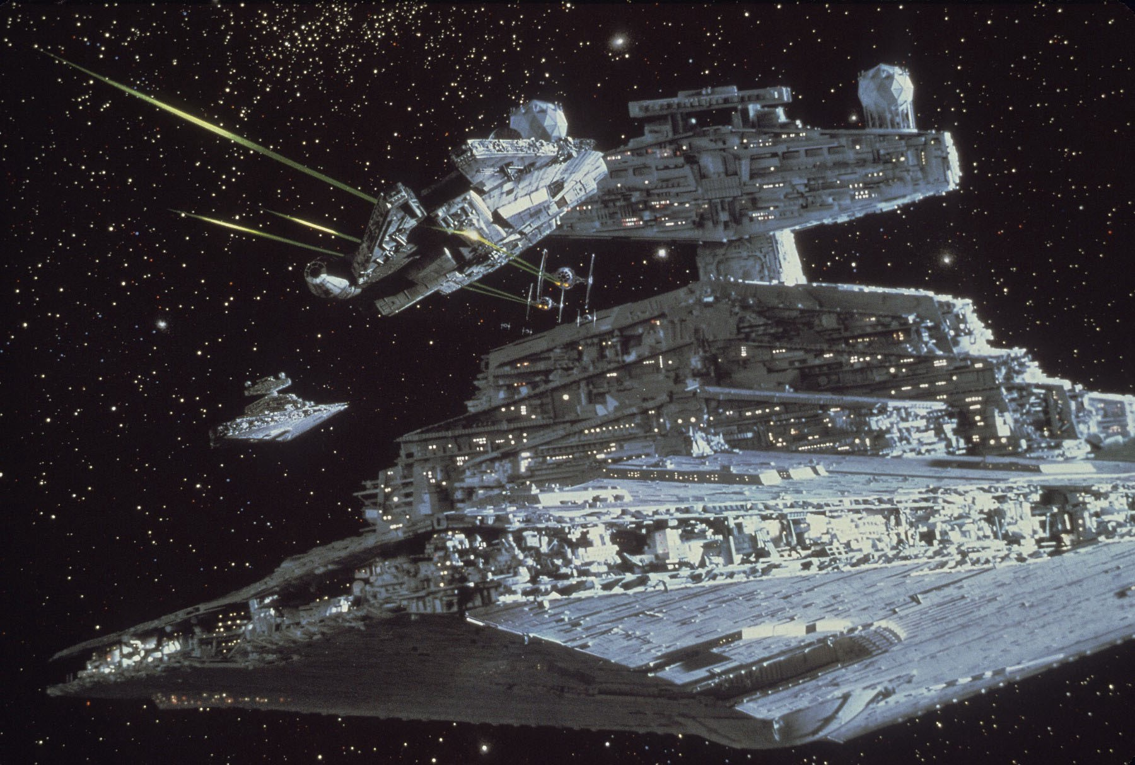
“One of the first and the most significant steps for digital effects was the legendary “Star Wars” in 1977. Spaceship battles in Star Wars were created using the motion-control photography technique and, moreover, it saved a lot of time for movie creators in contrast if they had done spacewars manually.”
(McCarthy, 2007)

The 1970’s were another 10 years of only progression in effects. However it wasn't a good time to be working for many effects studios as a lot of them took a hit from the industry’s recession in the early 1970’s and unfortunately many had to close down.
However luckily in 1977 this finally started improving, this was all because of 1977’s hit Star Wars, which introduced some major improvements in the special effects industry, millions of people were amazed with the amount of effects used in this movie.
This created the special effects studio, Industrial Light and Magic who are even still going today working on films like “Spiderman Far from Home” and Disney's “Aladdin”.
Star wars was not the only 70s film that is still thought of as impressive in the VFX industry today. Other 70’s films such as “The Hindenburg”, “The Poseidon Adventure” and “The Exorcist” all brought a wide majority of techniques together to create the effects in these movies.
Such as matte paintings which is still a widely used technique VFX in today's industry.
The effects in the Exorcist were also considered hugely impressive, one example of an effect they used was to make a persons head rotate 360 degrees which can just show how effects can be used to make grotesque things.
All of this combined made the 70’s a very good and impressive year for Visual Effects.

ILM (Industrial Light and Magic) was started by Dykstra, Edlund while creating their miniature ships for Star Wars, which they would go on to win their first oscar for.
Because of Star Wars being such a huge hit ILM actually went by the code name “Kerner Company”. In which all purchases were done through that name. which stopped the fans from going through all of their rubbish trying to get their hands on some of the Star Wars miniatures.

At the same time of the Star Wars release, there was a lot of hype in the media about the idea of space. “NASA's twin Voyager probes – Voyager 1 and Voyager 2- were launched in 1977 to explore the outer planets in our solar system.”(Howell, 2018)
This made a huge impact in the sales of Star Wars as people were getting excited from exploring space as it was happening in the real world.

Jungle Book
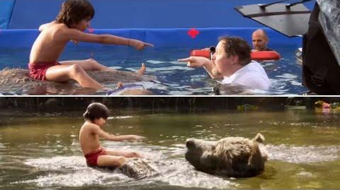

“The Jungle Book” (2016) had outstanding effects. Worked on by MPC and Weta Digital, creating 54 types of animations as well as a complete CGI jungle for Mowgli to explore.
There were also many simulations made by MPC, who simulated water, fire and earth.
The most famous characters created completely in CG were Baloo, Mowgli, Bagheera and many more included in The Jungle Book Story.
In total there were 224 Unique animals created for this movie completely in CG

Rob Legato learned how to integrate environments with digital figures from both Cameron and Scorsese. From creating algorithms which allow the first digital people to move on board the deck of the “Titanic” to creating crash scene from “Aviator” in which the camera pan and tilt would be replicated on a computer. “We shoot as if it’s real” he said. “On ‘Avatar,’ Jim would add motion capture to it to take advantage of CG” (Thompson, A. ,2017)

Because the jungle in The Jungle book was completely CG, it was okay that it was almost impossible to travel around if it were in the real world. The work that the VFX team put into creating this jungle immersed audiences with vibrant and exotic environment much on par with Avatars Pandora.

“Legato built on and advanced effects techniques from “Avatar” and “Gravity.” “The movie is a bit of a Frankenstein,” Favreau said. “It worked.” (Thompson, 2017)
The amount of depth that Legato took to make the film as realistic as it could be is just extraordinary. To the extent of making a digital camera an actual element in the scene in the seem to make it appear as though it was shot in real life.

“Disney agreed to go whole hog with realism, said Legato. “Everybody was on board making the same realistically rendered movie,” he explained. “We went through to design the shots — so you can hear a tiger shake an imaginary camera on the ground and kick dirt into the lens, like you’d put into an action movie as a cool piece of footage. We made it up and put it in on purpose just to remind the audience, we’d purposely screw up the shot to let everyone know the camera was there, a piece of glass hit with mud.””
(Thompson, 2017)

Legato used something similar to Tippet’s “Go Motion” method in which he tries to make sure every frame isn't perfect, and has the imperfections that a real world or creature would have. Legato does this by trying to simulate the look of a camera even when working with CG. Making “subtle reminders of live action movies that people have seen before, by putting something out of focus, instead of nailing it on a computer so everything is perfect,” (Thompson, 2017).
This alone is subconsciously telling the viewer that what they're watching was really filmed, by a real person in a real place, even when it was not.

The details that Legato went into when creating this movie was extraordinary, one of the challenges the team faced when creating this movie was how the animal mouths would be moved by human words. However Legato found his way of making the human mouths seem natural and realistic.
“This naturalism extended to how animal mouths moved around human words. “We don’t make them human,” said Legato. “They don’t enunciate every word. The voice that comes out of a parrot doesn’t do anything a parrot can’t do.”(Thompson, 2017)

Sethi (The actor who played Mowgli) was also recreated completely in CG and this 3D double of him was used in around 100 scenes. This means that were were parts which were truly 100% animation CGI. The human eye is very good at spotting fakes, and so to do this was both daring and impressive, “something odd, but you don’t know what it is,” said Legato. “The stand-in has to give complete physicality that Sethi doesn’t have as individual actor. We literally photographed or motion-captured on screen the CG double crawling up to the tree and looking at the man village, or being held by the snake.”(Thompson, 2017).

Sethi had many real life doubles all specialised in different things that Sethi couldn't do himself. After every “performance” from one of these actors the movements were then recreated perfectly in CG, recreating what a real human can do.

This movie had a huge success at the VES Awards and the BAFTAs in 2017 but The Jungle Book had the most unique VFX process of all of the other studios there, because this movie was shot completely against a blue screen with all of the environments and all the characters (except Mowgli) being completely CGI, making this move, almost 100% animated.
MPC ended up being the film's lead visual effects studio.
“"This is a very proud day for me and my crew at MPC," said MPC VFX supervisor Adam Valdez at the awards ceremony. "I speak for everyone when I say how grateful we are for this honour from the Academy. Taking part in making a great film is a rare gift. Being recognised for our craft is deeply gratifying.”
On that night Valdez said “This is a very proud day for me and my crew at MPC. I speak for everyone who was lucky enough to work with Jon Favreau and the great team at Disney when I say how grateful we are for this honor from the Academy. Taking part in making a great film is a rare gift. Being recognized for our craft is deeply gratifying.”” (Harris, 2017)

One of the things that this movie did superbly was they created everything within the realms of reality. In an interview with Adam Valdez he said “I think here we all had one goal: a magic trick. Will the audience feel like they’re really watching this kid in the jungle with animals? So the approach was, let’s not make this too spectacular or it will lose credibility.” (Frei, 2016)

The jungle book also had a real world impact in the form of trying to protect pangolins, a currently endangered species.
“Jon Favreau, director of the 2016 remake of the Jungle Book, has said Los Angeles Zoo staff suggested the inclusion of a pangolin – a critically endangered species which subsequently received widespread media coverage. Disney added a pangolin to its merchandise selection as a “commitment to raise awareness”.”(Exeter.ac.uk, 2017)

Computer Generated Imagery (CGI) visual effects are a major part of the movie industry today. The development of CGI has continued to improve since the first CGI movie was created. The three images I chose were movies iconic to me but through them I could clearly see the changes and leaps in VFX.
I find it interesting how it can be used in so many different ways: in a natural realistic way hardly noticed (rain, fire etc.), to create creatures which don't actually exist, amazing environments, dynamic effect (explosions, collisions etc) the list is endless.

CGI can make a mundane movie exciting but some people are beginning to consider CGI to be overused.

How CGI has changed movies today?
How has CGI changed the viewing experience?
Bibliography

Sked, J. (2019). Jurassic Park at 25: how a dinosaur supervisor created its iconic effects and scenes. [online] inews.co.uk. Available at: https://inews.co.uk/culture/film/jurassic-park-effects

Thompson, A. (2017). Here’s Why ‘The Jungle Book’ Deserves More Oscar Respect. [online] IndieWire. Available at: https://www.indiewire.com/2017/01/the-jungle-book-oscar-jon-favreau-interview-visual-effects-1201768343/

McCarthy, E. (2007). 10 scenes that changed movie history. Popular Mechanics 2007, (184), pp.64-65.

Harris, M. (2017). How the 2017 Oscar-winning VFX of The Jungle Book were created. [online] Digital Arts. Available at: https://www.digitalartsonline.co.uk/features/motion-graphics/how-2017-oscar-winning-vfx-of-jungle-book-were-created/

Frei, V. (2016). THE JUNGLE BOOK: Adam Valdez – VFX Supervisor – MPC. [online] The Art of VFX. Available at: https://www.artofvfx.com/the-jungle-book-adam-valdez-vfx-supervisor-mpc/

Pluralsight.com. (2015). The Evolution of VFX in Movies: The 60s Till Now. [online] Available at: https://www.pluralsight.com/blog/film-games/evolution-vfx-movies-60s-till-now

Pierce, T. (2018). The force behind the original “Star Wars” magic: VFX legend Richard Edlund. [online] Medium. Available at: https://medium.com/art-science/the-force-behind-the-original-star-wars-magic-vfx-legend-richard-edlund-8cc8ef632e8b

Edlund, R. (2019). Richard Edlund, ASC - About. [online] Richardedlund.com. Available at: http://www.richardedlund.com/about.html

Exeter.ac.uk. (2017). Featured news - Conservationists should harness ‘Hollywood effect’ to help wildlife - University of Exeter. [online] Available at: https://www.exeter.ac.uk/news/featurednews/title_611657_en.html

Howell, E. (2018). Voyager Spacecraft: Beyond the Solar System. [online] Space.com. Available at: https://www.space.com/17205-voyager-spacecraft.html

Boissoneault, L. (2018). Jurassic Park's Unlikely Symbiosis With Real-World Science. [online] Smithsonian. Available at: https://www.smithsonianmag.com/science-nature/jurassic-park-reveals-delicate-interplay-between-science-and-science-fiction-180969331/

