

Assessment 2

Student name:​ Elizabeth Cuffie
Student ID: ​ (1913507)
Module name: Mental Disorders and Psychopathology​
Module code: BMHP6006_LON
Lecturer name: Bianca Sanfilippo

Contents page number

Introduction - 3
General anxiety disorder 3
Classification of GAD within ICD-10 3
Causes of anxiety 4
When anxiety can be diagnosed 5
Current treatments (give an evaluation = positive and negative).
Divide the treatments according to the severity 6
Schizophrenia - (1000 words for Schizophrenia) 7
Data on Schizophrenia in the World and UK 7
classification (Schizophrenia within the ICD–10 is classified as
schizotypal and delusional disorders (F20-F29), 7-8
Autism 9
Data on children, people with autism in the world and the UK 9-10
Causes/Diagnosis 10
Conclusion 11
Recommendation 12-13
References 14-16

Introduction

In this report, a critical examination of the classification, diagnosis, treatment and measurements of rehabilitation of 3 mental disorders from the ICD-10 (WHO, 2010) will be provided, such as General Anxiety Disorder, Schizophrenia and Autism and will provide recommendations for one or more of the aspects that will be discussed in this report.
Literature
General Anxiety Disorder (GAD) (1000 words for general anxiety disorder)
General Anxiety Disorder, according to the NHS (2021) is defined as a constant feeling of stress, extreme panic and fear which can have a serious detrimental impact on an individual’s everyday life, affecting physical and mental health and wellbeing. One key difference between GAD and normal anxiety according to NHS (2022) is that GAD is a long-term condition which is causing people to feel anxious about many things and situations instead of simply being anxious about an issue, as a result of this, they are never relaxed because one issue is always replaced with another.
Szalek, Welch and Thekkumpurath (2021) argued that anxiety is a form of arousal which is required for action. Adding that the problem then becomes when it is too much because too much anxiety is damaging to constructive action.
Classification of GAD within ICD-10
The WHO classified mental and behavioural disorders into different categories starting from F00 – F99. However, for this report, the focus is on GAD, which is classified within ‘F40-F48 Neurotic, stress-related and somatoform disorders. Gad is under F41.1

  - People suffering from a general anxiety disorder in the UK.
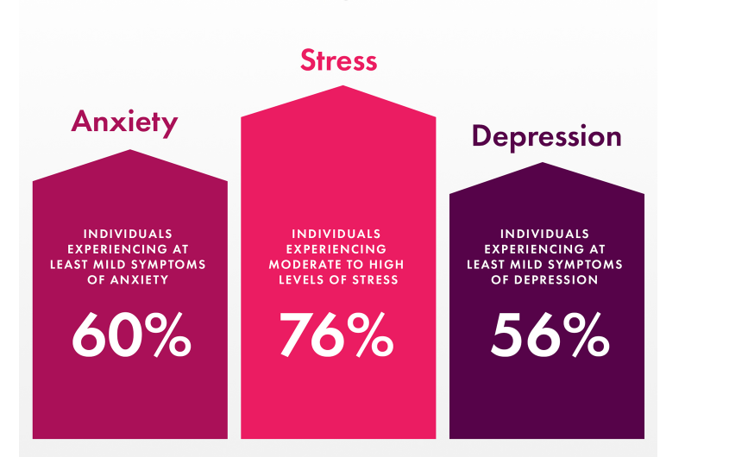

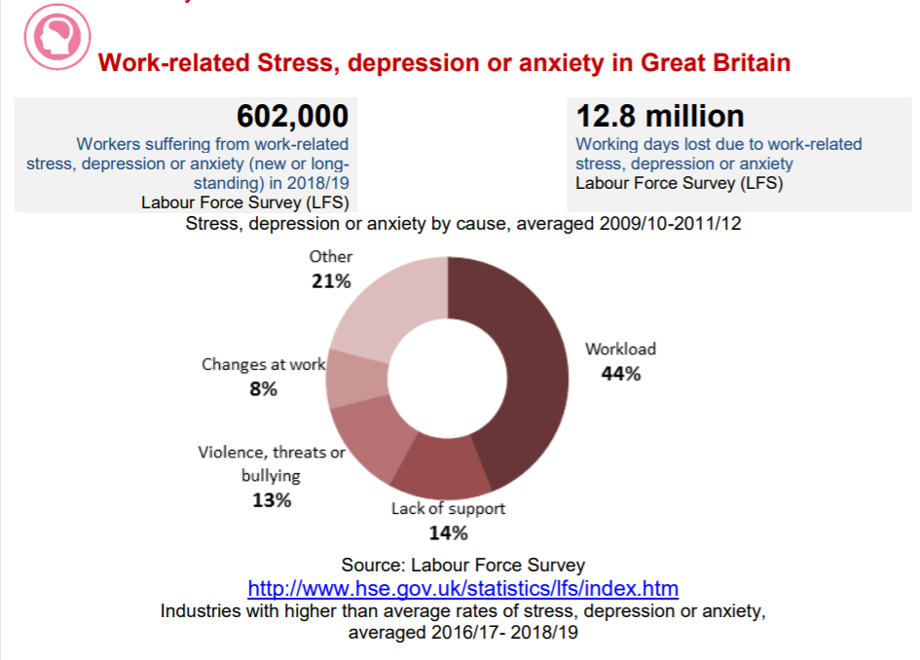

Source: anxiety in UK percentage 2020 - Bing images

Causes of anxiety (Aetiology)
Mental Health UK (n.d), explained that there is no one cause of anxiety because there are many things that could lead to someone developing anxiety, amongst many things identified in the week 3 teaching slide (2023):
Genetics – Some people are influenced by the gene they are born with which causes them to be more anxious than other people.
Life experience – the personal experiences that people go through can also cause people to develop an anxiety disorder. For example, a traumatic experience of growing up in a war-torn country.
Drugs – Some legal drugs such as caffeine and alcohol and illegal drugs such as cocaine and cannabis can impact one’s body which can make people feel really anxious.
Personal circumstances – People may be experiencing personal challenges that they are aware of which is causing them to be anxious, when this problem is fixed, the anxiety will disappear.

The signs and symptoms
Worry, the symbol symptom of (GAD), is a spoken language pattern of fearful thoughts of the future and for sufferers of GAD, this thinking style is constant and cannot be controlled (Taylor et al., 2021). Even though worry is treated as a style of continuous adverse thinking, there are some traits that set it apart from other forms of negative thoughts, such that individuals who worry display inadequacies in self-consciousness and working memory, regardless of GAD status; worry and its associated working memory deficits also have been linked to academic difficulties (Taylor et al., 2021).
Other signs and symptoms identified by the WHO include complaints of persistent nervousness, trembling, muscle tension, sweating, light-headedness, dizziness and epigastric discomfort. Furthermore, the week 3 teaching slide (2023) listed mental and physical symptoms associated with GAD, not exclusive to changes in appetite, problems with sleeping, feeling irritable, heavy and breathing fast, hair loss, dry mouth and hot flushes and brushes. As a result of these signs and symptoms, sufferers would want to run away from these feelings or thoughts, try to avoid the situation, or would be fidgety.
When anxiety can be diagnosed
Someone is most likely to be diagnosed with GAD if they have had some or all of the above-mentioned symptoms for 6 months or more. Not only that but finding it difficult to manage one’s feelings of anxiety is also an indication that you may have the condition. Determining when anxiety is too much and has become a disorder can be challenging. Szalek, Welch and Thekkumpurath (2021) said that things that trigger intervention are severity/intensity, duration, a trivial stimulus or situation as a trigger, and deviation from the previous level of functioning with a detrimental impact on social, occupational or personal life.
Also, NHS (2022) explained that, because GAD is very difficult to diagnose, in order to help with the diagnosis, GPs may carry out a physical examination or blood tests to rule out other conditions that may be causing the symptoms, such as anaemia (a deficiency in iron or vitamin B12 and folate) or an overactive thyroid gland hyperthyroidism) Questionnaires can be completed by the patients. GAD7
Current treatments (give an evaluation = positive and negative). Divide the treatments according to the severity
Generalised anxiety disorder (GAD) is by far the most common anxiety disorder seen in older adults (Szalek, Welch and Thekkumpurath, 2021). It is always important to consider the level of distress, including suicide risk, and functional impairment, rather than solely relying on the number, severity or duration of symptoms. At the first stage of GAD, currently treated usually through self-help. Meaning there are things the person suffering from mild GAD can do to help reduce the anxiety. These include but are not limited to taking self-help courses, doing regular exercise, healthy eating, sleeping well, quitting smoking, reducing alcohol and caffeine consumption, applied relaxation techniques and exploring mental health apps and tools in the NHS Library.
If the above is not working, a sufferer can refer themselves directly to the NHS for cognitive behavioural therapy (CBT) talking therapies without any prescription, which is beneficial because it helps the person manage their problems by altering their thoughts and behaviour (NHS, 2022). However, this report observes that this may not be an effective approach as it is relying on someone who is struggling mentally to make the initial contact.
At the extreme end, long or short-term medications will be prescribed. However, as Baldwin (2022) explained, many patients will experience negative unwanted effects during treatment and significant distress when the dosage is reduced and/or stopped due to the development of dependence.
Principles of care for people with generalised anxiety disorder (GAD)
(NICE)
The National Institute for Health and Care Excellence (NICE) developed 3 Principles of care which provide support for people with generalised anxiety disorder, their Carers and their families. Some of the information includes but is not limited to building a relationship and working in an open, engaging and non-judgemental manner, exploring the person's worries in order to jointly understand the impact of GAD, providing information appropriate to the person's level of understanding about the nature of GAD and the range of treatments available, negotiating between the person with GAD and their family or carers about confidentiality and the sharing of information and providing written and verbal information on GAD and its management, including how families and carers can support the person (NICE, 2011)
Schizophrenia - (1000 words for Schizophrenia)
Definition
Schizophrenia is one of the most severe mental disorders when it comes to its detrimental effects on various psychosocial areas and the overall quality of life of the patient (Mahfoud et al., 2023). NHS (2023) defined Schizophrenia as a long-term mental health condition that causes many diverse psychological symptoms causing the individual to sometimes not be able to differentiate their own thoughts and ideas.
Data on Schizophrenia in the World and UK
The estimates of the international prevalence of schizophrenia among non-institutionalized individuals are 0.33% to 0.75% (Larrauri, Travaglia, and Brady, 2023). WHO (2022) estimates that Schizophrenia affects approximately 24 million people or 1 in 300 people (0.32%) worldwide. This rate is 1 in 222 people (0.45%) among adults. In England, Seminog et al. (2022), estimates that schizophrenia accounts for a quarter of all psychiatric admissions in the age group 10–18 years, and the admission rate increases with age. NICE (2009) estimated that the prevalence across all ages and populations in the UK is 0.7%, In 1992/93 the direct cost of health and social care for people with schizophrenia was estimated to be 2.8% of total NHS expenditure, and 5.4% of NHS inpatient costs. Health and social services costs alone amounted to £810 million, of which inpatient care cost more than £652 million.
classification (Schizophrenia within the ICD–10 is classified as schizotypal and delusional disorders (F20-F29),
WHO classifies Schizophrenia within the ICD–10 as those that can either be continuous, or episodic with progressive or stable deficit, or there can be one or more episodes with complete or incomplete remission. Hence, the F20 category has 8 different classes starting with F20.0 Paranoid schizophrenia, F20.1 Hebephrenic schizophrenia, F20.2Catatonic schizophrenia, F20.3Undifferentiated schizophrenia, F20.4Post-schizophrenic depression, F20.5 Residual schizophrenia, F20.6 Simple schizophrenia, F20.8 Other schizophrenia and F20.9 Unspecified schizophrenia (World Health Organisation, 2016).
Causes (Aetiology)
Chandak (n.d) stated that multiple factors normally lead to the onset of schizophrenia, however, actual studies do not exist that show a full understanding of the causes of schizophrenia. Numerous studies such as Du et al (2021), have looked at the causes of schizophrenia from different perspectives. Factors that are common amongst these studies that could cause schizophrenia include brain chemistry or brain abnormality, transplantation from a person with schizophrenia, heredity, and complications during pregnancy and birth.

Signs/Symptoms
Schizophrenia is very difficult to diagnose due to its symptoms. However, WHO (2022) notes that Schizophrenia can be identified by major deteriorations in the way reality is seen and the changes in behaviour related to continuous delusions, persistent hallucinations, hearing, smelling, seeing, touching, or feeling things that are non-existent, experiences of influence, control or passivity, disorganized thinking, which is often observed as jumbled or irrelevant speech, highly disorganised behaviour very limited speech, restricted experience and expression of emotions, inability to experience interest or pleasure, and social withdrawal and/or extreme agitation or slowing of movements, maintenance of unusual postures.
People with schizophrenia often also experience persistent difficulties with their cognitive or thinking skills, such as memory, attention, and problem-solving.
Diagnosis
Substance abuse is very common in schizophrenia and is linked to many negative results (Potvin, Sepehry and Stip, 2007). However, there is no single test for schizophrenia and it mental health specialists that can diagnose such after an assessment.
Current treatments
There is no current cure for schizophrenia, what the health professional does is reduce the severity of the schizophrenic episode through treatment through therapy (psychosocial intervention and social training) and medication (which help in stopping things like delusions, hallucinations etc.).
measurements of rehabilitation,

With this condition, we can only measure the quality of care and treatments provided to effectively control and manage the condition and avoid complications, such as self-harm and suicide, substance misuse, neglect and self-neglect, lack of dignity and violation of human rights. A measure of the quality of life with the indicators that are used for long-term mental disorders is done using the Quality Indicator for Rehabilitative Care(QuIRC-SA)’ usually completed by a manager or senior member of staff. This tool includes specific indicators that show that quality of care and effectiveness are provided to manage the condition, these include the living environment, therapeutic environment, treatments and Interventions, self-management and autonomy, social interface, human rights and recovery-based practice) which are then compared to the average ratings of similar services in your country (QuIRC-SA, n.d). Schizophrenia is a long-term condition, and, in this case, it is important to support the service users to have a good quality of life. We can measure this by using indicators for rehabilitative care which apply to all long-term mental health conditions.
Guidance and principle of Care NICE
The clinical guidance given by NICE covers recognising and managing psychosis and schizophrenia in adults. According to NICE (2014), this guidance and principle aim to improve care through early recognition and treatment, and by focusing on long-term recovery. Actions that improve the service users’ experience, supporting carers, understanding the race, culture and ethnicity of the service, providing complete/detailed services, sharing of information and decision-making would

Autism - 1000 words for autism

The definition of autism has evolved over the years and could continue to do so in future years as knowledge of autism continues to increase (National Autistic Society, n.d). Another reason for these changes in definitions is that practitioners and academics alike feel the spectrum is too broad, arguing an autistic person with 24-hour support needs should not be compared with a person who needs little or no support.
Notwithstanding, the Centres for Disease Control and Prevention (CDC) (2022) defined autism as a developmental disability caused by differences in the brain, which often lead to problems with social communication and interaction, and restricted or repetitive behaviours or interests.
Classification (F80-F89 Disorders of psychological development, ICD, 2010)

Data on children, people with autism in the world and the UK

WHO (2023) points out that 1 in 100 children in the world has autism. However, that figure is far less according to CDC (2023), which they say is 1 in 36 children as of 2020, prior to this, in 2018, the figure was 1 in 44, in 2018, the figure was 1 in 54, Furthermore, figures from CDC (2023), show that ASD is nearly 4 times more common among boys than among girls. Between 2009-2017, about 1 in 6 (17%) children aged 3–17 years were diagnosed with a developmental disability.
In the UK, according to the National Autistic Society (n.d), there are around 700,000 autistic adults and children in the UK.
The below figure compares children born in 2016 and 2020 in the USA and the likelihood of being identified as having autism.
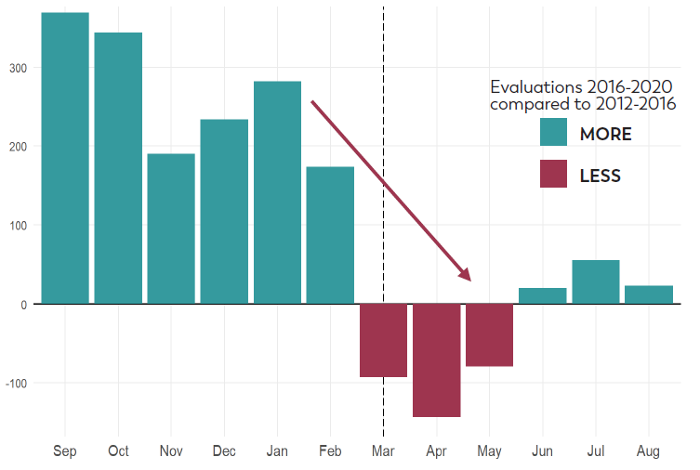
Source: CDC (2023).

Causes (Aetiology)

NHS (2022) acknowledge that it is unclear what causes autism or if it has a cause. (National Autistic Society, n.d) suggests that evidence may point to the notion that autism may be genetic, with research into identification of the specific genes that might be implicated in autism is still ongoing. Despite this, Autism is believed to be likely caused by multiple genes rather than a single gene. Signs /symptoms
Diagnosis

The advice from NHS (2022) is that if a person (adult or child) displays signs of autism, the starting point for diagnosis is to discuss with medical practitioners such as (GP), Health Visitors (for children under 5) any other health professional you or your child see, such as another doctor or therapist special educational needs (SENCO) staff at your child's school to determine whether an autism assessment should be done.
autism assessment

An autism assessment is where a team of autism specialists check if you or your child are autistic. This procedure is determined by whether the assessment is for a child or an adult (who can complete a self-referral questionnaire). The National Autistic Society (n.d) noted that there are many tools that are used to diagnose autism, however, these mainly centre around descriptions of the person’s development and behaviour collected via an interview and direct observation of that behaviour.
NHS (2022) explains that an assessment team may ask the parent or carer or adult about any problems the child or adult is experiencing whilst interacting with other people speak to people who know you or your child well, such as family, friends, your GP or your child's teachers.
During an assessment of a child, the health practitioner may ask the parent or carer about the child's development, such as when they started talking. They will observe how you and your child interact, and how your child plays and read any reports sent by the GP and the nursery or school. A member of the team may also visit your child's school to watch them in class and at break time. At the end of the assessment, you'll be given a report saying if you or your child are autistic.
Diagnostic measures include The Autism Diagnostic Interview-Revised (ADI-R).

Another tool available to health practitioners to aid the diagnosis of autism is the ADI-R (a clinical diagnostic instrument for assessing autism in children and adults 18 months and above) (National Autistic Society, n.d). The tool centres around the behaviour of the person being assessed. For example, do they engage in two-way social interaction, how do they communicate, and the language used and whether they engage in any restricted and repetitive, stereotyped interests and behaviours?
Current treatments

In their study of the theories of autism and this has impacted practice, (Vivanti and Messinger, 2021) argued throughout history, autism and its treatment have experienced many changes which are caused by changes in the way autism is understood in academia. Notwithstanding, the approach adopted is to minimise the symptoms and maximise the person’s abilities by giving them suitable therapies and interventions (National Institute of Health (NIH), 2021).
According to NIH (2021), treatment must focus on the specific needs of the person. These treatments include early intervention, behavioural management therapy, cognitive behaviour therapy, educational and school-based therapies, joint attention therapy, medication therapy, nutritional therapy, occupational therapy, parent-mediated therapy, physical therapy, social skills training and speech and language therapy.
measurements of rehabilitation: ‘Childhood Autism Rating Scale (CARS)’ and observation, called ADOS - ‘Autism Diagnostic Observation Schedule’.

According to Schopler et al. (2010), Childhood Autism Rating Scale is a clinical rating scale used in rating the spectrum of autism disorder in children and adults after observation. Research shows that CARS has now been replaced by CARS–2 because it was not accurate in its identification of higher-functioning individuals. The rating scale includes 15 things that are scored but are not limited to body use, object use, emotional response etc.

Guidance and principle of care - NICE
In a publication on autism spectrum disorder in adults, diagnosis and management, NICE (2012) developed 11 guidance and principle of care for working with autistic adults and their families, partners and carers. These include but are not limited to partnership working relationships, staff must understand the nature, development and course of autism and encouraging autistic adults to participate in self-help or support groups or access one-to-one support.

Conclusion

This report started with a definition of General Anxiety Disorder (GAD), Schizophrenia and autism and showed how they are classified and the statistics of people suffering from these mental conditions. The causes of anxiety Schizophrenia and autism, their signs and symptoms, and their diagnosis were also identified and discussed. A critical review of current treatments for anxiety Schizophrenia and autism was discussed, and the principles of care were also discussed for each of the conditions.
Based on the findings from the research, the following recommendations are suggested:
Recommendations for improvement of anxiety (Complementary therapies)
- Use of complementary therapies. For example, studies, such as Shohani et al. (2018) demonstrated the effectiveness of yoga in reducing anxiety in women. This will have a positive impact as it will reduce the use of drugs and their side effects.

- Using high-intensity interval training (HIIT). Findings from studies, for example, Orumiyehei et al. (2022) show that undertaking high-intensity interval training reduces the possibility of anxiety behaviour.

Recommendations for improvement of Schizophrenia
- Literature such as the Harvard Mental Health Letter (2008) points out that there is growing agreement that this first psychotic episode is a critical time for treating schizophrenia. Noting that it provides a rare opportunity to build a therapeutic alliance between patient and clinician. Hence the treatment is done right the first time around and do everything possible to improve long-term outcomes.

Recommendations for improvement of AUTISM

- This report recommends the use of audio-visual social stories and pragmatic exercises as it has been found in studies, for example, Amani-Babadi et al. (2022) to be an effective way to improve pragmatic levels in children with autism spectrum disorder.

- This report recommends the use of naturalistic developmental behavioural interventions as an approach for improving autism in children with autism spectrum disorder as it has been demonstrated in studies such as Tupou, (2020) as effective in improving a range of outcomes for children with autism spectrum disorder

References
Amani-Babadi, M., Ghiasian, M.S., Zandi, B. and Ahadi, H. (2022), ‘The Study of the Effect of Audio-Visual Social Stories and Pragmatic Exercises on Improving (Non)verbal Communication Skills in Children with Autism, Language Related Research, vol. 12, no. 6, pp. 707–740,
Baldwin, D.S. (2022) Clinical management of withdrawal from benzodiazepine anxiolytic and hypnotic medications’ Addiction, 117(5), pp. 1472–1482.
Centers for Disease Control and Prevention (CDC) (2022) Signs and Symptoms of Autism Spectrum Disorder. Accessed via: https://www.cdc.gov/ncbddd/autism/signs.html#:~:text=Autism%20spectrum%20disorder%20(ASD)%20is,%2C%20moving%2C%20or%20paying%20attention. (Accessed: 05 May 2023).
Centers for Disease Control and Prevention (CDC) (2023) Data & Statistics on Autism Spectrum Disorder.Accessed via: https://www.cdc.gov/ncbddd/autism/data.html. (Accessed: 05 May 2023).
Harvard Mental Health Letter (2008) Treating “first-episode” schizophrenia: current thinking about the best way to manage this critical phase’, 25(5), pp. 1–3.
Larrauri, C.A., Travaglia, A. and Brady, L.S. (2023) ‘Early Intervention for Schizophrenia on the Horizon: Implications for Clinicians and Patients’, Psychiatric Times, 40(4), pp. 13–14
Mahfoud, D, El Ahdab, J, Helwe, S, Topalian, M, Tarabay, C, Rifi, K, Haddad, G, Obeid, S & Hallit, S (2023), The Indirect Effect of Depression between Nightmares and Well-Being in Lebanese Patients with Schizophrenia’, Perspectives in Psychiatric Care, pp. 1–9.
National Autistic Society (n.d), What is Autism. Accessed via: https://www.autism.org.uk/advice-and-guidance/what-is-autism#:~:text=Until%20that%20research%20is%20done,700%2C000%20people%20in%20the%20UK. (Accessed: 04 May 2023).
National Institute of Mental Health (NIH) (2021). What are the treatments for Autism? Accessed via: https://www.nichd.nih.gov/health/topics/autism/conditioninfo/treatments. (Accessed: 04 May 2023).
NHS (2021) Anxiety and panic attacks. Available at: Anxiety and panic attacks - NHS (www.nhs.uk) (Accessed: 04 May 2023).
NHS (2022) Diagnosis - Generalised anxiety disorder in adults. Accessed via https://www.nhs.uk/mental-health/conditions/generalised-anxiety-disorder/diagnosis/?msclkid=5661d0a9a54011ec880a278cfce57bff. (Accessed: 04 May 2023).
Orumiyehei, A., Khoramipour, K., Rezaei, M.H., Madadizadeh, E.; Meymandi, M.S.; Mohammadi, F., Chamanara, M.; Bashiri, H.; Suzuki, K. (2022) High-Intensity Interval Training-Induced Hippocampal Molecular Changes Associated with Improvement in Anxiety-like Behaviour but Not Cognitive Function in Rats with Type 2 Diabetes. Brain Sci., 12, 1280.
Potvin, S., Sepehry, A.A. and Stip, E. (2007) ‘Meta-analysis of depressive symptoms in dual-diagnosis schizophrenia’, Australian & New Zealand Journal of Psychiatry, 41(10), pp. 792–799.
Schopler, E., Van Bourgondien, M.E., Wellman, G.J. and Love, S.R. (2010) Childhood Autism Rating Scale, 2nd edn. Los Angeles: Western Psychological Services.
Seminog, O, Hoang, U, Goldacre, M and James, A (2022), ‘National record-linkage study of hospital admissions for schizophrenia in childhood and adolescence in England’, European Child & Adolescent Psychiatry, vol. 31, no. 12, pp. 1943–1951
Szalek, A., Welch, K. and Thekkumpurath, P. (2021) ‘Diagnosing anxiety disorders in older adults can be challenging’, Practitioner, 265(1844), pp. 17–21.
Taylor, D.L., Espeleta, H.C., Kraft, J.D. and Grant, D.M. (2021) Early childhood experiences and cognitive risk factors for anxiety symptoms among college students’, Journal of American College Health, 69(3), pp. 268–274.
The National Institute for Health and Care Excellence (NICE) (2011) Generalised anxiety disorder and panic disorder in adults: management. Accessed via: https://www.nice.org.uk/guidance/cg113/chapter/Recommendations#principles-of-care-for-people-with-generalised-anxiety-disorder-gad. (Accessed: 04 May 2023).
Tupou, J. (2020) ‘Meta-analysis supports naturalistic developmental behavioural interventions as a promising approach for improving a range of outcomes for children with autism spectrum disorder’, Evidence-Based Communication Assessment & Intervention, 14(4), pp. 206–210.
Vivanti, G. and Messinger, D.S. (2021) ‘Theories of Autism and Autism Treatment from the DSM III Through the Present and Beyond: Impact on Research and Practice’, Journal of Autism & Developmental Disorders, 51(12), pp. 4309–4320.
World Health Organisation, WHO (2010) ICD-10 VERSION. Available at: https://icd.who.int/browse10/2010/en#/F30-F39 (Accessed: 04 May 2023).
World Health Organisation, WHO (2016) ICD-10 VERSION. Available at: https://icd.who.int/browse10/2016/en#/F20-F29. (Accessed: 04 May 2023).

Appendix A: Generalised Anxiety Disorder Questionnaire GAD –7.

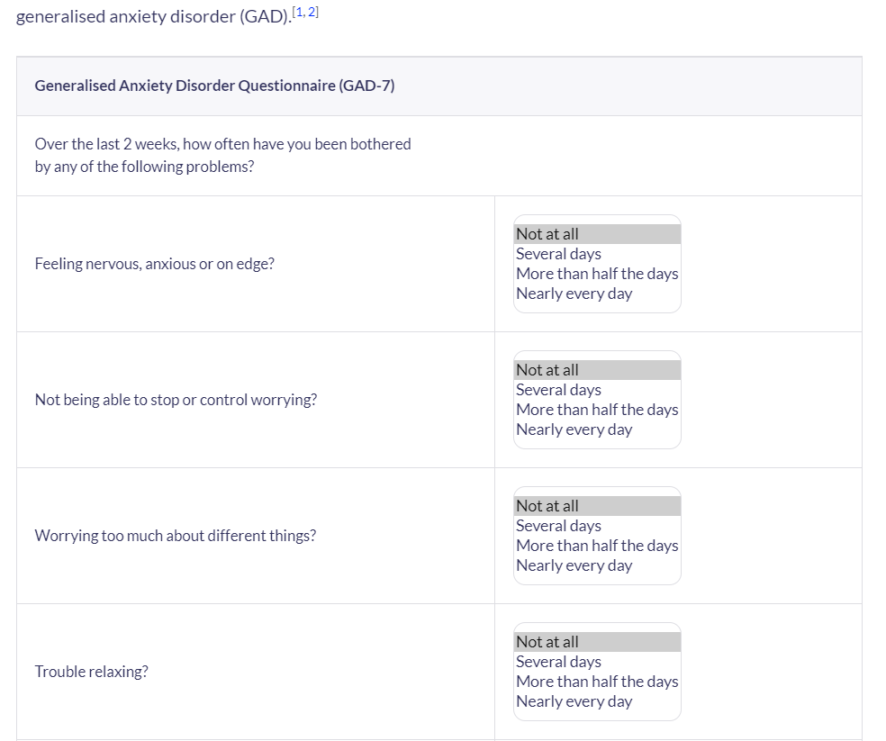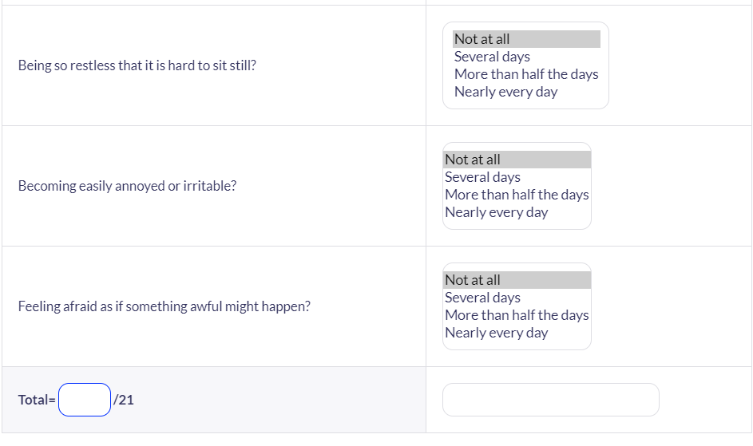

Appendix B: Indicators for rehabilitative care:

‘Quality Indicator for Rehabilitative Care (QuIRC-SA)’
The indicators to be considered are the these:
‘Living Environment’,
‘Therapeutic Environment’,
Treatments and Interventions,
Self-Management and Autonomy,
Social Interface,
Human Rights
Recovery Based Practice.



