PROGRAMME: SBMA7100 FINANCIAL MANAGEMENT

LECTURER: Dr Jiao Miao

Assignment title: Corporate financial Analysis

Student name Fatima Elabgari

Contents
INTRODUCTION 3
BRIEF HISTORY OF DEBENHAMS 4
MARKS AND SPENCER PLC 7
PROFITABILITY 9
LIQUIDITY 14
EFFICIENCY 17
GEARING 18
Table 7 18
Projections for Debenhams’s future performances 19
The pro and cons of ratio analysis 19
CRITICAL ANALYSIS 20
Conclusion 22
1. Bibliography 23

ABSTRACT

This case study is about the financial performance of Debenhams an international retail company headquartered in England United kingdom together with a comparison of another UK retail company on the FTSE 100 called marks and spencer plc .Key performance measures were calculated in this report with a view for an analysis which brings out the truth about the financial performance of these two retail giants .The comparison is for a period of 5 years from 2012.As for future performance it can be said without equivocation that Debenhams will grow into the future.

INTRODUCTION
This report analyses the financial status of Debenhams Plc whose shares have been traded on the London stock exchange since 1928. Debenhams Plc is a FTSE 100 company and one of the top five retail companies in the UK. Marks and spencer a retail giant headquartered in the UK with the same English heritage as Debenhams will be also be analysed for comparison purposes. The report has a detailed but brief history of Debenhams which is the chosen company for this case study.
Subsumed in the report is a ratio analysis together with a comprehensive critical review of the financial performance of the of Debenhams and Marks and Spencer. The calculation of these ratios bring out and reveal an analysis about critical points that are highlighted and critically reviewed outside the usual optimistic speeches that are sometimes given through a chairman’s speech and issues that could escape the attention of investors.
Key financial measures have been calculated in the report namely ratios for gross profit and net profit percentages and ratios that will reveal the liquidity of the company. Furthermore, ratios have again been calculated in the report which reveal whether the company is low or highly geared and other key financial ratios that ascertain if the company relied more on borrowed funds or equity. Efficiency ratios were also calculated in the report.
The trend of the ratios over a five-year period and the changes over the years reveal a marked increase and or decrease which again gives further reasons or warrant further investigative issues through the ratio analysis with a view to bring out the truth or again further analysis.
The major competitor chosen for purposes of this report was marks and spencer plc. However, the report shows that one of the two major retail giants in the UK has a better cash position while another apart from the publicity and expectation has a very bad liquidity and has a liquidity crisis which might lead to its inability to negotiate or pay short term lending such as overdrafts.

Both Debenhams and marks and spencer are in the UK retail sector which is very competitive in terms of the of the sales volume but also changing because of consumer preferences and taste and UK retail sales especially that of clothing industry are affected by the weather changes

BRIEF HISTORY OF DEBENHAMS

Debenhams is an international conglomerate with an English heritage having been founded in England in 1778 .It’s a major departmental retail store whose global reach is in 27 nations and has 240 stores in the world with about 100 stores in Britain .Debenhams became the first retail store in Britain to reach £1 billion of sales revenue .The majority of customers for Debenhams are of a middle class decent .Debenhams store was founded by William Clark and his first trading address has a significant mark in the historical records of the company as the store became successful over the years .
Clark’s first trading address was 44 Wigmore street ,London .A partnership followed as the business progressed which saw the introduction of William Debenhams introduced as a new partner and his introduction into the business resulted in the change of name of the business to Clark and Debenhams after 53 years of trading and that was in 1831 (Debenhams .com).Over the years the business built a goodwill with its customers and diversified its operations into manufacturing and maintaining its customer base through offering credit facilities and a Debenhams credit card offered through Newsday a credit card company regulated under the financial services authority in the UK. Debenhams bought Harvey Nichols in 1913 and it first listed its shares on the London stock exchange in 1928. Growth saw the company opening its biggest store in Birmingham in 2003 and in 2017 they opened stores in Stevenage and Wolverhampton.
However apart from the success that has associated Debenhams the flagship store has had its shares drop in 2017.
As of October 2016 Debenhams has been accused of bullying its suppliers .The telegraph a UK broadsheet newspaper reported the bullying issue a report which was also cited and reported City AM , a financial newspaper. City AM(2017) pointed out that that Debenhams was demanding discounts from its suppliers so that the major retail giant could pay its invoices from suppliers within three months .Yougov ( 2017) reported that Debenhams was blamed by the UK government as the worst company that paid its staff below the national minimum wage .It can however be further explained that the department of industrial energy UK (2017) found Debenhams to have underpaid 11,858 of its workers below the national minimum wage .According to its annual reports(2016) Debenhams employs 30 624 people.
On investments, Mike Ashley the boss of sports direct bought £33 million worth of shares in Debenhams making him to own 11% of Debenhams. (cityam 2014) and the Ft(2017) reported that Ashley was to increase his stake in the shares from Debenhams .
Debenhams launched the Debenhams TV ,the store also has kiosks which offer delivery and Debenhams has an online store .One of the cash cow for Debenhams has been its clothing range in the financial year ending 2012 Debenhams had a 17% market share on its clothing range and John Lewis a rival competitor only had 10% (debenhams.com) However customers in the UK are also changing their taste and preferences .According to Richard Lim the chief executive of the British retail economics pointed out that the British are spending less on fashion which is a major brand and cash cow for Debenhams

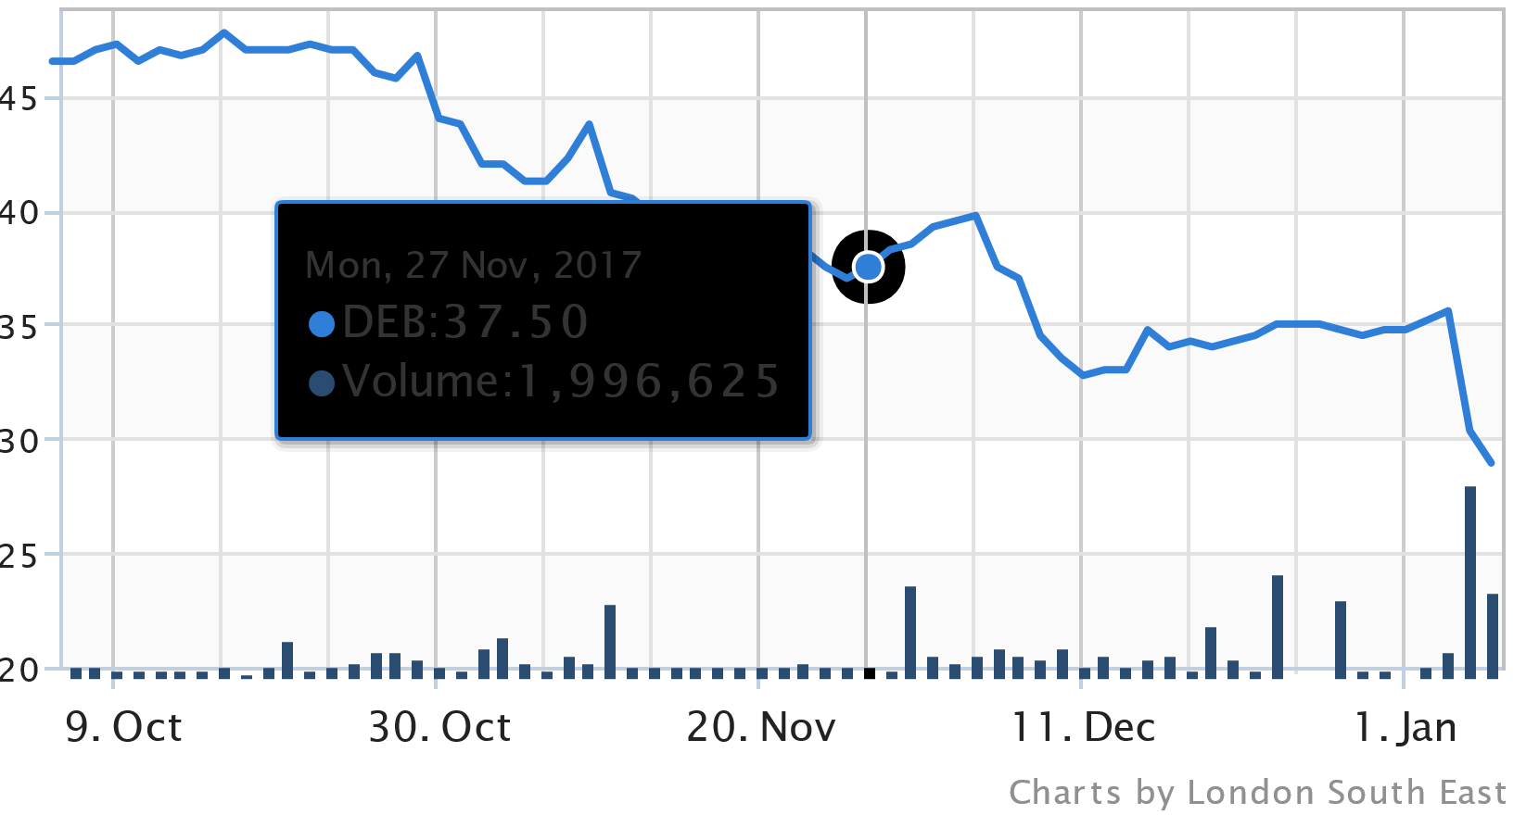
CHART 1
The chart above shows the latest movement of the share price of Debenhams.
The slump in the share price of Debenhams (DEB)shown on the image above depicts the true reflection of the Debenham share price on the financial markets .DEB completes 89 years of trading on the London stock exchange in 2018 but analysts are worried of how the store will withstand the continued fall in its share price 2018 after a disappointing year 2017 for the store .However contrary to expectations from some analysts according to Debenhams .com (2017) the like for like sales have increased by 7 % in early January 2018 and mainly recorded in the beauty department of the store .In early January 2018 the shares of Debenhams rose showing some resilience from turbulent times with its shares in 2017.

MARKS AND SPENCER PLC

According to marks and spencer .com(2017) the major retailer has 300 stores compared to Debenhams’s 240 stores from across the globe. Marks and Spencer are going to be closing some of their shops M and s also operates financial services and it provides its customers with credit cards and loans including insurance and pensions schemes.
The history of M and S dates back to 1894 when Tom spencer and Michael Marks entered into partnership similar the partnership that made the major retailer Debenhams but different in that M and s started as a partnership while Debenhams entered into partnership later on .M and s started selling foodstuffs for a penny .The first store was in Leeds .M and S also made £ 1 billion pre -tax profit in 1998 but the shares crashed in 2001 the profits dropped to £145 million .They launched their online business in 2001 they opened their biggest store in Dubai in 2007 and also opened another in Shanghai ,china .M and S sold their financial services to HSBC bank.as for investors M and S have always paid dividends a good sign for investors as is shown by the diagram below .

M and S shares plunged in 2016 and they announced they will shut down about 30 of its stores and they announced that they were to shut down its flagship store in Paris and they also announced massive job cuts at their head office. Such is the plight of one of the largest British retailer, but they do maintain a market share and an important historical as one of the most successful stories of British business enterprise.

As for investors M and S have always paid dividends a good sign for investors as is shown by the diagram below. However, paying dividends is not a sign that the business is in good hands but that they made profits and were able to parcel some as dividends.

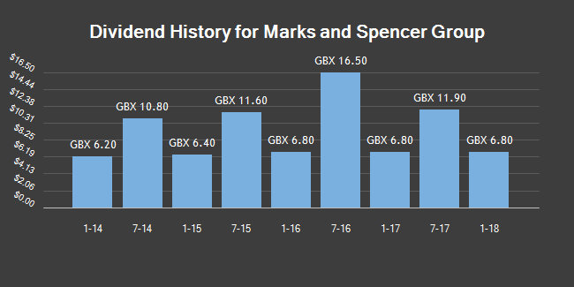

PROFITABILITY

Profitability for an organisation is very important. The goal of the firm is to maximise shareholder‘s wealth .Therefore the company exists to make a profit and firms that make losses may go out of business or placed into receivership and then bankruptcy. Therefore, since Debenhams is a public limited company its investors will be interested to know how profitable the business is as this will also determine the returns that investors will get by way of dividends and will also determine their willingness to invest more.
In explaining that an organisation needs to have a good relationship with profitability and leverage lins at al(2017) pointed out that it is vital that the organisation should have lower agency costs if the organisation has a high debt capacity .

Table 1
GROSS PROFIT PRECENTAGE | IN MILLIONS OF POUND STERLING
 | 2012 | 2013 | 2014 | 2015 | 2016
GROSS PROFIT X100% | 302,3 X 100% | 310.1 X 100% | 279,3 X 100% | 299,9 X 100% | 2341,7 X 100%
REVENUE (SALES) | 2229.8 | 2228.2 | 2312,7 | 2322,7 | 2341,7
TOTAL % | 13.8% | 13.6% | 12.07% | 12.09% | 12.09%

Graph 1 represents gross profit % over 5 years

In table 1 above are calculations for the gross profit for Debenhams plc which is expressed as a percentage for a period of 5 years beginning with the financial year (FY) 2012 to FY 2016.
The grossed profits for Debenhams are not very impressive over the period .Debenhams do manufacture some of their clothing range a good innovative venture that they undertook when they decided to diversify operations into manufacturing .However it appears the cost of production remains static even if the revenue has been increased .Between 2012 and 2013 the sales increased by 10 % but the grossed profits decreased from 13,8 % to 13,2 % a net decrease of 0.2% this however would warrant an investigation as to why gross profit would decrease when the sales are increasing.
A look at the chairman report of ( 2012 ) shows that the sales for stores that remained opened for at least a year which are measured as like for like sales rose by 1,6 % this however according to the chairman indicated a rise in the demand from consumers as the same time the chairman curiously mentioned that in the same year Debenhams decided a share buy -back .several reasons for that decision when the sales revenue was said to be increasing .Maybe Debenhams management had insider information that the investors did not have and they wanted to reduce the shareholding or reduce the cost of capital or could be because the shares were undervalued several reasons play out .
It is clear however that the cost of production for the flagship store is excessively high. That there is depressed consumer demand can be seen in how the gross profits remain about the same for the period throughout the 5-year period. It will be interesting to find out the cash position of Debenhams since the gross profits are not so inspiriting the danger is that Debenhams may go out of business if the trend of having the same percentage of profits continues.
It appears the store have costs of production that it cannot vary and which are very expensive .The company has been in the media for the wrong reasons one of which was underpaying a third of its workforce and the net effect of that move would have been to reduce the wages and hence the gross profit percentage would have been higher and with that in mind it would then appear that the grossed figures of the profit would be overvalued if some to the production workers who could have been paid the national average and that however still points to a not so good trading position of Debenhams.
In the research why fashion brands need outlet malls (2017) carried in the Harvard business review number 24 of November -December 2017 it is recorded that a researcher analysed 5 years of the sales data from a USA fashion firm. The fashion firm had outlet stores .It was found out that the incomes of the customers from the outlet stores and that of the regular customers is similar. Its therefore important to companies like Debenhams or marks and spencer to use the results of these ground -breaking research in reputable academic journals for strategic planning which could reduce the production costs. It can be shown in the research that the location of the business is lost once a business goes online and trades online and therefore that would reduce costs associated with the brick and mortar stores and production costs would come down as well.
From 2014 to 2016 the gross profit expressed as a percentage of the sales shows that it remained at 12% that information should be really worrying to the management for Debenhams since this shows that the production costs and possibly the costs of the sales are really high .Cost of sales reduction strategies should however be devised to avert the danger of the company not being able to pay its short term loans and also having problems of liquidity this however can only be find out by calculation of further ratios and further ratio analysis will reveal more information about Debenhams and will unmask the optimism in the chairman’s report

Table 2
NET PROFIT PRECENTAGE | IN MILLIONS OF POUND STERLING
 | 2012 | 2013 | 2014 | 2015 | 2016
NET PROFIT X100% | 158,3 X 100% | 154,0 X 100% | 105,8 X 100% | 113,5 X 100% | 118,2 X 100%
REVENUE (SALES) | 2229.8 | 2228.2 | 2312,7 | 2322,7 | 2341,7
TOTAL % | 7.09% | 6.75% | 4.58% | 4.58% | 5.5%

Graph 2 represents net profit % over 5 years

M and S 2016 net profit percentage
NP 570.8
SALES 10555.4
NP % = 5.6%
Table 2 above shows the net profit expressed as a percentage of the sales . It appears that both companies have a very low net profit percentage in the year 2016 almost similar Debenhams with about 5.5 % and M and with S 5.6 % the retail giants are in the same industry but a low net profit shows that the operating expenses are excessively high .Debenhams however have seen its grossed profits whittled down from 12 % to a net profit of 5% of the sales revenue. A lot of industries however can have low net margins but margins only show how much the pound that is collected by these companies as revenue is translated into profit. About 5,5% of the amount that was collected by Debenhams in 2016 was earned as profit that shows however that the other 95% went into payments of production and operating expenses .Put differently Debenhams earns 5 pence in every pound it collects as revenue and marks and spencer also earn the same amount as well.

LIQUIDITY

Table 3
CURRENT ASSETS: CURRENT LIABILITIES | IN MILLIONS OF POUND STERLING
 | 2012 | 2013 | 2014 | 2015 | 2016
CURRENT ASSETS | 459.57 | 459.7 | 486.3 | 459.7 | 502.8
CURRENT LIABILITIES | 727.0 | 741.9 | 758.0 | 695.7 | 688.2
CURRENT RATIO | 0.63:1 | 0.62:1 | 0.64:1 | 0.66:1 | 0.73:1

Table 3 above shows that Debenhams plc has 63 pence in 2012 to pay every £1 of liabilities it owes to its creditors .The trend can be seen that the store’s position on its preparedness to settle its debts did not improve in the subsequent years following the 2012 financial year .since the ratio is under 1 throughout the 5 year period that must be very worrying as this indicates that that Debenhams’s liabilities are huge and bigger than its assets .In the event that the store goes into bankruptcy it will not be able to pay its creditors and as for investors this information alone is not healthy .However it has to be pointed out that most companies in the retail industry usually have ratios under 1 for the current ratio .Since this is unusual for purposes of comparison we compare with the current ratio for Marks and Spenser in 2016 only

Marks and Spencer 2016 in millions of pounds sterling
CA:CL
Current assets 8476, 4
Current liabilities 2104, 8
Current ratio: M and S 4.02:1
Current Ratio: Debenhams 0.73:1

As can be seen it is clear that M and S are in a better financial position that Debenhams .Both companies are in the same industry but it has to be pointed out that their operations are not the same and a closer look at their current assets and current liabilities will reveal that they differ .So for the sake of perspective and comparison it can be pointed out that the current ratio has its own limitations .the current ratio does not point out which current assets to use including those that can be easily be converted into cash .The figures above however shows that m and s have £4 to every £1 they owe the creditors .that however is a very healthy position .Debenhams’s position might not mean they are going bust but that they are negotiating a longer payments period with suppliers as pointed out earlier in the history of the Debenhams when it was revealed that Debenhams are negotiating a three month payment period with suppliers if however they are insisting on a shorter payment from their debtors it could result in the a ratio that is lower than 1 but the acceptable for the current ratio is 2: 1 .However if by use of the current ratio it can be stated that Debenhams will find it difficult to pay its debts .It is also important to understand the liquidity of the companies without cash will find it difficult to settle short term commitments .The table below calculates the liquidity of the two companies .
Table 4
CURRENT ASSETS (CA) LESS STOCK: CURRENT LIABILITIES | IN MILLIONS OF POUND STERLING
 | 2012 | 2013 | 2014 | 2015 | 2016
C.A. LESS STOCK | 127.2 | 112.6 | 140.6 | 128.1 | 176.5
CURRENT LIABILITIES | 727.0 | 741.9 | 758.0 | 695.7 | 688.2
QUICK RATIO | 0.18:1 | 0.16:1 | 0.18:1 | 0.17:1 | 0.24:1

Quick ratio M and S 2016
CA 876.4
Inventory (799.9)
CL 2104.8
Quick ratio 0.036
The quick ratios for both companies Debenhams and M and S show that both companies are relying mostly on the inventories to pay the short-term debts like the bank overdraft. However, companies may not be encouraged to have very high quick ratios as this could indicate that they have too much debtors on their books they may not be able to collect the debt. The problem with quick ratio however may be about the accounts receivables it can be difficult to collect debt and a very high quick ratios may also indicate that the company is keeping too much cash .cash has a cost and keeping it is risky and the opportunity cost of keeping cash is that you can invest the amount and it can earn interest elsewhere .However the liquidity position will also depend on what time both companies will be given by the suppliers to settle its debts and also on what these retailers will give their debtors to settle its debts.

EFFICIENCY

Table 5
EFFICIENCY | IN MILLIONS OF POUND STERLING
 | 2012 | 2013 | 2014 | 2015 | 2016
TOTAL SALES | 2229.8 | 2228.2 | 2312.7 | 2322.7 | 2341.7
TOTAL NET SALES | 661 | 744.4 | 767.4 | 853.9 | 883.9
ASSET TURNOVER RATIO | 3.37 TIMES | 29.93 TIMES | 3.01 TIMES | 2.72 TIMES | 2.65 TIMES

The table for asset turnover ratio above measures how Debenhams could generate sales from its assets .so the ratio shows how many times can Debenhams efficiently generate sales using the company’s assets .LTM pham at al (2017 )pointed out that not much research has been carried out about how assets influence the company’s investment policies .However these scholars state that the imperfection in the markets would affect the amount that a firm can raise .Most firms however invest in research and development for their products and porter (1992) stated that research and development is essential for corporate development. The figures above show that Debenhams in 2012 could convert its assets three times into cash that why asset liquidity is important. Pham at al (2017) investigated the relationship between asset liquidity and the firm’s innovation. They researched from 1980 and 2013 using regression analysis they find out that firms with highly liquid assets invest more in R and D and this is important in the retail market such as the one that Debenhams and marks and spencer trade in. Research and development leads to product diversification and differentiation which is important in the retail market.
Table 6
INVENTORY TURNOVER RATIO | IN MILLIONS OF POUND STERLING
 | 2012 | 2013 | 2014 | 2015 | 2016
INVENTORY X 365 | 332.3 X 365 | 357.9 X 365 | 345.7 X 365 | 331.6 X 365 | 326.3 X 365
COST OF SALES | 1927.5 | 1972.1 | 2033.4 | 2023.5 | 2039.8
INVENTORY TURNOVER | 63 DAYS | 68 DAYS | 62 DAYS | 60 DAYS | 58 DAYS

Debenhams kept inventory in hand for 63days in 2012 and subsequently 68 days in 2013 62 days in 2014 60 days in 2015 and lesser days in 2016 58 days it could be also be interesting to know how much time does Debenhams collect money from its customers. The debtor collection period for Debenhams could be the reason why its cash position is really bad since it has been established through ratio analysis that the net margin between m and s and Debenhams is almost the same

GEARING

Table 7
GEARING | IN MILLIONS OF POUND STERLING
DEBENHAMS
 | 2012 | 2013 | 2014 | 2015 | 2016
TOTAL DEBT | 163.4+249.3 | 163.1+235.9 | 202.1+235.9 | 155.4+197.1 | 135.6+199.7
TOTAL  EQUITY | 661  0.38 | 744.4  0.41 | 757.4  0.57 | 853.3  0.53 | 883.9  0.62
GEARING | 38% | 41% | 57% | 53% | 62%
M&S
TOTAL DEBIT |  |  |  |  | 297.5+1774.7
TOTAL EQUITY |  |  |  |  | 3443.4
GEARING |  |  |  |  | 60%

The ratio shows that 62% of the funds of Debenhams in 2016 came from borrowed funds and 60% of the funds of M and S came from borrowed funds
Gearing ratios as those for the Debenhams are important in the measurement of financial risk. The level of Unilever’s debt to its equity is expressed as a percentage in the diagram. The gearing ratio is important for the lenders as well as for the investors. The percentages above also shows the debt ratio .It was however important in this case study to investigate the debt ratio

CRITICAL ANALYSIS

Projections for Debenhams’s future performances

Apart from the negative liquidity position however the like for like sales for the Debenhams store have been on the increase and the like for like sales are the most common measure to project for future growth .Some of the revenues for Debenhams comes for customers that shop online and the figures for the company show that online shoppers bring in 17% of the company’s total revenue therefore they are a significant part of the customer base .The beauty department is outperforming the clothing department .one of the greatest strengths of Debenhams has been its strengths to remove its obligation on relying on borrowed funds .Debenhams however have built a very strong business model over the long period of trading .

The pro and cons of ratio analysis
As can be seen from the above calculation and critical analysis the calculations did provide some simplifications and the ratios have provided comparison from year to year and important information such as the liquidity position of the company could be revealed easily and also if the companies are making any reasonable profit .However the ratios analysis has limitations company’s operations are different and accounting policies that make the preparation of accounting and financial statements on which the ratios are prepared allow choice and so different choices can produce different results and hence different results also on the ratios and the ratios information could then be unreliable and the results from the ratios could be results derived from information that is past but investors could be interested in the present information to make decisions because companies change or their financial performance change

CRITICAL ANALYSIS
There are factors that influence the market for shares. The factors that happen in the market influence the share price although the profits for Debenhams have been maintained constantly over the 5-year period. Debenhams have not incurred a loss despite its share price crashing and market analysts predicted that Debenhams will follow the BHS route. BHS went into receivership and liquidation however recent news have shown that like for like sales for Debenhams have increased by 7% as for January 2018. On the other hand, Marks and Spencer have laid off a lot off members of staff and are going to shut down about 30 stores. Debenhams have problems with liquidity as their current ratio is very low and their liquid assets cannot be easily converted into cash, however current ratios of companies in the retail industry can be less than 1 and it does not mean that the company is going into liquidation. When the dividends are expressed as a percentage of the share price Marks and Spencer are at the top this also shows how much cash flow the investors in Marks and Spencer get from the amount they invested. Debenhams also pay their investors well as dividends are compared in the retail industry and they have not however incurred a loss and are opening more shops instead of shutting down therefore in terms of business progression Debenhams appear to be on the right track.
The table below shows the companies in the retail industry who pay their dividends it can be seen that Marks and Spencer are at the top followed by Debenhams however paying dividends does not mean or predict that the company will not face any financial hardships in the future. In regard to financial statements and ratio analysis the information that is used in the ratio analysis is from the past an investor need current information for the current performance of the company although the past events in the company and its performance in the markets can make informed judgements about the company.

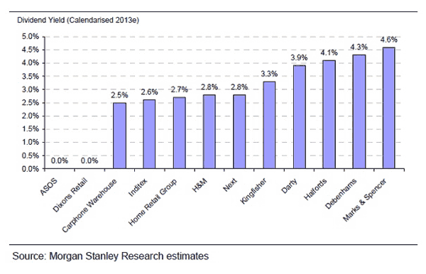

Conclusion
Conclusively, the ratio analysis of a company will bring out the truth and information that normally would not be under the watchful eyes of investors and other interested parties .The financial status of the company can be reviewed and comparable after calculation of a key financial ratios which can reveal if the company has been surviving from borrowed funds and if is capable to sustain or service the long term debt .Other key financial measures like the interests cover ratio would also reveal if the interests on loans can be covered with the funds and most importantly the cash in a business is like the blood in a human being any sudden withdrawal of large amounts of cash will lead to a serious financial difficulty in the business and hence liquidity of a business is of major concern because companies might end up not being able to pay short term borrowings like bank overdrafts .Key financial ratios were calculated and subsequently a critical analysis of the ratios were given including the meaning of the ratios calculated .the report also discussed the pros and cos of the ratio analysis and there was a comparison of with the chosen competitor company of this report which was marks and spencer

Bibliography

- Abraham, A., Glynn, J.J., Perrin, J. and Murphy, M.P. (2008) Accounting for managers. Thomson.
- Bhimani, A. (1996) Management accounting: European perspectives. Oxford: Oxford University Press.
- Bhimani, A., Horngren, C.T., Datar, S.M. and Foster, G.M. (2007) Management and cost accounting. 4th edn. Prentice Hall.
- Cooper, R. and Kaplan, R.S. (1999) The design of cost management systems: Text, cases, and readings. 2nd edn. United States: Pearson Education (US).
- Drury, C. (2015) Management and cost accounting. 9th edn. Cengage Learning EMEA.
- Gray., S.J., Salter, S.B. and Radebaugh, L.H. (2001) Global accounting and control- A managerial emphasis. John Wiley & Sons.
- Pendlebury, M.W. and Groves, R.E. (2001) Company accounts: Analysis, interpretation, and understanding. : Thomson Learning.
- Perks, R. (2010) Financial accounting for non-specialists. 2nd ed. McGraw-Hill.
- Proctor, R. (2008) Managerial accounting for business decisions. 3rd ed. Prentice Hall.

- ww.cityam.com/278204/debenhams-share-price-drops-20-per-cent-profit-warning-city

- http://www.cityam.com/271583/debenhams-trading-director-steps-down
- http://www.cityam.com/259147/debenhams-outed-not-paying-nearly-12000-workers-national
- http://www.cityam.com/article/1389921784/ashley-takes-option-stake-debenhams
- https://www.ft.com/content/f4f8a372-ba6c-11e7-9bfb-4a9c83ffa852
- http://www.annualreports.com/HostedData/AnnualReportArchive/d/LSE_DEB_2012.pdf
- , T. and Ahmed, N., 2017. Capital Structure, Business Strategy and Firm’s Performance: Evidence from Pakistan. European Online Journal of Natural and Social Sciences, 6(2), pp.pp-302.
- Agnihotri, A. and Bhattacharya, S., 2017. Corporate Name Change and the Market Valuation of Firms: Evidence from an Emerging Market. International Journal of the Economics of Business, 24(1), pp.73-90.
- Agrawal, A. and Cooper, T., 2017. Corporate governance consequences of accounting scandals: Evidence from top management, CFO and auditor turnover. Quarterly Journal of Finance, 7(01), p.1650014.
- Blaylock, B., Gaertner, F.B. and Shevlin, T., 2017. Book-tax conformity and capital structure. Review of Accounting Studies, 22(2), pp.903-932.
- Bosiu, T., Nhundu, N., Paelo, A., Thosago, M.O. and Vilakazi, T., Growth and Strategies of Large and Leading Firms-Remgro Limited Company Assessment1.
- Cheung, L., 2017. Divestiture as Conglomerate Merger Remedy, with Case Study of 2005 P&G-Gillette Merger.
- Clift, R., Sim, S., King, H., Chenoweth, J.L., Christie, I., Clavreul, J., Mueller, C., Posthuma, L., Boulay, A.M., Chaplin-Kramer, R. and Chatterton, J., 2017. The challenges of applying planetary boundaries as a basis for strategic decision-making in companies with global supply chains. Sustainability, 9(2), p.279.
- Dhaene, J., Hulle, C., Wuyts, G., Schoubben, F. and Schoutens, W., 2017. Is the capital structure logic of corporate finance applicable to insurers? Review and analysis. Journal of Economic Surveys, 31(1), pp.169-189.
- Pham ,l.t.m. ,Vo,v.l.,Lee,h.t.t.,Lee,d.v.(2017)asset liquidity and firm innovation international review of financial analysis .

