Financial Management for the Hotel Industry
BMIH5007
Business Report; Comparison of Two Hospitality Organisations

Student name: Florentina Raluca Iamandi
Student ID: 2246151
Lecturer name: Tristan Hawkins

Executive Summary
The primary initiative including a proper volume of benchmarking Concept has been initiated to provide a comparative analysis support in relation to the business position in the context of both financial and non-financial. The applicability of proper comparative analysis in relation to two different businesses Shangri-La Hotels and Premier Inn Hotels is mainly evaluated in this report with the recognition of the revenue position of the business including the market growth-initiated structures support. Additional leader applications of Ansoff’s matrix are also initiated for the evaluation of market growth potential structure in a specified order which brings a structural development including the contemporary market positioning approach. Associated with the same approach the applicability of the CSR initiatives of both the business are also evaluated to identify the market potential positions in a specific order.

Table of Contents
Introduction 4
Discussions 4
Comparison between Shangri-La Hotels and Premier Inn Hotels in revenue prospect 4
Comparison between Shangri-La Hotels and Premier Inn Hotels regarding market position 6
Comparison between Shangri-La Hotels and Premier Inn Hotels regarding marketing growth 7
Comparison between Shangri-La Hotels and Premier Inn Hotels regarding CSR contribution 8
Recommendation with Bowman's Strategic Clock to identify the business strategic level 9
Conclusions 10
References 11

Introduction
The present positions related to the UK hospitality sector are rapidly expanding due to the reasons of progressive market development and standardization support. The primary value related to the hospitality business indicates the level of 24.7 billion GBP which indicates a progressive financial standardised processing engagement in the UK economy (Statista, 2024). However, the general consequences related to the Brexit referendum, inflation level, and market insufficiencies mainly initiate a certain uncertainty that imposes a challenging approach on the hospitality business in the United Kingdom. In this report, a detailed analysis including both financial and non-financial analysis is provided for the general initiative of marketing growth support.

Discussions

Comparison between Shangri-La Hotels and Premier Inn Hotels in revenue prospect
For the hospitality sector, the primary engagement related to the environment of Occupancy rate, Revenue per available room, and also the average daily rate is essential as depending on search the revenue is mainly formulated. A business with a positive level of Occupancy rate mainly represents a positive marketing demand and revenue positioning approach with branding level.
The company Shangri-La Hotels is identified as a Chinese hospitality business that presently operates in the United Kingdom. The present occupancy rate of this business is around 66% which indicates a comparatively lower operating approach. The level of current room rate of this business is around 608.72 GBP with a RevPAR level of 401.74 GBP. The formulation of such engagement indicates the revenue positioning level of the business from 2018 to 2023 provided (Shangri-La Group, 2024).
 | 2018 | 2019 | 2020 | 2021 | 2022 | 2023
Revenue | 1924108.55 | 1857898.8 | 789732.47 | 948391.03 | 1117349.28 | 1636723.79
Growth rate |  | -3.4% | -57.5% | 20.1% | 17.8% | 46.5%

The general positioning level of the business currently indicates a progressive growth positioning level of 46.5% (in 2023) compared to the previous standard of 17.8% (in 2022) representing a progressive growth formulation that is sustainable in relation to the present marketing position. As per the general initiative, the progressive level of demand related to high-quality hospitality in the Middle East formulates a progressive level of operating position and revenue initiative structure in this business that mainly imposes a proper level of quality progressive support. The primary applicability of general economic progress in the Middle East represents a proper volume of Occupancy rate increasing approach which mainly represents the perfect applications of the law of supply while the increasing level of prices associated with the services generally influences the volume of quality supply (scmp.com, 2023). Additionally, the present initiative of robust recovery structure related to the easing of cross-border restrictions imposes a proper revenue progressive support in the business operating development on a progressive basis (Lun, 2023).
The present operating position and performance structure of the parent company Whitbread PLC (Premier Inn Hotels) represents a progressive revenue formulation support that indicates a standardised marketing demand with the inclusions of 853 hotels and 85000 rooms facility support. The present level of occupancy rate of the business is 82.2% which indicates the general involvement of £79.76 ARR, and £65.56 RevPAR support that represents a formulated revenue positioning structure in the present level (Whitbread PLC, 2023). The overall revenue growth initiative of the business is provided.
 | 2018 | 2019 | 2020 | 2021 | 2022 | 2023
Revenue | 3295.1 | 2049.1 | 2071.5 | 589.4 | 1703.4 | 2652.2
Growth rate |  | -37.8% | 1.1% | -71.5% | 189.0% | 55.7%

The formulated positioning structure of the business currently indicates the level of 55.7% growth initiative compared to the previous standard of 189.0% fundamentally imposes a certain level of declining approach compared to earlier growth. In the present position reductions of the restaurant portfolio and primary focus on the hotel branding initiative by the management of this business represents a proper volume of stability development including revenue formulation support also which mainly represents the positive initiative of supply law engagement as well. The primary focus on the extensions of 3500 new room engagement including the marketing potential of the business represents a formulated growth support that will be sustainable for the initiative of business stability approach in the upcoming (Baker, 2024).

Comparison between Shangri-La Hotels and Premier Inn Hotels regarding market position
The identification of market growth or the marketing positions depends upon the overall supply chain initiative including the operating formulation basis which is sustainable for the maintenance of hospitality business in an accurate order. In relation to the positioning structure of the market, the primary valuation in the context of customer demographics, market share processing and branding are mainly focused.
According to the basic attribute, the market share capital structure of Shangri-La Hotels represents the level of 49.50 per share with a general level of 6.435 billion as the market capital position. The general analysis related to the structure of beta of this business indicates the level of 0.16 times positions with the Earning per share level of 1.79 times (TradingView, 2023). The primary initiative related to the customer demographic engagement of the business mainly provide focused on the upper-class customer with the involvement of luxury branding initiative that ultimately represents a proper volume of marketing standard and stability progress approach. The primary involvement of world-class services including the processing of fine dining attributes of this business represents contemporary marketing growth as well which is one of the primary marketing potentials for this business (Ahmad, 2024). As per the basic engagement the involvement of more than 100 hotels including the branding initiative with the structure of 4 potential brands related to Shangri-La Hotels and Resorts, Kerry Hotels, JEN, and Traders indicates progressive operating support in this business that represent an optimal positioning growth initiative of the business operating level mainly.
In relation to the market value the share capital position of Premier Inn Hotels currently represents the level of 3137 per share pricing structure with the market capital level of 5.601 billion which indicates an accountability growth processing approach. The volume of the present beta of the business is 1.11 times which indicates a certain level of risk engagement in relation to the business operations for investors (London Stock Exchange, 2024). The primary level of price-earnings ratio level of the business is around 19.61 times including the marketing structure of EPS as 1.60 times. As per the basic identifications the level of the present branding initiative of the business indicates around 93% awareness structure including 42% usage support with 37% loyalty initiative from the customer perspective which indicates a proper engagement of supply law-initiated level where with the formulations of expanded pricing level the supply level of services is positively emphasized. According to the primary identifications level of profit and cash flow formulations of this particular business have been expounded in a proper order that ultimately represents the dividend plus share buyback initiative in this business of around £150 million (DirectorsTalk Interviews, 2024). The application of this type of engagement also represents the ROE position of the business with 15.5% of development initiatives that are standardized and formulated for the business progress.

Comparison between Shangri-La Hotels and Premier Inn Hotels regarding marketing growth
The general initiative about proper market analysis or the market growth initiative is relevant for every business in the prospect of recognising the market potential processing. According to the basic identifications the applicability of Ansoff’s Matrix has been initiated for the evaluation support of the present operating structure including the competitive market scenario of both the business which will be sustainable for the realisations of market growth also.
In relation to the present operating structure the primary applicability of the current initiative regarding “Pioneers of Asian Hospitality” represents a proper volume of progressive market development strategic initiative for the business of Shangri-La Hotels with the operating potential support (businesschief.asia, 2021). The general initiative of “Iconic Global Projects” of the business also indicates the applications of diversification support including the service development initiative as well which will provide a proper volume of standard development initiatives regarding business accountability (Shangri-la.com, 2021). Apart from that the present initiative of “Holistic Programmes for the Modern Urbanite” is also initiated in this business for the development and progressive operational support purpose to manage the diversified working culture including the market penetration strategic initiative in the Middle East Market which will be a sustainable attribute for the business expansions and accountability.
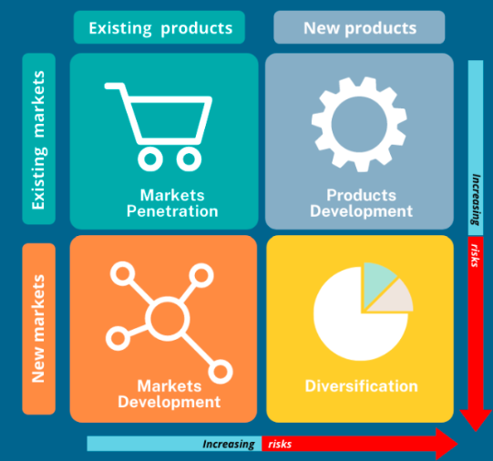
On the other hand, to represent a proper volume of business contemporary growth managerial department of Whitbread PLC has decided to focus on driving restaurant performance despite plans to cut estate through the initiative of converting or selling 238 of its circa 450 restaurants and providing a primary focus on the hotel business expansions through commencing new rooms initiatives (Price, 2024). Application of this can be identified in the general market development initiative structure of the business which will be sustainable for maintaining the share-initiated progress accurately. Additionally, the business also focuses on initiating 400 additional room facilities in Germany which will be a supportive approach for the business accountability growth in the market (erika, 2021). Following the same order, the business provides a significant volume of diversification in the leadership approach through the engagement of gender equality progress which will be a sustainable approach for business stability in the upcoming.

Comparison between Shangri-La Hotels and Premier Inn Hotels regarding CSR contribution
The application of Corporate Social Responsibility is defined as a type of contribution which is initiated by every individual business with the intentions of social development and environmental benefit. According to basic identifications, the primary level of carbon emissions controlling level is initiated in Shangri-La Hotels up to 15% with the inclusions of the same proportions in energy intensity which represents a progressive volume of standardization support. As per the primary identifications to formulate a proper volume up environment stability around 50% of single plastic usage level has been declined in this business which represents a proper volume of environmental initiated progress. In the present situation for initiating proper social development, the business also offers 11158 new hiring engagements which represents a proper volume of turnover initiative in this business (Experiences, 2023). The applications of present operating growth including the governance initiative of the business also initiate a standardised value positioning support which is influential for the operating growth of this business.
Associated with the same approach the present CSR initiative of Premier Inn Hotels represents a progressive operating structure that indicates a general contribution of £2.4 million that was mainly initiated for the purpose of Great Ormond Street Hospital Children’s Charity. In Germany this year, this organisation raised around €907k for the national charity Children which represents a proper community development initiative including the operating growth processing beneficial support (premierinn.com, 2023).

Recommendation with Bowman's Strategic Clock to identify the business strategic level
The primary application of this particular strategic clock can be identified as a relevant approach for the determination of strategic goals related to the business operations in the upcoming which will be a sustainable attribute for the maintenance of stability.
Depending on the present operating structure and performance initiative if the performance level of Shangri-La Hotels lies within the position of 5 to 7 standard therefore with the Initiative of a proper focus on the differentiations The applicability of monopolistic pricing attribute can be initiated in this business which will be a progressive attribute for the maintenance of stability in the upcoming.
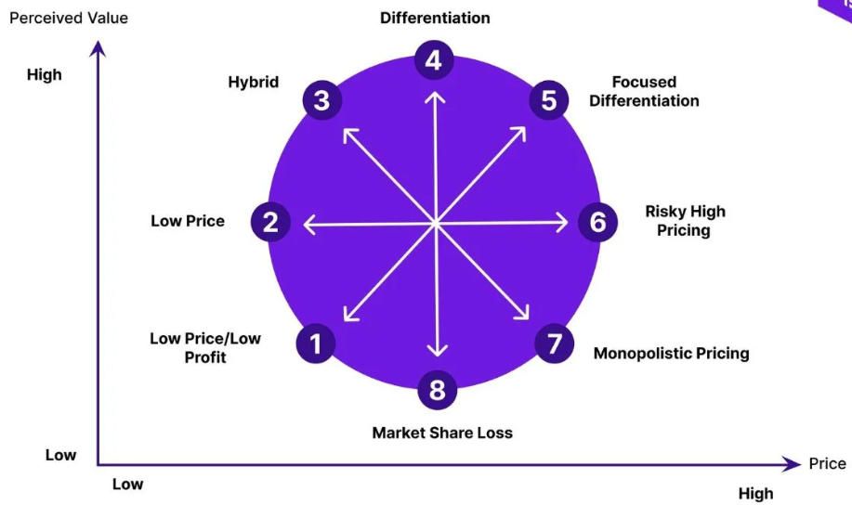
Associated with the present operating structure if the management of Premier Inn Hotels provides a general level of significance to the clocking position within 2 to 3 will be Sustainable for the business with the existence of low pricing approach with hybrid operating support in order to maintain a proper volume of standardisation growth including the market potential approach in the upcoming.

Conclusions
The above analysis related to both the financial and non-financial measurements including the market initiative of both businesses indicates standardised formulation support including the market stability initiative that represents a positive volume of economic formulation support in the United Kingdom. The present strategic development including market growth formulations including the expansion strategies also represents a positive volume of operating statutory initiative support which will be progressive for the standardized development support of this business more accurately. The applied formulations of the clock initiative also represent a proper volume of diversification including the lower pricing attributable to engagement in business to maintain a compatibility operating development structure.

References
Ahmad, A.A., 2024. Corporate Governance and Its Determinants: A Study on Shangri-La Hotel (Malaysia) Berhad. Available at SSRN 4694743.
Baker, T. (2024). Whitbread Starts To Reduce Restaurant Portfolio To Focus on Premier Inn Hotel Brand. [online] CoStar. Available at: https://www.costar.com/article/1573146000/whitbread-starts-to-reduce-restaurant-portfolio-to-focus-on-premier-inn-hotel-brand [Accessed 9 Oct. 2024].
businesschief.asia. (2021). Shangri-La: Celebrating 50 years of Asian hospitality. [online] Available at: https://businesschief.asia/videos/shangri-la-celebrating-50-years-asian-hospitality [Accessed 9 Oct. 2024].
DirectorsTalk Interviews. (2024). Whitbread PLC Preliminary Results: Profit and cashflow soar with Premier Inn UK success. [online] Available at: https://www.directorstalkinterviews.com/whitbread-plc-preliminary-results-profit-and-cashflow-soar-with-premier-inn-uk-success/4121154066 [Accessed 9 Oct. 2024].
erika (2021). Whitbread opens warehouse in Germany to support expansion plans. [online] Whitbread PLC. Available at: https://www.whitbread.co.uk/whitbread-opens-warehouse-in-germany-to-support-expansion-plans/ [Accessed 9 Oct. 2024].
Experiences. (2023). Environmental, Social and Corporate Governance | Shangri-La Experiences. [online] Available at: https://www.shangrilaexperiences.com/community-and-social-impact [Accessed 9 Oct. 2024].
London Stock Exchange (2024). London Stock Exchange | London Stock Exchange. [online] www.londonstockexchange.com. Available at: https://www.londonstockexchange.com/stock/WTB/whitbread-plc/our-story [Accessed 9 Oct. 2024].
Lun, T.N. (2023). Shangri-La Asia posts H1 net profit of $177m on recovery of hotel business. The Straits Times. [online] 30 Aug. Available at: https://www.straitstimes.com/business/companies-markets/shangri-la-asia-posts-h1-net-profit-of-us1314-million-on-recovery-of-hotel-business [Accessed 9 Oct. 2024].
premierinn.com (2023). Build it Beat it. [online] Available at: https://www.premierinn.com/gb/en/news/2023/build-it-beat-it.html [Accessed 9 Oct. 2024].
Price, K. (2024). Whitbread focused on driving restaurant performance despite plans to cut estate. [online] Hospitality Investor. Available at: https://www.hospitalityinvestor.com/northern-europe/whitbread-focused-driving-restaurant-performance-despite-plans-cut-estate [Accessed 9 Oct. 2024].
scmp.com (2023). Exclusive | Shangri-La Group’s expansion in the Middle East to start paying off. [online] South China Morning Post. Available at: https://www.scmp.com/business/article/3239583/shangri-la-poised-benefit-middle-easts-economic-rebound-after-decades-long-expansion-spree [Accessed 9 Oct. 2024].
Shangri-La Group (2024). Shangri-La Group. [online] www.shangri-la.com. Available at: https://www.shangri-la.com/group/media/media_post?post=Shangri-La%20Group%20Releases%202023%20Full%20Year%20Results [Accessed 9 Oct. 2024].
Shangri-la.com. (2021). Shangri-La Group. [online] Available at: https://www.shangri-la.com/group/media/media_post?post=Global%20Brand%20Campaign [Accessed 9 Oct. 2024].
Statista (2024). Hotel industry market size UK 2022. [online] Statista. Available at: https://www.statista.com/statistics/1364712/hotel-industry-market-size-uk/ [Accessed 9 Oct. 2024].
TradingView. (2023). SHANGRI-LA HOTELS (M) BHD. [online] Available at: https://www.tradingview.com/symbols/MYX-SHANG/ [Accessed 9 Oct. 2024].
Whitbread PLC. (2023). Year in review. [online] Available at: https://www.whitbread.co.uk/investors/annual-report/ [Accessed 9 Oct. 2024].

