Socket Programming and

Concurrency (ACCA6028)

Task 2 – Implementation:

Simple Web Server

  - Gareth John Williams
(1910285)

23rd April 2024

Contents
1. Introduction 3
2. Requirements 3
2.1 Requirements HTTP Scope 3
2.2 Server Threading 4
2.3 HTTP Client Behaviour 4
3. Code Design 5
3.1 Class Hierarchy Overview 5
3.2 Program Flow 6
3.3 Development Tools 7
3.4 Generative AI 7
4. Test Outcomes 8
4.1 Remote Connections 8
4.2 Increasing socket buffer size 9
4.3 Framework Code 9
4.4 Example 404 response 9
5. Improvements 10
6. Conclusion 10
7. References 11
8. Appendices 11

Figure 1 - High-Level Class Diagram 5
Figure 2 - Program Flow 6
Figure 3 - Parallel Load 8
Figure 4 - Remote Connections 8
Figure 5 - Curl verbose output 9
Figure 6 - Code Reuse 9
Figure 7 - 404 Not Found 10

Table 1 - Class Names and Class Purpose 6

Introduction
This report described the features and design decisions of the simple web-server application that demonstrates the establishment of communication between networked machines using socket programming in C++.

The project implements a subset of the HTTP 1.1 protocol, the RFC9110 describes HTTP:

“The Hypertext Transfer Protocol (HTTP) is a family of stateless, application-level, request/response protocols that share a generic interface, extensible semantics, and self-descriptive messages to enable flexible interaction with network-based hypertext information systems” [1]

Any HTTP 1.1 compliant browser or tool such as curl should be able to interact with this implementation of a web-server.

Please see the README in the root of the codebase for description on how to build and execute. By default, the web server runs on localhost:8080, to access from remote networked machines the web server will need to be configured with the hosts own IP address, this can be down as command line arguments e.g.,

./server.out 15017 192.168.0.250

Requirements
The application will utilise elements of the HTTP1.1 Protocol to demonstrate socket programming works and highlight some of the design considerations such as request and response size.

Requirements HTTP Scope
This simple web server will only implement a subset of the standard to demonstrate the main elements of receiving web requests and responding to them.

The HTTP protocol defines an HTTP message as having three segments:

- Request – what is being asked of the server? For example, retrieve or accept data
- Headers – Key-Value pairs that contain metadata about the request
- Content – The body of the message.

For demonstration, only the following key areas are implemented:

- Request types: GET, POST
- POST request content: e.g., JSON Blob
- Response Content: HTML, JS, CSS and JPEG
- HTTP Keep-alives
  - HTTP 1.0 – Open close on each request (not implemented)
  - HTTP 1.1 – keep the socket open for a given length of time unless the client closes.
- MIME Types

Server Threading
Multithreading will be used to handle multiple tasks concurrently. Each incoming connection would be handled by a separate thread, allowing the server to serve multiple clients simultaneously.

Although asynchronous IO approaches could be used such as epoll or kqueue to allow a thread to handle more than one connection this was deemed too complex.

HTTP Client Behaviour
It was noted during development that browsers and tools such as curl implement a pooling connection and threading strategy, e.g., up to 3 socket connects for a single page load where a page would contain the HTML, CSS and JavaScript.

This results that for a single client request to load a page, multiple server threads were created allowing for increased performance due to parallel load of page components.

This behaviour also supports the stateless [1] nature of the HTTP protocol.

Code Design
This web-server implementation avoids the use of helper libraries for such tasks as HTTP request handling and validation as this abstracts the low-level socket handling – libcurl [2] is an example of one such library.

The solution uses the INet4Address helper class which is adapted from a framework provided as part of the course lectures module. In addition, the code also borrows the read-byte and write-byte functions from course material. Small modifications have been made to allow the code to be built using the POSIX socket libraries.

The solution utilises the std::string type, which allows the efficient storing of variable length byte data, this avoids resizing byte arrays and has the benefit of using out-of-the-box string methods when processing requests.

Once the data is prepared, it is finally converted into arrays of bytes for transmission back to the requesting client browser.

Class Hierarchy Overview
The class diagram in Figure 1 shows the relationships between the main classes. For simplicity, not all properties and methods are shown.

Because of the similar structure of an HTTP message for both requests and responses, a base class of HttpMessage is used, this base class is inherited by HttpRequest and HttpResponse classes. The classes have overridden properties and methods to handle class-specific use cases such as serialisation and deserialization, for example, an HTTP request has a message request line to start whereas the response the first line is known as the status line.

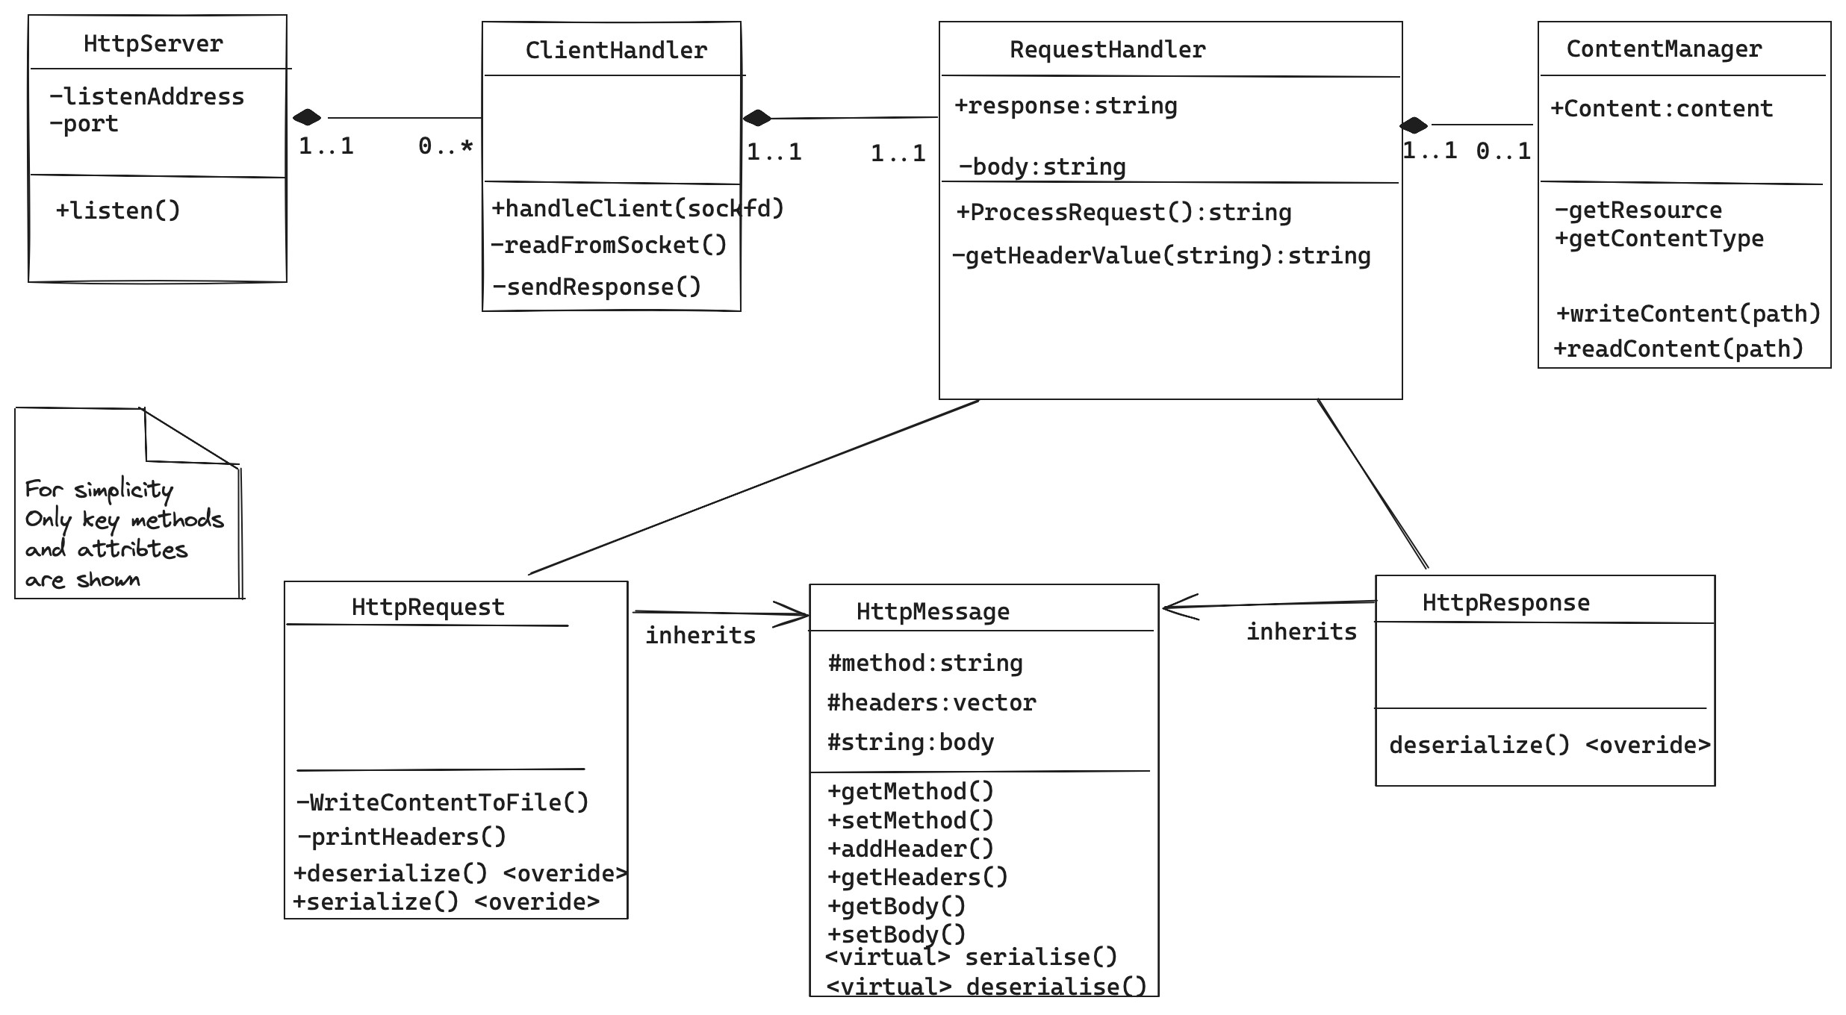
Figure 1 - High-Level Class Diagram

Program Flow
The section briefly describes how the classes relate to the program flow.

The sequence diagram in Figure 2 shows how the server loops and listens for incoming connections. A new connection will instantiate a dedicated worker thread that reads the bytes of the request.

The request handler de-serialises the bytes into an HTTPMessage object and acts upon the values within the object e.g., is it a GET or POST. The ContentHandler class performs the IO routines to read HTML pages, images, and JavaScript from files. To avoid thread conflicts on IO resources, mutexes are used.

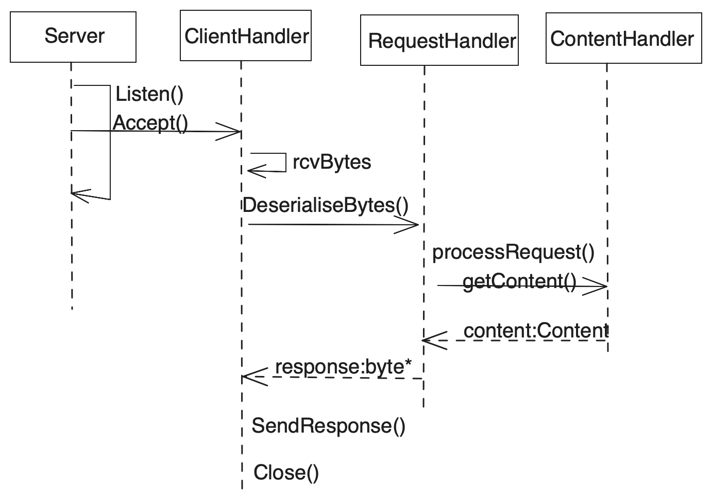
Figure 2 - Program Flow

The main function instantiates a single Server object, the server object runs in a continuous loop. Table 1 describes the key classes and their main purposes.

Table 1 - Class Names and Class Purpose
Class name | Main Purpose
Server | Establishing a listener and accepting incoming connections.  Listens for new connection requests and hands each one off to a new dedicated thread.
ClientHandler | Main thread for a connection, with receive bytes and respond bytes logic
RequestHandler | Unpacks the request bytes into the HTTP request object and acts upon the content of the message i.e., GET or POST
ContentHandler | Simple helper class to read and write message content from disk, for example, the website pages.

Development Tools
The code will be built using MacOS clang++ std=20. The project should also build on any recent Linux OS with little or no change with g++.

To build on Windows OS, the code would require directives to use the correct socket libraries.

As the code was built using VSCode, the .vscode folder of the project provides the build tasks and launch tasks for debugging.

Generative AI
ChatGPT was used as a development tool to help with some of the code, mainly to advise with syntax and provide code samples to point the developer in the right direction.

In building and debugging, the AI tool was also a useful support tool to post code snippets to see if there were any best practices or code enhancements to a method or coding style.

For example, the following question was asked:

“I'm creating an httpRequest and httpResponse class, what are the common elements I could put in to achieve inheritance?”

This provides a boilerplate piece of code that was adapted and built upon for the final C++ HTTPMessage class.

Test Outcomes
The browser developer tools networking tab shows the page content loading in parallel, this can be seen in Figure 3.

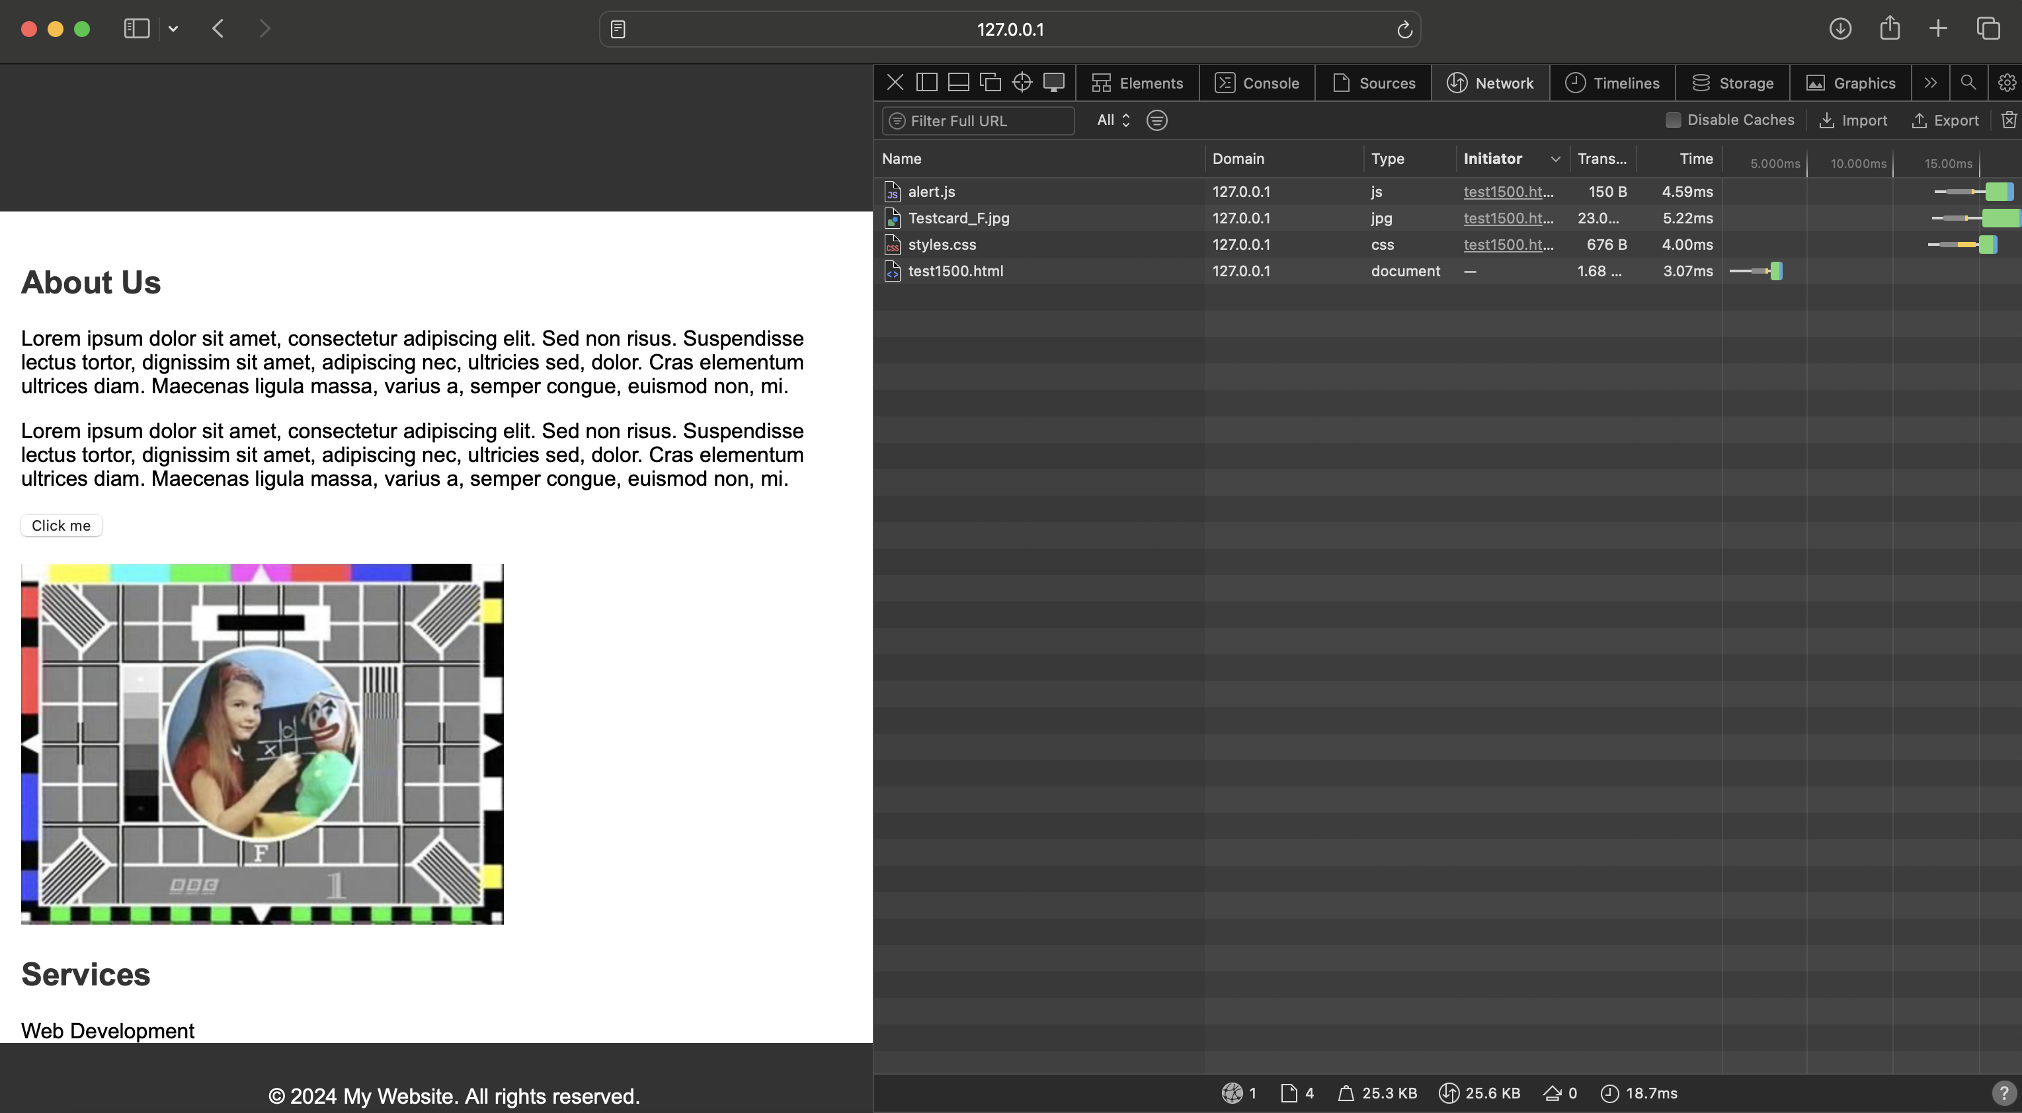
Figure 3 - Parallel Load

Remote Connections
When the server is configured to run with a host IP, it will allow connections in from networked devices. The screen shot in Figure 4 shows the content loaded in to Microsoft Edge Browser using the web host IP and port in the URL.

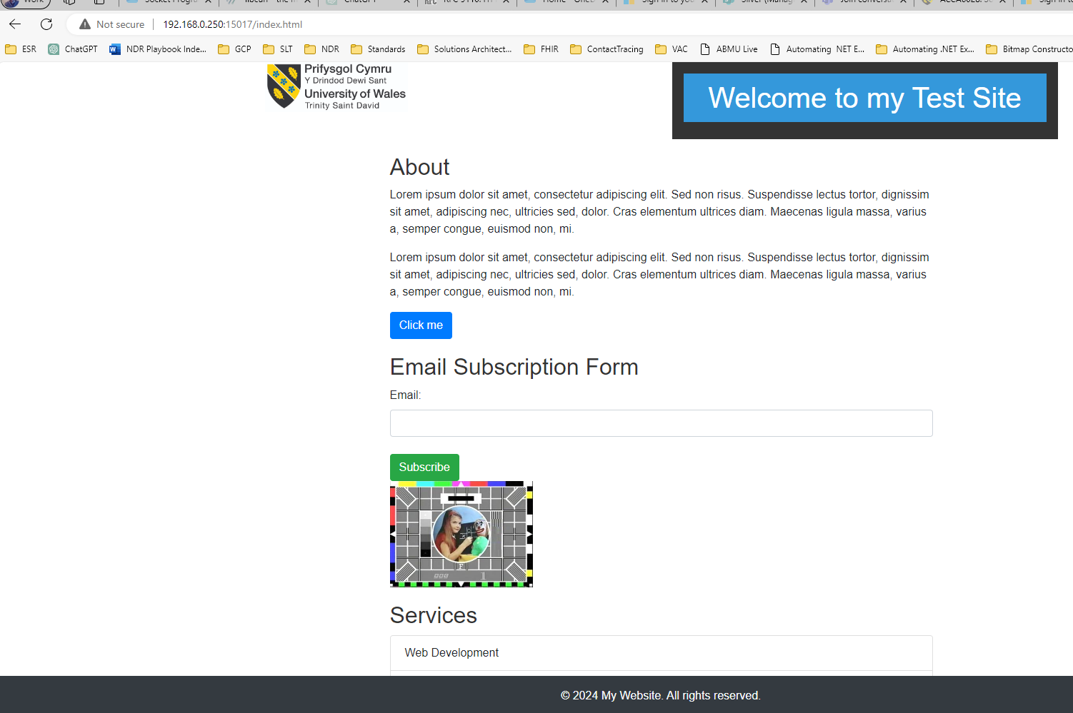
Figure 4 - Remote Connections

Increasing socket buffer size
Curl was used with test payloads to see how the server would handle large request sizes. The –verbose option was used to print useful byte sent and received information during development.

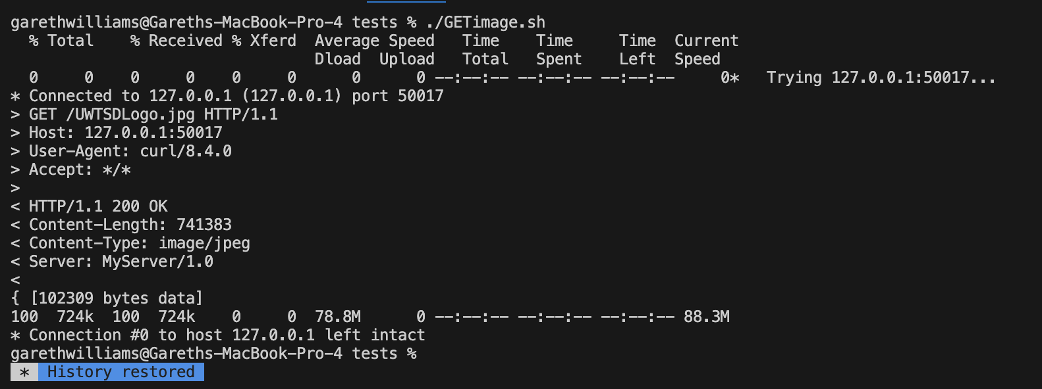
Figure 5 - Curl verbose output

Framework Code
The following Figure 6 shows how the framework code provided at the lecture was copied and modified slightly. The use of the framework saved development time by authoring essentially the same code from scratch.

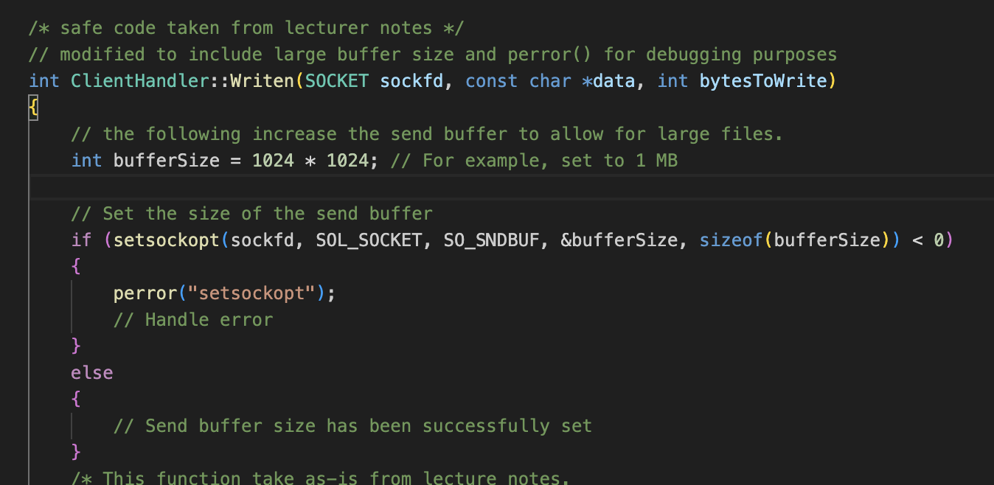
Figure 6 - Code Reuse

Example 404 response

If an invalid path is requested then the web server correctly responds with a 404 Not Found as shown in Figure 7.

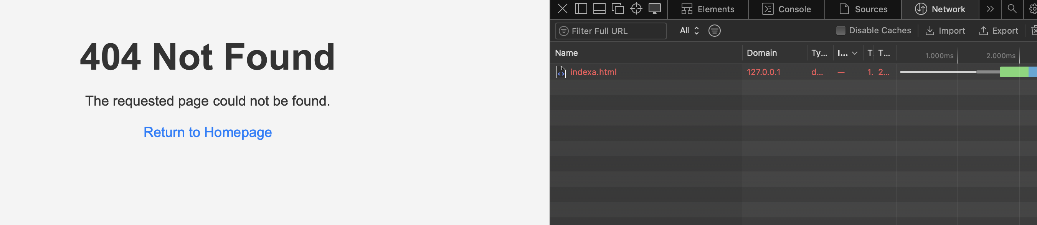
Figure 7 - 404 Not Found

Improvements
Content Caching strategy – server side. As IO operations are resource intensive, it would be good to read site static content once on server startup and hold it in memory for quick access.

Graceful server shutdown – in line with TCP standards, it would be best practice to stop any new connections, allow existing requests to complete and then close sockets gracefully. To achieve this a signal could be sent to the server class to end the loop.

Conclusion
This implementation of a simple web server demonstrates the relationship between the HTTP protocol in the application layer and the API to the transport layer of the OSI model – in this case TCP.

Generative AI helped with some coding tasks and sign-posting to solve particular C++ syntax problems. It was not used to provide full solutions, but just one more developer tool in the same way as GitHub and developer community and collaboration sites such as Stack Overflow and Youtube are used.

It was rare an example piece of code would work the first time and required a good developer understanding to either alter the code example or refinement of the question asked of the AI.

The use of industry-level HTTP frameworks such as libcurl may help provide a more robust solution, however, as the aim of the design was to illustrate the HTTP and socket programming concepts, the use of such libraries would have abstracted away complexity and understanding.

References

[1] | IETF, “RFC 9110: HTTP Semantics,” IETF, June 2022. [Online]. Available: https://www.rfc-editor.org/rfc/rfc9110. [Accessed 2024].
[2] | “libcurl - the multiprotocol file transfer library,” Daniel Stenberg, 2024. [Online]. Available: https://curl.se/libcurl/. [Accessed 04 April 2024].

Appendices

Copy of README.md from source

# Simple WebServer

Written in POXIS C++

## Build

To Build from linux terminal, using compiler of choice, clang++, c++ or g++, in the project root directory ...

```bash
g++ -std=c++20 -g main.cpp HttpServer.cpp ClientHandler.cpp INet4Address.cpp ContentManager.cpp HttpMessage.cpp HttpRequest.cpp HttpResponse.cpp -o server.out
```

To run the server with default port 8080 simply run the executable.

```bash
./server.out
```

The default home page is

```bash
http://127.0.0.1:8080/index.html
```

To stop the server use cntrl + c

## Site Content

The web server application expects all web site content such as HTML files, CSS and JavaScript files to appear in a folder:

```bash
./sitecontent
```

## HTTP Posts

For demonstration purposes, the included ./sitecontent allows a post of an email address. Anything posted will be written to the ./post folder with a timestamp filename.

## Tests Folder

In the ./tests folder, there are a number of bash scripts that used curl to test both Get and Post, in addition to stress test the multi threading.

Note: the ip and port would need to be changed to match what ever the configuration is running as.

