CertHE Computing Skills for Workplace

ACCA4026 - Software Solutions for Business


Name: | Qays Khan
ID: | 2617185
Lecturer’s Name: | Osman Elgawi
University: | University of Wales Trinity Saint David
Campus: | Quay Place

Contents:

Task 1. e-Commerce Website builders/software solutions 2
Wix: 2
Shopify: 2
Task 2a. Mind-map of contemporary software applications. 3
Task 2b. Mind-map of contemporary software applications 4
Task 3a. Office Applications for creating, storing, presenting, and analysing information/data. 5
MS Word 5
MS PowerPoint 5
MS Excel 5
MS Access 6
Task 3b. Office Applications for creating, storing, presenting, and analysing information/data. 7
IF Function: 7
Task 4. Communication and Collaboration applications. 10
Microsoft Outlook 10
Microsoft Teams 12
References 14

Task 1. e-Commerce Website builders/software solutions

e-Commerce are websites for buying and selling products online and is good for people who are starting up a business. e-Commerce Website builders provide tools and software for anyone to build their own websites. Examples of some e-commerce website builders include Shopify, eBay, Wix, Vinted and WooCommerce.

Wix:
Wix is an e-commerce website builder that is cost effective and can be great for beginners. “If you’re researching a free website builder or learning how to make a website without technical skills, Wix is one of the first website builders you’ll come across, and for good reason. Wix is a powerful, no-code website builder that helps individuals, creators and businesses design, publish and grow online from one place.” [1] Wix is also very accessible as these websites can be created using computers, tablets and even mobile devices.

Shopify:
Shopify is another example of an e-commerce website builder and is seen as a popular leading e-commerce platform. The reason for this is that is allows small business to grow by offering tools and software to easily buy and sell products. This can be done online, marketplaces, in person and on social media. You also do not need coding skills to create these websites so great for beginners. [2] Even though with Shopify subscription plans are offered, the initial start-up is given as a free trial. Please refer to ‘figure 1’ which breaks down the different Shopify price plans.
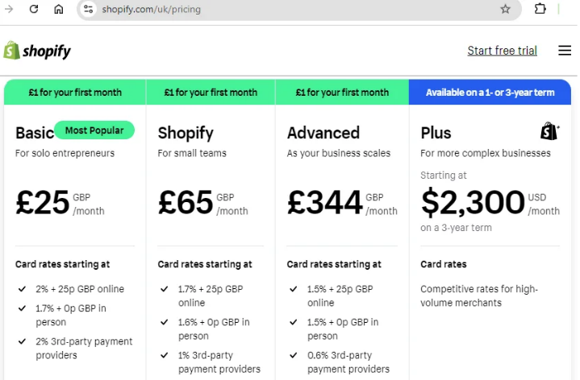
Figure 1 [11]

Task 2a. Mind-map of contemporary software applications.

Mind mapping is visual diagram also known as brainstorming that allows individuals to actively participate and give ideas towards a central topic. This central topic is at the centre of the diagram and then branches out to subtopics which can then be elaborated in detail. Colour and images can also be added to mind maps to increase the visual appeal of it. [3]

Moreover, brainstorming can be done with classic methods such as pen and paper/whiteboard, or you can also use more up to date online and digital programmes such as MS Word, Canva or MindMeister. It’s about brainstorming thoughts and ideas and bringing them to life using mind-mapping visuals, colour and specific text.

Furthermore, there are many benefits of using mind mapping. Some of these benefits, specific to business operations include:
- Organising ideas that the team discuss in meetings.
- Helps problem solving and decision making.
- Saves time.
- Improves focus.
- Boosts creativity.
- Clarifies complex ideas.
These and many more benefits of mind maps can ultimately increase productivity as it allows individuals using them to prioritise tasks efficiently. [4] Even website builders need mind maps to regulate activities and produce efficient websites for client needs.

Finally, mind maps can be used to collaborate with other businesses and ideas can be shared this way. “A strong business strategy through an effective mind map is totally achievable, especially if you set aside time to regularly update and revise on your mind map as your business evolves and new ideas are developed.” [5] Various communication tools can be used to easily deliver mind maps to each other such as via email, zoom calls or even MS Teams. There is another bonus to this which is that most of the communication and ideas given via these ‘mind maps’ can all be documented electronically and ownership can be recorded for the most part.

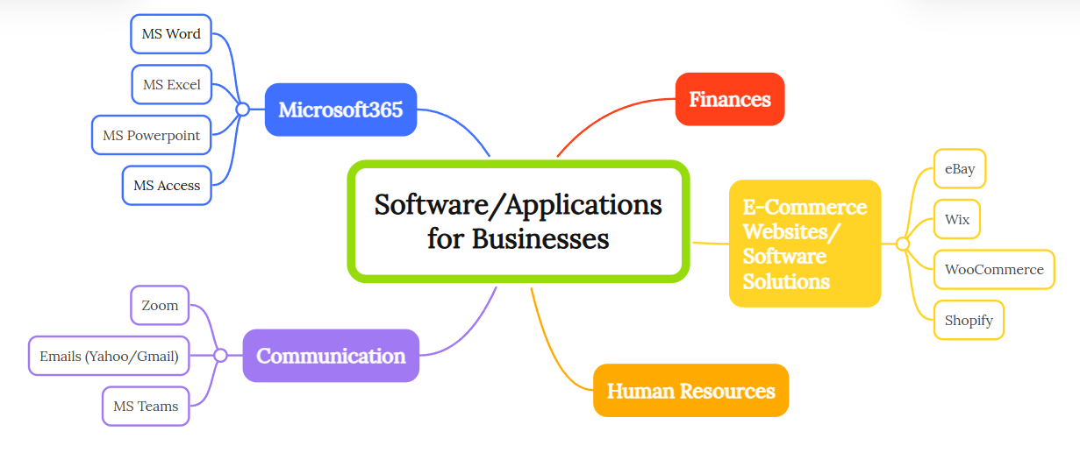
Task 2b. Mind-map of contemporary software applications
Mind Map: Created by myself using www.mindmeister.com [12]

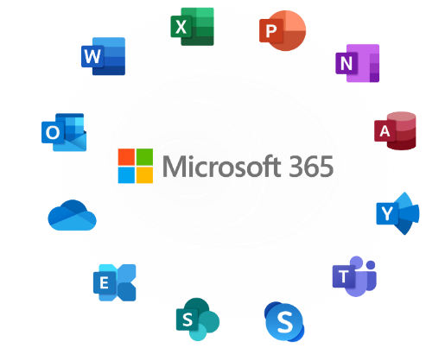
Task 3a. Office Applications for creating, storing, presenting, and analysing information/data.
Microsoft 365 is a well-used and generic office application. This software helps produce, store, present and simplify information/data. Please see below some examples of the tools offered in Microsoft 365.

MS Word

Microsoft Word is a software that produces online documents that you can save, edit, and format effectively. These online documents can produce posters, professional letters, assignments and these can all be edited without having to start from scratch or covering mistakes as you would do if it was done by hand. These documents can then be shared widely and accessed by many. For example, a poster can be created in word and then published online or sent as an attachment in an email to spread the information efficiently.

MS PowerPoint
Microsoft PowerPoint is another software that is provided by Microsoft 365. This software helps present information in a professional manner and can also be fun and creative. You can input information on various slides and make it more attentive based on your audience. For example, you can attach animations to information boxes for them to appear in a unique manner. This can be beneficial when presenting information to others as it can be more interactive and entertaining. As well as that Microsoft PowerPoint also offers ready-to-use templates of various pre-designed content which can save time when creating presentations. [6]

MS Excel
Furthermore, Microsoft Excel can be used to create spreadsheets which help manage, analyze and report data. It allows individuals to organise their information, make it easier to understand as well as input calculations and initiate reports using features like formulas, pivot tables, and charts. This can then be used to share information more effectively, for example in financial meetings or project management tasks. Also, automation tools, such as macros, is another beneficial feature in excel as it helps save time by managing repetitive tasks. [7] One thing to note, however, is that Excel can be very sensitive. What I mean by this is that if a formula is entered incorrectly the whole spreadsheet can be affected by this as it is all linked.

MS Access

Finally, Microsoft Access. This software is similar to Microsoft Excel where it helps manage, analyze and report data. However, where it differentiates itself is where it produced user-friendly forms for data entry, searching and editing data. Microsoft Access is a lot more technical and can require programming knowledge and digital skills. With this you can create forms, professional-looking reports and make queries e.g. search for a book. Furthermore, Access is useful for monitoring the levels of inventory and stock as well as tracking sales and even storing employee records. Overall, it is good to use for large databases. [8]

Task 3b. Office Applications for creating, storing, presenting, and analysing information/data.

IF Function:
Within MS Excel I used the IF function. This function helps highlight specific requests. Please see screenshot below for more information.

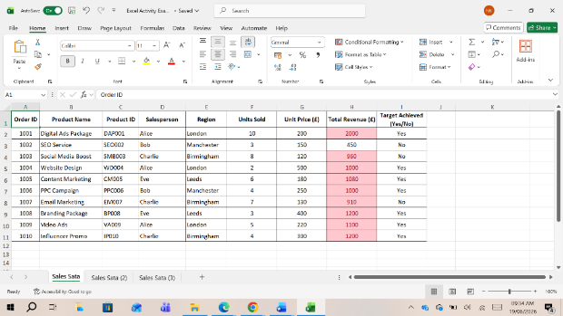
This is the MS Excel spreadsheet I implemented the IF function in.

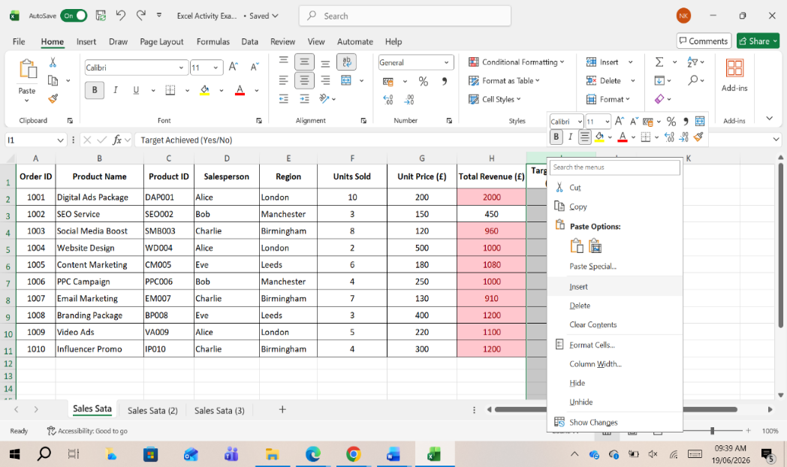

I inserted an extra column to the spreadsheet where I needed to input the IF function.

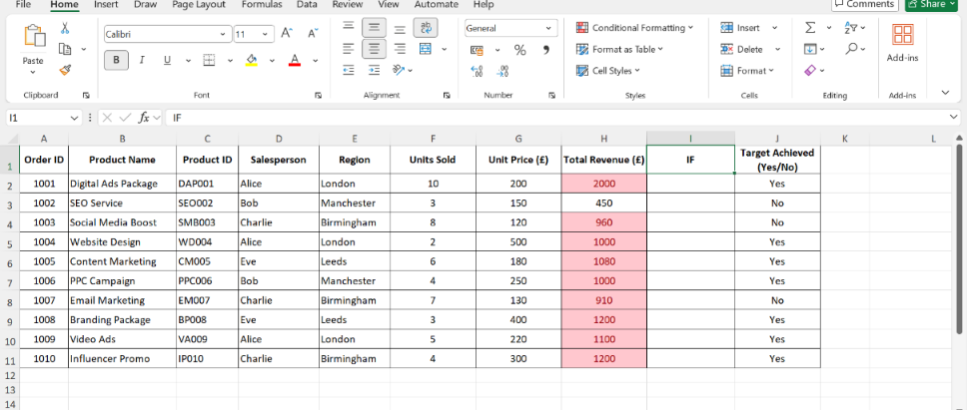
My IF function will go into this column.

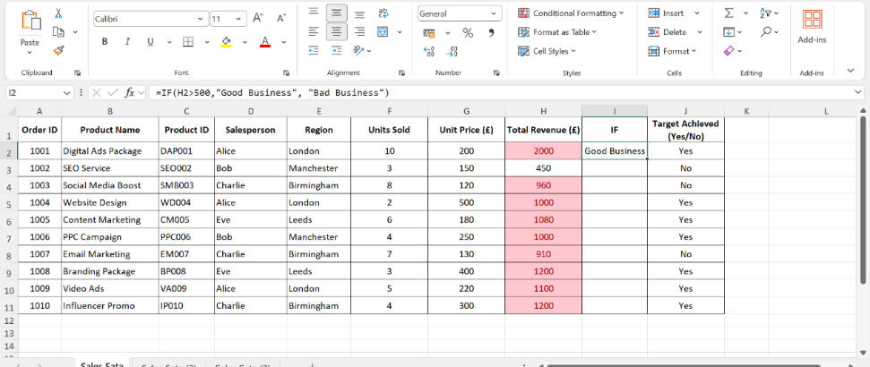

I want the function to tell me if the company is making more the £500 in total revenue. If it is making more the £500 in total revenue it is a “Good” business and if it is not, then it is a “Bad” business. So, using the IF function I type =IF(“Click the cell that has the amount of total revenue”>500,"Good Business", "Bad Business") in my spreadsheet this formula looks like this: =IF(H2>500,"Good Business", "Bad Business")

Once I click enter the formula should work and the IF function is applied.

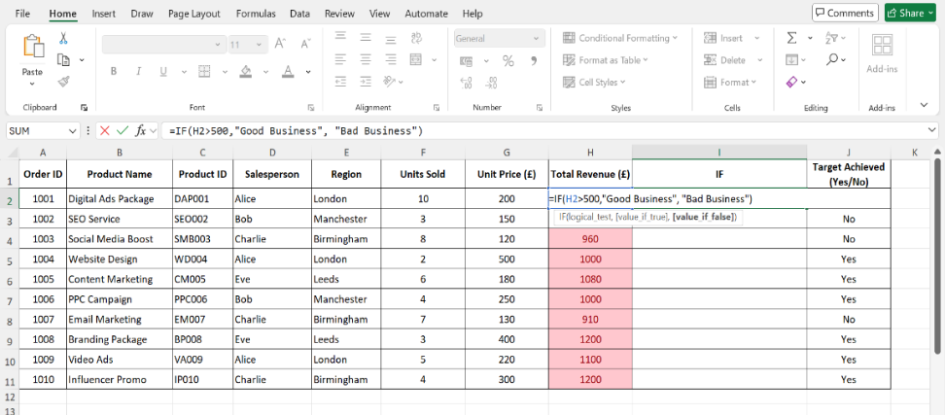

I then use the corner cross the drag the formula down to apply it to the rest of the column. This then shows me using the IF function which companies are ‘Good’ and which are ‘Bad’ without me having to go through the whole list, one by one.

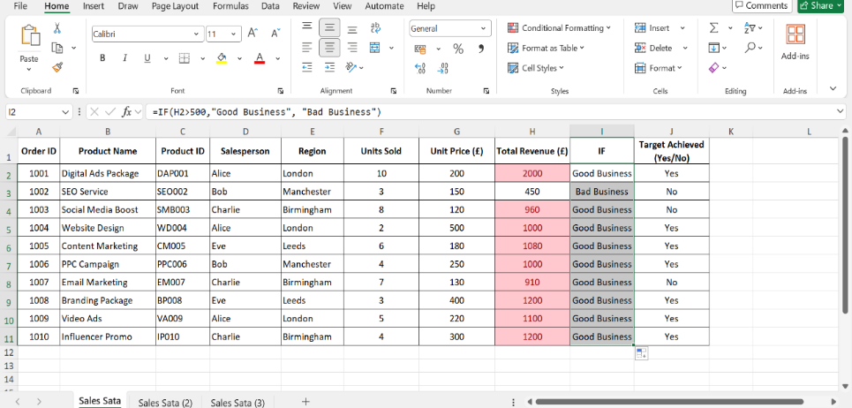

Task 4. Communication and Collaboration applications.
(Approx. 1000 words)

Microsoft Outlook
Outlook is a modern communication software application that is widely used in businesses and organisations. It is part of Microsoft Office 365.

“With Outlook on your PC, Mac or mobile device, you can:
- Organize email to let you focus on the messages that matter most.
- Manage and share your calendar to schedule meetings with ease.
- Share files from the cloud so recipients always have the latest version.
- Stay connected and productive wherever you are.” [9]

Businesses and organisations can store and organise contacts in different teams and group departments accordingly. A single email can be sent to several individuals, and these recipients can be Carbon Copied (CC). You can also Blind Carbon Copied (BCC), which hides the recipient addresses from each other, ensuring privacy, which is ideal for large recipient lists or when discretion is needed. There are many more features that can be accessed when using Outlook such as linking your calendar to keep yourself updated and organised. Finally, you can set up an email signature which allows you to complete your emails without having to retype as specific signature repeatedly.

Please see below screenshots of how to CC and BCC in Microsoft Outlook.

- Log in to your Outlook account. Click ‘New email’ to create a new email.
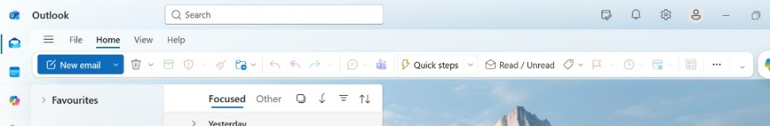

- Enter all the recipients in the appropriate field where it be ‘To’, CC’ or ‘BCC’.

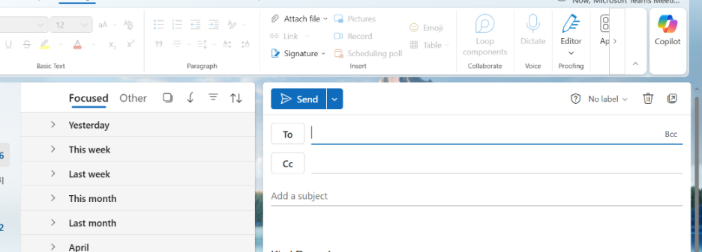

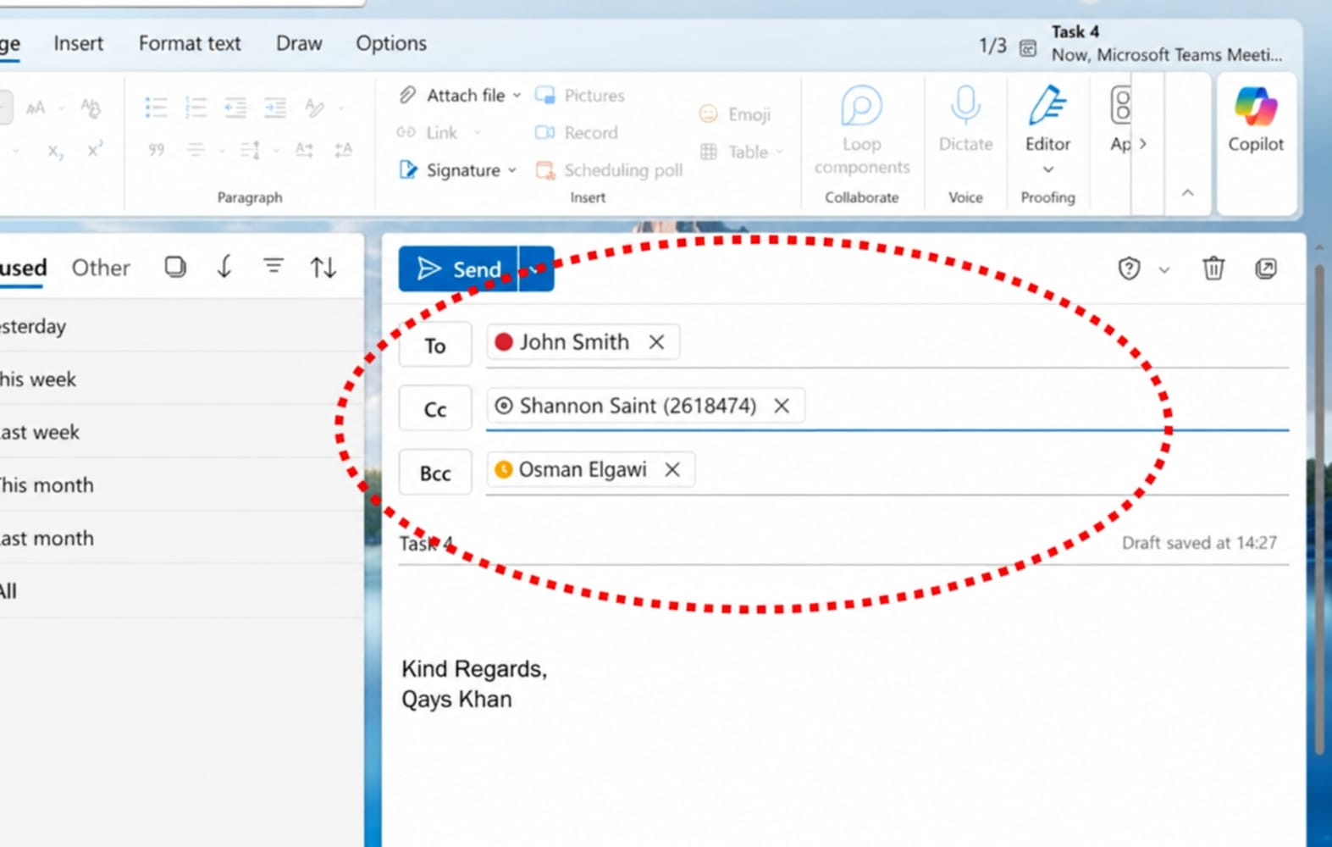

Microsoft Teams

A collaboration software that is used widely by businesses and organisations is Microsoft Teams. “Microsoft Teams is the hub for teamwork in Microsoft 365. The Teams service enables instant messaging, audio and video calling, rich online meetings, mobile experiences, and extensive web conferencing capabilities.” [10]

As mentioned above Microsoft Teams is used to make video calls, this is great if you are communicating with individuals and businesses that are not very local to you and face-to-face meetings are difficult to arrange. It also saves time as people can communicate collaboratively from the comfort of their own space. Group meetings can also be arranged and this can even be requested in various calendars so all involved are aware an can be present remotely.

Please see below screenshots of how to arrange meetings in Microsoft Teams.

- Log in to your Teams account and go into your calendar.
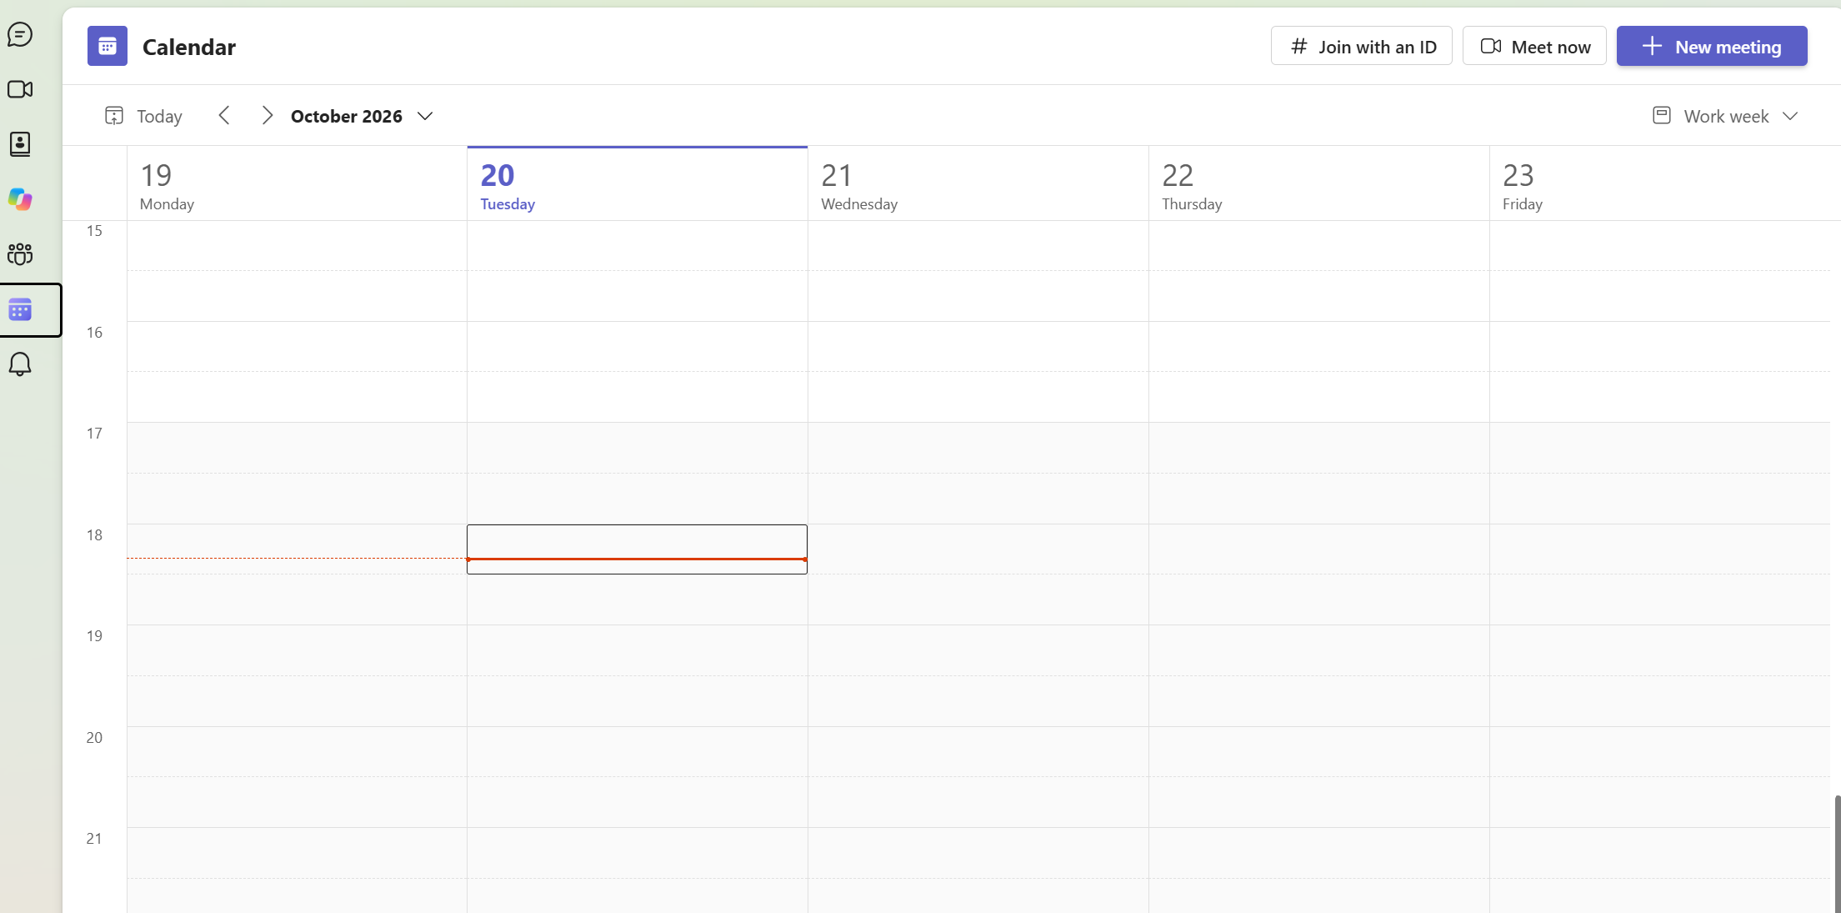

- Arrange a meeting as normal with title, date, time, a brief message and then select ‘Teams Meeting’ so everyone involved is aware this meeting will be a video call

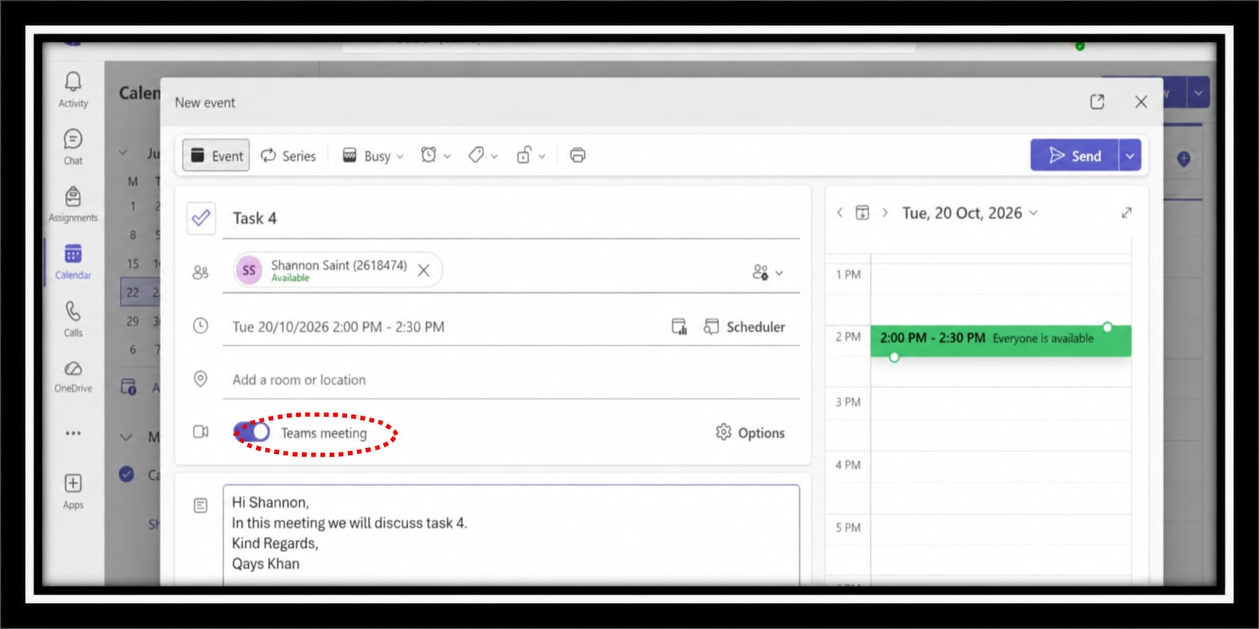

- After pressing ‘Send’ the meeting should appear in everyone’s calendar like a normal meeting and the date and time will be blocked out appropriately.
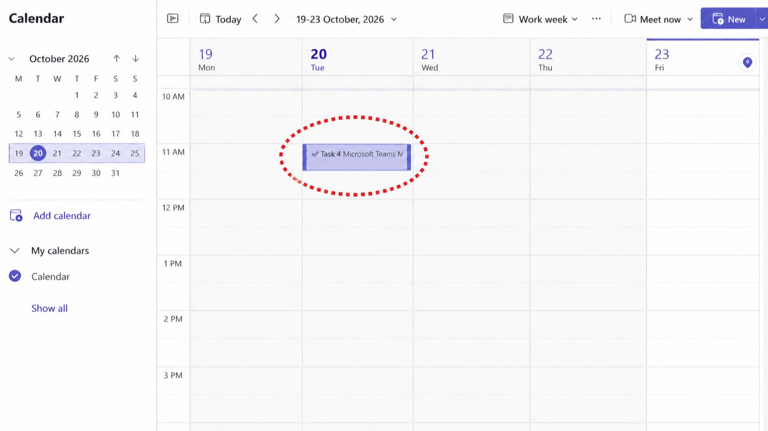

References

[1] | "What Is Wix? Everything you need to know about the website builder," [Online]. Available: https://www.wix.com/blog/what-is-wix. [Accessed May 2026].
[2] | "10 Best Ecommerce Platforms for Small Business in 2026 - Shopify India," [Online]. Available: https://www.shopify.com/in/blog/best-ecommerce-platform-small-business?term=create%20online%20shop%20website&adid=565806725674&campaignid=15439902611&utm_medium=cpc&utm_source=google&bucket=website_other&matchtype=b&network=g&gad_source=1&gad_campaignid=1. [Accessed May 2026].
[3] | "Mind mapping - Note-taking: a Practical Guide - Subject Guides at University of York," [Online]. Available: https://subjectguides.york.ac.uk/note-taking/mind-map. [Accessed May 2026].
[4] | "12 Benefits of Mind Mapping for Students and Professionals," [Online]. Available: https://www.theknowledgeacademy.com/blog/benefits-of-mind-mapping/. [Accessed June 2026].
[5] | "Boost Small Business Growth with Mind Mapping Techniques — Micromentor," [Online]. Available: https://micromentor.org/blog/how-can-mind-mapping-enhance-small-business-growth-1. [Accessed May 2026].
[6] | SlideUpLift, "Advantages and Disadvantages of Microsoft PowerPoint: Pros, Cons, and AI Features Explained," SlideUpLift, 10 09 2025. [Online]. Available: https://slideuplift.com/blog/advantages-and-disadvantages-of-using-powerpoint-for-presentations/. [Accessed June 2026].
[7] | GeeksforGeeks, "Importance of Microsoft Excel in the Workplace (With RealWorld Examples)," GeeksforGeeks, 21 02 2025. [Online]. Available: https://www.geeksforgeeks.org/excel/importance-of-microsoft-excel-in-workplace/. [Accessed June 2026].
[8] | R. Jones, "What is Microsoft Access? Its Uses and Benefits (Guide for 2026)," NetCom Learning, 05 April 2026. [Online]. Available: https://www.netcomlearning.com/blog/what-is-microsoft-access-a-complete-guide. [Accessed Jun 2026].
[9] | deepamKolhe. [Online]. Available: https://support.microsoft.com/en-us/outlook/training/what-is-outlook. [Accessed Jun 2026].
[10] | "Microsoft Teams service description - Service Descriptions.," [Online]. Available: https://learn.microsoft.com/en-us/office365/servicedescriptions/teams-service-description. [Accessed June 2026].
[11] | "Shopify Fees UK Explained - How Much is Shopify UK?," [Online]. Available: https://linkmybooks.com/blog/shopify-fees-uk. [Accessed May 2026].
[12] | "Mind Meister," Mind Meister, [Online]. Available: https://www.mindmeister.com/4020203540/software-applications-for-businesses. [Accessed Jun 2026].

