Fighting Cancer Together
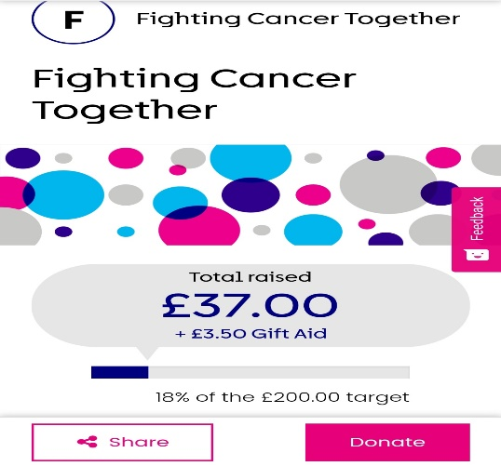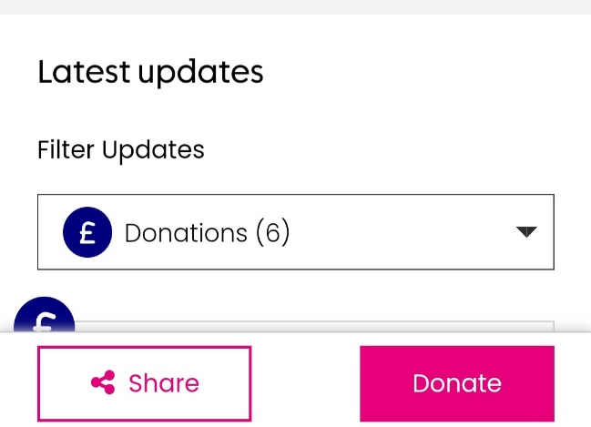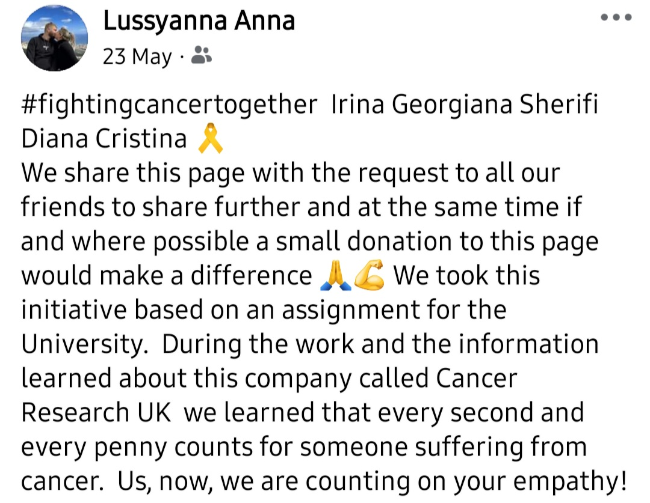
Currently, our project is well defined, and each of our contributions is leading it to its completion. Our objective is to collect £200 for the organisation Cancer Research UK by utilising an internet fundraising platform. Currently, 18% of the total amount has been collected, with a remaining timeframe till 30.06.2024 to raise the whole amount. Over the past fortnight, we have made significant progress in terms of raising awareness and ensuring broad accessibility and visibility of the project. We have distributed flyers and promoted them on social media. Additionally, I have taken the responsibility of designing an Online Donor Form (attached below) to gain insights into our mistakes and areas for improvement. We will consider this feedback form and make an effort to include the items that were overlooked.
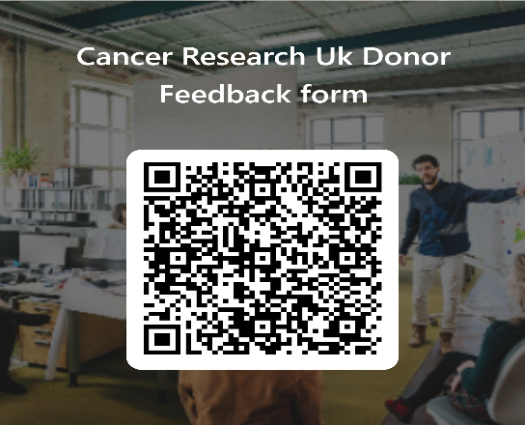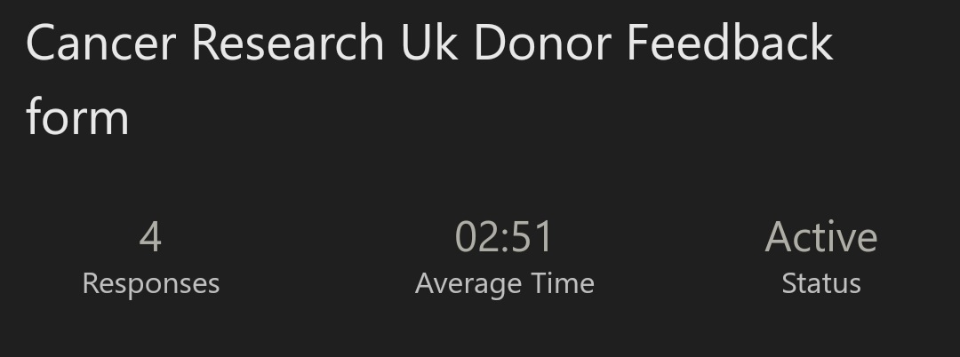
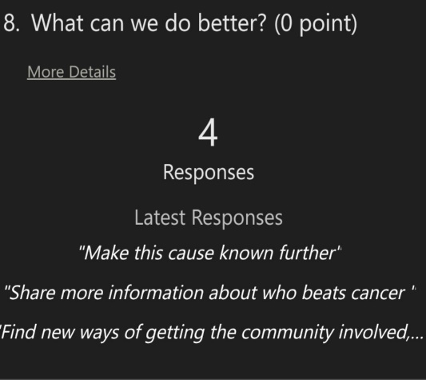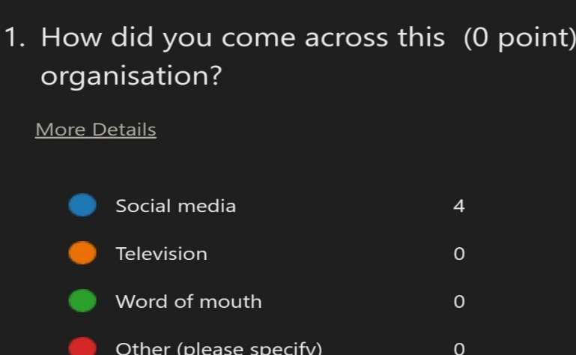
Upon reflecting on the feedback received, I have reached to the conclusion that individuals lack education on the subject matter. In terms of marketing, our primary channel for reaching people was social media, and most of the remarks we received originated from social media. Based on the timing, my view is that the specified sum is too large to be raised within the given timeframe. One of the elements that led me to this conclusion is a SWOT analysis conducted on Cancer Research UK. One of the company's weaknesses is its dependence on individuals' contributions. Regarding finances, people have been experiencing economic hardships recently.

