
OME – Electromagnetic Radiation (ACDC5009), Analysis of Electromagnetic Wave Propagation

12/04/2025

Nathan Rowe - 1910544

Declaration
I declare that this report is the product of my own work and is not being submitted for any other degree etc.

Contents

1 References 4
2 Introduction 5
2.1 Task 1 5
2.2 Task 2 5
3 Background 5
3.1 Electric Field 5
3.2 Magnetic Field 5
3.3 Electromagnetic Field 6
3.4 Electromagnetic Radiation 6
3.5 Waveguides 6
3.5.1 Propagating modes 7
3.5.2 Transverse Electric (TE) 7
3.5.3 Transverse Magnetic (TM) 7
3.5.4 Transverse Electromagnetic (TEM) 7
3.5.5 Waveguides continued 7
3.5.6 Cutoff frequencies 7
3.6 Antenna 8
3.6.1 Dipole antenna 8
3.6.2 Dipole Halfwave theory 8
3.6.3 Radiation patterns 8
4 Simulation 1 10
4.1 Identifying the Dominant Mode 10
4.2 Port Field Display 10
4.2.1 Port 1 10
4.2.2 Port 2 11
4.3 Magnitude and Vectors 12
4.3.1 TE10 E field 12
4.3.2 TE10 H field 13
4.3.3 TE20 E field 14
4.3.4 TE20 H field 14
4.3.5 TE30 E field 15
4.3.6 TE30 H field 16
4.4 Cut-off Frequency 16
4.4.1 Theoretical values 16
4.4.2 Simulation values 17
5 Simulation 2 17
5.1 Identifying the Dominant Mode 17
5.2 Port Field Display 17
5.2.1 Port 1 17
5.2.2 Port 2 18
5.3 Magnitude and Vectors 19
5.3.1 TE10 E field 20
5.3.2 TE10 H field 20
5.3.3 TE20 E field 21
5.3.4 TE20 H field 22
5.3.5 TE30 E field 22
5.3.6 TE30 H field 23
5.4 Cut-off Frequency 24
5.4.1 Theoretical values 24
5.4.2 Simulation values 24
6 Simulation 3 24
6.1 Calculations 25
6.1.1 Halfwave antenna length 25
6.1.2 Operating frequency 25
6.1.3 Simulation values 25
6.1.4 Radiation Pattern 26
7 Discussion 26
7.1 Simulation 1 Discussion 26
7.2 Simulation 2 Discussion 26
7.3 Simulation 3 Discussion 27
8 Conclusion 27

References

[1] | J.Stalin, Electromagnetic Radiation Lectures, 2025.
[2] | “Isaac Physics,” [Online]. Available: https://isaacphysics.org/concepts/cp_electric_field. [Accessed 12 04 2025].
[3] | “Live Science,” [Online]. Available: https://www.livescience.com/38169-electromagnetism.html. [Accessed 12 04 2025].
[4] | D. J. Griffiths, “Introduction to Electrodynamics, 4th Edition,” p. Chapters 7 & 9 .
[5] | “Research Gate,” [Online]. Available: https://www.researchgate.net/figure/Two-typical-examples-of-closed-waveguides-a-rectangular-waveguide-and-b-cylindrical_fig1_220451636. [Accessed 12 04 2025].
[6] | “MATLAB,” [Online]. Available: https://www.mathworks.com/help/antenna/gs/antenna-classification.html. [Accessed 12 04 2025].
[7] | D. M. Pozar, Microwave Engineering, 4th Ed..
[8] | Sadiku, Elements of Electromagnetics, 7th Ed..
[9] | “Physics,” [Online]. Available: https://physics.stackexchange.com/questions/659296/are-the-field-lines-on-a-bar-magnet-diagram-contour-lines. [Accessed 12 04 2025].
[10] | “Science Direct,” [Online]. Available: https://www.sciencedirect.com/topics/neuroscience/electromagnetic-radiation#:~:text=Electromagnetic%20radiation%20refers%20to%20the,radio%20waves%20to%20gamma%20rays.. [Accessed 12 04 2025].
[11] | S. Rahmatia, “Research Gate,” [Online]. Available: https://www.researchgate.net/figure/The-structure-of-l-2-dipole-antenna-5_fig1_320751102. [Accessed 12 04 2025].

Introduction
The purpose of this study and document is to give a background into Electromagnetic Radiation, some of its theories, and a series of practical simulations/demonstrations which are summarised into 2 main tasks, which are detailed further as follows:

Task 1
- Designing of a rectangular waveguide
- Identifying the dominant modes passing through the waveguide
- Recording the port field display
- Obtaining magnitude and vectors of electromagnetic fields
- Cutoff frequencies
- Waveguide comparisons

Task 2
- Designing of a halfwave dipole antenna
- Halfwave theory
- Operating frequency
- Radiation patterns

Background

Electric Field
An electric field is a region of space around a charged particle where other charged particles experience a force. It is a vector field, meaning it has both magnitude and direction.
The electric field (E) at a point is defined as the force (F) experience per unit positive test charged (Q0) placed at that point: $Ε= \frac{F}{q0}$ and is measured in newtons per coulomb or volts per meter [1].
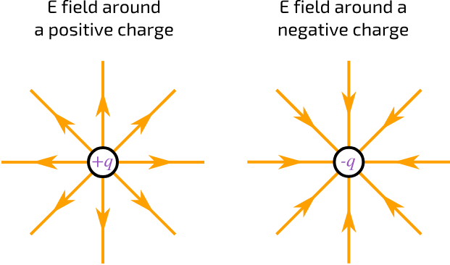
Figure 1 - Electric Field Diagram [2]

Magnetic Field
A magnetic field is a region around a magnet moving electric charge, where magnetic forces act. They have magnitude and direction (charge travels from north to south poles)
The magnetic field at a point is defined as force (F) experience by moving a charge in the field is proportional to the charge (q), the velocity of the charge (v) and the angle. This can be given as: $f=qυΒsin⁡(θ)$ and is measured in tesla or weber per meter squared [1].
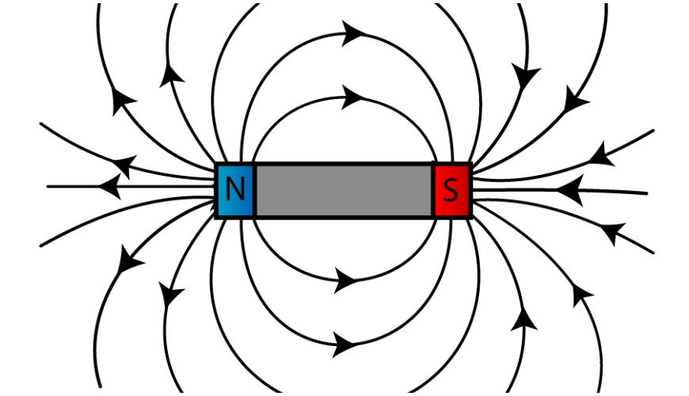
Figure 2 - Magnetic Field Diagram [3]

Electromagnetic Field
An electromagnetic field is where an electric and magnetic field interacts and influences one another. The magnetic field is created when current flows through a conductor. Electric charges generate an electric field while, while moving charge generate a magnetic field. Thus, creating an electromagnetic force that occurs between electronically charged particles.
These fields propagate as waves [4] such as light and radio waves. Their behaviour can be given by the Maxwell’s equations.

Electromagnetic Radiation
Electromagnetic radiation is energy that is transmitted at the speed of light through oscillating electric and magnetic fields. These are perpendicular to each other and to the direction of travel as shown in [Figure 3]. Electromagnetic radiation can propagate as light, radio waves, microwaves, and x-rays, etc.
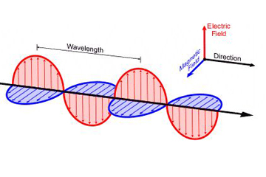
Figure 3 - Electromagnetic Radiation Diagram [3]

Waveguides
Electromagnetic waveguides are a structure which guide both electric and magnetic waves with minimal energy loss by restricting energy transmission to one direction [1]. Generally, they are of a metallic construction and work on the principle of total internal reflection from the structures conducting walls. Typically, there are two main types of waveguides: rectangular and circular per [Figure 4]. These support TE and TM modes as [Section 3.6] expands upon.
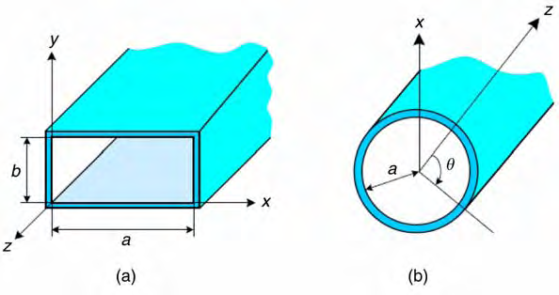
Figure 4 - Typical Waveguide Construction [5]

Propagating modes
The propagating mode is the lowest frequency mode which can propagate within a waveguide, also known as the cut-off frequency. Below this frequency, no signals can propagate along the guide. The result of this, is the waveguide can also be considered a high-pass filter. There are 3 main types of mode which are summarised as follows:

Transverse Electric (TE)
TE waveguide mode is dependent on the transverse electric waves, generally characterised by the electric vector being perpendicular to the direction of propagation.

Transverse Magnetic (TM)
TM waveguide mode is dependent on the transverse magnetic waves, generally characterised by the magnetic vector being perpendicular to the direction of the propagation.

Transverse Electromagnetic (TEM)
TEM waveguide mode is characterised by the principle of both the electric and magnetic waves are perpendicular to the direction of propagation.

Waveguides continued
The geometry of the waveguide also affects the cut-off frequency. In each mode, (a) and (b) of [Figure 4] denote the indices, where (a) and (b). In this example, the mode can be given by ${TE}_{ab}$.

Cutoff frequencies
As described in [Section 3.6] the cut-off frequency is the minimum frequency at which a specific mode can propagate through the waveguide. Below this, it does not propagate and decays exponentially, this is known as evanescence.
The cut-off frequency of a rectangular waveguide can be calculated with the following equation: $f_{c}=\frac{c}{2}\sqrt{{\left(\frac{m}{a}\right)}^{2}+{\left(\frac{n}{b}\right)}^{2}}$. where (m) indicates the number of half wavelength variations in the azimuthal direction, (n) indicates the number of half wavelength variations in the transverse direction, (a) width of waveguide, (b) height of waveguide, and C is the velocity of light.

Antenna
An antenna converts electric current to electromagnetic waves. It can also be used to do the opposite; thus, it can be known as a transmitter or receiver. There are numerous types of antennae which are classified by their design, such as:
- Wire antenna
- Aperture
- Reflector
- Lens
- Micro strip
- Array
The design of antennas varies by application and frequency range [1].

Dipole antenna
A diploe antenna is typically a straight conductive wire divided into equal halves, extending in opposite directions from the central feed point per [Figure 5].
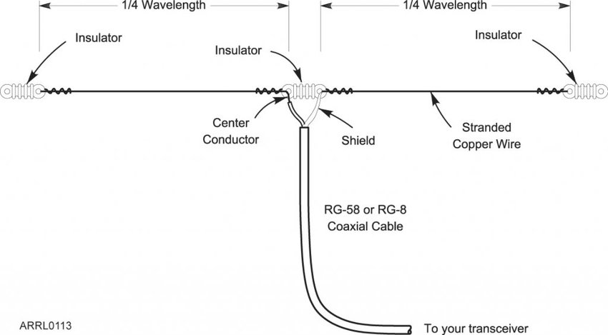
Figure 5 - Dipole Antenna Diagram [5]
The central feed point connects to the transmission line and is the best place to feed a signal given the low impedance. A key feature of a dipole antenna is that the current is maximum at the centre, and minimum at the ends. Voltage is the opposite of this. At resonance, there is a high amount of radiation efficiency and impedance matching.
Dipole antenna theory also advises that they are most efficient when the antenna overall length is an odd multiple of the half wavelength.

Dipole Halfwave theory
The frequency of operation of a dipole half wave antenna is half that of its wavelength. Where the length of the total wire equals half of the wavelength. This can be given as $L=\frac{λ}{2}$

Radiation patterns
As described in [Section 3.11] a dipole antenna emits radiation. There are generally 3 types of radiation pattern, such as:

Isotropic
Radiates uniformly in all directions with the same amount of intensity throughout. The pattern forms a spherical shape [Figure 6], thus there is no preferred direction. It can be referred to as an ideal lossless antenna.
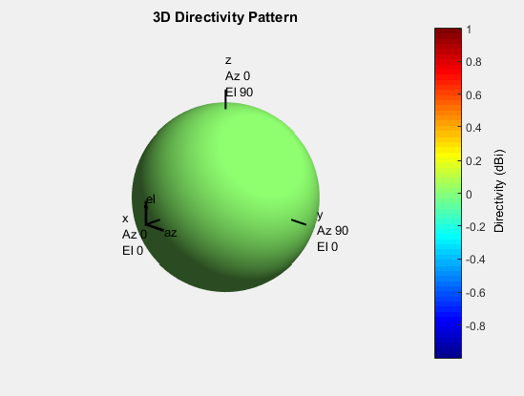
Figure 6 - Isotropic Antenna Radiation Pattern [6]

Omnidirectional
Radiates uniformly (much like isotropic) in all directions with the same amount of intensity throughout, but only in a single plane [Figure 7].
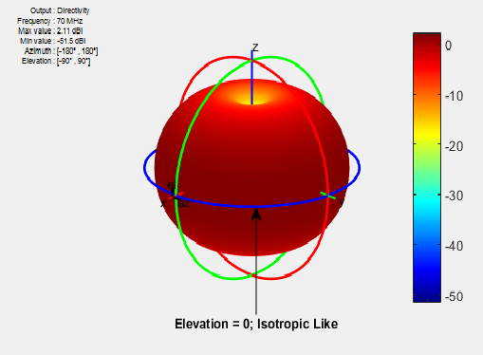
Figure 7 - Omnidirectional Antenna Radiation Pattern [6]

Directional/Beam
Direction antennas are highly directive in a given direction. As such, they have a high special selectivity and narrow bandwidth. The pattern of this is shown in [Figure 8]
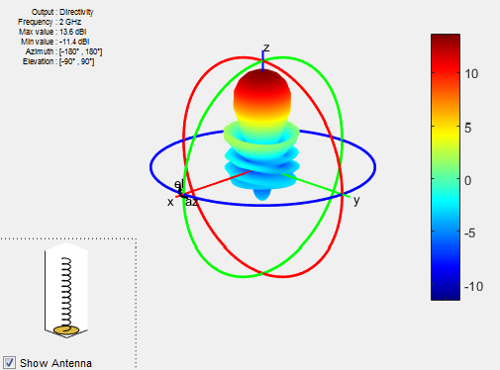
Figure 8 - Directional Antenna Radiation Pattern [6]

Simulation 1
A rectangular waveguide with perfect electric conductor (PEC) walls is filled with a vacuum. Given dimensions of the waveguide are (a) = 19, (b) = 5, and length = 50mm. The simulation is run between a frequency of 2GHz and 30GHz in order to analyse the behaviours.

Identifying the Dominant Mode
TE10 is the dominant mode in rectangular waveguides. This is backed up by the calculations as presented in [Section 4.7.1]

Port Field Display

Port 1
The field display for port 1 is captured in the following figures:
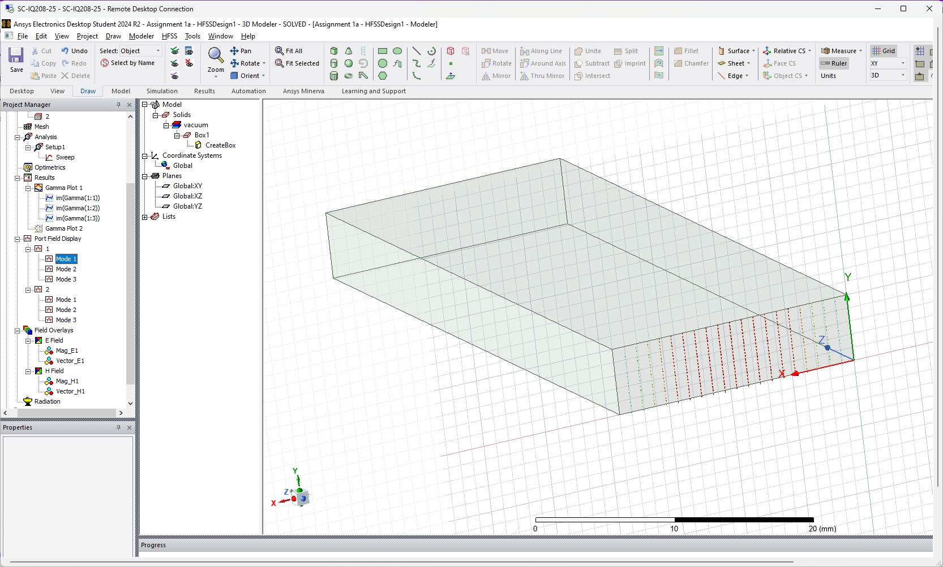
Figure 9 - Field Display, Port 1 TE10
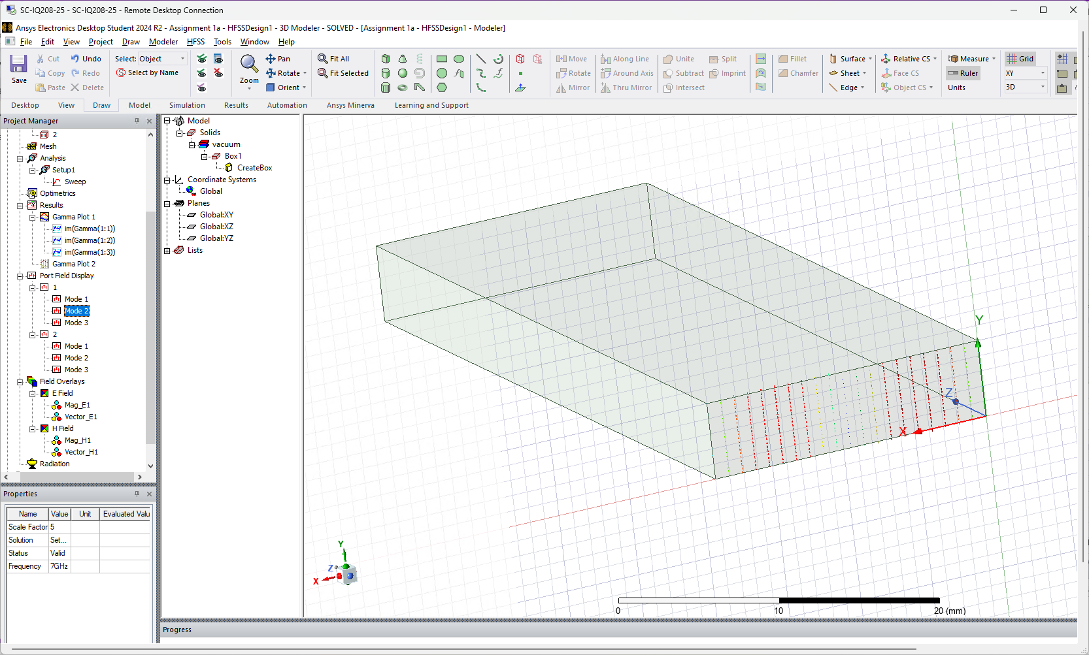
Figure 10 - Field Display, Port 1 TE20
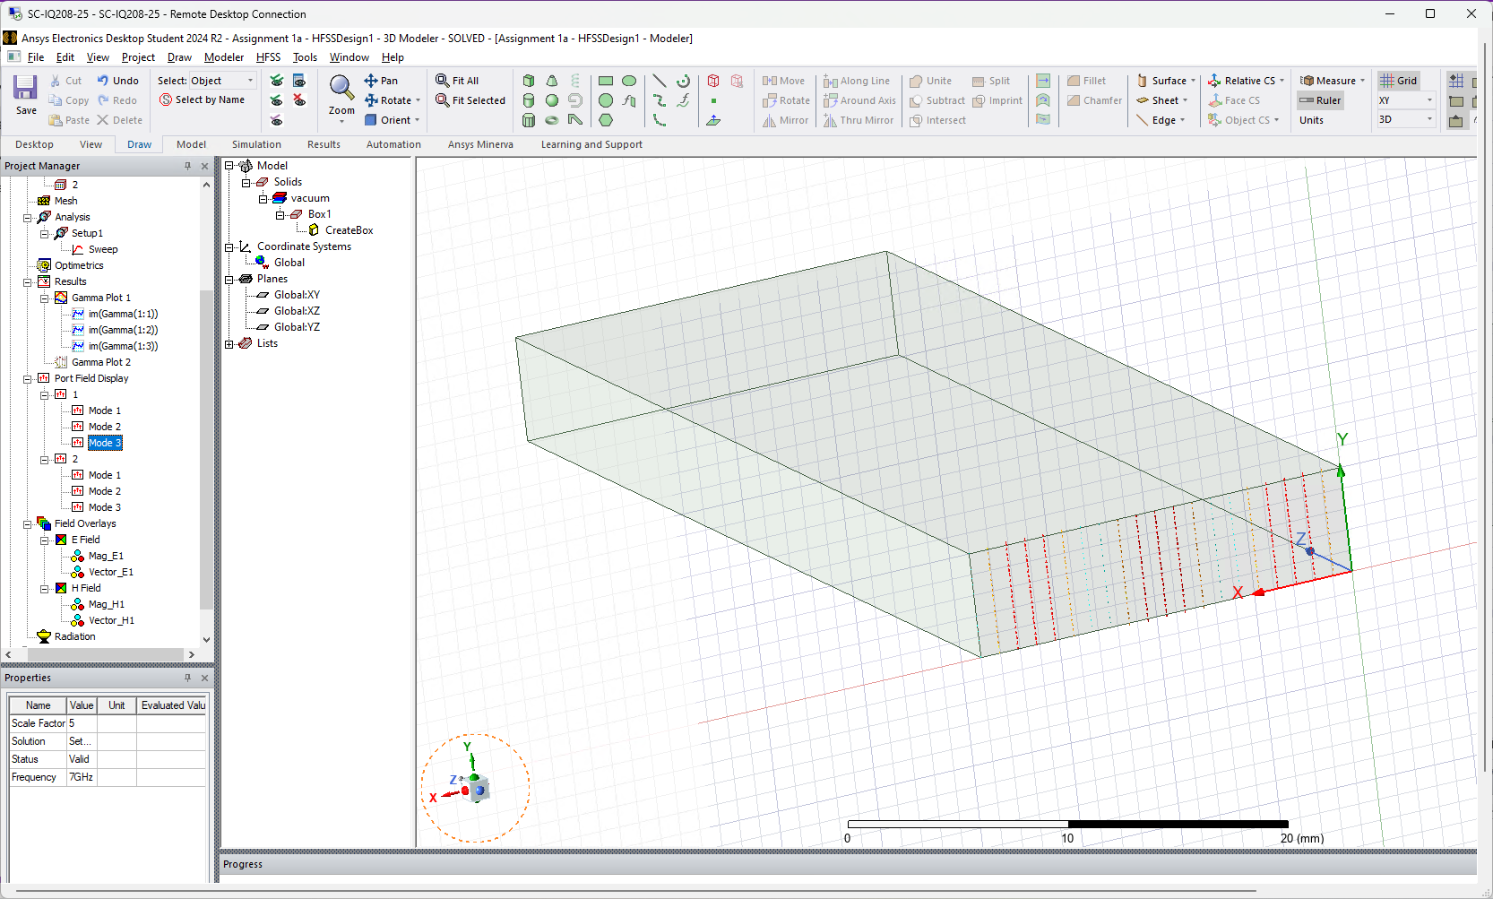
Figure 11 - Field Display, Port 1 TE30

Port 2
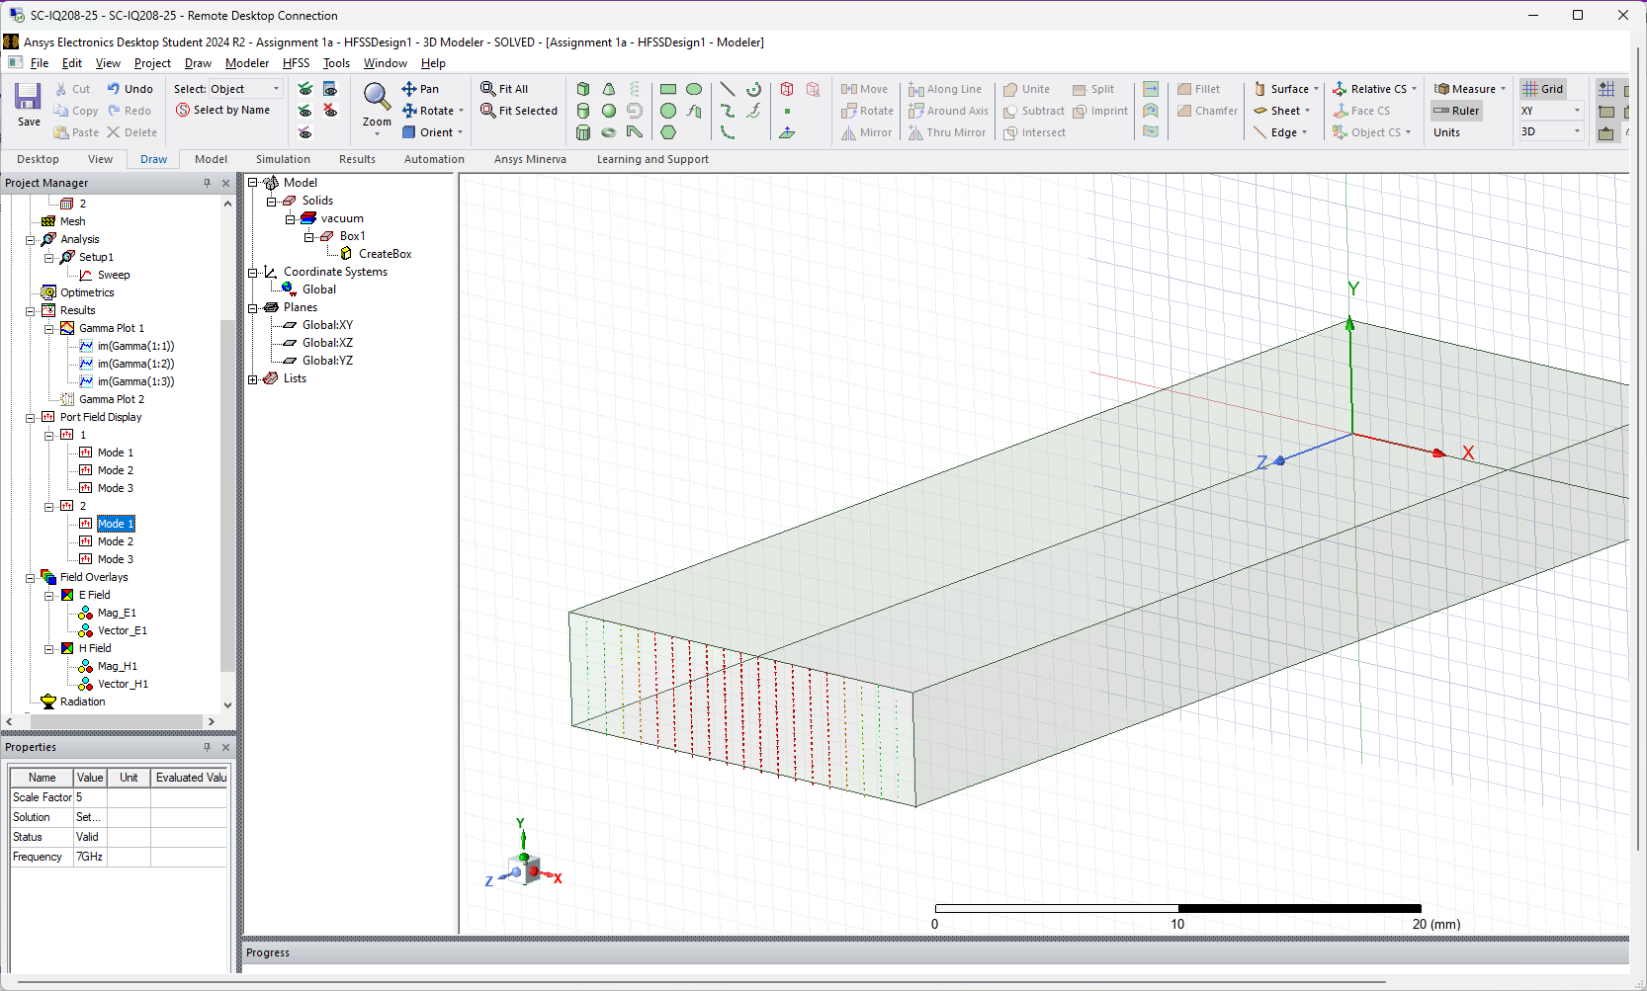
Figure 12 - Field Display, Port 2 TE10
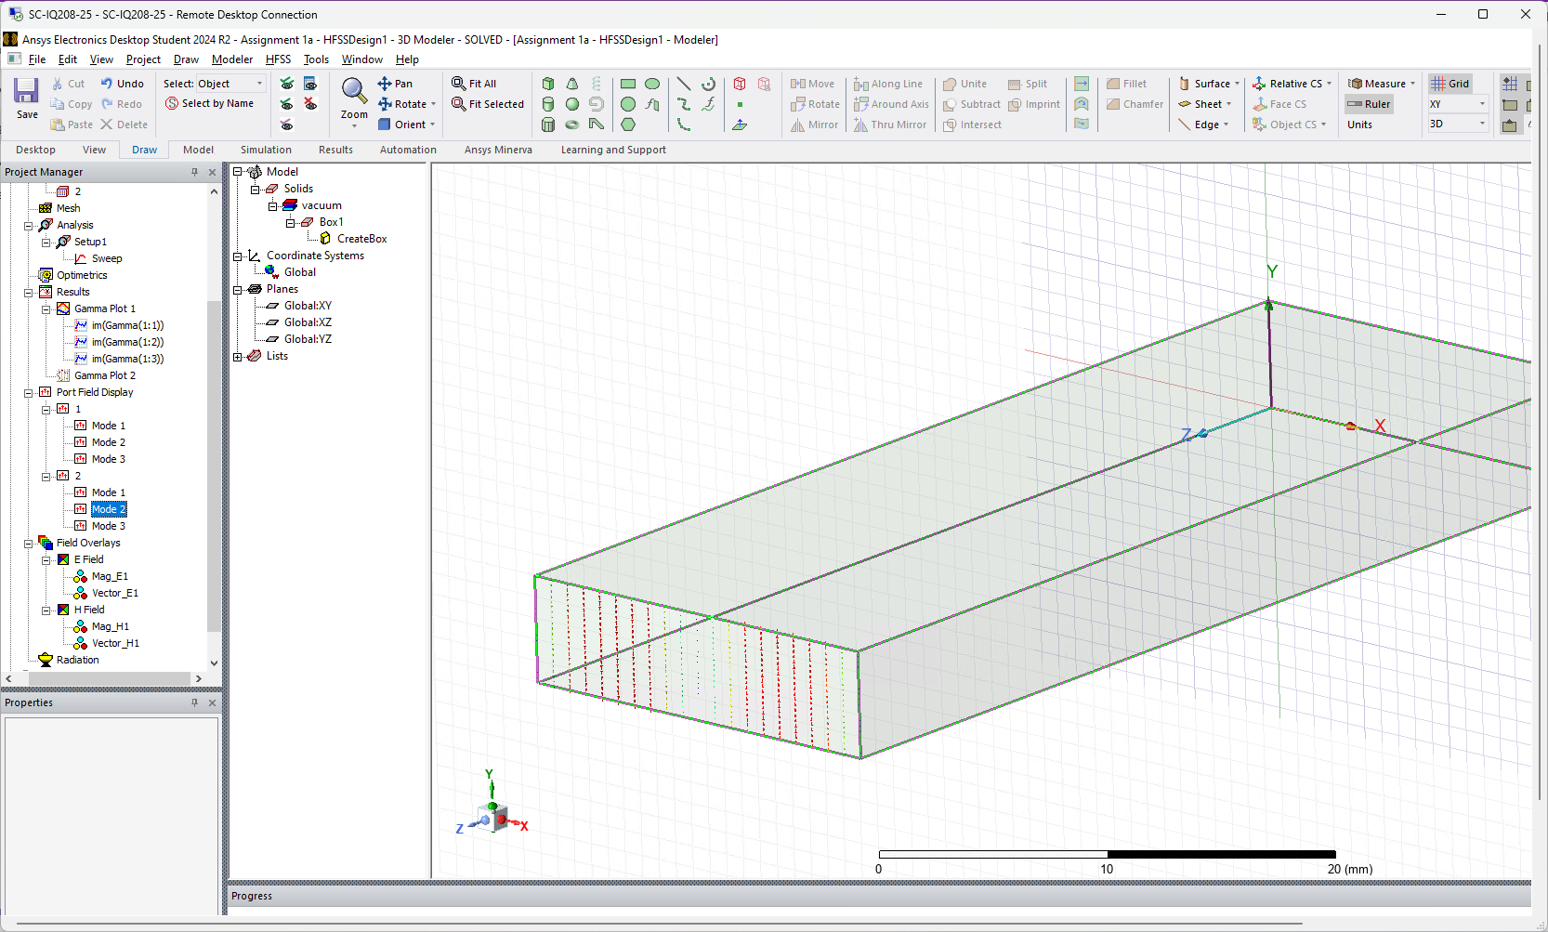
Figure 13 - Field Display, Port 2 TE20
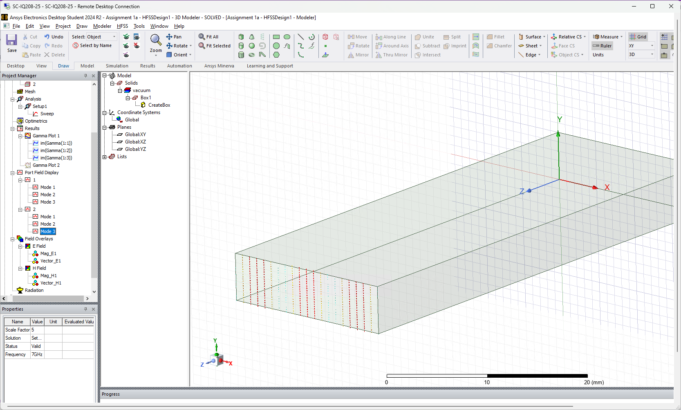
Figure 14 - Field Display, Port 2 TE30

Magnitude and Vectors
The magnitude and vectors of the waveguide is captured in the following section. Both the electric field (E field) and magnetic field (H field) are displayed.
The e field represents the force exerted on a unit charge at a given point in space.
The h field represents the intensity of the magnetic field.

TE10 E field

Magnitude
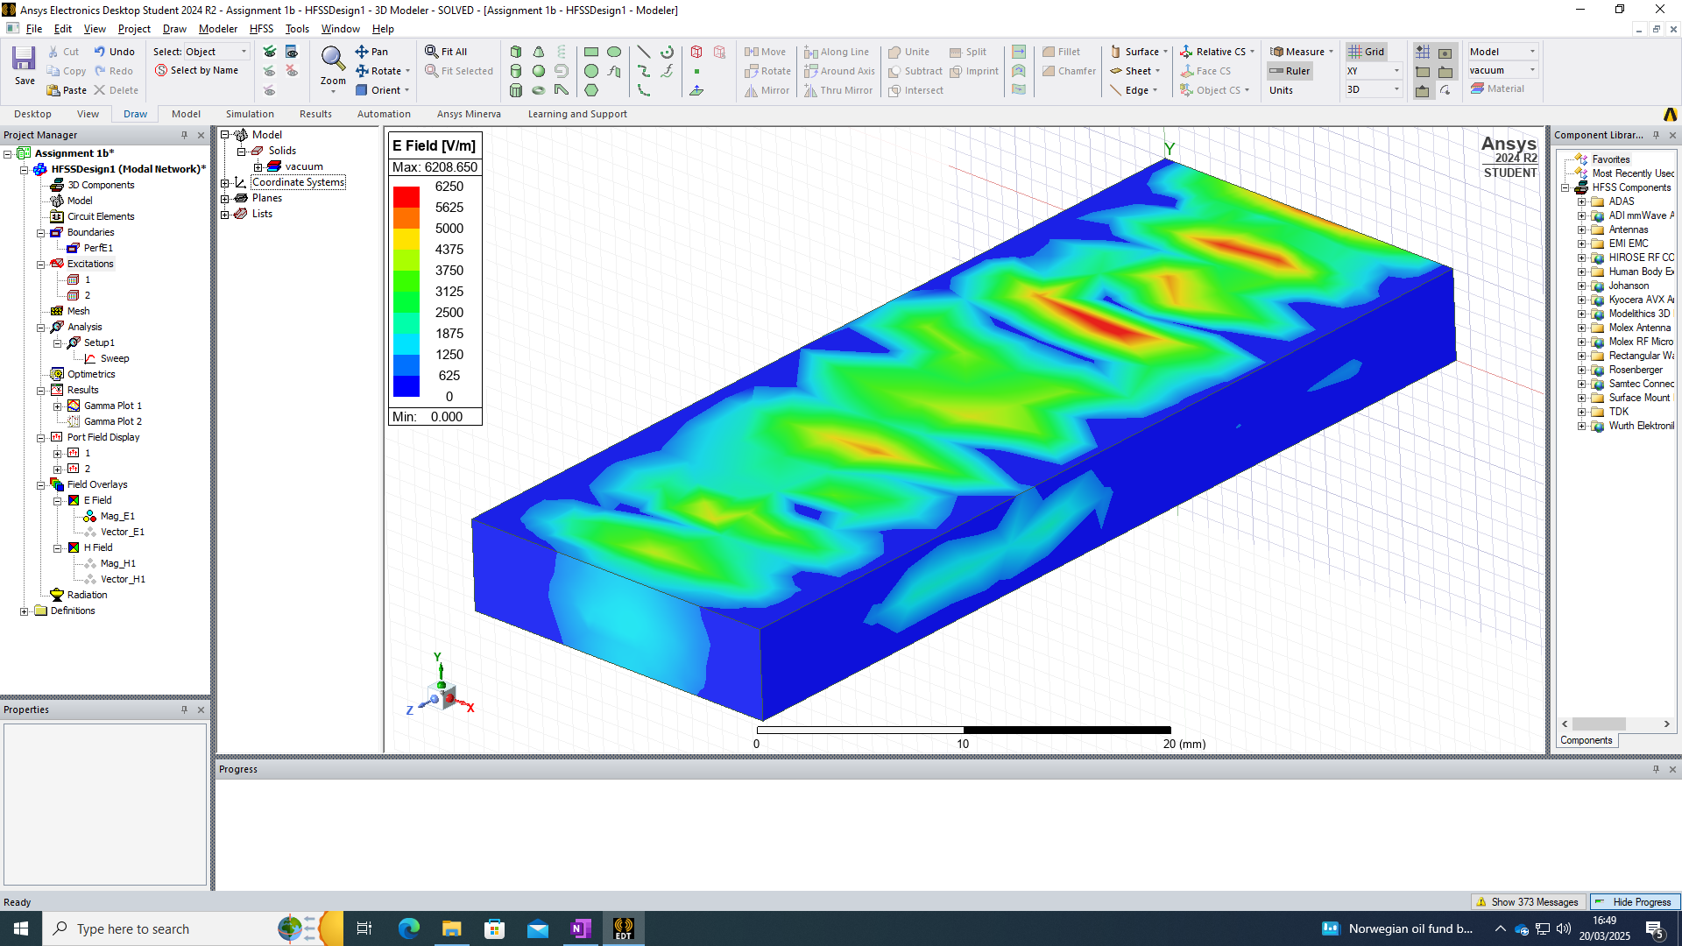
Figure 15 - Electric Field, Magnitude TE10

Vector
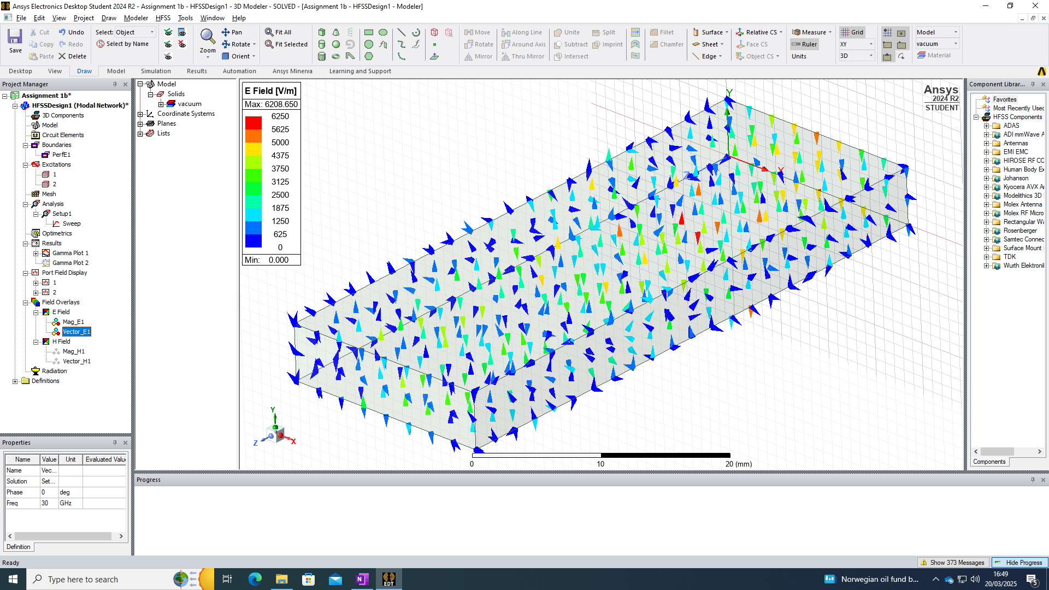
Figure 16 - Electric Field, Vector TE10

TE10 H field

Magnitude
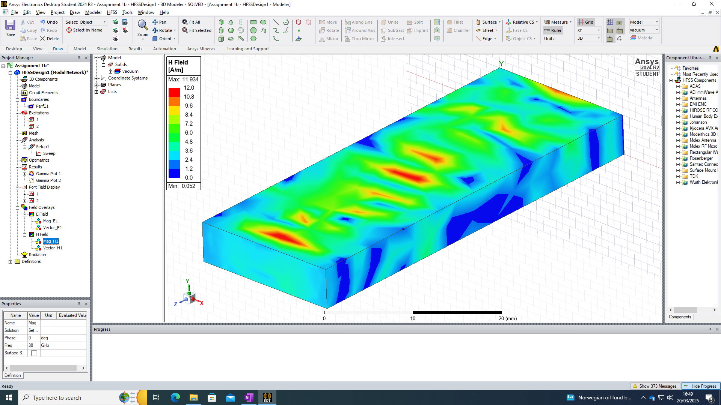
Figure 17 - Magnetic Field, Magnitude TE10

Vector
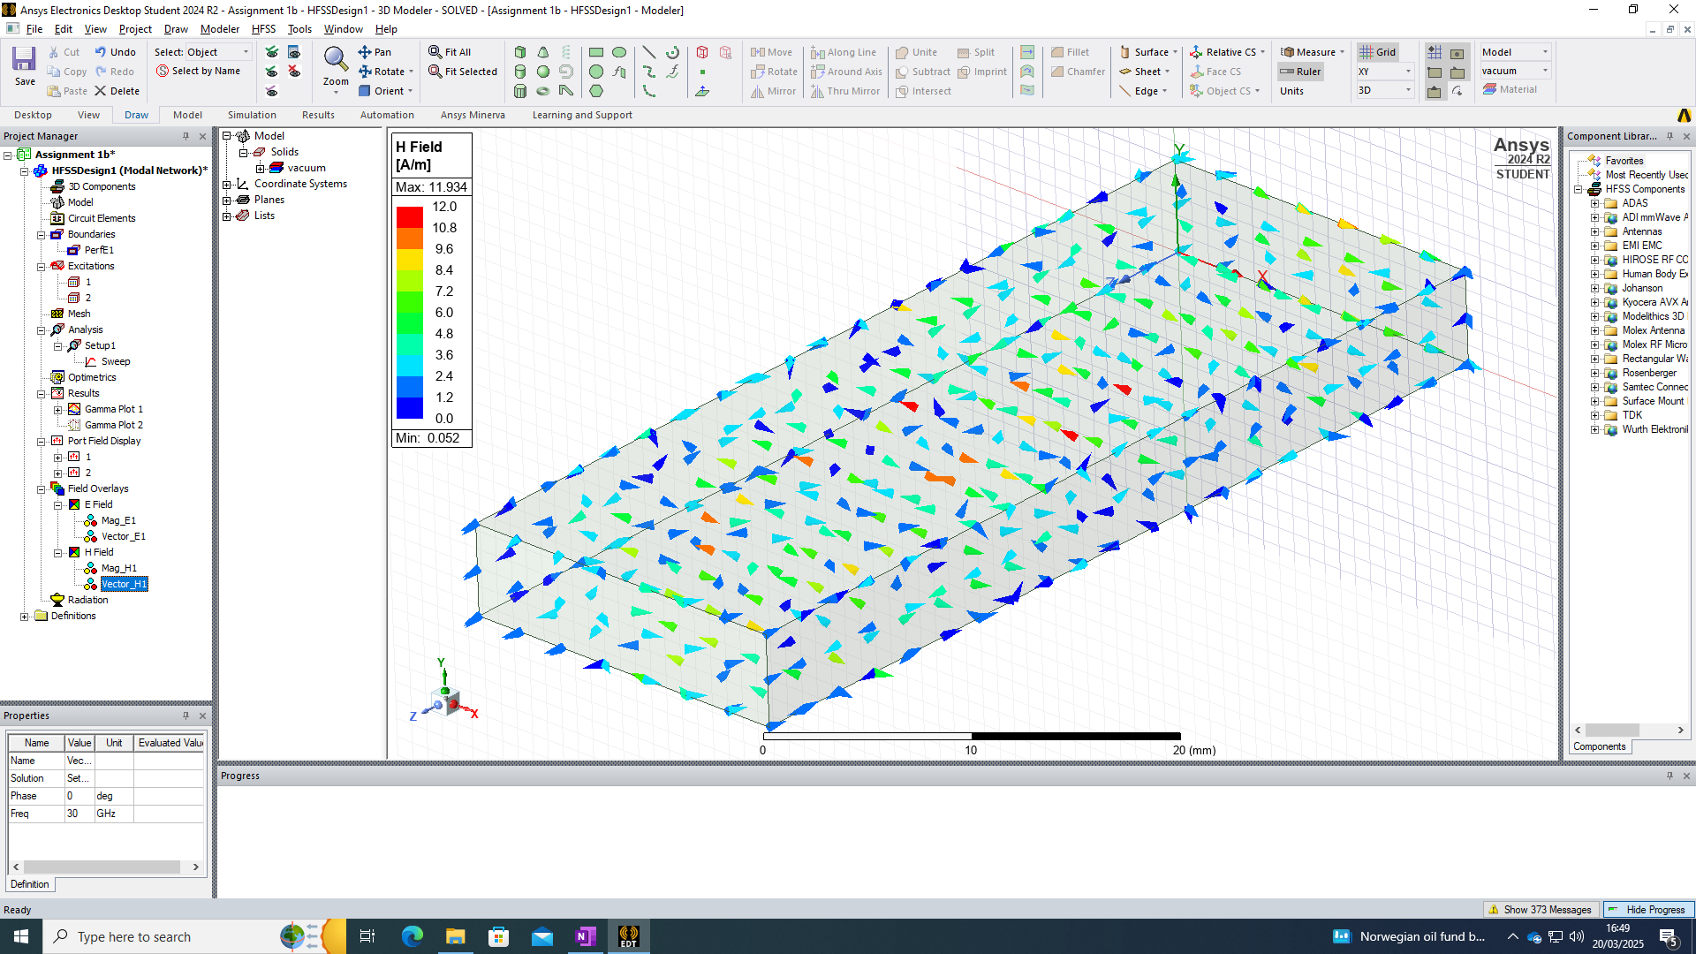
Figure 18 - Magnetic Field, Vector TE10

TE20 E field

Magnitude
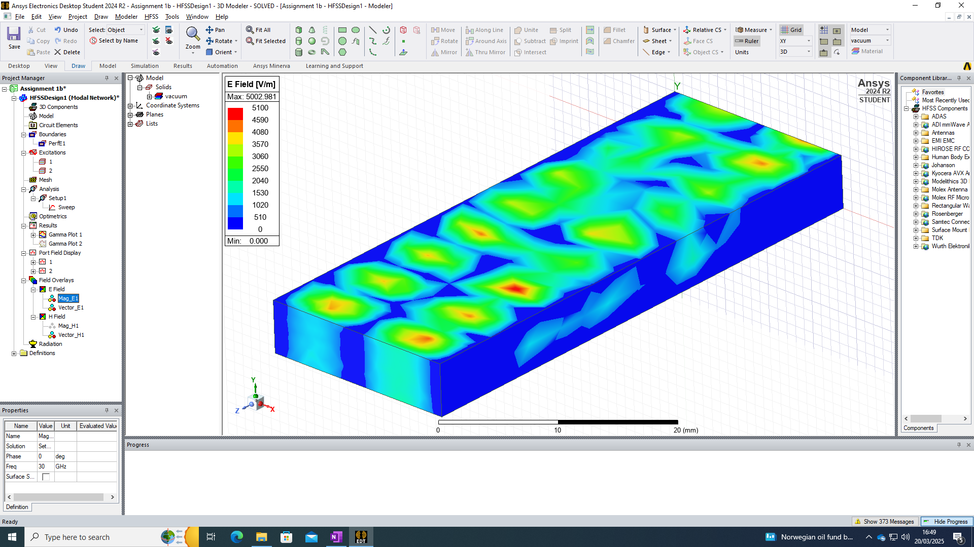
Figure 19 - Electric Field, Magnitude TE20

Vector
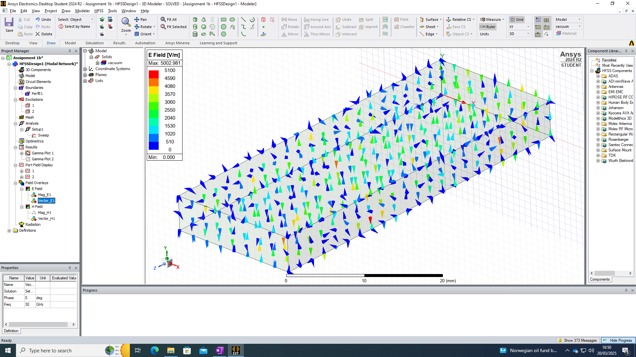
Figure 20 - Electric Field, Vector TE20

TE20 H field

Magnitude
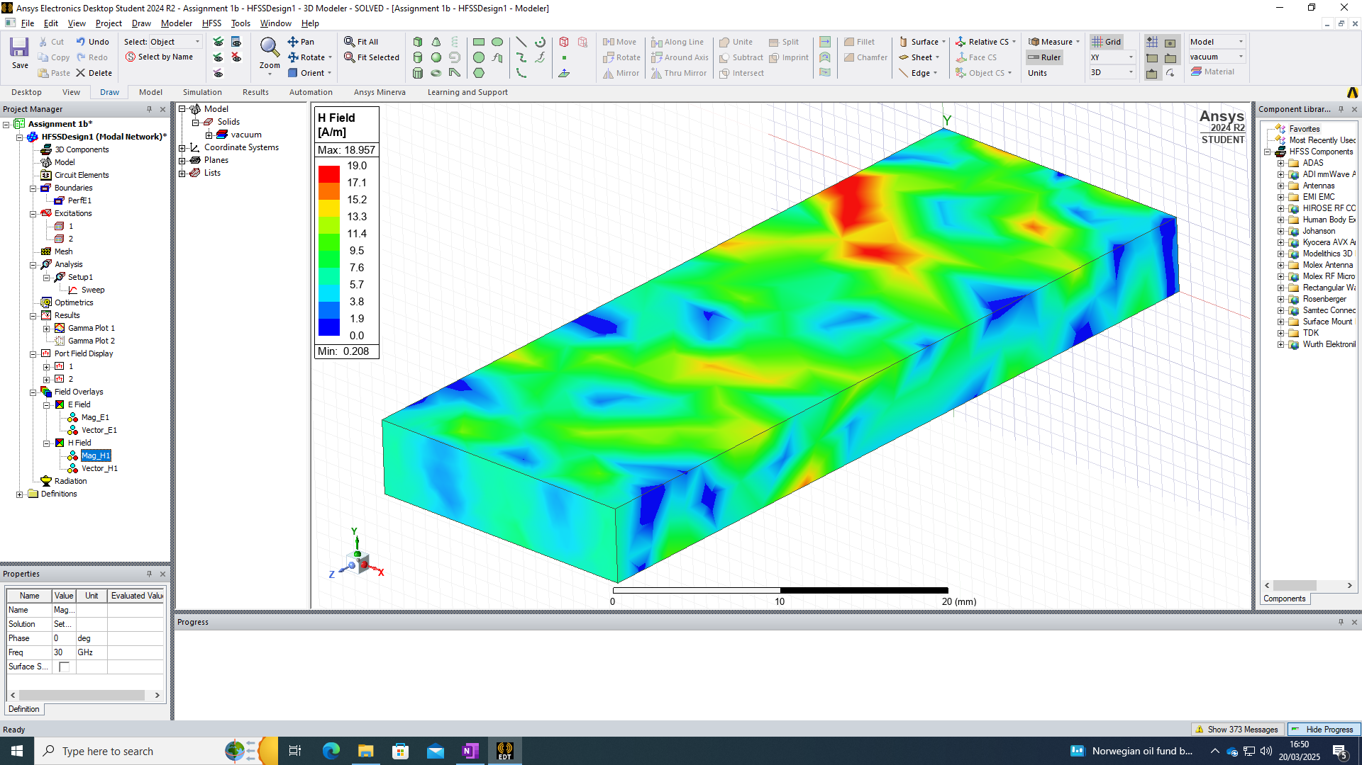
Figure 21 - Magnetic Field, Magnitude TE20

Vector
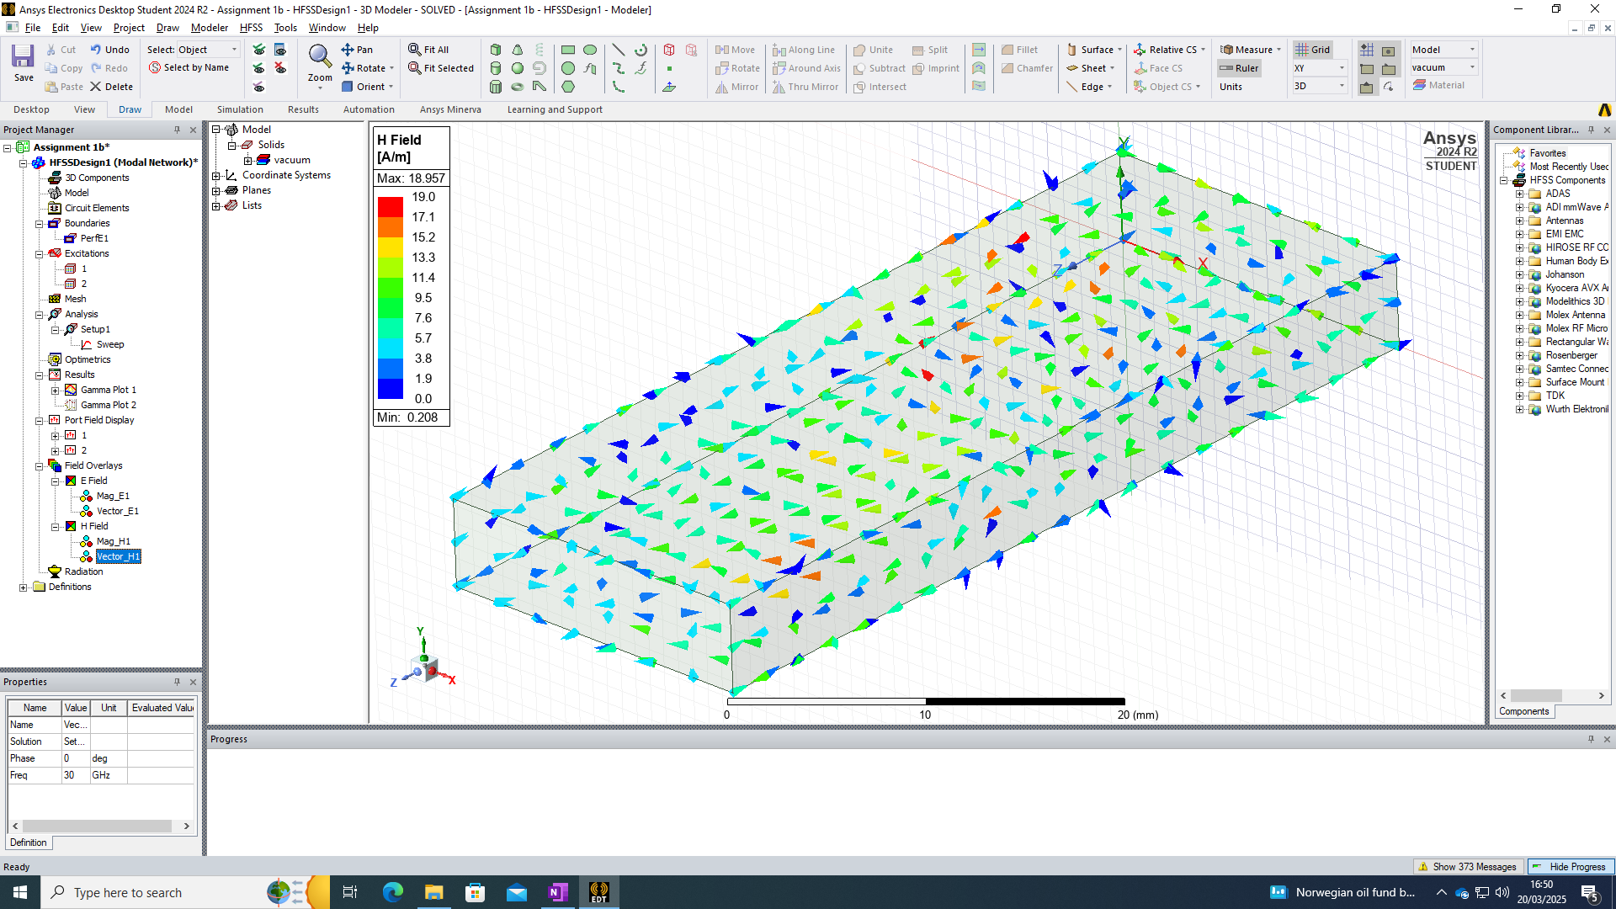
Figure 22 - Magnetic Field, Vector TE20

TE30 E field

Magnitude
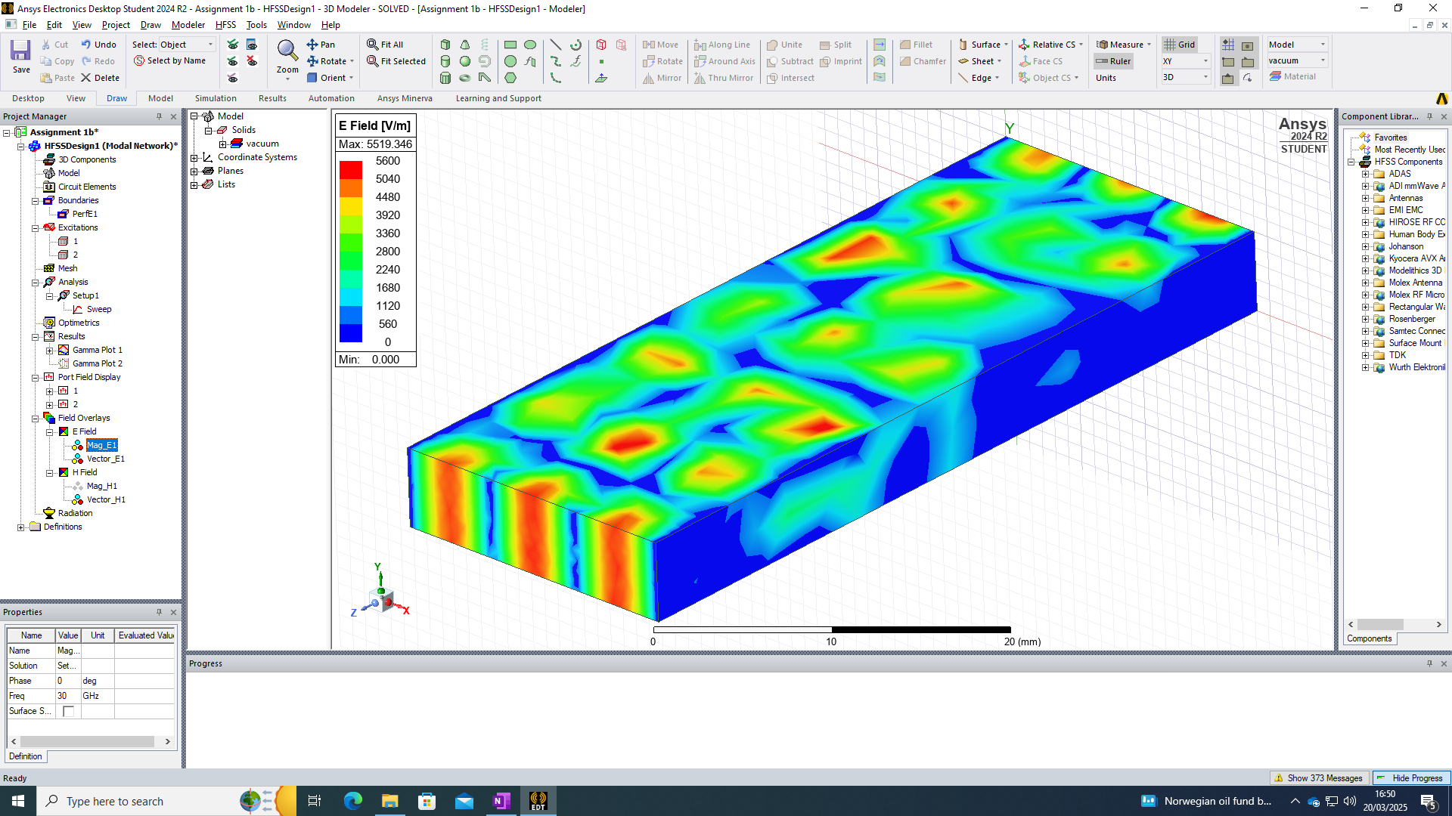
Figure 23 - Electric Field, Magnitude TE30

Vector
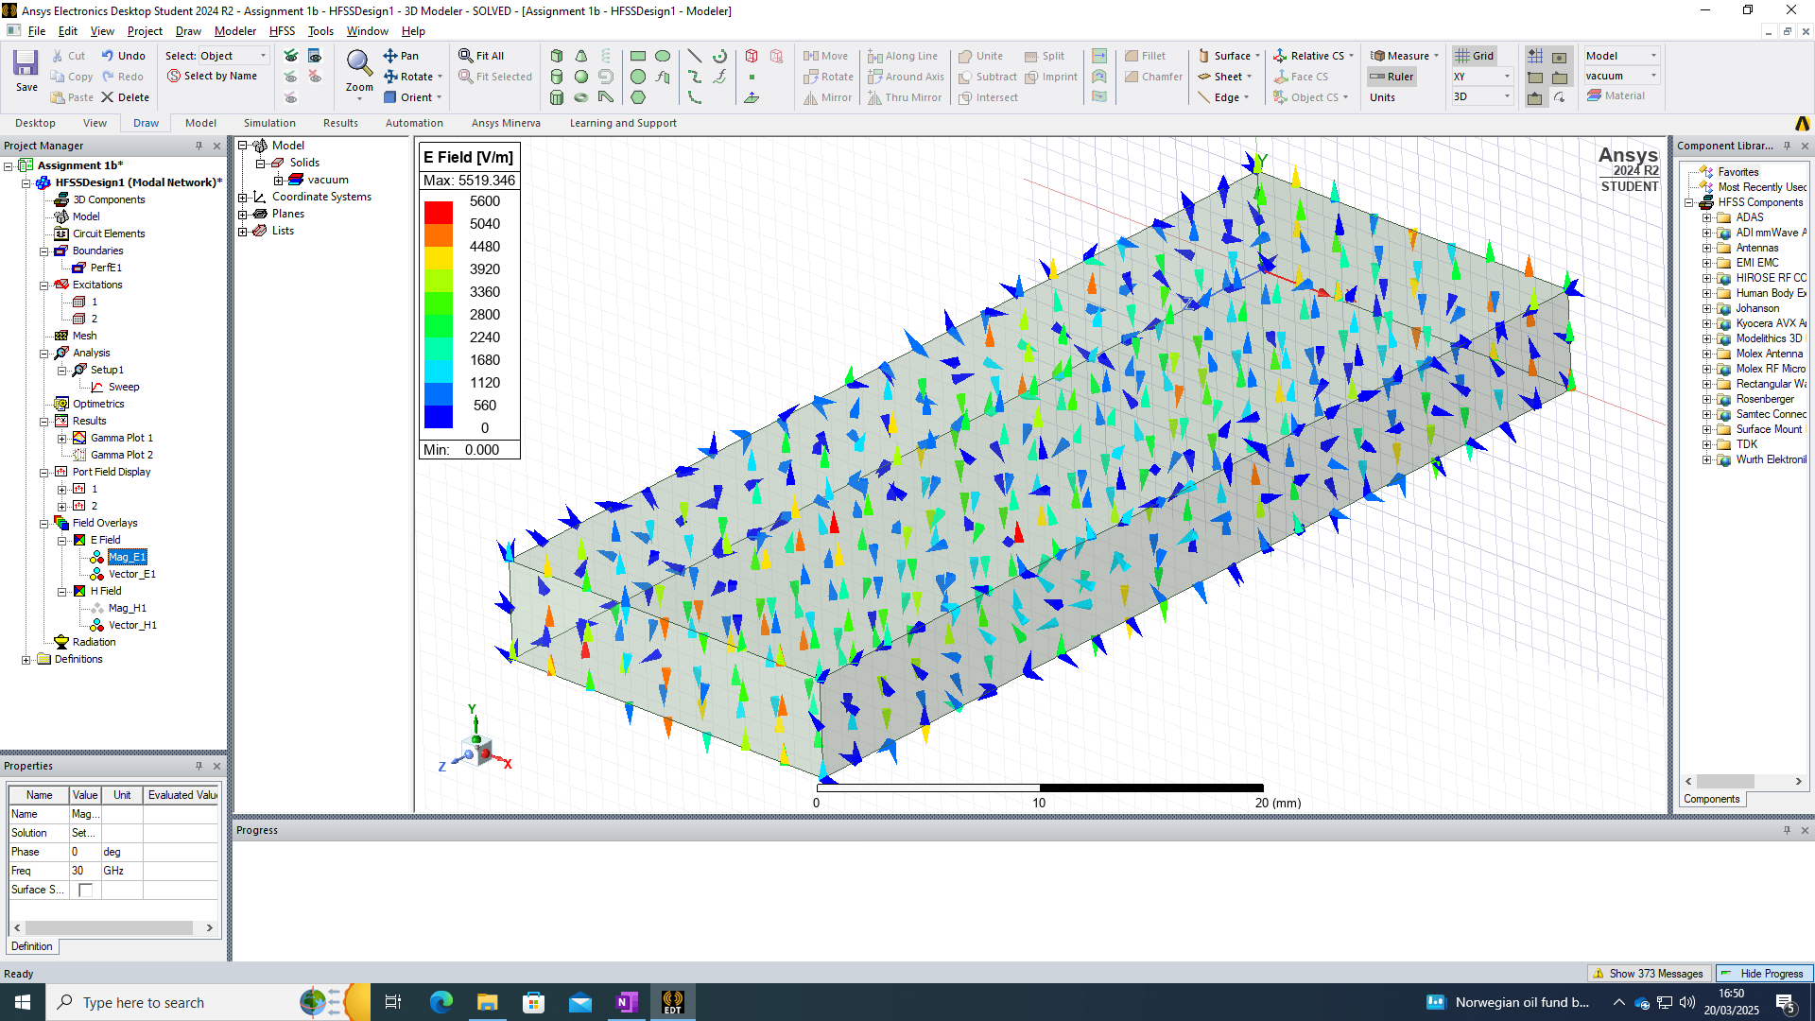
Figure 24 - Electric Field, Vector TE30

TE30 H field

Magnitude
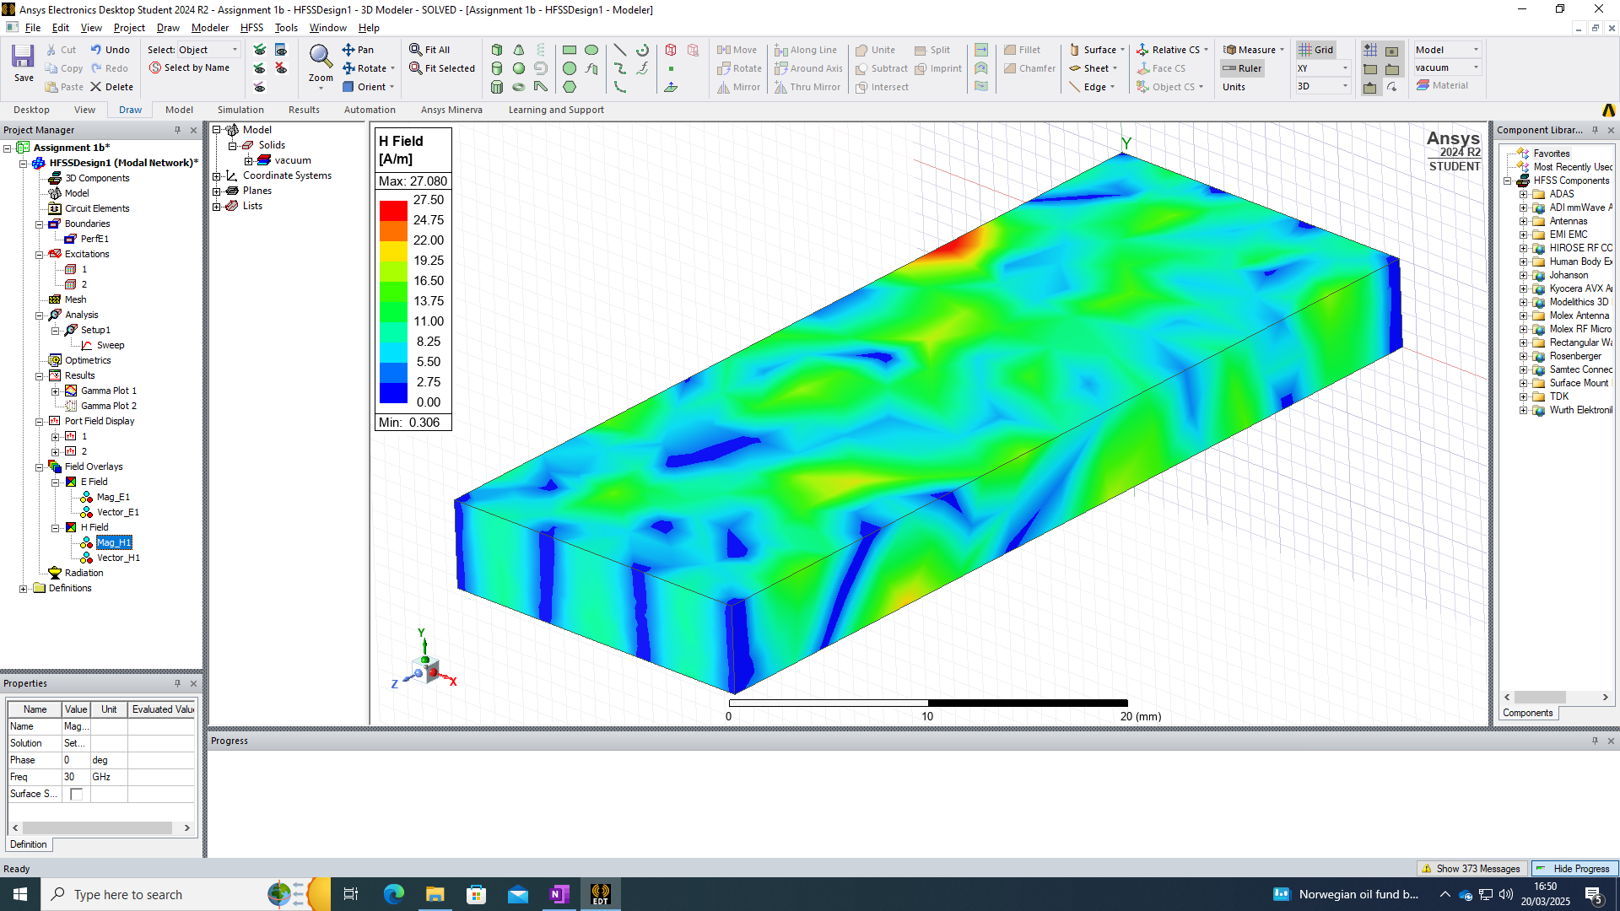
Figure 25 - Magnetic Field, Magnitude TE30

Vector
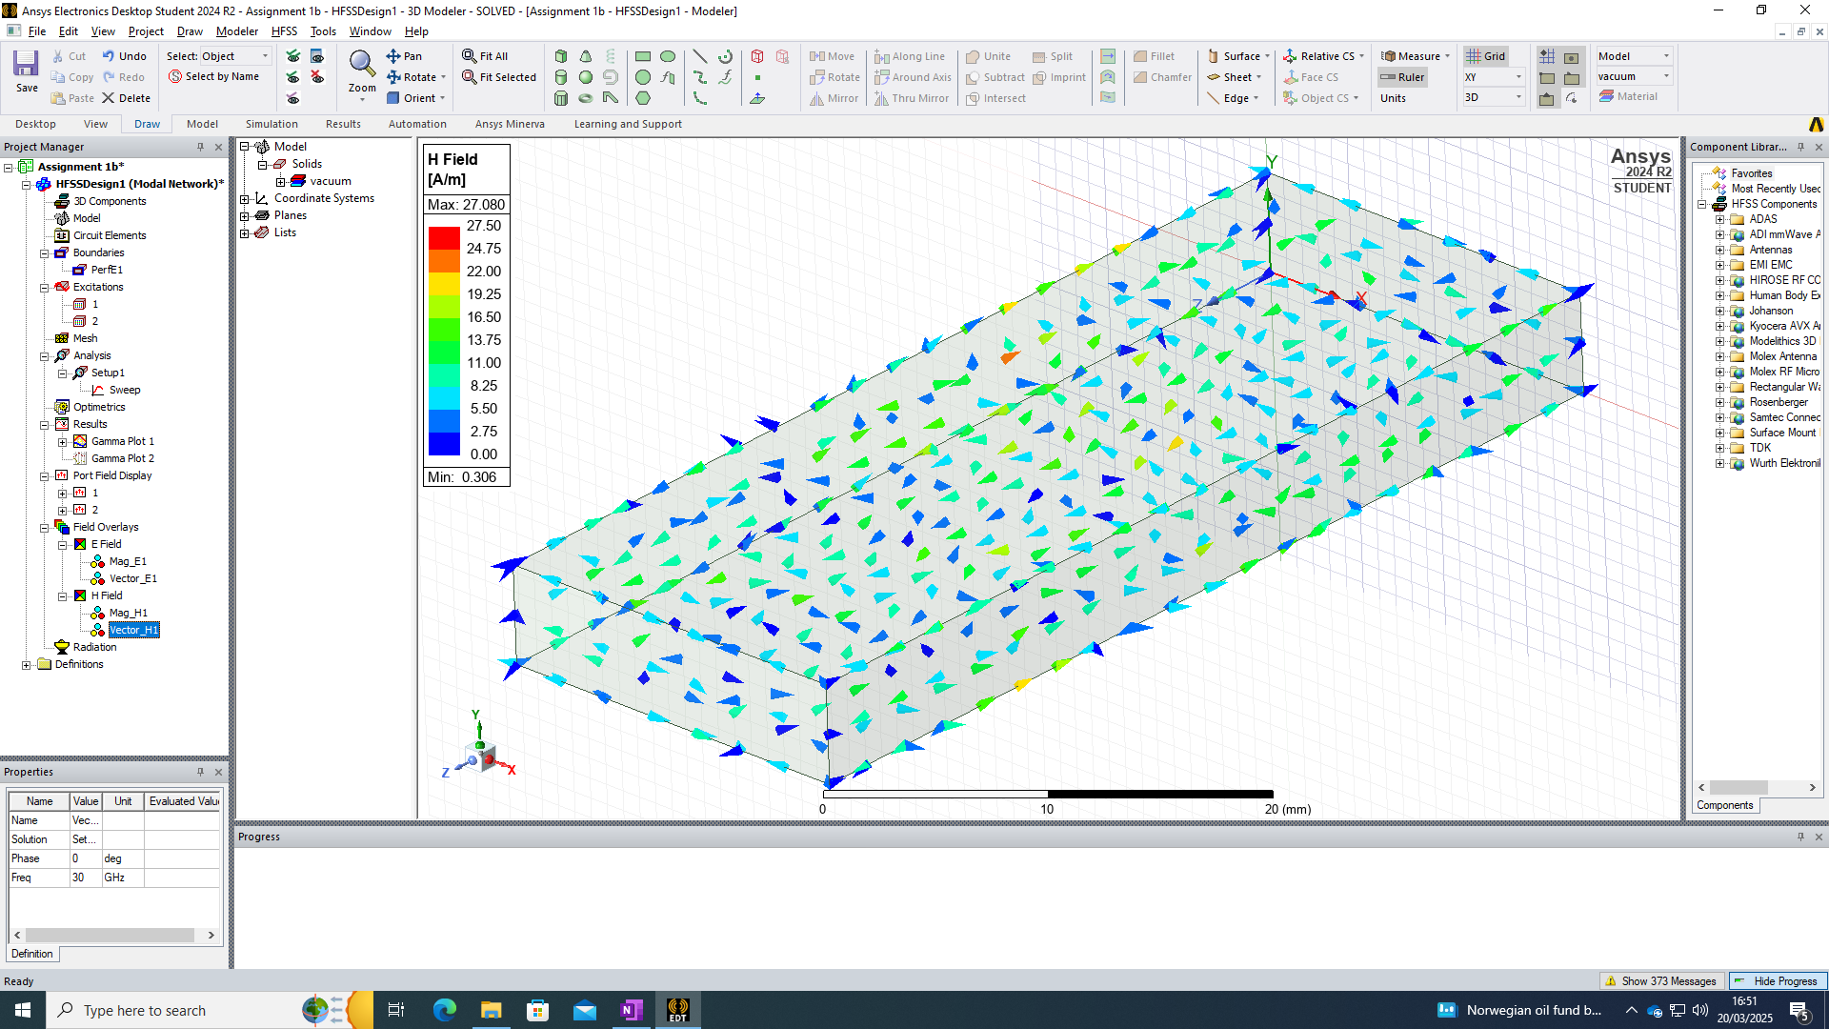
Figure 26 - Magnetic Field, Vector TE30

Cut-off Frequency

Theoretical values
Theoretical values can be calculated with the following equation: $f_{c}= \frac{c}{2}\sqrt{{(\frac{m}{a})}^{2 }+ {(\frac{n}{b})}^{2 }}$
Thus,
TE10 - $f_{c}= \frac{c}{2}\sqrt{{(\frac{m}{a})}^{2 }+ {(\frac{n}{b})}^{2 }} = \frac{3 * {10}^{8}}{2 * 0.019} =7.89GHz$

TE20 - $f_{c}= \frac{c}{2}\sqrt{{(\frac{m}{a})}^{2 }+ {(\frac{n}{b})}^{2 }}*2= \frac{3 * {10}^{8}}{2 * 0.019} =15.8GHz$

TE30 - $f_{c}= \frac{c}{2}\sqrt{{(\frac{m}{a})}^{2 }+ {(\frac{n}{b})}^{2 }}* 3= \frac{3 * {10}^{8}}{2 * 0.019} =23.7GHz$

Simulation values
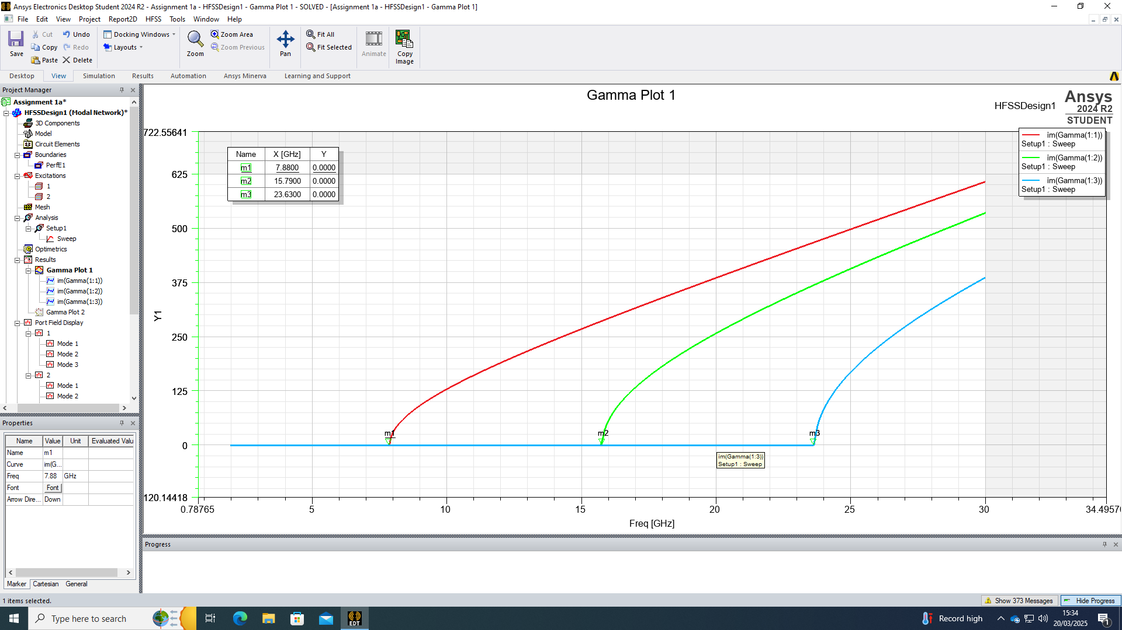
Figure 27 - Cut-off Frequency Plot

Simulation 2
A rectangular waveguide with perfect electric conductor (PEC) walls is filled with Teflon, which has a relative permeability of 1, and relative permittivity of 2.1. Given dimensions of the waveguide are (a) = 19, (b) = 5, and length = 50mm, per Simulation 1 in [Section 4]. The simulation is run between a frequency of 2GHz and 30GHz in order to analyse the behaviours.

Identifying the Dominant Mode
TE10 is the dominant mode in rectangular waveguides. This is backed up by the calculations as presented in [Section 5.7.1]

Port Field Display

Port 1
The field display for port 1 is captured in the following figures:
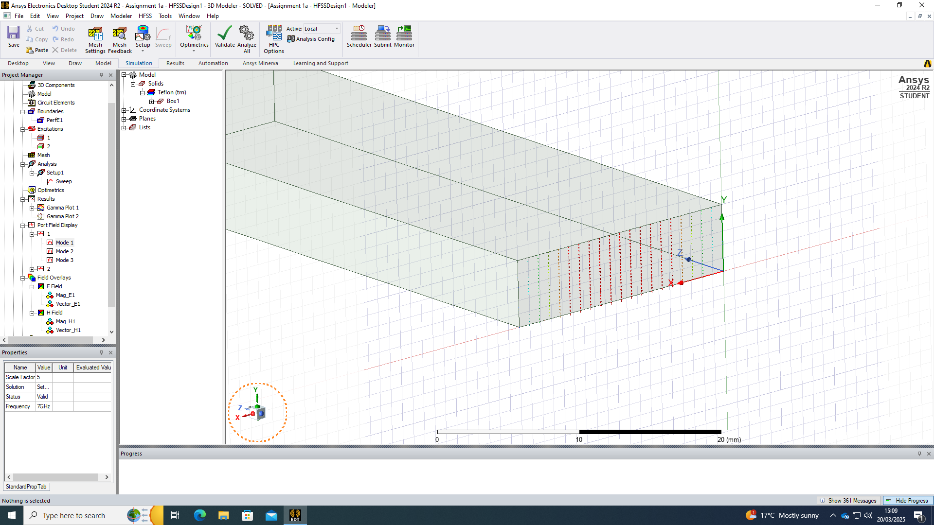
Figure 28 - Field Display, Port 1 TE10
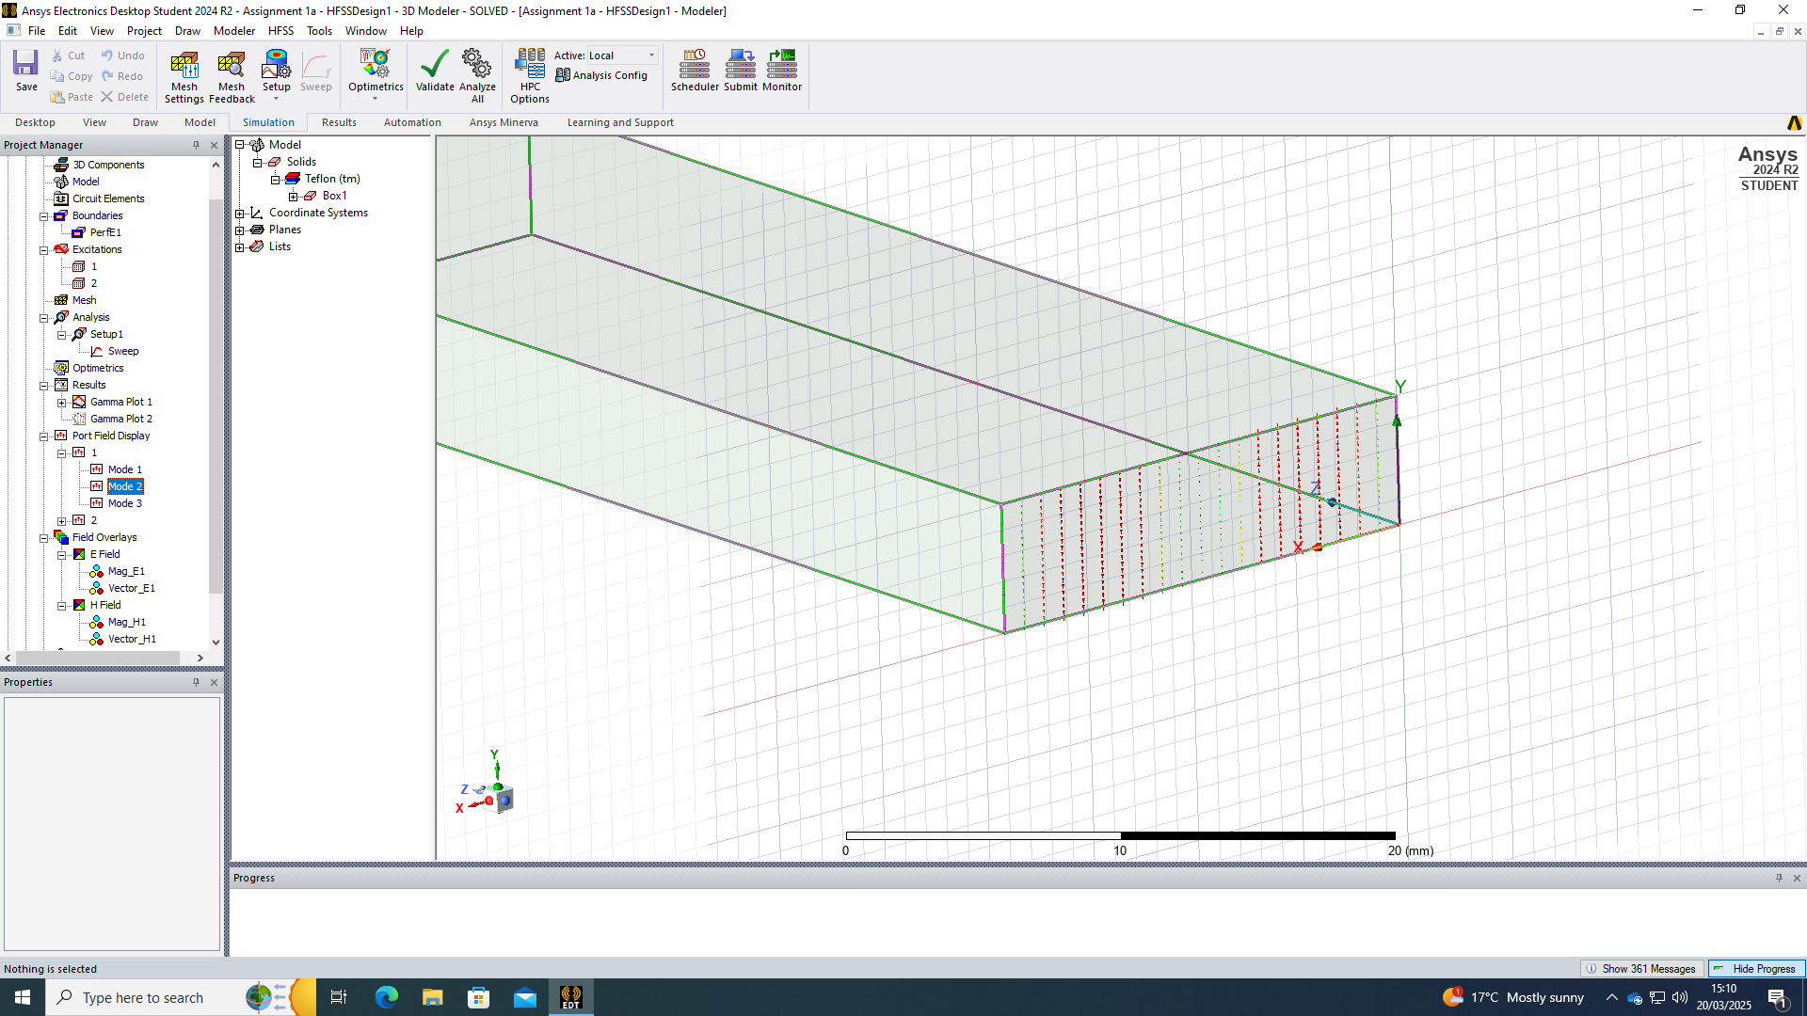
Figure 29 - Field Display, Port 1 TE20
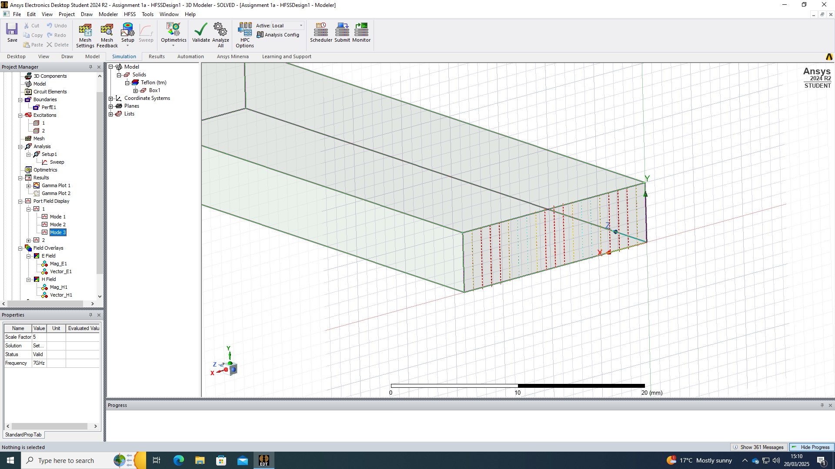
Figure 30 - Field Display, Port 1 TE30

Port 2
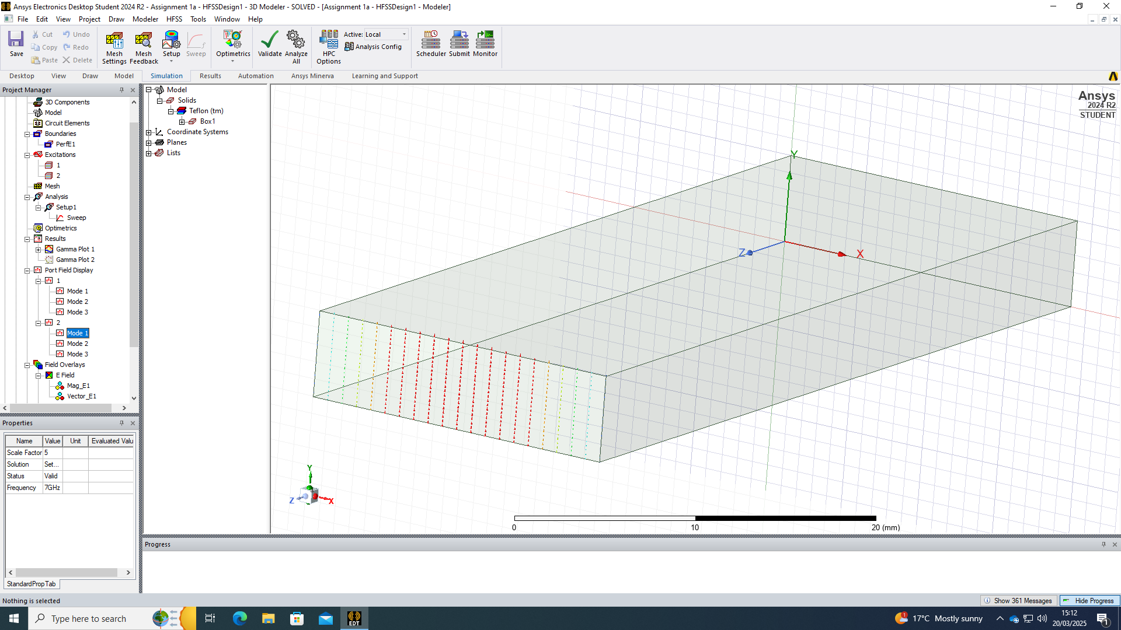
Figure 31 - Field Display, Port 2 TE10
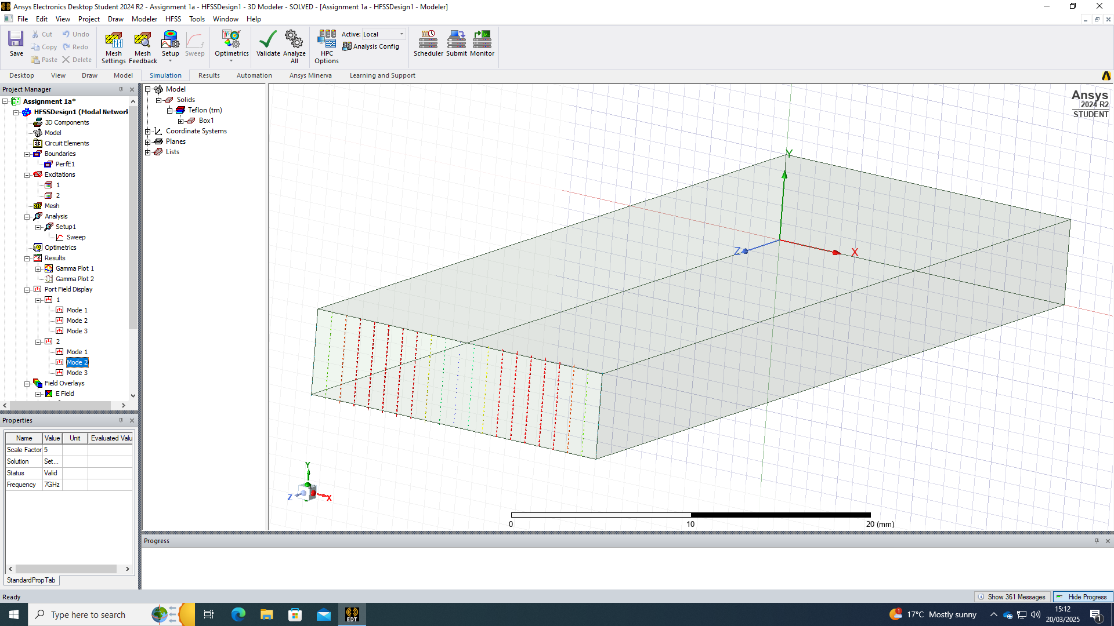
Figure 32 - Field Display, Port 2 TE20
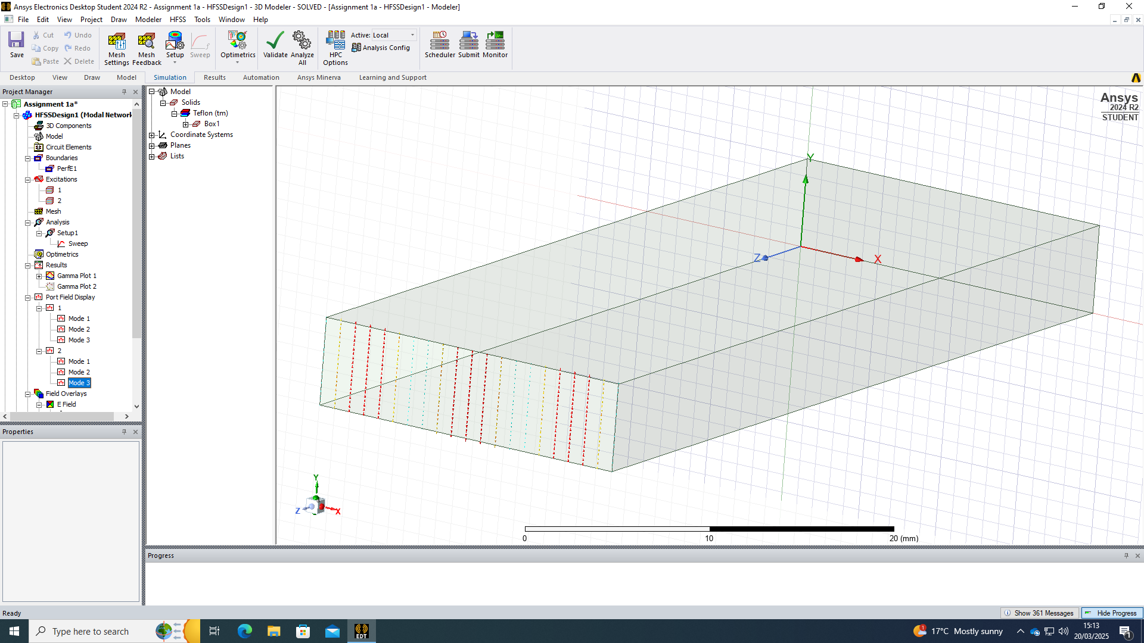
Figure 33 - Field Display, Port 2 TE30

Magnitude and Vectors
The magnitude and vectors of the waveguide is captured in the following section. Both the electric field (E field) and magnetic field (H field) are displayed.
The e field represents the force exerted on a unit charge at a given point in space.
The h field represents the intensity of the magnetic field.

TE10 E field

Magnitude
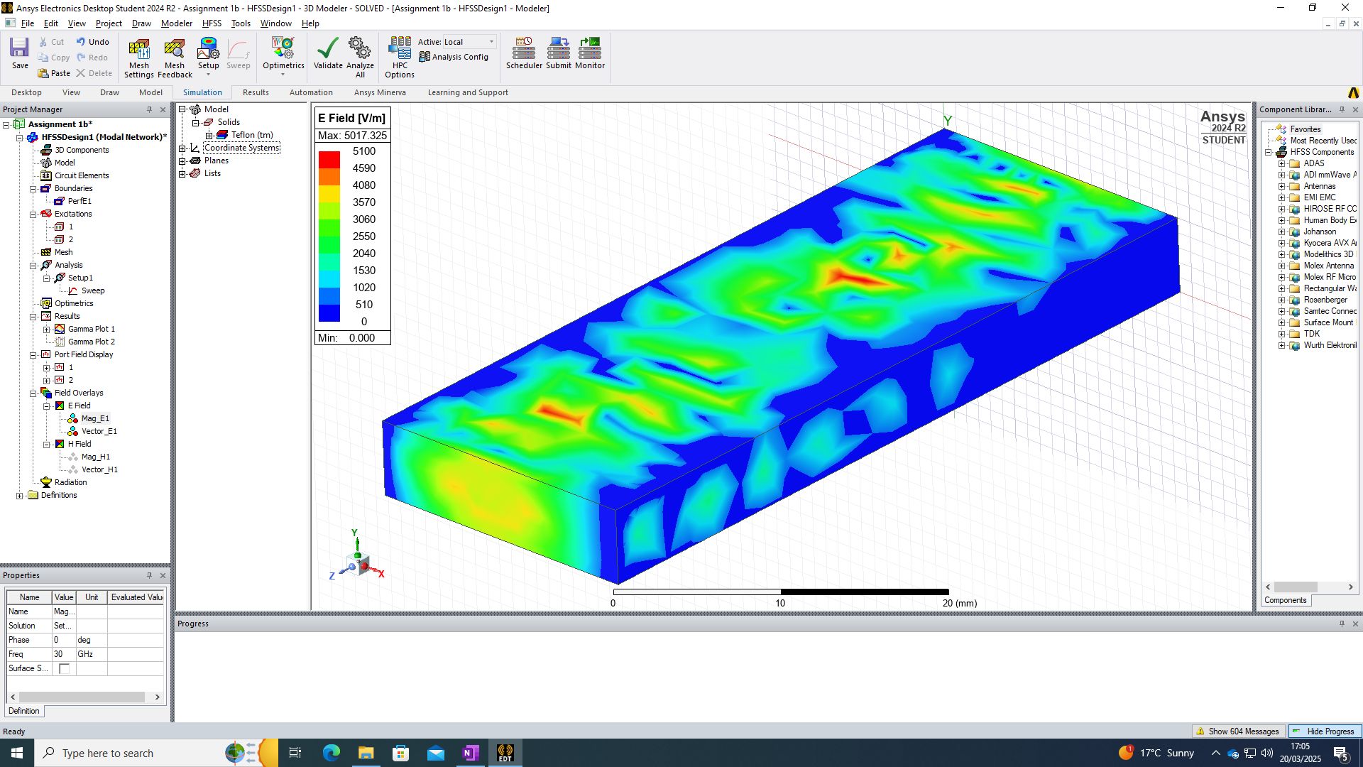
Figure 34 - Electric Field, Magnitude TE10

Vector
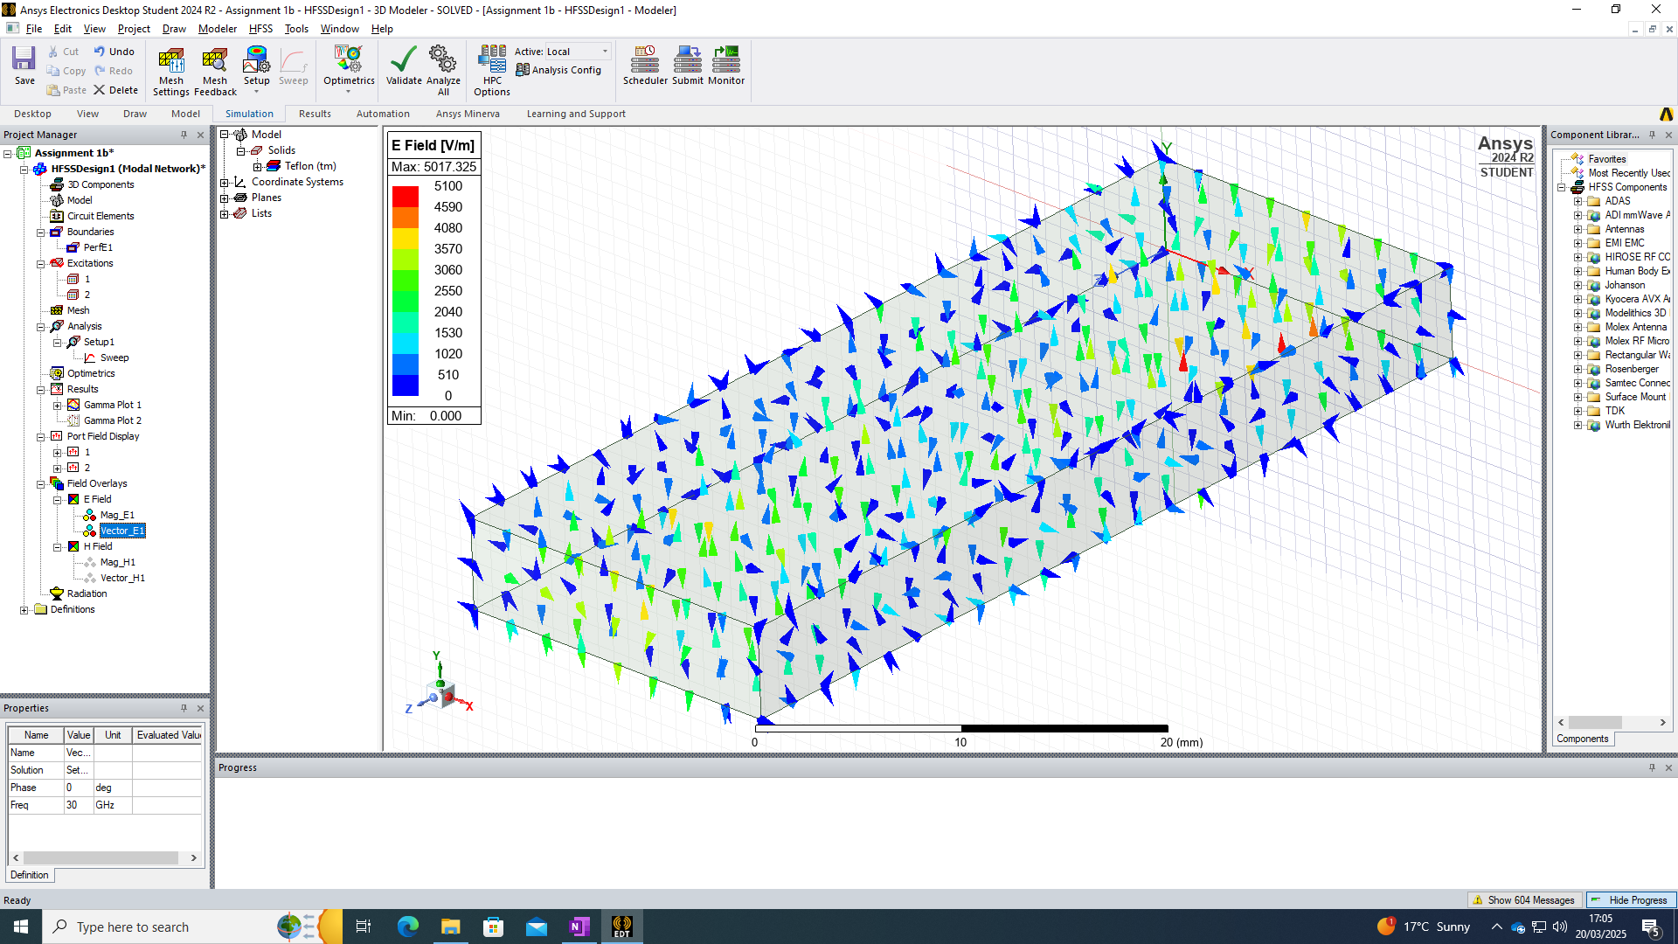
Figure 35 - Electric Field, Vector TE10

TE10 H field

Magnitude
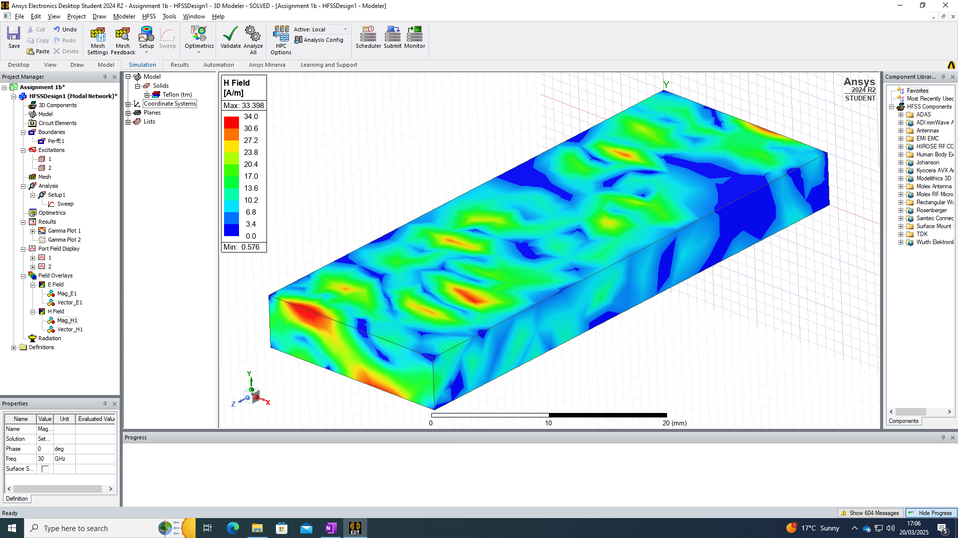
Figure 36 - Magnetic Field, Magnitude TE10

Vector
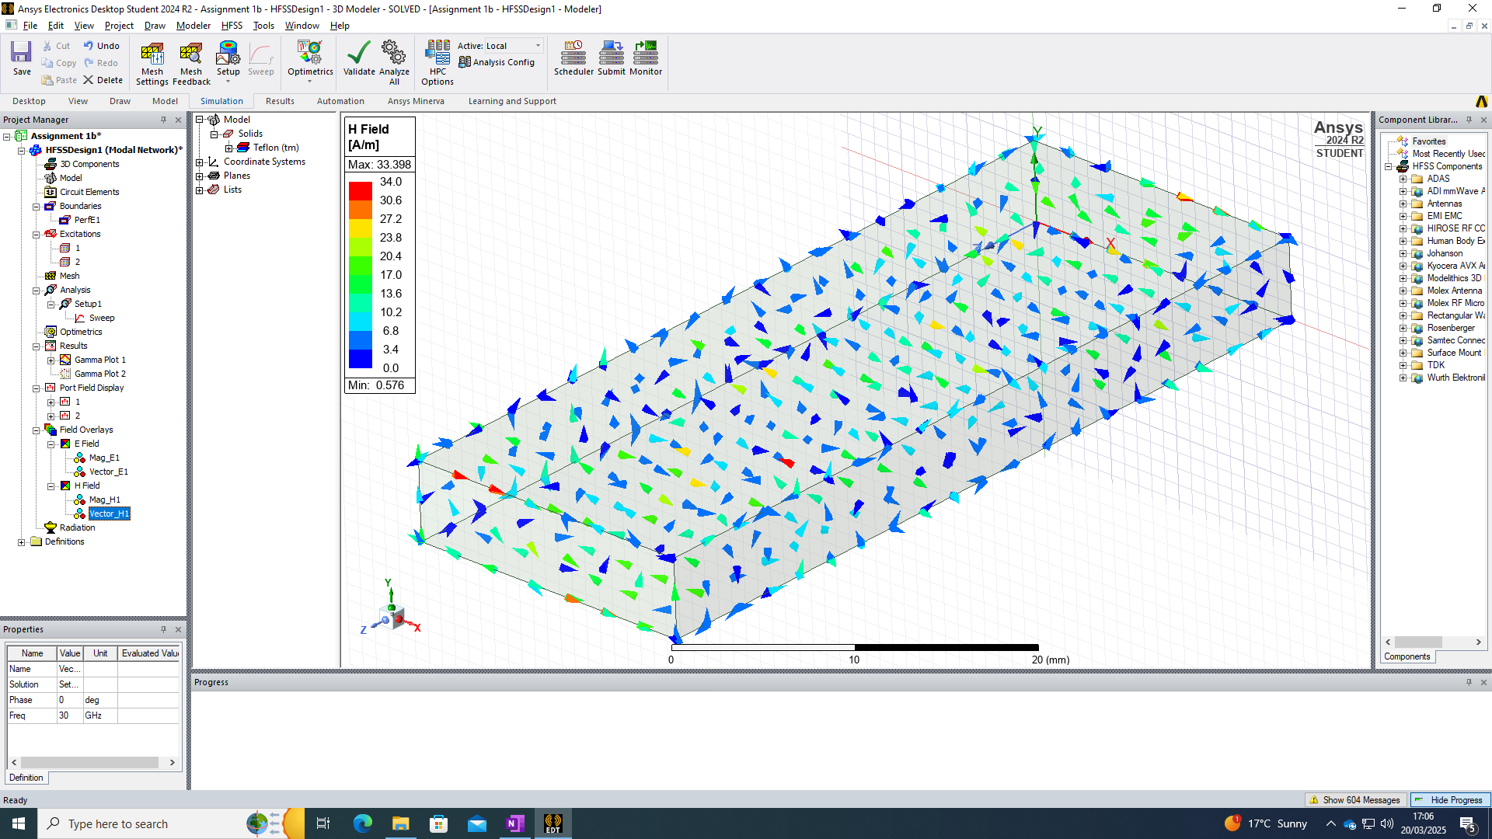
Figure 37 - Magnetic Field, Vector TE10

TE20 E field

Magnitude
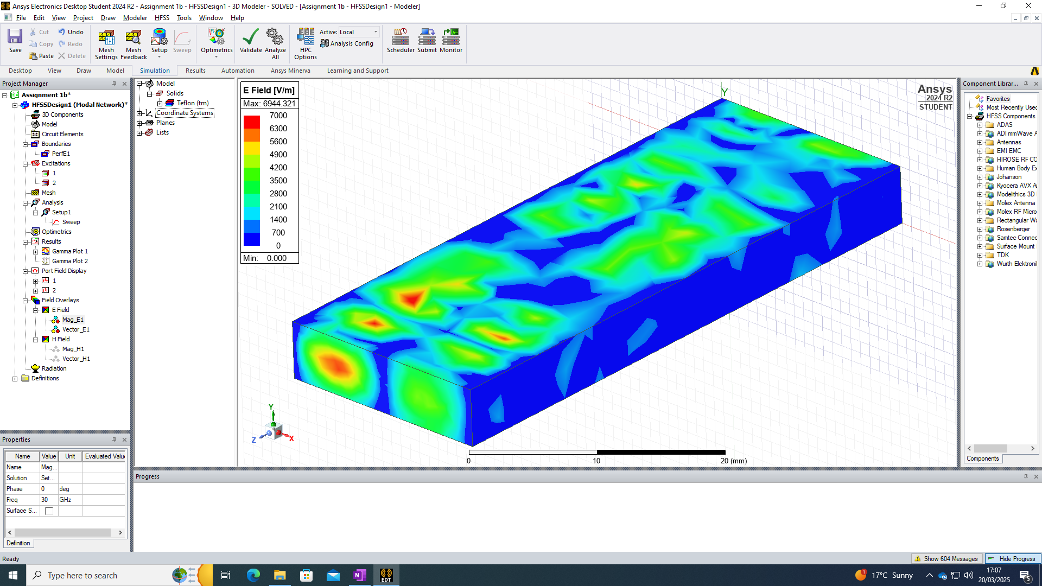
Figure 38 - Electric Field, Magnitude TE20

Vector
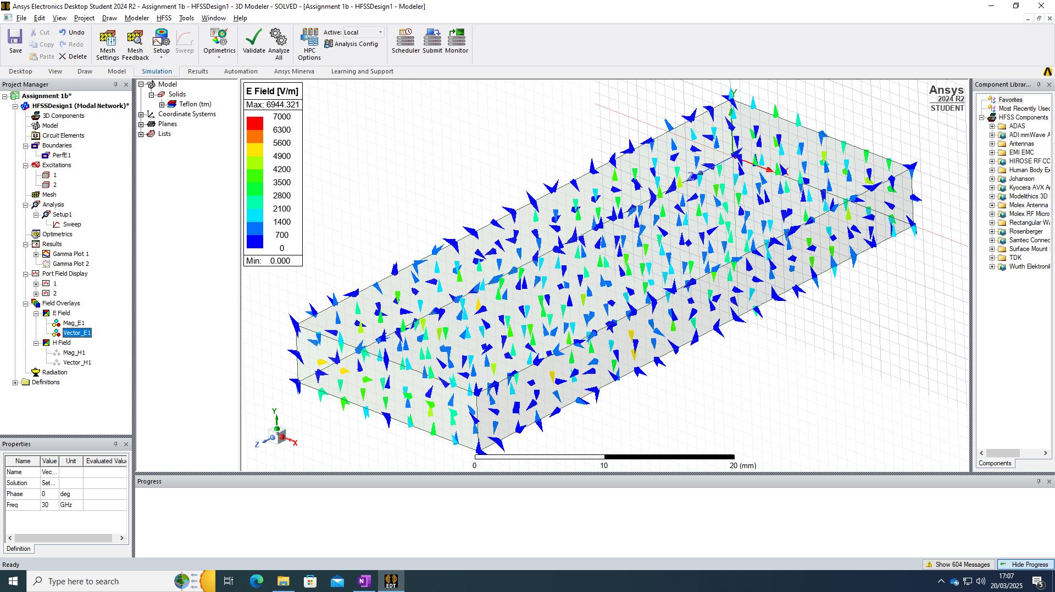
Figure 39 - Electric Field, Vector TE20

TE20 H field

Magnitude
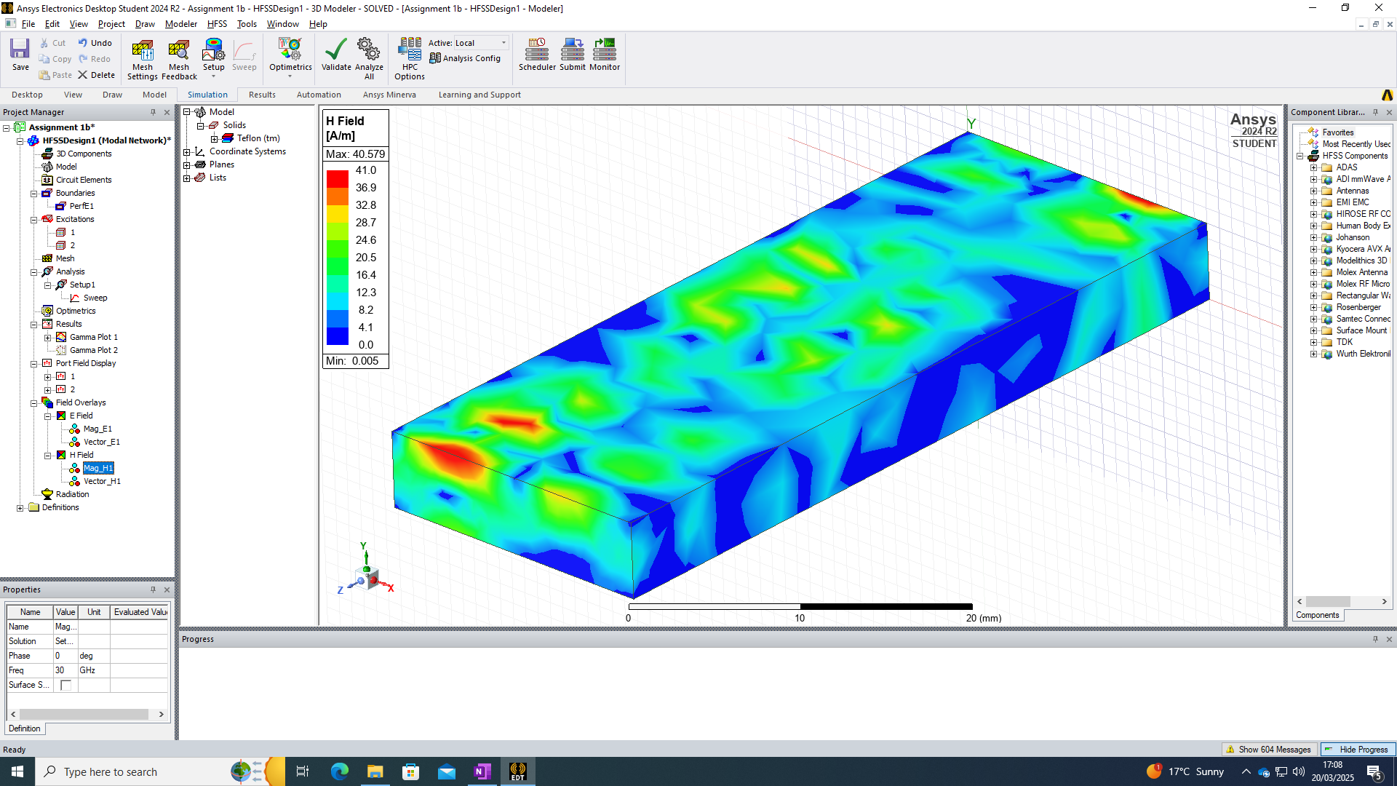
Figure 40 - Magnetic Field, Magnitude TE20

Vector
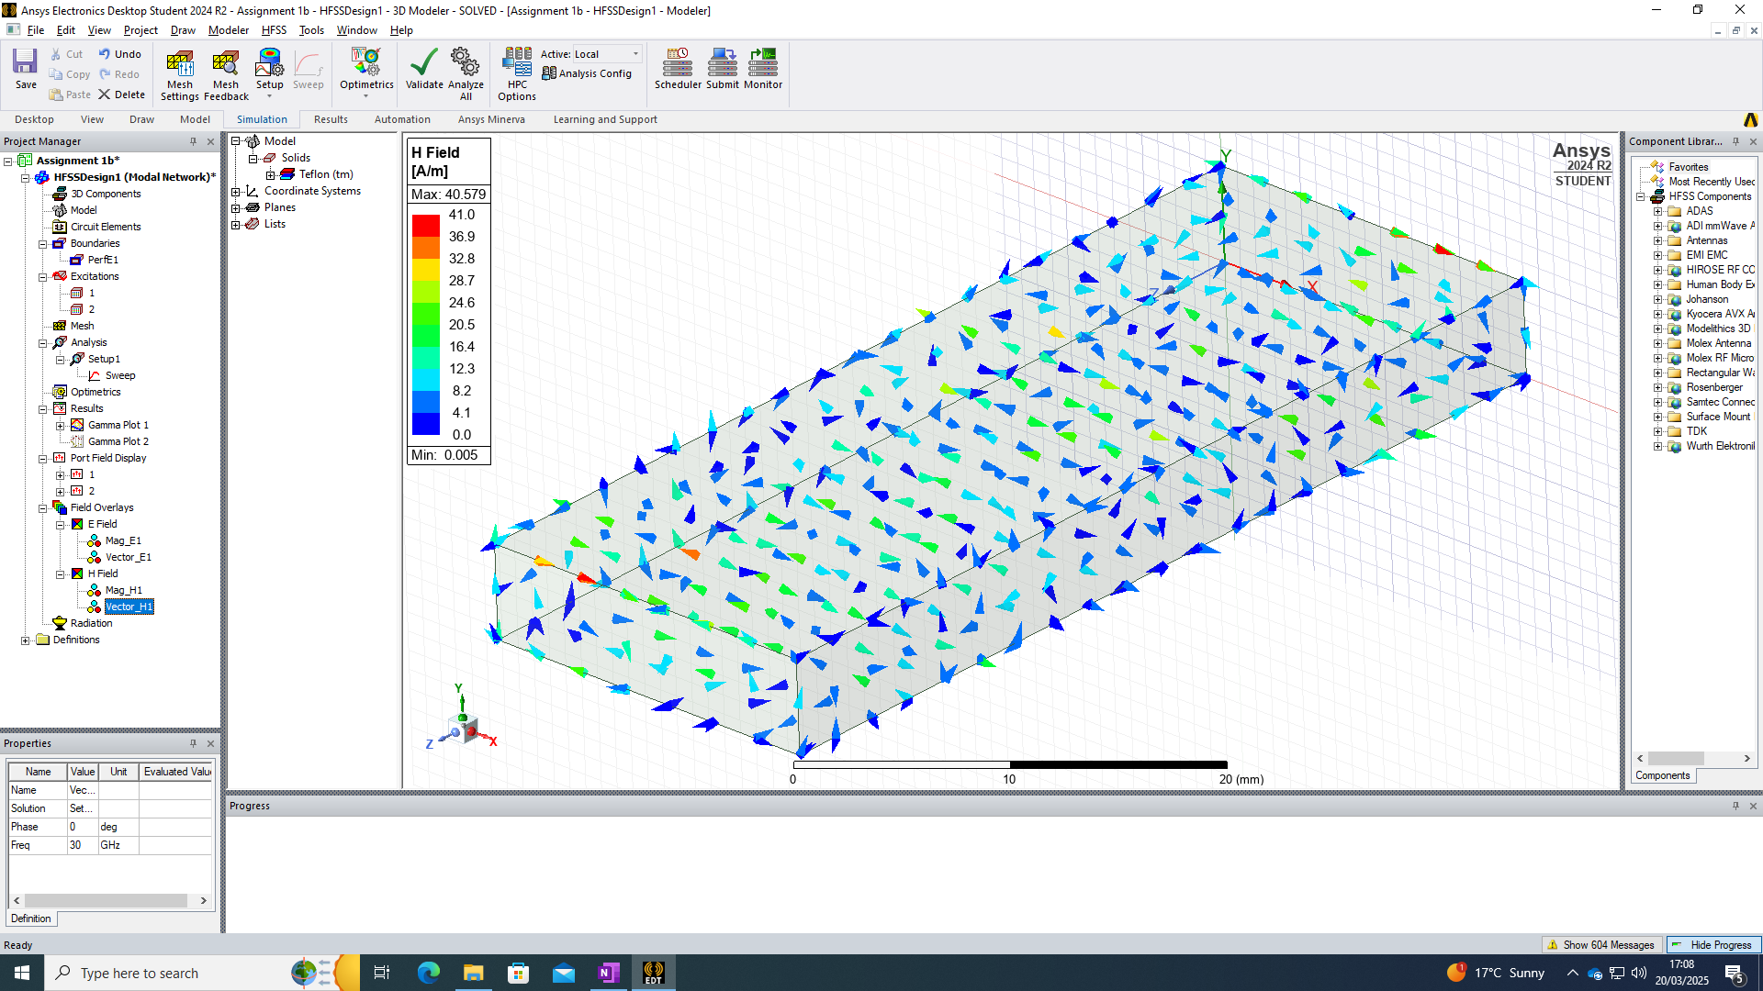
Figure 41 - Magnetic Field, Vector TE20

TE30 E field

Magnitude
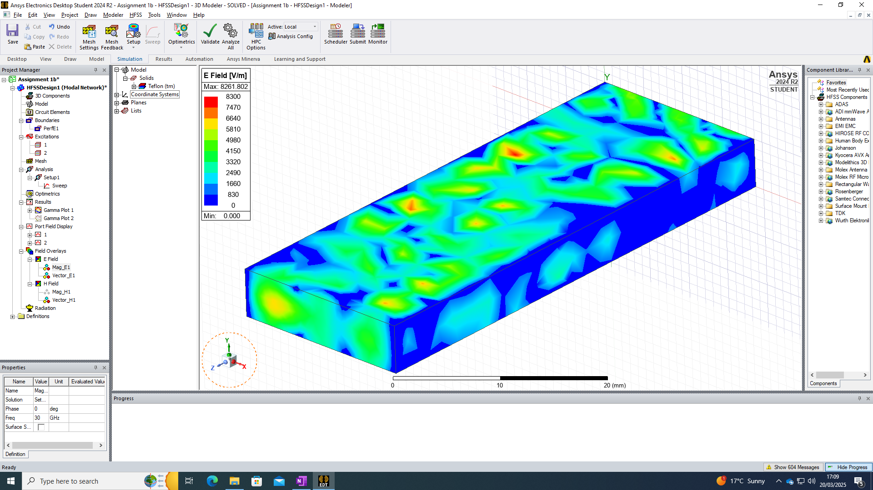
Figure 42 - Electric Field, Magnitude TE30

Vector
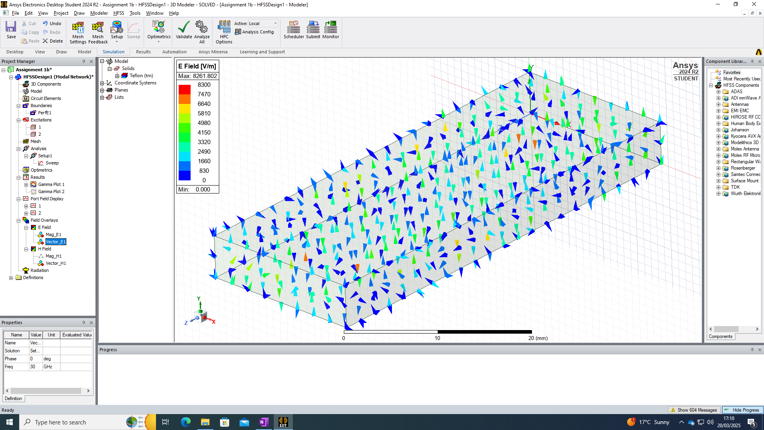
Figure 43 - Electric Field, Vector TE30

TE30 H field

Magnitude
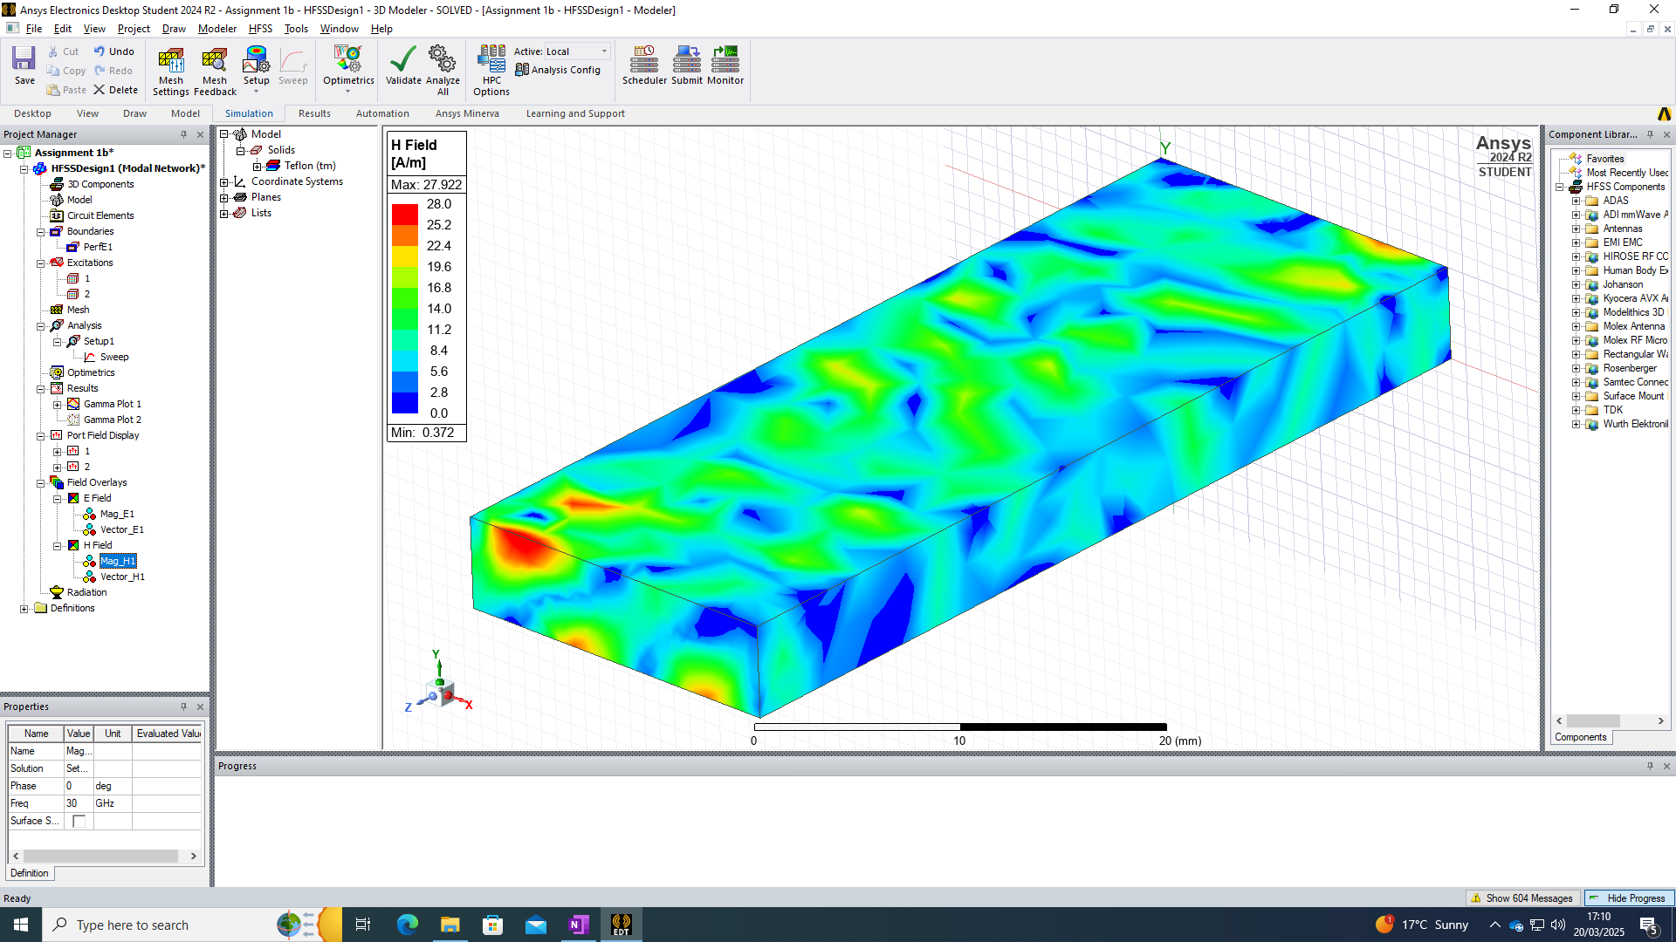
Figure 44 - Magnetic Field, Magnitude TE30

Vector
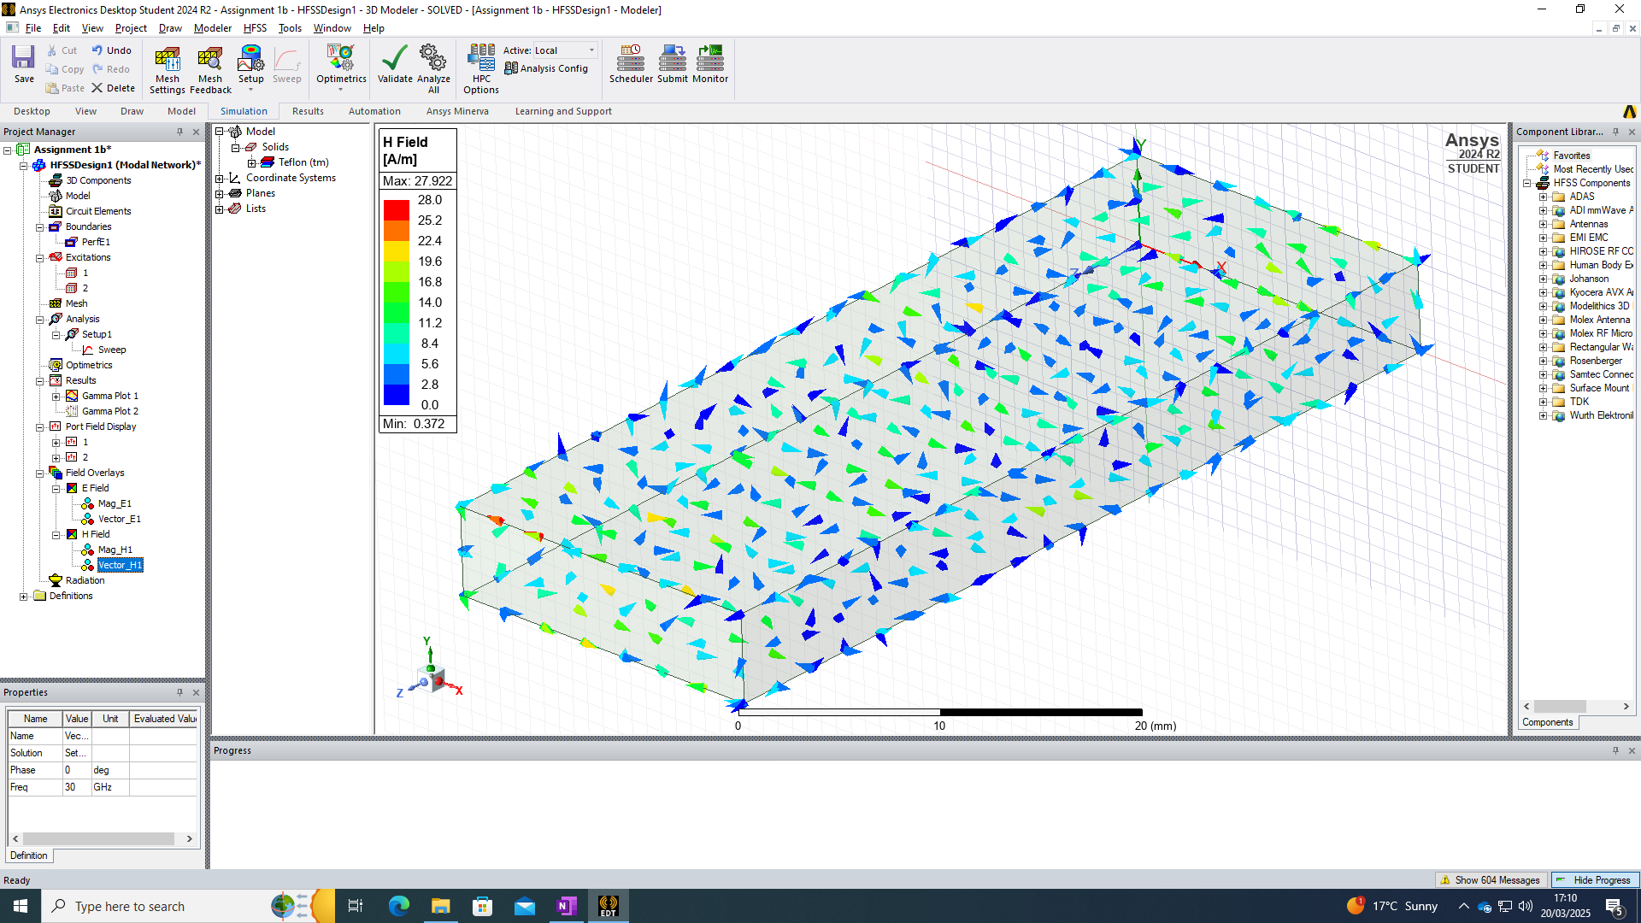
Figure 45 - Magnetic Field, Vector TE30

Cut-off Frequency

Theoretical values
Theoretical values use the same formula as given previously $f_{c}= \frac{c}{2}\sqrt{{(\frac{m}{a})}^{2 }+ {(\frac{n}{b})}^{2 }}$, with the exception of now considering the Teflon fill within the waveguide, as opposed to vacuum. This can be accounted for by considering: $v = \frac{c}{\sqrt{ε_{r}}}=\frac{3 * {10}^{8}}{\sqrt{2.1}}=2.07 * {10}^{8} m/s$
Thus,
TE10 - $f_{c}= \frac{2.07 * {10}^{8}}{2 * 0.019} =5.45GHz$

TE20 - $f_{c}= \frac{2.07 * {10}^{8}}{0.019} =10.89GHz$

TE30 - $f_{c}= \frac{2.07 * {10}^{8}}{0.01} =20.7GHz$

Simulation values
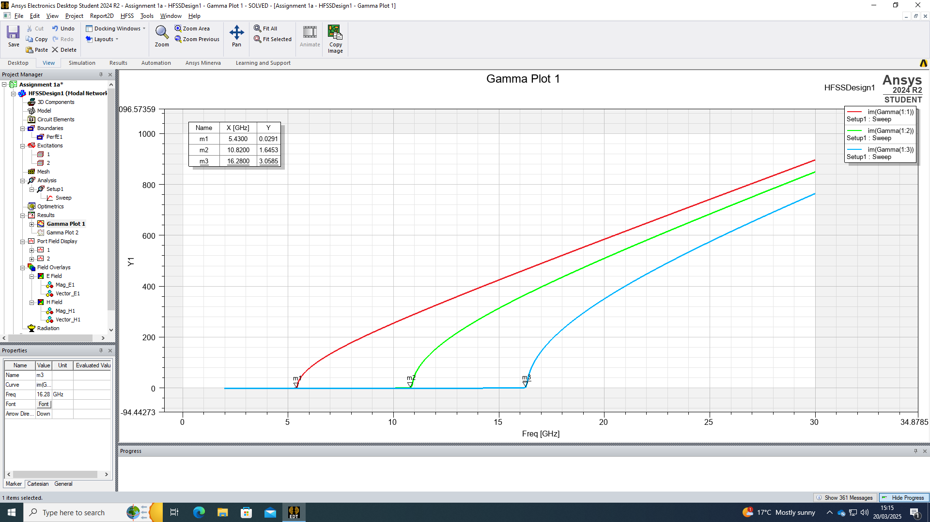
Figure 46 - Cut-off Frequency Plot

Simulation 3
A halfwave dipole antenna with a radius of 1mm, intended to radiate an electromagnetic wave with a wavelength of 𝜆mm, where 𝜆 is 191. The antenna is PEC and excitation is provided through a lumped port with an impedance of 50 Ohms.
a and b parameters are 5mm and 19mm, respectively.
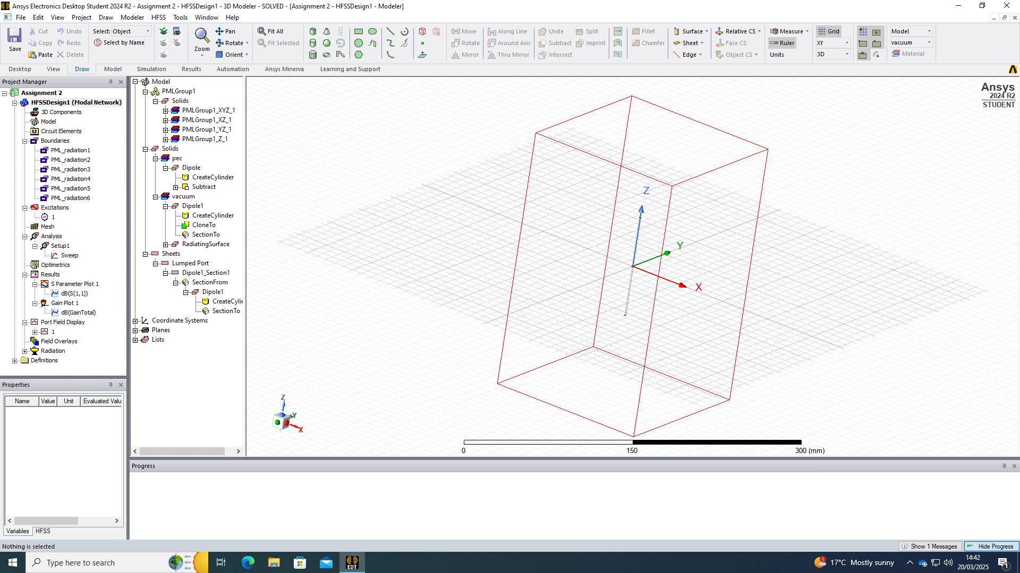
Figure 47 - Antenna Model

Calculations

Halfwave antenna length
The length of a halfwave dipole is given by: $L= \frac{λ}{2}$ where $λ$ = 191mm
$$L= \frac{0.191}{2}=0.0955m or 95.5mm$$

Operating frequency
The operating frequency (f) is given by: $f= \frac{c}{λ}$ where C = speed of light $=3 x {10}^{8}m/s$
$λ$= 191mm
$$f= \frac{3 x {10}^{8}}{0.095}=1.57GHz$$

Simulation values
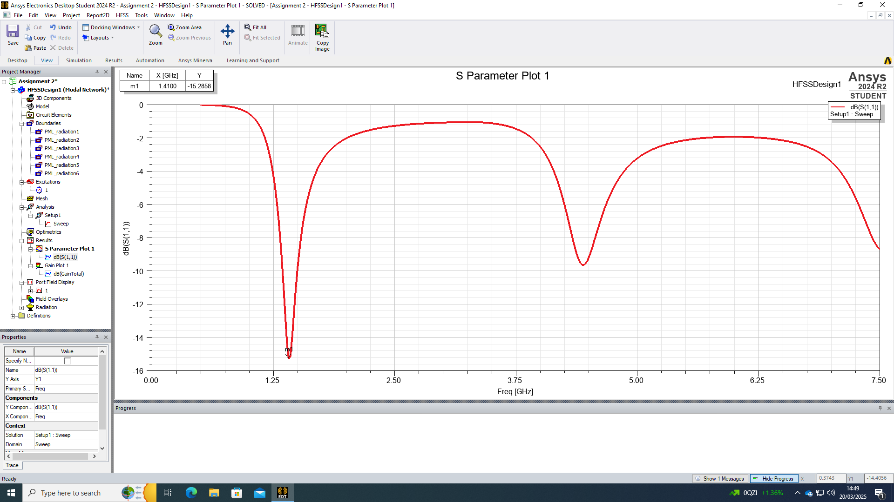
Figure 48 - Operating Frequency S-parameter Plot

Radiation Pattern
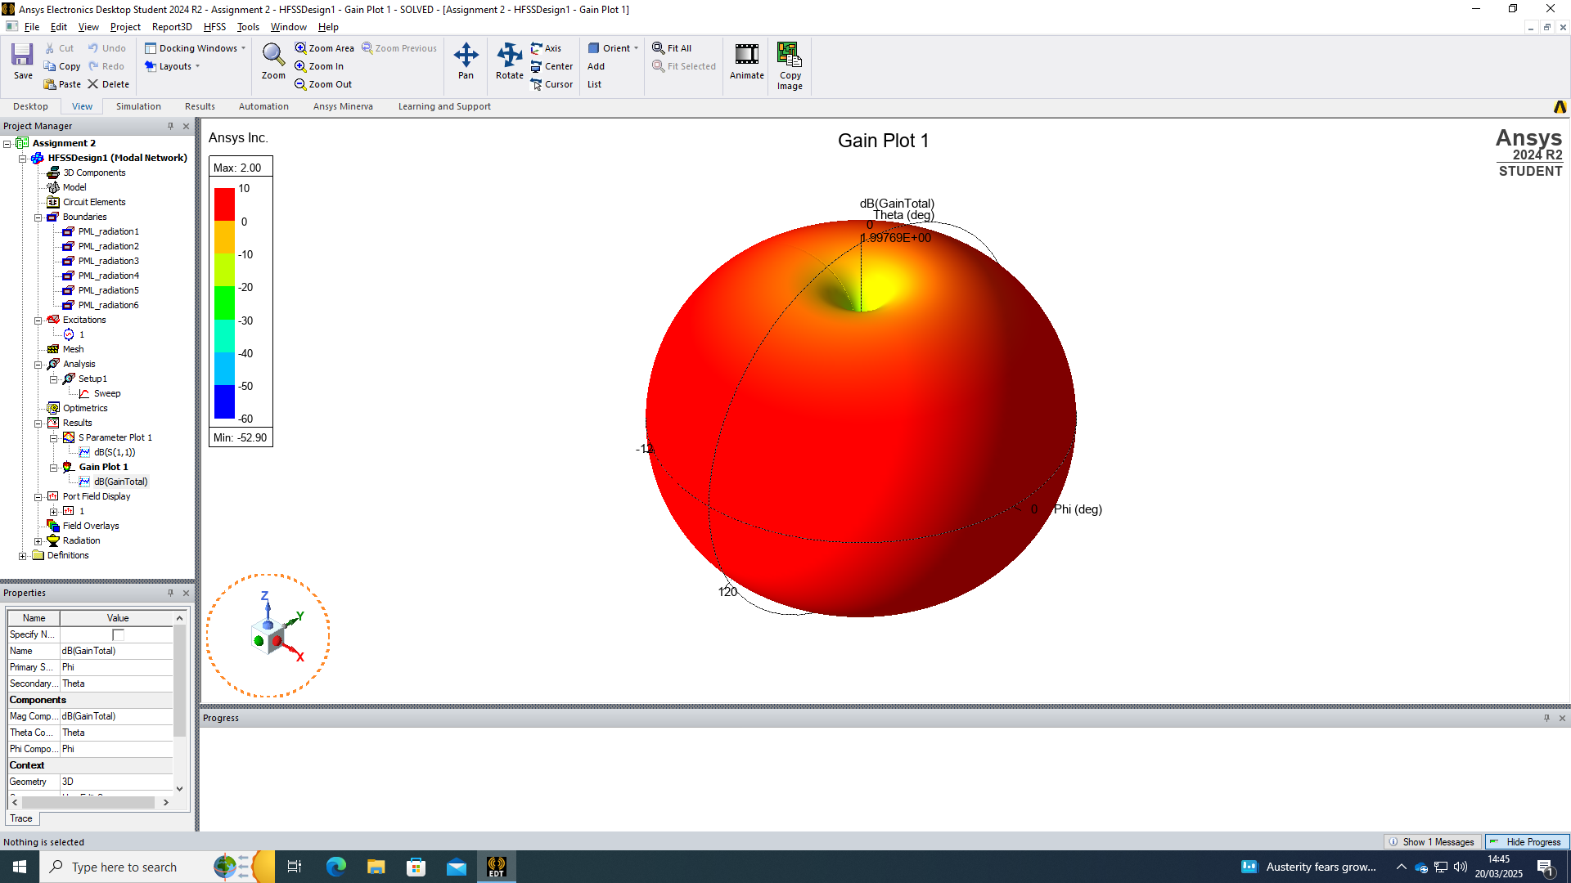
Figure 49 - Radiation Pattern

Discussion

Simulation 1 Discussion
Electric and Magnetic fields. Briefly summarised: all 3 modes appear to have a normal electric field magnitude behaviour throughout the length of the waveguide, such that it is at it’s highest at the centre and lowest (generally 0) at the wall. [Figure 15], [Figure 19], and [Figure 23] shows this, along with a clear representation of the modes, TE10, TE20, and TE30 respectively. A degree of symmetry is observed, and all 3 modes appear to have a normal electric field vector behaviours through the length of the waveguide, such that is displays a consistent flow of energy along the z axis with minimal spreading, scattering, and loss. This is represented at [Figure 16], Figure 20], and [Figure 24].
Strange and overlapping field shapes may indicate mode conversion within the waveguide. In these examples, no mode mixing appears to be present throughout the simulations.
There are some irregularities throughout the simulations, which could be attributed to improper excitation or geometry issues. In this case, it is thought that the geometry is less than ideal, given the figures were arbitrarily picked.
Theoretical/Calculated cut-off values for the waveguide are given in [Section 4.4.1]. These are comparative to the results gained in the cut-off frequency plot in [Section 4.4.2].

Simulation 2 Discussion
Since the 2nd simulation was much a repeat of the first, the discussion will revolve around the observed difference between each of the simulations. It is clear that the removal of the internal vacuum and addition of the Teflon fill has had an observable impact on both the electric and magnetic fields magnitude and vectors.
All 3 modes are visible, but there is a notable difference in the consistency along the z axis and symmetry. Irregularities are much more prevalent throughout when comparing [Figure 34] and [Figure 15].
Theoretical/Calculated cut-off values for the waveguide are given in [Section 5.4.1]. These are comparative to the results gained in the cut-off frequency plot in [Section 5.4.2], with the exception of the results gathered for TE30. This could be attributable to several variables, such as:
- Geometries. Calculated cut-off frequency assumes perfect geometry, compared to the simulation which could have rounded edges or port tapering [7].
- Meshing. All types of finite element simulation software’s are heavily reliant on the type of meshing that is used. A coarse mesh could offer less accurate field resolution [8].
- Material Properties.
- Boundary Conditions
The radiation pattern as plotted in [Figure 49] displayed an Omnidirectional behaviour, as discussed in the background at [Section 3.6.3.2].

Simulation 3 Discussion
The S-plot at [Figure 48] of the halfwave dipole antenna shows a clear resonance at 1.57GHz with a return loss of -15.2dB, confirming efficient radiation and correct impedance matching to 50 Ohms source. The theoretical values given at [Section 6.1.2] affirm the resonance value.
The antenna exhibits a narrow bandwidth typical for a resonant dipole with minimal reflection losses.

Conclusion
This report investigated the behaviour of electromagnetic fields in rectangular waveguides, and dipole antennas across 3 different simulations.
Simulation 1 demonstrated an expected electric and magnetic field characteristic. Theoretical and simulated cut-off frequencies showed agreement, which validated the performance of the waveguide with the exception of some minor irregularities, again, likely attributable to geometric imperfections between the theoretical and simulation.
Simulation 2 demonstrated that a Teflon dielectric fill had a noticeable difference in the electric and magnetic field distributions. There was an increased amount of asymmetry and irregularities throughout, particularly in the high order mode of TE30. The cut-off frequencies between the theoretical and simulation remained comparable, except for TE30 which could be attributable to a number of variables as discussed at [Section 7.2].
Simulation 3 went well, affirming the expected behaviours between theoretical and simulation.

