FESTO Cyber Physical Production System – Goods Dispatch Process Automation Development
ACMA 5002: Manufacturing Design and Technology
Andrew Burgess (2115107)
2022
Contents
Introduction 3
The problem 3
Requirements 4
Research 5
Universal Robots UR3 Cobot 5
Functions 5
Design Requirements 7
Design 8
Concepts 8
Concept One 8
Concept Two 8
Concept Three 8
Final Design 9
Manufacturing 10
Material 10
Design/Function 10
Features 10
Initial Design 11
Design Failure Mode and Effect Analysis 12
Topology Optimisation 13
Evaluation 14
Conclusion 14
References 15
Appendix 17
Appendix A – Functional Analysis 17
Appendix B – Process Failure Mode and Effect Analysis 18
Appendix C – Quality Function Deployment 20
Appendix D – Universal Robots UR3 Cobot Technical Specification 21
Appendix E – Functional Means Analysis 22
Appendix F – Concept 1: Scoop 23
Appendix G – Concept 2: Single Piece Gripper 24
Appendix H – Concept 3: Locking Gripper 25
Appendix I – Design Failure Mode and Effect Analysis 26
Appendix J – Stress Analysis: Fixed Jaw 27
Appendix K – Stress Analysis: Moving Jaw 28
Appendix L – Final Design 29

Introduction
The purpose of this report is to describe and explain the methods used when designing a new end-effector for a cobot (collaborative robot). This new cobot is intended to be used alongside the Festo cyber physical production system.
This report aims to show the design methods that were used. This includes tools or decisions that were made using relevant sources. The report will analyse the processes currently in use and suggest processes or equipment that can solve the problem set out in the brief. To support these changes, digital tools will be used, establishing limitations and manufacturing processes to be used to manufacture any physical parts that are developed as a result of this task. The lifecycle of this product will encompass the design, manufacture and disposal of the product at the end of its useful life.

The problem
The Festo cyber physical production system assembles a mobile phone (also known as the device) using a predetermined selection of parts. At the end of the assembly process, the mobile phone is ejected onto a chute which can hold a maximum of four devices before the system acknowledges the chute is full and does not eject any more devices.
To alleviate this issue, a cobot was introduced to move the devices from the chute and onto an autonomous guided vehicle (AGV). A new end-effector was required to lift, transport and release the mobile phone into the correct position and orientation onto the AGV.
An issue was found where some of the mobile phone cases were not secured fully, meaning that some cases would detach from each other. This had the potential for parts of the device to become damaged as it is dropped from height. Therefore, the solution had to factor failure modes in both the process and the solution itself, taking precautions in the design and operating procedure to minimise occurrence and the severity of potential failure modes.

Requirements
The client has specified some requirements which the final outcome must comply. This includes the following:
- “The final design should be appropriate for high-volume manufacturing.” This means the design of the outcome should have feature that allow it to be produced easily and economically using high-volume or mass production methods.

- “The gripper should be mechanically actuated.” The final outcome should use some form of mechanism to hold the mobile phone whilst it is being transported. It cannot rely solely on other work-holding techniques like vacuum due to the issue with the mobile phones described above.

- “The design should be sufficiently robust to withstand sustained use within a production environment.” The final outcome must be able to withstand standard forces of operation without failing or degrading substantially. Similarly, this product must be used repetitively with varying loads at different times without substantial degradation of properties.
There were a number of additional requirements described in the brief. These requirements are expected by the client and not directly stipulated. For this reason, they had to be be recorded. A functional analysis was used as specified by Burge (2021). A functional analysis is used to simplify the function of a system and identify necessary features (Burge, 2021). The functional analysis diagram can be found in Appendix A. These additional requirements are:
- The end-effector must be able to support the weight of the mobile phone throughout the whole operation.

- The end-effector must allow the cobot to place the device in the correct position and orientation without impeding its performance.

- The combined mass of the mobile phone and the end-effector must not exceed the Safe Working Load (SWL) of the cobot itself.

- The end-effector must be able to hold the device in a way that does not allow it to fall apart.

- The end-effector must not damage the device during any part of the operation.

- Given this product is intended to be produced in high volumes, it should be inexpensive to produce.
To further assess the process in which the end-effector is expected to be used, a Process Failure Mode and Effect Analysis (PFMEA) was conducted. According to Popov, Lyon and Hollcroft (2016), a PFMEA is intended to be used as a method to identify all means a system can fail to meet its intended purpose. Burge (2021) adds that a PFMEA can find additional requirements that should be considered. This makes use of the recommended improvements that are intended to find potential solutions to the failure mode itself. In this case, the PFMEA was constructed using the functions established in the functional analysis. The PFMEA can be found in Appendix B. Using the risk priority numbers highlights the areas of most concern, to be considered as an additional requirement. As a result of this, the following requirements can be considered:
- Alignment with relevant interfaces should be maintained at all times.

- The speed of operation must be adjustable

- The end-effector should fit onto the cobot with no further adjustment required

- The device can only be released once it has confirmed location.
Now with a broader understanding with the requirements of this end-effector, more detailed research and decisions can be made regarding potential solutions.

Research

Universal Robots UR3 Cobot
The Universal Robots UR3 cobot (or UR3) is the cobot that the end-effector is being designed to interface with. Therefore, it is important to understand the abilities and restrictions of this equipment. The technical specifications of the UR3 can be found in Appendix D and the user manual can be found at Universal Robots (Universal Robots, 2015b).

Functions
To provide a solution for a function, research was required into options to be incorporated into the final design. A range of support techniques were researched to find methods of holding and supporting the device. A gripper is a method to support the device. Grippers are ubiquitous, being used in multiple applications (Universal Robots, 2019). Variations of the gripper includes finger grippers, magnetic grippers and vacuum grippers. Finger systems can work in most applications (Honarpardaz, et al., 2017).
Magnetic grippers are different shapes and sizes to provide grip in different applications. This type of gripper is often lightweight, consisting of purely electronic parts. Yet, this system can only hold ferromagnetic materials (Roy, 2015). This would make magnetic grippers unsuitable for use with the plastic device case. Vacuum grippers were rejected by the client due to the likelihood of the product falling apart.
Another function was the ability of the cobot to sense the position of the end-effector. There are methods that can be used to determine position in robotics. The table below highlights some of the most common position measuring systems.
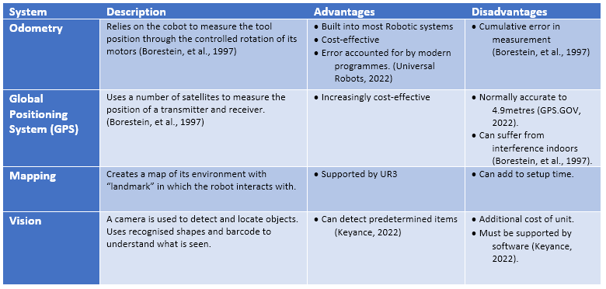
The PFMEA found there was a risk the device could be ejected mid-process. Therefore, systems were explored to reduce the likelihood of this occurring and adding greater detectability. To stop the device being ejected, a Poka-Yoke design was required. Poka-Yoke is a concept developed to “mistake-proof” a design (Anderson, 2014). For this application, the device needed to remain held by the end-effector until signalled to be released. If a gripper was to be used, the jaws would be required to remain shut when not actuated. A method to achieve this would be a sprung mechanism. Therefore, the spring force would have to be sufficient to hold the device in place if there was a loss of power to the UR3.
To establish how much force would be required for a friction gripper to support the device, the following formula was used (Monkman, G. J., Hesse, S., Steinmann, R. & Schunk, H. 2007).
$${Force}_{Grip}=\frac{mass ×acceleration due to gravity}{Coefficient of friction between jaw and workpiece ×number of jaws}$$
If a compression spring was used to provide the necessary force, the spring rate would be used to identify the force it would exert (Childs, 2014). Connecting springs in parallel would combine the total spring rate and increase the overall force subjected by the end-effector (Childs, 2014).

Design Requirements
With the requirements confirmed, the specification, or design requirements, could be developed. Dym, et al. (2022) defines design requirements as a list of functions and features, measuring how well it should be able to perform those functions. To find the measurable goals and properties that would allow the end-effector to function as intended a Quality Function Deployment (QFD) was required (Dym, et al., 2022). Quality Function Deployment is a method developed to record the “voice of the customer” and translate customer requirements into design requirements or specifications (Johnson, 2003). The design requirements were assessed according to their relevance to each customer requirement (Johnson, 2003). In some circumstances, competitors’ products can be compared according to the customer requirements. For this task, it is not possible as competitors’ products have not been assessed according to the requirements and application set out in this report. Additionally, some information regarding competitors’ products is not widely available for comparisons to be made. The completed QFD can be found in Appendix C.
The design requirements that have been established can be found in the table below. This includes the factors that should be considered to solve all stipulated and unspoken requirements set out by the customer. Due to the scarcity of information and specialist application of this product, definite limits could not be applied in some cases.
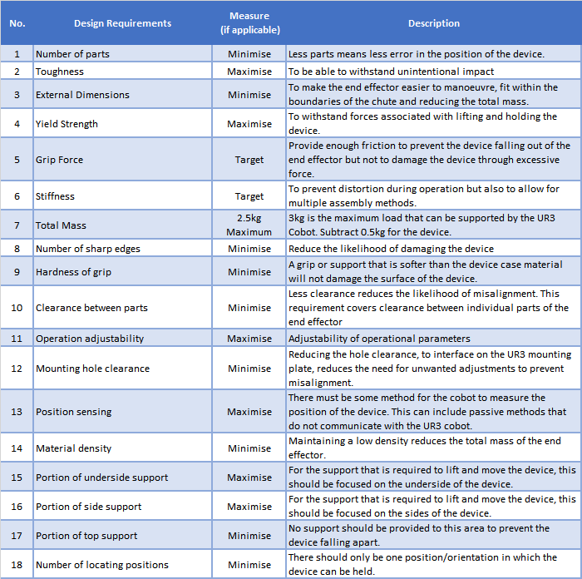

Design
With the necessary customer and design requirements developed, focus can be turned towards developing concepts and solutions for the end-effector. Burge (2006) states that a final design can be created from multiple concepts, often incorporating the benefits of each. Taking this into account, a method called Function Means Analysis (FMA) was used. FMA plots the basic function that must be performed by the end-effector and provide multiple solutions, or means, for each function. Completing the functional analysis diagram provided some of the basic functions any end-effector must perform. The QFD analysis developed customer requirements into design requirements, which brought about a number of different functions that were pertinent to the overall function of the end-effector. These functions were combined into the FMA to develop a number of solutions. The completed FMA can be found in Appendix E. The legend shows the selected pathways for each solution. Pathways showing two highlighted functions indicates a hybrid or dual approach has been selected.

Concepts
The following concepts were generated from the FMA with the aim of fulfilling the design requirements established in the QFD analysis. A Pugh matrix was used to assess each concept according to the design requirements to establish a final design.

Concept One
See Appendix F for the sketch of this solution. This concept uses a simple scoop to lift, transport and lower the device into the sled. Lifting and lowering is controlled solely by the cobot, meaning that the device sits loose on the scoop. There is a cut-out at the front of the scoop to straddle the stop at the end of the chute. No modification is required to the chute or sled for this concept. Weight sensors are incorporated into the scoop body to detect if the device is present and a vision system to align the scoop to the body.

Concept Two
A simpler concept, this uses a single profiled piece. This piece has hooks at the end of each jaw to act as snap fittings that secure to the back of the device as it is pushed into place. To release the device, it must be pressed into the retaining parts of the sled. This stops the device being released mid-cycle and can only be released with the corresponding location areas. This adds elements of Poka-Yoke to the process, controlling the failure modes highlighted in the PFMEA. The sled would require modification to accommodate the release mechanism of this concept. The sketch for this concept can be found in Appendix G

Concept Three
Matching the description of a traditional gripper set out by Honarpardaz, et al. (2017), this gripper features two jaws which are indexable to support the device. The jaws are spring loaded in the shut position but opened and held in the open position using a cam and detent. During tranport, the jaws cannot be opened accidentally adding a similar level of Poka-Yoke to the process as Concept Two. The cam is driven by the tool flange of the UR3, eliminating the need for an external actuator but only when the orientation of the device is locked by the chute and the sled. Whilst suspended, the device can only be turned rather than released. The sketch for this concept can be found in Appendix H.

Final Design
To find the most suitable concept to develop, a comparison with the design requirements and functions of the end-effector was made. In this instance, a Pugh Matrix was used. According to Burge (2009) the Pugh Matrix is completed by comparing the requirements and functions to the concepts, scoring each by compliance. A point is earned through conformance and zero points are earned through non-compliance (Burge, 2009). For this analysis, only design requirements that refer to function and operation of the end-effector was assessed. Material choices were discounted as it is generally considered in the design stages. Burge (2009) and Childs (2014) states this is acceptable for making conclusive decisions. The Pugh matrix can be found in the table below. Concept 3 is the most compliant to the criteria, hence will be developed into the final design.
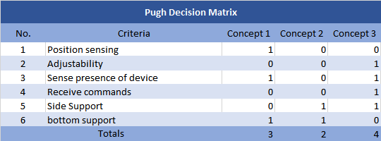
Next, the relationships between the design requirements were explored. Where correlations were highlighted in the QFD analysis, they have common links that were important to determine when completing the final design. The table below shows the relationships between the design requirements highlighted in the QFD analysis.
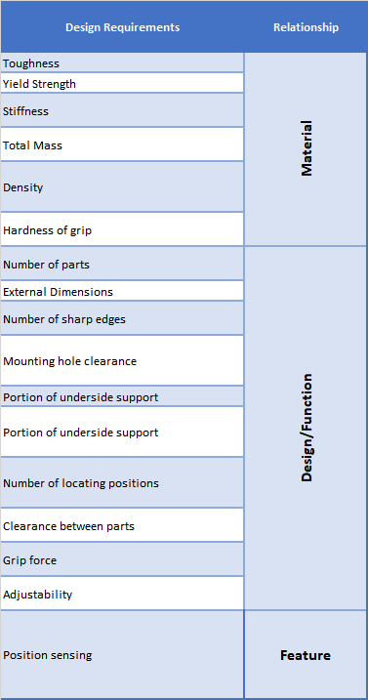

Manufacturing
It was a requirement that the end-effector must be suitable for high volume production. Akdogan and Serder Vanli (2020) defines high volume manufacturing as production methods that can consistently produce large numbers of parts within a short amount of time. 3D printing has allowed for high-volume production of parts through optimisation of geometry and print volume through nesting of multiple parts (Hong-Tzong & Che-Wei, 2021). Additionally, Slant3D offer a high-volume 3D printing service that does not incur high tooling costs associated with methods like injection moulding. This is done using large numbers of printers to create a batch of parts, in a setup called a printing farm (Slant 3D, 2021).

Material
Some of the most common and versatile materials used in 3D printing includes ASA, ABS and PLA plastic (Slant 3D, 2021). Whilst there are options for metals, these are being disregarded due to their higher density. Simplify3D (2022) regards ASA as the most durable material of the selection. The following properties are given for each material.
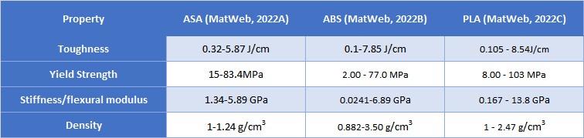
From this table, ASA provides a much higher set of minimum properties, despite some properties having higher maximum values. Due to a higher base value for each mechanical property and having the lowest maximum density. Additionally, ASA is a thermoplastic, meaning it can be remoulded at the end of its life (Lefteri, 2014). This makes it a good candidate for cyclic use amongst its other mechanical properties.

Design/Function
All parts were designed to be manufactured using 3D printing. Guidance and design features from Redwood, B., Schöffer, F. and Garret, B. (2017) were used in each design. The final design reflects the features of the concept but incorporated changes that allowed it to be 3D printed. The gripper can only be opened and closed when located into the chute or onto the sled with the device. Doing this eliminates the possibility for the device to be accidentally released through program error or loss of power. Effectively, this is a control form of Poka-Yoke that prevents an error occurring (Dennis, 2015).

Features
For this design a lever microswitch will be used to detect the presence of the device in the end-effector. This provides autonomation, also known as Jidoka, to the operation (Dennis, 2015). Doing this provides a human level sensing ability that would detect when the end-effector has failed to collect a device from the chute.
The spring force that would be required was calculated as shown below. The value coefficient of friction was taken from Monkman, et al. (2007).
$${Force}_{Grip}=\frac{0.5 ×9.81}{1.0 ×2}$$
$${Force}_{Grip}=2.4525N$$
This answer provides the minimum spring force that is required to hold the device in place. No safety factor has been included in this calculation. To overcome this, additional springs were added to account for variations for each device and the increase in downward force caused by the accelerating UR3 (Monkman, et al., 2007).

Initial Design
The design is setup as shown in the following images.
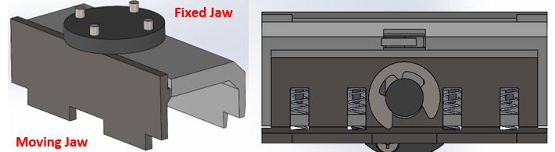
The moving jaw is normally closed due to the springs fitted to the underside of the jaw. The jaw is opened to accept the device on the chute and is actuated by the cam on the mounting plate; which is rotated by the tool flange on the UR3. For the jaw to open, the rotation of the tool must be locked by the fixed jaw. The jaw is closed onto the device when the fixed jaw is located into the chute profile. The jaw is opened when the device is located into the platform and locks the rotation of the fixed jaw. A notch is present at top dead centre of the cam which holds the jaw open between the release of the previous device and the location onto the next device in the chute.
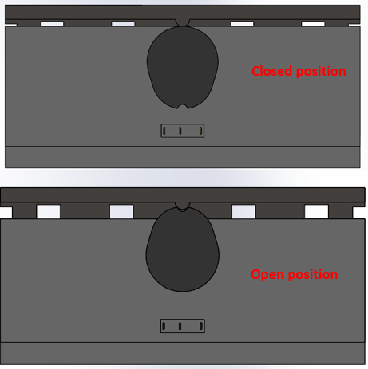

Design Failure Mode and Effect Analysis
The initial design was analysed using a Design Failure Mode and Effect Analysis (DFMEA) This was used to highlight the issues with this design and make recommendations for improvement. This can be found in Appendix I. This established issues with the design and suggested improvements to be made. These improvements were made prior to further analysis. The changes can be seen in the following images.
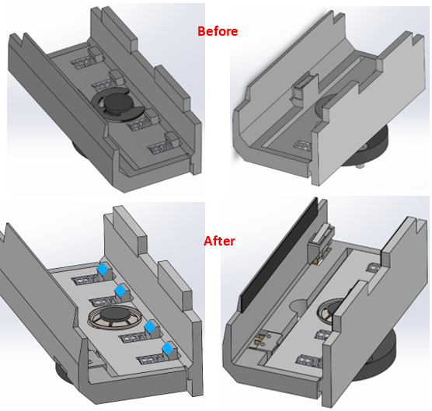
Lead angles have were added (highlighted blue) to aid with the fitment of the springs as stipulated by Boothroyd, et al. (2011). The E-clip has been replaced with a Starlock washer. This simplifies the assembly process and reduced the number of assembly axis (Boothroyd, et al., 2011). Another switch was added to detect the position of the moving jaw. Similarly, both switches can be assembled in the same way as the e-clip, providing autonomation to the operation of this end-effector. The new snap fit connectors were modelled through the guidance of Bonenberger (2016).
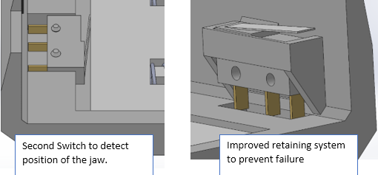

Topology Optimisation
To further reduce the mass of the final product, reduce printing time but ensure stiffness remains high, topology optimisation was used. Topology optimisation is a method used to refine the geometry of a part, minimising mass but maintaining structural integrity (Redwood, et al., 2017). This technique was used on the fixed and moving jaw, due to volume of material each would use and the gripping forces that are being applied through these parts.
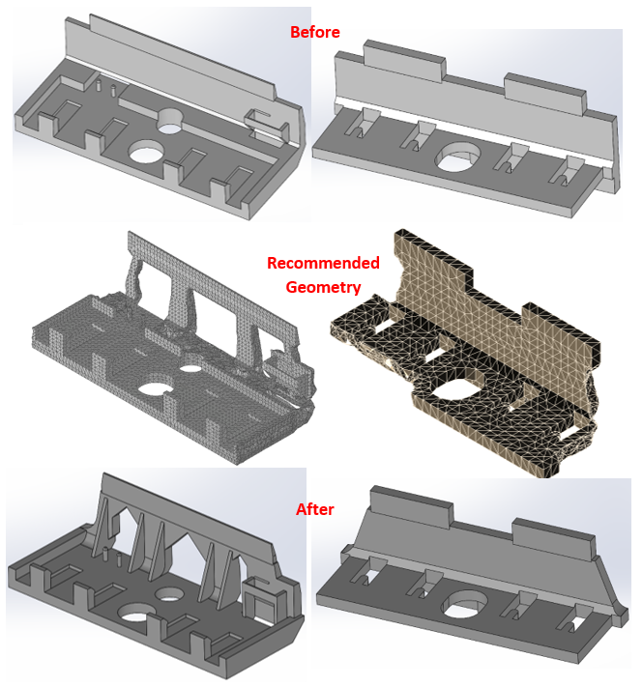
The topology study provided a result which would be difficult to create using 3D printing. To develop these designs further, material was removed from areas where the topology study found it to be unnecessary. This produced the following parts. 45° overhangs were incorporated to allow the parts to be printed with less support material, saving material and reducing printing time (Redwood, et al., 2017). To validate these designs, a stress analysis was performed. Loads were applied to the faces in contact with the device and the springs which simulated real world forces. The results for both the fixed and moving jaw can be found in Appendix J and K. The results determined a minimum safety factor of 17.3 for the fixed jaw and 23.2 for the moving jaw. The total deflection on each jaw was less than 0.2mm, not enough to cause misalignment of the end effector with chute or sled. With the designs fully developed and analysed, the final drawings were developed. These can be found in Appendix L.

Evaluation
This project was completed by identifying the problems experienced by the client. Considerable effort was placed into understanding the problem and establishing solutions that can be rectified by the design of this end-effector. One of the problems that were identified included the need for the end-effector to hold the device in a way that would prevent it to fall apart. Issues were handled by recording and developing them into functional requirements.
Requirements were developed as objectively as possible, using recognised tools and methods such as functional analysis and PFMEA. The PFMEA was successful in developing functions that were not stipulated by the client and those that were expected on a subconscious level. QFD was used to develop the customer requirements into design requirements. Whilst this method was successful in producing design requirements, some of these requirements were difficult to measure and could not be compared to products offered by other companies due to niche application associated with this product. Given the opportunity to complete this task again, a greater number of measurable attributes would have been selected.
The design stage was used to produce a variety of concepts, each with different functions and features. The final design was selected using a recognised method of Pugh analysis. Again, the process was objective and used previously specified functions and requirements to form the criteria. A clearer set of requirements from the QFD would have created a stronger assessment but fulfilled its purpose, nonetheless.
The selected concept was developed into the final design according to its functions and life cycle. This included its method of manufacture and materials that are used. The material selection considered mechanical properties and disposal. The result is a product that, theoretically, can hold the device, can withstand the forces that would be applied and only weighs 216g.

Conclusion
Overall, the project achieved its aim to create an end-effector that aids in transporting a mobile phone from the chute to the AGV. A number of tools were used to obtain more information and to justify important decisions. Digital tools were used to create designs and validate them against stated requirements. The design was further refined to save materials and improve manufacturability and reduce production times. The life cycle of the product was considered, designing it to meet its requirements, to be manufactured easily and to be disposed of safely.

References
Anderson, D. M. (2014). Design for Manufacturability. Boca Raton: CRC Press.
Bonenberger, P. R. (2016). The First Snap-Fit Handbook. 3rd ed. München: Carl Hanser Verlag.
Boothroyd, G., Dewhurst, P. & Knight, W. A. (2011). Product Design for Manufacture and Assembly. 3rd ed. Boca Raton: CRC Press.
Borestein J., Everett, H. R., Feng, L. & Wehe, D. (1997). Mobile Robot Positioning: Sensors and Techniques. Journal of Robotic Systems, 14(4), pp. 231-249.
Burge, S. (2006). The Systems Engineering Toolbox, Coventry: Unpublished.
Burge, S. (2009). Pugh Matrix (PM), Coventry: BurgeHughesWalsh.
Burge, S. (2021). Perform Functional Analysis, Coventry: Burge Hughes Walsh Limited.
Childs, P. R. (2014). Mechanical Design Engineering Handbook. Oxford: Elsevier.
Dennis, P. (2015). Lean Production Simplified. 3rd ed. Boca Raton: CRC Press.
Dym, C. L., Little, P. & Orwin, E. J. (2022). Engineering Design A product-based Introduction. 4th ed. Hoboken: Wiley.
GPS.GOV (2022). GPS Accuracy. [Online]
Available at: https://www.gps.gov/systems/gps/performance/accuracy/
[Accessed 4 June 2022].
Honarpardaz, M., Tarkian, M., Ölvander, J. & Feng, X. (2017). Finger Design Automation for Industrial Robot Grippers: A Review. Robotics and Autonomous Systems, Volume 87, pp. 104-119.
Hong-Tzong, Y. & Che-Wei, H. (2021). Nesting of 3D irregular shaped objects applied to powder-based. The International Journal of Advanced Manufacturing Technology, 115(5-6), pp. 1843-1858.
Johnson, C. N. (2003). QFD Explained, Milwaukee: American Society for Quality.
Keyance (2022a). Laser sensors. [Online]
Available at: https://www.keyence.co.uk/products/sensor/laser/
[Accessed 04 June 2022].
Keyance (2022b). Vision-Guided Robotics, Milton Keynes: Keyance (UK) Ltd.
Lefteri, C. (2014). Materials for Design. London: Laurence King Publishing.
MatWeb (2022A). Overview of materials for Acrylonitrile/Styrene/Acrylate (ASA), Unreinforced, Molded. [Online]
Available at: https://www.matweb.com/search/datasheet.aspx?matguid=24c5655bc30e42c3949df6c53122bd61&ckck=1
[Accessed 5 June 2022].
MatWeb (2022B). Overview of materials for Acrylonitrile Butadiene Styrene (ABS), Molded. [Online]
Available at: https://www.matweb.com/search/DataSheet.aspx?MatGUID=eb7a78f5948d481c9493a67f0d089646
[Accessed 5 June 2022].
MatWeb (2022C). Overview of materials for Polylactic Acid (PLA) Biopolymer. [Online]
Available at: https://www.matweb.com/search/DataSheet.aspx?MatGUID=ab96a4c0655c4018a8785ac4031b9278
[Accessed 5 June 2022].
Monkman, G. J., Hesse, S., Steinmann, R. & Schunk, H. (2007). Robot Grippers. 2nd ed. Weinheim: Wiley-VCH.
Popov, G., Lyon, B. k. & Hollcroft, B. (2016). Risk Assessment: A practical Guide to Assessing Operational Risks. Hoboken: John Wiley & Sons.
Redwood, B., Schöffer, F. & Garret, B. (2017). The 3D Printing Handbook. Amsterdam: 3D Hubs.
Roy, D. (2015). Development of Novel Magnetic Grippers for Use in Unstructured Robotic Workspaces. Robotics and Computer-Integrated Manufacturing, Volume 35, pp. 16-41.
Simplify3D (2022). Filament Properties Table. [Online]
Available at: https://www.simplify3d.com/support/materials-guide/properties-table/
[Accessed 5 June 2022].
Slant 3D (2021). How High Volume 3D Printing Works?. [Online]
Available at: https://www.slant3d.com/production-3d-printing-quote-2.html
[Accessed 5 June 2022].
Universal Robotics (2015a). UR3 Technical Specifications, New York: Universal Robotics.
Universal Robots (2015b). User Manual, Odense: Iniversal Robots.
Universal Robots (2019). Robot Grippers Explained. [Online]
Available at: https://www.universal-robots.com/blog/robot-grippers-explained/
[Accessed 03 June 2022].
Universal Robots (2022). How to Calibrate Your Robot. [Online]
Available at: https://www.universal-robots.com/articles/ur/robot-care-maintenance/how-to-calibrate-your-robot/
[Accessed 5 May 2022].

Appendix

Appendix A – Functional Analysis
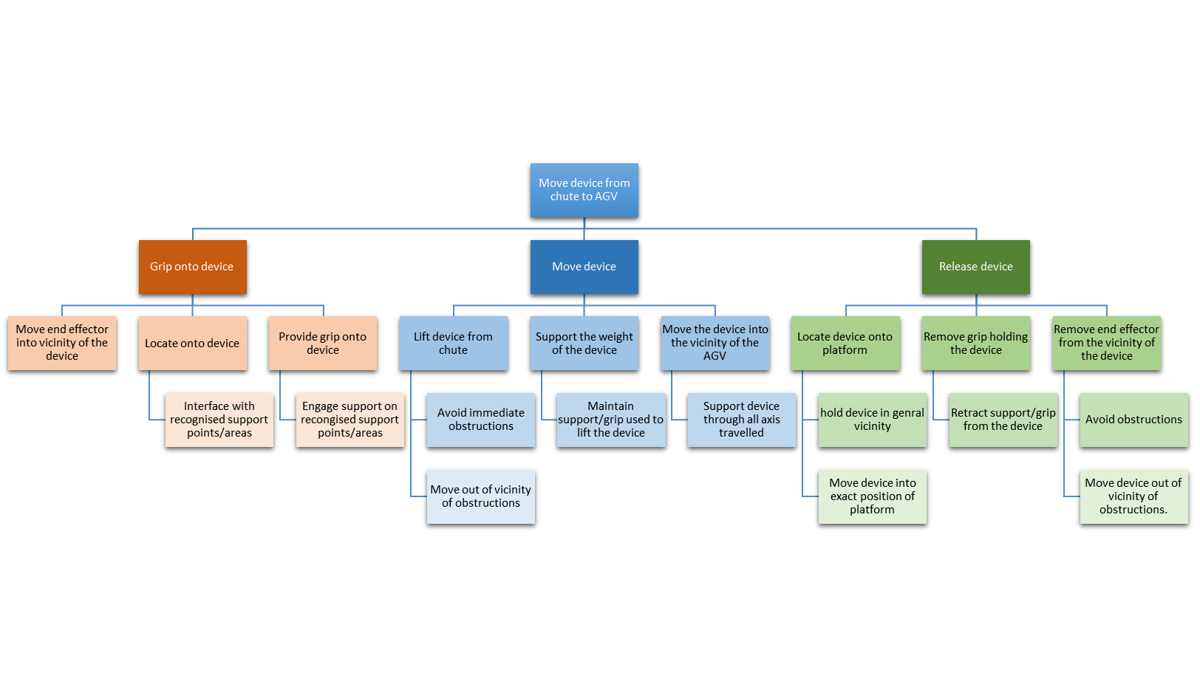

Appendix B – Process Failure Mode and Effect Analysis
PROCESS FAILURE MODE AND EFFECT ANALYSIS
Process: | Lifting and transporting mobile phones from chute to AGV
 |  | Potential Effect(s) of Failure | Sev | Potential Cause(s)/ Mechanism(s) of Failure | Occur | Current  Process  Controls | Detec | RPN | Recommended Action(s)
Move end-effector in vicinity of the machine | Doesn't move | No function of end-effector | 10 | Failure of program, no power, program not started | 2 | Start-up procedure, Failure detection | 1 | 20 | Program planning
Move end-effector in vicinity of the machine | Moves into the incorrect area | No function, misalignment, damage to end-effector, damage to device | 8 | Program error, misalignment of robot | 5 | None | 5 | 200 | Alignment jig for robot. Align and secure robot, use of vision system
Move end-effector in vicinity of the machine | Hits obstacle | Damage device, damaged machine, damaged end-effector, Injury, dropped device, damage obstacle | 8 | Program error, misalignment of robot, obstacle not detected | 3 | Program planning, | 3 | 72 | Alignment jig for robot. Align and secure robot, use of vision system
Locate into device | Doesn't locate onto device | Damage device, damaged machine, damaged end-effector, Injury, dropped device, damage obstacle | 8 | Mobile phone misaligned. Robot misaligned, end-effector misaligned | 3 | Chute guides | 2 | 48 | Alignment jig for robot, alignment jig for end-effector, use of vision system
Locate into device | Doesn't locate onto correct areas | Damage device, damaged end-effector, Injury, dropped device | 6 | Mobile phone misaligned. Robot misaligned, end-effector misaligned | 4 | Chute guides | 4 | 96 | Alignment jig for robot, alignment jig for end-effector, use of vision system
Support device | Doesn't support | No function | 10 | Failure of program, no power, program not started | 2 | Start-up procedure, Failure detection | 1 | 20 | Program planning
Support device | Insufficient support | Dropped device, damaged device, Damages machine | 7 | Failure of program, no input | 3 | Start-up procedure, Failure detection, use of friction grips | 2 | 42 | Program planning, use of friction grips
Support device | Excessive support | Damaged device, damaged end-effector | 8 | Input too high, leverage too high, misalignment of device | 2 | Program planning, chute guides | 6 | 96 | Program planning, use of friction grips
Lift device from chute | Doesn't lift | No function | 10 | Failure of program, no power, program not started, overload of cobot | 2 | Program planning | 1 | 20 | Program planning, lightweight design
Lift device from chute | Lifts excessively high | Misalignment of device, misalignment of end-effector, ejection of device, damage to device, damage to end-effector | 6 | Input too high, | 2 | Program planning | 2 | 24 | Program planning
Lift device from chute | Lifts too little | Misalignment of device, misalignment of end-effector, damage to device, damage to end-effector, damage to machine | 7 | Input too low. Overload of cobot | 1 | Program planning | 7 | 49 | Program planning, lightweight design
Lift device from chute | Hits obstacle | Misalignment of device, misalignment of end-effector, damage to device, damage to end-effector, damage to machine, damage to obstacle | 8 | Program error, misalignment of cobot, obstacle not detected | 3 | Program planning | 2 | 48 | Program planning, alignment jig for cobot, vision system
Lift device from chute | Lifts too quickly | Misalignment of device, ejection of device, damage to device, damage to end-effector, damage to machine | 6 | Program error, input too high | 2 | Program planning | 5 | 60 | Program planning
Support weight of device | Doesn't support weight | No function, damage to end-effector, damage to device, dropped device | 5 | Program error, no input to end-effector, end-effector error | 4 | Program planning | 2 | 40 | Detailed program planning, end-effector testing, vision system
Support weight of device | intermittent support | No function, damage to end-effector, damage to device, dropped device | 5 | Program error, no input to end-effector, end-effector error | 3 | Program planning | 1 | 15 | Detailed program planning, end-effector testing, vision system
Move device into vicinity of AGV | No movement | No function | 10 | Program error, no input to cobot | 2 | Program planning | 1 | 20 | Detailed program planning, pre-start checks
Move device into vicinity of AGV | Moves too far | Misalignment of device, damage to device, damage to cobot, damage to machine, device dropped | 8 | Program error, misalignment of Cobot, hit obstacle, misalignment of end-effector | 4 | Program planning | 3 | 96 | Detailed program planning, alignment jig for cobot, alignment jig for end-effector
Move device into vicinity of AGV | Move too little | Misalignment of device, damage to device, damage to cobot, damage to machine, device dropped | 8 | Program error, misalignment of Cobot, hit obstacle, misalignment of end-effector | 4 | Program planning | 3 | 96 | Detailed program planning, alignment jig for cobot, alignment jig for end-effector
Move device into vicinity of AGV | Move too slow | excessive time taken for one operation | 1 | Program error, Input to cobot too low | 6 | Program planning | 5 | 30 | Detailed program planning
Move device into vicinity of AGV | Moves too fast | Damage to cobot, damage to end-effector, ejection of device, damage to damage. | 9 | Program error, Input to cobot too high | 3 | Program planning | 6 | 162 | Detailed program planning.
Locate device onto platform | Doesn't locate | Damage to device, damage to end-effector, damage to AGV | 8 | Program error, misalignment of Cobot, misalignment of AGV | 5 | Program planning | 3 | 120 | Detailed program planning, Alignment jig for cobot, alignment adjusted for AGV
Locate device onto platform | Locate too far from platform | Damage to device, damage to end-effector, damage to AGV | 6 | Program error, misalignment of Cobot, misalignment of AGV | 5 | Program planning | 4 | 120 | Detailed program planning, Alignment jig for cobot, alignment adjusted for AGV
Locate device onto platform | Incorrect orientation | Damage to device, damage to end-effector, damage to AGV | 5 | Program error, misalignment of Cobot, misalignment of AGV | 6 | Program planning | 3 | 90 | Detailed program planning, Alignment jig for cobot, alignment adjusted for AGV, pre-start checks, alignment jig for end-effector
Remove support | Doesn't remove support | Damage to device, damage to AGV | 5 | Program error, damaged end-effector | 4 | Pre-start checks | 1 | 20 | Detailed program planning. Inspection of end-effector prior to start up.
Remove support | Support removed too quickly | Dropped device, damaged device, Damaged end-effector | 4 | Program error, Input to cobot too high | 4 | Program planning | 3 | 48 | Detailed program planning, Pre-start checks
Remove support | Support not fully removed | Dropped device, damaged device, Damaged end-effector | 4 | Program error, misalignment of cobot, misalignment of AGV | 3 | Program planning, pre-start checks | 3 | 36 | Detailed program planning, alignment jig for cobot, alignment jig for AGV
Remove support | Support removed too slow | excessive time taken for one operation | 1 | Program error, Input to cobot too low | 6 | Program planning | 2 | 12 | Detailed program planning
Remove end-effector from vicinity of device | Doesn't remove end-effector | No function | 10 | Program error, no input to cobot | 2 | Program planning | 1 | 20 | Detailed program planning, pre-start checks
Remove end-effector from vicinity of device | End-effector moved too little | Hit obstacle, damage to AGV, damage to end-effector, damage to cobot | 7 | Program error, misalignment of Cobot, misalignment of AGV | 3 | Program planning | 2 | 42 | Detailed program planning, pre-start checks
Remove end-effector from vicinity of device | End-effector moved too far | Hit obstacle, damage to end-effector | 6 | Program error misalignment of cobot | 3 | Program planning | 5 | 90 | Detailed program planning, alignment jig for cobot
Remove end-effector from vicinity of device | Hit obstacle | damage to end-effector, damage to cobot, damage to obstacle | 6 | Program error misalignment of cobot, no control of obstacles in vicinity of cobot | 3 | Program planning, pre-start checks | 2 | 36 | Detailed program planning, alignment jig for cobot, cordon area around cobot vision system
Legend |  | Severity  1 (least severe) – 10(most severe) |  | Occurrence  1(remote) – 10(frequent) |  |  | Detectability  1(highly detectable) – 10(undetectable)

Appendix C – Quality Function Deployment
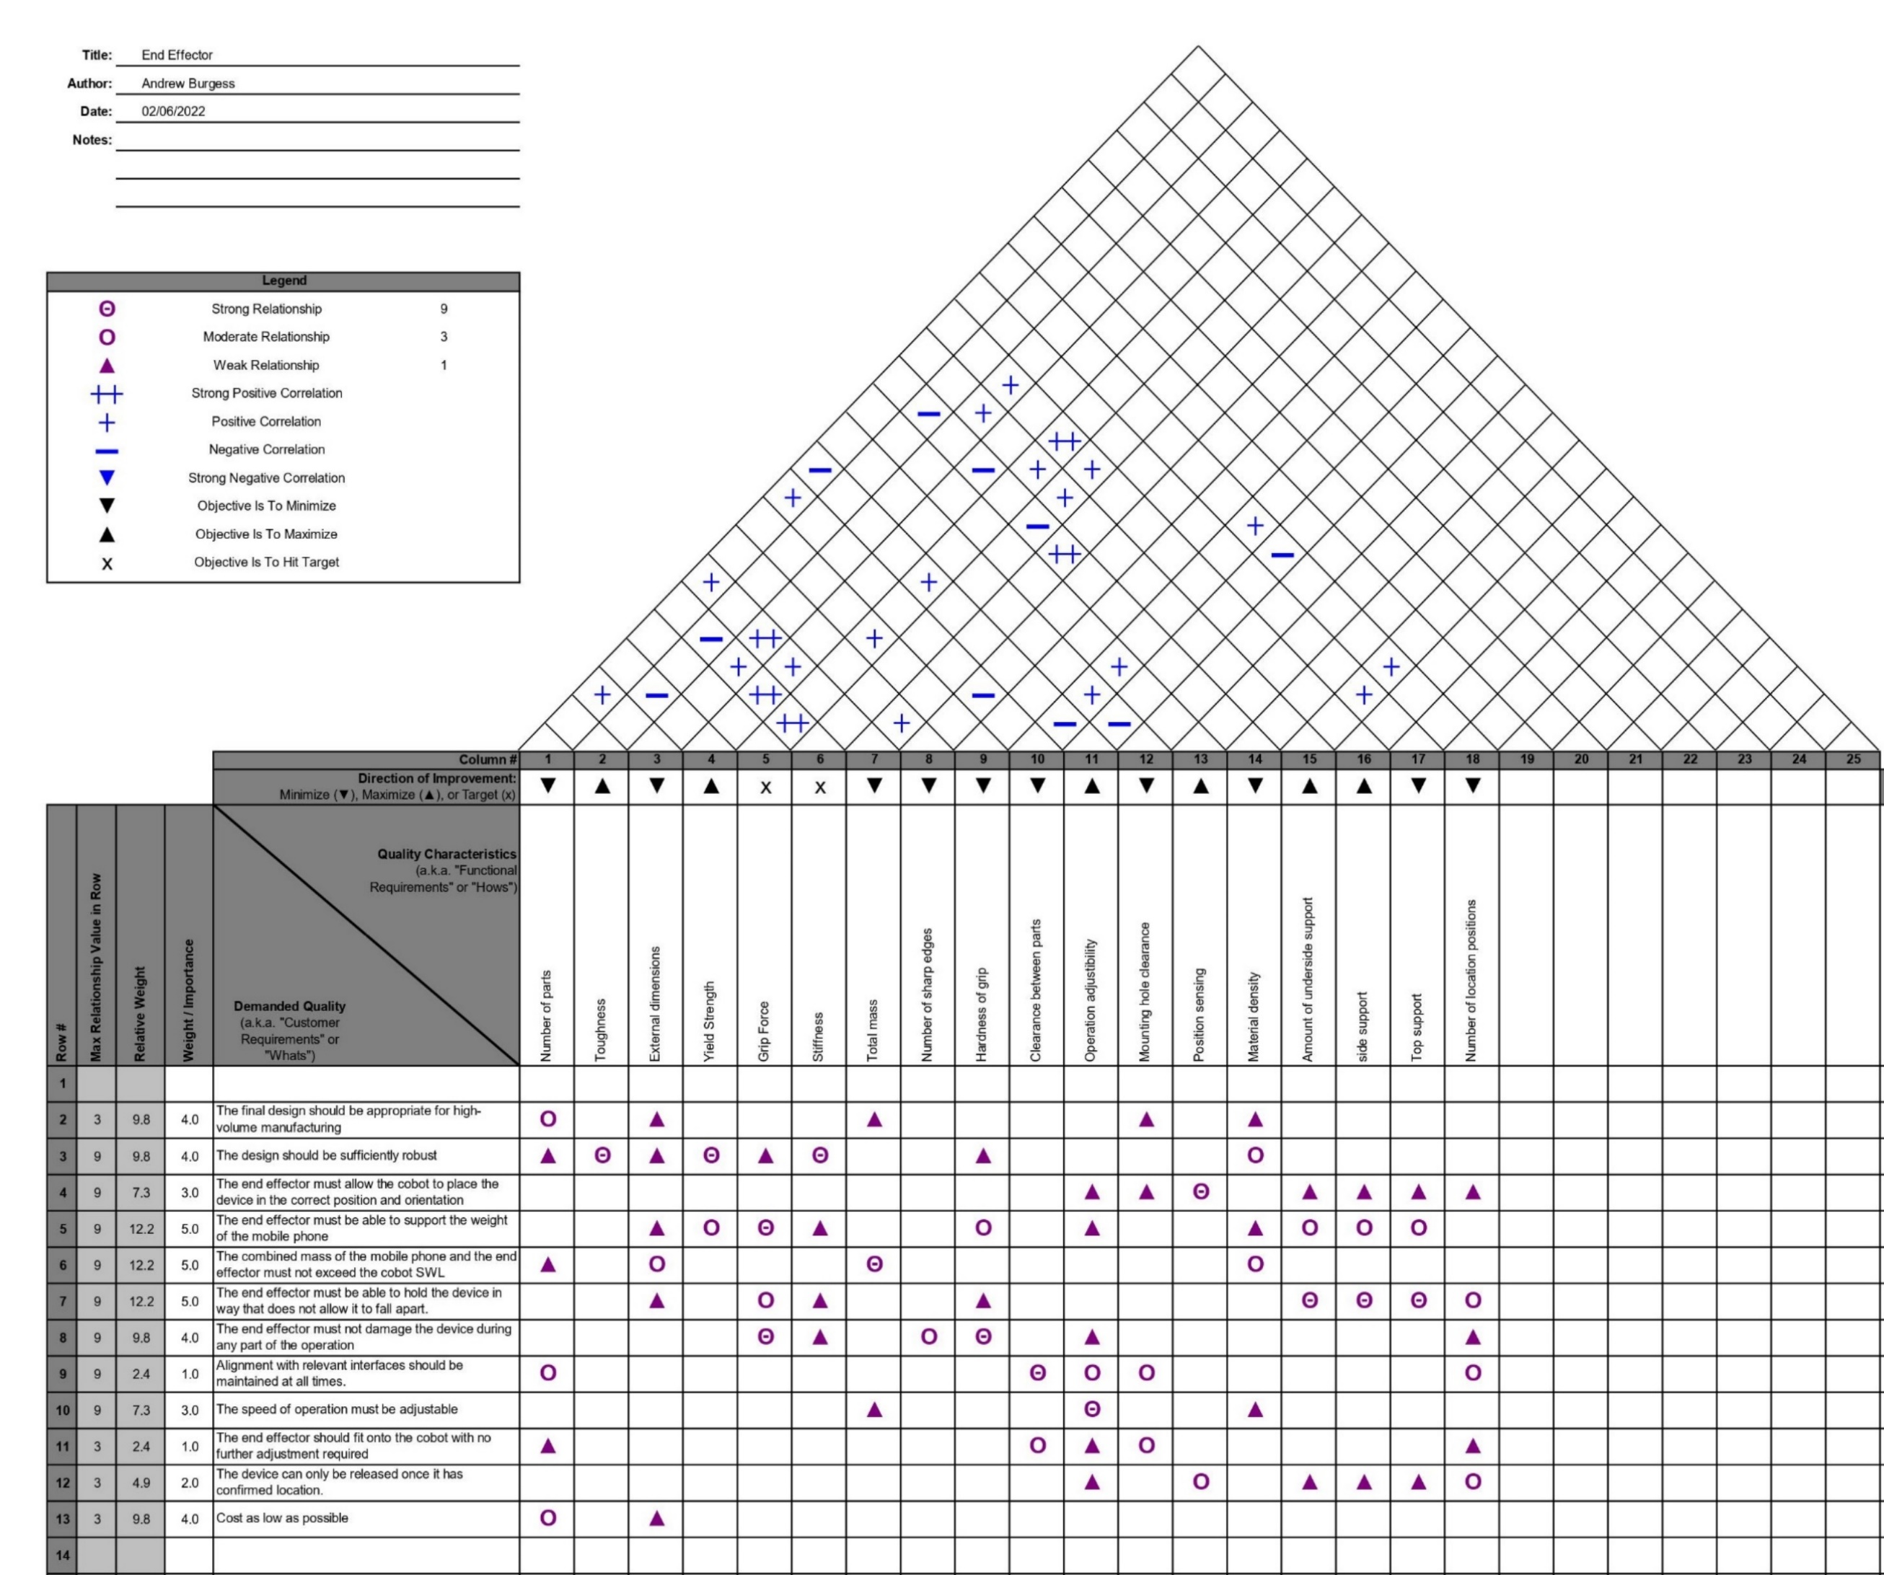

Appendix D – Universal Robots UR3 Cobot Technical Specification
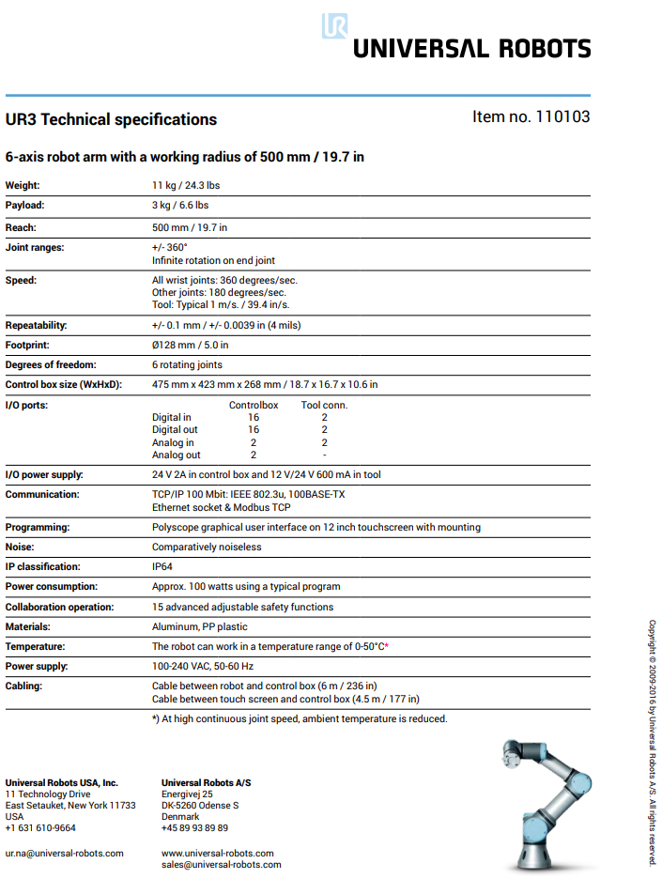

Appendix E – Functional Means Analysis

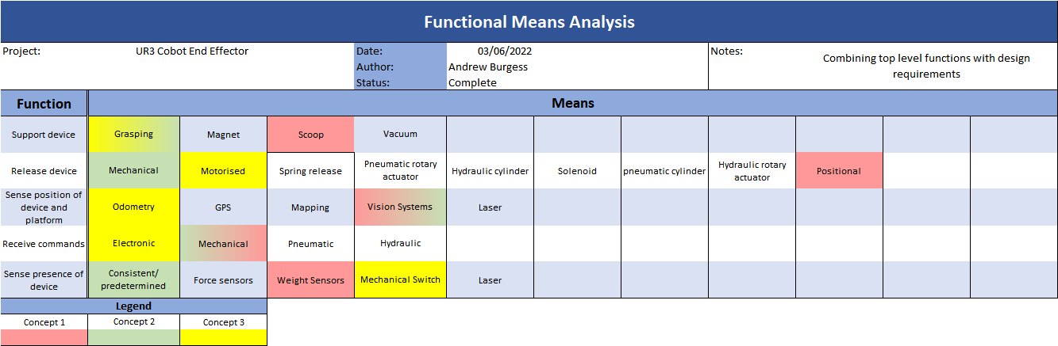

Appendix F – Concept 1: Scoop
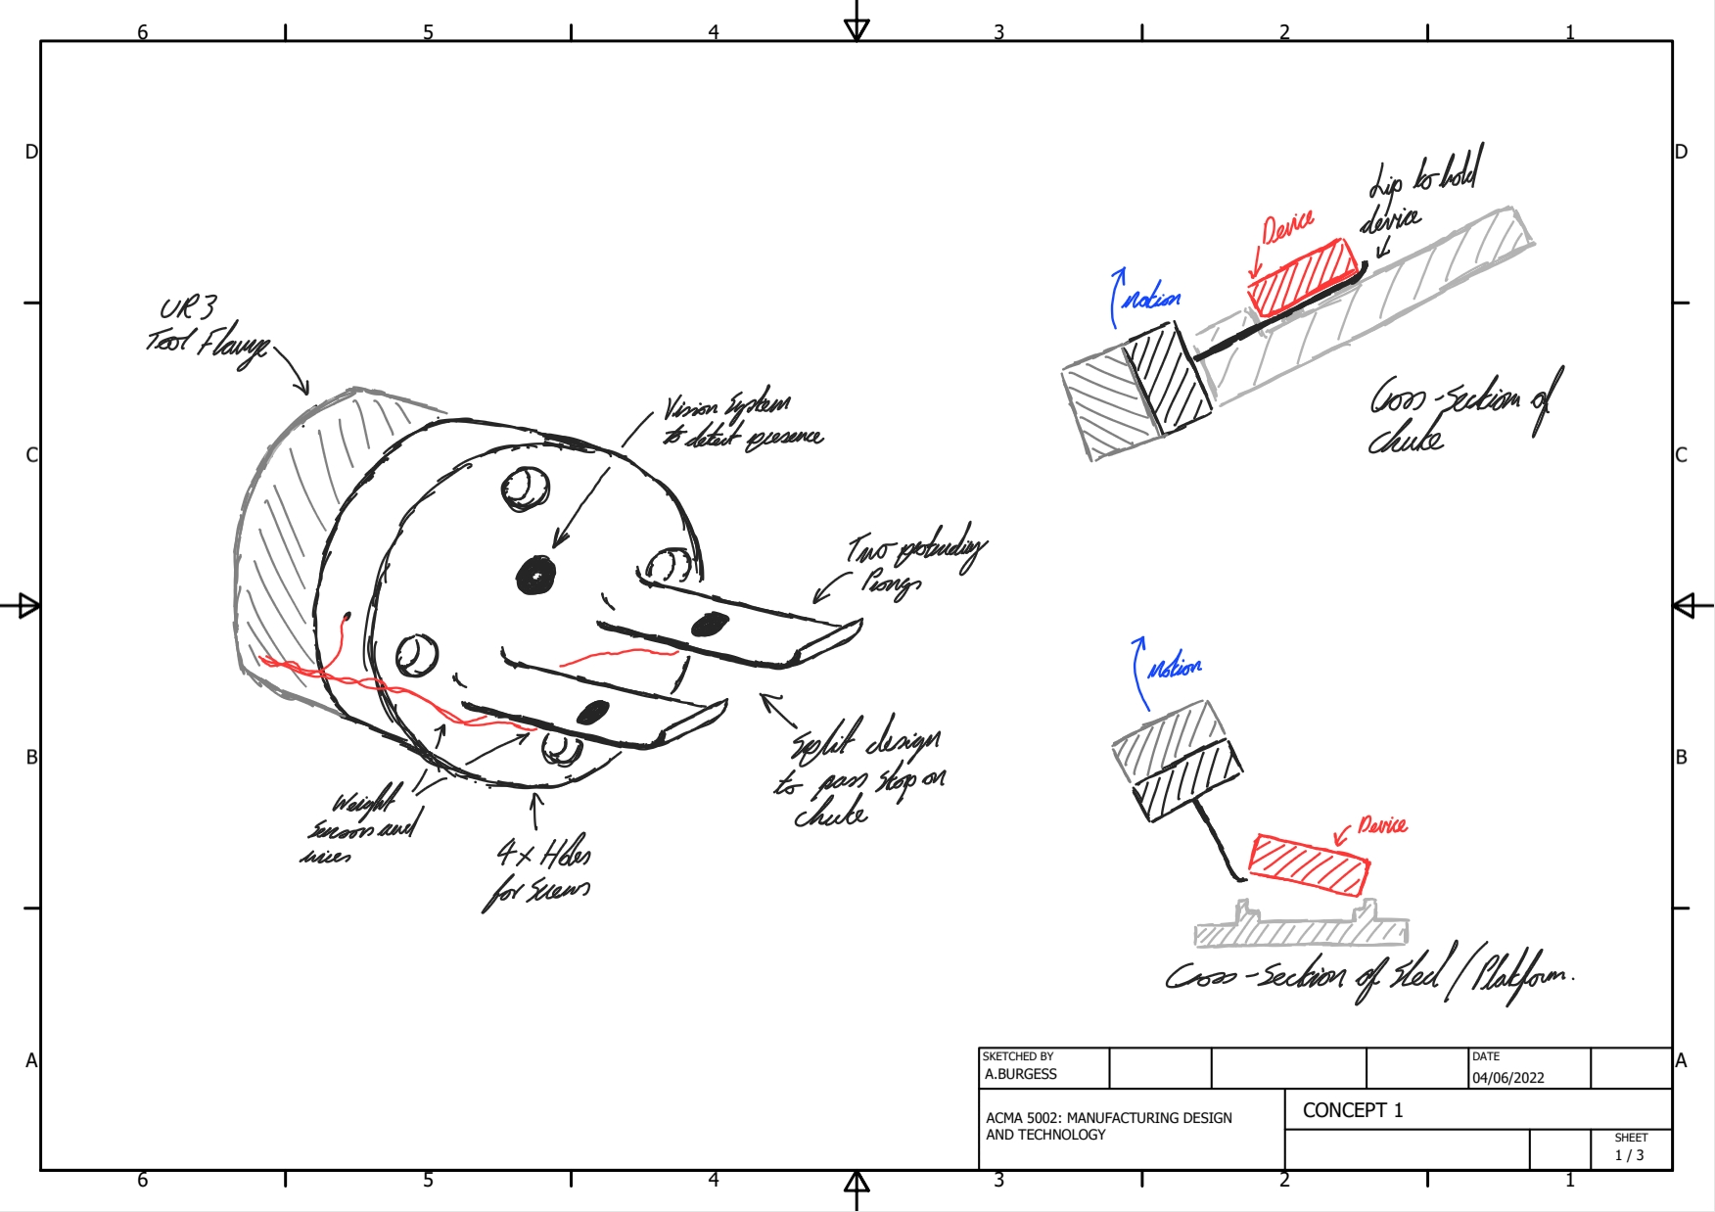

Appendix G – Concept 2: Single Piece Gripper
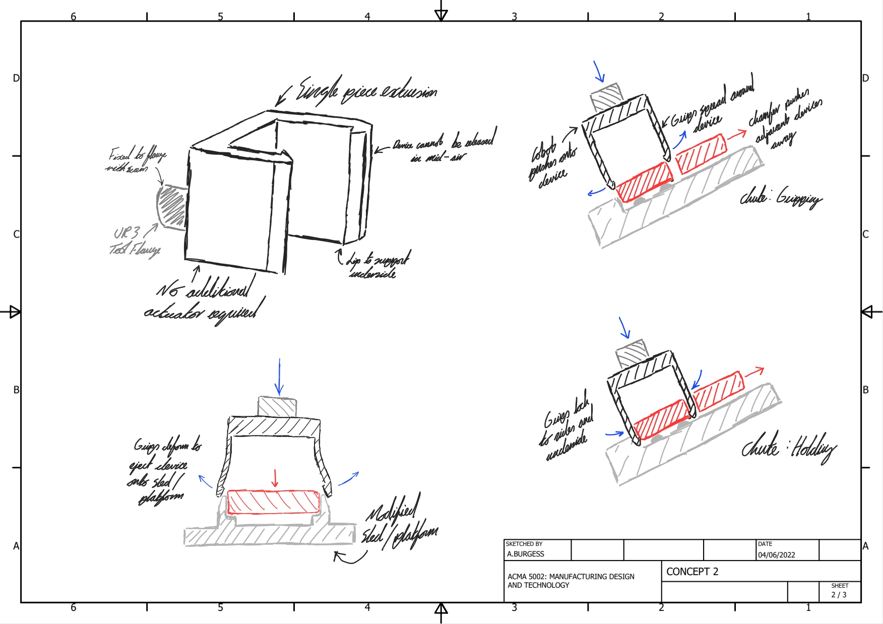

Appendix H – Concept 3: Locking Gripper
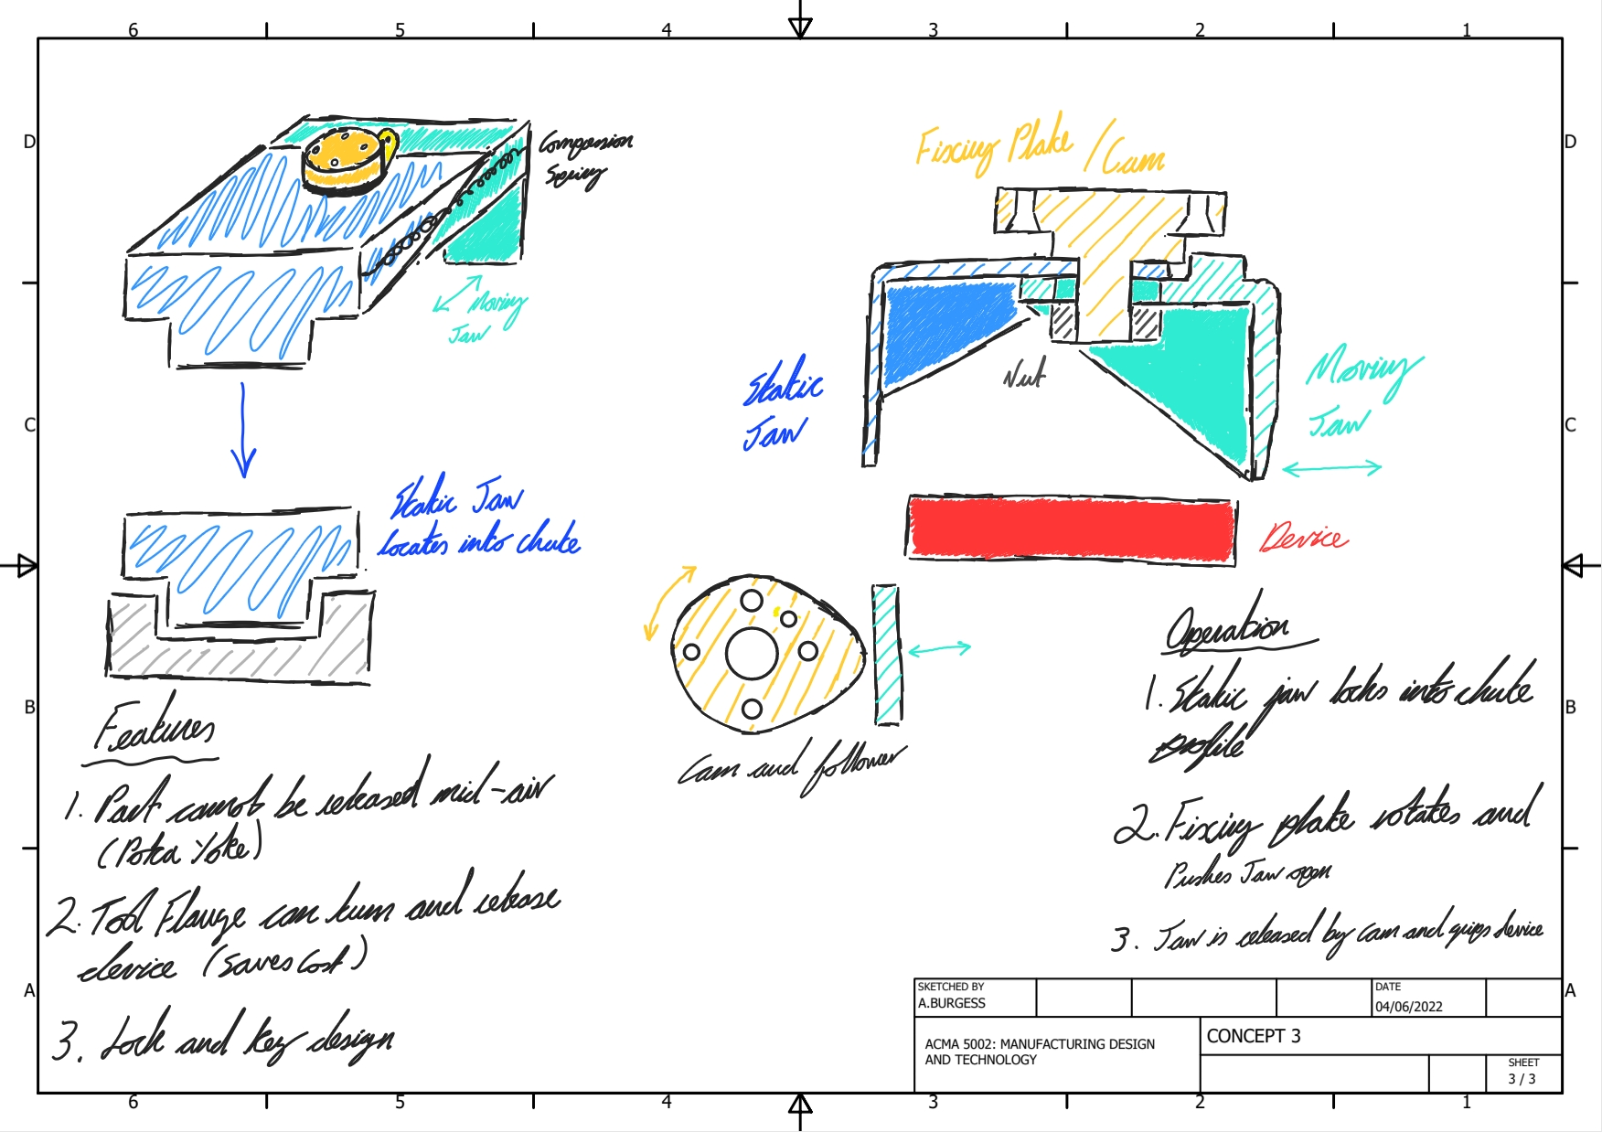

Appendix I – Design Failure Mode and Effect Analysis

DESIGN FAILURE MODE AND EFFECT ANALYSIS
Item: | Mobile phone gripping end-effector
Process Function | Potential Failure Mode | Potential Effect(s) of Failure | Sev | Potential Cause(s)/ Mechanism(s) of Failure | Occur | Detec | RPN | Recommended Action(s) | Action Results
 |  |  |  |  |  |  |  |  | Actions Taken | Sev | Occ | Det | RPN
Assembly: fitting e-clip | E-clip cannot be located | Damage to fixing plate | 8 | Assembly orientation, low clearance | 6 | 2 | 96 | Use push fittings instead | Use push fittings | 2 | 2 | 2 | 8
Assembly: fitting springs | Spring not locating | No/reduced grip, damage to device | 7 | Assembly orientation. | 8 | 4 | 224 | Guided fitment | Guided fitment | 4 | 3 | 3 | 36
Assembly: fitting switch | Switch does not fit | Switch not located; snap fittings fail | 9 | Fitting clearance, print orientation | 5 | 3 | 135 | Change orientation of snap-fit features, provide sufficient clearance, correct proportions of snap fit feature | Change orientation of snap-fit features, provide sufficient clearance, correct proportions of snap fit feature | 4 | 2 | 3 | 24
Assembly: Fixing to UR3 | Screws cannot locate | Cannot fit end-effector, damage to screw threads, damage to UR3 threads | 8 | No/restricted access to screw holes | 10 | 1 | 80 | Provide access to screws through end-effector | Provide access to screws through end-effector | 1 | 1 | 1 | 1
Operation: gripping onto device/holding device | End-effector cannot provide enough grip to device | Cannot grip or hold device | 3 | Gripper material too hard, Surface rouhgness too low | 7 | 6 | 126 | Add friction material to grip surfaces | Add friction material to grip surfaces | 3 | 1 | 6 | 18
Operation: gripping onto device | Cannot detect when jaws are closed | Fail to grip device, drops device, damage device | 5 | Lack of sensing ability/Jidoka | 4 | 6 | 120 | Add switch to detect open or closed jaw | Add switch to detect open or closed jaw | 1 | 1 | 6 | 6
Legend |  | Severity  1 (least severe) – 10(most severe) |  |  | Occurrence  1(remote) – 10(frequent) |  |  |  | Detectability  1(highly detectable) – 10(undetectable)

Appendix J – Stress Analysis: Fixed Jaw

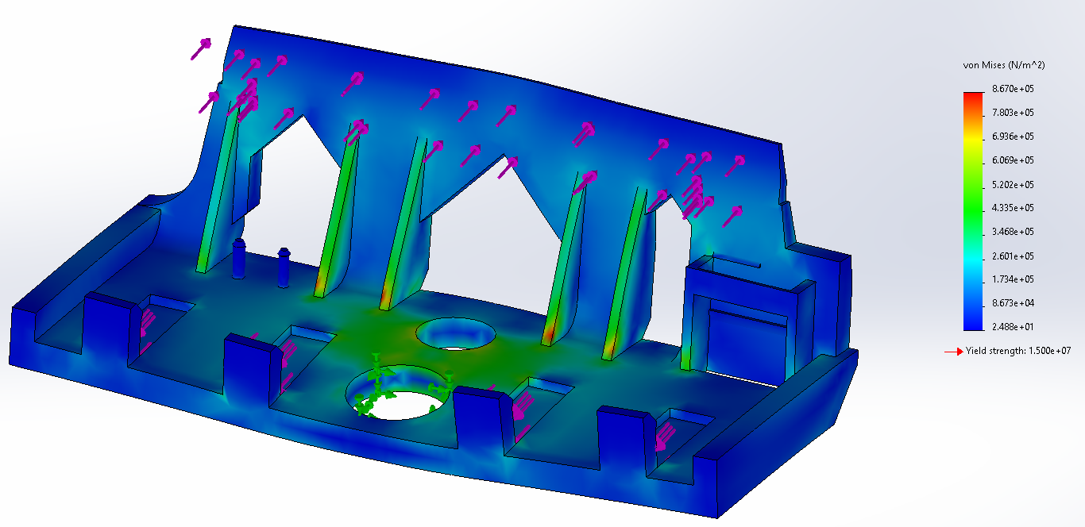
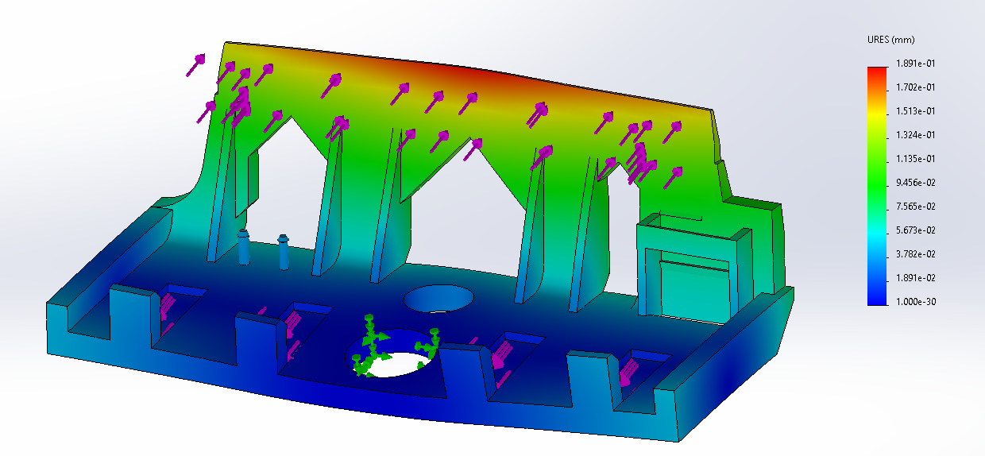
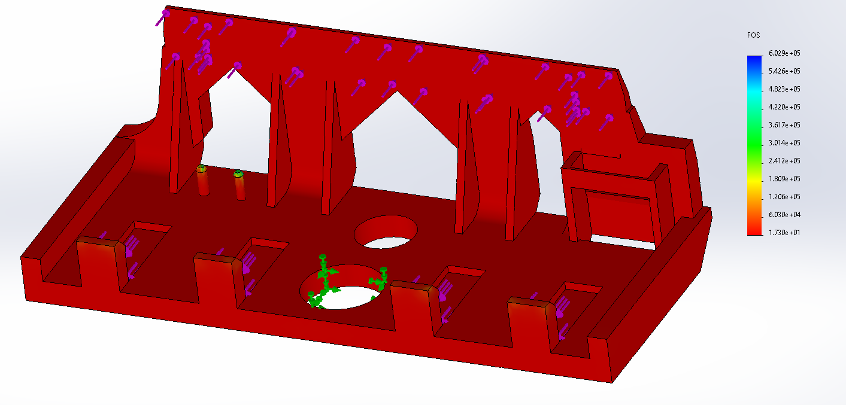

Appendix K – Stress Analysis: Moving Jaw

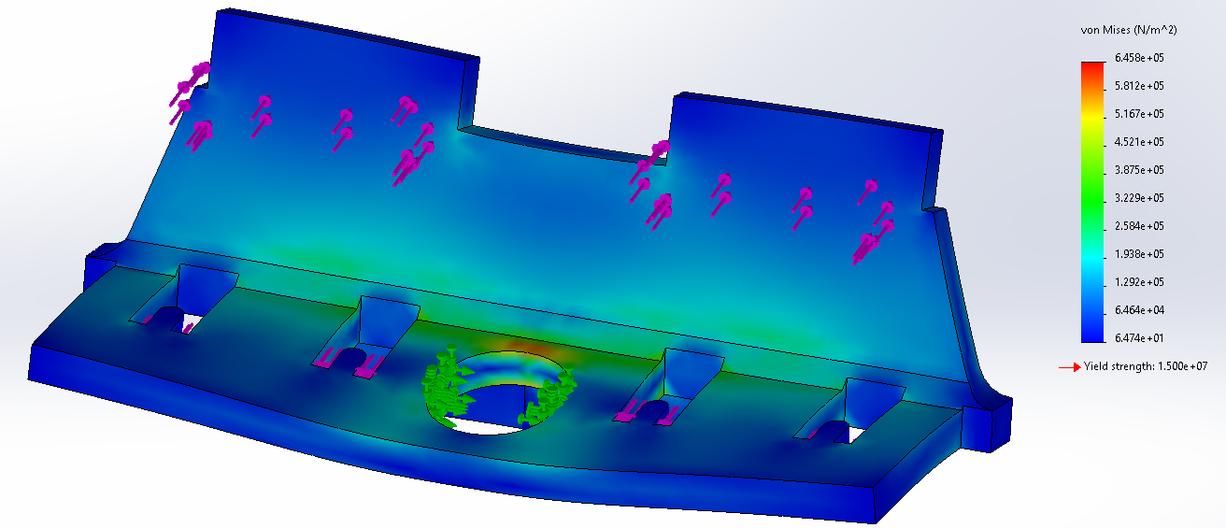
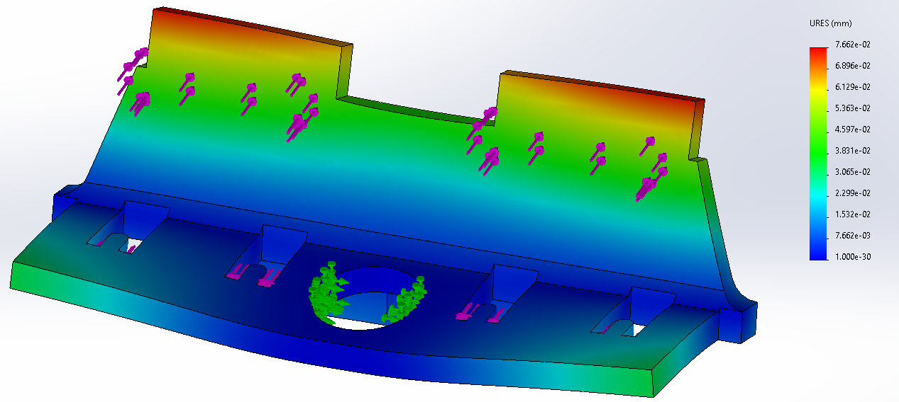
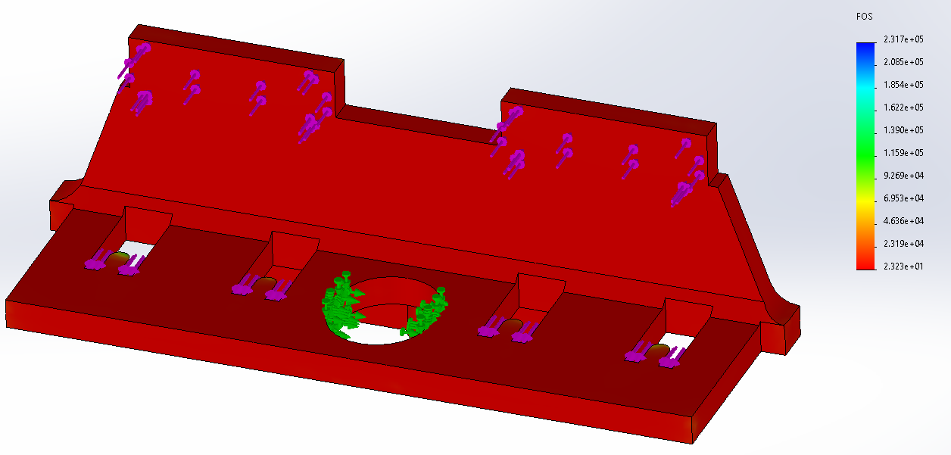

Appendix L – Final Design
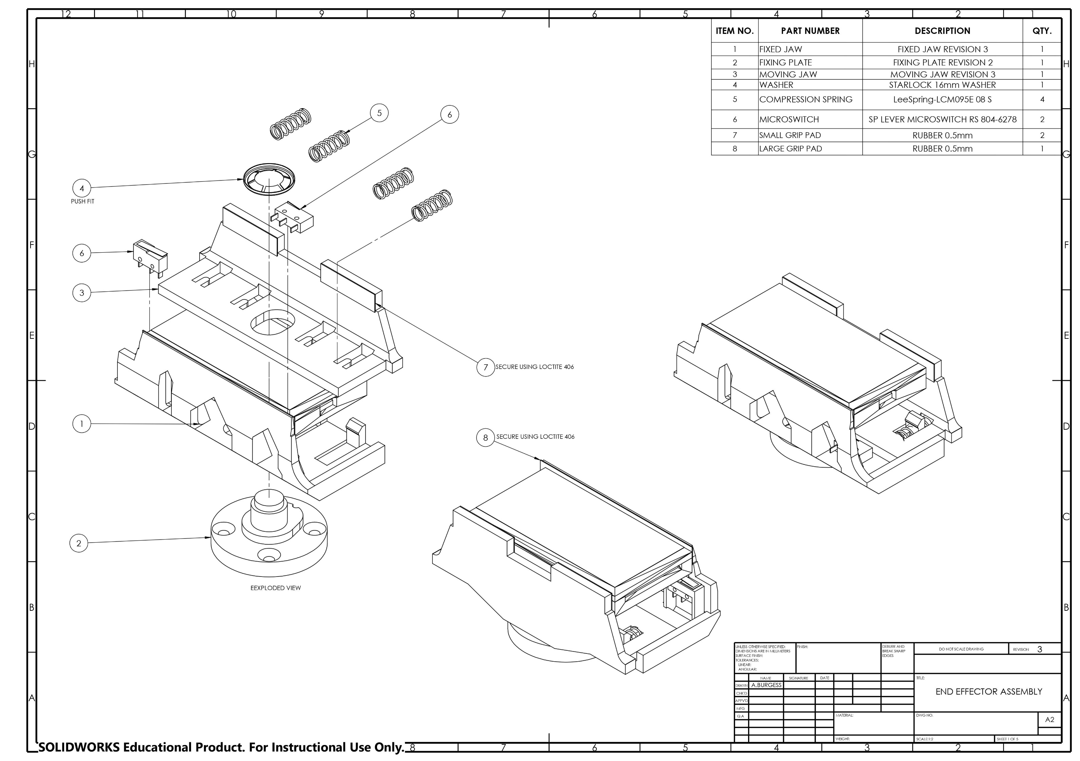
215.68g


