The Case Study.

Student Name: Karen Elizabeth Ruddock
Student ID: 2015942
Module Code: BMSW 4003_BIRM
Lecturer’s Name: Rebecca Kavanagh

Contents Page

Introduction 2

Social Identity Theory 3

Attribution Theory 5

Frustration Aggression Hypothesis 6

Emery-Driefuss Muscular Dystrophy 7

CONCLUSION AND RECOMMENDATION 8

REFERENCES 9

Introduction

This report is solely based on the case study provided. In this report there will be a discussion on 3 key theory’s which are, Social Identity Theory, Attribution Theory and Frustration Aggression Hypothesis. There will also be a brief diagnosis of Emery-Dreyfuss Muscular Dystrophy and what can be caused by living with this. In this report there will also be a discussion about Covid 19 and the impact of the pandemic of what it has caused. This has caused a lot of hostility about Social Distancing in small rooms and face masks being worn. There will also be a graph of statistical rates of suicide in this age range to try and help gain acknowledgement and why it’s important to seek professional help. The focus of this report will keep relating back to the key factors to the case study to make any points strong. In this report the recommendation to whether the staff member should be employed or sacked will be included.

Social Identity Theory

Stets and Burke (2000) stated, with social psychology it needs to be a theory of self. This can both be macro or micro in processes. It can avoid separate theories of different aspects of self. This purpose core components of the identity theory and the social identity, which differences exists between the two. These are more different bases of identity’s which emphasis than kind. So, the core components examine the different bases of the identity such as (category/ or groups even roles), of the theories. We have faith in three areas’ to central linking the two theories, which are roles of identity and categories groups. The concept of the identity the self-reflex that can take as an object and classification of this social identify theory. We need to establish the general theory’s and avoid the redundances and separate different aspects. Social and theory identity think this intersection cause both theories to be linked within an ultimate way (Burke & Jan, 2000).

According to Hogg (2020) stated that the social identity theory is the psychological assessment role of understanding in group memberships and group process also intergroup relationships this can help you focus of group life. With social identity theory in terms of people, this can collectively distinguish them collectively from people. It addresses being prejudice, also discrimination to others, and stereotyping even conflict with other people. This social identity was developed in the 1978 in England by Henri Tajfel from his scientific as well as his personal interests. In the past forty-five years this has attracted many followers. In 1979 John Turner was also introduced to SIT alongside Henri Tajfel (Hogg, 2020).

McCall (2020) stated that the Core themes of symbolic interaction is a fundamentally theory which develops moral thinker's reaction against fundamental views of human’s which they felt wrongly doubtful overly distinctive, for the word insane. Thomas Hobbs wrote humans nature and lives, nasty, solitary, and short even through it was ground-breaking (McCall, 2020).

This above shows this relates to the case study of the 15-year-old boy who acts different with less patients towards the lady as being young he’s finding it difficult to control himself and lashes out towards the lady who’s a lot older being 58 years old showing her verbal aggression. This characteristics floor from the 15 years old boy shows the conflicting side part the intergroup selection.

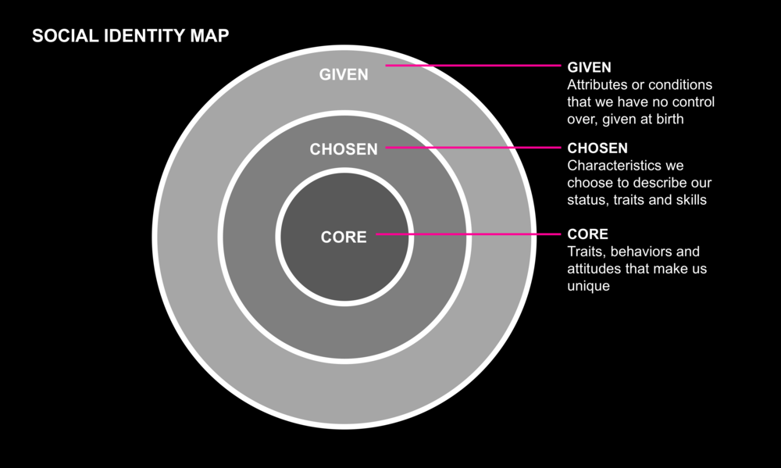
Figure 1. Picture of Social Identity Map

( YStudios, 2020).

Attribution theory

According to Weiner (2010) stated that the Attribution theory is a combination of beliefs, hypotheses, and data. theory’s related to extraordinary causality which fall under the attribution theory. This refers to several fields of injury’s rather it being exact logical outset. This will present you aspects of the attribution thinking which are relevance for our education. This will identify cause of either success or failure with achievement’s which are related in context. Having confidence in your self and to think positive will help people who want to be successful and perform best at what they are good at doing. But over the years there has been a study and research that has suggested there as been doubts on assessment. Motivation beliefs do play a little different as specific self-critical this gives strong evidence, meaning if you failed the first time your much harder to pass on the second time trying. So, it’s important to keep trying till you get it right being motivated will give you strength and self-improvement. It’s most important to remember that these spectacular differences need to highlight as even though separating motivational strategies have been embraced, both groups endeavour at the same goal line and desires and of their needs. Example is a person wanted to learn a new career chapter in their life and needed to learn threw university they would pick the best one who would learn them best to have a better learning skill (Weiner, 2010).

Sabini, Siepmann and Stein (2009) said this will also encourage you to make the right choice. With errors within the fundamental attribution errors decides weather its true of their behaviour if its external which is used in their behaviours. Behaviour is observed and is used by attributions studies. Meaning of this is when people behave internally or externally and their errors of what they decide to decision make (Sabini. Siepmann & Stein , 2009). So, with this case study this is showing you behaviour of how both the service users reaction toward the staff member and how he was towards the staff member by being abrupt, rude, and aggression whereas the staff towards the service user was firm but straight to the point and following the guidelines of the policy and procedures within the company. The staff member was trying to keep it her cool but firm to avoid more conflict.

Frustration, Aggression Hypothesis

Cohen (1955) stated that a few of the provisions of what frustrations can widely produce the wave of aggression. He also stated that it is dependant on the individual on how to react to such forms of aggression and the actions cannot be sympathetic or justified. He also stated that the frustration can lead by uninformed positions that follow the hostility followed (Cohen A.R, 1955).
Lewis and Bucher (1992) stated that the issues stem from purification towards the anger. The firmly believed that if there was a frustration aggression issue then therapeutically can be avoided. They also stated this can help look at the health, whether this interacts with the impact of the aggression (Lewis and Bucher, 1992).

Breuer and Elson (2017) stated that the Frustration-Aggression Hypothesis was initially articulated around 1930’s. This is known as the emotion event in an individuals mind where they have predisposition of the aggressive behaviour traits as well as the reaction part of the aggression. They stated that the research to find the unknown ways of trying to help stop this is very hard and long process. The investigation that was showed was to try and identify the path that leads from dissatisfaction to violent behaviour (Elson and Breuer , 2017)
Due to the 15-year-old boy who has a diagnosis of Emery-Dreifuss Muscular
Dystrophy, it had a huge impact on his life of not being able to go to the Aston villa training academy which affected his daily life. This could help his joint’s and stop causing him to stiffen up daily.


Figure 2. Picture of Covid-19 affected cells.

(CDC, 2013)

Emery-Dreifuss Muscular Dystrophy

Heller Et Al., (2019) stated that Emery-Dreifuss Muscular Dystrophy known as EDMD is a rare life-threatening cardiac difficulty. They stated that this gets passed through the genes from the parents. This is where they show symptoms of vulnerability in the muscles, cardiac irregularities, and weakness in the early stages. Traditional diagnosis does help to direct and evaluate it towards the EDMD, this can support clarification of misleading genetic testing results. Although it’s important that you monitor the patient’s very closely even more so in case of protentional cardiac difficulties. They stated that this causes a lot of pain in the cervical spine and causes walking problems. The commonest symptom is early motor symptoms which is walking or running (Heller Et Al., 2019).
As EDMD ties in with the case study as it states that the 15-year-old boy had to leave Aston Villa Football Academy as it shows that he had the early motor symptom and for the pain to stop he must walk around.

Conclusion and Recommendation

My opinion with this case study I would not dismiss the Receptionist for raising her tone of voice towards the 15-year-old boy, but I would give her verbal warning. The reason behind for raising her voice could be trying make the 15-year-old boy understand as he was not following the covid guidelines set out by the government which should be adhered by the setting he was in. She was unaware about his illness as this would be a breach of data protection. My opinion would be that the receptionist is new so this should be taken out into consideration and the decision should be upheld. The 15-year-old boy should also get a verbal warning even though he is a patient, but he should respect the rules and regulations of the counselling session.

References

Cohen, A. R., (1955) Special Norms, Arbitrariness of Frustration, and the Status of the Agent of Frustration in the Frustration-Aggression Hypothesis [Online] Available at: https://psycnet.apa.org/record/1956-04182-001 (Accessed on: 3rd December 2021)

Weiner, B., (2010) Social and Emotional Aspects of Learning [Book] Available at: https://books.google.co.uk/books?hl=en&lr=&id=y_S1pFc7LNIC&oi=fnd&pg=PA9&dq=attribution+theory+in+social+psychology&ots=3jfMGAipUj&sig=2ug-3GVg6bKWO_3FYN56Nn-CQEo#v=onepage&q&f=false (Accessed on: 15th November 2021).

CDC (2013) Remembering SARS – 10 Years Later [Online] Available at: https://www.cdc.gov/about/history/sars/ (Accessed On: 19th November 2021).

McCall, G. J., (2020) Chapter 1 Symbolic Interaction Framework [Book] Available at:
https://www.degruyter.com/document/doi/10.1515/9781503605626-003/html (Accessed on: 9th November 2021)

Stets, J. E., and Burke, P. J., (2000) Identity Theory and Social Identity Theory [Online] Available at:
https://www.jstor.org/stable/2695870?casa_token=E2iMnWLmTMAAAAAA%3ANbk5Iikfvk2MHRVTHJIzAJw_NxZSEKKmgcxBD4nz6zIcYwZ30lAxPRcSq7Zf3ue02N5yi7GsU4pic0HaCZNfPxJkv_L6e48TL6C5-JtsWwZ33gS-CsQ&seq=1#metadata_info_tab_contents (Accessed on: 9th November 2021).

Breuer, J., and Elson, M. (2017) Frustration-Aggression Theory [Online] Available at: https://www.ssoar.info/ssoar/handle/document/61070#
(Accessed on: 3rd December 2021)

Sabini, J., Siepmann, M., and Stein, J. (2009) The Really Fundamental Attribution Error in Social Psychological Research [Online] Available at:
https://www.tandfonline.com/doi/abs/10.1207/S15327965PLI1201_01 (Accessed on: 15th November 2021).

Lewis, A. W., and Bucher, A. M., (1992) Anger, Catharsis, the Reformulated Frustration-Aggression Hypothesis and Health Consequences Available at: https://psycnet.apa.org/record/1993-18542-001 (Accessed on: 3rd December 2021)

Hogg, M. A., (2020) Chapter 5 Social Identity Theory [Book] Available at:
https://www.degruyter.com/document/doi/10.1515/9781503605626-007/html (Accessed on: 9th November 2021).

Heller, S. A., Shih, R., Kalra, R., and King, P. B., (2019) Emery-Dreifuss Muscular Dystrophy [Online] Available at:
https://onlinelibrary.wiley.com/doi/full/10.1002/mus.26782 (Accessed on: 3rd December 2021)

YStudios (2020) What Factors Really Influence Identity? [ Online] Available at: https://ystudios.com/insights-people/influence-on-identity (Accessed on: 9th November 2021).

