Cycle 1 – The Learner – who am I teaching?
ECAD4007-C
Lauren Bourne – 1C

Contents
Using the pupil profile given, identify how specific aspects of the child’s holistic development could be met within an educational setting. Underpin this with references to relevant theories, research and examples of excellent practice. 2
Appendix 6
References 8

Target 1 | Address the minor errors in referencing and proof read my work carefully.
Target 2 | Interrogate the literature more carefully and offer an evaluative conclusion to sentences - do I agree or disagree?

Using the pupil profile given, identify how specific aspects of the child’s holistic development could be met within an educational setting. Underpin this with references to relevant theories, research and examples of excellent practice.

A professional teacher should have a good understanding of child development so that they are able to aid the child where possible. The Foundation Phase Framework states that: “Educational provision for young children should be holistic with the child at the heart of any planned curriculum.” (Welsh Government, p6, 2015) A holistic approach ensures that teachers are looking at the whole of a child’s development and that all areas of development are catered for in the school setting. A teacher should be able to identify where a pupil requires help in an area of development, and then put provision in place to aid the progression of the child; they have a legal responsibility to ensure children’s rights are adhered to while they are in their care at school, including Articles 3 and 29: the right for the child’s best interests to be a top priority and the right to an education that helps them reach their fullest potential. (UN Convention on the Rights of the Child, 1989). Using Ella’s pupil profile (Cox, 2019), I intend to identify areas of her development which could be improved within an educational setting to aid her in reaching her full potential.
In Ella’s profile (Cox, 2019), we are not given much information about her home life other than that she has ‘supportive parents’. This can make it difficult for us to investigate her development as we may be missing key factors, e.g. if she comes from a cultural background, how many siblings she has, or who lives at home with her? All of these factors affect Ella’s development and need to be considered in line with the Foundation Phase Framework which states: “The experiences that children have had before entering the setting/school need to be recognised,” (Welsh Government, p6, 2015). Bronfenbrenner’s ecological systems theory supports this, as he believed that “in order to fully explore child development, we need also to take into account the wider environmental influences upon the child.” (p98-99, 2012). We have limited information about Ella’s ‘microsystem’, see appendix (i); we are given information about her in the school setting, but we are yet to find out about the rest of Ella’s immediate environments such as her family, home and neighbourhood. Due to this lack of information, we are unable to pinpoint factors that may contribute to or hinder Ella’s development including any Additional Learning Needs that may also be having an effect.
A child is considered to have an Additional Learning Need if they have a learning difficulty or disability that requires the use of Additional Learning Provision (ALP); ALP is provision which is additional to or different from the general provision given to mainstream pupils. (Welsh Government, 2019). The Foundation Phase Framework suggests that “barriers to experiential play, to learning and participation caused by physical, sensory, communication or learning difficulties,” (Welsh Government, p6, 2015) need to be accounted for when promoting child development. It is not the role of the teacher to diagnose Ella, however if there were concerns regarding Ella’s learning or development, these should be passed on to the Additional Learning Needs Co-ordinator (ALNCo) so that this can be monitored and appropriate action taken with parental consent. This could range from the creation and use of an Individual Development Plan, to referring to the Local Authority in the case of the ALNCo not being able to evaluate the extent or nature of the Additional Learning Need as expressed in the ‘Implementing the Additional Learning Needs and Education Tribunal Act’ (Welsh Government, p5, 2018).
Despite not having the full picture, we are still able to identify where Ella is at in terms of development and recognise where we can help her in the educational setting. For the purpose of this assignment I will be investigating three areas of Ella’s development: emotional, cognitive and social.
Firstly, Ella’s emotional development is difficult to interpret; as her communication and social skills are limited, she is unable to express her feelings verbally. Due to this, we need to identify Ella’s emotions from her actions and put provision in place so she has opportunities to express how she is feeling. One example of practice I observed on bridging was the use of ‘mood boards’ in each class. The children have a picture of themselves, which they would stick to the corresponding emoticon on the board to indicate their feelings to the teacher. As Ella is usually reluctant to communicate, this would be a non-verbal way for her to express her emotions.
We know from the profile (Cox, 2019) that Ella can be reluctant to separate from her mother. I would suggest that Ella would fit into the ‘secure’ category of Mary Ainsworth’s Attachment Classification System as she shows distress on separation from her caregiver, but is also a happy member of the class meaning she then settles. (Beckett and Taylor, p53, 2010). Comparing this assessment to Erikson’s Stages of Psychosocial Development (McLeod, 2018), I would say that Ella has formed trust from consistency of care from her parents, which has then passed onto her relationships in the class. Looking at another stage of Erikson’s theory, ‘Initiative vs Guilt’ (McLeod, 2018), Ella is at a stage where she must begin to form initiative and feel secure in making decisions. Play is an integral part of this stage as it gives children the opportunity to initiate activities and form interpersonal skills. (McLeod, 2018). Ella mostly engages in solitary play and does not appear aware of her peers during this time; we also know that she only imitates her peers briefly which could be a result of Ella developing a sense of guilt. Erikson believed that if a child’s tendency to form initiative is quashed by caregivers that consider the behaviour unruly or a nuisance, that children develop a sense of guilt that can hinder their psychosocial development. (McLeod, 2018). If this is the case with Ella, in the school setting we must provide opportunities for Ella to engage and play with her peers, whether that be through group activities, social clubs at play times, or if Ella continued to appear subdued and withdrawn, perhaps a referral to an Emotional Learning Support Assistant (ELSA) with parental consent. An ELSA is a member of staff that has been specifically trained to support pupils with signs of emotional underdevelopment through a series of sessions; I saw evidence of this in both schools that I attended for bridging.
Moving on to look at Ella’s cognitive development, she appears to be behind when compared to the Foundation Phase Framework’s Literacy and Numeracy tables. (Welsh Government, 2015). Ella is unable to point to and count 10 objects accurately, and does not appear interested in sorting, matching or counting songs and rhymes. The table states that at Reception level, pupils should be able to “count reliably up to 10 objects”, and “recite a range of number rhymes and songs.” (Welsh Government, p30, 2015). Montessori believed that children should only be introduced to reading, writing and counting when they show an interest and that children experience “periods of special sensitivity during which they are eager to learn.” (Pound, p30, 2005). Perhaps Ella has not reached this ‘period of sensitivity’ yet in regards to her mathematical development.
Montessori believed that the child is in control of their own learning, and that they should be given the freedom to explore and add to their personal experiences. (Pound, 2005). Based on this idea, I believe Ella needs to be given more control over her own learning. In some school settings, particularly in the Foundation Phase (Welsh Government, 2015), they offer enhanced provision created by a mixture of the teacher and pupils from which the children can choose their own activity. Ella may benefit from being able to make a choice about what she would like to do and her goals being shared with her.
“Sharing challenging goals/learning intentions with students is a major condition of successful learning, but on top of this it helps considerably if students share a commitment and sense of engagement to these goals.” (Hattie, p31, 2009)
Hattie’s ‘Visible Learning’ (2009) concept is used in schools by making children aware of where they are in their learning and their ‘next steps’.
In one of the school’s I visited, ‘Visible Learning’ (Hattie, 2009) and Dweck’s ‘Growth Mindset,’ (2017) were embedded throughout the school. See appendix (ii). The children received positive feedback, and constructive targets, from Nursery through to Key Stage 2, encouraging children to reach their ‘next step’ without disheartening the child and providing consistency in assessment for learning throughout their school-lives. Physical symbols of ‘next steps’ used in the school were differing ‘Lego’ blocks given to the children when they had achieved their challenges and they were then able to physically show the rest of the class what they had achieved during the plenary. For young children like Ella, a physical reward for reaching a goal promotes a positive outlook on learning; this can be supported by Skinner’s work on positive reinforcement. Skinner believed in operant conditioning, in which “an association is made between a behaviour and its consequences.” (Gray and MacBlain, p36, 2012). This would result in the behaviour associated with praise and rewards being strengthened, and negative reinforcers, such as missing play time, discouraging certain behaviours. A mixture of positive reinforcement from behaviourism and learning through self-experience and choice from constructivism, I believe will promote Ella’s cognitive development using the practices explained above.
Piaget described the growing child as a ‘lone scientist’, giving a constructivist image of “a child alone, exploring the immediate environment, and drawing conclusions about the nature and structure of the world.” (Pritchard, p30, 2005). This idea is mirrored above by Montessori’s beliefs and I agree that it will aid Ella’s cognitive development.
I believe that a social constructivist approach would also be beneficial for both Ella’s cognitive and social development. Ella’s social development seems to be varied from the pieces of information we are given (Cox, 2019):
- Ella engages in solitary play, not appearing aware of others;
- she is reluctant to share resources with others;
- she is unable to resolve conflict without the help of an adult;
- Ella can talk, usually with one word responses – although not always clearly;
- she occasionally uses sentences with up to five words;
- rarely initiates conversation, but will respond;
- and is able to hear as well as having good listening skills.
Looking back to the Foundation Phase Framework’s tables (Welsh Government, 2015), we can see that Ella will need support to develop her social skills and her cognitive development in regards to language. The tables state that at a Reception level, children should be able to interact with others during activities, “talk about things from their experience,” use simple sentences, and “ask questions about something that has been said.” (Welsh Government, p14-17, 2005). As Ella seems reluctant to communicate and engage with adults and her peers, this may have an effect on her social and cognitive development. Vygotsky was a social constructivist who believed that dialogue was integral to developing, sharing and understanding ideas. (Pritchard, p30, 2005). Usually the dialogue would be with a more knowledgeable other, which could be an adult or a peer. In Ella’s case I would recommend more opportunities for her to engage in dialogue with an adult or her peers to promote her social skills. Examples of practice that could be used are:
- through a ‘talk partner’ activity overlooked by an adult so that she can discuss ideas with a peer;
- a daily ‘check in’ or ‘circle time’ activity in which she has the opportunity to share feelings and personal news to an adult or a small group;
- or if a serious barrier to communication arose, perhaps a referral to a nurture intervention group.
On my bridging days, whilst in a Nursery class, I saw a SALLEY (Structured Activities for Language and Literacy in the Early Years) activity being carried out, which I believe could benefit Ella due to the simplicity of the instructions given. SALLEY activities promote language skills, taking turns and listening carefully to peers and for instructions, all skills that I believe Ella would benefit from.
Looking at each section of Ella’s development and identifying where she is at is only the first step in aiding Ella to reach her full potential. After this provision is put in place, Ella’s development should continue to be monitored and reviewed so that if further action or intervention needs to take place this can be implemented. Ella’s development should continue to be looked at with a holistic approach, in that these provisions will benefit more than one area of her development. For example, adopting Dweck’s ‘Growth Mindset’ (2017) and Hattie’s ‘Visible Learning’ (2009) across the school setting could not only promote Ella’s cognitive learning, but also have a positive effect on her self-esteem and emotional development, as well as her social development if having to assess a peers work etc. It is also important to remember that although we have milestones, stages and frameworks as a guide, each child will acquire skills and attributes at different times to others and that they “must be allowed to develop at their own unique, individual pace.” (Welsh Government, p4, 2015)
Appendix

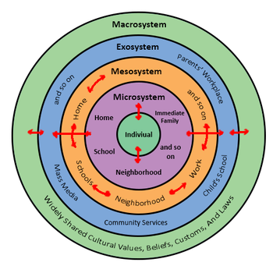
- Bronfenbrenner’s Ecological Systems Theory. Available at: https://psychology.wikia.org/wiki/Bioecological_model (Accessed: 10/12/19)

- Growth Mindset Display, taken at a Pembrokeshire Primary School on the Cognitive Development Bridging Day 18/11/19.

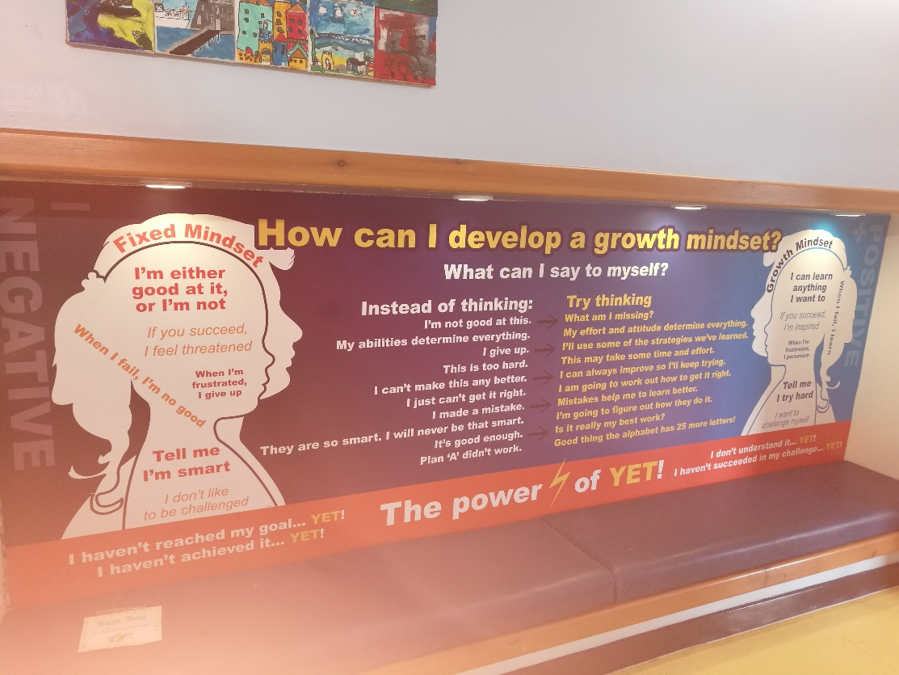

- Table 3.1 - Piaget’s stages of development. Photo taken of Alan Pritchard’s ‘Ways of Learning’ (p23, 2005).
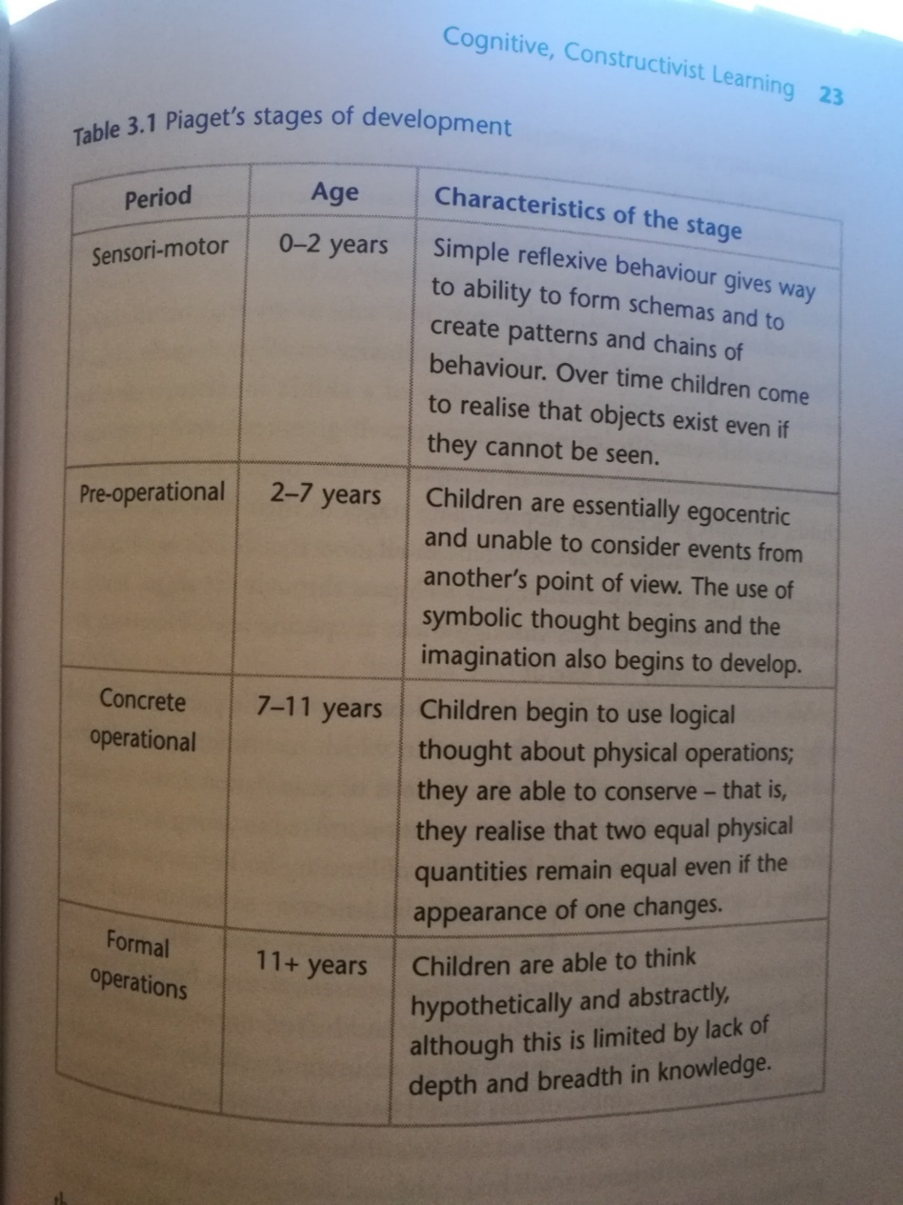

References

Beckett, C. and Taylor, H. (2010) Human Growth and Development 2nd Ed. London: SAGE Publications Ltd.

Cox, T. (2019) Ella’s Pupil Profile Available at : https://moodle.uwtsd.ac.uk/course/view.php?id=7360 (Accessed: 7th November 2019)

Dweck, C. (2017) The Power of Believing You Can Improve. Available at: https://www.bing.com/videos/search?q=dweck+growth+mindset+ted+talk&view=detail&mid=1035C4B9F6D216351E531035C4B9F6D216351E53&FORM=VIRE (Accessed 2nd December 2019)

Gray, C. and MacBlain, S. (2012) Learning Theories in Childhood London: SAGE Publications Ltd.

Hattie, J. (2009) Visible Learning: a synthesis of over 800 meta-analyses related to achievement London; New York: Routledge.

McLeod, S. (2018) Erik Erikson’s Stages of Psychosocial Development Available at: https://www.simplypsychology.org/Erik-Erikson.html (Accessed: 4th December 2019)

Pound, L. (2005) How Children Learn Warwickshire: Step Forward Publishing Ltd.

Pound, L. (2009) How Children Learn 3 – Contemporary Thinking and Theorists London: Practical Preschool Books

Pritchard, A. (2005) Ways of Learning – Learning Theories and Learning Styles in the Classroom London: David Fulton Publishers.

Welsh Government (2019) Additional Learning Needs Transformation Programme – Frequently Asked Questions Cardiff: Welsh Government

Welsh Government (2015) Foundation Phase Framework. Cardiff: Welsh Government.

Welsh Government (2018) Implementing the Additional Learning Needs and Education Tribunal (Wales) Act. Cardiff: Welsh Government.

