MODULE CODE: BMSK6004

TITLE: Strategic Management for SMEs

Firon Miah
1605305

Table of Contents
Introduction 4
Strategic management in practice 4
Strategic management 4
Strategy development processes 5
Strategic management in different contexts 6
Different business level strategies that help to achieving competitive advantage in business 6
Corporate level strategy 7
Strategic options 7
Portfolio management 8
Corporate parenting roles 8
Expectation of stakeholder in align with the organizational purpose 8
Importance of governance 8
Stakeholder mapping 9
Ethical issues and their impact on strategic development 10
Porter’s Five- forces model analysis 10
PESTEL analysis 12
Strategic groups Analysis 13
Critical success factors (CSF) analysis 14
Resources-Capabilities (core competencies) Analysis 15
SWOT analysis 16
Strategic evaluation and selection 18
Strategy evaluation 18
Different strategic development options 18
Conclusion 19
Reference 20

Introduction
Strategic management is the opportunities grabbing strategic management by which a business can find the new marker in the customer segment and in the customer variant. The management will help company keep it more competitive and more opportunists (David, 2019). To be strategic leader, any company needs to analyze its internal and external environment. There are different model and methods of strategic management which are the helpful for environment analysis of a small and medium enterprise. To analyze the strategic environment, the report is considering a UK SME named plan.com. Plan.com is a mobile communication and data serving company doing business in United Kingdom. The company’s co-founder Dan Craddock renovates the airtime market in the recent time. The company’s office-based and data communication service help the business group. The company takes the benefits from the staff by the giving the issues required for the market-leading commission and the discretionary bonus.

Strategic management in practice

Strategic management
Strategic management is all about the strategic management in the business environment of the external and internal factors. The business of different industry has different strategic decision to look forward (David, 2019). The management about the strategic position, strategic choices, and strategy into action are the focusing point for the strategic management. The issues in the management process are as follows-

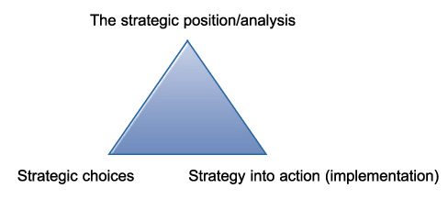

Strategic position: it is the analysis of business environment, capabilities strategic of the business, culture, assumption, belief and the expectation and power of the stakeholders. The key issues in the environmental analysis are competitors, market, discoveries, and regulations which may impact on the environmental threats and opportunities. Strategic capabilities are the analysis of the resources and competencies by which the business may be strong or weak. Different cultural environmental factors such as value, norms, belief and the assuming scenarios are the focus for the strategic position analysis as well. The expectation and the power of the customer, suppliers, lender, borrowers, and shareholders are also analyzed in the positional analysis (Rothaermel et al, 2017).
Strategic option: it the ways of choosing the strategy for the business. Typically it follows the strategic position analysis. The choice option can be chosen by the generation of strategic option, evaluating the options and the finally the selection of the strategy. There are so many options to be taken in case of business strategy. All the option may not be equally optimum for the business in all scenarios. For generating the strategy basically three factors to be considered which are competing ways, direction of competing and the method of the growth. The options of the strategies are to be sustainable, acceptable and feasible when they are evaluated. The final chosen strategy may be expansion by acquiring or investing new project.
Strategy in action: planned and the chosen strategy should be implemented in the step. According to scholars, the implementation of the strategy are organizing for success, enabling the success and managing the strategic change. By the three issues, strategic manager may want to implement the strategy taken and the management of the change due to strategy taken.

Strategy development processes
It is all about the determination of strategic position, strategy development, building the plan and managing the performance. In the strategy developing process, the current strategic position will help to determine the future plan through performance management. To do strategic position analysis different strategic issues in the farm, industry and market data, customer insights and SWOT analysis are done through the position analysis, the deployment of strategy will start. The overall strategic development is mission, value and vision development. Besides organization-wide strategies and the long term objectives are also determined here. Plan building for plan.com after using the SWOT analysis will help to make smart goals and KPI- key performance indicators. Besides the departmental goals, team member goals and the budgetary goals are the plan building for the business. Finally the performance monitoring is needed to roll out the strategy in the business. For that calendar setting, leveraging tool and quarterly and updated review, etc. are needed (Rothaermel et al, 2017).

Strategic management in different contexts
Strategic management is the managing of the strategic objectives and the goals of a business farm. The management is the concerning task of the top-level management and the operational management (Patanakul, 2015). The strategy management by them are as corporate strategy and business-level strategy.
Corporate level strategy: the strategies are the strategies of the management for the business expansion or contraction. Investment decision and the reaping the investment in a smart way are also a corporate decision. The decisions are taken by the corporate body is top ones from the business.
Business level strategy: business-level strategies are those which are the operative strategies taken by the business farm. To promote the business efficiency and the effectiveness of the business, business-level strategies are important. Product development and market development are the prime business-level strategy for a business farm.

Different business-level strategies that help to achieving competitive advantage in business
There are so many options for business-level strategies that may generate competitive advantage for both small and large business (Rothaermel et al, 2017). Yet business like Plan.com takes the options of following discussion-
Cost leadership: the best price offered of the product selling in the market is the cost leadership. The service offering company like Plan.com needs to offer the best price for the service of the voice, cloud, and data offering. The purpose of cost leadership will be gained by serving large number of customer. If the serving customer are large, the service offering price will also be lower that may fulfill the best price offering purpose. The best offer in the market of same service offering will have a place of competitive advantage. Too more profit-generating opportunists will help the company to take the advantages. More loyal customer for best price offering will help to increase the profit potentials.
Service differentiation: service that have separate feature from the existing product and service offering by the virtue of superior quality and experience is service differentiation. To be differentiation in the service experience, more worth feature are to be included in the service package. The process of service delivery and customer service may be differentiating the service experience. Bandwidth and speed level and voice clarity level etc. are the differentiation features in the business like Plan.com.
Focused cost leader: it is the way of as like cost leadership. The strategy also tells about the best price for the marketing service and products. But the strategy needs to be focused on only specific aspects of the customer or market features. Different market features such as city, location, national, international, etc and different customer features like income, sex, age, etc. are the issues to be considered in the focused cost leader.
Focused differentiation: like as the focused cost leadership focused differentiation is also the deed based on the specific market segment or specific customer group. Here the strategic manager of plan.com has to do focus doing only for a customer segment or specific market segment. Market feature and customer group feature will have to be specialized from the competitor. Specific plan and implementation for the target group need to formulate by plan.com.
Defensive strategy: the style of the strategies are not as the offensive ones where the corporation like plan.com will take step to take competitive advantage by devising the hidden strategies that are not be practiced by the competitors. The nature of the strategies is not like the cost leader and differentiators as the competitors are betting here by the hidden strategies.

Corporate level strategy

Strategic options
Product diversity: it is a corporate level strategy where the strategic authority will focus on the product marketing in or out the current boundaries of the business. The company like plan.com will often try to market or adapt those products in the way that the corporation may be profitable form the strategy. The introducing products need to be searched and developed so generously that the promotion and the introduction may not fail in it circulation and end. Market scenarios are to be examined before launching the product diversity.
International diversity: corporation may introduce product and service in the domestic environment which there are options for the international diversity. Plan.com can go global expansion strategy to grab the international opportunities for the profit-making. Future activities of the company will help the company to attain the market mechanism from domestic to international level. It can be done through integration and the expansion of the business activities. Neighboring countries of United Kingdom and the digitally moving counties may be more suitable for the international diversity.

Portfolio management
For the business expansion and integration, business environment of assistance will help the company like plan.com to consider all the business unite as a whole and integrate correlated ones. The correlation and the integration of business will also help to motivate about the portfolios construction for the business. For managing the product portfolio, the consideration of what business to be in or to be out and the possibility analysis of vertical and horizontal integration should be conceptualized (Patanakul, 2015). The risk management due to portfolio reduction or production, the strategy for the strategic options need to be monitored and ensured fro the success in the product portfolio management.

Corporate parenting roles
In the strategy formulation, the role of the corporate body is indescribable. Company’s vision and mission are to be achieved in order to progress in the business development. To be succeeded in the corporate strategy, plan.com has to do some roles as allocating the resource in the strategic employees, establish the expectations of the employees and customers. Besides, increase in the competitive position and the addition of the farm value, etc are also the corporate role on the strategic progression. By the role applying in the strategic position, plan.com will get the certainty of vision achievement.

Expectation of stakeholder in align with the organizational purpose

Importance of governance
Corporate governance is the rules and abiding for the employees and the management to follow in the ways of goal achievement and the vision advancement. In the corporate governance, board of director is the agent from the stockholder in order to implement the visionary goals for the organization. The governing rule and the regulations bind the employees and the managers to go on the goal-achieving path (Patanakul, 2015). Without the governing rule and regulation, goals may not be achieved as the stakeholder may not be aware about the activities that maybe go to worse path.

Stakeholder mapping
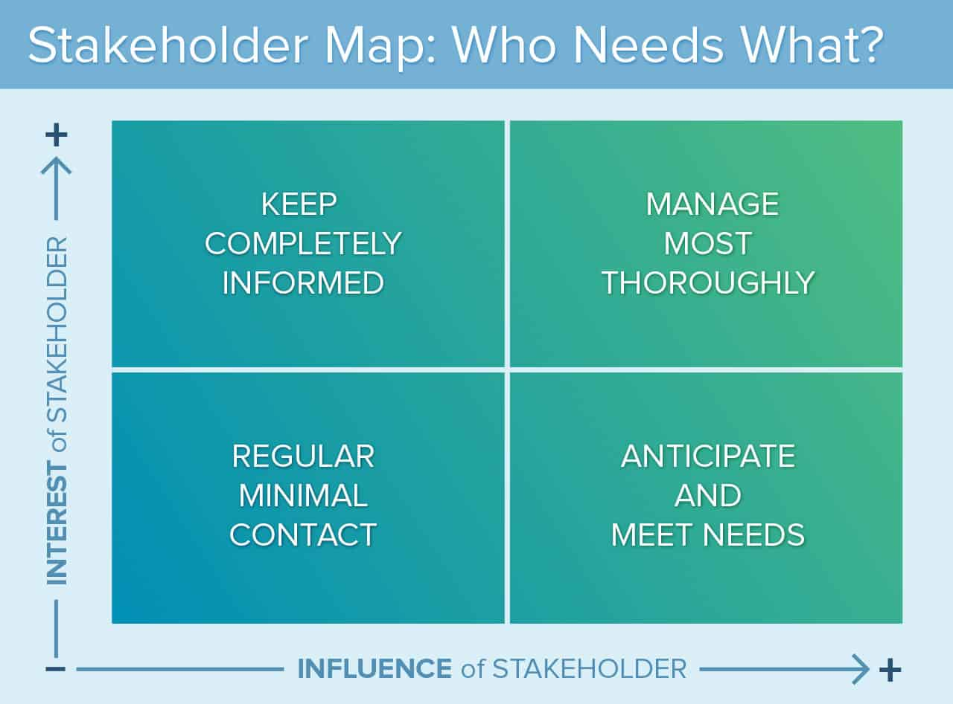

It is necessary to map the stakeholder in the business decision of strategic move. The necessity of it is for the reason that the strategies taken by the company like plan.com will be implemented by the stakeholder. So the more interested but less influential stakeholder needs to be contact at a minimal rate. Both more interest and more influential stockholder are managed more prudentially. Fully informed about the less influential and more interested stockholder is done in case of that type customer. More influential less interested stockholders are need to be anticipated for demand fulfilling.

Ethical issues and their impact on strategic development
For the strategic development, the ethical issues are to be considered. There are many issues that are to be considered as the ethical issues for the strategic manager. The compliance of the ethical issues is necessary to grow the company with legal and most gentle ways. Not being more dependent on the customer for the implementation of the strategy without appropriate compensation is impactful in the business progression. Without practicing the ethical issues in the business, the ultimate goal of the business like plan.com is not possible. The satisfaction issues are not gotten by the unethical achievement in the business. So ethical practice need to be monitored by the corporate rules and regulations (Patanakul, 2015.

Porter’s Five- forces model analysis
The models of the key elements of the Plan.com strength and threats for considering entrance of any new market and measuring the level of importance for the company. The five forces have five dimension of Plan.com to analyze. For example-
Rivalry among competitors: the most powerful and important factor for Plan.com basically focus on the competitive advantages of the strategies taken by the competitors. The competition among the competitors of Plan.com will be high if the demand is decreasing, doing business of same nature and size, decreasing overall market price. The more competition, the less attractive to profit. So Plan.com will face a high completion in the industry of mobile service provider as the size and the entry barrier are low in the industry (Gerard, 2018).
Threats of new entrants: if the industry of Plan.com is faced with the new entrants in the business, the attractiveness of the industry will suppress. The more entry threats, the less profit in the industry due to profit-sharing by the more company. Plan.com will high entry threats as the easiness of doing the business. So the Plan.com need to barrage the entry by different ways. More customer grabbing, making brand loyalty, managing proper distribution channel, investing more capital, etc. are the possible ways of entry barrier for Plan.com.
Threats from substitute products: there are potentials of the development of substitute products. Too more products of same demand serving and doing business for Plan.com may lead to the threats of the forces. The more substitute products, the more products diversity. So the suppression for Plan.com is increasing as the industry is emerging day by day. Facing low switching cost of the customers of Plan.com and potentiality of the price decreasing may increase the threats of the company. So considering the situation of the company, it can be said that Plan.com can face high substitute products threats (Gerard, 2018).
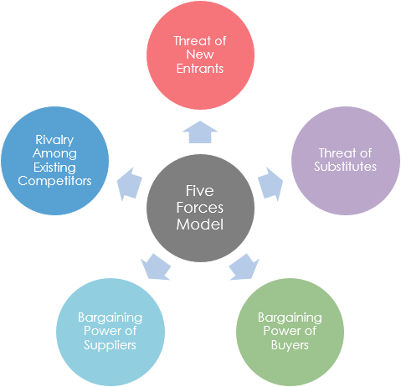

Bargaining power of suppliers: input supplier and the raw material supplier play an important role for Plan.com. The role may be negative and positive. The power of suppliers may be increased if the customer is high but supplier is lower. The industry nature of Plan.com is demanding increasing momentum. So the increasing number of the same nature farm will increase the bargaining power of the suppliers. The control on the supplier company of Plan.com will have a less impact on the business if the strategies of the suppliers company are more sophisticated to understand.
Bargaining power of buyers: to be more customers oriented the player in the industry of Plan.com is to offer more lucrative package of voice, data and mobile. The completive environment of the industry will increase the power of both seller and the buyers as the customer and seller will increase in the coming days. The power of the consumer of Plan.com will be medium as the industry is prone to increasing nature. The ways of lowering the power can be able if the buyer has low switching coast and important to the service providers. Besides, the knowledge customer and falling demand will also increase the power of the customers (Gerard, 2018).

PESTEL analysis
PESTEL is a well-known framework for analyzing the macro environment of the business like Plan.com. Political, economic, social, technological, environmental and legal, etc. are the factors to be analyzed in the analysis.
Political: the country to which the company like Plan.com maintains or will expand their business has to analyze the political environment of the country. Status of the business people, political party’s movement, state governing policies, trade policies, etc. are the issues for Plan.com to analyses in the business environment (Masih, 2019).

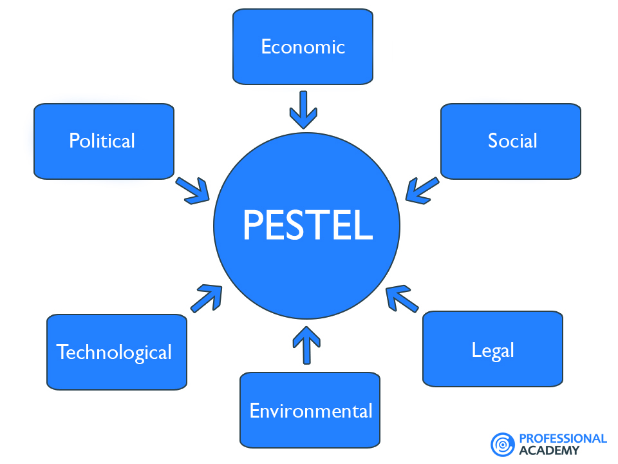

Economic: the factors in the economic environment are also important to analyze to find out any opportunity for profit. National income level, inflation, growth rate an many other macro-economic factors relating the business like Plan.com are to be analyzed. Due to the Brexit policy by the government will also affect the economic condition.
Social: not only the non-social factors are important to analyze in the opportunities for the business like Plan.com. Different demographic attributes such as age, sex, income, profession and the inherent issues in the people are the influencing factors keeping impact in the operation of the business like Plan.com. So the social culture is to be investigate to take decision about the business (Masih, 2019).
Technological: it the present age, technology is changing dramatically due to the changing environment of the business. Plan.com is a telecommunication and data serving company. That’s why the company need to offer new offers as to the new technology. The requirement of the new tech in the business environment will require more skilled and learned employees.
Ecological: natural endowment in the locality of the business and the care for the business will pave the way of positive result for the business like Plan.com. The data and voice producing instrument are to be environmentally friendly in the business motive. Ecologically awareness will bring the best result of the business.
Legal: the legal framework and the requirement for the business start-up like Plan.com will render or close facilities for the business improvement of Plan.com. Legal structure, legal policies, legal amendment, and more other legal issues are to be considered when the company analyzes the future opportunities of the business (Masih, 2019).
These macro factors for the company are to be analyzed as whole features of the business farm. Positive and negative issues are to be considered in the case of analysis.

Strategic groups Analysis
It is the position analysis of the competitors who are doing business in the same industry and offering the same services and products. The focus points of the analysis of group are mainly the strategic choice and strategic features of the business farms doing business in the industry. Usually, the groups are identified by analysis two or three factors of the same nature.
The strategic groups have different diversity of activities to follow. For example- extend of products coverage, location coverage, integration and segregation status, product and service quality, pricing policies, distributing channel and the marketing policies, etc.
The analysis is used in different ways. The number and extension of the direct competitors are known by the strategic group analysis, possibility of simultaneous move by the competitive partner and the capturing the strategic opportunities, etc. are the outcome of the Strategic Group Analysis (SGA).

Critical success factors (CSF) analysis
Critical success factors (CSF) is a concept introduced by Ronald Daniel which describe some key factors needed by management in order to grab the success end of the business or project some key success of the concepts are as follows-
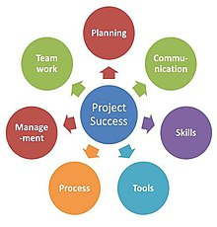

Planning: it is primary need for the company like Plan.com to be success in the projects taken. Every implementation should be planned before those are executed. The key performance indicators (KPI) are to be determined to go forward (Patanakul, 2015).
Team Work: the plan and the performance of the company like Plan.com will be implemented easily if the effort for the execution is coming from the team of Plan.com. As the combined commitment is more prone to success than individual effort.
Skills: the people doing work for implementing the planning will have to be possessed skill required for the projects and plan progression. The necessity for the skilled people in Plan.com will be more when the company will compete for market share.
Communication: not only formulating planning is a key success factor for Plan.com but also disseminating that plan to the team member and employees are to be ensured. Without communicating the planning issues any company like Plan.com will success.
Process: the value generation process and the revenue-generating process and other process used on the business performance need to be evident and not complex to understand by the employees. The process through which lifeblood of the company is coming, it’s need to be cared.
Tools: the infrastructural and supporting activities for the plan implementation are the required tools for the business growth planning. The needed factors and financial and non-financial requirement for the business plan implementation will pace implementation process.
Management: the authorities for the planning and the implementing responsibility will be the management team for Plan.com. The strategic decision and the operational plan to promote the business and the trained the employees are the requirement for management (Patanakul, 2015).
By the success factor, if these are taken as the serious ones to be successes, the company like Plan.com will expand and grow to the positive market vibe. So the factors are to be managed and handled so prudentially that the farm can grab the potentials and profit opportunities.

Resources-Capabilities (core competencies) Analysis
Core competencies analysis is also another strong tool for competitive advantage analysis and the depth of the competencies is also known by the core competencies analysis. The competencies are the company’s differentials from the other market player in the industry. These are the activities and functions of business farm that gives a company best in essence. Core competencies need to be valuable, rare, known imitable and not sustainable ( Pietrzak, 2017). Basic competencies for the business like Plan.com are as follows-
Resources: these are the functional inputs and the requirement to allow the company like Plan.com to do activities and operations efficiently. The major resources for Plan.com are physical assets, human resources, and the organizational capital. The resources for Plan.com may be tangibles and intangibles. Tangibles asset of Plan.com may be plant, property, and equipment. Besides intangible asses are non-financial assets of Plan.com like organizational reputation and brad quality. To be core, the resources should be valuable, hard to imitate and no sustainable. The unique resource will give the company competitive advantages over the other market players in the industry.
Capabilities: the capabilities of a company doing strategic move in the competitive market are the expertise of the company like Plan.com which help the company to use the core resource in most efficient and effective ways. These capabilities are making Plan.com mastered in any activities. The inimitable and valuable capabilities are the strengths of the company like Plan.com. The capabilities of handing the resource will allow the company to go expansion.
Strategic importance of Core competencies: to be more competitive advantage holder I the competitive market, importance of core competencies like resources and capabilities of using those is known no bound. The competitive advantage from the core competencies will give Plan.com a place for more profit generation by creating more values. The core competencies act as glue for the connecting among the catalysts of competitive advantage. Long term competitive advantage derived from core competencies will ensure the customer loyalty to the business. The more customers for the business will derive from the core competencies’ best utilization. The market-leading position and the highest revenue potential are insured by the help of core competencies as well. So the management and the business team of plan.com should be more careful about the creation core competencies (Pietrzak, 2017).

SWOT analysis
Strength, weakness, opportunities, and threats are the issues to take decision on the internal health of the business farm analyzing the external factors.
Strength: the strengths of the company like Plan.com will give the place for the internally motivated by the company to expand and operate efficiently. The uprising revenue and the demand position of the company is the foremost strength for the business. Increasing market share and the profitability for the share will keep the company an ahead place for the business. New offer and innovative package have the attractive value from the business entity. The panacea for breaking the financial and operational impediment is the strength of the business (Gürel et al, 2017).
Weakness: in the process of potential progression analysis, weakness may be the disheartening issues in the whole process for the expansion and progression. The weaknesses are need to be transferred into the strength for betterment of the business. The weakness of the business may be unskilled employees; backward business model, bureaucratic delay, etc. are the weakness of the business like Plan.com. So the weakness of the business model and the process are to identify if the weaknesses are to transfer into strengths.

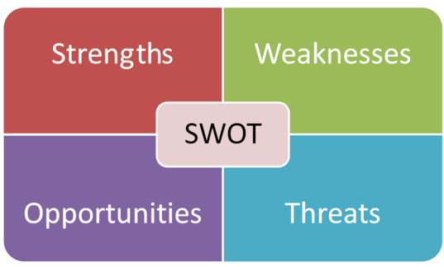

Opportunities: these are the issues for the business to get the profit generation path easy. As the opportunities of the business environment will help the company to boost up its revenue generation. Plan.com should to analyze the opportunity driven by the internal and external environment to grab the revenue potentials. The opportunities need to be tag with the Plan.com strengths issues. Thus opportunities of the company will help Plan.com go forward. By the growth potential for the company from the environment especially from external one will emerge the company as a market leader, if Plan.com can utilize the potential in a smart way (Gürel et al, 2017).
Threats: though the strengths and opportunities for a company are the positive drive from future development, threats from external environment and weakness from internal environment can spoilt the positive aspects, if the treats from environment is not manage prudentially. The threats for Plan.com will be cost reduction pressure from the competitors’ market price, innovative offer by the competitors, potentials of loss of market share, etc. The potential threat will hamper the performance of Plan.com. That’s why the threats are to be managed smartly (Gürel et al, 2017).
The analysis of SWOT is the lifeblood for analyzing the potential market and the potentials market environment. The factors in the analysis are as the factors discussed above.

Strategic evaluation and selection

Strategy evaluation
When the strategy is to implement, the strategic resources and the management are to handle the emerging obstacles in the ways of implementation. So the strategies are to be evaluated for the sake of corrective and advancing action requirement. The evaluation process for the business is a three-step process. At first, the underlying bases for the strategic evaluation are to be determined. Next, the standard and actual results are to be compared with a view to determining the deviation of the strategy. Finally, the desired results are to maintained and deviated actions are to be checked and modified. The evaluation process needs to be consonant, consistent, advantageous and feasible. Every evaluation process is to be consistent and congruent in the way of competitive advantages getting.

Different strategic development options
Balanced scorecard: it is a three criteria strategic development option where the objectives, measures, and initiatives are the criteria (Nørreklit, 2018). The strategic objectives are determined at first, the proxy measure for the objectives are the next determination for the balanced scorecard. To promote the positive results and neutralize the negative, the action should be taken
Strategy map: it is a necessary tool for the communication of strategic plan of plan.com and to know the high profile business objectives. The map is a part of balanced scorecard which may use easily to disseminate the high-level business goals to the stakeholder. It helps to unify all goals into one strategic objective and a visual representation of the business farm plan.
Gap planning: it is the need gap analysis which analyzes the deviation of the business performance from the expected ones. In the gap analysis, the current status and the desired objectives are the evaluated to decrease the gap. To boost up the current scenarios of plan.com, the company has to take corrective action.
Blue ocean strategy: it another strategic development option where plan.com can create a uncontested market space rather the developed or saturated one. It has emerged in a book named by the same title. By the blue ocean plan.com can take the massive advantages of the market share growth and the promotion of the growth (Nørreklit, 2018).
VRIO framework: it stands for value, rarity, imitability and organization which relate the mission statement rather than the overall strategic objectives. Here plan.com should be more valuable advantage generator which is rare, imitability and organized. The completive advantages by the strategy are the best ones for the business like plan.com.

Conclusion
The analysis of the business environment will help the company from variant perspectives. The company analyzed will be able to find out the competitive market and the optimum price position by the help of result from the business environment. After the internal capabilities and strengths findings, the company will be able to compete in the domestic and international market, if the company takes the benefit of its internal strength and capabilities. External analysis will help the company to overcome the threat and the weakness of the environment. Thus the company will take the competitive advantage over other company.

Reference

- Beckford, J. (2002). Quality. 2nd ed. London: Routledge.
- Bruce, A. and Langdon, K. (2000). Strategic Thinking. London: Dorling Kindersley.
- David, F.R. and David, F.R., 2019. Strategic management: A competitive advantage approach, concepts, and cases. Pearson.
- Gerard, H.T., 2018. The Relevance Of Porter’s Five Forces In Today’s Innovative And Changing Business Environment.
- Gürel, E. and Tat, M., 2017. SWOT analysis: A theoretical review. Journal of International Social Research, 10(51).
- Johnson, G; Scholes, K; Whiitington, R. (2010) Exploring Strategy, Harlow: FT Prentice Hall.
- Johnson, G; Scholes, K; Whittington, R. (2007) Exploring corporate strategy: text and cases (Online) Harlow: FT Prentice Hall.
- Lasserre, P., 2017. Global strategic management. Macmillan International Higher Education.
- Masih, J., Rajkumar, R., Matharu, P.S. and Sharma, A., 2019. Market Capturing and Business Expansion Strategy for Gluten-Free Foods in India and USA Using PESTEL Model. Sciences, 10, pp.202-213.
- Nørreklit, H., Kure, N. and Trenca, M., 2018. Balanced Scorecard. The International Encyclopedia of Strategic Communication, pp.1-6.
- Omsa, S., Abdullah, I.H. and Jamali, H., 2017. Five Competitive Forces Model and the Implementation of Porter’s Generic Strategies to Gain Firm Performances.
- Patanakul, P., 2015. Key attributes of effectiveness in managing project portfolio. International Journal of Project Management, 33(5), pp.1084-1097.
- Pietrzak, M. and Pietrzak, P., 2017. Mapping strategic groups in higher education: Evidence on the Polish technical faculties. Online Journal of Applied Knowledge Management, 5(2).
- Rothaermel, F.T., 2017. Strategic management. New York, NY: McGraw-Hill Education.
- Sa, A., Thollander, P. and Cagno, E., 2015. Industrial energy management gap analysis. Innov Energy Res, 4(122), p.2.

