Name: Shabila Hussain
Student Number: 2410302
Module Code: BMHP5014
Lecturer Name: Tomy Adattu Chacko
Assignment Title: Component 2
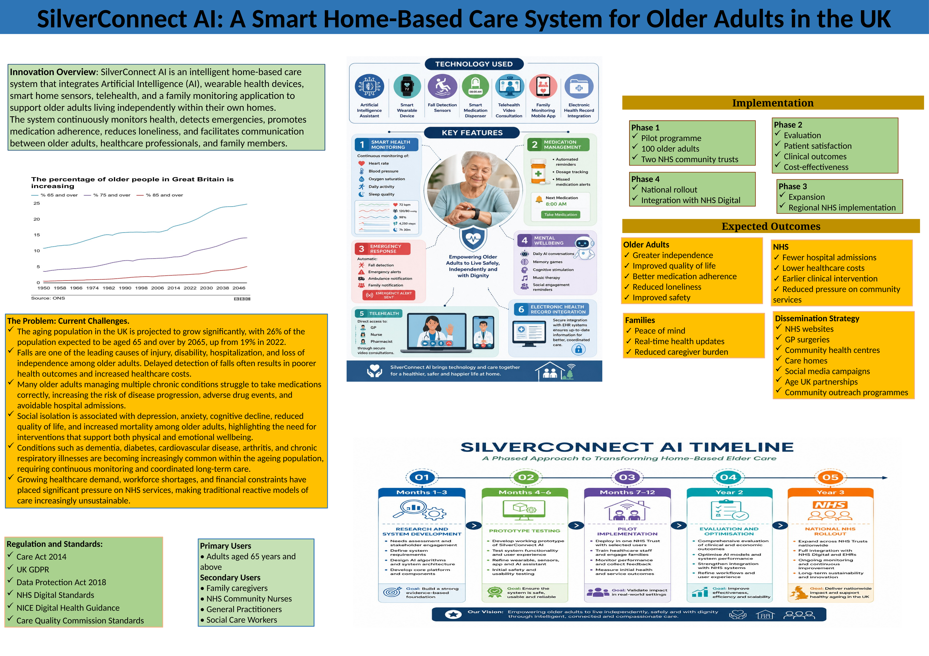

SilverConnect AI: A Smart Home-Based Care System for Older Adults in the UK
Population ageing is one of the greatest demographic changes impacting the health and social care system in the United Kingdom. Advances in life expectancy have led to an increasing number of older people with multiple long-term conditions (LTCs) (cardiovascular disease, diabetes, dementia, arthritis, and respiratory conditions) and a rise in the complexity of the health services required to meet these needs. In addition to physical health issues, many older adults face social isolation and loneliness, which have been linked to depression, cognitive impairments, a lower quality of life, and greater use of health services. Additionally, falls are one of the most common reasons for injury, disability, and emergency room visits for older people, and they are a significant financial and operational burden on the National Health Service (NHS). Old methods of care, largely reactive and resource-heavy, are no longer able to keep up with these rising needs. Therefore, there is a need for innovative solutions that combine technology with person-centred approaches to enable independent living and proactive healthcare delivery. SilverConnect AI is proposed as an intelligent home-based care system that combines AI technology, smart home technology, wearable health monitoring, and telehealth services to keep older people safe, well, and independent, prevent unnecessary hospitalisation, and help the NHS be sustainable in the long term.

Why This Innovation Is Needed
Home care is becoming more vital as demographics change and older people choose to age in place. With proper health and social care assistance, older individuals who age in place have better psychological well-being, autonomy, and quality of life than those in institutional care (Facchinetti et al., 2023). The frequency of healthcare professional visits limits the traditional home care model's ability to monitor sudden health changes, falls, missed medications, and crises in real time. Thus, many preventable problems go undiagnosed until the patient is hospitalised. Systematic reviews have found that smart home technologies like wearable devices, environment sensors, and intelligent monitoring systems can improve chronic disease management, independent living, and care dependence through continuous monitoring and early intervention (Wang et al., 2024). Chen et al. (2023) also feel that intelligent technology can improve coordination, responsiveness, and customisation in community-based senior care. SilverConnect AI is a direct solution to the demand for a proactive, person-centred, technology-driven care strategy that can enable the individual to live independently while improving healthcare efficiency and decreasing NHS pressure.

Description of SilverConnect AI
SilverConnect AI creates a coordinated home healthcare environment using artificial intelligence, wearable health care technology, smart home sensors, telehealth, and mobile communications. An artificial intelligence-driven virtual assistant engages naturally with older persons to provide individualised health advice, medication reminders, appointment and time reminders, water reminders, and wellbeing encouragement. Wearable smart devices monitor physiological parameters like heart rate, blood pressure, oxygen saturation, sleep habits, and physical activity, and smart home sensors detect falls, inactivity, abnormal movement patterns, and home dangers. AI continuously analyses this data to detect health decline. Abnormal patterns trigger an automated emergency alert to healthcare professionals and nominated family members via protected mobile app. Telehealth consultations allow GPs, nurses, and other healthcare professionals to remotely evaluate patients' data and intervene without visiting the hospital. SilverConnectAI combines real-time monitoring, predictive analytics, remote clinical support, and family involvement in a single intelligent system to provide coordinated, person-centred care that improves older adults' safety, independence, and quality of life and optimises NHS resources.

Creativity and Value Creation
SilverConnectAI embodies the seven principles of modern healthcare and social care: creativity, innovation, value generation, resourcefulness, and person-centred care. Imagining traditional home care as a linked, automated, and smart environment that recognises health threats and does not react afterward shows creativity. This novel approach will combine AI, wearables, smart home monitoring, and telehealth into a single platform to coordinate care. Many parties profit from the innovation. Personal help allows older persons to stay at home, improving their independence, safety, and quality of life. Family carers feel less stressed with real-time monitoring and communication. Healthcare workers receive real-time information for early clinical action and educated decision-making. SilverConnect AI helps the NHS reduce hospital admissions, improve care coordination, and maximise health resources by providing proactive, person-centred care.

Technology Integration
The technology behind SilverConnect AI provides continuous, intelligent, and integrated home care for older persons. AI analyses health and behavioural data to discover early health issues and recommend preventative measures. Internet of Things (IoT) technologies connect wearable devices, drug dispensers, environmental sensors, and smart home equipment to collect and deliver real-time health data. Electronic health records and remote monitoring provide seamless data sharing with healthcare professionals, assuring accurate, accessible, and coordinated patient data. Electronic health records and remote monitoring provide accurate, accessible, and coordinated patient data sharing with healthcare professionals. Predictive analytics can also identify patterns related to falls, medication adherence, or chronic disease progression, allowing early intervention. Smart technology in home care for elderly persons improve care quality, facilitate interdisciplinary work, and improve health outcomes when utilised to encourage independent living.
Implementation Strategy
SilverConnect AI will be phased in for feasibility, stakeholder participation, and assessment. A selected NHS Trust will conduct Phase One trials for independent older chronic disease patients. Set up and teach healthcare professionals on wearables, smart home sensors, and AI platform SilverConnect. In Phase Two, stakeholder feedback and continuous data collection will evaluate patient satisfaction, system usability, cost-effectiveness, operational performance, and clinical results. Phase Three will expand to community health services, care homes, and primary care networks after this success. Phase Four will implement nationally with NHS England and major technology partners. GPs, community nurses, social workers, care home providers, technology developers, local authorities, family carers, and older persons must work together to deliver integrated, person-centred, sustainable care.

Policy and Ethical Considerations
This innovation promotes freedom, wellbeing, and individualised care under the Care Act 2014. UK GDPR enables authorised processing, storage, and protection of personal health information. It will meet NHS Digital and NICE digital health technology criteria. To ensure no older adult is disadvantaged, implementation must be ethical, allow informed consent, retain data governance openness, protect cybersecurity, and be technology accessible by socioeconomic status and disability.

Expectation and Conclusion
SilverConnect AI can make home-based aged care proactive, preventive, and person-centred. Continuous health monitoring, intelligent decision aid, and timely professional intervention should improve older individuals' home life, loneliness, independence, and safety. The innovation should reduce unnecessary hospital admissions, improve chronic illness management, improve provider-family communication, and reduce NHS long-term costs by using resources more efficiently. Creative digital solutions are needed for sustainable health and social services for the UK’s ageing population. In conclusion, NHS organisations and policymakers should adopt SilverConnect AI, a practical, evidence-based, and visionary plan to assist older people age well, improve integrated care, and provide high-quality, person-centred services.

References

Care Act 2014. (2014) Care Act 2014. London: The Stationery Office.
https://www.legislation.gov.uk/ukpga/2014/23.

Chen, H., Zhang, Y. and Wang, L. (2023) ‘A study on the quality evaluation index system of smart home care for older adults in the community—based on Delphi and AHP’, BMC Public Health. https://link.springer.com/article/10.1186/s12889-023-15262-1

Facchinetti, G., Petrucci, G., Albanesi, B., De Marinis, M.G. and Piredda, M. (2023) ‘Can smart home technologies help older adults manage their chronic condition? A systematic literature review’, International Journal of Environmental Research and Public Health.
https://www.mdpi.com/1660-4601/20/2/1205

Wang, Y., Sun, H., Xu, S., Xia, Q. and Tang, X. (2024) ‘Smart home technologies for enhancing independence of living and reducing care dependence in older adults: A systematic review’, Journal of Advanced Nursing. https://onlinelibrary.wiley.com/doi/10.1111/jan.16569

