Learning in the Digital Era

Evidence of Learning (E-Portfolio)

Student name: Mariana Chitorog
Student ID: 2221813

Table of Contents
Task 1 3
Preparing for higher education 3
Task 2 5
Mind Map 5
Task 3 7
Task 4 11
Reflection 11
References 12

Task 1

Preparing for higher education
An important procedure that has a big impact on a student's success in college or university is getting ready for higher education (Marine, 2011). When preparing for higher education, there are many various aspects to take into account, such as academic readiness, professional objectives, financial planning, and personal readiness.
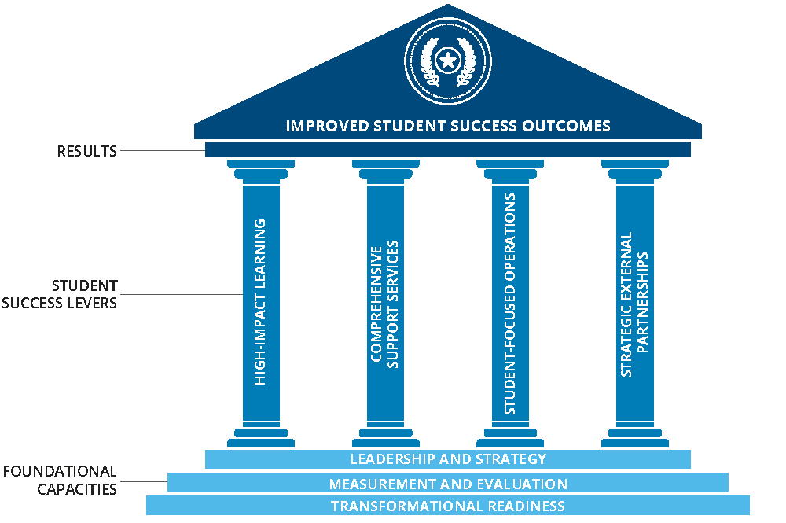
Figure: Success in higher education
Source: (Marine, 2011)
Success in higher education depends on academic preparation. This involves enrolling in difficult high school courses, such as AP or IB classes, to show admissions officers that you are capable of tackling the demanding requirements of a college curriculum (UCAS, 2021). Students should prepare for these exams through test preparation courses or study materials because standardised tests like the SAT or ACT are crucial for college admissions.
Career aspirations are a crucial component of higher education preparation. When picking a college or university and a major, students should take into account their chosen career prospects (Lacina, 2022). Students can choose the best educational and employment path for their future by researching potential careers and talking to experts in the subject.
Planning finances is essential when getting ready for higher education. Students and their families should research all available financial aid options, including scholarships, grants, and loans, and create a budget to meet the costs of tuition, housing, and other expenses because attending college may be expensive (Freeman, 2015). Being personally prepared is essential for success in higher education. Students should prepare for college by learning time management and study skills, getting support from family and friends, learning to manage stress, and maintaining a healthy work-life balance. College may be a demanding and stressful experience (Barton, 2019).
Preparing for higher education is a complex process that takes careful planning and thought. Students can improve their chances of succeeding in college or university and position themselves for a successful future by focusing on academic preparation, professional objectives, financial planning, personal readiness, and taking specific efforts to prepare.

Task 2

Mind Map

Figure: Mind Map
Source: Author
The three main areas of becoming a digital learner are covered by this mind map: digital tools, online resources, and study habits (Montebello, 2019).
Digital technologies, such as productivity apps, communication tools, and note-taking apps, can assist students with time management, group collaboration, and task organisation.
Online resources include search engines, online libraries, and MOOCs (massive open online courses), which provide access to a plethora of knowledge and educational opportunities (Ferris, 2011).
To succeed as a digital learner, one must develop specialised study habits, such as time management and good note-taking, as well as self-directed learning, which entails taking ownership of one's learning (Pak, Han and Cho, 2021).
These branches can all be divided further into more specialised subtopics. For instance, under digital tools, students may utilise note-taking apps like Evernote or OneNote, communication tools like email or video conferencing, or productivity apps like calendars or to-do lists (Kim and Park, 2021).
Online sources may include search engines like Google or Bing as well as online libraries with access to scholarly publications like JSTOR or Project MUSE. Platforms like Coursera or edX, which offer courses from top universities throughout the world, may be included in MOOCs.
Self-directed learning techniques like goal-setting and reflective practice, time management apps like Pomodoro or Trello, and note-taking techniques like the Cornell system or mind maps are all examples of good study habits.
Learners can improve their digital learning efficiency and make use of the various opportunities provided by digital technology by making use of these digital tools, online resources, and study habits.

Task 3

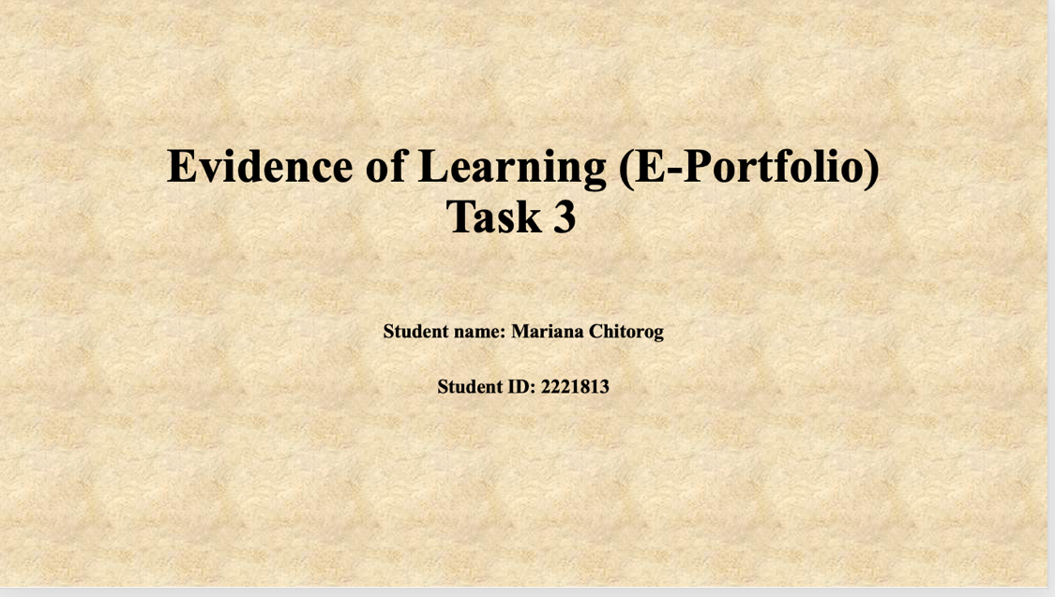

The variety of characteristics and attributes that make up a person's unique self. All of these qualities, encounters, convictions, ideals, and attitudes are admissible (Weinberg, 2011). I'll discuss how my sense of place, values, and beliefs impact both my own identity and my ability to work well with others in my response.

My feeling about where I am has a big impact on how I feel about myself. I was raised in a varied town and was exposed to individuals of many ages, races, and socioeconomic statuses (Hershenov and Taylor, 2017). This has impacted my capacity to value many points of view and my desire to accept variety. This makes it possible for me to be an excellent team player who is understanding of the opinions of my teammates and open-minded.
My beliefs and ideals also influence how I see myself. Integrity, decent behavior, and teamwork are things that I value highly (HEATHWOOD, 2010). I believe that effective teamwork requires open communication and mutual respect. This shows that even if my colleagues' ideas may differ from mine, I am receptive to hearing them. This helps me, as a team player, to be cooperative and supportive of others, producing an environment that promotes collaboration and cooperation.
My life experiences and my philosophical ideas have all shaped who I am now. I value education and growth highly since I am a lifelong learner (HEARN, 2017). I am always looking for ways to broaden my skills and knowledge, and I am open to constructive criticism. This encourages me to provide constructive criticism that can help our team grow and improve as a team player and also makes me receptive to learning from my teammates.
A person's distinct identity is shaped by a multitude of factors, including feelings of location, values, beliefs, and experiences. These qualities foster empathy, respect, cooperation, open-mindedness, and continuous improvement, all of which contribute to an individual's ability to work well with others. These qualities are important for a team player to form close relationships with teammates and function well as a team to achieve common goals.

Task 4

Reflection
The reflective tool of Borton offers a structure for thinking back on experiences and extracting lessons from them. I have used this tool to reflect on my experiences beginning my studies at the University of Wales, adjusting to online learning and resources, and producing my first assignments.
What?
My path as a university student has been fascinating and demanding at the same time (Johnson et al., 2013). Because of the pandemic, I'm doing my coursework online. I was concerned about using the tools and platforms for online learning.
So What?
I concluded that if I wanted to succeed in my studies, I had to actively seek out help when I needed it and take ownership of my education (Laurillard, 2013). I took the time to learn about the new system by browsing the online learning platform and using the university's resources.
Furthermore, it was difficult for me to write my first tasks. I had never conducted research before, let alone written academically. I had trouble putting my ideas and thoughts into a coherent structure.
Next what?
I've learned the value of approaching my academics in an organised manner as a result of this experience. I now have a better understanding of how to use the web tools that are at my disposal. I have also discovered the value of time management and efficient job planning.
I intend to ask my tutors for input in the future to increase my writing abilities and my knowledge and grasp of the academic writing style (Slater and Davies, 2020).
Adjusting to online learning and resources since commencing university has been a learning process. I now have a better grasp on the significance of being accountable for my learning, making use of the tools at my disposal, and organising my work efficiently. I am eager to advance academically and use the knowledge and abilities I have acquired to do so.

References
Barton, A. (2019). Preparing for Leadership Turnover in Christian Higher Education: Best Practices in Succession Planning. Christian Higher Education, 18(1-2), pp.37–53. doi:https://doi.org/10.1080/15363759.2018.1554353.
Ferris, S.P. (2011). Teaching, learning, and the net generation : concepts and tools for reaching digital learners. Hershey Pa: Igi Global.
Freeman, M.L. (2015). HEALing Higher Education: An Innovative Approach to Preparing HSI Leaders. New Directions for Higher Education, 2015(172), pp.7–18. doi:https://doi.org/10.1002/he.20148.
HEARN, J. (2017). National identity: banal, personal and embedded. Nations and Nationalism, 13(4), pp.657–674. doi:https://doi.org/10.1111/j.1469-8129.2007.00303.x.
HEATHWOOD, C. (2010). THE SIGNIFICANCE OF PERSONAL IDENTITY TO ABORTION. Bioethics, 25(4), pp.230–232. doi:https://doi.org/10.1111/j.1467-8519.2010.01845.x.
Hershenov, D.B. and Taylor, A.P. (2017). Personal Identity and the Possibility of Autonomy. Dialectica, 71(2), pp.155–179. doi:https://doi.org/10.1111/1746-8361.12188.
Johnson, I.P., Palmer, E., Burton, J. and Brockhouse, M. (2013). Online learning resources in anatomy: What do students think? Clinical Anatomy, 26(5), pp.556–563. doi:https://doi.org/10.1002/ca.22219.
Kim, M.J. and Park, Y.M. (2021). Analysis of the impact of college students’ digital literacy attitude on digital literacy competency. Korean Association For Learner-Centered Curriculum And Instruction, 21(6), pp.495–507. doi:https://doi.org/10.22251/jlcci.2021.21.6.495.
Lacina, J.G. (2022). Preparing international students for a successful social experience in higher education. New Directions for Higher Education, 2002(117), pp.21–28. doi:https://doi.org/10.1002/he.43.
Laurillard, D. (2013). Rethinking University Teaching. Routledge.
Marine, S.B. (2011). Stonewall’s legacy : bisexual, gay, lesbian, and transgender students in higher education. San Francisco, Calif.: Jossey-Bass ; Hoboken, N.J.
Montebello, M. (2019). Handbook of Research on Digital Learning. Hershey: IGI Global.
Pak, S., Han, Y.J. and Cho, Y.H. (2021). Understanding Digital Competence and Digital Divide of Elementary School Students from Teacher Perspectives. Korean Association For Learner-Centered Curriculum And Instruction, 21(16), pp.479–492. doi:https://doi.org/10.22251/jlcci.2021.21.16.479.
Slater, D.R. and Davies, R. (2020). Student Preferences for Learning Resources on a Land-based Postgraduate Online Degree Programme. Online Learning, 24(1). doi:https://doi.org/10.24059/olj.v24i1.1976.
UCAS (2021). Getting ready for higher education. [online] UCAS. Available at: https://www.ucas.com/undergraduate/results-confirmation-and-clearing/getting-ready-higher-education.
Weinberg, S. (2011). Locke on Personal Identity. Philosophy Compass, [online] 6(6), pp.398–407. doi:https://doi.org/10.1111/j.1747-9991.2011.00402.x.

