BUILDING SURVEY
Property Address:

Photograph here

CONTENTS

Introduction 4
Client Details 4
Date of Survey 4
Date of Report 4
Weather Conditions 4
Scope of Instructions 4
Limitations of Inspection 5
Condition Rating 6
About the Property 8
Council Tax Band 8
Access to the Property 8
Construction 9
Exterior 9
Roof – Rear Elevation 10
Chimney – Rear Elevation 10
Walls 11
Windows & Doors 13
Eaves, Soffits, Guttering & Rain Water Pipes 14
External Pipes 14
Front Garden 15
Rear Garden 16
Boundaries 17

Interior 19
Ground Floor 19
Hall 19
Dining Room & Lounge 19
Kitchen 19
Lean-to 20
Stairs 21
First Floor 21
Master Bedroom 21
Bedroom 2 21
Bedroom 3 21
Bathroom 22
Loft 22
Services 23
Gas 23
Electricity 23
Water 24
Heating & Hot Water 24
Drainage 24
Sanitary Fittings 25
Environmental 25
Security 25
Health & Safety 25
Legal Matters 26
Summary 27

INTRODUCTION

Client Name & Address

IENT NAME & ADDRESS

Date of Survey

Date of Report

Weather Conditions

Scope of Instructions

This is a report on the construction and condition of the above semi-detached two storey house following my survey carried out in accordance with your instructions of the XXXXX.
This report is for the private and confidential use of our client, Client Name here, for whom the report is undertaken and should not be reproduced in whole or part or relied upon by third parties for any use without the express written authority of Your company name here.
I have provided two copies of this report, as many clients find it useful to forward a copy on to their legal adviser.

Limitations of Inspection

The house is currently occupied and fully furnished with timber laminate/sold timber and linoleum coverings laid throughout the ground floor. The stairs has a fitted carpet and the first floor has exposed and stained floorboards throughout.

The Vendor was present in the property for the whole of the survey although I was unaccompanied during the process.

My inspection covered all those parts of the building that could be seen either from ground level internally and externally. I used binoculars to examine the roof covering and I also used a ladder to gain access to the roof space. A damp test meter was used internally. Many parts of a building such as foundations and sub-floor areas are concealed during the course of construction and these are not disturbed. It follows that for practical reasons I have not inspected woodwork or other parts of the structure that were covered, unexposed or inaccessible and I am therefore unable to report that any such part of the building is free from defect. Where a property is occupied and fully furnished and has floors covered, this clearly limits the inspection possible particularly of floor surfaces. Tests were taken at random with a moisture meter in all rooms where practicable. As far as services are concerned, my inspection was limited to a superficial one and in the absence of any specific tests no warranty can be given as to their condition, design or efficiency.
The suitability of the main supply and acceptability of installations connected to them is something on which the water and electricity authorities have the ultimate responsibility. Underground pipework serving the drainage system where buried obviously cannot be inspected and commented upon.
I have used digital photographs to illustrate my comments in the report.
In drafting this report my comments have been limited to more material matters and in particular I have not listed individual items such as a slightly loose door or window fittings or minor decorative blemishes which have non-structural significance.
We inspect the interior and exterior of the main building and all permanent outbuildings. We also inspect the parts of the electricity, gas/oil, water, heating, drainage and other services that can be seen, but these are not tested other than through their normal operation in everyday use.

Condition Rating
To help describe the condition of the property we apply a condition rating to the main and permanent outbuildings, and some parts externally.
We describe the element that has the worst condition rating first and then outline the condition of the other parts.
The condition ratings are as follows:-
3 | Defects that are serious and or/need to be repaired, replaced or investigated urgently.
2 | Defects that need repairing or replacing but are not considered serious or urgent.  The property must be maintained in the normal way.
1 | No repair is currently needed. The property must be maintained in the normal way.
NI | Not inspected. See Important Note below.

Important Note:
We carry out a desk-top study and make oral enquiries about matters affecting the property.
We carefully and thoroughly inspect the property using our best endeavours to view as much of it as is physically possible. Where this is not possible an explanation will be provided.
We visually inspect roofs, chimneys and other surfaces on the outside of the building from ground level and, if necessary, from neighbouring public property and with the aid of binoculars. Flat roofs no more than 3m in height are inspected using a ladder and where it is safe to do so.
We inspect the roof structure from inside the roof space if there is safe access. We examine floor surfaces and under floor spaces so far as there is safe access and permission from the owner.
We are not able to assess any condition on the inside of any chimney, boiler or other flues.
We do not lift floor coverings without the owner’s consent. Intermittent faults may not be apparent on the day of inspection.
If we are concerned about any parts of the property that the inspection cannot cover, the report will tell you about any further investigations that are needed.
Where practicable and agreed, we report on the cost of any work for identified repairs and make recommendations on how these repairs should be carried out. Some maintenance and repairs that we suggest may be expensive. Purely cosmetic and minor maintenance defects that have no effect on performance may not be reported. The report that we provide is not a warranty.

About the Property
The property is a former local authority built, semi-detached 3 bedroomed house. The ground floor comprises the hall with stairs to the first floor, store, dining room, lounge and kitchen. The rear exit from the kitchen opens onto a lean-to structure. The first floor comprises the 3 bedrooms and family bathroom. The landing has a loft hatch access.
From historical map data the house was built in between 1938 and 1946.
The present owners purchased the property in 2013/14 from the male vendor’s parents.
The house is built on a steep slope with sloping front and rear gardens, both which have been recently terraced and, to the rear, fitted with timber decking in parts. A patio slab area has been formed in front of the main elevation, which affords views across the whole of Swansea Bay.

Council Tax Band
The Welsh Assembly Government changed the number and range of council tax bands from 1 April 2005. All dwellings in Wales were re-banded into nine bands, A to I, with A being the lowest. The new bands were based on the open market capital value as at 1 April 2003. From data available on the City & County of Swansea website, the property is rated at band B.

Access to the Property

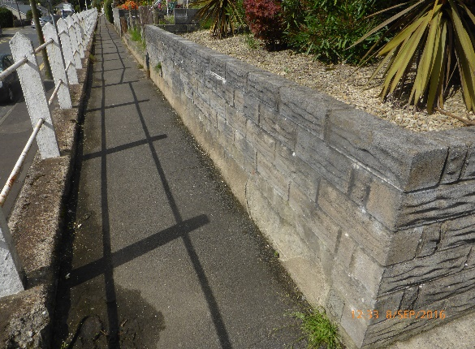
The property boundary is accessed from the public highway and pavement level, via 9no. steps to a second higher level pavement, also giving access to adjoining properties.
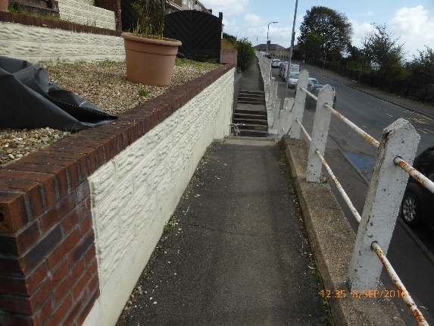

To access the property, a set of 17no. steps are negotiated. These steps are common to the neighbouring semi-detached property and are separated with a handrail.
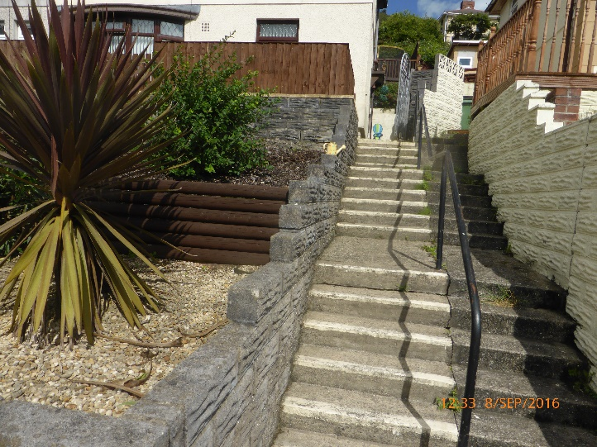
The main door is situated to the right of the property (as viewed from the front) and rear access is also provided via a fundamental lean-to at the rear and then to the rear door.
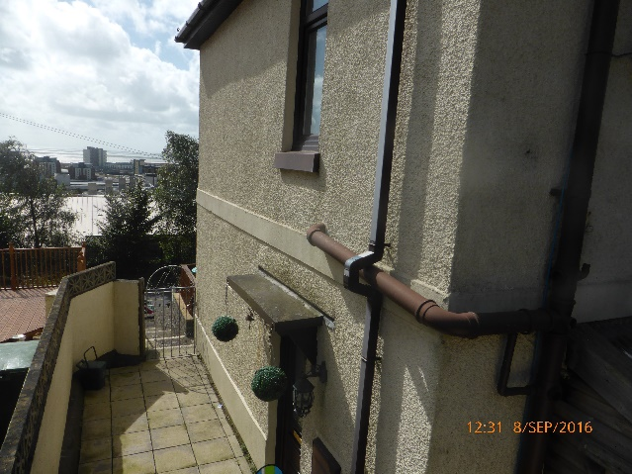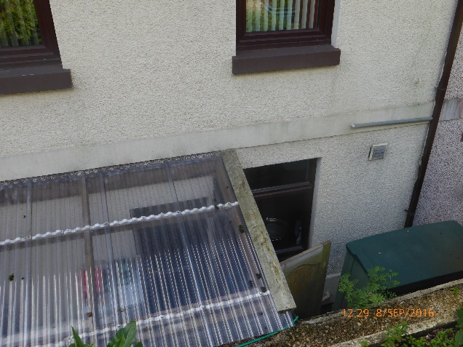

Construction
The construction comprises a cavity wall and externally applied wall insulation with rough cast cement render (date undetermined). The roof comprises a traditional ‘cut-roof‘, hip construction with slate forming the main covering with ridge tiles on each of the junctions. The shared chimney has had the pots removed. Due to its height we could not access the top of the chimney.
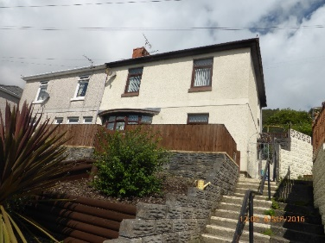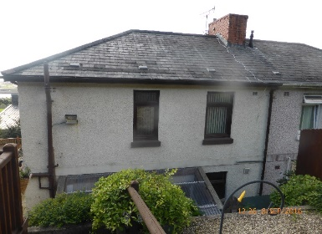

Exterior

Roof – Rear Elevation
The roof covering comprises riven slates with concrete ridge tiles. Some of the tiles are cracked, broken on the edges and some slippage has occurred on the rear elevation. The ridge tile bedding is cracked in places. Moss is present in a few small areas.
No vantage point could be gained to view the front roof elevation.

Chimney – Rear Elevation
The chimney is composed of facing brick with a decorative detail overlap on its topmost edge. Chimney pots have been removed. The top of the chimney could not be accessed.
A television aerial is attached to the chimney. Cabling to the aerial from the interior trails across the surface of the roof.
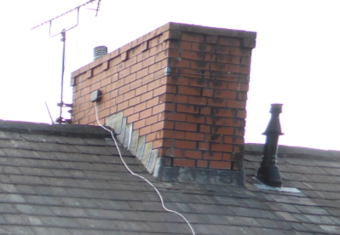

Lead flashing around the chimney is single step but does not meet current standards. The lead should overlap the slate by a minimum of 150mm, including the front apron which should be clipped. The saddle at the ridge should also overlap the ridge tile and have a welted edge.
There is some damage/spalling to the brickwork at the chimney rear corner. The lowest course at the chimney rear at lead flashing level is retaining some moisture and needs further investigation.

Walls
The external walls have been externally insulated and finished with a cement rough cast render aggregate and painted. There is a smooth cement band between floors and above damp proof course level around the property.

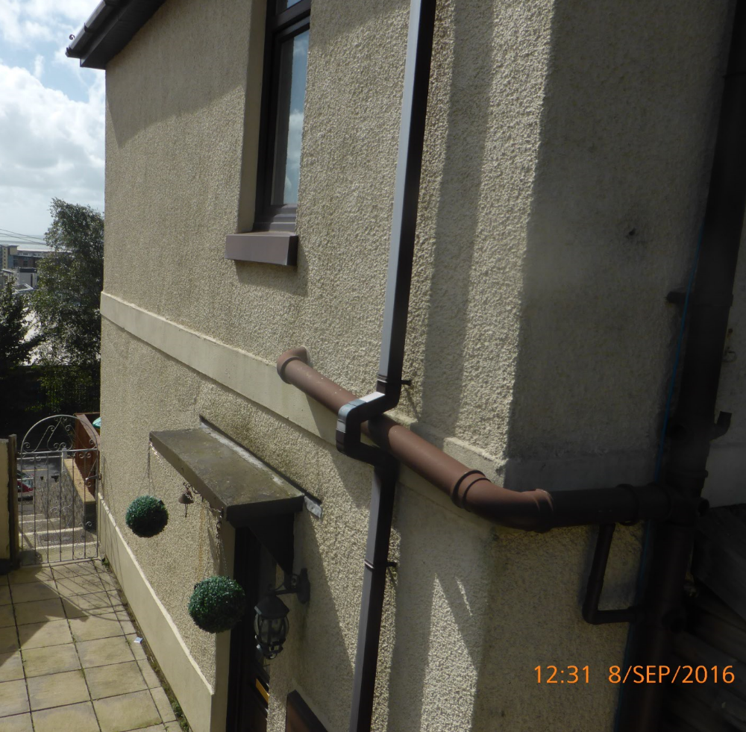

The middle concrete band shows some hairline cracking on the front elevation which continues through the external rendering. Some hairline cracks have been repaired. This requires further
investigation.

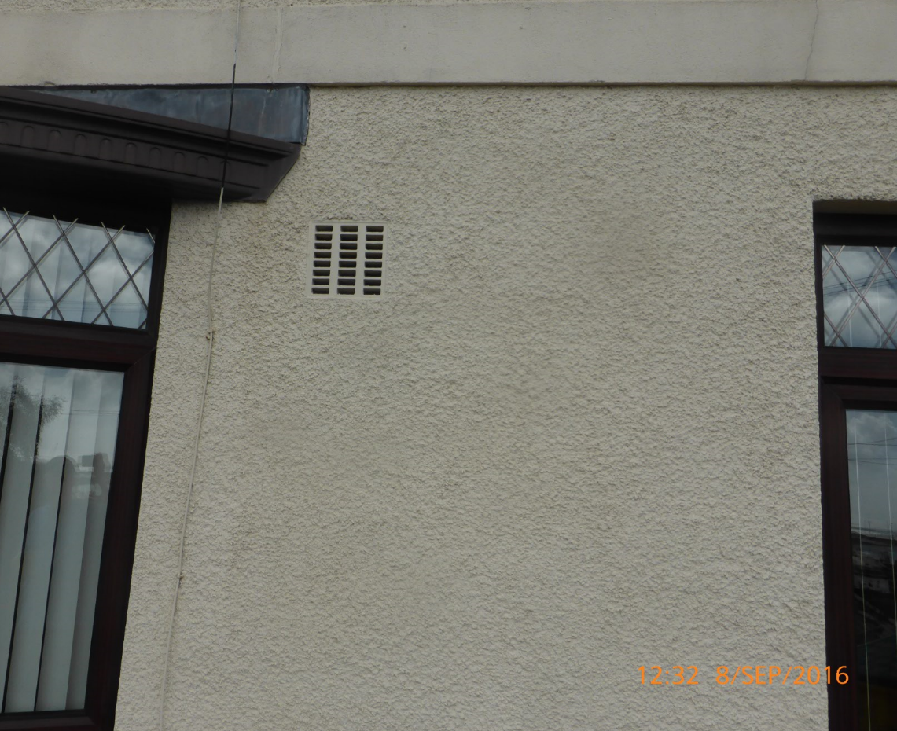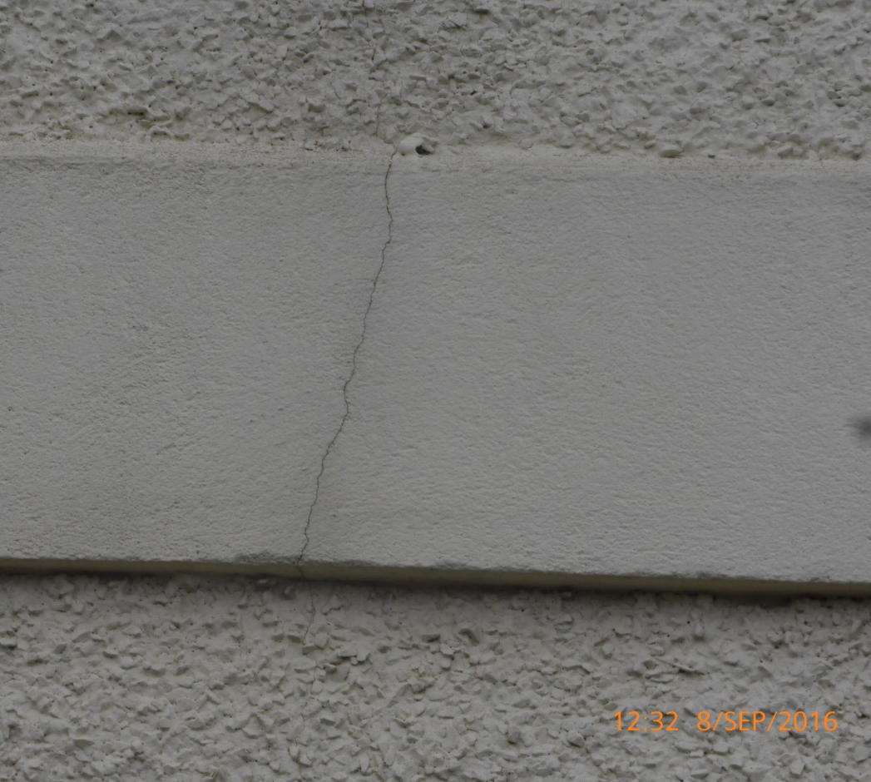
At the side elevation near the front and middle of the elevation, there is evidence of slight bulging in the render just below the horizontal concrete band. The possibility is that this was a repair but needs further investigation.
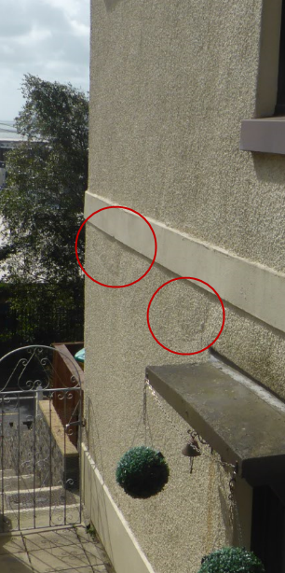

At the junction of the front and side elevations at dpc level there is visible cracking of up to 15mm-20mm wide in places and running down the side elevation for approximately 400mm before becoming a hairline crack. This requires further investigation.

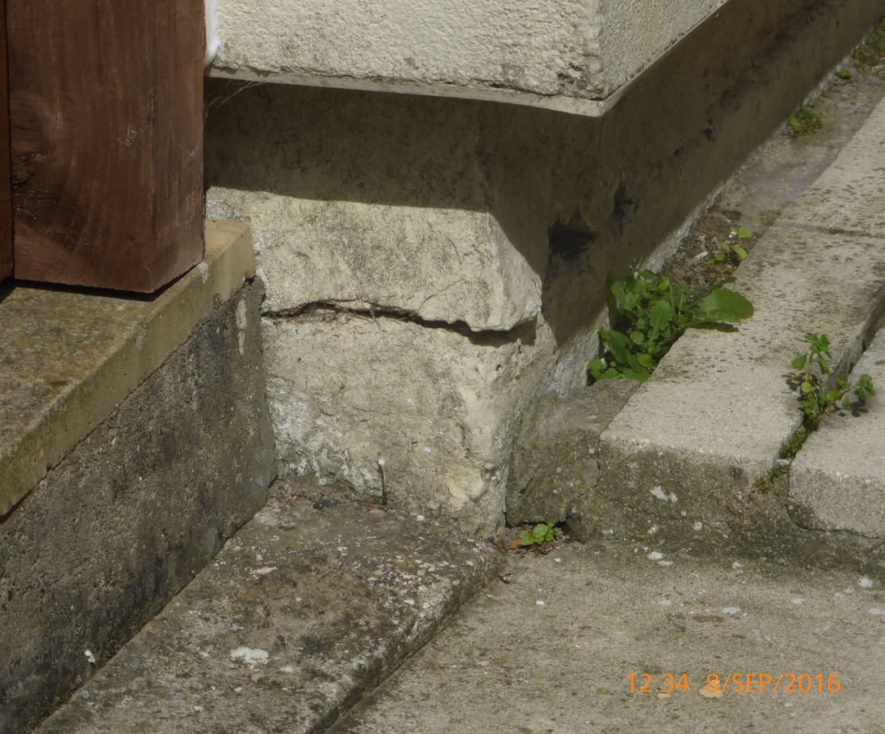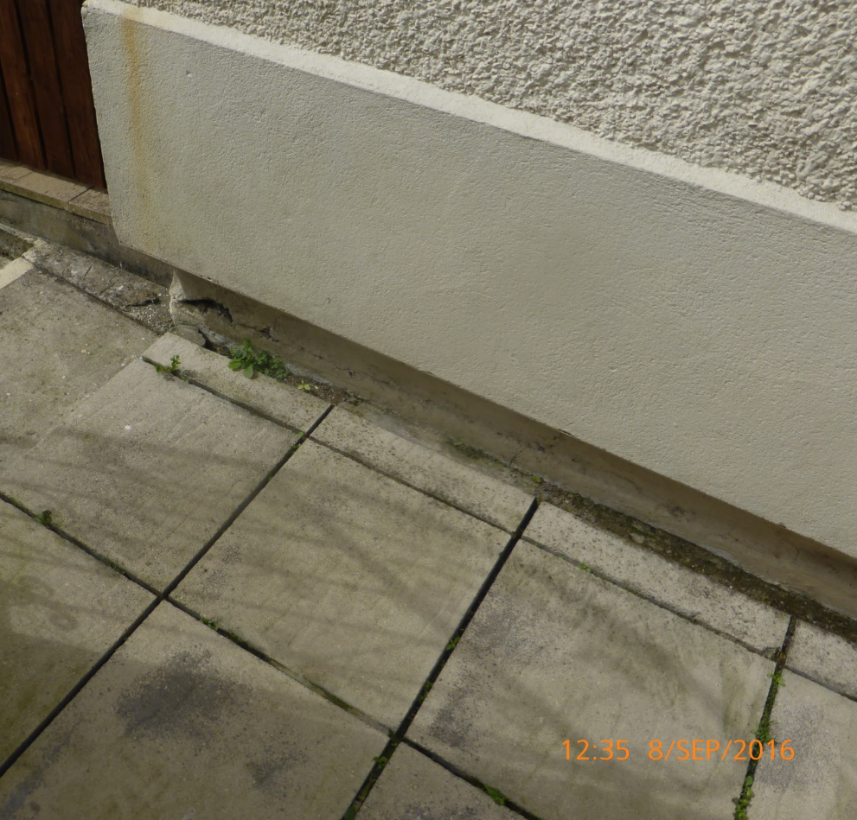
At the reveal of the main door access, left hand side (see photograph, page 13), the shoe retaining the external insulation is projecting downwards. This could allow water ingress and in winter could freeze and exacerbate the issue. This requires further investigation.
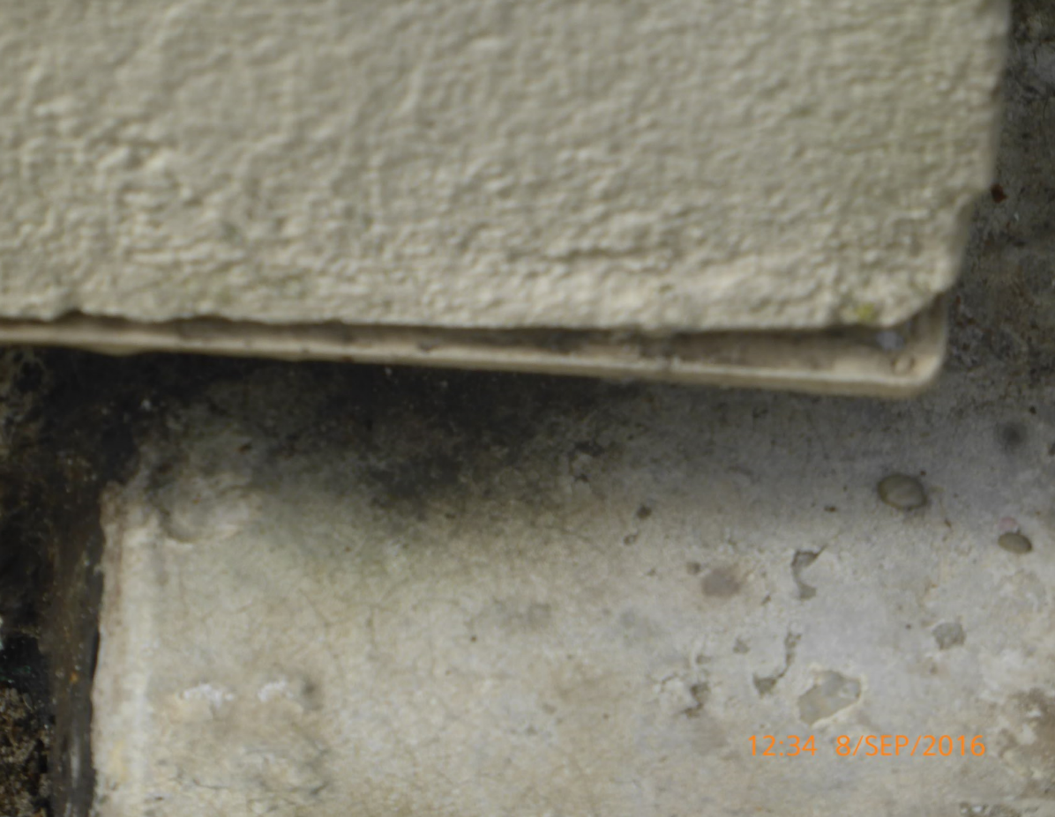

Windows & Doors
Double glazed windows and external doors are of pvc-u construction and are a recent installation (date undetermined) on all elevations, with a dark woodgrain finish. All are in a good condition.
With the exception of the front bay window, aluminium sills have been added over the existing
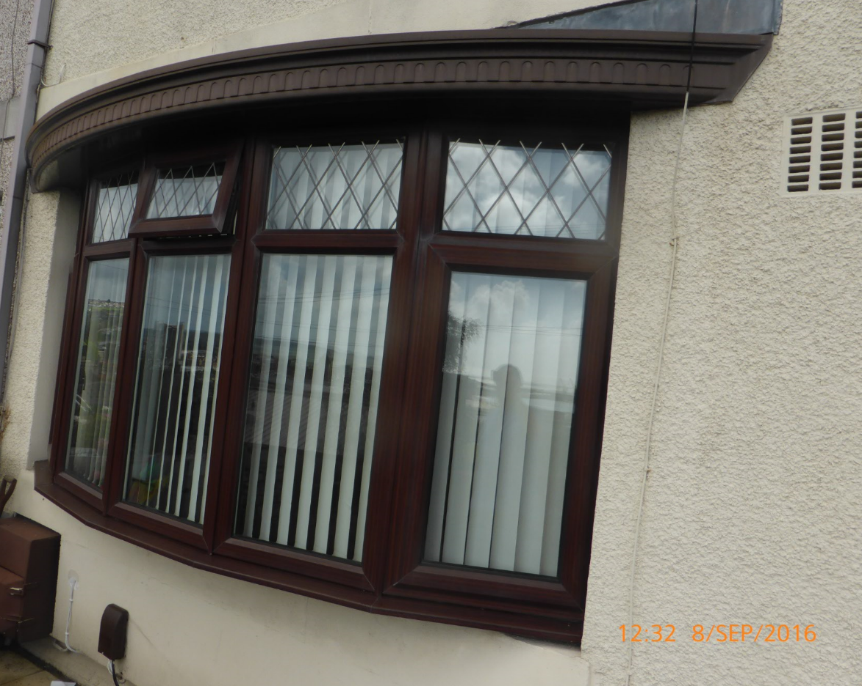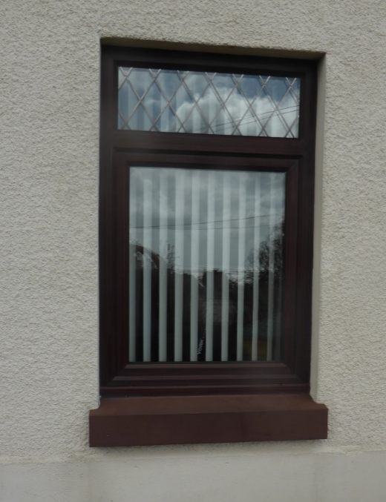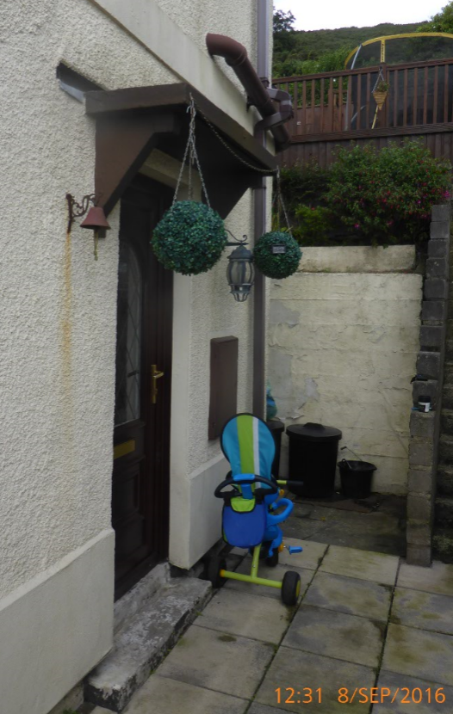

sills and painted. An original concrete canopy is present above the main entrance.
Wall vents are present on front and rear elevations and, internally, some vents are in the closed position and painted over which prevents operation. This requires further investigation.
A cooker hood extractor is present in the rear elevation to the right of the kitchen window (see photograph, page 14). The vent orifice is too large for the vent and there are gaps around the vent allowing the ingress of moisture. This requires further investigation and rectification with appropriate sealing.
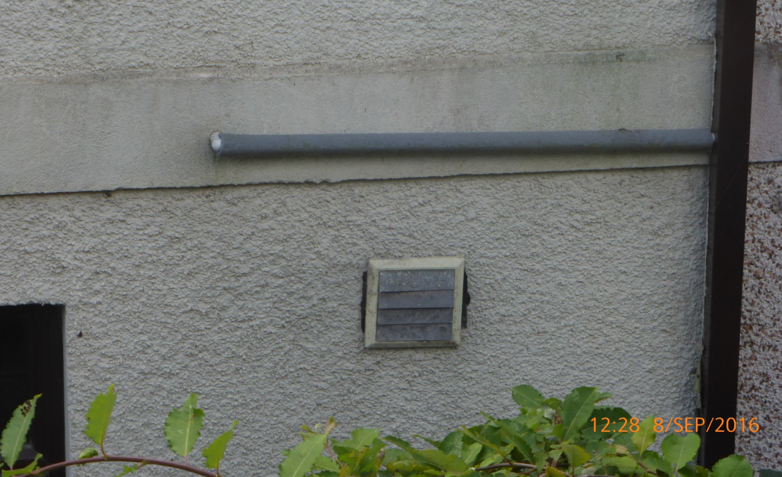

The rear elevation has a high wattage spotlight to illuminate the rear of the property. The light is operable from inside the lean-to where the end of the cable is plugged into a socket. THIS IS HIGHLY DANGEROUS AND SHOULD NOT BE USED. It is recommended that this wiring is checked by a qualified operative.
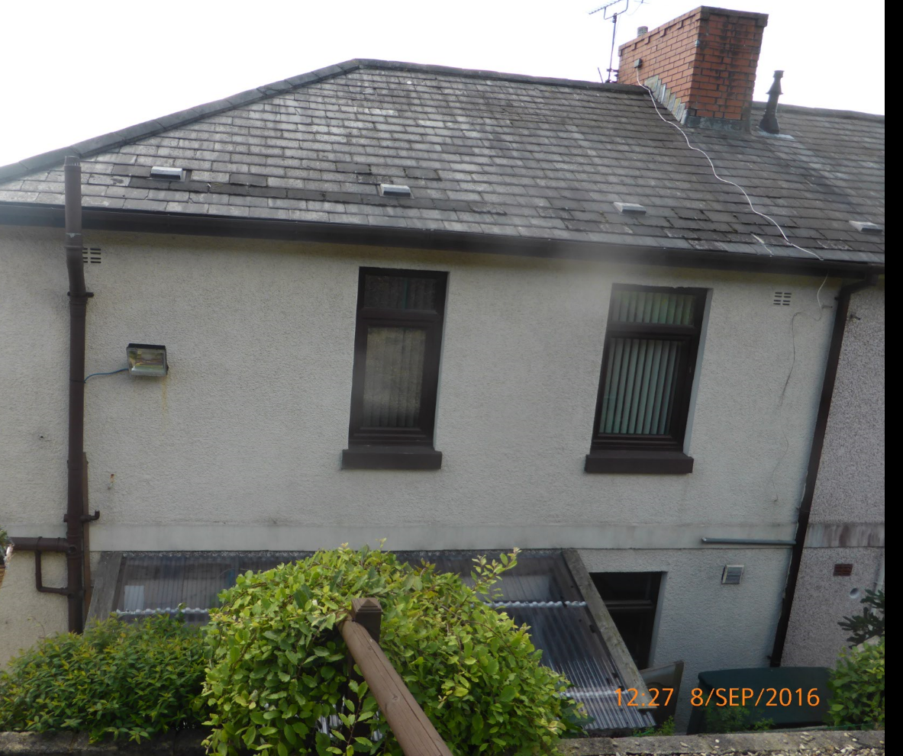

Eaves, Soffits, Guttering & Rain Water Pipes
All eaves, soffits, guttering & rain water pipes are of pvc-u construction in a dark brown colour to match the windows and doors. All are in good condition. The rain water pipe on the front elevation at the boundary with the semi-detached neighbour is severely faded due to solar exposure.

External Pipes
The soil and vent pipe and other waste pipes are external, and, as would be expected of a property of this era, is of the single-stack type installation. Boss connections and reducer inlets are in use. The soil & vent pipe is topped with a perforated cover and the soil & vent conforms with current regulations regarding minimum height above opening windows (Approved Document Part H, Drainage & Waste Disposal, The Building Regulations 2010).
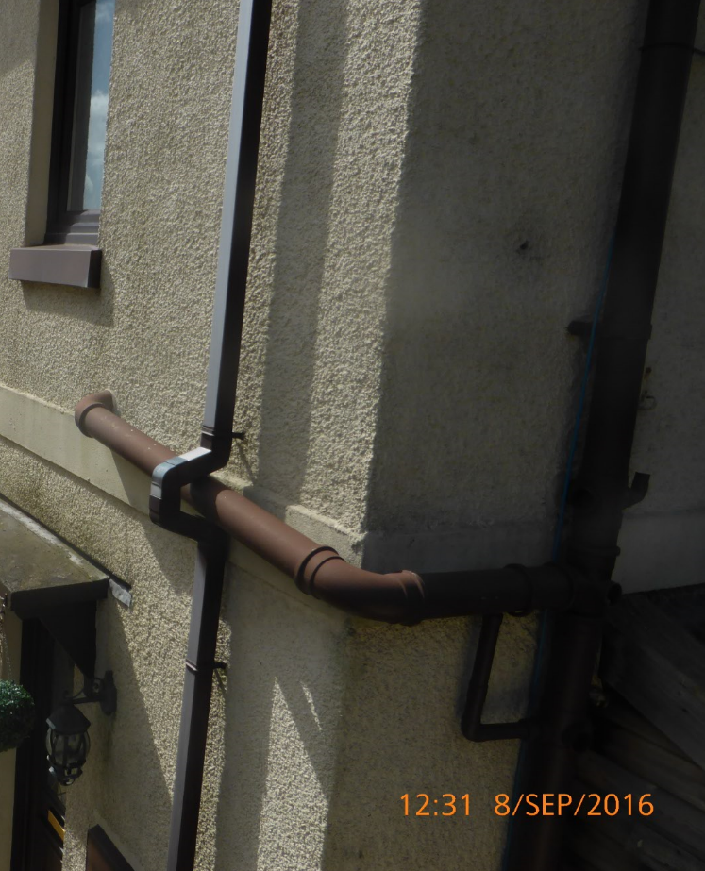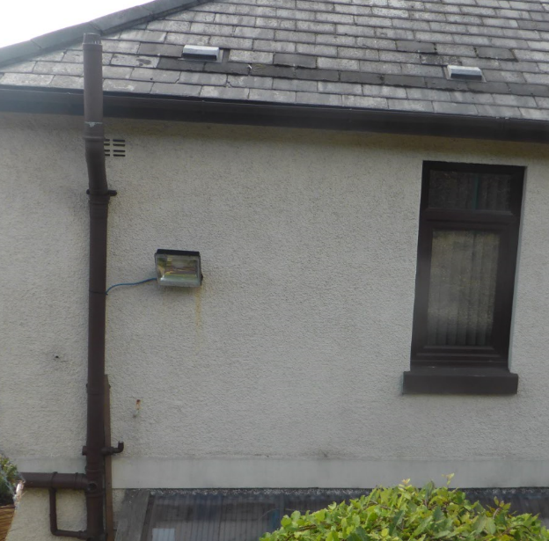

Front Garden
The front garden is terraced and retained with semi-dressed effect concrete blocks to the lower level which forms the front garden boundary with the upper level pavement. The upper level adjoining the patio is constructed similarly.
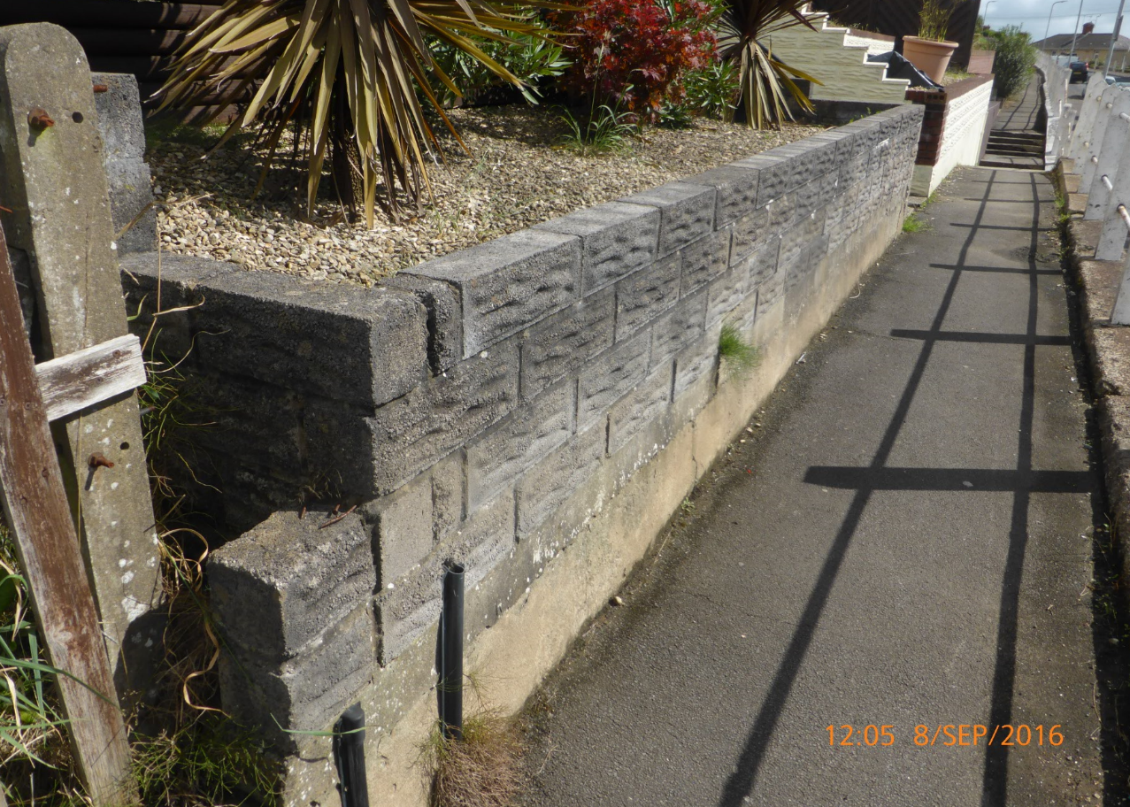
The left hand boundary comprises stepped concrete blocks alongside, what is assumed to be, the original concrete post and chain link fence boundary. Your legal advisor should determine if this is the property boundary. The chain link is in need of some maintenance.
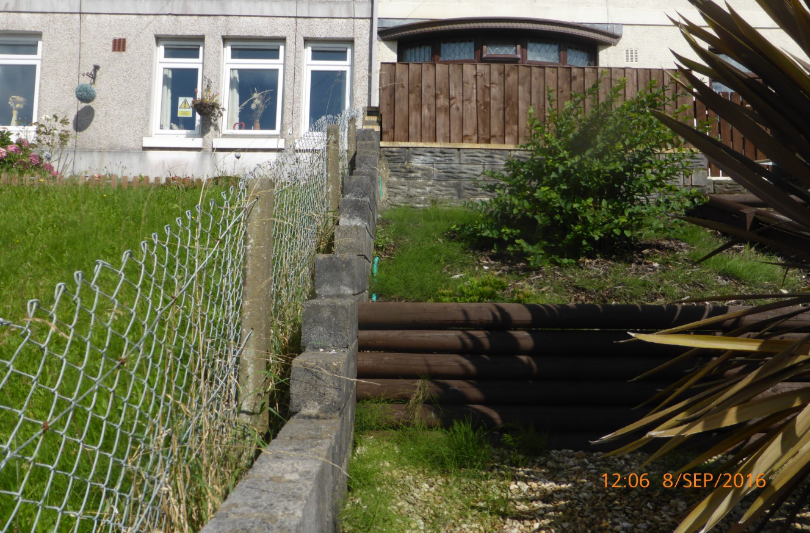
The right hand garden boundary wall, again, is semi-dressed effect concrete blocks and adjacent to the steps. The middle of the steps (looking at the front of the property) is separated by a tubular steel handrail. Your legal advisor should determine if this is the property boundary.
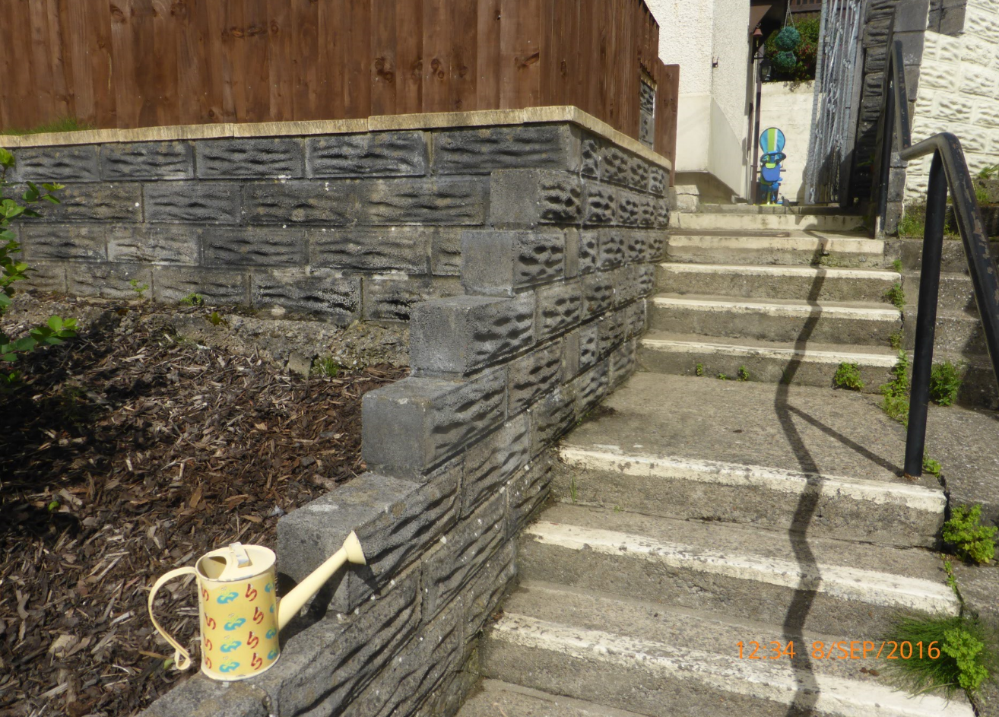
There is some cracking to the steps and, if left untreated, could cause further damage with the ingress of water and subsequent freezing. Weed growth needs to be eradicated.
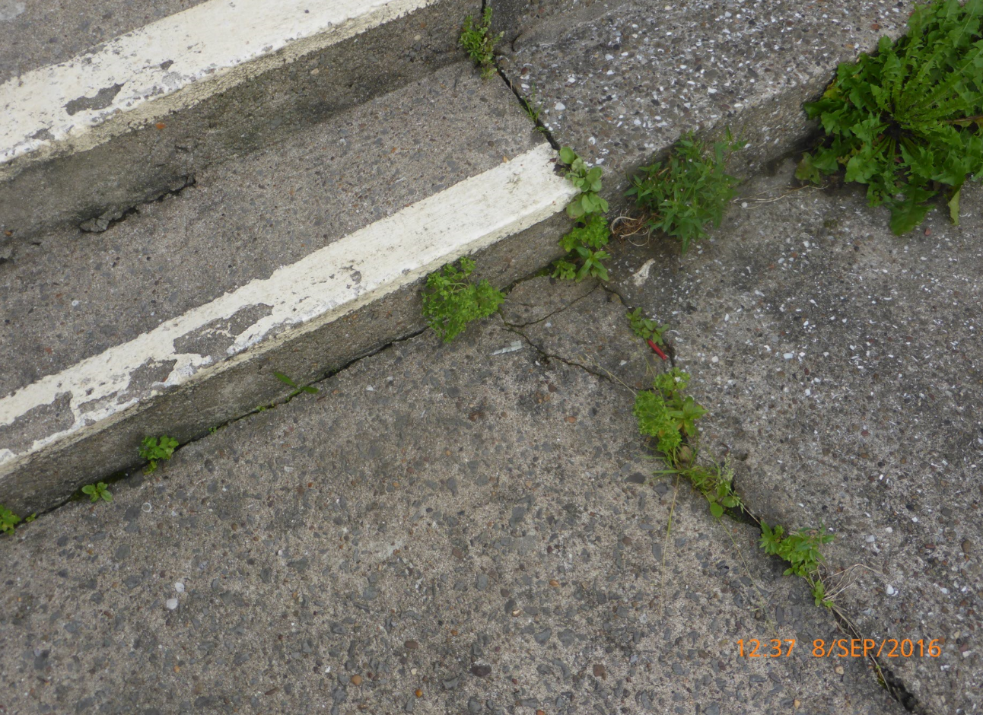

Rear Garden
The rear garden has been recently terraced (date undetermined) and timber decking has been constructed to form 2no. areas.

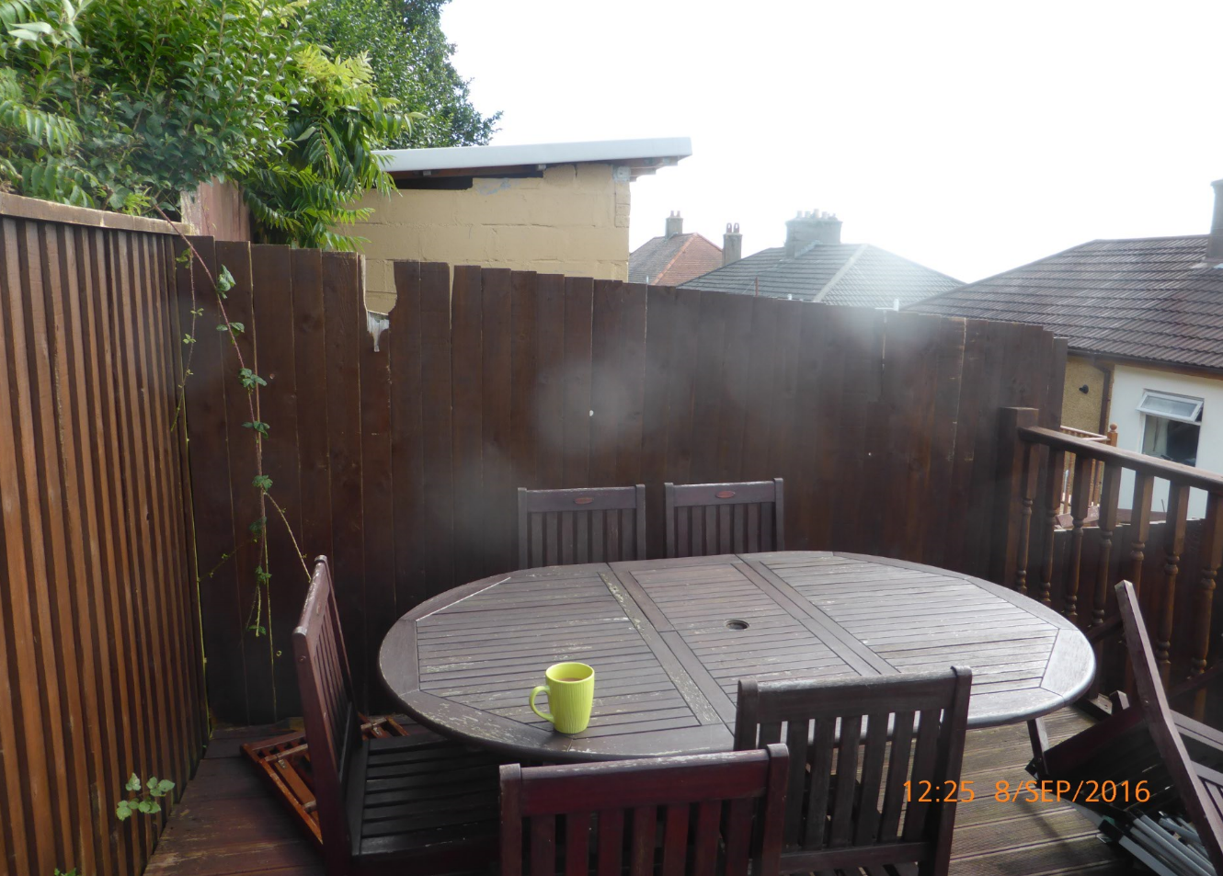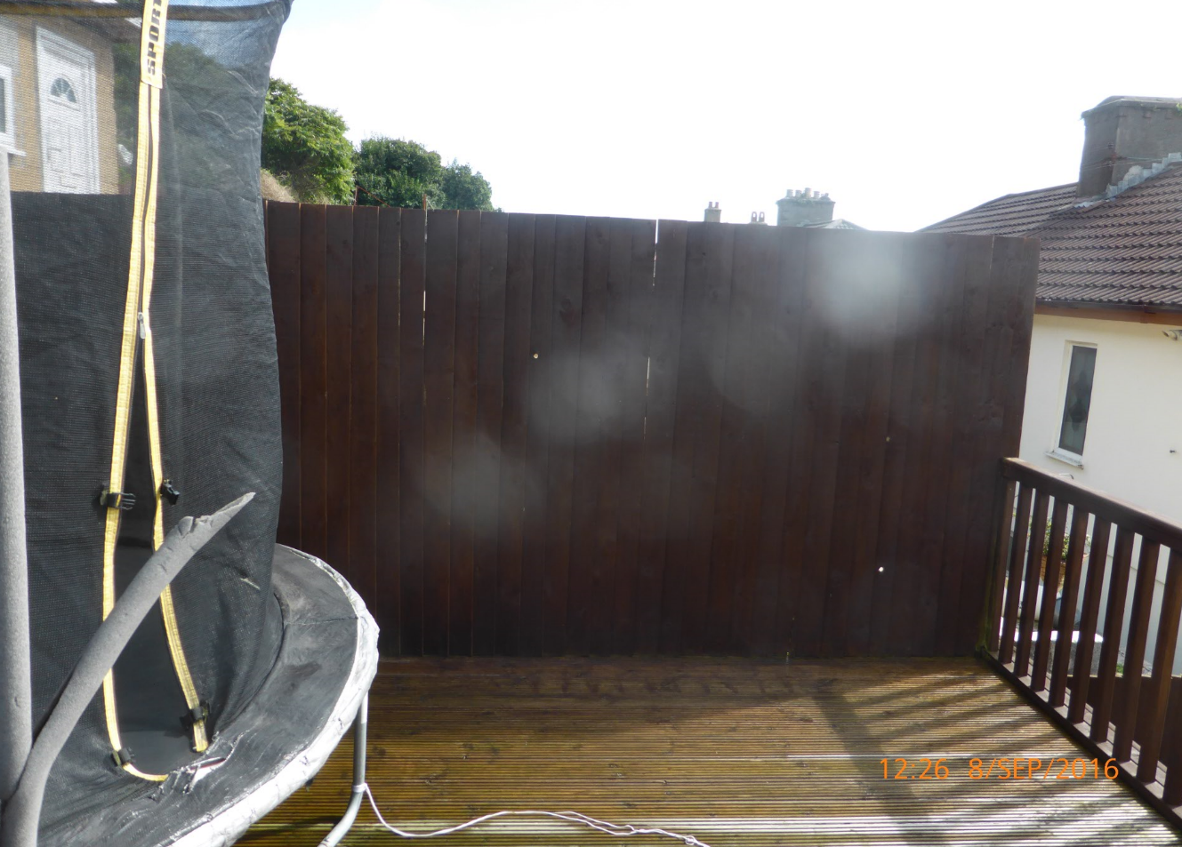

Boundaries
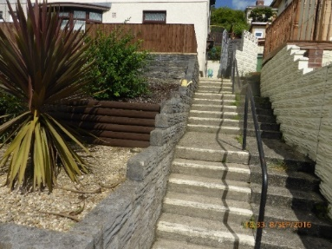
Front

Sides
The right hand side boundary (as viewed from the front of the property) is possibly the tubular steel handrail. Your legal representative should ascertain this. The handrail ends at a smooth rendered and painted wall with feature concrete blockwork on top.
At the angled junction, adjacent to the steel entrance gate, a 1mm-2mm crack in the wall is evident.
This requires further investigation and checked for stability.
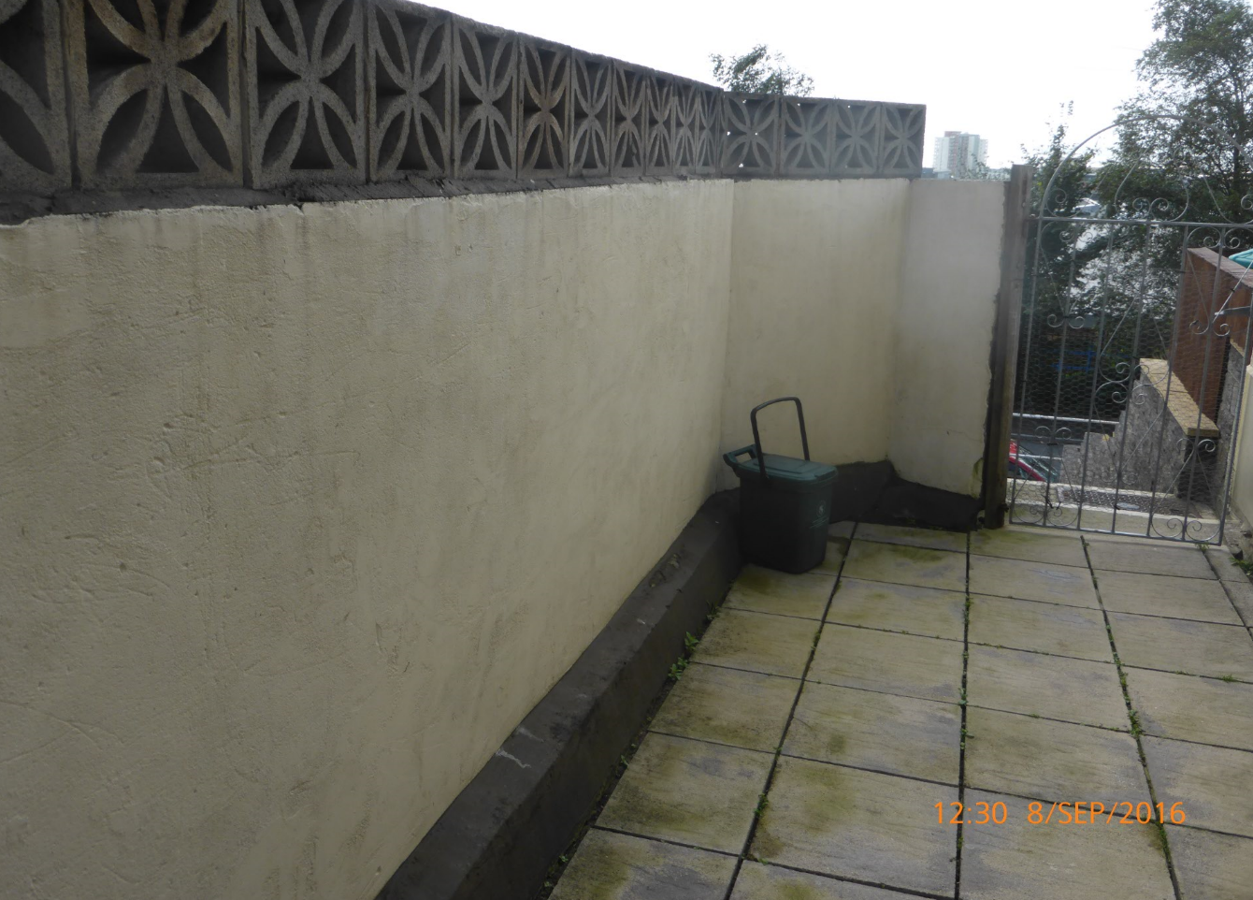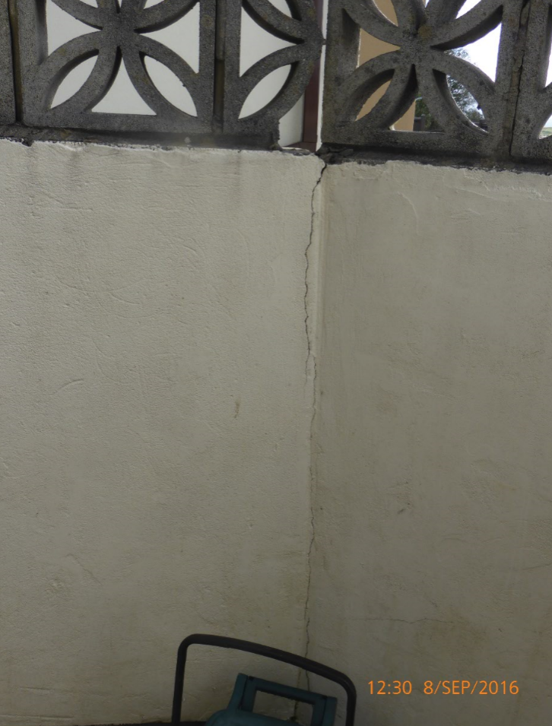
At the boundary adjacent to the 2no. deck areas, a secondary feather-edged board fence has been erected. This stands off the neighbouring concrete block low level wall by approximately 100-150mm. Your legal representative should confirm that this block wall is the boundary between the two properties.
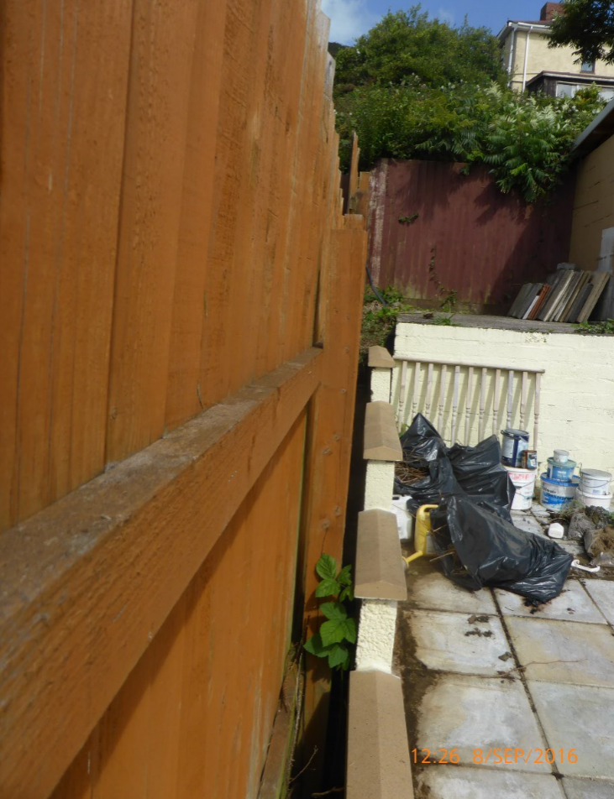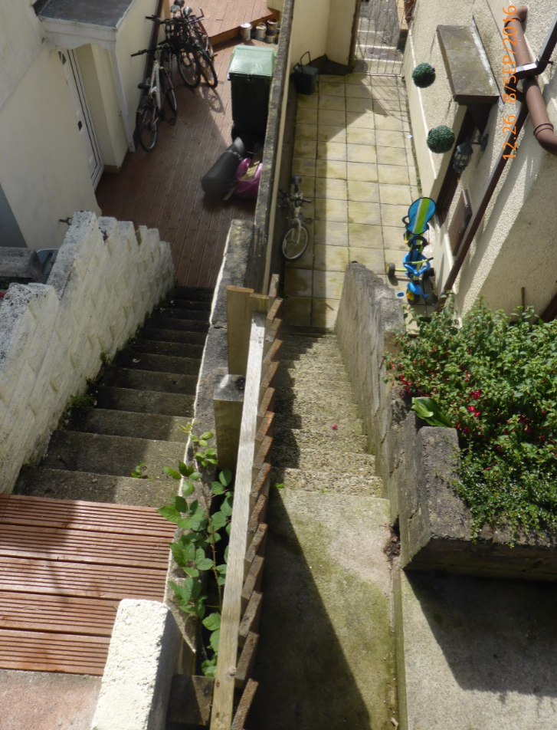

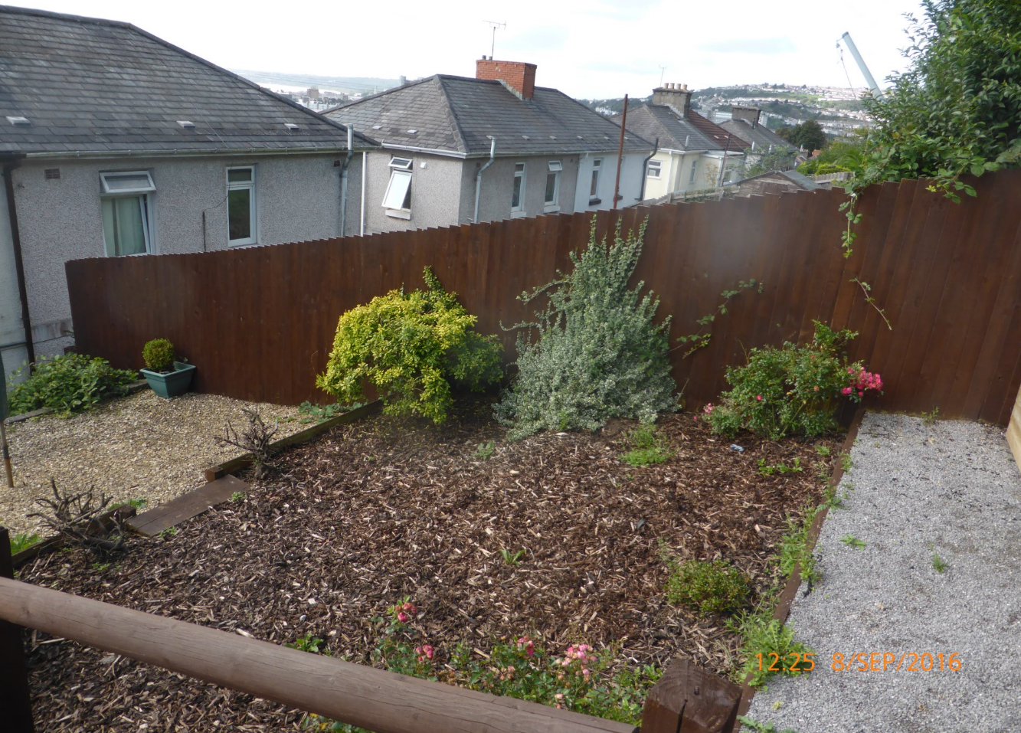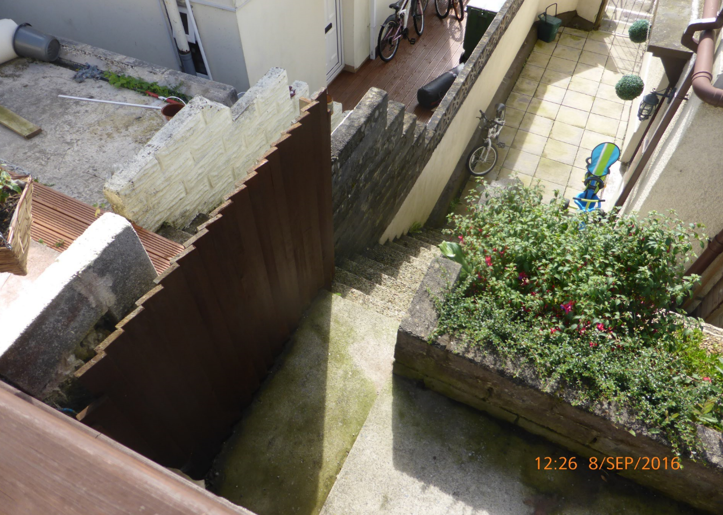
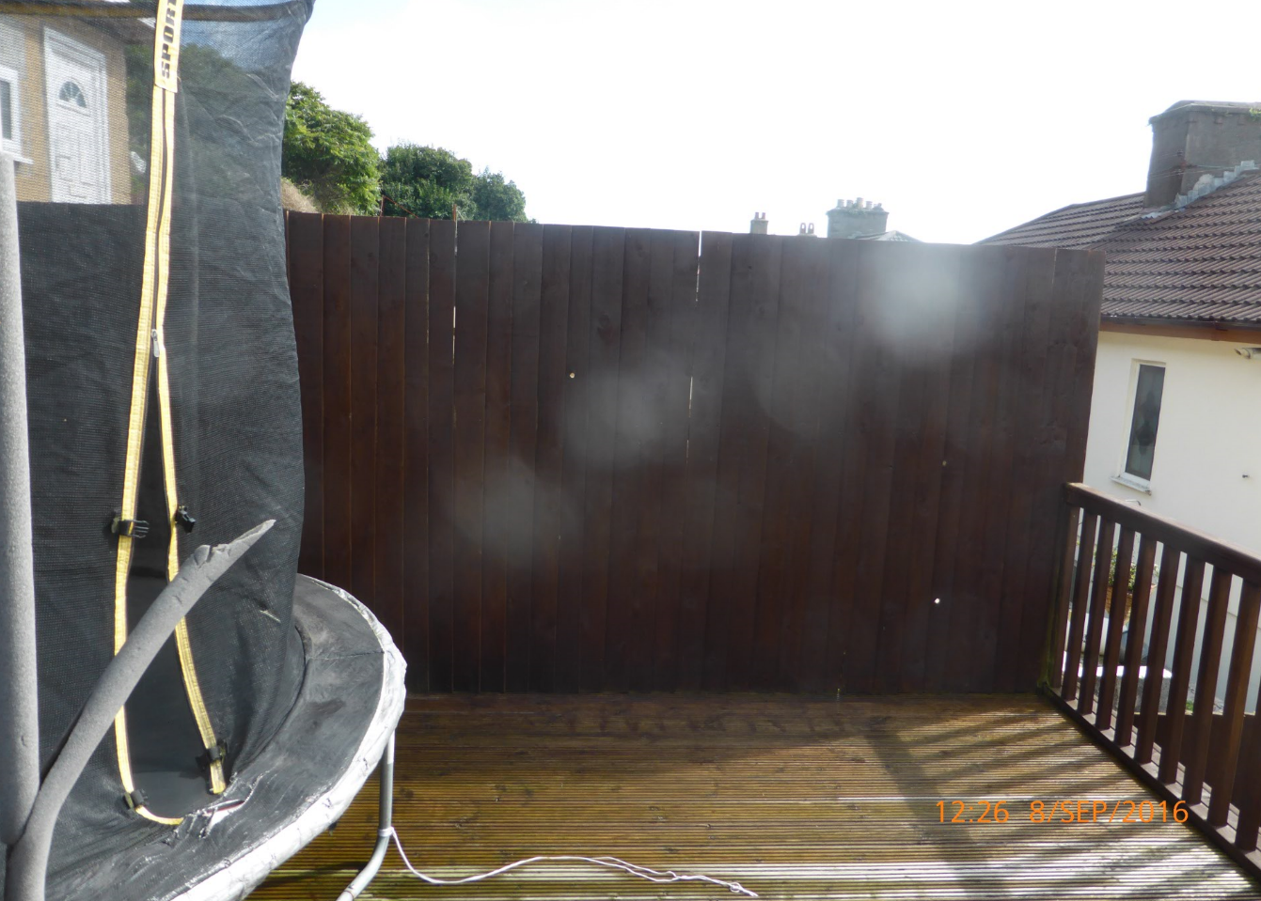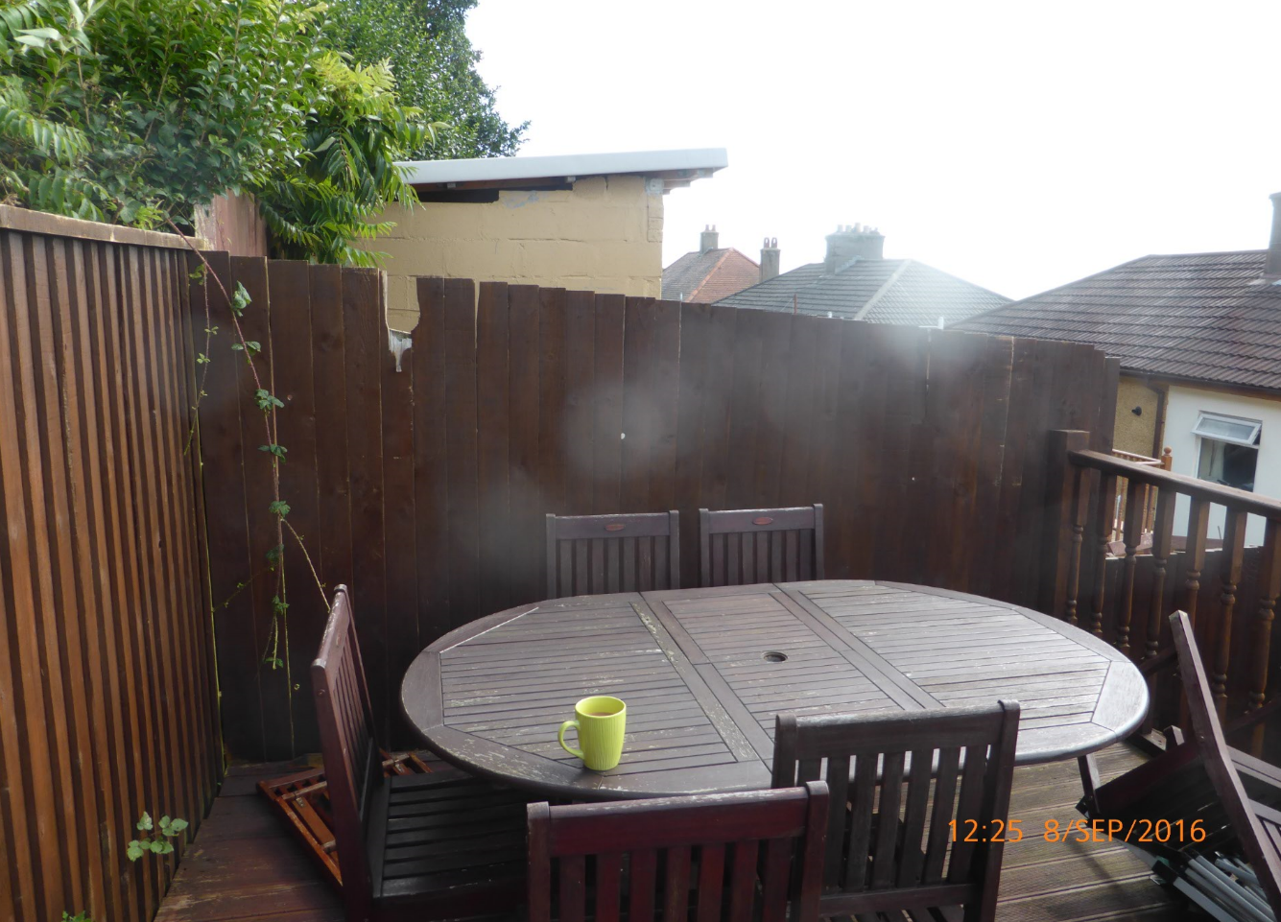
Rear
The rear boundary has undergone the same development as the left hand boundary with timber feather-edged boarding approximately 1.8m in height. Your legal representative should check that this fence is the actual rear boundary of the property.
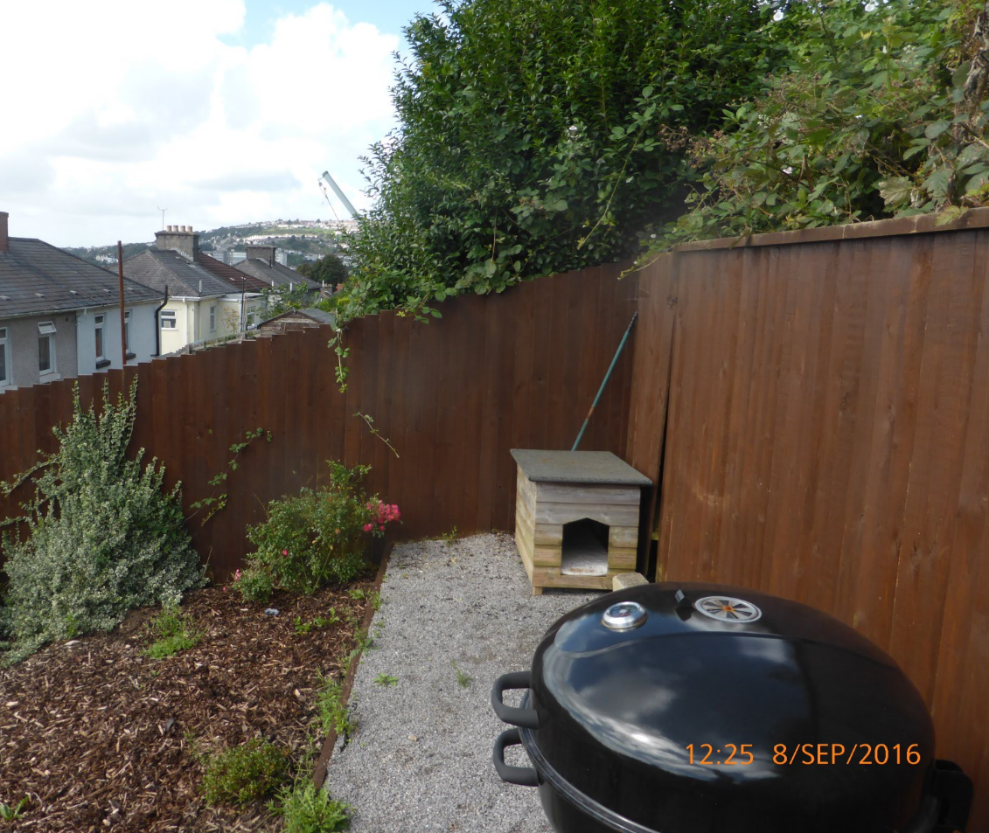

Interior

Floor

Hall
Leading off the hall is a store, entrances to dining room and kitchen, and stairs to first floor. The entrance hall has skimmed painted walls and ceiling with stained skirtings and vinyl flooring. The electrical consumer unit is to the left and above main door.

Dining Room & Lounge
The dining room and lounge have artexed ceilings and are in good condition, plastered and painted walls with laminated/hardwood timber flooring continuing into the lounge area. Original fireplaces have been removed and sealed. There is a vent present in the dining room fireplace and an electric fire on the lounge chimney breast. A ceiling level vent is present in the lounge. Radiators have thermostatic valves fitted.
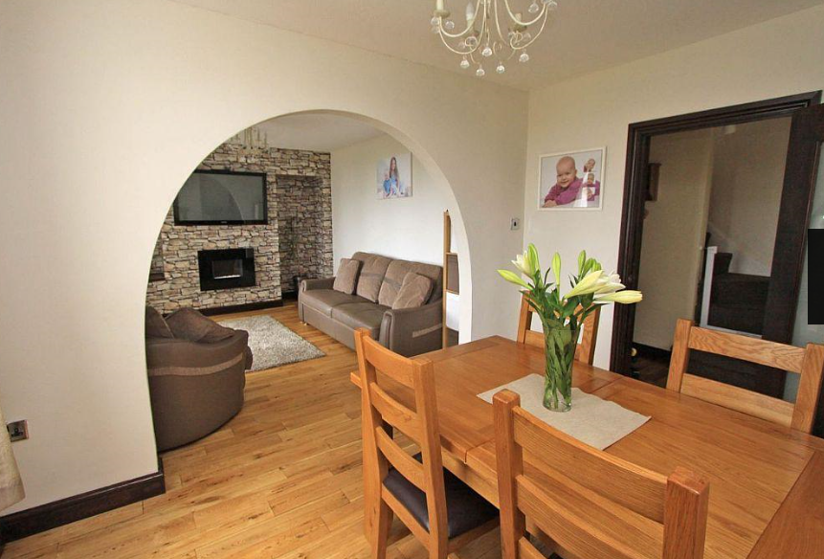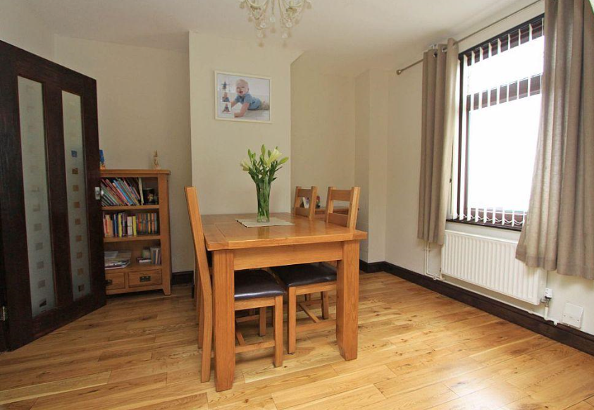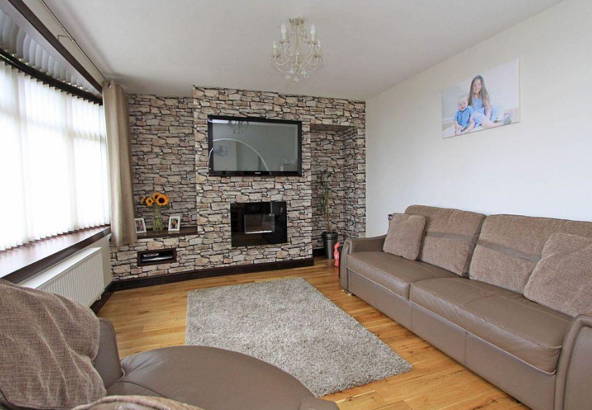

Kitchen
The kitchen units comprise timber floor and wall units. The ceiling is of artex finish and the floor has a vinyl floor covering. A pantry/store exists under stairs. The underside of the stairs has tongue & groove boarding painted white. The walls are plastered in the under stairs store and could be the original finish. An extractor hood exhaust above the hob is connected to an exterior vent.
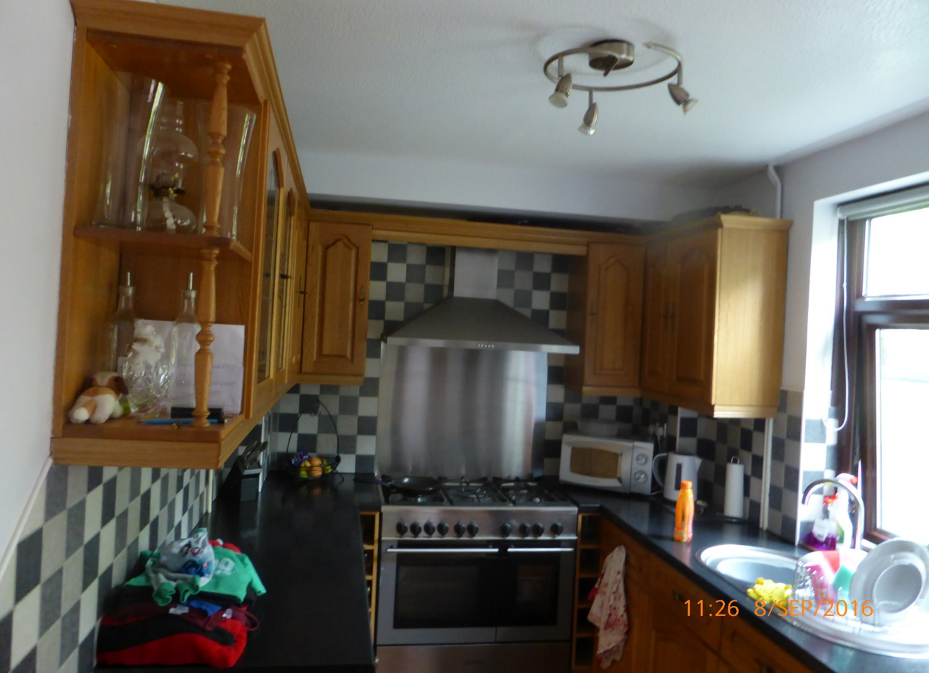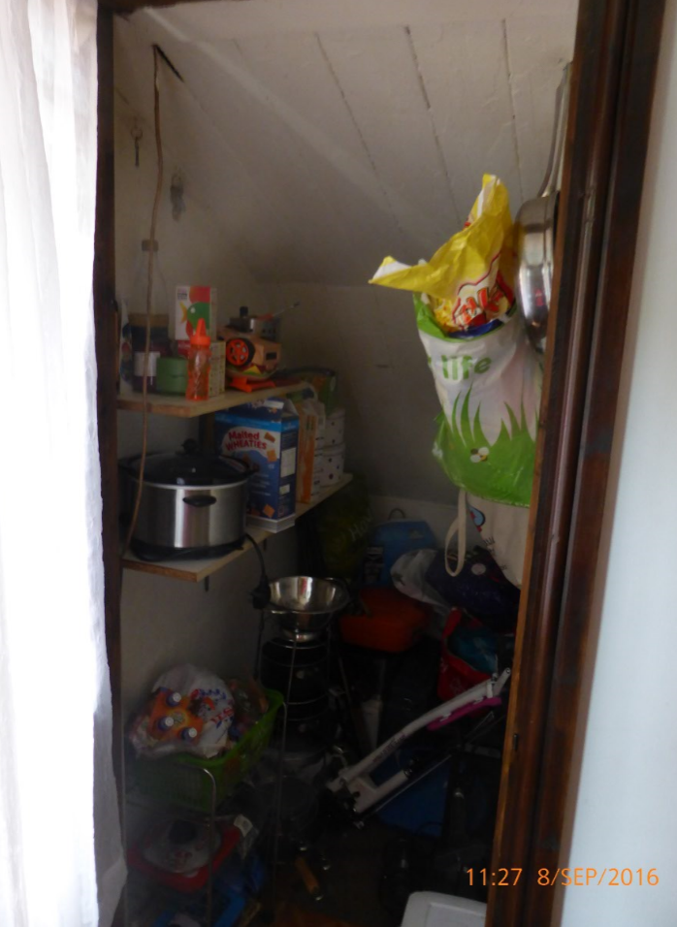

Lean-to
The lean-to at the rear of the property utilises the rear retaining garden walls as its rear wall. This wall slopes backwards and has been painted. The paint is peeling on this wall because of the moisture present in the concrete blocks.
The lean-to has a roof covering of corrugated translucent plastic sheets on timber rafters. Both ends of the lean-to have doors exiting to the exterior. The floor is of timber suspended construction with sleeper timbers resting on the external concrete path.
There is considerable ingress of moisture due to the rudimentary construction, and is to be considered as a temporary structure. All of the timber in the lean-to is saturated with moisture to varying degrees.
The presence of electrical equipment such as washing machine and tumble dryer, gives rise to serious concerns regarding electrical safety and the use of electrical equipment in this area should cease with immediate effect and until it can be checked by a competent and qualified person.
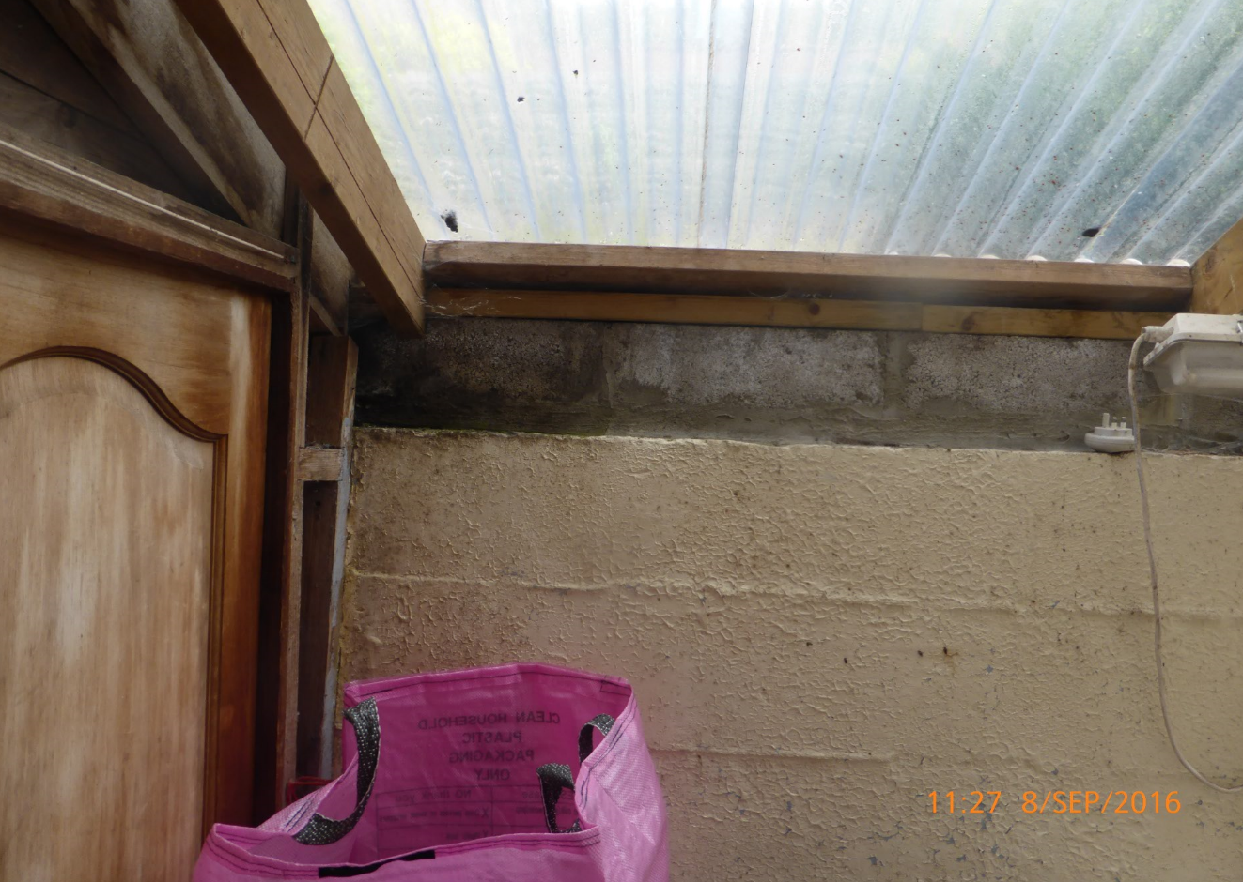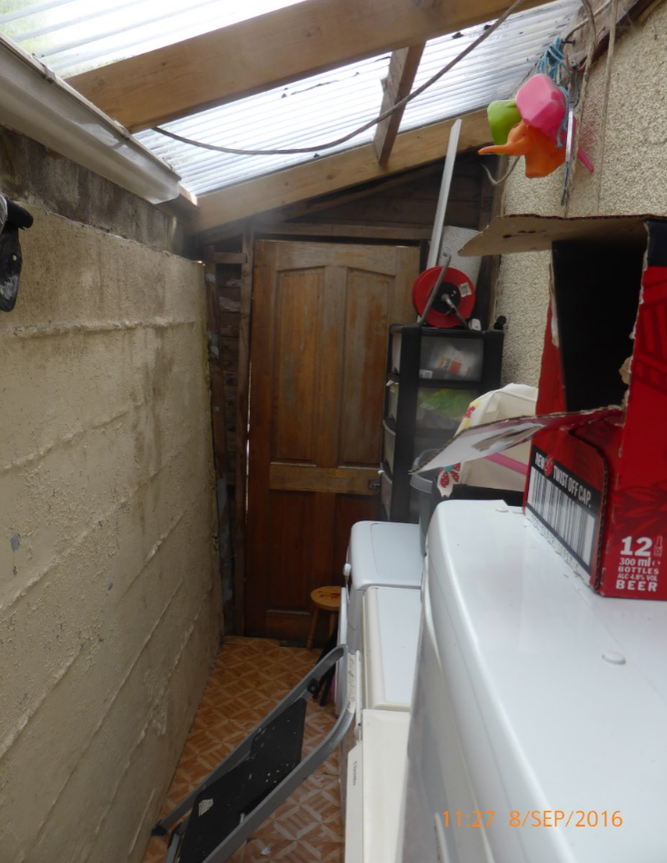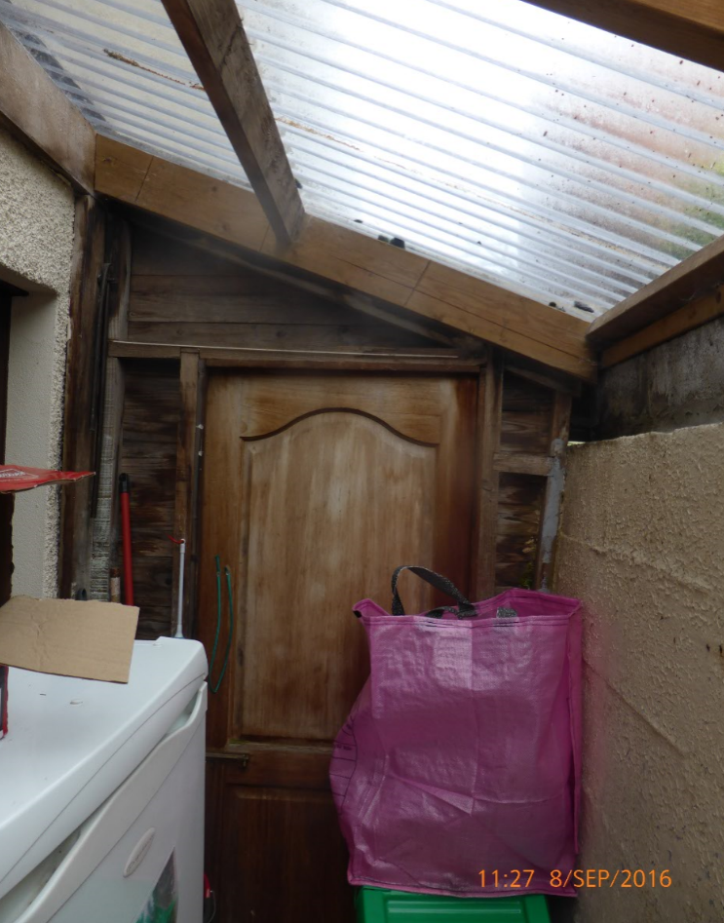

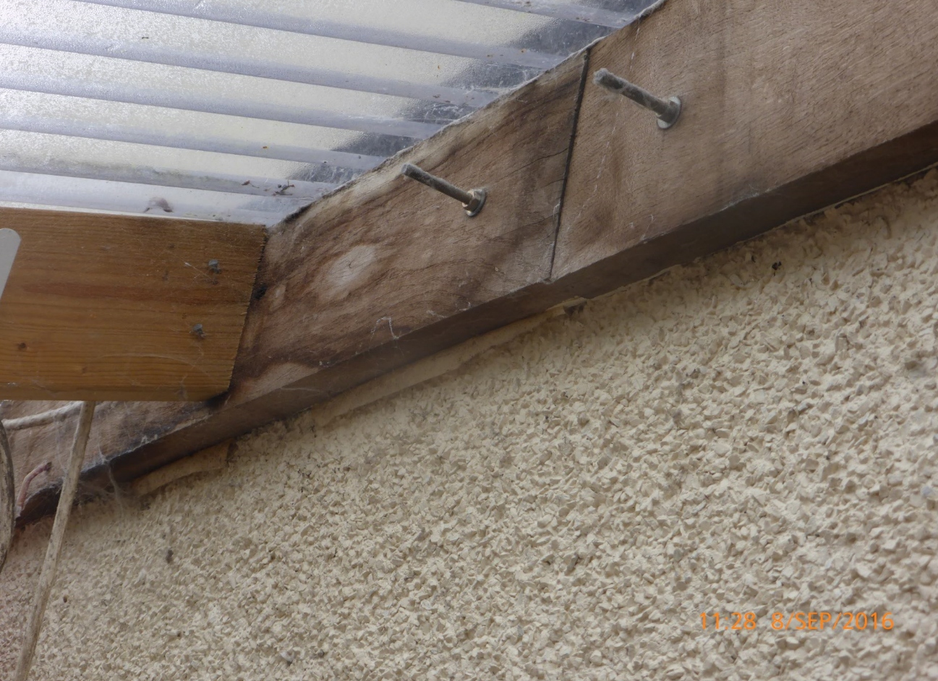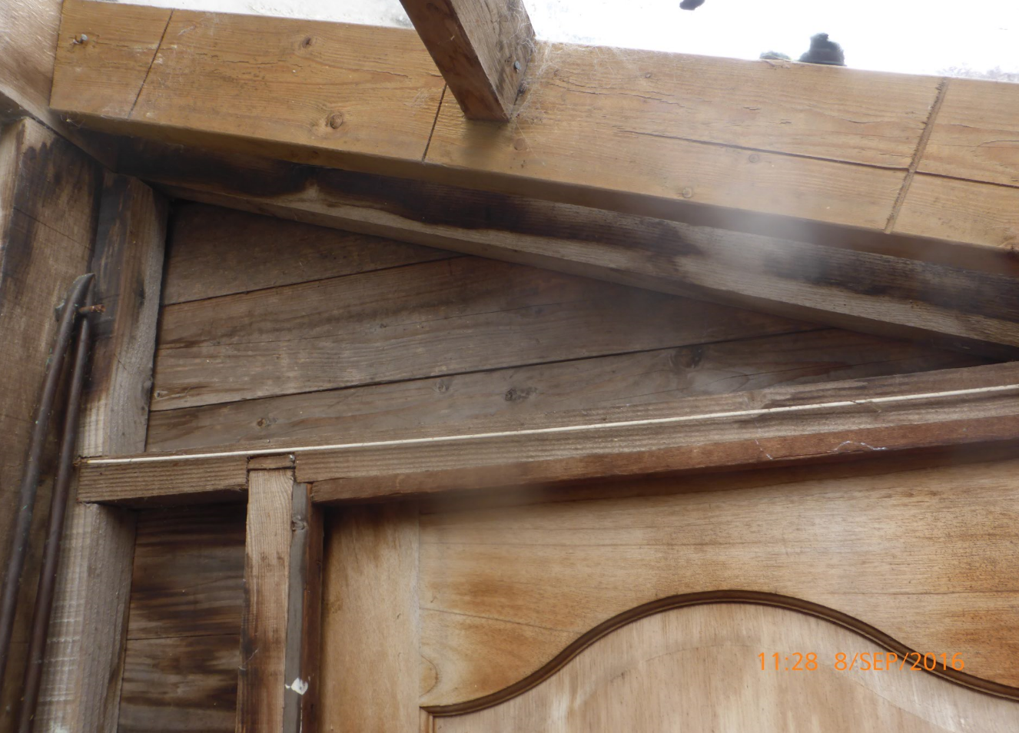

Stairs
The stair walls are plastered and painted and a rear window is in place at the top of the stairs. The winder type stairs are carpeted and open onto the first floor landing. The stringer, newel post and balustrade are painted in gloss white and are likely to be original.
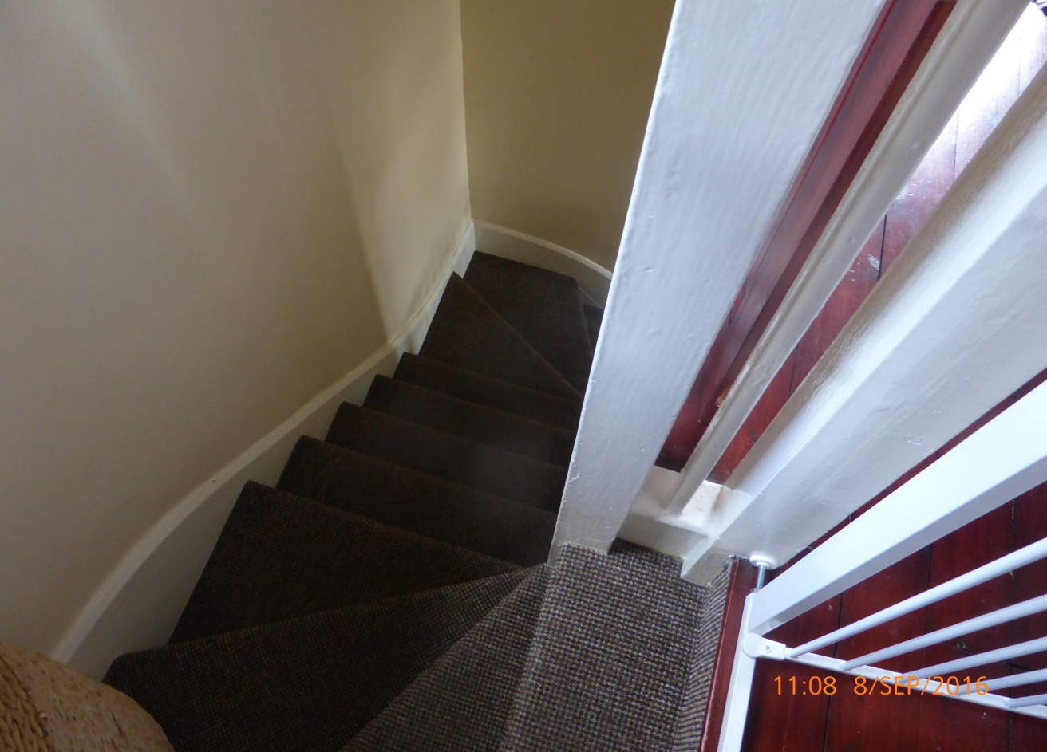

First Floor
The flooring to the whole of the first floor comprises exposed and stained timber floorboards. It is likely that these are original floorboards and are fixed down adequately with no movement.
All woodwork, including doors have been stained.

Master Bedroom
The master bedroom to the front of the property has an artexed ceiling with some hairline cracking which needs further investigation. The walls are plastered and painted. It is likely that the original chimney breast has been removed and replaced with a fitted closet.
This bedroom houses the airing cupboard with a gas combi type boiler installed.

Bedroom 2
Bedroom 2 to the front of the property has an artexed ceiling and the walls are plastered and painted.

Bedroom 3
Bedroom 3 to the rear of the property has an artexed ceiling and the walls are plastered and painted. The original fireplace is not present in the chimney breast and has a vent placed at low level.
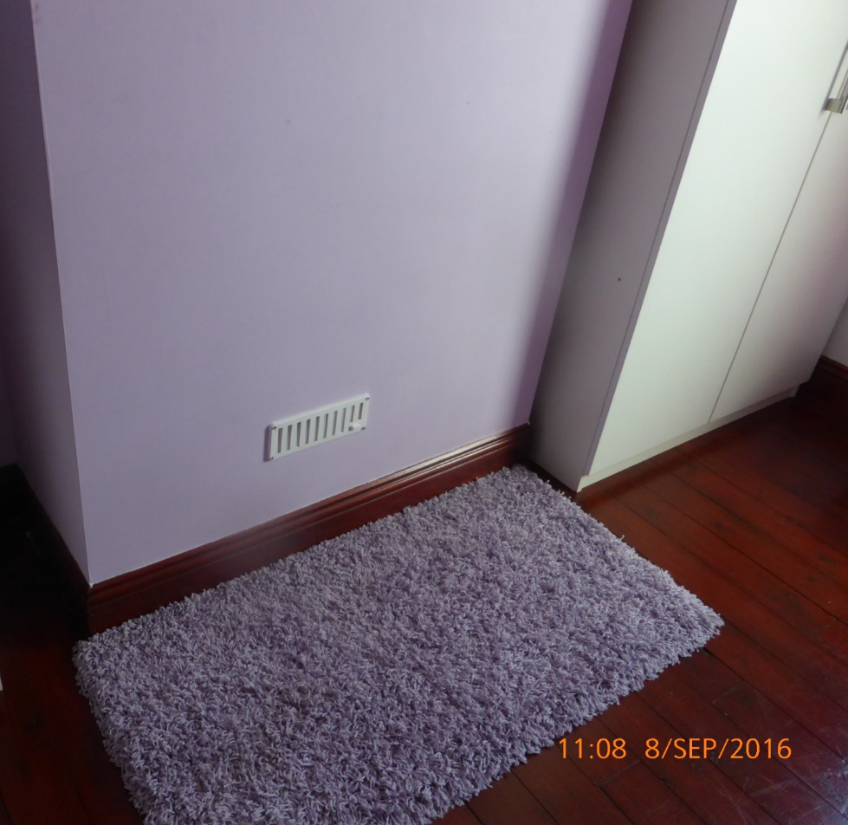

Bathroom
The bathroom houses a modern type suite with full tiling on the bathroom surround and half wall tiling elsewhere. The ceiling is smooth skimmed plaster and painted. The vent to the exterior, situated above the bath corner has been tiled over. There is no electrical extraction present.
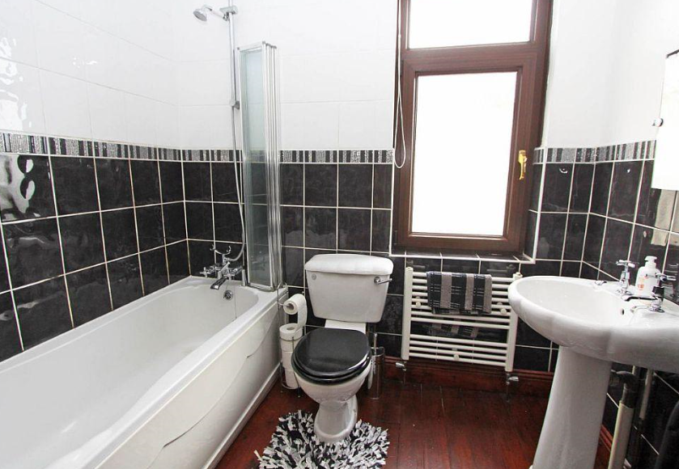

Loft
The loft space contains insulation between the joists but, by current standards, is inadequate. The insulation should be increased to 270mm thickness and laid across the joists.
At some point there has been some water ingress which is evident with water staining at ridge level. This water intrusion may still be occurring and requires further investigation as there is some timber wet rot in evidence.
The party wall also shows some water staining and requires further investigation.
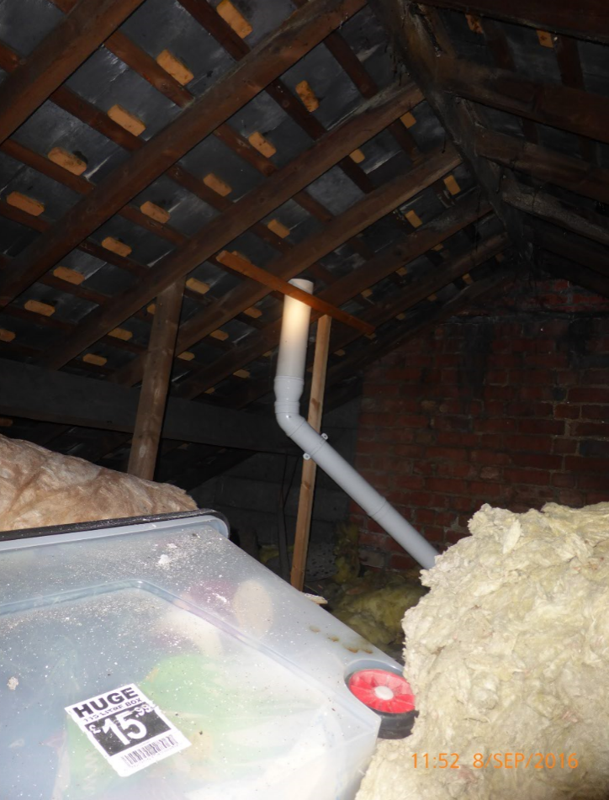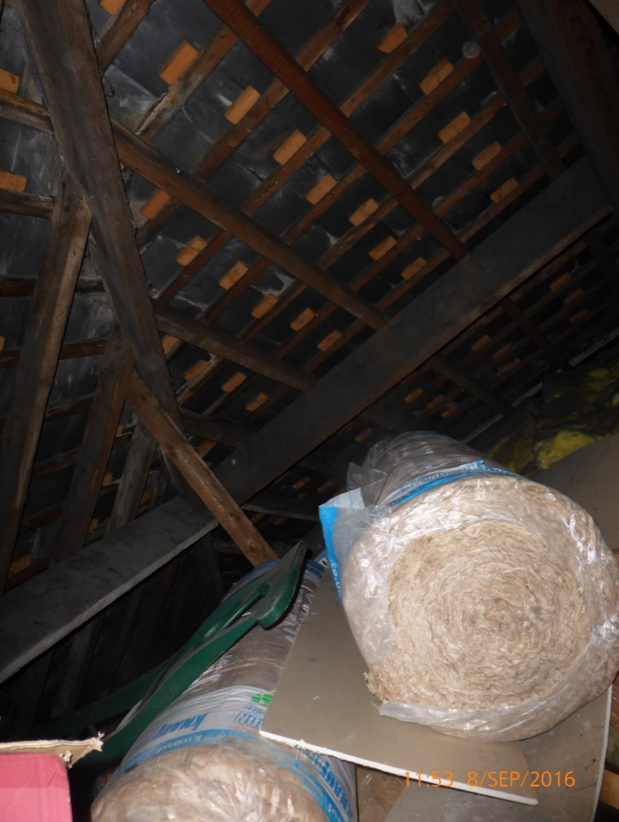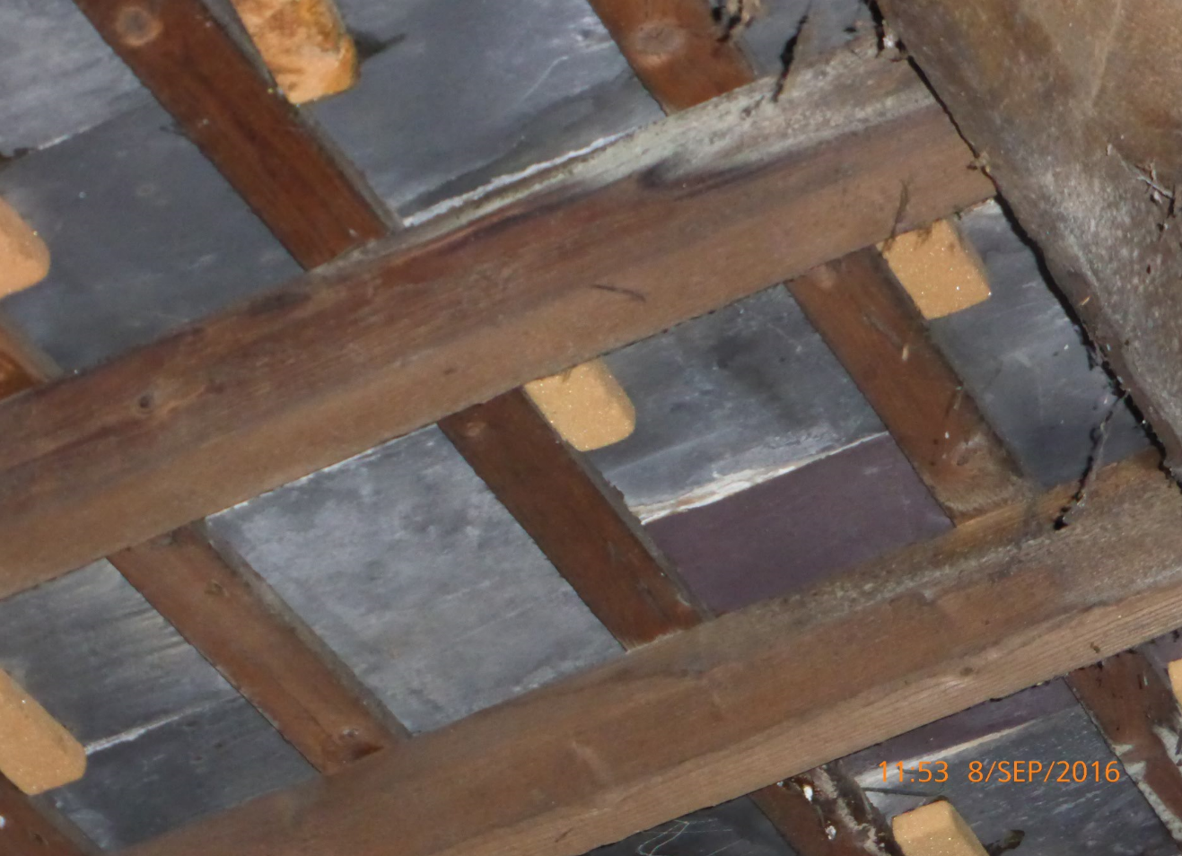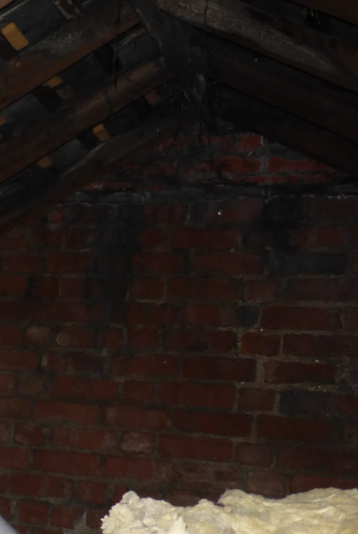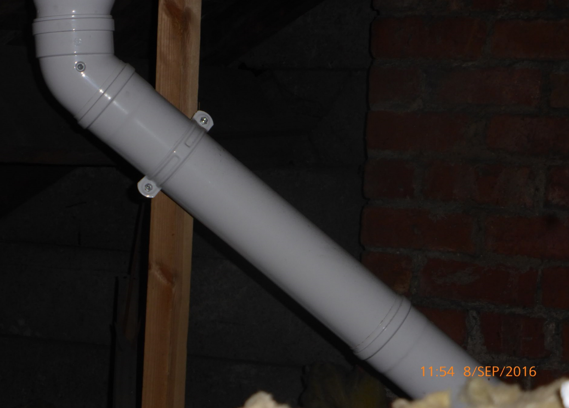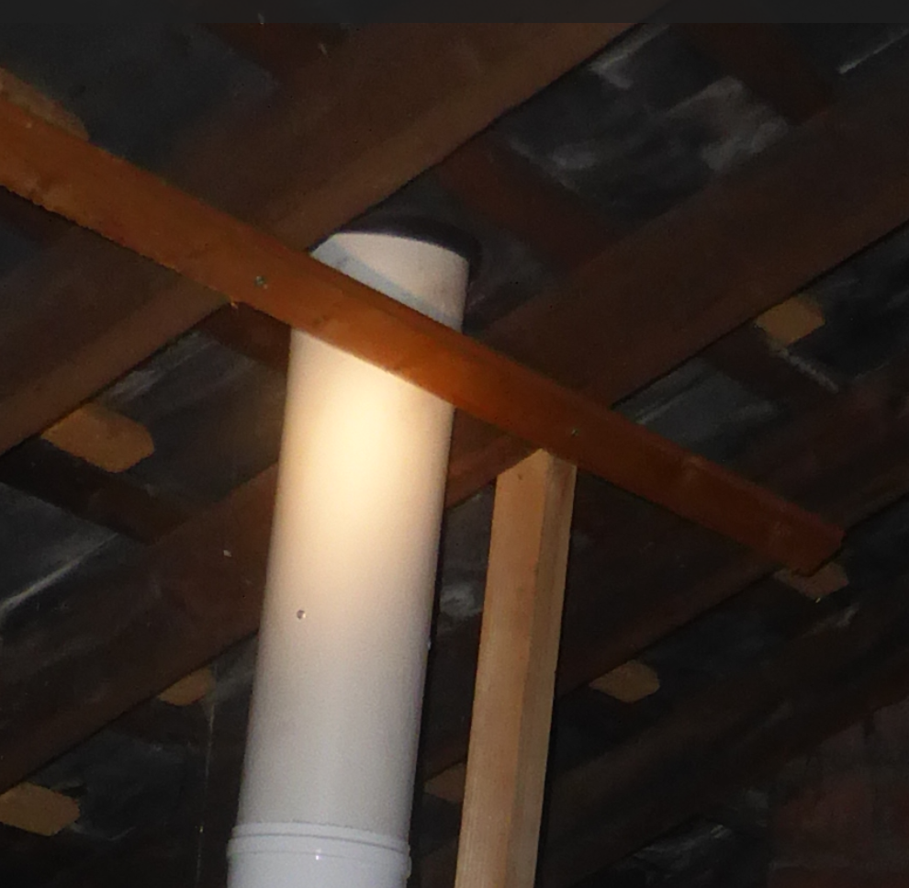
The roof covering of slate is directly nailed to the timber battens with no felt present and is typical of houses built around this time. This roof has a number of slipped and broken slates and is allowing water ingress as small amounts of daylight are visible from inside the roof space. At a very minimum the slates need to be replaced and/or re-fixed.
The flue from the gas combi boiler in the master bedroom is not adequately fixed and needs to be secured in a permanent position.

Services

Gas
The gas meter is situated externally to the left of the front bay window and feed to the gas combi boiler in the master bedroom airing cupboard.
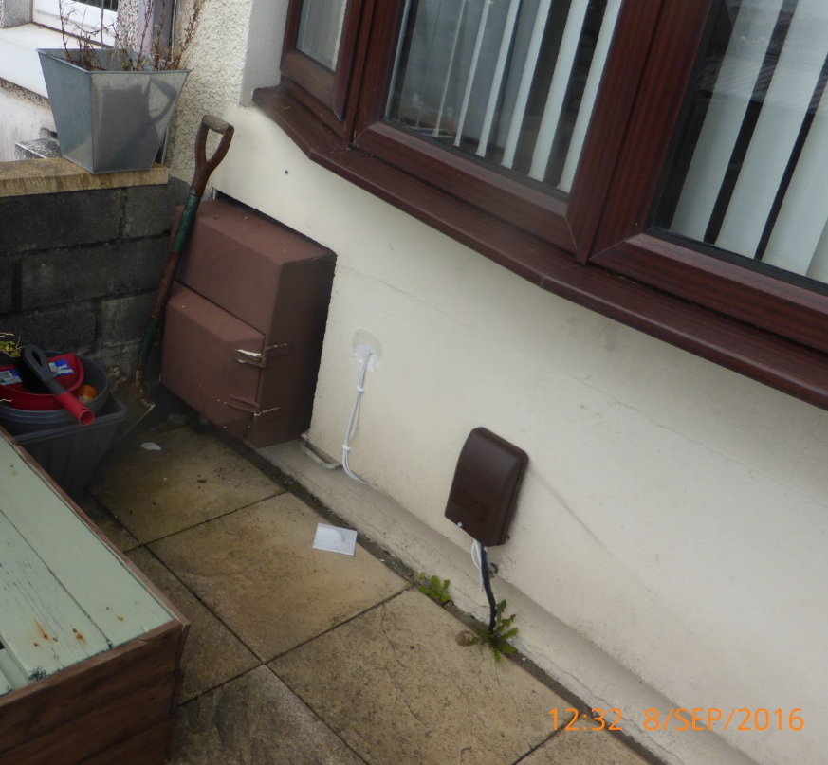

Electricity
The electricity meter is situated externally to the right of the main entrance.
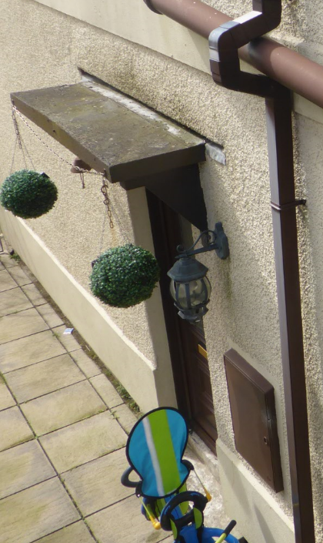

A modern consumer unit is located internally above the main entrance and is connected to the former
fuse board on which is located the service head/cutout. A competent and qualified person needs to inspect the cabling and fix down to wall if necessary.
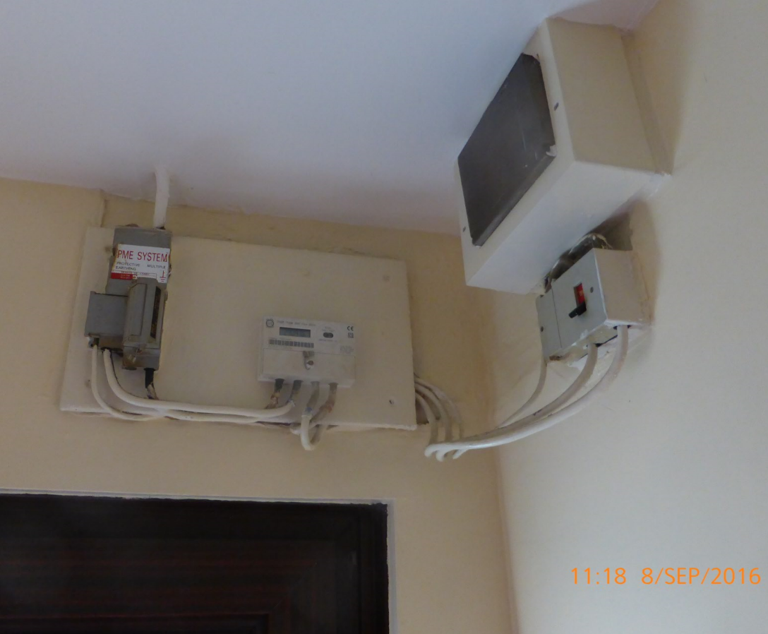
Water
The water supply is connected to the mains and from vendor information the main stop valve is located in the dining room at low level and accessed by removing a screwed flap. It would be advisable to replace with a hinged mechanism for speed of access should it become necessary.
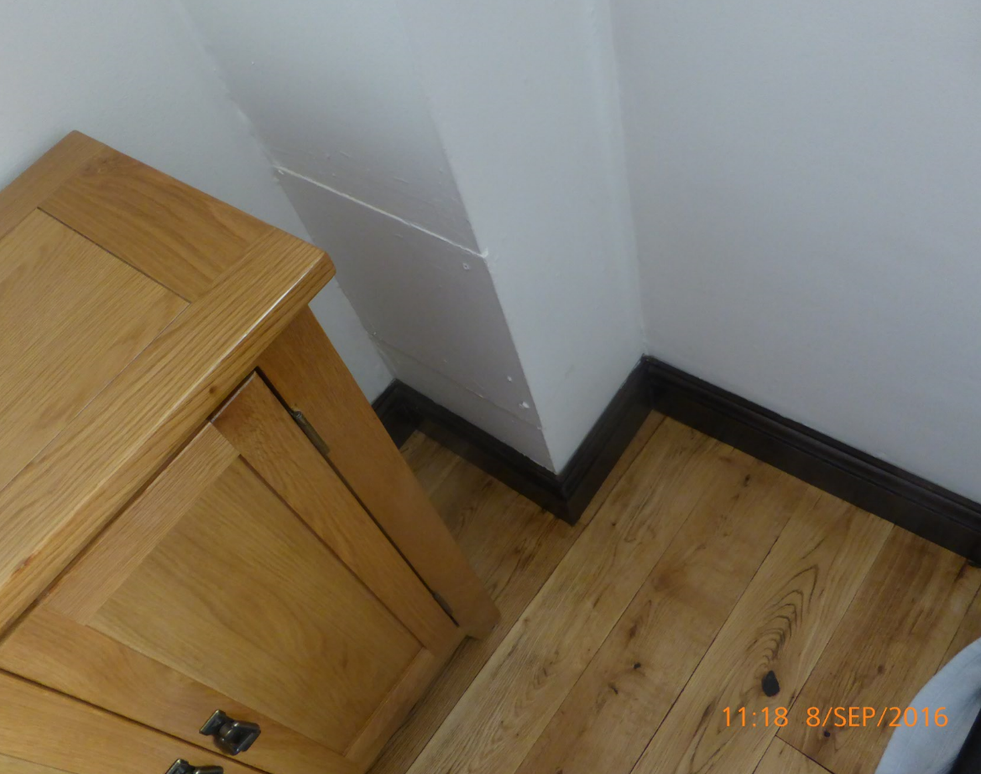

Heating & Hot Water
From vendor’s information an Ariston gas combi boiler has been fitted within the last 5 years and is located in the airing cupboard in the master bedroom. The boiler supplies hot water to taps and to central heating radiators.
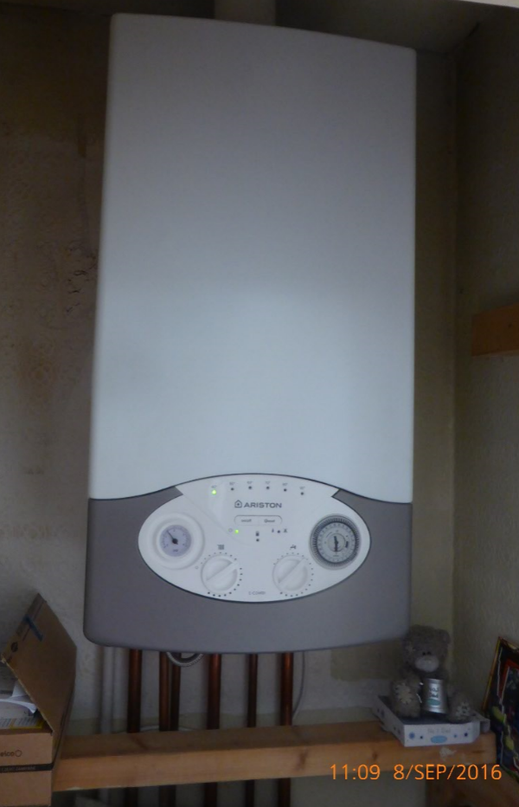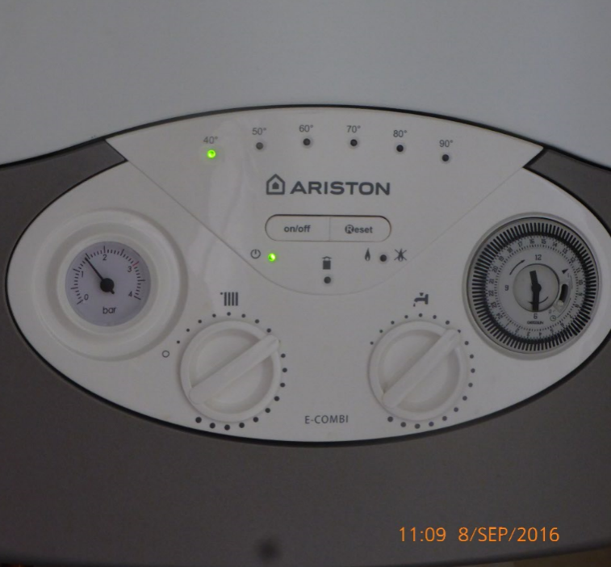

Drainage
Drainage is separated into surface water and foul sewer. The foul sewer, located at the rear of the property could not be internally inspected due to the lack of cover lifting points.
The surface water inspection chamber is located at the top of the entrance steps and contains a 100mm outlet with a connecting branch, probably from the neighbouring property.
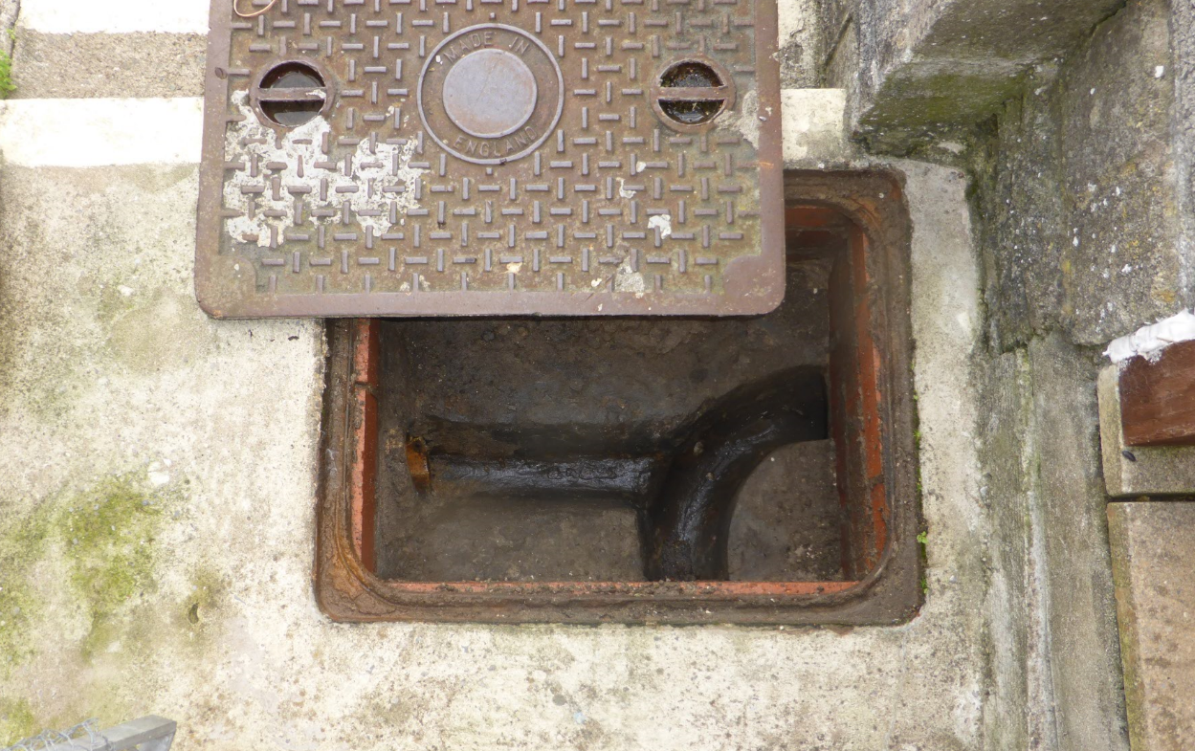

Sanitary Fittings
The sanitary fitting are all located in the first floor bathroom with an over-bath shower and a folding screen. All are in a good and usable condition,
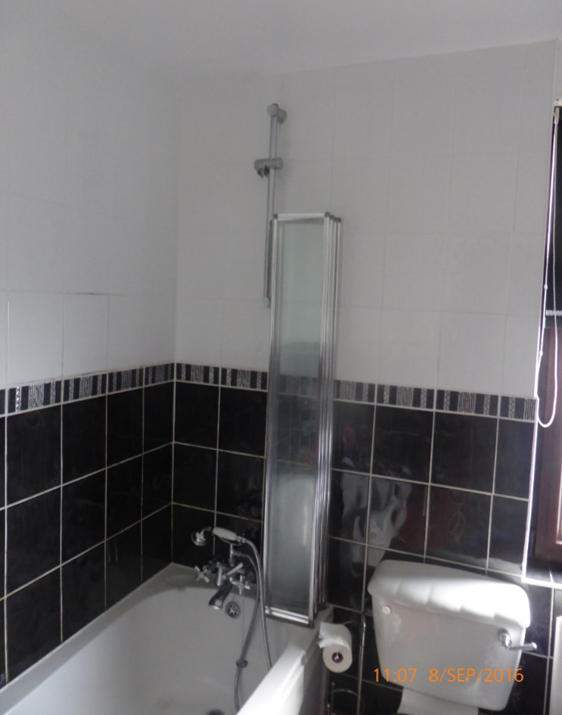

Environmental
This is an area which, historically, has been associated with coal mining and from historical map data a mine was present, called Dan-y-Graig Drift Colliery, in 1879 but was not present on the 1899 map edition. This mine was in the vicinity, and located at the northern end, of what is now called St Illtyd’s Crescent. This working was more than 20 metres from the surveyed property. Your legal adviser should obtain a coal authority mining report if it is deemed necessary.
I have not investigated whether the site has or may have been put to contaminate uses in the past and your legal adviser should investigate the usual sources to ascertain whether the subject property is built on land which has a history of contaminative use before you enter into any legal commitment to purchase. My report is on the assumption that the land has not been put to contaminative use and would not be placed on a register of land which may have been put to contaminative use.

Security
There is no security system fitted.

Health & Safety
There are a number of health and safety issues that need to be considered:-
Glazing of internal doors may not be of toughened glass and therefore should be replaced.
Electrical installations and heating boilers can be a safety risk unless they are properly serviced and maintained.
In terms of the means of escape, the escape from the first floor level is via the stairs and there are doors to the side and rear of the building.

Legal Matters
Your legal advisor needs to confirm and check the following points:
Obtain proper FENSA documentation in relation to any windows that were installed after 2002.
Confirm the location and liability for maintenance and upkeep of all boundaries.
Confirm details in relation to the pedestrian access at the upper level pavement and where the property boundary is located in relation to this pedestrian access.
Obtain any guarantees that may exist in relation to timber treatments.
Obtain any guarantees which may be in existence in relation to damp and timber treatments.
Obtain any guarantees in relation to the wall insulation treatment.
If the water supply is found to be shared, check that proper legal arrangements are in hand.
Check that proper necessary easements exist and establish liability for maintenance and upkeep of any section of private sewer that runs through land outside your boundaries before connecting with the mains.

Summary
 | 1 | Investigate the safety of the lean-to electrics by a suitably qualified operative.
 | 2 | Investigate the temporary nature of the lean-to construction.
 | 3 | Investigate bulging render on side elevation.
 | 4 | Replace, re-fix slipping, cracked and broken slates. Re-bed ridge tiles where necessary.
 | 5 | Renew lead flashing around chimney to current standards.
 | 6 | Re-fix central heating boiler flue in loft space.
 | 7 | Increase thickness of loft insulation.
 | 8 | Renew cooker hood exterior vent and make good.
 | 9 | Repair/adjust insulation shoe at dpc level at main entrance.
 | 10 | Fix hinged panel to stop valve access in dining room.
 | 11 | Repair/re-fix/renew cracked concrete blocks on all boundaries.
 | 12 | Renew broken feather-edged boards on fences.
 | 13 | Some weather proofing and repointing of the chimney stack will be required to ensure that it remains watertight.
 | 14 | Install a mechanical extractor in the bathroom.
 | 15 | A qualified heating engineer should be asked to check and service the boiler and arrange for an annual maintenance agreement.
NI |  | Foul sewer inspection chamber could not be inspected because of broken lifting bars.

You must obtain full estimates and reports for all the work I have recommended and seek further specialist advice where that has been suggested before you commit yourselves to purchase.

