NETWORKS AND CYBER SECURITY  ESSENTIALS  Academic Assessment Submission | MODULE CODE  ACCA4024  SUNNY ANIBABA


STUDENT  Sunny Anibaba | STUDENT ID  2210976
ASSESSMENT INFORMATION
Programme | CertHE Computing Skills for Workplace
Lecturer | Dr. Anum Paracha | Internal Verifier | Sadhana Jha
Contribution to Overall Module Assessment (%) | 50% | Module | Networks and Cyber Security Essentials
Assignment Title | Synthesize a Solution to a Potential  Real-Life Scenario

Table of Contents
Executive Summary 3
1. Introduction 4
2. Threat Identification 4
2.1 Internal Cybersecurity Threats 4
2.2 External Cybersecurity Threats 4
Threat Register 5
3. Security and Data Governance Policies 5
4. Mitigation Measures 6
5. Monitoring and Incident Response 9
6. Training and Awareness Program 10
7. Implementation Roadmap 11
8. Conclusion 12
References 13
Appendix 14
(POWERPOINT SLIDES FOR SFM BOARD PRESENTATION) 14

Executive Summary
SteelForm Manufacturing Ltd (SFM) is no longer operating as an isolated factory. Its IoT sensors, automated machinery, remote maintenance links and cloud production system connect the office network to the shop floor. That connection supports faster production, but it also means that a stolen account or compromised supplier link could affect systems that the factory depends on. The recent malware alerts, phishing emails sent to procurement and attempted network intrusions therefore need to be treated as business risks, not simply IT problems [1], [3], [4].

The recommended approach is based on confidentiality, integrity and availability, supported by ISO/IEC 27001:2022 and the six NIST CSF 2.0 functions: Govern, Identify, Protect, Detect, Respond and Recover. Together, these provide a practical structure for ownership, asset and data classification, access control, network security, monitoring, incident response and recovery [2], [3].

The first priority is to close the weaknesses most likely to be exploited. During the first 90 days, SFM needs to introduce phishing-resistant multi-factor authentication (MFA), review privileged accounts, restrict supplier remote access, test immutable backups, correct critical vulnerabilities and strengthen separation between IT and OT. The board should judge progress by the reduction in residual risk and by evidence that essential services can be recovered, rather than by the number of security products purchased.
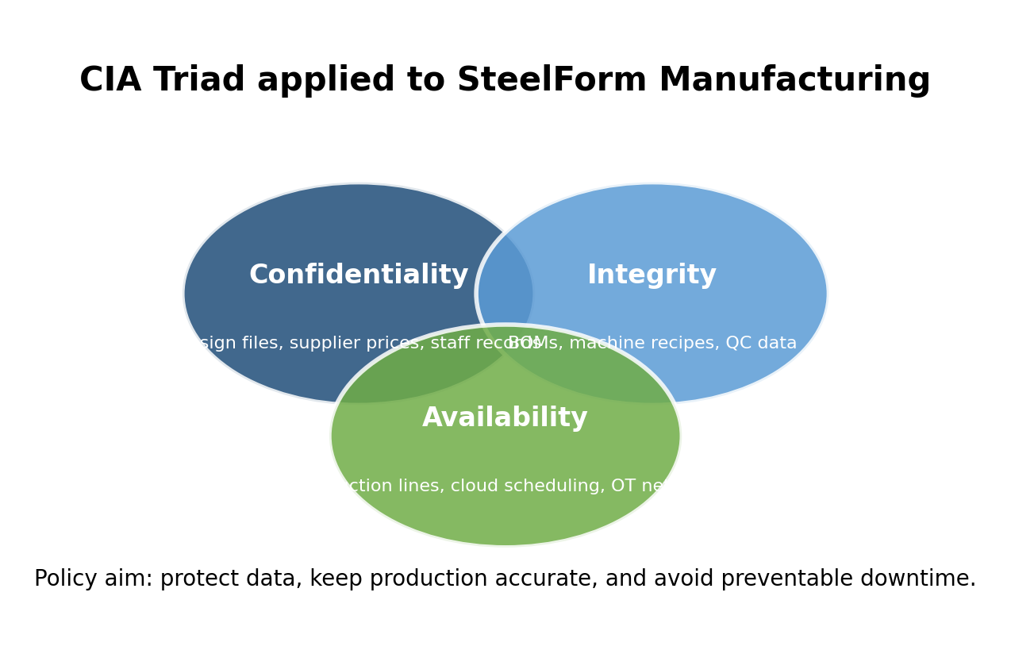
Figure 1: CIA Triad applied to SFM (Author’s Own work created in Canva)

Introduction

Modern manufacturing depends on reliable digital services. Production schedules, bills of materials, machine settings, customer drawings and supplier information now move between cloud services, office systems, industrial gateways and shop-floor equipment. If one of these services is compromised, the impact can extend from commercial data loss to inaccurate production, downtime or a safety issue. OT security therefore must protect reliability and safety as well as information [4].

The threat is credible. ENISA continues to identify ransomware, attacks on availability and data theft as major concerns, and manufacturing remains among the affected sectors [1]. At SFM, an incident could lead to lost production, missed contracts, recovery costs, fraudulent payments and reputational damage. It may also force staff to work without normal system visibility, increasing the chance of mistakes during recovery.

This report considers threats from employees, external attackers and suppliers. It then sets out the policies, layered controls, monitoring arrangements, incident response process and staff training needed to reduce those risks. Recommendations are prioritised according to how likely each event is and how seriously it could affect production.

2. Threat Identification

2.1 Internal Cybersecurity Threats
Mistakes by employees and contractors are a common source of exposure. A member of staff may open a convincing phishing message, approve an unexpected MFA request, use an unauthorised USB device or change a configuration without understanding the wider effect. Procurement staff face additional risk because attackers often imitate suppliers and request urgent changes to invoices or bank details. Excessive access, shared accounts and weak processes for starters, movers and leavers also make misuse harder to detect. Privileged work must therefore be linked to a named individual, approved, time-limited and logged [7].

2.2 External Cybersecurity Threats
External attackers may use ransomware, credential phishing, business-email compromise, unpatched internet-facing services or stolen supplier accounts. Valid credentials are particularly dangerous because they can allow an attacker to look like an authorised user while moving between systems. If the boundary between office IT and production OT is weak, an incident that starts in email or on a laptop could eventually interrupt manufacturing [4], [6].

SFM also depends on equipment vendors, cloud providers, maintenance engineers and logistics partners. Their accounts and services can provide a trusted route into the organisation. Suppliers should therefore be assessed according to the access they receive and the importance of the service they provide. Contracts need clear security and incident-notification requirements, while remote access should be approved, monitored and removed when it is no longer required.

Threat Register
Threat | Source | Likelihood | Impact | Main controls
Ransomware and double extortion | External | High | Production stoppage, data theft, ransom demand | EDR, immutable backups, segmentation, phishing controls
Phishing / business email compromise | External | High | Fraudulent payments, credential theft | MFA, email filtering, staff simulations, payment checks
Industrial espionage | External | Medium | Loss of drawings, tolerances and customer trust | Data classification, DLP, least privilege, logging
Cloud account compromise | External | Medium | Unauthorised changes to production schedules/data | MFA, conditional access, API logging, backup exports
Unpatched IoT or remote access | External/Internal | High | Entry into OT network or sensor manipulation | Asset register, patching, secure gateway, VPN/JIT access
Insider misuse or error | Internal | Medium | Data leakage, sabotage, compliance breach | Joiner-mover-leaver process, monitoring, disciplinary policy
Supplier compromise | External | Medium | Trusted route into SFM or payment fraud | Supplier security questionnaire, contracts, access review
Loss of backup or recovery failure | Internal | Medium | Extended downtime after incident | 3-2-1 backups, monthly restore tests, offline copy

3. Security and Data Governance Policies
The board should approve the policy framework, with the IT Security Manager coordinating implementation and named managers in HR, procurement, operations and engineering owning the relevant risks. Policies need an annual review and an earlier review after a serious incident; a major system change or a new legal requirement. Exceptions should record the reason, owner, compensating control, expiry date and residual risk.

Data classification must be clear enough to use in day-to-day work. SFM can classify information as Public, Internal, Confidential or Restricted. Customer drawings, aerospace documentation, production recipes, employee records and security credentials belong in the higher categories. Each dataset

needs an owner, an approved storage location, a retention period and a defined group of authorised users.
These policies are intended for a medium-sized manufacturer. They set minimum expectations without creating procedures that staff are likely to avoid or work around.

Policy | Minimum requirement
Access Control Policy | Unique accounts, MFA, least privilege, no shared admin accounts; quarterly access review.
Password and MFA Policy | Passphrases or password manager; MFA required for cloud, VPN, privileged and finance systems.
Network Security Policy | Separate IT, OT, guest and supplier networks; firewall rules reviewed quarterly.
Patch and Vulnerability Policy | Risk-based patching; emergency patches for exploited vulnerabilities; OT patches tested before deployment.
Backup and Recovery Policy | 3-2-1 backups with one immutable/offline copy; monthly restore tests; defined RTO/RPO.
Data Classification Policy | Public, Internal, Confidential, Restricted labels with rules for storage, sharing and retention.
Supplier Security Policy | Security due diligence, contract clauses, access expiry, incident notification requirements.
Incident Response Policy | Clear reporting routes, severity levels, evidence handling and board/legal escalation.
Acceptable Use Policy | Approved devices and software only; no unauthorised cloud tools, USB storage or credential sharing.
Remote Access Policy | VPN or secure access broker; MFA; named approval; session logging; no direct PLC remote access.

4. Mitigation Measures
Defense in depth is appropriate because no single safeguard will stop every attack. SFM needs several connected layers: governance, staff awareness, identity security, perimeter controls, internal segmentation, secure applications and endpoints, data protection, monitoring, incident response and recovery. Each layer must have an owner and a clear purpose, and it should be tested against the threat it is meant to control [3], [6].
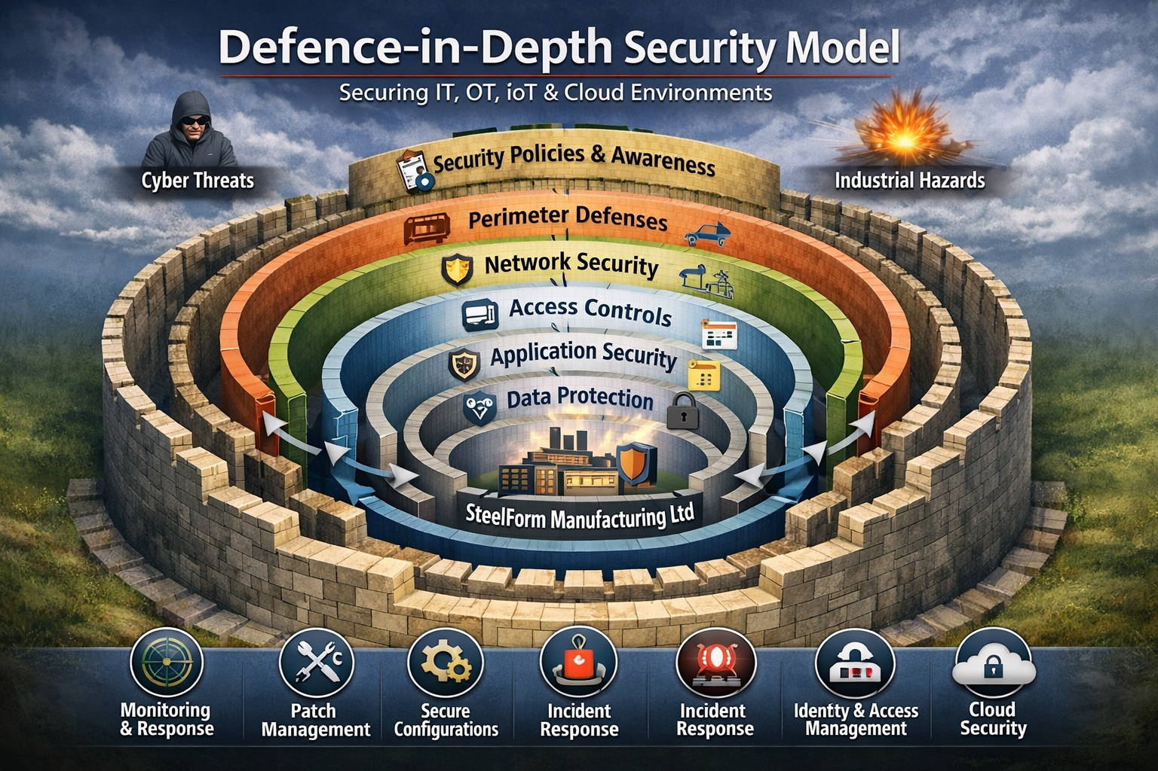
Figure 2: Defence-in-depth security model showing multiple layers of protection used by SteelForm Manufacturing Ltd to reduce cybersecurity risks across IT, OT, IoT, and cloud environments. (Author’s Own work created in Canva)

Identity is the starting point. Every user needs a named account, and MFA must protect email, cloud production systems, VPN access and privileged functions. Administrators should use separate accounts for routine work and elevated tasks. Privileged access should be approved for a limited period and reviewed regularly.

The network also needs clearer boundaries. Office IT, cloud connections, the industrial DMZ, OT, IoT devices and guest Wi-Fi should be separated. PLCs and production controllers should not have unrestricted internet access or direct exposure to ordinary user devices. Vendor access should pass through a monitored gateway and hardened jump host [4].

Endpoint protection and monitoring should be applied where it is technically safe. Laptops, servers and production workstations can use centrally managed endpoint detection and response. Where older OT devices cannot support an agent, SFM should use application allow-listing, passive network monitoring, restricted communications and tighter physical control.

Backups are a production-resilience measure, not just an IT task. Critical servers, cloud production data and core file stores need immutable or offline copies. SFM should test restoration in the correct dependency order and confirm that recovered systems are trustworthy before reconnecting them to production.
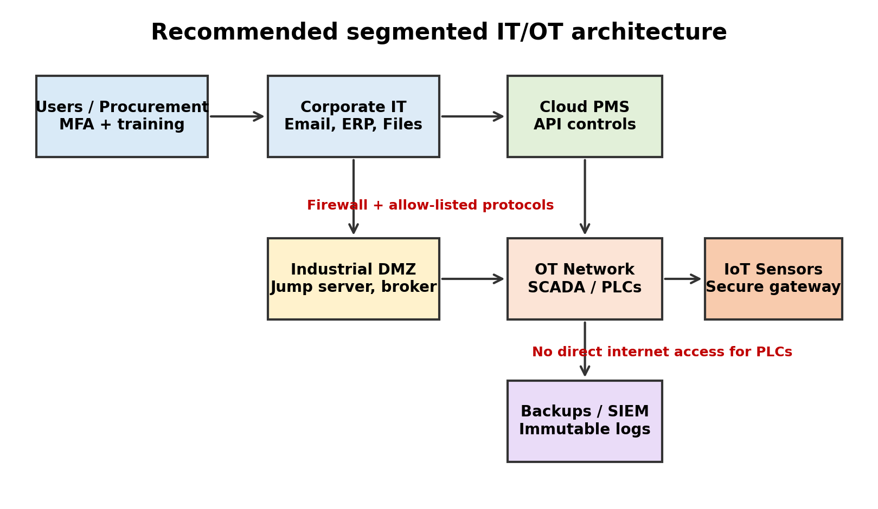
Figure 3: Proposed segmented architecture for IT, cloud and OT systems

Measure | Implementation | Threat minimised
MFA and least privilege | Identity provider configuration, remove shared accounts, quarterly review | Stops credential reuse and limits damage from phishing
IT/OT segmentation | Firewalls, industrial DMZ, jump server, allow-listed protocols | Prevents malware moving easily into production
EDR + OT network monitoring | EDR on endpoints; passive monitoring for PLC/SCADA traffic | Improves detection without destabilising legacy OT
Vulnerability management | Asset register, scanning, patch windows, exception register | Reduces exploit risk from known weaknesses
Immutable backups | Offline/immutable copy, restore tests, RTO/RPO targets | Provides recovery route without paying ransom
Supplier controls | Due diligence, contract clauses, expiry dates for access | Reduces third-party and remote maintenance risk
Data loss prevention | Classification labels, restricted sharing and logging | Protects drawings, customer data and sensitive IP

5. Monitoring and Incident Response

Monitoring needs to cover identities, email, endpoints, firewalls, cloud administration, servers, remote-access gateways and, where it is safe, OT network traffic. A SIEM can bring these records together, while endpoint and network tools provide the detail needed for investigation. Useful alerts include unusual mailbox rules, repeated MFA prompts, unexpected privilege changes, disabled security tools, mass file changes and unauthorised traffic across the IT/OT boundary [4], [6].

Management reporting should focus on decisions. Suitable measures include the proportion of critical systems sending logs, unresolved high-risk vulnerabilities, privileged-access exceptions, time taken to report phishing, completion of supplier-access reviews, successful backup tests and the time required to contain and recover from incidents.

SFM’s response process should follow NIST SP 800-61 Rev. 3 and sit within the wider CSF 2.0 risk programme [3], [9]. When an incident occurs, the team must establish its severity, preserve evidence, identify affected accounts and systems, contain the threat, remove the cause and restore trusted services. Operations and safety staff must be involved before isolating or shutting down OT equipment, because a technically correct action could still create a production or safety problem.

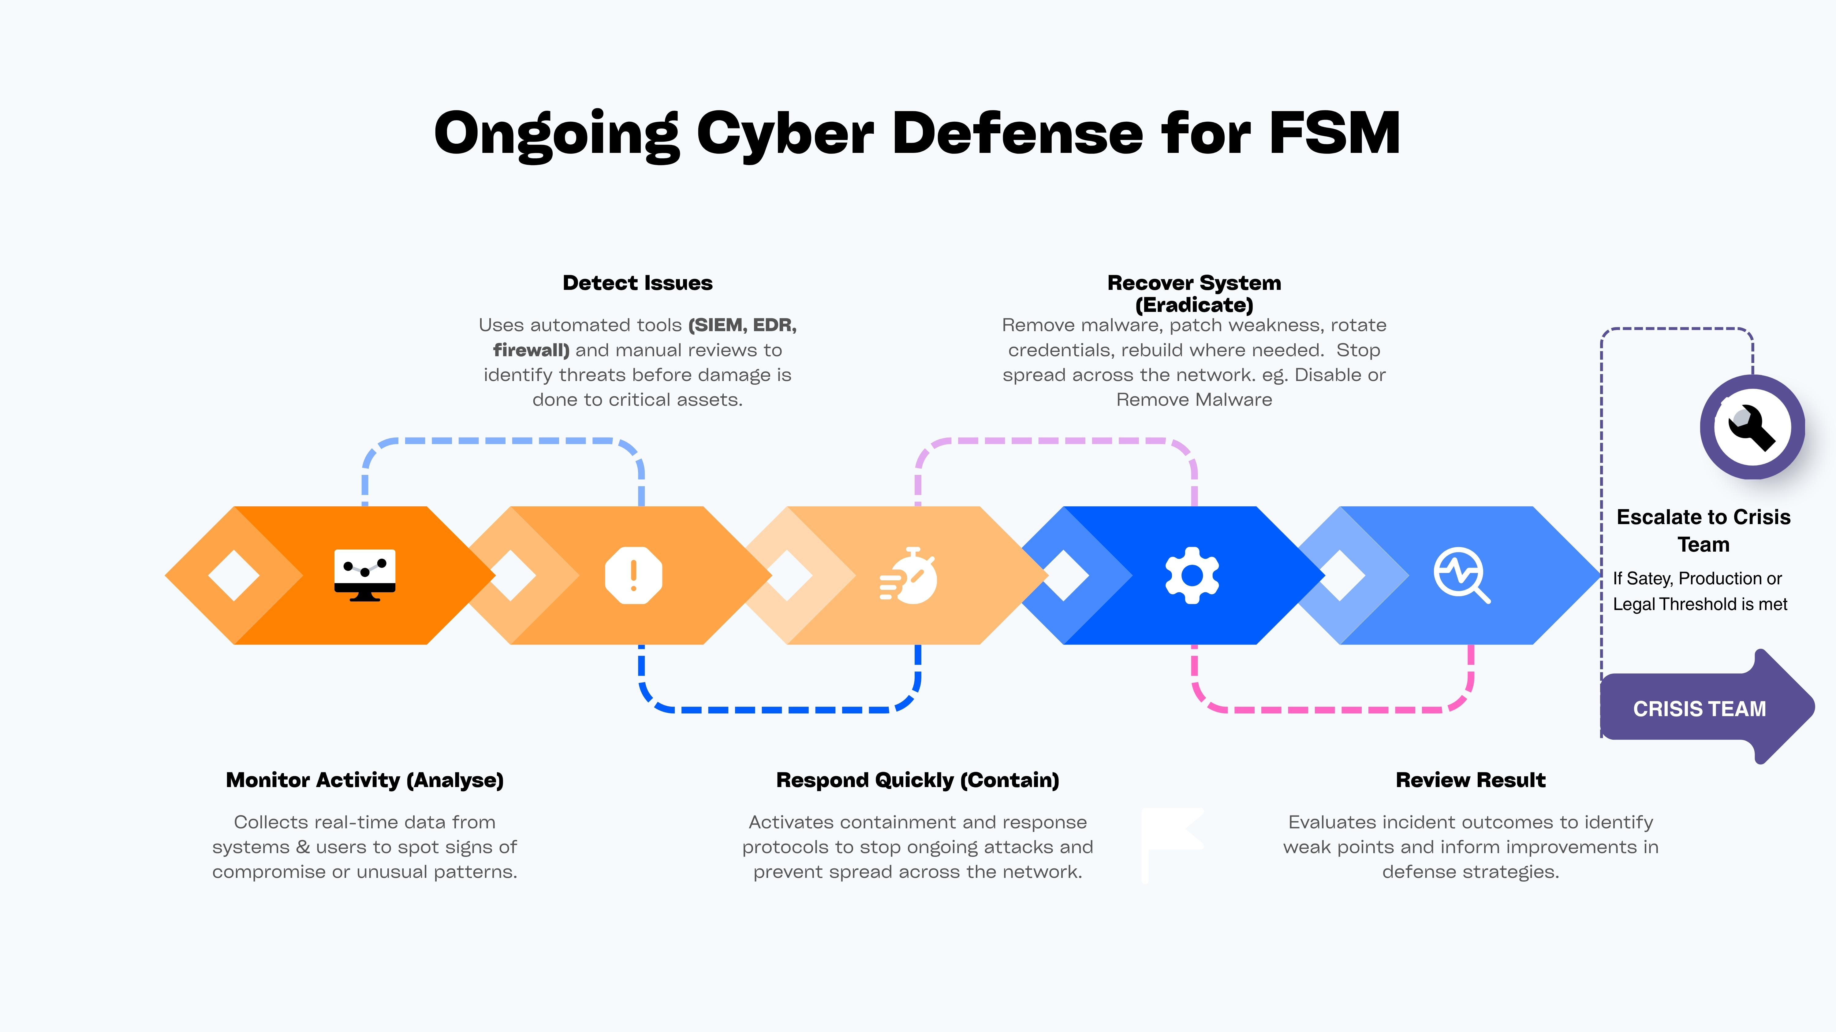
Figure 4: Incident response workflow for SFM
(Author’s own work created in Canva)

Phase | SFM action
Prepare | Maintain contacts, playbooks, backups, clean admin accounts and evidence procedure.
Detect | Use SIEM, EDR, firewall, cloud and OT alerts; allow staff to report quickly.
Analyse | Confirm scope, affected systems, data at risk and safety/production impact.
Contain | Isolate devices, disable accounts, block indicators, preserve evidence.
Eradicate | Remove malware, patch weakness, rotate credentials, rebuild where needed.
Recover | Restore from known-good backups, test integrity, monitor for recurrence.
Lessons learned | Update policies, controls, training and board risk register.

6. Training and Awareness Program

Staff are part of the defence and should not be treated as the automatic cause of every incident. Training should begin at induction and continue through short, relevant sessions on phishing, MFA, safe use of devices and removable media, data classification, remote working and incident reporting. Procurement staff need examples involving false invoices and supplier impersonation; engineers and operators need training on remote access, USB media and controlled changes to OT.

Visible support from the board will show that security is an organisational responsibility. New starters should complete basic training before receiving full access, and contractors should receive training that reflects the systems they can reach. Staff must also feel able to report a mistake quickly. Early reporting gives the security team a better chance of limiting the damage.

Phishing simulations are useful when they lead to coaching and better controls, rather than embarrassment or punishment. SFM should measure reporting rates, time to report, repeated interaction with test messages, completion of role-based learning and performance in tabletop exercises. If many staff struggle with the same type of message, email filtering and the underlying business process should also be reviewed [6].

Audience | Content | Frequency
All staff | Induction, annual refresher, phishing reporting, acceptable use | Before access + annual + quarterly micro-learning
Procurement/Finance | BEC, supplier bank changes, purchase-order fraud | Quarterly scenario training
Engineering | Data classification, CAD sharing, removable media, IP protection | Twice yearly
Production/OT users | Reporting abnormal machine behaviour, no unauthorised fixes | Twice yearly toolbox talks
Managers/Board | Incident decisions, legal escalation, communication and risk appetite | Annual tabletop exercise
Privileged users | Admin security, logging, emergency access and change control | Twice yearly plus access review

7. Implementation Roadmap

Implementation should be phased so that urgent weaknesses are addressed without creating an unmanageable programme. In the first 30 days, SFM should remove unnecessary remote access, verify backups, enable MFA for priority systems and review privileged accounts. The next stage should introduce stronger segmentation, centralised logging, endpoint protection and supplier-access controls. Later work can focus on formalising the ISMS, improving OT monitoring and testing recovery through exercises.

The board needs to sponsor the programme and agree how much risk SFM is prepared to accept. Some legacy OT risks may not be removable immediately, but exceptions must be documented, given an owner and expiry date, and reviewed. This avoids temporary workarounds becoming permanent weaknesses.

Period | Key deliverables
0-30 days | MFA for priority systems, backup validation, privileged account review, staff reporting route
31-90 days | Asset register, core policies, phishing simulation, segmentation design, supplier access list
3-6 months | EDR deployment, SIEM onboarding, vulnerability process, remote access hardening
6-12 months | Tabletop exercise, full restore test, supplier assurance cycle, board risk dashboard
Ongoing | Policy review, audits, training refresh, incident lessons learned, continuous improvement

8. Conclusion

SFM’s recent incidents show that informal security practices are no longer suitable for a connected manufacturing environment. The most serious risks are procurement phishing and business-email compromise, ransomware, compromised supplier access, insecure IoT or legacy devices and movement from office IT into production systems. The likely consequences include fraud, theft of intellectual property, extended downtime and possible safety concerns.
The most effective response is a combination of governance and engineering. SFM needs an ISO/IEC 27001-aligned management system, clear NIST CSF 2.0 outcomes, strong identity controls, IT/OT segmentation, secure supplier access, risk-based vulnerability management, protected backups, central monitoring, rehearsed incident response and training that reflects each role. Applied consistently and reviewed over time, these measures will make compromise harder, limit an attacker’s movement and improve the organisation’s ability to restore production safely [2], [6], [9].

The objective is not merely to prevent incidents for FSM, but to create infrastructures capable of resisting, detecting, containing, and recovering from increasingly sophisticated threats.

References
[1] European Union Agency for Cybersecurity, “ENISA Threat Landscape 2025,” Oct. 2025. [Online]. Available: https://www.enisa.europa.eu/publications/enisa-threat-landscape-2025. [Accessed: Jul. 21, 2026].
[2] International Organization for Standardization, ISO/IEC 27001:2022, Information Security, Cybersecurity and Privacy Protection—Information Security Management Systems—Requirements. Geneva, Switzerland: ISO, 2022.
[3] National Institute of Standards and Technology, The NIST Cybersecurity Framework (CSF) 2.0, NIST CSWP 29, Feb. 2024, doi: 10.6028/NIST.CSWP.29.
[4] K. Stouffer et al., Guide to Operational Technology (OT) Security, NIST Special Publication 800-82 Rev. 3. Gaithersburg, MD, USA: NIST, Sep. 2023, doi: 10.6028/NIST.SP.800-82r3.
[5] International Electrotechnical Commission, IEC 62443-3-3:2013, Industrial Communication Networks—Network and System Security—Part 3-3: System Security Requirements and Security Levels. Geneva, Switzerland: IEC, 2013.
[6] Center for Internet Security, “CIS Critical Security Controls v8.1,” Jun. 2024. [Online]. Available: https://www.cisecurity.org/controls/v8-1. [Accessed: Jul. 21, 2026].
[7] National Institute of Standards and Technology, Security and Privacy Controls for Information Systems and Organizations, NIST Special Publication 800-53 Rev. 5, Dec. 2020, doi: 10.6028/NIST.SP.800-53r5.
[8] National Cyber Security Centre, “Mitigating malware and ransomware attacks.” [Online]. Available: https://www.ncsc.gov.uk/guidance/mitigating-malware-and-ransomware-attacks. [Accessed: Jul. 21, 2026].
[9] A. Nelson, S. Rekhi, M. Souppaya and K. Scarfone, Incident Response Recommendations and Considerations for Cybersecurity Risk Management: A CSF 2.0 Community Profile, NIST Special Publication 800-61 Rev. 3. Gaithersburg, MD, USA: NIST, Apr. 2025, doi: 10.6028/NIST.SP.800-61r3.

Appendix

(POWERPOINT SLIDES FOR SFM BOARD PRESENTATION)

Slide No 1

Slide No 2

Slide No 3

Slide No 4

Slide No 5

Slide No 6

Slide No 7

Slide No 8

Slide No 9

Slide No 10

