Section 1: Literature Review
Context
As a secondary school English teacher with previous middle leadership experience, my professional development involves collaborating with the Assistant Head Teacher (AHT) responsible for Teaching and Learning. My current remit is to research and evaluate the new curriculum for Wales in relation to School A’s current pedagogical position so that the AHT is supported in establishing and disseminating teaching and learning strategies to ensure that teachers are supported, and pupils are provided with opportunities for rich and authentic learning experiences (Donaldson, 2015). The priority, as a non-pioneer school, is to accelerate progress as effectively as possible.
Introduction
This literature review engages with a range of academic research, government documentation and cognitive theories to evaluate the pedagogy promoted in Donaldson’s ‘Successful Futures’ (Donaldson, 2015). The Four Purposes and Twelve Pedagogical Principles establish the need for learners to be striving to achieve a balance between both knowledge and skills, and process and outcome to support higher order critical thinking and problem solving. The overall vision of nurturing independent lifelong learners who are confident and resilient collaborators in a technological and fast changing twenty first century society will clearly rely on a shift in paradigm that encourages an evaluation of different strategies and techniques for optimising learner potential. An evaluation of literature focusing on these key elements, highlights the potential challenges and opportunities in relation to School A.
What is pedagogy?
Donaldson defines pedagogy as a range of methods and strategies utilised by teachers to ensure the effective development of pupils’ knowledge and skills. It is acknowledged that expertise, an understanding of the ‘social and psychological’ factors that affect learning as well as the ability to inspire pupils are the qualities that not only underpin good teaching but support the effective development of learners (Donaldson, 2015, p. 63). This is reinforced by Hattie who promotes the need for teachers to remain focused on the impact their every decision has on the learner by utilising a range of established good pedagogical features (OECD, 2005; Hattie, 2012).
Effective pedagogy is therefore synonymous with good teaching (Donaldson, 2015). Hattie’s meta-analyses, establishes collective teacher efficacy as having the most significant impact on learning and teaching with an effect size of 1.57 (Killan, 2017). This is potentially more relevant for Wales since the shift in paradigm from a historically transmissionist to constructivist approach to teaching and learning may depend on the teachers’ collective evidence-based belief that they can impact positively on learners (Priestley & Humes, 2010). This somewhat conflicts with previous evidence that suggests that a combination of pedagogical knowledge and opportunities for learners to embed skills are the two most significant attributes of good teaching (Coe, et al., 2014). Therefore, one potential challenge for the new curriculum may be for leadership to ensure that there is a measured understanding of all factors that constitutes effective pedagogy.
Knowledge Versus Skills
In Donaldson’s third pedagogical principle, his promotion of a blend of approaches to teaching and learning validates traditional pedagogical techniques that are still impactful. Direct teaching approaches are promoted in balance with active, constructivist strategies (Donaldson, 2015). Although the former is associated with didactic approaches for imparting rather than constructing knowledge, it remains an essential element – especially since explicit instruction conveys powerful knowledge and scaffolds learning which encompasses success criteria, modelling practice and regular peer/teacher feedback (Young, 2013; Donaldson, 2015).
The knowledge versus skills debate is one challenge that threatens the successful implementation of the new curriculum. Young believes that a constructivist or active learning approach to knowledge acquisition within a curriculum empowers learners to engage with wider knowledge more relevant to authentic contexts which supports Donaldson’s promotion of pupils learning through authentic experience (Young, 2013; Donaldson, 2015). The role of the teacher as facilitator is therefore imperative (Sinnema & Aitken, 2013; Priestley & Drew, 2016). It is significant that Hirsch argues that the development of skills is ineffective due to a lack of a specific focus of expertise and argues that only when the concept of a skills-based curriculum is ruled out, will there be an improvement in language competence through a specialisation of subject specific knowledge (Hirsch Jr, 2016). In support of this, Ericsson claims that focused practice is the only route to mastery which, in support Dweck’s Growth Mindset theory (Ericsson, 2006; Dweck, 2012) raises a significant issue regarding the need for a set of pedagogical principles that balance skills development with knowledge acquisition. It is therefore relevant that in Donaldson’s recommendations for pedagogy, he does not make specific reference to the requirement for the curriculum to balance the importance of knowledge and skills and in his introduction dismisses it as a debating point (Donaldson, 2015). This creates a sense of uncertainty for teachers in terms of what knowledge is significant for deepening learning. However, it has also been suggested that the teachers’ level of knowledge relating to subject content may not have a substantial impact on learning which raises further uncertainty (Hattie & Yates, 2014, p. 11). Although the vagueness of Donaldson’s recommendations create debate, one clear positive is that they encourage a dialogue that may result in improved collective teacher efficacy.
Non-pioneer schools can only make limited progress until ‘What Matters’ criteria is released by the Education Advisory Service (EAS). However, School A has positively engaged with skills development across the curriculum and it could be argued that embedded skills provide the foundation for more creative and appropriate pedagogical strategies to be utilised. This, along with assessment for learning strategies has provided an opportunity to develop more independent learners.
Assessment for Learning
Donaldson’s seventh principle promotes assessment for learning (AFL) with recommendation thirty- seven positively prioritising formative assessment as a powerful tool for enhancing the learning culture since it is at the core of teaching and learning (William, 2010; Donaldson, 2015). It ensures that not only the varying individual needs of learners are met but learners are encouraged and motivated with challenging aspirations, modelling, clear scaffolding and structured feedback to progress further. Ultimately, it encourages the self-regulation of the learning process by learners therefore fostering greater understanding of metacognition: it therefore aids the development of autonomous, lifelong learners (Clark, 2012). However, William argues that meta-analyses effect sizes for formative assessment fail to reflect consistency across contexts (William, 2016) which may raise concerns regarding the validity of the impact it has. In School A, book scrutiny and external results suggest that formative assessment has impacted positively on learner outcomes although the level of independent learning at Key Stage 5 may reflect the legacy of earlier approaches to AfL. The encouragement of learner to teacher feedback makes learning more visible and impactful (Hattie, 2012) In effect, the learners become their own teachers in this process which supports constructivism (Hattie, 2012; Hattie & Yates, 2014).
Although Donaldson states that teacher behaviour is the largest threat to formative assessment implementation, it could be argued that the culture of summative assessment and accountability that School A is restricted by presents the greatest challenge. One argument is that the development of higher order thinking skills and how to apply them to authentic contexts must lead to more flexible assessment arrangements (Darling-Hammond, 2017). Donaldson recommends a shift towards process focused, constructive learning, yet teacher agency is stifled due to accountable external, summative measures such as ESTYN and external results. This conflict was evident in Scotland’s ‘Curriculum for Excellence’(CfE) (The Scottish Government, 2008) which initially reflected a paradigm that continued to be dominated by performativity (Priestley & Humes, 2010) and internationally, in countries such as Hong Kong (Berry, 2011). In contrast, counties such as New Zealand have successfully adopted assessment processes that are process focused (Ministry of Education (NZ), 2007). The challenge for any school will be to achieve an effective balance between formative and summative assessment and this can only be achieved once assessment design for the new curriculum has been released by the Assessment and Progression Group.
Resilience
Principle two reinforces the need for learners to develop resilience – something formative assessment also supports. Donaldson clearly supports the view that intelligence is not fixed and that learners have ability to achieve challenging aspirational targets if they are resilient and determined to pursue success, overcoming failure and acknowledging that it is an integral part of the learning process (Dweck, 2012; Hattie, 2012; Hochanadel & Finamore, 2015). Donaldson’s reference to ‘intrinsic satisfaction’ (Donaldson, 2015, p. 64) is supported by the views of Watkins, Carnell and Lodge (Watkins, et al., 2007, p. 116) who suggest that pupils who are more intrinsically motivated care less for extrinsic rewards. Hence, the focus is on the process of learning rather than the outcome which significantly relies on independent learners who understand not just why they learn but how; this ultimately supports the development of metacognitive understanding which develops successful lifelong learners (Duggan & Solomons, 2014). It could also be argued that that a growth mindset is dependent on a deep commitment being developed by the learner (Hochanadel & Finamore, 2015) which reflects the notion of ‘academic tenacity’ (Dweck, et al., 2014, p. 4); hence learners must be comfortable with and committed to challenge. This clearly highlights the importance of promoting resilience which School A has previously introduced, but with a high staff turnover, one challenge for SLT might be to ensure that the mindset of teachers reflects a similar resilience.
Collaborative Learning
In principle twelve, Donaldson states that collaboration is a good feature of teaching and learning (Donaldson, 2015). Its position as the last principle potentially enhances the relevance of collaborative working in relation to the support it would provide in realising several other pedagogical principles and strategies such as AFL and the development of independent learning as established in principle ten. The fourth pedagogical principle promotes the importance of learners developing transferable problem solving, creative and critical thinking skills that can be applied to new situations which is also supported by collaboration (OECD, 2008; Donaldson, 2015; OECD, 2017a; OECD, 2017b).
Firstly, there is a subtle difference between Donaldson’s references to collaboration and co-operative working (Donaldson, 2015) as noted by Watkins et al who state that collaborative working encompasses the achievement of a shared goal yet co-operative learning focuses on working together to achieve individual targets (Watkins, et al., 2007). Hattie’s original meta-analyses provides evidence to suggest that co-operative learning is impactful with effect sizes for ranging from 0.54 – 0.59 which is higher than individualistic and competitive learning (Hattie, 2012, p. 88). The positive impact of peer working is evident yet as a caution, Didau raises concerns over the Education Endowment Foundation’s (EEF) evaluation of collaborative learning as increasing the pace of learning by 5 months (Education Endowment Foundation, 2017) since translated into the effect size used by Hattie it would have an average impact around the hinge point of 0.4. suggesting that the EEF has over-inflated the implied impact of collaboration (Didau, 2015). This conflicts with Hattie’s updated effect size of 1.2 for the jigsaw method which is a collaborative process (Killan, 2017). This creates some uncertainty for practitioners who may question the validity and consistency of research results.
One opportunity presented by enhanced collaboration is the advancement of high order thinking skills. Vygotsky argued that interactions between learners leads to internalised thinking: collaboration enhances independent thought (Vygotsky, 1978, p. 57). In support of this, Alexander argues that dialogic classroom interactions such as exploration and argumentation enhance higher order cognitive development through the process of constructing knowledge collaboratively (Wolfe & Alexander, 2008). Dialogic teaching is regarded as a pedagogical strategy which enhances the teachers’ role in facilitating rather than dictating opportunities for classroom interactions that are uninhibited which enhances higher order thinking skills (Alexander, 2017). This philosophy promotes the requirement for teachers to be skilful in adapting pedagogical approaches to classroom dialogue – which supports Donaldson’s view that a broad range of pedagogical approaches should provide structured opportunities for collaboration (Alexander, 2017; Donaldson, 2015). The Education Endowment Foundation (EEF) clearly states the need for the most effective collaboration to be structured with clear pedagogical approaches which supports the concept of scaffolding and modelling as recommended by Donaldson (Donaldson, 2015; Education Endowment Foundation, 2017). Bloom’s Taxonomy (Forehand, 2011) and the level of challenge that a learner engages with, supported by scaffolding as suggested by Vygotsky’s Zone of Proximal Development, validates this (Vygotsky, 1978; Chaiklin, 2003; Culatta, 2011).
One challenge is that teachers need to be skilful enough to execute the conditions essential for effective collaboration. Donaldson’s promotion of collaboration is supported by neuroscience research which highlights that spoken language is a most powerful tool for enhancing cognitive development (Alexander, 2017). However, this opposes views that traditionally, classroom talk has been teacher dominated with lower order thinking skills resulted in a regurgitation of transmitted knowledge (Lefstein & Snell, 2011; Alexander, 2017). Furthermore, Alexander refers to historical research, including that of Bruner which supports the notion that talk between learners is often low-level and embedded as a challenge in education (Alexander, 2017). This is supported by 2015 PISA results which reflect low scores for collaborative problem-solving on an international level (OECD, 2017a; Mercer & Mannion, 2018). A consistency in approach from all teachers across the curriculum is key. Hence, leaders need to ensure that training opportunities are established.
Engaging strategies for all learners to engage with effective collaboration is a significant challenge. Initially, the concept of authentic talk can be challenged by the argument that no-one speaks authentically since humans inherently utilise the ideas of others (Bakhtin, 1981). This could be regarded a challenge in ensuring pupils are motivated to creative ideas, the sharing, development and challenging of ideas is imperative to the development of confident learners. One challenge proposed by Didau is the Ringelmann Effect in groupwork, where students instinctively disengage to let others take responsibility in larger groups (Wikipedia, 2018), hence raising concerns over consistent individual effort and progress (Didau, 2013). In addition to this, Fullan and Hargreaves warn that giving learners too much autonomy can lead to disengagement, especially if their home context does not support the individual (Fullan & Hargreaves, 2016). International research suggests that the gap in collaborative problem solving not only exceeds that in reading, but also raises questions regarding linguistic attainment in learners from poorer families (Hirsch Jr, 2016; OECD, 2017a; OECD, 2017b). Traditional teaching methods may stifle oracy which impacts poorer learners negatively which supports Donaldson’s reference to a range of strategies being engaged (Donaldson, 2015; Stafenberg, 2018). Learners’ attitudes to collaboration vary according to socio-economic background and gender. Girls’ ability to collaborate is supported by their willingness to engage with alternative ideas yet boys are more reluctant listeners (Luckin, 2017; OECD, 2017a; OECD, 2017b). Schleicher states the need for schools to develop the quality of relationships between pupils, especially isolated pupils who are disengaged. PISA results suggest that disadvantaged learners value collaboration more significantly than other socio-economic groups, so this presents an opportunity to promote equity and equality through collaboration in the classroom (OECD, 2017b). Ensuring the inclusion of all pupils in collaborative situations is a challenge for School A, with 20% Free School Meal (FSM) learners yet this research suggests that developing collaborative opportunities could be an ethical advantage that promotes social justice.
Section 2: SWOT Analysis and Strategic Plan
In this section, the SWOT analysis has been used to identify pedagogical areas that need addressing as priorities in a strategic plan with the objective of continuing to implement Donaldson’s curriculum for Wales within School A. An evaluation of strengths, weakness, opportunities and threats highlights current areas of strength but also pedagogical priorities for School A.
Strengths (Internal) | Weaknesses (Internal)
- Re-structuring into faculties facilitates a future focus on collaborative working between colleagues to address pedagogy.  - CPD addressed through PLCs and weekly ‘Teach Meets’ inhouse as well as external provision, often an EAS provision.  - Humanities faculty starting to introduce discreet independent projects into curriculum with an attempt to address the four purposes and twelve pedagogical principles.  - Reflective staff open to sharing ideas.  - Clear development of a skills-based curriculum with advancements in LNF and DCF with wider skills addressed through Pixl edge.  - Strong focus on AFL with formative feedback and self/peer assessment as standard practice.  - Some promotion of Growth Mindset and the need for resilience. | - Structural changes to both hierarchy and physical space in the workplace has caused an instability amongst staff which has distracted many from pedagogy as well as impacting on staff well-being and retention.  - PLC - focus on cross curricular groupings with a decided focus by SLT. The need for faculty-based action research based on the twelve pedagogical principles to be decided by the faculty is evident.  - Inconsistencies in the way action research is addressed in PLCs – professional learning – a need to address the new teaching standards.  - Lack of consistency amongst staff in terms of the way skills delivery is implemented – may suggest varied levels of understanding.  - Teacher understanding of Donaldson’s pedagogical principles and their interdependency with the four purposes lacks consistency from individual to individual.  - Limited financial capacity to support external CPD.  - Limited time capacity to introduce new initiatives to already excessive workloads.  - Lack of consistency in the way AFL is addressed across faculties as identified through SLT book scrutiny.  - Opportunities for listening to learners is limited to faculty reviews and small samples of learners.  - Oracy skills identified as needing whole school development – group work is essential in most faculty areas yet teachers’ perception that the final product is of central importance may limit effectiveness due to lack of scaffolding to support the process which is where the learning takes place. Inconsistency leads to pupils’ skills not being transferred across learning.  - Resilience of pupils not as supported by pedagogy or pastoral system as it could be. Pupils have limited understanding of what ‘learning to learn’ or metacognition means. Staff understanding may vary.  - Strategies for developing independent learners in lower school identified through a review of KS5 where learners are lacking the confidence and resilience required to lead their own learning.
Opportunities | Threats
- Further CPD for staff on the four purposes and twelve pedagogical principles – internal and external.  - A range of staff have attended learning visits to pioneer schools – pedagogical approaches need to be shared with all staff during INSET – not just SLT so that wider discussion is encouraged.  - Teachers can start to work collaboratively in faculty-based PLCs to address some of the facets of pedagogy that support the concept of the independent learner and what that means for each faculty. Initial focus - Oracy/co-operative learning.  - Resilience/Growth Mindset needs to be reinforced but with strategies for supporting students to persevere.  - The whole concept of the independent learning needs to be addressed to develop a learning culture and ethos fitting for 21st century lifelong learners.  - Metacognition could be addressed as an essential wider skill on a whole school level which would support learners to become more independent. | - Successful Futures could be judged as a vague document that lends itself to many interpretations within one setting thus impacting on consistency in understanding without a clear shared vision.  - ESTYN’s expectations, school categorisation and the need to sustain a culture of high performance creates conflict for teachers.  - Lack of risk taking due to accountability.  - SLT need to ‘buy in’.  - Financial limitations  - Lack of training for individual staff to effectively deliver any pedagogical idea effectively to whole staff.

Strategic Plan
Priority | Tasks | Success Criteria | Timescale | Monitoring/Evidence
1.To develop staff CPD and professional learning opportunities that focus on the four purposes and twelve pedagogical purposes. | Staff Inset to recap on the four purposes and develop a deeper understanding of the twelve pedagogical principles with a focus on expectations for learners.  Faculties to evaluate what they deem to be their current strengths and weaknesses based on current pedagogy.  Faculties to identify one principle of pedagogical strategy that they will focus on for their Professional Learning Community (PLC)  INSET session on strategies for instigating effective action research – focusing on evidence and impact. | Staff develop confidence with the four purposes and twelve pedagogical principles.  Faculties conduct action research to improve collaborative working.  Raised profile of professional learning.  Improved Collective Teacher Efficacy. | Autumn Term 2018 – Spring 2019 | AHT to monitor attendance to groups and manage collaboration.  Shared documentation and educational articles/texts on shared area on Google Drive  Presentations to all staff: an evaluation of findings.

Justification:
The SWOT analysis highlights that there are inconsistencies in teachers’ understanding of the recommendations in ‘Successful Futures’ (Donaldson, 2015). Continued Professional Development (CPD) is an essential facet of the teachers’ role (The Welsh Government, 2017), so a more holistic overview and understanding must be gained regarding what Donaldson’s vision of pedagogy is. This strategy places an emphasis on collaborative working between staff within their faculties which fosters a clear need for closer teamwork which will inevitably impact on the effectiveness of curriculum development but also Collective Teacher Efficacy (CTE) which is evidently an impactful pedagogical consideration (Hattie, 2012; Killan, 2017). Following Furlong’s recommendations, newly trained teachers should engage more consistently with the new curriculum especially in terms of metacognition and enabling learners to understand the process of learning, although upskilling more experienced teachers is imperative (Furlong, 2015).
Empowering teachers to take responsibility for the development of the new curriculum highlights the importance of teacher agency (Priestley & Drew, 2016) yet this cannot be achieved without structured support from SLT. Teachers are restricted by accountability and capacity – it is essential that they are supported in their engagement with Donaldson’s policy. Therefore, the focus on action research through Professional Learning Communities (PLC) not only provides teachers with an academic focus for CPD but also allows them to be more autonomous which supports the ethos of the new curriculum.

Priority | Tasks | Success Criteria | Timescale | Monitoring
2.To improve the quality of oracy across the curriculum so that Donaldson’s purposes and pedagogical principle 12 is supported.  (Positively impacts on principles: 2,3,4,7,10 also.  (Donaldson, 2015)) | Whole school INSET during the autumn term.  Areas to address include:  - An overview of the document ‘Oracy Across the Welsh Curriculum’ (Mercer and Mannion: 2018) to be shared as current research and evaluation of oracy.  - Linking of oracy to the twelve pedagogical principles and four purposes. What is Donaldson’s vision?  - The impact of enhanced oracy skills and language on higher order cognitive development.  - A recap on Bloom’s Taxonomy, Vygotsky’s Zone of Proximal Development (ZPD) and dialogic learning, linked with different types of talk specifically relating to the twelve pedagogical principles and the emphasis placed on collaborative/co-operative critical thinking and problem solving in the new curriculum.  - What oracy currently looks like in our school/faculty/classroom? Voice 21 survey used to gauge current position and what needs to be done. Listening to learners survey for Year 8/9 to be completed and evaluated so that learners’ perception of oracy is established.  - A launch of the Voice 21 Tooklit to introduce ideas such as:  -talking for different purposes;  -creating authentic contexts;  - scaffolding discussion through teacher, peer support;  -effective collaboration and how it enhances critical thinking and problem solving;  -making talk visible;  -protocols for talk – ground rules;  -active listening strategies;  -metacognition and talk – explicit teaching;  -the application of the progression steps and evaluation of use;  -AFL, tracking and intervention.  Faculty Actions:  - Faculties must establish who their oracy lead is.  - Faculty lead to identify a current oracy task in their autumn term Scheme of work for Year 7 that could be adapted to trial the Voice 21 approach.  - Working Party made up of faculty oracy leads and two SLT members to focus on action research based on Voice 21 guidelines with the development/adaptation of Voice 21 resources to suit each faculty.  - Listening to Learners – Year 7 Survey – at start and finish.  - English teachers to evaluate impact of Voice 21 on Year 7 final attainment. NC Levels/Voice 21 Progression Steps.  Working Party to feedback to whole school at the end of the Autumn Term – based on the outcomes, aspects of Voice 21 could then be embedded in Year 7 Schemes of work for the rest of the academic year. The AHT can then draft a whole school Oracy Policy based on findings.  The whole school profile of oracy to be enhanced by:  - A review of assemblies and how they can become more interactive. SLT should trial and support the delivery of more interactive assemblies based on Voice 21 ideas.  - Debating Club and any other extra-curricular activity that promotes effective oracy – e.g. TED Talks event.  - A celebration event focussing on oracy achievements during the year – all faculties to nominate pupils, performances, speeches. Parents and Governors invited. | All staff will have an enhanced understanding of the necessity to facilitate effective co-operative and collaborative learning opportunities.  Staff will have revised theorists such as Piaget, Bruner, Bloom and Vygotsky which should enhance dialogue about pedagogy and the need for on-going professional learning  Staff should be able to make specific links between effective oracy and what the four purposes/twelve pedagogical principles promote.  Teachers should develop confidence in using and adapting the toolkit.  Opportunities to evaluate on progress encourages greater collaboration/professional learning  Whole School Oracy Policy agreed by Governing Body.  The modelling of an interactive assembly will raise the profile of oracy but also establish expectations/guidance for form tutors who will need to deliver assembly during the year. | Autumn Term 2018 | Led by Head of Faculty, English teachers to conduct routine assessments so that a baseline is established. National Curriculum Levels/Voice 21 Progression Steps.  (Appendix 1)  Voice 21 survey for staff  Listening to Learners survey: Year 8/9.  Lesson observations.  AHT to monitor resource adaptation/development.  English teachers’ – final oracy assessments to compare to baseline completed at the start of the process.  Listening to learners – Year 7.  Evaluation report/presentations of findings produced by working party to whole staff.  Assembly Observations – identifying good practice.

Justification:
Based on the SWOT analysis relating to School A, there is a clear strength in the approach to embedding literacy, numeracy (LNF) and digital skills (DCF) across the curriculum. However, oracy is a skill that is rarely at the forefront of whole school pedagogical strategy (Mercer & Mannion, 2018). Based on Donaldson’s promotion of increased collaboration, it is clear that the profile of oracy must be raised across the curriculum since learners’ use of language will impact on the effectiveness of any dialogue and the knowledge/understanding conveyed or constructed (Donaldson, 2015; Mercer & Mannion, 2018). Based on faculty review and lesson observation evidence, SLT has identified that oracy is a skill that requires a more explicit focus in lessons to enhance the level of confidence and coherence that learners demonstrate during collaboration so that higher order thinking skills are addressed (Forehand, 2011). However, there has not yet been a shared strategy for addressing this consistently. This provides initial justification for oracy being prioritised.
Furthermore, learning visits to School B, a suburban mixed secondary school of 1400 near Newport and a similar School C in Swansea, both pioneer schools, revealed that both are currently focusing on oracy across the curriculum and the impact of the spoken work on cognitive development as well as writing skills (Vygotsky, 1978). This supports the idea that effective oracy across the curriculum is an integral component of the new curriculum that needs a raised profile nationally and, as PISA results suggest, internationally (OECD, 2017a; OECD, 2017b; Mercer & Mannion, 2018).
Staff INSET aims to provide training on strategies for developing a whole school oracy culture based on the Voice 21 initiative supported by the EEF (Voice 21, 2018). Structuring oracy effectively is not a skill possessed by all teachers (Watkins, et al., 2007). There may be inconsistencies amongst teachers who have not formally observed or assessed the process of learning through collaborative talk. For example, because social, human processes begin with the spoken word, often the assumption is made that pupils are working independently if working in a group. As previously highlighted, not all learners will engage and certainly not without a clear framework (Watkins, et al., 2007; Didau, 2013; Education Endowment Foundation, 2017; Mercer & Mannion, 2018; Voice 21, 2018) so addressing this is imperative.
The EEF’s Oracy21 project provides a credible toolkit for schools which addresses a framework and resources for addressing oracy across the curriculum. As a piloted and evaluated project (Smith, et al., 2018) with collaboration from Neil Mercer at Cambridge University, it is a viable starting point without the burden of financial commitment or the need for increased workload due to resource development: both other challenges identified in the SWOT Analysis. Although the project serves the English Curriculum, Mercer’s recent collaboration with the EAS (Mercer & Mannion, 2018), implies that it is a pedagogical strategy that should be adaptable to suit School A and support the development of the new curriculum effectively.
New teaching standards emphasise the importance of professional learning; hence, the language of learning needs to be academic and based on evidence (Hattie, 2012; Killan, 2017; The Welsh Government, 2017). Therefore, the inclusion of Bloom’s Revised Taxonomy and Vygotsky’s Zone of Proximal Development feature so that connections can be made with cognitive theories.

Section 3: i) Academic Poster
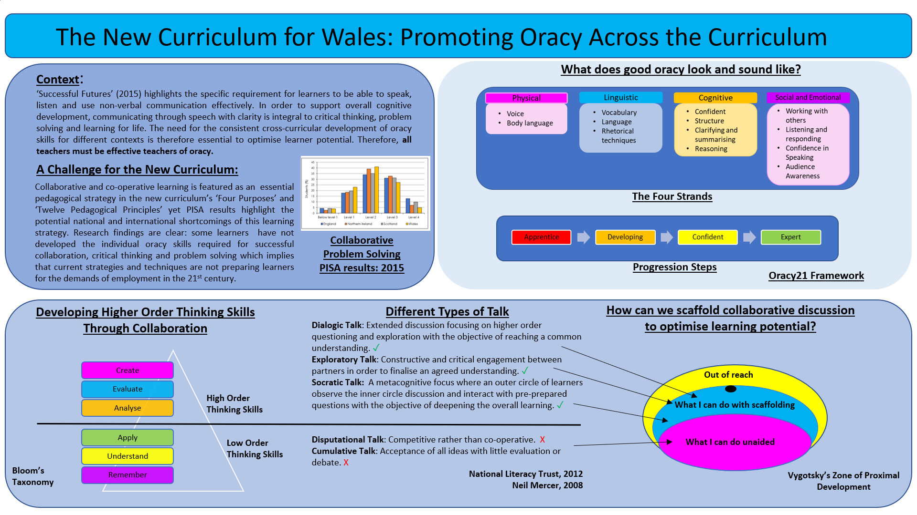
ii) Rationale
The poster entitled: ‘The New Curriculum for Wales: Promoting Oracy Across the Curriculum’ links specifically to the strategic plan for SLT in School A which has identified oracy as an area in need of pedagogical focus. This is supported by its dominant presence in chapter 5 and 6 of ‘Successful Futures’ with collaboration being highlighted as a core pedagogical principle that also enhances many other principles that encourage the learner to take more responsibility for the process of learning (Principles: 2,3,4,7,10, 12). This focus is also supported by national and international evidence that reflects collaboration as not being as impactful as it needs to be to support high order thinking skills, critical thinking and problem solving which are essential in an increasingly automated society (Donaldson, 2015; OECD, 2017a; OECD, 2017b; Mercer & Mannion, 2018).
The intention of the poster is to act as a prompt for discussion amongst teaching staff to initially engage them in a dialogue about how well oracy is represented in their faculty through schemes of work and classroom practice. The wider intention is to encourage a whole staff reflection on their own practice but also the current ethos of the school in relation to the way oracy is approached and both teachers’ and learners’ attitudes to it. Not only should it provide an opportunity for good practice to be discussed and eventually modelled for all teachers, but it should also encourage the acknowledgement, by some, that they have areas that need to be developed in terms of their pedagogical understanding of approaches to facilitating the effective construction of knowledge through scaffolded oracy that has been modelled for the learners (Alexander, 2017; Voice 21, 2018). This is an opportunity to promote an enhanced focus on professional learning as laid out in the teaching standards (The Welsh Government, 2017).
iii) Critical Evaluation
Section 1:
Initially the context section of the poster is essential in linking the initiative clearly to the title of the poster but more significantly to the new curriculum for Wales as reflected in the four purposes and twelve pedagogical principles (Didau, 2015; Donaldson, 2015). It also explicitly highlights that oracy development is the responsibility of all teachers. This requires emphasis since traditionally, speaking and listening skills have been established skills predominantly linked with the teaching of English, Welsh and Modern Foreign Languages (MFL). Due to accountability for the formal assessment of these skills being adopted by these subject areas (HM Government, 2009), there is a possibility that attitudes to oracy may potentially be dismissive. Even though oracy features in the LNF, complexities of assessing and tracking something so process without a well-developed framework is problematic. Certainly, PISA evidence supports this (Donaldson, 2015; OECD, 2017a; OECD, 2017b; Mercer & Mannion, 2018).
Emphasising the positive impact on other cross-curricular features such as literacy, numeracy (LNF) and digital literacy (DCF) is stated with the intention of teachers ‘buying in’ to the promotion of oracy since it may enhance these cross-curricular skills which all teachers are responsible for: clear communication is key (Watkins et al, 2007). In effect, it could positively impact on every classroom experience: a welcomed strategy to support good quality teaching. By acknowledging the other core merits of improved cognitive development with enhanced opportunities to develop critical thinking and problem-solving skills, this section of the poster is attempting to persuade its audience of the merits to be reaped from a whole school pedagogical development of oracy (Vygotsky, 1978; Goswami, 2015; Alexander, 2017).
The introduction of any initiative or strategy for school improvement needs to be explicitly evidence based to maximise impact and evaluate consistently. Hence, the inclusion of the small PISA graph and explanation relating to lower scores in collaborative problem solving promotes that oracy is a strategic pedagogical focus is based on valid international and national research (Donaldson, 2015; OECD, 2017a; OECD, 2017b; Mercer & Mannion, 2018). Furthermore, the new Teaching Standards also promote professional learning as a significant area of focus for all teachers which should raise the status of the profession and promote improved quality of education (Furlong, 2015; The Welsh Government, 2017) so SLT must model and promote the need for external research-based evidence which may then support the development of action research internally.
Section 2:
To promote enhanced professional learning as a means of creating a firm foundation for the pedagogical development of oracy in School A, the bottom half of the poster attempts to encourage some opportunity for reflection on cognitive theories such as Bloom’s Taxonomy (Forehand, 2011) and Vygotsky’s Zone of Proximal Development (Vygotsky, 1978), both of which have been integrated with different collaborative talk types and their impact in terms of the level of challenge and engagement of thinking skills (Mercer, 2008; National Literacy Trust, 2012). Initially staff may reflect on Bloom’s hierarchy (Forehand, 2011), prioritising creating, evaluating and analysing as higher order skills (HOTS) as opposed to application, understanding and remembering as Lower order thinking skills (LOTS). In terms of pitching oracy tasks within Vygotsky’s Zone of Proximal Development, individual talk has been omitted based on the assumption that students who develop confidence for co-operative problem solving and critical thinking will develop language skills that augur well for individual based oracy contexts. This potentially raises a significant point for discussion amongst staff who may well question the impact of tasks generated within their learning environments and to consider how oracy is monitored, adapted and tracked within a faculty. This supports the need for there to be a great discussion of metacognition between staff and students, as reinforced in the strategic plan. Voice 21 resources would support this (Voice 21, 2018).
Section 3:
The literature review highlights the need for a clear framework to be established to support the whole school development of oracy as a cross-curricular skill (Donaldson, 2015; Education Endowment Foundation, 2017). The section on ‘What good oracy looks and sounds like’ aims to provide a brief overview of the framework shared by the Voice 21 initiative thus clarifying for teachers that they will be supported through the process by a framework that has been researched, applied and evaluated (Smith, et al., 2018; Voice 21, 2018) (Appendix 1). It is intentional that descriptors of these features have been omitted so that teachers can discuss what each feature means in their own learning environment. It must be acknowledged that there will be differences in the way oracy is represented across Areas of Learning and Experience (AofLE) and teachers should engage in a dialogue regarding this. Some may even feel that some of these ideas are not relevant which should engage them in a discussion with the potential to modify the list to suit our setting of their faculty environment, thus promoting increased teacher agency. The Progression Steps have not been elaborated on to avoid over-loading teachers with new ideas; this document will be provided separately (Appendix 2).
Conclusion
The implementation of the new curriculum in Wales clearly raises several concerns, firstly regarding the vagueness of the policy, but secondly, regarding the greatness of the shift in pedagogical expectations for both teachers and learners. However, collaboration between learners, and learners and teachers, is a most significant principle, due to the positive impact on all areas of pedagogy such as AFL and the development of resilience. Ultimately, successful learners are successful communicators which will be evermore important in a diverse 21st century society.

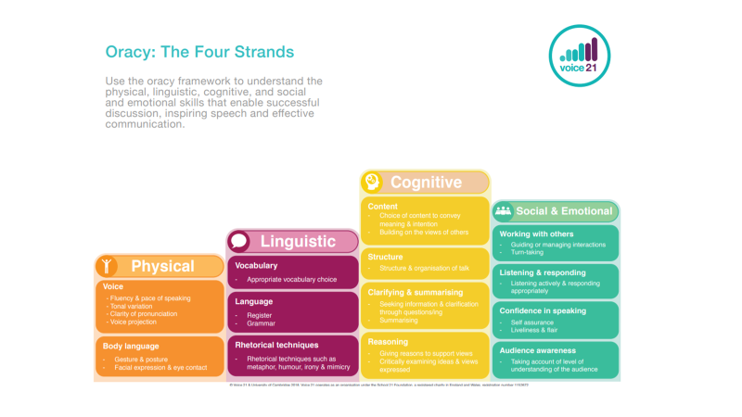
APPENDIX 1
#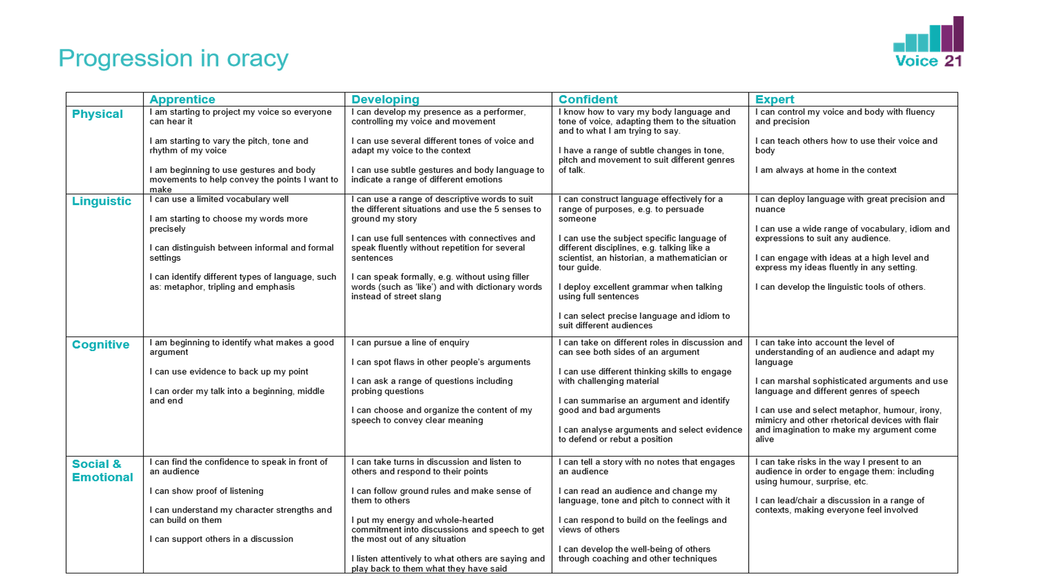
APPENDIX 2

References

Alexander, R., 2017. Dialogic Teaching in Brief. [Online]
Available at: https://www.robinalexander.org.uk/wp-content/uploads/2012/10/Dialogc-teaching-in-brief-170622.pdf
[Accessed 14 July 2018].
Bakhtin, M. M., 1981. The dialogic imagination: Four essays, Austin, TX: University of Texas Press.
Berry, R., 2011. Assessment trends in Hong Kong: seeking to establish formative assessment in an examination culture. [Online]
Available at: https://www.tandfonline.com/doi/abs/10.1080/0969594X.2010.527701
[Accessed 14 July 2018].
Chaiklin, S., 2003. The Zone of Proximal Development in Vygotsky’s Analysis of Learning and Instruction. [Online]
Available at: https://zodml.org/sites/default/files/%5BAlex_Kozulin,_Boris_Gindis,_Vladimir_S._Ageyev,_S_0.pdf
[Accessed 28 August 2018].
Clark, I., 2012. Assessment is for Self-Regulatory Learning. [Online]
Available at: https://link.springer.com/article/10.1007%2Fs10648-011-9191-6
[Accessed 20 July 2018].
Coe, R., Abisi, C., Higgins, S. & Major, L. E., 2014. What Makes Great Teaching? Review of the Underpinning Research. [Online]
Available at: https://www.suttontrust.com/wp-content/uploads/2014/10/What-Makes-Great-Teaching-REPORT.pdf
[Accessed 15 July 2018].
Culatta, R., 2011. Innovative Learning: Zone of Proximal Development. [Online]
Available at: http://www.innovativelearning.com/educational_psychology/development/zone-of-proximal-development.html
[Accessed 26 August 2018].
Darling-Hammond, L., 2017. Developing and measuring higher order skills: Models for state performance assessment systems. [Online]
Available at: https://learningpolicyinstitute.org/sites/default/files/product-files/Models_State_Performance_Assessment_Systems_BRIEF.pdf
[Accessed 29 August 2018].
Didau, D., 2013. Effective Group Work. [Online]
Available at: https://learningspy.co.uk/behaviour/effective-group-work/
[Accessed 6 August 2018].
Didau, D., 2015. Should Groupwork be imposed?. [Online]
Available at: https://learningspy.co.uk/featured/group-work-big-deal/
[Accessed 6 August 2018].
Donaldson, G., 2015. The Donaldson Review of Curriculum and Assessment, Cardiff: The Welsh Government.
Duggan, L. & Solomons, M., 2014. Building Resilience: The Seven Steps to Creating Highly Successful Lives. Milton Keynes: Developing Potential Ltd..
Dweck, C. S., 2012. Mindset. London: Robinson.
Dweck, C., Walton, G. & Cohen, G., 2014. Tenacity: Mindsets That Promote Resilience: When Students Believe That Personal Characteristics Can be Developed. [Online]
Available at: https://ed.stanford.edu/sites/default/files/manual/dweck-walton-cohen-2014.pdf
[Accessed 6 August 2018].
Education Endowment Foundation, 2017. Teaching and Learning Toolkit: Collaborative Learning. [Online]
Available at: https://educationendowmentfoundation.org.uk/evidence-summaries/teaching-learning-toolkit/collaborative-learning/
[Accessed 22 August 2018].
Ericsson, K. A., 2006. The Influence of Experience and Deliberate Practice on the Development of Superior Expert Performance. [Online]
Available at: http://psych.colorado.edu/~ketels/psych4145/Ericsson_2006.pdf
[Accessed 26 August 2018].
Forehand, M., 2011. Bloom’s taxonomy. Emerging perspectives on learning, teaching, and technology, 41 p. 47. [Online]
Available at: https://www.d41.org/cms/lib/IL01904672/Centricity/Domain/422/BloomsTaxonomy.pdf
[Accessed 30 August 2018].
Fullan, M. & Hargreaves, A., 2016. Bringing the profession back in. [Online]
Available at: https://learningforward.org/docs/default-source/pdf/bringing-the-profession-back-in.pdf
[Accessed 30 August 2018].
Furlong, J., 2015. Teaching Tomorrow’s Teachers, Cardiff: The Welsh Government.
Goswami, U., 2015. Children’s Cognitive Development and Learning. CRPT Research Survey 3. [Online]
Available at: https://cprtrust.org.uk/wp-content/uploads/2015/02/COMPLETE-REPORT-Goswami-Childrens-Cognitive-Development-and-Learning.pdf
[Accessed 29 August 2018].
Hattie, J., 2012. Visible Learning for Teachers: Maximising Impact on Learning, London: Routledge.
Hattie, J. & Yates, G. C., 2014. Visible Learning and the Science of How we Learn. London: Routledge.
Hirsch Jr, E. D., 2016. Why Knowledge Matters: Rescuing Our Children from Failed Educational Theories. Cambridge, MA: Harvard Educational Press.
HM Government, 2009. National Curriculum, Fourth Report of Session 2008-09. [Online]
Available at: http://educationengland.org.uk/documents/pdfs/2009-CSFC-national-curriculum.pdf
[Accessed 27 August 2018].
Hochanadel, A. & Finamore, D., 2015. Fixed and Growth Mindset in Education and How Grit Helps Students Persist in the Face of Adversity. [Online]
Available at: https://files.eric.ed.gov/fulltext/EJ1051129.pdf
[Accessed 28 August 2018].
Killan, S., 2017. Hattie’s 2017 updated list of factors related to student achievement. [Online]
Available at: http://www.evidencebasedteaching.org.au/hatties-2017-updated-list/
[Accessed 12 July 2018].
Lefstein, A. & Snell, J., 2011. Classroom Discourse: The Promise and Complexity of Dialogic Practice. [Online]
Available at: http://johnsonj.blog.monroe.edu/files/2015/08/promise-and-complexity-of-dialogic-practice.pdf
[Accessed 5 August 2018].
Luckin, R., 2017. Collaborative problem-solving and why it matters for learning. [Online]
Available at: https://ioelondonblog.wordpress.com/2017/11/21/collaborative-problem-solving-andwhy-it-matters-for-learning
[Accessed 28 August 2018].
Mercer, N., 2008. Three Kinds of Talk. [Online]
Available at: https://thinkingtogether.educ.cam.ac.uk/resources/5_examples_of_talk_in_groups.pdf
[Accessed 28 August 2018].
Mercer, N. & Mannion, J., 2018. Oracy Across the Welsh Curriculum. A research- based Review: Key Principles and Recommendations for Teachers. [Online]
Available at: https://oracycambridge.org/wp-content/uploads/2018/07/Oracy-across-the-Welsh-curriculum-July-2018.pdf
[Accessed 16 August 2018].
Ministry of Education (NZ), 2007. The New Zealand Curriculum. [Online]
Available at: http://nzcurriculum.tki.org.nz/The-New-Zealand-Curriculum
[Accessed 23 August 2018].
National Literacy Trust, 2012. Understanding Different Types of Talk. [Online]
Available at: https://www.thomastallisschool.com/uploads/2/2/8/7/2287089/different_types_of_interactive_talk.pdf
[Accessed 28 August 2018].
OECD, 2005. Teachers Matter: Attracting, Developing and Retaining Effective Teachers. [Online]
Available at: http://www.oecd.org/education/school/34990905.pdf
[Accessed 12 July 2018].
OECD, 2008. Innovating to Learn, Learning to Innovate. [Online]
Available at: http://www.oecd.org/education/ceri/41656508.pdf
[Accessed 20 August 2018].
OECD, 2017a. PISA 2015 Results (Volume V): Collaborative Problem Solving. [Online]
Available at: https://www.oecd-ilibrary.org/education/pisa-2015-results-volume-v_9789264285521-en
[Accessed 27 August 2018].
OECD, 2017b. PISA 2015 Results (Volume V): Collaborative Problem Solving (Editorial). [Online]
Available at: https://www.oecd-ilibrary.org/education/pisa-2015-results-volume-v/editorial_9789264285521-2-en
[Accessed 27 August 2018].
Priestley, M. & Drew, V., 2016. Teachers as agents of curriculum change; closing the gap between policy and practice. [Online]
Available at: https://dspace.stir.ac.uk/handle/1893/24179#.W4p4CehKjIV
[Accessed 29 August 2018].
Priestley, M. & Humes, W., 2010. The development of Scotland’s Curriculum for Excellence: Amnesia and Déjà Vu. [Online]
Available at: http://dspace.stir.ac.uk/handle/1893/2110#.WbkxpmWfeOo
[Accessed 29 August 2018].
Sinnema, C. & Aitken, G., 2013. Reinventing the curriculum: New trends in curriculum policy and practice. London: Bloomsbury.
Smith, J. et al., 2018. Voice 21 Pilot Report and Executive Summary. [Online]
Available at: https://educationendowmentfoundation.org.uk/public/files/Projects/Evaluation_Reports/Voice_21.pdf
[Accessed 29 August 2018].
Stafenberg, J., 2018. Strict traditional teaching methods are ‘pushing oracy out’ says MP in Schools Week. [Online]
Available at: https://schoolsweek.co.uk/strict-traditional-teaching-methods-are-pushing-oracy-out-says-mp/
[Accessed 31 August 2018].
The Scottish Government, 2008. Curriculum for Excellence. [Online]
Available at: http://www.gov.scot/resource/doc/226155/0061245.pdf
[Accessed 26 August 2018].
The Welsh Government, 2017. Professional Standards for teaching and leadership. [Online]
Available at: http://learning.gov.wales/resources/collections/professional-standards?lang=en
[Accessed 10 August 2018].
Voice 21, 2018. [Online]
Available at: https://www.voice21resources.org/
[Accessed 28 August 2018].
Vygotsky, L. S., 1978. Mind in society: The development of higher psychological processes. Cambridge, MA: Harvard University Press.
Watkins, C., Carnell, E. & Lodge, C., 2007. Effective Learning in Classrooms. London: SAGE.
Wikipedia, 2018. The Ringelmann Effect. [Online]
Available at: https://en.wikipedia.org/wiki/Ringelmann_effect
[Accessed 7 August 2018].
William, D., 2010. The Role of Formative Assessment in Effective Learning Environments. [Online]
Available at: https://read.oecd-ilibrary.org/education/the-nature-of-learning/the-role-of-formative-assessment-in-effective-learning-environments_9789264086487-8-en#page1
[Accessed 9 August 2018].
William, D., 2016. Leadership for Teacher Learning. USA: Learning Sciences International.
Wolfe, S. & Alexander, R., 2008. Argumentation and Dialogic Teaching: Alternative Pedogogies for a Changing World. [Online]
Available at: http://www.robinalexander.org.uk/wp-content/uploads/2012/05/wolfealexander.pdf
[Accessed 7 August 2018].
Young, M., 2013. Overcoming the crisis in curriculum theory: a knowledge based approach. [Online]
Available at: http://tinyurl.com/ydfvwh4v
[Accessed 5 March 2018].

