Appendix Contents
- Ethics form
- B Consent form
- Questionnaire for pupils
C1- Overview of pupil responses
- Questionnaire for teachers
D1- Overview of teacher responses
- Interview with pupils
- Interview with teacher
- Observation form
- Observation write up

Appendix A- ethics form


PG2 / E1 FORM

APPLICATION FOR ETHICAL APPROVAL

In order for research to result in benefit and minimise risk of harm, it must be conducted ethically. A researcher may not be covered by the University’s insurance if ethical approval has not been obtained prior to commencement.

The University follows the OECD Frascati manual definition of research activity: “creative work undertaken on a systematic basis in order to increase the stock of knowledge, including knowledge of man, culture and society, and the use of this stock of knowledge to devise new applications”. As such this covers activities undertaken by members of staff, postgraduate research students, and both taught postgraduate and undergraduate students working on dissertations/projects.

The individual undertaking the research activity is known as the “principal researcher”.

Ethical approval is not required for routine audits, performance reviews, quality assurance studies, testing within normal educational requirements, and literary or artistic criticism.

Please read the notes for guidance before completing ALL sections of the form.

This form must be completed and approved prior to undertaking any research activity. Please see Checklist for details of process for different categories of application.

Delete the Guidance Notes at the end of the form BEFORE submitting your application

SECTION A: About You (Principal Researcher)
Full Name: |  | Megan Powell
Tick all boxes which apply: |  | Member of staff: | ☐ | Honorary research fellow: | ☐
Undergraduate Student | ☒ | Taught Postgraduate Student | ☐ | Postgraduate Research Student | ☐

Faculty/School/Centre: | Initial Teacher Education, Yr Athrofa
Campus: | Carmarthen
E-mail address: | 1800574@student.uwtsd.ac.uk
Contact Telephone Number: | 07495508424
For students:
Student Number: | 1800574
Programme of Study: | BA Primary Education with QTS
Director of Studies/Supervisor: | Dr. Sioned V. Hughes

SECTION B: Approval for Research Activity
Has the research activity received approval in principle?  (please check the Guidance Notes as to the appropriate approval process for different levels of research by different categories of individual) |  | YES | ☒ | NO | ☐
 |  |  |  | Date
If Yes, please indicate source of approval (and date where known): Approval in principle must be obtained from the relevant source prior to seeking ethical approval | Research Degrees Committee |  | ☐
 | Faculty Research Committee |  | ☐
 | Other (write in) ECAD5010 Module Lead |  | ☒ | 27.02.20

SECTION C: Internal and External Ethical Guidance Materials
Please list the core ethical guidance documents that have been referred to during the completion of this form (including any discipline-specific codes of research ethics, and also any specific ethical guidance relating to the proposed methodology). Please tick to confirm that your research proposal adheres to these codes and guidelines.
UWTSD Research Ethics & Integrity Code of Practice | ☒
UWTSD Research Data Management Policy | ☒
BERA referred to at https://www.bera.ac.uk/researchers-resources/publications/ethical-guidelines-for-educational-research-2018 | ☒
 | ☐

SECTION D: External Collaborative Research Activity
Does the research activity involve collaborators outside of the University? |  | YES | ☐ | NO | ☒
If Yes, please provide the name of the external organisation and name and contact details for the main contact person and confirmation this person has consented to their personal data being shared.as part of this collaboration.
Institution
Contact person name
Contact person e-mail address

Has this individual consented to sharing their details on this form? |  | YES | ☐ | NO |  |  | ☐
Are you in receipt of a KESS scholarship? |  | YES | ☐ | NO |  |  | ☐
Is your research externally funded |  | YES | ☐ | NO |  |  | ☐
Are you specifically employed to undertake this research in either a paid or voluntary capacity? | Voluntary | YES | ☐ | NO |  | ☐
 | Employed | YES | ☐ | NO |  | ☐
Is the research being undertaken within an existing UWTSD Athrofa Professional Learning Partnership (APLP) | If YES then the permission question below does not need to be answered. | YES | ☒ | NO |  |  | ☐
Permission to undertake the research has been provided by the partner organisation | (If YES attach copy)  If NO the application cannot continue | YES | ☐ | NO |  |  | ☐

Where research activity is carried out in collaboration with an external organisation
Does this organisation have its own ethics approval system? | YES | ☐ | NO | ☒
If Yes, please attach a copy of any final approval (or interim approval) from the organisation

SECTION E: Details of Research Activity
Indicative title: | To what extent is questioning inclusive?
Proposed start date: | 02.03.20 | Proposed end date: | 01.04.20
Introduction to the Research (maximum 300 words)
Ensure that you write for a Non-Specialist Audience when outlining your response to the three points below:
- Purpose of Research Activity
- Proposed Research Question
- Aims of Research Activity
- Objectives of Research Activity
Demonstrate, briefly, how Existing Research has informed the proposed activity and explain
- What the research activity will add to the body of knowledge
- How it addresses an area of importance.
Purpose of Research Activity
- To develop research skills
- To trail different research tools such as interviews, questionnaires and observation in practice.
- To explore how the AFL strategy questioning effects pupils.

(this box should expand as you type)
Research Question

To what extent is questioning inclusive?

(this box should expand as you type)
Aims of Research Activity
- To explore the perception of staff and learners on the AFL strategy questioning.
- To evaluate the three research tools critically.
- To develop personal research skills to use in practice.
- To develop further personal knowledge and understanding on AFL focussing on questioning.
- To improve personal professional practice.

(this box should expand as you type)
Objectives of Research Activity
- To critically explore the AFL strategy of questioning.
- To observe the different questioning approaches used by staff by observing a lesson in a year 5/6 class.
- To explore pupil’s views on questioning using a questionnaire.
- To focus on staff’s views about questioning using a questionnaire and conducting an interview with a class teacher.
- To interview learners from a year 5/6 class to capture their views of questioning in class.
- To reflect on the process of using 3 research tools in order to collect data.

(this box should expand as you type)
Proposed methods (maximum 600 words)
Provide a brief summary of all the methods that may be used in the research activity, making it clear what specific techniques may be used. If methods other than those listed in this section are deemed appropriate later, additional ethical approval for those methods will be needed.
Interviews – A small group from a mixed year 5/6 class will be involved in semi-structured interview where they will respond to key questions. For example, questions will be asked such as do you volunteer to answer a question, or will you only answer if the teacher asks you to? Do you think questions help you to understand more? Do you feel confident when answering questions? These interviews will be conducted in an informal setting to ensure the pupils feel at ease during the interview. Throughout this I will make notes on their responses in a notebook and I will also use an audio recorder so after the interview I can write up further notes that I might have missed. The pupils will not be forced to participate, and I will make them aware that if they do not want to answer a question then they do not have to answer. I will also make them aware that at any point they can exit and withdraw from the research without needing a reason. Prior to conducting the interview all pupils will be asked if they would like to be involved, here I will be gaining assent. I will give pupils a red card and on the other side a green card and at points throughout I will check that they are all still on green and are happy to continue. No names will be recorded throughout the interview.

Questionnaire- I will ask the year 5/6 class who would like to take part in the questionnaire, I will explain to the class that no one has to do it and they will not be thought of differently if they do not take part. I will gain the pupils assent before starting. For pupils who do want to take part they will answer questions based on questioning such as do you like answering questions? How often do you put your hand up to answer questions? The questionnaire will be anonymous, I will look at the data online as I will be using Microsoft forms and therefore the data gets collected electronically.
I will also try and get the class teacher and the other two teachers in the year 5/6 class to answer my questionnaire to explore their feelings on questioning. This questionnaire will also be anonymous, and I will again use Microsoft forms so once the questionnaire is completed, I can look at the data electronically. I will also inform them that they also, do not have to complete the questionnaire and it is optional. I will ask questions such as how often do you use the following types of questions, closed, open, probing. What questioning technique do you think is best and why?

Observations – I will observe a mixed year 5/6 class in a lesson. Within this lesson I will be focusing on what types of questions will be asked. Who answers the question, tallying how many boys, how many boys, and how many higher ability, middle ability and lower ability pupils answer. I will also take note of how confident pupils are and I will use the Leuven scale. I will also tally how many times the teacher asks a pupil with their hand up and how many times they ask a pupil at random to answer. I will also make brief notes throughout and then write up notes in full straight after the observation. Within the observation I will not make note of any names of the pupils. Prior to starting he observation I will also ask if any one does not want to be observed, if I have pupils who say they do not want to then I will explain that they will not be included in any of my observation notes.

(this box should expand as you type)

Location of research activity
Identify all locations where research activity will take place.
The research will take place in a large rural area in Wales with approximately 400 pupils in the school.

(this box should expand as you type)
Research activity outside of the UK
If research activity will take place overseas, you are responsible for ensuring that local ethical considerations are complied with and that the relevant permissions are sought. Specify any local guidelines (e.g. from local professional associations/learned societies/universities) that exist and whether these involve any ethical stipulations beyond those usual in the UK (provide details of any licenses or permissions required). Also specify whether there are any specific ethical issues raised by the local context in which the research activity is taking place, for example, particular cultural and/or legal sensitivities or vulnerabilities of participants.
N/A

(this box should expand as you type)
Use of documentation not in the public domain: Are any documents NOT publicly available? | NO | ☒
 | YES | ☐
If Yes, please provide details here of how you will gain access to specific documentation that is not in the public domain and that this is in accordance with prevailing data protection law of the country in question and England and Wales.

(this box should expand as you type)

SECTION F: Scope of Research Activity
Will the research activity include: | YES | NO
Use of a questionnaire or similar research instrument? | ☒ | ☐
Use of interviews? | ☒ | ☐
Use of diaries? | ☐ | ☒
Participant observation with their knowledge? | ☒ | ☐
Participant observation without their knowledge? | ☐ | ☒
Use of video or audio recording? | ☐ | ☒
Access to personal or confidential information without the participants’ specific consent? | ☐ | ☒
Administration of any questions, test stimuli, presentation that may be experienced as physically, mentally or emotionally harmful / offensive? | ☐ | ☒
Performance of any acts which may cause embarrassment or affect self-esteem? | ☐ | ☒
Investigation of participants involved in illegal activities? | ☐ | ☒
Use of procedures that involve deception? | ☐ | ☒
Administration of any substance, agent or placebo? | ☐ | ☒
Working with live vertebrate animals? | ☐ | ☒
Other primary data collection methods, please explain in this box  For example, ‘focus groups’. Please indicate the type of data collection method(s) in this box and tick the accompany box. | ☐ | ☒
Details of any other primary data collection method:  (this box should expand as you type) | ☐ | ☒
If NO to every question, then the research activity is (ethically) low risk and may be exempt from some of the following sections (please refer to Guidance Notes).

If YES to any question, then no research activity should be undertaken until full ethical approval has been obtained.

SECTION G: Intended Participants
Who are the intended participants: | YES | NO
Students or staff at the University? | ☐ | ☒
Adults (over the age of 18 and competent to give consent)? | ☒ | ☐
Vulnerable adults? | ☐ | ☒
Children and Young People under the age of 8? (Consent from Parent, Carer or Guardian will be required) | ☒ | ☐
Prisoners? | ☐ | ☒
Young offenders? | ☐ | ☒
Those who could be considered to have a particularly dependent relationship with the investigator or a gatekeeper? | ☐ | ☒
People engaged in illegal activities? | ☐ | ☒
Others (please identify specifically any group who may be unable to give consent) please indicate here and tick the appropriate box. | ☐ | ☒
Other – please indicate here:  (this box should expand as you type) | ☐ | ☒

Participant numbers and source
How will you identify participants and how will they be recruited?
How many participants are expected? | 30 participants (approx. 27 for the observation, 7 for the interview, approx. 30 for the questionnaire)  (this box should expand as you type)
Who will the participants be? | 3 teachers, 27 pupils (pupils of a mixed year 5/6 class)  (this box should expand as you type)
How will you identify the participants? | I will identify the participants as I have previous experience in this school from PTE2.  (this box should expand as you type)

Information for participants: | YES | NO | N/A
Will you describe the main research procedures to participants in advance, so that they are informed about what to expect? | ☒ | ☐ | ☐
Will you tell participants that their participation is voluntary? | ☒ | ☐ | ☐
Will you obtain written consent for participation? | ☒ | ☐ | ☐
Will you explain to participants that refusal to participate in the research will not affect their treatment or education (if relevant)? | ☒ | ☐ | ☐
If the research is observational, will you ask participants for their consent to being observed? | ☒ | ☐ | ☐
Will you tell participants that they may withdraw from the research at any time and for any reason? | ☒ | ☐ | ☐
With questionnaires, will you give participants the option of omitting questions they do not want to answer? | ☒ | ☐ | ☐
Will you tell participants that their data will be treated with full confidentiality and that, if published, it will not be identifiable as theirs? | ☒ | ☐ | ☐
Will you debrief participants at the end of their participation, in a way appropriate to the type of research undertaken? | ☐ | ☐ | ☒
If NO to any of above questions, please give an explanation
(this box should expand as you type)

Information for participants: | YES | NO | N/A
Will participants be paid? | ☐ | ☒ | ☐
Is specialist electrical or other equipment to be used with participants? | ☐ | ☒ | ☐
Are there any financial or other interests to the investigator or University arising from this study? | ☐ | ☒ | ☐
Will the research activity involve deliberately misleading participants in any way, or the partial or full concealment of the specific study aims? | ☐ | ☒ | ☐
If YES to any question, please provide full details
(this box should expand as you type)

SECTION H: Anticipated Risks

Outline any anticipated risks that may adversely affect any of the participants, the researchers and/or the University, and the steps that will be taken to address them.

If you have completed a full risk assessment (for example as required by a laboratory, or external research collaborator) you may append that to this form.
Full risk assessment completed and appended? |  | Yes | ☐
 |  | No | ☒
Risks to participants
For example: emotional distress, financial disclosure, physical harm, transfer of personal data, sensitive organisational information
Risk to Participant:  Pupils may feel that they must give the correct answer rather than how they actually feel.  Pupils may just copy what their friend might have said.  Pupils may feel stressed.  Pupils may worry that what they tell myself will get back to the teacher and then the teacher may be annoyed.  Pupils may make accusations.  Pupils could be scared of their data being shown.  (this box should expand as you type) | How will you mitigate the Risk to Participant  It will be explained to pupils that there is no consequence for anything that they say. What they tell me will stay between me and them and all I want is honest answers and their true opinion on the question. I will make it clear that what they tell me will have no consequence at all for their education and there will not be any repercussions for their actions with each answer they give. I will inform them that they have nothing to worry about I just want to know how they feel. I will also remind them at any time if they do not want to answer any questions or complete the questionnaire or be observed then it is absolutely fine, and they can withdraw. I will always have another adult present at all times to reduce any possible allegations. I will anonymise the pupils and the school.  (this box should expand as you type)
If research activity may include sensitive, embarrassing or upsetting topics (e.g. sexual activity, drug use) or issues likely to disclose information requiring further action (e.g. criminal activity), give details of the procedures to deal with these issues, including any support/advice (e.g. helpline numbers) to be offered to participants. Note that where applicable, consent procedures should make it clear that if something potentially or actually illegal is discovered in the course of a project, it may need to be disclosed to the proper authorities
N/A
(this box should expand as you type)
Risks to investigator
For example: personal safety, physical harm, emotional distress, risk of accusation of harm/impropriety, conflict of interest
Risk to Investigator:  While completing the research allegations might be made from pupils.  Pupils might disclose some personal information during the interview.  (this box should expand as you type) | How will you mitigate the Risk to Investigator:  Majority of the research will be taken place during a normal activity within the classroom where another member of staff will be there.  During the interview I will have another member of staff present to protect myself from any possible allegations.  Inform to the necessary people if any distressing personal information has been disclosed during the interview.  (this box should expand as you type)
University/institutional risks
For example: adverse publicity, financial loss, data protection
Risk to University:  Not behaving appropriately which could impact the relationship between school and university.  Sharing information that has been discussed.  (this box should expand as you type) | How will you mitigate the Risk to University:  I will always behave in a professional and appropriate manner.  I will not share any information that has been discussed with anyone and will always anonymise the participants and school.  (this box should expand as you type)

Disclosure and Barring Service
If the research activity involves children or vulnerable adults, a Disclosure and Barring Service (DBS) certificate must be obtained before any contact with such participants. | YES | NO | N/A
Does your research require you to hold a current DBS Certificate? | ☒ | ☐ | ☐

SECTION I: Feedback, Consent and Confidentiality
Feedback
What de-briefing and feedback will be provided to participants, how will this be done and when?
N/A

(this box should expand as you type)
Informed consent
Describe the arrangements to inform potential participants, before providing consent, of what is involved in participating. Describe the arrangements for participants to provide full consent before data collection begins. If gaining consent in this way is inappropriate, explain how consent will be obtained and recorded in accordance with prevailing data protection legislation.
I will discuss with my class teacher and inform them of the research I will be undertaking. I will provide a reason and rationale behind the research prior to conducting the research. I will explain to my class teacher that I would like to explore their perspective on questioning and have an interview with her too as well as them completing a questionnaire, gaining their consent first. I will also discuss with the other 2 year 5/6 teachers if they would be happy to complete my questionnaire to explore their perspective on questioning. I will verbally ask the pupils if they would like to participate in the research explaining to them what research I am undertaking. I will tell them that I am looking at your perspective and views of questioning, so how you feel about answering questions in class and if you think it is useful. I will ask pupils if they are happy to complete a questionnaire and if they are happy to be observed prior. For the focus group I will ask if they are happy to talk to me about their views, gaining assent before conducting the interview. I will also give them a red/green card where they can show me how they are feeling and if they feel they need to leave or no longer want to take part then they can show me the red card. This is so I can check throughout that they are still happy to continue. I will also tell the pupils that they have the right to withdraw at any time and it does not matter in any way if they do want to as it is not affecting them at all. In the interview it will be encouraged to the pupils to respond honestly and I will take their interest and well-being in mind. I will also inform pupils they can approach me at any time to ask questions about their contribution to the project.

(this box should expand as you type)
Confidentiality / Anonymity
Set out how anonymity of participants and confidentiality will be ensured in any outputs. If anonymity is not being offered, explain why this is the case.
Throughout this research no names will be written down and no names will be recorded. I will not disclose of any names and I will ensure that no individual data are made available to the school or parents. I will ensure to anonymise the school, staff and pupils throughout the research.

(this box should expand as you type)

SECTION J: Data Protection and Storage
In completing this section refer to the University’s Research Data Management Policy and the extensive resources on the University’s Research Data Management web pages (http://uwtsd.ac.uk/library/research-data-management/).
Does the research activity involve personal data (as defined by the General Data Protection Regulation 2016 “GDPR” and the Data Protection Act 2018 “DPA”)? | YES | NO
“Personal data” means any information relating to an identified or identifiable natural person (‘data subject’). An identifiable natural person is one who can be identified, directly or indirectly, in particular by reference to an identifier such as a name, an identification number, location data, an online identifier or to one or more factors specific to the physical, physiological, genetic, mental, economic, cultural or social identity of that natural person. | ☐ | ☐
If YES, provide a description of the data and explain why this data needs to be collected:
(this box should expand as you type)
Does it involve special category data (as defined by the GDPR)? | YES | NO
“Special category data” means sensitive personal data consisting of information as to the data subjects’ –  (a) racial or ethnic origin,  (b) political opinions,  (c ) religious beliefs or other beliefs of a similar nature,  (d) membership of a trade union (within the meaning of the Trade Union and Labour Relations (Consolidation) Act 1992),  (e) physical or mental health or condition,  (f) sexual life,  (g) genetics,  (h) biometric data (as used for ID purposes), | ☐ | ☐
If YES, provide a description of the special category data and explain why this data needs to be collected:
(this box should expand as you type)
Will the research activity involve storing personal data and/or special category data on one of the following: | YES | NO
Manual files (i.e. in paper form)? | ☐ | ☐
University computers? | ☐ | ☐
Private company computers? | ☐ | ☐
Home or other personal computers? | ☐ | ☐
Laptop computers/ CDs/ Portable disk-drives/ memory sticks? | ☐ | ☐
“Cloud” storage or websites? | ☐ | ☐
Other – specify: | ☐ | ☐
For all stored data, explain the measures in place to ensure the security of the data collected, data confidentiality, including details of password protection, encryption, anonymisation and pseudonymisation:
(this box should expand as you type)
All Data Storage
Will the research activity involve any of the following activities: | YES | NO
Electronic transfer of data in any form? | ☐ | ☐
Sharing of data with others at the University? | ☐ | ☐
Sharing of data with other organisations? | ☐ | ☐
Export of data outside the European Union or importing of data from outside the UK? | ☐ | ☐
Use of personal addresses, postcodes, faxes, emails or telephone numbers? | ☐ | ☐
Publication of data that might allow identification of individuals? | ☐ | ☐
Use of data management system? | ☐ | ☐
Data archiving? | ☐ | ☐
If YES to any question, please provide full details, explaining how this will be conducted in accordance with the GDPR and DPA (and/or any international equivalent):
(this box should expand as you type)
List all who will have access to the data generated by the research activity:
(this box should expand as you type)
List who will have control of, and act as custodian(s) for, data generated by the research activity:
(this box should expand as you type)
Give details of data storage arrangements, including security measures in place to protect the data, where data will be stored, how long for, and in what form. Will data be archived – if so how and if not why not.
(this box should expand as you type)
Please indicate if your data will be stored in the UWTSD Research Data Repository (see https://researchdata.uwtsd.ac.uk/ ). If so please explain. (Most relevant to academic staff)
(this box should expand as you type)
Confirm that you have read the UWTSD guidance on data management (see https://www.uwtsd.ac.uk/library/research-data-management/) | YES | ☐
 | NO | ☐
Confirm that you are aware that you need to keep all data until after your research has completed or the end of your funding | YES | ☐
 | NO | ☐

SECTION K: Declaration
The information which I have provided is correct and complete to the best of my knowledge. I have attempted to identify any risks and issues related to the research activity and acknowledge my obligations and the rights of the participants.

In submitting this application I hereby confirm that I undertake to ensure that the above named research activity will meet the University’s Research Ethics and Integrity Code of Practice
Signature of applicant: | Megan Powell | Date:  27.02.20

For STUDENT Submissions:
Director of Studies/Supervisor: | Dr. Sioned V. Hughes | Date: 27.02.20
Signature: | S.V.Hughes | Date: 27.02.20

For STAFF Submissions:
Head of School/Assistant Dean: |  | Date:
Signature: |  | Date:

Checklist: Please complete the checklist below to ensure that you have completed the form according to the guidelines and attached any required documentation:
☒ | I have read the guidance notes supplied before completing the form.
☒ | I have completed ALL RELEVANT sections of the form in full.
☒ | I confirm that the research activity has received approval in principle
☐ | I have attached a copy of final/interim approval from external organisation (where appropriate)
☐ | I have attached a full risk assessment (and have NOT completed Section H of this form) (where appropriate) ONLY TICK IF YOU HAVE ATTACHED A FULL RISK ASSESSMENT
☒ | I understand that it is my responsibility to ensure that the above named research activity will meet the University’s Research Ethics and Integrity Code of Practice.
☒ | I understand that before commencing data collection all documents aimed at respondents (including information sheets, consent forms, questionnaires, interview schedules etc.) must be confirmed by the DoS/Supervisor, module tutor or Head of School.
☒ | I have deleted the guidance notes before submitting the PG2 for consideration

Appendix B- consent form
Rhif Adnabod Cyfranogwr:
Participant Identification Number:
FFURFLEN GANIATÂD CYFRANOGIAD | PARTICIPATION CONSENT FORM
Teitl Y Prosiect: / Project Title:
Enw'r Ymchwilydd / Name of Researcher:

1 | Cadarnhaf fy mod wedi deall y wybodaeth a roddwyd gan ......................... (enw’r ymchwilydd) ar gyfer ei chynnig ymchwil. Rwyf wedi cael y cyfle i ystyried y wybodaeth, gofyn cwestiynau, ac rwyf wedi cael ateb boddhaol i’r rhain. |  | I confirm that I understand the information given by ……………for her research proposal. I have had the opportunity to consider the information, ask questions and have had these answered satisfactorily.
2 | Deallaf fy mod yn cymryd rhan o’m gwirfodd a bod croeso i mi dynnu’n ôl ar unrhyw adeg, heb roi rheswm. |  | I understand that my participation is voluntary and that I am free to withdraw at any time, without giving any reason.
3 | Deallaf y gellir defnyddio unrhyw wybodaeth a roddir gennyf mewn adroddiadau, erthyglau neu gyflwyniadau gan y tîm ymchwil. |  | I understand that any information given by me may be used in future reports, articles or presentations by the research team.
4 | Deallaf na fydd fy enw’n ymddangos mewn unrhyw adroddiadau, erthyglau neu gyflwyniadau. |  | I understand that my name will not appear in any reports, articles or presentations.
5 | Cytunaf i gymryd rhan yn yr astudiaeth uchod. |  | I agree to take part in the above study.
Enw’r Cyfranogwr Name of Participant |  |  |  | Llofnodwyd  Signature
Ymchwilydd  Researcher |  |  |  | Llofnodwyd  Signature

Cewch wrthod cymryd rhan yn yr astudiaeth hon. Cewch ddod â’ch cyfranogiad yn yr astudiaeth hon i ben unrhyw bryd. Os penderfynwch barhau’n ddienw, bydd sicrhau hynny’n flaenoriaeth a chymerir pob cam ymarferol i guddio pwy ydych. Os yw’n well gennych fod yn anhysbys, ni fydd unrhyw wybodaeth yn eich enwi ar dapiau sain na thrawsgrifiadau o’r cyfweliad hwn nac o unrhyw un arall. Ni fydd neb yn clywed unrhyw dapiau sain nac yn gweld unrhyw drawsgrifiadau heb eich cydsyniad o flaen llaw. Bydd deunyddiau a grëir yn sgil y cyfweliad hwn neu unrhyw gyfweliad arall yn aros yn gyfrinachol. | You may decline to participate in this study. You may end your participation in this study at any time. If you decide to remain anonymous, maintaining your anonymity will be a priority and every practical precaution will be taken to disguise your identity. If you prefer anonymity, there will not be any identifying information on audiotapes or transcripts of this or any interview. No-one will hear any audiotapes or see any transcripts without your prior consent. All materials generated from this or any interview will remain confidential.

Ar ôl llenwi’r ffurflen, dychwelwch hi yn yr amlen a ddarperir (lle bo’n berthnasol). Rhoddir un copi i’r cyfranogwr a chedwir y gwreiddiol yn ffeil y tîm ymchwilio yn: | When completed please return in the envelope provided (if applicable). One copy will be given to the participant and the original to be kept on the file of the research team at:
ENW A CHYFEIRIAD YR YMCHWILYDD | NAME & ADDRESS OF RESEARCHER  …………  c/o Dr Sioned V Hughes  University of Wales  Trinity Saint David  Carmarthen  SA31 3EP

Appendix C- pupil questionnaire

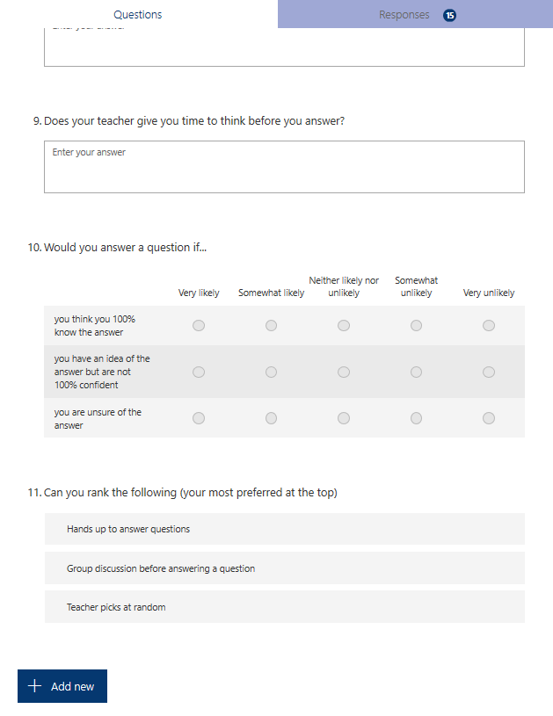
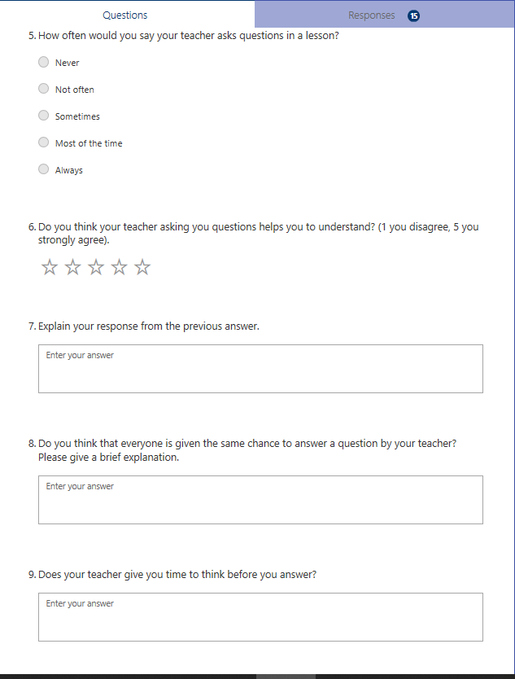
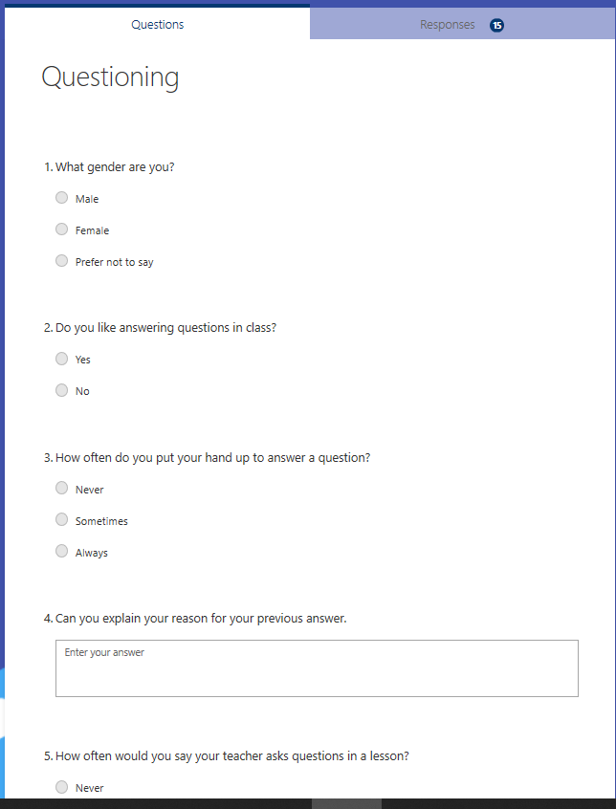
Appendix C1- overview pupil response
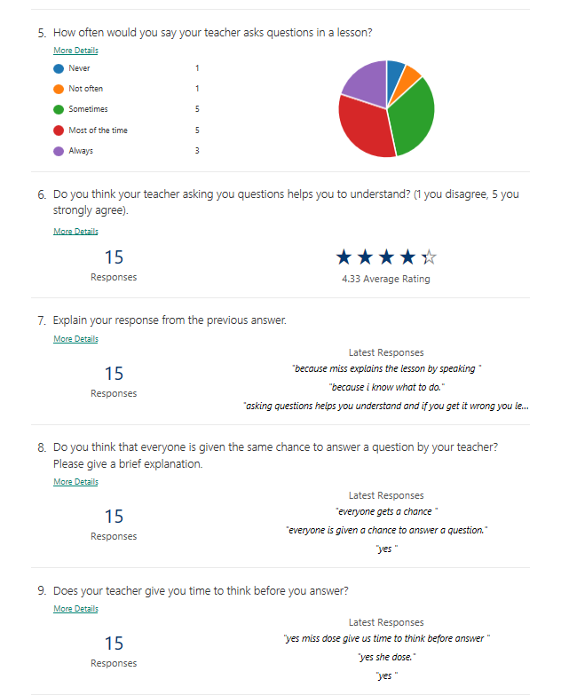
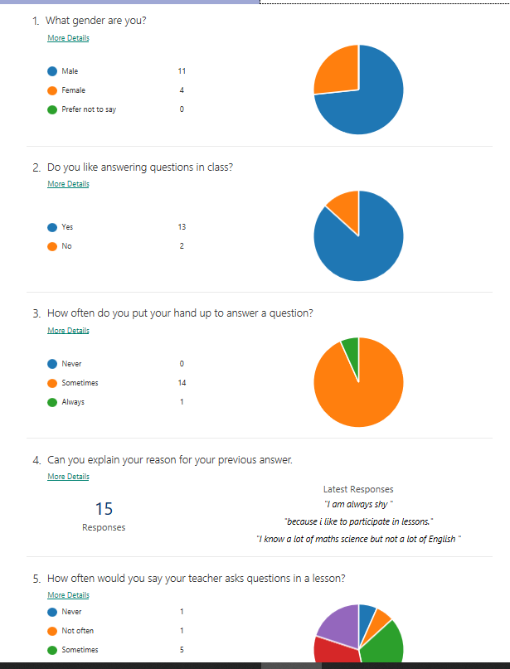

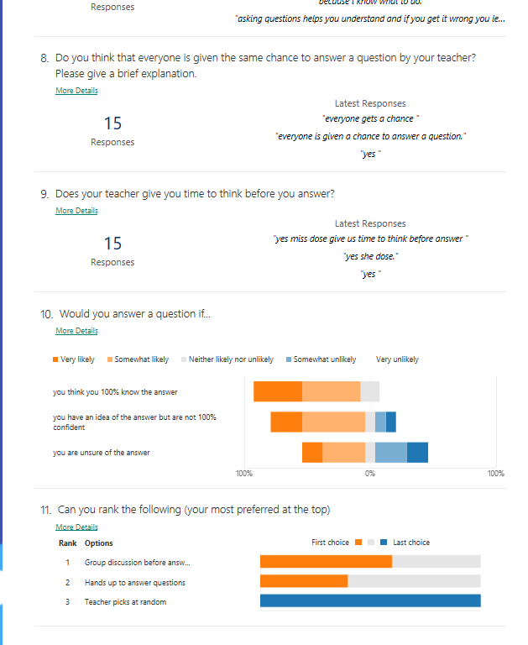

Appendix D – teacher questionnaire
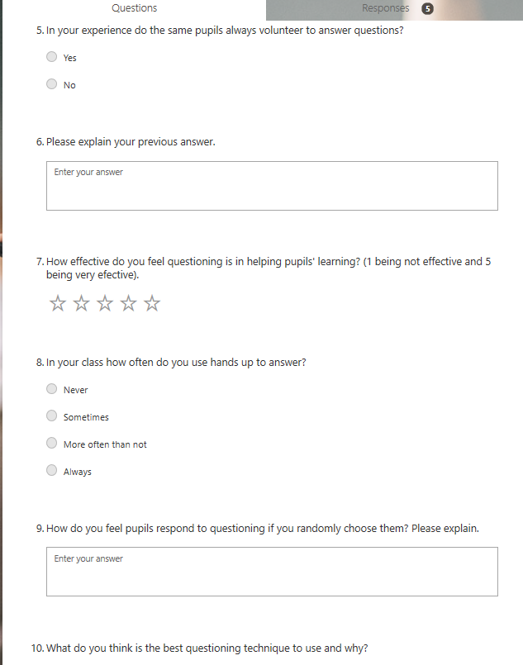
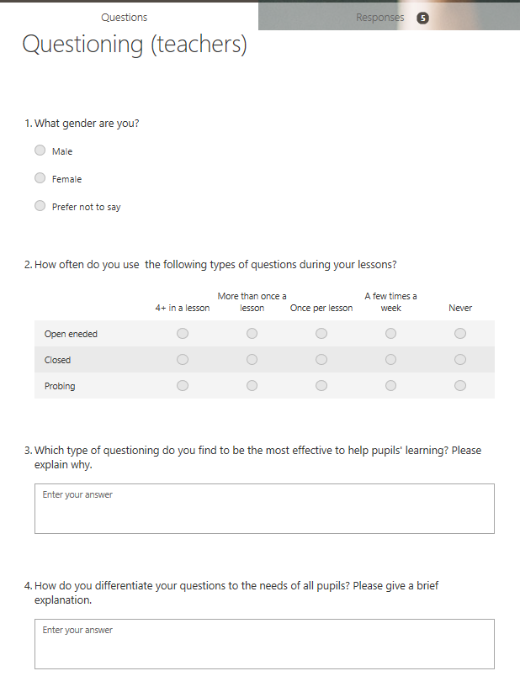
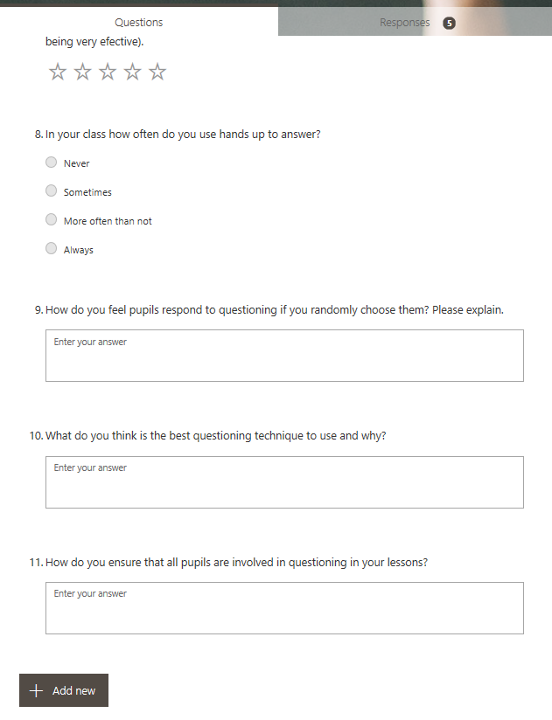

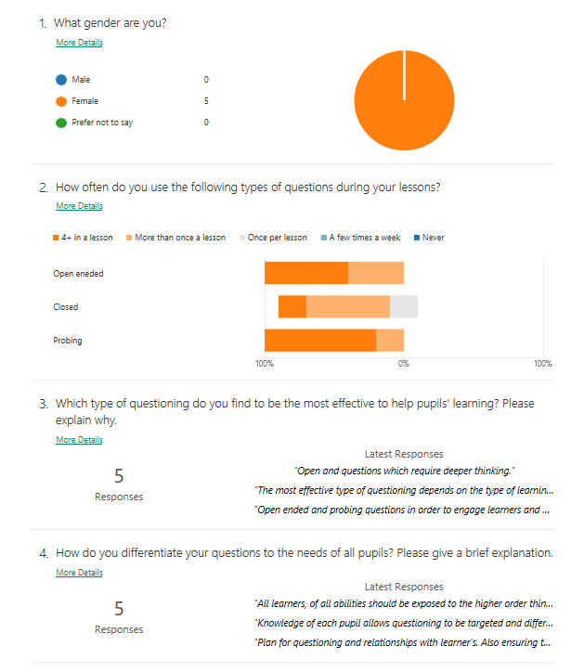
Appendix D1 – overview teacher response

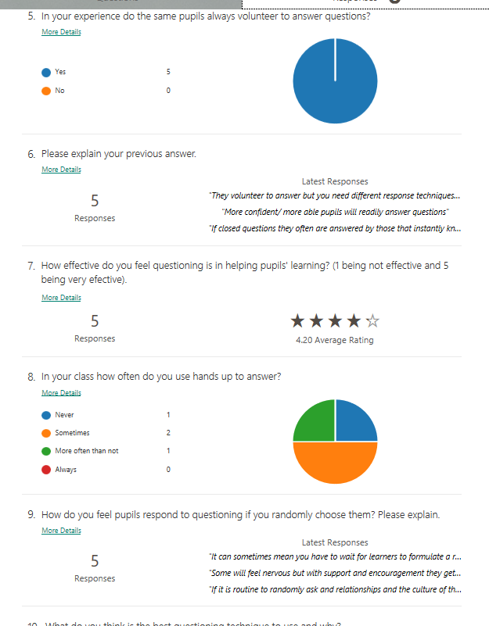

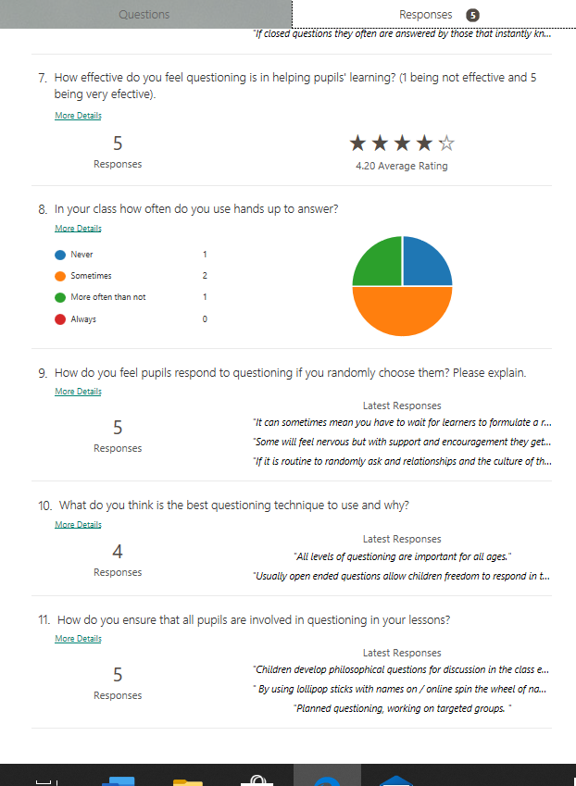

Appendix E- interview with pupils
- When your teacher asks a question, do you volunteer to answer, or do you only answer if the teacher asks you? Why?
Pupil A: Sometimes I put my hand up, but it depends, I only really put my hand up if I know the answer.
Pupil B: I only put my hand up if I know the answer and it is polite to put hand up rather than shouting out.
Pupil C: Sometimes I put my hand up, generally it is only if I know the answer otherwise I wouldn’t.
Pupil D: I think the same as pupil C I do the same, only if I know the answer.
Pupil E: Sometimes if I know the answer.
Pupil F: Only if I know the answer otherwise, I don’t put my hand up.
- Do you think your teacher always asks the same pupils to answer?
Pupil A: I think that miss choses a lot of different people to answer in class.
Pupil B: I agree, miss always asks different people to answer questions.
Pupil C: No, she gives everyone the chance to answer questions
Pupil D: I think she is really fair; everyone has a chance to answer.
Pupil E: I think she asks different people to answer.
Pupil F: She always asks different people.

- How do you feel when your teacher asks you a direct question? Do you get nervous if you are not sure of the answer?
Pupil A: I am happy that I have been chosen by the teacher to answer a question. I like the fact that I am able to share my ideas with the class. I do feel a bit pressured if a question is asked where I am not 100% confident with my answer.
Pupil B: I am okay with responding to direct questions providing I know the answer. Maybe I feel some pressure if I am not confident with my answer.
Pupil C: I feel happy that I have been chosen to answer if I know the answer. If I do not know the answer I try and give it a go. Miss always helps if we get stuck.
Pupil D: I do not mind really, I always give it a go and if I don’t know the answer I don’t really feel bothered I just try.
Pupil E: I feel scared when I’m asked a question people might not like my opinion.
Pupil F: I feel nervous as people might laugh at what I have said.
- Do you think that questions asked during lessons help you to understand?
Pupil A: yes, as if someone answers a question then you get to hear the answer which does make you understand more.
Pupil B: I agree it also clarifies some information as miss then explains more about the answer.
Pupil C: I think it does help me understand because miss then goes over the answer
Pupil D: I agree it does help as you can learn from what other people has said and then miss will go over the answer.
Pupil E: sometimes yes, or sometimes I can get a bit confused as there could be lots of information given.
Pupil F: most of the time yes, it is useful to hear answers and opinions.
- When a question is asked what usually happens?
Pupil A: normally people just put their hand up if they want to answer a question, sometimes we might discuss ideas first.
Pupil B: Either just hands up or a discussion about the question and then we feedback.
Pupil C: sometimes we talk in groups about the question, sometimes we just put our hand up to answer.
Pupil D: yeah that’s what we do usually, discuss or just put hand up.
Pupil E: talk to the person next to you sometimes or just use hands up
Pupil F: usually just hand sup to answer a question although I don’t often do this.
- Do you ever give an extended answer to a question in class?
Pupil A: I don’t know really I just say what ever comes to mind in response to the question. Sometimes it is extended and sometimes its not.
Pupil B: I feel that I always at least try and give an extended response when I answer a question. I try and use point, evidence, and explain when I give answers.
Pupil C: if I am confident with the answer then yes I will try and give an extended response.
Pupil D: it depends on the question to be honest, if I understand the question and I think I can give an extended response then I will try.
Pupil E: Not very often, only if miss asks me.
Pupil F: No, I don’t, only if I have to.
- Do you feel confident in answering questions?
Pupil A: yes as I listen to the questions and usually I know what I am saying so I do feel confident when I answer.
Pupil B: most of the time I feel confident when I answer questions apart from when I might not 100% know if I am right.
Pupil C: I am only confident if I know the answer.
Pupil D: it depends on the question if I know the answer, then I will be confident.
Pupil E: no because I get nervous.
Pupil F: it depends what is being asked, if I think I know the answer then I don’t mind so much.
- What do you do if you don’t understand a question or do not understand the answer someone has given?
Pupil A: I would tell the teacher I am not sure of the question, usually then they repeat it or make me understand what the question is asking. I will always be honest if I am unsure about the answer of the question. But if I was stuck at my desk I would use 3 before me which is partner, table, others in class then ask the teacher.
Pupil B: I would ask for the teacher to explain the question again and then if I didn’t understand what someone had said I would ask them. But I would also use 3 before me if I was stuck when doing work as it saves the teacher time.
Pupil C: the teacher helps me if I am unsure and I will be honest with them and say I don’t understand the question or that I do not know the answer.
Pupil D: I will ask the teacher to explain the question again, I will just give it a go and say what I think and if I’m not sure what a pupil has said I will ask them.
Pupil E: I ask for them to ask the question again or ask what do you mean. I will ask the person can they explain more if I don’t understand what someone has said.
Pupil F: I ask can they repeat the question or ask can you explain more please.
Appendix F- teacher interview

- What types of questions do you usually ask during lessons?
I use questions to extend learning or to recap wat pupils have previously learnt which usually are open ended questions. I like to use open ended questions as it gives the pupil freedom to discuss their views with the confidence that they are not wrong as it is their own opinion.
- Do you give pupils the chance to discuss/think before getting a response?
Most of the time yes unless it is a quick-fire recap where they should easily respond to the question.
- Do you feel the same pupils put their hand up to answer a question?
Yes usually the more confident ones.
- Do you choose pupils who have their hands up to answer or do you choose at random?
Sometimes I pick random to get different people answering or if I know they have not been paying full attention or have not been listening I will chose them, and then usually they do listen.
- How do you ensure that all pupils are involved in the questioning part of the lesson?
Discuss in groups to ensure that all pupils have some impact of the questions that are asked.
- How do you think pupils respond to questioning?
Generally I think they respond really well. Most of the time pupils are very eager to answer questions.
- How do you think they feel when they are asked a question where they may not have had their hand up?
Pressured and uncomfortable with fright of getting it wrong but I always encourage for them to give it a go it doesn’t matter if they are wrong. I try support them and encourage as much as I can.
- What do you do if you see a pupil is struggling to answer?
I give the option to phone a friend which gives them the freedom to ask someone else. Or I comfort them telling them it is okay don’t worry just have a go.
- How do you go best go about eliciting an extended response?
Usually I use more questioning to gain an extended response and if I want one from lower ability, I will use simpler vocabulary in the questions.
- How do you ensure that all your pupils understand the question and response before moving on?
I use assessment for learning before moving on to ensure that all pupils understand, usually ask for them to give me thumbs up or down. Or I will ask someone to explain what their task is.

Appendix G- Observation form

Whole Class Observation: To what extent is questioning inclusive?
Date: 02/03/2020 Time: 09:30 Year group: 5/6 Subject: English
Focus | Introduction | W  E  L  L  B  E  I  N  G  4 | Main | W  E  L  L  B  E  I  N  G  4 | Plenary | W  E  L  L  B  E  I  N  G  3 | Notes
Boys answering | IIII II | W  E  L  L  B  E  I  N  G  4 | I | W  E  L  L  B  E  I  N  G  4 |  | W  E  L  L  B  E  I  N  G  3 | 12 boys in the class.
Girls answering | II | W  E  L  L  B  E  I  N  G  4 |  | W  E  L  L  B  E  I  N  G  4 |  | W  E  L  L  B  E  I  N  G  3 | 4 girls in the class.
Type of question | Closed: II  Open: IIII III  Probing: I | W  E  L  L  B  E  I  N  G  4 | Closed: II  Direct: I | W  E  L  L  B  E  I  N  G  4 |  | W  E  L  L  B  E  I  N  G  3 | Open: used for an extended opinion and recapping previous lesson  Closed: clarifying what a pupil was doing.  Probing: to lead class discussion.  Gave pupils time to think before answering.
HA Answering | III | W  E  L  L  B  E  I  N  G  4 | I | W  E  L  L  B  E  I  N  G  4 |  | W  E  L  L  B  E  I  N  G  3 | All pupils listening and came up with questions just before introduction of lesson. All pupils were engaged in discussion throughout lesson.
MA answering | IIII | W  E  L  L  B  E  I  N  G  4 |  | W  E  L  L  B  E  I  N  G  4 |  | W  E  L  L  B  E  I  N  G  3 | All were engaged and quite a few had hands up eager to answer.
LA answering |  | W  E  L  L  B  E  I  N  G  4 |  | W  E  L  L  B  E  I  N  G  4 |  | W  E  L  L  B  E  I  N  G  3 | No LA pupil put their hand up to answer a question but did seem engaged in group discussion.
Confidence with answer | IIII III | W  E  L  L  B  E  I  N  G  4 | III | W  E  L  L  B  E  I  N  G  4 |  | W  E  L  L  B  E  I  N  G  3 | Generally, questions asked to gain pupil’s opinion on the topic. All were confident with their answers as own opinion.
Who gave extended response? | MA BOY I  HA BOY I | W  E  L  L  B  E  I  N  G  4 |  | W  E  L  L  B  E  I  N  G  4 |  | W  E  L  L  B  E  I  N  G  3 | Extended their answer using because or the phrase “building on from what x said…”
Chosen pupil with hand up | IIII II | W  E  L  L  B  E  I  N  G  4 | Whole class response  I (closed) | W  E  L  L  B  E  I  N  G  4 |  | W  E  L  L  B  E  I  N  G  3 | Generally, teacher used hands up to answer a question.
Chosen pupil at random | II | W  E  L  L  B  E  I  N  G  4 |  | W  E  L  L  B  E  I  N  G  4 |  | W  E  L  L  B  E  I  N  G  3 | Asked an opinion from a pupil who did not have their hand up.
Clarify/extend the question/response | IIII I | W  E  L  L  B  E  I  N  G  4 | I | W  E  L  L  B  E  I  N  G  4 |  | W  E  L  L  B  E  I  N  G  3 | Always clarified what was said before moving on.

Appendix H- Observation Write up

Introduction
- Pupils had time before the lesson started to discuss questions that they could use for their balanced argument using prior knowledge from the previous lesson. They came up with questions relating to the topic of pollution.
- The teacher then asked a series of questions recapping with the class about what they did last lesson “what did you do last week?” then allowed them time to think before then receiving responses from pupils
- Asked a pupil with their hand up to respond.
- Lots of recap questions were used throughout to get pupils thinking back to what they had done last week in English.
- “what do you think about…”, “what is your opinion on…” to probe the discussion within the class was used.
- “who can tell me about…”, “what do you think?” to ask for opinions and ideas about the pollution topic.
- She then suggested a question that they could use for their balanced argument and asked pupils what did they think about it? Gave pupils time to talk to the person next to them before gaining responses.
- A lot of open-ended questions to gain pupils opinions, thoughts and perspectives, beginning to form arguments.
- Probing questions were used to start a discussion about the questions within the class.
- All pupils were engaged within the introduction of the lesson, responding to the questions being asked, you could see that they were trying to think of ideas, and they all responded to small group discussions.
- The class has more boys in the class than girls but generally boys appeared to be more eager to answer the questions posed by the teacher. Some of the boys who answered gave an extend response by adding because and in my opinion to discuss their ideas.
- Teacher generally favoured to ask pupils with their hand up rather than choosing randomly.
- After every question asked and mini discussion the class had they would clarify and recap what was just said before moving on.
- Pupils seemed very confident in answering questions. The teacher also gave pupils wait time before expecting a response.
- At the end of the lesson individuals had to decide what question they were going to research further information for their argument.
- Closed questions were asked to each child to ask which question they would then be researching.
Main
- Pupils were then in small groups one group for each research question.
- Pupils were on the chrome books finding information about their chosen research question where the teacher modelled on the board how the table in their books should look where they had arguments for on one side and arguments against on the other side.
- “Are you listening?” to gain attention before explaining what she expected of them where pupils responded with “yes miss”
- All groups seemed engaged and eager to begin with finding out information for their question. They did not seem easily distracted and were eager to get their points written down. Good use of discussion too based on what pupils had read.
- Direct question to a pupil was asked “Where is your question have you written it down?” the pupil quickly realised they needed to write their research question down.
- Throughout the lesson teacher would go around checking on pupils, some pupils would ask questions like “do you think I should include this?” from the research they had found out.
- Near to the end of the lesson a closed question was asked “do you need tomorrows lesson too?” to which pupils responded with “yes please miss”.
Plenary
- By the end of the lesson pupils had completed their arguments ‘for’ the following lesson the teacher said they expected the against arguments to be finished so they could move onto the next stage.
- Before packing away the last five minutes of the lesson pupils became fussy and began talking off topic.
- Teacher than asked managerial question “can you put your books on my desk please?”

