

UNDERGRADUATE DISSERTATION
RESEARCH PROPOSAL FORM

Please complete the following research proposal and submit it to Turnitin.
Please get rid of the red writing for your final submission.

NAME: Ben Doyle | STUDENT ID No.: 1920592

DRAFT RESEARCH TITLE QUESTION:
Crime – Is it Nature or Nurture? Why do people commit crime?

INTRODUCTION:

Over recent years that has been a sharp increase in crime in the UK. This has been fuelled by a number of different causes, such as economic hardship, increased unemployment, reduction in the number of Police Officers and increased demand of the Court and Judicial System.

The increase in Crime has had an adverse affect of the UK economy. In April 2021, The Times newspaper reported that Crime in the UK is costing close to £100billion pounds per year.

There are many theories regarding what causes a person to commit a crime and the reasons for it. There is a clear divide between those who view criminals as being bad people, who have a pre-disposition to want to commit crime, to those who believe that criminals are a projection of the nurturing and the background that they have been brought up in.

The sharp increase in crimes in recent years which came after significant reductions almost certainly has multiple causes, but one of the main factors is likely the cuts to public services imposed across the UK when the government was implementing austerity measures.

Crime figures began to increase just as funding for the police hit a low of 16.35 billion pounds in 2013/14, with funding not increasing by any significant amount until 2017/18. One of the main consequences of these spending cuts was a reduction in the number of police officers after 2010.

Another factor driving the overall increase in crime figures is the sudden increase in certain types of crime, such as sexual offences, which rose significantly after 2012/13. The fact that sexual crimes were often under-reported in the past combined with the new investigations into historic sex offences has driven some of this increase. Many of which investigations have received major media attention.

According to TCSEW estimates, adults aged 18 years and over experienced 12.8 million offences in the year ending December 2021. This was an 18% increase in estimated levels of crime compared with the year ending December 2019.

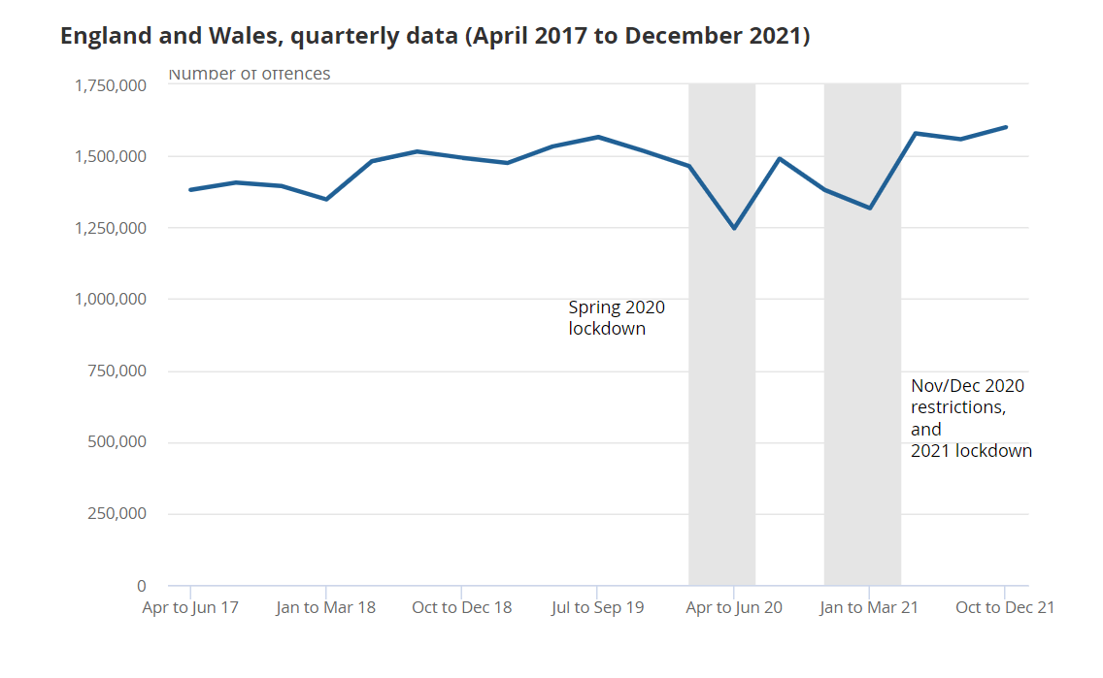

This has been affected by the COVID Pandemic and subsequent lockdowns. However, crime now again appears to be on the rise again, as shown in the above graph. This is why I feel that this topic is very relevant to myself and a probationary Police Officer as this will directly affect me in my everyday role as a Response Officer.

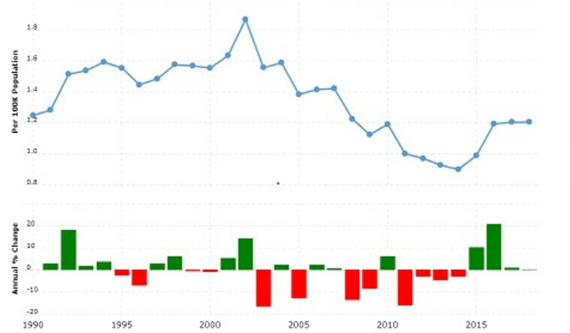

The UK spends millions of pounds each year funding a range of community projects and rehabilitation projects and facilities in an attempt to divert offenders away from committing further crime.

Rehabilitation to prevent re-offending is becoming increasingly important as Clark (2014) found that in 2019/20, the average cost of a prison place in England and Wales was £44,600 pounds a year, compared with £43,200 pounds in 2018/19, an increase of £1,400.

This is a huge part of the Governments annual budget and it is important to ensure that the money is being spent correctly on the correct rehabilitation courses.

SUMMARY OF RESEARCH OBJECTIVES:

- Identify recent crime figures for the UK and ascertain whether there is a trend, whether this is an increase or decrease.
- Understand why crime figures are trending in this way. What impact factors are present to cause the fluctuation.
- Identify what impact factors are present around offender’s family and history, which could impact their likelihood to offend.
- Identify what impact factors relate to the Nurturing environment around offender’s which could impact their likelihood to offend.
- Understand whether Nature or Nurture has the biggest impact to a person’s likelihood to offend.
- Look at what rehabilitation courses and projects are being funded by the Government and assessing if these are an effective way to prevent re-offending, i.e is this value for money for the general public.

LITERATURE REVIEW:

Throughout this piece of work I will be utilising research that has been conducted around the world and which covers both sides in order to create a balanced argument.

I have viewed Kaiser and Rasminsky’s research into the Biological factors that can contribute to a person’s behaviour and likelihood to commit crime. This is a thorough piece of research, however, it does provide causes of offending and disruptive behaviour in the persons environment as influences in a likelihood of a person offending.

Warr’s study, which is published in Cambridge’s Companions in Crime covers the social aspects of criminal conduct and the likelihood of a person to offend based on the influences that they have around them.

These two studies are two of a multitude if studies that have been conducted around the causes of criminality. I will be utilising the findings of these studies to create an argument of which factor has the greatest influence on offenders.

SUMMARY OF RESEARCH –SURVEY METHOD:

A variety of research methods will be used to provide a balanced and unbiased view across the study.

The Oxford Dictionary defines Research as “The systematic investigation into and study of materials and sources in order to establish facts and reach new conclusions”.

Johnson and Onwuegbuzie 2014 state that a mix of qualitative and quantitative research as the traditional method for conducting research. I intend to use this mix as I believe that this will give me the fairest and most independent results.

Quantitative research deals with numbers and statistics, while qualitative research deals with words and meanings. Quantitative methods allow you to systematically measure variables and test hypotheses. Qualitative methods allow you to explore concepts and experiences in more detail.

Quantitative data will provide me with crime figures and also the number of persons who have taken part in the research that has been conducted around my objective. The qualitative data will assist me in understanding the results and placing this in perspective in relation to my dissertation objective of understanding whether nature or nurture is the biggest influence on the likelihood of a person offending.

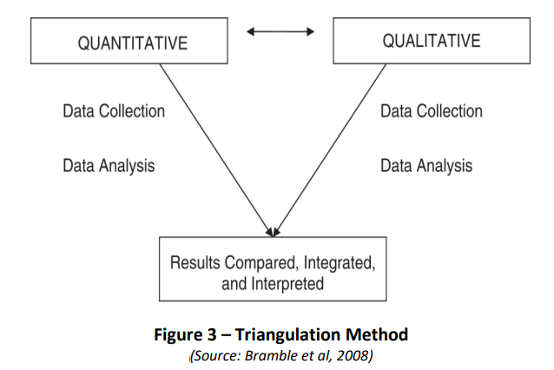

SUMMARY OF SAMPLING FRAMEWORK:

I will be utilising existing research in order to obtain figures in relation to crime statistics and re-offending rates. I will also use government statistics to outline how much funding is being provided by the local government to diversionary programmes and to evaluate whether these services are effective and if they are providing good value for money.

I have considered using public questionnaires in order to obtain the publics opinion on crime rates in the UK and their perceived effectiveness of diversionary tactics.
I will also be utilising research that has been conducted directly into the Nature v Nurture argument and I will be evaluating the results of this research and using this to interpret which factor is the biggest influence on offending. I believe that this is the most effective way to carry out this argument, as I need to view the argument as a whole and see the big picture before creating my conclusion.

ETHICAL ISSUES:

An ethical issue that may arise is that to understand a person’s nature, some studies may have conducted research into an offender’s family or medical history. This could mean that there is a potential for part of a person’s medical history to be illustrated on a paper of research.

I will ensure that no personal details of any person or any part of a person’s medical history will be published within my dissertation.

TIME SCALE:

During this academic year, I have many demands on my time both inside and outside of work. I am working full time in South Wales Police on a Response Team, which involves a shift-pattern style of working. Outside of work, I am planning an imminent Wedding and Honeymoon as well as family and other commitments. It is therefore crucial that I manage my time effectively and have deadlines throughout the process of writing my dissertation in order to ensure that all parts of this piece of work are competed in a timely manner.

I also have to factor in my University workload from the University Trinity St David, where I have a number of Workbooks to complete alongside this dissertation.

I have therefore created the below table to illustrate how I will allocate my time to this dissertation.

No | Project Name | 2022-2023
No | Project Name | May | Jun | Jul | Aug | Sept | Oct | Nov | Dec | Jan
1. | Proposal
 | - Define Research Aims, Objectives & Methodology
2. | Literature Review
 | - Carry out research
 | - Compile research and review results
3. | Findings & Analysis
 | - Collate and Analyse feedback
 | - Consider alternative research methods for any gaps in results
 | - Conclusion
4. | Submission Preparation
 | - Consultations with Supervisor
 | - Proof-read and editing
 | - Submission

Throughout this dissertation, I will be utilising resources form the UWTSD website and Moodle to supplement Journals and Studies conducted on the core topic. I will also consider providing questionnaires to colleagues and friends in order to obtain more data if necessary.

REFERENCE LIST:

Blackstone’s Student Handbook 2020. Backstones, Oxford, Oxford Press.

Bramble et al (2008) "Examining barriers to health information technology adoption"

Kaiser, B., & Rasminsky, J. (2010, October 25). Biological Risk Factors for Challenging Behavior. Retrieved November 3, 2013, from Education.com: http://www.education.com/reference/article/biolgical-risk-factors-challenging/

Mixed Methods of Research, Published by R. Burke Johnson, Anthony J. Onwuegbuzie 2014. University of South Alabama, College of Education. Volume: 33 issue 7 Pages: 14-26

Office for National Statistics, www.ons.gov.uk, Crime in England and Wales - Office for National Statistics. Crime and Justice bulletins. London, UK

Statista - Cost per prisoner England and Wales 2020. (Clark 2014)

Warr, M. (2002). Companions in Crime. Cambridge, United Kingdom: Cambridge University Press

