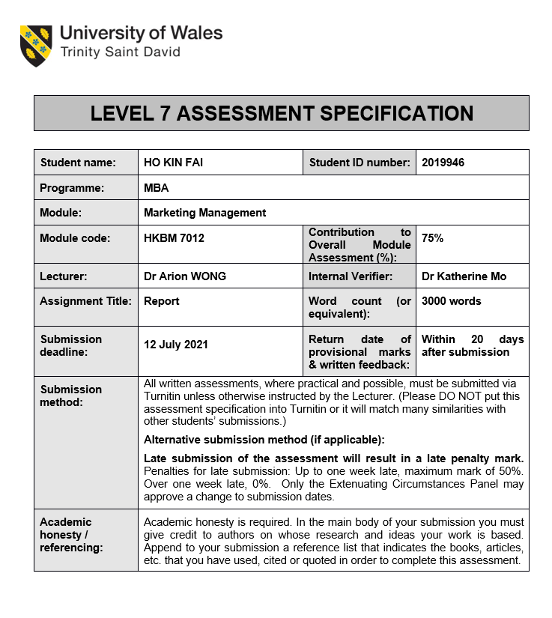

Content Word Count: 3300 (excluding Table of content, Executive Summary and Reference)
Executive summary
Under the COIVD-19 pandemic, the consumer is beginning to pay attention to their health and demand for health products. In Hong Kong, herbal drinks have always been a health product with reasonable prices and practical. The consumer can be going to traditional herbal tea shops to purchase herbal drinks. In addition, a new type of herbal tea shop is also constantly increasing. They are providing different kinds of herbal drinks. They have fashionable store designs, diversified sales strategies, and business models different from traditional herbal tea shops.
This report will analyse the Macroeconomic in Hong Kong by PEST to looking for the sale value affecting the Herbal Drink retail, the e-commerce changing consumer behaviour and getting marketing information directly. After the COVID 19 pandemic, most consumers are getting more health-conscious about health products. Porter five Force used to evaluate the Herbal Drink retail with our case study company "Hung Fook Tong" by the bottle of herbal drink in this market environment. We have to analyse the current products, prices, consumer segments to recommend the future development plan using the 4P Marketing Mix Strategy to promote herbal drinks to segmented consumers and maintain products' sustainability. We have suggested that the case study company enhance using Social Media for marketing promotion and recommend the company educate consumers about herbal drinks to increase brand recognition.
Table of contents

Chapter 1 – Introduction 4
1.1 Company background 4
1.2 Industry overview 5
Chapter 2 - Situation Analysis 6
2.1 PESTEL Analysis 6
2.2 Porter's Five Force 9
Chapter 3 - Segmentation, Targeting and Positioning 11
3.1 Market Segmentation 11
3.2 Market Targeting 11
3.3 Product Positioning 12
Chapter 4 - Marketing Mix Strategy 13
4.1 Product Strategy 13
4.2 Price Strategy 15
4.3 Place Strategy 16
4.4 Promotion Strategy 17
Chapter 5 - Future Developments in the Area of Marketing 18
5.1 Increase Brand Recognition 19
5.2 Enhance Social Media Utilisation 19
5.3 Recommendations and Conclusion 21
References 22

Chapter 1 – Introduction
1.1 Company background
Hung Fook Tong is a Chinese herbal drink chain shop based in Hong Kong founded in 1986 and opened the first outlet at Kwai Chung. Hung Fook Tong began to rebrand in 1990 to attract new consumers. They set up a factory to centralise the manufacturing and introduced herbal tea in plastic bottles for sale in supermarkets. In addition, Hung Fook Tong also began to open branches in stations along the subway to attract different consumers and sell soups and snacks to make a profit. Hung Fook Tong was finally successfully listed in 2014. Their product line widely from Chinese herb teas, soups, healthy food and Guilinggao. The Group had a market share of 37.5% in Hong Kong's wellness drink market (Hung Fook Tong, 2016) and 115 retail shops in operations with 891 employees in Hong Kong (Hung Fook Tong, 2019).
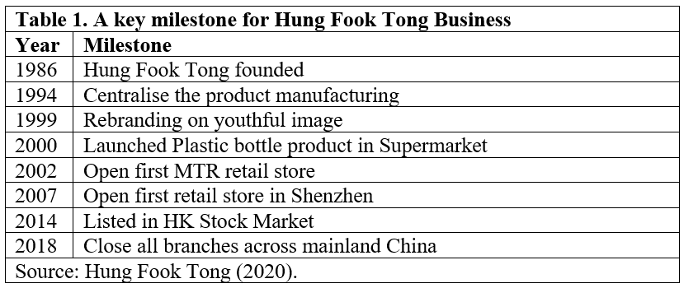
According to the annual report of the marketing segment, the Group has estimated its advertising and promotion expenses. In 1H2020, the advertising and promotion expenses of the Group were HK$13.1 million, a decrease of 16.0% from HK$15.6 million in 1H2019. As a result, the marketing expenses in 1H 2020 and 1H2019 as a percentage of revenue are 3.8% and 4.0%. Therefore, the Group is more cautious in managing marketing expenses (Hung Fook Tong, 2020).

1.2 Industry overview
Herbal Drink has several competitors in Hong Kong. However, Table 2 showed they have differentiated business models based on their product and sales channels. A highly potential competitor with similar models in the market is Healthworks. Since COVID-19, the consumer has been more conscious of health care, an area where the Group has expertise in healthy products. To meet their needs, the Group have launched a convenient and hygienic pre-packaged food portfolio. In addition, the demand for working from home and dining at home is another opportunity that the Group will seek to seize by strengthening its online business and delivery services (Hung Fook Tong, 2020).
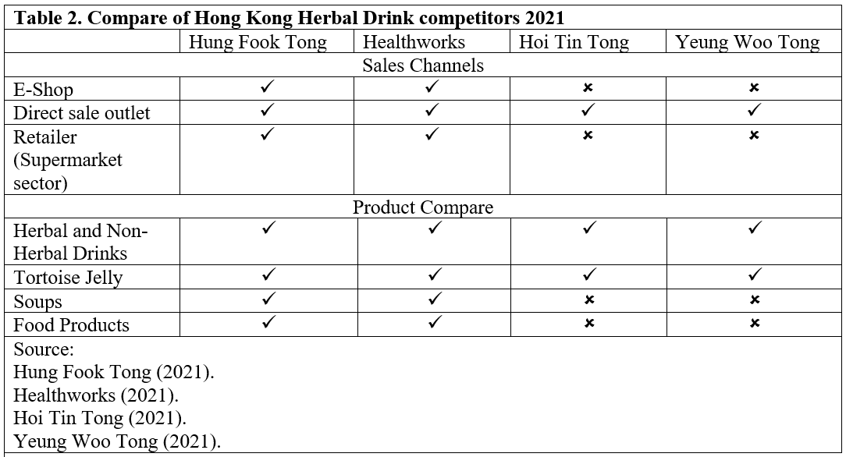

Chapter 2 - Situation Analysis
This chapter will analyse the existing environment by PESTEL analysis and use Porter five forces framework to analyse the competition within an industry and business strategy development.

2.1 PESTEL Analysis
In this PESTEL analysis, we will focus on the Economic factor in Hong Kong retail market, the Technology factor on how e-commerce affects consumer purchasing behaviour. The last is the Social factor to looking at the health-conscious consumer growing up on-demand for health products during the pandemic outbreak.
Economic Factors
According to a report shown the retail sale market in Hong Kong began to decline -26.4% in 2019. And affected by the epidemic, the retail value had continued to decrease to -46.70% in 2020. In 2021, the fell has shrunk to -14% (Trading Economics, 2021). Figure 1 shows the value of traditional Chinese medicine retail sales in Hong Kong from 2010 to 2020. In 2020, the retail sales value of Chinese drugs and herbs in Hong Kong approximately around 4.1 billion Hong Kong dollars (Yihan, 2021). According to this statistic, we can compare with 2019 that retail sales value in 2020 has significantly decreased because the public awareness of epidemic prevention has reduced the number of diseases. Still, the provisional estimate of sales value and comparing March 2021 with March 2020 on Chinese drugs and herbs have increased +27.7% (C&SD, 2021b). It also proves that consumer has shifted from protection against epidemics to health preservation.
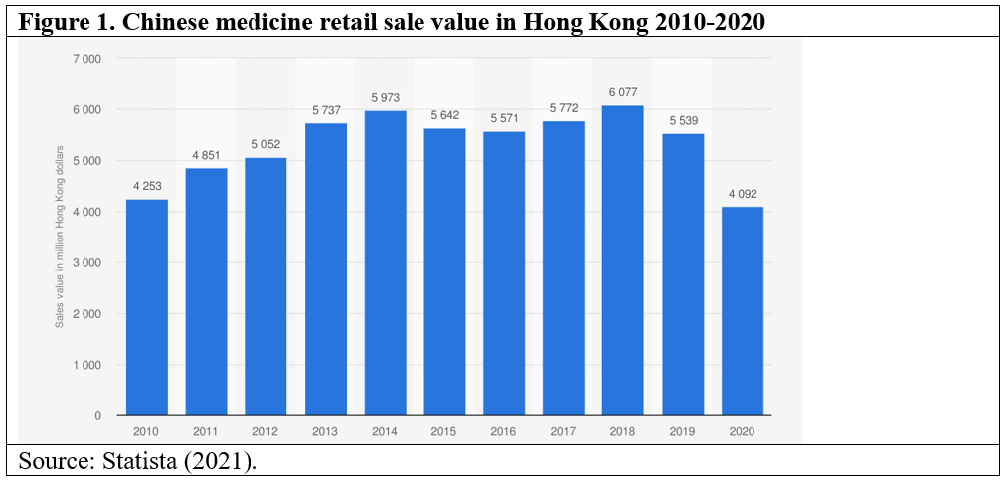
According to the Group annual report projected the total revenue had decreased to HK$276.9 million (1H2019: HK$296.5 million) in revenue in 1H2020 (Hung Fook Tong, 2020). That data approved the revenue will be related to Hong Kong retail operation when the economic environment changes and consumer' needs drop.
Technological Factor
Since the epidemic has developed for a while, attention on epidemic prevention, maintaining health care has become a new trend for the citizen. In addition, internet search and social media provide a powerful channel for consumers to obtain more information, from which they can inquire about other health products.
Figure 2. Increase in online shopping demand
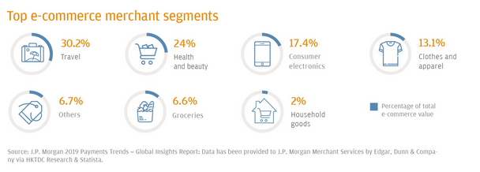
Source: J.P. Morgan (2019).
Figure 2 shows the top e-commerce merchants, where 24% of health and beauty business trends are e-commerce (J.P. Morgan, 2019). Hong Kong has more than 4.5 million online shoppers. The e-commerce penetration rate in 2018 was 59.8% and expected to reach 72.6% in 2022. Hong Kong's e-commerce sales have been growing steadily. As the market continues to grow, now is the best time to establish an e-commerce business (Syahirah, 2021). Due to the market having too many substitutes, consumers are susceptible to online information to influence their purchase intentions and decision-making. However, online shopping is prevailing, and it is easier for the consumer to buy at home. Therefore, the B2C business will reduce the sales in physical stores.

Social Factor
According to the Nielsen report in 2018, 50% of consumers have health-conscious of their health and try to keep the current lifestyle to ensure their wellbeing. At the same time, 25% of consumers are serious health maintainers. They will use their way to maintain their health.
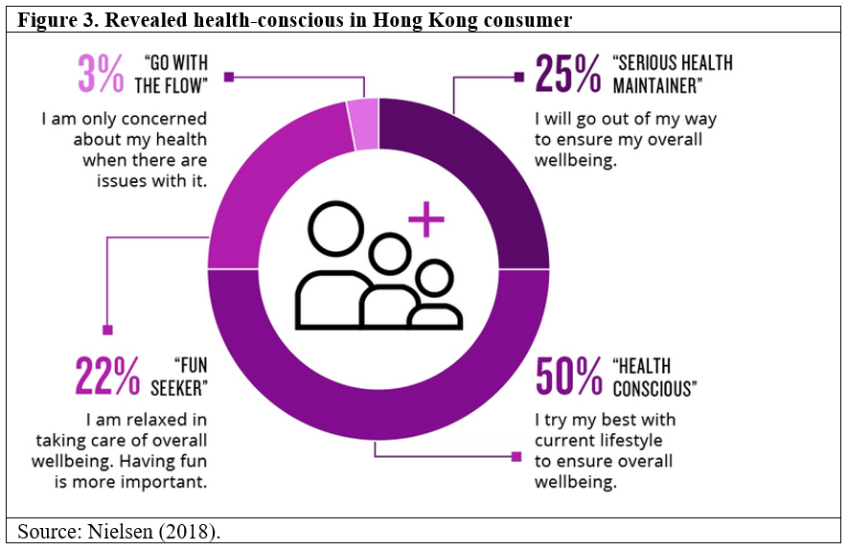
Since the COVID-19 outbreak, 35% of Hong Kong respondents have found a way to make their bodies healthier, and 31% have started to track their mental Health (Manulife, 2020). Thus, health awareness is constantly improving, and lifestyle habits are undoubtedly changing towards a healthier physical and psychological life. In post covid era, they are a growing health consciousness in Hong Kong. Although many consumers had a surge in demand for health products in the early stage of the epidemic, herbal drinks have always been cheaper and effective health products. As a result, the public once again recognised the herbal drinks.

2.2 Porter's Five Force
Porter five forces is a framework used for analysing the level of competition within an industry and business strategy development (Porter, 2008). We use this model to study the microenvironment of the Group performance in the Herbal drinks business.
The intensity of competitive rivalry:
Hong Kong herbal tea shops have evolved from a traditional business model to modern granules and packaged beverages sold in supermarkets to cater to fashion needs. Nowadays current business model is divided into conventional and new-style shops. Traditional shops maintain a single product category of herbal drinks. And the new-style shops also sell desserts, carrot cakes, fish balls and other snacks. Most competitors hope to maintain product differences with their rivals to counter the competition (Si, 2013).
Threat from new entrants:
Herbal beverages are not a new industry in Hong Kong. Developing a herbal tea shop to establishing a loyalty brand cannot be achieved in a short time. Although new-style tea shops can try to enter the market, they must differentiate their products to compete with market leaders. Hung Fok Tong has certain advantages in providing diversified products to preventing competition.
Bargaining power of buyers:
Most consumers can purchase herbal drinks from physical stores or online stores and choose their favourite brands, or new products launched by other competitors will attract them. In addition, a consumer is price-sensitive when purchasing products. Therefore, they will first look at the product information and compare products of other competitors. These factors will change consumer buying behaviour.
Bargaining power of suppliers:
Since Hong Kong has various types of herbal drink manufacturers and Chinese medicine clinics, there is a particular demand for raw materials. The international trade volume of medicinal plants and their products was 60 billion U.S. dollars n 2010 and expected to reach 5 trillion U.S. dollars by 2050 (Mariana, Murilo and Daniel, 2015). Since the place of origin may be affected by the epidemic and reduce output, it will affect the supply of raw materials to manufacturers. Therefore, when the demand rises, the purchase price will also rise immediately.
The threat of substitutes:
There are many similar Herbal drinks substitutes on the local retail market. As a result, consumers are easy to purchase equivalent products from different competitors. Generally, the substitutions have divided into higher-quality products sold at the same price or sold at a lower price. As a result, their products are easy to be replaced.
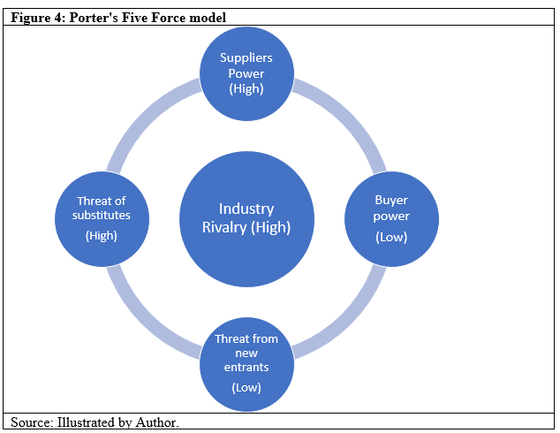
A Summary in Figure 4 shows the result of the five force evaluation. We concluded that Industry Rivalry is high because there are already have the same type and mature sales model competitors. However, the products sold by competitors are so similar that consumer chooses to buy alternatives. And the supplier power is high because of the high cost of importing raw materials.

Chapter 3 - Segmentation, Targeting and Positioning
This chapter used the STP marketing model to examine the Group's products and market segmentation. The model can help the marketer break down into different consumer groups and target the most profitable segments (Camilleri, 2018).

3.1 Market Segmentation
Since 1999, the Group has rebranded to be youthful, creating a fresh and natural image to target younger consumers. So they are keeping to launch a variety of products to fulfil the younger age segmented customer. After the COVID-19 pandemic, the younger generation began to pay attention to health care while continuously driving the growth of the health product market. This growth waked up the Group to increase the investment and upgrades in related business formats to focus on the Y-Gen age group. As health care is becoming a consumer demand, products have also begun to reach and segment into the health-conscious market.
Customer segmentation enables marketers to plan more effective and refined marketing plans. For example, the Group can better use existing marketing communication channels and conduct targeted advertising and promotional activities for the segmented consumer.

3.2 Market Targeting
Differentiated Marketing strategies can apply to the market targeting. For example, since herbal drinks have different competitors in the market, the Group must find the advantages of its products and marketing models to promote it by providing various offers, prices, promotions, distributions or some combination of marketing variables (Camilleri, 2018).
Differentiated marketing strategies usually involve targeting multiple market segments, so companies should conduct thorough market research to understand how to meet their selected market segments and develop a marketing plan for each segmented consumer. The Group must create new products or services to achieve differentiation and increase competitiveness.

3.3 Product Positioning
After establishing market segmentation and market targeting, the final stage is product positioning. The Groups can formulate positioning statements to show that they want to occupy a higher position in the minds of target consumers relative to the products or services of other competitors.
Table 3 shows Hung Fook Tong's product position on cost-performance ratio, their product sold at $24 with a 500ml volume of the bottle. The product comes with an average container at a reasonable price. But the consumer will compare similar products or services on the market. So marketers must develop positioning strategies to increase consumer awareness of their products (Camilleri, 2018). 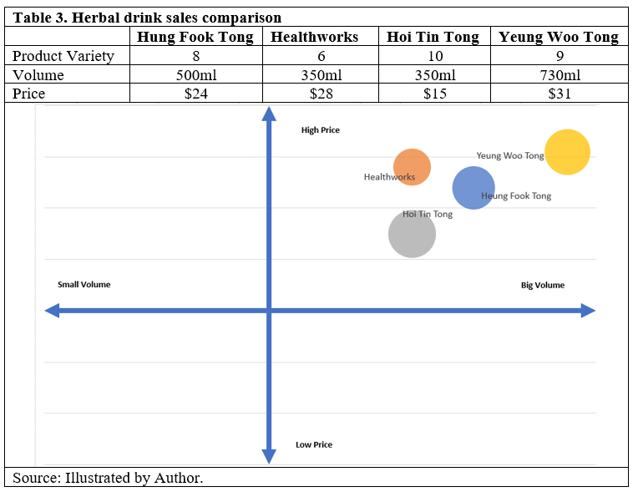
Although herbal drinks are considered a mature product in the market, the Group can still position itself in an undeveloped niche market, positioning itself through its high-standard services, additional convenience facilities, etc., to stand out from the competition.

Chapter 4 - Marketing Mix Strategy

4.1 Product Strategy
In the current market, All kinds of herbal drinks on the market appear every season. But from the perspective of Chinese medicine. Herbal beverages should be drunk at the right time to achieve their effect. Therefore, we suggest that the Group divide the products into four seasons. Table 4 is according to TCM (Mingpao, 2012), which offer the appropriate products.
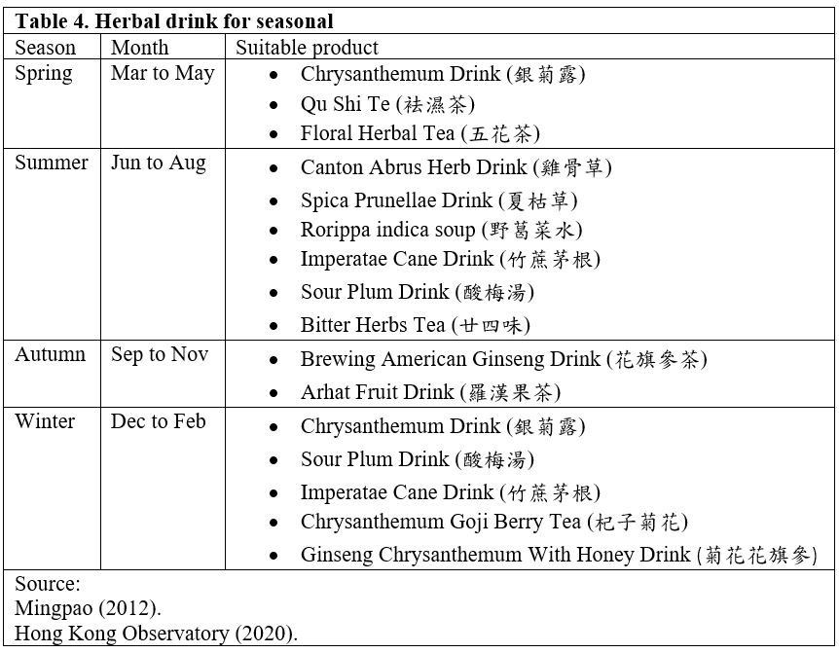

Herbal drink as a sessional product, for these products, typical will make awareness before sales start. Usually, the sales value will increase when the product launches and quickly declines at the seasonal end. Figure 5 shows a concept of the seasonal demand and product life cycle. The model has two surges that can be observed. First is the seasonal peak, and second is the discount for sales (Joffrey and Joannes, 2012). After two-stage, the product will decline. So for meeting the consumer needs or interest, we suggest rotating the product segments based on a different season and providing a discount to upsell the product before starting a decline.
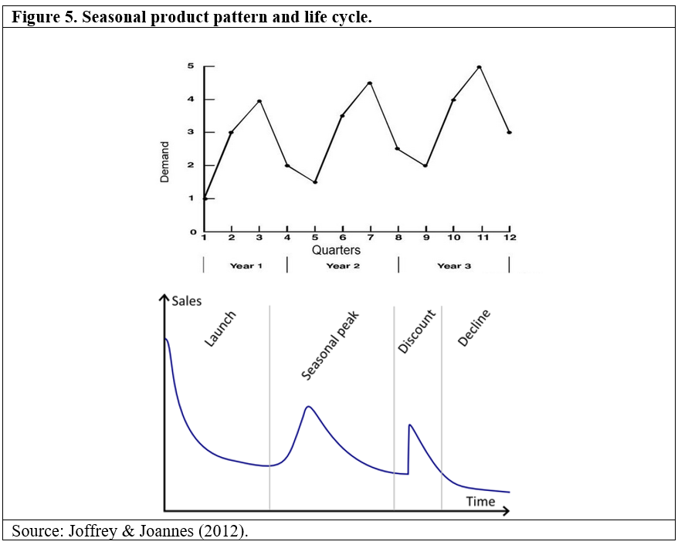

4.2 Price Strategy
The competitors sell the same products with prices differential to attract the consumer. We need to show the product advantages to consumers when they are seeking price rather than volume. Table 5 shows a similar product sold on each competitor. However, Hung Fok Tong set the product price positioning on an average price level. Therefore, we suggest the Group establish a price strategy matrix (Joel, 1976) to estimate the competitiveness between competitors. As a result, many consumers will choose a trustworthy brand whose products are better than competitors and willing to pay more.
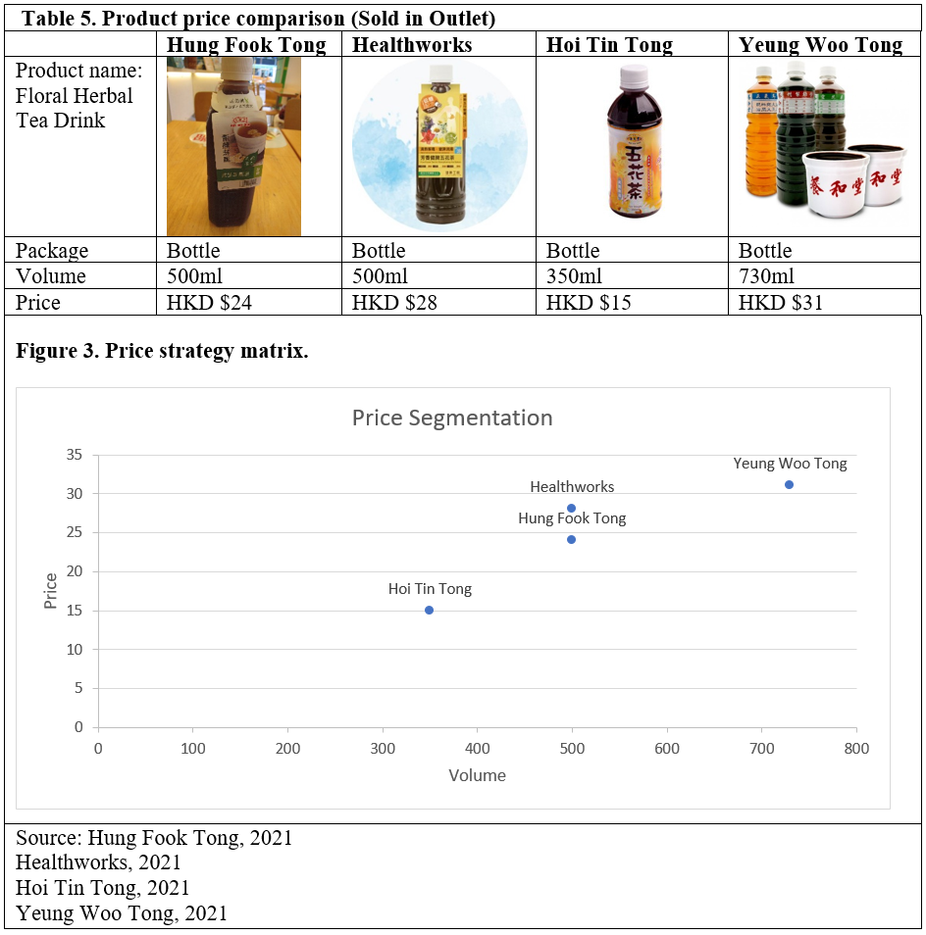

4.3 Place Strategy
Hung Fook Tong also takes advantage of the geographical location of its branches to help promote the "fast-food culture" of herbal drinks. In 2002, Hung Fook Tong gradually opened 115 self-operated retail stores, including 54 stores in the MTR station, and most of the rest located in shopping malls in estates (Hung Fook Tong, 2019).
The location strategy of Hung Fook Tong's retail stores is to take advantage of the extensive coverage and flow of people brought by the Hong Kong rail network, hoping to allow more consumers to have access to the products produced by them. But at the same time, another competitor also used the same strategy to open many branches along the railway, causing market competition.
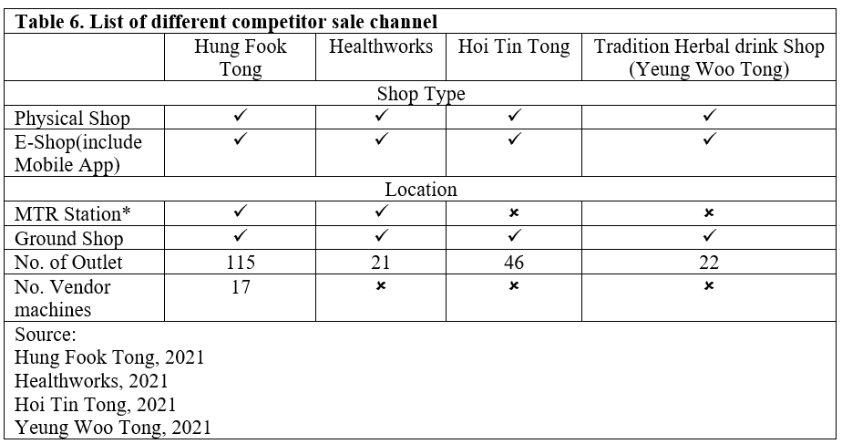
Table 6 shows the Group uses a total of retail stores to calculate the market share, but some branches are opened in the same area and sell the same products. Those branches will diversify the consumer group and generate the zero-sum effect (Kenton, 2020), so we suggest that Hung Fook Tong perform market segmentation (Wendell,1956) to classify each branch according to different consumer groups. For example, sold fast-moving consumer goods in MTR stations and sold food products on the ground or shopping malls branches.

4.4 Promotion Strategy
The primary purpose of the promotion strategy is to enable marketers to inform, persuade or remind consumers and use the media to influence their opinions or arouse their reactions. Due to the company's will change their goals to meet with targeted segment, and use a different format to promote. As a result, this allows a consumer to obtain incomplete information from various channels. The promotional goals should include creating awareness, getting people to try products, providing information, retaining consumers, increasing product sales, identifying potential consumers, and imparting knowledge to potential consumers to "co-create" the products offered. Any promotion way can seek to achieve one or more goals (Lawrence, 2012).
Table 7. Promotion Mix Element
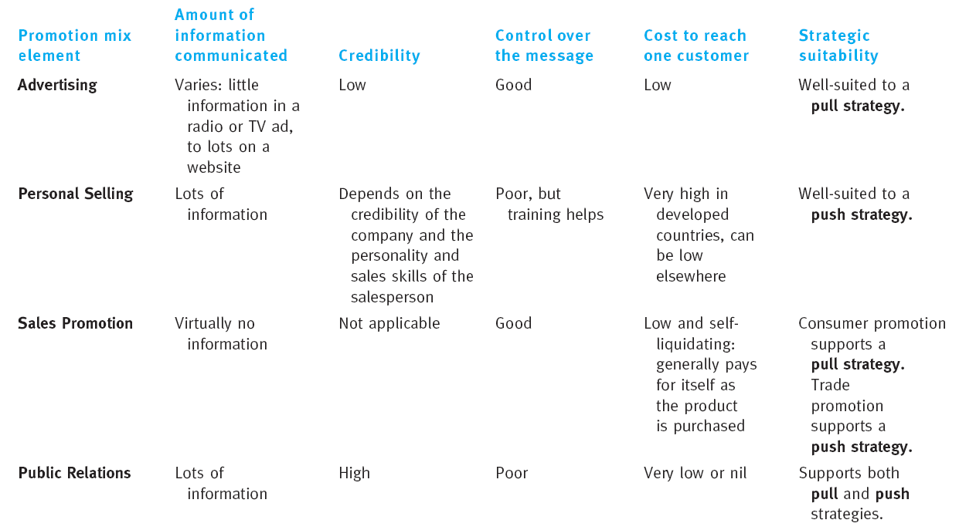
Source: Mullins, J. and Walker, O., (2013).
Table 7 provided an idea of the promotion mix element by Mullins and Walker (2013). We can evaluate and suggest to the Group for the promotion planning.
Advertising: We still recommend that companies use advertising to promote product information, make more social media platforms, and recommend adding dynamic video ads.
Personal Selling: For the Group, which owns a directly operated store, the salesman can conduct face-to-face marketing in response to customer needs. But they must have familiarity with each product.
Sale Promotion: The Group has a substantial branch network is a significant advantage for sales promotion. They can use stores to promote and sell products directly.

Chapter 5 - Future Developments in the Area of Marketing
This chapter has performed a literature review to provide a future development focus on increasing brand recognition and using social media to promote the products.
According to Data Bridge market research (Figure 4), the herbal beverage market has grown during the forecast period from 2021 to 2028. The analysis shows the market will reach an estimated value of US$1.47 billion and will grow at a compound annual growth rate of 9.80% in the above forecast (Data Bridge, 2021).
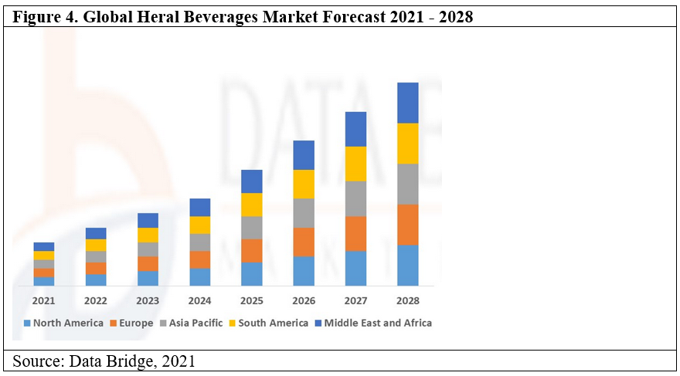
After the epidemic outbreak, the consumers are increasing health awareness, and the growth of young consumers demanding the Chinese herbal products are the main factors driving herbal beverages. In addition, people's consumption of organic products is also increasing, which will further create new opportunities for the herbal beverage market during the forecast period from 2021 to 2028. The Group still has an advantage in the market. They must seize the opportunity and carry out targeted marketing strategies to attract and retain the potential consumer.

5.1 Increase Brand Recognition
Brand recognition is the ability of the consumer to identify characteristics when a company and a competitor sell the same product. When consumers can see the product, they can immediately associate with the brand even if they do not hear the company name (Will, 2018).
The initial recognition given to the consumer by the Group was to sell herbal drinks. Meanwhile, other competitors sold the substitute products in the market, and consumers will begin to transfer their recognition to competitors' product categories.
To measure the brand awareness and effectiveness of promotional and marketing activities, we recommended that the Group conduct market research for focus consumers and a wide range of consumers. Both auxiliary and non-assisted recall tests can use for these groups. For example, when consumers see similar products, even if the quality of the two brands is the same, look at the customer's memories to remind them of which is easily recall the brand, usually the more well-known ones. To test their ability to think of the brand name in their memory (Stephen and Cindy, 1997). However, the consumer who is loyal to the product should think of the Group right away.

5.2 Enhance Social Media Utilisation
Social media is a powerful and lower costing tool to help an organisation boost up its brand recognition. Facebook, Instagram even YouTube providing a channel to broadcast a mass of marketing promotional and educational material. Figure 5 shows the breakdown of the age group of Facebook and Instagram users, and the age range has reflected the Hung Fok Tong target consumer coincidentally.
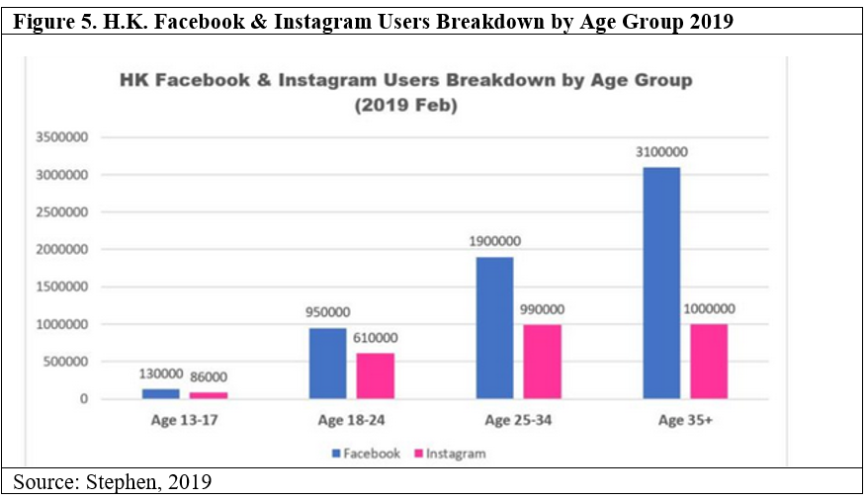
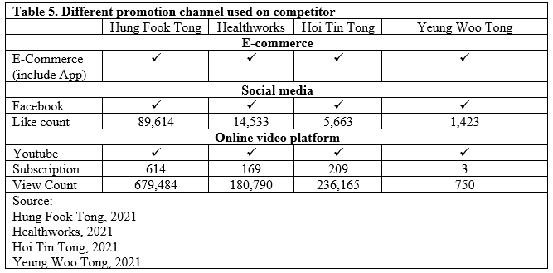
According to Table 5 data, the Group is not without using social media for marketing. But there are only about 80,000 viewers on Facebook, and only 600 people have subscribed on Youtube. Compared with the number of users in Figure 4, the count views do not seem to be desired. Therefore, the Group should utilise social media to help them improve the brand image to increase consumer recognition and building communication. By running a digital campaign to promote their products while also using the platform to educate the consumer to understand the effects of herbal drinks and recognise the company's brand when they think of or see herbal beverages.

5.3 Recommendations and Conclusion
Hung Fook Tong is not an unfamiliar brand, but consumers may only recognise various herbal products instead of the brand when consumers think of the herbal drink. There are different types of herbal tea shops in the market. Some old styles emphasise efficacy and new fashions that pursue convenience, allowing consumers to buy their products anytime, anywhere. In addition, the herbal drink is a traditional product. However, it has listed as an intangible cultural heritage but less known to a younger consumer group. Hung Fook Tong, as a large-scale herbal beverage manufacturer and retail store in Hong Kong, can play a crucial role in promoting herbal tea culture. Let the general public know that besides expensive nutritional supplements, there is also a cheap and effective product that can improve that health-conscious.
In this digital era, the consumer will be able to obtain product information through different channels. The Group must continue to put effort into promoting herbal tea culture through various media. Any consumer segment can be a target consumer to learn the benefits of their product and instil the association with the brand and related products. In addition, we understand that the development of diversified products can increase the Group revenue. Still, we have to suggest that the Group try to return to the basics and allocate resources to develop the herbal beverage market. When consumers think of Hung Fok Tong, they always think of herbal drinks.

References
Abdelmajid, A. 2011. Consumer' true brand loyalty: the central role of commitment, Journal of Strategic Marketing, Volume 6, 1998 - Issue 4.
C&SD, 2021a. Producer Price Indices for Industrial Sector by Selected Industry Grouping. [online] Available at https://www.censtatd.gov.hk/en/web_table.html?id=97 [Accessed 10 June 2021].
C&SD, 2021b. Provisional statistics of retail sales for March 2021. [online] Available at https://www.censtatd.gov.hk/en/press_release_detail.html?id=4852 [Accessed 4 June 2021].
Camilleri, M.A., 2018. Market Segmentation, Targeting and Positioning. In: Travel Marketing, Tourism Economics and the Airline Product. Tourism, Hospitality & Event Management. Springer, Cham.
Catharina, C., 2018. Your ultimate guide to Chinese herbal Tea in Hong Kong. [online] Available at https://www.localiiz.com/post/food-drink-guide-chinese-herbal-tea-hong-kong [Accessed 12 June 2021].
Chuwiruch, N., Jhundra Indra, P. and Boonlua, S., 2015. Marketing innovation strategy and marketing performance: a conceptual framework. Allied Academies International Conference.Academy of Marketing Studies.Proceedings, 20(2), pp. 82-93.
Data Bridge Market Research, Mar 2021. Global Herbal Beverages Market – Industry Trends and Forecast to 2028[online] Available at https://www.databridgemarketresearch.com/reports/global-herbal-beverages-market# [Accessed 15 June 2021].
Healthworks, 2021. Official Website. [online] Available at https://www.health-wks.com [Accessed 15 June 2021].
Hoi Tin Tong, 2021. Official Website. [online] Available at http://www.hoitintong.com.hk [Accessed 15 June 2021].
Hong Kong Observatory, 2020. Definition of seasons. [online] Available at https://www.hko.gov.hk/en/education/climate/general-climatology/00545-definition-of-seasons.html [Accessed 11 June 2021].
Hulya, A., 2013. Customer Service: The New Proactive Marketing. [online] Available at https://www.huffpost.com/entry/customer-service-the-new-_b_2827889 [Accessed 15 June 2021].
Hung Fook Tong, 2016. Hung Fook Tong Achieves Turnaround in Profit for 2015 Annual Results" (PDF). Hung Fook Tong Group Holdings Limited. [online] Available at https://www.hungfooktong.com/en/uimg/herba_OZiurXCS.pdf [Accessed 10 June 2021].
Hung Fook Tong, 2020. Hung Fook Tong Announces 2019 Annual Results (13 June 2021)
Hung Fook Tong, 2021. Annual Report. [online] Available at https://www1.hkexnews.hk/listedco/listconews/sehk/2021/0423/2021042301017.pdf [Accessed 10 June 2021].
James, L. H., 2008. Facts about Consumer and Loyalty, Harvard Business Review. [online] Available at https://www2.byui.edu/HMM10/customer_focus/the_three_rs.html [Accessed 15 June 2021].
Jeong, W. S. & Jin K. K., 2020. Factors that influence purchase intentions in social commerce, Technology in Society Volume 63.
Joel, D. 1976, Pricing Policies for New Products. Harvard Business Review November 1976.
Joffrey, C. and Joannes V., 2012. Product life-cycle (Supply Chain). [online] Available at https://www.lokad.com/product-life-cycle-(inventory-planning) [Accessed 15 June 2021].
J.P. Morgan, 2019, E-commerce Payments Trends: Hong Kong, Hong Kong's e-commerce market trends: Compact city-state slow to adopt e-commerce.
Kenton, Will., 2020. Zero-Sum Game. Investopedia. Retrieved 2021-04-25.
Lawrence, J. G., 2012. Distributing and Promoting Products and Services Introduction to Business page 106
LCSD, 2021. Intangible Cultural Heritage - Herbal Tea. [online] Available at https://www.lcsd.gov.hk/CE/Museum/ICHO/en_US/web/icho/representative_list_herbaltea.html [Accessed 10 June 2021].
Manulife, 2020. COVID-19 fuels were growing health consciousness in Hong Kong. Manulife survey finds. [online] Available at https://www.manulife.com.hk/en/individual/about/newsroom/manulife-asia-care-survey-20200805.html [Accessed 14 June 2021].
Mariana Furio, F. B., Murilo Pazin, Lilian C. P. and Daniel, J. D., 2015. Impact of Pesticides on Environmental and Human Health, Toxicology Studies - Cells, Drugs and Environment, Ana Cristina Andreazza and Gustavo Scola, IntechOpen, DOI: 10.5772/59710. [online] Available at https://www.intechopen.com/books/toxicology-studies-cells-drugs-and-environment/impact-of-pesticides-on-environmental-and-human-health [Accessed 12 June 2021].
Mingpao Daily, 2012. Herbal tea for four sessions. [online] Available at https://www.mingpaocanada.com/healthnet/content.php?artid=816 [Accessed 10 June 2021].
Mullins, J. and Walker, O., 2013. Marketing Management: A Strategic Decision-making Approach McGraw-Hill/Irwin series in marketing. 8th ed. NY: McGraw-Hill.
Nielsen, 2018. Hong Kong Consumer' Health Conscious: Enjoyment in a Practical Way.
Porter, M.E., 2008. The Five Competitive ForcesThat Shape Strategy, Harvard Business Review, January 2008, pp. 79–93.
Porter, S.S. and Claycomb, C.,1997. The influence of brand recognition on retail store image, Journal of Product & Brand Management, Vol. 6 No. 6, pp. 373-387.
Si, C. M., 2013. Hong Kong Herbal Tea. [online] Available at http://cculture.hku.hk/content/hkculture/tm/food/food05.pdf [Accessed 10 June 2021].
Situ W. F., 2019. Interview of Hung Fok Tong CEO" 涼茶現代化 鴻福堂CEO深耕之道." [online] Available at https://article.hkgolden.com/mobile/article.aspx?id=25248&catid=37 [Accessed 10 June 2021].
Smith, W.,1956. Product Differentiation and Market Segmentation as Alternative Marketing Strategies. Journal of Marketing, 21(1), 3-8.
Statista, 2021. The value of retail sales of Chinese drugs and herbs in Hong Kong from 2010 to 2020. [online] Available at https://www.statista.com/statistics/975647/hong-kong-chinese-drugs-and-herbs-retail-sales-value/ [Accessed 11 June 2021].
Stephen, L., 2019. Facebook VS Instagram. Which one is suitable for your branding? [online] Available at https://www.marketingtips.hk/facebook-vs-instagram/ [Accessed 13 June 2021].
Syahirah A. A., 2021. Hong Kong Statistics for Aspiring E-commerce Entrepreneurs in 2021. [online] Available at https://osome.com/hk/blog/2021-ecommerce-trends-hk/ [Accessed 24 June 2021].
Will, K., 2018. Brand Recognition, Investopedia [online] Available at https://www.investopedia.com/terms/b/brand-recognition.asp [Accessed 15 June 2021].
Xie, P., 2017. Sharing Wealth and Sorrows A Look at Modern Herbal Tea and Social Culture from Hung Fook Tang, Vol 57, Cultural Studies, Lingnan University H.K.
Yeung Woo Tong, 2021. Official Website. [online] Available at http://www.yeungwootong.com [Accessed 15 June 2021].
Yihan M.,2021. Chinese medicine retail sales value in Hong Kong 2010-2020. Published by Statista, 17 May 2021.

