Create and safeguard passwords

To start a spreadsheet click on google drive and select new and start a google sheet.

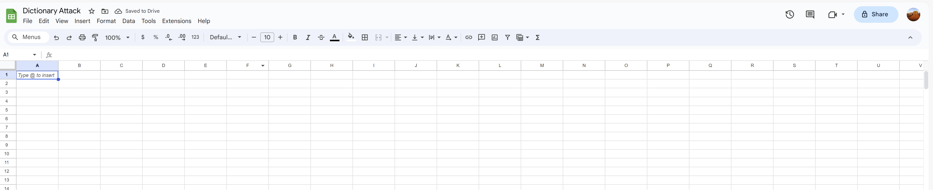

Rename sheet one ´´Fake Passwords´´

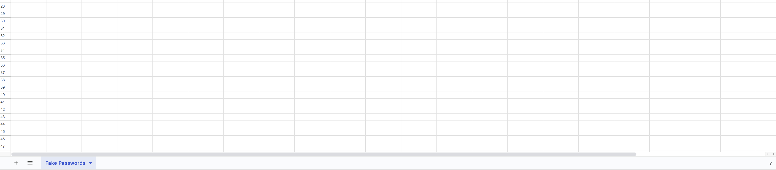

List of passwords:

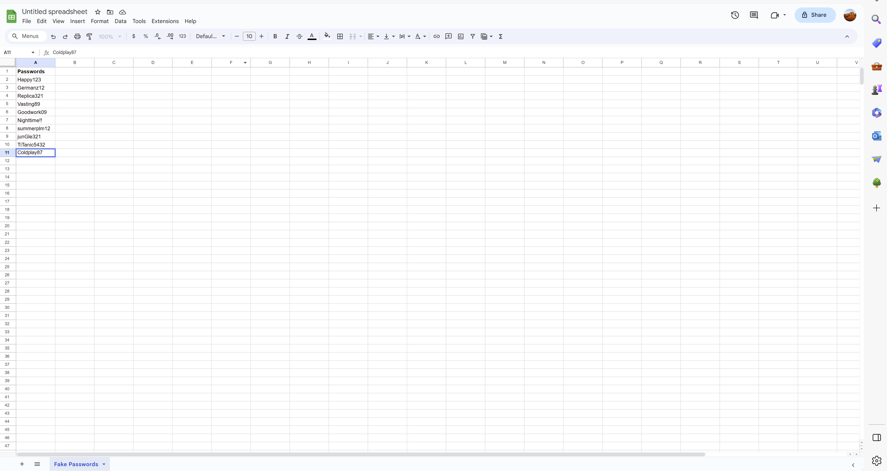

List of popular words:

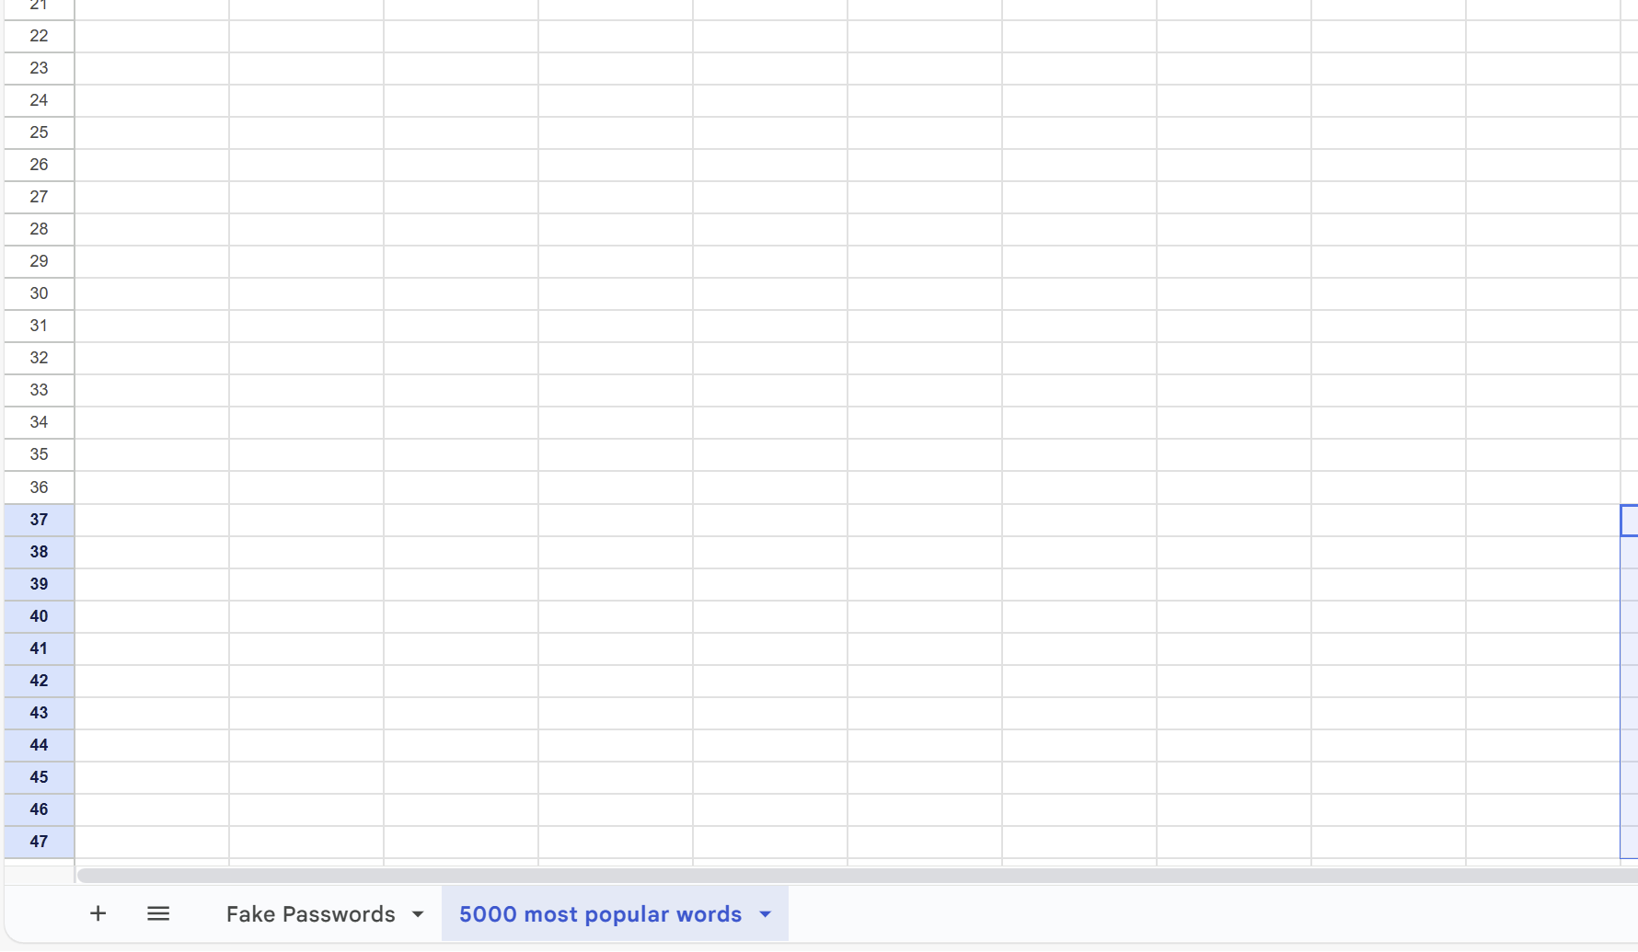

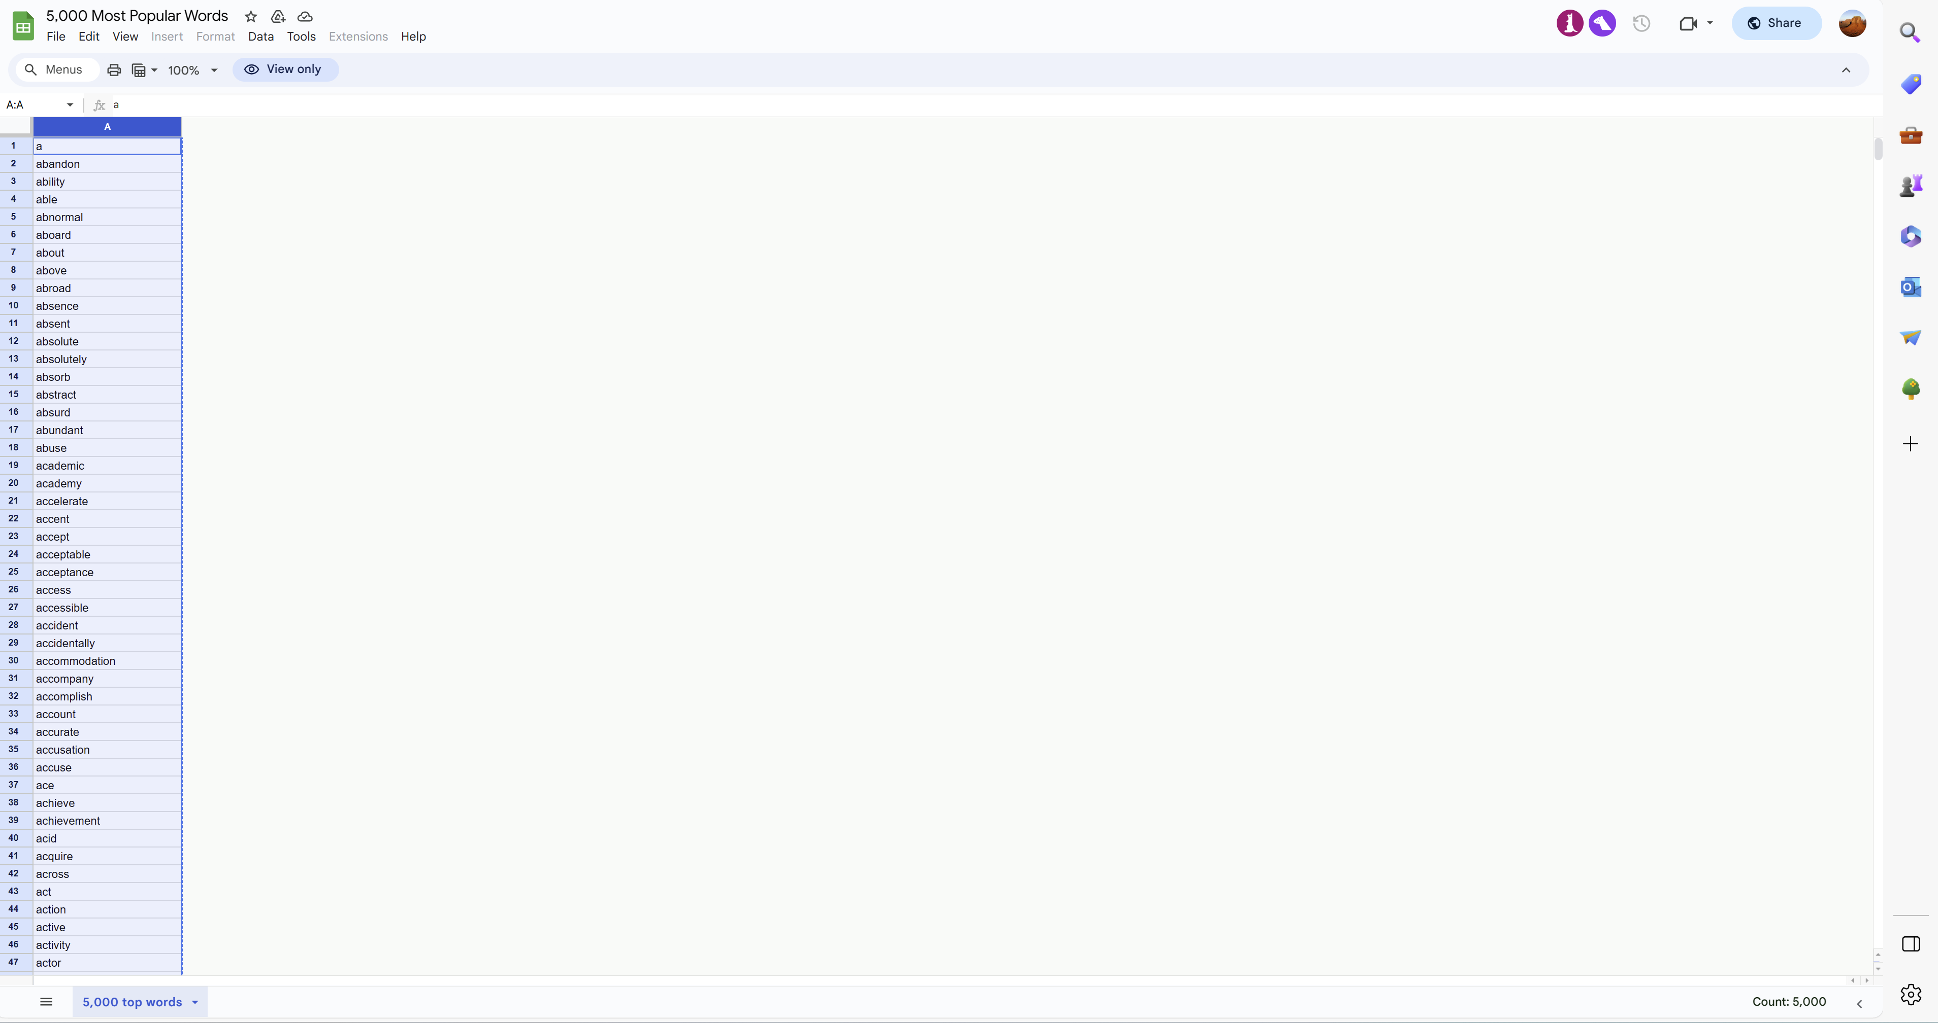

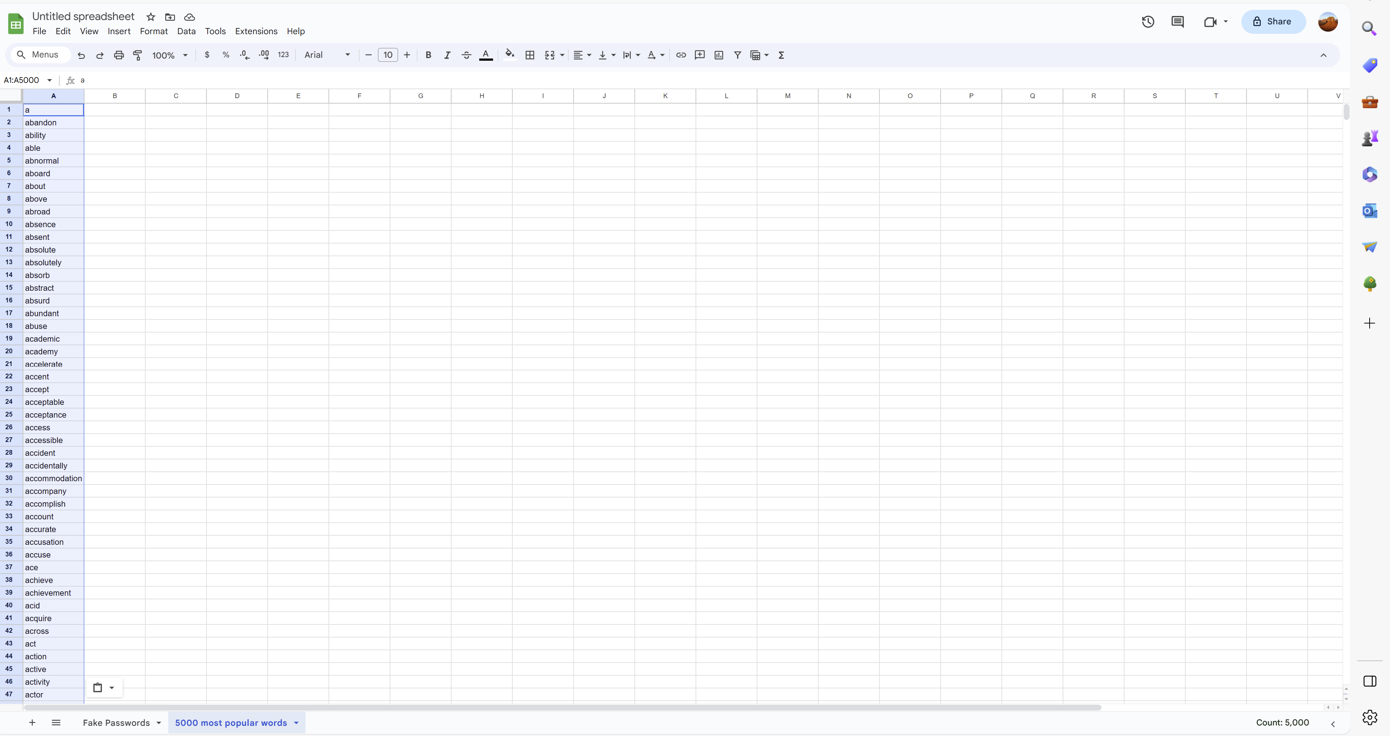

Using concatenate function to create word variations:

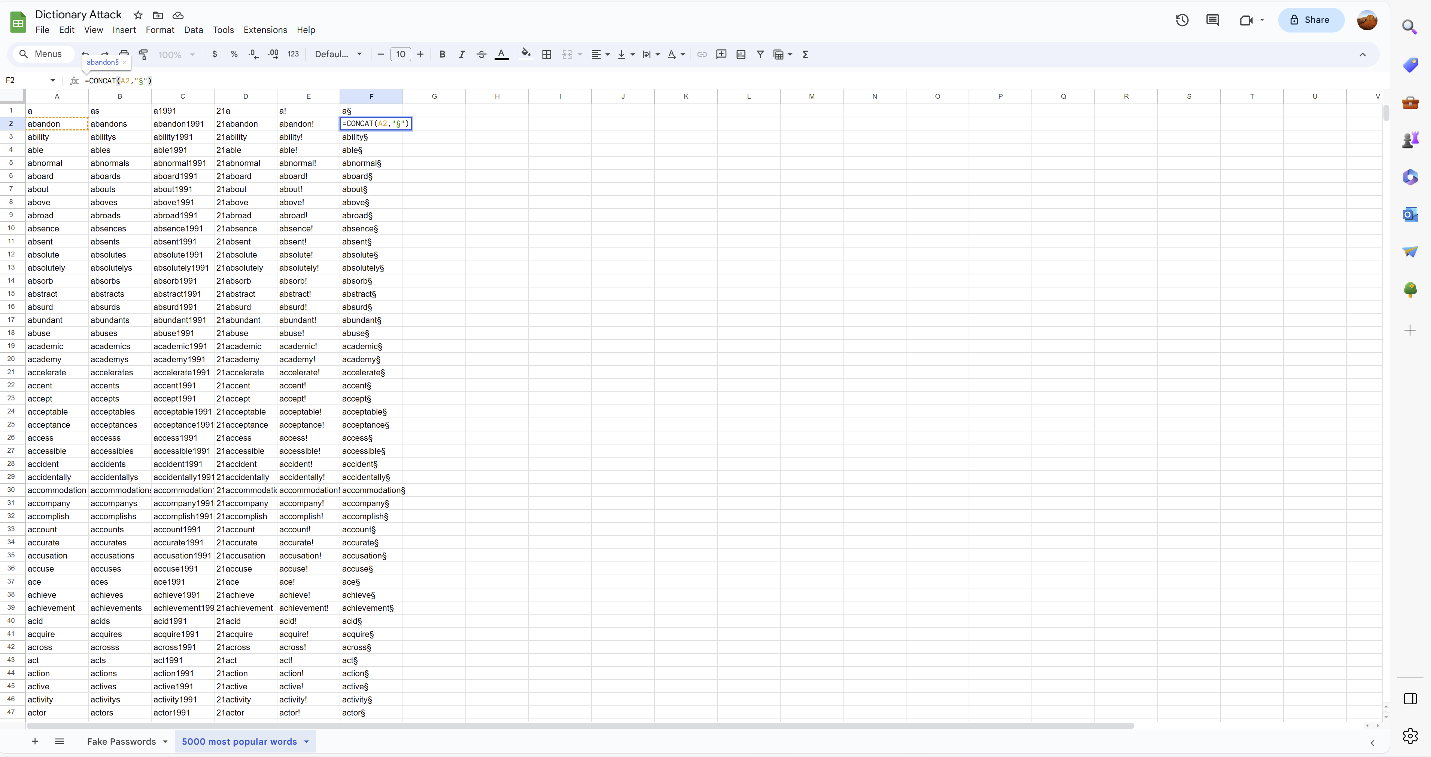

Launching a dictionary attack on myself:

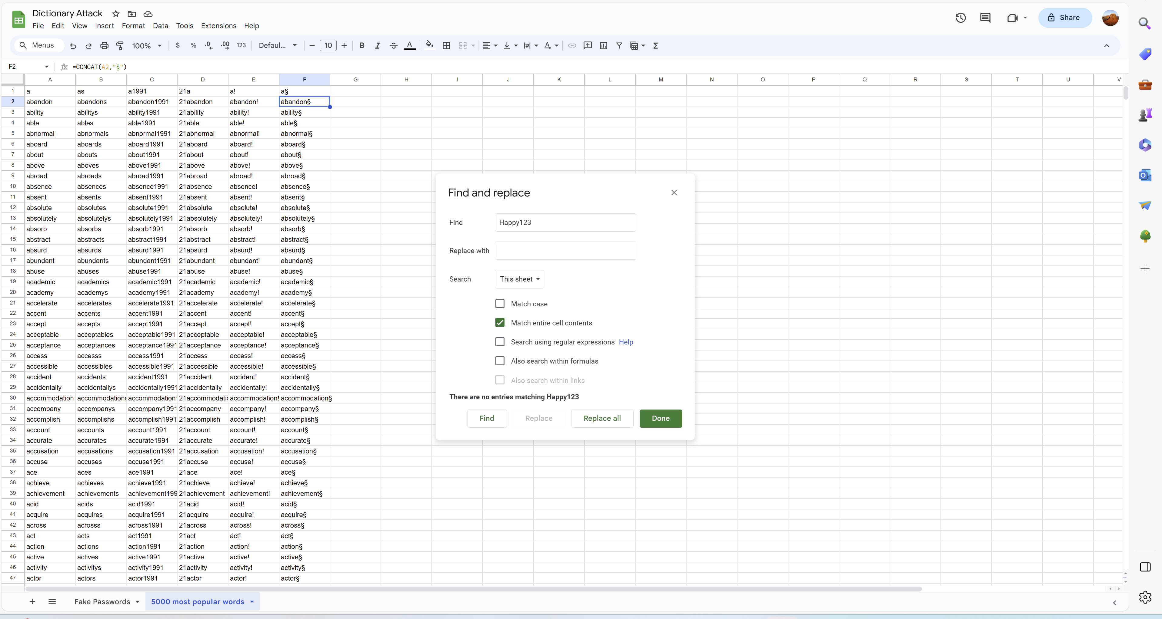

Creating a secure and protected password:

To create a secure password one should use a minimum of 8 characters long word. A mix of upper and lower case letters, numbers and symbols. It needs to be something that is easy to remember. Never use same password for different accounts. Never write down passwords on desk. Using a password manager and 2 step verification helps you secure your password.

