Reflective Practice
Introduction
Reflection consists of analysis or diving into a topic or subject to examine alternative views from a variety of angles and viewpoints, in order to provide the most effective outcome. The more complicated or difficult the topic or issue, the more in-depth study is necessary. (Brock, Avril 2014)
In the reflecting process, emotion and intuition are also essential. Through the processes of reading, studying as well as, conducting professional practice which develops, personal experiences. The process of reflection develops, the intellectual properties used when identifying knowledge and skills that enable understanding, empathy, and professional conduct that can benefit children and families who require support. (Avril 2014)
Reflecting upon your work helps you to acknowledge your own strengths and weaknesses. Areas that need improving such as, communication can be acknowledged and therefore worked upon by putting a plan into place that gives you set target that you intend to meet.
Reflection and Professional Practice.
In order for it to become a controllable skill that can be used effectively in day-to-day activities and occurrences, practitioners must learn how to integrate reflection with the use of critical thinking. These might include things like following policies and procedures or reflecting on previous activity. Price (2004).
In the learning process, reflection is an important action. Professional practise requires the establishment of knowledge. As well as the abilities of action-reflection and reflection-on-action. These give you the power to come up with broad principles from expertise, which allows the practitioner to adapt ahead of time to new circumstances that may be presented. Robertson (2005)
Reflection-in-action
Professionals don't only accomplish by knowing what they're doing; they also think about it. This is referred to as 'reflection-in-action'. Schon (2005)
Pattern recognition may be involved in reflection-in-action, and it may be prompted by the realisation that "something doesn't feel right."
Reflection-on-action
Reflection-on-action occurs after the activity that has been carried out rather than during an activity which is reflection-in-action. It usually starts by recreating the experience, paying special attention to the context that was established throughout. As well as, considering as many different angles as possible.
This necessitates that the practitioner not only be aware of the situation, but also be capable of explaining it in a clear, non-judgmental manner, which generally involves comparing and contrasting past experiences on similar situations.
Effective Communication
Working with children, young people, their families, and carers requires effective communication. It is an essential component of the Common Core. It entails paying attention to, questioning, comprehending, and responding to what children, young people, and adults who care for them are saying. (Dunhill, 2009)
A majority of people have a preferred method of communication. Consequently, being aware of people preferences helps within ensuring, that any communicational requirements are met, and suitable measures are put in place for that to occur. Hence why reflective practice helps promotes and improves interaction with the child or their family. As barrier that may reduce the likeness of effective communication occurring can be identified when one is reflecting upon their practice and the strategies in which, they have in place and use. Petrie, P. (2011
In a situation where a strong accent, usage of dialect, jargon or slang can make English is which others can understand becomes more difficult for those who may not be familiar with certain areas to know what is being specified. This as a result, can cause miss-interpretations to occur or information not be recognized or understood which can have numerous consequences upon a child ability to learn and interpretate what is going on around them.
Strategies that can be used to overcome language need and preference include, ensuring that the service preference on the way they communicate are met even if a translator is required. As a practitioner ensuring that you communicate clearly and use word in which are not scientific can have an impact upon the effectiveness of communication.
Any words that are not understood should be clarified to provide a full response. In a care setting all poster and leaflets should be multi-lingual and include and translate into the language that is used by members of the local community.
Theorists
Experimental Learning-Kolb
Kolb's reflective method is known as experiential learning. This idea is built on the foundation of our own experiences, which are the building blocks of how we learn and develop intellectually throughout our lives.
Kolb's theory is strongly influenced by the practitioners own cognitive processes and takes into account the building blocks that are formed in what they have carried out beforehand. Taking variables into account will help within moving forward positively in the future and achieving the best possible results. As it allows one to reflect on their work. During this reflective process, you ensure that key areas are identified, what needs to be improved in the future, and what has been done well.
Gibb's Reflective Cycle
It's one of the more complicated forms of reflection, but you could find that having many stages of the process to guide you is reassuring. Gibb's cycle is divided into six stages:
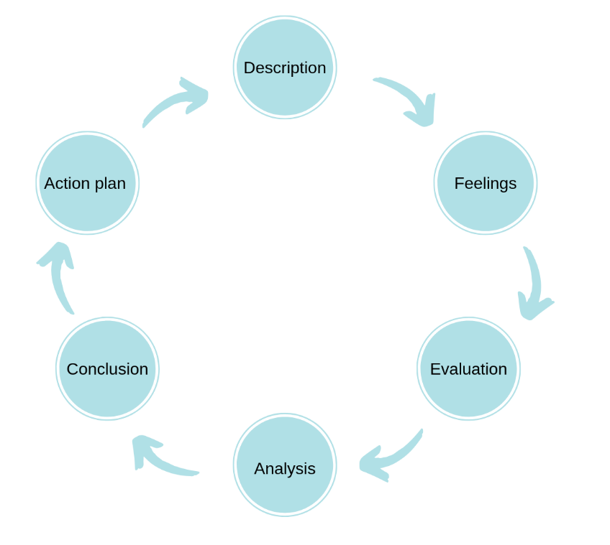 Gibbs, G. (1998)
Gibb's starts with a summary of the experience being discussed. It then urges the practitioner to concentrate on their emotions during and after the event. The next stage is to assess the event and determine what was positive and what was negative from your perspective. This evaluation may then be used to evaluate the situation and understand the context of it. This investigation will lead to a conclusion on what alternative steps we may have taken to get a different result. The last stage is creating an action plan of measures that we may follow the next time we encounter a similar circumstance. Gibbs, G. (1998)

References

References
Lawrence Robinson, J. S. P. D. a. M. S. M., 2020. Help Guide. [Online]
Available at: https://www.helpguide.org/articles/relationships-communication/effective-communication.htm
[Accessed 12th October 2021].
McLeod, S., 2017. Kolb's Learning Styles and Experiential Learning Cycle. [Online]
Available at: https://www.simplypsychology.org/learning-kolb.html
Price, A., 2004. Encouraging reflection and critical thinking in practice. Encouraging reflection and critical thinking in practice, pp. (Vol. 18, Issue 47).
Robertson, K., 2005. Reflection in professional pratice and education. [Online]
Available at: https://www.racgp.org.au/afpbackissues/2005/200509/200509robertson.pdf
[Accessed 17th October 2021].

References
McLeod, S., 2017. Kolb's Learning Styles and Experiential Learning Cycle. [Online]
Available at: https://www.simplypsychology.org/learning-kolb.html
Price, A., 2004. Encouraging reflection and critical thinking in practice. Encouraging reflection and critical thinking in practice, pp. (Vol. 18, Issue 47).
Robertson, K., 2005. Reflection in professional pratice and education. [Online]
Available at: https://www.racgp.org.au/afpbackissues/2005/200509/200509robertson.pdf
[Accessed 17th October 2021].
Brock, A. (2015). The early years reflective practice handbook. Routeldge. https://doi.org/10.4324/9780203117248
Brodie, K and Savage, K. (2015) Inclusion and Early Years Practice. London: Routledge https://ezproxy.uwtsd.ac.uk/login?url=https://search.ebscohost.com/login.aspx?direct=true&db=nlebk&AN=958635&site=ehost-live&ebv=EB&ppid=pp_4
Dunhill, A., Elliott, B., & Shaw, A. (2009). Effective communication and engagement with children and young people, their families and carers. Learning Matters. Available at: https://search-ebscohost-com.ezproxy.uwtsd.ac.uk/login.aspx?direct=true&db=nlebk&AN=411650&site=ehost-live (Accessed: 17 September 2021). . https://doi.org/10.4324/9781315237473
Hart (1992) Ladder of Participation. Hart (1992) 'Ladder of Participation'. | Download Scientific Diagram (researchgate.net)
Klein, G. (n.d.). Intuition or experience? Tacit knowledge in decision making.
Orey, M. (2014) Communication Skills Training. Virginia: ATD Press.
Paige-Smith, A., & Craft, A. (2011). Developing reflective practice in the early years (2nd ed.). McGraw Hill.
Petrie, P. (2011) Communication Skills for Working with Children and Young People : Introducing Social Pedagogy. London: Jessica Kingsley Publishers. Available at: https://search-ebscohost-com.ezproxy.uwtsd.ac.uk/login.aspx?direct=true&db=nlebk&AN=387979&site=ehost-live (Accessed: 16 October 2021).
University of Cambridge Libraries (No Date). Models of Reflection. Available at: Models of reflection - Reflective Practice Toolkit - LibGuides at University of Cambridge Subject Libraries

