Project Initiation Document
Name: Ethan Randell
P Number: P150496
Module: Software Engineering Principles
Course: Computer Games Development

Introduction/Purpose
This project is being created for the welsh government to try and bring more tourists to the country, so when a user goes to Welsh heritage site for example Saint Fagan’s or to the Millennium stadium in Cardiff thee app will pull up information about the site so what the site is when was it built etc.
Objectives
There are multiple objectives to this project which are going to be achieved
- There will be a prototype of the application made before the final product is made.
- The prototype application will go through multiple tests to make sure that they work and there are no bugs or glitches in the code.
- There will be multiple meetings set up with the client to make sure what the client wants in the end product.
- Use efficient code so that it is easy to understand and edit.
Scope
The boundaries for the project is first the type of work the project team will be doing, the team will only be creating the structure of the application then create all the processes inside of the application e.g. create a search bar, create a navigation bar for ease of access and will create the pages where the information about the welsh heritage sites will be placed. If the client wants anymore work done to the application like more features etc. a meeting will be set up so that the project team and client can talk.
Next is the scope of users the application is meant for the general public to use.

Constraints
The constraints for this project will be the budget if the budget is too small the application will probably take longer to be created because there is not enough money to pay for more employees if the budget was substantial the application will be more likely to be completed in a smaller amount of time.
Another constraint is time if the client wants an application in a small amount of time the application might not be completed or it might be completed but riddled with bugs and errors which makes the application useless. If the client gave a reasonable amount of time for the application to be created, it will most likely be done with a small amount of bugs and errors.
Deliverables
For this project there will be three deliverables there will reports on the project how well it is going building the project are there any delays in project production because of external circumstances. Another is meetings between the project team and the client to see if the client likes the look of the project and how it works if not changes will have to be made and also to see if the client wants to make any additional changes to the project. The last deliverable is the actual project itself which will be an application created on either Microsoft Visual Studio 2015 or 2017.
Authority
Project team

Project Leader: Ruaidhri Cook

Ethan Randell
Rhiannon Thomas

The main authority in this project will be the project leader Ruaidhri Cook who will assign roes to the other two programmers in the team. The other main authority in the project will be the client themselves because they are paying for the project and giving a decent amount of time to the team to create a decently made product.
Risk Analysis
There are many risks to this project for one if the project team was working on the applications code and power surge happened it can result in a loss of work and could lose cause damage to any of the hardware that the project team is using.
To reduce the probability of this risk the team can have 20 minute intervals of constant working and when the new 20-minute interval starts the team can save their work and another way to reduce the risk of losing work instead of saving the work to a hard drive or external hard drive the team should save their work onto a cloud storage service like Microsoft OneDrive or Google Documents.
To reduce the risk of any hardware being damage because of the power surge the project team could use decent laptops instead of using PC’s which are connected to the main power socket.
Another risk could be one of the project team could not make it to an important meeting with the customer due to circumstances e.g. severely ill or oversleeping etc.
To reduce the possibility of this happening instead of meeting up with the client it would be better to speak to the client through a service which allows users to video call each other examples of this service is Skype or Facebook etc.
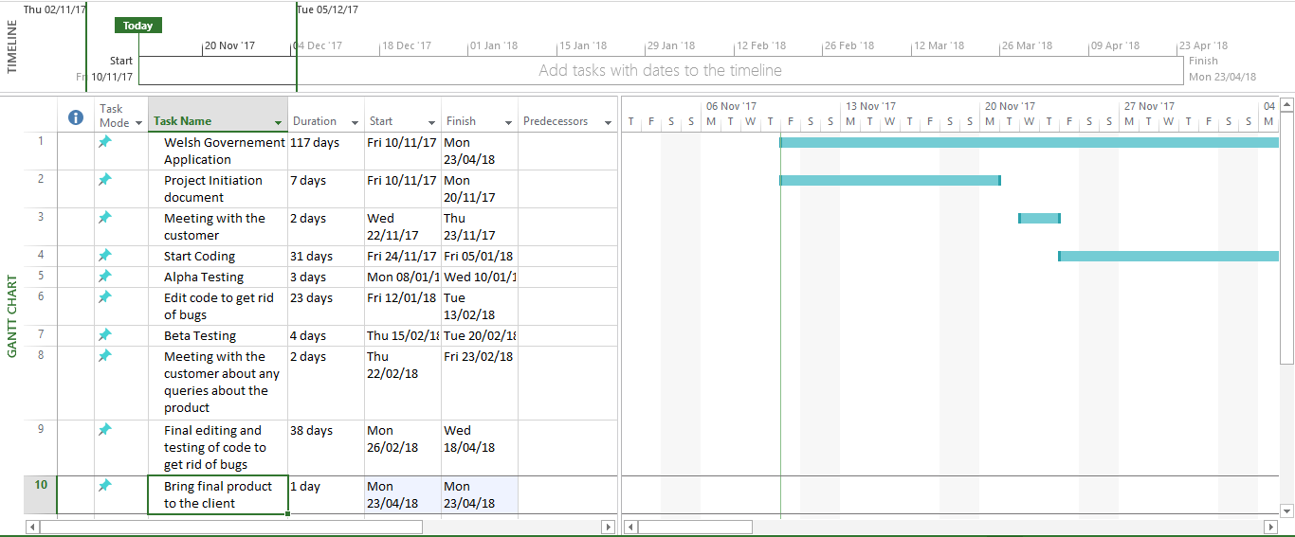
Schedule

In the screenshot above it shows a Gantt chart of the project. So what tasks will be done and how much time the project team has to complete the tasks.
Project Control
For project control the team will monitor their progress by setting daily tasks for each other e.g. create the navigation bar for the application in three days etc. Also when a working day is completed the team will have a meeting to see if they have completed their daily tasks if not the project may take more time to be completed.
Quality Control
For Quality Control rules will be used for example the team must use efficient coding so not using unnecessary code in the program. Also the code will go under Alpha and Beta testing to make sure that there are no bugs and errors in the code also the project manager will look over all the code that has been written to make sure there are no obvious errors in the code.
Roles and Responsibilities
In this section there will be a list of roles and responsibilities for the project team.
Rory Cook – Project manager and head programmer. Email address rauidhricook@gmail.com.
Ethan Randell – Time keeper and programmer. Email address ethanrandell117@gmail.com. Who will report to Rory Cook.
Rhiannon Thomas – Programmer. Email address rhiannonthomas@gmail.com. Who will report to Roryh Cook

