

Name: Paul Austin

P Number: P148321

Module: Advanced Instrumentation Systems

Assignment

Lecturer: Dr Stephen Mosey

Brief
You are commissioning an upgrade to the RADAR systems at two sites.
Site one is used for surveillance and covers an area extending for 350 km radius from the site for 270 degrees over sea. Site one is located on a peninsula approximately 80m above sea level and 1km from the shore.
Site two is used for tracking fast moving objects travelling away from the site. The site covers an area extending for 50 km covering an angle of 45 degrees of sea. Site two is located approximately 10m above sea level and 150m from the shore.
Both sites should be able to detect a reflector with a RCS of 10 m2 within the frequency band used at any point within their envelope. Assume a minimum detectable signal of -150 dBW for both systems.
Discuss the required specifications for both sites.
Discuss the advantages and disadvantage of using secondary RADAR or other technologies such as over-the-horizon RADAR at site one in addition to the main surveillance RADAR.
Your report should include a literature review of the technology, detailed specifications of the systems you are recommending for the two sites, along with a discussion on your chosen technology.

Table of Contents
3 List of Figures and Tables 3
3.1 List of Figures 3
3.2 List of Tables 3
4 Introduction 4
4.1 What is RADAR 4
4.2 Primary Surveillance Radar (PSR) 6
4.3 Secondary Surveillance Radar (SSR) 7
4.4 Radar Range Calculation 8
5 Summary 9
6 Site 1 10
6.1 Chosen Technology 10
6.2 Range Calculations 10
6.3 Example 11
7 Site 2 12
7.1 Chosen Technology 12
7.2 Range Calculations 12
7.3 Example 13
8 Conclusion 14
9 References 16
10 Bibliography 17
11 Appendix 1 18
11.1 Further Radar Types 18
12 Appendix 2 19
12.1 Radar Horizon 19
12.2 Cone of Silence. 19
12.3 Obscuration / low altitude 20

List of Figures and Tables

List of Figures
Figure 1: Image showing comparison between PSR & SSR [4] 5
Figure 2: Diagram taken from UWTSD Advanced Instrumentation Systems (M6X00942) lecture slides. 8
Figure 3: A commercial example of a PSR that may be suitable for Site 1 is: 11
Figure 4: A commercial example of a radar that would perhaps be suitable for this location would be the Coast Watcher 100 from Thales: 13
Figure 5: Lyra Radar: 14
Figure 6: Variant Radar. 15
Figure 7: Example of how Radar Horizon 19
Figure 8: How the Cone of Silence works 19

List of Tables
Table 1: Summary of Advantages and Disadvantages of PSR. 9
Table 2: Summary of Advantages and Disadvantages of SSR. 9

Introduction

What is RADAR
RAdio Detection And Ranging (RADAR) operates by transmitting a waveform of a known frequency and detecting the waveforms reflected echo. In other words, when the waveform strikes an object, some of that waveform is reflected and returned back to the antenna location. This reflected waveform allows for the following information to be obtained:
- Range.
  - This is derived from the time it takes for the transmitted waveform to be reflected and return.
- Direction.
  - This can be determined from the direction that the radar is pointing in – especially if the radar is directional.
- Speed.
  - Objects that are moving create a different waveform reflection than stationary objects.
There are two main types of Radar:
- Primary Surveillance Radar (PSR).
  - Continuous Wave – continuously transmits its waveform while processing the received waveform.
  - Pulse Radars – transmit waveform pulses. The repetition of the received pulsed waveforms are used to determine the range of the target.
- Secondary Surveillance Radar (SSR).
  - Requires the tracked object to have a Transponder to return a coded response signal.
The disadvantage of a Secondary Surveillance Radar is that you are not able to receive information from a vehicle that is not fitted with a transponder or is deliberately not cooperative. For this reason, the military tends to use Primary Surveillance Radar.

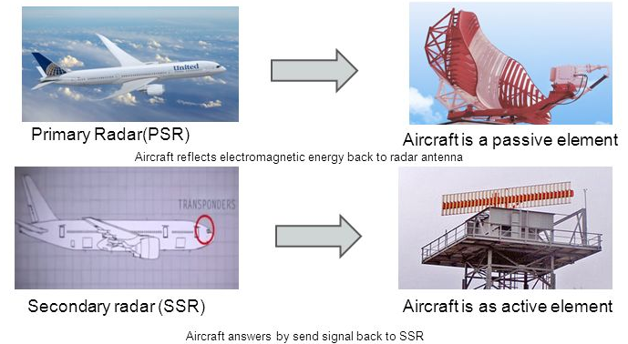
Figure 1: Image showing comparison between PSR & SSR [4]
Why use different types of radar?
As the waveform moves further away from the radar, the reflected waveform becomes weaker. This is due to the fact that radar beams broaden with distance. The radar beam is also further from the ground with distance. This is due to the Earth's curvature, and the fact that the radar beam tends to be slightly inclined. Utilising more than one type of radar resolves these difficulties.

Primary Surveillance Radar (PSR)
Primary Surveillance Radar is what a traditionalist would perhaps refer to as being the typical type of radar.
This works by transmitting a signal and receiving the reflections from the target. The direction of the antennae gives the bearing of the object and the range can be calculated. This calculation uses the fact that electromagnetic waves travel at the speed of the light. Therefore, the time taken from the start of the transmission till the receiving signal is obtained provides distance. The advantage with Primary Radar is that it does not need the object to provide permission for tracking.
Primary Radar displays a visual (blip) on a scope, showing the location of an object. Clutter, or visual noise, from stationary objects (buildings, terrain, towers, bridges) can sometimes confuse the display, this may mask the target which would mean other mechanisms would be required for tracking the target.
These Radars can be Monostatic (transmitter and receiver in the same location), Bistatic (transmitter and receiver in difference locations) or Multistatic (Monostsatic and Bistatic radars sharing an area of coverage).

Secondary Surveillance Radar (SSR)
Secondary Surveillance Radar is best described as a point-to-point communicator rather than a traditional radar. The Transmitter broadcasts a message and the transponder of the plotted craft responds to that message. These transmissions are conducted using a coded derivation depending on the information being requested / transmitted which typically include:
- Unique Identifier.
- Location.
- Altitude.
- Velocity.
This is usually used with civilian aircraft and grew from a Second World War concept of Identification of Friend or Foe (IFF).
There are three main modes of interrogation (transmission):
- Mode A.
  - Relays a 4 digit Octal code sent at 8µs delay.
- Mode C.
  - Allows the ground station to interrogate the aircraft transponder and retrieve the pressure altitude of the aircraft – every 21µs.
- Mode S.
  - This is sent every 3.5µs thus allowing for more interrogation.
The information received from the Transponder means that the scope can now display a target showing information derived from the results sent within the coded transmissions.

Radar Range Calculation
The following formula is used to derive the maximum range of a radar antenna with known characteristics:
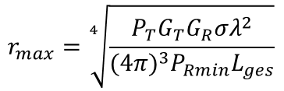
Figure 2: Diagram taken from UWTSD Advanced Instrumentation Systems (M6X00942) lecture slides.
where;
- r_{max} = Maximum Radar Range.
- P_{T} = Transmitted Power.
- G_{T} = Transmitted Gain.
- G_{R} = Received Gain.
- σ = Radar Cross Sectional Area.
- λ = Lamda = for L-Band, this is $\frac{C}{Frequency}$ where C is the speed of light (3x10⁸).
- P_{Rmin} = Receiver minimum power.
- L_{ges} = Sources of loss.
This formula is relevant because the specification defines a maximum range that the radar at each site needs to be able to reach.

Summary
There are many examples of radars that are commercially available, examples of technical data sheets for these highlight key features of the radars such as Range Detection. However, not all information is provided within these data sheets. Without further enquiry to the manufacturer, it is not possible to support the technical information that has been specified.
As such, it is not possible to make an informed decision as to whether or not to use a readily available “off the shelf” radar from the data sheets alone.
In terms of the main technologies (PSR and SSR) that are available, there are various advantages and disadvantages of each:
Advantages | Disadvantages
Operates totally independently of the target aircraft - that is, no action from the aircraft is required for it to provide a radar return. | - Requires a large amount of power.  - Correlation of a particular radar return with a particular aircraft requires an identification process.
 | - Impairment of the RADAR display due to ground clutter even though the RADAR is equipped with MTI
 | - Displays degraded by weather conditions, especially precipitation
Table 1: Summary of Advantages and Disadvantages of PSR.

Advantages | Disadvantages
- Greater range than PSR due to strength of “reply” signal. | Requires aircraft to carry a transponder.
- Fewer problems with signal attenuation.
- Less power required for transmission.
Table 2: Summary of Advantages and Disadvantages of SSR.
Based on these advantages and disadvantages, recommendations for each site have been derived using an ideal scenario within the Radar Range calculations with examples being provided as to how the radars may look.

Site 1

Chosen Technology
Primary Surveillance Radar.

Range Calculations
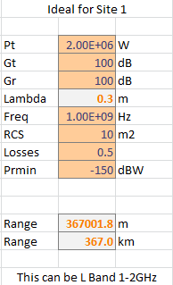
Transmitted power and receiver minimum power have been adjusted to allow for the specified range of 350km to be reached.

Example
Figure 3: A commercial example of a PSR that may be suitable for Site 1 is:
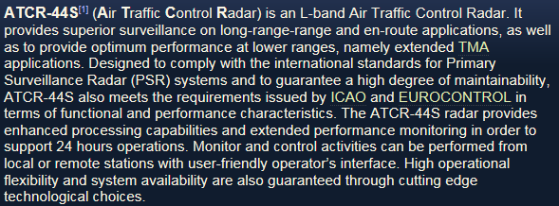
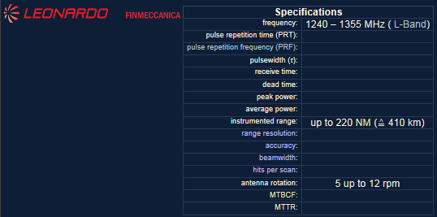

Site 2

Chosen Technology
Primary Surveillance Radar

Range Calculations
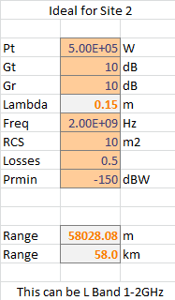
The radar at Site 2 only has to reach a range of 50km, so the transmitted power does not have to be as high as site 1.

Example
Figure 4: A commercial example of a radar that would perhaps be suitable for this location would be the Coast Watcher 100 from Thales:
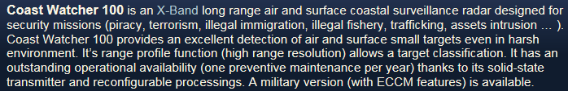
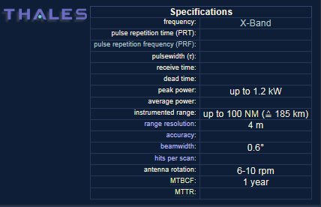

Conclusion
The solutions proposed for Sites 1 and 2 are an ideal model based on the Radar Range equation as opposed to a commercial model based on what options are available in the general market.
As there is no requirement for detailed information on the object being tracked to be displayed / obtained, the solution can therefore use PSR at both locations rather than SSR. Alternative radar technology (such as Identification of Friend or Foe (IFF)) is not required as per the specification provided. The specification does not state whether the search requirements for the radars is limited to aircraft alone. As such a radar requirement for multiple object types is required.
Due to the height of the Radar at Site 1, its overall location and the requirement to track to a distance of 350Km, there are further considerations with the radar where the following could cause an issue with tracking objects;
- Radar Horizon.
- Cone of Silence.
- Obscuration / low altitude.
An appropriate workaround to resolve these issues would be to put an additional radar at Site 1.
Therefore, an example supplement to Site 1 could be:
Figure 5: Lyra Radar:
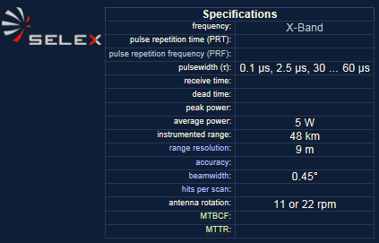

One method that could be used to overcome the issue with the height at Site 1 and the horizon could be to use “Refraction” making use of the fact that a radar beam travelling through the atmosphere does not travel in a perfectly straight line. In free space the beam would be straight, but in the atmosphere, changes in temperature and humidity as a result of altitude
Additional radar would make the discussed disadvantages seen at that site obsolete and provide a more effective overall solution.
Should there be a commercial requirement in terms of the radar solution for these sites (as opposed to a technical one), then an overall solution could be resolving the solution for both sites under the same umbrella as opposed to treating them differently.
An example of this could be:
Figure 6: Variant Radar.
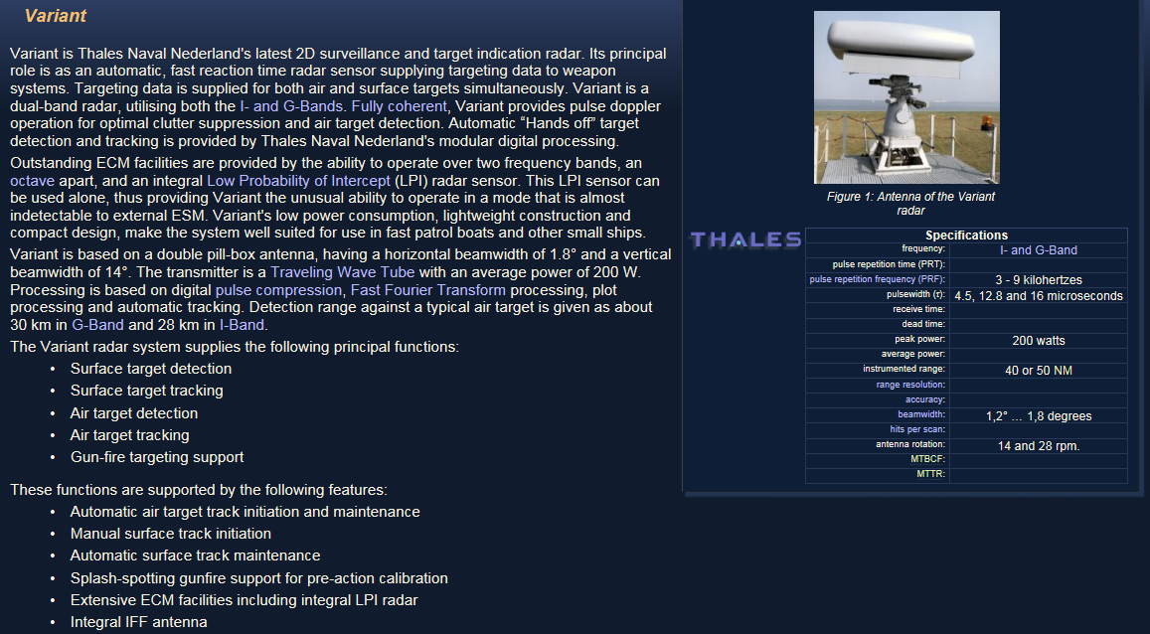

References
- Radar Definition: https://searchmobilecomputing.techtarget.com/definition/radar - accessed 08:20 on 7th June 2018.
- COMSOL BLOG – What is the Doppler Effect? By Alexandra Foley, 15th July 2013. https://www.comsol.com/blogs/what-is-the-doppler-effect/ - accessed 09:00 on 7th June 2018.
- SONAR and RADAR: http://slideplayer.com/slide/5750694/ - accessed 09:45 on 7th June 2018.
- How air traffic control radar work: http://slideplayer.com/slide/8907716/ - accessed 10:30 on 7th June 2018.
- Pulse Doppler Radar - Principles, Technology, Applications, Alabaster. C, SciTech Publishing, 2012, ISBN: 978-1-891121-98-2.
- Target Detection by Marine Radar, Briggs. J, Institution of Engineering and Technology, 2004, ISBN: 978-0-86341-359-9.
- Card Index of Radar Sets: http://www.radartutorial.eu/19.kartei/07.naval/karte009.en.html - last accessed 11:30 on 15th June 2018.
- Air Traffic Services Surveillance Systems, Including An Explanation of Primary and Secondary Radar, Vabre, P, extract taken from http://www.airwaysmuseum.com/Surveillance.htm - accessed 13:30 on 15th June 2018.
- Radar Line of Sight: http://www.radartutorial.eu/07.waves/wa16.en.html - accessed 11:30 18th June 2018.
- UWTSD Advanced Instrumentation Systems (M6X00942) lecture slides.
- Cone of Silence: http://www.radartutorial.eu/01.basics/Radar%20Coverage.en.html – accessed 13:30 on 18th June 2018

Bibliography
- Target Tracking with Adaptive Sampling Intervals Using a Phased Array Radar (Electronics & Communications in Japan, Part 1: Communications, 2002, Vol.85 (10), p.44-55), Yanbe. A, Ito. M, Tsujimichi. S, Kosuge. Y, Business Source Complete, ISSN: 87566621.
- Tracking The Evolution Of Radar (Microwaves & RF. Jun2011, Vol. 50 Issue 6, p23-23. 1p.), Browne. J, ISSN: 0745-2993.
- EXPLAINTHATSTUFF! Radar: https://www.explainthatstuff.com/radar.html - accessed 08:15 on 7th June 2018
- Modern Radar Systems, Browne. J, Business Source Complete, Part of Electronic Design 2014 P S12, ISSN: 00134872.
- SkyRadar PSR, Security and SSRSuite data sheet: http://www.didalab-didactique.fr/2008/upload/121213_121021_ME_8XCub8.pdf - accessed 12:00 on 7th June 2018.
- Modern Radar Detection Theory, Maio. D, Greco. A, Sabrina. M, Institution of Engineering and Technology, 2010, ISBN: 978-1-61353-199-0.
- Radar Systems Analysis and Design Using Matlab® (3rd Edition), Mahafza. R, Taylor & Francis, 2013, ISBN: 978-1-4398-8496-6.
- Exact Aircraft Radar Ranges: https://rhk111smilitaryandarmspage.wordpress.com/exact-aircraft-radar-ranges/ - accessed 09:00 on 13th June 2018.
- Fundamentals of Ground Radar for Air Traffic Control Engineers and Technicians, Bouwman. R, SciTech Publishing, 2009, ISBN: 978-1-891121-75-3
- How Radar Works – Australian Government Bureau of Meteorology: http://www.bom.gov.au/australia/radar/about/what_is_radar.shtml - accessed 08:00 on 7th June 2018.
- Multi-Static Primary Surveillance Radar – An examination of Alternative Frequency Bands, a report for EUROCONTROL, reference 72/07/R/376/U, July 2008 - Issue 1.2: https://www.eurocontrol.int/sites/default/files/publication/files/surveillance-report-multi-static-primary-surveillance-radar-an-examination-of-altervative-frequency-bands-200807.pdf - accessed 12:10 on 7th June 2018.
- Thales PRIMARY SURVEILLANCE RADAR FOR AIR TRAFFIC CONTROL: https://www.scribd.com/document/352950080/Star-Ng-Datasheet-Final - accessed 12:15 on 7th June 2018.
- ASCSignal L-band Air Traffic Control Radar Antenna System product specifications: http://www.cpii.com/docs/datasheets/359/L-BandAirTrafficControlRadar2012%20(1).pdf – accessed 12:20 on 7th June 2018.
- INDRA Primary Surveillance Radar: https://www.indracompany.com/sites/default/files/12_psr_brochure_v1_02-2009_eng.pdf - accessed 12:25 on 7th June 2018.
- Assessing the Tikhomirov NIIP L-Band Active Electronically Steered Array, Kopp. C, Air Power Australia Analysis 2009-06 14th September 2009: http://www.ausairpower.net/APA-2009-06.html - accessed 10:00 on 13th June 2018.
- Introduction to Radar Target Detection, Tait. P, IET, 2005, ISBN: 978-0863-4150-12.

Appendix 1

Further Radar Types
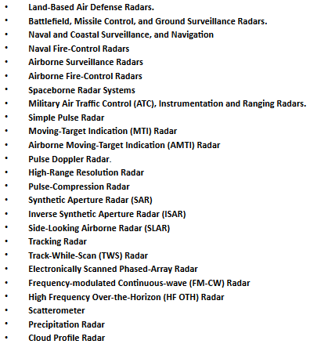

Appendix 2

Radar Horizon
Under normal atmospheric conditions, the curvature of a radar beam is slightly less than the curvature of the Earth. As such, with an increase in distance, the beam climbs higher meaning that it becomes harder to track objects that are further away. This is caused by changes in altitude and the decrease of pressure, temperature and humidity. In addition, due to the fact that radio waves travel in a straight line, it is possible for an aircraft to effectively be below the detection area of a radar as the straight line is in tangent with the curvature of the Earth. This would mainly be the case with more powerful and long range radars.
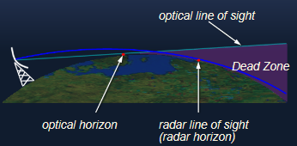
Figure 7: Example of how Radar Horizon

Cone of Silence.
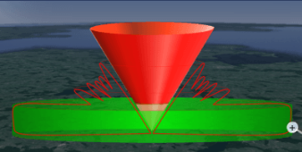
Figure 8: How the Cone of Silence works
As per the above diagram, there is an area above a radar where due to the line of transmission, there is a gap in the detection area. It is this gap that is referred to as the “Cone of Silence”.

Obscuration / low altitude
Where buildings and other obstacles are present, the radar cannot “penetrate” these resulting in a loss of detection for anything behind that item.
The ground can also cause issue with undulating terrain. In the case of Site 1 where the radar is set back, the ground could obscure low level aircraft or watercraft as they become closer to the radar location.

Radar Definition: https://searchmobilecomputing.techtarget.com/definition/radar - accessed 08:20 on 7th June 2018.
COMSOL BLOG – What is the Doppler Effect? By Alexandra Foley, 15th July 2013. https://www.comsol.com/blogs/what-is-the-doppler-effect/ - accessed 09:00 on 7th June 2018.
Air Traffic Services Surveillance Systems, Including An Explanation of Primary and Secondary Radar, Vabre, P, extract taken from http://www.airwaysmuseum.com/Surveillance.htm - accessed 13:30 on 15th June 2018.
Air Traffic Services Surveillance Systems, Including An Explanation of Primary and Secondary Radar, Vabre, P, extract taken from http://www.airwaysmuseum.com/Surveillance.htm - accessed 13:30 on 15th June 2018.
Example taken from Card Index of Radar Sets: http://www.radartutorial.eu/19.kartei/07.naval/karte009.en.html - last accessed 11:30 on 15th June 2018.
Example taken from Card Index of Radar Sets: http://www.radartutorial.eu/19.kartei/07.naval/karte009.en.html - last accessed 11:30 on 15th June 2018.
See Appendix 2 for further information.
Example taken from Card Index of Radar Sets: http://www.radartutorial.eu/19.kartei/07.naval/karte009.en.html - last accessed 11:30 on 15th June 2018.
Example taken from Card Index of Radar Sets: http://www.radartutorial.eu/19.kartei/07.naval/karte009.en.html - last accessed 11:30 on 15th June 2018.
Image taken from SONAR and RADAR: http://slideplayer.com/slide/5750694/ - accessed 09:45 on 7th June 2018.

